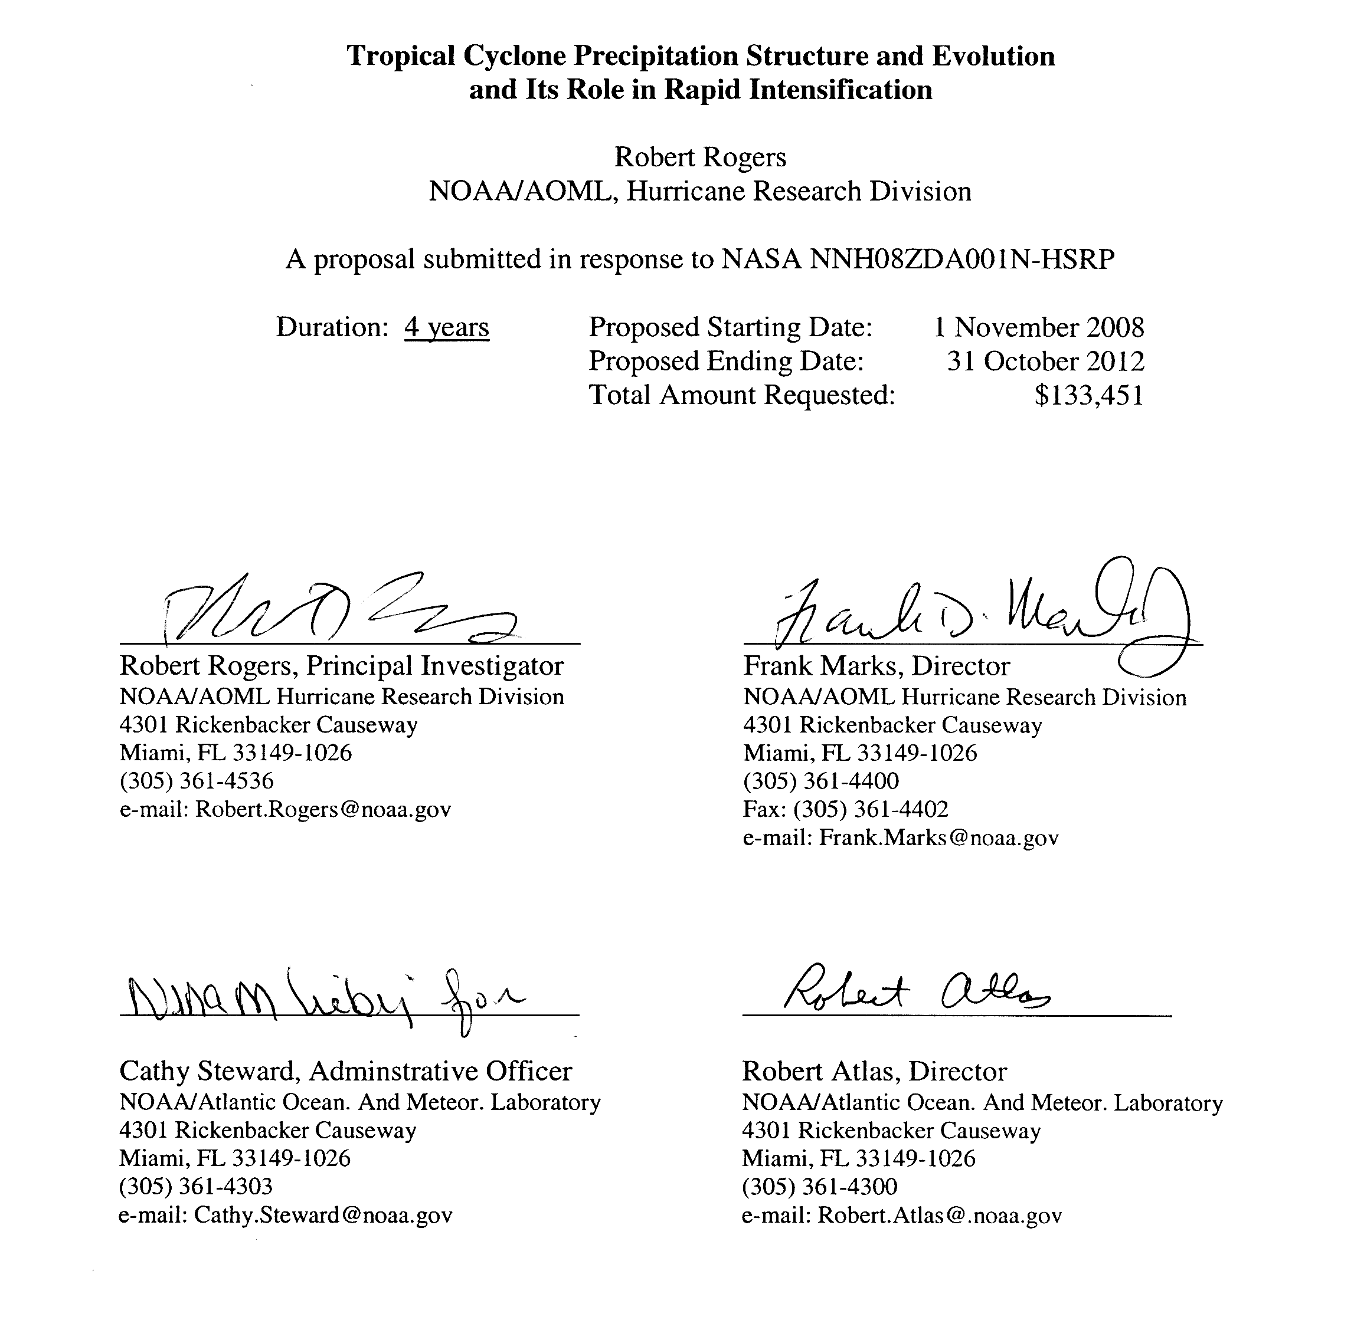

Tropical Cyclone Precipitation Structure and Evolution
and Its Role in Rapid Intensification

Principal Investigator: Dr. Robert Rogers, NOAA/AOML Hurricane Research Division
Co-Investigator: Dr. Dan Cecil, University of Alabama at Huntsville
Co-Investigator: Dr. Shuyi Chen, RSMAS, University of Miami
Co-Investigator: Dr. Andrew Heymsfield, National Center for Atmospheric Research
Collaborator: Dr. Gerald Heymsfield, NASA/Goddard Space Flight Center

ABSTRACT
One of the most challenging aspects in tropical cyclone research is developing an improved understanding of the processes underlying rapid intensification (RI). This task is challenging because the processes important in RI span spatial scales of many orders of magnitude from the synoptic-scale to the microscale. While the importance of environmental fields is fairly well-established, what is not as well understood are the roles of convective-scale and microscale processes and their interaction with the vortex.
Observational and modeling studies have linked RI to the occurrence of deep convection, sometimes referred to as convective bursts, within the core. The goal of this research is to better understand the structures of these convective bursts, how they evolve, and how that evolution feeds back onto the vortex-scale circulation. To accomplish these goals the following questions will be addressed:
- What are the dominant convective and microphysical structures associated with convective bursts?
- What is the role of precipitation morphology in determining the feedback of convective bursts on the vortex-scale circulation during RI? Is the vortex response to convective bursts tied to the strongest vertical velocity cores or areas of weaker vertical motion? What is the relative role of convective vs. stratiform precipitation processes in RI?
- What is the dependence of the convection-vortex feedback on the vortex structure and intensity?
- Is there a systematic difference in the structure of the convection for bursts that are associated with RI compared with bursts that are not associated with RI?
- What is the relative importance of dust and humidity in determining convective structure and evolution and its impact on TC structure and intensity?
- How accurate the current high-resolution (O(1 km) grid length) models capture the dominant burst structures and interactions with the vortex-scale environment?
- Can these models differentiate between burst structures that may be more conducive to RI vs. burst structures that are not as conducive?
These questions will be addressed through a combination of observing platforms and high-resolution modeling. For the observations, satellite data from TRMM and Aqua and airborne data from the NASA DC-8, ER-2 and NOAA P-3’s will be used, as well as microphysical probe measurements from previous joint NASA-NOAA field campaigns (CAMEX-3, -4, TCSP, NAMMA). For the models, both the WRF-NMM and WRF-ARW will be run at cloud-resolving grid length for comparison with the observations and with each other.

TABLE OF CONTENTS

Abstract………………………………………………………………………………… i
1. Background and statement of the problem………………………………………….. 1
a) Motivation……………….………………………………………………...... 1
b) Science questions………………………………............................................ 2
c) Approach......................................................................................................... 3
d) Relevance to NASA objectives....................................................................... 4
e) Results from previously-funded research…………………………………… 4
i) Convective burst and TC intensification studies……………….......... 4
ii) Model microphysics field evaluations……......…………….............. 7
iii) TRMM PR and model simulated rainfall structure............................ 8
2. Description of work…………………………………………………………………. 9
a) Observational component………………………………………………….... 10
i) Satellite-based census........................................................................... 10
ii) Aircraft-based case study.................................................................... 12
iii) Airborne in situ analysis……………………………………….…... 12
b) Modeling component....................................................................................... 12
c) Work plan…………………………………………………………………..... 13
i) Year One (2008-2009)…………………………………………..….... 13
ii) Year Two (2009-2010)……………...……………………………..... 14
iii) Year Three (2010-2011)……………………………………………. 14
iv) Year Four (2011-2012)……………………………………………... 15
3. References cited…………………………………………………………………....… 15
4. Biographical sketches / Personnel.……….………………………………………….. 18
5. Current and pending support …….………………………………………………...... 25
6. Statements of commitment…………………....……………………………………… 31
7. Budget justification………………………………………………………………....... 33
a) Combined budget narrative…………………………………………………… 33
b) Budget details………………………………………………………………… 35

1. Background and Statement of the Problem
a) Motivation
One of the most challenging problems in tropical cyclone (TC) research is understanding the processes underlying rapid intensification (RI). This task is challenging because the processes important in RI span spatial scales of many orders of magnitude, ranging from the synoptic-scale to the microscale, and they involve processes with varying levels of predictability, ranging from highly predictable to essentially stochastic. While the importance of favorable environmental fields (e.g., low vertical wind shear, high sea surface temperature) is fairly well-established, what is not as well understood are the roles of convective-scale and microphysical-scale processes and their interactions with the TC vortex circulation.
Observational and modeling studies have linked RI to the intermittent occurrence of deep, strong convection (sometimes referred to as convective bursts) within the inner core. Convective bursts are recognized many ways, with cloud tops getting colder and expanding in infrared (IR) measurements, very low brightness temperatures due to ice scattering in the passive microwave channels, an increase of lightning flash rates, and towers of high radar reflectivity (e.g., Squires and Businger 2008, Hennon 2006, Kelley et al. 2004, Rodgers et al. 1998, Gentry et al. 1970, many others). While a link between convective bursts and RI has been clearly established, what is not clear is whether bursts cause RI or are simply a reflection of other processes occurring within the vortex that cause RI. This uncertainty is illustrated by Fig. 1, which shows that there is nearly an equal number of TCs that weaken as intensify, regardless of whether or not deep convection (such as a convective burst) is occurring within the core (Fig. 1). Clearly much more research is needed to understand the role of deep convection in TC intensification and RI.

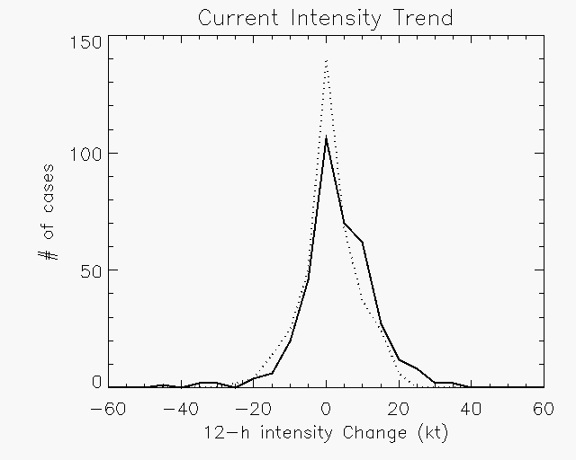
Figure 1. Histogram of intensity changes for 740 Atlantic basin cases based on the minimum value of their TRMM TMI 85 GHz ice scattering. Solid line: stronger than normal convection, with minimum 85 GHz below the sample median (172 K). Dashed line: weaker than normal convection, with minimum 85 GHz above the sample median.

The relationship between convective bursts and RI has generally been linked to enhanced diabatic heating through latent heat release in the storm core. Some recent TC genesis studies have emphasized a different mechanism by which convective bursts impact the TC vortex circulation, however. These studies (Hendricks et al. 2004, Montgomery et al. 2006) focus on vortical hot towers (VHTs), which are localized areas of strong updrafts collocated with cyclonic rotation. In this hypothesis, convectively-generated vorticity anomalies in the VHTs are axisymmetrized by the parent vortex, leading to an amplification of the system-scale vorticity and intensification of the TC. This hypothesis has been extended to RI as well.
The role of diabatic heating in RI in TCs is dependent on the magnitude, duration, horizontal and vertical distribution, and the orientation of the heating relative to the eyewall. An example of the importance of the heating orientation is shown in Fig. 2 (Desflots and Chen 2008), which shows a high-resolution numerical model simulation of Hurricane Lili (2002). This figure shows distinct diabatic heating patterns in Hurricane Lili (2002) during a period of RI and during a relatively steady-state phase. While the magnitude of the diabatic heating during the period of RI is less than the heating during the steady-state phase, the heating profile is upright relative to the eyewall during RI, whereas the heating is tilted outward along the eyewall during the steady-state phase. The morphology of the precipitation, e.g., distribution of convective precipitation and whether the precipitation is organized into a predominantly convective or predominantly stratiform mode, determines the vertical structure and longevity of the diabatic heating. Precipitation morphology may thus also play a significant role in determining the response of the vortex to the heating. An improvement in the understanding of these precipitation processes may lead to an improvement in our understanding of the role of convective bursts in RI. Furthermore, the importance of precipitation morphology on the vortex also depends on the characteristics of the vortex itself, such as the strength of the primary and secondary circulations and the horizontal and vertical extent of the circulations. Since convective bursts are easily identifiable in real time, improving the understanding of precipitation structure and evolution during RI may lead to the ability to recognize which ones portend RI and which do not.

Figure 2. Model simulated azimuthally-averaged diabatic heating (color) in K h⁻¹ and absolute angular momentum (AAM, contours at interval of 2.5 x 105 m² s⁻¹) in Hurricane Lili on 2 October 2002 during a rapid intensification at (a) 1500 UTC and a relative steady period (d) 2100 UTC. The solid (dashed) vertical white line marks the location of the RMW at time t (t+12 minutes). (Adapted from Desflots and Chen 2008).

b) Science Questions
The goal of this research is to better understand the structures of convective bursts, how they evolve, and how that evolution feeds back onto TC intensity and structure change. A special emphasis will be placed on understanding how these processes relate to RI. To accomplish these goals the following questions will be addressed:
- What are the dominant convective and microphysical structures associated with convective bursts?
- What is the role of precipitation morphology in determining the feedback of convective bursts on the vortex-scale circulation during RI? Is the vortex response to convective bursts tied to the strongest vertical velocity cores or areas of weaker vertical motion? What is the relative role of convective vs. stratiform precipitation processes in RI?
- What is the dependence of the convection-vortex feedback on the vortex structure and intensity?
- Is there a systematic difference in the structure of the convection for bursts that are associated with RI compared with bursts that are not associated with RI?
- What is the relative importance of dust and humidity in determining convective structure and evolution and its impact on TC structure and intensity?
- How accurately can current high-resolution (O(1 km) grid length) models capture the dominant burst structures and interactions with the vortex-scale environment?
- Can these models differentiate between burst structures that may be more conducive to RI vs. burst structures that are not as conducive?
A key aspect underlying these questions is: How do those burst properties and mechanisms that are important to rapid intensification map to properties that can be routinely observed via remote sensing and simulated via numerical models? Conversely, how do remote sensing observables and numerical simulations map to those properties and mechanisms that are important to rapid intensification? Also, we have purposefully left “convective burst” and “rapid intensification” vaguely defined. Meaningful ways of defining these terms will be explored in the context of these questions.
c) Approach
These questions will be addressed by analyzing a combination of observational datasets and high-resolution model output. In CAMEX-3 in 1998, Hurricanes Bonnie and Georges both had convective bursts that were seen by the aircraft missions and TRMM satellite. Tropical Storm Chantal in 2001 had strong convection during a CAMEX-4 aircraft mission, but did not substantially intensify on its way to landfall. In 2005 Hurricane Dennis was well observed by TCSP aircraft missions as it intensified in the Caribbean, and Hurricane Emily in 2005 had extremely intense convection observed by TCSP aircraft. Debby in 2006, which showed indications it was being impacted by the Saharan Air Layer, was fully sampled by NASA aircraft during the NAMMA experiment. If NASA conducts another aircraft-based experiment in the near future, it may provide other cases for analysis. Airborne Doppler radar, radiometer, dropsonde, and other data from aircraft missions for suitable cases will be augmented with satellite observations. The satellite focus will be on TMI and AMSR-E passive microwave ice scattering measurements, supplemented by other related passive microwave radiometers (particularly SSMI and SSMIS). Geostationary imagery will also be used to assess the temporal evolution of bursts. While individual cases from the field campaigns will be studied in detail, a broader census-type approach will be taken with the long term record of TRMM and AMSR-E measurements. This census will be limited to cases that have sufficient aircraft reconnaissance, in order to have TC intensity estimates that are mostly independent of the satellite data used in this study. For the models, both the WRF-NMM and WRF-ARW will be run at cloud-resolving grid length for comparison with the observations and with each other. The simulations will be used to investigate particular cases that are of interest from the field campaigns and satellite census, and to investigate statistical properties from ensembles of simulations. Details of the approaches to be used are in Section 2.

d) Relevance to NASA objectives
This proposal directly addresses the Hurricane Science Research Program objective of using field experiment and satellite data in conjunction with numerical model simulations to better understand tropical cyclone genesis and intensification processes. It particularly (but not exclusively) exploits measurements from the CAMEX, TCSP, and NAMMA field campaigns and the TRMM and Aqua satellites. It addresses multiple HSRP science questions, most notably: “What environmental, oceanic, and inner-core factors govern rapid intensification?” “Do hot towers and convective bursts play a major role or are they merely an indicator of energy conversion processes?” “What is the predictability of rapid intensification and what observations are most critical to its observation?” “What is the role of internal structure changes... on tropical cyclone intensity change?” More generally, the proposal addresses NASA Strategic Subgoal 3A (“Study Earth from space...”) and Research Objective 3A2 (“Enable improved predictive capability for weather and extreme weather events”).
e) Results from previously-funded research
i) Convective burst and TC intensification studies
Previously-funded work has started to address the questions proposed here. The main emphasis has involved trying to differentiate between convective bursts that are associated with RI and those that are not, using analyses of a combination of observations and simulations. The Tropical Cloud Systems and Processes (TCSP) ER-2 aircraft mission into Hurricane Emily on 17 July 2005 was noteworthy and is an example of the issue at hand. Emily had deepened to 929 hPa late on 16 July, but began filling with a central pressure of 943 hPa at 06 UTC 17 July, prior to the ER-2 flight. The ER-2 flew over intense convection, with instrument scientists reporting the highest lightning rates and most impressive radar reflectivity tower they had seen in any ER-2 hurricane mission. The ER-2 Doppler radar (EDOP) measured 40 dBZ radar echoes to about 14 km (Fig. 3, from Quinlan et al. 2008), while the Advanced Microwave Precipitation Radiometer (AMPR)’s 85 GHz brightness temperatures were scattered down to 100 K, and even the low frequency channels had scattering by large ice (Fig. 4). When the next reconnaissance aircraft arrived near 12 UTC, the pressure was 946 hPa. Why did Hurricane Emily not deepen during this episode of intense convection? Initial analysis suggests the strong convection was somewhat sporadic, and concentrated in the northwest through south sectors of the eyewall. What is not clear is if there was any aspect of the structure of the convective burst itself that may have prevented Emily from intensifying further.
Other work has looked at ways to differentiate convective bursts associated with RI from bursts not associated with RI by evaluating vertical profiles of reflectivity from the TRMM Precipitation Radar (PR) (Rogers et al. 2008a). Figure 5 shows the vertical profile of mean reflectivity for Atlantic TC cases from 1998 to 2005 that had a convective burst associated with them and subsequently underwent RI and cases that also had a convective burst but did not undergo RI. As can be seen from this figure, there are few differences in the profile of mean reflectivity. The only noteworthy difference lies in the slope of reflectivity at high altitude, between 9 and 14 km. The slope of the reflectivity is less for the RI case than for the non-RI case, suggesting that upward motion is stronger in the high altitudes for the RI cases than for the non-RI cases. While these results do suggest some physically-based difference between RI and non-RI bursts, much more work is needed to determine if there are any robust differences between these structures.

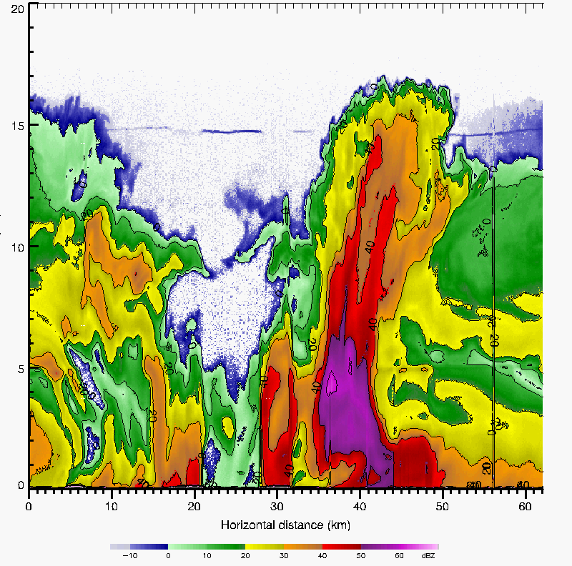

Figure 3. EDOP reflectivity during first transit of Hurricane Emily’s center, 0750-0755 UTC 17 July 2005. Contours in 10 dB increments; 40 dBZ is the transition from orange to red. Axes span 20 km vertical by 62 km horizontal, with east-southeast on the left and west-northwest on the right. From Quinlan et al. 2008.

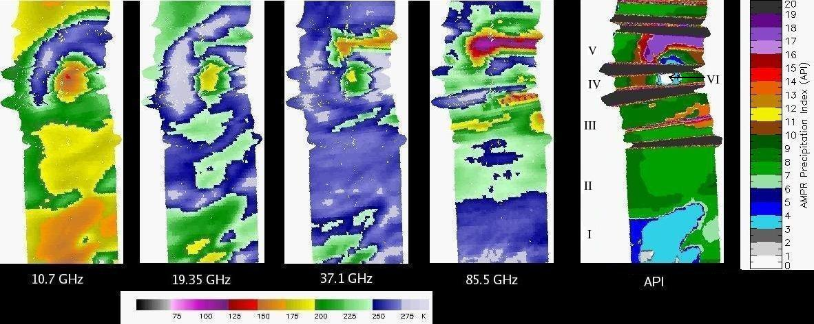

Figure 4. AMPR brightness temperatures at 10, 19, 37, and 85 GHz, and AMPR Precipitation Index (API; Hood et al. 2006), 0746-0755 UTC 17 July 2005. High values of API indicate strong convection, with large ice particles scattering the upwelling radiation at progressively lower frequencies. East-southeast is at bottom and west-northwest at top. From Quinlan et al. 2008.

Other research has approached the problem from a modeling perspective. Rogers et al. (2008b) has performed a high-resolution MM5 simulation of Hurricane Dennis, which underwent a period of rapid intensification that was well-captured in the 1.67-km simulation. Prior to and during the period of RI several episodes of convective bursts, defined based on exceeding a vertical velocity threshold, occurred in the model. An examination of the distributions of vertical motion for the bursts that occurred prior to RI with those that occurred during RI (Fig. 6) shows a generally similar distribution of vertical velocity for the weak and moderate magnitudes of vertical motion. For the strongest cores, there is a slightly higher portion of points evident for the bursts prior to RI, indicating that the main difference in the bursts prior to RI with those during RI was in the (small) percentage of area experiencing the strongest vertical velocity cores.

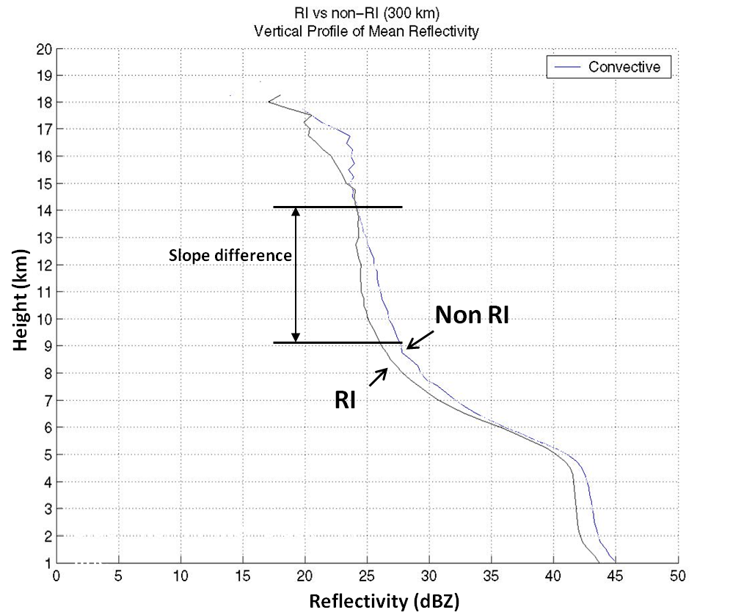

Figure 5. Vertical profile of mean reflectivity in the convective region of Atlantic basin TCs that underwent rapid intensification within 24 h of TRMM overpass and those that did not undergo rapid intensification. Cases used were from 1998-2005, with 12 (15) cases used for the RI (non-RI) dataset.

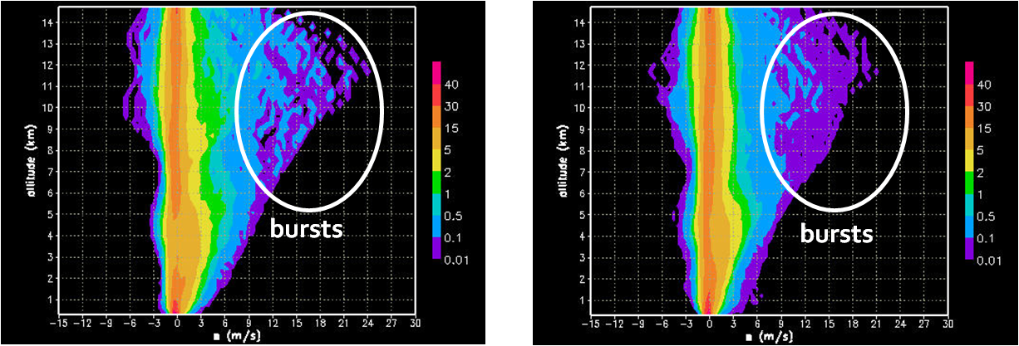
(a) (b)
Figure 6. Contoured Frequency by Altitude Diagram (CFAD; %) of vertical velocity for burst times (a) prior to RI and (b) during RI in the MM5 simulation of Hurricane Dennis (2005).

While the primary differences in the pre-RI and the RI bursts in the simulation occur for the strongest vertical velocity cores, it is not clear how important those differences are to the structure and evolution of the vortex. Figure 7 shows mean potential vorticity (PV) and aggregate vertical mass flux binned by vertical velocity within the inner core (inner 75 km) for the pre-RI and RI bursts shown in Fig. 6. The mean PV shows the presence of high PV associated with the strongest upward motion, indicative of the VHTs discussed in Hendricks et al. (2004). These VHTs are evident both in the pre-RI and RI bursts, though the peak PV is concentrated at lower altitudes for the RI bursts. By contrast, the aggregate mass flux for both time periods shows that the mass flux is concentrated in the weak to moderate vertical velocity bins (i.e., 1-3 m s⁻¹). This indicates that the bulk of the total upward mass flux is accomplished by the (much higher frequency of) weak to moderate updrafts rather than the (much lower
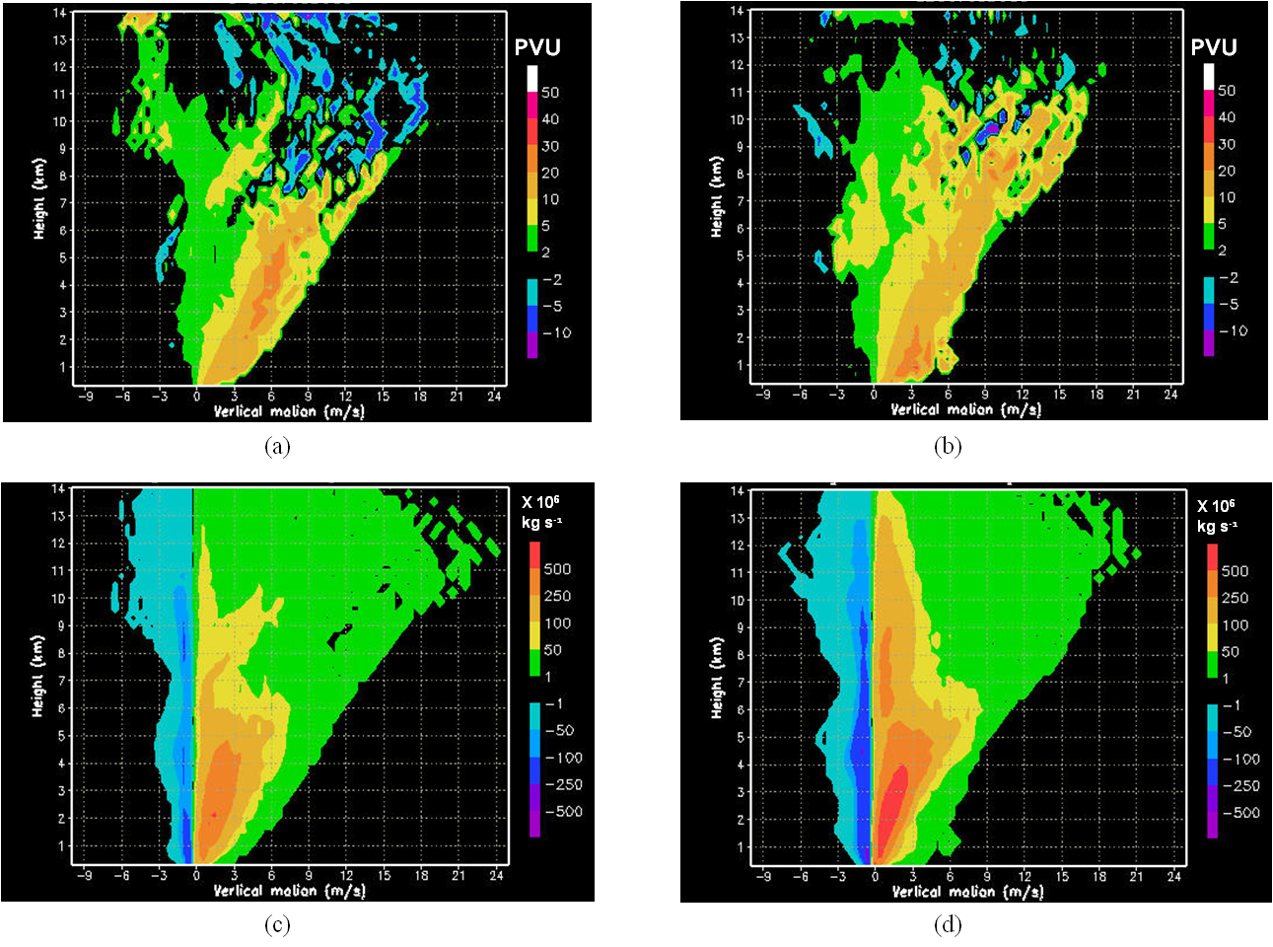
Figure 7. (a) Mean potential vorticity (PVU) binned by vertical velocity for bursts occurring prior to RI; (b) As in (a), but for bursts occurring during RI; (c) Aggregate vertical mass flux (x 10⁶ kg s⁻¹) for bursts occurring prior to RI; (d) As in (c), but for bursts occurring during RI.

frequency of) strong updrafts. This result is consistent with radar observations of Florida convective systems done in Yuter and Houze (1995).
ii) model microphysics field evaluations
Recent work has also looked at evaluating microphysics fields from high-resolution tropical cyclone simulations by comparing them with airborne and spaceborne measurements (e.g., Rogers et al. 2007). Most of these comparisons have compared the distributions of radar reflectivity from airborne Doppler radar and TRMM PR measurements with model-derived reflectivity and vertical motion measurements from airborne Doppler radar with simulated vertical velocity fields. An example of these comparisons is shown in Fig. 8, which shows CFADs of reflectivity from the eyewall and stratiform regions of 34 TRMM PR overpasses, 233
aircraft radial legs, and 24 hours of output from MM5 simulations of two tropical cyclones. From Fig. 7, the distributions of reflectivity are broader for the simulations than for the observations, indicating a higher percentage of high reflectivities in the model. Modal and maximum reflectivity values are higher in simulations, reflecting the high reflectivity bias commonly seen in these types of simulations (e.g., Orville et al. 1984, Farley 1987, Orville and Kopp 1990, Liu et al. 1997, Rogers et al. 2003). The TRMM and airborne radar CFADs are
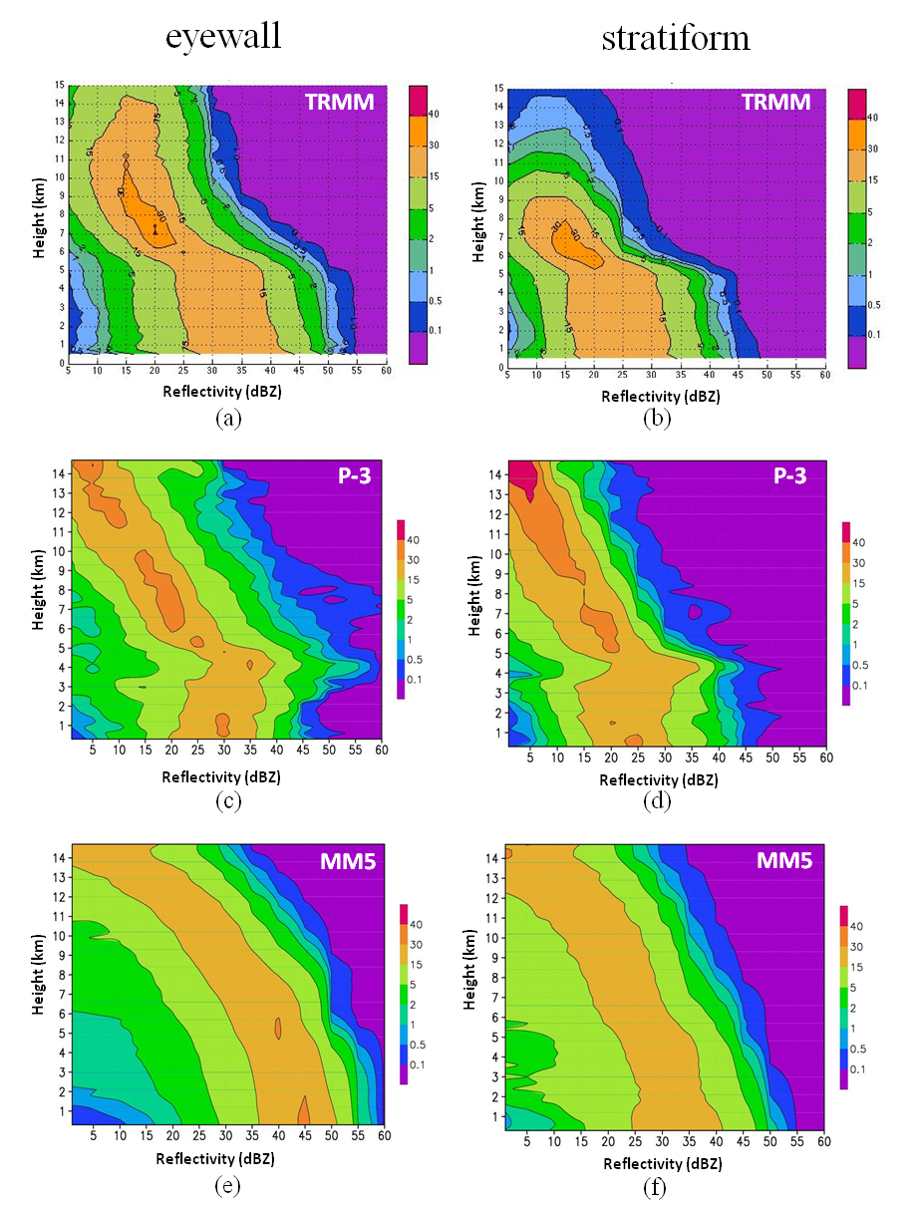
Figure 8. Contoured frequency by altitude diagrams (CFADs) of reflectivity (%) for different platforms. (a) TRMM PR eyewall CFAD for global distribution of TCs from 2004-5; (b) As in (a), but for stratiform regions; (c) NOAA P-3 airborne Doppler radar eyewall CFAD for nine TCs sampled from 1985-1994 (Rogers et al. 2007); (d) As in (c), but for stratiform regions; (e) 1.67-km MM5 simulation eyewall CFAD for 24 h of simulation time for Hurricanes Bonnie (1998) and Floyd (1999) (Rogers et al. 2007); (f) As in (e), but for stratiform regions.

comparable, except for a shallower depth in the stratiform regions of the TRMM data compared to both the airborne observations and the model fields. Comparisons such as these can provide valuable information on the robustness of numerical simulations, highlighting potential biases in the models, as well as reveal details about the precipitation processes and structures operating within various regions within a tropical cyclone.
iii) TRMM PR and model simulated rainfall structure
Using TRMM TMI data, Lonfat et al. (2004) compiled a global TC rainfall climatology. Chen et al. (2006) further examined the TC rainfall structure to storm intensity, environmental vertical shear, and storm motion. These studies provided a benchmark for evaluating TC rainfall structure over various ocean basins globally. To further evaluate model simulated rainfall structure, Zheng and Chen (2006) compared five MM5 simulated hurricanes including Floyd (1999), Lili (2002), Frances (2004), Katrina and Rita (2005) with the TRMM PR data. The model with 1.67 km resolution was able to produce the azimuthally averaged rainfall observed by TRMM PR (Fig. 9a). However, the rainrate distribution shows that the model over-estimated (under-estimated) rainfall and rainrate in the inner core region (outer rainband region) compared to that of TRMM PR (Fig. 9b).

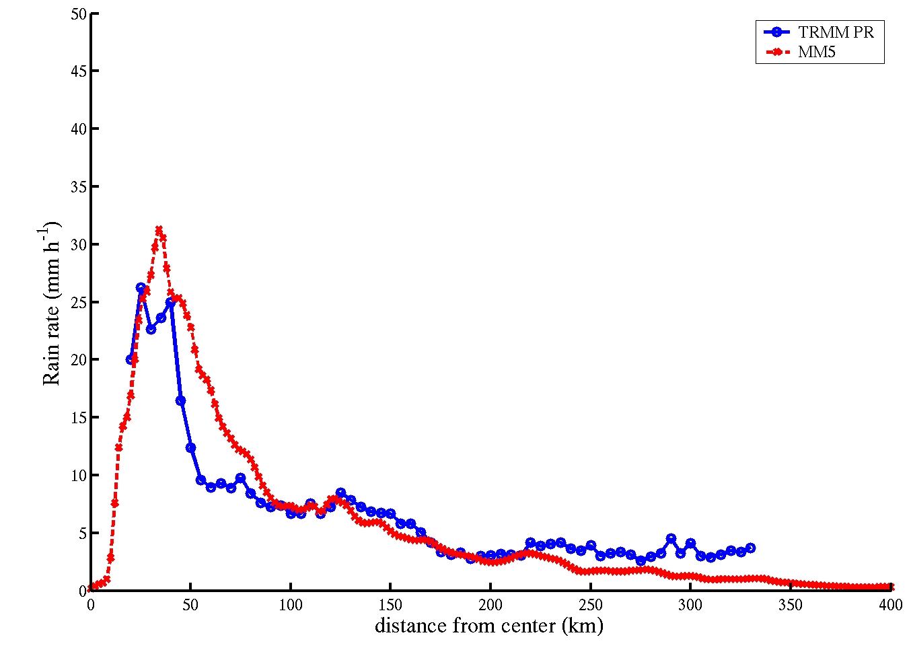 | 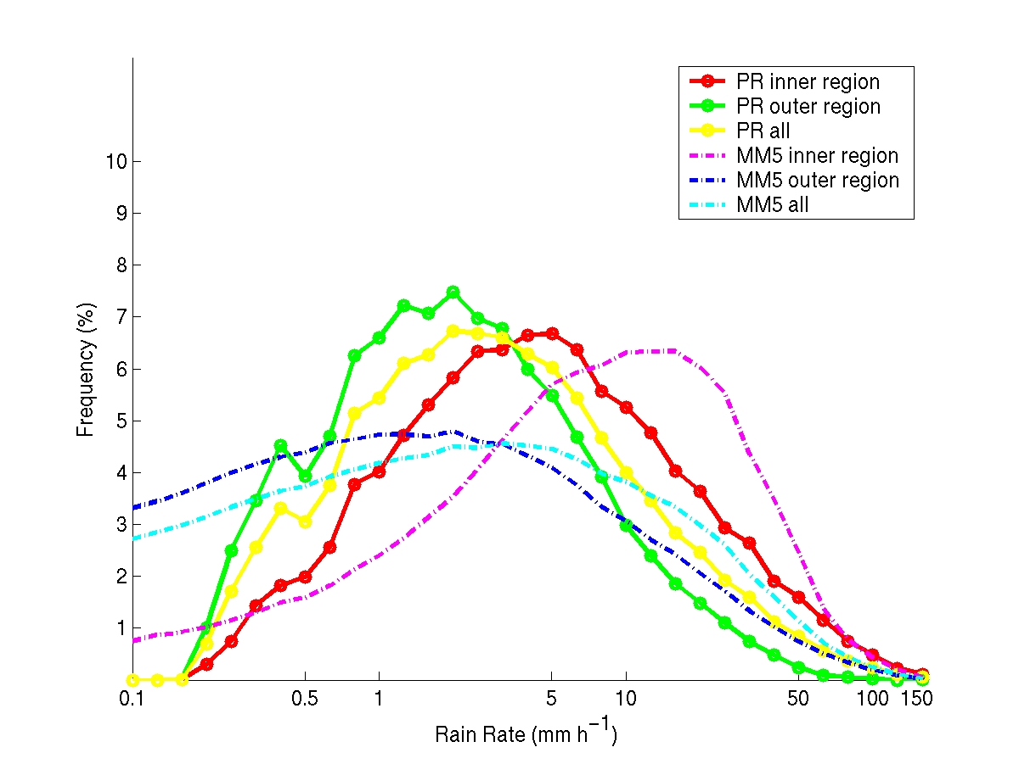 | Figure 9. Model simulated and TRMM PR rainrate comparisons in five major hurricanes including Floyd, Lili, Frances, Katrina and Rita (left). The rainrate distribution for the inner core and outer rainband regions from the model and TRMM PR (right).

iv) Hydrometeor distributions
In situ cloud physics probe measurements in tropical cyclones (and tropical convection in general) have been analyzed to identify important microphysical parameters such as hydrometeor species and particle size distributions (PSD’s). An example of these measurements is shown in Fig. 10, which shows PSD’s and hydrometeor images during the passage of a NOAA P-3 aircraft through the eyewall of Hurricane Dennis (2005) at temperatures ranging between -2 C and 10 C. As can be seen from Fig. 10, considerable variability in the hydrometeor species and PSD’s occurs across the eyewall and surrounding precipitating areas. Reasonably representing this variability represents a significant challenge for most existing single-moment bulk microphysical parameterization schemes, though it may play a large role in governing latent heat release in the tropical cyclone.

2. Description of work
The science questions presented in Section 1b will be addressed using a combination of satellite and airborne observational datasets and numerical model simulations. Two approaches will be pursued. The first approach focuses on case studies, targeting TCs that experience convective bursts that were sampled by aircraft and satellites during NASA field campaigns. The individual cases that will be studied are included in Table 1. High-resolution numerical model simulations (discussed below) will be performed for these cases. Combined with the observational datasets, they will provide a detailed picture of the convective and microphysical-scale processes important in each of the cases, some of which underwent RI and others which did not. The second approach follows a census-type approach, comparing statistics of relevant convective and microphysical-scale fields from a multitude of TCs. Airborne, satellite, and numerical model simulations will all be included in these calculations, providing a more robust set of comparisons to identify the distinctions between RI and non-RI events. The observational and modeling components are included below.
(a) Observational component
The observational portion of this study includes a satellite-based census of many tropical cyclones, detailed analysis of selected aircraft-based cases, and examination of in situ

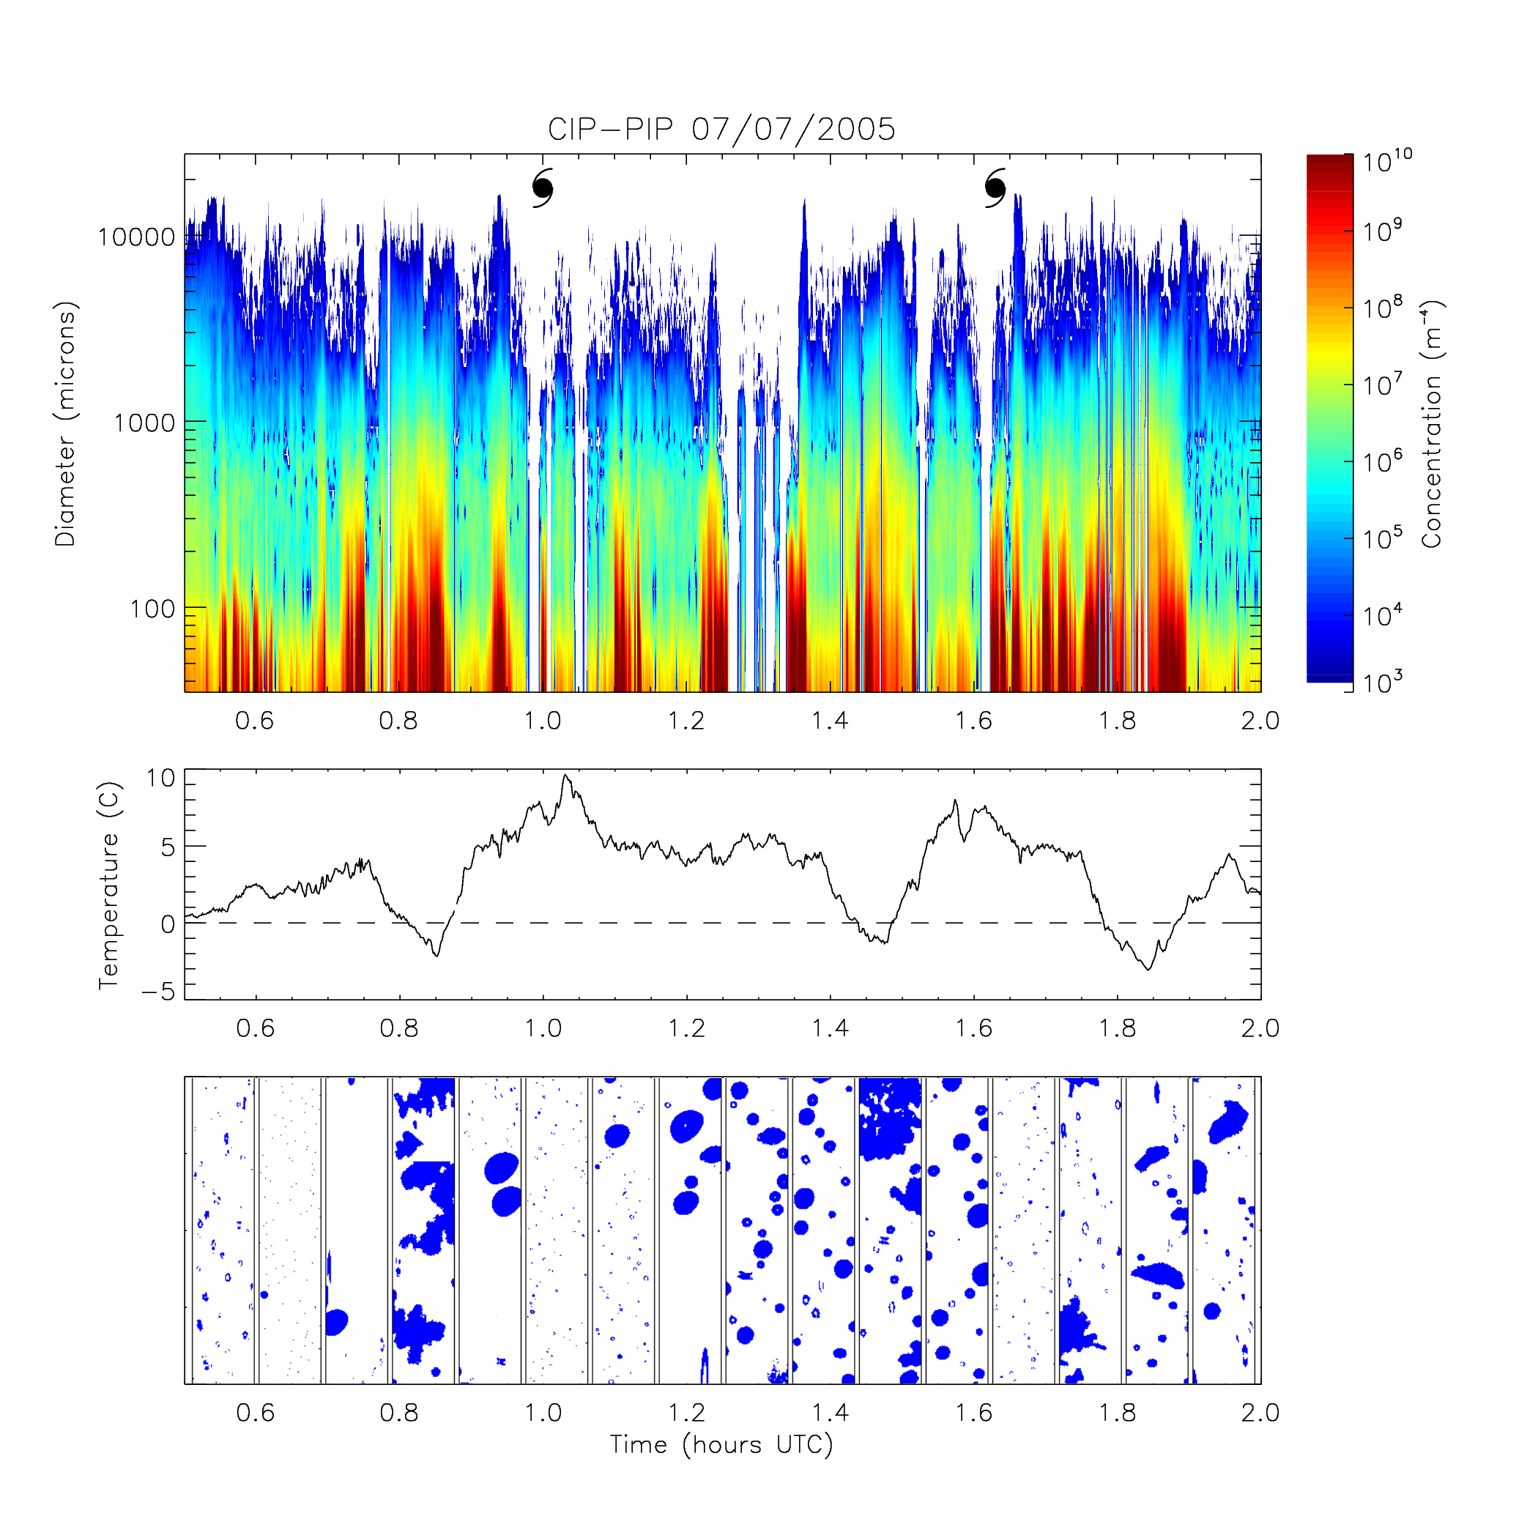
Figure 10: Top: Particle size distribution measurements during two NOAA P3 penetrations through the eye of Hurricane Dennis. The hurricane symbols show the locations of the eye. The color-coding shows representations of the particle size distributions, with an average size distribution plotted over 5-sec intervals along the time (abscissa) axis. Concentrations are color-coded as a function of diameter (ordinate) according to color chart shown. Center: temperature trace, with 0C level shown with dashed line. Bottom: Examples of images of particles from the 2D-C at locations across the penetrations. Distance between vertical bars is about 1 mm.

measurements from the aircraft. These will be described separately here, but in practice they will overlap with and influence each other, as will the modeling component also described below.
i) Satellite-based census
Passive microwave brightness temperatures from TMI and AMSR-E on the TRMM and Aqua satellites, as well as SSMI on DMSP satellites, provide information about the precipitation structure and convective intensity that cannot be adequately assessed via the infrared cloud top temperatures alone. These passive microwave measurements will be assembled for an extensive record of tropical cyclones. The complete TMI dataset back to 1997 and SSMI datasets for tropical cyclones back to 1988 are already on hand at UAH as a result of other projects. Some of the AMSR-E data is similarly on hand, and the remainder will be assembled for this project. Parameters describing the structure and vigor of precipitation and convection will be compiled

Storm | Dates of interest | Observational platforms | NASA Field Campaign
Bonnie | August 20-28, 1998 | NASA: DC-8, ER-2, TRMM  NOAA: P-3, G-IV, GOES | CAMEX-3
Georges | September 19-26, 1998 | NASA: DC-8, ER-2, TRMM  NOAA: P-3, G-IV, GOES | CAMEX-3
Chantal | August 16-20, 2001 | NASA: DC-8, ER-2, TRMM  NOAA: P-3, G-IV, GOES | CAMEX-4
Humberto | September 21-25, 2001 | NASA: DC-8, ER-2, TRMM  NOAA: P-3, G-IV, GOES | CAMEX-4
Dennis | July 5-10, 2005 | NASA: ER-2, TRMM, Aqua  NOAA: P-3, G-IV, GOES | TCSP
Emily | July 12-17, 2005 | NASA: ER-2, TRMM, Aqua  NOAA: P-3, GOES | TCSP
Debby | August 21-25, 2006 | NASA: DC-8, TRMM, Aqua  NOAA: GOES | NAMMA

Table 1. TC cases most likely to be included in case study evaluations.

and examined for all cases in which aircraft-based reconnaissance provides an accurate estimate of the overall tropical cyclone intensity (and intensity change).
This builds from development of the Statistical Hurricane Intensity Prediction Scheme with Microwave Imagery (SHIPS-MI) at UAH (Jones et al. 2006; Jones and Cecil 2007). Several microwave-based statistics are stored from that project, and that initial database was used to generate Figure 1. The passive-microwave based analysis in this proposal will start with those statistics, but will also consider new formulations based on the specific aim here toward rapid intensification, and also based on results from the aircraft-based case study and numerical modeling components. Furthermore, the restriction to cases that have reliable aircraft-based reconnaissance will yield more reliability in the analysis of intensity change. Conclusions based on analyzing the microwave data may provide valuable additions to the environmental parameters used in the Rapid Intensification Index (Kaplan and DeMaria 2003). Combining the microwave information with the environmental fields will provide a straightforward way to consider environmental factors when examining relationships between satellite-based characteristics and rapid intensification. In some "null" cases where the satellite-based characteristics are suggestive of RI, the environmental factors may explain why RI is not likely to occur.
While the main thrust of this satellite-based census uses the passive microwave data, the TRMM Precipitation Radar (PR) and Lightning Imaging Sensor (LIS) will also be used. The PR provides full vertical profiles of radar reflectivity (~17 dBZ minimum signal), but over a smaller swath width than TMI (~250 km vs ~750 km). LIS provides lightning flash locations, but only during the ~90 s duration while the satellite passes over a scene. This is a short time scale compared to normal lightning flash rates in tropical cyclones, but in a broad survey would allow some examination of how/whether the highest observed flash rates relate to rapid intensification. TRMM TMI Precipitable Water (TPW) will be used to identify the environmental condition that may be favorable for RI (Ortt and Chen 2004).

ii) Aircraft-based case study
The aircraft-based case study component will examine in more detail particular cases that were well observed by NASA aircraft during field campaigns. Some initial analysis of Hurricane Emily from TCSP was shown in Section 1d. As such, this section is somewhat abbreviated. The initial Emily study characterizes the convection at the time of the ER-2 flight (and times immediately before and after), but does not yet answer the questions posed in this proposal. Did the intense convection seen during the ER-2 flight play a role in the slow weakening trend of the hurricane at the time, or was it merely coincidental? Did similar intense convection play a role in the rapid deepening and subsequent rapid filling of Emily immediately prior to the flight? The proposed study will further that analysis of Emily, and apply similar methods to other cases. Numerical simulations (Section 2b below) will also contribute to the case studies, in order to examine the mechanisms and interactions involving the convection and vortex evolution. The modeling component will inform the case studies in this way, and the case studies will provide the modeling component with a verification of the observed storm structures.
While Emily is a fascinating case from the ER-2 perspective, some prior cases have a greater variety of observational data available. The NASA ER-2 and NOAA P-3 flew coordinated missions while Hurricane Dennis (2005) intensified, with the P-3 radar providing valuable context for the ER-2 measurements. Hurricanes Bonnie and Georges (1998) from CAMEX-3 have been studied by this team and others (Heymsfield et al. 2001; Rogers et al. 2003; Cecil et al. 2000; Geerts et al. 2000), and will be the subject of further examination in the context of this proposed study. TS Debby from NAMMA also holds considerable promise. Although the efforts under this proposal exploit cases from NASA field programs, team members have also been involved in NOAA and NSF hurricane field programs that can aid our progress in this proposed research.
iii) Airborne in situ analysis
The use of aircraft-based in situ observations is not limited to the aircraft-based case studies described above. We have observations in intense convection in low latitudes from CAMEX-4, CRYSTAL-FACE, NAMMA and recently TC4. These data sets include particle size distribution measurements from tens of microns to cm sizes, direct measurements of the ice water content from which the mean ice density can be deduced, and for many of these cases measurements of the air motion and estimates of ice particle fallpeeds from the combination of the Doppler radar and particle probe measurements. Our observations span a wide range of subfreezing temperatures (0 to <-50C) and our observations include highly resolved graupel particles (CRYSTAL-FACE, NAMMA) through to snow in expansive stratiform ice regions. These data sets will be mined to deduce properties of the ice microphysics and will be incorporated directly into the modeling effort.

(b) Modeling component
The modeling component of this project focuses on conducting high-resolution simulations of the cases shown in Table 1 using two versions of the WRF model: the WRF-ARW and the WRF-NMM.Both versions of WRF have the capability to run two-way interactive meshes that move with the storm, allowing for high resolution (grid lengths of O(1 km)) for multiple days. They also have multiple options for physical parameterizations, including single-moment bulk microphysical parameterizations that allow for multiple ice species and 3D TKE-based turbulence parameterizations. The main differences between these two models are the dynamical core used, which dictates the type of numerics used to solve the equations and the grid configuration. Running both of these models for the same cases will enable a reliable set of comparisons between the performance of the models for the unique challenge of simulating RI events.
The model and data comparison and evaluation will be built on the previous high-resolution MM5 modeling results by the PIs (Rogers and Chen). The convective and microphysical scale structure and evolution of convective bursts in the simulated storms will be evaluated and compared with the airborne and satellite observations collected during the multiple NASA field campaigns, using techniques that provide robust comparisons of the statistical properties of the relevant variables (e.g., Black et al. 1996, Rogers et al. 2007) and how they vary with time. Having numerical model simulations of these cases will provide temporal continuity to the analysis of convective structure and evolution and its impact on the vortex evolution. It will also enable detailed diagnostics, such as vorticity and heat budgets, to be calculated. Statistics from these simulations will also be calculated and compared to the statistics from the satellite census.

(c) Work plan
The proposed study will proceed in the following steps:

i) Year one (2008-2009):
- Select storms and time periods where TC intensity estimates are reliably based on aircraft reconnaissance for census study (Cecil, Rogers)
- Compare the initial microwave-derived statistics to intensity and intensity change for cases in census study (Cecil)
- Assemble, reprocess, and begin analysis of all satellite and airborne datasets for cases in Table 1, including downward- and upward-pointing Doppler radar observations (Cecil, A. Heymsfield, Rogers)
- Identify regions of convective/stratiform or eyewall/rainband/stratiform precipitation for Table 1 cases, including an indentification of graupel and regions of updraft (Rogers, A. Heymsfield)
- Acquire initial and boundary condition files for cases listed in Table 1, begin WRF simulations of Hurricane Dennis and Emily (2005) using TCSP data (Rogers, Chen)
The bulk of the work this year will focus on assembling and organizing the satellite and airborne data sets and acquiring the necessary fields for conducting the numerical model simulations. Most of the satellite analysis will be performed by UAH, in conjunction with UM. Initial results should be suitable for manuscript submission. UAH will also perform some of the airborne remote sensing analysis, in conjunction with HRD. This project will also benefit substantially from collaborating with the project being proposed by G. Heymsfield, entitled “Multiscale Analysis of Tropical Storm Hot Tower and Warm Core Interactions Using Field Campaign Observations.” Profiles and CFADs of reflectivity and vertical velocity from the EDOP provided during G. Heymsfield’s proposal will aid us in evaluating the WRF simulations (discussed below). For all of the datasets precipitation regions will be partitioned into convective/stratiform regions or eyewall/rainband/stratiform regions, using code developed by HRD. NCAR will perform analyses of the microphysical fields collected during the field campaigns, collaborating with HRD to refine the microphysical parameterizations used in the simulations. HRD will perform the numerical simulations using the WHFS model, while UM will perform the numerical simulations using the AHW model, in addition to performing. HRD and UM will work together to calculate diagnostics from the numerical model simulations and compare the models with each other and with the observations. Additionally, it is expected that the team will contribute to scientific leadership when/if NASA considers a subsequent hurricane-related campaign. Opportunities to transition research results toward operations will also be pursued, but are not explicitly listed because the timetable cannot be anticipated.

ii) Year two (2009-2010):
- Continue work on satellite census: develop objective measures of the precipitation structure from TRMM PR and LIS and revise the initial microwave-based measures based on findings from the case study and modeling components (Cecil, Chen, Rogers)
- Compile statistics for these properties from the full TRMM database (and AMSRE / SSMI for microwave) and compare with recon-based TC intensity and intensity change (Cecil, Rogers)
- Continue airborne analysis of priority cases, including airborne remote sensing and cloud physics probes (Cecil, A. Heymsfield, Rogers)
- Analyze microphysical characteristics of precipitation: evaluate radar reflectivity factor and reflectivity-weighted mean particle fallspeed against in-situ observations; develop Vz vs Ze relationships for retrievals of air motions from Doppler radar observations; work with Dr. Gerald Heymsfield to derive vertical motion fields for select cases; develop parameterizations for graupel and snow particle size distributions (PSDs) and fallspeeds (A. Heymsfield, G. Heymsfield, Rogers)
- Continue model simulations of priority cases, calculate diagnostic fields for comparison with comparable airborne observations, identify physical processes that are key to RI, and begin to incorporate refinements to microphysical parameterizations (Rogers, Chen, A. Heymsfield)
- Manuscript preparation/submission (Rogers, Cecil, Chen, A. Heymsfield)
The work this year will see a continuation of the analysis begun in the first year. Further diagnostic analyses will be performed for all datasets (satellite, airborne, numerical model), and during this time there will be some feedback between preliminary results from the simulations, the aircraft-based case studies, and the satellite analyses. For the airborne in situ analyses work will focus on improving the representation of microphysical parameters (e.g., PSD’s as a function of temperature, radar reflectivity factor, and reflectivity-weighted mean particle fallspeed, and fallspeed parameterizations). These results will be considered together with the Doppler radar measurements and used in refining microphysical parameterizations used in the simulations. It is anticipated that simulations of one or two1-2 of the cases will be completed during this year, as well as detailed analyses of the airborne remote sensing, in situ cloud physics probe, and ancillary data. Comparisons will begin to be made between the structures in the model and those diagnosed from observations, and how they relate to the vortex evolution.

iii) Year three (2010-2011):
- Continue analysis of objective satellite-derived properties in the context of intensity / intensity change, revise the definitions/computations of these properties based on findings from the case-study and modeling components (Cecil, Rogers, Chen)
- Continue analysis of aircraft-based case studies, including airborne Doppler and cloud physics data (Cecil, A. Heymsfield, Rogers)
- Continue numerical simulations, diagnostics, and evaluations with airborne data (Rogers, Chen, A. Heymsfield)
- Calculate statistics from all model simulations to compare with TRMM and airborne data with a focus on diabatic heating and RI (Rogers, Chen, Cecil)
- Conduct model senstivitity experiments and apply relationships derived from cloud physics data to changes to the microphysical parameterization schemes in the simulations (Rogers, Chen, A. Heymsfield)
- Manuscript preparation / submission (Rogers, Cecil, Chen, A. Heymsfield)
Further data analysis will continue during this year. It is anticipated that simulations and analysis of 2-3 additional cases will be completed during this year. As more cases are simulated, more robust statistics from the simulations will enable comparisons with the satellite-derived datasets, in addition to the comparisons between the simulations and the airborne data. Furthermore, any revised relationships identified based on the analysis of the cloud physics data will be applied to the microphysical parameterization scheme used in the WHFS model. This work will be overseen by NCAR and HRD. Finally, manuscripts will be begun during this time.

iv) Year four (2011-2012)
- Re-visit previous satellite-based findings, after considering the subsequent findings from all components (satellite, aircraft, modeling) of the study (Cecil, Rogers, Chen, A. Heymsfield)
- Complete airborne case studies, including new cases that may have arisen from a possible future field program (Cecil, A. Heymsfield, Rogers)
- Complete all model simulations and sensitivity studies of convective structure and microphysics on RI in TCs (Rogers, Chen, A. Heymsfield)
- Summarizing science findings for publications (Rogers, Cecil, Chen, A. Heymsfield)
The data analysis will be completed this year. In addition, any new cases that are collected in possible future field programs that are appropriate to this study will be included. Manuscript writing will continue during this time as well, with submissions to referred journals anticipated near or just after the end of this project.

3. References

Cecil, D. J., E. J. Zipser, G. M. Heymsfield, R. E. Hood, and M. G. Bateman, 2000: An investigation of precipitation structures in Hurricane Bonnie. Preprints, 24th AMS Conference on Hurricanes and Tropical Meteorology.
Chen, S.S., J. Knaff, F.D. Marks, 2006: Effect of vertical wind shear and storm motion on tropical cyclone rainfall asymmetry deduced from TRMM. Mon. Wea. Rev., 134, 3190-3208.
Chen, S.S., J.F. Price, W. Zhao, M.A. Donelan, and E.J. Walsh, 2007: The CBLAST – Hurricane Program and the next-generation fully coupled atmosphere-wave-ocean models for hurricane research and prediction. Bull. Amer. Meteor. Soc, 88, 311-317.
Desflots, M., and S.S. Chen, 2008: Rapid intensity change in Hurricane Lili (2002). Part I: Balance vs. unbalanced flows in an intensifying storm. Mon. Wea. Rev., submitted.
Farley, R.D., 1987: Numerical Modeling of Hailstorms and Hailstone Growth. Part III: Simulation of an Alberta Hailstorm—Natural and Seeded Cases, J. Appl. Meteor., 26, 789–812.
Geerts, B., G. M. Heymsfield, L. Tian, J. B. Halverson,, A. Guillory, and M. I. Mejia, 2000: Hurricane Georges’s landfall in the Dominican Republic: Detailed airborne Doppler radar imagery. Bull. Amer. Meteor. Soc., 81, 999-1018.
Gentry, R. C., T. T. Fujita,, and R. C. Sheets, 1970: Aircraft, spacecraft, satellite and radar observations of Hurricane Gladys, 1968. J. Appl. Meteor., 9, 837-850.
Hendricks, E. A., M. T. Montgomery, and C. A. Davis, 2004: The role of “vortical” hot towers in the formation of Tropical Cyclone Diana (1984). J. Atmos. Sci., 61, 1209-1232.
Hennon, P. A. 2006: The role of the ocean in convective burst initiation: implications for tropical cyclone intensification. Ph.D. dissertation, Ohio State University, 185 p.
Heymsfield, G. M., J. B. Halverson, J. Simpson, L. Tian, and T. P. Bui, 2001: ER-2 Doppler radar investigations of the eyewall of Hurricane Bonnie during the Convection and Moisture Experiment-3. J. Appl. Meteor., 40, 1310-1330.
Jones, T. A., D. J. Cecil, and M. DeMaria, 2006: Passive microwave-enhanced statistical hurricane intensity prediction scheme. Weather and Forecasting, 21, 613-635.
Jones, T. A. and D. J. Cecil, 2007: SHIPS-MI forecast analysis of Hurricanes Claudette (2003), Isabel (2003), and Dora (1999). Weather and Forecasting, 22, 689-707.
Kaplan, J.. and M. DeMaria, 2003: large-scale characteristics of rapidly intensifying tropical cyclones in the North Atlantic basin. Weather and Forecasting, 18, 1093-1108.
Kelley, O. A., J. Stout, J. B. Halverson, 2004: Tall precipitation cells in tropical cyclone eyewalls are associated with tropical cyclone intensification. Geophys. Res. Lett., 31, L24112, doi:10.1029/2004GL021616.
Liu, Y., D.-L. Zhang, and M.K. Yau, 1997: A multiscale numerical study of Hurricane Andrew (1992). Part I: Explicit simulation and verification. Mon. Wea. Rev., 125, 3073-3093.
Lonfat, M., F.D. Marks, and S.S. Chen, 2004: Precipitation distribution in tropical cyclones using the Tropical Rainfall Measuring Mission (TRMM) microwave imager: A global perspective. Mon. Wea Rev., 132, 1645-1660.
Montgomery, M. T., M. E. Nicholls, T. A. Cram, and A. B. Saunders, 2006: A vortical hot tower route to tropical cyclogenesis. J. Atmos. Sci., 63, 355-386.
Ortt, D., and S.S. Chen, 2004: Atmospheric water vapor and tropical cyclone intensity changes. Preprints, 26th Conference on Hurricanes and Tropical Meteorology, 3-7 May 2004, Miami, Florida, AMS, 202-203.
Orville, H.D., R.D. Farley, and J.H. Hirsch, 1984: Some surprising results from simulated seeding of stratiform-type clouds, J. Appl. Meteor., 23, 1585–1600.
Orville, H.D., and F.J. Kopp, 1990: A numerical simulation of the 22 July 1979 HIPLEX-1 Case, J. Appl. Meteor., 29, 539–550.
Quinlan, K., D. Cecil, and J. Mecikalski 2008: Conditions influencing Hurricane Emily’s (2005) precipitation patterns, convection, and upper tropospheric outflow. 28th Conference on Hurricanes and Tropical Meteorology, http://ams.confex.com/ams/htsearch.cgi.
Rodgers, E. B., W. S. Olson, V. M. karyampudi, and H. F. Pierce, 1998: Satellite-derived latent heating distribution and environmental influences in Hurricane Opal (1995). Mon. Wea. Rev., 126, 1229-1247.
Rogers, R.F., S.S. Chen, J. Tenerelli, and H. Willoughby, 2003: A numerical study of the impact of vertical shear on the distribution of rainfall in Hurricane Bonnie (1998). Mon. Wea. Rev., 131, 1577-1599.
Rogers, R. F., M. L. Black, S. S. Chen, and R. A. Black, 2007: An evaluation of microphysics fields from mesoscale model simulations of tropical cyclones. Part I: Comparisons with observations. J. Atmos. Sci., 64, 1811-1834.
Rogers, R.F., F.D. Marks, Jr., K. Valde, and A. Hagen, 2008a: Tropical Cyclone Precipitation Structures Derived from Reflectivity Statistics Using TRMM PR. Presented at 10th Annual TRMM workshop, February 4-8 2008, Las Vegas, NV.
Rogers, R.F., S.S. Chen, A. Heymsfield, and G. Heymsfield, 2008b: Precipitation Morphology and Vortex Evolution During the Rapid Intensification of Hurricane Dennis (2005). Presented at the 28th Annual AMS Conference on Hurricanes and Tropical Meteorology, April 28-May 2 2008, Orlando, FL.
Squires, K. and S. Businger, 2008: The morphology of eyewall lightning outbreaks in two category five hurricanes. Mon. Wea. Rev., in press.
Yuter, S. E. and R. A. Houze, 1995: Three-dimensional kinematic and microphysical evolution of Florida cumulonimbus. Part II: Frequency distributions of vertical velocity, reflectivity, and differential reflectivity. Mon. Wea. Rev., 123, 1941-1963.
Zheng, X., and S. S. Chen, 2006: Hurricane rainfall from numerical simulations and TRMM observations, AGU Fall Meeting, San Francisco, CA, 10-14 December 2006.
4. Biographical sketches

Robert F. Rogers (Principal investigator)
NOAA/AOML Hurricane Research Division
4301 Rickenbacker Cswy, Miami, FL 33149
Telephone: (305)-361-4536
Fax: (305)-361-4402
Email: Robert.Rogers@noaa.gov

RESEARCH INTERESTS:
Dr. Rogers is an employee of NOAA’s Hurricane Research Division in Miami, FL. His main areas of research involve using a combination of numerical models and observations to investigate the role that precipitation processes play in tropical cyclone genesis and intensity change. Recent work has involved evaluating microphysical fields from numerical models using airborne Doppler radar and cloud physics probe measurements.

PROFESSIONAL PREPARATION:
The Pennsylvania State University Meteorology Ph.D., 1998
The Pennsylvania State University Meteorology M.S., 1995
University of Virginia Environmental Sciences B.A, 1991

APPOINTMENTS:
- 2003-current: Meteorologist, NOAA/AOML Hurricane Research Division, Miami, FL
- 2000-2003: Assistant Scientist, Cooperative Institute for Marine and Atmospheric Studies, University of Miami, Miami, FL
- 1998-2000: National Research Council Postdoctoral Research Associate, Hurricane Research Division, Miami, FL

PUBLICATIONS:
Rogers, R.F., F.D. Marks, Jr., and T. Marchok, 2008: Tropical Cyclone Rainfall. Encyclopedia of Hydrologic Sciences. In review.
Rogers, R.F., and E.W. Uhlhorn, 2008: Observations of the three-dimensional structure and evolution of wind asymmetries in Hurricane Rita (2005). Geophysical Res. Lett., In review.
Rogers, R.F., M.L. Black, S.S. Chen, and R.A. Black, 2007: An Evaluation of Microphysics Fields from Mesoscale Model Simulations of Tropical Cyclones. Part I: Comparisons with Observations. Journal of the Atmospheric Sciences, 64, 1811-1834.
Lonfat, M., R. F. Rogers, F. D.Marks, Jr., and T. Marchok, 2007: A Parametric Model for Predicting Hurricane Rainfall. Monthly Weather Review, 135, 3086-3097.
Marchok, T., R. F. Rogers, and R. Tuleya, 2007: Validation Schemes for Tropical Cyclone Quantitative Precipitation Forecasts: Evaluation of Operational Models for U.S. Landfalling Cases. Weather and Forecasting, 22, 726-746.
Halverson, J., M. Black, S. Braun, D. Cecil, M. Goodman, G. Heymsfield, R. Hood, J. Molinari, R.F. Rogers, C. Velden, E. Zipser, R. Kakar, 2007: NASA's Tropical Cloud Systems and Processes (TCSP) Experiment: Investigating the Genesis and Intensification of Hurricanes, Bulletin of the American Meteorological Society, 88, 867-882.
Rogers, R.F., S.D. Aberson, M.L. Black, P. Black, J. Cione, P. Dodge, J. Dunion, J. Gamache, J. Kaplan, M. Powell, N. Shay, N. Surgi, and E. Uhlhorn, 2006: The Intensity Forecasting Experiment (IFEX): A NOAA Multi-year Field Program for Improving Tropical Cyclone Intensity Forecasts. Bulletin of the American Meteorological Society, 87, 1523-1537.
Houze, R.A.,Jr ., S.S. Chen , W.-C. Lee , R. F. Rogers, J. A. Moore, G. J. Stossmeister, J.L. Cetrone, W, Zhao, and M. M. Bell, 2006: The Hurricane Rainband and Intensity Change Experiment (RAINEX): Observations and modeling of Hurricanes Katrina, Ophelia, and Rita (2005) Bulletin of the American Meteorological Society, 87, 1503-1521.
Nuissier, O., R.F. Rogers, and F. Roux, 2005: Numerical simulation of tropical cyclones. Hurricane Bret on 22-23 August 1999. Quart. J. Roy. Met. Soc., 131, 155-194.
Rogers, R.F., S.S. Chen, J.E. Tenerelli, and H.E. Willoughby, 2003: A numerical study of the impact of vertical shear on the distribution of rainfall in Hurricane Bonnie (1998). Monthly Weather Review, 131, 1577-1599.
Rogers, R.F., S. Aberson, J. Kaplan, and S. Goldenberg, 2002: A pronounced upper-tropospheric warm anomaly encountered by the NOAA G-IV aircraft in the vicinity of deep convection. Monthly Weather Review, 130, 180-187.
Rogers, R.F., and J.M. Fritsch, 2001: Surface cyclogenesis from convectively-driven amplification of mid-level mesoscale convective vortices. Monthly Weather Review,129, 605-637.
Rogers, R.F., J.M. Fritsch, and W.C. Lambert, 2000: A simple technique for using radar data in the dynamic initialization of a mesoscale model. Monthly Weather Review, 128, 2560-2574.
Rogers, R.F., and J.M. Fritsch, 1996: A general framework for convective trigger functions. Monthly Weather Review, 124, 2438-2452.
Rogers, R.F., and R.E. Davis, 1993: The effect of coastline curvature on the weakening of Atlantic tropical cylcones. International Journal of Climatology, 13, 287-299.
Davis, R.E., and R.F. Rogers, 1992: A synoptic climatology of severe storms in Virginia. The Professional Geographer, 44, 319-332.

SYNERGISTIC ACTIVITIES:
- Member, NOAA-wide Service Assessment Team for Hurricanes Katrina and Rita, 2005-2006
- Member, NASA Tropical Cloud Systems and Processes (TCSP) Science Team, 2005-present
- Field Program Director for the Hurricane Research Division’s Hurricane Field Program, July 1-September 30, 2005
- Invited to attend NOAA Leadership Seminar, March 2005, in Warrenton, VA
- Elected to serve as Adjunct Faculty in the Department of Meteorology and Physical Oceanography, University of Miami/RSMAS, September 2004-present.
- Associate Editor, Weather and Forecasting
- Member, Science Working Group for TEXMEX II Field Program (2003-4)
- Invited Member, Ph.D. committee for Dr. Olivier Nuissier, Université Paul Sabatier, Toulouse, France, 2003
- Member, Committee for drafting NOAA Long-term Research Program Plan entitled “Solving the Hurricane Intensity and Inland Flood Forecast Problem”, 2003
- Visiting Research Scientist at Centre Nationale de la Recherche Scientifique, Toulouse, France (May-Novermber, 2001)
- Member, NASA CAMEX-4 Science Team, 2001-2004
Daniel J. Cecil (Co-Investigator)
Research Areas
Tropical cyclone intensity and precipitation, thunderstorms, remote sensing (emphasis on radar, passive microwave, lightning), tornadoes in landfalling tropical cyclones. Participated in TEFLUN, CAMEX-3, CAMEX-4, and TCSP field programs.

Education
Ph.D., Atmospheric Science, Texas A&M University, 2000.
M.S., Meteorology, Texas A&M University, 1997.
B.S., Meteorology, Saint Louis University, 1994 (magna cum laude).

Professional Experience
2006- Research Scientist IV and affiliate faculty, Earth System Science Center, University of Alabama – Huntsville (UAH)
2002-2006 Sr Research Associate and affiliate faculty, Earth System Science Center, UAH
2001-2002 Research Associate, Earth System Science Center, UAH

Current Projects
NASA Precipitation Science team: Analyzing global distribution of extreme convective storms and their environments. (Principal Investigator)
NASA Tropical Cloud Systems and Processes (TCSP): Observational study of the response of tropical cyclone precipitation structure to environmental forcing. Participated in mission science activities (identifying objectives and targets, formulating and directing flight patterns) during field phase. (Principal Investigator)
NOAA Hazardous Weather Testbed – Huntsville: Hazardous weather threats affecting the southeastern United States, particularly focusing on landfalling tropical cyclones and tornadoes associated with them. (Co-Investigator)
Associate Editor, Weather and Forecasting.
Reviews for AMS, AGU, and various other journals, and for NASA and NSF proposals.
President, Huntsville Area Chapter of American Meteorological Society (2007-08)

Peer Reviewed Publications:
Liu, C., E. J. Zipser, D. J. Cecil, S. W. Nesbitt, and S. Sherwood, 2008: A cloud and precipitation feature database from 9 years of TRMM observations. J. Appl. Meteor. Clim., early online release, DOI: 10.1175/2008JAMC1890.1.
Cecil, D. J. 2007, Satellite-derived rain rates in vertically sheared tropical cyclones, Geophys. Res. Lett., 34, L02811, doi:10.1029/2006GL027942.
Jones, T. A. and D. J. Cecil, 2007: SHIPS-MI forecast analysis of Hurricanes Claudette (2003), Isabel (2003), and Dora (1999). Weather and Forecasting, 22, 689-707.
Jones, T. A., D. J. Cecil, and J. Dunion, 2007: The environmental and inner core conditions governing the intensity of Hurricane Erin (2001). Weather and Forecasting, 22, 708-725.
Halverson, J. B., M. Black, S. Braun, D. Cecil, M. Goodman, A. Heymsfield, G. Heymsfield, R. Hood, T. Krishnamurti, G. McFarquhar, J. Molinari, R. Rogers, J. Turk, C. Velden, D.-L. Zhang, E. Zipser, and R. Kakar, 2007: NASA's Tropical Cloud Systems and Processes (TCSP) Experiment: Investigating Tropical Cyclogenesis and Hurricane Intensity Change. Bull. Amer. Meteor. Soc., 88, 867-882.
Hood, R. E., D. J. Cecil, F. J. LaFontaine, R. Blakeslee, D. Mach, G. Heymsfield, F. Marks, Jr., E. Zipser, and M. Goodman, 2006: Tropical cyclone precipitation and electric field information observed by high altitude aircraft instrumentation. J. Atmos. Sci., 63, 218-233.
Jones, T. A., D. J. Cecil, and M. DeMaria, 2006: Passive microwave-enhanced statistical hurricane intensity prediction scheme. Weather and Forecasting, 21, 613-635.
Zipser, E.J., D.J. Cecil, C. Liu, S.W. Nesbitt, and D.P. Yorty, 2006: Where are the most intense thunderstorms on earth? Bull. Amer. Meteor. Soc., 87, 1057-1071.
Cecil, D. J., S. J. Goodman, D. J. Boccippio, E. J. Zipser, and S. W. Nesbitt, 2005: Three years of TRMM precipitation features. Part 1: Radar, radiometric, and lightning characteristics. Mon. Wea. Rev., 133, 543-566.
Boccippio, D. J., W. A. Petersen, and D. J. Cecil, 2005: The tropical convective spectrum: 1. Archetypal vertical structures. J. Climate, 18, 2744-2769.
Koshak, W. J., R. J. Solakiewicz, R. J. Blakeslee, S. J. Goodman, H. J. Christian, J. M. Hall, J. C. Bailey, E. P. Krider, M. G. Bateman, D. J. Boccippio, D. M. Mach, E. W. McCaul, M. F. Stewart, D. E. Buechler, W. A. Petersen, and D. J. Cecil, 2004: North Alabama Lightning Mapping Array (LMA): VHF Source Retrieval Algorithm and Error Analysis. J. Atmos. Oceanic Tech., 21, 543-558.
Cecil, D. J., and E. J. Zipser, 2002: Reflectivity, ice scattering, and lightning characteristics of hurricane eyewalls and rainbands. Part II: Intercomparison of observations. Mon. Wea. Rev., 130, 785-801.
Cecil, D. J., E. J. Zipser, and S. W. Nesbitt, 2002: Reflectivity, ice scattering, and lightning characteristics of hurricane eyewalls and rainbands. Part I: Quantitative description. Mon. Wea. Rev., 130, 769-784.
Toracinta, E. R., D. J. Cecil, E. J. Zipser, and S. W. Nesbitt, 2002: Radar, passive microwave, and lightning characteristics of precipitating systems in the Tropics. Mon. Wea. Rev., 130, 802-824.
Nesbitt, S. W., E. J. Zipser, and D. J. Cecil, 2000: A census of precipitation features in the Tropics using TRMM: Radar, ice scattering, and lightning observations. J. Climate, 13, 4087-4106.
Cecil, D. J. and E. J. Zipser, 1999: Relationships between tropical cyclone intensity and satellite-based indicators of inner core convection: 85 GHz ice-scattering signature and lightning. Mon. Wea. Rev., 127, 103-123.
Shuyi S. Chen (Co-Investigator)
Rosenstiel School of Marine and Atmospheric Sciences, University of Miami
4600 Rickenbacker Causeway, Miami, FL 33149
Phone: (305) 421-4048, FAX: (305) 421-4696, E-mail: schen@rsmas.miami.edu

Education:
1990 Ph.D. Meteorology The Pennsylvania State University
1985 M.S. Meteorology University of Oklahoma
1982 B.S. Meteorology Peking University
Professional Employment:
2007 - Present Professor, University of Miami
2006 – Present Affiliate Scientist, NCAR
1998 - Present Affiliate Professor, University of Washington
2000 - 2006 Associate Professor, University of Miami
1997 - 1999 Associate Research Professor, University of Miami
1995 - 1997 Assistant Research Professor, University of Washington
1991 - 1995 Research Associate, University of Washington
1990 - 1991 Research Associate, Pennsylvania State University
Professional Membership:
1991 - Present Member, The American Geophysical Union
1984 - Present Member, The American Meteorology Society
Field Program Experience:
1992 - 1993 Satellite Scientist, providing guidance and directing aircraft missions,
Tropical Ocean and Global Atmosphere Coupled Ocean and Atmosphere Response Experiment (TOGA COARE), Honiara, Solomon Islands
2005 - Principle Investigator/Chief Scientist, Hurricane Rainbands and Intensity Change Experiment (RAINEX), Miami, Florida
Editorial Responsibilities:
2004 – 2006 Editor, Weather and Forecasting, AMS
2000 - 2003 Associate Editor, Weather and Forecasting, AMS
Honors and Awards:
2006 NASA Group Achievement Award
2002 First Place Award, the National Collegiate Weather Forecasting Contest, the Faculty and Staff Division (2001-2002).
Panel and Science Committee:
- American Geophysical Union – Committee on Cloud and Precipitaion
- Science Steering Committee for the NSF Coastal Ocean Processes (CoOP)
- Ocean Research Initiative Observatory Networks (ORION) Modeling Committee
- Science Advisory Board for Weather Research and Forecasting (WRF) Model
Five Most Relevant Publications:
Chen, S. S., J. F. Price, W. Zhao, M. A. Donelan, and E. J. Walsh, 2007: The CBLAST-Hurricane Program and the next-generation fully coupled atmosphere-wave-ocean models for hurricane research and prediction. Bull. Amer. Meteor. Soc., 88, 311-317.
Houze, R. A., S. S. Chen, B. Smull, W.-C. Lee, M. Bell, 2007: Hurricane intensity and eyewall replacement. Science, 315, 1235-1239.
Chen, S. S., J. Knaff, F. D. Marks, 2006: Effect of vertical wind shear and storm motion on tropical cyclone rainfall asymmetry deduced from TRMM. Mon. Wea. Rev., 134, 3190-3208.
Houze, R. A., S. S. Chen, and co-authors, 2006: The Hurricane Rainband and Intensity Change Experiment (RAINEX): Observations and modeling of Hurricanes Katrina, Ophelia, and Rita (2005). Bull. Amer. Meteor. Soc., 87, 1503-1521.
Davis, C., W. Wang, S. S. Chen, Y. Chen, K. Corbosiero, M. DeMaria, J. Dudhia, G. Holland, J. Klemp, J. Michalakes, H. Reeves, R. Rotunno¹, and Q. Xiao, 2008: Prediction of landfalling hurricanes with the Advanced Hurricane WRF Model, Mon. Wea. Rev., 136, in press.
Rogers, R., S. S. Chen, J. E. Tenerelli, and H. E. Willoughby, 2003: A numerical study of the impact of vertical shear on the distribution of rainfall in Hurricane Bonnie (1998), Mon. Wea. Rev., 131, 1577-1599.
Five Significant Publications:
Chen, S. S., W. Zhao, J. E. Tenerelli, R. H. Evans, V. Halliwell, 2001: Impact of the Pathfinder sea surface temperature on atmospheric forcing in the Japan/East Sea, Geophys. Res. Lett., 28, No. 24, 4539-4542.
Chen, S. S., and R. A. Houze, Jr., 1997a: Diurnal variation and lifecycle of deep convective systems over the tropical Pacific warm pool. Quat. J. Roy. Meteor. Soc., 123, 357-388.
Chen, S. S., and R. A. Houze, Jr., 1997b: Interannual variability of deep convection over the tropical warm pool. J. Geophys. Res., 102, 25,783-25,795.
Chen, S. S., R. A. Houze, Jr. and B. E. Mapes, 1996: Multiscale variability of deep convection in relation to large-scale circulation in TOGA COARE. J. Atmos. Sci., 53, 1380-1409.
Chen, S. S., and W. M. Frank, 1993: A numerical study of the genesis of extratropical convective mesovortices. Part I: Evolution and Dynamics. J. Atmos. Sci., 50, 2401 - 2426.
Graduate and Postgraduate Advisors:
Dr. Y. Sasaki and Dr. R. Doviak, M.S. Thesis advisors, University of Oklahoma
Dr. William M. Frank, Ph.D. Thesis advisor, Penn State University
Dr. Robert A. Houze, Jr., Postdoctoral advisor, University of Washington
Thesis advisor in the past five years to:
University of Miami: Manuel Lonfat, John Cangilosi, Joel Cline, Derek Ortt, Peter Kozich, Melicie Desflots, Xue Zheng, Chiaying Lee, Falko Judt; Qingdao Ocean University: Wei Zhao; University of Washington: David Mechem.
Postdoctoral-scholar sponsor in the past five years to:
Dr. Wei Zhao, RSMAS/University of Miami;
Dr. Olivier Nuissier, RSMAS/University of Miami.

Andrew J. Heymsfield (Co-Investigator)

Education:
1973 Ph. D. in Geophysical (Atmospheric) Science, University of Chicago
1970 M. S. in Atmospheric Sciences, University of Chicago
1969 B.A. in Physics, State University of New York

Experience:
1975 to Present Scientist (currently Senior Scientist), National Center for
Atmospheric Research, Mesoscale and Microscale
Meteorology Division
1973 to 1975 Scientist, Meteorology Research Inc., Altadena, CA

Selected Publications:

Heymsfield, A. J., 1972: Ice crystal terminal velocities J. Atmos. Sci., 29, 1348-1357.
Heymsfield, A. J., 1976: Particle size spectra measurement: An evaluation of the Knollenberg Optical Array Probes. Atmos. Tech., 8, 17-24.
Heymsfield, A. J., and D. Baumgardner, 1985: Summary of a workshop on processing 2-D probe data. Bull. Amer. Meteor. Soc., 66, 437-440.
Heymsfield, A. J., and Kajikawa, M., 1987: An improved approach to calculating terminal velocities of plate--like crystals and graupel. J. Atmos. Sci., 44, 1088-1099
Heymsfield, A. J., 1993: Microphysical structures of Stratiform and Cirrus Clouds. Chapter 4, Aerosol-Cloud-Climate Interactions, edited by P. Hobbs, Published by Academic Press, Inc, 97-121.
Heymsfield, A. J., A. Bansemer, P. R. Field, S. L. Durden, J. Stith, J. E. Dye, W. Hall, and T Grainger, 2002: Observations and parameterizations of particle size distributions in deep tropical cirrus and stratiform precipitating clouds: Results from in situ observations in TRMM field campaigns. J. Atmos. Sci. 59, 3457-3491.
Heymsfield, A. J., 2003: Properties of Tropical and Midlatitude Ice Cloud Particle Ensembles: Part I: Median Mass Diameters and Terminal Velocities. J. Atmos. Sci., 60, 2592-2611.
Heymsfield, A. J., A. Bansemer, C. G. Schmitt, C. Twohy, and M. R. Poellet, 2004: Effective ice particle densities derived from aircraft data. J. Atmos. Sci., 61, 982-1003.
Heymsfield A. J., 2007: On measurements of small ice particles in clouds. Geophys. Res. Lett., 34, L23812, doi:10.1029/2007GL030951.
Heymsfield, A. J., and coauthors, 2007: Testing IWC retrieval methods using radar and ancillary measurements with in-situ data. J. Cli and Appl Met., 47, 135-163.
5. Current and pending support
Rogers:

Evaluating and Improving Microphysical Parameterizations for Hurricane Lifecycle Studies
NASA Tropical Cloud Systems and Processes
7/1/2005 – 6/30/2008
$231,200 total
Role: PI (3 months/year)

Tropical Cyclone Lifecycle Observations to Improve Intensity Forecasts
NOAA Special Projects Initiative
6/1/2008 – 5/31/2009
$114,000 total
Role: Co-I (1 month/year)

Cecil:

Precipitation Response To Environmental Forcing in Tropical Cyclones
NASA Tropical Cloud Systems and Processes
9/15/2005 – 9/14/2008
$285K total
Role: PI (0.5 FTE)

Mapping Hazardous Convective Weather Events and Their Environments
NASA Precipitation Science Program
2/12/2007 – 2/11/2010
$280K total
Role: PI (0.4 FTE)

Tornado and Hurricane Observations and Research (THOR) Center Activities
within the Huntsville Hazardous Weather Testbed (HWT-Huntsville) [NOAA]
8/1/2006 – 7/31/2008
Role: Co-I (0.08 FTE)

NOAA Hazardous Weather Testbed Activities
8/1/2007 – 7/31/2009
Role: Co-I (0.12 FTE)

Chen
- Project / Proposal Title: Tropical Cyclone Structure & Rainfall as Deducted by TRMM and a High-Resolution Numerical Model
Source of Support: NASA
Total Award Amount: $254,255
Location of Project: Miami
Start & End Date: 06/15/04 – 06/14/08
Person-Month per Year Committed to the Project: Cal: 1.8

- Project / Proposal Title: Collaborative Research: Observational and Modeling Study of Hurricane Rainbands and Intensity Changes
Source of Support: NSF
Total Award Amount: $498,042
Location of Project: Miami
Start & End Date: 12/15/04 – 05/31/08
Person-Month per Year Committed to the Project: Cal: 1.3

- Project / Proposal Title: High-Resolution Data Assimilation of Ocean Vector Winds for Tropical Cyclone Prediction Using a Coupled Atmosphere-Ocean Model
Source of Support: NASA
Total Award Amount: $75,092
Location of Project: Miami
Start & End Date: 07/01/06 – 06/30/08
Person-Month per Year Committed to the Project: Cal: 1.0

- Project / Proposal Title: Observed and Environmental of Developing and Non-Developing Tropical Cyclones in the Western North pacific Using Satellite Data
Source of Support: ONR
Total Award Amount: $145,397
Location of Project: Miami, Fl.
Start & End Date: 01/01/08 – 12/31/09
Person-Month per Year Committed to the Project: Cal: 1.0

PENDING SUPPORT:

- Project / Proposal Title: Fully Coupled Atmospheric-Wave-Ocean modeling of Tropical cyclones and Impacts over the Western Pacific Ocean
Source of Support: ONR
Total Award Amount: $805,275
Location of Project: Miami, FL.
Start & End Date: 01/01/08 – 12/31/10
Person-Month per Year Committed to the Project: Cal: 3.0

- Project / Proposal Title: Florida COE of Information Technologies for Disaster Resilient Business Communities
Source of Support: FIU
Total Award Amount: $180,000
Location of Project: Miami, FL.
Start & End Date: 07/01/08 – 06/30/11
Person-Month per Year Committed to the Project: Cal: 0.8

- Project / Proposal Title: CDI-Type II: Collaborative Research: Hurricane Data: Modeling, Analysis, and Prediction (CURRENT PROPOSAL)
Source of Support: NSF
Total Award Amount: $900,000
Location of Project: Miami, FL.
Start & End Date: 10/01/08 – 09/30/12
Person-Month per Year Committed to the Project: Cal: 1.25

Heymsfield
6. Statements of commitment

I acknowledge that I am identified by name as Co-Investigator to the investigation, entitled "Tropical Cyclone Precipitation Structure and Evolution and Its Role in Rapid Intensification", that is submitted by Rob Rogers to the NASA Research Announcement NNH08ZDA001N-HSRP, and that I intend to carry out all responsibilities identified for me in this proposal. I understand that the extent and justification of my participation as stated in this proposal will be considered during peer review in determining in part the merits of this proposal. I have read the entire proposal, including the management plan and budget, and I agree that the proposal correctly describes my commitment to the proposed investigation.

Dan Cecil

Dr. Daniel J. Cecil
Earth System Science Center
University of Alabama in Huntsville
320 Sparkman Dr.
Huntsville, AL 35805
CecilD@uah.edu
Phone: (256) 961-7549

From Shuyi Chen:

I acknowledge that I am identified by name as Co-Investigator to the investigation, entitled "Tropical Cyclone Precipitation Structure and Evolution and Its Role in Rapid Intensification", that is submitted by Rob Rogers to the NASA Research Announcement NNH08ZDA001N-HSRP, and that I intend to carry out all my responsibilities in this proposal. I understand that the extent and justification of my participation as stated in this proposal will be considered during peer review in determining in part the merits of this proposal. I have read the entire proposal, including the management plan and budget, and I agree that the proposal correctly describes my commitment to the proposed investigation.

Signed by Shuyi Chen (Official letter head from RSMAS/UM)

Dear Rob,

I acknowledge that I am identified by name as Co-Investigator to the investigation, titled "Tropical Cyclone Precipitation Structure and Evolution and its Role in Rapid Intensification", that you are preparing for NASA Research Announcement NNH08ZDA001N-HSRP, and that I intend to carry out all responsibilities identified for me in this proposal. I understand that the extent and justification of my participation as stated in this proposal will be considered during peer review in determining in part the merits of this proposal. I have read the entire proposal, including the management plan and budget, and I agree that the proposal correctly describes my commitment to the proposed investigation.

Dr. Andy Heymsfield
UCAR NCAR MMM
1850 Table Mesa Drive
Boulder, CO 80305
303-497-8943

Dear Rob,

I acknowledge that I am identified by name as a Collaborator to the investigation, entitled
"Tropical Cyclone Precipitation Structure and Evolution and Its Role in Rapid Intensification",
that is submitted by Robert Rogers to the NASA Research Announcement
NNH08ZDA001N-HSRP, and that I intend to carry out all responsibilities identified for
me in this proposal. I understand that the extent and justification of my participation as
stated in this proposal will be considered during peer review in determining in part the merits
of this proposal. I have read the entire proposal, including the management plan and budget,
and I agree that the proposal correctly describes my commitment to the proposed investigation.

Gerry Heymsfield

--
*---------------------------------------------------------------------*
* Gerry Heymsfield NASA/Goddard Space Flight Center*
* gerald.heymsfield@nasa.gov Mesoscale Atmospheric *
* Phone: (301) 614-6369 Processes Branch *
* Phone: (301) 614-6296 (Branch) Code 613.1 *
* (301) 614-6287 (Alt. Branch) East Campus, Bld 33, Rm A405 *
* Fax: (301) 614-5492 (or,301-286-1626) Greenbelt, MD 20771 *
* High Altit. Radar Group: URL: http://har.gsfc.nasa.gov/ *
*---------------------------------------------------------------------*

7. Budget justification
This project has several principal investigators, and the synergies created by combining what would have been multiple proposals into one yielded substantial savings compared to what would have been requested if this were submitted as separate proposals.

(a) Combined Budget Narrative
i) Direct labor
The HRD budget mainly covers partial salary support (2 months per year) of a staff assistant to aid in the analysis of airborne and model data. Dr. Rogers’ time commitment of 4 months per year will be fully covered by an in-kind contribution from NOAA. His efforts will concentrate on performing the simulations and analysis of the cases using the WHFS model. He will also oversee the observational data analysis work performed by the HRD staff assistant and coordinate interactions with UM, UAH, NCAR, and NASA GSFC. The budget also includes one-half of one month’s time to cover IT support to ensure adequate computing capabilities for the project goals.

The UAH budget mainly covers participation (4 months per year) by the UAH PI (Dan Cecil) and a research associate to be determined later. Cecil will lead all components of the UAH portion of the study. The research associate will be tasked with assembling datasets that are not already on hand, and assisting with the analysis. Travel is budgeted for Cecil to participate in one science team meeting and one scientific conference per year. Locations are not yet known, but the budget is based on recent meetings and conferences.

The UM budget covers a partial salary support (0.5 month per year) for Dr. Chen who will lead the UM modeling and data analysis effort in this project. We also request a partial salary support (9 months per year) for a post-doc who will be responsible for WRF model simulations and model-data comparisons. Brandon Kerns who is expected to graduate in July 2008 and join this research team. Brandon participated in the NASA TCSP field program in 2005. The costs for travel to science conferences and peer reviewed publications are included in the budget.

The NCAR budget covers primarily salary support for an associate scientist, under the guidance of Dr. Andrew Heymsfield. They will work closely with the PI to identify the microphysical variables that are most needed for progress on modeling of the microphysics. In particular, we will focus our efforts on representing the properties of graupel—density, fall velocity, size distributions, maximum diameter as a function of vertical wind speed, among others.

ii) Facilities and equipment
All of the processing and analyses described here will occur on existing platforms and computing facilities. Funding is requested from each organization for routine maintenance of the computing systems (e.g., hard drives, storage media, memory).

iii) Travel
The PI and Co-I’s seek funding for travel each year to attend science team meetings, conferences, or collaborative meetings. Details are included in the budget details section.

iv) Other
Funding is sought to cover publication costs. Publications are budgeted based on pricing for the AMS journals, anticipating the need for many color figures to effectively demonstrate results from this type of project.
(b) Budget details
AOML/HRD Budget

Budget narrative
Direct labor
The HRD budget mainly covers partial salary support (2 months per year) of a staff assistant to aid in the analysis of airborne and model data. Dr. Rogers’ time commitment of 4 months per year will be fully covered by an in-kind contribution from NOAA. His efforts will concentrate on performing the simulations and analysis of the cases using the WHFS model. He will also oversee the observational data analysis work performed by the HRD staff assistant and coordinate interactions with UM, UAH, NCAR, and NASA GSFC. The budget also includes one-half of one month’s time to cover IT support to ensure adequate computing capabilities for the project goals.

Facilities and equipment
All of the processing and analyses described here will occur on existing platforms and computing facilities. Funding is requested for routine maintenance of the computing systems (e.g., hard drives, storage media, memory).

Travel
The PI seeks funding for travel each year to attend science team meetings, conferences, or collaborative meetings.

Other
Funding is sought to cover publication costs. Publications are budgeted based on pricing for the AMS journals, anticipating the need for many color figures to effectively demonstrate results from this type of project.
Budget narrative
The UAH budget mainly covers participation (4 months per year) by the UAH PI (Dan Cecil) and a research associate to be determined later. Cecil will lead all components of the UAH portion of the study. The research associate will be tasked with assembling datasets that are not already on hand, and assisting with the analysis. Travel is budgeted for Cecil to participate in one science team meeting and one scientific conference per year. Locations are not yet known, but the budget is based on recent meetings and conferences.
University of Miami Budget

Budget narrative
The UM budget covers a partial salary support (0.5 month per year) for Dr. Chen who will lead the UM modeling and data analysis effort in this project. We also request a partial salary support (9 months per year) for a post-doc who will be responsible for WRF model simulations and model-data comparisons. Brandon Kerns who is expected to graduate in July 2008 and join this research team. Brandon participated in the NASA TCSP field program in 2005. The costs for travel to science conferences and peer reviewed publications are included in the budget.

UCAR NCAR MMM Budget Justification
Tropical Cyclone Precipitation Structure and Evolution and its Role in Rapid Intensification
NCAR Proposal 2008-312
Period of Performance 11/01/2008 – 10/31/2012

Detailed Budget

Budget Narrative

Personnel and Work Effort

Personnel | Year 1  % Effort | Year 2  % Effort | Year 3  % Effort | Year 4  % Effort
Dr. Andy Heymsfield  Senior Scientist, Section Head | 2% | 2% | 2% | 2%
To Be Determined  Associate Scientist III | 8% | 8% | 8% | 8%

Total Budget

The total budget for NCAR MMM is $99,999 for this 4-year proposal.

Salary and Benefits

Salaries are calculated at 86% for worked-time only. (Vacation, holidays, sick time, and other non-worked time are paid from the UCAR benefits pool.) Salary is budgeted with an increase of 5% each fiscal year for inflation and merit raises. Benefits are calculated at 53.5% of salary for fiscal year 2009 on a base of $35,638.

Dr. Andy Heymsfield, a senior scientist and section head, is budgeted at 2% effort each year. An undetermined associate scientist is budgeted at 8% effort each year.

UCAR prefers to provide salary ranges rather than actual salaries to provide some privacy for staff member. (However, actual salaries are used in budget calculations.) The salary ranges for the positions of the MMM staff on this project are as follows:

Position Minimum Market Point Maximum
Senior scientist, section head $112,925 $141,157 $183,503
Associate scientist III $63,766 $79,707 $103,619

A total of $35,638 is requested for salary expenses for this 4-year effort. A total of $19,066 is requested for benefits over 4 years.

Travel

A budget of $2,000 per year is requested for the PI to attend the annual Miami meeting. This $2,000 per year reflects 1 standard trip of $1,500 plus an additional of $500 per year which will be used to partially support travel for other project staff. The travel budget is based on UCAR experience with typical airfare, per diem, ground transportation, conference registration, and miscellaneous expenses. A typical domestic trip costing $1,500 is estimated as follows: duration 4 days, airfare $400-$600, per diem $250, ground transportation $50, lodging $500, miscellaneous $100, conference registration $0-$200.

A total of $8,000 is requested for travel for this 4-year effort.

Computing Service Center (CSC)

CSC expenses are a method of distributing the cost of computer support personnel fairly among many different projects. The CSC rate for fiscal year 2009 is $6.50 per worked hour for the MMM Division. The CSC rates are established each year within the framework of “Specialized Service Centers” in OMB Circular A-122. No inflation factor was applied to the CSC rates.

A total of $4,751 is requested for MMM’s CSC expenses for this 4-year effort.

Indirect Costs

UCAR’s overhead is calculated at 51.9% of Modified Total Direct Costs (MTDC) for fiscal year 2009 on a base of $62,704.

The recovery of indirect costs is consistent with standard practices employed by non-profit organizations that perform government-sponsored research. OMB Circular A-122, Cost Principles for Nonprofit Organizations, is the primary federal regulation governing UCAR cost practices.

A total of $32,544 is requested for overhead expenses for this 4-year effort.

Facilities and Equipment

Equipment: No equipment is requested by UCAR for the proposed work.

Facilities: WRF (Weather Research and Forecasting system)
Researchers in the Mesoscale and Microscale Meteorology (MMM) Division of NCAR are leading the development efforts toward creating an advanced analysis and forecasting system at scales that resolve convective systems scale, including systematic evaluation, improvement of model numerics and physics, development of appropriate verification techniques, and extensions for broader applications. WRF has now matured to the stage of operational testing within NCEP and AFWA, and is widely used by academia as a community mesoscale model. This model has been developed and is being extended as a continuing collaborative effort among NCAR, NCEP, FSL, CAPS, AFWA, NRL, the FAA, and a number of university scientists. Our common goal is to improve the forecast accuracy of significant weather features across scales ranging from cloud to synoptic, with priority emphasis on horizontal model grids of less than 10 km.

Facilities: Computer Resources
The MMM Division provides computational support for staff and visitors ranging from desktop systems to small clusters running Linux, Mac OSX, or Microsoft Windows operating systems. Additional resources to facilitate research include several computational, graphical, and productivity software packages, printers, and high speed network access.

As a part of UCAR and NCAR, the MMM has access to high-end computational and mass storage resources, a visualization laboratory, and the extensive technical expertise provided by the Computational and Information Systems Laboratory. State of the art networks provide wide area connections which include a gigabit path to the Front Range Gigapop with high bandwidth connections to National Lambda Rail, Internet 2, and the commodity Internet. The core computer room, networking closets, and network equipment are supported by UPS and emergency power generation facilities. These systems and networks are monitored around the clock by a dedicated operations staff who are prepared to resolve problems or escalate to expert staff should the need arise.

Facilities: Office Resources
Office facilities and resources available to the investigators include the overall facilities and administration of UCAR/NCAR as well as administrative support from the Mesoscale and Microscale Meteorology Division. This includes staff office space and fully equipped conference facilities as well as a variety of experienced support staff including administrative assistants, in-house catering, audio-visual technicians, system administrators, accountants, legal counsel, contract administrators, and many others.

NCAR Standard Information

- The National Center for Atmospheric Research (NCAR) is operated by the University Corporation for Atmospheric Research (UCAR), DUNS# 078339587, under the sponsorship of the National Science Foundation (NSF). NSF, our cognizant audit agency, approves UCAR rates annually. Out year rates are estimated based on current rates and are subject to change. During certain time periods, budgets may include proposed rates, which are subject to review and approval of NSF.
- The salary budget includes direct labor charges only for time worked. The employee benefit rate includes direct charges for non-work time of vacation, sick leave, holidays and other paid leave, as well as standard staff benefits. The casual benefit rate applies to casual employees who do not receive the full benefit package.
- Indirect Costs are applied to all modified total direct costs (MTDC). Items excluded from MTDC are equipment costing $5,000 or more, participant costs, and individual subcontract amounts in excess of $25,000 per fiscal year.
- The UCAR management fee is a fixed fee, calculated as a percentage of proposed MTDC and NCAR applied indirect costs.
- The budget may include a charge for scientific computing and networking support in accordance with OMB circulars and NCAR management policy allocating the costs of scientific computing system infrastructure.
- Non-NSF and NSF Special Fund research at NCAR is monitored by our sponsor, the National Science Foundation, in accordance with criteria and guidelines approved by NSF/Division of Atmospheric Sciences.
- For funds provided by direct agreement with UCAR, contractual arrangements should be made with Ms. Virginia Taberski, Manager of Sponsored Agreements, UCAR Sponsored Agreements, P.O. Box 3000, Boulder, CO 80307-3000, Phone (303) 497-2132, Fax (303) 497-8501. Please refer to the NCAR proposal number on all correspondence with UCAR.

