NASA COVER PAGE

Evaluating and Improving Microphysical Parameterizations for
Hurricane Lifecycle Studies

Robert Rogers
NOAA/AOML, Hurricane Research Division

A proposal submitted in response to NASA NNH04-ZYS-003N

Duration: 3 years Proposed Starting Date: 1 October 2004
Proposed Ending Date: 30 September 2007
Total Amount Requested: $231,200

_______________________________ _______________________________

Robert Rogers, Principal Investigator Frank Marks, Director
NOAA/AOML Hurricane Research Division NOAA/AOML Hurricane Research Division
4301 Rickenbacker Causeway 4301 Rickenbacker Causeway
Miami, FL 33149-1026 Miami, FL 33149-1026
(305) 361-4536 (305) 361-4400
e-mail: Robert.Rogers@noaa.gov Fax: (305) 361-4402
e-mail: Frank.Marks@noaa.gov

_______________________________ _____________________________

Cathy Steward, Adminstrative Officer Peter Ortner, Acting Director
NOAA/Atlantic Ocean. And Meteor. Laboratory NOAA/Atlantic Ocean. And Meteor. Laboratory
4301 Rickenbacker Causeway 4301 Rickenbacker Causeway
Miami, FL 33149-1026 Miami, FL 33149-1026
(305) 361-4303 (305) 361-4300
e-mail: Cathy.Steward@noaa.gov e-mail: Peter.Ortner@.noaa.gov

CIMAS COVER SHEET
NCAR COVER LETTER

TABLE OF CONTENTS

Abstract………………………………………………………………………………… i
1. Background and statement of the problem………………………………………….. 1
a) Previous work on microphysical parameterizations in tropical
cyclone simulations…………………………………………………….. 1
b) Results from previously-funded research…………………………………… 1
c) Possible differences in microphysics and dynamics for mature
vs. incipient tropical cyclones…………………………………………. 5
d) Objectives and approach……………………………………………………. 6
2. Description of work………………………………………………………………… 7
a) Modeling component………………………………………………………. 7
b) Observational component………………………………………………….. 10
1) In situ measurements………………………………………………. 10
2) Remotely-sensed measurements…………………………………… 11
c) Comparison of model microphysics and observations…………………….. 12
1) Statistical comparisons…………………………………………….. 12
2) Water budget calculations………………………………………….. 13
d) Work plan………………………………………………………………….. 14
1) Year One (2004-2005)…………………………………………..…. 14
2) Year Two (2005-2006)…………………………………………….. 15
3) Year Three (2006-2007)…………………………………………… 15
3. References cited…………………………………………………………………… 16
4. Personnel………………………………………………………………………….. 19
5. Facilities and Equipment………………………………………………………….. 21
6. Collaborations……………………………………………………………………… 21
7. Budget justification……………………………………………………………….. 21
8. Current and pending support……………………………………………………… 22
Curriculum Vitae
Budgets

Evaluating and Improving Microphysical Parameterizations for
Hurricane Lifecycle Studies

Principal Investigator: Dr. Robert Rogers, NOAA/AOML Hurricane Research Division
Co-Investigator: Dr. Shuyi Chen, Department of Meteorology and Physical Oceanography, University of Miami
Co-Investigator: Dr. Andrew Heymsfield, National Center for Atmospheric Research
Co-Investigator: Dr. Gerald Heymsfield, NASA/Goddard Space Flight Center

PREAMBLE

This research is a component of the Cooperative Institute for Marine & Atmospheric Studies (CIMAS), a NOAA Joint Institute with the University of Miami specifically through CIMAS Theme 1 (Climate Variability). The proposed research supports ongoing efforts at the NOAA/AOML research laboratories dealing with improving the representation of water in numerical models of tropical cyclones. In so doing it addresses the NOAA Strategic Plan Mission Goal 3 “Reduce Society’s Risks from Weather and Water Impacts”, Strategy 2 “Understand and Describe” by working to improve the understanding and prediction of tropical cyclones.

ABSTRACT

The primary objective of the work proposed here is to improve the understanding and prediction of tropical cyclone genesis, intensity change, and rainfall by evaluating and improving microphysical parameterization schemes in simulations of tropical cyclones at all stages of their lifecycle. These investigations will be carried out by comparing high-resolution numerical simulations of incipient and mature tropical cyclones with in situ and remotely-sensed data gathered by the NOAA P-3’s, NASA DC-8, and NASA ER-2 aircraft collected as a part of the TCSP field program. Current bulk ice microphysical parameterization schemes have been used in high-resolution simulations and compared with observations from mature tropical cyclones. The current proposal seeks to evaluate the performance of these parameterization schemes for weak or incipient tropical cyclones by addressing the following questions:

- What are the microphysical characteristics of incipient tropical cyclones and how do they differ from mature ones?
- What role, if any, do these microphysical differences play in governing the development and evolution of convective and stratiform regions in incipient tropical cyclones?
- What is the importance of the stratiform region in determining the development/non-development of incipient tropical cyclones?
- How well do existing microphysical parameterization schemes capture the differences between incipient and mature tropical cyclones?
- How can existing microphysical parameterization schemes be improved to better handle incipient tropical cyclones?

Mature and incipient systems have differences that span a variety of scales, from the mesoscale to the convective scale and the microscale. These differences highlight the importance of having a microphysical parameterization scheme robust enough to adapt to the different environments. The evaluations proposed here will be critical in assessing the robustness of current microphysical schemes, suggesting ways for improving them, and implementing them into the new operational models.

The performance of the simulations will be evaluated by two methods: 1) comparing the structural features and statistical distributions of hydrometeor mixing ratio, reflectivity, and vertical motion with microphysical probe measurements from vertically-stacked aircraft (NOAA P-3’s and NASA DC-8) and Doppler radar measurements from the NOAA P-3’s and NASA ER-2; and 2) calculating budgets of water mass from observations and simulations of tropical cyclogenesis and comparing them against budgets from mature storms to document differences between observations and simulations at different stages in the systems’ lifecycle. Furthermore, improved estimates of hydrometeor fall speeds will be possible from coincident measurements of hydrometeors from the P-3’s and ER-2. Drs. Rogers (NOAA/AOML) and Chen (UM/RSMAS) will perform the simulations and oversee data collection from the NOAA P-3’s, Dr. A. Heymsfield (NCAR) will collect microphysical data from the NASA DC-8, and Dr. G. Heymsfield (NASA/GSFC) will collect Doppler radar data from the NASA ER-2. Such measurements and comparisons with the simulations will lead to the identification of biases in the simulations and point to suggested improvements in the schemes. These improvements will improve the specification of latent heating magnitude and distribution, which will improve forecasts of tropical cyclone genesis, intensity change, and rainfall.

1. Background and statement of the problem

a) Previous work on microphysical parameterizations in tropical cyclone simulations
Much work has been done in recent years to collect microphysical data to better understand the processes determining the creation, conversion, and fallout of precipitation particles and its feedback on tropical cyclones. This work is important because these microphysical processes can play an important role in governing the magnitude and distribution of latent heating, which ultimately determines tropical cyclone intensity and rainfall. With the advent of high-resolution numerical models (grid length ≈ 1-2 km), simulations of tropical cyclones can be performed that do not require the parameterization of deep convection, which is a traditional source of uncertainty in determining latent heating distributions. However, the parameterization of the microphysical processes mentioned above is still required, and their accurate representation assumes an even greater importance in producing reliable simulations of intensity and rainfall.
Many different parameterization schemes exist, ranging in complexity from a simple removal of supersaturation to spectral ice schemes that explicitly predict the size spectra of ice particles (e.g., Hall 1980; Farley and Orville 1986). A common class of schemes used in operational and research mesoscale models are bulk microphysical schemes. These are fairly simple single- and double-moment schemes that assume a time-invariant size distribution for each species in the scheme. A key difference in these schemes is in the number and type of ice categories explicitly predicted, with some schemes predicting two types of ice, cloud ice and snow (Cotton et al. 1982; Hsie et al. 1984), others adding either graupel (Rutledge and Hobbs 1984) or hail (Lin et al. 1983), and another including equations for both graupel and hail (Ferrier 1994, Ferrier et al. 1995). Various studies have been performed evaluating the performance of these schemes in mesoscale convective systems and tropical cyclones. Zhang (1989) documented the necessity of using a two-class ice scheme (vs. no ice scheme) to accurately capture the evolution of a midlatitude mesoscale convective system. McCumber et al. (1991) found that using a three-class ice scheme (using graupel instead of hail) produced better simulations of tropical convection than just a two-class ice scheme or no ice scheme at all. In a simulation of an idealized tropical cyclone using an axisymmetric, nonhydrostatic model, Lord et al. (1984) found that inclusion of a three-class ice scheme (rather than no ice scheme) was necessary to produce many of the features typically observed with tropical cyclones, including mesoscale downdrafts that formed below the melting level, low-level convergence under the downdrafts, and rainbands.

b) Results from previously-funded research
While the studies mentioned above have evaluated the performance of various microphysical schemes compared with the gross characteristics of deep convection and tropical cyclones, only recently have efforts been made to perform rigorous statistical comparisons of the distributions of relevant parameters (e.g, hydrometeor mixing ratio, vertical motion, reflectivity) in simulations and observations (Rogers et al. 2004, McFarquhar et al. 2004). From work funded by a previous NASA proposal (“Evaluating Microphysical Parameterization Schemes for Use in Hurricane Environments”, Robert Black Principal Investigator), Rogers et al. developed a framework for performing intercomparisons between tropical cyclone observations and high-resolution simulations for various microphysical parameters such as vertical motion, reflectivity, and hydrometeor mixing ratio. The intercomparisons focused on such statistical properties as the mean, median, mode, and correlations of the various microphysical parameters and how those properties varied as a function of height and location within the storms (either observed or simulated). As such, these intercomparisons provide a means of evaluating a particular microphysical parameterization scheme that is less dependent on achieving a precise temporal and spatial match of convective and stratiform rain within the simulation. Such comparisons can provide information on biases in the microphysical parameterization scheme being evaluated, leading to improvements in the scheme and improved simulations of the spatial and temporal distributions of latent heat release, tropical cyclone intensity change, and rainfall.
Rogers et al. (2004) tested this evaluation methodology using a single-moment bulk microphysical scheme in 1.67-km MM5 simulations of Hurricanes Bonnie (Rogers et al. 2003) and Floyd (Tenerelli and Chen 2002). They compared these simulations with microphysical probe measurements from Hurricane Bonnie and tail Doppler radar measurements taken at vertical incidence from a multitude of storms (Rogers et al. 2004). Figure 1 shows a comparison

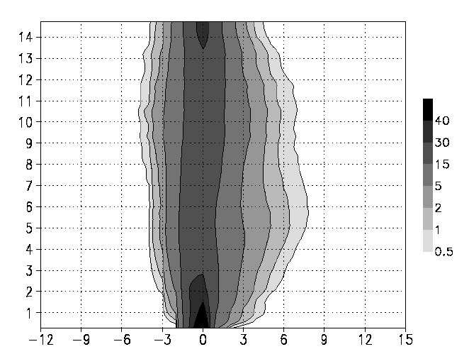
Observed Simulated

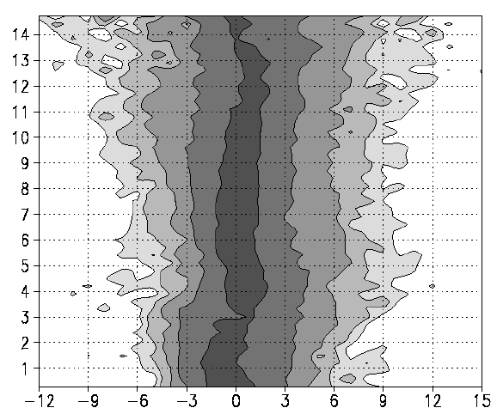
height (km)
height (km)

w (m/s)
w (m/s)

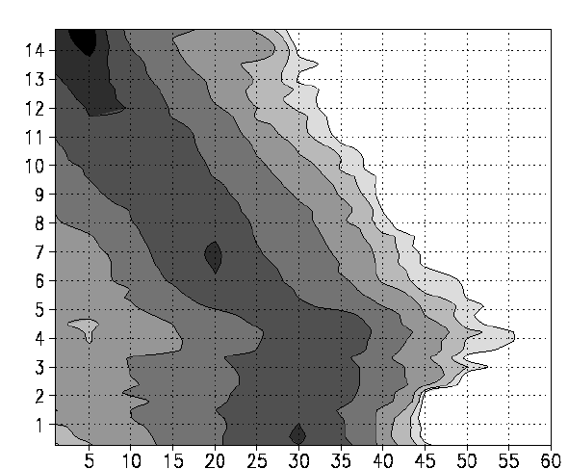
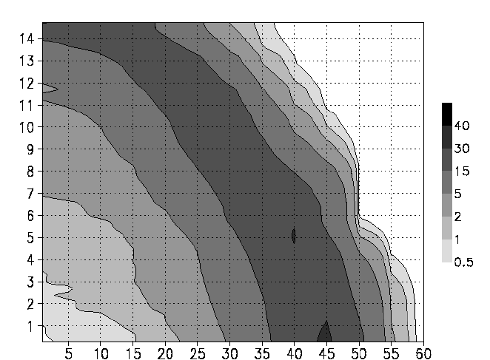
(a) (b)
height (km)
height (km)
reflectivity (dBZ)
reflectivity (dBZ)

(c) (d)

Figure 1. Contoured frequency by altitude diagrams (CFADs; shading, %) of Doppler-derived and simulated vertical motion for the eyewall region of (a) observed storms and (b) simulated storms and reflecitivity of (c) observed storms and (d) simulated storms.

of model output and observations using contoured frequency by altitude diagrams (CFADs; Yuter and Houze 1994). These diagrams plot the variation of probability distribution functions with height. Figure 1 shows CFADs of vertical motion for the observations and simulations for the eyewall regions of all storms. As in Black et al. (1996), the majority of observed vertical motions (Fig. 1a) are weak (|w| < 2 m s⁻¹), but a small fraction (1-2%) of up- and downdrafts exceed 6 m s⁻¹. Values of observed vertical motion in the eyewall range from –6 to 9 m s⁻¹ below the melting level at 4.5 km. The distributions are fairly constant with height below the melting level, but they broaden with height above, indicating strong up- and downdrafts aloft for the extreme events (from –12 m s⁻¹ to 12 m s⁻¹ ) at 13 km. The maximum frequency (i.e., mode) of observed vertical motions is slightly negative in the lowest 2 km, but it becomes near zero or slightly positive above there. Above 9 km the mode of vertical motion is clearly upward, reflecting the loss of hydrometeors and reduction in water loading in the upper levels. In contrast to the observations, the simulated vertical motion CFAD (Fig. 1b) shows a narrower distribution of vertical velocities. The majority of simulated up- and downdrafts are weak, similar to the observations, but values of the maxima are less than the observed values. Values in the lower troposphere range from –3 to 4 m s⁻¹. The range of upward motions increases with increasing height up to the melting level at 5-6 km, at which point the top 1% of points have upward motion of about 8 m s⁻¹. Above the melting level the maximum values decrease, but then there is another relative maximum at about 10 km. Above 10 km, the distribution narrows, in contrast to the observed distributions. The modal values in the eyewall are about zero in the lowest 2 km and become negative up until 8 km, above which it becomes slightly positive.
The observed eyewall reflectivity CFAD (Fig. 1c) is broadly distributed, with peak values around 45 dBZ in the lowest 2 km and values as high as 30 dBZ at 12 km for the top 1% of points. The distribution shows a slight decrease in reflectivity with height in the lowest 1-2 km, and then the values increase with height up to the melting level as warm rain processes cause an increase in hydrometeor mixing ratios. The distributions also show a maximum in reflectivity at the melting level, followed by a sharp drop-off above the melting level. The mode is 30 dBZ in the lower troposphere in the eyewall region. In the simulations (Fig. 1d), the eyewall CFAD shows the high reflectivity bias commonly seen in simulations, as values approach 60 dBZ for the top 1% of points and the mode in the lowest 3 km is around 40-45 dBZ for the eyewall. At 6.5 km, the 45 dBZ value comprises nearly 15% of the points in the simulations, but it comprises only 0.7% of the points in the observations. The values of reflectivity in the top 20% of the distribution remain nearly constant or decrease slightly with height below the melting level. This slope is in contrast to the observations, which show an increase in height between about 2 km and the melting level. A significant difference between the CFADs of observed and simulated reflectivity is the fact that the decrease with height of reflectivity above 5 km is much smaller in the simulations than in the observations.
A scatter plot of flight-level vertical motion and probe measurements of hydrometeor mixing ratio for a portion of the flight track is compared with a scatter plot from an equivalent “flight-level” measurement from the model (Fig 2). The subsample of the flight track used was taken through a line of mixed convective and stratiform rain. As indicated by the linear regression lines fit to each distribution, there is virtually no relationship between observed vertical motion and mixing ratio at 9.9 km. The percent of variance explained by the regression line (r²) is much less than the model, where values of cloud ice mixing ratio are less than 0.4 g kg⁻¹ for updrafts weaker than 0.5 m s⁻¹, but increase to 0.6 g kg⁻¹ for updrafts between 1.5 and 2 m s⁻¹. A comparison similar to that done in Fig. 2a-b was performed for vertical motion and reflectivity from the radar dataset and the simulations of both Bonnie and Floyd (Fig. 2c-d). From the radar data (Fig. 2c), there is a fair amount of scatter between observed reflectivity and vertical motion at 9.9 km. Two separate linear regression lines were calculated: one for vertical motions greater than 1.5 m s⁻¹ and one for vertical motions less than -1.5 m s⁻¹. The slopes and variance explained of the regression lines for the updrafts and downdrafts are less than those for the simulations, indicative of a stronger relationship between vertical motion and reflectivity in the simulations.
The comparisons illustrated in Figs. 1 and 2 show distinct differences between the simulations and the observations, suggestive of biases in the microphysical parameterization scheme used here. For example, one of the most apparent biases suggested by these results is that water loading is too prominent a factor in the simulations. This is supported by several differences between the simulations and the observations, e.g., the simulations consistently underdevelop the strongest vertical velocities and overdevelop the highest reflectivities; and the correlation between vertical motion and reflectivity and vertical motion and hydrometeor concentration is much stronger in the simulations than in the observations. The likely culprit for the water loading problem is an underestimate of hydrometeor fall speed. When fall speeds are underestimated, hydrometeors reside in a model layer longer than they should, resulting in
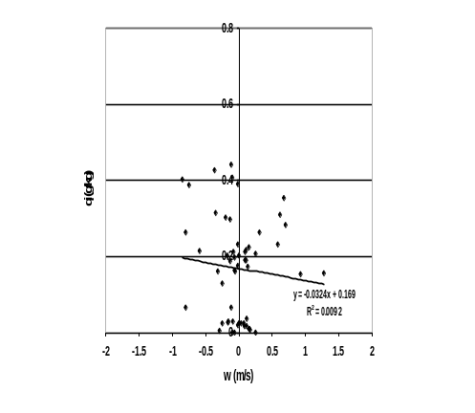
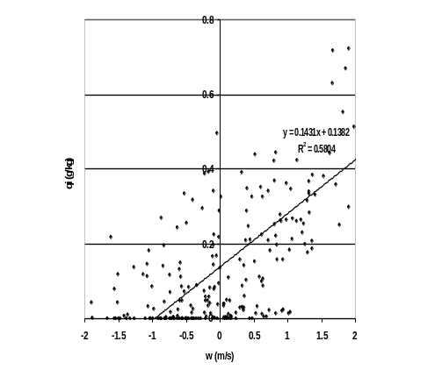

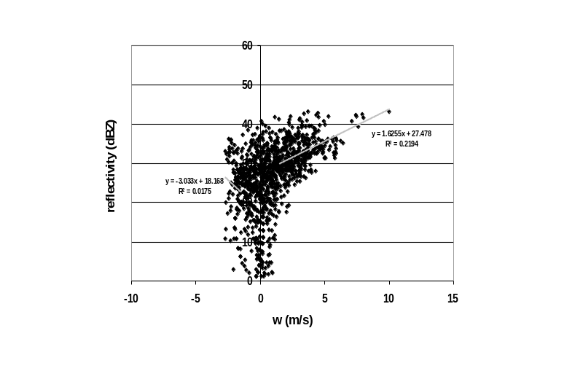
(a) (b)
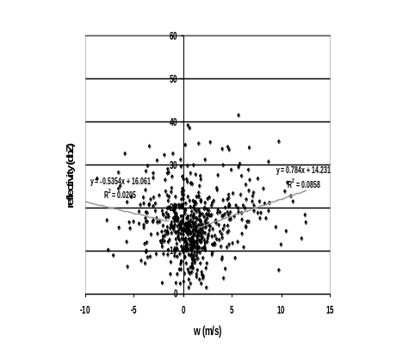

(c) (d)

Figure 2. Scatter plots of flight-level vertical motion (m s⁻¹) and hydrometeor concentrations (g kg⁻¹) at 9.9 km for (a) observations and (b) simulation of Bonnie; and Doppler-derived vertical motion (m s⁻¹) and reflectivity (dBZ) for (c) all observed storms and (d) simulations of Bonnie and Floyd.

increased water loading, reduced updrafts, enhanced reflectivity, and a decrease of reflectivity that is too slow for a given updraft magnitude. It should be emphasized that these postulated improvements are preliminary; others have found different improvements are necessary (e.g. Braun, 2004, personal communication) to improve simulations. Work is currently underway to test the impact of changes such as those postulated here and others (e.g., reducing (increasing) the production (conversion) terms for graupel) on the statistical properties of the distributions of vertical motion, reflectivity, and hydrometeor mixing ratio in the eyewall, rainband, and stratiform regions of the simulated storms.

c) Possible differences in microphysics and dynamics for mature vs. incipient tropical cyclones
The comparisons described above were performed for simulations and observations in mature tropical cyclones. However, there are many differences in the structure and dynamics of mature vs. incipient tropical cyclones. For example, it is not known whether the intensity of convection in incipient systems is stronger than convection in mature systems. If incipient systems have stronger convection than mature systems, then updraft magnitudes are correspondingly higher. Higher updraft magnitudes will support the transport of more supercooled water to high altitudes and allow the growth of more and larger graupel particles and increased electrical activity. This higher population of graupel may have ramifications on the development and maintenance of a stratiform region, since reduced residence times will inhibit the downshear transport of ice crystals important in the development of stratiform rain (e.g., Houze 1989, 1998). As a result, the partitioning of rainfall into convective and stratiform regions is likely different in incipient compared with mature tropical cyclones. Differences in convective versus stratiform partitioning will lead to differences in the magnitude and distribution of latent heating, which will in turn impact the subsequent development of incipient tropical cyclones.
In addition to the possible differences in microphysics between mature and incipient tropical cyclones, there are significant differences in the dynamics of these systems that highlight the importance of having a robust microphysical parameterization scheme capable of adapting to the different environments. Numerous investigators have identified midlevel mesoscale convective vortices (MCVs) that often develop in the stratiform regions of mesoscale convective systems as possible precursors to tropical depressions (e.g., Bosart and Sanders 1981; Velasco and Fritsch 1987; Miller and Fritsch 1991; Zehr 1992; Fritsch et al. 1994; Bister and Emanuel 1997; Ritchie and Holland 1997; Simpson et al. 1997; Rogers and Fritsch 2001). These MCVs have a lower inertial stability than mature tropical cyclones, however. One way for an incipient tropical cyclone to develop into a tropical depression is to have the latent heating from the system occur in a region of reduced effective static stability (Hack and Schubert 1986). This reduction in static stability can occur by saturating the atmosphere in a broad area around the latent heating (Durran and Klemp 1982; Chen and Frank 1993; Rogers and Fritsch 2001). This region of high humidity is especially important in the midlevels, where the latent heating is maximized (e.g., Johnson 1984). Such an area of high-humidity air occurs in broad shields of stratiform rain. In addition, the horizontal scale of the latent heating and the duration of the heating are important factors in determining the likelihood for tropical cyclogenesis, with larger areas and longer time periods of heating being more favorable for continued development. For these reasons, an active, broad stratiform region may be key for the continued development of a weak system.
The importance of this elevated humidity is also illustrated by observations of the environments of tropical cyclones at several different stages in their lifecycle. Figure 3 shows profiles of water vapor anomalies derived from NOAA GPS dropsondes for weakening, steady-state, and intensifying tropical cyclones at the tropical storm, category 1-2, and category 3-5 stage of their lifecycle. For the tropical storms and category 1-2 hurricanes, weakening systems show a pronounced dry anomaly, especially in the lower to middle troposphere. For intensifying systems, there is a marked moist anomaly that extends over a significant depth of the troposphere. These differences highlight the challenge for microphysical parameterization
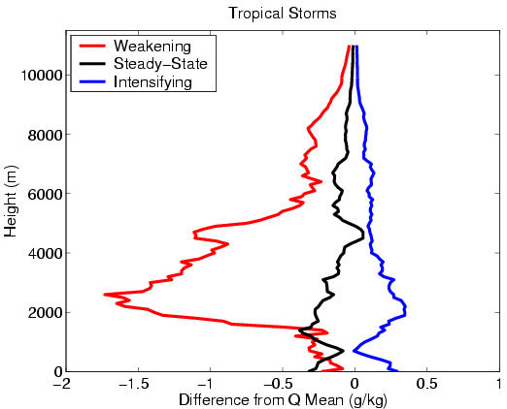
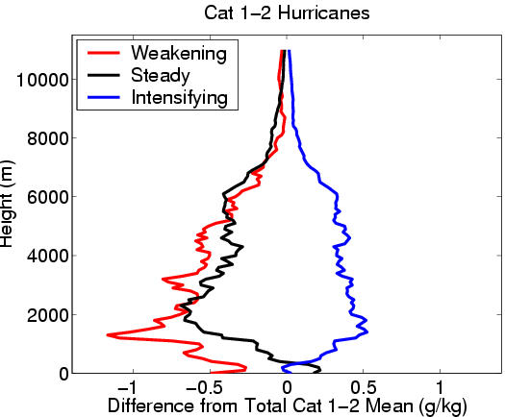
(a) (b)
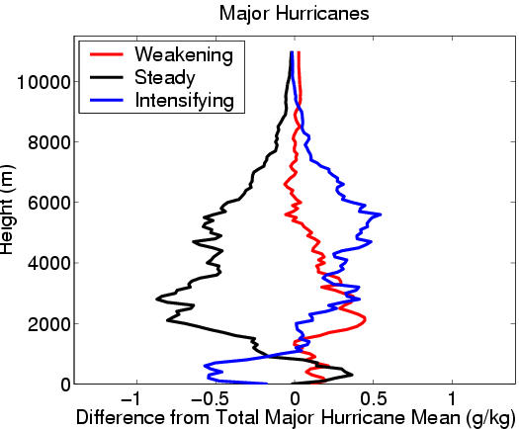

(c)

Figure 3. Composite of water vapor anomaly measured by the GPS dropsondes from the NOAA G-IV hurricane flights from 1997-2003. The dropsonde data are grouped by three storm intensity stages, i.e., intensifying (blue), steady (black), and weakening (red) for (a) tropical storms, (b) category 1-2 hurricanes, and (c) category 3-5 (major) hurricanes (from Ortt and Chen 2004).

schemes, especially in cases of weak systems: they need to be able to respond to these different environments and produce convective and stratiform regions that are dependent on their local environments.

d) Objectives and approach
The differences between mature and incipient tropical cyclones discussed above highlight a series of questions that this proposed research will address:

- What are the microphysical characteristics of incipient tropical cyclones and how do they differ from mature ones?
- What role, if any, do these microphysical differences play in governing the development and evolution of convective and stratiform regions in incipient tropical cyclones?
- What is the importance of the stratiform region in determining the development/non-development of incipient tropical cyclones?
- How well do existing microphysical parameterization schemes capture the differences between incipient and mature tropical cyclones?
- How can existing microphysical parameterization schemes be improved to better handle incipient tropical cyclones?

These questions will be addressed by performing high-resolution simulations of the tropical cyclogenesis cases observed during TCSP and evaluating their performance against observations collected during the experiment. (The evaluation methodology is discussed in more detail in the next section.) Coordinated flight patterns, involving the NOAA P-3’s, NASA DC-8, and NASA ER-2 aircraft, will be flown to provide both in situ and remotely-sensed measurements of the vertical variations of hydrometeor type and amount, vertical motion, and reflectivity. The ability of the P-3 to sample strong eyewall convection with its vertical radar capabilities and in situ microphysical measurements, in concert with the capabilities of the NASA DC-8 and ER-2 aircraft, will provide a nonpareil sampling of the important hurricane convective and stratiform features.
The unique aspect of this proposal is the close coordination that will occur between the investigators who will be performing high-resolution simulations and those who will be collecting observations from a variety of NASA and NOAA platforms. These platforms include microphysical probe data from the NASA DC-8 and NOAA P-3’s, radar data from the NASA ER-2 and NOAA P-3’s, and dropsonde data from the NASA DC-8, NASA ER-2, and NOAA P-3’s. This coordination will be vital in initializing and evaluating the performance of the model, enabling substantial parameterization evaluation and development for tropical cyclogenesis environments.

2. Description of work

a) Modeling component
The modeling component of the proposed research will be carried out using the Penn State/NCAR three-dimensional mesoscale model (i.e., MM5, see Dudhia 1993), which has demonstrated the capability to simulate weather systems spanning a wide range of environments (see the review by Anthes 1990). As the capabilities improve, the Weather Research and Forecasting (WRF) model, one version of which will become the operational hurricane model in the near future, will also be used. Both Rogers and Chen have obtained successful simulations of mature tropical cyclones using MM5, simulating Hurricanes Bonnie (1998), Georges (1998), Floyd (1999), Lili (2002), and Isabel (2003) (Rogers et al. 2003, 2004; Orndorff et al. 2002; Tenerelli and Chen 2002; Cangialosi and Chen 2004). The MM5 contains a) nonhydrostatic dynamics; b) multiple-nested grid capability; c) a choice of the Anthes-Kuo, the modified Arakawa-Schubert and the Kain-Fritsch and Betts-Miller convective schemes; d) explicit calculations of cloud water/ice, rainwater/snow and graupel as predictive variables; and e) high-resolution boundary-layer schemes. A detailed description of the model can be found in Grell et al. (1995).
For the research proposed here high-resolution simulations of tropical cyclogenesis will be required. While simulations of this stage of a tropical cyclone’s lifecycle are less common, there has been some success in producing MM5 simulations of tropical cyclogenesis in a baroclinic environment (e.g., Davis and Bosart 2001, 2002). Furthermore, it is felt that the addition of data from the numerous flights from both NASA and NOAA aircraft in the East Pacific planned as a part of TCSP will provide significant enhancement to the global model analysis fields that provide the initial and boundary conditions for the simulations. For these reasons, we feel we will be able to successfully obtain simulations of tropical cyclogenesis.
A two-way interactive, vortex-following, quadruply nested-grid configuration will be employed to achieve the multiscale simulations. Table 1 describes the (x, y) dimensions. A total of 28 levels in the vertical will be used, with higher resolution in the PBL. The outermost mesh A-domain is fixed and designed to simulate the large-scale environment in which the incipient storm develops and evolves. The size of the domain is chosen sufficiently large to minimize the influence of the lateral boundary conditions on the evolution of the system. The intermediate mesh B-domain is used to simulate the mesoscale environment around the system, while mesh C is designed to explicitly simulate the system-scale flows and provide boundary conditions for the innermost mesh D. The finest mesh D-domain, with a grid size of 1.67 km, is designed to resolve explicitly the deep convection and central core of the developing system. Coarser meshes provide finer meshes with time-dependent lateral boundary conditions, while the finer-mesh solutions are fed back to coarser meshes every time step, thereby achieving the two-way interaction of the meshes. The outermost lateral boundary conditions (i.e., for mesh A) are specified by linearly interpolating NCEP's 12-h observational analysis according to Perkey and Kreitzberg (1976). A unique aspect of this configuration is the use of a vortex-following nested-grid that allows for long integrations with very high grid resolution in the inner core region of hurricanes (Tenerelli and Chen 2002). The inner domains move automatically with the storm, based on the location of the 500 hPa geopotential minimum associated with the storm. Basing a mesh-moving scheme on a midlevel geopotential minimum may pose problems in incipient systems, where weak and/or multiple midlevel centers may be present. We feel we will be able to overcome this potential problem, however, by either keeping the inner mesh fixed or prescribing the movement of the mesh until a dominant midlevel center develops.

Table 1: The model domain configuration.

Domain Mesh A Mesh B Mesh C Mesh D
Dimensions (x, y) 86 x 86 160 x 160 160 x 160 160 x 160

Grid size (km) 45 15 5 1.67

The model water cycles include the simultaneous use of the Kain-Fritsch convective parameterization and the Tao-Simpson (1993) cloud microphysics scheme for the 45- and 15-km grid meshes, but only the cloud microphysics scheme is used for the 5- and 1.67-km grid meshes. The Tao-Simpson microphysics scheme, which was modified from Lin et al. (1983), is a three-class bulk ice scheme that contains prognostic equations for cloud water (ice), rainwater (snow) and hail/graupel, and it allows for the generation of supercooled water. This scheme includes the processes of condensation/evaporation, freezing/melting, sublimation/deposition, autoconversion (i.e., aggregation) of cloud water (ice, snow) to form rainwater (snow, hail/graupel), collection by rainwater (snow), and accretion. Additional microphysical parameterization schemes, including one which contains prognostic equations for only cloud water (ice) and rainwater (snow) (Dudhia 1989) and one which is a double-moment scheme that explicitly predicts number concentration (Reisner et al. 1998) are readily available for use in MM5 and can also be tested in this framework. More sophisticated bin microphysical schemes can also be evaluated in the framework used here. Since requirements for operational forecasts preclude the usage of such schemes for the next several years, however, the schemes described above will be used in this project.
Other model physics include the Blackadar (1979) PBL parameterization (Zhang and Anthes 1982), which has been extensively tested in various weather conditions and whose flaws and merits are better known. The Blackadar scheme is modified for these runs to include the modification based on Pagowski and Moore (2001) in which different roughness scales for temperature z_{t} and moisture z_{q} are used. This configuration of the model has been used successfully to simulate Hurricane Bonnie of 1998 (Rogers et al. 2003), Hurricane Georges of 1998 (Orndorff et al. 2002; Cangialosi and Chen 2004), and Hurricane Floyd of 1999 (Tenerelli and Chen 2002). Radiative effects are included in a cloud-radiation interaction scheme (Dudhia 1989; Grell et al. 1995). Sea surface temperature is held constant during the integration , and the land surface temperature is predicted using surface energy budget equations in which the effects of short- and long-wave radiation and cloud radiation are included. For a more detailed description of MM5, the reader is referred to Dudhia (1993) and Grell et al. (1995).
The model will be initialized using NCEP 1° analyses, which are then enhanced by rawinsondes, surface observations and the Navy's SST field. Simulations conducted for this proposal will be aided by work proposed by another project, entitled “Assimilation of CAMEX Airborne and Spaceborne Data in Tropical Cyclones” with Dr. Sharanya Majumdar of RSMAS/University of Miami as Principal Investigator. Dr. Majumdar’s project proposes to use satellite and airborne data to construct and reposition incipient vortices and perform data assimilation to produce the optimal initial conditions on the mesoscale. We will work with Dr. Majumdar’s project to coordinate simulations so that initial fields created from his project can be used in our high-resolution simulations.
Once the simulations are conducted, detailed diagnostic fields will be computed from the model that will facilitate comparison with the probe data and other observational platforms onboard the planes. Budgets of hydrometeor mass and conversion processes will be computed in a manner consistent with the measurements taken from the probes. Model-derived radar reflectivity will also be computed and compared with Doppler radar onboard the P-3 and ER-2. Additional validation will be performed by comparing model output with satellite-derived wind and reflectivity fields from the NOAA GOES, QuickScat and NASA TRMM satellites, and with low-level in situ measurements of temperature, pressure, humidity, and winds from the Aerosonde aircraft as proposed by Dr. Joseph Cione et al. in a project entitled “Integrated Use of the Aerosonde UAV Platform to Observe the Near-Surface Tropical Cyclone Environment.” Since it is virtually impossible for the model to perfectly replicate the magnitude and distribution of hydrometeor concentrations, distributions of relevant microphysical parameters will be compared statistically, in a manner similar to that described in the previous section, to provide a picture of the distribution of hydrometeors independent of position, intensity, and timing errors associated with the simulations. See Comparison of Model Microphysics and Observations below for a more detailed discussion of these evaluation techniques.
The microphysical parameterization evaluations performed here can be applied to any model that uses these same schemes. The WRF model is one such model that would be ideal for performing these comparisons. Current formulations of the WRF, however, preclude simulations at a sufficient resolution for reliable comparisons with the observations. As the capabilities of WRF improve, the initial fields used for MM5 can certainly be used to test the WRF model. The framework for evaluating the microphysical scheme in this proposal (described below) can easily be adapted to the WRF model.

b) Observational component
The thrust of the observational component of this work is to do coordinated sampling between the instruments on the NOAA P-3’s and the NASA DC-8 and ER-2. This should provide a synergism that has not been available heretofore. This proposed coordinated microphysics and remote sampling will provide a data set to allow parameterization development and model comparisons, in addition to remote sensing comparisons and algorithm development. The ability of the P-3 to sample strong convection with its vertical radar capabilities and in situ microphysical measurements, including the large hydrometeor sampling capabilities of the 2D-P monoprobe in concert with the capabilities of the NASA DC-8 and ER-2 aircraft, will provide unparalleled sampling of the important convective and stratiform features of incipient tropical cyclones.

1) In situ measurements
We have extensive knowledge of the microphysical processes in the vicinity of the freezing level. We find substantial amounts of graupel only in significant updrafts (> 10 m s⁻¹) in eyewall and rainband convection, and ice aggregates and complex-growth ice hydrometeors virtually everywhere else (Black and Hallett 1999). Ice is pervasive in the entire hurricane volume, with the possible exception of the inner eyewall updrafts. Most downdrafts have very high concentrations (100-200/liter) of small ice. We do not know to what elevations the graupel extends, or to what elevation the high concentrations of aggregates extend. Recent observations from the NASA DC-8, however, have found significant quantities of soft, low-density graupel at temperatures as low as –40ºC (Black et al. 2003; Herman and Heymsfield 2003), indicating the presence of supercooled water at these high altitudes. One immediate focus of the work proposed herein, therefore, is to address questions regarding the vertical extent of ice particle and condensed water substance fluxes. It is this component of the observational puzzle for which the DC-8 and ER-2 will provide the necessary key observations. But it is important that these measurements be obtained in a coordinated context.
Data collection and analyses onboard the planes will follow techniques used by numerous investigators in past missions (e.g., Black and Hallett 1986, Heymsfield et al. 2002, Stith et al. 2002). Specifically, raw 2-D image data files will be checked for start and stop, as well as for the numerous known image defects, in a timely manner. WP-3D data will be analyzed in the same way as the DC-8 data, with similar products produced. Analysis of the 2-D particle image data will include artifact rejection and partial restoration of incomplete images following the techniques presented in Black and Hallett (1986) and others. Special problems with the raw image data will be overcome as circumstances require. The basic product is the particle size distribution, from which many derived quantities are computed. The size distributions are computed for four species of water: liquid, irregular ice, columns/needles, and rounded ice particles. Computed quantities include number concentration, ice and liquid water content, radar reflectivity, ice and water mixing ratio, radar attenuation, median volume diameter, and the parameters of a exponential fit to the size distribution in a manner similar to that done in Black (1990). If the images are in rain, rain rate is computed. Other products include particle imagery and average cross-sectional area. These products will be made available for distribution to the research community via anonymous ftp as easily readable files.
For the DC-8, we will be making a comprehensive set of measurements of aerosol and hydrometeor properties, including cloud particle sizes, shapes and liquid and ice water contents and aerosol size, volatility, light absorbing particles (LAP), solubility, and optical parameters from instruments mounted on the TCSP mid- and upper-level research aircraft. This data collection will be carried out as a part of a separate proposal by Dr. A. Heymsfield entitled “Microphysical measurements and analysis in support of the tropical cloud systems and processes (TCSP) program”. Our TCSP data will also be archived to be available for other scientific investigations.
In addition to providing data for the statistical comparisons and water budget analyses (described in more detail below), the probe data will be helpful for improving graupel fallspeed estimates. Because we have direct measurements of the ice water content we can obtain population-mean densities (Heymsfield et al. 2004), a parameter crucial for the assignment of fall speeds in many parameterization schemes. We can also relate the mean mass-weighted fall velocities from TCSP to such properties as the slope of the particle size distribution and compare them with model-derived relationships to check for consistency. We hope to extend these to a broader set of observations in convection, with graupel hopefully, for TCSP. This relates directly to questions (iv) and (v) listed above.

2) Remotely-sensed measurements
In addition to the microphysical probe data described above, we will be using vertical motion and reflectivity observations collected from Doppler radar onboard the NOAA P-3’s and NASA ER-2. Airborne Doppler radar systems on each of the two NOAA P-3 research aircraft record the data for determining the vertical air motion. A 3.2-cm (X-band) Doppler radar is mounted in the tail of the aircraft and scans in a vertical plane normal to the aircraft track. The radar system records the radial velocities of precipitation particles, toward and away from the aircraft, and reflectivity data that depict the vertical structure of precipitation. When the antenna is at vertical incidence (VI) the Doppler velocities are the vertical motions of precipitation particles relative to the aircraft. When the antenna is not pointing directly up or down, horizontal motions of the air and aircraft influence the vertical motion measurements. A maximum separation angle ≤0.5° from true nadir or zenith is allowed to minimize contamination of the data by horizontal motions. The radar rotates 10 times per minute, has a 1.9° beam in the plane of rotation, a 1.35° beam perpendicular to it, a maximum range of 95 km, and an unambiguous velocity interval of 12.9 m s-1. Jorgensen (1984) provides other characteristics of the radar.
The P-3 aircraft fly at typical ground speeds of ~125 m s-1, so the tail radar antenna points in a particular direction at intervals of ~750 m along the flight track. Although the upward and downward pointing rays are 3 s apart, they are mapped continuously in the vertical at the center time of the two radials. The maximum tops of the precipitation echoes are usually lower than 15 km height. Regardless of aircraft altitude, therefore, the horizontal beamwidth at vertical incidence is <400 m in areas with echo, and successive vertical incidence rays sample non-overlapping volumes. During flights, the radar operator selects the length of the range gates to be 75, 150, or 300 m; the value may vary with distance from the aircraft.
EDOP is an X-band (9.6 GHz), Doppler radar located in the nose of the ER-2 and is described in Heymsfield et al. (1996). It utilizes a fixed dual-beam (nadir and forward-looking beams) configuration that allows computation of both vertical and along-track horizontal winds. The antennas have 3º beam widths and a spot size of about 1.2 km at the surface (assuming a nominal 20 km aircraft altitude). EDOP samples with a 37.5 m gate spacing and a pulse-repetition-frequency of 4400 Hz providing a Nyquist velocity of ~34 ms⁻¹. Processed values are obtained every 0.5 s, which corresponds to approximately 100 m of aircraft translation. The horizontal resolution of EDOP is ~500 m at 10 km altitude. The integration time for dwells is 0.5 s, which corresponds to 100 m sampling along-track. Thus, EDOP is oversampling and should resolve horizontal scales somewhat less than 1 km for 10 km altitude clouds.
Calculation of vertical air motion w from the measured Doppler velocity requires removal of aircraft motions and estimation of fallspeeds. For EDOP and the P-3 radar, aircraft motions are removed post-flight to better than 0.5 ms⁻¹, thus leaving the fallspeed estimate as the largest source of error in w. An automatic procedure was used for removing the fallspeeds based on reflectivity fallspeed relations. In some cases, the errors in fallspeeds can be large, such as in strongly convective regions where graupel is present and a snow fallspeed relation is assumed. In these regions we suspect errors as large as 8 m s⁻¹. Discussions at the last CAMEX science team meeting came up with the idea of flying downlooking EDOP and the Cloud Radar System (CRS) 94 GHz radar directly over the NOAA P3. By adding the Doppler velocities from EDOP nadir pointing and the P3 tail radar zenith-pointing data at approximately the same point in time and space, the reflectivity-weighted fallspeed can be estimated. We desire stacked ER-2/P-3 flight legs in various precipitation regions when opportune. The ER-2 flies faster than the P3 so this will require flight planning to be able to stack the aircraft closely enough in time during some portion of the flight leg. This effort, in collaboration with Dr. G. Heymsfield under a separate proposal entitled “Studies of Tropical Storm Genesis and Tropical Cirrus Using ER-2 Radars” (G. Heymsfield, P.I.), will provide more quantitative fallspeeds in convective regions, and help in deciding which Z-v relation to use when a single aircraft is present.
These radar measurements, combined with dropsonde data released from the NOAA P-3’s and NASA ER-2, will also provide an excellent means of documenting the structure and evolution of the midlevel MCVs in the incipient tropical cyclones. This will help us in following the evolution of the systems as they undergo genesis and validate the performance of the simulations.

c) Comparison of model microphysics and observations
Observations from tropical cyclogenesis environments are sparse, so evaluations of the robustness of microphysical parameterization schemes in these environments are not possible. One of the key goals of the upcoming TCSP experiment is to collect measurements from weak or developing tropical systems. The work described here proposes to take measurements of hydrometeor type, amount, and size distribution, vertical motion, and reflectivity and compare them with high-resolution simulations of tropical cyclogenesis cases using the following evaluation methodologies:

1) Statistical comparisons
The evaluation methodology described in the previous section provides a means of testing microphysical parameterization schemes in the environment of incipient tropical cyclones. Comparing the distributions of relevant microphysical parameters (e.g., hydrometeor mixing ratios, vertical motion, reflectivity) in a statistical framework obviates the need for producing a precise spatial and temporal match between the simulations and the observations, and allows for inferences to be made about the performance of the model in the context of parameterization performance. In a manner similar to what was done previously (Rogers et al. 2004), we will be comparing the means, medians, and modes of the fields from both the simulations and the observations. We will derive mixing ratios from the probe data on the P-3’s and the DC-8, and we will be able to sort this data by temperature and vertical motion, which will be obtained from flight-level data. From this sorting we will be able to determine the correlation between vertical motion, temperature, and hydrometeor mixing ratio. Since the P-3’s will be flying at and below the melting level and the DC-8 will be flying coincident with the P-3’s at about 35,000 ft, we will have a vertically-coherent set of observations in a range of environments in which to compare the simulations with the observations. In addition to the data collected as a part of this project, we will be coordinating our efforts with another proposed project by Dr. Robert Houze, entitled “Stratiform Precipitation in Tropical Convection and cyclone Development in TCSP and ASHE.” Data collected as a part of their project will be added to our observational database, and we will provide our data to them as their needs dictate.
We will also use vertical motion and reflectivity data as determined remotely from the P-3 tail Doppler and EDOP instrument onboard the ER-2. To derive the motion of the air (w_{air}) will require an assumption of the particle fall velocity as measured by each of the radars. As described above, the ER-2 will also be flown coincident with the lower-level aircraft to provide simultaneous looks at the same volume of air. Having simultaneous looks from both aircraft will aid in estimating the fall speeds to determine w_{air}. To remove the uncertainty in calculating vertical air motion associated with the fallspeed estimates, we will also use the magnitude of the total vertical motion as measured by the radar (W_{dop}). From the calculation of W_{dop} we will be able to calculate mass flux (M_{dop}), which can easily be compared with the mass flux from the model. Because of the much greater spatial coverage provided by the radars, we will be able to examine the variation with height of the distributions (CFADs, Yuter and Houze 1994) of air vertical motion (w_{air}), total vertical motion (W_{dop}), mass flux (M_{dop}), and reflectivity (Z). Additionally, we will be able to sort reflectivity by w_{air}, W_{dop}, and M_{dop} to enable correlation calculations among these variables.

2) Water budget calculations
Another method of evaluating the performance of the models is to calculate budgets of water from the simulations and compare them with budgets from the observations. It has long been known that the principal energy source in tropical cyclones is the heat of condensation liberated in the cloud areas of the storms. The details of the water budget, then, are of paramount importance in the inner workings of the storm systems, including the genesis, initial development, maintenance of the circulation, and changes in intensity. Previous analyses of the water budgets of mature storms (Hawkins and Rubsam 1968; Hawkins and Imbembo 1976; Marks and Houze 1987; Gamache et al. 1993) have revealed important insights into the important processes governing the generation and distribution of hydrometeors in tropical cyclones. However, in these studies the convergence of moisture into the eyewall, the primary source of condensate and latent heating in the storm, has been deduced from analyses based on numerous underlying assumptions, so that this critical component of moisture inflow into the eyewall has not been amenable to strict observational comparison. Model simulations are a useful means for analyzing the water budget, because the complete details of the water budget are available for scrutiny without sampling and instrumental problems. Until recently, though, the resolution of model simulations has not been adequate for realistic progress using a water budget approach. The high resolution of present model simulations (1-2 km) makes possible meaningful water budget analyses, and budget analyses for mature storms have already begun (e.g., Braun 2004). The detailed water budget components can now be compared statistically to measured in situ and remotely-sensed components of the water budgets of observed storms. These comparisons provide a synergism to provide advances towards the goal of understanding the genesis and intensity change of real storms. In this effort we propose to use our past microphysical, dynamical, and radar data sets, including data collected as a part of CAMEX-3 and CAMEX-4, to make statistical comparisons of simulated and observed water budget components. In addition, we propose to collect coordinated data to make water budget component comparisons for genesis and developing cases in TCSP.
Although we will look at other components of the water budget, we will emphasize study of the condensate budget (cloud and precipitation) in comparisons of model and observed components. The condensate is initially released as cloud water and ice, which subsequently evolves into precipitation hydrometeors (rain, snow, and graupel) – budget components which are available in the simulations. Observationally, these components are available to a limited degree from in situ microphysical measurements and from the three-dimensional radar sampling of the storm volume (P-3 tail radar and ER-2 EDOP). In a few cases three-dimensional wind fields are available to provide advective transports, and they will be available for TCSP from Doppler-derived wind fields. Both outward transport and in situ production of precipitating water and ice are study components of particular interest. The development and maintenance of stratiform precipitation and bright band regions in developing storms are targets of study from a water budget perspective. The overall fraction of convective versus stratiform precipitation will also be analyzed in detail in both the simulations and the observations.
We have a substantial database of vertical incidence tail radar data in tropical storms and hurricanes that we propose to use to develop the statistical analyses of the observed water budget components. These data span a wide range of storm states. We propose to use this database, combined with observations collected from TCSP flights, to compare to the water budget components derived from existing simulations of mature storms and of genesis cases done as a part of the proposed TCSP work. We propose to examine and compare the water budget components in detail in several pertinent height ranges in the vertical. For example, in both the observations and the simulations, we will stratify the data into the following layers: 1) a layer from the surface to cloud base; 2) cloud base to the base of the melting layer; 3) a layer encompassing the melting layer; 4) from the top of the melting layer to -25ºC; and 5) from -25ºC to cloud top or the tropopause. Stratifying the data into these vertical layers will provide information on the creation and transport of hydrometeors and its dependence on height and provide additional evaluations of the effectiveness of the simulations in producing these distributions in the vertical.

d) Work Plan
The proposed study will proceed in the following steps:

1) Year one (2005-2006):
- coordinate flight plans with NASA DC-8 and ER-2
- fly missions for TCSP, gathering probe and remotely-sensed data in coordination with NASA
- begin processing of data
- perform water budgets of existing high-resolution simulations of Hurricanes Bonnie and Floyd
- begin simulations of tropical cyclogenesis cases from TCSP

The main goal of the first year is to plan the coordinated TCSP missions that will gather the microphysical data and to prepare the model for conducting simulations of the storms flown during the field program. Paul Willis, Robert Black, and Michael Black of NOAA/HRD will work with A. Heymsfield and G. Heymsfield to design missions that will collect hydrometeor data simultaneously at levels below and just above the melting level (NOAA P-3), about 40,000 ft (NASA DC-8), and at 65,000 ft (NASA ER-2). This coordination will allow for the computation of vertical hydrometeor profiles, ice aggregation rates, and updraft magnitudes associated with the convective and stratiform regions in the incipient. Willis and R. Black will be responsible for the collection and processing of microphysical probe data from the NOAA P-3’s, A. Heymsfield will be responsible for the collection and processing of probe data from the NASA DC-8, M. Black will collect and process the tail Doppler radar data from the NOAA P-3, and G. Heymsfield will collect and process the EDOP radar data from the NASA ER-2.
The modeling component during the first year will consist of beginning simulations of tropical cyclogenesis cases from TCSP and performing water budgets from existing high-resolution simulations of Hurricanes Bonnie (a CAMEX3 storm) and Floyd. The purpose of calculating the budgets from the existing cases of mature storm simulations is to provide a comparison for comparing the budgets for the tropical cyclogenesis cases. Rogers will be responsible for calculating the budgets from the existing simulations. Rogers and S. Chen will be responsible for performing the simulations of the TCSP cases.

2) Year two (2006-2007):
- complete processing of data
- perform statistical analyses of observations
- begin computation of water budgets of different species from observations
- continue simulations of TCSP cases
- analyze simulations, performing statistical analyses of microphysical parameters
- begin calculation of water budgets from simulations for comparison with observations

The second year will see a completion of the processing of the probe and radar data begun in the first year by Willis, R. Black, M. Black, A. Heymsfield, and G. Heymsfield. Budgets of hydrometeor mass distributions and conversion rates will be computed, and statistical analyses of the data will be performed for the different species. Simulations of selected TCSP cases by Rogers and Chen will continue. Model evaluation will occur using the techniques described above (section 2c – Comparison of model microphysics and observations). Diagnostic analyses computed from the simulations will include the fields described above and other model validation accomplished by comparing simulation results again Best Track data from NHC, GPS dropsondes, satellite infrared, water vapor, and wind data, and hydrometeor vertical profiles from the TRMM satellite if available. Comparisons of the statistics and budgets from the observations of mature storms (available in the literature) and incipient storms will address questions (i)-(iii) above (see section 1d, “Questions to address and approach”).

3) Year three (2007-2008):
- complete statistical analyses and budget calculations for observations and simulations
- identify differences between statistics for tropical cyclogenesis and mature storm cases from statistical and budget analyses
- determine ability of parameterization scheme to capture these differences
- identify possible areas for improvement based on these comparisons
- conduct sensitivity studies based on suggested improvements
- investigate possibility of using WRF model for similar evaluations
- write up results

The final year will see the completion of the analyses of the probe and radar data by Willis, R. Black, M. Black, A. Heymsfield, and G. Heymsfield. The simulations of the TCSP cases by Rogers and Chen will also be completed during this year. Based on comparisons with the probe and radar data, deficiencies in the parameterization scheme in this environment will likely be identified. Areas for possible improvement will be identified, and sensitivity tests of these improvements will occur to evaluate the impact of these improvements on the hydrometeor distribution, radar reflectivity, and tropical cyclogenesis. These activities will directly address questions (iv) and (v) from above (see section 1d, “Questions to address and approach”). The results obtained from these analyses may guide future developments of parameterization schemes that can apply to both tropical cyclogenesis and mature cyclone environments. It is anticipated that by this time there may be a configuration of the WRF model that will be appropriate for running at a high enough spatial resolution for conducting meaningful comparisons with the observations collected in this proposal. Rogers will investigate this possibility and perform the simulations and comparisons if necessary. These results will be written up for publication in scientific journals.

3. References cited

Anthes, R.A., 1990: Recent applications of the Penn State/NCAR mesoscale model to synoptic, mesoscale, and climate studies. Bull. Amer. Meteor. Soc., 71, 1610-1629.
Black, M.L., R.W. Burpee, and F.D. Marks, Jr., 1996: Vertical motion characteristics of tropical cyclones determined with airborne Doppler radial velocities. J. Atmos. Sci., 53, 1887-1909.
Black, R.A., and J. Hallett, 1986: Observations of the distribution of ice in hurricanes. J. Atmos. Sci., 43, 802-822.
Black, R.A., and J. Hallett, 1999: Electrification of the hurricane. J. Atmos. Sci., 56, 2004-2028.
Braun, S.A., 2004: High-resolution simulation of Hurricane Bonnie (1998). Part II: Water budget. Submitted to J. Atmos. Sci.
Cangialosi, J., and S.S. Chen, 2002: A numerical study of the topographic effects on structure and rainfall in Hurricane Georges (1998). Preprints, Twenty-sixth Conference on Hurricanes and Tropical Meteorology, 3 – 7 May 2004, Miami, FL, 528-529.
Chen, S.S., and W.M. Frank, 1993: A numerical study of the genesis of extratropical convective mesovortices. Part I: Evolution and dynamics. J. Atmos. Sci., 50, 2401-2426.
Cotton, W.R., M.S. Stephens, T. Nehrkorn, and G.J. Tripoli, 1982: The Colorado State University three-dimensional cloud-mesoscale model –1982. Part II: An ice-phase parameterization. J. Rech. Atmos., 16, 295-320.
Davis, Christopher A., Bosart, Lance F. 2001: Numerical Simulations of the Genesis of Hurricane Diana (1984). Part I: Control Simulation. Mon. Wea. Rev., 129, 1859–1881.
Davis, Christopher, Bosart, Lance F. 2002: Numerical Simulations of the Genesis of Hurricane Diana (1984). Part II: Sensitivity of Track and Intensity Prediction. Mon. Wea. Rev., 130, 1100–1124.
Dudhia, J., 1993: A nonhydrostatic version of the Penn State-NCAR mesoscale model: Validation tests and simulation of an Atlantic cyclone and cold front. Mon. Wea. Rev., 121, 1493-1513.
Dudhia, J., 1993: A nonhydrostatic version of the Penn State-NCAR mesoscale model: Validation tests and simulation of an Atlantic cyclone and cold front. Mon. Wea. Rev., 121, 1493-1513.
Durran, Dale R., Klemp, Joseph B. 1982: On the Effects of Moisture on the Brunt-Väisälä Frequency. J. Atmos. Sci, 39, 2152–2158.
Farley, R.D., and H.D. Orville, 1986: Numerical modeling of hailstorms and hailstone growh. Part I: Preliminary mdoel verification and sensitivity tests. J. Climate Appl. Meteor., 25, 2014-2035.
Ferrier, B.S., 1994: A double-moment multiple-phase four-class bulk ice scheme. Part I: Description. J. Atmos. Sci., 51, 249-280.
Ferrier, B.S., W.-K. Tao, and J. Simpson, 1995: A double-moment multiple-phase four-class bulk ice scheme. Part II: Simulations of convective storms in different large-scale environments and comparisons with other bulk parameterizations. J. Atmos. Sci., 52, 1001-1033.
Fukuta, N., and C.M. Gramada, 2000: Vapor pressure measurement of deeply supercooled water. Preprints, 13th International Conference on Clouds and Precipitation. Reno, Nevada, 14-18 August 2000, 613-616.
Gamache, J.F., R.A. Houze, and F.D. Marks, 1993: Dual-Aircraft Investigation of the inner Core of Hurricane Norbert. Part III: Water Budget. J. of Atmos. Sci., 50, 3221–3243.
Grell, G. A., J. Dudhia, and D. R. Stauffer, 1995: A description of the fifth-generation Penn State/NCAR Mesoscale Model (MM5). NCAR Technical Note NCAR/TN-398+STR, 138 pp.
Hack, J.J., and W.H. Schubert, 1986: Nonlinear response of atmospheric vortices to heating by organized cumulus convection. J. Atmos. Sci., 43, 1559-1573.
Hall, W.D., 1980: A detailed microphysical model within a two-dimensional dynamic framework: Model description and preliminary results. J. Atmos. Sci., 37, 2486-2507.
Hawkins, H. F., and S.M. Imbembo, 1976:.The Structure of a Small, Intense Hurricane—Inez 1966. Mon. Wea. Rev., 104, 418-442.
Hawkins, H. F., and D.T. Rubsam,. 1964: Hurricane Hilda 1964. II. Structure and budgets of the hurricane on October 1, 1964. Mon. Wea. Rev., 96, 617-636.
Heymsfield, A. J., A. Bansemer, P.R. Field, S.L. Durden, J.L. Stith, J.E. Dye, W. Hall, C. Grainger, 2002: Observations and Parameterizations of Particle Size Distributions in Deep Tropical Cirrus and Stratiform Precipitating Clouds: Results from In Situ Observations in TRMM Field Campaigns. J. of Atmos. Sci., 59, 3457–3491.
Heymsfield, G.M., S.W. Bidwell, I.J. Caylor, S. Ameen, S. Nicholson,W. Boncyk, L. Miller, D. Vandemark, P.E. Racette, L.R. Dod, 1996: The EDOP Radar System on the High-Altitude NASA ER-2 Aircraft. J. of Atmos. and Ocean. Tech., 13, 795–809.
Houze, R.A., 1989: Observed structure of mesoscale convective systems and implications for large-scale heating. Quart. J. Roy. Met. Soc., 115, 425-461.
Houze, R.A., 1998: Stratiform precipitation in regions of convection: A meteorological paradox? Bull. Amer. Met. Soc., 78, 2179-2196.
Hsie, E.-Y., Anthes, R.A., and D. Keyser, 1984: Numerical simulation of frontogenesis in a moist atmosphere. J. Atmos. Sci., 41, 2581-2594.
Johnson, R.H., 1984: Partitioning tropical heat and moisture budgets into cumulus and mesoscale components: Implications for cumulus parameterization. Mon. Wea. Rev., 112, 1590-1601.
Lin, Y.-L., R.D. Farley, and H.D. Orville, 1983: Bulk parameterization of the snow field in a cloud model. J. Climate Appl. Meteor., 22, 1065-1092.
Lord, S.J., H.E. Willoughby, and J.M. Piotrowicz, 1984: Role of a parameterized ice-phase microphysics in an axisymmetric nonhydrostatic tropical cyclone model. J. Atmos. Sci., 41, 2836-2848.
Marks, Frank D., and R.A. Houze, 1987: Inner Core Structure of Hurricane Alicia from Airborne Doppler Radar Observations Journal of the Atmospheric Sciences 44: 1296-1317
Mason, B.J., 1971: The Physics of Clouds (2nd edition). Clarendon Press, Oxford, 659 pp.
McCumber, M., W.-K. Tao, J. Simpson, R. Penc, and S.-T. Soong, 1991: Comparison of ice-phase microphysical parameterization schemes using numerical simulation of tropical convection. J. Appl. Meteor., 30, 985-1004.
McFarquhar, G.M., H. Zhang, G. Heymsfield, J. Dudhia, J.B. Halverson, R. Hood, and F. Marks, Jr., 2004: Factors affecting the evolution of Hurricane Erin and the distributions of hydrometeors: Role of microphysical processes. Submitted to J. Atmos. Sci.
Orndorff, C., S.S. Chen, and J.E. Tenerelli, 2002: Precipitation and landmass interaction during Hurricane Georges (1998) landfall at Puerto Rico. Preprints, Twenty-fifth Conference on Hurricanes and Tropical Meteorology, 29 April – 3 May 2002, San Diego, CA, 297-298.
Ortt, D., and S.S. Chen, 2002: Atmospheric water vapor and tropical cyclone intensity changes. Preprints, Twenty-sixth Conference on Hurricanes and Tropical Meteorology, 3 – 7 May 2004, Miami, FL, 202-203.
Perkey, D.J., and W. Kreitzberg, 1976: A time-dependent lateral boundary scheme for limited area primitive equation models. Mon. Wea. Rev., 104, 744-755.
Reisner, J., R.M. Rasmussen, and R.T. Bruintjes, 1998: Explicit forecasting of supercooled liquid water in winter storms using the MM5 mesoscale model. Quart. J. Roy. Meteor. Soc., 124, 1071-1107.
Rogers, R.F., and J.M. Fritsch, 2001: Surface cyclogenesis from convectively-driven amplification of mid-level mesoscale convective vortices. Mon. Wea. Rev., 129, 605-637.
Rogers, R.F., S.S. Chen, J.E. Tenerelli, and H.E. Willoughby, 2003: A numerical study of the impact of vertical shear on the distribution of rainfall in Hurricane Bonnie (1998). Monthly Weather Review, 131, 1577-1599.
Rogers, R.F., M.L. Black, S.S. Chen, and R.A. Black, 2004: Evaluating microphysical parameterization schemes for use in hurricane environments. Part I: Comparisons with observations. Submitted to J. Atmos. Sci.
Rutledge, S.A., and P.V. Hobbs, 1984: The mesoscale and microscale structure and organization of clouds and precipitation in midlatitude cyclones. Part XII: A diagnostic modeling study of precipitation development in narrow cold-frontal rainbands. J. Atmos. Sci., 41, 2949-2972.
Stith, J. L., J.E. Dye, A. Bansemer, A.J. Heymsfield, C.A. Grainger, W.A. Petersen, R. Cifelli, 2002. Microphysical Observations of Tropical Clouds. J. of App. Meteor., 41, 97–117.

Tao, W.-K., and J. Simpson, 1993: The Goddard cumulus ensemble model. Part I: Model description. Terr. Atmos. Oceanic Sci., 4, 35-72.
Tenerelli, J.E., and S.S. Chen, 2002: Intensity change and eyewall replacement in Hurricane Floyd (1999). Preprints, Twenty-fifth Conference on Hurricanes and Tropical Meteorology, 29 April – 3 May 2002, San Diego, CA, 168-169.
Tripoli, G.J., and W.R. Cotton, 1980: A numerical investigation of several factors contributing to the observed variable intensity of deep convection over South Florida. J. Appl. Meteor., 19, 1037-1063.
Zhang, D.-L. and R.A. Anthes, 1982: A high-resolution model of the planetary boundary layer - sensitivity tests and comparisons with SESAME-79 data. J. Appl. Meteor., 21, 1594-1609.
Zhang, D.-L., 1989: The effect of parameterized ice microphysics on the simulation of vortex circulation with a mesoscale hydrostatic model. Tellus, 41A, 132-147.

4. Personnel

Dr. Robert Rogers is an employee of NOAA’s Hurricane Research Division in Miami. He has experience in performing numerical simulations of midlatitude and tropical convective systems (e.g., Rogers and Fritsch 2001; Rogers et al. 2003) and developing new techniques of data assimilation (e.g., Rogers et al. 2000; Nuissier et al. 2004). Current work centers on improving our understanding and forecasting of tropical cyclone intensity change and rainfall by studying the factors important in governing the distribution of rainfall from tropical cyclones and comparing the performance of microphysical parameterization schemes in mature tropical cyclone environments with in situ and remotely-sensed observations.

Dr. Shuyi Chen has experiences in data analysis using satellite data over the tropics and high-resolution modeling of tropical convection using MM5. Dr. Chen's recent research has been investigating the multiscale variability of tropical deep convection and its relation to the equatorial large-scale circulation using the GMS IR data, satellite MSU data, the ECMWF global analysis fields, TAO and IMET surface measurements, and other COARE datasets over the western Pacific warm-pool region (Chen et al. 1995; 1996; Chen and Houze 1997a; 1997b). These works have linked a broad range of time and space scales from seasonal average fields, through intraseasonal variability, down to individual mesoscale cloud clusters observed over the western Pacific warm-pool region. Dr. Chen has a long track record using numerical models as a tool to study convective cloud systems, from midlatitude MCSs (e.g., Chen and Frank 1993) and coastal cold-air outbreak events (Chen et al, 2001), tropical cloud systems over the western Pacific (e.g., Chen 1997, Su et al. 1999 and 2000, Mechem et al. 2002), to tropical cyclones (e.g., Tenerelli and Chen 2000, Chen et al. 2002, Rogers et al. 2002).

Dr. Andrew Heymsfield is a senior scientist at the National Center for Atmospheric Rsearch and head of the Physical Meteorology Section of the Mesoscale and Microscale Meteorology Division. Dr. Heymsfield is currently an editor for the Journal of the Atmospheric Sciences. His interest in Cloud Physics covers a wide range of topics and he has been on the forefront of investigations which have contributed significantly to developments in the field. His PhD. thesis at the University of Chicago represented the first quantification of the microphysics (size spectra, ice content, etc.,) of cirrus clouds, and the dynamics and mechanisms of maintenance of these clouds. In the late 1970's to mid 1980's, his research focused on the study of particle growth and entrainment in thunderstorms. Using data from the NOAA/NCAR sailplane, he was the first to show the existence of unmixed updraft cores within cumulus congestus clouds and suggested a mechanism for their formation. He has since been working on problems related to cirrus cloud formation and evolution, hurricane microphysics, and remote sensing of ice cloud layers.

Dr. Gerald Heymsfield is an employee of NASA's Goddard Space Flight Center in Greenbelt, Maryland who has experience in satellite and aircraft remote sensing of mesoscale precipitation systems ranging from individual thunderstorms to hurricanes. He has been involved in the development of the two ER-2 airborne radars and has applied data from them to a variety of mesoscale studies. Current work centers on observational studies of tropical storm structure with emphasis on effects of vertical shear and inner core convection on intensity, structure and processes related to convectively-generated cirrus, and algorithms associated with precipitation retrievals from airborne radar and TRMM radar observations.

Mr. Michael Black is a research meteorologist with the Hurricane Research Division (HRD) of AOML in Miami, Florida. Mr. Black's current research involves the use of airborne radar data and Global Positioning Satellite (GPS) dropwindsondes, which are deployed in and around tropical cyclones from the NOAA P-3 and G-IV research aircraft. He analyzes data from these dropsondes, which are greatly improving the hurricane track forecasts and provide unprecedented detail of the wind, temperature, and moisture structure of the inner core region of tropical cyclones. He is also actively involved with HRD's annual field program where he designs flight experiments and serves as a lead project scientist, dropsonde scientist, or radar scientist on hurricane research missions with the NOAA aircraft. In addition to his work with the GPS dropsondes, Mr. Black works extensively with airborne Doppler radar data in efforts to help understand the physical mechanisms in the hurricane eyewall that contribute to intensity change.

Mr. Robert Black, an employee of NOAA/OAR/AOML in the Hurricane Research division, has extensive experience analyzing cloud particle image data obtained from a variety of instruments that have been mounted on the WP-3D aircraft. His research interests include the electrification process, the distribution of supercooled water in hurricane clouds, and the relation between vertical velocity and hurricane intensity. Relevant references include Black and Hallett (1986), Black et al. (1994), Black and Hallett (1999), and Black and Heymsfield (2003).

Mr. Paul Willis is an employee of the University of Miami through the NOAA cooperative institute (CIMAS). He has experience in collecting and analyzing airborne microphysical and dynamical data in hurricanes, and other tropical and mid latitude convective systems. He is particularly interested in microphysics – cloud and hydrometeor distributions and morphology, electrification, and water budgets of clouds and melting layers associated with convective cloud systems (Willis et al. 2004, Willis and Heymsfield 2000, Willis et al. 1993, Willis and Hallett, 1991, Willis and Heymsfield, 1989, Willis 1984). Current work centers on the relation between microphysical characteristics, electric fields, and radar structure in Florida convective anvils clouds.

5. Facilities and equipment

The facilities required for this project are largely already available. Both in situ and remotely-sensed measurements will be collected by instruments already available and mounted on the aircraft. Data processing will occur on computers already available at AOML, NCAR, and NASA (with some funding requested for routine upgrades). Computer simulations will be performed at the Division of Meteorology and Physical Oceanography at RSMAS on multi-processor Opteron Linux boxes. We are requesting partial funding for the acquisition of this hardware.

6. Collaborations

Dr. Gerald Heymsfield, NASA/GSFC

Dr. Sharanya Majumdar, University of Miami/RSMAS

Dr. Robert Houze, University of Washington

Dr. Joseph Cione, NOAA/AOML Hurricane Research Division

7. Budget Justification

NOAA/AOML:
Dr. Rogers will provide 3 months of effort per year on a cost-shared basis. As principal investigator, he will oversee the functions of the project to assure their satisfactory completion. He will work with Dr. Chen and a graduate student to produce successful tropical cyclogenesis simulations using MM5 based on cases observed during TCSP. If available, he will also perform preliminary simulations using the WRF model during the third year. He will also calculate the water budgets from the simulations for comparisons with Dr. A. Heymsfield and Mr. P. Willis. Mr. M. Black is requesting 1 month of salary support to collect and oversee the processing of airborne radar data to be used in the model intercomparisons. Mr. R. Black requests 1 month of salary support to collect and process microphysical probe measurements from the NOAA P-3. Mr. P. Willis requests 2 months of salary support to calculate the water budgets from mature storms and incipient storms as collected during TCSP. They also request 1 month salary support for a support person to perform the processing of airborne radar data with M. Black. It is anticipated that data will be collected during the first year of the proposal. The requirement is five days of flights using one plane with two people collecting data. All labor and travel costs are shared equally between NOAA and NASA. Flight hour costs are paid by NOAA. Equipment costs include $5000 during the first year to help defray the cost (along with RSMAS) of acquiring a multi-processor Linux box at RSMAS to perform the numerical simulations and $3000 during the first year to upgrade computer systems at AOML for data processing. Computer infrastructure costs of $6000 per year are requested to contribute to hardware and software maintenance. They are requesting $3000 per year for travel costs to attend scientific meetings and conferences.

UM/RSMAS:
Dr. Chen is requesting 0.5 month salary support, along with 0.5 month salary support for a research coordinator, to assist in the conducting of MM5 simulations. She is also requesting 12-month support for a graduate student who will be performing the simulations. She is requesting $1000 per year for computer supplies (e.g., disk storage) and $1500 per year for travel to scientific meeting and conferences. Equipment costs include $5000 during the first year to help defray the cost (along with AOML) of acquiring a multi-processor Linux box at RSMAS to perform the numerical simulations.

NCAR:
Dr. A. Heymsfield is requesting 12% salary support for an associate scientist to process the DC-8 probe data. He is also requesting $9,400 during the first year to pay for the deployment costs for one person to pay a field site visit to Acapulco for one month.

NASA/GSFC:
Dr. G. Heymsfield is not requesting any support from NASA for this proposal. His participation is on a no-cost basis (see attached letter).

8. Current and pending support

Robert Rogers

Title: “Improving the validation and prediction of tropical cyclone rainfall”
Funding agency: NOAA
Duration: Year 2 of 2 years (7/1/2004-6/30/2005)
Total amount requested: $42,500

Gerald Heymsfield

Improved Understanding of TRMM PR Derived Products Using Aircraft Radar Observations
NASA UPN: 622-32-99-02 Period: 5/03 - 4/06 $350K

Development of a Low Cost UAV Radar for Measurement of Precipitation and Surface Winds in Tropical Storm Genesis
Goddard Instrument Research and Development Period: 10/03-9/04 $185K

CRYSTAL-FACE Analyses
NASA UPN: 622-45-06 Period: 10/03-11/04 $50K

CAMEX-4 Analyses
NASA UPN: 622-31-10 Period: 10/03-11/04 $25K

CoSSIR Development (J. Wang P.I.)
NASA UPN: 622-43-37 Period: 10/04-9/06 $40K

UM and NCAR current and pending support

Robert Fulton Rogers
NOAA/AOML Hurricane Research Division
4301 Rickenbacker Cswy, Miami, FL 33149
Telephone: (305)-361-4536
Fax: (305)-361-4402
Email: Robert.Rogers@noaa.gov

PROFESSIONAL PREPARATION:

The Pennsylvania State University Meteorology Ph.D., 1998
The Pennsylvania State University Meteorology M.S., 1995
University of Virginia Environmental Sciences B.A, 1991

APPOINTMENTS:

2003-present: Meteorologist, NOAA Hurricane Research Division, Miami, FL

2000-2003: Assistant Scientist, Cooperative Institute for Marine and Atmospheric Studies, University of Miami, Miami, FL

1998-2000: National Research Council Postdoctoral Research Associate, Hurricane Research Division, Miami, FL

FIVE MOST RELATED PUBLICATIONS:

Rogers, R.F., M.L. Black, S.S. Chen, and R.A. Black, 2004: Evaluating microphysical parameterization schemes for use in hurricane environments. Part I: Comparisons with observations. Submitted to J. Atmos. Sci.

Nuissier, O., R.F. Rogers, and F. Roux, 2004: Numerical simulation of tropical cyclones. Hurricane Bret on 22-23 August 1999. Quart. J. Roy. Met. Soc., in press.

Rogers, R.F., S.S. Chen, J.E. Tenerelli, and H.E. Willoughby, 2003: A numerical study of the impact of vertical shear on the distribution of rainfall in Hurricane Bonnie (1998). Monthly Weather Review, 131, 1577-1599.

Rogers, R.F., and J.M. Fritsch, 2001: Surface cyclogenesis from convectively-driven amplification of mid-level mesoscale convective vortices. Monthly Weather Review,129, 605-637.

Rogers, R.F., J.M. Fritsch, and W.C. Lambert, 2000: A simple technique for using radar data in the dynamic initialization of a mesoscale model. Monthly Weather Review, 128, 2560-2574.

SYNERGISTIC ACTIVITIES:

Associate Editor, Weather and Forecasting

Member, Science Working Group for TEXMEX II Field Program (2003-4)

Invited Member, Ph.D. committee for Dr. Olivier Nuissier, Université Paul Sabatier, Toulouse, France, 2003

Member, Committee for drafting NOAA Long-term Research Program Plan entitled “Solving the Hurricane Intensity and Inland Flood Forecast Problem”, 2003

Member, Max Eaton committee to determine best student presenter at 25th Conference on Hurricanes and Tropical Meteorlogy, San Diego (2002)

Visiting Research Scientist at Centre Nationale de la Recherche Scientifique, Toulouse, France (May-Novermber, 2001)

Guest lecturer for University of Miami Advanced Weather Analysis and Forecasting class (2000) and Numerical Weather Prediction class (2003)

COLLABORATORS:

Everyone on the staff at NOAA’s Atlantic Oceanographic and Meteorological Laboratory should be considered a collaborator. Other collaborators are:
Name Affiliation Relationship

S.-S. Chen Univ. of Miami Coauthor
F. Roux CNRS/Toulouse, France Coauthor
O. Nuissier CNRS/Toulouse, France Coauthor
H.E. Willoughby Florida Intl. Univ. Coauthor
D.L. Zhang Univ. Maryland Collaborator
J.M. Fritsch PSU M.S., Ph.D. Advisor, Coauthor
J. Tenerelli Univ. of Miami Coauthor

Thesis Advisor:
J.M. Fritsch PSU M.S., Ph.D. Advisor
Shuyi S. Chen
Division of Meteorology and Physical Oceanography
Rosenstiel School of Marine and Atmospheric Sciences
University of Miami
4600 Rickenbacker Causeway, Miami, FL 33149
Phone: (305) 361-4048, FAX: (305) 361-4696, E-mail: schen@rsmas.miami.edu

Education:
1990 Ph.D. Meteorology The Pennsylvania State University
1985 M.S. Meteorology University of Oklahoma
1982 B.S. Geophysics Peking University

Professional Employment:
1999 - pres Associate Professor, University of Miami
1998 - pres Affiliate Associate Professor, University of Washington
1997 - 1998 Associate Research Professor, University of Miami
1996 - 1997 Assistant Research Professor, University of Washington
1991 - 1996 Research Associate, University of Washington
1990 - 1991 Research Associate, The Pennsylvania State University

Professional Membership:
1991 - pres Member, The American Geophysical Union
1984 - pres Member, The American Meteorology Society

Field Program Experience:
1992 - 1993 Satellite Scientist, providing guidance and directing aircraft missions,
Tropical Ocean and Global Atmosphere Coupled Ocean and Atmosphere Response Experiment (TOGA COARE), Honiara, Solomon Islands

Professional Service:
2004 - pres Editor, Weather and Forecasting, America Meteorological Society
2000 - 2003 Associate Editor, Weather and Forecasting, America Meteorological Society
2002 - pres Panel Member, U.S. CLIVAR PanAm Panel

Closely Related Publications:
Lonfat, M., F. D. Marks, S. S. Chen, 2004: Precipitation distribution in tropical cyclones using the Tropical Rainfall Measuring Mission (TRMM) microwave imager: A global perspective. Mon. Wea. Rev., 132, 1590-1605.
Rogers, R., S. S. Chen, J. E. Tenerelli, and H. E. Willoughby, 2003: A numerical study of the impact of vertical shear on the distribution of rainfall in Hurricane Bonnie (1998), Mon. Wea. Rev., 131, 1577-1599.
Chen, S. S., Wei Zhao, J. E. Tenerelli, M. A. Donelan, 2002: Atmosphere-Wave-Ocean Coupling in Tropical Cyclones. Preprints, 25th Conference on Hurricanes and Tropical Meteorology, 28 April – 3 May 2002, San Diego, California, AMS, 599-600.
Ortt, D., and S. S. Chen, 2004: Atmospheric water vapor and tropical cyclone intensity changes. Preprints, 26th Conference on Hurricanes and Tropical Meteorology, 3-7 May 2004, Miami, Florida, AMS, 202-203.
Tenerelli, J. E., and S. S. Chen, 2002: Intensity change and eyewall replacement in Hurricane Floyd (1999). Preprints, 25th Conference on Hurricanes and Tropical Meteorology, 28 April – 3 May 2002, San Diego, California, AMS, 168-169.
Chen, S. S., W. Zhao, J. E. Tenerelli, R. H. Evans, V. Halliwell, 2001: Impact of the Pathfinder sea surface temperature on atmospheric forcing in the Japan/East Sea, Geophys. Res. Lett., 28, No. 24, 4539-4542.
Mechem, D. B., R. A. Houze, Jr., and S. S. Chen, 2002: Layer inflow into precipitating convection over the western tropical Pacific, Quat. J. Roy. Meteor. Soc., 128, 1997-2030.
Houze, R. A. Jr., S. S. Chen, D. Kingsmill, Y. Serra, S. E. Yuter, 2000: Convection over the Pacific warm pool in relation to the atmospheric Kelvin-Rossby wave. J. Atmos. Sci., 57, 3058-3089.
Su, H., C. S. Bretherton, and S. S. Chen, 2000: Self-Aggregation and Large-Scale Control of Tropical Deep Convection: A Modeling Study. J. Atmos. Sci. 57, 1797-1816.
Chen, S. S., and R. A. Houze, Jr., 1997a: Diurnal variation and lifecycle of deep convective systems over the tropical Pacific warm pool. Quat. J. Roy. Meteor. Soc., 123, 357-388.
Chen, S. S., and R. A. Houze, Jr., 1997b: Interannual variability of deep convection over the tropical warm pool. J. Geophys. Res., 102, 25,783-25,795.
Chen, S. S., R. A. Houze, Jr. and B. E. Mapes, 1996: Multiscale variability of deep convection in relation to large-scale circulation in TOGA COARE. J. Atmos. Sci., 53, 1380-1409.
Su, H., S. S. Chen, and C. S. Bretherton, 1999: Three-Dimension week-long Simulations of TOGA COARE Convective Systems Using the MM5 Mesoscale Model. J. Atmos. Sci., 56, 2326-2344.
Chen, S. S., and W. M. Frank, 1993: A numerical study of the genesis of extratropical convective mesovortices. Part I: Evolution and Dynamics. J. Atmos. Sci., 50, 2401 - 2426.

Graduate and Postgraduate Advisors:
Dr. Y. Sasaki and Dr. R. Doviak, M.S. Thesis advisors, University of Oklahoma
Dr. William M. Frank, Ph.D. Thesis advisor, Penn State University
Dr. Robert A. Houze, Jr., Postdoctoral advisor, University of Washington

Thesis advisor in the past five years to:
Manuel Lonfat, University of Miami; John Cangilosi, University of Miami; Wei Zhao, Qingdao Ocean University; David Mechem, University of Washington; Melicie DesFlost, University of Miami; Joel Cline, University of Miami; Peter Kozich, University of Miami.

Postdoctoral-scholar sponsor in the past five years to:
Dr. Wei Zhao, RSMAS/University of Miami.
Dr. Olivier Nuissiur, RSMAS/University of Miami.

Recent Collaborators:
Jimy Dudhia, NCAR/MMM; Ralph Foster, APL/University of Washington; Tim Liu, JPL/Institute of California Tech.; Bob Houze and Chris Bretherton, University of Washington; Frank Marks and Rob Rogers, NOAA/AOML/HRD; Linwood Jones, Central Florida University; Bill Frank, Penn State University; Ed Rapport, NOAA/NHC; David Mechem, University of Oklahoma; Hui Su, UCLA; Wen-Chau Lee, NCAR/ATD; Lew Rothstein, University of Roude Island; Roger Lukas, University of Hawaii; Steve Anderson, Horizon Marine; Ed Walsh, NASA/GSFC; Hendrik Tolman, NOAA/NCEP.
Andrew Heymsfield

National Center for Atmospheric Research
Mesoscale and Microscale Meteorology Division
P.O. Box 3000
Boulder, CO 80307-3000

Education:
1973 Ph. D. in Geophysical (Atmospheric) Science, University of Chicago
1970 M. S. in Atmospheric Sciences, University of Chicago
1969 B.A. in Physics, State University of New York

Experience:
1975 to Present Scientist (currently Senior Scientist), National Center for Atmospheric Research, Mesoscale and Microscale Meteorology Division
1973 to 1975 Scientist, Meteorology Research Inc., Altadena, CA

Selected Publications:
Heymsfield, A. J., and R. G. Knollenberg, 1972: Properties of cirrus uncinus generating cells. J. Atmos. Sci., 29, 1358-136.
Heymfield, A. J., and C. M. R. Platt, 1984: A parameterization of the particle size spectrum of ice clouds in terms of the ambient temperature and ice water content. J. Atmos. Sci., 41, 846-855.
Heymsfield, A. J., and A. G. Palmer, 1986: Relationships for deriving thunderstorm anvil ice mass for CCOPE storm water budget estimates. J. Cli. Appl. Meteor., 25, 691-702.
Heymsfield, A. J., 1986: Ice particles observed in a cirriform cloud at 83°C and implications for polar stratospheric clouds. J. Atmos. Sci., 43, 851-855.
Heymsfield, A. J., and K. M. Miller, 1988: Water vapor and ice mass transported into the anvils of CCOPE thunderstorms: Comparison with storm influx and rainout. J. Atmos. Sci., 45, 3501-3514.
Heymsfield, A. J., and G. M. McFarquhar, 1996: On the high albedos of anvil cirrus in The tropical Pacific warm pool: Microphysical interpretations from CEPEX and from Kwajalein, Marshall Islands. J. Atmos. Sci., 53, 2424-2451.
Heymsfield, A.J., G.M. McFarquhar, W.D. Collins, J.A. Goldstein, F.P.J. Valero, J. Spinhirne, W. Hart, and P. Pilewskie, 1998: Cloud properties leading to highly reflective tropical cirrus: interpretations from CEPEX, TOGA COARE, and Kwajalein, Marshall Islands. J. Geophys. Res., 103, 8805-8812.
Heymsfield, A. J., A. Bansemer, P. R. Field, S. L. Durden, J. Stith, J. E. Dye, W. Hall, and T Grainger, 2002: Observations and parameterizations of particle size distributions in deep tropical cirrus and stratiform precipitating clouds: Results from in situ observations in TRMM field campaigns. . J. Atmos. Sci., December 2002.
*Herman R. L., and A. J. Heymsfield 2003: Aircraft icing at low temperatures in Tropical Storm Chantal (2001). Geophys. Res. Ltrs, 30, 1955.
*Webster, C. R., and A. J. Heymsfield, 2003: Water Isotope Ratios D/H, 18O/16O, 17O/16O in and out of Clouds Map Dehydration Pathways. Science, 302, 1742-1745.
*Heymsfield, A. J., A. Bansemer, C. G. Schmitt, C. Twohy, and M. R. Poellet, 2004: Effective ice particle densities derived from aircraft data. J. Atmos. Sci., in press.
*Heymsfield, A. J., A. Bansemer, S. L. Durden, and T. P. Bui, 2004: Ice microphysics observations in Hurricane Humberto: Comparison with non-hurricane generated ice cloud layers. Submitted to J. Atmos. Sci.
Heymsfield, A. J., L. M. Miloshevich, C. Schmitt, A. Bansemer, C. Twohy, M. Poellot, A. Fridland, and H. Gerber, 2004: Homogeneous Ice Nucleation in Subtropical and Tropical Convection and its Influence on Cirrus Anvil Microphysics. J. Atmos. Sci., in press.
*Fridlind, A., A. Ackerman, E. Jensen, A. Heymsfield, M. Poellot, D. Stevens, D. Wang, L. Miloshevich, D. Baumgardner, P. Lawson, C. Wilson, R. Flagan, J. Seinfeld, H. Jonsson, T. VanReken, V. Varutbangkul, and T. Rissman, 2003: Evidence that most Florida anvil crystals derive from upper tropospheric aerosols, Science, 304, 718-722.

(* CAMEX-4 and CRYSTAL-FACE related publications)

Dr. Gerald Heymsfield
Mesoscale Atmospheric Processes Branch
NASA/Goddard Space Flight Center

RESEARCH AREA EXPERIENCE: Satellite and radar meteorology, structure and
dynamics of convective storms, hurricanes, and frontal systems, airborne Doppler radar

EDUCATION: 1971 - B.A. - Physics and Mathematics, State University of New York -College at Fredonia
1972 - M.S. - Geophysical Sciences, The
University of Chicago
1976 - Ph.D. - Meteorology, The University of
Oklahoma

PREVIOUS POSITIONS: 1971 - 1973 Research Assistant, The University of Chicago
  - Research Assistant, The University
of Oklahoma
1976 - 1979 Research Associate, The University
of Chicago

PROFESSIONAL SOCIETY
MEMBERSHIPS: American Meteorology Society, Member
American Geophysical Union, Member

PATENTS: "Method for Ambiguity Resolution in Range-Doppler Measurements", G. M. Heymsfield and L. Miller, Pat. Number 5,276,453, 1994.

RELATED EXPERIENCE:
1993 Mission Science Team, Convection
And Moisture Experiment-I
- Mission Science Team, Convection And Moisture
Experiment (CAMEX-2)
- Mission Science Team, Convection And Moisture
Experiment (CAMEX-2)
1998 Mission Scientist, Texas and Florida Underflights Experiment (TEFLUN-A)
1998 Mission Scientist, Texas and Florida Underflights Experiment (TEFLUN-B)
1999 Session Convenor, TRMM Special
Session, Spring AGU meeting
2000 ER-2 Mission Scientist, TRMM-
LBA (Brazil)
1990-present ER-2 Doppler Radar (EDOP)
Principal Investigator
1994-present ER-2 Cloud Radar System (CRS)
Principal Investigator

RELEVANT PUBLICATIONS:

Heymsfield, G. M., I. J. Caylor, J. M. Shepherd, W. S. Olson, S. W. Bidwell, W. C. Boncyk, and S. Ameen, 1996: Structure of Florida thunderstorms using high-altitude aircraft radiometer and radar observations. J. Appl. Meteor., 10, 1736-1762.
Heymsfield, G. M., S. Bidwell, I. J. Caylor, S. Ameen, S. Nicholson, W. Boncyk, L. Miller, D. Vandemark, P. E. Racette, and L. R. Dod, 1996: The EDOP radar system on the high altitude NASA ER-2 aircraft. J. Atmos. Oceanic Tech., 13, 795-809.
Olson, W.S., C. D. Kummerow, G. M. Heymsfield, and L. Giglio, 1996: A method for combined passive/active microwave retrievals of cloud and precipitation profiles,” J. Appl. Meteor., 35, 1763-1789.
Caylor, I.J., G.M. Heymsfield, R. Meneghini, and L. S. Miller, 1997: Correction of sampling errors in ocean surface cross-section estimates from nadir-looking weather radar, J. Atmos. Oceanic. Tech., 4, 203-210.
Heymsfield, G.M., J.B. Halverson, and I.J. Caylor, 1999: A wintertime gulf coast squall line observed by EDOP airborne Doppler Radar. Mon. Wea. Rev., 12, 2928-2949
Geerts, B., G. M. Heymsfield, L. Tian, J.B. Halverson, A. Guillory, and M. I. Mejia, 2000: Hurricane Georges' landfall in the Dominican Republic: detailed airborne Doppler radar imagery, Bull. Amer. Meteor. Soc., 81, 999-1018.
Heymsfield, G. M., B. Geerts, and L. Tian, 2000: TRMM Precipitation radar reflectivity profiles compared to high resolution airborne and ground-based radar measurements, J. Appl. Meteor., 81, 2080-2102.
Heymsfield, G.M., J. B. Halverson, J. Simpson, L. Tian, P. Bui, 2001: ER-2 Doppler Radar (EDOP) investigations of the eyewall of Hurricane Bonnie during CAMEX-3, J. Appl. Meteor, 40, 1310-1330.
Tian, L., G. Heymsfield, and R.C. Srivastava, 2001: Measurement of attenuation with airborne and ground-based radar in convective storms over land and its microphysical implications. J. Appl. Meteor., 41, 716-733.
Skofronic-Jackson, G. M., J. Wang, G.M. Heymsfield, R. Hood, W. Manning, R. Meneghini, and J. Weinman, 2003: Combined radiometer-radar microphysical profile estimations with emphasis on high frequency brightness temperature observations, J. Appl. Meteor., 42, 476-487.
Li, L., G. Heymsfield, P. Racette, L. Tian, E. Zenker, 2004: The 94 GHz cloud radar system on the NASA ER-2 aircraft. (In press, JTech) [avail. CRS site http://rsd.gsfc.nasa.gov/912/radar]

AOML BUDGET SUMMARY

For period from 10/01/04 to 9/30/05

• Provide a complete Budget Summary for year one and separate estimated for each subsequent year.
• Enter the proposed estimated costs in Column A (Columns B & C for NASA use only).
• Provide as attachments detailed computations of all estimates in each cost category with narratives as required to fully explain each proposed cost. See Instructions For Budget Summary on following page for details.

| NASA USE ONLY |
A B C
1. Direct Labor (salaries, wages, and
fringe benefits) __77,300__ _________ _________

2. Other Direct Costs:
a. Subcontracts _________ _________ _________

b. Consultants _________ _________ _________

c. Equipment ___8,000__ _________ _________

d. Supplies _________ _________ _________

e. Travel ___8,700__ _________ _________

f. Other - Publications _________ _________ _________

IT infrastructure ___6,000__ _________ _________

Flight hours _176,000__ _________ _________

3. Indirect Costs* __33,500__ _________ _________

4. Other Applicable Costs _________ _________ _________

5. Subtotal--Estimated Costs _309,500__ _________ _________

6. Less Proposed Cost Sharing (if any) _224,800__ _________ _________

7. Carryover Funds (if any)
a. Anticipated amount :
b. Amount used to reduce budget _________ _________ _________

8. Total Estimated Costs __84,700__ _________ XXXXXXX

9. APPROVED BUDGET XXXXXX XXXXXXX _________

*Facilities and Administrative Costs.

AOML BUDGET SUMMARY

For period from 10/01/05 to 9/30/06

• Provide a complete Budget Summary for year one and separate estimated for each subsequent year.
• Enter the proposed estimated costs in Column A (Columns B & C for NASA use only).
• Provide as attachments detailed computations of all estimates in each cost category with narratives as required to fully explain each proposed cost. See Instructions For Budget Summary on following page for details.

| NASA USE ONLY |
A B C
1. Direct Labor (salaries, wages, and
fringe benefits) __63,700__ _________ _________

2. Other Direct Costs:
a. Subcontracts _________ _________ _________

b. Consultants _________ _________ _________

c. Equipment _________ _________ _________

d. Supplies _________ _________ _________

e. Travel ___3,000__ _________ _________

f. Other - Publications ___2,000__ _________ _________

IT infrastructure ___6,000__ _________ _________

3. Indirect Costs* __36,200__ _________ _________

4. Other Applicable Costs _________ _________ _________

5. Subtotal--Estimated Costs _110,900__ _________ _________

6. Less Proposed Cost Sharing (if any) __40,000__ _________ _________

7. Carryover Funds (if any)
a. Anticipated amount :
b. Amount used to reduce budget _________ _________ _________

8. Total Estimated Costs __70,900__ _________ XXXXXXX

9. APPROVED BUDGET XXXXXX XXXXXXX _________

*Facilities and Administrative Costs.

AOML BUDGET SUMMARY

For period from 10/01/06 to 9/30/07

• Provide a complete Budget Summary for year one and separate estimated for each subsequent year.
• Enter the proposed estimated costs in Column A (Columns B & C for NASA use only).
• Provide as attachments detailed computations of all estimates in each cost category with narratives as required to fully explain each proposed cost. See Instructions For Budget Summary on following page for details.

| NASA USE ONLY |
A B C
1. Direct Labor (salaries, wages, and
fringe benefits) __68,100__ _________ _________

2. Other Direct Costs:
a. Subcontracts _________ _________ _________

b. Consultants _________ _________ _________

c. Equipment _________ _________ _________

d. Supplies _________ _________ _________

e. Travel ___3,000__ _________ _________

f. Other - Publications ___2,000__ _________ _________

IT infrastructure ___6,000__ _________ _________

3. Indirect Costs* __39,300__ _________ _________

4. Other Applicable Costs _________ _________ _________

5. Subtotal--Estimated Costs _118,400__ _________ _________

6. Less Proposed Cost Sharing (if any) __42,900__ _________ _________

7. Carryover Funds (if any)
a. Anticipated amount :
b. Amount used to reduce budget _________ _________ _________

8. Total Estimated Costs __75,500__ _________ XXXXXXX

9. APPROVED BUDGET XXXXXX XXXXXXX _________

*Facilities and Administrative Costs.

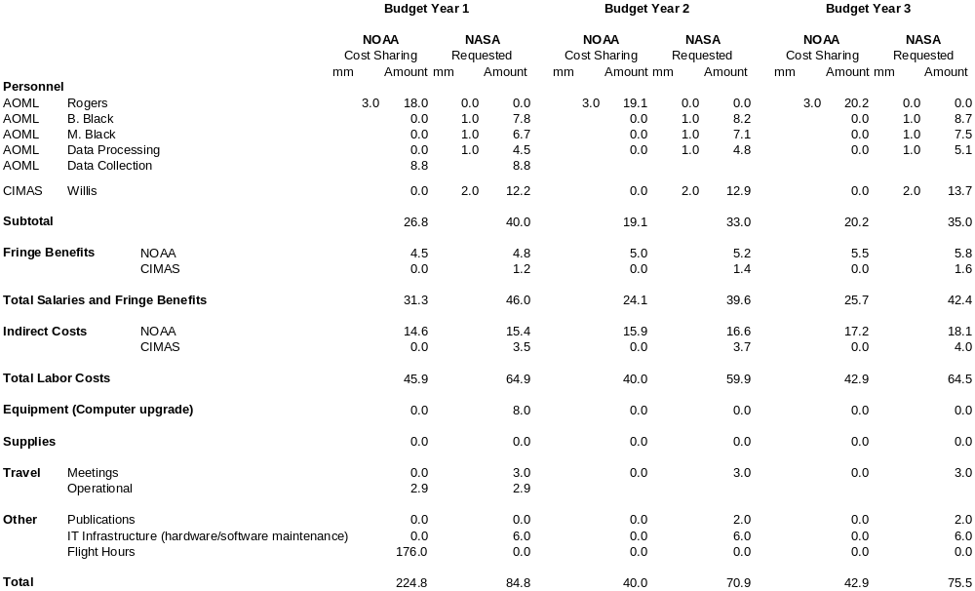AOML BUDGET DETAIL

Collection of Microphysical and Radar Data (requirements and costs):

It is anticipated that data will be collected during the first year of the proposal. The requirement is five days of flights using one plane with two people collecting data. All labor and travel costs are shared equally between NOAA and NASA. Flight hour costs are paid by NOAA.

LETTER FROM GERRY SAYING HE’S NOT ASKING FOR MONEY

