WMO/CAS/WWW

THIRD INTERNATIONAL WORKSHOP ON TROPICAL CYCLONE LANDFALLING PROCESSES

7.2: Summary of Forecast Activities and Progress

Rapporteur: Bruce Harper
Systems Engineering Australia Pty Ltd (SEA)
PO Box 3125, Newstead, Qld 4006, Australia

Email: bruce.harper@systemsengineeringaustralia.com.au
Phone: +61 7 3254 0782

Working group:
Nadao Khono (JMA, Japan)
Philippe Caroff (Meteo France, La Reunion)
Li Yongping (STI, CMA, China)
Jamie Rhome (NOAA/NHC, USA)
Val Swail (Environment Canada)

Abstract:
This report briefly summarizes recent plans and progress in operational tropical cyclone storm surge forecasting procedures and tools since the last summary at IWTC VI (Dube et al. 2006). The nexus between accurate storm forecasting, in regard to track, intensity and especially structure, is emphasised. The essential need for incorporation of uncertainty estimates is highlighted, as is ensuring that the predictive systems adequately encompass the wide range of coastal environments and have sufficient data and resolution to capture the true ocean response and impacts. Finally, it is acknowledged that agencies need adequate staff training and support and that the timely and plain communication of the warnings is especially critical.

7.2.0. Introduction
Many forecast agencies now routinely apply well-established numerical hydrodynamic modelling techniques and systems to provide estimates of potential storm surge heights produced by tropical cyclones (TCs). Some obtain the forecast track and ocean forcing directly from NWP, whether deterministic or ensemble, while most utilise ensemble NWP track forecasts and utilise intensity and structure estimates (e.g. derived from Dvorak, scatterometry etc.) to help construct parametric wind and pressure forcing scenarios. Some also employ the use of pre-computed (atlas) descriptions of storm surge response to gauge uncertainty while others can directly generate stochastic storm surge responses.
In spite of this increase in basic capability, experience shows that many storm surge forecasting and warning systems must not be adequate enough, because there continues to be loss of life as a result of unexpected outcomes. While some negative impacts are likely due to a lack of emergency resources, preparedness, knowledge or communication, some are simply unavoidable due to limited options (e.g. low lying remote islands) and many are likely caused by previously uncontrolled human settlement in high hazard areas.
Notwithstanding the widespread basic capability in storm surge modelling it is not clear whether all products are sufficiently detailed to provide reliable advice at a local scale, either because the model resolutions are too coarse, or there is simply a lack of essential data or coverage, or not all the necessary components of water level are being addressed.
As reported in the companion report (Khono et al. 2014) there is a groundswell of interest and initiatives in producing “integrated” modelling systems, ostensibly to link coastal, estuarine and riverine water level impacts during TC events, thus bringing together ocean, coastal and hydrological modelling. For some specific areas (e.g. so-called mega-cities with high exposure and vulnerability) this may well be of significant importance. However, for the vast majority of vulnerable regions such approaches will likely not be required and such philosophies may inhibit more pragmatic improvements in basic forecast skill and warning effectiveness.
In particular there seems to be a notable absence of recognition that the astronomical tide is a principal component of the total water level that often has a magnitude and wavelength of similar scale to an incoming tropical cyclone storm surge, and that the relative phasing of tide peak and surge peak (typically at closest approach) often dictates the outcome. It is not that tide is ever ignored but it seems that many predictive tools treat it as an additional step, perhaps requiring manual input or judgement. Where this is so, it should be corrected so that tide information is explicitly included.
Secondly, the impact of extreme waves needs special attention in exposed areas, both in the context of coastal and island communities. In addition to the possibility of dangerous wave setup there is also the potential for non-linear interactions with the incoming surge that may trigger bore-like responses with very damaging consequences.
Finally, it is the “total water level” comprised of the various subcomponents, together with their timing, magnitude and interactions that must be reliably forecast and communicated. The continued use of “surge” terminology in warnings should ideally be replaced to reflect these complexities and to ensure that absolute height references are forecast and clearly communicated, so that flooded extents and depths can be determined.

7.2.1. Progress in TC Forecasting Relevant to Storm Surge
For accurate storm surge predictions, accurate TC forecast information (intensity, size, speed, and track) is clearly indispensable and a storm surge forecast can never be more accurate than that of the forcing parameters. This section summarizes recent developments in TC forecasting that are of direct relevance to storm surge prediction.

(a) TC track forecasts
Recently numerical weather prediction (NWP) models have been improved progressively and are capable of often very reliable track predictions. Track forecast in the short range has been improved and 24 h forecast error is within several tens of km, which can be usefully applied directly to storm surge prediction. However, models sometimes fail to predict the true TC track near landfall because of various reasons related to topography or larger scale environmental conditions. Because storm surge impacts are ultimately dependent on the landfall point, even 10 km error in the location may lead to a large storm surge prediction error, especially close to the TC center.

(b) TC intensity forecasts
As for track, the forecast accuracy is not yet fully reliable. The majority of intensity forecasts worldwide still depend on application of the Dvorak method (e.g. Dvorak 1984). Recent prognostic high resolution non-hydrostatic numerical modelling has produced increasingly realistic intensity estimates, with some additional aids such as data assimilation or bogus modification. However, the modelled intensity generally tends to be much weaker than best track analyses based on data, especially when a TC is strong and its size is rather small. Storm surges are mostly significant when a TC is intense, and thus use of NWP forcing alone is still not yet suitable for direct storm surge prediction and reliance on parametric wind and pressure modelling remains (refer later).

(c) Ensemble or stochastic forecasts
Storm surge predictions not only remain dependent on the accuracy of the TC forecasts but also the phasing with the tide and the specific coastal characteristics near to the track. It is very difficult to reliably forecast storm surge responses deterministically and stochastic approaches are needed to represent the high degree of uncertainty.
Storm surge forecasts based on an ensemble track system or multi scenarios are now common in the operational field. For example, JMA storm surge forecasts are carried out with 6 possible scenarios including NWP forcing. NOAA/NHC also includes variation in hurricane intensity and size and the storm surge predictions are statistically determined by the results. The Australian SEAtide system also allows the forecaster to specify the estimated uncertainty range in every forecast parameter.
The merit of ensemble or stochastic forecasts is obtaining the indicated spread in the information as well as the mean (expected or consensus) information, which indicates the reliability and range of the predicted values. In ensemble forecasts, reliability increases as the number of forecast members increases but it requires more computer resources. Therefore, use of simplified parametric forcing models rather than complex models remains a practical way to increase ensemble members without significant computing overheads. Stochastic approaches are especially useful for extended forecast times (e.g. 2 to 3 days) when TC track forecast error can still be relatively large and emergency managers are looking for early indications of threat.

7.2.2 Storm Tide Forecasting System Development perspectives

This section comments on ongoing or development prospects for improving storm surge forecasting in the near future.

(a) Hydrodynamic Models

Non-structured storm surge models will likely be increasingly popular and become more widely used in the near future if there are sufficient data and computer resources available in specifically threatened areas. However conventional “open coast” nested models will still provide efficient and very acceptable accuracy that is likely well within the uncertainty of the driving track and intensity forecasts and the available coastal details in the majority of cases. As a minimum, for inundation prediction, any model must have a reasonably accurate estimate of the ground elevation in the threatened areas. Also, the tidal planes and their associated datum must be reliable and the tidal constituents must be sufficient to provide predictions or to calibrate the hydrodynamic model. Even this requirement will be a barrier to accurate storm surge prediction in some parts of the world, which will thus not be improved by unnecessarily pursuing “higher resolution unstructured” model capabilities but rather insitu data collection instead.

(b) Surface Wind and Pressure forcing
Although, storm surge prediction based on NWP storm tracks is readily amenable, experience shows that the NWP-derived intensity is not capable of matching the accuracy of even relatively simple parametric wind and pressure models. Accordingly most operational storm surge models rely on surface wind and pressure forcing calculated in a semi-empirical parametric way, such as those derived from the gradient wind relation, assuming a MSL pressure profile such as Holland (1980), Schloemer (1954) or Fujita (1952). This provides a practical diagnostic approach that ensures that the appropriate intensity, scale and asymmetry can be represented based on either remotely-sensed or insitu data, NWP guidance or, most likely, Dvorak estimates.

Notwithstanding the demonstrated utility of the parametric wind and pressure forcing approach, there are many situations that clearly cannot be reliably depicted, especially in association with complex coastal topography that is likely to alter the surface stress or nearby mountainous regions. Also, parametric models are designed to represent mature TCs in equilibrium conditions and will be less reliable during periods of rapid change in intensity, structure or speed. Methods intermediate between parametric and full NWP have also been widely used to help improve this situation, with the use of 1D or so-called “slab” boundary layer models being popular. Importantly, Kepert (2012) evaluated various boundary layer representations in TC simulations and highlighted a number of potential flaws. However, the review also provides useful pointers to ways that existing parametric approaches could be improved to better represent the likely more detailed structure of surface wind and pressure fields useful for storm surge modelling.

Advances in the understanding of the surface drag coefficient behavior are also increasingly being applied to existing storm surge models, which can result in the need to re-calibrate other previously developed empirical coefficients. Extension to tide, surge and wave-coupled modelling in recent advanced storm surge forecasting systems may require such reconsiderations.

(c) 2D Barotropic vs 3D and Baroclinic Modelling

While the dominant wind-forced setup in shallow water environments is generally well represented by the available array of efficient 2D barotropic model codes, there are situations that are less well handled. For example, bed friction in 2D models tends to act against and suppress the peak surge, while in more realistic 3D representations that permit over-turning in near-equilibrium situations, the bed friction will likely enhance the peak slightly.

Likewise, some tidal-like motions are generated by deepwater baroclinic processes that create inertial oscillations and can typically change the base water level prior to the storm effectively mixing the upper layers. This creates error in a storm surge prediction and would require modelling of baroclinic process if considered of sufficient significance, thus potentially increasing the data needs and model initialization and running times.

(d) Inundation Extents and “Precision” Modelling
Increasingly, models are required to accommodate realistic wetting and drying and generate high-resolution inundation extents to assist in emergency management. In real-time, anything more than a simple horizontal projection of open coast water levels is often computationally prohibitive and that can result in significant error in the estimated flood extent. This is because of the dynamics of the surge and tide hydrograph, combined with spatially varying surface friction, and can result in either under or over-prediction of extents, depths and durations depending on the situations.
Also, there remains a significant challenge to simultaneously model large scale oceanic forcing at the same time as localized hydraulic processes such as wave runup and overtopping or hydraulic structures such as levees or weirs in rivers. This adds considerably to the computational effort required, places extreme demands on data requirements and requires expert consideration of the relative precision of the various inputs. Given that the greatest uncertainty in storm surge prediction currently lies with the estimation of intensity, size and track at landfall, it is important that “high precision modelling” does not over-sell its promised benefits, at least until all vulnerable regions have basic reliable storm surge forecasting capabilities.

(e) The Role of Observations
Storm surges are most reliably observed at established tide stations, which facilitate model verification. Although many observed data are now shared under the Global Sea Level Observing System (GLOSS), the number of tide stations is still far from satisfactory and denser observation networks are desired, which can be a costly long-term activity.
One of the options therefore is to increase utilization of remote sensing data. The eSurge project funded by the European Space Agency (ESA) though its Data User Element (DUE) program, is aiming to facilitate better access to satellite-derived water level data for the storm surge modelling community and create a dataset accessible via the web. The project also aims to improve the modelling and forecasting of storm surges through the increased use of advanced satellite data, including products such as scatterometry and coastal altimetry.
Notwithstanding this initiative, it remains difficult for satellites to directly measure transient storm surge impacts because sensors typically require finite sampling footprints that are corrupted by coastal crossings and the utilised polar-orbiting satellites have infrequent passes. Therefore direct use of satellite observations will require further research and development activities before they replace the precision and reliability of a tide station. However, satellites can observe larger scale environmental conditions such as the global tides, and map inundation areas subject to saltwater incursions. Hence, increasing utilization of remote sensing data for storm surge will be likely in the near future.

(f) Practical Integrated Threat Information / Communication
As noted previously, there is an increasing trend towards providing integrated threat advice on TC-related water levels as emergency managers realise both the complexity of the responses that may be possible, the increasing capability of various modelling systems and the ability to provide rapid GIS-based interpretation. Accordingly there are many research projects aiming to provide an integrated system better capable of providing emergency managers with all of the information they may need. To achieve this will require increasing interdisciplinary cooperation across a wide range of fields, such as oceanography (surges, tides, waves), meteorology (TC structure, precipitation), hydrology (rainfall runoff, river flows) and social science (information and decision making). For accurate forecasting however, enhanced observational (real time water levels, flows, rainfall, waves and winds) and spatial data (bathymetry and topography) will be even more critical. Emergency managers also must be appropriately trained to correctly interpret the integrated model outputs and apply additional judgement in their decision making that considers the range of uncertainty.
The perception of increasing flood risks in some cities as a result of recent severe damaging events and losses, especially within the context of climate change, has gained significant interest within the hydrological community. For example, Adhas et al. (2012) summarized the current status and perspectives on Urban Flood Risk Management (UFRM) and the ESCAP/WMO Typhoon Committee recently published guidelines on UFRM (ESCAP/WMO Typhoon Committee, 2013). The Working Group on Hydrology (WGH) of the Typhoon Committee also proposed a new project in 2013 to develop an Operational System for Urban Flood Forecasting and Inundation Mapping (OSUFFIM) for TC Members. This project aims to establish a forecasting system for urban flood risk within three years. It is noted that there are many megacities situated on vulnerable coasts that can be impacted by storm surge inundations, as well as river flooding from inland precipitation. UFRM is principally being promoted by the hydrological community but, in cooperation with the marine meteorological community, will be indispensable for dealing with flood/ inundation processes in vulnerable cities near tropical coasts.

7.2.2 Example Operational Storm Surge Prediction Systems
Many National Met/Hydro Services (NMHS) now use storm surge models in operations and issue warnings or advisories based on their predictions. This has been facilitated by the training opportunities available from the series of JCOMM /TCP workshops on storm surge and wave forecasting. As well, the ready availability now of high-powered PCs or server machines has enabled many NHMS to run their own storm surge models for forecasting without the demands and delays normally associated with numerical weather models.

(a) PAGASA Manila, Philippines
In 2013, Super Typhoon Haiyan impacted the Philippines causing a severe disaster on Leyte Island. Following training workshops organized by the Asian Disaster Preparedness Center (ADPC) in June 2013, the Philippine Atmospheric, Geophysical and Astronomical Services Administration (PAGASA) was prepared to use a storm surge model operationally and PAGASA conducted its own storm surge prediction, estimating a maximum surge height of 5m. Figure 1 shows one of the results of the real-time predictions. Considering the astronomical tidal range (about 1.5m) in the Leyte Gulf, PAGASA issued a 5-7m storm surge warning in the area, which was comparable to the observed levels.
Figure 1. Results of real-time storm surge prediction for STY Haiyan in 2013, modelled by PAGASA staff. Initial time is 00UTC on NOV 08; valid for 03UTC (left) and 06UTC (right).

(b) CMA, Shanghai, China
An integrated storm surge forecasting system is now operating in the China Meteorological Administration (CMA), established by the Shanghai Typhoon Institute (STI). It is based on the three-dimensional hydrodynamic model ECOM with very high resolution that includes the astronomical tide, a real-time operational hydrological, as well as a storm surge forecast system for the Huangpu River, which flows through the centre of Shanghai. The Huangpu River is about 75 km long and several hundred meters wide, and is very important for drainage during typhoon impacts. The prediction system can provide water flow and water level forecast within 48 hours, twice per day. Some product examples are shown in Figure2.
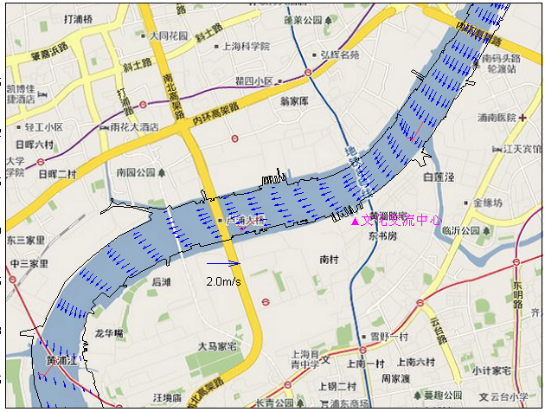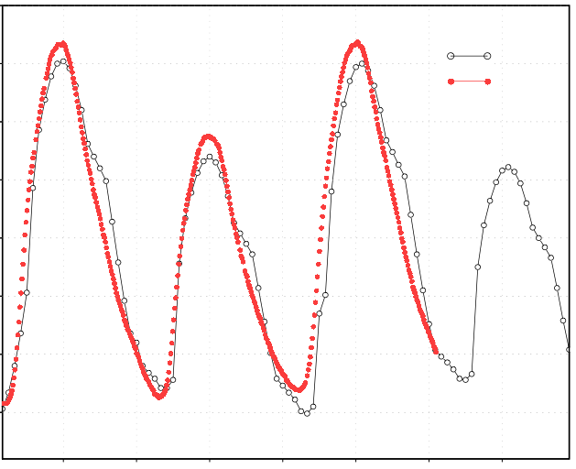Figure 2. Product examples for STI-HPH, the current (left, part of the domain) and water level (right)
4

3

2

1

18 00 06 12 18 00 06 12
May 29 Jun 1 Jun 2
Forecast
Obs

(c) RSMC Tokyo, Japan.
As outlined in the companion research report (Khono 2014), the Japan Meteorological Agency (JMA) extended its existing in-house modelling to provide a regional Storm Surge Watch Scheme (SSWS) in the North-West Pacific, which began in June 2011. Real-time storm surge predictions are provided whenever a typhoon exists in the region, accessible by many countries, but not at a fine scale resolution.

(d) RSMC La Reunion.
Since the last IWTC in 2010, some significant work on storm surge has been undertaken at RSMC La Reunion in the framework of establishing a WMO/Storm Surge Watch Scheme (SSWS) for the South-West Indian Ocean region (CR I). Using the storm surge model from Meteo-France an atlas of tropical cyclone induced storm surges has been built for all the coastal regions of the South-West Indian Ocean (SWIO) region (mostly Madagascar, Mozambique and the island nations of the western part of the basin). An operational tool providing storm surge guidance has also been designed and implemented for the RSMC La Reunion TC forecasters.
The SWIO atlas of TC-related storm surges has been created for 591 coastal points (Figure 3) at a spatial resolution of 8 NM, with bathymetry at 12” for La Reunion, Mauritius and Mayotte Islands, and a 1’ bathymetry resolution otherwise.

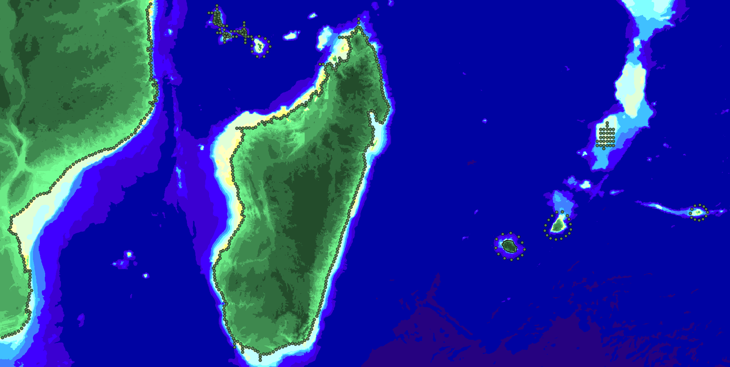
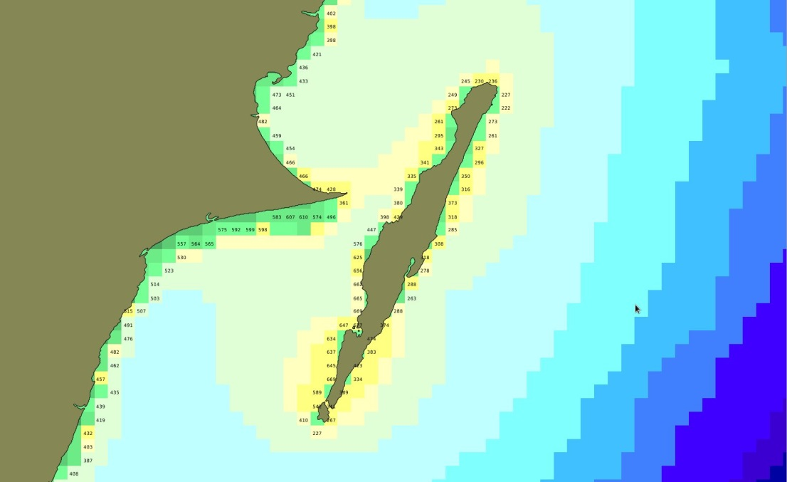
Figure 3. Map (top) shows the region covered by the Atlas of storm surges in the South-West Indian Ocean and (bottom) has a higher resolution example of absolute storm surge maxima (cm) obtained for Sainte-Marie Island and the adjacent coast of Madagascar.
For each domain associated with a reference point (2x2 degrees for landfalling points), multiple simulations have been run by varying the different parameters to modulate the storm surge generated by the corresponding synthetic storms :
Intensity : varied Vmax from 60 to 130 kt in 10 kt steps
Angle of impact: heading varied in steps of 20 deg
Eye size : RMAX varied from 5 to 25 NM in 5 NM steps
Storm MSLP : varied by ±15 hPa
Storm motion: varied from 5 to 20 kt in 5 kt steps

Around 3 million simulations have been run (representing 1700h of computer time). For each simulation in each domain, the maximum height of storm surge obtained at each point has been retained, yielding 6726 coastal points in the database. The volume of data is about 150 GB and is accessible through a POSTGRES/POSTGIS database and can be displayed by a GIS (geographic information system). The whole package is designed to be able to be delivered to interested users (such as the National Meteorological Centres of the SWIO region).
An operational interface tool has also been designed to assist the RSMC TC forecasters by providing the most appropriate guidance in terms of operational storm surge prediction. Originally enabling the TC forecaster to simply run the Meteo-France storm surge model in compliance with their current TC track/intensity/structure forecast, it has been refined in order to take into account the uncertainty around the official forecast. The concept is to access the atlas of storm surges database, choosing simulations that correspond to the assumed range of uncertainty around the official forecast. For the track forecast uncertainty the dynamical probabilistic cone of uncertainty based on the spread on the EPS members (Ensemble Prediction System from the European Centre) is used, as calculated following the methodology explained in Dupont et al. (2011). The points of reference used for the calculations are points of impact located within the cone of uncertainty. The uncertainties of the other relevant parameters are defined automatically (for instance : -10, 0 and +10 kt for the intensity forecast). In the future the TC forecasters will be able to define their own ranges of uncertainty.

(e) RSMC Delhi, India.
As outlined in the companion research report (Khono 2014), the Indian Meteorological Department (IMD) developed a SSWS in the Northern Indian Ocean region for the WMO/ESCAP Panel on Tropical Cyclones, and RSMC-Delhi began issuing storm surge graphical advisories in 2013.

(f) BoM, Australia
A variety of storm surge forecasting tools have been in use by the Bureau of Meteorology (BoM) at its Tropical Cyclone Warning Centres (TCWC) of Perth, Darwin and Brisbane. A central project has been initiated that is planned to deliver a unified system by 2017 providing TC and non-TC driven storm surge predictions and warnings using a dynamical ocean model and ensemble forcing for TCs. The Perth TCWC currently utilises a discrete hydrodynamic modelling system for its region of responsibility.
Since 2005, the Darwin TCWC has been using the proprietary SEAtide probabilistic modelling system (e.g. SEA 2014) that provides a very rapid stochastic assessment based on the use of parametric surge, wave, wave setup and tidal prediction modelling, which are built from base hydrodynamic and spectral wave models. SEAtide does not rely on a pre-computed “atlas” or “MEOW” approach but rather can rapidly generate tide, surge, wave and wave setup responses parametrically in real time and combine the water level components together with non-linear interaction. The forecaster can readily perturb any of the forecast TC parameters to produce a stochastic simulation and a probabilistic total water level prediction. The original model covered a complex coastline of over 2,500 km at a resolution of 2.8 km, with some higher resolution regions to 500 m near Darwin and the western coast of the Gulf of Carpentaria. Tidal forcing, which varies in range up to 12 m across the region, is a major component of the storm tide response that is automatically integrated into the model’s stochastic processing.
Since 2006, the Brisbane TCWC has used an in-house storm tide forecasting system for the east coast of Queensland based on earlier pre-SEAtide parametric model development (Harper 2001) and funded further SEAtide development in 2012. In 2014 this was augmented by State Government funding to include the western side of Cape York and to extend the model along the entire east coast of Queensland based on 26,000 hydrodynamic model runs. This includes the complex tide and surge response within the shallow Gulf of Carpentaria, the Torres Strait islands and along the entire length of the Great Barrier Reef. The total length of SEAtide-modelled coastline in Australia now exceeds 6,000 km in varying resolution to suit the coastal landforms and comprises over 10,000 individual coast and island sites at which probabilistic storm tide forecasts can be rapidly generated and communicated to emergency managers. Figure 4 illustrates the wide range of products currently available from SEAtide, which has an easy-to-use interface much appreciated by forecasters.

(g) RSMC Miami, NOAA/NHC, USA.
As detailed further in the companion research report (Khono 2014) NOAA/NHC has invested considerable effort recently in improving storm surge threat information, following the experiences from significant storm surge events in recent years (e.g. Hurricanes Katrina and Rita in 2005, Ike in 2008, Sandy in 2012). This capability builds on the long-established SLOSH model, which has been integrated into the probabilistic wind warning system with enhanced prediction capability for freshwater flooding and waves.

(h) RSMC Nadi, FMS, Fiji.
It is understood that the Fiji Meteorological Service will be the recipient of new storm surge forecasting capabilities under the WMO/JCOMM CIFDP-F program.

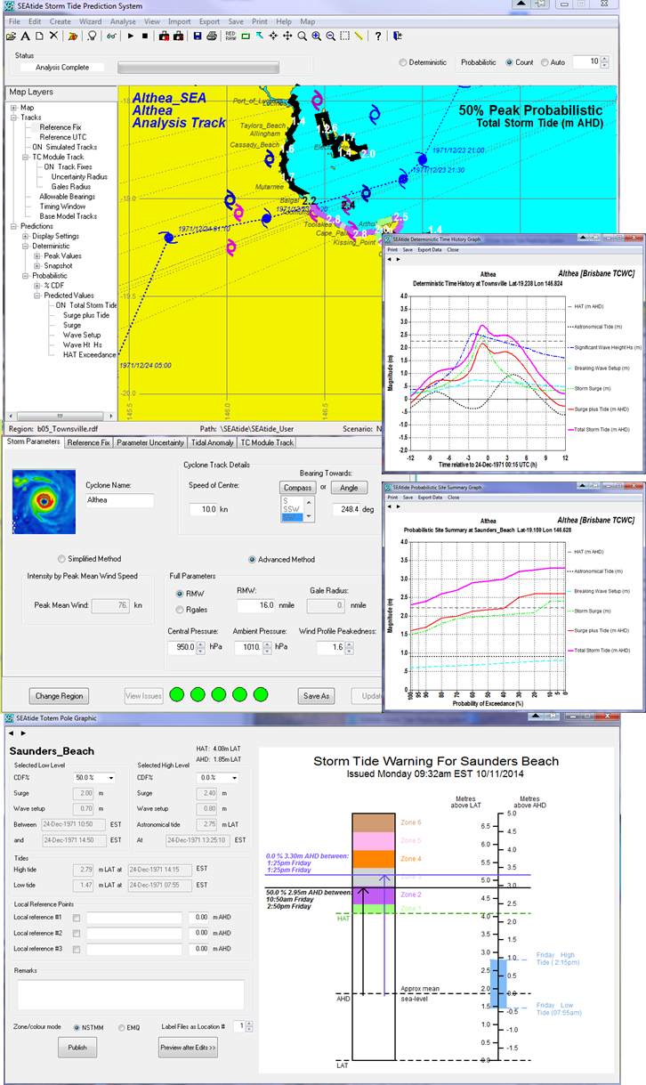
Figure 4 A selection of Australian BoM SEAtide model forecast products
Acronyms used in the report
ADPC: Asian Disaster Preparedness Center
BoM: Bureau of Meteorology, Australia.
CMA: China Meteorological Administration
EPS: Ensemble Prediction System from the European Centre
GLOSS: Global Sea Level Observing System
IMD: Indian Meteorological Department
JCOMM: Joint scientific and technological Committee on Marine Meteorology
MEOW: Maximum Envelope of Waters
NOAA: National Oceanographic and Atmospheric Administration
NHC: National Hurricane Center, NOAA
NMHS: National Meteorological and Hydrological Services
NWP: Numerical Weather Prediction
PAGASA: Philippine Atmospheric, Geophysical and Astronomical Services Administration
SSWS: Storm Surge Watch Scheme
STI: Shanghai Typhoon Institute
SWFDP: Severe Weather Forecast Demonstration Project
SWIO: South West Indian Ocean
TC: Tropical Cyclone
TCP: Tropical Cyclone Program, WMO

References
Adhas K. Jha, Robin Bloch, Jessica Lamond, 2012: Cities and Flooding: A Guide to Integrated Urban Flood Risk Management for the 21st Century, World Bank Publications, 632pp.
Dube S.K. et al., 2006: Observations and forecasts of storm tides. Rapporteur Report, Proceedings Sixth International Workshop on Tropical Cyclones, WMO/CAS/WWW, San Jose, Costa Rica.
Dupont et al., 2011: Verification of ensemble-based uncertainty circles around tropical cyclone track forecasts. Weather and Forecasting, 26, 664-676.
Dvorak, V.F., 1984: Tropical cyclone intensity analysis using satellite data. NOAA Technical Report NESDIS 11, 45pp.
ESCAP/WMO Typhoon Committee, 2013: Guidelines on Urban Flood Risk Management (UFRM), TC/TD-No 0008, 91pp.
Fujita, T., 1952: Pressure Distribution within a Typhoon. Geophys. Mag., 23, 437 – 451.
Harper B.A., 2004: Queensland climate change and community vulnerability to tropical cyclones – ocean hazards assessment: Stage 1a – Operational Manual, Queensland Government, Mar, 75pp. [Available from https://www.longpaddock.qld.gov.au/about/publications/vulnerabilitytocyclones/index.html ]
Holland, G. J. 1980: An analytical model of the wind and pressure profiles in hurricanes. Mon.Weather Rev., 108, 1212–1218
Kepert, J.D., 2012: Choosing a Boundary Layer Parameterization for Tropical Cyclone Modeling. Mon. Wea. Rev., 140, 1427–1445.
Khono N. et al., 2014: Summary of Storm Surge Research Activities and Progress. Rapporteur Report, Proceedings Third International Workshop on Tropical Cyclone Landfalling Processes, WMO/CAS/WWW, Jeju, South Korea, 8-10 December.
SEA, 2014: SEAtide operating manual. Systems Engineering Australia Pty Ltd. [Available from: http://www.systemsengineeringaustralia.com.au/V2_NT_SEAtide_web_page.htm ]

The SEAtide model development plans include extension to other Pacific and Indian Ocean areas, as well as imbedded hydrodynamic and spectral wave models, reef-top wave setup, wind swaths and inundation extents.

