WMO/CAS/WWW

THIRD INTERNATIONAL WORKSHOP ON TROPICAL CYCLONE LANDFALLING PROCESSES

7.1: Summary of Storm Surge Research Activities and Progress

Rapporteur: Nadao Kohno
Japan Meteorological Agency
1-3-4, Otemachi, Chiyoda-ku, Tokyo, 100-8122, Japan

Email: nkono@met.kishou.go.jp; nkohno@mri-jma.go.jp
Phone: +81-3-3212-8341 Ext. 5139

Working group:
Shishir Dube (IIT, India)
S.H.M. Fakhruddin (CIFDP-B system developer, Thailand)
Bruce Harper (Systems Engineering Australia, Australia)
Boram Lee (WMO)
Jamie Rhome (NHC, USA)
Val Swail (Environment Canada)
Li Yongping (STI, CMA, China)
Abstract:
This report briefly summarizes recent progress in storm surge forecast research of special relevance to the problem of estimating the impacts of tropical cyclone landfall. Numerical hydrodynamic storm surge models have become very reliable over recent decades and the basic model numerics have changed little. Recent improvements have been mainly in the application of higher resolution models, integration of various formerly separate models and a shift towards integrated and practical information rather than only storm surge magnitude information.
Recent progress in model integration includes coupled model systems or the combination of many forecasted elements. It is clear that storm surge risk should not be interpreted solely based on estimated storm surge magnitude, but rather together with other critically important factors such as tides and waves. Such integrated forecasting systems developed in the research fields are gradually being applied in operations.
Besides the system developments, improvement in information of direct practical use by emergency management is being advanced. Storm surge is an oceanographic phenomenon but its potential magnitude alone does not directly indicate the emergency risk because disasters are caused by coastal inundation. The importance of inundation risk information, rather than storm surge magnitude alone, is highlighted. Many efforts are dedicated to the creation of and issuing of inundation risk information based on exposure and vulnerability.

7.1.0. Introduction
Although major storm surge events are rare, they are capable of causing significant disasters as measured by loss of life and critically damaged infrastructure. In recent years, severe disasters by storm surges successively happened worldwide: in Myanmar by Cyclone Nargis in 2008, USA by Post-Hurricane Sandy in 2012, and in the Philippines by Typhoon Haiyan in 2013. Those storm surges brought about high death tolls and/or huge economic damages in the regions. Therefore, storm surge is surely one of the key topics in disaster risk reduction.
Nowadays, storm surge information is typically created from the use of a numerical hydrodynamic storm surge model. The basic storm surge model numerics have remained unchanged for some time and there has been little improvement in understanding of the basic physical processes. The improvement has mainly been in dynamical processes such as grid resolution or coordinates. The other improvement is model coupling. When we talk about a risk of storm surges, it means rather inundation risk which is also affected simultaneously by many factors: astronomical tides, waves, river flows or precipitation and so on. Recently, various associated atmospheric and wave models have become increasingly reliable and useful, coupled models can consider interacting processes and make integrated information based on the total water level envelope (TWLE).
This is a report for IWTCLP3 that deals with tropical cyclones (TCs), which tend to produce a large magnitude surge response and much depends on TC location and intensity relative to the coastal landforms. Accuracy of TC storm surge prediction highly depends on accurately forecasting of surface wind and pressure patterns over large areas and the availability of detailed coastal bathymetry.
Storm surges generated by mid-latitude low pressure systems, although more frequent than TC events, are typically of much lower magnitude and are not the focus of this review. They can however, in combination with high tides, also result in life-threatening emergencies and so the lessons of risk communication are equally relevant.

7.1.1. Progress in Numerical Models / Systems

In the last decade, what are commonly called “community models” have become increasingly popular and widespread. For example, hydrodynamic ocean models like the Princeton Ocean Model (POM) (Blumberg and Mellor, 1987) have come to be widely used in storm surge predictions, together with many other similarly constructed regular-mesh finite difference models (2D and 3D). Dube et al (2009) provides an overview of many such models and their capabilities.

Recently, non-structured numerical storm surge models have been increasingly adopted, such as Finite-Volume Coastal Ocean Model (FVCOM) (Chen et al., 2003), Advanced CIRCulation Model (ADCIRC – finite element) (Luettich and Westerink, 2004), Semi-implicit Eulerian-Lagrangian Finite-Element model (SELFE) (Zhang, Y., and A. M. Baptista, 2008), Delft3D (Deltares). There are also commercial models like Mike (DHI) and Tuflow (BMT-WBM) that have widespread application in both hydrologic and oceanic environments. The advantage of non-structured model is flexibility of grid resolution: very fine in the shallow coastal zone but coarser in the deep off shore, which is very satisfactory for storm surge simulations because the ocean response in coastal areas is of most concern. This may be partly because parallel computing with a cluster machine or graphics processor has become common instead of a traditional vector machine where simple finite differential models are adequate for fast calculation. Recent advanced models may have a grid resolution of several tens of meters in the finest mesh, and can simulate detailed water behaviour including inundation in beach zones.

Most of these models were not developed only for storm surge simulation but for general oceanic circulation and three dimensional (3D) storm surge simulation is also possible with those models. Some researches such as Zheng et al.(2013) and Harper et al (2001) report that a 3D storm surge model will likely produce a slightly larger surge than an equivalent 2D model. This relates to the bed friction assumption in a depth-integrated model whereby the resistance is always against the net flow, but in a 3D model with potential vertical flow reversal, the bed friction acts together with the net flow. However, 3D modelling requires much greater computer resources, and 3D storm surge modelling over large areas is not yet mainstream. However, where possible, sensitivity testing should be undertaken in specific locations to assess the importance of any 3D effects.

Nowadays ocean wave models are also available and a recent trend is to develop a surge - (tide) - wave coupled system. Qi et al. (2008) developed a coupled system with FVCOPM and SWAVE. Roland et al. (2012) researched the wave-current interaction effect with SELFE and wave coupled model. Dietrich et al. (2012) developed a coupled system with ADCIRC and the wave model SWAN and checked the performances by simulating several severe hurricane cases. The results were very reasonable in terms of both storm surge and wave prediction. Wave setup is a rather small scale phenomenon but such a high resolution models may have the ability to simulate that effect with some accuracy.

It should be noted that the governing equations or basic parameterizations in 2D storm surge models are relatively mature and there has been little advance in recent years. Many empirical formulae are still used, especially in stress calculations (surface drag coefficient and bottom friction) and the wind and pressure fields. In a sense, the main research effort has focused on developing coupled surge-wave model systems and high resolution models.

7.1.2 Development of Global Scale Storm Surge Information Systems

Although storm surge impacts are rather localized small scale phenomena, severe storm surge events can be devastating and monitoring and risk analysis is warranted on a global scale to assist threatened nations having limited resources. Development of a framework of global scale storm surge alert has been proceeding for recent years. Two projects – Storm Surge Watch Scheme (SSWS) and Global Disaster Alert and Coordination System (GDACS) are introduced.

a) WMO Storm Surge Watch Scheme (SSWS)

Several severe storm surge disasters occurred worldwide over recent years. The disaster caused by Cyclone Nargis in Myanmar in 2008 was a strong trigger for the establishment of a global storm surge watch scheme. In the 60th WMO Executive Council held in Geneva, June 2008, a request to facilitate development of a storm surge watch scheme was presented to WMO/SG, with a view to it being implemented in each Regional Area. A schematic of the SSWS project is shown in Figure 1.

Figure 1. The WMO Storm Surge Watch Scheme (SSWS)

In Regional Association II (Asia), following discussions at the 14th RA II meeting in December 2008 and the 41st Typhoon Committee in January 2009, the WMO/ESCAP Typhoon Committee decided to establish a Regional Storm Surge Watch Scheme in the North-West Pacific. Accordingly, RSMC-Tokyo (JMA) developed a regional storm surge forecasting system for the typhoon region (Hasegawa et al., 2011). The operation started in June 2011 and real-time storm surge predictions are provided whenever a typhoon exists. The predicted products are horizontal distribution maps and time series charts at 40 stations and these are uploaded to the RSMC-Tokyo Numerical Typhoon Prediction (NTP) website. Some product examples are shown in Figure 2.
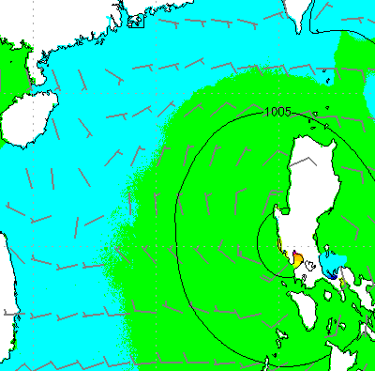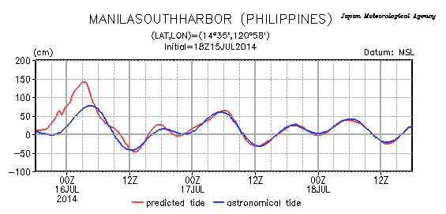
Figure 2. Product examples for SSWS by RSMC-Tokyo

In the Northern Indian Ocean, the WMO/ESCAP Panel on Tropical Cyclones and RSMC-Delhi developed a SSWS in that region, and RSMC-Delhi began issuing storm surge graphical advisories in 2013. Region Area I (Africa) and V (South-West Pacific) formulated their SSWS regional projects in 2012 and are developing each SSWS.

b) Global Disaster Alert and Coordination System (GDACS)

GDACS is a cooperation framework between the United Nations and the European Commission. GDACS provides alerts in real-time and impact estimations after major disasters. A multi-hazard disaster impact assessment service is managed by the European Commission Joint Research Centre (JRC), and much related information is disseminated via web-site.

GDACS deals with various kinds of natural hazards: earthquakes, tsunamis, cyclones, floods and volcanoes crisis and so on (Probst and Francello 2012). Storm surge information is also created for major TCs using the numerical model HyFlux2, a hydrodynamic code implementing shallow water equations (Francello and Krausmann 2008). Figure 3 shows product examples uploaded to GDACS web site.

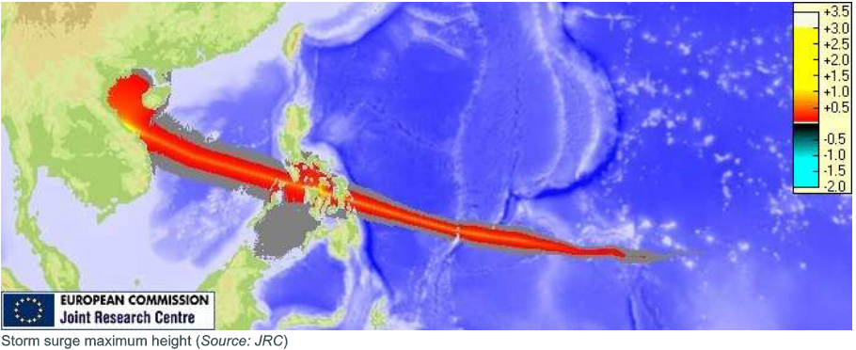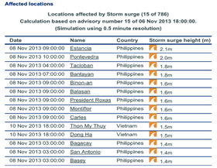Figure 3. Product examples issued by GDACS

7.1.3. Integrated / Sophisticated information for Disaster Risk reduction (DRR)

A storm surge disaster is usually synonymous with an inundation episode caused by the storm surge. However, even a large storm surge is not dangerous if the land height is sufficiently high. The inundation risk is highly related to the water level fluctuations that are determined by the periodic astronomical tide. Therefore, it is imperative that the risk of inundation is related directly to the state of the tide, the storm surge magnitude and timing and the land elevation, rather than indirectly concentrating on the magnitude of the storm surge itself. In Australia, for example, where the tidal range can be significant, the term “storm tide” is used to emphasise the combined effects of astronomical tide, storm surge and wave setup (Harper 2001).

Since large storm surges are relatively rare events at any specific location, many coastal residents are typically not familiar with the characteristics of storm surge and it can be difficult for them to understand the warning meaning and inundation risk adequately. This situation means that the warning information should be given in plain word formats that assist understanding and clearly indicate the risk.

Therefore, several efforts have been made in recent years to provide direct and plain information on inundation risk.
(a) Impact base-inundation information (NOAA NHC)
NHC has invested considerable effort in improving storm surge threat information, following the experiences from significant storm surge events in recent years (e.g. Katrina and Rita in 2005, Ike in 2008, Sandy in 2012). Now the information content of NHC warnings has been significantly modified. Storm surge information was previously given accompanying TC wind warnings, and tide or wave information was commented on independently, which is still common in many countries. This conventional information grouping can be very difficult to understand and to effectively convey the real disaster risk from storm surge.
Accordingly, NHC has developed integrated information based on total water level rise in which surge, tides, waves, and fresh water and background anomaly are included. In addition, predicted water levels are “translated” to inundation guidance and issued as graphical images by utilizing a GIS tool. The new graphical images (an example is shown in Figure 4) showing potential water depth over the ground are explicitly clear and residents can understand the risk much easier than text message warnings. The guidance is also generated based on a probabilistic forecast, taking into consideration the TC forecast and landfall prediction errors etc.
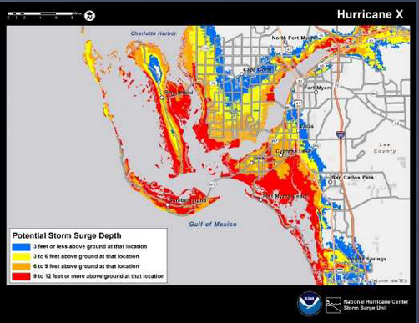
Figure 4. Example of inundation risk (depth) map issued by NHC.
(b) WMO Coastal Inundation Forecast Demonstration Project (CIFDP) (http://www.jcomm.info/index.php?option=com_content&view=article&id=167)
While the resulting inundation is due to the presence of the storm surge, it can also be affected by tides, high waves, river flows, and precipitation. The Joint WMO-IOC Technical Commission for Oceanography and Marine Meteorology (JCOMM ) is leading the implementation of the WMO Coastal Inundation Forecasting Demonstration Project (CIFDP), jointly with the WMO Commission for Hydrology (CHy). It is intended to demonstrate how integrated coastal inundation forecasting and warnings can be improved and effectively coordinated by the NMHSs (Figure 5).
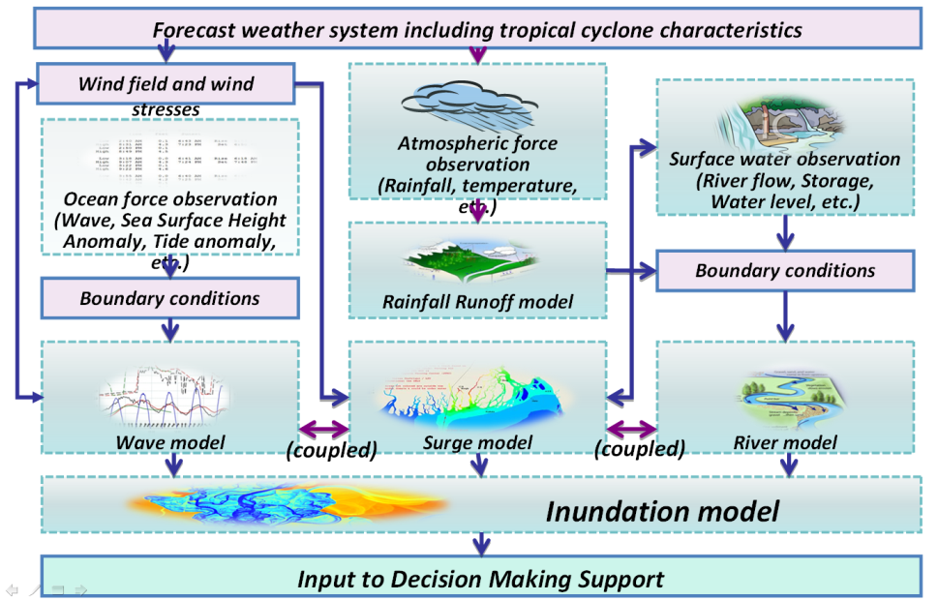
Figure 5. CIFDP project image
CIFDP is aiming to develop an integrated system for inundation forecasts, which is intended to be used in operational work. The project deals with coordination of effective information and how it flows to end users too. This is a demonstration project intended to focus on demonstrating operational forecasting capabilities for integrated coastal inundation. Five national Sub-Projects of CIFDP are currently being implemented in Bangladesh, Dominican Republic, Fiji, Indonesia and Shanghai/China (Figure 6).
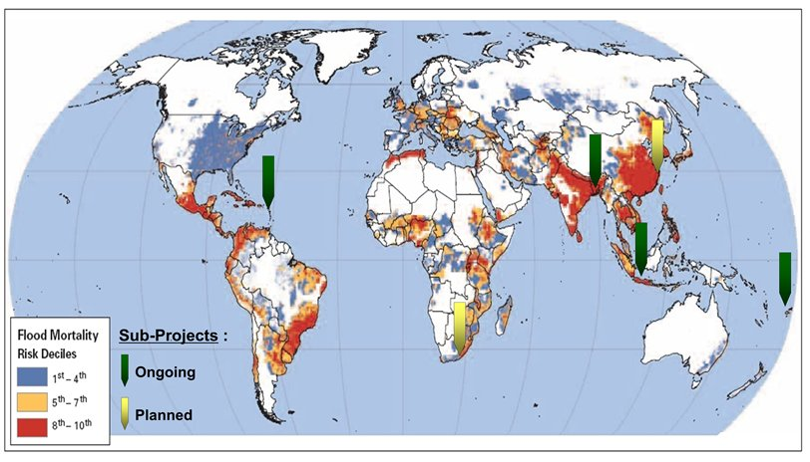
Figure 6. CIFDP sub-project map
(c) Resilience-Increasing Strategies for Coasts – tool KIT (RISC-KIT)
http://www.deltares.nl/en/news/news-item/item/16418/new-toolkit-improves-coastal-protection
The project RISC-KIT focuses on ten European case study sites in nine European countries which are located in the regions of the North East Atlantic Ocean, Baltic Sea, Black Sea, North Sea, and Mediterranean Sea. In addition to these, there are also case studies in Bangladesh and the U.S. All case study sites are frequently affected by coastal risks such as storm surges and erosion.
According to research conducted at the RISC-KIT case study sites there is considerable variation in how DRR planning is organized and how measures are implemented, somewhat implemented, and/or not implemented in European countries. These differences are also reflected in the design, content, and use of policy under specific socio-cultural situations.
The Work Package 1 meeting of the EU FP7 Resilience-Increasing Strategies for Coasts – tool KIT (RISC-KIT), which included a case study on a Bangladesh coastal site (Sandwip island) that will complement the decision-making support through the CIF operation by using an advanced framework developed by European institutions (Coastal Risk Assessment Framework: CRAF). The project concept and work plan were introduced to the national stakeholders, followed by the user consultation and interview to better understand specific end-user requirements for the Bangladeshi coast. The user components of CIFDP-B NCT and EU RISK-KIT WP1 are to be shared through these joint activities. Benefits from parallel activities of the common goal were highlighted: for example, CIFDP-B and RISC-KIT will complement each other in delivering final outcomes and benefits to users in Bangladesh, CIFDP-B will clearly demonstrate the benefit of improved forecasting through the local application for coastal risk assessment by RISC-KIT, and the RISC-KIT will benefit from the technical development and data sharing achieved by the national framework of the CIFDP-B. For Bangladesh’s national stakeholders, a clear direction for current and future improvement needs to be demonstrated through a streamlined and collaborative implementation of the CIFDP-B, RISC-KIT and other development projects, from user requirement identification, technical development for forecasting, analysis of the impacts and community response and preparedness.
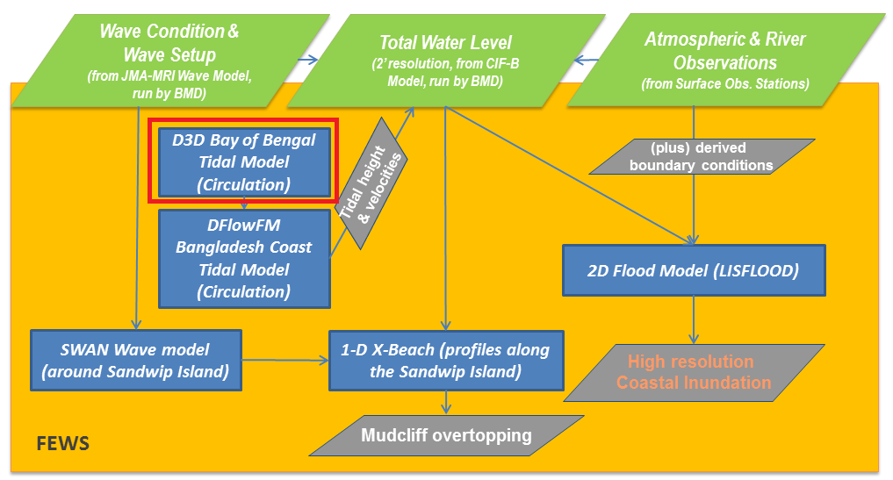
Figure 7. Framework of RISK KIT in Bangladesh

Acronyms used in the report
ADCIRC: Advanced CIRCulation Model
CIFDP: Coastal Inundation Forecast Demonstration Project
FVCOM: Finite-Volume Coastal Ocean Model
GDACS: Global Disaster Alert and Coordination System
JCOMM: Joint scientific and technological Committee on Marine Meteorology
NOAA: National Oceanographic and Atmospheric Administration
NHC: National Hurricane Center, NOAA
PAGASA: Philippine Atmospheric, Geophysical and Astronomical Services Administration
SELFE: Semi-implicit Eulerian–Lagrangian Finite Element model
SSWS: Storm Surge Watch Scheme
TWLE: Total Water Level Envelope
References
Adhas K. Jha, Robin Bloch, Jessica Lamond, 2012: Cities and Flooding: A Guide to Integrated Urban Flood Risk Management for the 21st Century, World Bank Publications, 632pp.
Blumberg, A.F., Mellor, G.L., 1987: A description of a three-dimensional coastal ocean circulation model. In Three-dimensional Coastal Ocean Model, N.S. Heaps, Ed., Coastal. Estuar. Sci., 4, 1-6.
Chen, C. H. Liu, R. C. Beardsley, 2003: An unstructured, finite-volume, three-dimensional, primitive equation ocean model: application to coastal ocean and estuaries. J. Atm. &Oceanic Tech., 20, 159-186.
Chen, C, R. C. Beardsley and G. Cowles, 2006: An unstructured grid, finite-volume coastal ocean model (FVCOM) system. Special Issue entitled “Advance in Computational Oceanography”, Oceanography, 19(1), 78-89.
Chen, C., R.C. Beardsley, R.A. Luettich Jr., J.J. Westerink, H. Wang, W. Perrie, Q. Xu, A.S. Donahue, J. Qi, H. Lin, L. Zhao, P.C. Kerr, Y. Meng, B. Toulany, 2013: Extratropical storm inundation testbed: Inter model comparisons in Scituate, Massachusetts, J. Geophysical Res.: Oceans, 118, 10, 5054–5073.
Dietrich, J. C., S. Tanaka, J. J. Westerink, C. N. Dawson, R. A. Luettich Jr, • M. Zijlema, L. H. Holthuijsen, J. M. Smith, L. G. Westerink, H. J. Westerink, 2012: Performance of the unstructured-mesh, SWAN+ADCIRC model in computing hurricane waves and surge, J. Sci. Comput., 52, 468–497.
Dube S.K, Murty T.S., Feyen J.C., Cabrera R., Harper B.A., Bales J.D. and Amer S. (2009) Storm surge modeling and applications in coastal areas. In Chan J. and Kepert J. (Eds.) Global Perspectives on Tropical Cyclones, World Scientific.
ESCAP/WMO Typhoon Committee, 2013: GUIDELINES ON URBAN FLOOD RISK MANAGEMENT (UFRM), TC/TD-No 0008, 91pp.
Franchello G., and E. Krausman, 2008: HyFlux2: a numerical model for the impact assessment of severe inundation scenario to chemical facilities and downstream environment, JRC Scientific and technical report, European Commission. 20pp.
Fujita, T., 1952: Pressure Distribution within Typhoon. Geophys. Mag., 23, 437 – 451.
Harper B.A. (ed.), 2001: Queensland climate change and community vulnerability to tropical cyclones - ocean hazards assessment - stage 1, Report prep by Systems Engineering Australia Pty Ltd in association with James Cook University Marine Modelling Unit, Queensland Government, March, 375pp. [available from: http://www.longpaddock.qld.gov.au/about/publications/pdf/climatechange/vulnerabilitytotropicalcyclones/stage1/FullReportLowRes.pdf ]
Hasegawa H., N. Kohno, H. Hayashibara, 2012: JMA's Storm Surge Prediction for the WMO Storm Surge Watch Scheme (SSWS), Technical review, RSMC Tokyo-Typhoon Center, 14, 1-12
Holland, G. J. 1980: An analytical model of the wind and pressure profiles in hurricanes. Mon.Weather Rev., 108, 1212–1218
Kepert, J.D., 2012: Choosing a Boundary Layer Parameterization for Tropical Cyclone Modeling. Mon. Wea. Rev., 140, 1427–1445.
Luettich, R. A., and J. J. Westerink, 2004: Formulation and numerical implementation of the 2D/3D ADCIRC finite element model version 44. [http://adcirc.org/adcirc_theory_2004_12_08.pdf.]
Probst, P., G. Franchello, 2012: Global storm surge forecast and inundation modeling, JRC Scientific and technical report, European Commission. 48pp.
Qi, J., C. Chen, R. C. Beardsley, W. Perrie, Z. Lai, and G. Cowles, 2009: An unstructured-grid finite-volume surface wave model (FVCOM-SWAVE): Implementation, validations and applications, Ocean Modell., 28, 153–166.
Roland L. A., Zhang Y., Wang H.V., Maderich V., Brovchenko I., 2012. A fully coupled wave-current model on unstructured grids. J. Geophysical Res.: Oceans, 117, Journal of Geophysical Research.
WMO 2013: CIFDP brochure. http://www.jcomm.info/images/stories/2013/cifdp_march2013.pdf
Zhang, Y., and A. M. Baptista, 2008: SELFE: A semi-implicit Eulerian–Lagrangian finite-element model for cross-scale ocean circulation, Ocean Modell., 21(3–4), 71–96.
Zheng, L., R.H. Weisberg, Y. Huang, R.A. Luettich, J.J. Westerink, P.C. Kerr, A.S. Donahue, G. Crane, L. Akli, 2013: Implications from the comparisons between two- and three-dimensional model simulations of the Hurricane Ike storm surge, J. Geophysical Res.: Oceans, 118, 3350-3369.

