1A.2 THE INTENSITY FORECASTING EXPERIMENT (IFEX): A NOAA MULTI-YEAR FIELD PROGRAM FOR IMPROVING TROPICAL CYCLONE INTENSITY FORECASTING

Robert Rogers¹, Michael Black¹, Robbie Hood², Jeff Halverson³, Ed Zipser⁴, and Gerry Heymsfield³

¹NOAA/AOML Hurricane Research Division
²NASA/Marshall Space Flight Center
³NASA/Goddard Space Flight Center
⁴University of Utah

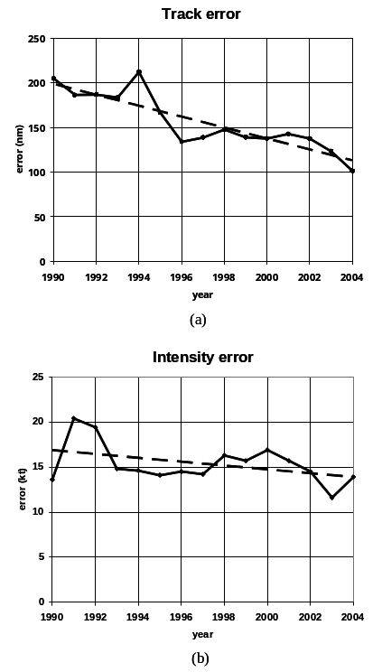

1. MOTIVATION FOR IFEX
One of the key activities in NOAA’s Strategic Plan is to improve the understanding and prediction of tropical cyclones (TCs). The NOAA National Hurricane Center (NHC) is responsible for forecasting TCs in the Atlantic and East Pacific basins, while NOAA’s Environmental Modeling Center (EMC) develops the numerical model guidance for the forecasters. With support from NOAA’s Hurricane Research Division (HRD) and others in the research community, continual progress has been made in improving forecasts of TC track over the past 30 years (Franklin et al 2003). By contrast, there has been much less improvement in forecasts of TC intensity (DeMaria et al. 2005). For example, Figure 1 shows that the official 48-h track forecast errors have decreased by nearly 45% during the past 15 years (3% yr⁻¹), while official 48-h intensity forecast errors have decreased by only 17% (1.1% yr⁻¹). The modest improvement in intensity forecasting is the result of many factors: 1) deficiencies in systematically collecting inner-core data to provide real-time estimates of TC intensity and structure to the forecasters at NHC and to assimilate into the numerical models at EMC and elsewhere; 2) limitations in the numerical models themselves, such as insufficient computing resources to run operational forecast models at high horizontal and vertical resolution, inadequate specification of the TC vortex in the initial conditions of the numerical models, and deficient representation of physical processes; and 3) gaps in our understanding of the physics of TCs and their interaction with the environment. Improvements in intensity forecasts will rely heavily on the use of improved numerical modeling systems, which in turn will rely on high-quality observational data sets for assimilation and validation.
The next-generation NOAA operational tropical cyclone model, the Hurricane Weather Research and Forecasting model (HWRF), is currently under development at EMC and will become operational in 2007. The HWRF is a coupled atmosphere-ocean-hurricane prediction system designed to improve forecasts for TC intensity, structure, waves, storm surge and rainfall for landfalling storms. The HWRF prediction system will run at high resolution (≈9 km grid length), using advanced data assimilation techniques making use of NOAA’s real-time radar observations to provide an initial three-dimensional description of the
____________________________________________
* Corresponding author address: Robert Rogers, NOAA/AOML Hurricane Research Division, e-mail: Robert.Rogers@noaa.gov

Figure 1. Annually-averaged official NHC 48-hr forecast errors for (a) tropical cyclone track (nm) and (b) tropical cyclone intensity (kt) for tropical cyclones in the Atlantic basin from 1990 to 2004.

hurricane core circulation, and advanced physics for the improved coupled HWRF system that are improved over those used in previous operational tropical cyclone models such as the GFDL model. In order to produce better forecasts of TC intensity, however, new data assimilation techniques must be developed and refined, physical parameterizations must be improved and adapted for both the TC storm-scale circulation and environment, and the models must be reliably evaluated against detailed observations from a variety of TCs and their surrounding environments. In addition to these modeling system upgrades, more accurate intensity forecasts will rely on less uncertainty in real-time observations of the intensity and structure of TCs that are adequately separated in time and space. Some of these observations will be from satellite platforms while others, particularly within the TC core, will come from airborne measurements.

2. GOALS OF IFEX
With these observational requirements in mind, HRD has worked with NHC and EMC to devise the following set of goals for IFEX:
GOAL 1: Collect observations that span the TC lifecycle in a variety of environments;
GOAL 2: Develop and refine measurement technologies that provide improved real-time monitoring of TC intensity, structure, and environment;
GOAL 3: Improve our understanding of the physical processes important in intensity change for a TC at all stages of its lifecycle.

The first goal is primarily derived from the need to improve the representation of TCs in numerical models. By employing a strategy that focuses on collecting observations at all stages of the TC life cycle, IFEX provides measurements that can be used to help develop the HWRF data assimilation to improve the initialization of the hurricane core circulation in the model and to develop an evaluation and validation package for the high resolution HWRF. Such an emphasis on all stages of the TC lifecycle represents a departure from previous field experiments conducted by HRD. Figure 2a shows the distribution of flights stratified by TC lifecycle stage involving the NOAA WP-3D aircraft during the 30 years prior to 2005. Over 90% of the flights were in systems that were already either tropical storms or hurricanes – indicating a bias in the HRD dataset toward mature storms. Therefore, one of
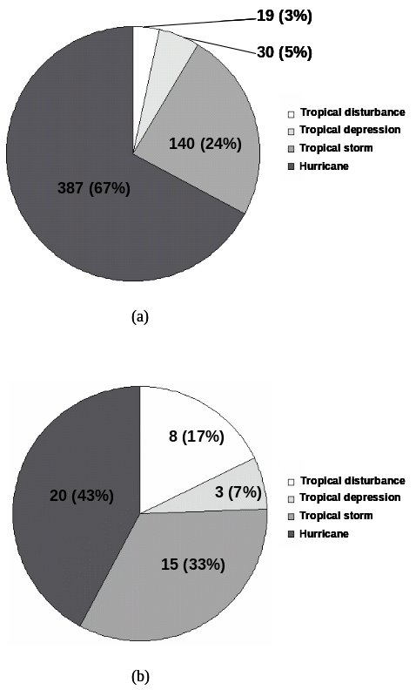

Figure 2. Total number and percentage of P-3 flights stratified by tropical cyclone lifecycle stage during the flight. (a) All research flights from 1976-2004; (b) All research and operationally-tasked flights in 2005.

the goals of IFEX is to collect more observations at the earlier stages of the TC lifecycle (i.e., from pre-depression to tropical depression and tropical storm stages).
The second goal is primarily targeted toward improving the real-time assessment of the TC intensity and structure. A variety of instruments are available to estimate the wind, temperature, pressure, and moisture fields within TCs. Some of these instruments were available for many years, but are just now showing promise for real-time applications. Examples of these instruments are the airborne Doppler radar and the Stepped-Frequency Microwave Radiometer (SFMR). In addition to the new instruments that have become available, new techniques for transmitting, quality assuring, and displaying the data from these instruments in real time have been developed. The primary example is the development of high-speed satellite communication (SATCOM) techniques developed by NESDIS and Remote Sensing Solutions, Inc. that allow large volumes of data to be transmitted to and from the aircraft in real time. These instruments and techniques provide the potential of improving the assessment of the intensity and structure of TCs in real time and providing a timely transmission of the intensity and structure of the TC to NCEP for assimilation into the HWRF.
A final goal of IFEX is to improve our understanding of various physical processes important in governing TC intensity change at all stages of the TC lifecycle. Specific topics that are targeted include convective-mesoscale interactions in tropical cyclogenesis, the role of shear and humidity in genesis and intensity change, the phase changes of moisture, the surface fluxes of heat, moisture, and momentum, the role of atmosphere-ocean feedbacks, and structural changes at landfall and extratropical transition. Improvements in the understanding of these processes can lead to better intensity forecasts by improving how they are represented in HWRF, e.g., the parameterization of surface fluxes or microphysical processes. They may also lead to refinements in existing algorithms for predicting intensity change, e.g., the Statistical Hurricane Intensity Prediction Scheme (SHIPS, DeMaria et al. 2005).

3. IFEX 2005 ACCOMPLISHMENTS
The 2005 Atlantic hurricane season was historic in terms of the number and intensity of tropical cyclones in the Atlantic basin, and the number of IFEX missions was commensurate with the amount of activity during the season. There were 45 NOAA P-3 and 48 NOAA G-IV research and operationally-tasked missions flown in a total of 14 different tropical cyclones or incipient tropical cyclones, with nearly 2500 dropsondes released (Table 1). A total of 220 NOAA P-3 and 44 G-IV research flight hours were used, while 186 NOAA P-3 and 388 G-IV operational flight hours were used for NHC-tasked missions. In addition to the flights by the NOAA aircraft, many of these flights were augmented by aircraft from operational Air Force Reserve WC-130 reconnaissance flights and partnering experiments, namely, the high-altitude NASA ER-2 aircraft during the NASA Tropical Cloud Systems and Processes (TCSP) project in July and the NRL P-3 during the NSF-sponsored RAINEX project in August and September. Additional information describing IFEX is available online, at http://www.aoml.noaa.gov/hrd/Storm_pages/ifex2005/ifex_cal.html, which is a calendar covering the time periods that IFEX missions were flown. It includes a daily web log of the field activities and mission summaries for the NOAA P-3 and G-IV research flights.
Many of the IFEX goals were advanced during the 2005 hurricane season. A summary of these activities is included below.
a) GOAL 1: Observations of tropical cyclones at various lifecycle stages
The distribution of flights stratified by TC lifecycle stage for 2005 is shown in Fig. 2b. Nearly 25% of the flights were in tropical cyclones either in the depression or pre-depression stage, a much larger proportion compared with previous years (cf. Fig. 2a).
This experiment was designed to provide airborne Doppler data sets at all stages of a TC’s lifecycle that can be used to improve the initiation and validation of the HWRF model. The flight module for this experiment was designed to be repeated every 12 hours (depression to weak hurricane stage) or 24 hours (mature hurricane stage) to provide the maximum possible temporal resolution over the lifetime of the storm to evaluate the accuracy of the model, and provide a temporal stream of data to assimilate into the model. The flight patterns were designed to be flown in either research or operationally-tasked missions. With this flight strategy, five of the TCs had flights in them for most or all their lifecycle:
• Dennis (tropical storm to landfall) – NOAA P-3’s and G-IV together with NASA ER-2 (TCSP)
• Gert (tropical disturbance to landfall) – NOAA P-3’s together with NASA ER-2 (TCSP)
• Katrina (tropical storm to landfall) – NOAA P-3’s, G-IV together with NRL P-3 (RAINEX)
• Ophelia (tropical depression to extratropical transition) – NOAA P-3’s, G-IV together with NRL P-3 (RAINEX)
• Rita (tropical storm to hours before landfall) – NOAA P-3’s, G-IV together with NRL P-3 (RAINEX)

Airborne Doppler data collected during these flights was provided to EMC and is being used to develop advanced data assimilation and model validation schemes for HWRF.

b) GOAL 2: Development and refinement of measurement technologies
There were several new and refined measurement technologies made available this year to NHC. They provided valuable information to NHC that aided in the real-time assessment of tropical cyclone intensity and structure.
1) Real-time Doppler radar analysis – This is a real-time analysis system that automatically performs QC, interpolates the Doppler data to a grid, synthesizes a wind field, and saves the QC data so they can be transmitted to EMC and assimilated into the HWRF model (e.g., Fig. 3);
2) SFMR algorithm refinement - The active 2005 Atlantic hurricane season provided ample opportunity to evaluate the SFMR's performance over the entire range of expected surface wind speeds (10-70 m s⁻¹), including Category-5 Hurricanes Katrina and Rita, which enabled the refinement of the geophysical model that assigns a wind speed to remove the low bias of the SFMR for surface wind speeds > 50 m s⁻¹;
3) Dropsonde improvements – New GPS dropsondes were used this year to improve the reporting of winds in the lowest few hundred meters in high-wind environments (> 50 m s⁻¹).

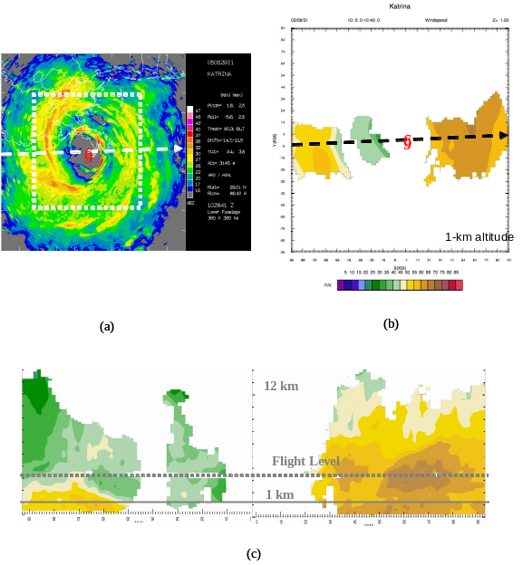

Figure 3. (a) Radar-reflectivity depiction (shaded, dBZ) of Hurricane Katrina in horizontal plan view at 1021 UTC 29 August 2005 from lower-fuselage fadar. Dashed box in (a) denotes analysis domain; (b) Horizontal analysis of total wind speed at 1-km level (shaded, m s-1) obtained from airborne Doppler data collected on N43RF during a pass through Hurricane Katrina centered at 1020 UTC on 29 August; (c) Vertical cross-section analysis of total wind speed (shaded, m s-1) taken from same pass. Dashed lines in (a), (b) and (c) show the flight track of the aircraft.

4) Synthesis for surface wind structure - HRD scientists were frequently at NHC this year to provide the specialists a synthesis and interpretation of the various data sources, including real-time airborne Doppler wind analyses, SFMR winds, and flight-level winds, for identifying the surface wind structure.
5) Use of unmanned aerial vehicles –Through a partnership among NOAA, NASA, and Aerosonde, the first-ever autonomous vehicle was flown in a tropical cyclone, Tropical Storm Ophelia, on September 16, 2005. The primary objective of this mission was to use the unique capabilities of the Aerosonde platform in order to document areas of the hurricane environment that are either impossible or impractical to routinely observe, including altitudes as low as 750 m in this case..

c) GOAL 3: Improved understanding of the physical processes important in TC intensity change
The experiments flown this year were all designed to improve our understanding of the processes that are important in governing TC intensity change at all stages of their lifecycle, from tropical cyclogenesis to a mature storm to landfall or extratropical transition. Here attention is focused on the experiments flown in partnership with the NASA TCSP campaign. These experiments include studies into the processes important in tropical cyclogenesis, and microphysics studies in developing tropical cyclones.
1) Tropical cyclogenesis - This experiment was designed to study how a tropical disturbance becomes a tropical depression with a closed surface circulation, with a focus particularly on dynamic and thermodynamic transformations in the low- and mid-troposphere and lateral interactions between the disturbance and its synoptic-scale environment.
There were two cases in 2005 for which the tropical cyclogenesis experiment was flown: a tropical disturbance in the East Pacific which possibly became Tropical Storm Eugene, and Tropical Storm Gert, which was first sampled as a tropical wave east of the Yucatan peninsula and developed into a tropical depression in the Bay of Campeche, ultimately making landfall as a tropical storm in southern Mexico. Gert was monitored every 12 h by P-3’s for its entire lifecycle, and two of the P-3 flights were flown in coordination with the NASA ER-2 aircraft as a part of the NASA TCSP project. The measurements for each case included flight-level, Doppler winds and reflectivity, dropsonde profiles of wind, temperature, and moisture, and microphysical probe measurements of precipitating and non-precipitating hydrometeors from the P-3’s, and reflectivity, vertical motion, temperature, and moisture profiles from the ER-2. The flights were targeted to regions of maximum convective activity within an identifiable cyclonic circulation, whether at the surface or the midlevels. A comparison of 4-km flight-level and

Figure 4. (a) Plot of P-3 lower-fuselage reflectivity (shaded, dBZ) from 0205 UTC 23 July for system that developed into Tropical Storm Gert. Flight-level winds (m s⁻¹; full barb is 5 m s⁻¹) are overlain. (b) As in (a), but when system was a tropical storm, valid 0547 UTC 24 July. (c) Plot of surface winds (m s⁻¹, full barb is 5 m s⁻¹), temperature (deg C), relative humidity (%), and surface pressure (hPa, standard convention) measured by dropsondes during flight shown in (a). (d) As in (c), but for flight shown in (b).
surface winds during the 24-h time period during which cyclogenesis occurred (Fig. 4) indicates that the system transitioned from a region of strong cyclonic shear vorticity in the mid-troposphere with no discernable surface reflection on 23 July to a closed mid-level and surface circulation by 24 July. The measurements provided by these flights should help to elucidate the mechanisms underlying the convective and mesoscale interactions important in tropical cyclogenesis.
2) Microphysics fields in developing tropical cyclones – This experiment focused on the study of microphysics fields in tropical cyclones at the early stages of their lifecycle. A variety of fields were measured from the aircraft involved, such as particle size spectra from the P-3’s, Doppler velocity and reflectivity from the P-3’s and ER-2; temperature and humidity profiles from the ER-2; and flight-level temperature, humidity, and wind fields from the P-3’s and the ER-2.
These fields were collected in all of the storms flown during the IFEX-TCSP partnership: Dennis, Gert, the East Pacific pre-Eugene environment, and Emily (ER-2 only). The best microphysics dataset collected, however, was in Hurricane Dennis. Dennis was monitored by either the P-3 or the P-3 and ER-2 jointly for almost all of its lifecycle, from the point it was first named a tropical storm until after landfall (Fig. 5). Joint P-3/ER-2 flights during the first two
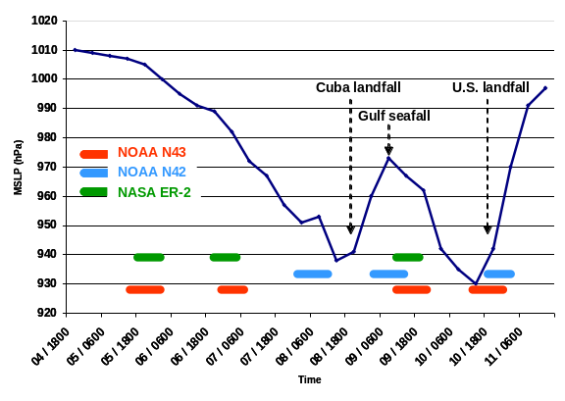

Figure 5. Plot of time series of best track central pressure for Hurricane Dennis from 18 UTC 04 July to 06 UTC 11 July. Times that storm was sampled by NOAA P-3’s (N43 and N42) and NASA ER-2 are denoted by colored bars.

days of Dennis’ lifecycle were targeted for the microphysics experiment, as good coordination was obtained between the two aircraft (Fig. 6). During the second of the two days shown in Fig. 6, the P-3 flew a pattern that began at 4.5 km (about +3 deg. C) altitude and ascended to 5.5 km (about -2 deg. C) while maintaining vertical alignment with the ER-2, then repeated the pattern by descending back to 4.5 km. During this pattern widespread areas of convective and stratiform rain were flown within the developing system. The measurements from the cloud physics probes and P-3 and ER-2 Doppler radars should provide a good basis for improving our understanding of microphysics processes at and above the melting layer in developing tropical cyclones.

4. FUTURE PLANS FOR IFEX
For 2006, the major goals for IFEX remain the same. The upcoming African Monsoon Multidisciplinary Analyses (AMMA) international field program and NASA-AMMA (NAMMA) supporting campaign that are planned for 2006 present a rare opportunity for IFEX to expand its research focus farther east into the central and possibly eastern North Atlantic. Specific objectives will include investigating the Saharan Air Layer (SAL) and its interactions with TCs and studying the early, mature, and decay phases of the TC lifecycle using the SFMR, airborne Doppler radar, GPS dropsondes, and UAVs. IFEX will use the data collected

Figure 5. Plot of P-3 lower-fuselage reflectivity (shaded, dBZ) from 2212 UTC 05 July for Tropical Storm Dennis. Flight track and times and flight-level winds (m s⁻¹; full barb is 5 m s⁻¹) for P-3 (black) and ER-2 (brown) are overlain. (b) As in (a), but for 0101 UTC 07 July.

during several of the G-IV and NOAA P-3 missions to assess and potentially improve the representation of humidity in NOAA’s GFS model and to examine the impacts of this improved humidity representation on forecasts of TC track and intensity.
IFEX plans to coordinate its G-IV, P-3, and Aerosonde missions with other research aircraft operating during AMMA and NAMMA (e.g. the North Dakota DC-8 and French Falcon). Such a coordinated effort will provide an expanded domain of aircraft coverage between continental North Africa (French Falcon aircraft) and the tropical eastern (DC-8 and French Falcon), central (G-IV), and western (G-IV, WP-3D, and Aerosonde) North Atlantic. Additionally, a number of remote sensing and in situ platforms will contribute to this coordinated effort providing a truly unique dataset for advancing our understanding and prediction of TC intensity change in the North Atlantic.

5. REFERENCES
DeMaria, M., M. Mainelli, L.K. Shay, J.A. Knaff, and J. Kaplan, 2005: Further Improvements to the Statistical Hurricane Intensity Prediction Scheme (SHIPS), Wea. Forecasting, 20, 531-543.
Franklin, J.L., C. J. McAdie, and M. B. Lawrence. 2003: Trends in Track Forecasting for Tropical Cyclones Threatening the United States, 1970–2001. Bull. Amer. Meteor. Soc., 84, 1197–1203.

