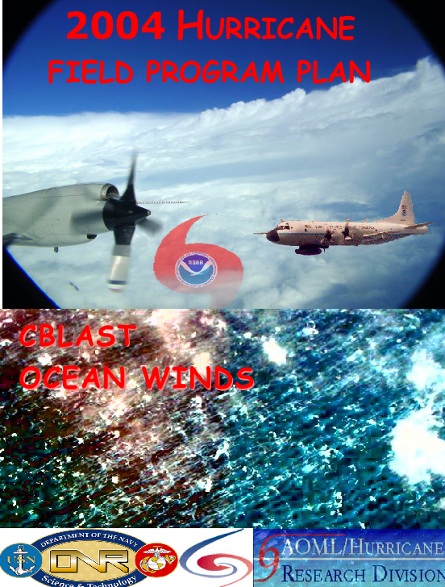

2004 Hurricane Field Program Plan

Hurricane Research Division
National Oceanographic and Atmospheric Administration
Atlantic Oceanographic and Meteorological Laboratory
4301 Rickenbacker Causeway
Miami, FL 33149

Prepared by:

Peter Dodge, Peter Black, Shirley Murillo, Neal Dorst, Howard Friedman, and Michael Black

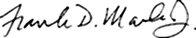
8 June 2004
Frank D Marks, Jr Date
Director, Hurricane Research Division

Distribution of the NOAA/HRD Hurricane Field Program Plan is restricted to personnel directly involved in the hurricane field program or to those persons who are on a need-to-know basis. This plan, in whole or in part, is either not to be abstracted, cited or reproduced in the open literature.

Mention of a commercial establishment, company or product does not constitute any endorsement by the NOAA/Office of Oceanic and Atmospheric Research or the U.S. Government. Use, for publicity of advertisement, of information from this publication concerning proprietary products or their testing is not authorized.

©2004, U.S. Department of Commerce, NOAA/AOML/Hurricane Research Division

Cover:
Top Panel: eyewall of Hurricane Olivia on September 24, 1994 taken by P. Black from a NOAA WP-3D aircraft. Superimposed are photos of the NOAA aircraft and logos of organizations responsible for the sponsorship and execution of the Hurricane Field Program.

Bottom Panel: Photo of the sea-surface and eyewall cloud base of Hurricane Gilbert on September 13, 1988 by M. Black from a WP-3D aircraft at 10,000 ft altitude. Logos of some of the collaborators involved in CBLAST are superimposed on the photo.

2005 HURRICANE FIELD PROGRAM PLAN

National Oceanic and Atmospheric Administration
Atlantic Oceanographic and Meteorological Laboratory
Hurricane Research Division
Miami, Florida. USA

INTRODUCTION

One of the key activities in NOAA’s Strategic Plan Mission Goal 3 (“Reduce Society’s Risks from Weather and Water Impacts”) is to improve the understanding and prediction of tropical cyclones (TCs). The National Centers for Environmental Prediction (NCEP) Tropical Prediction Center (TPC) is responsible for forecasting tropical cyclones in the Atlantic and East Pacific basins, while the Environmental Modeling Center (EMC) provides NWP guidance for the forecasters. Together they have made great strides in improving forecasts of TC track. With support from the research community, forecast errors of TC track have decreased by about 50% over the past 30 years. However, there has been much less improvement in forecasts of TC intensity and rainfall. The lack of improvement in intensity and rainfall forecasting is largely the result of deficiencies in routinely collecting inner-core data and assimilating it into the modeling system, limitations in the numerical models themselves, and gaps in our understanding of the physics of TCs and their interaction with the environment. Accurate forecasts will rely heavily on the use of improved numerical modeling systems, which in turn will rely on accurate observational datasets for assimilation and validation.

The next-generation TC model, the Hurricane Weather Research and Forecasting model (HWRF), is currently under development at EMC and is anticipated to become operational in 2007. The HWRF will run at high resolution (≈10 km grid length initially), using improved data assimilation techniques and physical parameterizations. Such a configuration holds the hope of improving our understanding and forecasting of tropical cyclone track, intensity, structure, and rainfall. In order to realize such improvements, however, new data assimilation techniques must be developed and refined, physical parameterizations must be improved and adapted for TC environments, and the models must be reliably evaluated against detailed observations from a variety of TCs and their surrounding environments.

To conduct the research necessary to address the issues raised above, NOAA has proposed an experiment designed to improve operational forecasts of TC intensity, called the Intensity Forecasting EXperiment (IFEX). The goals of this experiment have been developed through a partnership involving NOAA’s Hurricane Research Division (HRD), TPC, and EMC. The goals of IFEX are to improve operational forecasts of tropical cyclone intensity and rainfall by providing data to improve the operational numerical modeling system (i.e., HWRF) and by improving our understanding of the physics of intensity change and rainfall. These goals will be accomplished by satisfying a set of requirements and recommendations guiding the collection of the data:

- Collect observations throughout the life cycle of a TC for the development of a 3-D variational assimilation of the hurricane core circulation.
- Collect observations of the atmosphere and ocean in and around the storm scale circulation that can be used to develop an evaluation and validation package for the high resolution HWRF.
- Collect observations in a variety of atmospheric/oceanic conditions (e.g. atmospheric shear and humidity environments, oceanic warm core eddies) to assess the influence of these features on observed and model TC intensity and structure changes.
- Improve understanding and develop improved model representations of sea spray/surface flux effects on boundary layer structure and microphysics, especially in the core and rainbands. Develop techniques for evaluating ocean vertical mixing parameterizations against observed data.
- Improve the understanding of the phase changes of moisture.
- Determine the storm intensity and structure change during decay over cold water.

A unique, and critical, aspect of IFEX is the focus on providing measurements of TCs at all stages of their life cycle, from pre-genesis to intensification and subsequent landfall, decay over water, or extratropical transition. The focus of hurricane research flights during the past 25 years has been on mature storms, leading to a dataset biased toward these types of systems. The strategy of observing the entire life cycle of a TC is new and unique, and it will provide invaluable information, particularly in sparsely observed environments. The ability to target multiple basins provides greater flexibility for observing TCs at different stages of their life cycle. For example, the eastern North Pacific is an ideal location for genesis studies, since that region has the highest frequency of tropical cyclogenesis per unit area in the world. The western Atlantic, Caribbean Sea, and Gulf of Mexico are ideally suited for studying storms during their mature, landfalling, and extratropical transition stages of their lifecycle.

The field program presented here contains several flight experiments that are intended to be flown during the 2005 season. The flight patterns that comprise these experiments address various aspects of the tropical cyclone lifecycle, and they all specifically address IFEX goals. There is an experiment to investigate tropical cyclogenesis, an experiment to observe the structure of mature tropical cyclones, an experiment for decay over cold water, an experiment for sampling the tropical cyclone environment, and an experiment to measure the structural changes that accompany tropical cyclones at landfall. These experiments will be conducted with the NOAA/Aircraft Operations Center (AOC) WP-3D N43RF and N42RF and Gulfstream IV-SP aircraft. A summary of each experiment, along with which IFEX goals the experiment addresses, is included below. A more detailed description of each experiment follows, which includes a description of the scientific rationale for the experiment and flight patterns comprising the experiment.

(1) Tropical Cyclogenesis Experiment: This multi-option, multi-aircraft experiment is designed to study how a tropical disturbance becomes a tropical depression with a closed surface circulation. This experiment seeks to answer the question through multilevel aircraft penetrations using dropsondes, flight-level data, and radar observations on the synoptic, mesoscale, and convective spatial scales. It will focus particularly on dynamic and thermodynamic transformations in the low- and mid-troposphere and lateral interactions between the disturbance and its synoptic-scale environment. This experiment will address IFEX goals #1 and 2 by taking measurements at the beginning of the life cycle of a TC for the development of a 3-D variational assimilation for incipient disturbances and to be used for evaluation and validation of the HWRF model.

(2) Mature Storm Experiment:

(3) Tropical Cyclone Decay Experiment:

(4) Tropical Cyclone Landfall Structure and Intensity Experiment: This experiment is a multi-option, single-aircraft experiment designed to study the changes in TC surface wind structure near and after landfall. The experiment has several modules that could also be incorporated into operational surveillance of reconnaissance missions. An accurate description of the TC surface wind field is important for warning, preparedness, and recovery efforts. This experiment will address IFEX goals #2 and 3 by taking measurements at the end of the life cycle of a TC to be used for evaluation and validation of HWRF and by collecting observations in a variety of atmospheric/oceanic conditions to assess the influence of these features on observed and model TC intensity and structure changes.

(5) Hurricane Synoptic-Flow Experiment:

In addition to the experiments presented above that comprise IFEX, there are several experiments that are also occurring simultaneously with IFEX that will be partnering with IFEX. NESDIS will be conducting the Ocean Winds experiment, using N42RF for part of the season. NASA has planned an experiment called Tropical Cloud Systems and Processes (TCSP), one of whose primary goals is to increase the overall understanding of tropical cyclone genesis, intensity change, motion, and rainfall by identifying remote sensing measurements and modeling requirements for improved hurricane predictability. They will be based in San Jose, Costa Rica during the time period June-August 2005. HRD has committed to deploy to Acapulco, Mexico for up to 20 days during July 2005 to fly coordinated missions with the NASA DC-8 and ER-2 aircraft to study tropical cyclogenesis and decay. An overview of this experiment can be found at
http://research.hq.nasa.gov/code_y/nra/current/NNH04ZYS003N/index.html. Another experiment, called the Rainband and Intensity Experiment (RAINEX), has been funded by the National Science Foundation to investigate the role that the interactions between a tropical cyclone’s inner core and rainbands play in determining the intensity change of mature storms. This experiment will occur during August and September of 2005, and will use NOAA P-3 flight hours associated with IFEX and an NRL P-3 to conduct coordinated missions around rainbands and in the inner core of mature tropical cyclones. An overview of this experiment can be found at ftp://ftp.aoml.noaa.gov/hrd/pub/rogers/HFP/RAINEX.pdf.

Operations

1. Location

The primary base of operations for the NOAA aircraft will be Tampa, Florida, with provision for deployments to Bermuda, Barbados, Puerto Rico, and St. Croix for storms in the Atlantic basin (including the Atlantic Ocean and the Caribbean Sea).

The NOAA aircraft may deploy to U.S. coastal locations in the western Gulf of Mexico for suitable Gulf storms and to western Mexico for eastern Pacific storms. Occasionally, post mission recovery may be accomplished elsewhere.

2. Field Program Duration

The hurricane field research program will be conducted from 1 July through 31 October 2005.

3. Research Mission Operations

The decision and notification process for hurricane research missions is shown, in flow chart form, in Fig. A-1 (Appendix A in part II of the HFP). The names of those who are to receive primary notification at each decision/ notification point shown in Fig. A-1 are in Tables A-1 and A-2 (Appendix A in part II of the HFP). Contacts are also maintained each weekday among the directors of HRD/AOML, TPC/NHC, and AOC to discuss the "storm outlook."

Research operations must consider that the research aircraft are required to be placed in the National Hurricane Operations "Plan of the Day" (POD) 24 h before a mission. If operational "fix" requirements are accepted, the research aircraft must follow the operational constraints described in section 7.

4. Task Force Configuration

One NOAA/AOC WP-3D aircraft (N43RF), equipped as shown in Table B (Appendix B in part II of the HFP), will be available for research operations throughout the 2004 Hurricane Field Program (on or about 6 August through 31 October). The G-IV jet aircraft will be used during the Synoptic-Flow Experiment.

5. Field Operations

5.1 Scientific Leadership Responsibilities

The implementation of HRD's 2004 Hurricane Field Program Plan is the responsibility of the field program director and CBLAST Chief Scientist, who is, in turn, responsible to the HRD director. The field program director will be assisted by the field program ground team manager. In the event of deployment, the field program ground team manager shall be prepared to assume overall responsibility for essential ground support logistics, site communications, and HRD site personnel who are not actively engaged in flight. Designated lead project scientists are responsible to the field program director or designated assistants. While in flight, lead project scientists are in charge of the scientific aspects of the mission.

5.2 Aircraft Scientific Crews

Tables B-2.1 through B-2.10 (Appendix B in part II of the HFP) list the NOAA scientific crewmembers needed to conduct the 2004 hurricane field experiments. Actual named assignments may be adjusted on a case-by-case basis. Operations in 2004 will include completion of detailed records by each scientific member while on the aircraft. General checklists of NOAA science-related functions are included in E.2 through E.6 (Appendix E in part II of the HFP).

5.3 Principal Duties of the Scientific Personnel

A list of primary duties for each NOAA scientific personnel position is given in D.1 through D.12 (Appendix-D in part II of the HFP).

5.4 HRD Communications

The HRD/Miami Ground Operations Center (MGOC) will operate from offices at AOML on Virginia Key (4301 Rickenbacker Causeway, Miami, Florida) or from TPC/NHC (11691 S.W. 17th Street, Miami, Florida).

During actual operations, the senior team leader of the MGOC, or his designee, can be reached by commercial telephone at (305) 221-4381 (HRD/TPC/NHC) or at (305) 361-4400 (HRD/AOML). At other times, an updated, automated telephone answering machine [(305) 221-3679] will be available at the MGOC. In addition, MGOC team leaders and the field program director can be contacted by calling their cellphones or pager (phone numbers available at a later date).

MGOC, operating from AOML or TPC/NHC, will serve as "communications central" for information and will provide interface with AOC, TPC/NHC, and CARCAH (Chief, Aerial Reconnaissance Coordinator, All Hurricanes). In the event of a deployment of aircraft and personnel for operations outside Miami, HRD's field program ground team manager will provide up-to-date crew and storm status and schedules through the field program director or the named experiment lead project scientist. HRD personnel who have completed a flight will provide information to MGOC, as required.

6. Data Management

All requests for NOAA data gathered during the 2004 Hurricane Field Program should be forwarded to: Director, Hurricane Research Division/AOML, 4301 Rickenbacker Causeway, Miami, Florida 33149.

7. Operational Constraints

Hurricane research missions are routinely coordinated with hurricane reconnaissance operations. As each research mission is entered into the planned operation, a block of time is reserved for that mission and operational reconnaissance requirements are assigned. A mission, once assigned, must be flown in the time period allotted and the tasked operational fixes met. Flight departure times are critical. Scientific equipment or personnel not properly prepared for flight at the designated pre-take-off or "show" time will remain inoperative or be left behind to insure meeting scheduled operational fix requirements.

8. Calibration of Aircraft Systems

Calibration of aircraft systems is described in Appendix B in part II of the HFP (en-route calibration). True airspeed (TAS) calibrations are required for each NOAA flight, both to and from station and should be performed as early and as late into each flight as possible (Fig. B-1).
Experiments

1.Tropical Cyclogenesis Experiment

Program Significance and Background

While forecasts of tropical cyclone track have shown significant improvements in recent years (Aberson 2001), corresponding improvements in forecasts of tropical cyclone intensity have been much slower (DeMaria and Gross 2003). The lack of improvement in intensity forecasting is the result of deficiencies in the numerical models (e.g., resolution limitation and parameterization inadequacies), deficiencies in the observations, and deficiencies in our basic understanding of the physical processes involved. The problem becomes even more acute for forecasting tropical cyclogenesis. While global models have shown some skill in recent years in predicting tropical cyclogenesis, our understanding of the physical processes involved remains limited, largely because observing genesis events is a difficult task. However, a key aspect of the NOAA Intensity Forecasting Experiment (IFEX) is the collection of observations during all portions of a tropical cyclone’s lifecycle. This emphasis on all stages of the lifecycle, including the genesis stage, will provide an opportunity to observe several genesis events and improve our understanding of this key process.

Tropical cyclogenesis can be viewed as a rapid increase of low-level cyclonic vorticity organized on the mesoscale within a region of enhanced convective activity. Numerous hypotheses have been advanced in the literature to explain how this vorticity develops and amplifies. One set of theories places primary focus on the dynamical fields as playing the dominant role in genesis. For example, observations of multiple midlevel vortices prior to genesis have led some to view the genesis process as a stochastic one whereby chance merger and axisymmetrization of these midlevel vortices leads to growth of the circulation to the surface (Ritchie et al reference?). Another theory emphasizes the role of a parent midlevel vortex in axisymmetrizing nearby low-level convectively-generated cyclonic vorticity, leading to spin-up of the surface circulation (Montgomery and Enagonio 1998; Davis and Bosart 2001; Montgomery et al 2004). Another set of theories emphasizes the importance of changes in the thermodynamic fields in explaining genesis. These theories focus on the reduction of the effective static stability to low values in the core of the incipient cyclone. Suppression of convectively-induced downdrafts is one means of accomplishing this (Emanuel 1995; Raymond, Lopez, and Lopez 1998). Eliminating low-level outflows produced by the downdrafts allows the inflow of updraft air to spin up the low-level circulation, leading to the development of the warm-core characteristic of the tropical cyclone. In another theory related to the role of downdrafts in determining genesis potential, downdrafts driven by evaporational cooling advect the vorticity of the midlevel vortex downward, enhancing convection and low-level vorticity production (Bister and Emanuel 1997). A third group of theories highlights the combined importance of the dynamic and thermodynamic fields by emphasizing the role the midlevel vortex and high midlevel humidity play in providing a favorably-reduced local Rossby radius of deformation to retain the heating from convective bursts and spin up low-level vorticity through low-level stretching caused by the convective heating (Chen and Frank 1993; Rogers and Fritsch 2001). The purpose of the proposed experiment is to elucidate what role the dynamic (e.g., low- and mid-level vortices) and thermodynamic (e.g., static stability, humidity profiles) fields play in governing tropical cyclogenesis.

Since the onset of deep, moist convection is a crucial component in tropical cyclogenesis, the identification of large-scale environments favorable for such convective activity is an important step in identifying likely candidates for genesis. In the Atlantic Ocean, environments favorable for genesis have been revealed by composites of operational analyses and case studies of genesis and lysis events (Bracken and Bosart ???). Western and eastern Atlantic composites have shown the dynamical importance of ascent forced through cyclonic vorticity advection (CVA) in the incipient storm environment. Over the eastern Atlantic, this vorticity advection is generally found equatorward of a 200 mb zonally-oriented ridge axis in association with an upper-level easterly jet, while over the western Atlantic the CVA occurs downstream (upstream) of a 200 mb trough (ridge). In both composites the low-level disturbance is located beneath an area of CVA and near a minimum in vertical wind shear (200 mb-ATOLL level). Developing disturbances in both regions of the Atlantic are found downstream of a 700 mb southeasterly jet along the equatorward side of a ridge axis. The conditions important in the Atlantic basin are similar to those found to be important in other basins, where conditions of weak vertical shear, low-level positive vorticity, and the repeated development of convective bursts are all necessary conditions for tropical cyclogenesis.

For the East Pacific basin, an area of high frequency of tropical cyclone genesis and activity (Rosengaus et al. 2002), easterly waves are the dominant focusing mechanism (Avila et al. 2003). However, other features also play an important role in modulating the likelihood of genesis. The interaction of the easterly waves with the topography of southern Mexico and central America plays a significant role (Zehnder 1991), while the phase of the Madden-Julian oscillation (MJO) in the East Pacific also plays in important role in determining genesis, either through a direct effect on East Pacific convection or an indirect effect on the structure of pre-existing disturbances like easterly waves (Molinari et al. 1997; Maloney and Hartmann 2000). Because genesis in the East Pacific takes place at low latitudes, it is not believed that upper-level midlatitude troughs play a significant role here.

Recent observations from airborne Doppler radar have identified important processes on the mesoscale that contribute to tropical cyclogenesis. For example, results obtained from a WP-3D aircraft investigation of Dolly (1996) indicate its genesis was strongly influenced by persistent, deep convection in the form of mesoscale convective systems (MCSs) that developed in association with an easterly wave over the Caribbean. Within this deep convection an eye-like feature formed, after which time the system was declared a depression. The initial development of the low-level circulation in both Dolly (1996) and Guillermo (1991) occurred in the presence of multiple midlevel vortices. The close proximity of the low- and mid-level vorticity maxima (often within 50-100 km horizontally) observed in these two genesis cases supports a further examination of the aforementioned vortex merger ideas. To adequately diagnose the role of thesevortices, it is vital that they be sampled in their entirety (which will invariably depend on the distribution of precipitation scatterers) and with a temporal resolution that allows time continuity of the vortices to be established when possible.

In addition to the wind and rainfall measurements provided by the Doppler radars, measurements of temperature and moisture are vital to address the thermodynamic issues described above. Dropsondes released in a regular grid will enable the determination of thermodynamic fields in the vicinity of the incipient system, as well as enable the calculation of mean divergence and vorticity fields around the system, important in determining the strength and depth of the downdrafts (provided time aliasing is minimized). The dropsondes should be released from as high an altitude as possible to provide observations of mid-level humidity and winds where scatterers are not present. The tail radars on the P-3’s will also enable a determination of the presence of saturation when scatterers are observed.

Since both tropical cyclogenesis and tropical cyclone intensity change can be defined by changes in low- and mid-level vorticity, knowledge of the processes that play a significant role in genesis will also advance our understanding of intensity change. A better understanding of the processes that lead to an increase in low- and mid-level cyclonic vorticity will also allow NHC to better monitor and forecast tropical cyclogenesis and intensity change, improvements that would be especially valuable for those events that threaten coastal areas. Data obtained by aircraft investigating potential genesis events will positively impact operations and research in other ways as well. The collection of three-dimensional data at all stages in a tropical cyclone’s lifecycle is one of the key requirements for NCEP as a part of the IFEX experiment. Such data will provide information that will guide the development of balance assumptions and error covariance matrices important in the development of data assimilation schemes for models (i.e., HWRF) that will be used in these environments. They will also provide important datasets for evaluating the performance of HWRF. In addition to improving the understanding and forecasting of tropical cyclogenesis and intensity change, the proposed experiment will yield useful insight into the structure, growth and ultimately the predictability of the systems responsible for almost all of the weather-related destruction in the tropical Atlantic and East Pacific. Investigation of systems that fail to complete the genesis process will also result in a better understanding and prediction of easterly disturbances in general so that distinction can be better made between developing and non-developing tropical disturbances.

Objectives

In keeping with the discussions above, the objectives of this experiment are as follows:
- Develop means for identifying likely candidates for tropical cyclogenesis and techniques for finding and tracking low- and mid-level vortices within these candidates.
- Investigate role, if any, that midlevel vortex plays in organizing deep convection.
- Document the development of low-level vorticity in the presence of a midlevel vortex center.
- Study the interactions between low- and mid-level vortices in pre-genesis environments.
- Determine the importance of static stability decreases through downdraft suppression in tropical cyclogenesis.
- Study the role of humidity profiles and static stability in governing downdraft morphology and vortex response to convective heating.

Mission Description

This experiment may be executed with aircraft from NOAA alone, or NOAA in cooperation with the USAF and/or the NASA DC-8 and ER-2 aircraft flying into pre-genesis and incipient tropical disturbances over the Atlantic Ocean, Caribbean Sea, Gulf of Mexico, and tropical eastern North Pacific Ocean. The primary mission will require two WP-3Ds flying back-to-back with the G-IV aircraft flying a coordinated pattern. The two WP-3Ds will fly mesoscale survey patterns to document any suspected low- and mid-level vortices while the G-IV simultaneously flies at upper levels (42,000 ft or 175 mb) and collects observations to a distance of ~1500 km from the center of the disturbance. Crucial to a complete understanding of the genesis process is the collection of observations with high temporal and spatial resolution. Therefore, the staggered WP-3D missions are designed to commence on station at 1 am local and again on station at 1 pm local. The G-IV mission would occur coincident with the afternoon flight and consistent with synoptic missions centered on the 00 GMT synoptic time. If available, the USAF WC-130 aircraft can be used to enhance flight-level observations. Also if available, the NASA DC-8 can fly upper-level patterns (around 35,000 ft or 225 mb) to release dropsondes in the environment of the disturbance as well as taking upper-level measurements in the convective and stratiform precipitation of the incipient system to augment the lower-level measurements from the P-3’s. The ER-2 can fly at very high altitudes (around 65,000 or less than 100 mb), releasing sondes and measuring Doppler vertical velocities along flight legs coordinated with the lower-level aircraft.

The main aircraft for the mesoscale flights will be the two WP-3Ds. Doppler radar observations, GPS-sondes, and flight level observations obtained during these flights will help locate low- and mid-level vortices and help document their structures and life cycles. Primary aspects of this experiment will be to observe the complete life cycle and interaction of low- and mid-level vortices, understand how these vortices are influenced by the diurnal cycle of convection, and observe the evolution of the thermodynamic fields as the incipient system evolves. The location of persistent areas of deep convection and candidate vortices will be determined using high-resolution visible and infrared GOES-winds produced available online. Additionally, favorable large-scale environments for deep convection and vortex development, such as those described in the Introduction, will be identified using water vapor loops, model analysis fields enhanced by satellite winds, and QuikScat imagery, also available online.

Staggered missions with the two WP-3D aircraft will begin with the aircraft flying one of two low-level survey patterns at 700-500 mb (10,000-18,000 ft). The primary purpose of these patterns will be to collect F/AST Doppler radar and GPS-sonde data in the area of deep convection in order to map the evolution of the three-dimensional wind and thermodynamic structure of the deep convection and incipient vortex. There are two patterns possible, each with its advantages and disadvantages. In one pattern, a diamond configuration is flown (Fig. 1a). Leg lengths will be 250-350 nmi (450-650 km), and the pattern will be centered approximately on the vortex as identified from satellite analyses. The benefit of this pattern is that it covers a relatively broad horizontal area, while the return flight allows for some temporal continuity (on the order of 3 hours) to the data. The drawback to this pattern is that the configuration of the drop locations is not conducive to the calculation of low-level divergence and vorticity, which will be important for determining downdraft magnitude and depth. In addition, depending on the spacing between legs (a function of the separation distance between candidate low- and mid-level vortices), there is the possibility that the some of the disturbance may be out of range of the tail Doppler radar. A second survey pattern (Fig. 1b) consists of a square-spiral configuration centered on a candidate mid-level vortex. The benefits of this pattern are that it easily allows for adjustments in mid-flight if the actual mid-level vortex is displaced from the projected location, it allows for the calculation of low-level vorticity and divergence and provides a regular grid for mapping the thermodynamic fields around the system, and the spacing between spiral legs (111 km) should be sufficient for allowing complete coverage of the disturbance between legs for the tail radar. The drawbacks are that it does not provide two passes through the center of the disturbance and thus may not provide the temporal continuity that the diamond pattern does, and that this pattern is harder to coordinate with other aircraft (discussed below). For the survey patterns, the decision on which pattern to fly will be based on the anticipated transience of the convection and the vortices and the anticipation of the need for thermodynamic and dynamic budget calculations. If the system is rapidly-evolving, then the diamond pattern will be selected for its temporal continuity. If the system is more slowly-evolving and the budget calculations are desired, the square-spiral pattern will be flown.

Once a persistent mid-level vortex is identified, subsequent missions will fly a pattern centered on the vortex. This pattern will be either the square-spiral (Fig. 1b) or a rotating figure-4 pattern (Fig. 2). If no coordination with NASA aircraft is required, the square-spiral pattern will be flown. If coordination with NASA aircraft is required, the rotating figure-4 pattern will be flown. Flight legs for the figure-4 pattern will be 100-135 nmi (180-250 km) to allow for the collection of data with high temporal and spatial resolution in the vicinity of the vortex. The length of these flight legs is designed to completely include any low-level vortex within about 25-50 nmi (50-100 km) of the midlevel vortex center. This will be important in documenting any interaction between the low- and mid-level vortices. The NASA DC-8 will fly a rotating figure-4 pattern coordinated with the P-3 at higher altitude, while the NASA ER-2 will fly a single figure-4 pattern with much longer leg lengths to accommodate its higher ground speed. For those legs coincident with the ER-2, the P-3 will fly a portion of its leg with the tail radar in continuous, rather than F/AST, mode to obtain vertical incidence data. All other parts of the pattern will be flown in F/AST mode. For the square-spiral pattern (when no NASA aircraft are flying), the P-3 will also fly a portion of its pattern in continuous mode.

If available, the G-IV will be most beneficial flying a synoptic-scale pattern. It will fly at maximum altitude observing the upper and lower troposphere with GPS-sondes in the pre-genesis and incipient tropical disturbance environment. A potential genesis event occurring in conjunction with primarily an upper tropospheric anticyclone will require a flight pattern similar to that given in Fig. 3a. The aircraft will dispense 20-25 GPS-sondes mostly on the poleward side of the incipient disturbance during the flight to help define wind, temperature and moisture patterns near the ridge axis. Should a potential genesis event occur in association with an upper-tropospheric trough-ridge couplet a flight pattern similar to that shown in Fig. 3b will be required. This flight pattern will collect observations in the vicinity of both the trough and ridge with upwards of 20-25 GPS-sondes. These flight patterns are designed to define those regions where large-scale forcing for ascent exists and persistent deep convection is favored.

An enhancement of the data collected during genesis by the three NOAA aircraft may be accomplished by adding observations from investigative USAF WC-130 aircraft. Should a USAF WC-130 aircraft be available it would be requested to fly at maximum altitude dispensing GPS-sondes in the southern and eastern quadrants of the incipient disturbance. This aircraft would be requested to fly a saw-tooth pattern centered on asymptotes of confluence, convective inflow bands, and/or thermal boundaries within ~300 nmi (500 km) of the incipient disturbance.

In addition to the satellite and airborne data described above, temperature soundings of the mid- and upper-level thermodynamic environment of the system will be obtained using the GOES satellite and the AMSU instrument aboard the polar-orbiting NOAA-15 satellite. These observations will yield important information about the gross characteristics of the vortex’s thermal structure to the convective bursts that will complement well the GPS sondes dropped from the aircraft. Microwave imagery, available online, will also be used to infer the intensity of incipient disturbances during times when the aircraft are not flying.

The possible availability of multiple aircraft during this experiment leads to several different scenarios. A summary of the potential combinations of aircraft during genesis experiments follows:

- Option 1 (primary experiment):
The two core NOAA WP-3D aircraft alone will fly, in the East Pacific or Atlantic basins, either diamond or square-spiral survery patterns to locate low- and mid-level vortices (Fig. 1). Once a persistent mid-level vortex is located either rotating figure-4 or square-spiral patterns will be flown (Fig. 2) over a 2-4 day period.

- Option 2 (optimal experiments):
A) Option 1 augmented with large-scale upper- and lower-tropospheric observations obtained by the G-IV aircraft flying patterns similar to those given in Fig. 3 in the Atlantic basin.
B) Option 2A augmented with USAF WC-130 flying a standard reconnaissance mission.
C) Option 2A augmented with USAF WC-130 flying a targeted mission to sample asymptotes of confluence, convective inflow bands, and/or thermal boundaries within ~300 nmi (500 km) of the incipient disturbance.
D) Option 1 augmented with the NASA DC-8 and ER-2 aircraft flying patterns shown in Fig. 2 in the East Pacific basin.

Tropical Cyclogenesis Experiment

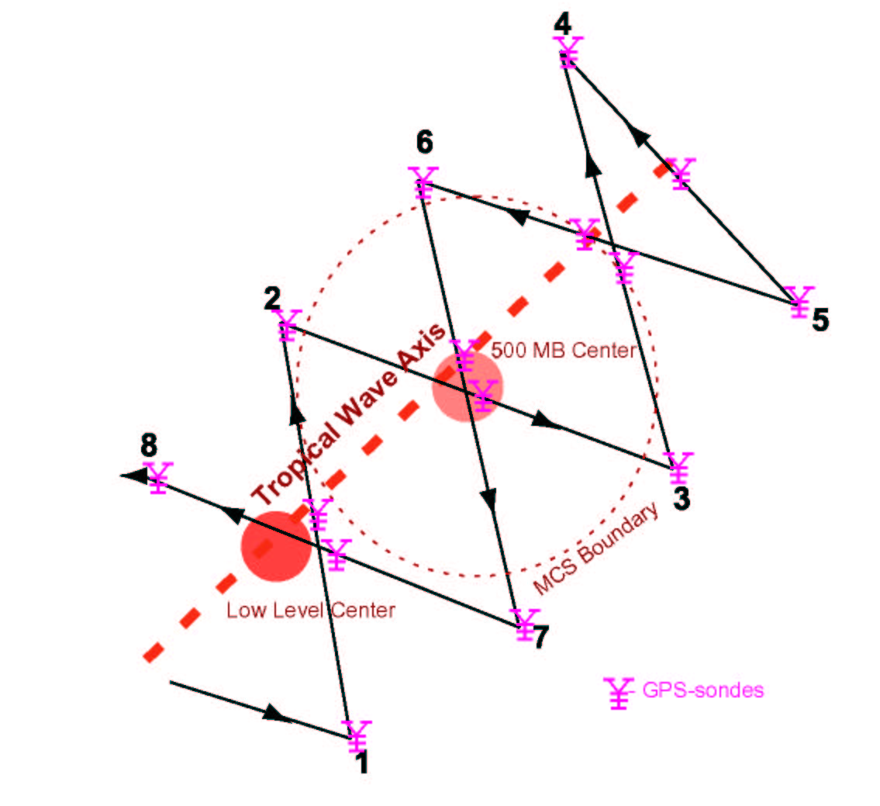
Figure 1a Vortex survey pattern – Diamond pattern
IP
FP

- Note 1: True airspeed calibration is required.
- Note 2. The pattern is flown with respect to the wave axis, typically inclined at 30-40° from N, or relative to circulation or vorticity centers.
- Note 3. Length of pattern (axis parallel to wave axis) should cover both low- and mid-level vortices.
- Note 4. Fly 1-2-3-4-5-6-7-8 at 1,000 ft (300 m) or 13,000 ft (4 km) altitude, passing through the low-level jet, low-level circulation center, MCS and associated mid-level center, or across mid-level jet.
- Note 5. Set airborne Doppler radar to scan F/AST on all legs.

Tropical Cyclogenesis Experiment

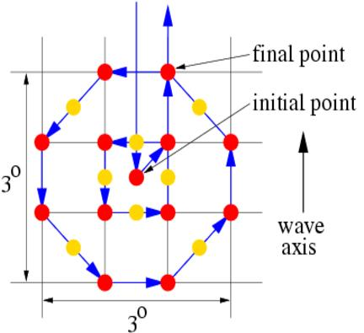
IP
1
11
10
9
8
7
6
5
4
3
2
12

Figure 1b Vortex survey pattern – Square-spiral pattern

- Note 1. True airspeed calibration is required.
- Note 2. The pattern is flown with respect to the wave axis, typically inclined at 30-40° from N, or relative to circulation or vorticity centers.
- Note 3. Drop sondes at all numbered points. Drops at intermediate points can be omitted if sonde supply is insufficient.
- Note 4. The spacing between the spiral legs can be shortened to increase spatial resolution if disturbance is small and expanded if disturbance is large.
- Note 5. Fly 1-2-3-4-5-6-7-8 at 1,000 ft (300 m) or 13,000 ft (4.0 km) altitude, passing through the low-level jet, low-level circulation center, MCS and associated mid-level center, or across mid-level jet.
- Note 6. Set airborne Doppler radar to scan F/AST on all legs.

Tropical Cyclogenesis Experiment

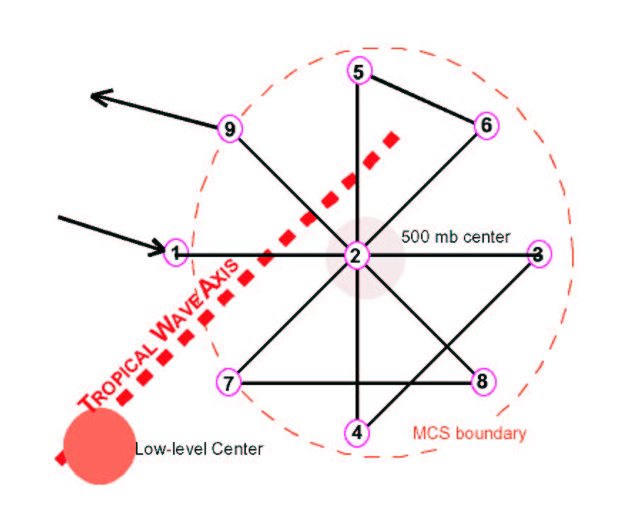
Figure 2 Mesoscale Aircraft Flight Track

- Note 1: True airspeed calibration is required.
- Note 2. The pattern may be entered along any compass heading.
- Note 3. Fly 1-2-3-4-2-5-6-2-7-8-2-9 at 600 or 700 hPa, 100-135 nmi (185-250 km) leg length.
- Note 4. Point 2 is near the moving apex of the trough axis.
- Note 5 Set airboirne Doppler radar to scan F/AST on all legs.
5. Hurricane Synoptic-Flow Experiment

Program Significance

Accurate numerical TC forecasts require the representation of meteorological fields on a variety of scales, and the assimilation of the data into realistic models. Omega dropwindsonde (ODW) observations from WP-3D aircraft obtained between 1982 and 1996 during the Hurricane Synoptic Flow Experiment produced significant improvement in the guidance for official track forecasts. Since 1997, more than 130 operational “Synoptic Surveillance” missions have been flown with the NOAA G-IV jet in the environments of TCs threatening the United States coastline; some of these have been supplemented with dropwindsonde observations from one or two WP-3D or USAF C-130-I aircraft. An improved dropwindsonde based on the Global Positioning System has been developed by the National Center for Atmospheric Research and has replaced the ODW. With further operational use of the G-IV aircraft, and as other mobile observing platforms become available, optimal sampling and utilization techniques must be devised to provide the greatest possible improvement in initial condition specification.

Objectives: The goal of the HRD synoptic flow experiment is to improve landfall predictions of TCs by releasing dropwindsondes in the environment of the TC center. These data will be used by TPC/NHC and NCEP to prepare objective analyses and official forecasts through their assimilation into operational numerical prediction models. Because the atmosphere is known to be chaotic, very small perturbations to initial conditions in some locations can amplify with time. However, in other locations, perturbations may result in only small differences in subsequent forecasts. Therefore, targeting locations in which the initial conditions have errors that grow most rapidly may lead to the largest possible forecast improvements. Locating these regions that impact the particular forecast is necessary. When such regions are sampled at regularly-spaced intervals the impact is most positive. The optimal targeting and sampling strategies is an ongoing area of research.

A number of methods to find targets have been investigated, mainly in the wintertime extratropics. Potential vorticity diagnosis can help to find the cause of forecast failure. Singular vectors of the linearized equations of motion can estimate the growth of small perturbations in the model. This method is relatively expensive, and full implementation in the Tropics where adiabatic processes dominate has proven difficult, and the linear assumption tends to break down at the 72 h forecast time necessary for the posting of hurricane watches and warnings. Related strategies involve the sensitivity vector, and quasi-inverse linear method. All these methods may depend on the accuracy of the initial conditions determined without the supplemental data.

A fully nonlinear technique uses the breeding method, the operational NCEP perturbation technique in which initially random perturbations are repeatedly evolved and rescaled over a relatively short cycling time. These vectors are related to local Lyapunov vectors and, therefore, define the fastest growing modes of the system. Changes to initial conditions due to dropwindsonde data obtained from operational synoptic surveillance missions during the 1997 and 1998 hurricane seasons grow (decay) in regions of large (small) perturbation in the operational NCEP Ensemble Forecasting System. Therefore, these bred-modes provide a good estimate of the locations in which supplemental observations are likely to have the most impact. However, though the breeding method can find locations of probable error growth in the model globally, it does not distinguish those locations which impact the particular forecast from those which do not.

A more generalized method which can use any dynamical ensemble forecast system is the ensemble transform. This method transforms an ensemble of forecasts appropriate for one observational network into one appropriate for other observational networks. Ensemble forecasts corresponding to adaptations of the standard observational network are computed, and the expected prediction error variance at the observation time is computed for each potential network. The prediction error variance is calculated using the distances between the forecast tracks from all ensemble members and the ensemble mean. These last two methods are currently undergoing testing with Observing System Experiments to discern an optimal targeting technique.

Mission Description: To assess targeting strategies a relatively uniform distribution of dropwindsondes will be released over a minimum period by various aircraft operating simultaneously. Specific flight tracks will vary depending on such factors as the location of the storm, relative both to potential bases of operation and to particular environmental meteorological features of interest.

A sample mission is shown in Fig. 21. The two WP-3D aircraft and the G-IV will begin their missions at the same time. Subject to safety and operational constraints, each WP-3D will climb to the 500-mb level (about FL 180) or above, then proceed, step-climbing, along the routes assigned during preflight. It is particularly important that both aircraft climb to and maintain the highest possible altitude as early into the mission as aircraft performance and circumstances allow, and attain additional altitude whenever possible during the mission.

GPS-sondes are released in one of two modes. Beyond 80 nm (150 km) from the storm center, drops are made at pre-assigned locations, generally every 25 min or 120 nm (222 km). These drop locations are provided with the particular mission flight tracks 2 h before departure. Within 80 nm (150 km) of the TC's center, drop locations are specified relative to the center's position (e.g., 40 nm (75 km) north of the eye). During in-storm portions of the mission, drops will be made with possible spacing <8 min or 40 nm (75 km).

If a NOAA-P3 aircraft is involved in the missions, at least one will fly through the TC center and execute a figure-4 pattern. This aircraft's Doppler radar should be set to record forward and aft (F/AST) continuously. If both aircraft penetrate the storm, the figure-4 pattern will generally be executed by the second aircraft through the storm, and the first aircraft through will collect vertical incidence Doppler data. Coordination with potential USAF reconnaissance is necessary to ensure adequate aircraft separation. The in-storm portion of the missions is shown schematically in Fig. 22, although the actual orientation of these tracks may be rotated.

Of paramount importance is the transmission of the dropwindsonde data to NCEP and TPC/NHC for timely incorporation into operational analyses, models, forecasts, and warnings. Operational constraints dictate an 0530 or 1730 UTC departure time, so that most of the dropwindsonde data will be included in the 1200 or 0000 UTC analysis cycle. Further, limiting the total block time to 9 h allows adequate preparation time for aircraft and crews to repeat the mission at 24-h intervals. These considerations will ensure a fixed, daily real-time data collection sequence that is synchronized with NCEP and TPC/NHC's analysis and forecasting schedules.
HURRICANE SYNOPTIC FLOW EXPERIMENT

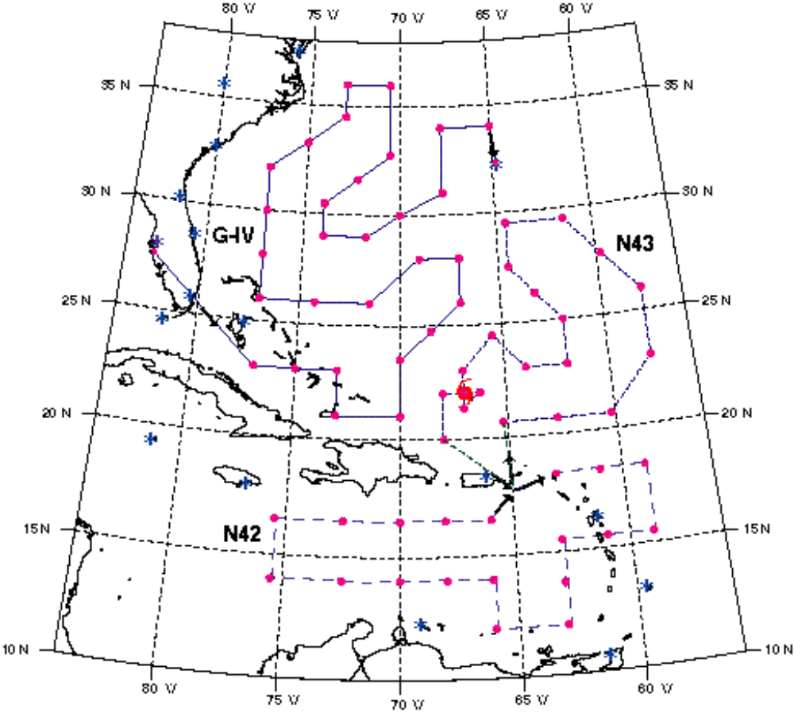
Fig. 21. Sample Environmental Patterns

• Note 1. During the ferry to the IP, the WP-3D aircraft will climb to the 500 mb level (about FL 180). The 400 mb level (about FL 250) should be reached as soon as possible and maintained throughout the remainder of the pattern, unless icing or electrical conditions require a lower altitude.
• Note 2. During the ferry to the IP, The G-IV should climb to the 41,000 ft (200 mb) as soon as possible and climb as feasible to maintain the highest altitude for the duration of the pattern.
HURRICANE SYNOPTIC FLOW EXPERIMENT

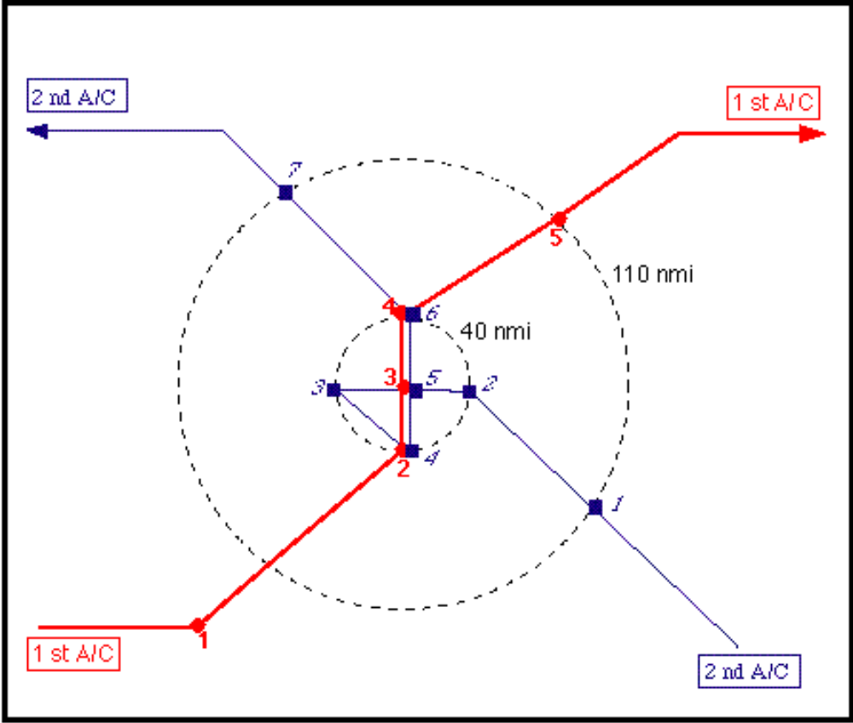

Fig. 22 In-Storm Patterns
• Note 1. Within the 40 nm (75 km) range ring, all legs are on cardinal tracks.
• Note 2. The second aircraft through the storm will execute the Doppler "figure-4" pattern. The Doppler radar should be set to continuously scan perpendicular to the track during radial penetrations and to F/AST on the downwind leg.
• Note 3. Numbered symbols (, ) reflect scheduled drops for each aircraft.
• Note 4. Drop #5 in the "figure-4" pattern occurs on the second pass through the eye.
• Note 5. A/C 1 should collect vertical incidence Doppler data during storm penetration.
• Note 6. If missions are not repeated, then block times may exceed 9 h. In addition to the GPS-sonde data, 3-4 RECCO's h-1 should be transmitted during each mission.

Special Notes: Missions similar to the Synoptic Flow missions may be flown in non-hurricane conditions to collect GPS-sonde data sets for satellite sounding evaluations. These missions differ from the normal experiment as follows:
• Block times are 10 h, and the experiment is not repeated on the following day.
• In-storm portion of the pattern (Fig. 22) is omitted and no Doppler data are collected.
• The G-IV does not participate in the mission.
Saharan Air Layer - Synoptic Surveillance Follow on

Mission Description: The G-IV (flying at 200 mb) dropwindsonde drop points will be based on slight modifications to a synoptic surveillance flight pattern selected using real-time GOES SAL tracking imagery from UW-CIMSS and mosaics of SSM/I total precipitable water from the Naval Research Laboratory. Specific effort will be made to gather atmospheric information within the SAL as well as regions of high moisture gradients along its boundaries. Several SAL/TC interaction scenarios are candidates for this mission:
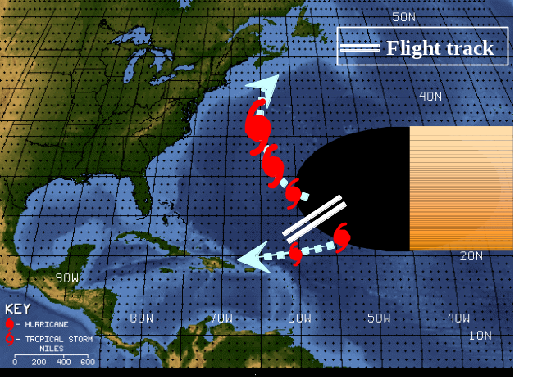
1) Classic two-disturbance scenario with connecting “rooster tail” of convection. This convection represents the leading edge of the westward advancing SAL. The northern tropical disturbance typically intensifies as it recurves and separates from the suppressing influence of the SAL. The southern tropical disturbance is often overrun by the SAL and dramatically weakened. GPS sonde transects (~20 km spacing) can be made to run perpendicular to the region of the “rooster tail”.

\
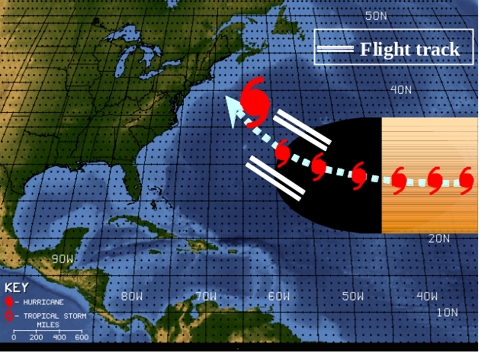
2) Single tropical disturbance is embedded within the SAL and intensifies upon emerging. These systems are often candidates for rapid intensification. GPS sonde transects (~20 km spacing) perpendicular to the leading edge of the SAL and near to possible points of the tropical disturbance’s emergence from the SAL are desirable.

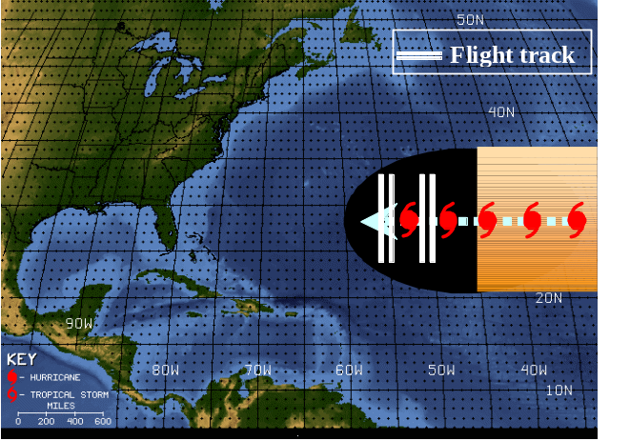
3) Single tropical disturbance embedded within the SAL. These systems struggle to intensify and are often characterized by their low-level circulation racing out ahead (west) of their deep convection. North-south GPS sonde transects (~50 km spacing) on the west and east sides of the TC are desirable in order to sample the SAL’s dry air and low to mid-level wind surge.

Fig. X: Sample SAL/TC scenarios

- Note 1: The G-IV/WP-3D aircraft should fly at 41,000/20,000 ft.
- Note 2: In order to capture the SAL’s structure, particular attention should be paid to regions of high moisture gradients along its boundaries.

Appendix A: Aircraft Scientific Instrumentation

Table A.1. NOAA/AOC WP-3D (N42RF, N43RF) instrumentation
Instrument | Parameter | PI | Group | Electronics  Location | Instrument  Location | 42RF | 43RF

Navigational
INE1/2 | LAT, LON |  | AOC |  |  | X | X
GPS1/2 | LAT, LON |  | AOC |  |  | X | X
APN-159 altimeter  (C-band) | Radar altitude |  | AOC |  |  | X | X

Standard Meteorological
dew point | Td |  | AOC |  |  | X | X
Rosemount temp | T, T’ |  | AOC |  |  | X | X
Static pressure | P |  | AOC |  |  | X | X
Dynamic pressure | P’ |  | AOC |  |  | X | X
Horizontal wind | U, V |  | AOC |  |  | X | X
Vertical wind | W |  | AOC |  |  | X | X

Infrared Radiation
Side CO2 radiometer | T |  | AOC |  |  | X | X
AOC down radiometer | SST |  | AOC | Under floor, | Down radiometer port | X | X
FRD down  radiometer ² | SST | French | ARL/FRD | Station C3X | LIPA |  | X

Weather Radar
LF radar | RR | Marks | HRD | Station 3 | Lower fuselage | X | X
TA Doppler radar | U, V, W vs Z, RR | Marks | HRD | Station 3 | Fuselage tail | X | X

Passive Microwave
HRD SFMR/horn ant. ¹ | U10, RR | P. Black,  Uhlhorn | HRD | Laser hole | LIPF |  | X
AOC SFMR/pod² | U10, RR | Goldstein | AOC | pod | Inner right pylon |  | X
USFMR (UMASS) ¹ | U10, RR | Zhang/  Chang | UMASS/  MIRSL | Station 7 | Laser hole | X
Active Microwave
IWRAP (CSCAT, KSCAT) ¹ | U10, V10; RR; U, V, W vs Z | Zhang/  Chang | UMASS/  MIRSL, NESDIS | Station 7 | Fore & aft pressure domes | X
SRA¹ | HS_{1/3}, WPS, WDS, RR | Walsh | NASA/  GSFC,ETL | Station 7 | Fore Press Dome |  | X

Laser Systems
Laser Altimeter¹ | H_{1/3}, WP | Terrill | SIO | Station 7 | Vert. Camera port |  | X
Particle Dynamics Analyzer² | Sea spray | Asher | UW/APL | Station C3X | Station3-window blank

Airborne Ocean Profiler
AXBT receiver  AOC DAT recorder¹ | TS vs Z | Cione | HRD | Station 2 | Free-fall chute (aft station 5) |  | X
AXBT DAT recorder | TS vs Z | Cione | HRD |  |  | X
AOC AXBT receivers | TS vs Z | Smith | AOC | Station 5 |  | X | X
AXBT/SFMR laptop¹ | processor | Uhlhorn | HRD | Station 2 | ------------------ | X | X
Sonobuoy receiver¹ | U10, RR | Terrill | SIO | Station 2 |  | X

Dropsonde Systems
GPS AVAPS Dropsonde- 4CH | U, TA, RH vs Z | Smith | AOC | Station 5 | Aft station 5 |  | X
GPS AVAPS Dropsonde- 8CH¹ | U, TA, RH vs Z | Smith | AOC | Station 5 | Aft station 5 | X
GPS Dropsonde-  ‘full up system’ | U, TA, RH vs Z | Smith | AOC | Station 5 | Aft station 5 | X

Video Systems
AOC video down | F(%), WD |  | AOC |  | Vert. Camera port | X
Side, nose video | LCL |  | AOC |  | Side, nose camera port | X | X
MASS (video down) ¹ | WC(%), F(%), WD | Terrill,  Melville | SIO | Station 7 | Vert. Camera port |  | X
Down IR camera ² | Wave breaking | Melville | SIO | Station 7 | Aft pressure  Dome |  | X

Cloud Microphysics/

Sea Spray
2D-P PMS mono probe | Precip size spectra, RR | R. Black | HRD/AOC | Station 4 | Outer left pylon |  | X
FSSP-100 probe | Aerosol, small cloud size spectra | R. Black | HRD/AOC | Station 4 | Outer left pylon | X | X
DMT CIP probe¹ | Spray spectra | Fairall | ETL | Station 2 | Outer left pylon |  | X
DMT CIP probe² | Cloud LWC | Fairall | ETL | Station 2 | Outer left pylon |  | X
DMT DAS² | processor | Fairall | ETL | Station 2 | ------------ |  | X
2D-C PMS mono probe | Cloud size spectra | R. Black | HRD/AOC | Station C3X | Outer left pylon | X
2D-P PMS grey probe | Precip size spectra, RR | R. Black | HRD/AOC | Station C3X | Outer left pylon | X
HVPS (replaces 2DP grey probe) | Precip size spectra, RR | R. Black | HRD/AOC/NASA | Station C3X |  | X
SEA M200 DAS | processor |  | AOC | Station 4 | ------------ | X | X
Johnson-Williams hot wire | Cloud liquid water | R. Black | HRD |  | Station x | X
King probe | Total liquid water | R. Black | HRD |  |  | X
Electric field mills (5) | 3-axis electric field | R. Black | HRD |  |  | X
Particle Dynamics Analyzer ² | Sea spray | Asher | UW/APL | Station C3X | Station 3-  window blank |  | X
Water salinity isotope analyzer ³ | Sea spray | Lawrence,  Geller | UHOU |  | Station 3-  window blank | X
TECO Ozone sampler ³ | ozone | Carsey | AOML |  |  | X | X

Turbulence Systems
Friehe radome gust probe system | U’,V’,W’,T’ | Drennan | UM/ RSMAS | Nose radome  bulkhead | Nose radome | X | X
BAT probe | U’,V’,W’,T’ | French | ARL/FRD | C3X | Nose boom |  | X
IRGA | q’ | French | ARL/FRD | C3X | Radome window compartment |  | X
FAST Hygrometer ¹ | RH, q’ | Drennan,  Hubler | UM/RSMAS,AL |  | fuselage |  | X
LICOR-750 water vapor analyzer² | q’ | Drennan | RSMAS/  AOC | Nose radome  bulkhead | Nose Radome  bulkhead | X | X

On board processing
HRD Workstation | GPS sonde, LF radar processing | Griffin | HRD | Station 3 |  | X | X
¹ Re-installation, user supplied
² 2003 installation
³ Lower priority
⁴ 2004 installation
* STD- data on standard DAT tape and CD- one each per aircraft

APPENDIX B: NOAA EXPENDABLES AND RECORDING MEDIA

Table B-1.1. Required expendables for 2004 experiments per flight day for 42RF, 43RF and G-IV
Experiment | GPS sondes |  |  | AXBTs |  | CADs |  | Sonobuoys
 | G-IV | 42RF | 43RF | 42RF | 43RF | 42RF | 43RF | 43RF
Saharan Air Layer | 15 | 20 | 15 | 20 | 15 | 20 | 15
Tropical Cyclogenesis | 15 | 30 | 10 | 18 | 18 | -- | --
Extratropical Transition | 15 | 30 | 30 | 18 | 18 | -- | --
TC Wind fields at Landfall |  | -- | 25 | -- | 20 | -- | 20
Hurricane  Synoptic-Flow | 40 | 35 | 35 | -- | -- | -- | --
Hurricane Air-Sea Interaction  Pre-Storm (Ahead)  Pre-Storm (Eddy)  In Storm |  | --  --  42  -- | 24  32  30 | --  --  46  -- | 24  --  20 | --  --  20  -- | 20  --  20 | --  --  --  --
CBLAST  Day 1  Day 2  Rainband Test |  | 68  64  30 | 24  24  30 | 23  18  -- | 17  24  -- | 20  18  -- | 17  14 | 10  10

Table B-1.2. Required recording media for 2004 experiments per flight day for 42RF, 43RF and G-IV
 | DATs¹ | CDs² | ZIPs | D-Audio | S-VHS
Experiment |  |  | BAT Probe | AXBTs | Nose/Side/Down
Saharan Air Layer  (SALEX)  42RF or 43RF | 1/1/4 = 6 | 1/2/2/-/1/1=5 | -- | 6 | 1/2/1=4
Tropical Cyclogenesis  42RF or 43RF | 1/2/4 = 7 | 1/2/2/-/1/1=5 | -- | 6 | 1/2/1=4
Extratropical Transition | 1/2/4 = 7 | 1/2/2/-/1/1=5 | -- | 6 | 1/2/1=4
TC Wind fields at Landfall  43RF | 1/2/4 = 7 | 1/2/2/2/1/1=7 | 6 | 6 | 1/2/-=3
Hurricane  Synoptic-Flow  42RF | 1/-/4 = 5 | 1/2/2/-/1/1=5 | -- | 6 | 1/2/1=4
43RF | 1/2/4 = 7 | 1/2/2/2/1/1=7 | 6 | 6 | 1/2/-=3
Air-Sea Interaction  42RF | 1/2/4 = 7 | 1/2/2/-/1/1=5 | -- | 6 | 1/2/1=4
43RF | 1/2/4 = 7 | 1/2/2/2/1/1=7 | 6 | 6 | 1/2/-=3
CBLAST  42RF | 1/2/4 = 7 | 1/2/2/-/1/1=5 | 6 | 6 | 1/2/1=4
43RF | 1/2/4 = 7 | 1/2/2/2/1/1=7 | 6 | 6 | 1/2/-=3
¹DATs required for Slow / Fast flight-level / Radar data
²CDs required for Slow / Fast flight-level / Cloud Physics / BAT / AVAPS / HRD workstation data
NOTE: 1 DAT and 1 CD are required for G-IV missions

Acknowledgment

The preparation of HRD's 2004 Hurricane Field Program Plan Part I was a team effort. The authors would like to express their appreciation to: the HRD scientists that contributed information on specific experiments and Neal Dorst and Peter Dodge for expertly drafting several of the figures.

