Understanding and PreDiction of Rainfall Associated with landFalling Tropical cyclones (UPDRAFT) Project Implementation Plan

Oct 10, 2016

1 An Overview of UPDRAFT 4
1.1 Background 4
1.2 Scientific Objectives 5
1.3 Expected outcomes and significance 6
2 Implementation Plan 7
2.1 Observations 7
2.1.1 Instruments and Measurements 7
2.1.2 Observation plan 12
2.1.3 Regional coordinated observing network 13
2.1.4 Regional radar mosaic of TC 14
2.1.5 Coordinated field campaign 15
2.2 Modeling Group 15
2.2.1 Identifying processes important to rainfall distribution and intensity 16
2.2.2 Evaluating the model representation of those identified processes 16
2.2.3 Improving poorly represented processes in current models 17
2.3 Understanding Group 18
2.3.1 Determining the role of environmental variables in modifying rainfall distribution 18
2.3.2 Studying how the thermal and dynamical field controls the rain types 20
2.3.3 Investigating the way of urban effects influencing the rainfall intensity 21
2.3.4 Studying how the PBL processes affect the characteristics of rainfall 23
2.3.5 Investigating the effects of topography-generated phenomena on changing rainfall features 24
2.3.6 Determining how the aerosol characteristics affect different rainfall distributions 25
2.4 Forecasting Group 25
2.4.1 Diagnosing and comparing errors in rainfall characteristics from different numerical models 26
2.4.2 Correcting the bias of raw model output rainfall products by various calibration techniques 27
2.4.3 Providing the consensus landfalling TC rainfall forecast 28
2.5 Data Management 28
2.5.1 Data transmission and collection 28
2.5.2 Processing of the radar measurements 28
2.5.3 Retrieval products from remote sensing measurements 29
3 Organization Structure 32
3.1 International Science Steering Committee (ISSC) 32
3.1.1 The charge for the ISSC 32
3.1.2 The composition of the ISSC 32
3.2 International and Local Technique Support Team (ITeST/LTeST) 33
3.2.1 The responsibility of the ITeST/LTeST 33
3.2.2 The composition of the ITeST/LTeST 33

An Overview of UPDRAFT

Background
The Understanding and PreDiction of Rainfall Associated with landFalling Tropical cyclones (UPDRAFT) project is a WMO/WWRP Research and Development Project (RDP) focusing on improving the understanding and prediction of rainfall associated with landfalling tropical cyclones (TCs) and promoting research on multi-scale dynamical and physical processes that govern rainfall intensity and distribution in landfalling TCs.
TC-related research programs have been part of the most important programs supported by the World Weather Research Program (WWRP) of World Meteorological Organization (WMO). Previous and ongoing TC-related programs have focused on unusual TC tracks [e.g., Special Experiment Concerning Typhoon Recurvature and Unusual Movement (SPECTRUM); THORPEX North Western Pacific Tropical Cyclone Track Ensemble Forecast Research Project (TCEFP)], the TC warning system [e.g., Typhoon Operational Experiment (TOPEX)], assessment of flash flood forecasting (e.g., Management Overview of Flood Forecasting Systems (MOFFS)] and storm surge warning (e.g. The Storm Surge Project; The Storm Surge Watch Scheme). These programs have greatly improved the forecast accuracy of TCs and reduced casualties and property damages in regions affected by TCs.
In addition to those programs led by WMO, many countries/regions have also conducted special research programs to improve the understanding of dynamical and physical processes associated with TCs. The Hurricane RAIN band and Intensity Change EXperiment (RAINEX) was carried out in the Gulf of Mexico and U.S. East Coast during 2005 (Houze et al. 2006). The coordinated observations from multi-platform instruments improved our knowledge of TC internal structures and their relations to TC intensity change (e.g. Houze 2007; Torn and Hakim 2009). The 10-year, on-going, aircraft-based Intensity Forecasting Experiment (IFEX), conducted every year since 2005, is intended to improve the prediction of TC intensity change by collecting observations that span the TC life cycle in a variety of environments, developing and refining measurement technologies that provide improved real-time monitoring of TC intensity, structure, and environment, and improving the understanding of the physical processes important in intensity change for a TC at all stages of its life cycle (Rogers et al. 2006; Rogers et al. 2013). The THORPEX Asian field campaign not only provided additional insights into TC internal dynamics but also addressed large-scale interaction through the planetary Rossby waveguide (Elsberry and Harr 2008; Bougeault et al. 2010). The more recent joint GRIP (Genesis and Rapid Intensification Processes; Braun, et al., 2013), IFEX (Rogers, et al., 2013) and PREDICT (Pre-Depression Investigation of Cloud-Systems in the Tropics; Montgomery et al. 2012) experiments in 2010 have addressed the TC genesis problem by evaluating different hypotheses using high-resolution numerical models and observations from specially designed field campaigns.
Although the aforementioned research projects have greatly advanced our knowledge of TC dynamics and structure and intensity changes, further improvements in forecast skills and better understanding of TCs are needed to achieve effective TC-related disaster prevention and mitigation. Landfalling TCs may cause severe disasters in coastal regions which are often featured by a very large population and dense infrastructure. However, limited research projects, especially with internationally coordinated efforts, have been devoted to understanding and forecasting landfalling TCs and their associated rainfall. Recently, three WMO agencies have cooperated on a five-year Typhoon landfall Forecast Demonstration Project (TLFDP) to improve track forecasting in the western North Pacific. While landfalling TC track forecasting is indisputably important, there still are other considerable challenges, such as rainfall, associated with landfalling TC forecasts.
Landfalling TCs can bring about strong wind, heavy rainfall, storm surge and even tornadoes to the coastal areas. Among these high-impact weather events, heavy rainfall can cause significant disaster due to its widespread and long-lasting characteristics. The research on TC rainfall over the ocean is an ongoing research issue, while TC rainfall during landfall is much more complicated due to variable environmental and land surface conditions. Moreover, landfalling TC rainfall often shows significant regionality due to the differences in topography and climate background. Therefore, coordinated international collaboration is required to understand the critical dynamical and physical processes associated with landfalling TC rainfall. The UPDRAFT project attempts to address these problems using state-of-the-art observational and modeling tools.

Scientific Objectives
The overall goal of the UPDRAFT project is to improve the understanding and prediction of rainfall associated with landfalling tropical cyclones. Both the basic research and the application are included in this project. In the former, the UPDRAFT intends to enhance the understanding of some key physical processes influencing the characteristics of tropical cyclone precipitation. In the latter, the UPDRAFT plans to develop an optimal configuration of state-of-the-art numerical models suitable for simulating and forecasting tropical cyclone rainfall. Based on model outputs, the UPDRAFT will further provide high-quality rainfall forecast products to the WMO through series of postprocessing techniques. To achieve this goal, five working groups are set up in the UPDRAFT projects.

Expected outcomes and significance
Based on the overall goal and research objectives of this proposed project, the outcome from this project will be to improve both our understanding and prediction of rainfall (particularly extreme rain events) associated with landfalling TCs. We anticipate considerable progress in dynamical vortex initialization methodology, improved understanding of vortex spin-down processes after landfall, improved physical parameterization schemes, observations from radar networks in coastal regions of East Asia and aircraft, and new consensus rainfall forecast systems.

Implementation Plan

Observation group
The observation component of UPDRAFT aims to provide high-resolution datasets for verification and understanding of key dynamic, thermodynamic and microphysical processes related to the rainfall forecast of landfalling TCs. We will target several high-impact and challenging landfalling TCs using the state-of-the-art instrumentation in field experiments. The collected dataset will be used in both quantitative evaluations of model forecasts and improvement of model physics. The field experiment is preliminarily planned to take place in the coastal regions of Southeast China (the first focus area) from June to September during 2017-2021. It will be open to participants from all international TC groups for conducting related regional TC field experiment modules.
An advanced observational network is already in place in the Southeast China coastal areas as a part of the China 973 Project UVLTCP. Instruments included in this network are Doppler radars, radar wind profilers, meteorological towers, and mobile observation vehicles. The field campaign part of UPDRAFT will be associated with a new 973 Program of China (2016--2020) and will include new types of observational tools. For example, both C-band and X-band dual-polarimetric mobile radars will be used in this field campaign.

Instruments and Measurements
The observational instruments that will be used in the field campaign are as follows:
- Operational surface observational network: High-density Automatic weather stations (AWSs) have been established over coastal and inland regions of southeast China. The AWSs are classified into manned national-level AWSs (with observers on duty), unmanned national-level AWSs, and regional AWSs. The average distance between the AWSs is ~10 km, which meets the requirements of mesoscale monitoring. Real-time quality control of the AWS observations is now conducted at the operational meteorological centers of China.
- Operational upper-air observational network: China Meteorological Administration (CMA) has built up a number of radiosonde stations in East China with the spatial resolution of roughly 200~300 km. The radiosonde observational stations in Guangdong, Guangxi, Hainan, Fujian, Zhejiang, Shanghai, Jiangsu will increase their observational frequency from twice a day to 8 times a day when TCs make landfall. The mobile GPS soundings will be used to enhance the standard upper-air observations, as well as to correct humidity errors in the radiosondes.
- Ground-based GPS water vapor observational network: There are at least 51 ground-based GPS water vapor observation stations in the coastal region of China that can measure precipitable water in the atmospheric column.
- Coastal ground-based S-band Doppler radar networks: There are at least 65 weather radars and 48 wind profilers in operation. The Doppler weather radars in Guangdong, Guangxi, Hainan, Fujian, Zhejiang, Shanghai, Jiangsu and Hong Kong will scan in the 6-min volume mode to detect the 3D distribution of precipitation and radial velocity, and to catch the convergence at low levels and locations of newly-born convective cells.
- Geostationary, polar-orbiting and precipitation Satellites: Japanese Himawari-8, as the first of the new generation of geostationary satellites among global among global meteorological observation systems, was launched by Japanese Meteorological Agency on 7 October 2014. It is now positioned in geostationary orbit nominally at 140.7ºE, and perched at 35,800 km above the equator. The Advanced Himawari Imager (AHI) onboard Himawari-8 is designed for 8 years of service for observing potentially life-threatening weather, including tropical storm activity in the Pacific Ocean at a full earth imaging refresh rate of 10 minutes. AHI provides spatially and temporally continuous observations with three visible channels, three near-infrared channels and ten infrared channels. The spatial resolutions for visible, near-infrared and infrared channels are 0.5, 1 and 2 km, respectively. Similar instruments, the Advanced Geostationary Radiation Imager (AGRI), will be onboard Chinese FengYun-4A which is scheduled to be launched in December 2016. Current operational polar-orbiting satellites includes Chinese Fengyun-3A/B/C, U.S National Oceanic and Atmospheric Administration (NOAA)-18/19 and Suomi. National Polar-orbiting Partnership (NPP), and European Meteorological Operational Satellite (MetOp)-A/B. All of them operate in the normal operational mode and provide images over the target area twice a day. The local equator crossing time for all of them is around 1:30 and 10:00 am/pm, which means an observing gap exists in the early-morning and late-afternoon. The polar-orbiting satellites obtain the radiance measurements in visible, infrared and microwave channels. The precipitation satellites are designed to advance the precipitation measurement from space and improve knowledge of precipitation systems, water-cycle variability and freshwater availability. The Global Precipitation Measurement (GPM) Core Observatory is the only operational precipitation satellite currently. It was deployed on February 27, 2014 and carries a Dual-frequency Precipitation Radar (DPR), operating at Ku and Ka bands (13.6 and 35.5 GHz, respectively). Relative to its precursor, i.e., the Precipitation Radar (PR) onboard the Tropical Rainfall Measuring Mission (TRMM), the DPR is more sensitive to light rain rates and snowfall. Its coverage extends to higher latitudes and provides more accurate cloud-top information. Moreover, Fengyun-3G, a precipitation satellite which has designs in optics and calibration similar to GPM Core Observatory, is scheduled to be launched in the year of 2020.
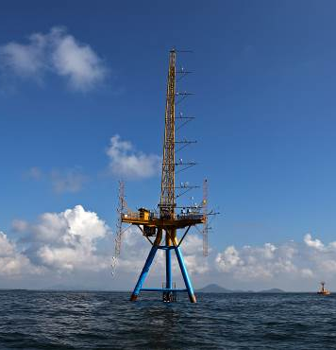
- Atmospheric Boundary-layer Observation Towers: There are two towers along the coastal zone of Guangdong and two over Beibu Gulf and South China Sea. In addition, there are 12 70-m anemometer towers along the coast and offshore in this region.
Figure 1. The boundary-layer observation tower in Maoming.
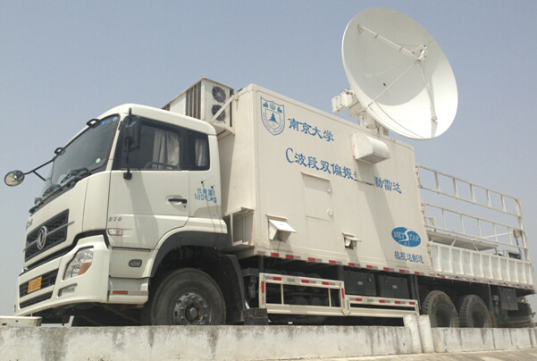
- Airborne observations: The new aircraft from Hong Kong observatory will be flown in TCs that are expected to make landfall within the flight information region (FIR) of Hong Kong. The new Challenger 3605 Bombardier aircraft will be able to collect flight-level temperature, pressure, wind, and humidity observations. The Vaisala dropsonde system has been installed on this aircraft for use in obtaining vertical profiles of wind, temperature and humidity from 11 km to the surface within and around TC’s prior to landfall. The CMA Weather Modification Centre (WMC) MA60 research aircraft will be jointly deployed to obtain detailed in situ measurements of cloud microphysical properties. The WMC MA60 was instrumented for basic-state parameter measurements, and had aboard DMT cloud and precipitation probes for measuring cloud particle imagery, concentration, and size spectra.
Figure 2. C-band mobile polarimetric radar of Nanjing University.
- Mobile dual-polarization radars: One C-band and one X-band dual-polarization radars will be deployed near the coast. The vertically-pointing (Ka-band) millimeter wave, micro-precipitation radars will be used together to detect the vertical distribution of the cloud and precipitation microphysical properties. The vertically-pointing 8 mm, Ka band radar can detect echo intensity, radial velocity, width of the velocity spectrum, and depolarization factor in clouds and light precipitation. This radar, in combination with microwave radiometers, can provide measurements to retrieve hydrometeor phases, drop spectra, water contents, locations of cloud top/cloud base, and vertical airflows. Using the 1.2 cm Ka-band frequency radar in CW (continuous wave) observing mode, the micro-precipitation radars can observe the precipitation parameters such as spectral size distribution of rain particles, water content, and rainfall rate. The multi-channel microwave radiometers can obtain profiles of air temperature, relative humidity, and liquid water continuously in time at heights up to 10 km. The dual-polarimetric radars will work with ground-based distrometers to verify measured polarimetric variables and improve the precipitation estimation.
- Mobile wind profiler: The network of operational and mobile wind profilers can detect the high-frequency variations of the wind fields surrounding precipitating systems, and thus can observe characteristics of the low-level jet (LLJ), low-level convergence, and shear lines. The mobile C-band and X-band dual-polarization radars, Doppler radar, and operational weather radars can be combined to retrieve 3D wind fields of precipitation systems.
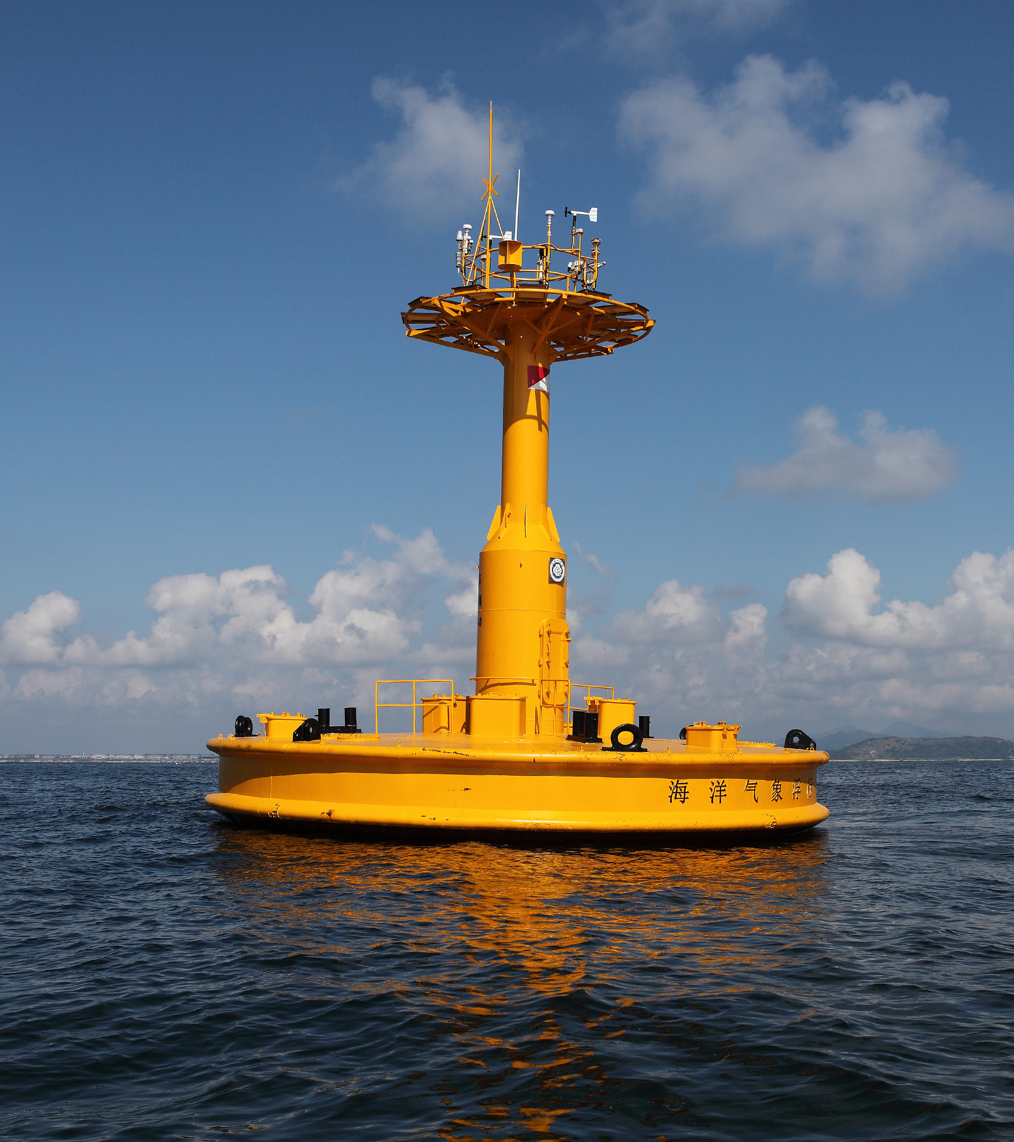
- The marine observation system: The marine meteorological observing systems in Guangdong and Hainan provinces will measure the vertical structure of the atmospheric boundary layer, meteorological parameters at the surface, and marine environmental elements, within the offshore atmospheric marine boundary layer.. The major instrument systems include 100-m boundary layer towers, wind profilers, wind-temperature-humidity gradient observing systems, Doppler velocity profile observing instruments, ocean wave instruments, and buoys.
Figure 3. The marine observation system in Maoming.
- The lightning detection system: The CMA lightning location operation system can monitor lightning events over a large area including the meso-α-scale observing network. The local lightning monitoring network can detect in real time the polarity, types, and characteristics of lightning, and thus provide 3D information of lightning events in the meso-β-scale observing network.
- The mobile sounding system: To obtain atmospheric basic-state parameters, a mobile rocket-based and hydrometeor videosonde sounding system will be deployed in the meso-β or meso-γ scale observing network. The system can collect pressure, temperature, humidity, winds and microphycial structure at heights up to 8 km.

Observation plan
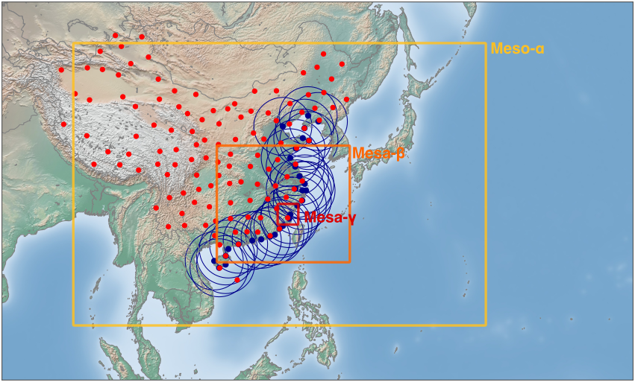
The observational plan is designed to collect data for different research and development tasks related to landfalling TCs. To get a better understanding of TC, it is crucial to have multi-scale and multi-variable observations. The selected observational areas in mainland China will cover Guangdong, Guangxi, Hainan, Fujian, Zhejiang, Shanghai, Jiangsu provinces and the adjacent oceanic areas, such as Taiwan area and the Philippines. The observational regions of the field campaign are composed of three levels of scales (i.e., the meso-α, meso-β, and meso-γ scale). When a potential TC is predicted to pass through the target areas, the corresponding observational network will be activated.
Figure 4. The domain of three nested observational networks used in UPDRAFT.

Meso-α-scale observing network
This network covers the region of Guangdong, Guangxi, Hainan, Fujian, Zhejiang, Shanghai, Jiangsu, Hong Kong and other Asian countries and regions. The main observational instruments are geostationary satellites, radiosonde stations and ground-based GPS water vapor stations. The temporal frequency of the radiosonde observations within this network will be increased from twice to 4 times a day when a potential landfalling TC is approaching during the field campaign. A number of Marine meteorological observatories will be also included as part of this observing network. The data from the meso-α-scale observing network will be collected and analyzed on a daily basis during May -- Sep of the field campaign year.

Meso-β-scale observing network
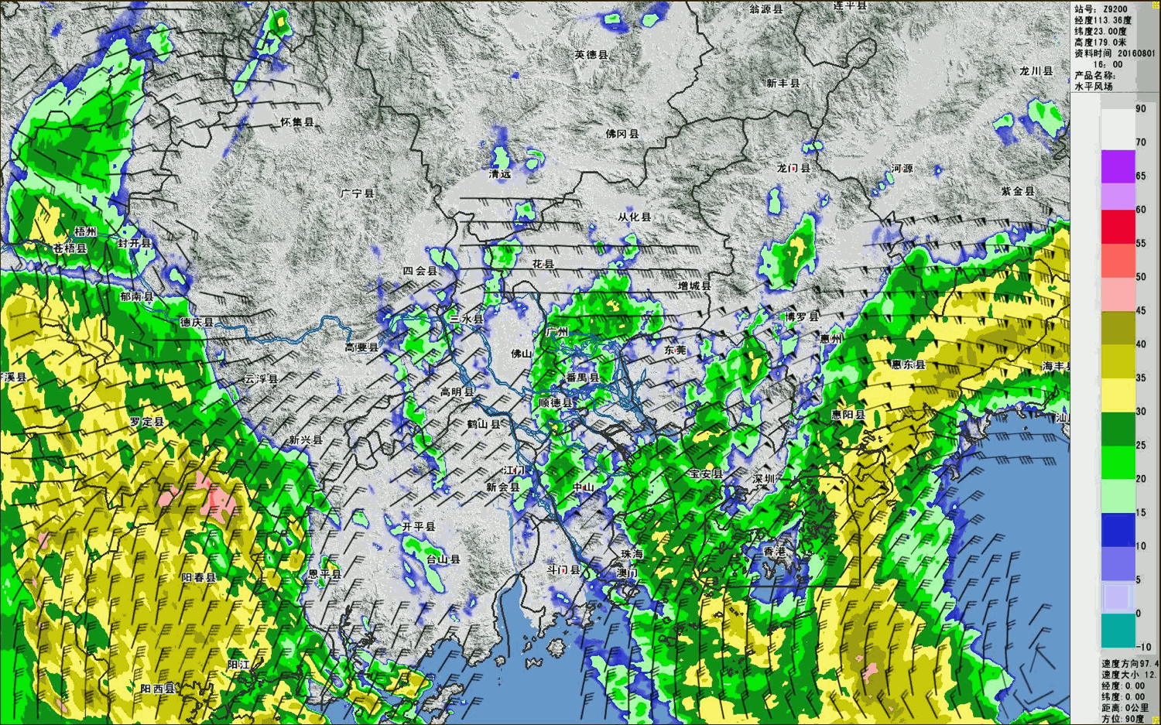
This network mainly covers the coastal provinces with previous landfalling TC records. The main observational instruments used in this network are ground-based S-band Doppler (and dual-polarization) radars. The network will be activated when a TC is within 500 km of the coastal line. The landfalling TC will be first constantly monitored by the satellite and radar mosaic (see Figure 5). The center and storm track will be retrieved from the radar observation. Based on the projected motion of TC, the mobile instruments will be deployed accordingly.
Figure 5. An example of realtime TC tracking and wind analysis by coastal radars.

Meso-γ-scale observing network
Two TC testbed sites at Sansha and Maoming in the coastal area of Fujian and Guangdong Provinces have been built up in last five years, where torrential rainfall occurs most frequently due to frequent landfalling TCs. We will conduct intensive observations on the meso-γ scale, including mobile polarimetric Doppler radars and profiling observational instruments for clouds and precipitation. The focus will be on properties of microphysics (such as hydrometeor phases, droplet spectrums, water contents) and airflow. The observation of this scale will be available when rainfall of a particular TC reaches the area of this network.

Regional coordinated observing network
TCs in the Northwest Pacific Ocean typically affect multiple countries/regions during their lifetime. In order to effectively monitor and forecast TC, it is desirable to have detailed observations during its whole lifetime. In this RDP, real-time data and products sharing between multiple Asian countries/regions including Mainland China, Hong Kong, Taiwan, K orea, Japan and Philippine will be established. It is expected that through this international information sharing, a better forecast of TC and its rainfall can be achieved.
Figure 6. Regional radar mosaic of landfalling TC Nida (2016).

Regional radar mosaic of TC
Weather radars are currently the best observation tools for TC due to its high temporal/spatial resolution and spatial coverage (for S-band radars). Countries/regions in the Northwest Pacific Ocean affected by TC have all established their own radar network for monitoring and forecasting TC. Currently the data of these radar observations are only shared within each country/region. This practice brings difficulty to the monitoring and forecasting of TC for each country/region because of the limited range of single radar and the fast variation of the track and intensity of TC.
In this RDP, a data-sharing center for TC will be established in CMA to share radar data and products from countries/regions (Mainland China, Hong Kong, Twain Korea, Japan and Philippine) in real-time when a TC is affecting the related area. Except for the infrastructure of real-time radar data exchange and storage, CMA will also be in charge of generating a regional radar mosaic for a potentially landfalling TC (see Figure 6). The difference of radar wavelength and the mismatch of scan volumes will be accounted for over overlapped regions. The result of regional radar mosaic will be delivered to all participating countries/regions to be further used in their own assimilation or forecasting systems.

Coordinated field campaign
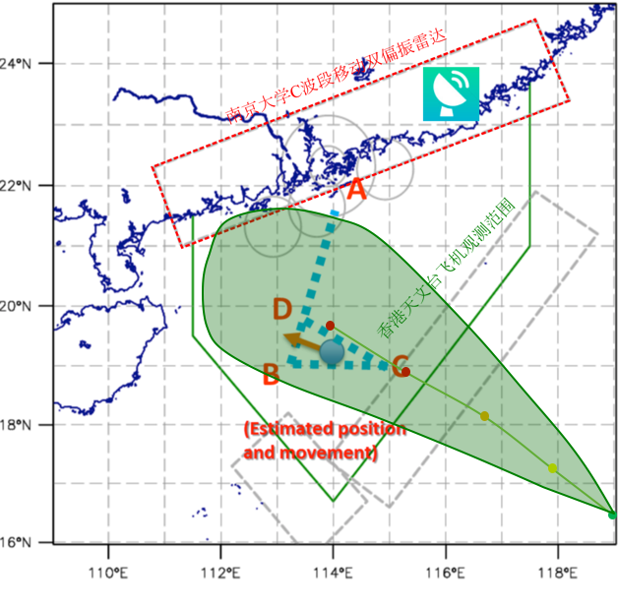
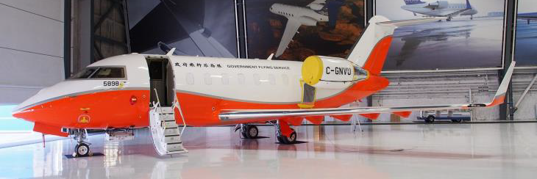
Different countries/regions usually have different set of observation tools. In this RDP, international collaboration makes the field campaign cross the boundaries of countries/regions possible. A coordinated field campaign will be launched once there is a TC near Hong Kong. A Challenger 3605 Bombardier aircraft (see Figure 7) with an in-situ probe and dropsondes and an S-band polarimetric radar from Hong Kong will participate the coordinated field campaign. The participant from Mainland China will act on the notice from Hong Kong. Mobile polarimetric radars, disdrometers and soundings will be deployed near Hong Kong (see Figure 8). Flight plan from Hong Kong will be shared with the participants from Mainland China. The mobile radar from Mainland China will try to observe the regions where the aircraft flies. The in-situ measurements (horizontal and vertical wind) from the aircraft will be verified against the mobile radar observations.
Figure 7. Hong Kong Flying Service Challenger 3605 Bombardier aircraft.
Figure 8. A diagram of coordinated field campaign with HongKong.

Modeling Group
The objective of this group is to configure high spatiotemporal resolution numerical models suitable for predicting landfalling TC rainfall. The preferred horizontal and vertical resolutions are 10 km and 40 levels, respectively. A coupled model is preferred in which the SST is time-dependent.

Identifying processes important to rainfall distribution and intensity
The UPDRAFT plans to test several hypotheses based on limited real-case and idealized simulations in order to identify processes that are important to precipitation characteristics. These hypotheses are:
- Test the sensitivity of rainfall distribution/intensity to various environmental wind shear profiles and moisture distribution;
- Modify CAPE/stability distributions to test impact on convective/stratiform distributions and mode of convection;
- Change surface boundary conditions to reflect urban/non-urban environments and test impact on rainfall intensity and distributions;
- Modify land-surface properties (e.g., soil moisture, vegetation cover) and test impact on rainfall;
- Design experiments to insert/modify/remove topography and conditions of inflowing air (e.g., wind speed, stratification);
- Run cases with different aerosol characteristics and test impact on rainfall;
- Specify different vortex and environmental wind profiles to produce different inertial stability distributions.

Evaluating the model representation of those identified processes
The UPDRAFT plans to evaluate how well the state-of-the-art high-resolution models represent those processes identified important for rainfall distribution and intensity above and further identify the model deficiencies. The evaluation will be conducted for both deterministic and probabilistic forecasts at different model resolutions (e.g., finer horizontal and vertical resolutions). The UPDRAFT will also compare high-resolution NWP results with coarse-resolution model forecasts, and assess the benefit of coarse-resolution ensemble prediction systems in comparison with high-resolution NWP forecast.
One specific and important factor to investigate is the sensitivity of the simulated track, intensity and structure to the surface exchange coefficients. It is planned to use WRF-ARW to conduct sensitivity assimilation using multiple cases. The C_{D} will be formulated in three different ways. The simulated precipitation will be compared with the merged precipitation product to understand the impact of C_{D}.

Improving poorly represented processes in current models
The UPDRAFT will improve the representations of those processes that are not well represented in current models, through modifying several parameterizations. Some key parameterizations are microphysics (e.g. minimum single-moment bulk, double-moment or bin, minimum 5-6 classes), planetary boundary layer (e.g. multi-level, TKE-based scheme), aerosol capability, convective parameterization. The cloud microphysical parameters from the airborne and ground-based measurements will be explored to improve the BMP in mesoscale models.
Although the proposed default horizontal resolution was 10 km, finer spatial resolutions between 1-4 km will be used to resolve PBL processes, such as convective rolls, and study their effects on the characteristics of rainfall. However, at the 1-4 km resolution range, parameterization of PBL turbulence by convectional PBL schemes is no longer adequate or appropriate. This is because PBL schemes are designed to model the ensemble-\spatial-averaged PBL flow, and are unaware of the model horizontal grid spacing. At the O(1 km) spacing range, the grid spacing (or strictly speaking the scale of the spatial filter) is comparable to the dominant length scale of the PBL, such that the most energetic PBL processes (e.g. roll vortices) are partially resolved and partially subgrid-scale. The grid range when PBL schemes break down is known as the PBL gray zone, or the terra incognita.
Recently, several adapted versions of the existing PBL schemes have been implemented since WRF V3.7, these include the modified YSU scheme (Shin and Hong 2015) and the modified MYNN scheme (Ito et al. 2015). The design and testing of both schemes in the original papers were done in dry convective boundary layers. During UPDRAFT, both schemes will be tested in the TC environment with high vertical wind shear and vigorous moist convection. Based on observations made during UPDRAFT, the empirical partition functions, which are the key components to the adaptation, will be optimally tuned. The optimized schemes will then be used to provide high quality simulations of the PBL processes and based on which investigations will proceed. In addition, the coupling and interaction of the adapted PBL schemes with other key parameterizations such as microphysics schemes and land-surface models are also to be investigated and relevant parameters optimized.
The initial storm structure is believed to be crucial for the forecast of TC. The satellite observations hold the advantage of large coverage with high temporal and spatial resolutions over TCs. In this project, we will focus on validating the various algorithms to facilitate optimal utilization of Himawari-8 and FengYun-3 data in a regional data assimilation system. Impacts of Himawari-8 and FengYun-3 radiance assimilation on quantitative precipitation forecasts and typhoon track and intensity forecasts will be assessed in either global or regional numerical weather prediction models. The research tasks include the following: (a) Validating the Himawari-8 and FY-3 measurements by using the European Center for Medium range Weather Forecasting (ECMWF) analysis and Community Radiative Transfer Model (CRTM) or Radiative Transfer for TIROS Operational Vertical Sounder (RTTOV). (b) Developing a quality control algorithm that separate the contaminated pixels from believable pixels for Himawari-8 and FengYun-3, respectively. (c) Testing the performance of the current available satellite data and potential Himawari-8 or FY-3 data assimilation on Typhoon forecasts in the WRF regional model (d) Identifying the contribution of Himawari-8 or FY-3 data to the comprehensive GSI data assimilation system from the other satellite observation or retrieved products. (c) Inter-comparing the performance between the direct assimilation of the satellite radiance and indirection assimilation of the satellite retrieved products

Understanding Group
The goal of this group is to understand the key processes influencing the intensity and distribution of landfalling TC precipitation. Several hypotheses will be tested and investigated in this group.

Determining the role of environmental variables in modifying rainfall distribution
Several studies have investigated the effects that vertical wind shear has on tropical cyclones (TCs) and their precipitation fields. Modeling studies have shown mechanisms by which the downshear and downshear-left regions are favored for upward motion and precipitation. Dry, adiabatic simulations identify two mechanisms for asymmetric vertical motion. Tropical cyclone intensity itself was also related to the amplitude of the asymmetry for TCs. Relative to vertical wind shear, the rainfall asymmetry maximum occurs downshear left (right) in the Northern Hemisphere (Southern Hemisphere) and increases (decreases) with shear strength (TC intensity). This asymmetry seems to depend on different basins. Although these works concluded an agreement that the vertical wind shear affected mainly the rainfall asymmetry of TCs, the extent to which the shear influences the rainfall distribution depends on other factors, such as dry air and TC intensity itself as well. Theoretical and modeling studies have suggested high environmental moisture may be conducive to TC intensification. Dry air intrusion into the storm vortex suppressed convective activity and increased the asymmetry of convection, leading to weakening of TC. However, observation shows that a strong TC does not always generate heavy precipitation. It is not clear how the detailed processes that control the rainfall intensity and distribution take place in strong and weak TCs, respectively. The above mentioned works basically focus on TCs that on the oceans, the rainfall features for landfalling TCs are also worth to be studied in order to improve the forecasting accuracy for this kind of TCs.
Prior to the landfall of a TC, its rainfall area is controlled primarily by the relative magnitude of SST in the TC local environment with respect to the tropical mean SST (that is, the relative SST) (Lin et al., 2015). In the tropics, relative SST strongly regulates the spatial distribution of mid-tropospheric humidity. TCs tend to expand as they move into regions where the mid-tropospheric humidity is high, which closely correspond to regions of high relative SST. But for TCs that make landfall, what factors and how they control the rainfall area of TC is not understood well in the world.
Given the previous results related to the precipitation distribution associated with TCs, and the open questions addressed above, the steps to implement this project are as follows:
1) Investigate and test the factors impact the precipitation distribution of TCs that put forward by previous scientists, such as environmental wind shear, underlying SST, TC intensity itself, environmental humidity etc. Examine the influences of VWS, SST, RH and TC intensity on precipitation distribution of landfalling TCs.
Firstly, we should make an observational analysis of precipitation for TCs prior to, at the time of and after landfall. Then, compare the differences between them and find feature changes along landfall. Then, the previous down-shear-left rainfall results and check the consistency or validity of this results as the TCs make landfall.
2) For rainfall area, examine which factor influences it most significantly.
Firstly, examine these factors, VWS, SST (or relative SST), environmental mid-layer humidity etc. Then investigate the detailed processes related to the nonuniform effects of environmental fields (e.g., the dynamical factors in which quadrant has the most influences). Predict the rainfall area using important factors.
3) In the quadrant of down-shear-left region of TC circulation, examine how far the maximum precipitation away from the TC center. Examine how this distance varies with different TC intensity and environmental conditions.
4) Using numerical simulations to verify observational results and reveal detailed processes that control the rainfall Area (A), Amplitude (P) and Location (L) of TCs. Verify the Hypothesis that the dry air intrusion along with land fall of TC would increase/reduce the eyewall region and promote/inhibit the vertical convection in the inner core region, resulting in an enhanment/decrease of TC precipitation. Examine how other factors such as environmental helicity and inertial stability play significant role in determining the rainfall distribution.

Studying how the thermal and dynamical field controls the rain types
Precipitation bands of varying size and extent typically spiral inward toward the center of a mature tropical cyclone. The most prominent of these rainbands, known as the principal rainband, makes up most of the ‘‘stationary band complex’’. Case studies have noted certain features of the vertical structure and dynamics of rainbands. Specifically, their upwind tips are more convective and their downwind ends more stratiform (Barnes et al. 1983; Hence and Houze 2008), convective cells have an outward-leaning tilt similar to that of the eyewall, and distinctly different microphysical and electrification properties occur in the inner and distant rainbands.
Radar-echo statistics (Hence and Houze, 2012) show that the tropical cyclone rainbands have a two-layered structure, with distinct modes separated by the melting layer. The inner-region rainbands are vertically confined by outflow from the eyewall but nevertheless are a combination of strong embedded convective cells and robust stratiform precipitation, both of which become more pronounced in stronger cyclones. For landfalling TCs, some questions related to the rain types are not answered. Whether the TCs those make landfall have two-layered rainbands as like the partners that do not make landfall. How the microphysical processes control the rain type in the inner-core and outer-core regions of TCs. We should also verify some hypotheses on these questions, such as the how the changes in CAPE, atmospheric stability and potential vorticity control the mode of convection and the partitioning between convective and stratiform rain. Based on observational analyses in which the vertical structure characteristics associated with the landfalling TCs are to be explored, we also plan to use numerical model further to verify the observation results.
1) How are the inner-region rainbands, and the outer-region rainband structures relatively insensitive to changes in storm intensity. 2) What is the combination of particles for the different two layers. Where these particles come from and how they varied with the storm strength. 3) The rainbands in both inner and outer regions are organized with respect to the environmental wind shear vector. We should test the influences of vertical wind shear has on the rainfall asymmetry of TCs, examine which quadrants are more convective in nature and which quadrants are predominantly stratiform. 4) Changes in rainband coverage, vertical structure, and the amount of active convection indicate a change in the nature of rainbands between the regions inward and outward of a radius. We try to find out this radius and give information to the TC rainfall forecast. 5) As shown by Hence and Houze (2012), the stratiform-like precipitation seen in tropical cyclones is as likely occur as a result of ice particles being transported over large distances and slowly falling out than from local growth of particles in mesoscale updraft motion outside of the eyewall. Thus, the stratiform precipitation in the moat region seems most likely to be a combination of echoes from the primary eyewall in some cases. We would examine this hypothesis in different situations such as when the primary eyewall was not entirely circular, or under the situation that the local circulation that has not been completely suppressed is relatively weak. 6) We should convince another hypothesis that the convective processes creating the eyewall are highly resistant to environmental vertical wind shear, with the left-of-shear side being only marginally favored for more intense convection with increasing shear.

Investigating the way of urban effects influencing the rainfall intensity
With the rapid development of urbanization and the ever-increasing urban population in the globe, the urban effect have played a more and more important role in modulating severe weather during recent decades, especially heavy precipitations. Not only the intensity but also the distribution of rainfall in urban regions is closely related with dominant wind, local circulation, topography, water body, buildings, and the property of underlying surface, etc. The precipitation can averagely increase as much as 5%~25% over background values in major cities from observational studies. Furthermore, thunderstorms may happen up to 40% more in these areas and last longer (Huff and Vogel, 1978; Changnon, 1979). However, it is still unclear whether the intensity or distribution of TC-related precipitation can be modulated by urban effects. If so, there is further need to investigate the physical mechanism on how urban effects influencing the TC rainfall.
Urban heat island (UHI) is the most immediate manifesto of urban effects (Manley, 1958). UHI can induce a convergence zone of local airflows from the different temperatures in and around the city. If a storm approached cities, the encounter between the TC circulation and the convergence flow caused by UHI would impact the formation and development of cyclone inner and outer rainbands. On one hand, the storm circulation is relatively weak when one TC locates at a distance from the city. Convective weathers would be triggered over the city because of the urban convergence associated with UHI. On the other hand, the TC rainfall would be enhanced if the storm rainbands met the convergence zone driven by the UHI effect. What detailed processes concerned with the interaction between the storm circulation and the UHI-induced convergence will be investigated in this project.
Besides the UHI effect, the convergence of local airflows that enlarges the TC rainfall can results from the increased surface friction in the city. First, the friction coefficients of the asphalt and concrete surfaces are greater than those of grassland and water. Second, the airflow is blocked due to building barriers (Bornstein and LeRoy, 1990). However, the storm rainfall can be reduced by increased surface friction in the city. It is because the storm intensity is significantly decreased by increasing surface friction. Then the TC radial circulation weakens, suppressing the upward motion and decreasing the precipitation intensity. This project will discuss on how the aforementioned two mechanisms work and their contributions to the TC rainfall change in real cases.
There are several other factors related to urban effects influencing the TC rainfall. First is the human activity in the city. The radiation balance over the city, which is critical to the local weather, is destabilized because of increasing greenhouse gases and anthropogenic aerosols emitted by vehicles and factories. Besides that, the increasing aerosols provide more condensation nuclei in the cloud, which can largely enhance the rainfall intensity. What is more important is that the development of TCs is directly influenced by greenhouse gases and particulate matter pollution (Wang et al., 2014). The storm with delayed development, weakened intensity and early dissipation was found under polluted conditions, associated with an enlarged rainband and increased precipitation (Wang et al., 2014). It is of great value to investigate the detailed structure of TC rainfall change caused by distinct aerosol effects.
Second is the surface flux change due to urbanization. The surface sensible and latent heat fluxes are modified in the city since the underlying surface is made by asphalt and concrete instead of soil and water. The change of surface heat flux can modulate the intensity and structure of storms and further influence the TC rainfall. How the urban surface heat flux impacts the features of storm precipitation will be discussed in this project.

Studying how the PBL processes affect the characteristics of rainfall
While the interaction between landfalling TC and land surface plays an important role in rainfall intensity and distribution, it predominantly takes place in the atmospheric boundary layer. However, most of atmospheric boundary layer and surface turbulent flux parameterization schemes currently employed in numerical models for TC simulation and prediction are slightly modified versions of their original schemes, which have been aimed at boundary layers over homogeneous and even ground surface under low wind speed and low humidity conditions. Simulations and predictions of TC rainfall often deviate away from observations, which is partly attributable to unrealistic and imprecise description of physical processes in the boundary layer by current atmospheric boundary layer and surface turbulent flux parameterization schemes. Therefore furthering our understanding of physical processes in the atmospheric boundary layer would help improve the simulation and prediction of TC rainfall intensity and distribution. To achieve the goal, we plan to carry out the following researches:
- Through analyzing observed turbulent data of landfalling TC, revealing turbulent energy transportation characteristic and turbulent flux exchange efficiency, checking the validity and universality of Monin-Obukhov Similarity Theory in high wind speed and high humidity environment, contributing to solving the problem that simulations based on current turbulence theories are often in bad agreement with observations under high wind speed and high humidity conditions;
- Revealing/analyzing the structures of mean and turbulent airflows and the development of the boundary layer in landfalling TC, checking current methods of deriving the boundary layer height and turbulent diffusion coefficient by comparing simulations with observations of landfalling TC;
- Evaluating the effects of atmospheric boundary layer and surface turbulent flux parameterization schemes on the simulation and prediction of landfalling TC rainfall, including numerical sensitivity tests on major dynamical and thermo-dynamical factors that have significant effects on boundary layer processes;
- Through comparing simulations with observations of landfalling TC rainfall intensity and distribution, improving atmospheric boundary layer and surface turbulent flux parameterizations to help advance the prediction of landfalling TC rainfall.

Investigating the effects of topography-generated phenomena on changing rainfall features
Orographic gravity waves (OGWs), or mountain waves, are generated as stably stratified airflow goes over mountains. The breaking of OGWs can deposit the wave momentum into the mean flow, resulting in the well-known orographic gravity wave drag (OGWD). The deposition of the wave momentum plays an important role in the momentum budget of atmospheric general circulation (Holton 1982). Because OGWs are in general subgrid-scale physical processes, their effect (i.e., OGWD) needs to be parameterized in numerical weather prediction (NWP) and general circulation models (GCMs; Kim et al. 2003).
Current OGWD parameterization exclusively makes use of the single column assumption, namely, OGWs propagate vertically within the model grid cell where the subgrid-scale orography (SSO) is present (Lott and Miller 1997). This assumption is appropriate for two-dimensional (2D) mountain waves. In contrast, three-dimensional (3D) waves can experience significant lateral propagation (Smith 1980), potentially violating the single column assumption. Recently, Eckermann et al. (2015) examined the effect of “horizontal geometrical spreading” for the first time. The wave amplitude was shown to decrease monotonically with height, giving rise to an increase of the wave-breaking level. However, the waves propagating out of the model grid cell was not considered. In addition, 3D mountain waves generated in directional shear wind will encounter selective critical levels during upward propagation (Shutts 1995). The selective critical level filtering could result in a lift force normal to the local mean wind (Xu et al. 2012), which is entirely different from the traditional OGWD.
In this project, we will make effort to improve the parameterization of OGWD in NWP models, by incorporating the horizontal spread of 3D OGWs that have not yet been well represented in existing schemes. In this regard, the approach of Gaussian beam approximation (GBA) is utilized, which is a higher-order ray approximation (Pulido and Rodas 2011)..
- Establishment of theoretical framework. Frist we deduce the asymptotic wave solutions using the GBA method and calculate the wave momentum flux (WMF) that is most relevant in the parameterization of OGWD. The derived solutions are then validated against high-resolution mesoscale numerical simulations. Upon the asymptotic solutions, a new OGWD parameterization scheme is proposed which addresses the vertical propagation of mountain waves.
- Offline test. The new scheme is tested using climate re-analysis data, such as the ERA-interim produced in ECMWF. The 3D effects of mountain waves can be estimated by comparing the new WMF profile with the old one produced by the model. In particular, the scheme will be adopted to address the problem of “missing OGWD near 60°S belt” which has source regions at Southern Andes and the Antarctic Peninsular.
- Operational application. The well-tested scheme is applied to operational models to better represent the realistic OGWD.

Determining how the aerosol characteristics affect different rainfall distributions
Atmospheric aerosol is an important part of earth-atmosphere-ocean system, which not only affects radiation budget by direct and indirect forcings but also provides condensation nuclei in the clouds. The physical features of rain drops, such as distribution, number, size, and hydrophobicity, significantly correlate with aerosol properties. How the rain drops in TCs influenced by different aerosols is still less understood. This project will use the observations from the field experiment to discuss this problem.

Forecasting Group
The objective of this group is to producing high-quality rainfall forecast of landfalling TCs by optimal calibration and consensus techniques. The GPM rainfall products are selected as the benchmark in the UPDRAFT. This group plans to provide quality-controlled rainfall forecast data at three levels. The level I is the raw rainfall forecast products on the GPM grids for individual models. The level II is the calibrated rainfall forecast products of individual centers. The level III is the consensus rainfall forecast product.

Diagnosing and comparing errors in rainfall characteristics from different numerical models
To compare different model results (deterministic vs. probabilistic, coarse-resolution vs. fine-resolution, and so on), multiple deterministic and probabilistic verification methods are carried out to demonstrate different aspects of quantitative precipitation forecasts (QPFs) and probabilistic QPFs (PQPFs), including the root mean square error (RMSE), spatial correlation, discrimination diagram, bias score (frequency bias or systematic bias), equitable threat score (ETS), probability of detection (POD), false alarm ratio (FAR), spread-skill relationship (spread vs. RMSE), continuous ranked probability skill score (CRPSS), Brier skill score (BSS), reliability diagram, area under the relative operating characteristic curve (ROCA) and potential economic value (PEV), etc.
In addition to the above statistical verification scores, the spatial verification methods, in particular object-oriented verification techniques, such as Method for Diagnostic Evaluation (MODE) and Contiguous Rain Area (CRA), are implemented to assess the forecast quality of precipitation distributions. This is very important for high-resolution NWP evaluation, because the traditional verification methods tend to contain double penalty for high-resolution gridded forecasts.
The UPDRAFT will verify both the rainfall products and physical variables from numerical models, including global and regional models as well as deterministic and ensemble models. The key verification techniques are several object-oriented methods, such as Method for Diagnostic Evaluation (MODE) and Contiguous Rain Area (CRA). The UPDRAFT plans to diagnose errors in rainfall size, location, intensity, spatial pattern, and orientation angle, and so on.
1) Rain band appearance verification
For typhoon forecast, the appearance of rain band is probably what the researchers care most. To quantitative identify the forecast errors, the geometric features such as centroid, curvature, and as well as angle of axis of the main rain band will be calculated. The centroid will be used to identify the rain band position errors while the curvature and angle of axis are used to identify the rain band structure errors. Additionally, the total interest will be calculated. Here, the weight of position will be given a smaller value than other properties.
2) Quantitative verification
For typhoon forecast, the precipitation amount could be record-breaking. Most of global models underestimate the extreme value while overestimate the small rainfall. The intensity error is inevitable due to model resolution and unresolved physics processes and as well as the use of smooth terrain. To identify the errors, we will first calculate the traditional neighborhood-based verification scores such as Critical Success Index (CSI), Gilbert Skill Score (GSS). Other skill scores like Fraction Skill Score (FSS) will also be calculated. Additionally, to reduce the impact of forecast intensity bias, the corresponding percentile-based verification scores will also be calculated.
3) The uncertainty of precipitation by global EPS
High-resolution EPSs are usually run as limited-area models (LAM), and uncertainties in initial conditions are considered in operational LAM EPSs. For example, NOAA/NCEP operationally implements short-range ensemble forecasting (SREF, Du et al. 2006) system, downscaled from global ensemble forecast system (GEFS). Yuan et al. (2005) studied short-range probabilistic quantitative precipitation forecasts over the Southwest United States by the RSM Ensemble System, and indicated that the initial perturbations are critical for regional EPS and the initial cycle (0000 UTC or 1200 UTC) also affects the precipitation forecasts. Satio et al. (2012) discussed the effect of lateral boundary perturbations on the breeding method and the local ensemble transform Kalman Filter method for mesoscale ensemble prediction. Also, model uncertainties play an important role in LAM EPSs. The SREF system uses multiple models and parameterization schemes to increase ensemble spread. In addition, uncertainties in observation/analysis and postprocessing precipitation forecasts from EPSs are important (Hamill 2010). The UPDRAFT will assess the effect of initial conditions, lateral boundary conditions, multiple physical parameterizations, and postprocessing in regional EPSs.

Correcting the bias of raw model output rainfall products by various calibration techniques
The UPDRAFT will use both purely statistical and dynamical-statistical methods to calibrate the raw model rainfall products. The former includes regression-based techniques (e.g. least-squares), probability-based techniques (e.g. Frequency Matched Method), Kalman filter, and analog. The latter is primarily based on regressions, such as Perfect Prog (PP) and Model Output Statistics (MOS).

Providing the consensus landfalling TC rainfall forecast
The UPDRAFT tends to combine several calibrated rainfall products from individual operational models into one data set, through regression-based techniques (e.g. least-squares), Ensemble Model Output Statistics (EMOS), and analog.

Data Management group
After collection/organization/quality control of all data collected during several field experiments, a database will be set up in the National Meteorological Information Center (NMIC) of CMA to provide these data along with their uncertainty estimates. For users’ convenience, the data products will be stored in standard, internationally common ‘self-explanatory’ (netcdf or hdf5) formats.
The sharing of data products will follow the WMO guidelines and data policy of CMA. The chief PD/PI has full responsibility to deliver/share all types of data collected during the field campaign and generated from model experiments to all participating members for research purpose related to the project. Although use of the data for other purposes are welcome, any use of the data beyond this project should be with written requests and get approval by WMO and CMA according to data sharing policies and with acknowledgments to this RDP efforts.

Data transmission and collection
Initial data observed by the meteorological operational network including AWSs, radiosounding stations, GPS water vapor stations, weather radars, and satellites will be conveyed to the National Meteorological Information Centre (NMIC) and CAMS in real time. Other (non-operational) data will be collected and organized after the field experiments. The intensive observational data will be shared with all participants in the field campaign.

Processing of the radar measurements
Quality control will be conducted to remove non-meteorological contamination and provide uncertainty estimates of the radar measurements. Disdrometer and rain gauge network observations will be used to map radar reflectivity correction factors for improvement of precipitation estimation accuracy. Procedures and algorithms of quality control will be provided by NMIC and LMSWE, Nanjing University/ MOE. 3D gridded radar reflectivity (at coordinates of longitude, latitude, and altitude) will be produced using the Radar gridding System developed by CAMS.

Retrieval products from remote sensing measurements

Hydrometeor classification
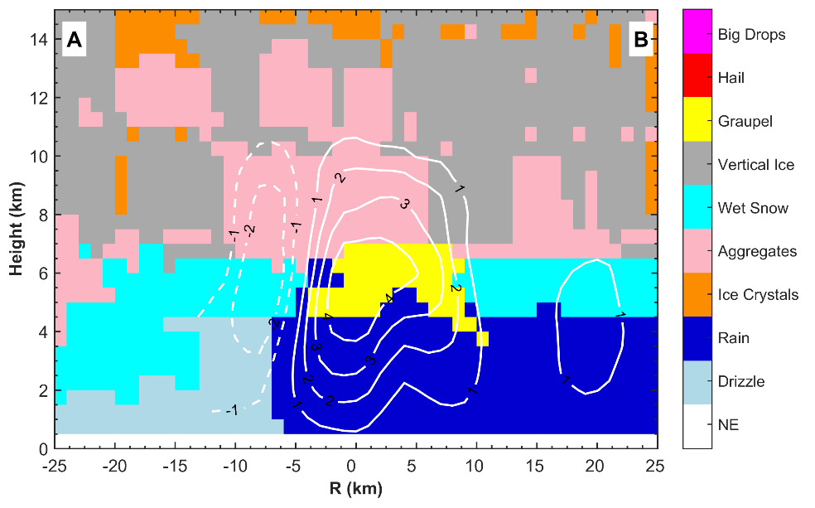
The measurements from dual-polarization radars in UPDRAFT will be used to infer different hydrometeor types in the precipitation system. An enhanced fuzzy-logic algorithm (see Figure 9) developed at the LMSWE of NJU will be applied to the quality-controlled radar observations in realtime. The retrieved products will be verified against ground-based or airborne microphysic in-situ observations. The performance of the retrieval algorithm will be evaluated and possible improvements will be included. The retrieved products will be used to understand the variation of microphysic structure of the precipitation associated with the landfalling TCs.
Figure 9. An example of hydrometero classification of a rainband in Typhoon Nida (2016).

Multiplatform-merged rainfall analysis
Zhuge et al. (2011) developed a daytime 10-min rain rate algorithm based on the Visible and Infrared Spin Scan Radiometer (VISSR)/FengYun-2C observations and rain gauge 10-min measurements. The satellite observation is instantaneous, while the rain rate is also temporally variable, and thus the satellite-based algorithm will be more accurate for the averaged rain rate during a shorter time interval. Therefore, Zhuge et al. (2011) improve the accuracy of satellite rainfall retrieval by using the 10-min gauge rainfall data rather than 1-hr gauge rainfall data as the reference value. However, this rainfall algorithm cannot be extended to the nighttime scene because the useful infrared channels are limited for VISSR/FengYun-2C. Besides, since the intervals of VISSR/FengYun-2C observations were half an hour, to obtain a continuous rain rate estimation every 10 minutes, 10-min-interval imagery sequences should be established by linear interpolation.
The AHI/Himawari-8 has much higher spectral resolutions than the VISSR/FengYun-2C, and provides a chance to develop an all-day rainfall algorithm. Moreover, the time interval between two full disk scans of AHI is 10 min, and it will reduce the retrieval error due to the linear interpolation. The all-day algorithm will includes three steps: 1) all the AHI pixels are divided into different cloud-type groups according to the cloud-top brightness temperature, tri-spectral brightness temperature, 3.9μm reflectance, and so on. 2) The regression equation between the gauge 10-min rain rate and cloud-top temperature is used for every cloud-type group. 3) The 1-hr (3-hr) rainfall is obtained through integrating six (eighteen) consecutive 10-min rainfall retrievals.
The infrared measurements from geostationary satellites provide excellent time and space coverage. The limitation is that the infrared brightness temperature primarily corresponds to cloud-top temperature and, implicitly, cloud height. Such information is poorly correlated to precipitation. In contrast, the passive/active microwave measurements from the polar-orbiting satellites and precipitation satellites have a direct physical connection to the hydrometeor profiles above the surface, but they provide a sparse sampling of the space-time occurrence of precipitation. To solve the problem, a multiplatform-merged rainfall is produced. The multiplatform-merged rainfall analysis is produced in two stages: 1) geostationary infrared estimates are created with microwave calibration; 2) the microwave and infrared are combined such that the microwave estimates are taken “as is” with the infrared estimates used to ﬁll the gaps.

Typhoon intensity Estimation
Broadly speaking, there are two approaches for estimating Tropical Cyclone (TC) intensity from geostationary satellite observations: (1) the convection’s organization level and (2) the convective vigor (e.g., the minimum brightness temperature or the number of pixels with brightness temperature <200K) according to the current literatures. However, one should be careful when using the second approach, because the inner-core convective vigor is more useful for forecasting than initial estimation as demonstrated by Olander and Velden [25]. If the positive relationship between convective vigor and TC current intensity is admitted unconditionally, this means the cyclone should be intense enough when the convection’s extreme case (i.e., the overshooting convection) is detected, which is at variance with the observations and model simulation results. Rozoff et al. (2006) and Wang (2008) argued that the rapid filamentation zone of intense TC would highly distort and even suppress the intense convection. Zhuge et al. (2015) have demonstrated that less than 25% of the TCs above Category 4 in Saffir-Simpson scale are found with the inner-core overshooting convection (the climatological average is approximately 35%) according to the Tropical Rainfall Measuring Mission (TRMM) satellite observations. Therefore, overshooting top may be not suitable to serve as an indicator of TC current intensity.
Because of this, a new technique to estimate TC current intensity based on geostationary satellite infrared window (IRW) and water vapor (WV) imagery will be explored. The WV minus IRW (WV-IRW) imagery is usually used in the overshooting top detection, so an indicator combining the information from IRW and WV-IRW imagery is proposed. This indicator can not only display the inner-core convection’s symmetrization level and vigor, but also is able to screen out overshooting tops from average deep convection. Whether this indicator can further improve the estimation of TC current intensity alongside the existing algorithms will be investigated.

Organization Structure

International Science Steering Committee (ISSC)

The charge for the ISSC
- Develop the UPDRAFT science.
- Develop the international research implementation plan.
- Establish research and development priorities.
- Provide guidance to the participants with regards to priority tasks.
- Establish collaborations between international and local participants on the common interests.
- Provide advice on data handling, computing environment, forecast products, training and verification etc. to international and local technical support team.

The composition of the ISSC
WGTMR
Dr. Robert Rogers
Hurricane Research Division/NOAA
USA
Dr. Johnny Chan
City University of Hong Kong
China
Dr. Ajit Tyagi
Ministry of Earth Sciences
India
WGMWFR
Dr. Hui Yu
Shanghai Typhoon Institute/CMA
China
JWGFVR
Dr. Jing Chen
Chinese Academy of Meteorological Sciences/CMA
China
WGSERA
NEED A PERSON!
UPDRAFT
Dr. Yuan Wang
Nanjing University
China
Dr. Yuqing Wang
University of Hawaii at Manoa
USA
Dr. Noel Davidson
Centre for Australian Weather and Climate Research
Australia

International and Local Technique Support Team (ITeST/LTeST)

The responsibility of the ITeST/LTeST
The ITeST/LTeST is an execution group led by the ISSC and PI to perform routinely the decision and tasks decided and approved by ISSC. Detailed responsibility includes:
- Execute the international and local research implementation plan.
- Manage database for both enhanced data distribution and products collection and dissemination.
- Coordinate with data management and technique support.
- Establish data products display (include website) and perform product verification.
- Conduct user training (include website).
- Coordinate and support annual international and local works.

The composition of the ITeST/LTeST
Observing Group
Dr. Peter Black (observation strategy design and implementation)
Naval Research Laboratory
USA
Dr. Kun Zhao (radar meteorology)
Nanjing University
China
Dr. Dong-In Lee (radar data analysis)
Pukyong National University
South Korea
Dr. Hiroshi Uyeda (dropsonde observation design and analysis)
Nagoya University
Japan
Dr. Ben Jou (radar data analysis)
National Taiwan University
Taiwan
Dr. Wai-Kim Wong (nowcasting and numerical simulation)
Hong Kong Observatory
China
Dr. Xiaotu Lei (TC dynamics and observation)
Shanghai Typhoon Institute/CMA
China
Dr. Jian Huang (TC dynamics and landfalling process)
Tropical Meteorology Institute/CMA
China
Dr. Liping Liu (Microphysical process observation and simulation)
Chinese Academy of Meteorological Sciences/CMA
China
Dr. Xiaowen Tang (radar data analysis)
Nanjing University
China
Modeling Group
Dr. Noel Davidson (improving convective parameterization)
Centre for Australian Weather and Climate Research
Australia
Dr. Yuqing Wang (sensitivities to various environmental conditions)
University of Hawaii at Manoa
USA
Dr. Ming Xue (improving microphysics processes)
Nanjing University
China
Dr. Baojun Chen (microphysical process analysis)
Nanjing University
China
Dr. Xuejin Zhang (sensitivities to the land surface properties and improving the land surface model)
Hurricane Research Division/NOAA
USA
Dr. Vijay Tallapagbada (sensitivities to aerosol characteristics and improving aerosol capability)
Environmental Modeling Center
USA
Dr. Hiroyuki Yamada (sensitivities to topography)
Japan Agency for Marine-Earth Science and Technology
Japan
Dr. Qilin Wan (sensitivities to the urban surface boundary)
Tropical Meteorology Institute/CMA
China
Dr. Suhong Ma (improving the PBL scheme)
National Meteorological Centre/CMA
China
Dr. Huiling Yuan (identify high resolution model deficiencies)
Nanjing University
China
Dr. Kefeng Zhu (evaluate high-resolution models representation of those identified processes)
Nanjing University
China
Understanding Group
Dr. Robert Rogers (aircraft observations analysis)
Hurricane Research Division/NOAA
USA
Dr. Liguang Wu (climate change of tropical cyclone activity)
Nanjing University of Information Science and Technology
China
Dr. Johnny Chan (tropical cyclone and monsoon climate)
City University of Hong Kong
China
Dr. Jeff Kepert (boundary layers and turbulence)
Centre for Australian Weather and Climate Research
Australia
Dr. Mark Lander (tropical climate and climate variability)
University of Guam
USA
Dr. Juan Fang (intensity and structure change of tropical cyclones)
Nanjing University
China
Dr. Shoujuan Shu (genesis of tropical cyclones)
Nanjing University
China
Dr. Xin Xu (meteorological data analysis)
Nanjing University
China
Forecasting Group
Dr. Hui Yu (tropical cyclone forecasting theory and technique)
Shanghai Typhoon Institute/CMA
China
Dr. Bowen Zhou (meteorological data analysis and processing)
Nanjing University
China
Dr. Guifu Zhang (Radar polarimetry for quantitative precipitation estimation and forecast)
University of Oklahoma
USA
Dr. Xiaoyong Zhuge (satellite-based retrieval of tropical cyclone rainfall)
Nanjing University
China
Dr. Jie Ming (forecast product verification)
Nanjing University
China
Dr. Jinjie Song (statistical weather forecasting theory and technology)
Nanjing University
China
Data Managing Group
NEED PERSONS!

Reference:
Barnes, G. M., E. J. Zipser, D. Jorgensen, and F. Marks Jr., 1983: Mesoscale and convective structure of a hurricane rainband. J. Atmos. Sci., 40, 2125–2137.
Bomstein, R., and M. LeRoy, 1990: Urban barrier effects on convective and frontal thunderstorms. Fourth AMS Conference on Mesoscale Processes, Boulder, CO.
Bougeault, P., Z. Toth, C. Bishop, B. Brown, D. Burridge, D.-H. Chen, B. Ebert, M. Fuentes, T. M. Hamill, K. Mylne, J. Nicolau, T. Paccagnella, Y.-Y. Park, D. Parsons, B. Raoult, D. Schuster, P. Silva Dias, R. Swinbank, Y. Takeuchi, W. Tennant, L. Wilson, and S. Worley, 2010: The THORPEX interactive grand global ensemble. Bull. Amer. Meteor. Soc., 91, 1059–1072.
Brown, B. G., L. Holland, J. E. H. Gotway, R. Bullock, D. A. Ahijevych, E. Gilleland, and C. A. Davis, 2007: Application of the MODE object-based verification tool for the evaluation of model precipitation fields 22nd Conf. Wea. Anal. Forecasting/18th Conf. Num. Wea. Pred., Salt Lake City, Utah, Amer. Meteor. Soc., Paper 10A.12.
Changnon, S., 1979: Rainfall changes in summer caused by St. Louis. Science, 205, 402-404.
Davis, C., B. Brown, and R. Bullock, 2006a: Object-based verification of precipitation forecasts. Part I: Methodology and application to mesoscale rain areas. Mon. Wea. Rev., 134, 1772-1784.
Davis, C., B. Brown, and R. Bullock, 2006b: Object-Based Verification of Precipitation Forecasts. Part II: Application to Convective Rain Systems. Monthly Weather Review, 134, 1785-1795.
DTC, 2009: Model Evaluation Tools Version 2.0 (METv2.0) User's Guide.
Ebert, E. E., 2008: Fuzzy verification of high-resolution gridded forecasts: A review and proposed framework. Meteorol Appl, 15, 51-64.
Eckermann, S. D., J. Ma, and D. Broutman, 2015: Effects of horizontal geometrical spreading on the parameterization of orographic gravity wave drag. Part I: Numerical transform solutions. J. Atmos. Sci., 72, 2330–2347.
Elsberry, R. L., and P. A. Harr, 2008: Tropical Cyclone Structure (TCS08) field experiment science basis, observational platforms, and strategy. Asia Pac. J. Atmos. Sci., 44, 209–231.
Hence, D. A., and R. A. Houze Jr., 2008: Kinematic structure of convective-scale elements in the rainbands of Hurricanes Katrina and Rita (2005). J. Geophys. Res., 113, D15108, doi:10.1029/2007JD009429.
Hence, D. A., and R. A. Houze Jr., 2012: Vertical structure of tropical cyclones with concentric eyewalls as seen by the TRMM Precipitation Radar. J. Atmos. Sci., 69, 1021–1036.
Holton, J. R., 1982: The role of gravity wave drag and diffusion in the momentum budget of the mesosphere. J. Atmos. Sci., 39, 791–799.
Houze, R. A. Jr., J. Cetrone, S. R. Brodzik, S. S. Chen, W. Zhao, W.-C. Lee, J. A. Moore, G. J. Stossmeister, M. M. Bell, and R. F. Rogers, 2006: The hurricane rainband and intensity change experiment: Observations and modeling of Hurricanes Katrina, Ophelia, and Rita. Bull. Amer. Meteor. Soc., 87, 1503–1521.
Houze, R. A. Jr., S. S. Chen, B. F. Smull, W. C. Lee, and M. M. Bell, 2007: Hurricane intensity and eyewall replacement, Science, 315, 1235-1239.
Huff, F., and J. Vogel, 1978: Urban, topographic and diurnal effects on rainfall in the St. Louis region. J. Appl. Meteorol., 17, 565-577.
Ito, Junshi, Hiroshi Niino, Mikio Nakanishi, and Chin-Hoh Moeng. 2015. “An Extension of the Mellor-Yamada Model to the Terra Incognita Zone for Dry Convective Mixed Layers in the Free Convection Regime.” Boundary-Layer Meteorology 157 (1): 23–43.
Johannes, J., F. Christoph, and S. Cornelia, 2008: Quantile-based short-range QPF evaluation over Switzerland. Meteorologische Zeitschrift, 17, 827-848.
Kim, Y. J., S. D. Eckermann, and H. Y. Chun, 2003: An overview of the past, present and future of gravity-wave drag parametrization for numerical climate and weather prediction models. Atmos.–Ocean, 41, 65–98.
Lott, F., and M. Miller, 1997: A new sub-grid orographic drag parameterization: Its formulation and testing. Quart. J. Roy. Meteor. Soc., 123, 101–127.
Manley, G., 1958: On the frequency of snowfall in the metropolitan England. Q. J. R. Meteorol. Soc., 84, 70-72.
Montgomery, M. T., C. Davis, T. Dunkerton, Z. Wang, C. Velden, R. Torn, S. J. Majumdar, F. Zhang, R. K. Smith, L. Bosart, M. M. Bell, J. S. Haase, A. Heymsfield, J. Jensen, T. Campos, and M. A. Boothe, 2012: The Pre-Depression Investigation of Cloud-Systems in the Tropics (PREDICT) Experiment: Scientific basis, new Analysis tools, and some first results. Bull. Amer. Meteor. Soc., 93, 153–172.
Pulido, M., and C. Rodas, 2011: A higher-order ray approximation applied to orographic waves: Gaussian beam approximation. J. Atmos. Sci., 68, 46–60.
Rezacova, D., Z. Sokol, and P. Pesice, 2007: A radar-based verification of precipitation forecast for local convective storms. Atmospheric Research, 83, 211-224.
Rogers, R., S. Aberson, M. Black, P. Black, J. Cione, P. Dodge, J. Gamache, J. Kaplan, M. Powell, J. Dunion, E. Uhlhorn, N. Shay, and N. Surgi, 2006: The Intensity Forecasting Experiment: A NOAA multiyear field program for improving tropical cyclone intensity forecasts. Bull. Amer. Meteor. Soc., 87, 1523–1537.
Rogers, R., and coauthors, 2013: NOAA'S Hurricane Intensity Forecasting Experiment: A progress report. Bull. Amer. Meteor. Soc., 94, 859–882.
Shin, H. H., and S.-Y. Hong. 2015. “Representation of the Subgrid-Scale Turbulent Transport in Convective Boundary Layers at Gray-Zone Resolutions.” Monthly Weather Review 143 (1): 250–71.

on tropical cyclones. Nature Climate Change, 4, 368-373.
Shutts, G. J., 1995: Gravity-wave drag parametrization over complex terrain: The effect of critical level absorption in directional wind-shear. Quart. J. Roy. Meteor. Soc., 121, 1005–1021.
Smith, R. B., 1980: Linear theory of stratified flow past an isolated mountain. Tellus, 32, 348–364.
Torn R. D., and G. J. Hakim, 2009: Ensemble data assimilation applied to RAINEX observations of Hurricane Katrina (2005). Mon. Wea. Rev., 137, 2817–2829.
Wang, Y., K. Lee, Y. Lin, M. Levy, and R. Zhang, 2014: Distinct effects of anthropogenic aerosols
Wilks, D. S., 1995: Statistical Methods in the Atmospheric Sciences. Academic Press, 464 pp.
Xu, X., Y. Wang, and M. Xue, 2012: Momentum flux and flux divergence of gravity waves in directional shear flows over three-dimensional mountains. J. Atmos. Sci., 69, 3733–3744.
Zhu, K., Y. Yang, and M. Xue, 2015: Percentile-based neighborhood precipitation verification and its application to a landfalling tropical storm case with radar data assimilation. Adv Atmos Sci, 32, 1449-1459.

