Numerical Simulation of Storm Surge along Sri Lanka Coast

I. M. S. P. Jayawardena
Department of Meteorology
Sri Lanka
(shirojaya2000@yahoo.com)

Keywords: Numerical model / Storm surge / cyclonic storms / depressions

- Introduction

During the months of November to December, depressions forming in the Bay of Bengal tend to intensify into cyclonic storms and move closer to Sri Lanka bringing much rain and wind; but chances of land fall along east coast are low. During the past 132 year period (1881- 2013), only eleven cyclonic storms and five severe cyclonic storms crossed the coasts of Sri Lanka (Fig 1). Although the frequency of landfall of cyclonic storms in Sri Lanka is not high, the coastal regions suffer in terms of loss of life and property caused by the surges. Storm surge disasters cause heavy loss of life and property, damage to the coastal structures and the losses of agriculture, which lead to annual economic losses in affected countries. Death and destruction arise directly from the intense winds characteristics of tropical cyclones blowing over a large surface of water, which is bounded by a shallow basin. As a result of these winds the massive piling of the seawater occurs at the coast leading to the sudden inundation and flooding of coastal regions. The number of causalities would be much lower if these surges could be predicted reasonably well in advance allowing effective warnings and evacuations in the threatened areas.

The main objective this study is to simulate the surges generated by cyclonic storms which struck the Sri Lanka coast using location-specific fine resolution model developed by IIT.

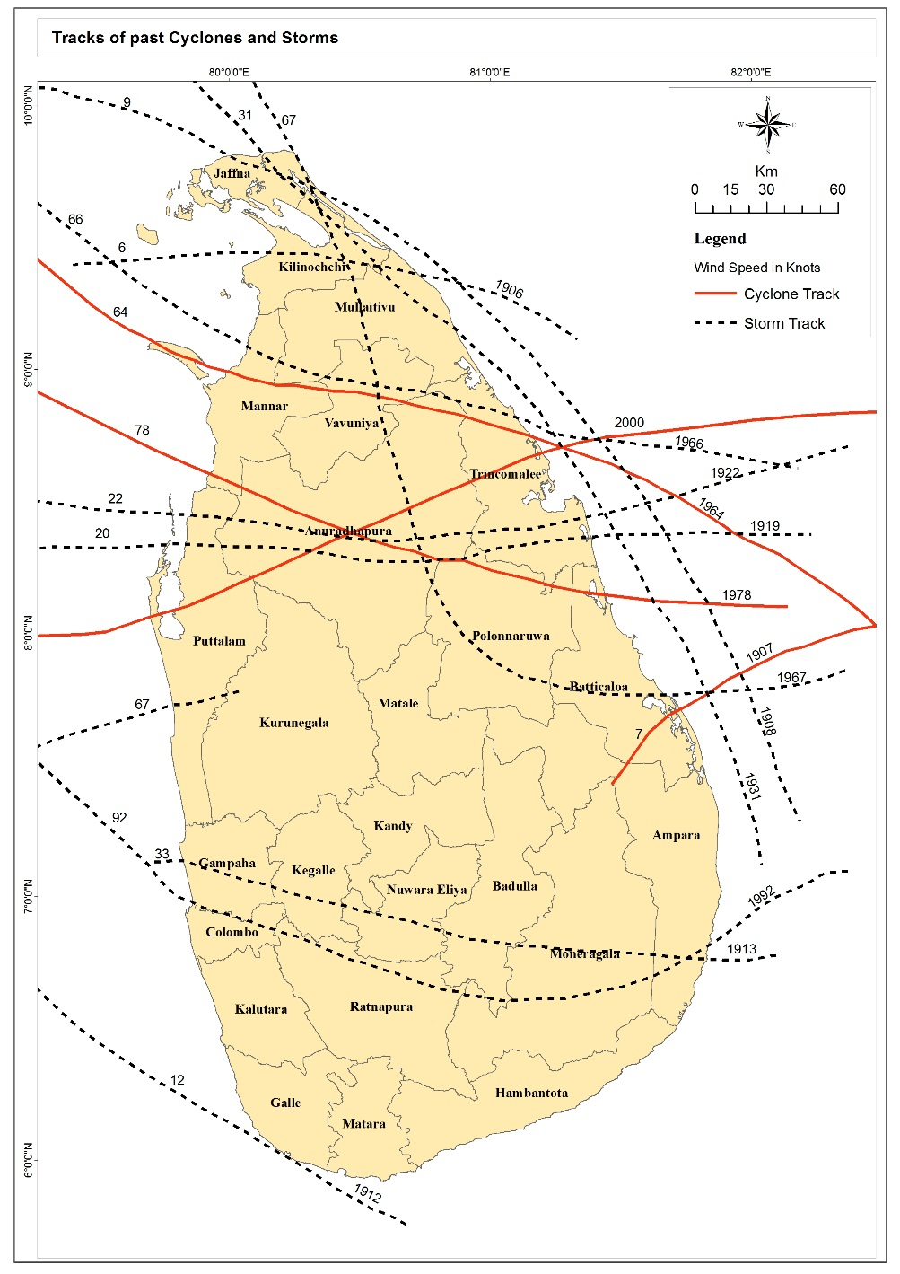
Fig 1. Tracks of past Cyclonic storms

- Methodology

The Storm Surge Model developed by the Indian Institute of Technology (IIT) is used for this study. Location–specific, high-resolution numerical models have been developed at Indian Institute of Technology Delhi (IITD) for predicting storm surges in the Bay of Bengal and the Arabian Sea (Chittibabu et al., 2000; Dube et al., 1994; Dube et al., 2004; Johns et al., 1985).
Surface winds associated with a tropical cyclone are derived from a dynamic storm model (Jelesnianski and Taylor, 1973). The model has been mostly applied to studies over Bay of Bengal area (Jain et al. 2006a, b; Chittibabu et al. 2002).

Input parameters for the model include the oceanographic parameters, meteorological parameters (including storm characteristics), hydrological input, basin characteristics and coastal geometry, wind stress and seabed friction and information about the astronomical tides. It has been seen that in many cases these input parameters strongly influence the surge development. The only meteorological inputs required for the model are the positions of the cyclone, pressure drop and radii of maximum winds at any fixed interval of times (Dube and Murty, 2003). Available data from Department of Meteorology (DOM), Sri Lanka, Indian Meteorological Department (IMD) Best track data and Joint Typhoon Warning Center (JTWC) best track data are used as meteorological input data for the model.

In order to validate IIT storm surge model several experiments were performed with past severe cyclonic storms land falling at Sri Lanka coast. Simulated maximum surge has been compared with available observations. The simulation was performed on the domain covering the area 77°E to 84°E and 5° to 12°N. The horizontal resolution for this study is set at 3 km at a time step of 30 seconds.

- Results and Discussion

3.1 December 2000 Cyclone (23-26 December):

The Very Severe Cyclonic Storm (23-26 December) had its origin over Southwest Bay as a depression at 12 UTC of 23rd when it lay centered near 8.0˚N / 85.0˚E. It further intensified into Severe Cyclonic storm at 12 UTC of 25th and rapidly into a very severe cyclonic storm by 18 UTC of 25th near 8.5˚N /82.5˚E with a clearly visible “eye” having a diameter of about 35 km (Fig 2) . It made landfall over the east coast of Sri Lanka on 26th December 2000, and emerged into the Gulf of Mannar on the West coast on 27th December 2000 and then moved in a westerly direction. Eight people were left missing and feared dead.
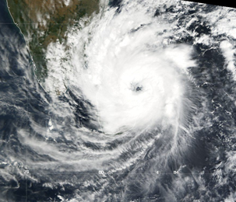
Fig 2. Tropical Cyclone near landfall on Sri Lanka on December 26, 2000

The amplitude of surge generated by this Cyclone using IIT Model with IMD Best track data and JTWC best track data is given in Figure 3a and 3b respectively. The maximum surge height simulated by IIT model with IMD Best track data and JTWC best track data is 1.6m and 0.97m respectively.
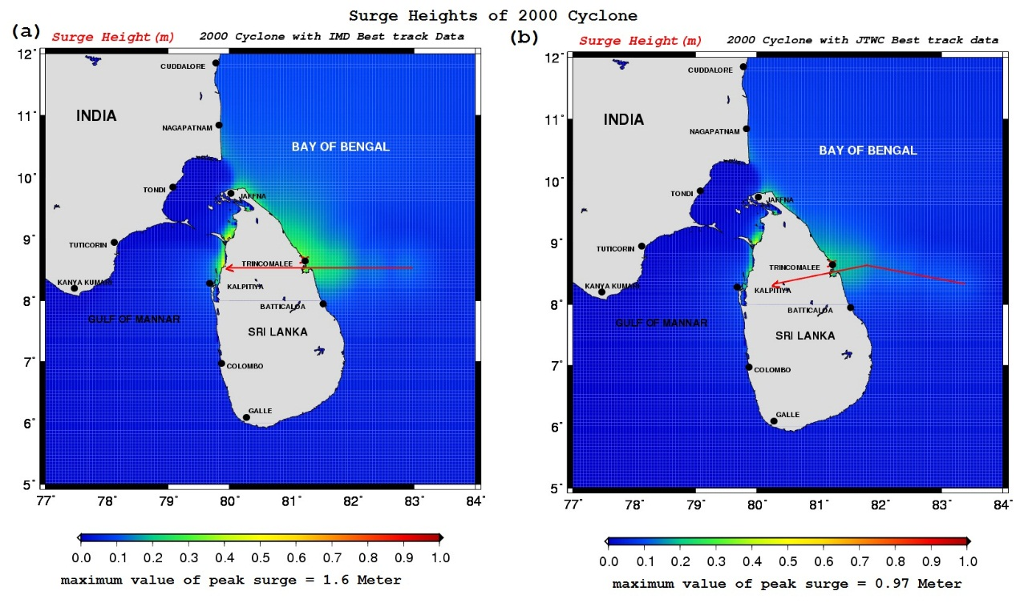
Figure 3: Surge generated by December 2000 Cyclone (Simulated using IIT Model with IMD Best track data (a), and JTWC best track data (b) )

3.2 November 1978 Cyclone (19-29 November):

This is another severe cyclonic storm which affected Sri Lanka and southern Indian peninsula. This system was initially developed as a depression on 17th November with its center near 6.5º N ,92.5º E. Moving slowly northwestwards, it intensified into a cyclonic storm near 8º N ,91ºE on 20th and intensified further into a severe cyclonic storm on 21st when it was centered near 7.5º N, 88.5ºE. The storm progressively intensified further and took a west-southwesterly direction and later a northwesterly course and crossed Sri Lanka coast on 23rd night near Batticoloa. According to satellite images the storm reached its peak intensity on 23rd morning and the estimated maximum winds were 116 knots. The 1978 cyclone alone affected more than one million people, killed nearly a thousand persons, partially and completely damaged nearly 250,000 houses.

The maximum surge height simulated by IIT model with available data from DOM, Sri Lanka and JTWC best track data is 1.95m and 0.82m respectively (Fig 4a and 4b). While using available data from DOM, Sri Lanka which gives the maximum winds as 116 knots the maximum surge height simulated by IIT model is in good agreement with reported observations which is 2m. According to the JTWC data, maximum winds are 90 knots and that is the reason for giving less storm surge height.

3.3 1992 Cyclone (06-17 November):

A disturbance over the South China Sea became a weak tropical depression on November 6. It moved westward, crossing the Malay Peninsula and entering the Bay of Bengal on the 8th. On the 11th, the system became Tropical Storm, and hit southern Sri Lanka as a 55 knots storm on the 12th. The next day it became a cyclone with a peak of 70 knots winds before hitting southern India. The maximum surge height simulated by IIT model over south east coast of Sri Lanka is 0.4m and over southern coast of India is 0.84m (Fig 5).

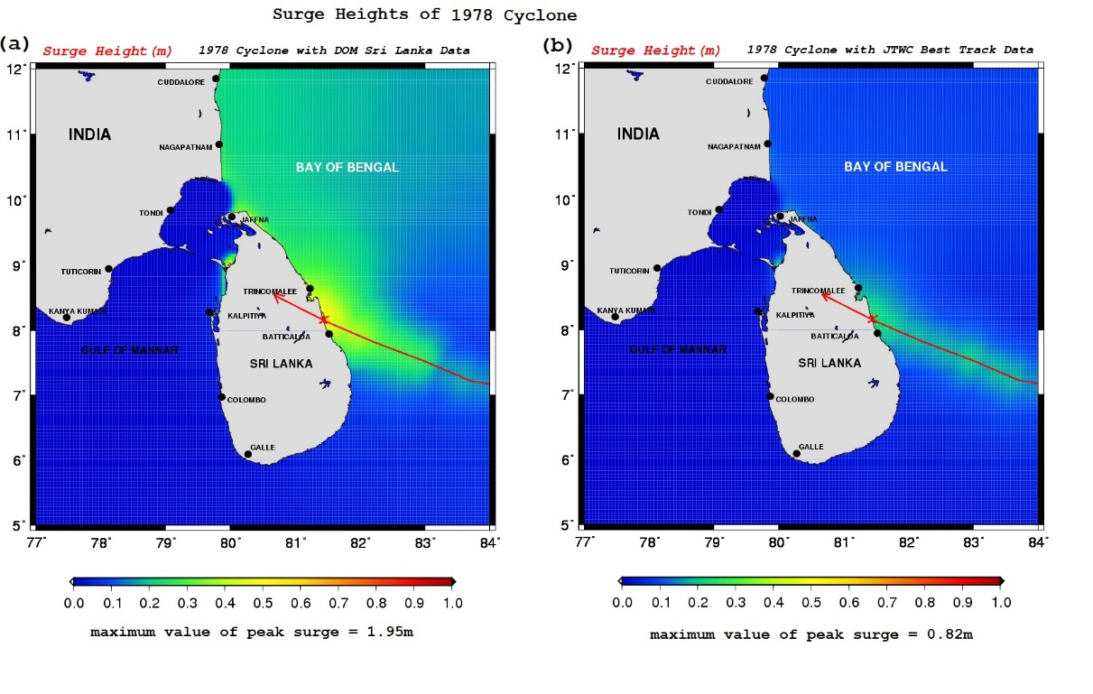
Figure 4: Surge generated by November Cyclone (Simulated using IIT Model with DOM, Sri Lanka available data (a), and JTWC best track data (b) )

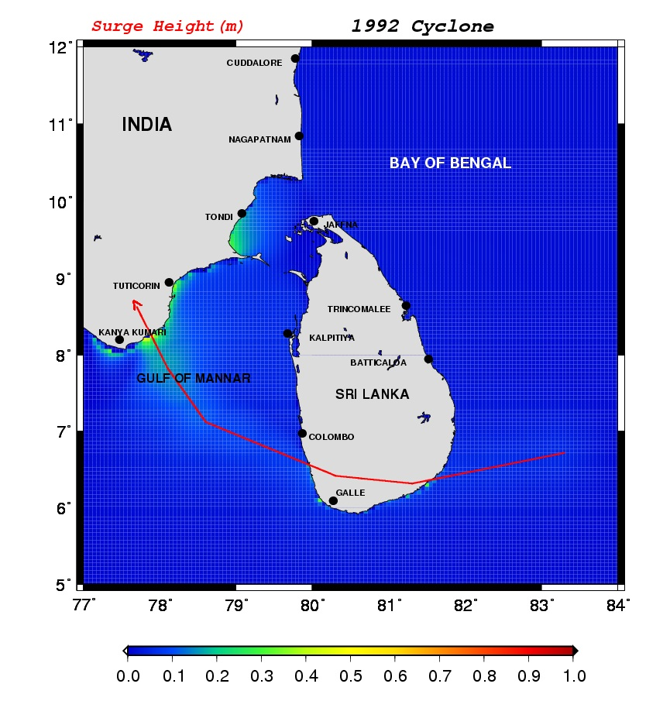
Figure 5: Surge generated by 1992 November Cyclone (Simulated using IIT Model)
3.4 1993 Cyclone (Occurrence of surge as indirect effect of a cyclone moving close to Sri Lanka (27 November-05 December))

IIT storm surge model is simulated to see the possibility of occurrence of surge as indirect effect of a cyclone moving close to Sri Lanka.

A disturbance over the South China Sea became a weak tropical depression on November 27. It moved westward, crossing the Malay Peninsula and entering the Bay of Bengal on the 29th. The system has intensified further in to a tropical storm by 1st December and started to move in West-northwest direction. On the 03rd, the system has further intensified in to a Tropical cyclone, and hit Southern India near Karaikal region on 4th December 1993. Even though the cyclone didn't hit, its path was very close to Sri Lanka.

Model simulation shows that the onshore wind component of the cyclone produce surge with 0.5m height between Mannar, Veravil and Poonerin in North-northwest coast where bathymetry is very shallow (Fig 6).
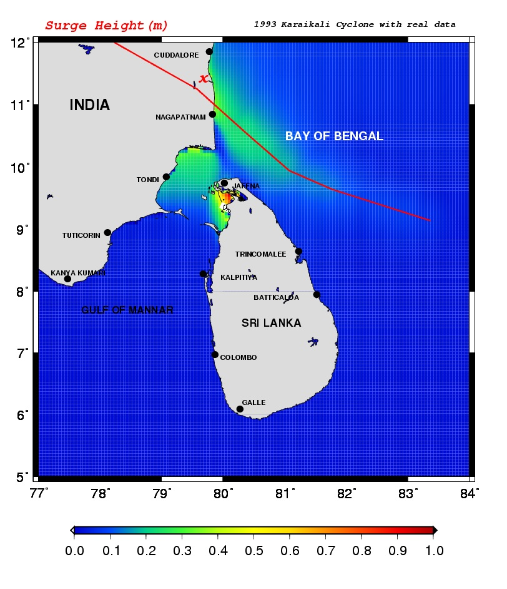
Figure 6: Surge generated by 1993 Karaikali Cyclone (Simulated using IIT Model)

- Conclusion

IIT storm surge model has been extensively used to simulate surge generated by severe cyclonic storms hitting Sri Lanka coast. Comparison of simulated surge with available observations was made for the cases of December 2000 Cyclone, November 1978 Batticaloa Cyclone, and 1992 Cyclone. These experiments gave a good confidence to run the model for predicting surges in Sri Lanka coast. In addition to those IIT storm surge model was simulated to see the possibility of occurrence of surge as indirect effect of a cyclone which moved close to Sri Lanka.

The model computed surges are in general agreement with the available observational estimates. The IIT model will provide useful guidance for the forecasters and forecasting of storm surge height will provide useful information for early warnings and evacuation preparations for the coastal communities to reduce the hazards

Acknowledgement:
This study was supported by the TCP Training Programme of World Meteorological Organization (WMO) organized at Indian Institute of Technology (IIT) Delhi. The author is extremely grateful to Prof. S. K. Dube, and Prof A. D. Rao for their valuable guidance, institutional, technical and moral support in learning storm surge modelling.

References

Chittibabu P, Dube SK, Rao AD, Sinha PC, Murty TS (2000) Numerical simulation of extreme sea levels using location specific high resolution model for Gujarat coast of India. Mar Geod 23:133–142.

Chittibabu P, Dube SK, Rao AD, Sinha PC, Murty TS (2002) Numerical simulation of extreme sea levels for the Tamilnadu (India) and Sri Lanka coasts. Mar Geod 25:235–244.

Dube SK, Sinha PC, Rao AD, Rao GS (1985a) Numerical modelling of storm surges in the Arabian Sea. Appl Math Model 9:289–294

Dube SK, Sinha PC, Roy GD (1985b) The numerical simulation of storm surges along the Bangladesh coast .Dyn Atmos Oceans 9:121–133.

Dube SK and Murty TS (2003) “Strom Surge in the bay of Bengal” Workshop on Wind wave and Storm Surge Analysis and Forecasting for Caribbean Countries

Dube SK, Chittibabu P, Sinha PC, Rao AD, Murty TS (2004) Numerical modeling of storm surges in the head Bay of Bengal using location specific model. Nat Hazards 31:437–453.

Jain I, Chittibabu P, Agnihotri N, Dube SK, Sinha PC, Rao AD (2006a) Simulation of storm surges along Myanmar coast using a location specific numerical model. Nat Hazards 39:71–82.

Jain I, Chittibabu P, Agnihotri N, Dube SK, Sinha PC, Rao AD (2006b) Numerical storm surge prediction model for Gujarat coast of India and adjoining Pakistan coast. Nat Hazards 42:67–73.

Jelesnianski CP, Taylor AD (1973) NOAA Technical Memorandum. ERL, WMPO-3, 33 pp

Johns B, Rao AD, Dube SK, Sinha PC (1985) Numerical modelling of the tide surge interaction in the Bay of Bengal. Philos Trans R Soc Lond A 313:507–535.

