WWW/CAS/WWW
SEVENTH INTERNATIONAL WORKSHOP ON TROPICAL CYCLONES
1.1 Environmental Impacts on Tropical Cyclone Structure and Intensity Change

Rapporteur: Jenni L. Evans
The Pennsylvania State University
Department of Meteorology
503 Walker Building
University Park, PA 16802 USA
Email: evans@meteo.psu.edu
Phone: +1+814+865 3240

Working group: E. Atallah, L. Avila, S. A. Braun, A. Burton, J. Callaghan, J. C. L. Chan, K. Cheung, M. D. Eastin, G. Elliott, K. A. Emanuel, J. R. Gyakum, E. A. Hendricks, J. A. Knaff, M. E. Kucas, G. M. Lackmann, M.-D. Leroux, L. M. Leslie, M. S. Peng, M. Plu, E. D. Rappin, J. Schwendike, B. Tang, K. Tory, B. Wang, Y. Wang

1.1.1. Introduction
Over the last decades, great progress has been made in understanding and forecasting tropical cyclone (TC) motion. Similarly, advances in ensemble forecasting and a number of field experiments have motivated explorations of TC predictability. However, in spite of these endeavours, the understanding of the TC response to its environment remains fragmented. One consequence of this is a persistent lack of TC structure forecasting skill (Avila pers. comm. 2010). Forecasts of TC structure change are restricted to intensity and surface wind metrics. Wind radii are difficult to analyse and currently are virtually impossible to verify quantitatively, although new approaches are showing some promise in weaker wind zones (Emanuel pers. comm. 2010). These forecasts have low utility, as any errors in the radii forecasts are typically masked by the much larger track errors (Avila pers. comm. 2010). These forecasting challenges are being met with concerted research efforts, many of which are described here.

1.1.2. Environmental impacts on tropical cyclone intensity change
Several environmental parameters are considered to evaluate whether TC intensification is likely. Dominant among these are the upper ocean heat content (OHC), the vertical shear of the environmental wind, interactions with other weather systems, impacts of dry air and landfall (Avila, pers. comm. 2010). While (for example) a TC moving toward an area of high shear would be expected to weaken or even to dissipate, our understanding of the processes involved – and our ability to observe and model these processes – has great room for improvement!

1.1.2.1. Broadscale environmental impacts on intensity change
Impacts of environmental vertical wind shear on tropical cyclones are generally (although not exclusively) expected to be detrimental to the continued development or maintenance of the storm as quantified either by intensity or structure metrics. One potential mechanism for the negative impacts of a sheared environment on a TC is the “ventilation effect” first proposed by Simpson and Riehl (1958): shear-induced development of mid-level, storm-relative flow imports low entropy air from the environment into the TC core, suppressing the convection and so reducing the surface-flux induced heating. Tang and Emanuel (2010) developed a set of idealized experiments to isolate the effects of this shear-induced ventilation on TC intensity. The reference framework is a steady, axisymmetric vortex in a slantwise neutral environment. The key findings are that ventilation decreases the maximum steady-state intensity below the potential intensity, and so imposes a minimum intensity below which a TC will unconditionally decay (Fig. 1); in this framework, one can determine an upper ventilation bound beyond which no steady TC can exist. Strongest intensification for all normalized intensities occurs with little to no ventilation (long blue arrows; Fig. 1).
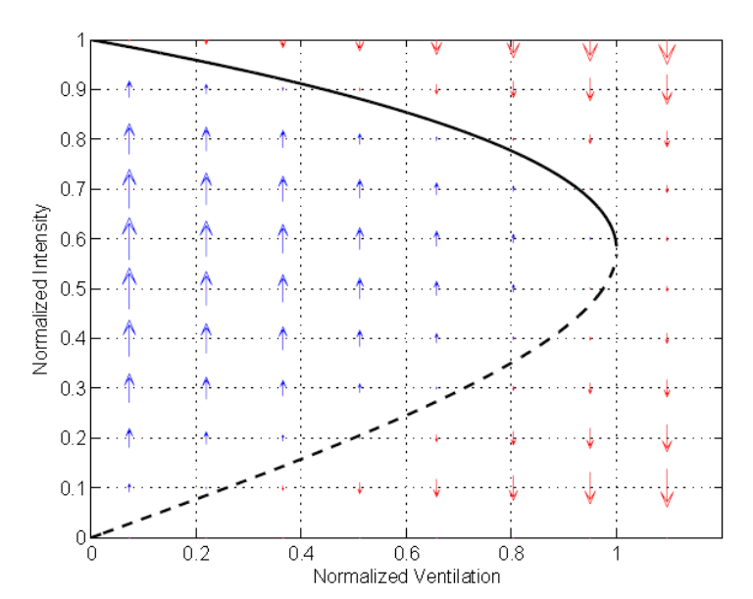 | Fig. 1. Normalized effects of ventilation on TC intensity based on the theoretical framework of Tang and Emanuel (2010). Solid line is the stable equilibrium intensity, and dashed line is the unstable equilibrium intensity. Blue (up) arrows denote strengthening TC and red (downward) arrows denote weakening. Ventilation is normalized such that a prohibitive value of ventilation is scaled to equal one; TC intensity is normalized by the potential intensity.
Two pathways to vortex weakening in the sheared environment were explored by Tang and Emanuel (2010): (i) downdrafts outside the eyewall drying (and so reducing the entropy of) the inflowing boundary layer air; and (ii) eddy fluxes of low ϑ_{e} air directly into the eyewall. Ventilation has a detrimental effect on intensity in either case since the maximum steady-state intensity in this lower ϑ_{e} environment is capped at a value significantly lower than the potential intensity of that vortex in a saturated environment. Once it reaches its “subsaturated boundary layer” intensity cap, the sheared TC will unconditionally decay (Fig. 1 red arrows). One consequence is that there is a bound on the magnitude of the shear-induced upper-level ventilation for a TC above which a steady-state cannot be maintained. Ventilation also decreases the thermodynamic efficiency as the eyewall becomes less buoyant relative to the environment, compounding the direct effects of ventilation alone (Tang and Emanuel 2010).
Riemer et al. (2010) elucidate the mechanisms linking the shear to the ventilation and TC weakening diagnosed by Tang and Emanuel (2010). They demonstrate that the interaction of a vortex with background shear induces vortex Rossby waves; asymmetries resulting from the combination of these vortex Rossby waves (primarily wavenumber 1) and the storm-relative mean flow help import low entropy air toward the TC core, where it excites downdrafts that transport the low entropy air into the boundary layer. Thus, since the last IWTC meeting, a coherent physical picture of the impact of a sheared environment on TC intensity and structure evolution has been developed: interactions of a TC with its (vertically) sheared environment induces asymmetries (storm-relative flow, vortex Rossby waves) that import low entropy environmental air towards the TC core where it interacts with convection to produce strong downdrafts. These (shear-induced) downdraughts transport the low entropy air into the boundary layer, where it is advected inward, reducing the flux of enthalpy from the sea to the air and so limiting the TC intensity achievable through the WISHE process (Riemer et al. 2010).
The recent results of Rappin et al. (2010) provide further support for the idea that interactions between a TC and its environment are communicated via the TC outflow as it develops in a region of low environmental inertial stability; the low inertial stability decreases environmental resistance to TC outflow expansion allowing for multiple outflow jets to ventilate the storm. The asymmetric outflow structure implied here may arise from direct interactions with another weather system (e.g. TUTT, midlatitude trough), evolution in a sheared environment or convective asymmetries (which may also arise from TC passage over a variable surface or the presence of dry air). Early in the lifecycle of a TC, such an asymmetric outflow structure may be detrimental to continued intensification since environmental impacts on the weak TC, suppressing the vigour of its convection. However, the ventilation provided by an asymmetric outflow with multiple outflow jets may play a positive role for the further intensification of a mature TC (Rappin et al. 2010; Sadler 1975 and others). While environmental shear induces a diabatic PV redistribution in the TC convection, since the maximum in convective heating is not in the high inertial stability region of the vortex, so conversion of diabatic warming to vortex kinetic energy is inefficient (Nolan 2007) and intensification is slow (compared to vorticity convergence in a symmetric vertical motion field).
For a more mature TC, asymmetric outflow in an environment of low inertial stability can favour enhanced intensification or a stronger overall intensity. This arises because the divergent outflow branch of the secondary circulation can become stronger in this region of weaker resistance to outflow, resulting in stronger updrafts through mass continuity.
Interaction of the mature TC with an upper tropospheric vorticity centre (e.g. upper-level trough) can result in TC intensification as these “upper” and “lower” vortices interact, enhancing the primary TC circulation directly or producing a secondary wind maxima (Nong and Emanuel 2003). Finally, a TC in a strongly sheared environment can generate a strong, long-lived convective event that leads to a new surface circulation on the downshear flank of the initial TC, a process known as down-shear reformation (Molinari et al. 2006).
McTaggart-Cowan et al. (2006) find that the presence of precedent, high-amplitude ridging along the North American east coastal region reinforced by diabatic ridging by the tropical cyclone itself, provides an environment that is especially conducive to high-latitude landfalls of hurricanes still in their tropical phase. Their compositing study is supported by the results of Milrad et al. (2009) who show that precedent ridging in the vicinity of the North American east coast is a unique characteristic of tropical cyclones that both intensify and travel poleward into the Canadian Atlantic provinces. While many of these cases are extratropical transitions, their tropical structures are typically maintained into relatively high latitudes.
McTaggart-Cowan et al. (2008) developed a dynamically-based TC classification scheme that classifies TC as either purely tropical (i.e. non-baroclinic) or baroclinic based on metrics of quasi-geostrophic forcing for ascent and low-level baroclinicity. Based on a sample of almost 500 TC, McTaggart-Cowan et al. (2008) conclude that 60% have baroclinic influences on their evolution. In many of these cases, synoptic-scale ridging impacts tropical cyclone structure, and intensity.
Studies by Zeng et al. (2007, 2008) seek to link observations to theories of limiting factors for TC intensification. Zeng et al. (2007) explore environmental dynamical controls on TC intensity that provide quantitative estimates of environmental vertical wind shear and storm speed conducive to intense TC development. They analyse the effects of storm motion and vertical wind shear on TC intensity evolution and peak intensity based on western North Pacific TC during 1981-2003. Strong vertical wind shear (≥ 20 m s⁻¹) and rapid TC motion (≥ 15 m s⁻¹) suppress TC intensification in agreement with previous studies; they also result in weaker lifetime peak intensities. The consistency of these results is not surprising since strong vertical wind shear is likely to be associated with strong steering currents. The most intense (and rapidly intensifying) TC in the study had translational speeds of 3-8 m s⁻¹ and relatively weak vertical shear (Fig. 2). Based on these analyses, Zeng et al. (2007) propose a new empirical maximum potential intensity (EMPI), which explicitly includes the combined negative effects of storm speed and vertical shear along with the positive thermodynamic contributions of warm SST and cool outflow temperatures. The objective of this new empirical MPI is to incorporate the thermodynamic and dynamical controls on TC intensity to diagnose the observed maximum intensity of a TC, rather than an idealized limiting intensity. Dynamical control of TC intensity is included via a dynamical efficiency that is inversely proportional to the combined amplitude of vertical shear and translational speed (Fig. 3).
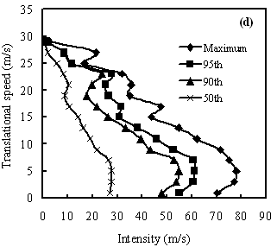 | 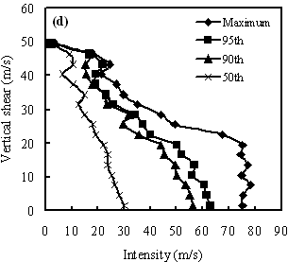
Fig. 2. TC intensity (corrected for storm motion; in m s⁻¹) versus (a) forward speed (m s⁻¹) stratified into 2 m s⁻¹ translational speed bands; and (b) vertical wind shear (m s⁻¹) for western North Pacific TC from 1981-2003. Lines correspond to the maximum intensity at each speed and the 95th, 90th, 50th intensity percentiles. From Zeng et al. (2007).

Zeng et al. (2008) analyse the impact of direction, magnitude and depth of vertical wind shear on intensities of North Atlantic TC using best track data and NCEP/NCAR reanalyses for 1981-2008. Once again, they confirm that TC intensity change is generally negatively correlated with vertical wind shear. Consistent with previous modelling studies, easterly shear in the upper troposphere has a weak effect on TC intensity, while westerly shear in the mid- to upper- troposphere has a strong negative effect on TC intensification.
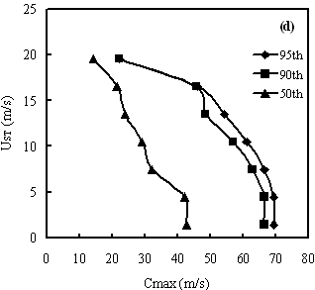 | Fig. 3. Lifetime TC intensity (corrected for storm motion; in m s⁻¹) C_{MAX} versus U_{ST}, a measure of the combined effect of storm translation and environmental vertical shear for western North Pacific TC from 1981-2003. Lines correspond to the 95th, 90th, 50th intensity percentiles for each U_{ST} band (corresponding to bins of 3 m s⁻¹ translational speed). From Zeng et al. (2007).

1.1.2.2. Rapid intensification (RI)
Intensity forecasting is not as advanced as track forecasting. The intensity forecast tends to be conservative and extreme events are almost never forecast (Fig. 4). For forecasts of 24 h and beyond, the average intensity error at the US National Hurricane Center (NHC) is about one Saffir Simpson hurricane category (15-20 kt, 7-10 m s⁻¹; Avila pers. comm. 2010). Intensity forecast errors are similar at both JTWC and Australian Tropical Cyclone Warning Centres (Kucas, Burton pers. comm. 2010). Rapid changes in TC intensity can have potentially devastating societal consequences, but rapid intensification (RI) forecasting remains a challenge for all forecast centres surveyed (e.g. Plu pers. comm. 2010).
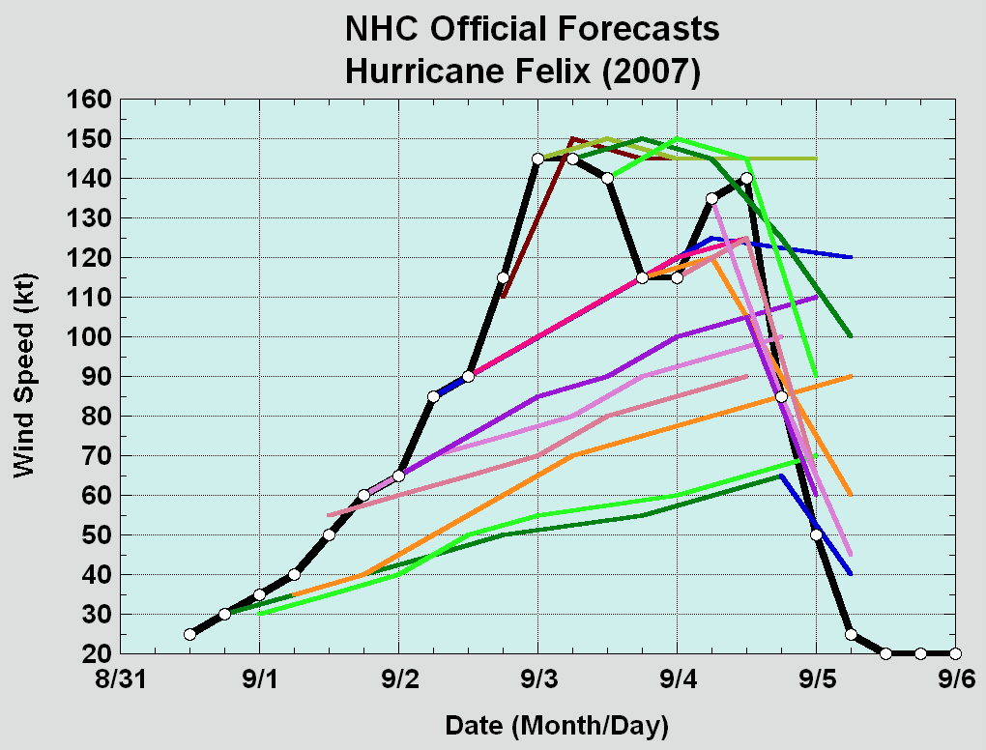 | Fig. 4. Best track of Hurricane Felix (black) and NHC official intensity forecasts (color lines). Note that none of the forecasts predicted the rapid intensification.

a) Case studies of RI
Case studies of rapid intensification reinforce the importance of favourable thermodynamic and dynamic environmental characteristics of anomalously warm SST/ocean heat content and weak vertical wind shear (e.g. Lowag et al. 2008). While these predictors are employed in current operational intensity forecast products (e.g. Statistical Hurricane Intensity Prediction Scheme, or SHIPS; Kaplan and DeMaria 2003, Kaplan et al. 2010), RI is still poorly forecast.
In considering the impact of the environment on RI, a rapidly intensifying TC in strong vertical shear provides a particularly vexing forecast problem; the role of the TC asymmetries so often observed in these cases remains a topic of active research. Theoretical modelling studies of TC responses to vertical wind shear have diagnosed the strongest convection primarily in the downshear left quadrant of the storm. Analysis of Hurricane Guillermo (1997) provides an example of a RI event in strong shear through a deep layer. Quasi-stationary, azimuthal wavenumber-one reflectivity and vertical motion patterns evolved in response to the shear with maxima located downshear (and down tilt) consistent with these earlier studies (Reasor et al. 2009). However, Hurricane Guillermo (1997) underwent a RI phase following the development in the eyewall (i.e. on the radial vorticity gradient maximum) of low-level asymmetric vorticity with higher wavenumber asymmetries that in turn appeared to trigger a series of convective bursts preferentially located downshear left. In their analysis of Hurricane Bret (1999), Lowag et al. (2008) hypothesize that in instances of RI internal TC processes respond nonlinearly to environmental forcing. Their hypothesis is supported by case studies of other recent storms (e.g. Sitkowski and Barnes 2009; Reasor et al. 2009). Taken together, this group of studies reinforce the hypothesis that in cases of RI external forcing due to vertical shear triggers a stronger TC response than typically expected driven by internal storm processes. The roles of internal TC structure and convective processes on RI highlighted by these studies are discussed in Section 1.2.

b) Observational climatologies of RI
Hendricks et al. (2010) examine environmental, climatology and persistence characteristics of intensity change for TC from the period 2003–2008 in the western North Pacific (WPAC) and North Atlantic (ATL) Oceans. Four intensity change bins were defined: rapidly intensifying (RI; 24 h change in maximum sustained wind of approximately 30 kt or greater), intensifying, neutral, and weakening. Environmental characteristics of RI versus other intensity change categories were calculated for both the western North Pacific and North Atlantic TC (Table 1). Intensity change was for the 24 h following the analysis of these environmental parameters.
An outstanding conclusion from this study is that there are very few significant differences between the environments of intensifying and rapidly intensifying TC, however there were clear differences between intensifying and neutral/weakening TC. This indicates that in the composite average, the rate of TC intensification is only weakly dependent on the environmental conditions, provided the environment is reasonably favourable (Hendricks et al. 2010).
Differences that were significant between the RI and more slowly intensifying TC are worth noting. Weaker environmental shear was favourable for RI in the North Atlantic, but shear values between RI and other intensifying cases were essentially the same in the western North Pacific. SST was not significantly different between the two intensification classes in either basin (Table 1), implying that, on average, the rate of intensification is not critically dependent on SST. However, for the western North Pacific thermodynamics were determined to be a factor in RI since it typically occurred in a more conditionally unstable environment (Hendricks et al. 2010); no difference in conditional instability was observed for North Atlantic TC. Consistent with the sensitivity of RI to TC internal dynamics, TC in both basins were more intense prior to undergoing an RI episode than either slowly intensifying TC or those with no intensity change (neutral TC). These three intensity change classes all had similar translation speeds and headings and average initial position for western North Pacific TC, but North Atlantic RI cases were located farther south and had a larger translation speeds and more westward movement than the weaker intensity change classes (Hendricks et al. 2010).
Quantity | Basin | W | N | I | RI | RI-W | RI-N | RI-I
Deep-layer shear (m s⁻¹) | WPAC | 12.09 | 10.64 | 9.87 | 10.38 | -1.71* | -0.26 | 0.51
Deep-layer shear (m s⁻¹) | ATL | 11.24 | 11.80 | 9.89 | 8.24 | -3.0* | -3.56* | -1.65*
SST (°C) | WPAC | 27.74 | 28.75 | 29.20 | 29.14 | 1.4* | 0.39* | -0.06
SST (°C) | ATL | 28.23 | 27.96 | 28.58 | 28.93 | 0.7* | 0.97* | 0.35
850 hPa RH (%) | WPAC | 77.83 | 78.75 | 80.01 | 80.19 | 2.36* | 1.44* | 0.18
850 hPa RH (%) | ATL | 73.93 | 76.27 | 76.12 | 76.45 | 2.52* | 0.18 | 0.33
500 hPa RH (%) | WPAC | 55.56 | 60.65 | 64.25 | 63.46 | 7.90* | 2.81* | -0.79
500 hPa RH (%) | ATL | 48.83 | 50.98 | 52.43 | 53.97 | 5.14* | 2.99* | 1.54
850 hPa Divergence (10⁻⁶ s⁻¹) | WPAC | -1.99 | -1.79 | -1.95 | -2.00 | -0.01 | -0.21 | -0.05
850 hPa Divergence (10⁻⁶ s⁻¹) | ATL | -1.63 | -1.19 | -1.40 | -1.25 | 0.38 | -0.06 | 0.15
200 hPa Divergence (10⁻⁶ s⁻¹) | WPAC | 4.77 | 4.18 | 4.65 | 4.59 | -0.18 | 0.41 | -0.06
200 hPa Divergence (10⁻⁶ s⁻¹) | ATL | 4.61 | 3.02 | 3.37 | 2.84 | -1.77* | -0.18 | -0.53
∂ϑ_{e}/∂p (10³ K Pa⁻¹) | WPAC | 0.147 | 0.162 | 0.199 | 0.289 | 0.142* | 0.127* | 0.090*
∂ϑ_{e}/∂p (10³ K Pa⁻¹) | ATL | 0.354 | 0.287 | 0.318 | 0.314 | -0.040 | 0.027 | -0.004
850 hPa Vorticity (10⁻⁶ s⁻¹) | WPAC | 14.1 | 13.0 | 13.0 | 14.2 | 0.1 | 1.2 | 1.2
850 hPa Vorticity (10⁻⁶ s⁻¹) | ATL | 7.71 | 6.91 | 6.48 | 5.0 | -2.71 | -1.91 | -1.48

Table 1. Average environmental parameters for Weakening (W), Neutral (N), Intensifying (I), and Rapidly Intensifying (RI) storms. ∂ϑ_{e}/∂p is averaged from 1013 hPa to 700 hPa. Differences between RI and the other intensity change classes are shown in the last three columns; an asterisk denotes statistical significance at the 95% confidence level. From Hendricks et al. (2010).
Wang and Zhou (2008) identify three indicators of RI potential in the western North Pacific: (a) a southward shift in the mean region of genesis, (b) increased low-level westerly shear vorticity and (c) decreased northerly vertical shear. The shift in genesis location contrasts with the stability of location for onset of the RI phase identified by Hendricks et al. (2010).
Dominant large-scale environmental flow patterns coincident with western North Pacific RI were characterized by Ventham and Wang (2007): (i) an 850 hPa monsoon confluence–shearline; and (ii) location under a region of divergence at 200 hPa, with flow into the midlatitude westerlies to the north and the towards the subequatorial trough to the south. The presence of an enhanced monsoon confluence–shearline region is consistent with increased low-level vorticity and the divergent flow aloft is consistent with the decreased northerly vertical shear identified by Wang and Zhou (2008).

1.1.2.3 Modulation of TC intensity by the Saharan Air Layer (SAL)
The early development of an incipient TC disturbance in the eastern North Atlantic can be dramatically altered by the thermodynamic character of its environment (e.g. Schwendike and Jones 2010, Landsea, pers. comm. 2010).
Analysis of the “ocean fall” of convective systems embedded in the African easterly waves (AEW) in West Africa and the eastern Atlantic reveals significant differences between the structure of convection over land and water: over land developing, mature and decaying phases of pre-tropical cyclone mesoscale convective systems (MCS) are clearly distinguished; in contrast, oceanic convection is characterised by the development and decay of short-lived systems. A study of the case of Hurricane Helene (2006) relates these distinctions to the shear patterns and dry air over land leading to a sustained boundary layer cold pool continually forcing ascent and enabling systems to grow upscale into mature MCS (Schwendike and Jones 2010). In spite of the more favourable oceanic thermodynamic environment in the region, the lack of this cold pool reduces the potential for convective forcing on a scale sufficient for pre-tropical cyclone disturbances to grow.
During the evolution of the MCS over land, the cyclonic relative vorticity increases at the height of the African easterly jet (600-750 hPa) via horizontal advection of absolute vorticity. Over the ocean, the relative vorticity maximum increases below and decreases above 700 hPa with time due to convection-induced stretching. The westward extension of the Saharan heat low further enhances the developing low-level relative vorticity anomaly and the interaction between this cyclonic anomaly and an AEW leads to the cyclogenesis of Hurricane Helene (Schwendike and Jones 2010).
A particularly striking feature of the North Atlantic is the Saharan air layer (SAL). The SAL is an elevated layer of warm, dry, dusty air that produces a very strong mid-tropospheric easterly jet. The thermodynamic and dynamic impacts of the SAL on the formation and evolution of Atlantic hurricanes remains unclear. The argument for a positive influence of the SAL on hurricane development is based upon (1) a region of instability equatorward of the jet providing a preferred location for developing waves that eventually form hurricanes and (2) rising motion south of the jet favouring development of deep convection; the jet is typically stronger in storms that intensify. Potential negative impacts of the SAL on TC include (1) low-level vertical wind shear associated with the jet; (2) increased thermodynamic stability due to the elevated warm layer; and (3) evaporative cooling leading to cold dry downdrafts in precipitating regions and weakening convection (Dunion and Velden 2004).

1.1.2.4 Forecasting TC intensity change
Intensity forecast practices across ocean basins generally rely on the consideration of the same set of environmental factors (upper level outflow, vertical wind shear and OHC), however the impacts of these environmental modulators on TC intensity varies across basins. Further, vertical wind shear can have a positive impact on TC intensity in some situations and a negative impact in others.
In the western North Pacific, tropical upper tropospheric troughs (TUTT) are most active during northern hemisphere summer. TUTT provide a sheared environment for the developing TC, however a TUTT positioned near a developing TC can be a positive influence on TC intensification by enhancing the TC outflow (consistent with Sadler 1975). However, a TUTT can also induce upper level subsidence, suppressing TC formation below; this highlights the importance of the relative locations of the developing TC and the TUTT in forecasting the outcome of this interaction. In addition, TUTT can be the source of incipient TC disturbances as closed circulation cells forming in the TUTT build down to the surface and develop into subtropical systems, or even TC.
Even in the western North Pacific, strong vertical wind shear has been demonstrated to have a negative impact on tropical cyclone intensification. However, eyewall convection downshear of the cyclonic circulation has been shown to be associated with rapid intensification (e.g. Reasor et al. 2009). Maintenance of gradient balance in the tilted vortex results in isentropic ascent/descent in quadrature with the shear: descent (ascent) rotated 90° cyclonically (anticyclonically) from the shear vector (e.g. Braun et al. 2006). Forecasters and researchers have developed a thermal advection diagnostic for the Brisbane Tropical Cyclone Warning Centre (Australian Bureau of Meteorology). This thermal advection diagnostic identifies this ascent/descent couplet and so is used to identify areas of extreme rainfall and to forecast the intensification of tropical lows or the enhanced intensification of tropical cyclones.
Two versions of the diagnostic have been implemented. A station-specific “climatological” version of the diagnostic is based on composite station soundings stratified by 24-hour rainfall rates. Thermodynamic conditions favourable for outbreaks of intense convection (and hence for TC intensification) are isolated using 850 to 500 hPa shear vector, 700 hPa vector wind and the magnitude of the 700 hPa flow perpendicular to the shear vector. Each vector pair provides an estimate of the sign and relative magnitude of thermal advection (Fig. 5).
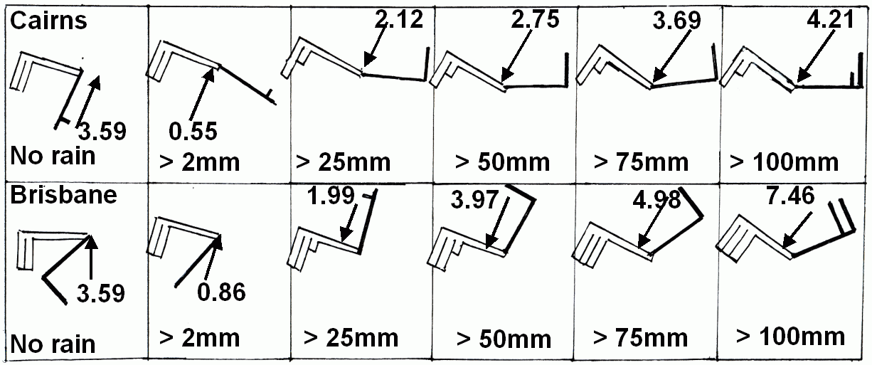 | Fig. 5. Climatological analyses for Cairns (16.9°S) and Brisbane (27.4°S) stratified by 24 hour rainfall rates of 850–500hPa shear (unfilled) and 700hPa wind (solid) [flag/ barb denote 25/5ms⁻¹]. Speed (in ms⁻¹) of the 700hPa wind normal to the shear direction is marked in each panel.
An equivalent gridded data product has also been developed. In this product, the mean thermal advection in the 850–500 hPa layer is calculated for the entire domain. Regions of significant warm air advection are indicators of intense rainfall potential and preferential tropical cyclone intensification.
Recent developments in rapid intensity change (RI) forecasting for the South Indian Ocean have taken advantage of research presented at previous IWTC workshops (Plu and Leroux pers. comm. 2010)! While translation of these synoptic climatologies into individual forecast events is not straightforward, insights gained from post-analysis can aid in understanding the processes contributing to RI.
JTWC issue forecasts for TC in the western North Pacific, Indian Ocean, and the South Pacific. The most skillful intensity prediction guidance available to JTWC is the Statistical Typhoon Intensity Prediction System (STIPS; Kucas, pers. comm. 2010). STIPS is calculated from model-forecasted values of large-scale environmental variables near JTWC forecast track positions. Forecasters use STIPS as a baseline forecast then modify it to incorporate additional information primarily focused on three key environmental features: upper level outflow, vertical wind shear, and ocean mixed layer heat content (OHC, or SST as available). The potential for dry air intrusion is also considered.
In the North Indian Ocean, the mid-summer Tropical Easterly Jet in the upper levels is a major vertical wind shear-inducing feature that suppresses the development and intensification of TC forming in the monsoon trough over the Bay of Bengal.
The Philippine Sea, Mozambique Channel and Gulf of Carpentaria are generally recognized as the most favorable regions in the JTWC area of responsibility for RI due to their high potential for strong upper level outflow and high SST (OHC). Ocean upwelling has minimal impact on TC intensity in these regions except for very slowly moving (and relatively intense) systems (Kucas, pers. comm. 2010).
The case of TC Dora (2007) in the South Indian Ocean provides an example of the complex environmental interactions that can lead to the RI of a TC. Dora underwent multiple periods of RI (30 m s⁻¹ on 1 Feb and 15 m s⁻¹ the following day) that were not explainable simply from thermodynamic considerations. The RI on February 1st coincided with an interaction between Dora and a deep (tropopause to 400 hPa) upper-level PV anomaly associated with a midlatitude Rossby wave break. This interaction was clearly identified in both the ECMWF operational analyses and water-vapour imagery. Vertical velocity and humidity patterns from the RI phase on the 2nd suggest that the upper-level PV anomaly helped to trigger convection outside the TC eyewall through this period consistent with Hoskins et al. (1985).
Reconciliation of the RI phase of cases such as Dora with the theories and observations presented here may facilitate further progress in this challenging and important area of forecasting. In addition, identification by forecasters of particularly challenging events or seasons would help to focus testing of current hypotheses.
While dry air intrusion is a common consideration in TC forecasting across all ocean basins, recent research has raised questions about the role of the SAL in North Atlantic TC development and intensity change. From a practical standpoint, forecasting possible SAL influences on the genesis of a disturbance or the intensification of an existing TC is problematic because of (1) the lack of detailed observations of the SAL, especially in the inner core of the TC; (2) current limitations on our understanding of SAL effects and (3) significant gaps in the incorporation of SAL into operational forecast tools (statistical and dynamical models) (Landsea, pers. comm. 2010). Thus, the impacts of both the thermodynamics and dynamics of the SAL environment on TC require further clarification before they can be incorporated into NHC forecasts of Atlantic hurricane development. However, while the SAL is not incorporated explicitly in NHC forecasts of North Atlantic TC, the potential effects of dry air (whether or not of SAL origin) on storm evolution are considered (Avila, Blake, Landsea, Pasch, pers. comm. 2010).
Dry air entrainment is rarely a factor in JTWC forecasts for western North Pacific, Indian Ocean, and South Pacific cyclones except during ET. Even TC approaching the desert in the Arabian Sea are considered to be shielded from the negative impacts of dry air entrainment on intensity, as long as there is some moist inflow into a TC (quantified using total precipitable water products), but weakening is expected if dry air penetrates directly into the TC core.
The impacts of land interaction on TC intensity are difficult to forecast and even analyze in some cases, particularly in sparsely populated or low-density synoptic observation areas. For example, TC tracking over northern Australia may experience minimal impacts on their structure and intensity, and in some cases can even intensify (Emanuel et al. 2008).

1.1.3. Environmental modulation of tropical cyclone structure
The impacts of a TC cannot be completely described by its intensity; the important roles of TC structure and size on storm impacts are now active topics of research. While other aspects of TC structure are likely as important, recent findings on the environmental modulation of TC structure, identified here as either precipitation or wind distribution, are summarized here.

1.1.3.1. Precipitation distribution
Recent research on the impacts of environmental vertical wind shear on TC intensity and the mechanisms leading to intensity change were reviewed in section 1.1.2. However, the impacts of vertical wind shear are not confined to the TC core: the broader TC vortex is also modified by its environment. Recent findings relating to environmental modulation of the TC precipitation field are reviewed here, followed by a discussion of environmental effects on the TC wind distribution.
Focusing on individual case studies, simulations of Hurricane Erin (2001) by Braun and Wu (2007) and Bonnie by Braun et al. (2006) reveal that an asymmetry in storm structure developed due to increasing environmental shear, with deep updraft towers generally forming on the down tilt-right side of the eyewall and dissipating on the down tilt-left side in association with cyclonically rotating eyewall mesovortices (e.g. Braun et al. 2006). The eyewall structure of Erin was dominated by two counter-rotating vortices superimposed upon the mean cyclonic flow of the TC (Braun and Wu 2007). Superposition of these vortices in the eye region resulted in strong flow across the eye and associated strong updrafts in the eyewall convection. Time averaging of this flow produces vertical motion characterized by weak ascent in a shear–induced wavenumber-one asymmetry. This vertical motion asymmetry is qualitatively consistent with an assumed balance between horizontal vorticity advection by the relative flow and stretching of vorticity, with relative asymmetric inflow (convergence) at low levels and outflow (divergence) at upper levels on the downshear side of the eyewall. Time-averaged asymmetric ascent in the eyewall is located in the direction of vortex tilt, consistent with the vertical motion required to maintain dynamic balance. Braun and Wu (2007) relate the variations in organization of the precipitation in Hurricane Erin to intensity changes in the system. As discussed below for the Australian region, evolution in the precipitation distribution of a TC can be a useful indicator for forecasts of intensity change (Callaghan and Tory, pers. comm. 2010).
Atallah et al. (2007) execute a climatological analysis of factors influencing the precipitation distributions of landfalling TC. They find that landfalling TC influenced by a mid-latitude trough (but not resulting in ET) have precipitation distributed almost exclusively along the TC track (AT) or to the right of the TC track (ROT); typically, the precipitation of TC undergoing ET is almost exclusively in the western poleward quadrant of the cyclone (left of track – a counter clockwise rotation about the TC compared to the non-ET cases).
Landfalling TC exhibiting ROT and AT precipitation distributions are interacting with a mid-latitude trough (although this interaction is relatively weak compared to TC that undergo ET) and so are experiencing environmental vertical wind shear. ROT storms generally have weak circulation centres at the time of landfall, and so are susceptible to the effects of even weak shear. In contrast, the TC circulation of AT systems is broader and stronger than the structure in the ROT composite. These more robust AT TC are expected to have more robust convection near the storm core (Atallah et al. 2007). PV rearrangement associated with this vigorous convection provides a mechanism for the AT cyclones to resist the effects of environmental vertical wind shear; thus, landfalling TC with AT precipitation distributions are likely to be larger and stronger than their ROT counterparts.
Diabatic heating and associated outflow due to a poleward moving TC typically results in downstream ridging. This enhanced ridging ahead of the TC amplifies the baroclinic wave pattern, increasing the thermal gradient between the TC and an approaching weak mid-latitude trough (Fig. 6). As the TC moves north into this environment, the shear over it increases and backs (from westerly to southwesterly, Northern Hemisphere). QG forcing for ascent increases rapidly in the region of the moving TC and shifts to the northeast quadrant of the storm. For the northward moving weak TC, this ascent to the northeast results in a ROT precipitation distribution.
The environment of an AT system comprises a relatively amplified trough/ridge couplet at low latitudes. This pattern provides little in the way of QG forcing for ascent as the thermal wind is generally parallel to the vorticity contours (Fig. 6). Without any significant synoptic-scale forcing, the composite AT system never completely couples with the mid-latitude trough and retains its warm-core structure. Initially, most of the precipitation remains isolated near the core of the storm, but as the AT system begins to interact with the midlatitude trough, it experiences enhanced 1000-200 hPa southerly environmental shear (i.e. along track shear for the northward moving TC) and the precipitation associated with the TC is displaced downshear (to the north) along the TC track. Eventually, an amplifying trough from higher latitudes merges with the lower latitude trough already interacting with the AT system. The combination of the existing strong upstream ridge and merging troughs produces a synoptic-scale environment similar to that in the incipient stages of ET (and indeed, over half of the AT storms eventually undergo ET).
For TC in the Southern Hemisphere, enhanced precipitation is known to be biased to the right of the deep-layer environmental shear vector. A very high resolution (2 km) simulation of western South Pacific severe TC Larry (2006) was characterized by an almost continuous swath of 24 hr accumulated rainfall of greater than 200 mm to the north (i.e. to the right) of the TC track, with embedded totals of more than 300 mm (Ramsay and Leslie 2008). This marked asymmetry in accumulated rainfall was verified by radar. Analysis of the 850-200 hPa environmental shear revealed that TC Larry was embedded in a generally weak (5-10 m s⁻¹) easterly shear in the 12 hours prior to landfall, in agreement with the northward rainfall bias produced by the model.
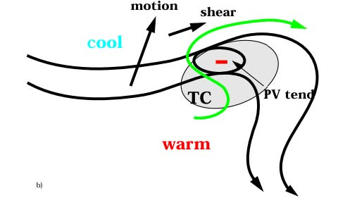
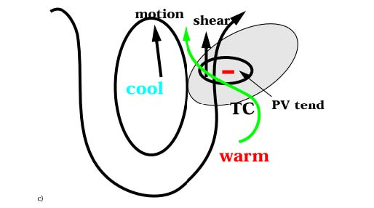
Fig. 6. Schematic of upper tropospheric flow configurations for a) ROT cyclones and b) AT cyclones. Heavy black curves indicate the approximate 300 hPa streamlines, green curve represents the parcel trajectory of an air parcel originating near the boundary layer, TC represents the location of the tropical cyclone, shading indicates the region of precipitation, - and + symbols indicate the local tendency of potential vorticity on the dynamic tropopause, and black arrows qualitatively represent the motion and shear vectors respectively.

Asymmetric friction due to proximity to land has been argued to cause a boundary-layer flow asymmetry similar in structure, but different in orientation, to that due to motion. To date, most of the evidence for this effect has been indirect (Ramsay et al. 2009, May et al. 2008), although Kepert’s (2006) analysis of dropsonde data in Hurricane Mitch showed a marked asymmetry which was consistent with a model calculation including the effects of land. The difficulty in the indirect studies has been in separating the effects on the convective asymmetry of the boundary-layer asymmetry due to nearby land, from those due to environmental shear.
An investigation of Northeast Australian TC since 2003 reveals that all intensifying tropical lows and TC have intensified in the presence of moderate 850-500 hPa vertical wind shear. Tropical and sub tropical rainfall has been shown to have a strong relationship with 850-500 hPa shear. In particular, heavy rain occurs when the vertical wind structure shows a
warm air advection (WAA) pattern of winds, such that the 850hPa to 500hPa
shear vector is approximately parallel to the 700hPa isotherms with warm
air to the left (right) in the Southern (Northern) Hemisphere (Callaghan and
Tory, pers. comm. 2010). These observations have been translated into a set of forecast diagnostics (e.g. Fig. 5) and forecasting strategies for the Brisbane Tropical Cyclone Warning Centre.

1.1.3.2. Tropical cyclone size
The range of tropical cyclone sizes extends from “midget” TCs such as TC Tracy (1974), the storm that devastated the city of Darwin in Australia to systems like Supertyphoon Tip (1979): Tracy’s gale force winds extended no more than 100 km from its centre and thus could be contained entirely within the 100 km diameter eye of Typhoon Tip.
Moyer et al. (2007) contrast measures of radius of maximum winds, as well as radii of tropical storm, damaging, and hurricane-force winds from two Atlantic hurricane databases. Analysis of a six year dataset of the H*Wind surface wind analysis system for consistency with previous studies confirmed the utility of the H*Wind radii in estimating storm surface wind radii. However, intercomparison of the derived H*Wind radii with the NHC Best Track database for 2004 and 2005 reveals an unexpected bias: the objectively-determined H*Wind threshold radii are consistently larger than the operationally-determined NHC Best Track wind radii for all but the smallest and least intense storms (Moyer et al. 2007).
Further examination of the tropical storm-force wind radii from H*Wind compared to the NHC Best Track radii for the same storm times demonstrates that while the objective H*Wind radii are large compared to the NHC Best Track, H*Wind is underestimating the extent of the tropical storm force wind area (Moyer et al. 2007). These results argue for further examination of the methods used to ascertain these significant wind radii.
Dean et al. (2009) used two different but partially overlapping data sets that include information on storm size, to examine the statistical distributions of outer radius, defined as the radius at which the circular component of the storm winds vanishes. At large radii from the centre storm-related winds are weak and the actual flow is dominated by other weather systems, so they extrapolated from the radius of gale-force (17 ms⁻¹) winds to the outer radius using a theoretical formula; this theoretical wind profile is derived by assuming that there is no deep convection outside the radius of gale-force winds and that the Ekman suction associated with the TC winds matches the environmental subsidence rate associated with radiative cooling. They showed that the overall distribution of the TC outer radius is very nearly log-normal with a peak near 400 km.
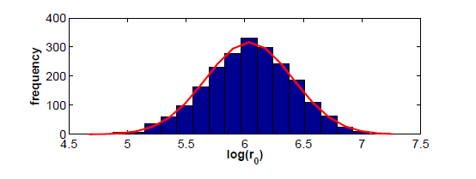
Fig. 7. Frequency distribution of the natural logarithm of the outer radius (measured in kilometres) as determined from QuikSCAT data. From Chavas and Emanuel (2010).
QuikSCAT-based scatterometer data for the years 1999-2008 were used by Chavas and Emanuel (2010) to estimate the wind distributions in the outer regions of TCs. They used a more accurate theoretical outer wind profile than Dean et al. (2009) to extrapolate from the radius of 12 ms⁻¹ winds to the radius of vanishing wind, and confirmed that the statistical distribution of outer radii is very nearly log-normal, with a peak near 420 km (Fig. 7). In contrast to the results of Dean et al. (2009), they found no improvement to the log-normal fit by normalizing the radii. They also found that the variability of the outer radius through the life of any individual storm (excluding the ET phase) is much less than the storm-to-storm variance in this quantity: the size of a storm at formation is maintained through its life as a tropical cyclone. The controls leading to this distribution of TC size and the relative stability of storm size throughout its lifecycle are yet to be identified.
TY  TS | Small < 1.8º (24) | Medium 1.8–2.6º (24) | Large > 2.6º (25)
Small < 1.1º (24) | 16 / 24 (67%) | 5 / 24 (21%) | 3 / 24 (12%)
Medium 1.1º – 1.8º (24) | 8 / 24 (33%) | 12 / 24 (50%) | 4 / 24 (17%)
Large > 1.8º (25) | 0 / 25 (0%) | 7 / 25 (28%) | 18 / 25 (72%)
Table 2. Definitions of small, medium, and large size (unit: degree latitude) TCs during the TS stage (first column) and TY stage (first row). Number in parentheses is the number of TC cases in each category. The other table entries are the proportion (percentages in parentheses) of cases that change from one TC size category to another during the intensification from TS to TY, and the diagonal entries (bold) indicate cases with no change in TC size category.
Lee et al. (2010) use the radius of 15 m s⁻¹ near-surface wind speed (R15) from QuikSCAT winds to explore environmental influences on TC size variations for 145 TCs in the western North Pacific during 2000–2005. For the 73 TC that intensified to typhoon intensity during their lifetimes, the 33% and 67% percentiles of R15 at tropical storm intensity and at typhoon intensity are used to categorize small, medium, and large TCs. In general, small TC form from an easterly wave synoptic pattern, while medium to large TC tend to form in the monsoon-related patterns defined by Lee et al. (2008). With the exception of three (that increased from small to large typhoons), these 73 typhoons stay in the same size category during intensification, which implies specific physical mechanisms for maintaining TC size in the basin (Table 2); no large typhoon in this 6-yr database becomes a small typhoon. Persistently large TC mostly had northwestward or north-northwestward tracks, while the 16 small TC had more variable genesis locations and tracks and are more influenced by the subtropical high during intensification. The conclusion is that it is the low-level environment that determines the difference between large and small size storms, or the so-called TC size pedigree, during the early intensification period in the western North Pacific.
Chen et al. (2010) characterize TC structure using a measure of compactness: (1) its RMW is smaller than average for a given intensity, and (2) the profile of tangential wind speed outside the RMW decreases more rapidly than average (corresponding to both smaller size and weaker strength than average). QuikSCAT winds for 171 TC from 2000-2007 reveal that compact TC (1) occur preferentially in the early intensification stage and (2) have a higher percentage of rapid intensification cases. Further, compact TC are axisymmetric with strong convection concentrated in a small region near the centre. Low-level flow and relative humidity are important environmental factors determining compactness; however, Chen et al. (2010) argue that compact TC maintain their structures predominantly through internal dynamics.
There is no reason to expect that a single factor controls TC size, and several mechanisms have been proposed. Hill and Lackmann (2009) hypothesize that the size of the outer TC wind field is related to the intensity and extent of precipitation outside the inner core of the TC. In this mechanism, diabatic lower-tropospheric PV production in outer rainbands expands the overall low-pressure envelope of the storm, so TC with more active outer precipitation would exhibit larger cyclonic wind fields. Since a moister TC environment is expected to enhance TC convective activity compared to a dry environment, they used numerical simulations to explore the link between environmental humidity and TC size. Hill and Lackmann (2009) isolate the dependence of TC size on environmental humidity through idealized numerical simulations of identical initial TC vortices in environments of varying relative humidity; a simulation was terminated once the storm attained a quasi-steady intensity. Their results showed that TCs in the dry environments were smaller by any measure than TC in the moist environment simulations. The simulated TC in the most moist environment featured eye-wall replacement cycles accompanied by lateral PV mixing in the eye wall and a dramatic increase in the size of the eye; the radius of hurricane-force wind (RHW) grew steadily, while the RMW grew in intermittent bursts, suggesting that the outer-core wind field was evolving somewhat independently of inner-core processes. These processes were not observed in TC embedded in drier environments.

1.1.3.3. Radial distribution of TC winds
Large variability in the TC surface wind structure outside the radius of maximum wind (RMW) can be broadly summarized through two parameters: strength [average azimuthal wind speed between RMW and a chosen radius] and size (radius of gale-force winds). While these definitions date back to the 1980s (e.g. Merrill 1984) and these parameters have long been recognized as impacting TC motion as well as sensible weather distribution (Moyer et al. 2007), until the recent widespread availability of satellite-derived winds, the lack of data over the oceans precluded detailed studies of this surface wind structure.
In 2002, Liu and Chan found that southwesterly surges and late-season 850-hPa flow patterns (associated with early winter monsoon surges) are related to the incidence of large TCs while a dominant subtropical ridge and monsoon-gyre patterns are associated with the occurrence of small TCs.
Variations in the impact of environmental vertical wind shear have been related to TC size. The modelling study of Wong and Chan (2004) revealed that smaller TC weaken more quickly than large TC in the presence of the same vertical wind shear. The source of the weakening in strong shear is entrainment of environmental air disrupting the secondary circulation of the TC and so weakening the storm diabatic heating; the secondary circulation, and so the convection, can be maintained in the presence of weak shear (Fig. 8).
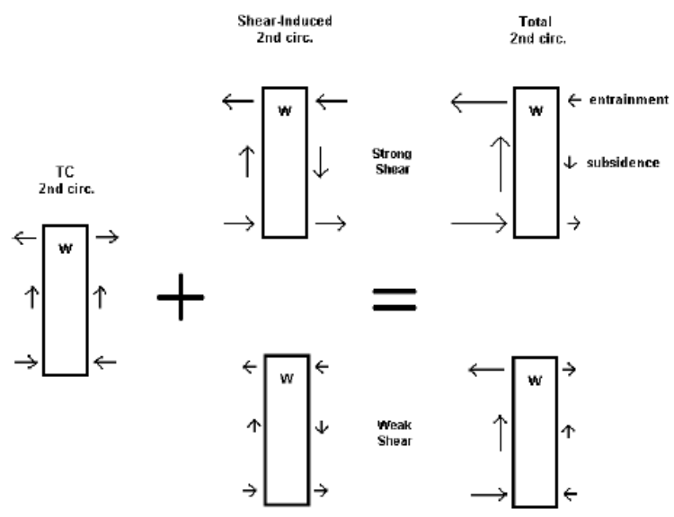 | Fig. 8. Schematic diagram showing the secondary circulation under strong and weak environmental vertical wind shear. Arrows indicate the direction and strength of the circulation; ‘‘W’’ stands for the warm core at the upper levels. From Wong and Chan (2004).

1.1.3.4. Forecasting TC wind structure change
Knaff et al. (2007) have quantified variations of significant wind radii based on climatological factors (translational speed, intensity, latitude) and persistence (i.e. initial condition) for three tropical cyclone basins. Given forecasts of intensity and track and initial 34-,50-, and 64-kt wind radii (corresponding to radii of 17, 26 and 33 m s⁻¹), their model returns a forecast of wind radii by quadrant (Fig. 9). Note how the wind field expands as the storm moves poleward and weakens. The Atlantic climatology has also been adapted for use in the Southern Hemisphere. The model has been incorporated into the operational NHC and JTWC ATCF systems and these forecasts form the control forecast for tropical cyclone structure at those centres. The climatological portion of this model has also been incorporated in Monte Carlo Wind speed probabilities that are based on NHC/JTWC’s official track and intensity forecasts (DeMaria et al. 2009).
Both Mueller et al. (2006) and Kossin et al. (2007) use several years of aircraft flight-level data analyses and coincident IR imagery to develop complementary methods to estimate tropical cyclone winds using azimuthally averaged IR brightness temperature profiles. Given access by tropical cyclone forecast centres to infrared satellite imagery, these algorithms can be used to diagnose and aid in forecasting tropical cyclone structure.
Mueller et al. (2006) used current intensity estimates, latitude, azimuthally average brightness temperatures and principle components of the IR brightness temperature to estimate the RMW and the tangential wind speed at 182 km (100 n mi). Using this information, parameters of a modified Rankine vortex are estimated; a motion-dependent wavenumber one asymmetry is then applied producing a two-dimensional (2D) “flight level” wind analysis for the storm. This methodology has been utilized in the construction of satellite based surface wind analyses, which is soon to be an NESDIS operational product (http://www.ssd.noaa.gov/PS/TROP/mtcswa.html).
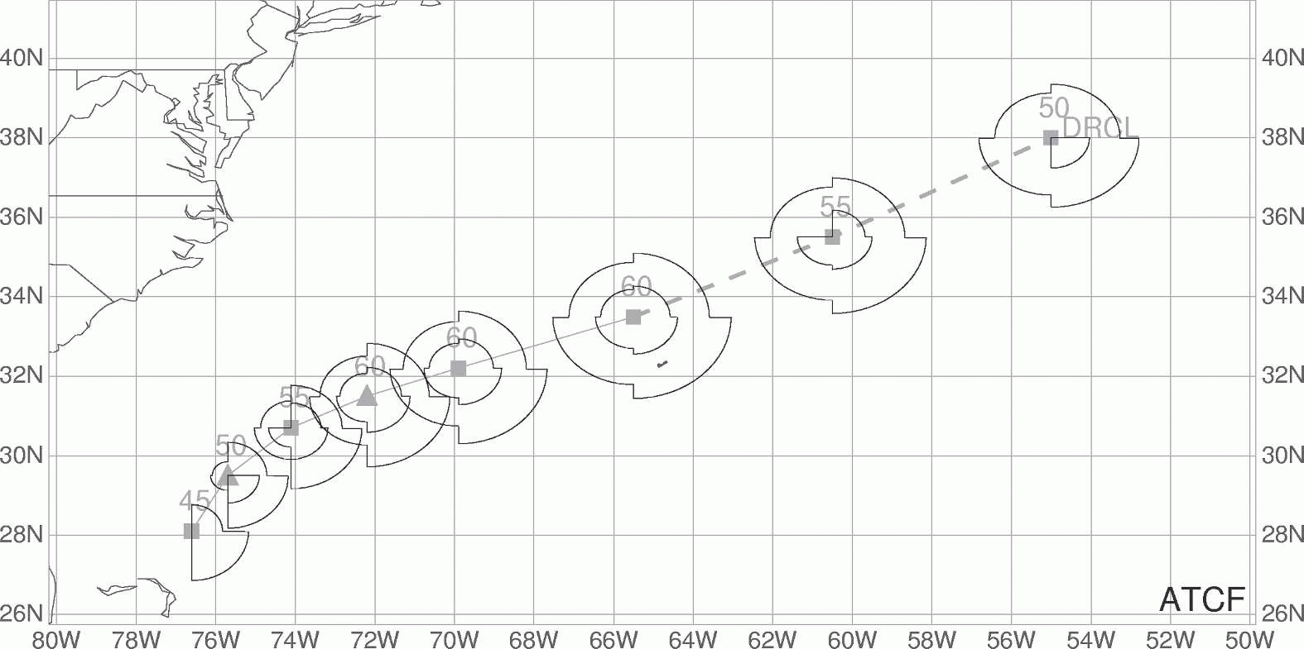
Fig. 9. An example forecast produced by the parametric form of the wind radii CLIPER model (DRCL, also the tech name in ATCF) for Tropical Storm Franklin at 0000 UTC 23 Jul 2005. Initial 34-kt wind radii are 40, 75, 0, and 0 n mi in the NE, SE, SW, and NW quadrants, respectively. The forecast intensities are listed in the figure at each forecast point valid for 0, 12, 24, 36, 48, 72, 96, and 120 h. From Knaff et al. (2007).
Kossin et al. (2007) also use IR data along with information about storm age, intensity and position to estimate the RMW, the significant wind radii and the 2D flight level winds. Radial wind profiles produced by the principle component –based approach of Kossin et al. (2007) are reasonable, but with somewhat lower peak winds and broader maximum wind regions than observed for the verifying dataset. As with Mueller et al. (2006), motion-based asymmetries were applied to symmetric wind estimates to create a 2D wind field. Both this method and that of Mueller et al. (2006) can be used to estimate TC wind structure using commonly available operational information.
Using similar flight-level wind analyses Maclay et al. (2008) examined the processes that were associated with increases in size and kinetic energy. Her findings established that intensifying TC generally maintain their size as they intensify but TC increase in size as they weaken or even maintain their current intensity. Her findings relate tropical cyclone growth to two basic drivers: (1) eyewall replacement cycles and (2) TC interaction with its environment. One of the most significant environmental forcings is vertical wind shear: TC tend to intensify and not grow in light shear regimes; they tend to intensify less but grow more in moderate shear; under very high shear, TC neither intensify nor grow.
The only element of TC structure analyzed and forecasted by JTWC is threshold wind radii (34, 50 knot and 64 knot). Wind radii forecasting is probably the most difficult component of TC forecasting for JTWC (Kucas, pers. comm. 2010) due to the lack of sound, dynamically-based forecast guidance – the first guess for wind a radii forecast is based on climatology and persistence.
Environmental considerations when developing a wind radii forecast include: expansion of the 34 knot wind radii into the gradient between the TC and steering feature (ridge); and general growth and downshear expansion of the 34 knot, 50 knot, and (if applicable) 64 knots wind radii during extratropical transition. Other adjustments to wind radii are primarily based on anticipated storm structure. The precise impact of environmental parameters such as vertical wind shear and upper level outflow, although conceptually understood, are not well described or captured by any of the forecast tools presently in use at JTWC (Kucas, pers. comm. 2010).

1.1.4. Summary
While the set of environmental factors governing TC intensity change have long been recognized (e.g. SST/OHC, vertical wind shear, dry air intrusion), recent research has begun to provide explanations of the processes by which the environment and TC interact to produce these intensity changes. Additional climatological studies of TC and environmental characteristics observed to result in specific intensity change regimes provide context for these theoretical studies and also additional guidance for intensity change forecasts.
Elements of this research are being considered in some forecast centres, although observational constraints can provide limitations on both inclusion of new theories and evaluation of their effectiveness in a forecast environment (Landsea, Burton pers. comm. 2010).
Of all intensity forecasting, rapid intensification is a particularly thorny problem (Plu, Leroux, Burton, Avila pers. comm. 2010). New theories on rapid intensity change are focusing on the roles of environmental shear as it impacts vortex asymmetry and convection, as well as outflow structure. In addition, some investigators propose that there is a nonlinear response of the TC vortex to environmental forcing in cases of RI.
While intensity forecasting remains a challenge, TC significant wind radii have possibly surpassed intensity as the most difficult operational forecasts to produce (Avila, pers. comm. 2010). The lack of validation of these forecasts – and the lack of appropriate data for validation – is a stumbling block to forecast improvement (Burton, Kucas pers. comm. 2010). Variations of TC size (as measured by these critical threshold radii) and even radial wind profiles are active and promising areas of research across the TC community, however these results require further testing and scrutiny before they can be transitioned to operations.

References
Atallah, E., L. F. Bosart, and A. R. Aiyyer, 2007: Precipitation Distribution Associated with Landfalling Tropical Cyclones over the Eastern United States. Mon. Wea. Rev., 135, 2185-2206.
Braun, S. A., M. T. Montgomery, and Z. Pu, 2006: High-Resolution Simulation of Hurricane Bonnie (1998). Part I: The Organization of Vertical Motion. J. Atmos. Sci., 63, 19-42.
Braun, S. A. and L. Wu 2007: A numerical study of Hurricane Erin (2001). Part II: Shear and the organization of eyewall vertical motion. Mon. Wea. Rev., 135, 1179-1194.
Chavas, D. R., and K. A. Emanuel, 2010: A QuickScat climatology of tropical cyclone size. Geophys. Res. Lett., 37, L18816, 4 pp, doi:10.1029/2010GL044558.
Chen, D. Y.-C., K. K. W. Cheung, and C.-S. Lee, 2010: The compactness of tropical cyclones in the western North Pacific. Wea. Forecasting, (submitted).
Dean, L., K. A. Emanuel, and D. R. Chavas, 2009: On the size distribution of Atlantic tropical cyclones. Geophys. Res. Lett., 36, L14803, doi:10.1029/2009GL039051.
DeMaria, M., J.A. Knaff, R. Knabb, C. Lauer, C.R. Sampson, R.T. DeMaria, 2009: A New Method for Estimating Tropical Cyclone Wind Speed Probabilities. Wea. Forecasting, 24, 1573–1591.
Dunion, J.P. and C.S. Velden, 2004: The impact of the Saharan air layer on Atlantic tropical cyclone activity. Bull. Amer. Meteor. Soc., 353-365.
Emanuel, K. A., J. Callaghan and P. Otto, 2008: A hypothesis for the redevelopment of warm-core cyclones over Northern Australia. Mon. Wea. Rev., 136, 3863-3872.
Hendricks, E.A., M.S. Peng, B. Fu, and T. Li, 2010: Quantifying environmental control on tropical cyclone intensity change. Mon. Wea. Rev., 138, 3243-3271.
Hill, K. A., and G. M. Lackmann, 2009: Influence of environmental humidity on tropical cyclone size. Mon. Wea. Rev., 137, 3294−3315.
Kaplan, J., and M. DeMaria, 2003: Large-scale characteristics of rapidly intensifying tropical cyclones in the North Atlantic basin. Wea. Forecasting, 18, 1093-1108.
Kaplan, J., M. DeMaria, and J. Knaff, 2010: A revised tropical cyclone rapid intensification index for the Atlantic and eastern North Pacific basins. Wea. Forecasting, 25, 220–241.
Kepert, J. D., 2006: Observed boundary–layer wind structure and balance in the hurricane core. Part II: Hurricane Mitch. J. Atmos. Sci., 63, 2194–2211.
Knaff, J. A., C. R. Sampson, M. DeMaria, T. P. Marchok, J. M. Gross, and C. J. McAdie, 2007: Statistical Tropical Cyclone Wind Radii Prediction Using Climatology and Persistence. Wea. Forecasting, 22, 781-791.
Kossin, J.P., J.A. Knaff, H.I. Berger, D.C. Herndon, T.A. Cram, C.S. Velden, R.J. Murnane, and J.D. Hawkins, 2007: Estimating hurricane wind structure in the absence of aircraft reconnaissance. Wea. Forecasting, 22, 89–101.
Lee, C.-S., K. K. W. Cheung, J. S. N. Hui, and R. L. Elsberry, 2008: Mesoscale features associated with tropical cyclone formations in the western North Pacific. Mon. Wea. Rev., 136, 2006−2022.
Lee, C.-S., K. K. W. Cheung, W.-T. Fang, and R. L. Elsberry, 2010: Initial maintenance of tropical cyclone size in the western North Pacific. Mon. Wea. Rev. (in press).
Liu, K. S. and J. C. L. Chan, 2002: Synoptic flow patterns associated with small and large tropical cyclones. Mon. Wea. Rev., 130, 2134-2142.
Lowag, A., M. L. Black, and M. D. Eastin, 2008: Structural and Intensity Changes of Hurricane Bret (1999). Part I: Environmental Influences. Mon. Wea. Rev., 136, 4320-4333.
McTaggart-Cowan, R., E. Atallah, J. R. Gyakum, and L. F. Bosart, 2006: Hurricane Juan (2003). Part I: A diagnostic lifecycle study. Mon. Wea. Rev., 134, 1725-1747.
McTaggart-Cowan, R., G. D. Deane, L. F. Bosart, C. A. Davis, and T. J. Galarneau, 2008: Climatology of tropical cyclogenesis in the North Atlantic (1948-2004). Mon. Wea. Rev., 136, 1284-1304.
Maclay, K.S., M. DeMaria and T.H. Vonder Haar, 2008: Tropical cyclone inner core kinetic energy evolution. Mon. Wea. Rev., 136, 4882-4898.
May, P. T., J. D. Kepert, and T. D. Keenan, 2008: Polarimetric Radar Observations of the Persistently Asymmetric Structure of Tropical Cyclone Ingrid. Mon. Wea. Rev., 136, 616-630.
Merrill, R. T., 1984: A comparison of large and small tropical cyclones. Mon. Wea. Rev., 112, 1408-1418.
Milrad, S., E. Atallah, and J. R. Gyakum, 2009: Dynamical and precipitation structures of poleward moving tropical cyclones in Eastern Canada, 1979-2005. Mon. Wea. Rev., 137, 836-851.
Molinari J, Dodge P, Vollaro D, Corbosiero KL, Marks Jr. F. 2006. Mesoscale aspects of the downshear reformation of a tropical cyclone. J. Atmos. Sci., 63, 341-354.
Moyer, A. C., J. L. Evans, and M. Powell, 2007: Comparison of observed gale radius statistics. Meteorology and Atmospheric Physics, doi: 10.1007/s00703-006-0243-2.
Mueller, K. J., M. DeMaria, J. Knaff, J. P. Kossin, and T. H. Vonder Haar, 2006: Objective Estimation of Tropical Cyclone Wind Structure from Infrared Satellite Data. Wea. Forecasting, 21, 990-1005.
Nolan DS. 2007. What is the trigger for tropical cyclogenesis. Austral. Meteorol. Mag., 56, 241-266.
Nong, S. and K. Emanuel, 2003: A numerical study of the genesis of concentric eyewalls in hurricanes. Quart. J. Roy. Meteor. Soc., 129, 3323-3338.
Ramsay, H. A., and L. M. Leslie, 2008: The effects of complex terrain on severe landfalling Tropical Cyclone Larry (2006) over northeast Australia. Mon. Wea. Rev., 136, 4334-4354.
Ramsay, H. A., L. M. Leslie, and J. D. Kepert, 2009: A High-Resolution Simulation of Asymmetries in Severe Southern Hemisphere Tropical Cyclone Larry (2006). Mon. Wea. Rev., 137, 4171-4187.
Rappin, E. D., M. C. Morgan and G. J. Tripoli, 2010: The impact of outflow environment on tropical cyclone intensification and structure. J. Atmos. Sci. (in press 2010).
Reasor, P. D., M. D. Eastin, and J. F. Gamache, 2009: Rapidly intensifying Hurricane Guillermo (1997). Part I: Low-wavenumber structure and evolution, Mon. Wea. Rev., 137, 603-631
Riemer, M., M. Montgomery, and M. Nicholls, 2010: A new paradigm for intensity modification of tropical cyclones: Thermodynamic impact of vertical wind shear on the inflow layer. Atmos. Chem. Phys., 10, 3163-3188.
Sadler, J. C. , 1976: A rôle of the Tropical Upper Tropospheric Trough in early season typhoon development. Mon. Wea. Rev., 104, 1266-1278.
Sadler, J. C., 1978: Mid- season typhoon development and intensity changes and the Tropical Upper Tropospheric Trough. Mon. Wea. Rev., 106, 1137-1152.
Schwendike, J., and S. C. Jones, 2010: Convection in an African Easterly Wave over West Africa and the eastern Atlantic: a model case study of Helene (2006). Quart. J. Roy. Meteorol. Soc., 136, 364–396.
Simpson, R. H., and H. Riehl, 1958: Mid-tropospheric ventilation as a constraint on hurricane development and maintenance. Technical Conf. on Hurricanes, Amer. Meteor. Soc., D4-10.
Sitkowski, M., and G. M. Barnes, 2009: Low-level thermodynamic, kinematic, and reflectivity fields of Hurricane Guillermo (1997) during rapid intensification. Mon. Wea. Rev., 137, 645–663.
Tang, B., and K. Emanuel, 2010: Midlevel ventilation’s constraint on tropical cyclone intensity. J. Atmos. Sci., 67, 1817-1830.
Ventham, J. D., and B. Wang, 2007 Large scale flow patterns and their influence on the intensification rates of western North Pacific tropical storms. Mon. Wea. Rev., 135, 1110-1127.
Wang, B., and X. Zhou, 2008: Climate variability and predictability of rapid intensification in tropical cyclones in the western North Pacific. Meteor. Atmos. Phys., doi: 10.1007/s00703-006-0238-z.
Wong, M. L. M., and J. C. L. Chan, 2004: Tropical cyclone intensity in vertical wind shear. J. Atmos. Sci., 61, 1859-1876.
Zeng, Z.-H., Y. Wang, and C.-C. Wu, 2007: Environmental dynamical control of tropical cyclone intensity-An observational study. Mon. Wea. Rev., 135, 38-59.
Zeng, Z.-H., L.-S. Chen, and Y. Wang, 2008: An observational study of environmental dynamical control of tropical cyclone intensity in the North Atlantic. Mon. Wea. Rev., 136, 3307–3322.

