Extra large particle images at 12 km in a hurricane eyewall: Evidence of
high-altitude supercooled water?

Robert A. Black¹
Gerald M. Heymsfield²
John Hallett³

¹NOAA Atlantic Oceanographic and Meteorological Laboratory,
Hurricane Research Division.
Miami, FL. 33149

²NASA Goddard Space Flight Center
Mesoscale Atmospheric Processes Branch
Greenbelt, MD. 20771

³University of Nevada
Desert Research Institute
Reno, NV. 89512

ABSTRACT

The conventional wisdom about hurricanes suggests that updrafts are weak and supercooled water is scarce in the eyewall, and almost non-existent at temperatures colder than about -5°C (Black and Hallett, 1986). However, there is evidence that some hurricanes are different. Questions about the existence of high-altitude supercooled cloud water cannot be answered with only the instruments aboard the typical propeller-driven aircraft. During the summer of 1998, the NASA DC-8 aircraft made penetrations of the intensifying eyewall of Hurricane Bonnie at 12 km MSL, collecting the first truly high-altitude 2-D particle imagery in a hurricane.
The similarity of the splash images in Hurricane Bonnie to those from raindrops obtained at higher temperatures in other hurricanes suggests that the large images obtained by the DC-8 were soft, low density graupel, rather than hard, high-density graupel particles or frozen raindrops. This implies that these particles grew to several millimeters in diameter at altitude, rather than simply advecting from lower, warmer altitudes. This growth in turn requires the presence of deeply supercooled cloud droplets. Thermal emission from supercooled water aloft increases the microwave brightness temperatures, giving a misleading impression that there is much less ice aloft than actually exists. The extra attenuation from the occasional presence of large graupel at these altitudes reduces the ability of microwave sensors to see precipitation at lower altitudes. Both of these effects impede efforts to accurately quantify condensate mass remotely from radiometric data such as that provided by the TRMM satellite.

Introduction.

Classical cloud physics (e.g. Pruppacher and Klett, 1978) indicates that supercooled water freezes homogeneously at a rapidly increasing rate as the temperature of the drops approaches -40°C. The homogeneous nucleation rate is also faster for (large) raindrops than cloud drops, leading them to freeze at warmer temperatures than -40°C. The growth rate of the ice embryos at these temperatures is also expected to be so fast that the drops that are nucleated freeze almost instantly. These results are so compelling that most researchers assume all liquid water freezes spontaneously at -40°C, indicating the need for caution in interpreting data that seem to indicate the existence of supercooled cloud at such temperatures in the absence of in-situ observations.
Nevertheless, deeply supercooled cloud liquid water has occasionally been reported. Lidar measurements in cirrus clouds at temperatures colder than -20°C (Sassen and Benson, 2001) and aircraft penetrations at temperatures as cold as -37.5°C in midlatitude convection (Rosenfeld and Woodley, 2000) both indicated that supercooled cloud existed. In the case of Rosenfeld and Woodley, the accumulation of rime ice on the windscreen of their aircraft showed that supercooled cloud was present. Neither of these researchers mentioned observing precipitation.
Tropical oceanic convection is not known for the strength of its updrafts, but exceptions occasionally occur in hurricanes. Hurricane Emily on 22 September 1987 was one such storm (Black et al, 1994). This hurricane was observed to contain updrafts with peak vertical velocities > 20 m s⁻¹ near the melting level continuously for several hours while it was finishing a rapid deepening cycle. Updrafts of this magnitude are required to loft substantial quantities of supercooled cloud drops, raindrops and dense graupel to high altitude. However, no direct measurements of large rimed particles were obtained to confirm that this occurs in a hurricane. This situation changed in 1998, when the NASA DC-8 aircraft made several eyewall penetrations in Hurricane Bonnie at about 12,000 m above mean sea level (MSL) on 23 August 1998. On this day, Bonnie was located east of the Bahamas at about 24.7 N, 71.7 W and was moving slowly NW at about 2 m s⁻¹.

Data.

Doppler radar data were obtained from the NASA ER-2 aircraft, and flight level pressure, temperature, relative humidity and winds were from the DC-8. The discussion about the analysis of these data, as well as a good description of the strong convection in Bonnie’s eyewall are found in Heymsfield et al, 2001. Particle image data obtained from the NASA DC-8 aircraft were measured by Particle Measuring Systems, Inc. 2-D OAP 2D-P (0.2 - 6.4 mm) and 2D-C (0.025 - 0.8 mm) probes. The OAP image data were processed using the methods of Black and Hallett (1986), and the imagery was saved as image files for easy perusal. Quicktime® format movie loops of the images presented here are available from AOML’s anonymous FTP site ftp.aoml.noaa.gov in directory pub/hrd/rblack/CAMEX3.
The DC-8 pass we are interested in occurred on an E-W run (Fig. 1) at an altitude of 11,760 m and at temperatures of -35° to -42°C. The NASA ER-2 also made an overflight of the storm coordinated with the DC-8. The DC-8 penetrated the upwind edge of the high altitude reflectivity core in the east eyewall. On the ER-2 radar (Fig. 2), this part of the eyewall exhibited an elevated reflectivity maximum that extended well above the 12 km flight level. Precipitation was continuous down to the surface at this location. Substantial vertical velocity on the order of 8 m s⁻¹ (Fig. 3b) was observed by the DC-8 in the high reflectivity zone, a necessary condition for supporting large particles and supercooled cloud at this altitude. Given that this cloud extended 1 - 2 km above the tropopause, we do not believe that this was the true maximum updraft in this cloud, as the DC-8 may have missed the peak in time and/or space.
Prior to and after encountering the large particles, the 2D-P and 2D-C both observed the usual assortment of small (< ~1 mm) irregular ice particles expected in a convective anvil. Notice the sharp peak in the median volume diameter (MVD) (Fig. 3c) and ice water content in the east eyewall near 2000:00, which corresponds to the middle of the warm part of the eyewall pass (1959:30 – 2004:30).
The larger particle sizes in the East eyewall are apparent from the spike in the 2D-P MVD. All of these images (Fig. 4) were observed within the warm core of the storm at temperatures ~ -36 -38˚C. The larger images are 2 - 3 mm in diameter, but also surprising are the rejected splash images (circled), like the one in the third row from the bottom. Such images are unusual in hurricane ice data at -5°C obtained at lower levels by the NOAA WP-3D aircraft, except in narrow mixed-phase regions in the eyewall. In fact, they are reminiscent of the wet graupel/rain breakup images obtained in mixed-phase convection at much warmer temperatures, an example of which is presented in Figure 5. This figure shows some images observed with the same 2D-P just above the melting level (-2°C) in a strong Caribbean hurricane. In these images, raindrop images are observed to be elliptical, whereas ice particles are not deformed. Note the streaks and splatters in the second and third strips, which are indicative of liquid, and the other large images in the fourth through twelfth strips, which we interpret to be soft, dense graupel and partially frozen drops. Ice particle bulk densities calculated from radar reflectivity data with the method of Black, (1990) indicated that the images in Fig. 5 were of relatively high-density particles, with bulk ice densities > 0.6 g cm⁻³. At these warm temperatures in the updraft, the particles were probably wet. Hard graupel/frozen drop particles are presented in Figure 6. These particles were observed in a 10 m s⁻¹ updraft at 6.4 km at a temperature of about –10˚C in Hurricane Claudette (1991). Note how these particles shattered instead of splashing like those in Hurricane Bonnie (1996).
If the particles observed by the DC-8 were frozen solid at warmer temperatures and had been growing predominantly by vapor diffusion instead of rime accretion in the updraft during the course of a long journey through an ice cloud from near the 6 km level, they would have angular edges and/or projections, whereas if they were growing mostly by the accretion of rime or had remained liquid, they would not. Indeed, a few of these images from the DC-8 do have such projections, but many others do not. At temperatures colder than about –30°C, diffusional growth is slow; any ice particle in a supercooled cloud at such temperatures will grow primarily by rime accretion. An examination of the images in Figure 4 shows that the largest images are relatively smooth-edged, indicating that little or no diffusional growth occurred.
The similarity of the images in Figures 4-6 suggests that they were formed in the same way (i.e rime accretion on partially frozen drop cores), even though they were observed at different altitudes and temperatures. While this is not definitive evidence, it is certainly suggestive that the images in Figure 4 are of partially frozen rimed drops. Some additional points to consider: First, the images in Figure 4 were observed in a substantial updraft at ~12 km MSL at a temperature of about -38°C in a moderate hurricane, whereas those of Figure 5 were at 5.5 km MSL at a temperature of ~ -2°C in a very intense hurricane. Those of Figure 6 were observed in a moderately strong (10 ms⁻¹) hurricane updraft at a temperature of about –10˚C

Discussion.

The existence of high altitude supercooled water is controversial at best. However, recently published evidence of the occurrence of supercooled water at high altitude in Tropical Storm Chantal (2001), presented by Herman and Heymsfield (2003), indicates that high altitude supercooled water may in fact be more common in tropical convection than was previously believed. The fact that deeply supercooled water has not often been observed there is probably only a by-product of the lack of high altitude storm penetrations. Another question to be considered is the origin of these particles. Rainrops of a few millimeters diameter having a normal spread of freezing nuclei may begin freezing at temperatures as high as –10ºC. Should the drops lack such nuclei and fail to contact other ice particles, supercooling to lower than –30˚C readily occurs (Pruppacher and Klett, 1979). Such situations may occur in moist oceanic air previously cleaned of aerosol by local precipitation, such as in the strongest updrafts in a hurricane eyewall. The freezing time of such drops is given by (Johnson and Hallett, 1968)

(1)

where L_{f} is the latent heat of fusion, ρ_{w} is the density of water, a is drop radius, K is the thermal conductivity of air, c_{w} is the specific heat of water, and F is the ventilation factor. This equation predicts that the freezing time of a 5 mm drop at –30˚C is about 1000 s, and that of a 2.5 mm drop is about 250 s. Freezing starts on the outside of the drop and progresses inward toward the center. The outer shell of ice remains near 0˚C until the drop is completely frozen, as the thermal conductivity of ice is much larger than that of air.
As for how such drops could reach high altitude, 2.5 mm diameter raindrops at 200 hpa fall at about 13 m s⁻¹, and updrafts exceeding this value are required to loft such particles. Updraft magnitudes of ~20 m s⁻¹ are not unusual at high altitude in the eyewall (Black et al, 1996). Such updrafts will easily loft 2.5 mm diameter particles in a partially frozen state from the –30˚C level to the –40˚C level, as indicated by the observations shown above. The greater the updraft, the greater the probability of partially frozen drops reaching higher, colder levels. Such considerations may well be responsible for the occasional reports of wet windshields during flights through the tops of such deep convection at temperatures near –40˚C (Simpson, 1963).
Assuming these particles were nucleated and advected from the –30˚C level (~10 km) at 10 m s⁻¹ (a reasonable estimate for an updraft speed of ~ 20 ms⁻¹), about 150 seconds are required for them to reach the DC-8 flight level. According to Eq. 1 above, this is insufficient time for all supercooled raindrops to be completely frozen, and more than enough time for the drops to become partially rimed. Each such drop is a source of thermal radiation close to 0˚C during its freezing lifetime and will be detected as such by any observing system observing the storm from above. Concentrations of partially frozen drops as small as 1000 m⁻³ over a depth of 1 – 2 km will provide almost a complete coverage of warm ice at temperatures close to 0˚C and will radiate as a hot spot. We therefore believe that the most likely origin of these particles is through the riming of partially frozen raindrops nucleated at high altitude in a strong updraft.
In the hurricane context, the attenuation caused by the existence of large warm particles in the upper reaches of the eyewall will impede efforts to remotely retrieve the eyewall precipitation structure with the Tropical Rainfall Measurement Mission (TRMM) satellite or other passive microwave sensors, particularly its vertical distribution. Further, the presence of deeply supercooled cloud water at altitude warms the microwave brightness, thereby masking the presence of ice from such sensors. These effects combine to limit the accuracy of the models upon which researchers depend to retrieve the water content and heating profiles from the TRMM and other satellite radiance measurements.

Acknowledgements
We would like to thank the many people who worked together to make the DC-8 and ER-2 missions possible, and also the crews of the NOAA WP-3D, who work under trying conditions to make this work possible. We would also like to thank our colleague Dr. Joanne Simpson for her many helpful comments and suggestions. John Hallett was supported by NASA grant
NAG5-7973.

References.

Black, R. A. : Radar reflectivity – ice water content relationships for use above the melting level in hurricanes. J. Appl. Meteor., 29, 955-961, 1990.

Black, R. A., and J. Hallett: Electrification of the hurricane. J. Atmos. Sci., 56, 2004-2028, 1999.

Black, R. A. and J. Hallett: Observations of the distribution of ice in hurricanes. J. Atmos. Sci., 43, 802-822, 1986.

Black, R. A., H. B. Bluestein, and M. L. Black: Unusually strong vertical motions in a Caribbean Hurricane. Mon. Wea. Rev., 122, 2722-2739, 1994.

Herman, R. L, and A. J. Heymsfield: Aircraft icing at low temperatures in Tropical Storm Chantal (2001). Geophys. Res. Letters, in press, 2003.

Heymsfield, G. M., J. Halverson, J. Simpson, L. Tian, and T. B. Bui: ER-2 Doppler radar investigations of the eyewall of Hurricane Bonnie during CAMEX-3. J. Appl. Meteror., 40, 1310-1330, 2001.
Johnson, D. A. and J. Hallett: Freezing and shattering of supercooled water drops. Quart. J. Roy. Met. Soc. 94, 468 – 482, 1968.

Mason, B. J.: The physics of clouds. Clarendon Press, Oxford, 670 pp, 1971.

Pruppacher, H. and J. D. Klett: Microphysics of Clouds and Precipitation. D. Reidel, Dordrecht, Holland. 714 pp, 1979.

Rosenfeld, D and W. L. Woodley: Deep convective clouds with sustained supercooled water down to -37.5 degree C. Nature, 405, No. 6785, 440-442, 2000.

Sassen, K. and S. Benson: A midlatitude cirrus cloud climatology from the Facility for Atmospheric Remote Sensing. Part II: Microphysical properties derived from Lidar depolarization. J. Atmos. Sci., 58, 2103-2112, 2001.

Simpson, R. H.: Liquid water in squall lines and hurricanes at air temperatures lower than –40˚C. Mon. Wea. Rev, 1963.
Figures

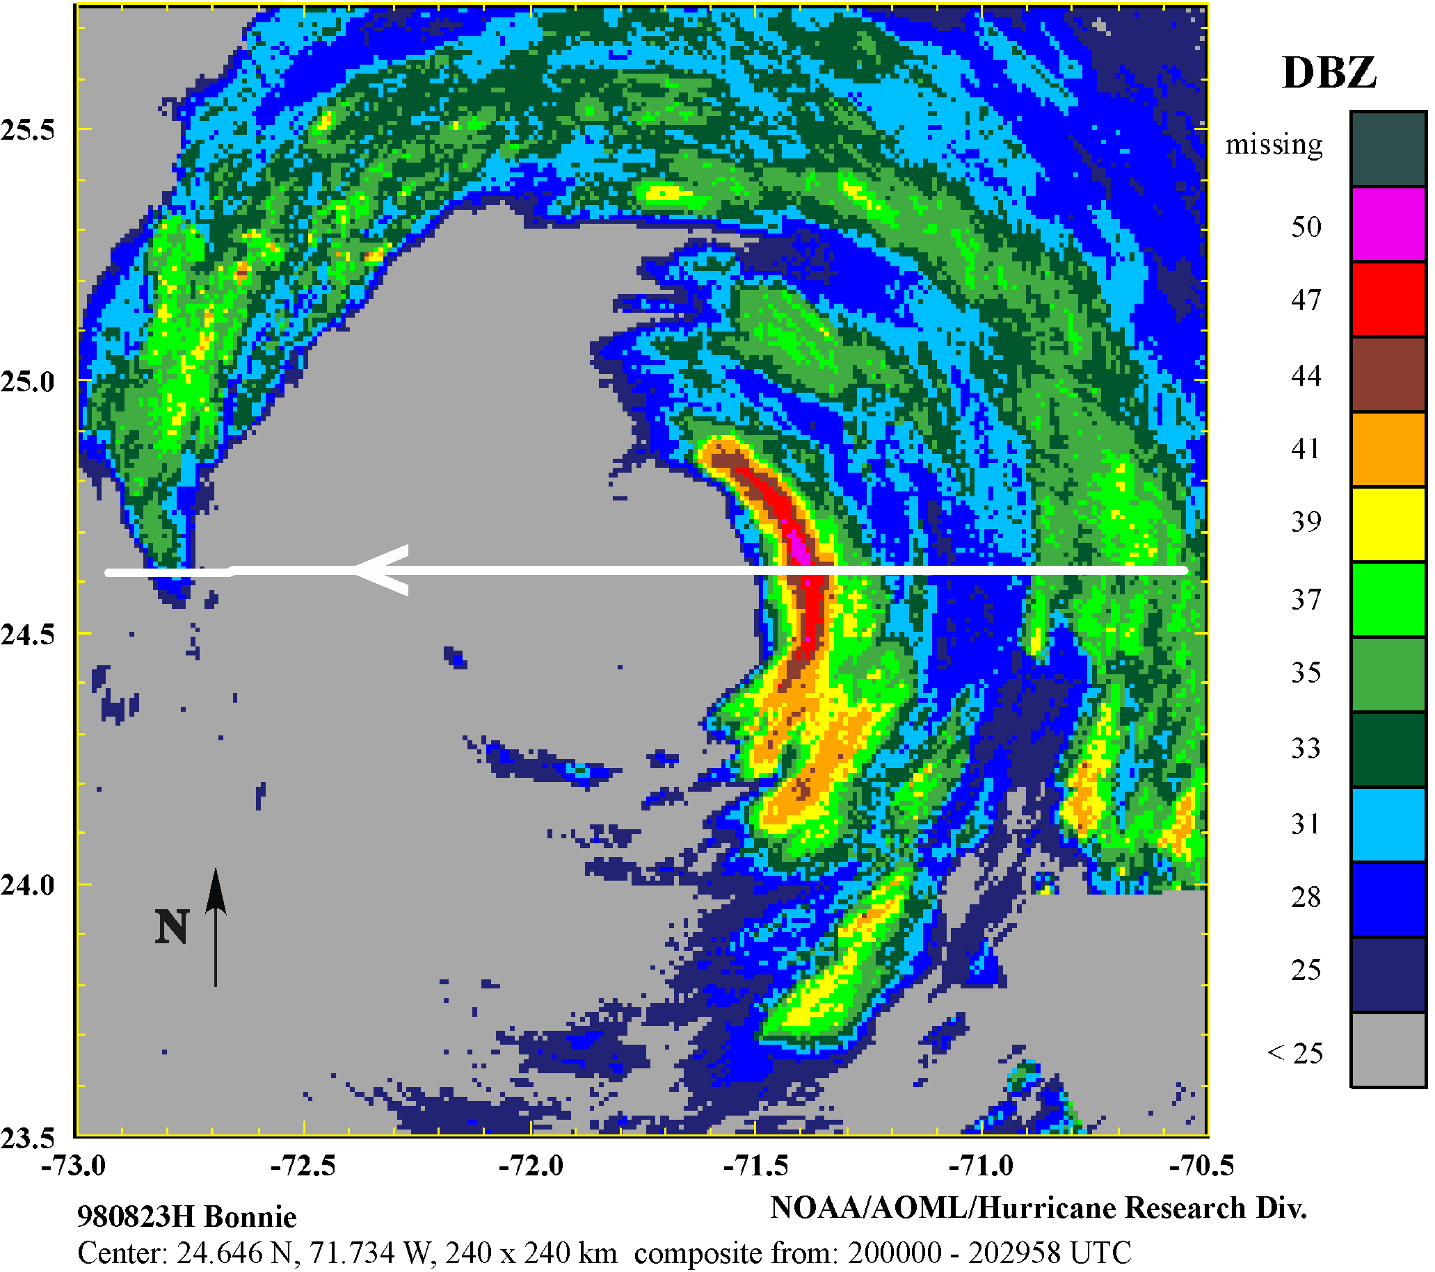

Figure 1. Composite PPI display from the NOAA WP-3D (~4.5 km) at the time of the coordinated ER-2 and DC-8 passes. The ER-2 flight track from 1952:46 – 2011:09 is shown.

Figure 2:

Radar cross-section from the ER-2. Reflectivity (top) and Doppler radial speed (bottom). DC-8 and WP-3D potential temperature, horizontal wind, and vertical wind. Also marked are the location of the eye and the warm core. The DC-8 encountered the large particle images in the updraft marked on the Figure by the thin vertical black lines and arrows. Adapted from Heymsfield et al (2001).

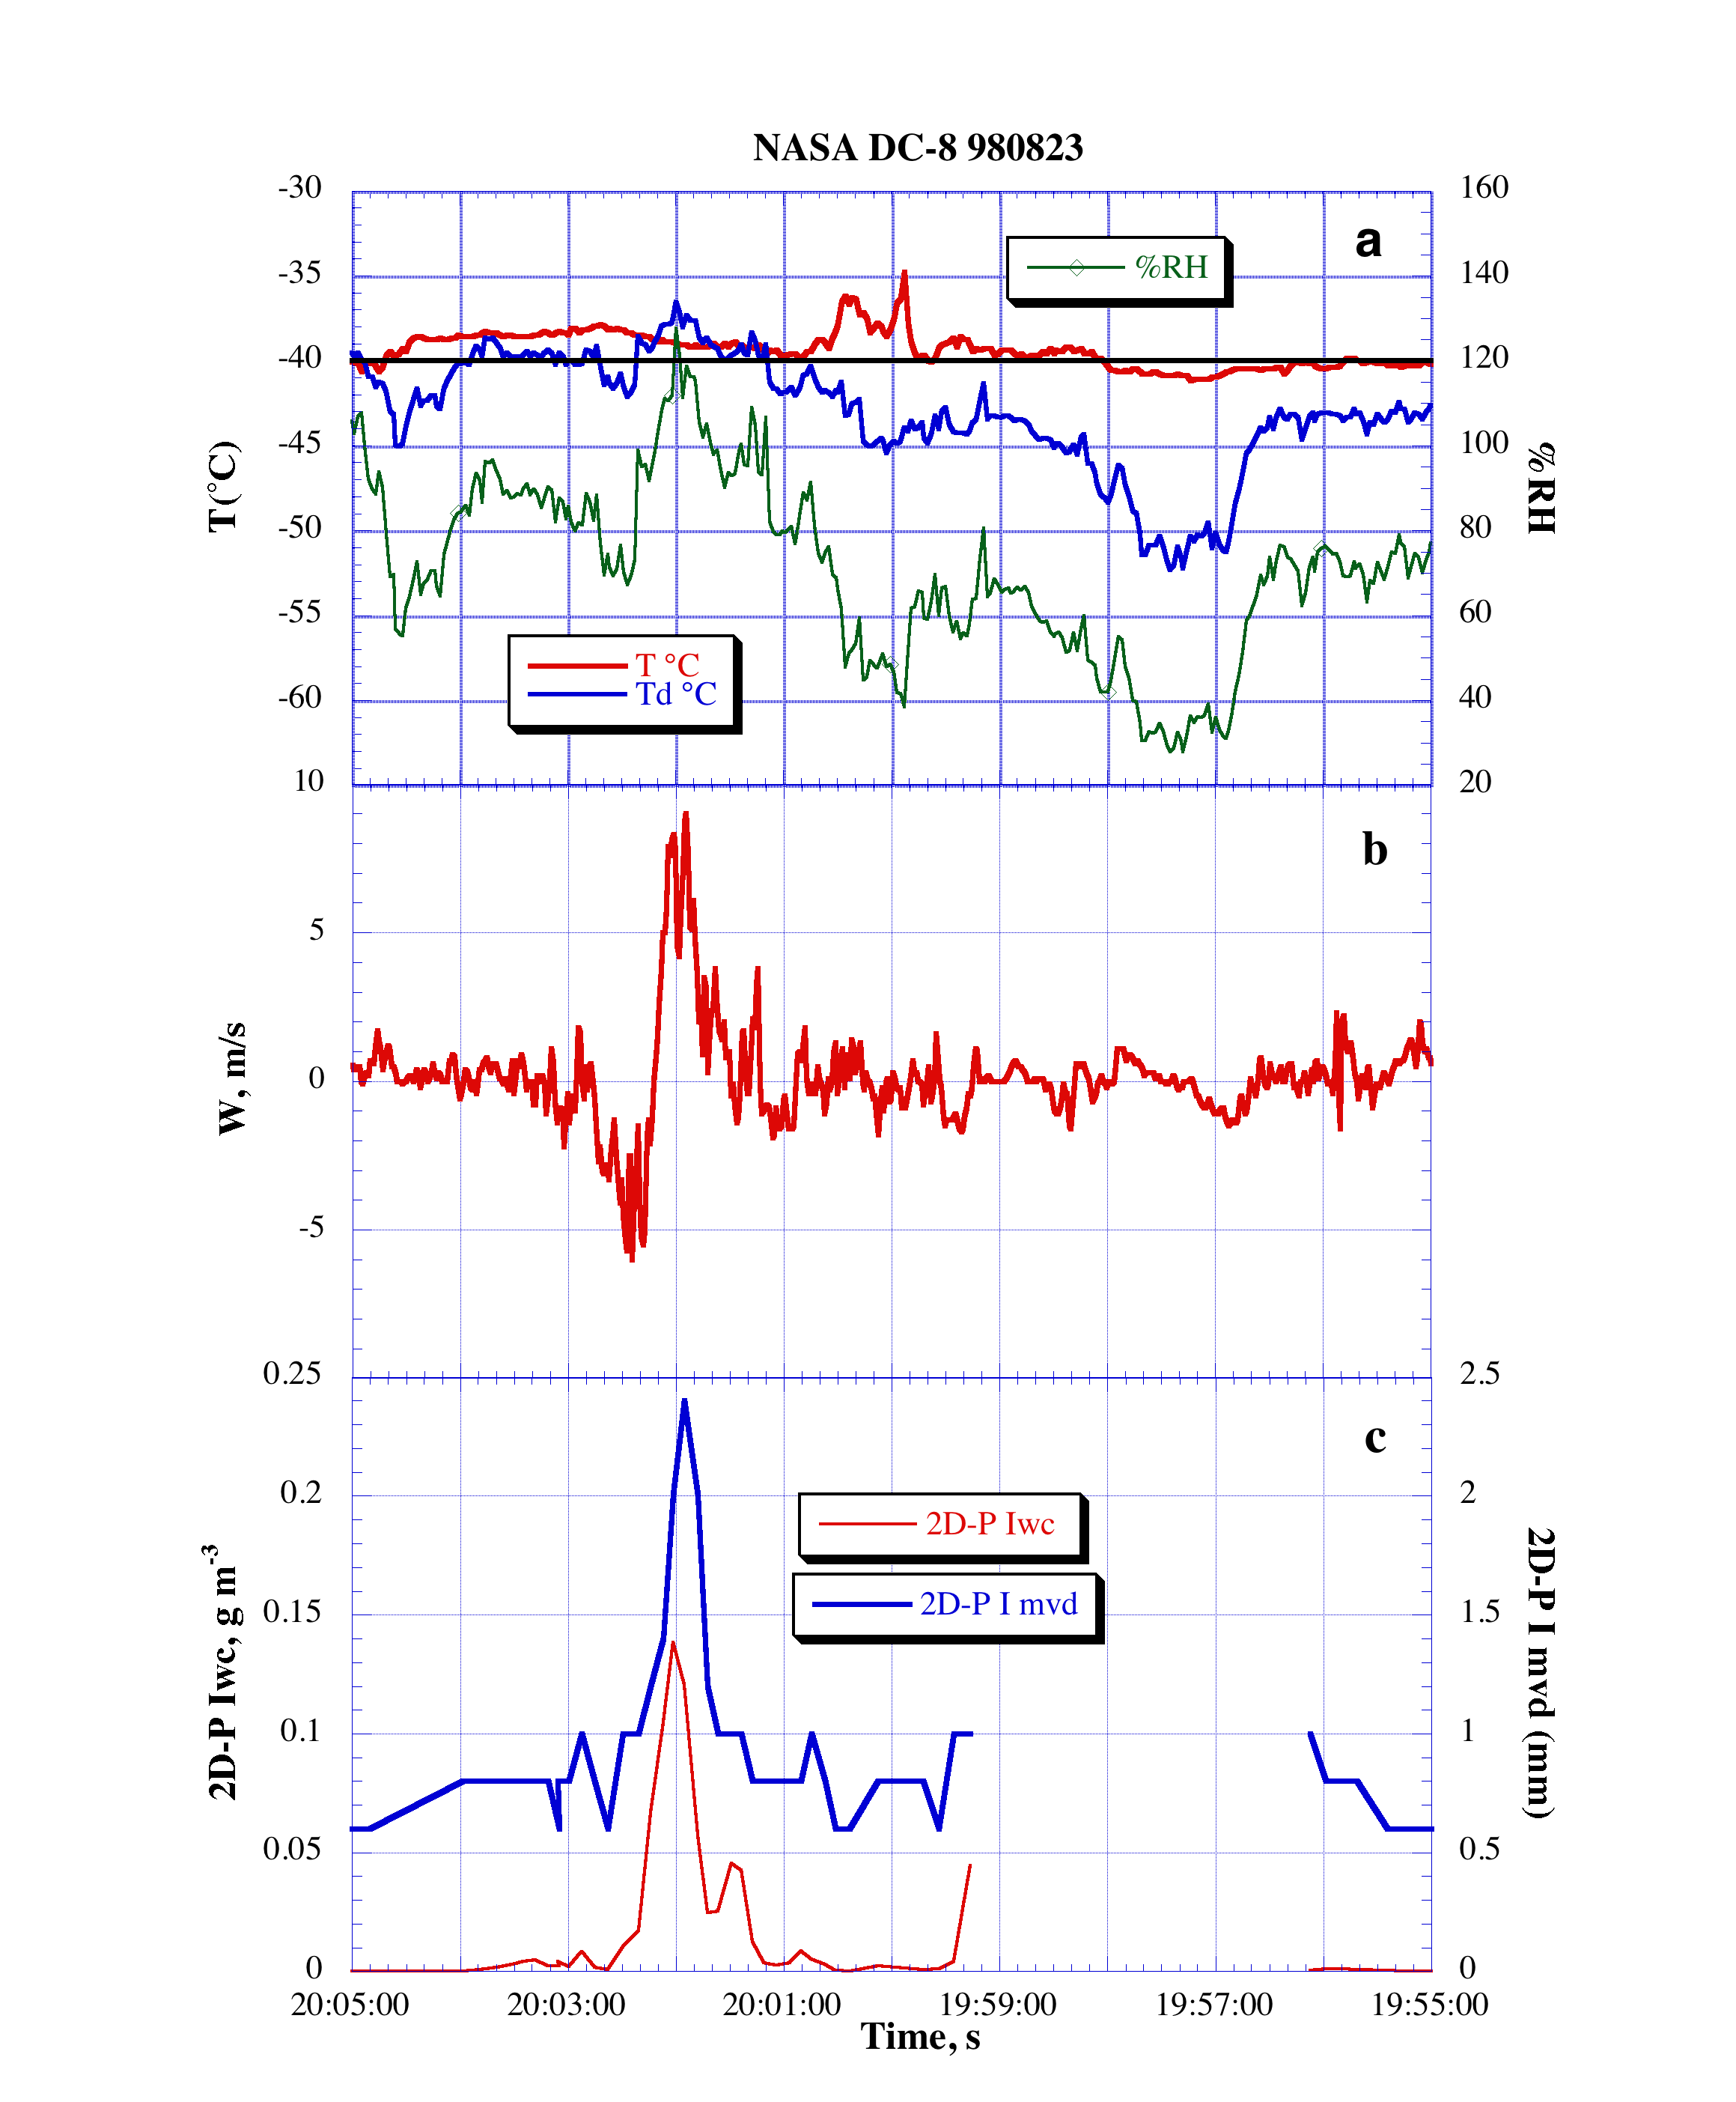
Figure 3. Time-series of DC-8 meteorological data near the time of the large particles. a) Temperature, dew point and relative humidity b) Vertical velocity c) 2D-P ice water content and median volume diameter. The time axis is reversed to match Figure 2, although these plots are not on the same scale.

Figure 4.

2D-P imagery from the NASA DC-8. Note the presence of large graupel. The (circled) breakup images are closer in appearance to partially frozen raindrops and/or soft, wet graupel than they are to hard graupel and/or frozen raindrops, which tend to shatter on impact with the probe.

Figure 5.

2D-P images of rain, graupel, and partially frozen rain from the eyewall of Hurricane Emily (1987) at an altitude of 5500 m and a temperature of –2.5°C. In these images, raindrops are smooth and elliptical with diameters usually < 2 mm. The splash in the last strip (circled) is from a partially frozen raindrop or dense graupel impact. Other freezing drops and large dense graupel are present in the preceeding strips. Compare these large images with those of Fig. 4.

Figure 6: Hard ice particles observed in a 10 m s⁻¹ updraft at the 6.4 km elevation at a temperature of about –10˚C in Hurricane Claudette (1991). Note the shape of the shatter patterns. Given their location in the eyewall updraft, these particles probably originated as frozen raindrops. Other parameters from this time are shown in Black and Hallett (1999), Figure 11.

