Intercomparison of GBVTD-retrieved circulation centers and structures of Hurricane Danny (1997) from two coastal WSR-88Ds

Shirley T. Murillo

NOAA/AOML/Hurricane Research Division

Miami, FL

Wen-Chau Lee, Michael M. Bell

UCAR/NCAR/EOL

Boulder, CO

Gary M. Barnes

University of Hawai′i at Manoa

Honolulu, HI

Frank D. Marks Jr., Peter P. Dodge

NOAA/AOML/Hurricane Research Division

Miami, FL

Submitted to Monthly Weather Review

April 2009

Corresponding Author’s address:
NOAA/AOML/Hurricane Research Division
4301 Rickenbacker Causeway
Miami, FL 33149
Shirley.Murillo@noaa.gov

ABSTRACT

A plausible primary circulation and circulation center of a tropical cyclone (TC) can be deduced from a coastal Doppler radar using the ground-based velocity track display (GBVTD) technique and the GBVTD-simplex algorithm. The quality of the retrieved primary circulation is highly sensitive to the accuracy of the circulation center that can only be estimated from the degree of scattering of all possible centers obtained in GBVTD-simplex analyses from a single radar in real TCs. This study extends previous work to examine the uncertainties in the GBVTD-simplex derived circulation centers and the GBVTD-derived primary circulations in Hurricane Danny (1997) sampled simultaneously from two Doppler radars (WSR-88Ds in Mobile, AL and Slidell, LA) for five hours.
It is found that the mean difference between the individually computed GBVTD-simplex derived centers is 2.13 km, similar to the estimates in previous studies. This value can be improved to 1.59 km by imposing time continuity in the radius of maximum wind, maximum mean tangential wind, and the center position in successive volumes. These additional physical criteria, not considered in previous work, stabilized the GBVTD-simplex algorithm and paved the way for automating the center finding and wind retrieval procedures in the future.
Using the improved set of centers, Danny’s axisymmetric tangential wind structures retrieved from each radar showed general agreement with systematic differences (up to 6 m s⁻¹) in certain periods. The consistency in the wavenumber one tangential winds was not as good as their axisymmetric counterparts. It is suspected that the systematic differences in the axisymmetric tangential winds were caused by the unresolved wavenumber two sine components rather than from the relatively small cross-beam mean wind components in Danny.
1. Introduction
Doppler radar has become the primary remote-sensing instrument to deduce three-dimensional internal structures of tropical cyclones (TCs) (e.g., Marks 2003). Wind damage and storm surge during a TC landfall are well correlated with the magnitude and areal extent of the primary circulation, which can be estimated using Doppler radial velocities at low levels. The structure and evolution of tropical cyclones have been studied with airborne pseudo-dual-Doppler radar for many years, primarily near the eyewall region (Marks and Houze 1984; 1987; Marks et al. 1992; Gamache et al. 1995). Physical insight into the storm structure and dynamics of TCs can be obtained through analyses of radar-derived kinematic fields in Cartesian and cylindrical coordinates (Marks et al. 1992; Dodge et al. 1999; Reasor et al. 2000). However, due to the sampling limitations (flight duration and pattern) of airborne Doppler radar, previous studies were only able to document a snapshot of the TC evolution on a time scales of hours or days.
The WSR-88D network in the United States and other countries (e.g., Taiwan, China, South Korea, Japan) enables continuous monitoring of landfalling tropical cyclones within ~200 km of the coastline. These radars can sample a TC approximately every six minutes and reveal TC evolution with unprecedented time resolution (e.g., Blackwell 2000). However, the average distance between WSR-88Ds is ~250 km in the United States, thus making dual-Doppler analysis of the entire storm impractical and necessitates single-Doppler radar wind-retrieval techniques for deducing the TC circulation. It has been demonstrated that the primary circulation of a TC can be retrieved reasonably well from a single Doppler radar using the ground-based velocity track display technique (GBVTD, Lee et al. 1999). The GBVTD technique has been used to study landfalling Typhoon Alex (1987) in Taiwan (Lee et al. 2000), Hurricane Charley (2004) in the U.S. (Lee and Bell 2007), and Typhoon Saomei (2006) in China (Zhao et al. 2008), revealing many features that had not been documented in previous Doppler radar observations. These authors all emphasized the importance of obtaining an accurate circulation center in order to accurately retrieve the TC circulation.
It has long been known that cylindrical coordinates provide a useful framework for studying vortex structure and dynamics. Within this conceptual framework the decomposition of a TC circulation into azimuthal wavenumber (harmonic) components has also proven to yield additional physical insights. For example, Willoughby (1992) demonstrated that a misplaced TC center resulted in an apparent wavenumber one asymmetry when decomposing an axisymmetric TC into azimuthal components. Since TC are axisymmetric, the best TC center was defined as the point that minimizes the wavenumber one asymmetry. Marks et al. (1992) used a simplex method (Nelder and Mead 1965) to identify Hurricane Norbert’s (1984) center from the pseudo-dual Doppler winds derived from observations of the NOAA WP-3D tail Doppler radar data. The circulation center was defined as a point that maximizes the storm-scale vorticity computed from a simplex method.
When the GBVTD-simplex algorithm was applied to Typhoon Alex (1987), Lee and Marks (2000) (hereafter LM) estimated the center accuracy was 1-2 km based on the scatter of multiple minima obtained through the simplex search. Alex's centers, obtained once every 15 minutes, deviated from a straight line, similar to the trochoidal motion documented by Muramatsu (1986b), but with a smaller spatial and shorter temporal scale. With data available only from one Doppler radar in Typhoon Alex, it is not clear whether this motion was real or due to the uncertainty in the GBVTD-simplex algorithm. Without other independent measurements of the “true” TC center from reconnaissance aircraft and/or observations from another Doppler radar in Alex, it was not possible to assess the accuracy of the GBVTD-simplex TC center finding algorithm documented in their study. As the GBVTD algorithm becomes a primary tool for operation and research to diagnose TC structures using WSR-88D data, quantifying the uncertainties in the GBVTD-simplex derived circulation centers and GBVTD-retrieved wind structure is necessary. Hurricane Danny (1997) provides a unique opportunity to examine the evolution of the wind and reflectivity fields of a TC that was simultaneously observed by two WSR-88Ds, Mobile, AL (KMOB) and Slidell, LA (KLIX), from nearly perpendicular vantage points over five hours. Hence, these two datasets can be considered independent and suitable to examine the uncertainties in the GBVTD-derived TC circulation and the GBVTD-simplex derived TC circulation center.
The primary goals of the study are: (1) to systematically compare these two independent sets (~60 volumes from each radar) of GBVTD and GBVTD-simplex solutions and to objectively evaluate the uncertainties in these algorithms, (2) to propose an improved TC center finding procedure by taking into account the time continuity of key TC characteristics, and (3) to solve for the full mean wind with data from both radars.

2. Analysis Methods
a. The GBVTD Technique
The GBVTD technique developed by Lee et al. (1999) is used to deduce the primary circulation of the storm using only single Doppler radar observations. This technique is based on the principle that the TC circulation is nearly circular and can be represented spectrally in azimuthal space. With a known circulation center, the Doppler velocities at each radius can be Fourier decomposed into a series of sine and cosine functions. The 3-D primary circulation of a TC can be reconstructed by compositing the primary circulation at each radius and height. The details of the GBVTD concept and technique are presented in Lee et al. (1999).
b. GBVTD-simplex Center Finding Method
An accurate TC center is a prerequisite to retrieve accurate wind fields by the GBVTD technique (LM). Although the axisymmetric circulation is less sensitive to the uncertainty of the TC center, the TC center needs to be accurate within 5% of the radius of maximum wind (RMW) to keep the error in the retrieved asymmetric circulation below 20% (LM). LM proposed the GBVTD-simplex center finding algorithm by incorporating the simplex method (Nelder and Mead 1965) into the GBVTD technique to provide an objective estimate of the TC center. The GBVTD-simplex method searches for a point that maximizes the mean tangential wind (e.g., wavenumber zero component) of a tropical cyclone (Marks et al. 1992). Hence, both the RMW and the maximum mean tangential wind (V_{T}) can be estimated simultaneously. The GBVTD-simplex algorithm has been applied in several tropical cyclone studies (e.g., Lee et al. 2000, Lee and Bell 2007, Zhao et al. 2008).
Following the procedures outlined in LM, we used 16 possible initial center positions surrounding the first-guess center location (estimated from reflectivity patterns or single Doppler velocity patterns) for the GBVTD-simplex calculation. It is assumed that these initial center guesses will surround the “true center” and better identify "global" rather than “local” maximum mean tangential winds in the process. The use of 16 initial guesses was determined as a balance between computational efficiency and sufficient statistics to confidently determine a center. The separation (or the distribution) among these initial guesses is a function of the size of the eye and the uncertainty in estimating the initial center. The constant altitude plan position indicator (CAPPI) of reflectivity and Doppler velocity are made from PPI data using bi-linear interpolation (e.g., Mohr et al. 1986) then interpolated onto concentric rings in a Cylindrical coordinates where its origin is the TC circulation center (Lee et al. 1999).
For each initial center, the calculations were performed on annuli with a width of 2 km centered on the estimated RMW of 20 km during the analysis period. Due to the inhomogeneous distribution of radar data above 5 km altitude, reliable centers could not be obtained there. The circulation above 5 km was retrieved using the center at 5 km. The estimated center location for each RMW is the arithmetic mean of center guesses from all 16 analyses. Estimated centers that are farther than one standard deviation from the estimated mean center for each apparent RMW and altitude are discarded and the TC center is recomputed by averaging the remaining points (LM). The TC center and the RMW can then be selected at each altitude below 5 km based on the maximum mean tangential winds for each altitude.
c. Hurricane Danny (1997) and datasets
Hurricane Danny was a category one hurricane that made landfall on 18 July 1997 at 0900 UTC near the mouth of the Mississippi River and again in the Mobile Bay area on 19 July 1997 at 1000 UTC (Fig.1). On 16 July 1997, an upper-level trough situated over the southeast US set off a cluster of thunderstorms over the lower Mississippi valley. This convection drifted over the northern Gulf and contributed to the development of a weak surface low. Danny developed from this low in the northwest Gulf of Mexico and on 16 July 1997 at 1200 UTC it was classified as a tropical depression. Peak winds reached 35 m s⁻¹ with a minimum pressure of 984 hPa on 19 July 1997 at 1500 UTC. Danny stalled for about 15 hours over Mobile Bay. It produced nearly 1000 mm of rain over the southern Alabama area (Rappaport, 1999). Figure 2 shows the extent of the outer rainbands that produced heavy rainfall over the Bay depicted from the KLIX radar.
Danny moved east-northeast toward Mobile Bay along the Gulf coast before making landfall (Fig. 1). The storm was within the Doppler-velocity ranges of both KLIX and KMOB for five-hours. A US Air Force Reserve WC-130 was performing a hurricane reconnaissance mission and a NOAA WP-3D was flying a landfall research mission during this period. GPS dropsondes were deployed throughout the storm from the aircraft. Several NOAA moored buoys and Coastal Marine Automated Network (C-MAN) platforms also were sampling the storm. For this study data from both KLIX and KMOB radars from 1600-2100 UTC on 18 July 1997 were used.
d. WSR-88D data and data processing
This study uses WSR-88D archive level-II radar data from KLIX and KMOB. These data have the highest spatial resolution [1º beam width x 250 m along the beam length (range gate)] of all the archived data and are available in an unprocessed form (Crum et al. 1993). KLIX and KMOB level-II data were quality controlled (e.g., ground clutter removal, Doppler velocity unfolding, removing noise and second-trip echoes) using the NCAR/SOLO package (Oye et al. 1995) employing the Bargen and Brown (1980) Doppler velocity unfolding algorithm.

3. Improvements in TC center finding
a) Original GBVTD-simplex derived centers
Danny’s GBVTD-simplex derived tracks from KLIX and KMOB data are shown in Fig. 3a. The mean, median, and standard deviation of the difference between these two sets of centers are illustrated in Table 1 (Labeled as the “original method”). Since the KLIX and KMOB scans were not coordinated to begin at the same time, the center locations were linearly interpolated into one-minute intervals to prevent differences due to staggered starting times of each radar volume. The RMW of Danny was approximately 18 km. The mean difference between these two sets of centers using the original method is ~2.1 km, exceeding the 1.9 km threshold for an 18 km RMW recommended in LM. The standard deviation of 1.2 km indicates that, assuming a normal distribution, there were more than 15% of the center pairs that differed more than one standard deviation (i.e., > 3.3 km). Closer examination of the data in Fig. 3a and b reveals two apparent discrepancies.
First, internal inconsistency on storm characteristics is apparent within each of the KMOB and KLIX analyses. Large fluctuations in derived quantities existed (sometimes from volume to volume) beyond the known uncertainties (e.g., ~2 km in center estimate and 1 km in RMW due to the width of the annulus). Examining the derived quantities from successive radar volumes revealed that the retrieved TC structures can be quite different when the GBVTD-simplex derived centers differed more than several kilometers or the successive RMWs derived from the same radar deviated more than 2 km. Typically, an incorrect higher mean tangential wind value is deduced due to missing data at greater radii, the existence of an outer eyewall, and/or combinations of velocity dipoles at an incorrect RMW. In this situation, the derived center may not be even close to the “true” center resulting in a completely different storm structure. Some of the fluctuations in TC center position in successive volumes appear to largely result from a relatively flat radial profile of the mean tangential wind speed near the RMW, such that the algorithm may choose different RMWs due to small perturbations in the derived mean tangential winds. Essentially, the original GBVTD-simplex algorithm has too many degrees of freedom in finding the maximum mean tangential wind without considering the physical integrity and time continuity of the TC structures; therefore, making the GBVTD-simplex algorithm very sensitive to inhomogeneous spatial data distribution.
Second, systematic differences in the retrieved TC quantities existed between these two independent analyses. For example, up to 5 m s⁻¹ differences between the maximum mean tangential winds (Fig. 3c) are apparent between 1900 to 2030 UTC. This discrepancy might be rooted in different viewing angle between KLIX and KMOB resulting in different aliasing magnitudes into the mean tangential winds from the unresolved terms such as the cross-beam mean winds and the sine component of the wavenumber two (Lee et al. 1999). This point will be discussed in Section 5.
b) Comparisons with other circulation centers
Figure 4 illustrates the derived GBVTD-simplex centers for both radars along with the centers from other independent estimates (i.e., NHC operational radar center fixes and aircraft flight-level fixes) for comparison. The storm is passing through the Chandeleur Islands off the coast of Louisiana. The GBVTD-simplex derived tracks are in general agreement with centers derived by other sources; however, the GBVTD-simplex derived tracks show more details as they are computed every six minutes. The GBVTD-simplex derived centers were within 10 km of the aircraft fixes. The GBVTD centers from KMOB and KLIX are consistent not only with each other but also with the aircraft fixes and the KLIX and KMOB NHC operational radar centers.
c) The improved GBVTD-simplex derived TC centers
Based on the findings in the last section 2a, several procedures were examined to improve the GBVTD-simplex derived TC centers and the recommended procedures are discussed, and the quality of the centers resulting from these procedures is examined in this section.

1) Include asymmetry in the curve fit
LM used only wavenumber zero in the fitting of TC circulation to the observed Doppler velocities along a constant radius. Since Danny was an asymmetric TC, it is intended to examine the effects of including asymmetry in addition to wavenumber zero in the GBVTD-simplex curve fit on the GBVTD-simplex algorithm. These results are illustrated in Figure 5. The inclusion of wavenumber one (i.e., wave 0+1, see Fig. 5b) in the GBVTD-simplex algorithm reduced the variability in the center locations from the analyses only including wavenumber zero (Fig. 5a). Including additional wavenumbers degraded the center estimates in this case (not shown).
It can be concluded that it is important to consider pronounced storm asymmetries in the GBVTD-simplex algorithm to yield the most consistent centers. This situation has been encountered in an elliptical-shape Typhoon Herb (1996) with a significant wavenumber two asymmetry (Lee et al. 2002) where the GBVTD-simplex algorithm failed using only wavenumber zero in the curve fit. The asymmetry of a TC can be inferred from the GBVTD analysis where an iterative procedure can be implemented based on the goodness of the curve fit to find the best fit (i.e., smallest overall standard deviation) to the observed Doppler velocities by including different wavenumbers.
2) Implement constraints on TC structures in space and time
The RMW, the maximum V_{T}, and the circulation center of a TC should evolve slowly and consistently in space and time without significantly large fluctuations during a six-minute period. These physical constraints should be applied when one selects the “best center” from the time series of the GBVTD-simplex derived quantities within the uncertainties of the 1-degree beam resolution and the 1-km grid resolution. Based on these physical constraints, it is determined that the reasonable range of fluctuations for storm characteristics due to evolution and advection are: 2 km for RMW, 5 m s⁻¹ for maximum mean tangential wind, and 2 km for the circulation centers on consecutive radar volumes in this study.
Based on the above discussions, all possible GBVTD-simplex centers at each time during the 5-hours were re-examined and two new sets of centers were selected (Fig. 3b) and their corresponding RMWs and maximum mean tangential winds are illustrated in Fig. 3d. It is apparent that the unrealistic fluctuations in center position, RMWs and maximum V_{T} in the “original” algorithm (Fig. 3a and 3c) were drastically reduced in the “improved” algorithm (Fig. 3b and 3d). The consistency in these storm characteristics appeared not only in results from single radar (KLIX or KMOB) but also in the cross comparisons. The mean difference (standard deviation) between the center position obtained by KMOB and KLIX is reduced to 1.59 (0.95) km from 2.12 (1.24) km obtained in the original algorithm (Table 1). The large differences at the beginning and ending periods are a result of poor data coverage because Danny was either entering KMOB or leaving KLIX’s Doppler ranges. The mean differences can be further reduced if these periods were excluded. Nevertheless, the mean center difference of 1.59 km resulting from two independent radar observations provides, for the first time, an objective assessment of the uncertainties in TC centers estimated by the GBVTD-simplex algorithm after taking into account the storm structures in the GBVTD-simplex algorithm.
Examining the differences in these two GBVTD-simplex centers (latitude and longitude) shown in Fig. 6 reveal temporal variability in both the latitude and longitude differences with magnitudes mostly less than 2 km except for the period between 1915-2045 UTC, where the largest difference is around 1930 UTC (> 4 km). This period coincides with the out of phase characteristics seen in V_{T} (Fig. 3d), indicating a systematic bias in deducing the centers and TC structures. The majority of the RMW differences are within 1 km (the radius resolution of the cylindrical analysis grid) with the largest difference of 2-3 km once again occurring around 1930 UTC (Fig. 3). This period is consistent with the systematic differences shown in center locations (Fig. 6) and V_{T} (Fig. 3).
A comparison of the differences between the simplex-derived centers from each radar with the center differences with the dual-Doppler wind field (Fig. 7) was performed. The dual Doppler center is obtained using the Marks et al. 1992 methodology, maximizing the vorticity at the RMW as in the GBVTD case, but using the full wind field. Additional physical constraints were not applied to the dual Doppler centers though - they are the center that maximizes the mean tangential wind from each combined radar volume independently. As can be seen from Fig. 7, neither KLIX or KMOB is doing significantly better than the other when compared to the dual Doppler, but they agree on average with the 'true' center and with each other to within ~2 km. There is also no evident bias in the results, but mostly scatter.

4. Intercomparison of the GBVTD-derived TC structures
Using the improved set of Danny’s centers, the kinematic structures of Hurricane Danny observed from both the KLIX and KMOB radars were deduced from the GBVTD technique for the entire five-hours with an unprecedented six-minute temporal resolution. Danny’s kinematic structures (axisymmetric and wavenumber-one reflectivity and tangential wind) are presented in time-radius space (Hovmoeller diagram) and will be used to evaluate the quality of the GBVTD-retrieved TC structures during the storm’s evolution.
a. Reflectivity evolution
Hovmoeller diagrams of the wavenumber zero (axisymmetric mean) reflectivity at 2-km altitude for KLIX (a) and KMOB (b) are shown in Fig. 8. The reflectivity patterns from both radars are nearly identical, which is expected because reflectivity is a scalar. The similarity in Fig. 8 also indicates that the radar reflectivity is not biased between KLIX and KMOB. The radius of peak axisymmetric reflectivity structure is located at R~18 km with the maxima observed from both radars of ~33 dBZ between 1600 and 1700 UTC. The peak axisymmetric reflectivity weakened to ~30 dBZ between 1700 and 1900 UTC, while remaining at around 20 km radius. An outer reflectivity maximum located at R~47 km began to intensify around 1700 and peaked around 1900 UTC. Afterward, the inner reflectivity maximum intensified and the radius contracted to ~14 km after 1900 UTC. Weaker reflectivity (<15 dBZ) persists inside the eyewall from R = 0-7 km.
The wavenumber-one reflectivity patterns (Fig. 9) for both radars are also in good agreement. The length (direction) of the vector in Fig. 9 is proportional to the magnitude (phase, relative to the TC center) of the wavenumber-one reflectivity. The large area of 14-22 dBZ, located 10-40 km southeast of the TC center from 1700-2000 UTC coincides with the minimum in the reflectivity wavenumber zero (Fig. 8). This sequence of events suggests that Danny evolved from a nearly axisymmetric storm (before 1700 UTC) to an asymmetric wavenumber one storm then evolved back into an axisymmetric storm after 2000 UTC. The enhanced wavenumber one reflectivity in the southeast quadrant indicated a period with a convective burst from ~1700–1840 UTC. The location of the peak convection rotated cyclonically from south-southeast to east in this period ending at about 1930 UTC.
b. Kinematic evolution
Danny’s axisymmetric wind structure is represented by wavenumber zero at 2 km altitude (Fig. 10). The Hovmoeller diagram for both KLIX (a) and KMOB (b) show the maximum tangential winds exceeding 30 m s⁻¹ (also in Fig. 3d). The agreement between the KLIX and KMOB wavenumber zero in Fig. 10 is definitely not as good as that in the wavenumber zero reflectivity (Fig. 8). One should not be surprised at this discrepancy since V_{T} is a derived quantity that is dependent on the viewing angle in the GBVTD formulation. A steady increase of wavenumber zero V_{T} is observed from KMOB with periodic episodes (duration ~1 hour) of high wavenumber zero V_{T} seen throughout the five-hours (Fig. 10b). A similar trend was also resolved in the KLIX analyses (Fig. 10a) but was not as clear as those shown in the KMOB analyses. KMOB analysis, in general, depicts stronger axisymmetric V_{T} than those resolved in KLIX, especially around the later periods (i.e. 2000 UTC). The differences between the two estimated axisymmetric V_{T}’s are typically within 2 m s⁻¹ except for a short period near 1710 UTC and a long period between 1910 and 2030 UTC where the magnitudes of the differences reaches 4 m s⁻¹. The “true” axisymmetric V_{T} is probably in between these two estimates. Hence, the uncertainty in the GBVTD-derived axisymmetric V_{T} is ~7% in Danny. Several possibilities that may contribute to these differences are examined later.
Figure 10 shows Danny’s wavenumber one V_{T}, whose amplitude and phase are represented by the length and direction of each vector as shown in Fig. 9. The consistency between the KLIX and KMOB derived wavenumber one V_{T} is not as good as anticipated, indicating the challenge to deduce reliable small amplitude asymmetric components in Danny. The KLIX analysis (Fig. 11a), in general, shows a slightly stronger wavenumber one asymmetry in V_{T} than the KMOB analysis (Fig. 11b). In both analyses, several episodes of enhanced wavenumber one V_{T} near the RMW are apparent. The enhancement between ~1700 to 2000 UTC coincides with the enhancement in the wavenumber one reflectivity (Fig. 9) and a general trend of weaker wavenumber zero amplitude in reflectivity (Fig. 8), further suggesting that Danny evolved from an axisymmetric storm into asymmetric storm during this period. A maximum wavenumber one V_{T} > 8 m s⁻¹ is seen around the RMW from both radars. The KLIX analysis depicts a more widespread maximum (V_{T} values > 6 m s⁻¹), extending beyond R = 30 km, than the KMOB analysis. However, the KLIX wavenumber one V_{T} shows a better correlation with its corresponding wavenumber one reflectivity (cf. Fig. 9a, 11a). The anti-correlation between the wavenumber zero and wavenumber one V_{T} in the KMOB and KLIX analyses may be related to how the total winds are decomposed into different wavenumbers. The phase and amplitude of the wavenumber one V_{T} possess a much wider area of small scale variations than those of the corresponding reflectivity and wavenumber zero, confirming that asymmetric winds are more sensitive to the center location and the uncertainties in the data and aliasing in the GBVTD formulation than their axisymmetric counterparts.
c. Structural comparison and discussion
Throughout the five-hour analysis period, KLIX and KMOB sampled Danny nearly from perpendicular vantage points. Since radial velocity can only be measured along the radar beam, these two radars therefore sampled nearly orthogonal components of Danny’s circulation. Because reflectivity is a scalar, it is not a surprise that the KLIX and KMOB reflectivity patterns agree much better than the GBVTD-derived velocity vectors that involve several assumptions and is sensitive to both viewing angle and TC centers. These two datasets and analyses provide a unique opportunity to evaluate the uncertainties embedded in the GBVTD analyses. Two times are chosen to closely examine the characteristics of the GBVTD-derived circulation of Danny. The first time is 1832 UTC, when the values of the axisymmetric V_{T} for both radars are nearly identical at all radii. The second time is 1954 UTC, when the axisymmetric V_{T} differs by ~4 m s⁻¹ (Fig. 3d).
Both radars show a similar reflectivity pattern at 1832 UTC (in contours) in the 2 km CAPPI (Fig. 12a and b). The TC center is about ~90 km from each radar. A small area exceeding 50 dBZ is seen in the southern half of the storm. This feature is part of the primary eyewall. A secondary reflectivity maximum (>35 dBZ) is seen in the northern quadrant. The velocity pattern at 2 km altitude as seen by both radars indicates that the most intense winds (~33 m s⁻¹) are located in the south to the southeast of the center, consistent with the reflectivity maxima.
The wavenumber one asymmetric structure in Danny is depicted in the GBVTD analysis (Fig. 12c and d). The reflectivity (shown in 10 dBZ contours) for both radars has a similar pattern showing positive (negative) anomalies in the southeast (northwest) quadrant. Although the patterns of the azimuthal wavenumber one V_{T} (in color) are consistent with each other, the magnitude is different, with KLIX possessing larger amplitude than the KMOB. Beyond R = 30 km, the peak of the wavenumber one V_{T} has shifted to the northwest side of storm. Nevertheless, the KMOB wavenumber one amplitude is generally weak (< 4 m s⁻¹). There is a concentrated area of V_{T} (8 m s⁻¹) that coincides with the reflectivity maxima as seen by KLIX, while KMOB barely detects it.
The wavenumber zero V_{T} from both radars are in good agreement (Fig. 13a). Both KLIX and KMOB GBVTD analyses (Fig. 13) demonstrate a maximum axisymmetric V_{T} of 33 m s⁻¹ at 20 km and 15 km from the center, respectively. The difference in the RMW can also be seen in the axisymmetric reflectivity (Fig. 13b). The reflectivity and V_{T} values decreased quicker past the RMW in the KLIX analysis compared to the KMOB analysis. In the KMOB analysis, the range of reflectivity and V_{T} between R = 15 and 20 km is ~1 dBZ and 1 m s⁻¹. Hence, the KMOB center was chosen with an RMW of 18 km, rather than the peak wavenumber zero V_{T} at 15 km, based on the criterion of the storm structure continuity. Other than this, the reflectivity wavenumber zero fields vary, but have a similar overall pattern. Two distinct peaks are seen by KMOB (Fig.13b). The secondary peak at around 45 km appeared in the KMOB analysis but is much broader in the KLIX analysis.
Figure 14 compares the derived total wind speed at 2 km from a dual-Doppler analysis with GBVTD-derived total winds from KLIX and KMOB. The dual-Doppler analysis is considered the “ground truth” (Fig. 14a). The dual-Doppler analysis is deduced from a fully three-dimensional variational technique, which solves the dual-Doppler equations (two dual-Doppler projection equations for zonal and meridional velocity using an estimate for the total vertical velocity) and the anelastic continuity equation simultaneously (Gamache, 1998; Reasor et al. 2009). Both GBVTD analyses (Fig. 14b and c) resemble the dual-Doppler analysis (Fig. 14a). All three analyses show the maximum wind speed located in the southeast quadrant, consistent with the reflectivity maximum (black contours in Fig. 14a). The GBVTD derived centers (shown in Fig. 14a) used for each GBVTD analyses are close to the circulation center used for the dual-Doppler analysis. The RMW remains consistent for all three analyses. The magnitude of the wind speed is larger in KLIX (Fig. 14b) than in the KMOB or dual-Doppler analyses. The KLIX CAPPI (Fig. 12a) reveals a stronger outbound radial velocity max than KMOB. This result is also consistent with the azimuthal wavenumber one V_{T} plot shown in Fig. 12c for KLIX. Danny was closer to the KLIX radar at this time and may have detected features in the storm not seen by the KMOB. In addition, the much smaller analysis domain in the dual-Doppler analysis (Fig. 14a) is an apparent limitation compared with both of the GBVTD analyses (Fig. 14b and c).
An hour and twenty minutes later (at 1954 UTC), Hurricane Danny’s structure changed significantly. The eyewall reflectivity weakened at the end of the period of enhanced wavenumber one component (Fig. 9) and the intensification of the wavenumber zero component (Fig. 8). The maximum reflectivity appeared in the north to northeast quadrant and a rainband spiraled clockwise outward and formed a broad arc of >35 dBZ in the southwest quadrant (Fig. 15a and b). The KLIX CAPPI reveals two areas of outbound (relative to radar location) velocities of 24 m s⁻¹ associated with the eyewall and the outer rainband. The typical hurricane inbound radial velocity pattern is seen from KMOB (Fig. 15b) while a weaker radial flow is shown from KLIX (Fig. 15a). This multiple maxima Doppler velocity pattern, especially only existing on the inbound or outbound side, can confuse the GBVTD-simplex algorithm because the maximum outbound Doppler velocity can be paired with either inbound Doppler velocity maximum from different centers in the original GBVTD-simplex algorithm. Applying the time continuity constraints alleviated this problem.
The reflectivity wavenumber one (in contours) pattern is also similar for both (Fig. 15c and d) but the magnitude is weaker than that shown in the previous example. The wavenumber one V_{T} for both radars have similar features near the storm center with two areas ±8 m s⁻¹ directly north and south of the center (Fig. 15d). There are two other areas of ±8 m s⁻¹ at 60 km and 45 km from the center for KLIX and KLOB respectively. The azimuthal wavenumber zero V_{T} for KLIX and KMOB have a similar pattern with a slight offset of the peak wind (Fig. 16a). This time KMOB shows a max of 33 m s⁻¹ at 18 km from the center while KLIX peaks at 28 m s⁻¹ at 18 km. There is also a nearly constant offset of ~6 m s⁻¹ beyond the RMW. The reflectivity wavenumber zero patterns are nearly identical with the peak reflectivity located at R = 17 km (Fig. 16b).
Comparisons of the GBVTD analyses from both radars to the dual-Doppler for 1954 UTC are demonstrated in Fig. 15. Although there are broad similarities such as the RMW and the wind speed maximum on the NE or E side of the storm, there are some notable differences in the other quadrants. These differences are not too distressing given that the V_{T0} from both radars shown in Fig. 16a are off. Several possible reasons that may cause the inconsistency between two GBVTD analyses are discussed in the next section.

5. Value of high-frequency analyses for monitoring storm evolution
Estimates of the circulation center location and kinematic structure of the eyewall are available every 6 minutes for 5 hours. Such a high temporal frequency enables a detailed evaluation of the evolution of the storm center, wind, and reflectivity fields that has been impossible in past studies. A future paper will examine this evolution is detail, but we shall make a few preliminary comments on the GBVTD derived analyses here.
The circulation center is well approximated by a linear regression (Fig. 3b, with R2 ≥ 0.9). Deviations from a linear fit are short-lived, 6-12 minutes, and are of small spatial extent, about 2 km or about one-tenth the horizontal scale of the RMW. Trochoidal motion or wobbles of the circulation center, detected for several other TCs (e.g., Jordan and Stowell 1955, Jordan 1966, Willoughby and Chelmow 1982, Muramatsu 1986a, Roux and Viltard 1995, Marks et al 2008) can have periods ranging from 20 minutes to more than 12 hours. Nolan et al. (2001) argue that the cause of such wobbles, which can be observed in their three-dimensional dry hurricane-like vortex model on time scales as short as 20 minutes, is possibly due to mixing of low vorticity air into the high vorticity annulus of the eyewall. In Danny, trochoidal motions are either not present or so small as to be inconsequential, at least for the five hours of sampling (Fig. 3b, KMOB centers). The lack of trochoidal motion may be caused by inherent uncertainties associated with the GBVTD-simplex technique resulting from the intrinsic assumptions in GBVTD. (Lee et al. 1999). As seen in Fig. 9, Danny’s reflectivity became dominated by a wavenumber one asymmetry during the middle part of the study period (1700-2000 UTC), with the vectors pointing towards the SE. Despite the presence of this pronounced asymmetry, there is not a distinct signature of trochoidal motion. The V_{T} (Fig. 11) also does not show any hint of such motions. This suggests that the presence (or absence) of trochoidal motions is not directly related to convective asymmetries, during this time. Hence and Houze (2008), suggested that the presence of a wavenumber one low-level wind maximum is related to the processes of convective mass transport. Based on what is demonstrated in Figs. 9 and 11, there is not a clear relationship between the asymmetric wind maximum and convective mass transport. If we use the reflectivity as a proxy for convective mass transport, it can be seen that there is not a direct relationship between the timing of the wavenumber one asymmetry in reflectivity with the asymmetry in V_{T}, i.e., when the reflectivity is dominated by wavenumber one, the V_{T} does not show the same signature. Furthermore, the phase of the reflectivity asymmetry (Fig. 9) remains fixed toward the southeast side of the storm, whereas the phase in the V_{T} asymmetry varies over multiple directions, suggesting that these asymmetries are not phase-locked. An examination of the GBVTD derived centers for KLIX and KMOB for the entire time that Danny is within 150 km range of either radar, a little over five days, may reveal if trochoidal motions are present for longer temporal scales.
The GBVTD analysis reveals a wavenumber one reflectivity pattern in the eyewall from about 1715 to 1945 UTC (Fig. 9). The magnitude exceeds 20 dBZ for both radars from about 1815 to 1940 UTC. This maximum in reflectivity moves slowly (~3 m s⁻¹) from the south-southeast to the east portion of the eyewall over 2.5 hours (Fig. 9, vectors). There is also a wavenumber one wind maximum (6-8 m s⁻¹) that is generally collocated with the maximum in reflectivity during the early stage of the asymmetry (Figs. 12 and 14). Later, the wavenumber one asymmetry tends to be downstream of the weakened reflectivity maximum (Figs. 15 and 17). The increase of the tangential winds is initially correlated with increased convection in the southeast quadrant. The wind then becomes relatively smooth in the eyewall as the convection dissipates. Higher tangential winds in the lower troposphere have been correlated with reflectivity features, presumed to be convective cells, in rainbands (Barnes et al. 1991) and in the eyewall (Marks et al. 1992).
Despite the appearance of the aforementioned wavenumber one pattern the RMW and the mean tangential winds are remarkably steady (Fig. 3d). The RMW decreases slightly from 18 to 17 km and the mean tangential winds decrease from 33 to 31 m s⁻¹ at 2 km altitude over 5 hours. During this period the best track record reveals that MSLP deepens ~3 hPa. There is no hint of development of concentric eyewalls in Danny that are believed to exist later when the TC is over Mobile Bay (Blackwell 2000). The GBVTD derived mean fields, obtained with such high temporal resolution, provide a superior method of monitoring the evolution of the eyewall. Application of the technique will provide the details of TCs as they make landfall, a time when aircraft reconnaissance may be limited.

6. Error sources in estimating mean tangential wind
The additional constraints (described in Section 4) applied in this study have significantly reduced the uncertainty of the original GBVTD-simplex derived TC centers from ~2 km to ~1.5 km, consistent with the requirement proposed and the estimated uncertainty in Typhoon Alex (1987) in LM. It is apparent that the GBVTD-derived structures of Danny using the improved center estimates are quite plausible and generally in agreement with the dual-Doppler synthesis. However, the reduced center uncertainty is unable to decrease the systematic differences of the V_{T} between the KLIX and KMOB analyses (c.f. Fig 10). This merits further discussion. In addition to the remaining uncertainties in center location, the disagreement between V_{T} in these two GBVTD analyses may be attributed to the following reasons: (1) sampling differences from the individual radars including differences in horizontal and vertical data coverage, and (2) unresolved asymmetric radial winds and cross-beam mean wind.
As Danny moved eastward across the radar sampling domain, different parts of the storm were sampled due to the limited Doppler range, discrete sampling in the vertical, and sampling from different vantage point (e.g., Fig. 12a, and b; Fig. 15a, and b). In addition, the resolution and altitude of the radar beam is a function of distance and is affected by the earth’s curvature. These aforementioned factors can contribute to the differences in GBVTD-retrieved storm structures. Unfortunately, it is very difficult to quantify the impact from these factors in this dataset and “reduce” the uncertainty in this respect.
Next, the impacts of the unresolved cross-beam mean wind and the sine component of the wavenumber two radial wind on the mean tangential winds are discussed. The GBVTD-derived wavenumber zero tangential wind (V_{T0}) has the following form [Eq. (20) in Lee et al. (1999)]:
. (1)
The third and fourth terms on the right-hand side (rhs) of (1) represent the unresolved cross-beam mean wind and the unknown wavenumber two radial wind. These two terms have been set to zero as the closure assumptions in previous GBVTD studies because they cannot be estimated from single Doppler observations. With simultaneous observations from KLIX and KMOB, the cross-beam mean wind and the wavenumber two component can be estimated.
The cross-beam mean wind can be resolved by radar observations from two different vantage points from the along beam mean flow,
(2)
(3)
The direction of the mean wind flow, θ_{M}, and the magnitude of the mean flow V_{M} can be solved as follows (interested reader can find the full derivation in the Appendix):
(4)
(5)
It can be seen that the unknown V_{R}C₁ and V_{R}C₃ will bias the resulting θ_{M} and V_{M}. Figure 18 demonstrates θ_{M} at 2 km altitude. The angles 45°, 0°, and -45° are northeast, east and southeast respectively. The direction of the mean wind flow in Danny possesses an easterly component except around 1923 UTC, where θ_{M} changes sharply, and then returns to the similar pattern as seen in early periods. Figure 19 illustrates the magnitude of the along beam V_{M} from KLIX and KMOB at 2 km altitude. KLIX (KMOB) sensed a positive (negative) along beam V_{M}, consistent with the general eastward movement of Danny. The mean wind magnitude fluctuated between 1 and 5 m s⁻¹ (not shown) which is relatively weak and consistent with the slow motion of Danny. Figure 20 displays the derived cross-beam mean wind, V_{X}, for both radars. Throughout the period, V_{X} fluctuates but the magnitude is in general less than 1 m s⁻¹, hence, the V_{X} component projected onto each radial has minimal impact on V_{T} and cannot explain the 5 m s⁻¹ difference between 1900-2030 UTC in Fig. 3c.
Though Danny is dominated by wavenumber one between 1700-1930 UTC, the wavenumber two component is non-negligible as shown in Fig. 21. Since the viewing angles from KMOB and KLIX are nearly 90 degrees apart, the aliasing effect from the wavenumber two radial winds to the V_{T} deduced from these two radars would be out of phase. While there is ongoing research attempting to improve the closure assumption on the asymmetric structures (e.g., Lee et al. 2006), an accurate partition of the total wavenumber two amplitude into its tangential and radial components is still not satisfactory. The peak total wavenumber two amplitude between 4-6 m s⁻¹ suggest that a radial wind asymmetry may have sufficient amplitude to account for most of the 5 m s⁻¹ bias in Danny.

7. Summary and future work
Previous ground-based velocity track display (GBVTD) studies (Lee et al. 2000, Harasti 2003) highlighted the significance of obtaining an accurate circulation center in order to derive a realistic asymmetric circulation from the technique. LM stressed that the circulation center of a TC needs to be accurately determined within 5% of its radius of RMW in order to retrieve acceptable asymmetric structures. However, previous studies could not quantitatively evaluate the accuracy of either the GBVTD-simplex derived circulation centers or the GBVTD-derived wind fields. In the Hurricane Danny (1997) case the sensitivity of the GBVTD solutions were evaluated using simultaneous observations by two coastal WSR-88D radars (KMOB and KLIX) every six minutes for five hours. The two radars sampled the circulation center from nearly perpendicular vantage points providing essentially two independent looks of Danny. This dataset provided a unique opportunity to quantitatively evaluate the GBVTD center-finding technique and the GBVTD-retrieved TC structures. With two Doppler radars observing the same storm, the mean wind magnitude (V_{M}), the direction of the mean wind (θ_{M}) and the cross-beam component (V_{X}) were derived to evaluate the effects of the unknown cross-beam mean wind in determining the storm structures.
These two sets of Danny’s centers, computed from the KLIX and KMOB data using the original GBVTD-simplex method, were generally consistent with each other with a mean difference of 2.1 km and a standard deviation of 1.2 km. Although these uncertainties were inline with estimates cited in previous studies, examining the retrieved TC characteristics (e.g., RMW, mean tangential winds, and center locations) revealed that unreasonably large fluctuations existed for successive periods. It is shown that the mean difference (standard deviation) between these two sets of centers was reduced to 1.6 (1.0) km by (1) including asymmetric components (wavenumber one in Danny) in the GBVTD-simplex curve fit, and (2) implementing physical constraints so the key TC characteristics are consistent in both space and time. Implementing these two additional constraints in the GBVTD-simplex algorithm drastically improved the stability and consistency of the retrieved TC center and subsequently retrieved more physically plausible kinematic structures in Hurricane Danny.
Danny’s kinematic structures were retrieved from KLIX and KMOB data using the improved sets of centers and compared with each other in the wavenumber domain in the TC-centered cylindrical coordinates. The reflectivity (a scalar) showed the best agreement. Danny evolved from a mostly axisymmetric TC into a wavenumber one asymmetric TC then returned to an axisymmetric TC during this period. The mean tangential winds between these two analyses show general agreement in magnitude and the RMW. Noticeable differences appeared as an out of sinusoidal variation in magnitude (~3 m s⁻¹) around a mean value of ~31 m s⁻¹ between 1900-2030 UTC. This variation is ~10% of the axisymmetric circulation. This feature may be a result of the aliasing from the unresolved cross-beam mean wind and/or the sine component of the wavenumber two radial wind. In Danny, the retrieved cross-beam mean wind is small and is not able to account for the differences in the derived mean tangential winds while the surges of wavenumber two with peak amplitude ~4-6 m s⁻¹ are capable of producing these variations in the mean tangential winds. Future studies on GBVTD closure assumptions (i.e., partitioning total asymmetric amplitudes into tangential and radial) is required to fully investigate this possibility.
This study provides a quantitative evaluation of the GBVTD-simplex derived TC centers, RMWs and mean tangential winds using two WSR-88D radars from two vantage points. The overall uncertainty of the GBVTD-simplex and the GBVTD algorithms is consistent with the theoretical and practical limits speculated in previous studies. This study also revealed some interesting differences in the GBVTD-retrieved TC structures that cannot be eliminated by implementing additional physical constraints to the algorithms. Hence, the uncertainties illustrated in this study may be the “practical” limits one can expect by using the GBVTD-simplex and the GBVTD algorithms using the current NEXRAD scanning strategy.
Algorithms such as the hurricane volume velocity processing (HVVP) (Harasti 2003) and generalized velocity track display GVTD (Jou et al. 2008) have shown encouraging results in estimating the full mean wind from single Doppler radar data and can be incorporated into the improved GBVTD-simplex and the GBVTD algorithm. Attempts to improve the closure assumptions are ongoing research topics (e.g., Lee et al. 2006). More importantly, the improved GBVTD-simplex algorithm presented in this study requires interactive selection of best centers by examining time continuity of several key TC characteristics and cannot be used in operational environments in its current form. The procedures described in this study have been combined with the HVVP (Harasti 2003) to form the basis of the “vortex objective radar tracking and circulation (VORTRAC)” software package to deduce circulation center and central pressure of landfall TCs at the National Hurricane Center in real time. A research version of VORTRAC is currently under development that will provide the capability for researchers to efficiently process large quantities of WSR-88D data for landfalling TCs in the future.

Acknowledgements
The first author appreciates the NCAR SOARS program for providing the opportunity to work on this project. The authors would like to thank some of the participants from the 1998 NCAR’s Advanced Study Program Summer Colloquium who used the SOLO software to unfold the radar data used in this study. This paper benefited from reviews by John Gamache and Mike Black of the NOAA/AOML/Hurricane Research Division. The authors would also like to thank three anonymous reviewers of this manuscript for their constructive and helpful comments. Gary Barnes acknowledges support by NSF ATM-0735867.
Appendix: Derivation of the mean wind from two radars
By examining the GBVTD equations, the mean tangential wind [eq. (20) in Lee et al. (1999)] is affected by the unknown cross-beam mean wind and the unknown wavenumber two radial wind. Here we examine the effects of the unknown cross-beam mean wind (V_{X}) to the mean tangential wind. Since two independent Doppler radars sampled Hurricane Danny, this provides a unique opportunity to solve for the mean wind flow (V_{M}) and evaluate the effect of V_{X}.
Taking equation (19) from Lee et al. (1999)

(A.1)

where
θ_{T} = the mathematical angle (i.e., 0 degrees east, 90 degrees north, etc.) for the tropical cyclone center viewed from the radar,
θ_{M} = the direction of the mean wind flow, which is a function of altitude,
A_{N},C_{N} = Fourier coefficients of wavenumber N for the intersections of the radar beam and a ring of radius R, and
V_{R} = radial velocity of the TC, positive outward from the center.

See Fig. 1 and Appendix A of Lee et al. (1999) for a complete description of the geometry of the GBVTD technique.
In this formulation, the left-hand side of Eq. (A.1) is referred to as the along beam V_{M} and the rhs represents general expressions between the observed Doppler velocities and the tangential and radial winds on a GBVTD ring (see Eqs. 13-18 of Lee et al. 1999). Rewriting it for both radars KMOB (MOB) and KLIX (LIX) yields

(A.2)
(A.3)

Rename the rhs in eqs. (A.2) and (A.3), to get

(A.4)
(A.5)

Applying the cosine trig identity: cos(x-y) = cosx cosy + sinx siny for eqs. (A.4) and (A.5), to get

(A.6)
(A.7)

To simplify further, we substitute C, D, E and F for θ_{T} terms in eqs. (A.6) and (A.7) and multiply V_{M} throughout and get

(A.8)
(A.9)

Multiply (A.8) by E and (A.9) by C to get

(A.10)
(A.11)

Multiply (A.8) by F and (A.9) by D to get

(A.12)
(A.13)

Now we have 2 sets of equations (A.10) & (A.11) and (A.12) & (A.13).

Subtracting (A.10)-(A.11) and (A.12)-(A.13) to simplify and get

(A.14)
(A.15)

Rearranging eqs. (A.14) and (A.15), to get

(A.16)

(A.17)

Dividing (A.16) by (A.17) to get

(A.18)

Simplifying eq. (A.18) we get

(A.19)

Solving for θ_{M} by taking the inverse tangent to get

(A.20)

Now expand terms C, D, E and F to get
$q_{M}={\text{tan}}^{−1}\left(\frac{B\text{cos}q_{T_{\text{MOB}}}−A\text{cos}q_{T_{\text{LIX}}}}{A\text{sin}q_{T_{\text{LIX}}}−B\text{sin}q_{T_{\text{MOB}}}}\right)$ (A.21)

where A and B are the rhs terms from eqs. (A.4) & (A.5)
The magnitude of the mean flow V_{M} has the following form from (A.16) and (A.17):

REFERENCES
Barnes, G.M., J.F. Gamache, M.A. LeMone and G.J. Stossmeister, 1991: A convective cell in a hurricane rainband. Mon. Wea. Rev., 119, 776-794.

Blackwell, K. G., 2000: The evolution of Hurricane Danny (1997) at landfall: Doppler-observed eyewall replacement, vortex contraction/intensification, and low-level wind maxima. Mon. Wea. Rev., 128, 4002-4016.

Bargen, D. W. and R. C. Brown, 1980: Interactive radar velocity unfolding. Preprints, 19th Conference on Radar Meteorology, Miami Beach, FL, Amer. Meteor. Soc., 278-285.

Crum, T. D., R.L. Alberty, and D. W. Burgess, 1993: Recording, archiving, and using WSR-88D Operational Support Facility. Bull. Amer. Meteor. Soc., 74, 645-653.

Dodge, P., R. W. Burpee, and F. D. Marks Jr., 1999: The kinematic structure of a hurricane with sea level pressure less than 900 mb. Mon. Wea. Rev., 127, 987-1004.

Gamache, J. F., 1998: Evaluation of a fully three-dimensional variational Doppler analysis technique. Preprints, 28th Conference on Radar Meteorology, Austin, TX, American Meteorological Society, Boston.

______, F. D. Marks and F. Roux, 1995: Comparison of three airborne Doppler sampling technique with airborne in-situ wind observations in Hurricane Gustav (1990). J. Atmos. Oceanic Technol., 12, 171-181.

Harasti P. R., 2003: The hurricane volume velocity processing method. Preprints, 31st Conf. on Radar Meteorology, Seattle, WA, Amer. Meteor. Soc., 1008-1011.

Harasti, P. R., C. J. McAdie, P. P. Dodge, W.-C., Lee, J. Tuttle, S. T. Murillo, and F. D. Marks, 2004: Real-time implementation of single-Doppler radar analysis methods for tropical cyclones: Algorithm improvements and use with WSR-88D display data. Wea. Forecasting, 19, 219-239.

Hence, D. A., and R. A. Houze Jr. (2008), Kinematic structure of convective-scale elements in the rainbands of Hurricanes
Katrina and Rita (2005), Geophys. Res. Lett., 113, D15108, doi:10.1029/2007JD009429.

Jordan, C. L., 1966: Surface pressure variations at coastal stations during the period of irregular motion of Hurricane Carla of 1961. Mon. Wea. Rev., 94, 454–458.

Jordan, H. M., and D. J. Stowell, 1955: Some small scale features of the track of Hurricane Ione. Mon. Wea. Rev., 83, 210–215.

Jou, B. J.-D., W.-C. Lee, S.-P. Liu, and Y.-C. Kao, 2008: Generalized VTD (GVTD) Retrieval of Atmospheric Vortex Kinematic Structure. Part I: Formulation and Error Analysis. Mon. Wea. Rev., 136, 995-1012.

Lee, W.-C., F. D. Marks and R. E. Carbone, 1994: Velocity Track Display- A technique to extract real-time tropical cyclone circulations using a single Doppler radar. J. Atmos. Oceanic Technol., 11, 337-356.

___, B. J.-D. Jou, P.-L. Chang and S.-M. Deng, 1999: Tropical cyclone kinematic structure retrieved from single Doppler radar observation. Part I: Interpretation of Doppler velocity patterns and the GBVTD technique. Mon. Wea. Rev., 127, 2419-2439.

___, B. J.-D. Jou, P.-L. Chang, and F. D. Marks, 2000: Tropical cyclone kinematic structure retrieved from single Doppler radar observations. Part III: Evolution and structure of Typhoon Alex (1987). Mon. Wea. Rev., 128, 3982-4001.

___, and F. D. Marks, 2000: Tropical cyclone kinematic structure retrieved from single Doppler radar observations. Part II: The GBVTD-simplex center finding algorithm. Mon. Wea. Rev., 128, 1925-1936.

___, P. R. Harasti, M. Bell, B. J.-D. Jou, and M.-H. Chang, 2006: Doppler velocity signatures of idealized elliptical vortices. Terr. Atmos. Oceanic Sci., 17, 429-446.

___, and M. M. Bell, 2007: Rapid intensification, eyewall contraction, and breakdown of Hurricane Charley (2004) near landfall, Geophys. Res. Lett., 34, L02802, doi:10.1029/2006GL027889.

__, P. R. Harasti, and M. Bell, 2002: An improved algorithm to resolve circulations of wavenumber two tropical cyclones. Preprints, 25th Conference on Hurricane and Tropical Meteorology, San Diego, CA., Amer. Meteor. Soc., 611-612.

Marks Jr., F. D., 2003: State of the science: Radar view of tropical cyclones. Meteorological Monograph, 30, American Meteorological Society, Edited by R. Wakimoto and R. Srivastava, 33-74.

Marks Jr., F. D., and R. A. Houze, 1984: Airborne Doppler radar observations in Hurricane Debby. Bull. Amer. Meteor. Soc., 65, 569-582.

____ and _____, 1987: Inner core structure of Hurricane Alicia from Airborne Doppler radar Observations. J. Atmos. Sci., 44, 1296-1317.

___, R. A. Houze, and J. F. Gamache, 1992: Dual-aircraft investigation of the inner core of Hurricane Norbert. Part I: Kinematic structure. J. Atmos. Sci., 49, 919-942.

____, P.G. Black, M.T. Montgomery, and R.W. Burpee, 2008: Structure of the Eye and Eyewall of Hurricane Hugo (1989). Mon. Wea. Rev., 136, 1237–1259.

Mohr, C. G., L. J. Miller, R. L. Vaughan, and H. W. Frank, 1986: The merger of mesoscale datasets into a common Cartesian format for efficient and systematic analyses. J. Atmos. Oceanic Technol., 3, 143-161.

Muramatsu, T., 1986a: Trochoidal motion of the eye of Typhoon 8019. J. Meteor. Soc. Japan, 64, 259–272.

____, 1986b: The structure of polygonal eye of a typhoon. J. Meteor. Soc. Japan, 63, 913-921.

Nelder, J. A. and R. Mead, 1965: A simplex method for function minimization. Comput. J., 7, 308-313.

Nolan, D. S., M. T. Montgomery and L. Grasso, 2001: The wavenumber-one instability and trochoidal motion of hurricane-like vortices. J. Atmos. Sci., 58, 3243-3270.

Oye R., C. Mueller, and S. Smith, 1995: Software for radar translation, visualization, editing and interpolation. Preprints, 27th Conf. on Radar Meteorology, Vail, CO, Amer. Meteor. Soc., 359–361.

Rapapport, E. N., 1999: Atlantic hurricane season of 1997. Mon. Wea. Rev., 127, 2012-2026.

Reasor, P. D., M. T. Montgomery, F. D. Marks Jr., and J. F. Gamache, 2000: Low-Wavenumber structure and evolution of the hurricane inner core observed by Airborne Dual-Doppler radar. Mon Wea. Rev., 128, 1653-1680.

____, P.D., M.D. Eastin, and J.F. Gamache, 2009: Rapidly Intensifying Hurricane Guillermo (1997). Part I: Low-Wavenumber Structure and Evolution. Mon. Wea. Rev., 137, 603–631.

Roux, F., and N. Viltard, 1995: Structure and evolution of Hurricane Claudette on 7 September 1991 from airborne Doppler radar observation. Part I: Kinematics. Mon. Wea. Rev., 123, 2611–2639.

Willoughby, H. E., 1992: Linear motion of a shallow-water barotropic vortex as an initial-value problem. J. Atmos. Sci., 49, 2015-2031.

Willoughby, H. E., and M. B. Chelmow 1982: Objective determination of hurricane tracks from aircraft observations. Mon. Wea. Rev., 110, 1298-1305.

Zhao, K., W.-C. Lee, and B. J.-D. Jou, 2008: Single Doppler radar observation of the concentric eyewall in Typhoon Saomei (2006) near landfall. Geophys. Res. Lett., 35, L07807, doi:10.1029/2007GL032773.
List of Figure Captions
FIG 1. Hurricane Danny (1997) best track plotted every six hours. The open red diamonds show the location of the NOAA moored buoys and Coastal Marine Automated Network (C-MAN) platforms. WSR-88Ds KLIX and KMOB locations are each denoted with a black diamond and the 150 km (blue solid) and 230 km (black dashed) radar range rings are shown.

FIG 2. KLIX base radar reflectivity images of Hurricane Danny approaching Mobile Bay, AL on 18 July 1997, 1723, 1832 and 1955 UTC.

FIG. 3. a) GBVTD-simplex centers at 2 km from KLIX and KMOB for Hurricane Danny using the original method that uses the maximum tangential wind as a criterion. b) The GBVTD-simplex centers after applying the additional constraints discussed in the text. c) The GBVTD derived mean tangential wind (VT) at the radius of maximum wind (RMW) using the original constraint and (d) using the additional constraints.

FIG. 4. Hurricane Danny’s track as it crosses the Chandeleur Islands off the coast of Louisiana. Both GBVTD derived tracks are plotted as well as the aircraft and NHC operational radar fixes for comparison. The circle depicts the GBVTD derived mean radius of maximum wind (RMW) for Danny (RMW = 18 km).

FIG. 5. GBVTD-derived storm positions at 2 km for KLIX and KMOB separated by storm position components (latitude and longitude) for (A) wavenumber 0 and (B) wavenumber 0+1.

FIG. 6. Latitudinal (black circles) and longitudinal (grey squares) differences (km) for GBVTD derived simplex center positions for KMOB and KLIX.
FIG. 7. Center differences (km) from each radar as well as differences with dual-Doppler.

FIG. 8. Time-radius (Hovmoeller) plot of Hurricane Danny reflectivity wavenumber zero for (A) KLIX and (B) KMOB.

FIG. 9. Time-radius (Hovmoeller) plot of Hurricane Danny reflectivity wavenumber one for (A) KLIX and (B) KMOB at 2 km. The vectors represent the phase of wavenumber one of each radius and time where the vector length (direction) represents the wavenumber one amplitude (location relative to the center). The vectors point in the direction of the asymmetry and the magnitude is in dBZ. KMOB depicts weaker reflectivity dBZ values than KLIX.

FIG. 10. Time-radius (Hovmoeller) plot of GBVTD derived mean tangential wind (m s⁻¹) wavenumber zero for (A) KLIX and (B) KMOB.

FIG. 11. Time-radius (Hovmoeller) plot of GBVTD derived mean tangential wind (m s⁻¹) wavenumber one for (A) KLIX and (B) KMOB.

FIG. 12. Comparison of GBVTD results from KLIX radar at 1832 UTC (left column) and KMOB at 1834 UTC (right column) at 2 km height. Panels (a) and (b) show the CAPPI radial velocity in color (m s⁻¹) and the 35 dBZ (thin solid line) and 50 dBZ (thick solid line) reflectivity contours. Panels (c) and (d) show the azimuthal wavenumber one tangential velocity in color, and reflectivity with 10 dBZ contours. The bold contour is 0 dBZ.

FIG. 13. Comparison of GBVTD results for KLIX and KMOB at 1834 UTC. (a) and (b) show the azimuthal wavenumber zero tangential velocity and reflectivity.

FIG. 14. Derived total wind speed (color, m s⁻¹) from (A) dual-Doppler analysis and GBVTD analysis of (B) KLIX and (C) KMOB radar data from Hurricane Danny at 1832 UTC at 2 km. The solid black lines in (A) denote the 40 dBZ reflectivity contours, with white circle indicating position of the center used in (B), and black circle indicating center used in (C). Cartesian distances are from KLIX radar in (A), and from GBVTD-derived centers in (B) and (C). The dual-Doppler analysis is considered the “ground truth”.

FIG. 15. Same as Figure 12, but at 1954 UTC. Reflectivity contours are 5 dBZ in panels (c) and (d) due to the weaker wavenumber one magnitude at this time.

FIG. 16. Same as Figure 13, but at 1954 UTC.

FIG. 17. Same as Fig. 14 but for 1954 UTC.

FIG. 18. The direction of the mean wind flow (θ_{M}) derived from Equation 4. The angles 45°, 0°, and -45° are pointing towards the northeast, east and southeast respectively as in Lee et al 1999.

FIG. 19. The mean wind flow (V_{M}) for KLIX and KMOB.

FIG. 20. V_{X} (cross-beam component) of V_{M} derived from KLIX and KMOB.

FIG. 21. Time series of wavenumber zero tangential wind (left axis, black and blue curves) and wavenumber two amplitude (right axis, red and green curves) from KLIX and KMOB GBVTD retrieval.
Table 1. Statistics on the differences between GBVTD-simplex derived storm center estimates using the “Original” method and the “new” method that takes into account TC structure continuity.
Difference between TC center estimates for KLIX and KMOB
 | Original method | Improved method
Mean (km) | 2.12 | 1.59
Median (km) | 1.89 | 1.37
Standard Deviation (km) | 1.24 | 0.95
RMS | 2.46 | 1.86

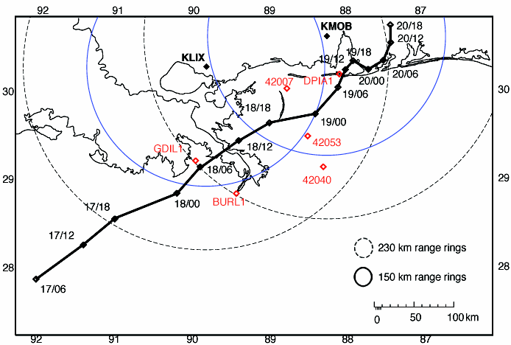
FIG 1. Hurricane Danny (1997) best track plotted every six hours. The open red diamonds show the location of the NOAA moored buoys and Coastal Marine Automated Network (C-MAN) platforms. WSR-88Ds KLIX and KMOB locations are each denoted with a black diamond and the 150 km (blue solid) and 230 km (black dashed) radar range rings are shown.

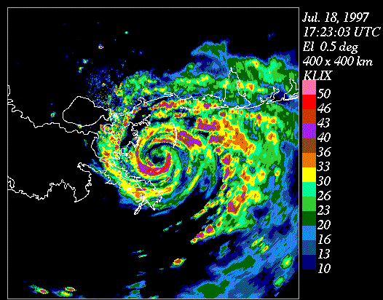
dBZ
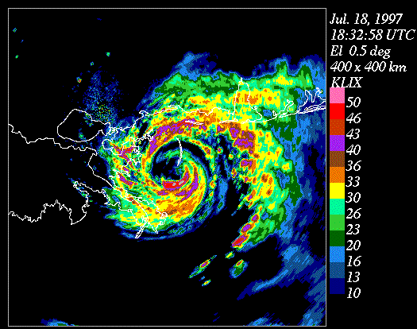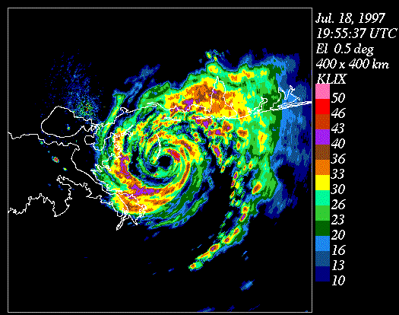
dBZ
dBZ
FIG 2. KLIX base radar reflectivity images of Hurricane Danny approaching Mobile Bay, AL on 18 July 1997, 1723, 1832 and 1955 UTC.
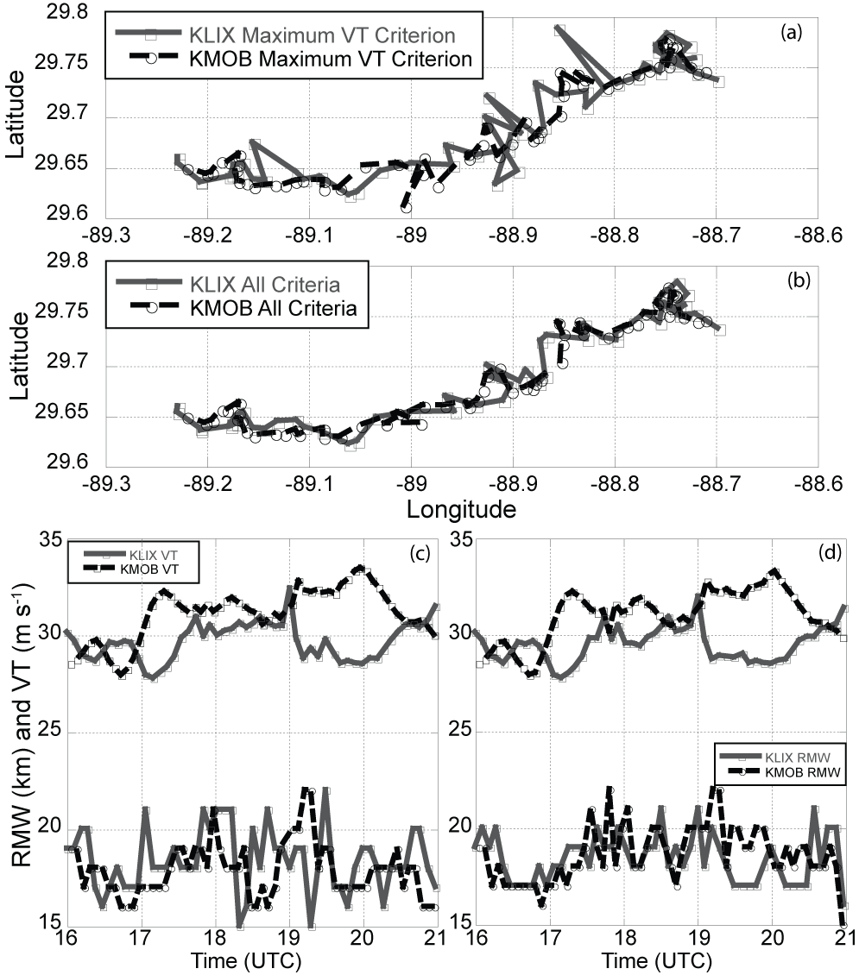
FIG. 3. a) GBVTD-simplex centers at 2 km from KLIX and KMOB for Hurricane Danny using the original method that uses the maximum tangential wind as a criterion. b) The GBVTD-simplex centers after applying the additional constraints discussed in the text. c) The GBVTD derived mean tangential wind (VT) at the radius of maximum wind (RMW) using the original constraint and (d) using the additional constraints.

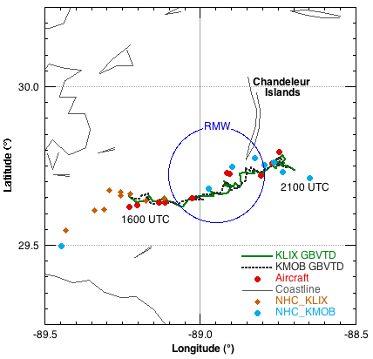
FIG. 4. Hurricane Danny’s track as it crosses the Chandeleur Islands off the coast of Louisiana. Both GBVTD derived tracks are plotted as well as the aircraft and NHC operational radar fixes for comparison. The circle depicts the GBVTD derived mean radius of maximum wind (RMW) for Danny (RMW = 18 km).

(A)

(B)

FIG. 5. GBVTD-derived storm positions at 2 km for KLIX and KMOB separated by storm position components (latitude and longitude) for (A) wavenumber 0 and (B) wavenumber 0+1.
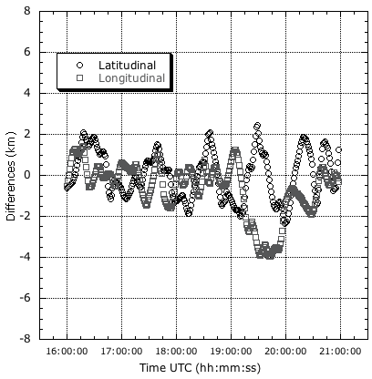

FIG. 6. Latitudinal (black circles) and longitudinal (grey squares) differences (km) for GBVTD derived simplex center positions for KMOB and KLIX.

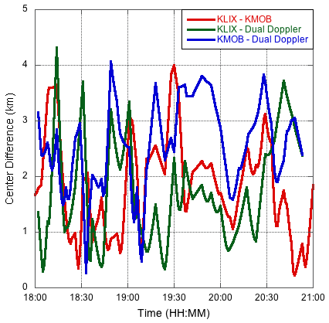

FIG. 7. Center differences (km) from each radar as well as differences with dual-Doppler.

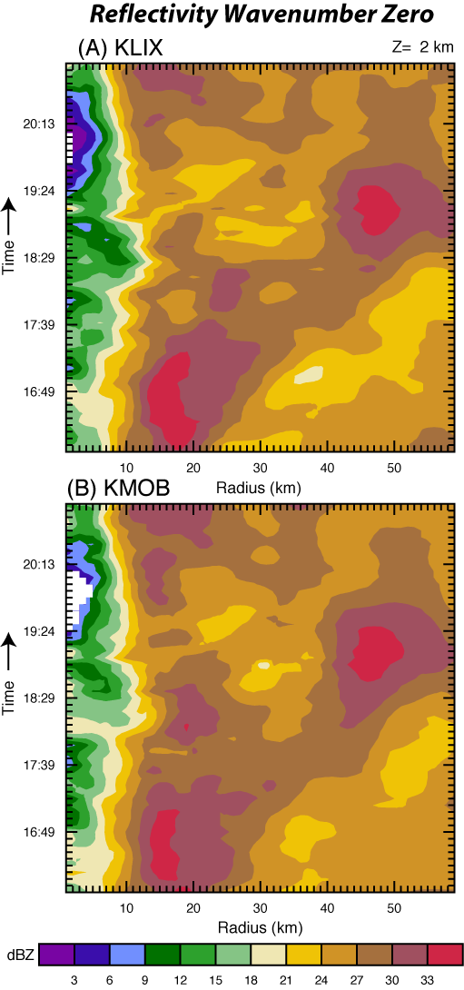

FIG. 8. Time-radius (Hovmoeller) plot of Hurricane Danny reflectivity wavenumber zero for (A) KLIX and (B) KMOB.
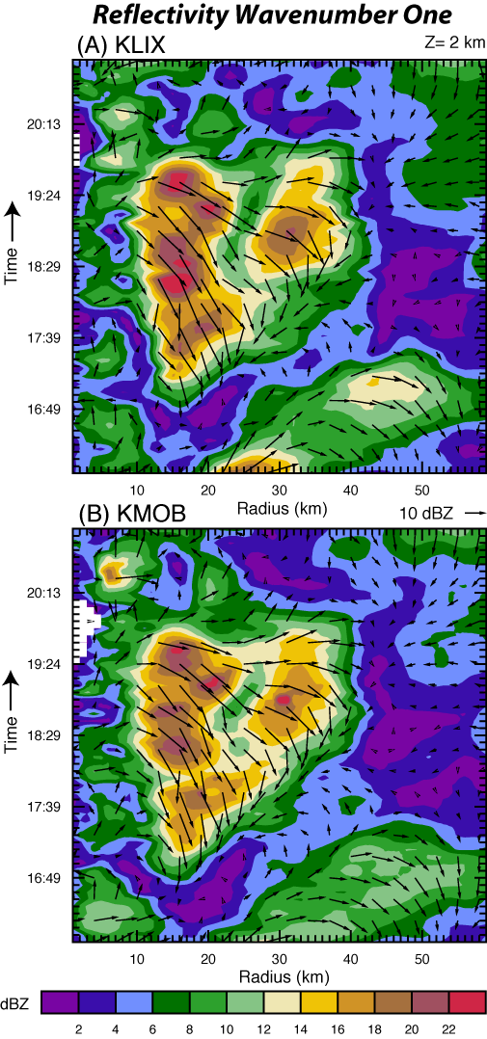
FIG. 9. Time-radius (Hovmoeller) plot of Hurricane Danny reflectivity wavenumber one for (A) KLIX and (B) KMOB at 2 km. The vectors represent the phase of wavenumber one of each radius and time where the vector length (direction) represents the wavenumber one amplitude (location relative to the center). The vectors point in the direction of the asymmetry and the magnitude is in dBZ. KMOB depicts weaker reflectivity dBZ values than KLIX.

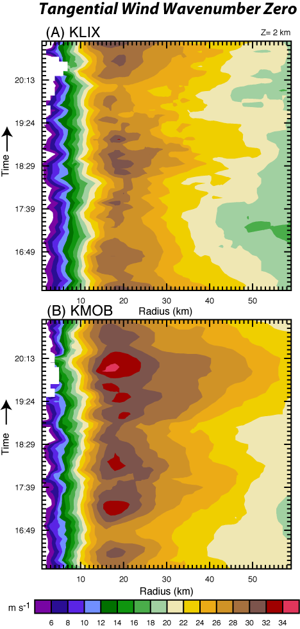

FIG. 10. Time-radius (Hovmoeller) plot of GBVTD derived mean tangential wind (m s⁻¹) wavenumber zero for (A) KLIX and (B) KMOB.
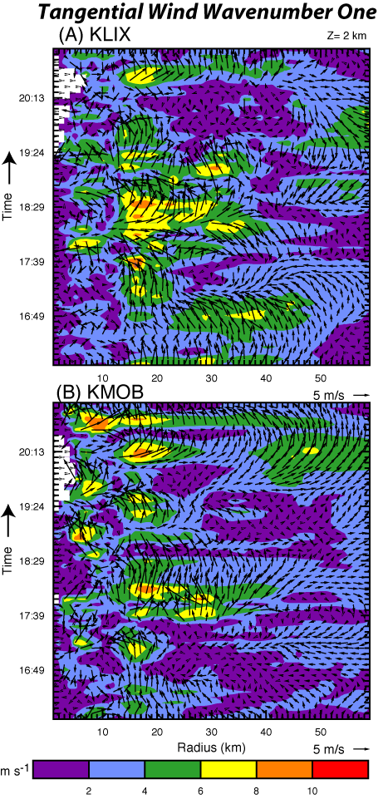

FIG. 11. Time-radius (Hovmoeller) plot of GBVTD derived mean tangential wind (m s⁻¹) wavenumber one for (A) KLIX and (B) KMOB.

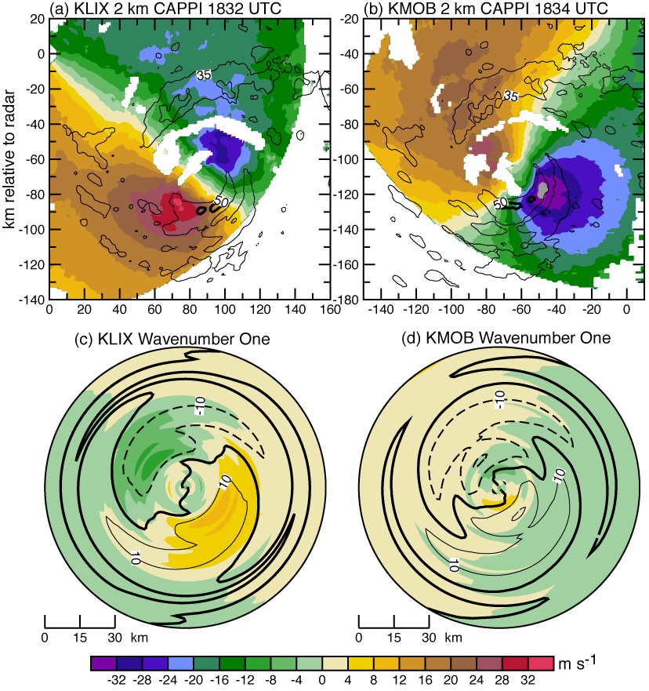

FIG. 12. Comparison of GBVTD results from KLIX radar at 1832 UTC (left column) and KMOB at 1834 UTC (right column) at 2 km height. Panels (a) and (b) show the CAPPI radial velocity in color (m s⁻¹) and the 35 dBZ (thin solid line) and 50 dBZ (thick solid line) reflectivity contours. Panels (c) and (d) show the azimuthal wavenumber one tangential velocity in color, and reflectivity with 10 dBZ contours. The bold contour is 0 dBZ.

(a)
(b)
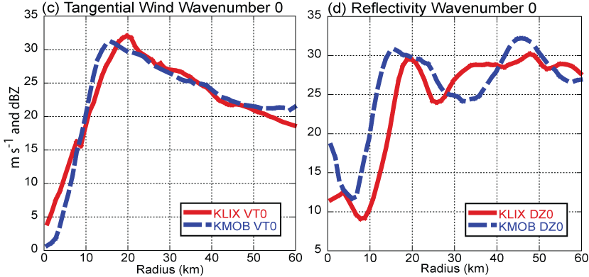
FIG. 13. Comparison of GBVTD results for KLIX and KMOB at 1834 UTC. (a) and (b) show the azimuthal wavenumber zero tangential velocity and reflectivity.
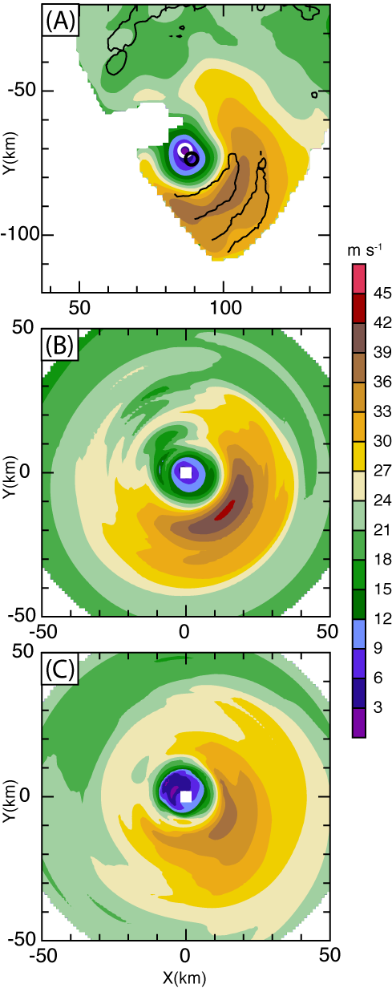

FIG. 14. Derived total wind speed (color, m s⁻¹) from (A) dual-Doppler analysis and GBVTD analysis of (B) KLIX and (C) KMOB radar data from Hurricane Danny at 1832 UTC at 2 km. The solid black lines in (A) denote the 40 dBZ reflectivity contours, with white circle indicating position of the center used in (B), and black circle indicating center used in (C). Cartesian distances are from KLIX radar in (A), and from GBVTD-derived centers in (B) and (C). The dual-Doppler analysis is considered the “ground truth”.
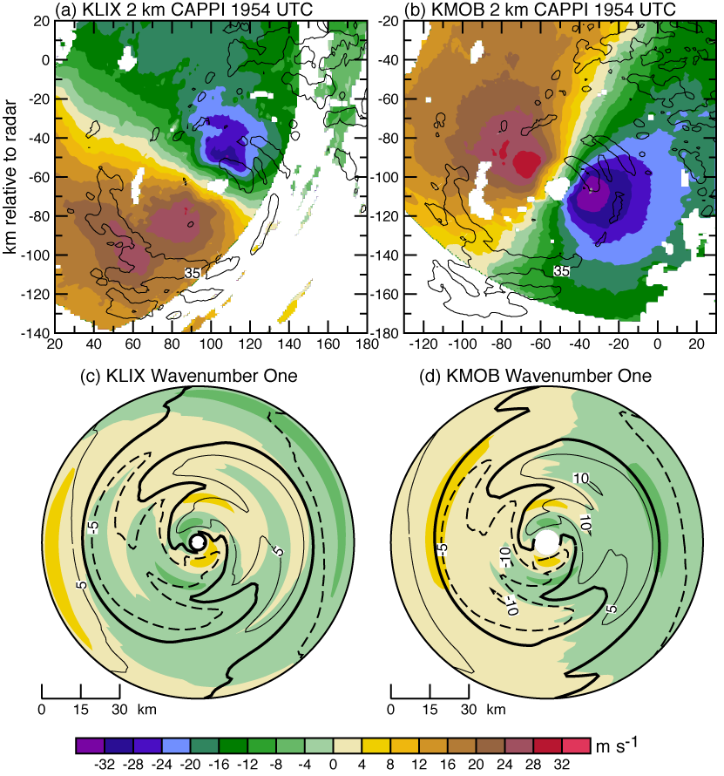
FIG. 15. Same as Figure 12, but at 1954 UTC. Reflectivity contours are 5 dBZ in panels (c) and (d) due to the weaker wavenumber one magnitude at this time.
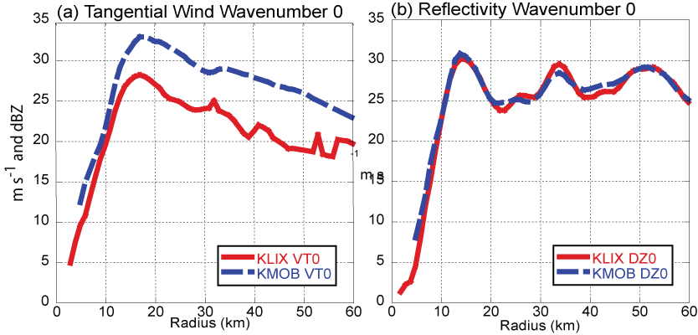
FIG. 16. Same as Figure 13, but at 1954 UTC.
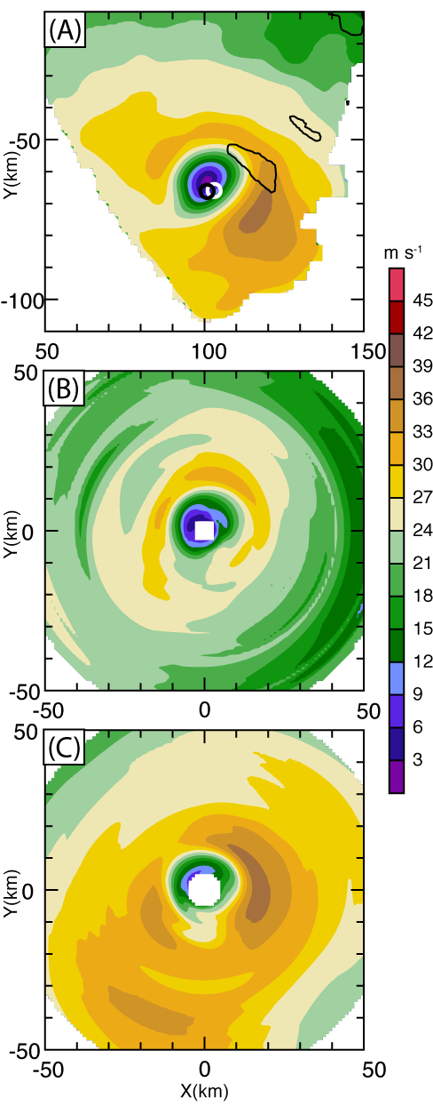

FIG. 17. Same as Fig. 14 but for 1954 UTC.
(A)
(B)

FIG. 18. The direction of the mean wind flow (θ_{M}) derived from Equation 4. The angles 45°, 0°, and -45° are pointing towards the northeast, east and southeast respectively as in Lee et al 1999.

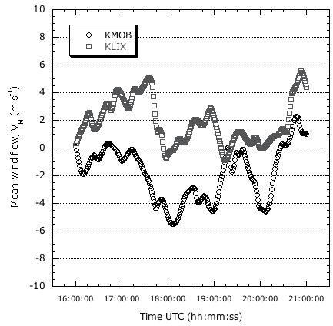

FIG. 19. The mean wind flow (V_{M}) for KLIX and KMOB.

FIG. 20. V_{X} (cross-beam component) of V_{M} derived from KLIX and KMOB.

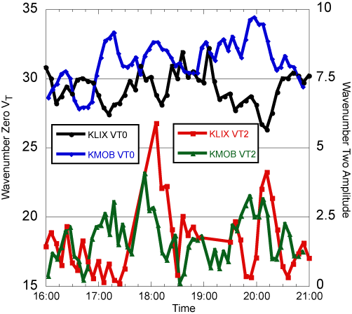

FIG. 21. Time series of wavenumber zero tangential wind (left axis, black and blue curves) and wavenumber two amplitude (right axis, red and green curves) from KLIX and KMOB GBVTD retrieval.

