Correlating Convective Bursts in Tropical Cyclones with Rapid Intensification using TRMM Precipitation Radar Reflectivity Profiles

Andrew Hagen

There have been several studies linking convective bursts (CBs) in tropical cyclones (TCs) to rapid intensification (RI), but RI does not occur every time there is a CB in a storm. Rapid intensification has been defined by a 30 kt or greater increase in maximum sustained winds in a period of 24 hours or less according to the Atlantic Hurricane Database (Kaplan and DeMaria, 2003). This study analyzes TRMM Precipitation Radar (PR) vertical reflectivity profiles to identify possible differences for convective burst cases in which the TC undergoes RI and compares these to convective burst cases in which the TC does not undergo RI. Graphs of reflectivity show that the slope of the reflectivity for the RI cases is nearly vertical between 8-13 km AGL, while the magnitude of the reflectivity decreases more with height for the non-RI cases in that level. This could mean that the RI cases contain faster upward vertical velocities than the non-RI cases in the middle to upper levels of the troposphere. Other significant findings include that the environmental vertical wind shear is lower for the RI cases and there is a larger extent of cold cloud tops within 200 km of the storm center for the RI cases.

Introduction.
Tropical cyclone forecasters around the world have been unsuccessful at anticipating rapid intensification in their forecasts. Some studies have linked the occurrence of convective bursts in tropical cyclones to RI, but there is some uncertainty as to whether internal processes or environmental factors are the greater cause for rapid intensification (Steranka et al. 1986; Eastin et al. 2006; Lander 1998; Hennon 2006). Perhaps environmental factors such as shear and SST trigger internal changes (formation of CBs) which then lead to RI. Convective bursts may only be responsible for a certain fraction of the intensification that takes place in a TC. Ultimately, the magnitude and the distribution of latent heat release within the core of the storm is responsible for changes in intensity (Rogers et al. 2006). This study focuses only on tropical cyclones that contain convective bursts and divides the cases into an RI dataset and a non-RI dataset. The goal is to determine any structural differences in the vertical profiles of radar reflectivity.
In this study, a convective burst is defined as a half-degree by half-degree or greater area of -70 ºC or colder cloud tops that persists for at least three hours as identified by the GOES IR satellite using the NRL website. This half-degree by half-degree area is determined subjectively. Another criterion that was used to define a CB was that the minimum brightness temperature in the CB must be less than 190 K using the 85 GHz PCT microwave imagery. In this study, TRMM satellite measurements of the vertical structure of radar reflectivity are considered with the best track data to determine if there are any systematic differences between cases in the RI group and the cases in the non-RI group.
The TRMM satellite has been used to track tropical weather systems since its launch in 1997. It orbits about 400 km above the earth in an elliptical orbit around the tropics. The satellite never exceeds latitudes of about 35 degrees north or south. The TRMM satellite contains several instruments onboard, one of which is the Precipitation Radar. Reflectivity data from the PR associated with Atlantic TCs was analyzed in this study. Any precipitation less than 17 dBZ may not be accurate because the sensitivity threshold of the Precipitation Radar is around that value (Kozu et al., 2001). The PR on the TRMM satellite has a horizontal resolution that varies between about 3 to 5 km depending on the level being observed, and it has a vertical resolution of about 250 m (Kozu et al., 2001; Kelley et al. 2004). It sees reflectivity data from the surface to 20 km altitude.

Methods.
Classification of cases into the dataset
There were several times during 1998-2006 when an Atlantic tropical cyclone underwent RI according to the Atlantic Hurricane Database as established by NHC’s Best Track. To establish a dataset of RI cases that contained a convective burst, geostationary infrared (Figure 1) and microwave imagery were used to determine cases for when a TC contained a CB within 200 km of the center of the storm between 0-24 hours before these periods of rapid intensification. Three of the four previously mentioned requirements must be met for a case to be considered for inclusion in the dataset. Once again, these four requirements are: 1) The size of < -70° C cloud tops must be larger than half-degree by half-degree. 2) The size of < -70° C cloud tops must be larger than half-degree by half-degree for more than three hours straight. 3) The distance from the center of the CB to the center of the storm must be less than 200 km. 4) The minimum brightness temperature must be less than 190 K. If a CB occurred only during the period of RI, the case was not included because it is useful to use CBs as a precursor to RI so RI can be forecasted. To establish a dataset for storms that did not undergo RI but that did have a CB, the GOES IR satellite image for every 30 minutes was analyzed for the storms that never underwent RI. If the criterion for a convective burst was met, then that case would be considered for inclusion in the non-RI dataset.

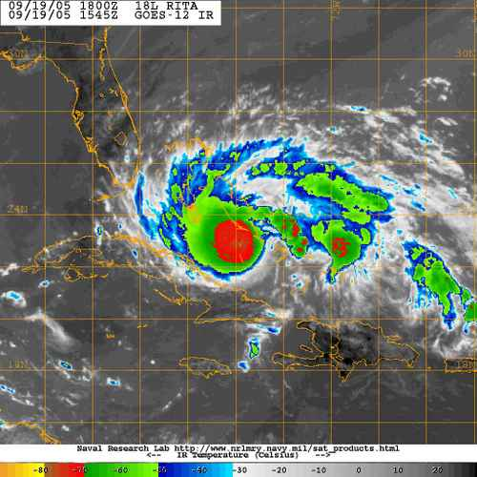
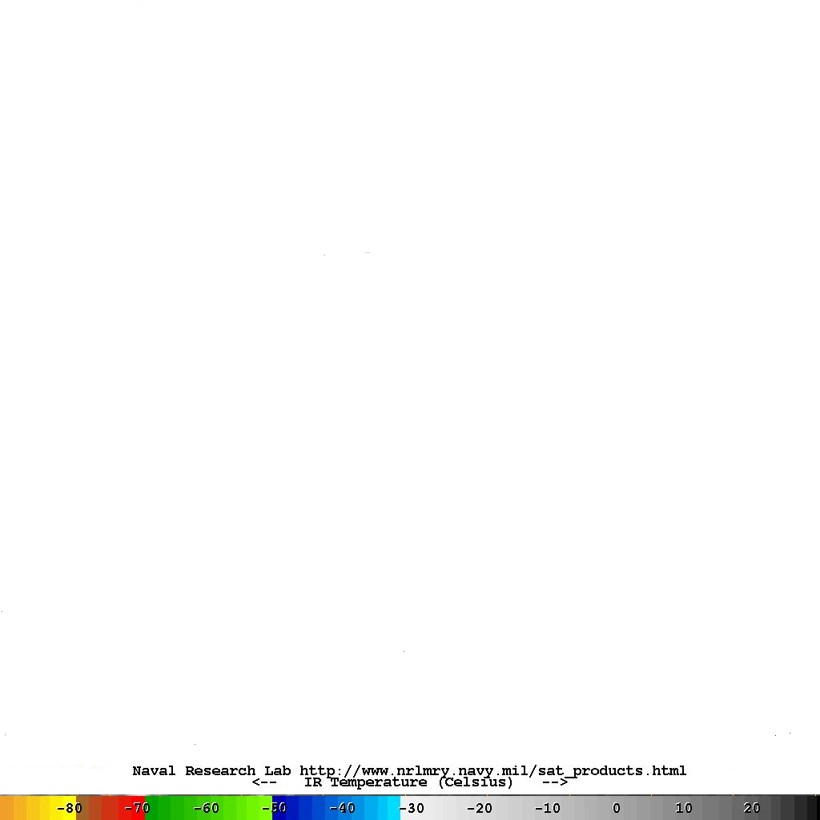
Figure 1. GOES IR image of Tropical Storm Rita (2005) on 19-Sep at 15:45 UTC. The intensity was 58 kt, and this image was taken 14 hours before the commencement of a period of rapid intensification. The red color represents cloud tops colder than -70 °C. Source: Naval Research Lab website.

Once these cases were established, TRMM PR reflectivity data was obtained by downloading reflectivity files from the NASA website and using a Matlab algorithm to obtain swaths of reflectivity (Figure 2). Many of the existing cases in the database that met CB criteria could not be included because they did not meet PR criteria for inclusion in the dataset. Cases were not included for which the center of the PR swath was greater than 300 km from the center of the storm because there would most likely be little or no useful reflectivity data. Also, the convective burst must have been in the PR swath for the case to have been included. The convective burst also must correlate with an area of precipitation, which can be verified by comparing a GOES IR image with a TRMM PR swath at the same time for the same location. All of the comparisons of IR images to PR swaths were less than one hour apart. The dataset used in this analysis contains 12 RI cases and 15 non-RI cases (Table 1), all of which passed the CB criteria and PR criteria for inclusion in the dataset.
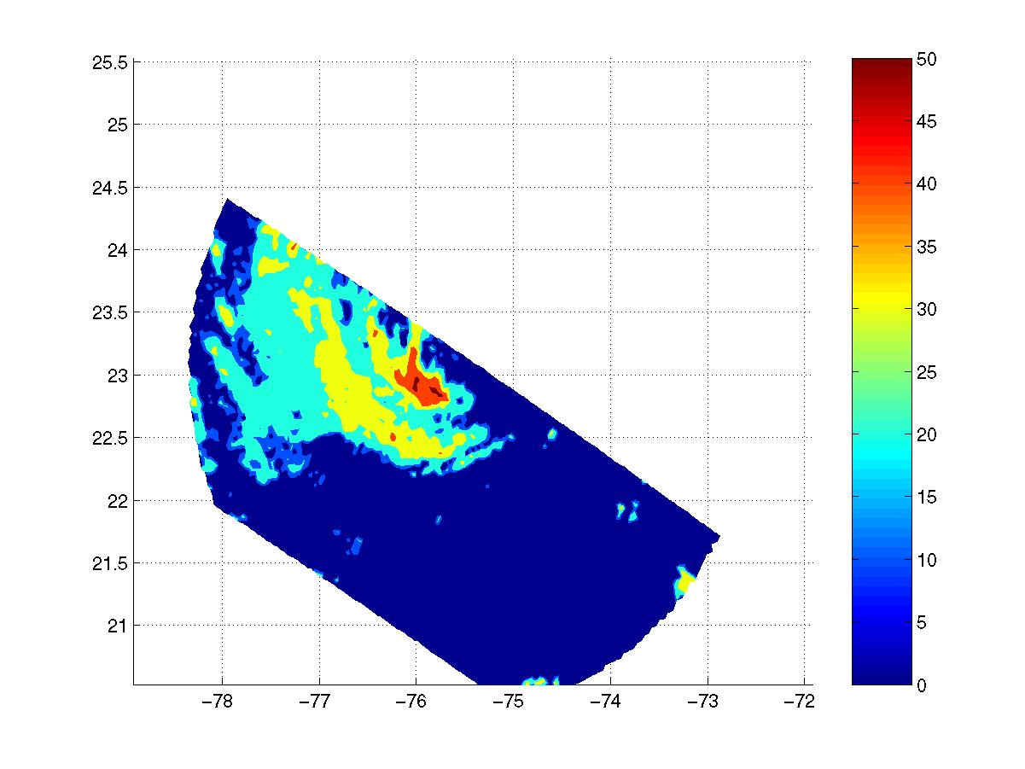
Figure 2. A swath of reflectivity at an altitude of 4 km from the precipitation radar for Tropical Storm Rita (2005) on 19-Sep at 15:55 UTC. The center of the storm was located at 23.0N, 75.4W at the time.
 | RI CASES |  |  |  | swath to storm | burst to storm | burst | burst | pixel <190 | % <-60° C | shear | wind
Year | Storm | Date | Time | hrs b4 RI | dist (km) | dist (km) | length | stage | in burst | cloud-tops | (kt) | (kt)
1999 | Floyd | 11-Sep | 10:22 | 13-14 hr b4 | 171.87 | 50 | unknown | unknown | yes | 75 | 14.4 | 95
1999 | Lenny | 16-Nov | 1:37 | 4-5 hr b4 | 134.29 | 40 | unknown | unknown | yes | 49 | 6.7 | 75
2000 | Issac | 21-Sep | 20:12 | 21-22 hr b4 | 144.66 | 30 | unknown | unknown | yes | 16 | 5.9 | 32
2001 | Iris | 7-Oct | 3:46 | 14-15 hr b4 | 42.657 | 40 | unknown | unknown | yes | N/A | 10.9 | 75
2002 | Isidore | 20-Sep | 19:10 | 4-5 hr b4 | 47.2 | 50 | >3 hr | mature | yes | 72 | 14.8 | 75
2002 | Lili | 1-Oct | 13:52 | 10-11 hr | 109.92 | 30 | >3 hr | post-weakening* | yes | 22 | 8.3 | 90
2004 | Alex | 2-Aug | 3:31 | 2-3 hr b4 | 249.96 | 120 | >3 hr | weakening | yes | 41 | 15.2 | 38
2005 | Cindy | 4-Jul | 0:16 | 23-24 hr b4 | 24.687 | 20 | >3 hr | strengthening | yes | N/A | 5.8 | 30
2005 | Katrina | 27-Aug | 20:53 | 3-4 hr b4 | 208.2 | 40 | >3 hr | strengthening | no* | 99 | 8.9 | 100
2005 | Rita | 19-Sep | 15:55 | 14-15 hr b4 | 127.79 | 70 | >3 hr | mature | unknown | 52 | 11.8 | 58
2005 | Wilma | 17-Oct | 3:01 | 14-15 hr b4 | 161.22 | 120 | >3 hr | mature | yes | 24 | 7.5 | 33
2005 | Wilma | 17-Oct | 17:53 | 0-1 hr b4 | 50.097 | 120 | >3 hr | weakening | yes | 45 | 8.2 | 45
avg |  |  |  |  | 123 | 61 |  |  |  | 50 | 9.9 | 62.2
stdev |  |  |  |  | 71 | 38 |  |  |  | 26 | 3.5 | 26.1
 | NON-RI CASES
1998 | Lisa | 7-Oct | 9:29 |  | 50.4 | 130 | unknown | unknown | yes | 23 | 27.2 | 50
2001 | Jerry | 8-Oct | 2:54 |  | 91.019 | 30 | >3 hr | weakening | yes | N/A | 22.5 | 45
2002 | Dolly | 30-Aug | 4:21 |  | 138.13 | 140 | >3 hr | mature | yes | 54 | 5.1 | 43
2002 | Edouard | 2-Sep | 3:00 |  | 37.46 | 80 | >3 hr | strengthening | yes | 20 | 21.4 | 33
2002 | Kyle | 27-Sep | 7:52 |  | 65.44 | 90 | >3 hr | strengthening | yes | 58 | 31 | 75
2002 | Kyle | 28-Sep | 13:28 |  | 157.55 | 100 | >3 hr | weakening | unknown | N/A | 28.2 | 58
2002 | Kyle | 30-Sep | 6:42 |  | 131.81 | 220 | unknown | mature | yes | 32 | 13.3 | 35
2003 | Claudette | 10-Jul | 6:46 |  | 109.4 | 50 | >3 hr | mature | yes | 47 | 26.4 | 57
2003 | Claudette | 13-Jul | 7:14 |  | 42.99 | 170 | >3 hr | mature | yes | 20 | 21.8 | 46
2003 | Mindy | 11-Oct | 7:35 |  | 37.21 | 80 | >3 hr | mature | yes | 36 | 25.4 | 39
2003 | Nicholas | 15-Oct | 12:10 |  | 79.15 | 90 | >3 hr | weakening | yes | 37 | 20.7 | 45
2005 | Arlene | 10-Jun | 12:45 |  | 117.42 | 180 | >3 hr | strengthening | yes | 14 | 24 | 51
2005 | Irene | 6-Aug | 12:32 |  | 40.272 | 210 | >3 hr | weakening | yes | 12 | 18.6 | 30
2005 | Irene | 14-Aug | 8:16 |  | 133.29 | 90 | 3 hr | mature | yes | 37 | 5.6 | 55
2005 | Maria | 2-Sep | 15:27 |  | 20.937 | 80 | unknown | unknown | unknown | 51 | 4.2 | 38
avg |  |  |  |  | 83 | 116 |  |  |  | 34 | 19.7 | 46.7
stdev |  |  |  |  | 45 | 57 |  |  |  | 15 | 8.7 | 11.6
 | brightness | temp | stdev
 | RI | 12.44
 | non-RI | 22.89
Table 1. This chart contains the 12 RI cases (above) and 15 non-RI cases (lower) used in this dataset. The columns from left to right contain the year, storm name, date, time (UTC), number of hours before the commencement of RI, distance from the center of the PR swath to the center of the tropical cyclone, distance between the center of the CB and the center of the tropical cyclone, burst length, burst stage, whether the minimum brightness temperature is less than 190K, the % of cloud tops with a temperature of less than -60 °C within 200 km of the center of the tropical cyclone, the 200-800 km environmental vertical wind shear, the interpolated maximum sustained wind of the tropical cyclone at the time of the PR swath. The average of all the standard deviation brightness temperatures for the RI and non-RI cases is also shown.
Ancillary Methods
Separating convective precipitation from stratiform precipitation is an important part of this research since convective precipitation should correspond well with the convective bursts. Therefore, an algorithm was used that separates convective precipitation from stratiform precipitation. The algorithm is based on spatial differences in the vertical profile of reflectivity. After the horizontal swaths of reflectivity were obtained, more code was run to obtain different types of vertical profiles of reflectivity. In this experiment, for all of the RI cases combined, convective precipitation makes up 11.3% of all precipitation and for the non-RI cases, convective precipitation makes up 11.5% of all precipitation within 300 km of the center of the storm, which is the radius limit of convective analysis in this experiment. The rest of the precipitation is non-convective.
There are several different ways the reflectivity data can be stratified to better understand the differences between the RI cases and the non-RI cases and to look at the influence of different factors on RI potential. The cases were separated into whether the CB was in its formative stage, diminishing stage, or steady state. That is essentially, at the time of the PR swath, if the burst was strengthening, becoming larger, or attaining colder cloud tops, it would be categorized as a strengthening burst case. If the CB was not changing much in structure before and after the time of the PR swath, it would be categorized as a mature/steady state case. If the CB was weakening, becoming smaller, or losing cold cloud tops, it would be categorized as a weakening burst. The cases were also separated into tropical cyclones that had maximum sustained winds between 50-75 kt and storms that had maximum sustained winds between 30-50 kt at the time of the PR swath. All of the non-RI cases in the sample had maximum sustained winds speeds of 75 kt or less. For this reason, RI cases with maximum sustained wind speeds over 75 kt at the time of the PR swath were eliminated from this comparison.
The PR reflectivity data were analyzed through various types of graphs and charts. One such chart is the mean reflectivity graph, which plots a line of mean reflectivity with height. The code can produce a chart that shows lines of mean reflectivity for both convective and stratiform precipitation, but all of the data shown in this paper is only for convective precipitation. The distribution of reflectivity and its variation with height is depicted with contoured frequency by altitude diagrams (CFADs). From these graphs and CFADs shown, an analysis was performed to look for differences in reflectivity and vertical structure between the RI cases and the non-RI cases.
In addition to analyzing TRMM PR reflectivity profiles, a few other parameters were analyzed in the environment of the tropical cyclones to see how the RI dataset differed from the non-RI dataset. A digital dataset containing the environmental vertical wind shear, the percentage of cloud tops within 200 km of the center that were -60 ºC or colder, and the standard deviation in brightness temperature was provided (John Kaplan, personal communication). The percentage of clouds tops less than -60 ºC within 200 km of the center is a statistic related to the size of the convective burst and its proximity to the center. The standard deviation in brightness temperature is a proxy for measuring the symmetry of a tropical cyclone.

Data and results.
The data is comprised of 12 RI cases and 15 non-RI cases. The 12 RI cases were all between the years of 1999-2005, and the non-RI cases took place during 1998-2005. For the RI cases, there were six hurricanes, three tropical storms, and three tropical depressions (at the time of the PR swath before RI), and for the non-RI cases, there was one hurricane, 13 tropical storms, and one tropical depression (see Table 1). The PR swath used in six of the RI cases was between 0-12 hours before the onset of RI. The PR swath used in the other six RI cases was between 12-24 hours before the onset of RI. The average shortest distance from the center of the storm to the middle of the PR swath for the RI cases was 123 km. The average shortest distance from the center of the storm to the middle of the PR swath for the non-RI cases was 83 km. Since the average distance from the center of the storm was closer to the center of the PR swath for the non-RI cases, the PR could have sampled storms better for the non-RI dataset than for the RI dataset. The convective bursts of the non-RI dataset might also have been sampled better.
From the established cases used in this study, a graph of mean convective reflectivity was created which plots all of the RI cases with the non-RI cases. This graph is shown below (Figure 3). Notice that the non-RI mean reflectivity values are slightly higher than the RI reflectivity values on average for most of the troposphere. Further analysis is required to determine the reason for this difference. The finding that is believed to be more significant is that the slope of mean reflectivity with height is more vertical for the RI cases, especially from 10-14 km; however, the 8-13 km level is used in this study to distinguish between steepness of reflectivity with height. Between 8-13 km, the slope of reflectivity with height is approximately -0.68 dBZ/km for the RI cases and -0.85 dBZ/km for the non-RI cases. There is even a more dramatic difference if the 10-14 km level is used.
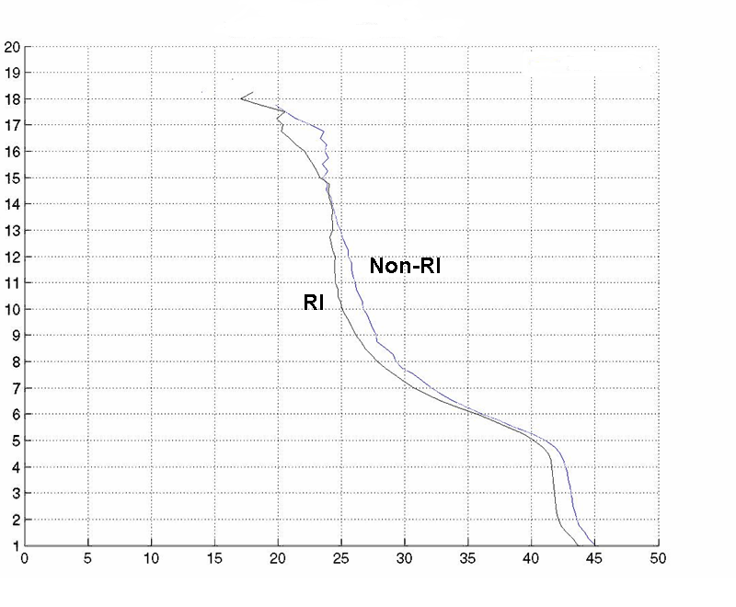
Vertical Profile of Mean Convective Reflectivity: RI vs. non RI
Reflectivity (dBZ)
Height (km)
Figure 3. Mean PR reflectivity as a function of height is shown for all RI cases vs. all non-RI cases for convective precipitation only.

A frequency distribution of reflectivity through the entire integrated column is shown below (Figure 4). Clearly, there is a peak of reflectivity at 35 dBZ for the RI cases and a peak at 20 dBZ for the non-RI cases. There may seem to be an inconsistency between figures 3 and 4 because in figure 3, the mean dBZ of the non-RI precipitation is greater than the mean dBZ of the RI precipitation for nearly 100% of the column. In figure 4, for the RI cases there is a higher frequency of points with 35 dBZ reflectivity and a higher frequency of points with 20 dBZ reflectivity for the non-RI cases. This apparent inconsistency between figures 3 and 4 can be explained. There was a more concentrated area of precipitation near 5 to 6 km for the RI cases (see the pink color on Figure 5), where the reflectivity averaged 35 dBZ. For the non-RI cases, the precipitation was more concentrated in the upper levels where the precipitation registered 20 dBZ (see the pink color on Figure 6).
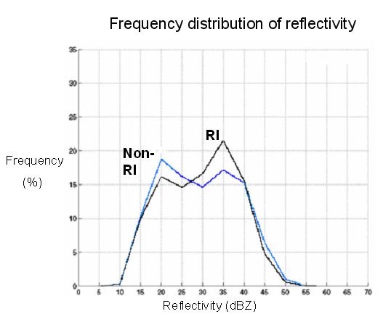
Figure 4. Frequency distribution of the entire integrated column of convective reflectivity for RI vs. non-RI.

While Figures 3 and 4 are useful, they do not tell the whole story. Shown below (Figures 5 and 6) are distributions of reflectivity at all levels for the RI cases and non-RI cases respectively. The middle of this distribution is the statistical mode of reflectivity (ie. the magnitude of reflectivity corresponding with the peak of the frequency distribution). It may be useful to define criteria for analyzing the value of a certain percentage of the highest reflectivity. Although a thorough statistical analysis was not performed in this study, some reflectivity statistics, such as the slope of reflectivity in a certain level, were estimated. The slope of the line representing the highest 15% of dBZ was more vertical for the RI cases than the non RI cases between 8-13 km. The slope of the right 15% line is 0.5 dBZ/km between 8-13 km for the RI cases. The slope of the right 15% line is 0.8 dBZ/km between 8-13 km for the non-RI cases.
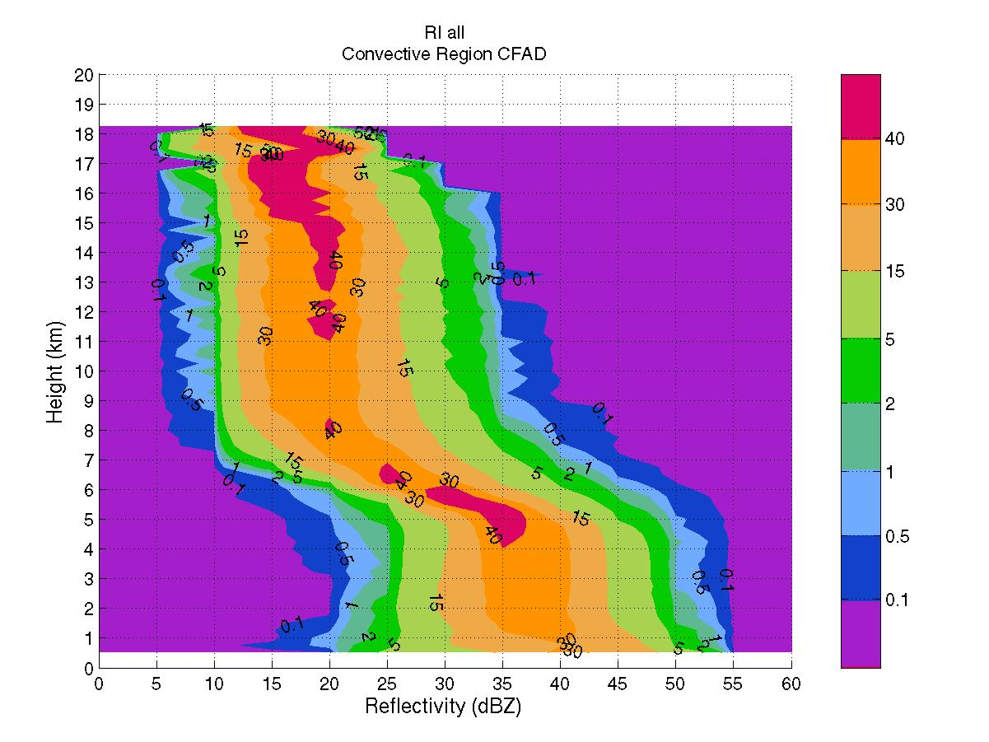
Figure 5. Convective reflectivity distribution for all RI cases.
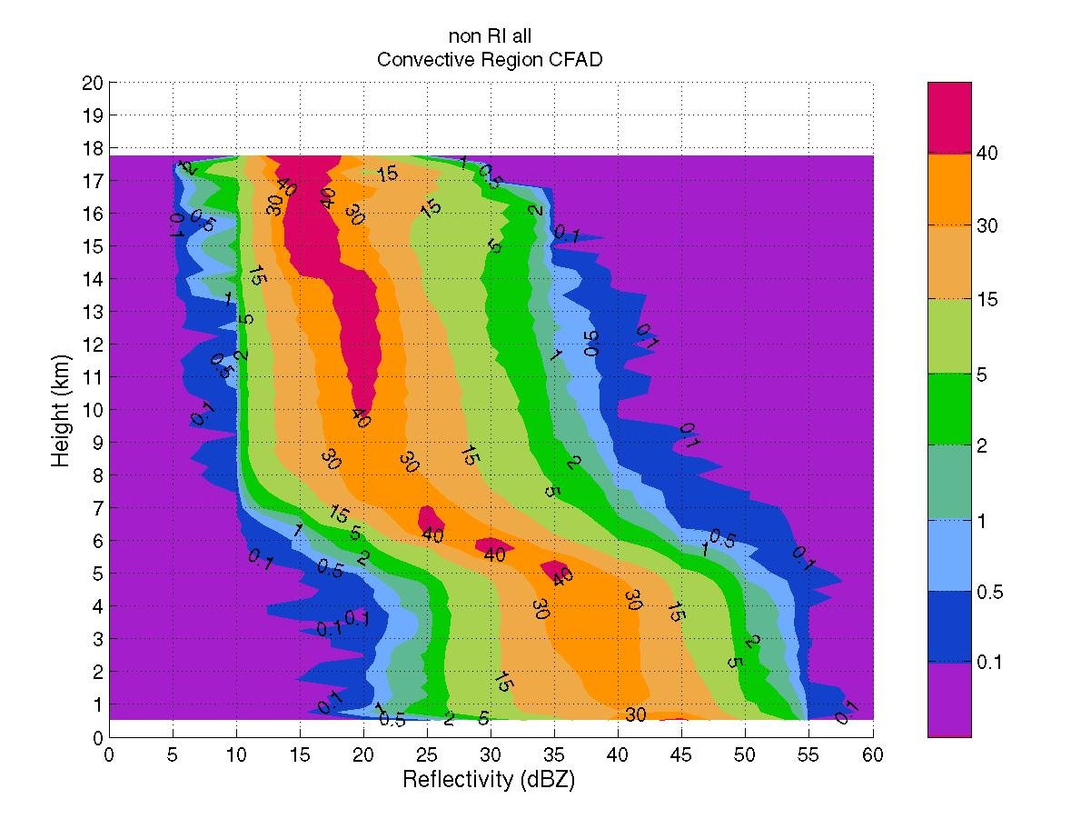
Figure 6. Convective reflectivity distribution for all non-RI cases.

Data stratified by burst stage
Graphs of mean reflectivity of the RI cases and the non-RI cases are shown below (Figure 7) for each stage of a convective burst. It is obvious from these graphs that the weakening bursts have the greatest effect on the magnitude of reflectivity when all of the cases are combined (Figure 3) because the non-RI mean reflectivity is greater than the RI mean reflectivity magnitude for nearly the entire troposphere. If only strengthening and mature bursts are considered, the magnitude of mean reflectivity of the RI cases would be greater than for the non-RI cases. Tests of the statistical significance of the overall differences in the magnitude of mean reflectivity await further analysis.
The slopes of reflectivity at certain levels in the atmosphere are also interesting to consider. The slopes of reflectivity can give a sense of the vertical motions occurring in the convection. The slopes of mean reflectivity for the RI and non-RI cases stratified by burst stage are shown in the table (Figure 7). For all of the burst stages, the mean reflectivity of the RI cases has a more vertical slope than the mean reflectivity of the non-RI cases in the middle to upper levels of the troposphere. This could mean that upward motions are stronger for the RI cases. When comparing the burst stages, strengthening bursts have the largest difference in slope between RI and non-RI, while weakening bursts have almost no difference.
Reflectivity Profiles Stratified by Burst Lifecycle Stage
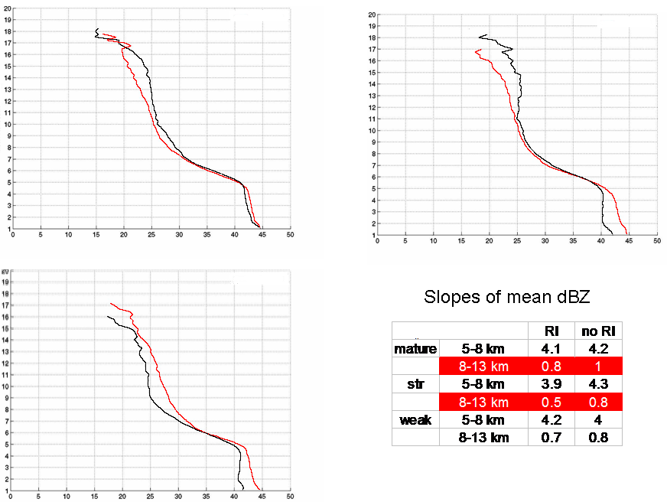
Reflectivity (dBZ)
Reflectivity (dBZ)
Reflectivity (dBZ)
Height (km)
Height (km)
Height (km)
Mature bursts
Strengthening bursts
Weakening bursts
RI
Non-RI
RI
Non-RI
RI
Non-RI
-
-
-
-
-
-
-
-
-
-
-
-
Figure 7. Vertical profiles of mean convective reflectivity (RI vs. non-RI) stratified by burst stage, i.e. whether the convective burst was a) steady state at the time of the PR orbit, b) becoming larger and attaining colder cloud tops, or c) shrinking and losing cold cloud tops. The approximate slopes of mean reflectivity for each type of burst between both 5-8 km and 8-13 km are shown in the chart.

Distributions of reflectivity for the stratified burst types are shown (Figure 8) for the RI cases and the non-RI cases. The cases for which the burst type is unknown are not included. The RI CFADs show more vertical slopes of modal reflectivity than the non-RI CFADs. Also, the strengthening CB CFADs show more vertical slopes of modal reflectivity than the weakening CB CFADs. It is evident that the slope of the mode of reflectivity is almost perfectly vertical above 8 km for the RI cases while for the non-RI cases, the slope of the mode decreases above 8 km, especially in the non-RI weakening burst plot.
Reflectivity CFADs Stratified by Burst Lifecycle Stage
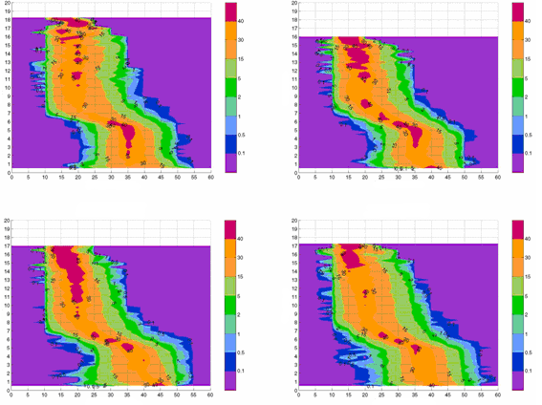
RI strengthening bursts
RI weakening bursts
Non-RI strengthening bursts
Non-RI weakening bursts
Reflectivity (dBZ)
Reflectivity (dBZ)
Height (km)
Height (km)
Height (km)
Height (km)
Reflectivity (dBZ)
Reflectivity (dBZ)
Figure 8. Reflectivity distribution comparing strengthening bursts and weakening bursts for the RI vs. non-RI cases.

Data stratified by storm intensity
Reflectivity data stratified by storm intensity are shown below (Figures 9 and 10). There were four RI cases and six non-RI cases with winds between 50-75 kts. There were five RI cases and nine non-RI cases for which the TC had maximum sustained winds between 30-50 kts at the time of the PR swath. The magnitudes of mean reflectivity for the RI cases compared with the non-RI cases are very similar for the strong tropical storms and category 1 hurricanes, but for the tropical depressions and weak tropical storms, the magnitude of mean reflectivity averages 2 to 3 dBZ greater for the non-RI cases. Again, the slopes of reflectivity are more vertical for the RI cases in the middle to upper levels of the troposphere. The probability density function diagram is shown below (Figure 10) for the 30-50 kt cases. Once again, it shows that the RI cases have a higher frequency of 35 dBZ reflectivity while the non-RI cases have a higher frequency of 20 dBZ reflectivity. In figure 10, the slope of the mode of reflectivity in the middle to upper troposphere is more vertical (or more positive) for the RI cases than the non-RI cases, but this is also the case for the stronger storms as compared with the weaker storms. Therefore, the diagram with the most positive slope is the 50-75 kt RI cases, and the diagram with the most negative slope is the 30-50 kt non-RI cases.

Reflectivity Profiles and PDF stratified by storm intensity
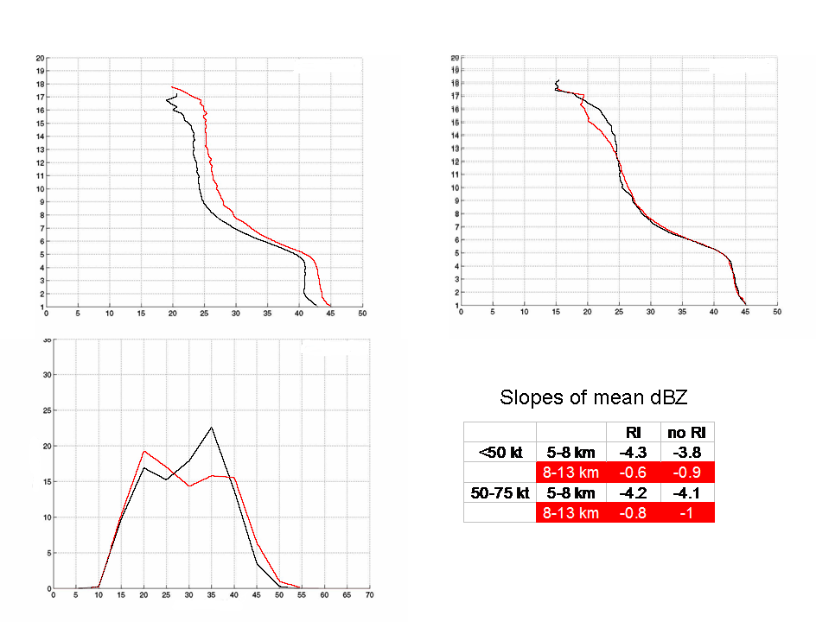
Reflectivity (dBZ)
Frequency (%)
Height (km)
Height (km)
Reflectivity (dBZ)
Reflectivity (dBZ)
Frequency Distribution (<50 kt storms)
Non-RI
RI
RI
Non-RI
RI
Non-RI
Mean reflectivity (<50 kt storms)
Mean reflectivity (50-75 kt storms)
Figure 9. Vertical profiles of mean reflectivity (RI vs. non-RI) stratified by storm intensity at the time of PR passage. A probability density function graph (lower left) is shown for the TCs less than 50 kt. Slopes of reflectivity between 5-8 km and 8-13 km are provided in the table.

Reflectivity CFADs Stratified by storm intensity
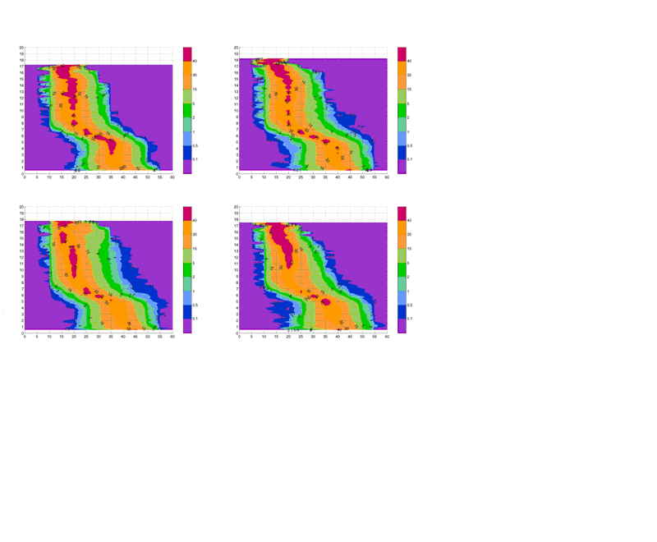
Reflectivity (dBZ)
Reflectivity (dBZ)
Reflectivity (dBZ)
Reflectivity (dBZ)
Height (km)
Height (km)
Height (km)
Height (km)
RI <50 kt
RI 50-75 kt
Non-RI <50 kt
Non-RI 50-75 kt
Figure 10. Reflectivity distribution stratified by storm intensity for the RI vs. non-RI cases.

Discussion of other factors.
In addition to the results obtained from analyzing the PR reflectivity, there were other results obtained using the vertical shear and objective infrared dataset mentioned previously. It was found that for the RI cases, the vertical wind shear averaged about 10 kt while for the non-RI cases, vertical wind shear averaged about 20 kt in the environment of the tropical cyclones. The percentage of cloud tops colder than -60 ºC within 200 km of the center was approximately 50% for the RI cases and 34% for the non-RI cases, which suggests that the size of the convective burst was larger on average for the RI cases. The standard deviation in brightness temperature was 12.4 for the RI cases and 22.9 for the non-RI cases, which implies that the tropical cyclones in the RI dataset were more symmetric on average than the tropical cyclones in the non-RI dataset. To analyze any possible biases in the sample, the average maximum sustained wind of the TC for the RI cases was compared with the non-RI cases. The RI cases averaged a maximum sustained wind speed of about 62 kt and the non-RI cases averaged 47 kt. This difference in intensity may have had an effect on the reflectivity results since it was found that the 50-75 kt storms have a more vertical slope than the 30-50 kt storms. Another important result is that the center of the convective burst for the RI cases averaged 61 km from the center of the storm, while the center of the convective burst for the non-RI cases averaged 116 km from the center of the storm, which also shows that the pre-RI cases were more symmetric because the convective burst was more co-located with the center of the storm.

Conclusions.
Several conclusions can be drawn from this project. The RI cases did not have higher reflectivity on average than the non-RI cases. However, mature and strengthening bursts did show a slightly higher reflectivity for the RI cases over the non-RI cases. For the entire integrated column, most RI cases displayed a higher frequency of 35 dBZ reflectivity and most non-RI cases showed a higher frequency of 20 dBZ reflectivity. Most RI cases have a more vertical slope of mean reflectivity in the middle to upper levels of the troposphere. This could mean that the RI cases had a higher upward vertical velocity in that layer. The RI storms contain more symmetry, have a higher percentage of colder clouds tops within 200 km of the center, and have lower environmental vertical wind shear. The average centers of the convective bursts are closer to the centers of the storms for the RI cases, which also imply symmetry.
There are several limitations in this experiment. The sample size is small, and it is unknown whether the differences in reflectivity profiles observed are statistically significant. An expansion of the dataset to include other basins will increase the sample size, but it may introduce inter-basin biases into the statistics. A lack of digital data to exactly quantify the area and temperature of the cloud tops may have caused the accidental inclusion or exclusion of one or two cases in the dataset. Also, the precipitation reflectivity sampled was not solely confined to the convective burst. Some of the convective precipitation included could have been from a separate smaller area of convective precipitation. In the future, stratiform precipitation differences could be analyzed, and the TRMM data can be compared with aircraft. Ultimately, the goal of this work is to help tropical cyclone forecasters be able to better forecast rapid intensification. Part of this future improvement can be accomplished by attaining a better understanding of the microphysical processes present in convective bursts within tropical cyclones as well as the vertical structure as analyzed by the vertical profiles of radar reflectivity.

REFERENCES
Rogers, R. F., M. L. Black, S. S. Chen and R. A. Black (2007). An Evaluation of
Microphysical Fields from Mesoscale Model Simulations of Tropical Cyclones. Part I: Comparisons with Observations, J. Atmos. Sci., 64, 1811-1834.
Eastin, M. D., P. D. Reasor, D. S. Nolan, F. D. Marks Jr. and J. F. Gamache (2006).
Evolution of low-wavenumber vorticity during rapid intensification: A dual-Doppler analysis, 27th Conf. on Hurricanes and Tropical Meteorology, Monterey, CA, Amer. Met. Soc.
Hennon, P. A. (2006). The Role of the Ocean in Convective Burst Initiation: Implications
for Tropical Cyclone Intensification, The Ohio State University, Ph.D Dissertation.
Kelley, O. A., J. Stout and J. B. Halverson (2004). Tall precipitation cells in tropical
cyclone eyewalls are associated with tropical cyclone intensification, American Geophysical Union: Geophysical Research Letters, 31, L24112.
Kaplan, J. and M. DeMaria (2003). Large-Scale Characteristics of Rapidly Intensifying
Tropical Cyclones in the North Atlantic Basin, AMS Journals Online: Weather and Forecasting, 18, 6, 1093-1108.
Kozu, T., T. Kawanishi, H. Kuroiwa, M. Kojima, K. Oikawa, H. Kumagai, K. Okamoto,
M. Okumura, H. Nakatsuka and K. Nishikawa (2001), Development of precipitation radar on board the TRMM satellite, IEEE Trans. Geosci. Remote Sens., 39, 102-116.
Lander, M. A. (1998). Pictures of the Month: A Tropical Cyclone with an Enormous
Central Cold Cover, Monthly Weather Review, 127, 132-136.
Steranka, J., E. B. Rodgers and R. C. Gentry (1986). The Relationship between Satellite
Measured Convective Bursts and Tropical Cyclone Intensification, Monthly Weather Review, 114, 1539 -1546.

