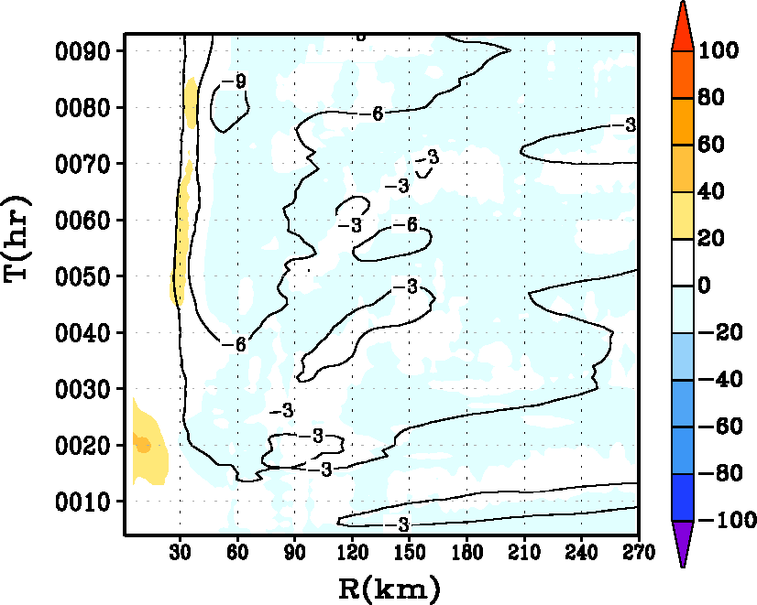
a
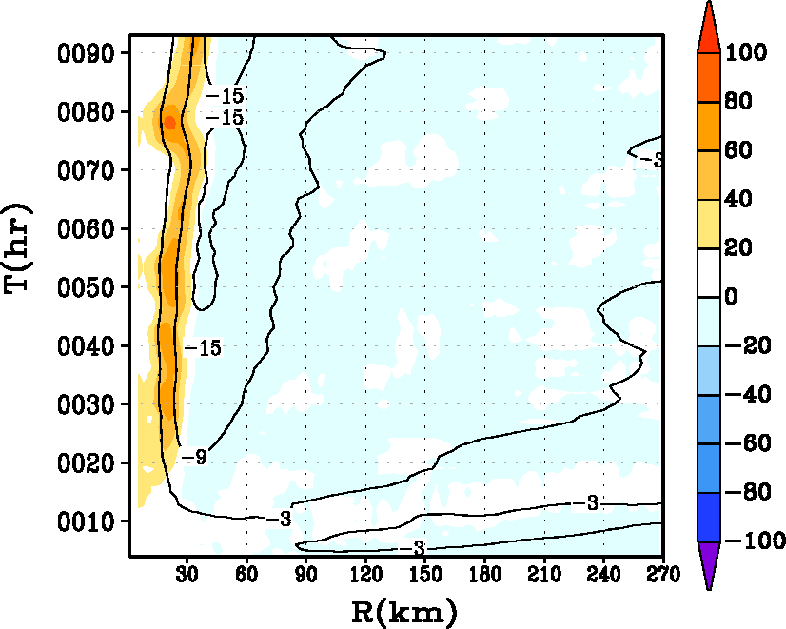
b
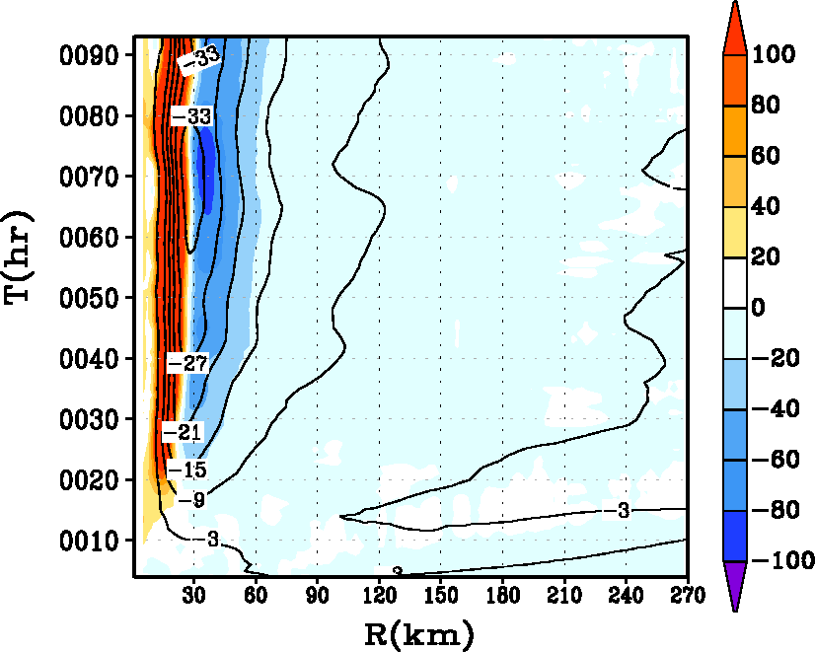
c

Fig.9. Hovemoller diagram of the tangentially averaged, 6-hourly time averaged radial component of velocity (in m s⁻¹). Superposed on the contour lines in shaded color is the net radial forcing term including radial friction in the governing equation for the secondary circulation (equation 2) for the HWRF runs with (i) α=1, (ii) α=0.5, and (iii) α=0.25 runs at the 30-m level. The blue end of the spectrum represents radial acceleration (convergence), and the red end of the spectrum represents deceleration within the inner eyewall region. Units of the net radial radial forcing term are in m s⁻¹ h⁻¹.

