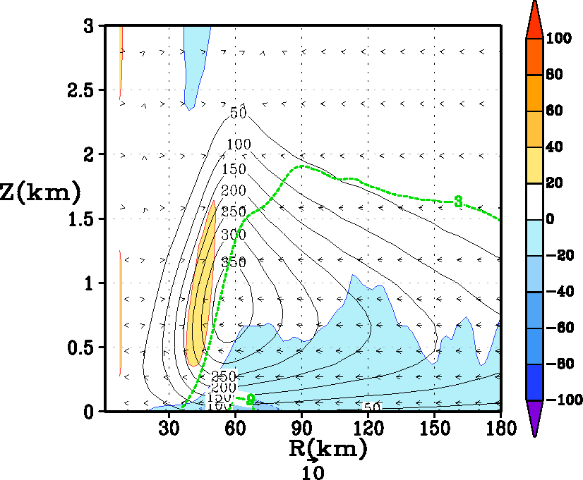
a
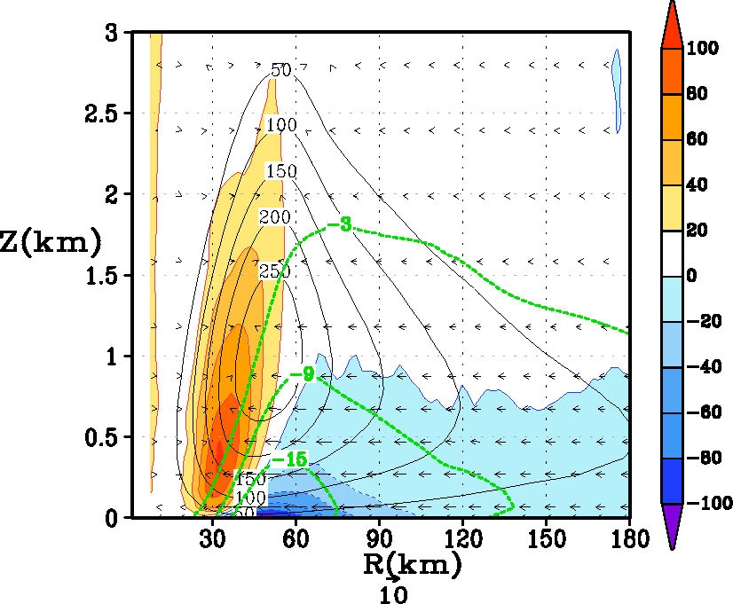
b
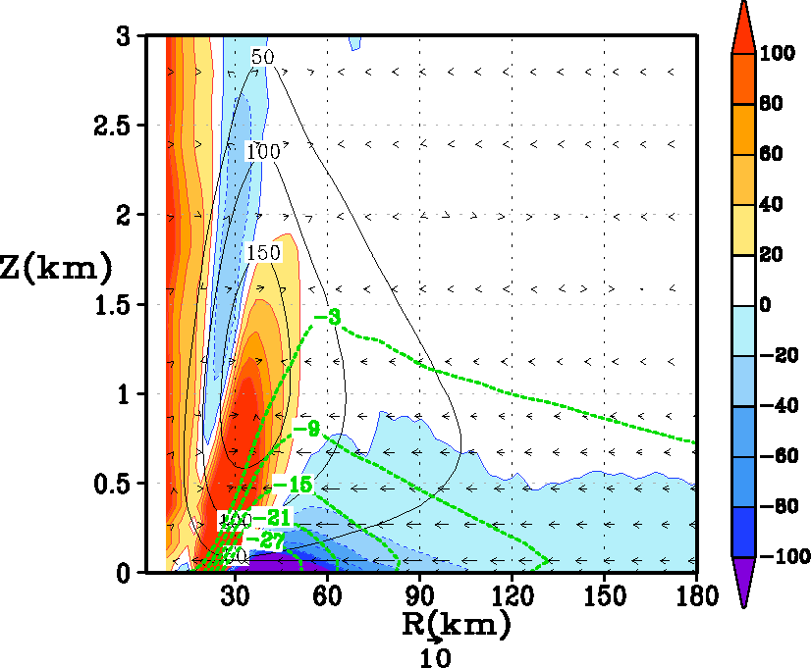
c

Fig 5: Tangentially averaged, 6-hourly time averaged, radius-height cross section of eddy diffusivity (Km) at 93 hours for (a) control (α=1), (b) Km reduced to half (α=0.50), and (c) Km reduced to a quarter (α=0.25). Superposed in color are the forcing terms related to gradient wind imbalance within the boundary layer (i.e., term B in equation 3). Units of the forcing term are in m s⁻¹ h⁻¹. The inflow is shown in the green background contours. For convenience, the vector field that compounded the tangentially averaged vertical and the radial velocity components is also provided. For the sake of clarity, only the first 3 km above the ground is displayed.

