Arc Cloud Module

Principal Investigator: Jason Dunion

Links to IFEX:
- Goal 1: Collect observations that span the TC life cycle in a variety of environments for model initialization and evaluation.
- Goal 3: Improve understanding of the physical processes important in intensity change for a TC at all stages of its lifecycle.

Motivation: Arc clouds are common features in mid-latitude thunderstorms and mesoscale convective systems. They often denote the presence of a density current that forms when dry mid-level (~600-850 hPa) air has interacted with precipitation. The convectively-driven downdrafts that result reach the surface/near-surface and spread out from the convective core of the thunderstorm. Substantial arc clouds (i.e. >55 nm (100 km) in length and lasting for several hours) are also common features in the tropics (Fig. 1), particularly on the periphery of African easterly waves (AEWs) and TCs. However, the physical processes responsible for such tropical arc clouds as well as their impacts on the short-term evolution of their parent disturbances are not well understood. The main objectives of the Arc Cloud Module are as follows:

- Collect observations in mid-level dry layers (e.g. the SAL) that are hypothesized to be a necessary ingredient for the formation of strong downdrafts and subsequent outflow boundaries and arc clouds.
- Collect observations across arc cloud features in the periphery of AEWs or TCs using aircraft flight-level data, tail Doppler radar data, and GPS dropsondes to improve our understanding of the physical processes responsible for their formation and evolution and how these features may limit short-term intensification.
- Target observations ahead of and behind arc cloud features to sample the horizontal gradients of temperature, moisture, and winds (e.g. outflow) from ~600 hPa to the surface.
- Quantify the capabilities of the operational coupled model forecast system to accurately capture and represent both mid-level dry air (e.g. the SAL) and thermodynamic and kinematic gradients across arc cloud features through direct comparison to observations as well as high-resolution analyses provided by HRD’s Hurricane Ensemble Data Assimilation System (HEDAS).

Background: Large low-level thunderstorm outflow boundaries emanating from TCs have been previously documented and have been hypothesized to occur when high vertical wind shear promotes the intrusion of dry mid-level air toward the TC eyewall (Knaff and Weaver 2000). However, the mid-level moisture found in the moist tropical North Atlantic sounding described by Dunion (2011) is hypothesized to be insufficiently dry to generate extensive near-surface density currents around an AEW or TC. However, Dunion (2011) also described two additional air masses that are frequently found in the tropical North Atlantic and Caribbean during the summer months and could effectively initiate the formation of large arc clouds: (1) the Saharan Air Layer (SAL) and (2) mid-latitude dry air intrusions. Both of these air masses were found to contain substantially dry air (~50% less moisture than the moist tropical sounding) in the mid-levels that could support convectively-driven downdrafts and large density currents. Furthermore, outward-propagating arc clouds on the periphery of AEWs or TCs could be enhanced by near-surface super-gradient winds induced by the downward transport of high momentum air. Since most developing tropical disturbances in the North Atlantic are associated with a mid-level jet and/or mesoscale convective vortex near a state of gradient balance, any convectively-driven downdrafts would inject high momentum air into a near-surface environment that often contains a weaker horizontal pressure gradient. In such cases, density currents may be temporarily enhanced during local adjustments to gradient balance. Finally, tropical arc clouds may be further enhanced by outward-propagating diurnal pulses that originate from the convective core of the tropical disturbance (see HRD’s TC Diurnal Cycle Experiment). New GOES IR TC diurnal cycle imagery indicates that arc clouds tend to form along the leading edge of outwardly propagating diurnal pulses that are associated with the TC diurnal cycle. The diurnal pulses reach peripheral radii where low to mid-level dry air is often located (e.g. R=300-500 km) at remarkably predictable times of day (e.g. 400 km at ~1200-1500 LST). Therefore, UW-CIMSS real-time TC diurnal cycle and visible satellite imagery, as well as P-3 lower fuselage (LF) radar data (where TC diurnal pulses are denoted by 25+ dBZ semi-circular convective bands propagating away from the storm) will be used to monitor the diurnal pulse propagation throughout the local morning hours and signs of arc cloud formation.

As arc clouds propagate away from the tropical disturbance, they visibly emerge from underneath the central dense overcast that can obscure them from visible an infrared satellite view. Therefore, when arc clouds are identified using satellites, they are often in the middle to later stages of their lifecycles. Hence, the mechanism of enhanced low-level outflow is likely occurring at the time of satellite identification, while the mechanism of cooling/drying of the boundary layer has already occurred (though the effects may still be observable by aircraft flight-level, GPS dropsonde, and satellite data). This necessitates that the arc clouds be identified and sampled as early in their lifecycle as possible using available aircraft observations (e.g. flight-level, GPS dropsonde and P-3 LF radar, and P-3/G-IV Doppler radar data) and satellite imagery (e.g. TC diurnal cycle infrared, visible, infrared, and microwave).

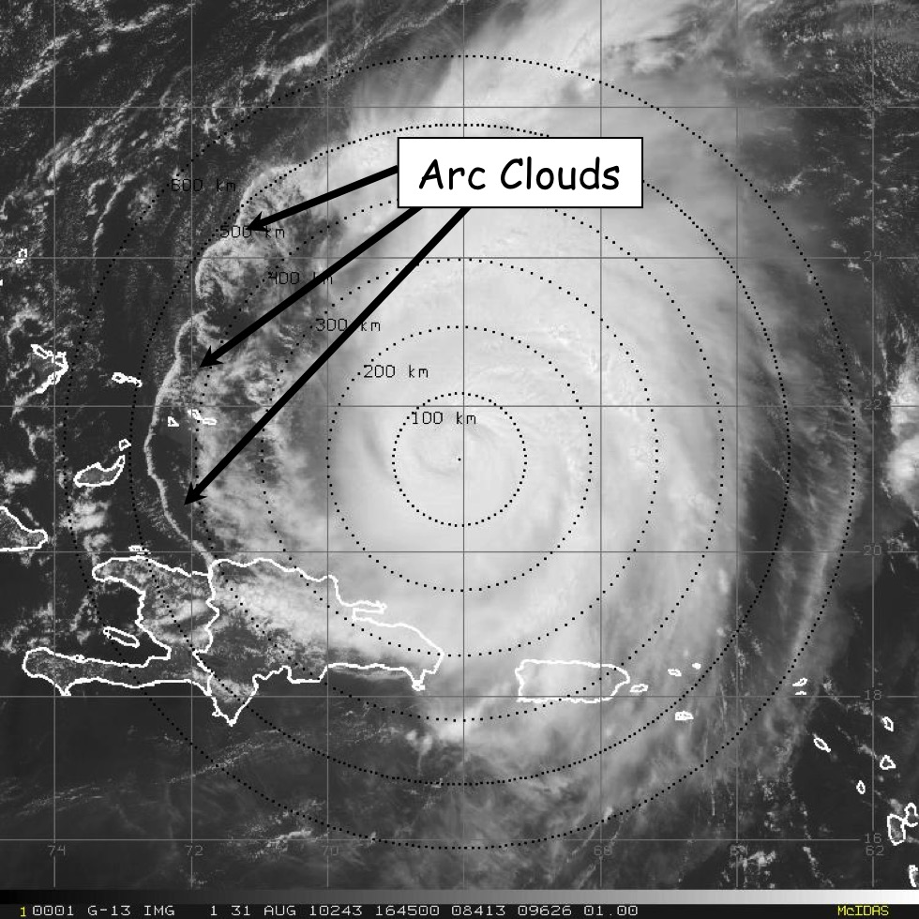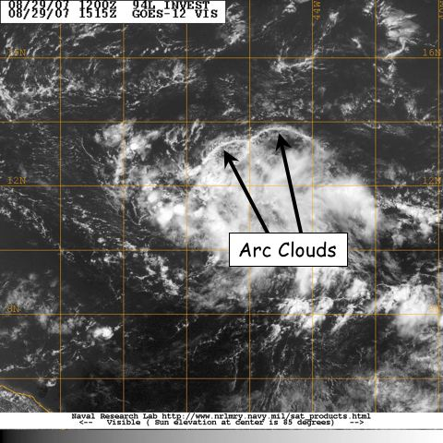

Fig. 1: GOES visible satellite imagery showing arc clouds racing away from the convective cores of (left) 2003 Hurricane Isabel and (right) 2007 Pre-Tropical Depression Felix.

Hypotheses:
- Hypothesis 1: Arc clouds form along the leading edge of TC diurnal pulses and are particularly favored to occur when these TC diurnal pulses reach areas of mid-level (~600-850 hPa) dry air (≤45 TPW) at radii of ~105-215 nm (~200-400 km).
- Hypothesis 2: the cool, dry air associated with the convectively-driven downdrafts that form arc clouds can help stabilize the middle to lower troposphere and may even act to stabilize the boundary layer. Arc clouds events tend to affect the TC near environment (R~100-150 km/55-80 nm) and peripheral environment (R~150-400 km/80-215 nm).
- Hypothesis 3: As they race away from the convective core region of the AEW or TC, arc clouds may act to disrupt the storm by creating low-level outflow in the quadrant/semicircle in which they form. This outflow pattern counters the typical low-level inflow that is vital for TC formation and maintenance.
Experiment/Module Description: This research module is designed to utilize the P-3 [flight-level (flying at multiple levels above 1500 feet), GPS dropsondes, and TDR data] or G-IV (GPS dropsonde and TDR data) aircraft. Although this module is not a standalone experiment, it could be included as a module within any number of missions. TPW microwave satellite imagery will be used to identify mid-level dry air (≤45 mm TPW) in the periphery of the AEW or TC. These areas of mid-level dry air will be favorable locations for arc cloud formation, especially when TC diurnal pulses are passing radii where this low to mid-level dry air is located. Additionally, when this low- to mid-level dry air is located in the upshear quadrant or semicircle of the storm, arc cloud formation may be especially favorable. These favorable areas will be regions of preferred arc cloud formation and should be monitored closely using satellite imagery (e.g. UW-CIMSS TC diurnal cycle IR imagery, 1 km GOES visible, and 37 GHz microwave) and the P-3 LF radar during the mission. Depending on connection rates on the aircraft, supplemental communications via X-Chat with scientists on the ground would be desirable, especially given the unpredictability and rapid evolution of arc cloud features.

Figure 1: GOES visible satellite imagery showing arc clouds racing away from the convective cores of (left) 2003 Hurricane Isabel and (right) 2007 Pre-Tropical Depression Felix.

Analysis Strategy: This experiment seeks to collect observations across arc cloud features in the periphery of AEWs or TCs using aircraft flight-level, GPS dropsonde, and TDR data to improve our understanding of the physical processes responsible for their formation and evolution, as well as how these features may affect TC structure and intensity in the short-term. The GPS dropsonde data will be used to calculate changes in static stability and possible impacts on surface fluxes both ahead of and behind the arc cloud (e.g. enhanced stability/reduced surface fluxes behind the arc cloud leading edge). Also, kinematics and thermodynamic associated with arc cloud events will also be compared to corresponding locations in model analysis fields (e.g. GFS and HWRF).
References:
Dunion, J.P., 2011: Rewriting the climatology of the tropical North Atlantic and Caribbean Sea atmosphere. J. Climate, 24, 893-908.
Knaff, J.A., and J.F. Weaver, 2010: A mesoscale low-level thunderstorm outflow boundary associated with Hurricane Luis. Mon. Wea. Rev., 128, 3352-3355.

