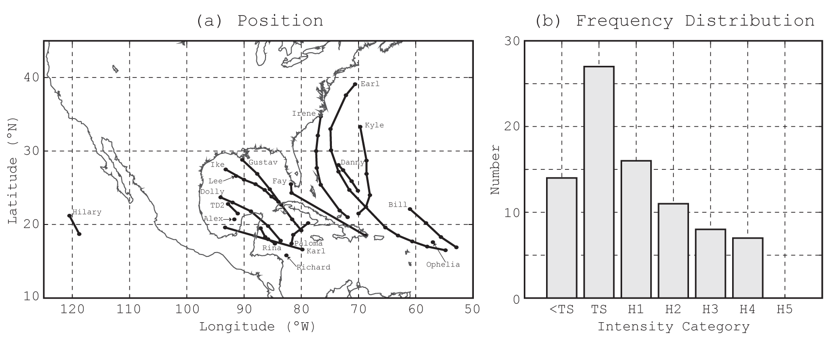
Figure 1. (a) Geographical distribution of storm tracks and (b) Frequency distribution of storm intensity for the 83 cases (20 TCs) examined in this study. .Cases that do not exist in the best track database (see Table 2) are assigned “<TS” category. “TS” and “H” stand for tropical storm and hurricane, respectively.

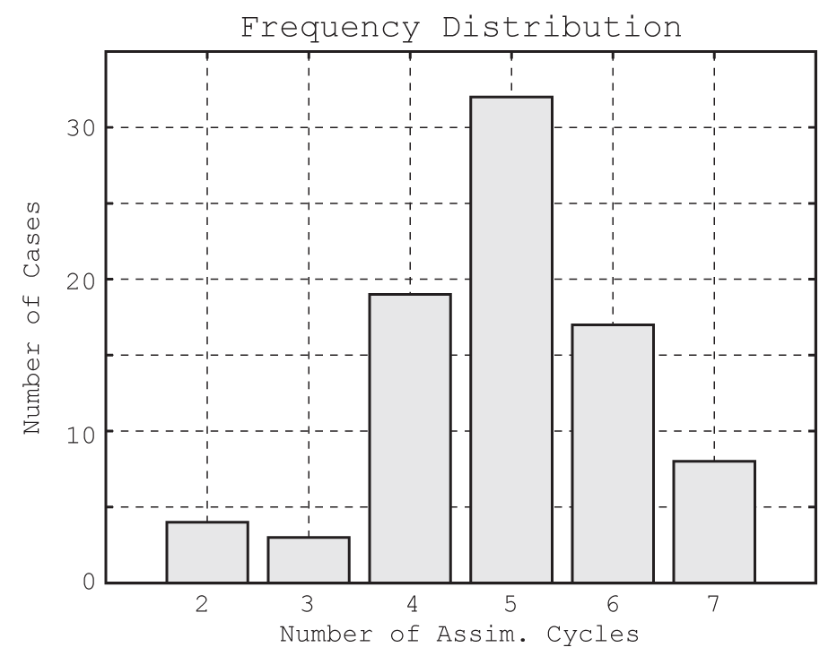
Figure 2. Distribution of the number of cases with respect to the number of assimilation cycles.

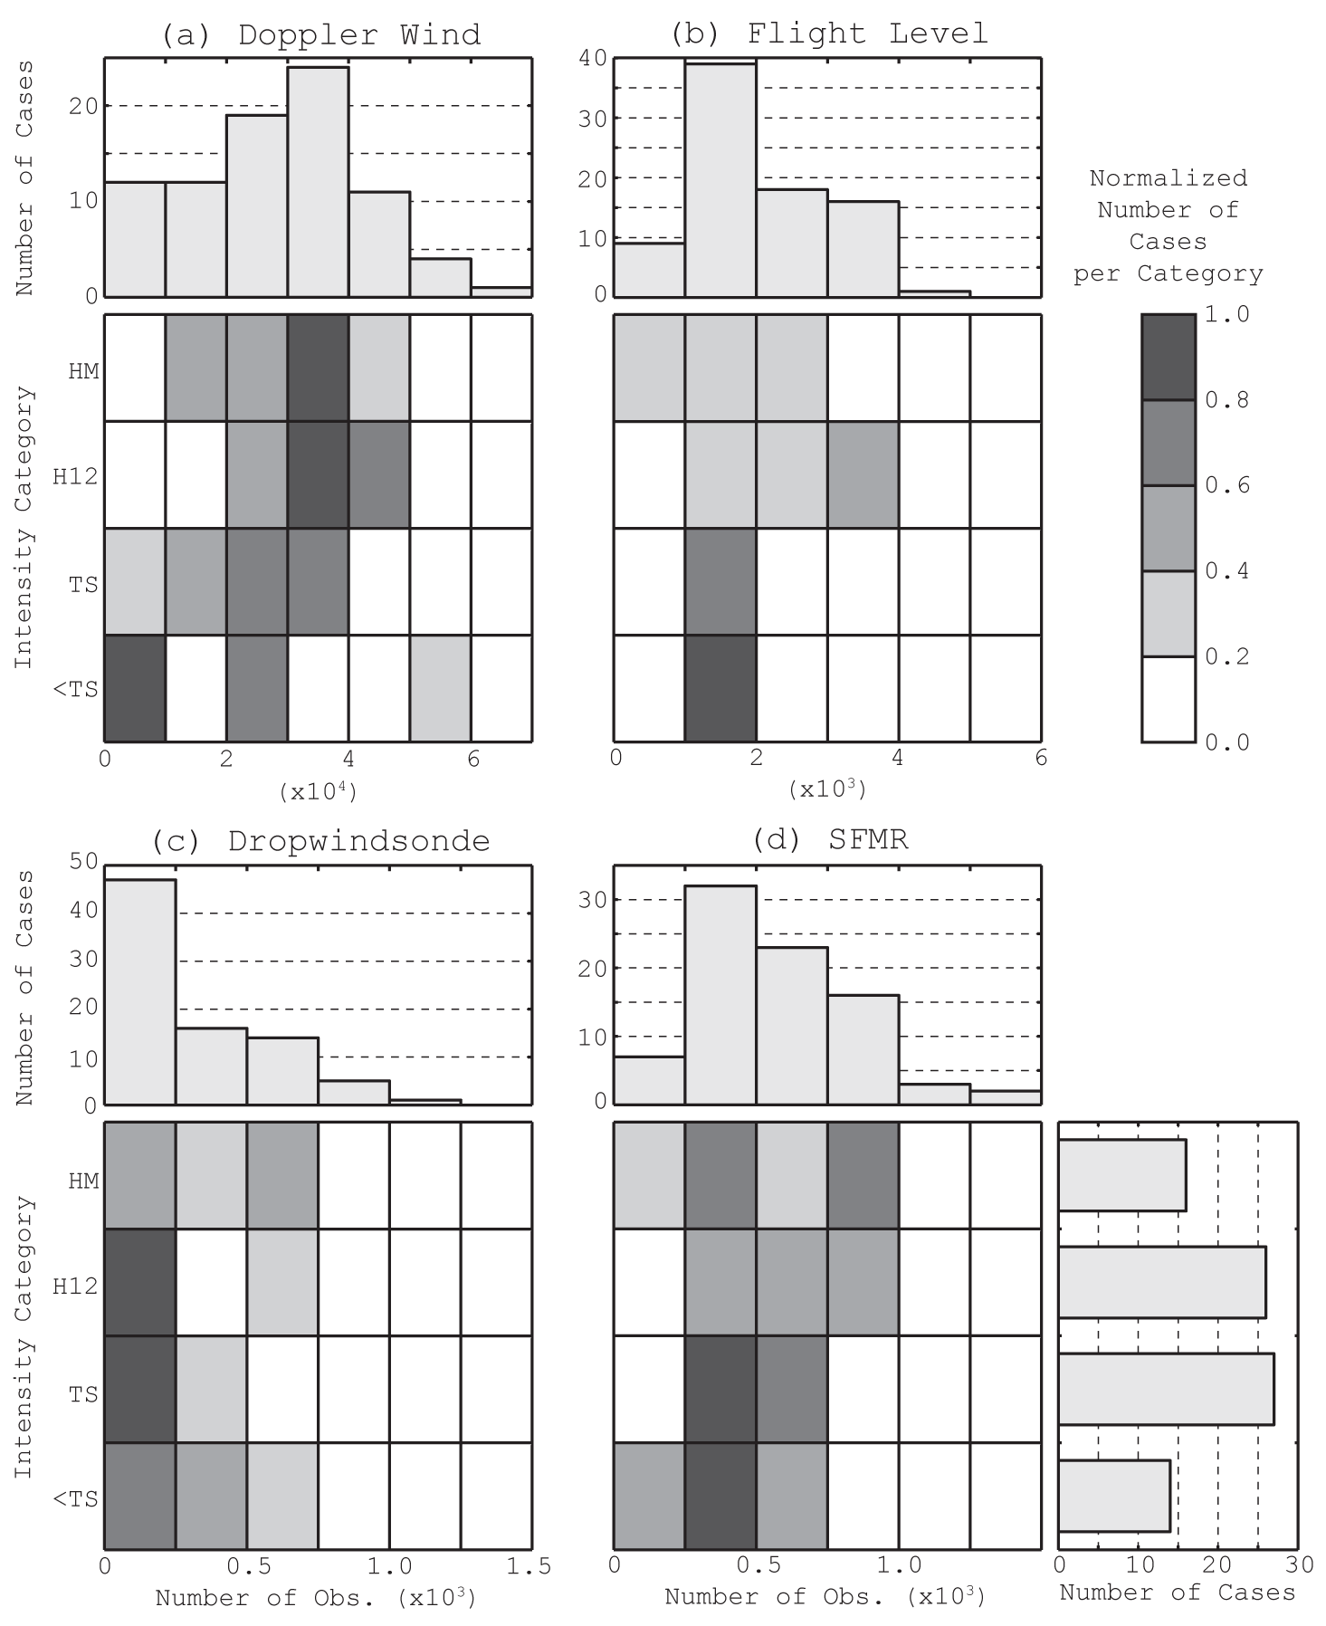
Figure 3. Distribution of the number of cases according to the number of observations assimilated per platform and intensity category (2-d matrix plots in each panel, color scale on top right), cumulative according to number of observations per platform (top histograms in each panel), and cumulative according to intensity category (bottom right histogram). The 2-d matrix plots are normalized by the respective maxima of populations for each intensity category. “TS”, “H”, and “HM” stand for tropical storm, hurricane, and major hurricane, respectively.

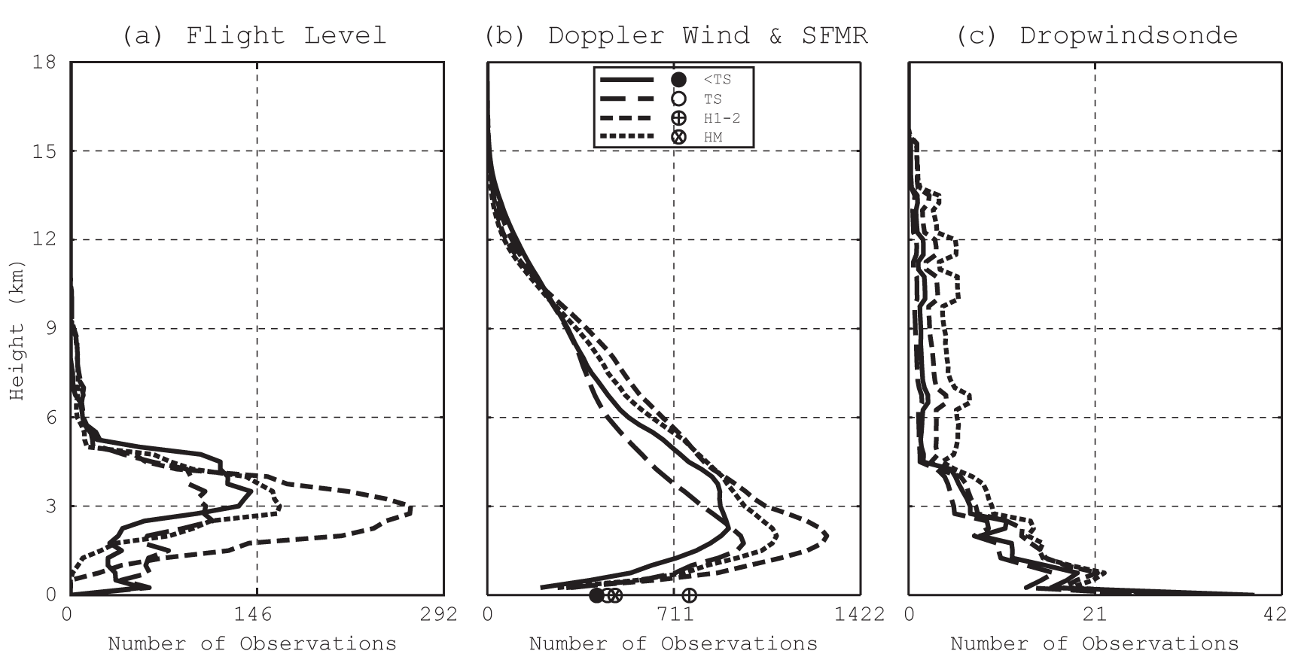
Figure 4. Vertical distribution of observations (binned in 500-m layers) for (a) flight-level, (b) Doppler wind and SFMR (shown with circles at 0-m height), and (c) dropsonde platforms. In each panel, distributions are stratified by storm intensity. Cases not in the best track database (see Table 2) are assigned 20-kt intensity for plotting purposes.

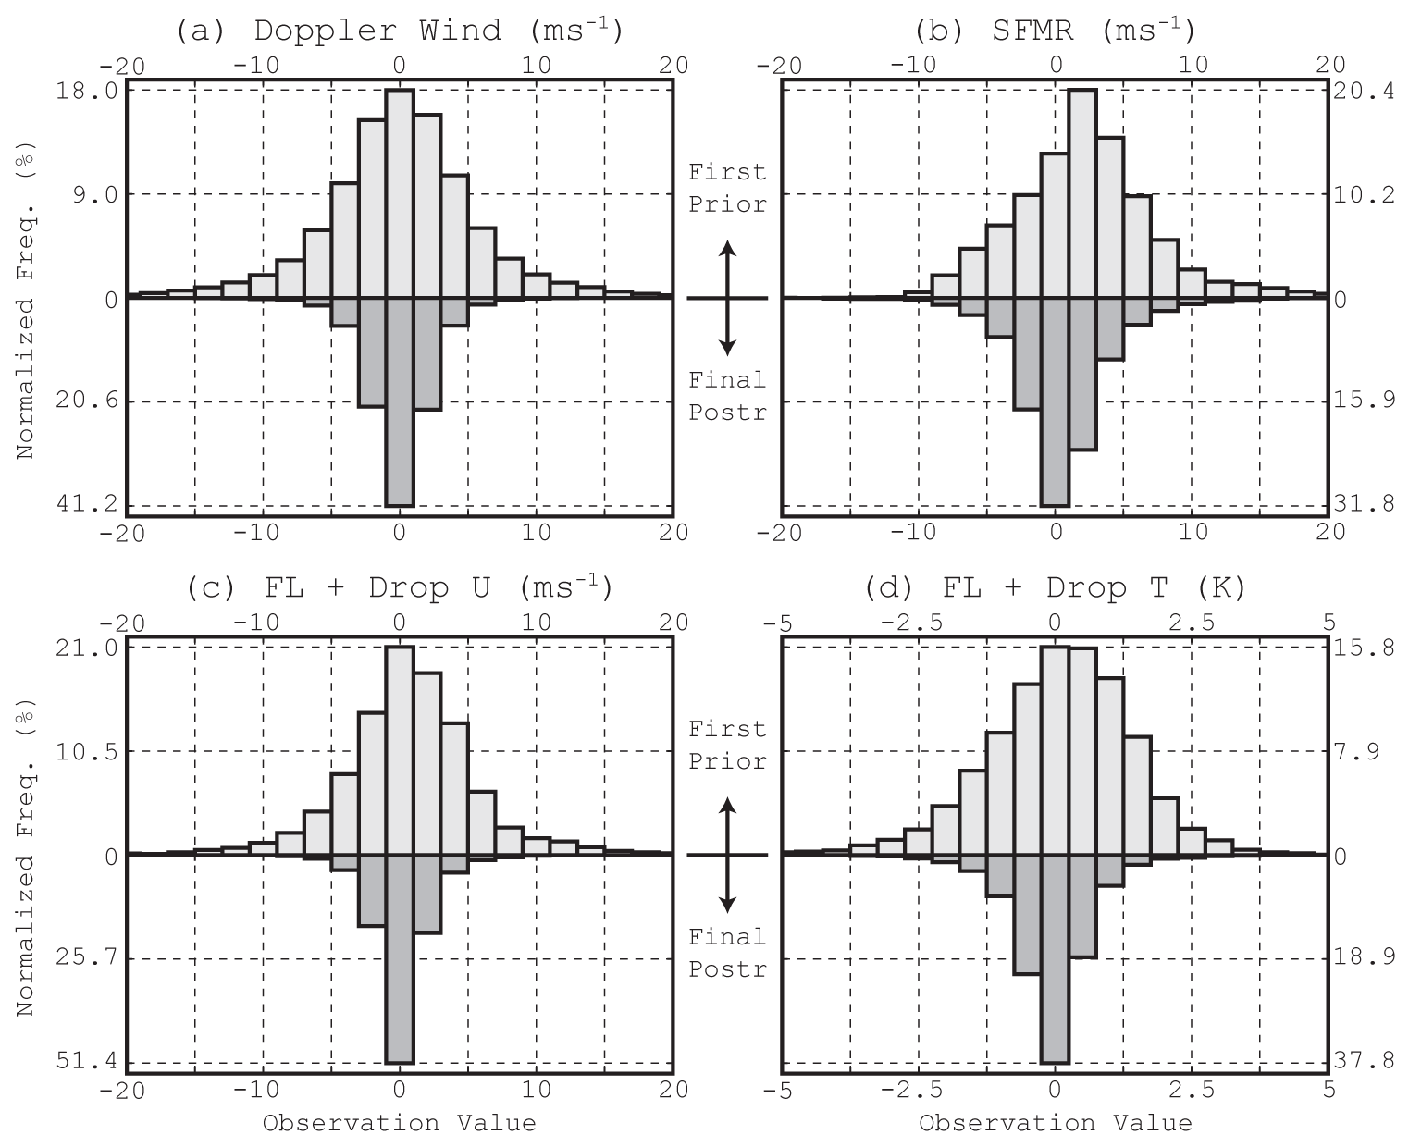
Figure 5. Normalized frequency distribution of innovations (%) for (a) Doppler wind speed, (b) SFMR, (c) flight-level and dropsonde zonal wind speed (U), and (d) flight-level and dropsonde zonal temperature observations. In each panel, prior distributions at the first assimilation cycle are shown in the top histogram, while posterior distributions at the final assimilation cycle are shown in the bottom histogram. Statistics are accumulated over all of the cases processed.

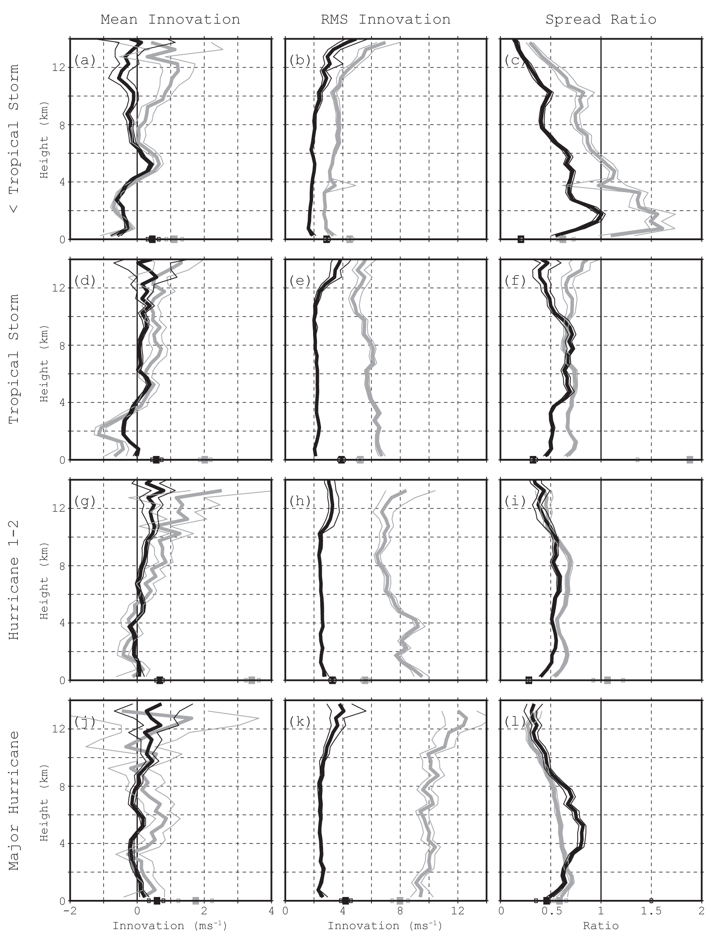
Figure 6. Observation-space innovation (observation-minus-model) statistics for Doppler wind speed and SFMR (shown with squares at 0-m height) the first-cycle prior (thick gray) and final-cycle posterior (thick black) distributions. Left panels: mean innovations, center panels: RMS innovations, and right panels: spread sufficiency ratio. For spread ratio, the black lines represent final-cycle prior distributions. The statistics are aggregated for weaker-than-tropical-storm (first row), tropical storms (second row), hurricanes of category 1 and 2 (third row), and major hurricanes (fourth row). Thin lines represent 95% confidence intervals.
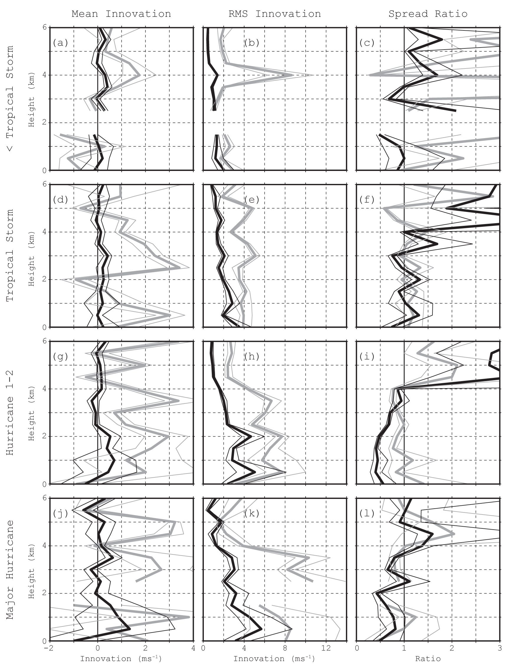
Figure 7. As in Figure 6, but for zonal wind speed observations. Gaps are due to limited number of observations, in which situation statistics are not computed.

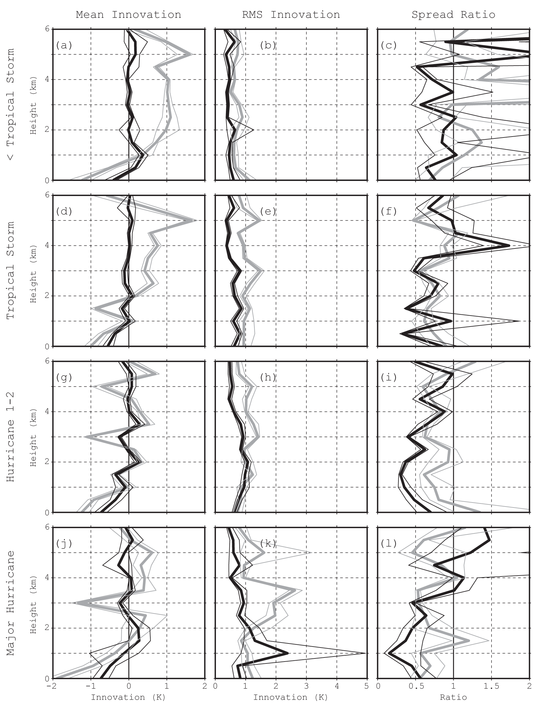
Figure 8. As in Figure 6, but for temperature observations.

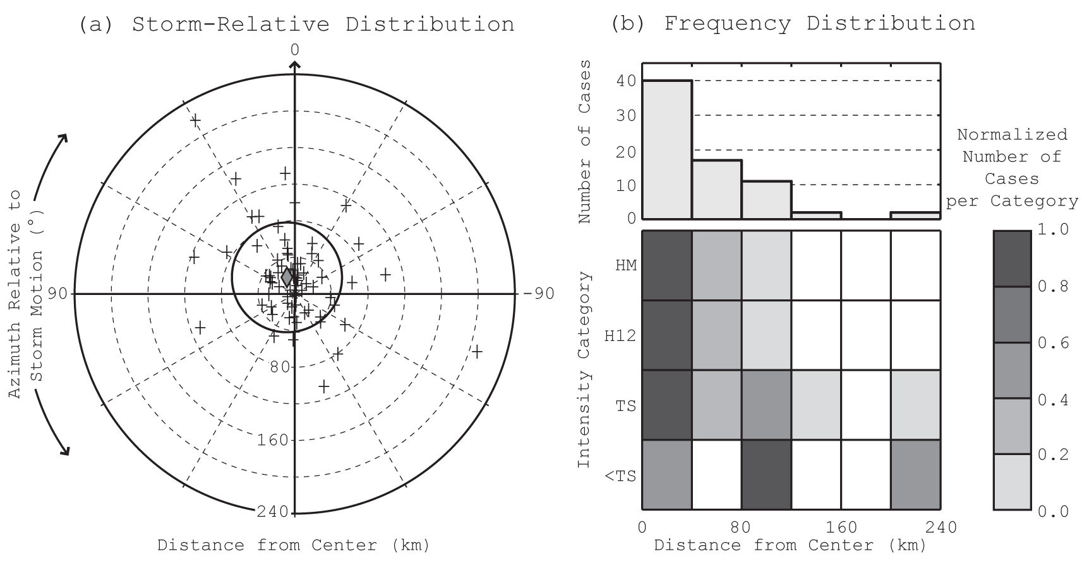
Figure 9. Position error in the final analysis as compared to the best track. (a) Analysis storm centers (plus markers) relative to the best track. Azimuth is measured relative to observed storm motion where 0° represents the direction of storm motion. Radial distance is measured from the best track storm center. The centroid location of all cases is shown with the diamond marker. The standard deviation of position errors is indicated with the circle around the centroid location. (b) Number of cases as a function of the analysis-observed radial distance of storm centers and intensity category (2-d matrix plot, color scale on right), and cumulative as a function of the analysis-observed radial distance of storm centers (histogram). The 2-d matrix plot population bin values are normalized by the respective maxima of populations for each intensity category.

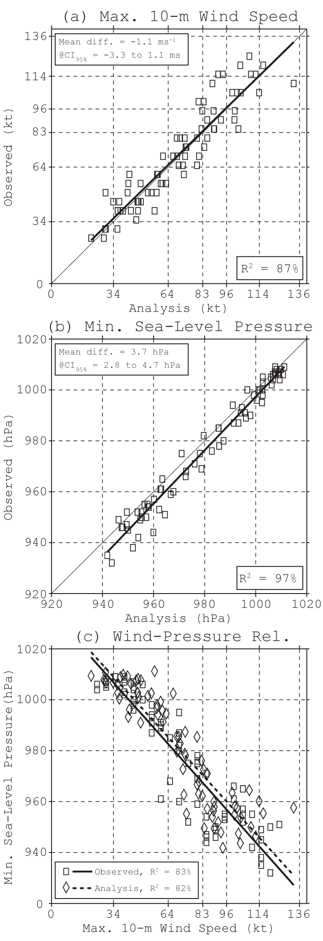
Figure 10. Intensity error in the final analysis as compared to the best track. (a) Analysis vs. observed scatter diagram of maximum 10-m wind speed (kt) for all cases in the best track database. The thick line represents the linear regression between analysis and observations. The coefficient of determination (R²) is presented in the lower-right box. The mean analysis-observation difference along with its 95% confidence interval bounds is given in the upper-left box. The dashed gridlines represent intensity category thresholds. (b) As in (a), but for minimum sea-level pressure. (c) Wind-pressure relationship in observed (square markers, solid linear regression line) and analysis (diamond markers, dashed linear regression line) data.

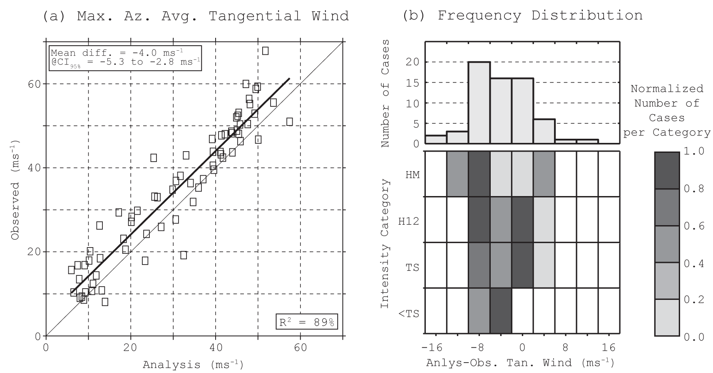
Figure 11. Maximum azimuthally averaged tangential wind speed (ms⁻¹) as compared to radar observations. (a) Analysis vs. observed scatter diagram for all cases in the best track database. The thick line represents the linear regression between analysis and observations. The coefficient of determination (R²) is presented in the lower-right box. The mean analysis-observation difference along with its 95% confidence interval bounds is given in the upper-left box. (b) Number of cases as a function of analysis-observation difference and intensity category (2-d matrix plot, color scale on right), and cumulative as a function of analysis-observation difference (histogram). The 2-d matrix plot population bin values are normalized by the respective maxima of populations for each intensity category.

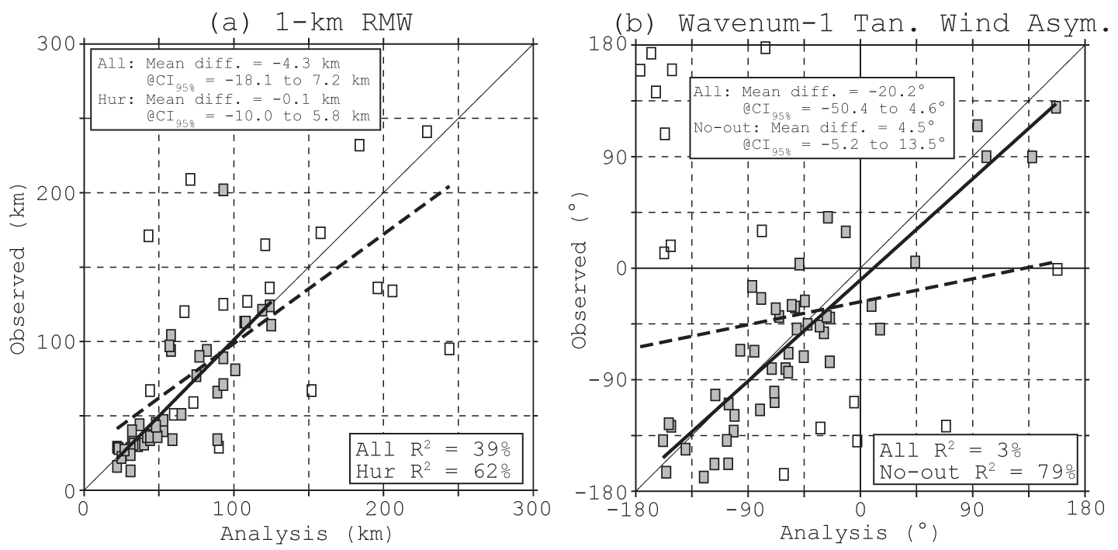
Figure 12. (a) Scatter diagram of analysis vs. radar-observed radius of maximum azimuthally averaged tangential wind speed (RMW, km) at 1-km altitude for all cases in the best track database. Filled squares represent hurricanes. The thick dashed (solid) line represents the linear regression between analyses and observations for all (hurricane) cases. The coefficients of determination (R²) are presented in the lower-right box. The mean analysis-observation differences along with their 95% confidence interval bounds are given in the upper-left box. (b) As in (a), but for the azimuthal phase of wavenumber-1 asymmetry (º from storm motion) at 1-km altitude. Filled squares represent cases that are deemed not to be outliers (see text). The thick dashed (solid) line represents the linear regression between analysis and observations for all (non-outlier) cases.

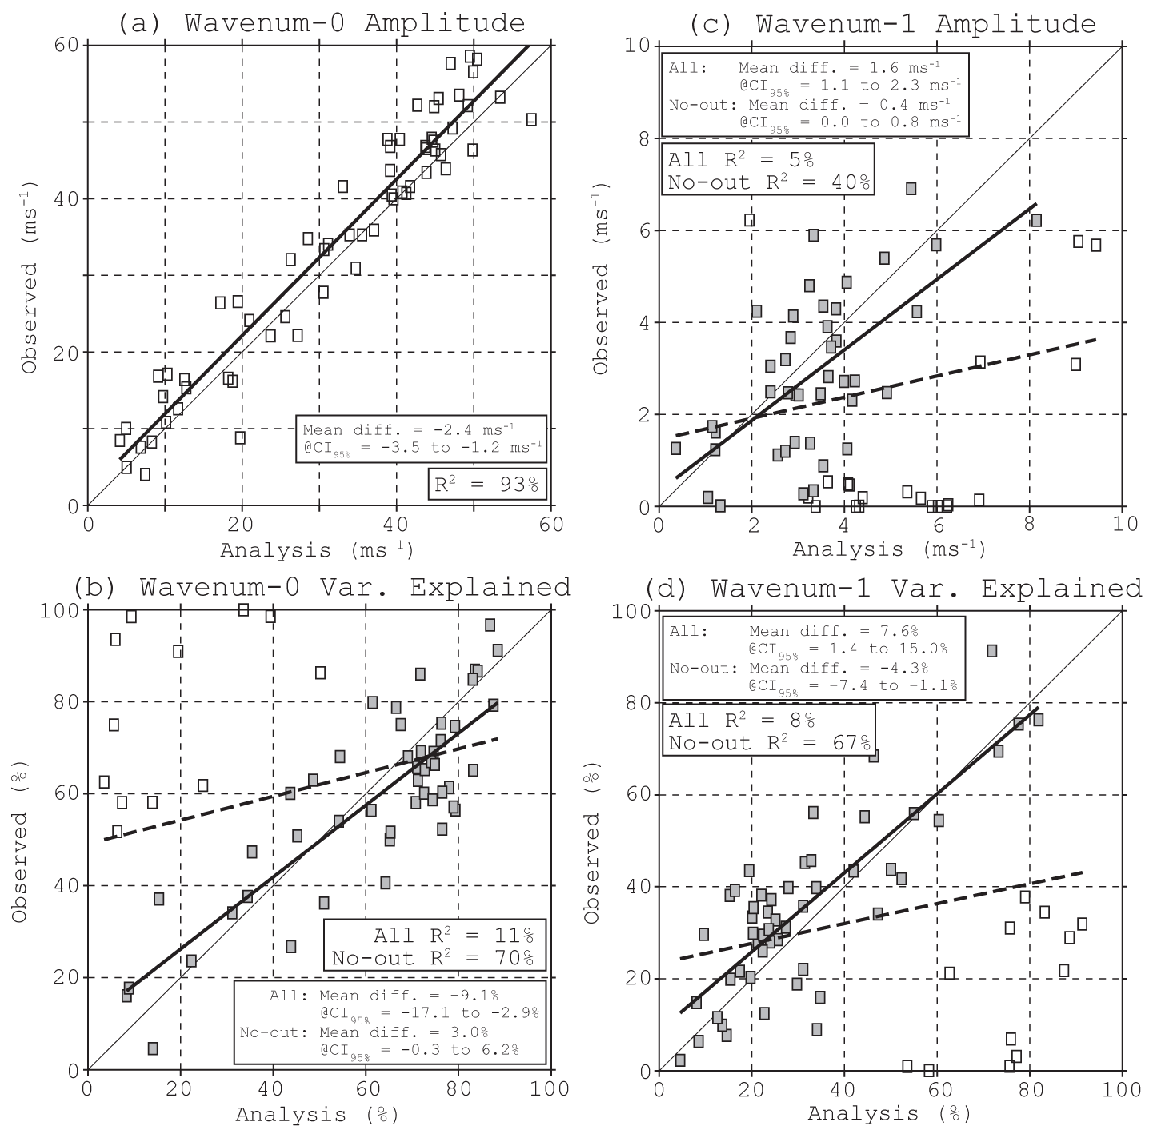
Figure 13. Analysis vs. radar-observed scatter diagram of azimuthal wavenumber 0 and 1 characteristics of azimuthally averaged tangential wind speed at 1-km altitude for all cases. (a) Wavenumber 0 amplitude (ms⁻¹). (b) Wavenumber 0 variance explained (%). (c) Wavenumber 1 amplitude (ms⁻¹). (d) Wavenumber 1 variance explained (%). The thick lines represent the linear regressions between analysis and observations for each parameter. In (b-d), filled squares represent cases that are deemed not to be outliers (see text). The dashed lines represent the linear regressions between analysis and observations for non-outlier cases.

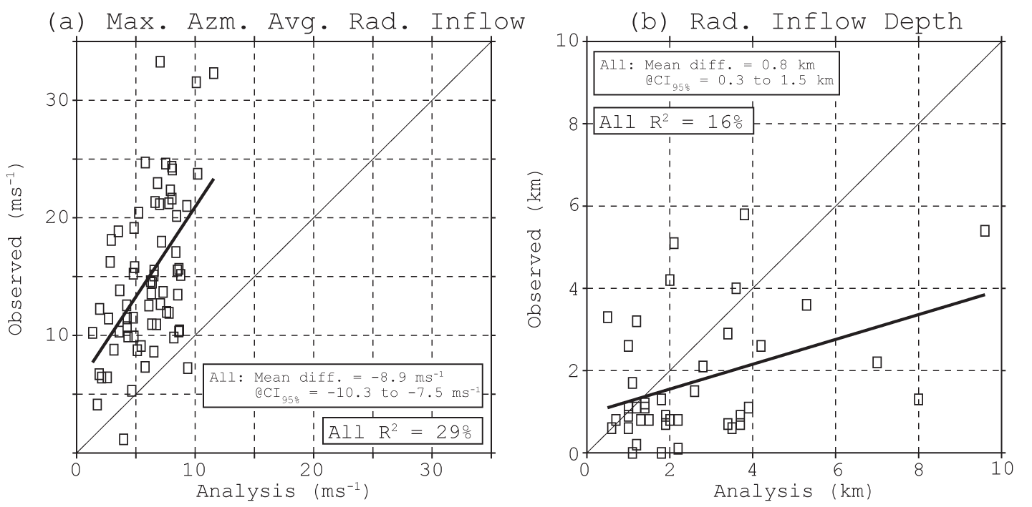
Figure 14. (a) Scatter diagram of analysis vs. radar-observed maximum azimuthally averaged radial inflow (ms⁻¹) for all cases in the best track database. The thick solid line represents the linear regression between analyses and observations for all cases. (b) As in (a), but for the depth of the radial inflow (km).

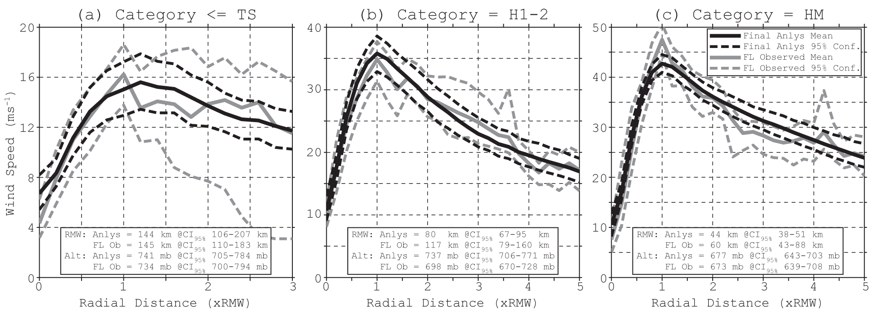
Figure 15. Composite radial profiles of azimuthally averaged horizontal wind speed at P-3 flight level for HEDAS final analyses (thick black) and in-situ aircraft observations (thick gray). 95% confidence intervals are shown as dashed lines. Average RMW and flight altitude (“Alt”) in analyses as well as observations are shown in the box inserts, along with corresponding 95% confidence intervals. (a) All cases that had tropical-storm or weaker intensity in the best track database. (b) All cases with category-1 and category-2 hurricane intensity. (c) Major hurricanes.

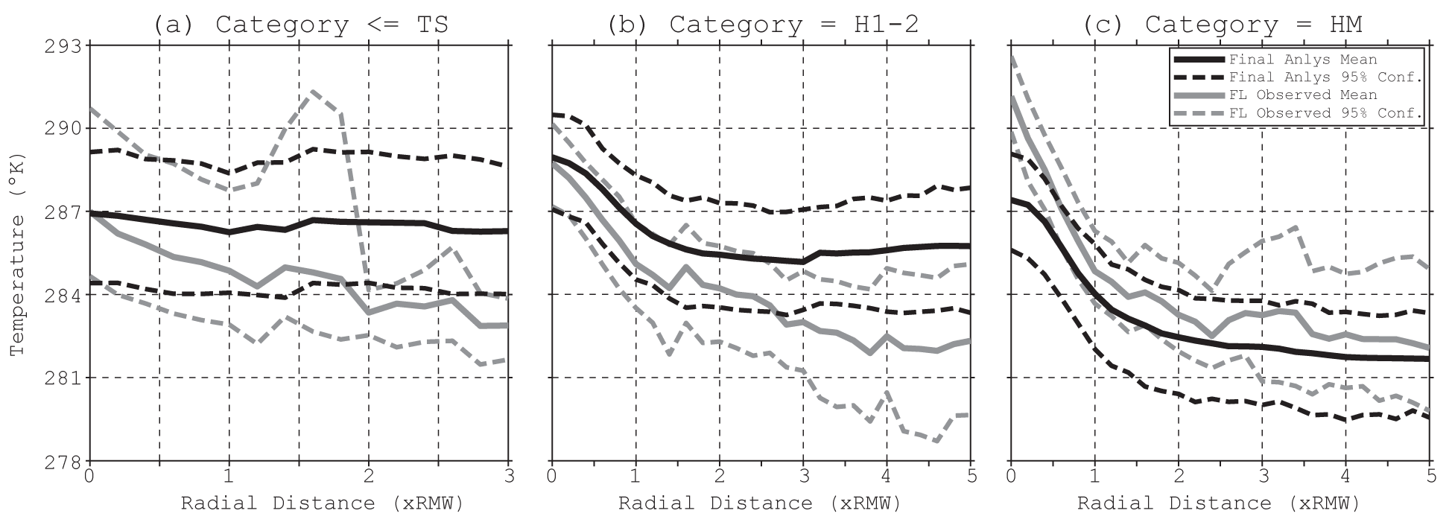
Figure 16. As in Fig. 15 but for temperature (K).

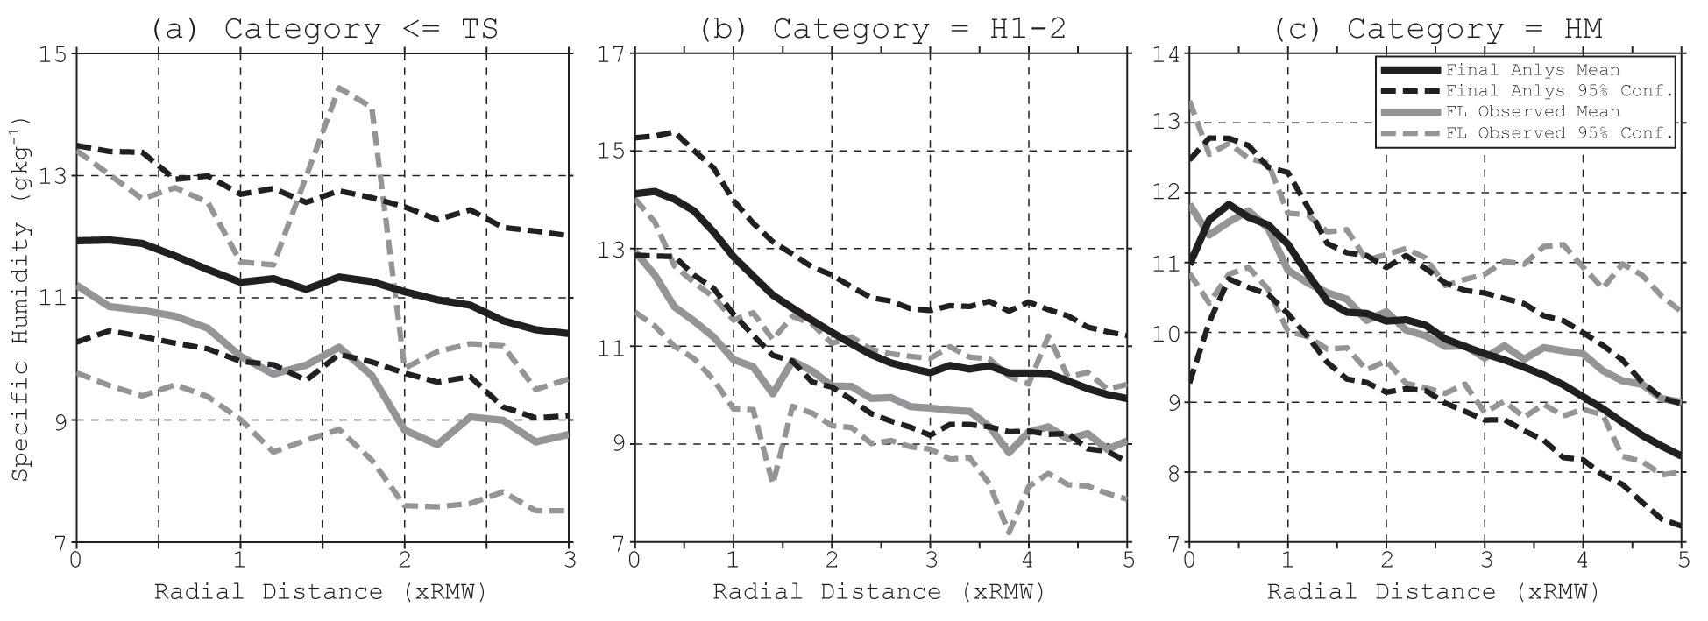
Figure 17. As in Fig. 15 but for specific humidity (g kg⁻¹).

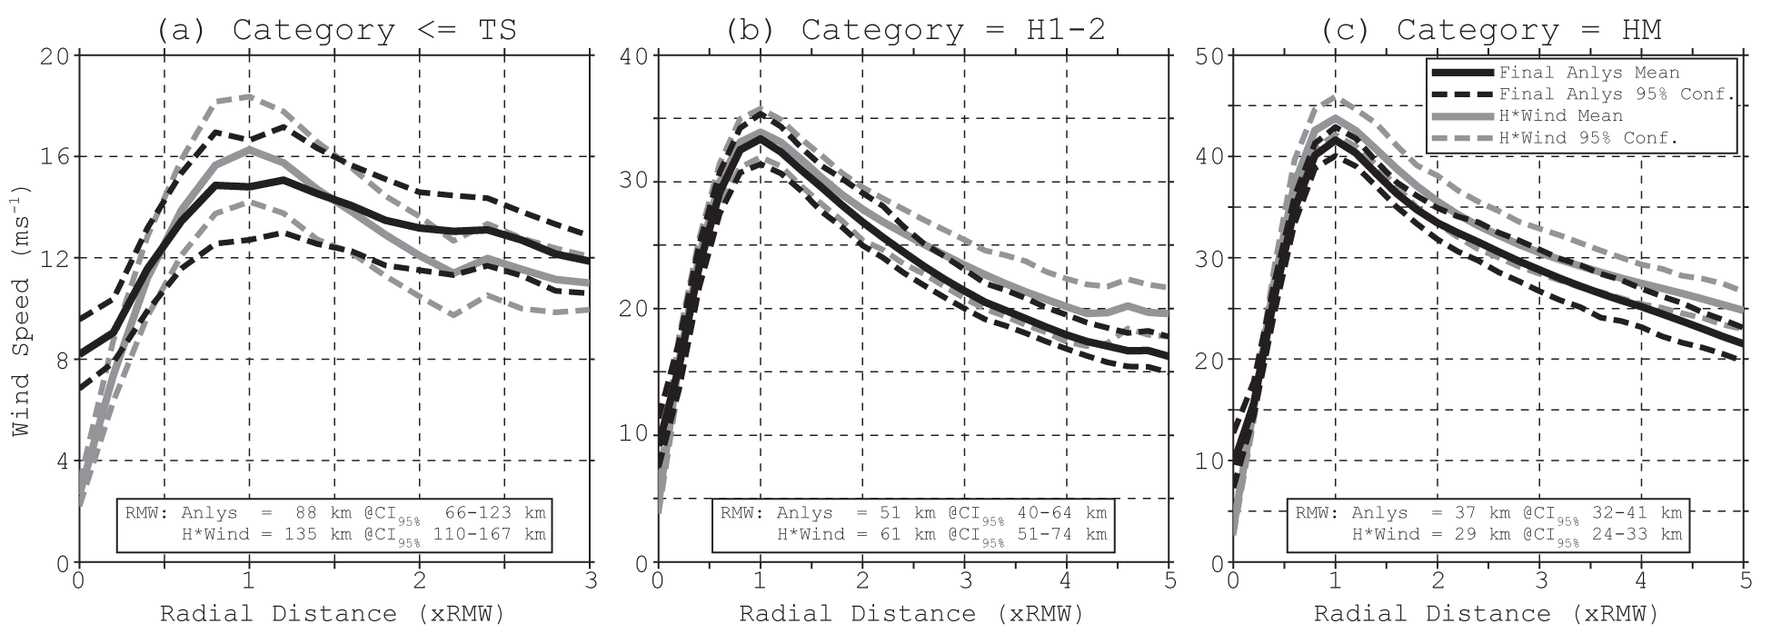
Figure 18. As in Fig. 15 but for surface (10-m) wind speed (m s⁻¹). Here, HEDAS analyses are compared to H*Wind analyses.

Table 1. Summary of the experimental setup.

Feature | Explanation
HEDAS
Filter type | Ensemble square root filter
Ensemble size, initialization | 30 members, initialized from GFS EnKF analysis ensemble, 3-4 h spin-up
Covariance localization, radii of influence | Through a compactly supported fifth-order correlation function, 80 grid distances in the horizontal and 15 model levels in the vertical
Assimilation domain | Static inner nest during spin-up and assimilation, 3-km horizontal resolution, with a 10-grid-point “buffer zone” to outer nest
Assimilation frequency, period | 1 h, duration of availability of NOAA P-3 observations
Assimilated observation types | Doppler radial velocity superobservations, dropsonde/flight-level wind and temperature, and SFMR 10-m wind speed
Experimental HWRF
Model version | WRF NMM core, version 3.0.1.1
Resolution | Horizontal: 9-km outer nest of approximate size 60°×60°, 3-km inner nest of approximate size 10°×10°; vertical: 42 eta levels with model top at 50 hPa
Physics | Ferrier et al. (2002) microphysics, Hong and Pan (1998) cumulus (only in the outer domain, explicit convection in the inner domain), Dudhia (1989) short-wave radiation, Mlawer et al. (1997) long-wave radiation, Hong and Pan (1996) PBL, Moon et al. (2007) surface layer, and Ek et al. (2003) land surface parameterization

Table 2. Summary of the cases considered.
Storm Name† | Verification Date/Time‡ | Observed Intensity§ (kt) | Storm Name† | Verification Date/Time‡ | Observed Intensity§ (kt)
Dolly | 2008-07-20-12Z | 40 | Alex | 2010-06-29-00Z | 55
Dolly | 2008-07-21-00Z | 45 | TD2 | 2010-07-07-00Z | n/a
Dolly | 2008-07-21-12Z | 45 | TD2 | 2010-07-07-12Z | 25
Dolly | 2008-07-22-00Z | 45 | TD2 | 2010-07-08-00Z | 30
Dolly | 2008-07-22-12Z | 55 | Earl | 2010-08-29-00Z | 55
Fay | 2008-08-14-12Z | n/a | Earl | 2010-08-29-12Z | 65
Fay | 2008-08-15-00Z | n/a | Earl | 2010-08-30-00Z | 85
Fay | 2008-08-15-06Z | n/a | Earl | 2010-08-30-12Z | 105
Fay | 2008-08-15-18Z | 35 | Earl | 2010-08-31-00Z | 115
Fay | 2008-08-18-18Z | 50 | Earl | 2010-09-01-12Z | 110
Fay | 2008-08-19-06Z | 55 | Earl | 2010-09-02-00Z | 120
Gustav | 2008-08-30-00Z | 75 | Earl | 2010-09-02-12Z | 115
Gustav | 2008-08-30-12Z | 110 | Earl | 2010-09-03-00Z | 90
Gustav | 2008-08-31-00Z | 120 | Earl | 2010-09-03-18Z | 75
Gustav | 2008-08-31-12Z | 100 | Earl | 2010-09-04-00Z | 60
Gustav | 2008-09-01-00Z | 95 | Karl | 2010-09-13-00Z | n/a
Gustav | 2008-09-01-12Z | 95 | Karl | 2010-09-13-12Z | n/a
Ike | 2008-09-10-00Z | 65 | Karl | 2010-09-14-00Z | 25
Ike | 2008-09-10-12Z | 80 | Karl | 2010-09-16-18Z | 70
Ike | 2008-09-11-00Z | 85 | Richard | 2010-10-23-06Z | 45
Ike | 2008-09-11-12Z | 85 | Tomas | 2010-11-04-00Z | 40
Ike | 2008-09-12-00Z | 85 | Tomas | 2010-11-04-12Z | 45
Ike | 2008-09-12-18Z | 95 | Tomas | 2010-11-15-00Z | 60
Kyle | 2008-09-23-00Z | n/a | Tomas | 2010-11-06-12Z | 60
Kyle | 2008-09-24-12Z | n/a | Tomas | 2010-11-07-00Z | 70
Kyle | 2008-09-25-00Z | 30 | Irene | 2011-08-24-00Z | 80
Kyle | 2008-09-25-12Z | 40 | Irene | 2011-08-24-12Z | 105
Kyle | 2008-09-26-00Z | 45 | Irene | 2011-08-25-12Z | 90
Kyle | 2008-09-26-18Z | 50 | Irene | 2011-08-26-00Z | 90
Kyle | 2008-09-27-00Z | 55 | Irene | 2011-08-26-12Z | 85
Kyle | 2008-09-27-18Z | 65 | Irene | 2011-08-27-00Z | 75
Paloma | 2008-11-07-06Z | 65 | Irene | 2011-08-27-12Z | 75
Paloma | 2008-11-07-18Z | 80 | Lee | 2011-09-02-00Z | 30
Paloma | 2008-11-08-18Z | 125 | Ophelia | 2011-09-24-18Z | 40
Ana | 2009-08-17-00Z | n/a | Hilary | 2011-09-28-18Z | 70
Bill | 2009-08-19-00Z | 105 | Hilary | 2011-09-29-18Z | 50
Bill | 2009-08-19-12Z | 115 | Rina | 2011-10-26-00Z | 100
Bill | 2009-08-20-00Z | 115 | Rina | 2011-10-26-18Z | 80
Bill | 2009-08-20-12Z | 105 | Rina | 2011-10-27-00Z | 80
Danny | 2009-08-26-12Z | 40 | Rina | 2011-10-27-18Z | 60
Danny | 2009-08-27-00Z | 50
Danny | 2009-08-27-12Z | 50
Danny | 2009-08-28-00Z | 40
† All cases except Hilary (2011, East Pacific basin) were observed in the Atlantic basin.
‡ Verification time here is defined as the closest synoptic time to the time of a final analysis.
§ Storm intensity for cases that did not exist in the best track database is denoted as “n/a”.
Table 3. Observation platforms/types assimilated.

Platform/Observation Type | Observation Error (Std. Deviation) | Notes on Processing
Tail Doppler radar (P-3)
Radial wind speed | 2 m s⁻¹ | Processed into superobs†
HDOBS (P-3, Air Force Reserve)
Flight-level zonal/meridional wind speed | 2 m s⁻¹ | Observations with “questionable” quality control values are removed
Flight-level temperature | 0.5 K | Correction applied based on dew point temperature if necessary§
SFMR wind speed | Rain rate dependent‡ with mean ~5 m s⁻¹ | Observations with “questionable” quality control values are removed
TEMPDROP (P-3, Air Force Reserve, G-IV)
Dropsonde zonal/meridional wind speed | 2 m s⁻¹ | Position and time interpolated based on drift deduced from wind speed, time, and location of release and splash
Dropsonde temperature | 0.5 K | Position and time interpolated based on drift deduced from wind speed, time, and location of release and splash
† As in Aksoy et al. (2012).
‡ As deduced from Uhlhorn et al. (2007).
§ As in Eastin et al. (2002).

