Saharan Air Layer Experiment (SALEX): Arc Cloud Module
PI: Jason Dunion

Program Significance:
Arc clouds are common features in mid-latitude thunderstorms and mesoscale convective systems. They often denote the presence of a density current that forms when dry mid-level (~600-850 hPa) air has interacted with precipitation. The convectively-driven downdrafts that result reach the surface/near-surface and spread out from the convective core of the thunderstorm. Substantial arc clouds (i.e., >100 km in length and lasting for several hours) are also common features in the tropics (Figure ARC-1), particularly on the periphery of African easterly waves (AEWs) and tropical cyclones (TCs). However, the physical processes responsible for such tropical arc clouds as well as their impacts on the short-term evolution of their parent disturbances are not well understood.

The mid-level moisture found in the moist tropical North Atlantic sounding described by Dunion (2011) is hypothesized to be insufficiently dry to generate extensive near-surface density currents around an African easterly wave (AEW) or tropical cyclone (TC). However, Dunion (2011) also described two additional air masses that are frequently found in the tropical North Atlantic and Caribbean during the summer months and could effectively initiate the formation of large arc clouds: (1) the Saharan Air Layer (SAL) and (2) mid-latitude dry air intrusions. Both of these air masses were found to contain substantially dry air (~50% less moisture than the moist tropical sounding) in the mid-levels that could support convectively-driven downdrafts and large density currents. Furthermore, outward-propagating arc clouds on the periphery of AEWs or TCs could be enhanced by near-surface super-gradient winds induced by the downward transport of high momentum air. Since most developing tropical disturbances in the North Atlantic are associated with a mid-level jet and/or mesoscale convective vortex near a state of gradient balance, any convectively-driven downdrafts would inject high momentum air into a near-surface environment that often contains a weaker horizontal pressure gradient. In such cases, density currents may be temporarily enhanced during local adjustments to gradient balance. Finally, tropical arc clouds may be further enhanced by outward-propagating diurnal pulses that originate from the convective core of the tropical disturbance (see HRD’s TC Diurnal Cycle Experiment). New GOES IR TC diurnal cycle imagery indicates that arc clouds tend to form along the leading edge of outwardly propagating diurnal pulses that are associated with the TC diurnal cycle. The diurnal pulses reach peripheral radii where low to mid-level dry air is often located (e.g. R=300-500 km) at remarkably predictable times of day (e.g. 400 km at ~1200-1500 LST). Therefore, UW-CIMSS real-time TC diurnal cycle and GOES visible satellite imagery will be used to monitor the diurnal pulse propagation throughout the local morning hours and signs of arc cloud formation.

It is hypothesized that the processes leading to the formation of arc cloud events can significantly impact an AEW or TC (particularly smaller, less developed systems). Specifically, the cool, dry air associated with the convectively-driven downdrafts that form arc clouds can help stabilize the middle to lower troposphere and may even act to stabilize the boundary layer, thereby limiting subsequent convection. The arc clouds themselves may also act to disrupt the storm. As they race away from the convective core region, they create low-level outflow in the quadrant/semicircle of the AEW or TC in which they form. This outflow pattern counters the typical low-level inflow that is vital for TC formation and maintenance. As arc clouds propagate away from the tropical disturbance, they visibly emerge from underneath the central dense overcast that can obscure them from visible an infrared satellite view. Therefore, when arc clouds are identified using satellites, they are often in the middle to later stages of their lifecycles. Hence, the mechanism of enhanced low-level outflow is likely occurring at the time of satellite identification, while the mechanism of cooling/drying of the boundary layer has already occurred (though the effects may still be observable in the aircraft, GPS dropsonde and satellite data). This necessitates that the arc clouds be identified and sampled as early in their lifecycle as possible using available aircraft observations (e.g. flight-level, GPS dropsonde and P-3 LF radar, and P-3/G-IV Doppler radar data) and satellite imagery (e.g. TC diurnal cycle IR, visible, infrared, and microwave).

Objectives: The main objectives of the TC/AEW Arc Cloud Module are to:
- Collect observations in mid-level dry layers (e.g. the SAL) that are hypothesized to be a necessary ingredient for the formation of strong downdrafts and subsequent outflow boundaries & arc clouds;
- Collect observations across arc cloud features in the periphery of AEWs or TCs using aircraft flight-level data, tail Doppler radar data, and GPS dropsondes to improve our understanding of the physical processes responsible for their formation and evolution and how these features may limit short-term intensification;
- Target observations ahead of and behind arc cloud features to sample the horizontal gradients of temperature, moisture, and winds (e.g. outflow) from ~600 hPa to the surface;
- Quantify the capabilities of the operational coupled model forecast system to accurately capture and represent both mid-level dry air (e.g. the SAL) and thermodynamic and kinematic gradients across arc cloud features through direct comparison to observations as well as high-resolution analyses provided by HRD’s state-of-the-art Hurricane Ensemble Data Assimilation System (HEDAS);

Links to IFEX: This experiment supports the following NOAA IFEX goals:
- Goal 1: Collect observations that span the TC lifecycle in a variety of environments;
- Goal 3: Improve our understanding of the physical processes important in intensity change for a TC at all stages of its lifecycle;

Model Evaluation Component: Arc clouds in the periphery of TCs represent the leading edge of large outflow boundaries that bring cool, dry air and enhanced outflow into the lower levels of the atmosphere. These rarely observed environments are formed in the presence of precipitation falling through mid-level dry air and are hypothesized to limit short-term TC intensification. Thermodynamic and kinematic observations that are collected during this module will be used to evaluate the robustness of the operational coupled model forecast system to represent the SAL and arc cloud environments. Data assimilation (DA) provides a natural platform to compare model output to observations by accounting for the underlying uncertainties of observations and model in a statistical framework. Normalization of model-observation differences by the total expected uncertainty allows for the identification of areas where lack of model performance is statistically the most significant. Furthermore, the high-resolution, three-dimensional analyses that DA produces provide the best estimate of the SAL structure within the modeling framework. Such analyses can be directly compared to operational model output to understand how well the SAL structure is represented in operational models and the consequences for subsequent model forecasts.

Mission Description:
This multi-option research module is designed to utilize the WP-3D [flight-level (flying at multiple levels above 1500 feet) and GPS dropsonde data] or G-IV (GPS dropsonde data) aircraft. Although this module is not a standalone experiment, it could be included as a module within any of the following HRD research missions: TC Diurnal Cycle Experiment, TC Genesis Experiment, TC Rapid Intensity Experiment, or TC Shear Experiment, or as part of operational G-IV Synoptic Surveillance and NHC-EMC-HRD Tail Doppler Radar (TDR) missions. Total precipitable water (TPW) satellite imagery will be used to identify mid-level dry air (≤45 mm TPW) in the periphery of the AEW or TC. These areas of mid-level dry air will be favorable locations for arc cloud formation, especially when TC diurnal pulses are passing radii where this low to mid-level dry air is located. Additionally, when this low- to mid-level dry air is located in the upshear quadrant or semicircle of the storm, arc cloud formation may be especially favorable. These favorable areas will be regions of preferred arc cloud formation and should be monitored closely using satellite imagery (e.g. UW-CIMSS TC diurnal cycle IR imagery, 1 km GOES visible, and 37 GHz microwave) during the mission. Depending on connection rates on the aircraft, supplemental communications via X-Chat with scientists on the ground would be desirable, especially given the unpredictability and rapid evolution of arc cloud features.

Option #1: G-IV aircraft. Once an arc cloud feature has been identified, a GPS dropsonde sequence (preferably running perpendicular to the arc cloud) should be made between the convective area where the arc cloud originated to at least 50 km beyond the leading edge of the arc cloud. Special attention should be paid to the transition zone across the leading edge of the arc cloud and to the environment adjacent to the convective core area where the arc cloud originated (behind the arc cloud). GPS dropsonde spacing should be ~35 km and the transect can be made inbound (sampling in front of, across, and then behind the arc cloud) or outbound (sampling behind, across, and then ahead of the arc cloud) relative to the convective core region of the AEW/TC. In addition to the more common arc cloud that propagates away from the AEW/TC, a second arc cloud has occasionally been observed propagating in toward the AEW/TC. This second arc cloud appears to spawn from the same convective region as the outbound arc cloud and simply moves toward the AEW/TC instead of away from it. If a second inward propagating arc cloud is identified, the GPS dropsonde sequence should be extended to span the environments ahead of (relative to arc cloud motion) both arc clouds. Figures ARC-2 and ARC-3 provide example G-IV flight patterns across arc cloud candidates. This option can be easily incorporated into pre-existing flight patterns with minimal additional time requirements.

Option #2: WP-3D aircraft: After an arc cloud feature has been identified, a multi-level flight pattern running perpendicular to the arc cloud should be initiated. The Doppler radar should operate in F/AST mode to permit sampling of the three-dimensional winds throughout any precipitating arc clouds. The initial pass should extend between the convection where the arc cloud originated to at least 20 km beyond the leading edge of the arc cloud. Flight altitude should be >3000 m to permit the deployment of multiple GPS dropsondes. Special attention should be paid to the transition zone across the leading edge of the arc cloud and to the environment adjacent to the convection where the arc cloud originated (behind the arc cloud). GPS dropsonde spacing should be ~20 km [reduced to ~10 km spacing closer (≤20 km) to the arc cloud] and the transect can be made inbound (sampling in front of, across, and then behind the arc cloud) or outbound (sampling behind, across, and then ahead of the arc cloud) relative to the convective core region of the AEW/TC. For the second pass, the aircraft should turn and descend to ~1000 m before proceeding back along the same transect extending from the originating convection to at least 20 km beyond the leading edge of the arc cloud. For the final pass, the aircraft should again turn and descend to ~500 m before again proceeding along a similar transect across the arc cloud. Flight altitudes for the second and final passes can be adjusted as needed for aircraft safety, but should sample as low as possible in order to capture any near-surface density current with the flight-level sensors. No dropsondes should be deployed on the second and final low-level passes. After the final low-level pass, the primary flight pattern can be resumed. The total time to complete this option should not exceed 60 min, and in most cases can be completed in less time. Figures ARC-2, ARC-3, and ARC-4 show sample fight patterns for this multi-level option.

Note: If other experiment goals, time constraints, and/or aircraft safety would prevent the low-level passes, this option could be altered to include only the initial pass with the dropsonde deployment sequence at altitudes >3000 m.

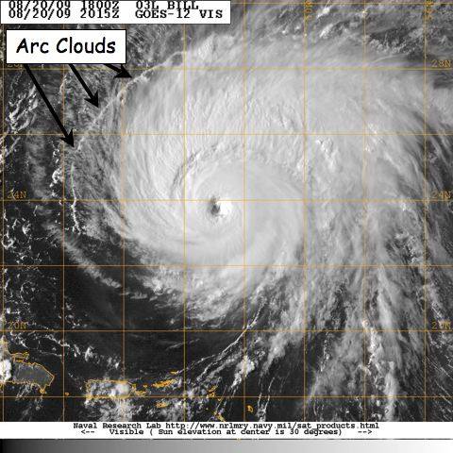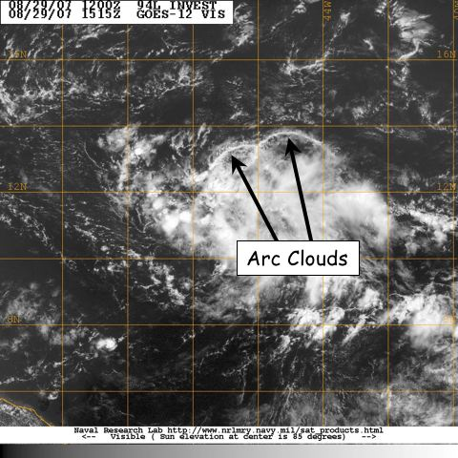

Figure ARC-1: GOES visible satellite imagery showing arc clouds racing away from the convective cores of (left) 2009 Hurricane Bill and (right) 2007 Pre-Tropical Depression Felix.
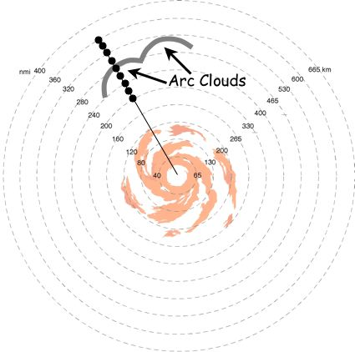

Figure ARC-2: The G-IV (or WP-3D) flight track inbound or outbound to/from the TC/AEW. Azimuth and length of GPS dropsonde sequences during G-IV missions will be dictated by the pre-determined flight plan. For these cases, any G-IV flight legs that transect through the trailing and leading edges of the arc cloud are candidates for this module. When multiple arc clouds are present, the feature closest to the pre-determined flight track is desirable.
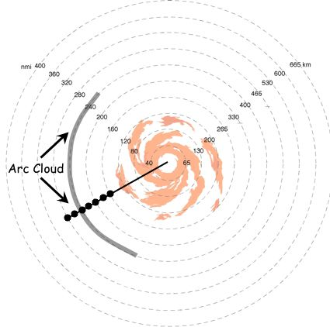

Figure ARC-3: The G-IV (or WP-3D) flight track inbound or outbound to/from the TC/AEW. Azimuth and length of GPS dropsonde sequences during G-IV missions will be dictated by the pre-determined flight plan. For these cases, any G-IV flight legs that transect through the trailing and leading edges of the arc cloud are candidates for this module.

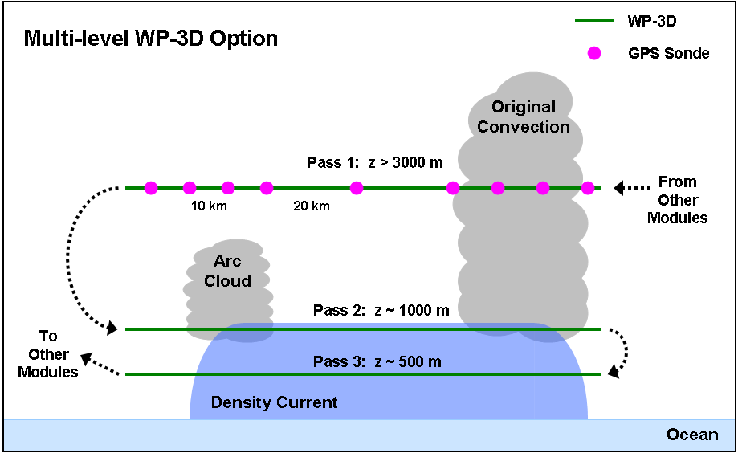

Figure ARC-4: The WP-3D flight track for the multi-level option. Azimuth and length of initial midlevel pass with GPS dropsonde sequence will be dictated by the pre-determined flight plan. Lengths of the low-level passes should span much of the distance between the arc cloud and its initiating convection, while flight altitudes should be near the top and middle of any near-surface density currents (adjusting for safe aircraft operation as needed).

Analysis Strategy
This experiment seeks to collect observations across arc cloud features in the periphery of AEWs or TCs using aircraft flight-level data, Doppler data and GPS dropsondes to improve our understanding of the physical processes responsible for their formation and evolution, as well as how these features may affect TC structure and intensity in the short-term. The GPS dropsonde data will be used to calculate changes in static stability and possible impacts on surface fluxes both ahead of and behind the arc cloud (e.g. enhanced stability/reduced surface fluxes behind the arc cloud leading edge). Also, kinematics and thermodynamic associated with arc cloud events will also be compared to corresponding locations in model analysis fields (e.g. GFS and HWRF).

