MISSION PLAN
FLIGHT ID | 20241107H1 | STORM | AL18/Rafael
MISSION ID | 1818A | TAIL NUMBER | NOAA-42
TASKING | HRD | PLANNED PATTERN | Rotated-4
MISSION SUMMARY
TAKEOFF [UTC] | 0829 | LANDING [UTC] | 1529
TAKEOFF LOCATION | KLAL | LANDING LOCATION | KLAL
FLIGHT TIME | 7 hr | BLOCK TIME | 7.3 hr
TOTAL REAL-TIME RADAR ANALYSES  (Transmitted) | 4 (4) | TOTAL DROPSONDES Deployed (Tx to GTS) | 23 (23)
OCEAN EXPENDABLES deployed (good) | 2 wave drifters (2) | sUAS (Type) | 40 Streamsondes
APHEX EXPERIMENTS / MODULES | RICO-SUAVE, CHAOS, NESDIS Ocean Winds
HRD CREW MANIFEST
LPS ONBOARD | Marks | LPS GROUND | Looney/Dunion
TDR ONBOARD | Marks | TDR GROUND | Reasor
ASPEN ONBOARD | N/A | ASPEN GROUND | Kaplan
NESDIS SCIENTISTS | N/A
GUESTS (Affiliation)GUESTS (Affiliation) | Kaisti (Skyfora), Reiner, Baringer (NOAA/AOML), Stienbarger (NOAA/GOMO),  Deloach (Embry-Riddle)
AOC CREW MANIFEST
PILOTSPILOTS | Copare, Wood, Reeves
NAVIGATORNAVIGATOR | Dunford, Saunders
FLIGHT ENGINEERS | Stokes, Perichet
FLIGHT DIRECTOR | Kalen
DATA TECHNICIAN | RIchards
AVAPS | Brannigan

PRE-FLIGHT
Flight Plan | Pattern: Fly Rotated Fig-4 pattern with 105 NM legs  - Any drop points over land can be omitted or repositioned at the discretion of the onboard LPS  Altitude:  - 10 kft preferred - 8 kft if AF deconfliction and minimum altitude overland rules are required (pressure altitude)  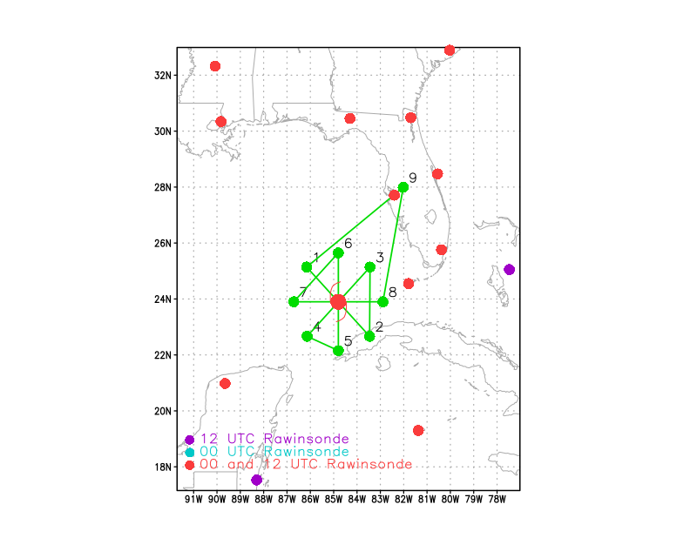
Expendable Distribution | Expendables:  - Load 40 Skyfora Streamsondes  - Load 2 A-Sized Wave Drifters (ASWDs) - see notes below  - Load 30 dropsondes - see notes below  - All dropsondes transmitted to the GTS in real time  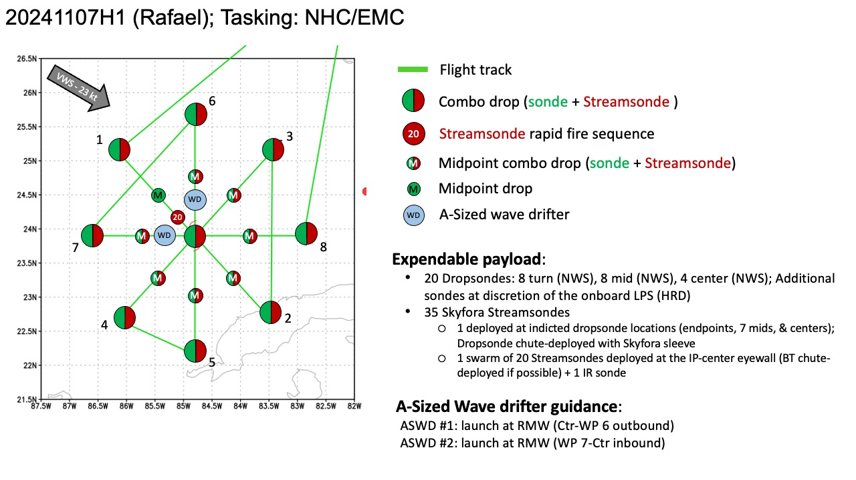
Preflight Weather Briefing | Rafael is on the southwest side of a low- to mid-level ridge over the western Atlantic and Florida. This ridge is forecast to build westward in response to  a developing deep-layer trough over the southwestern United States.  This evolution should cause the cyclone to continue moving westward across the Gulf of Mexico. The initial motion is 315/11. The global models suggest that the current shear should decrease in about 24 h, then increase again later in the forecast period.  Forecast for 07/1200Z: 24.4N 84.9W 85 KT  Previous P-3 mission:  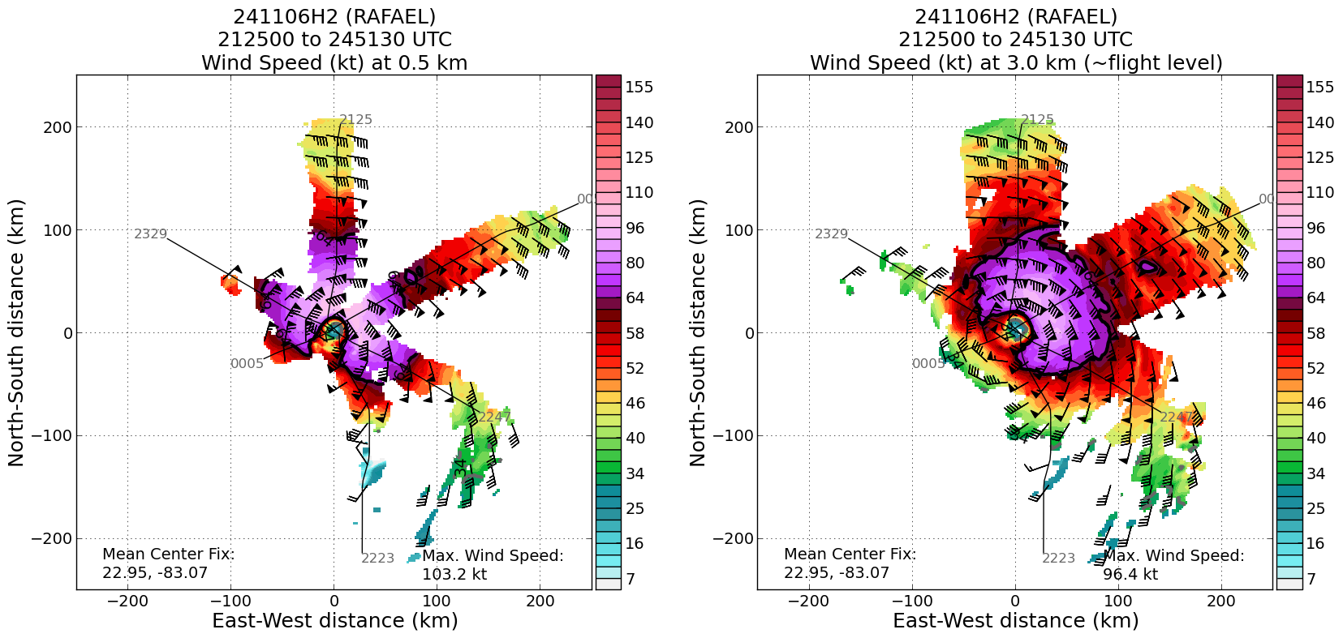  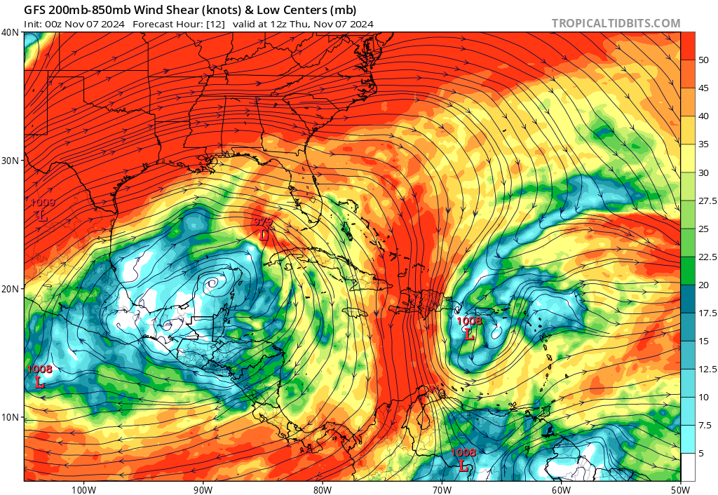
Instrument Notes | all instruments are nominal

IN-FLIGHT
Time [UTC] | Event
0829 | Take-off from KLAL
0836 | TDR up
0839 | SD-1057 @ 25.9205N, 85.81547W headed S at 3.5 kts  Wave Drift 1: 24.930N, 83.818W  Wave Drift 2: 24.754N, 85.062W  Wave Drift 3: 24.074N, 88.935W  Wave Drift 4: 24.301N, 89.338W
0851 | Targeting SD-1057 at IP. ETA 30 min
0900 | added drop for SD, about 30 n mi N of IP (charge to GOMO)
0911 | SD-1057 (5 min ago): 25.8835 N, 85.82362 W. headed S at ~4 kts. Wind 19 kts, gusting 22 kts, pressure: 1009.4 hPa, sig wave 1.9 m, SST 26.5C  N42 descending to 8000 ft altitude, 10 min out
0921 | Flyover of SD-1057, dropsonde 1, CH1, splash ~500 m from saildrone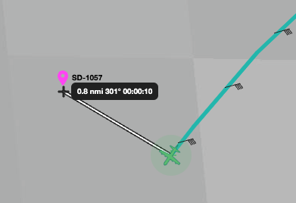  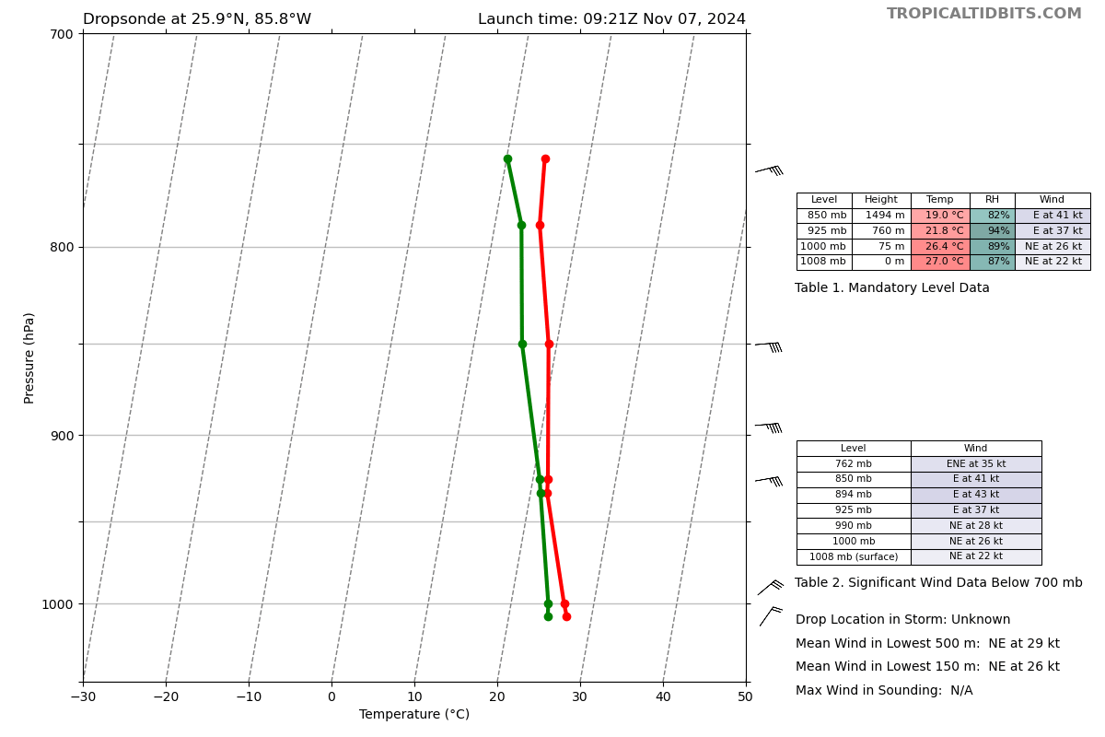
0927 | IP, start leg 1
0928 | Drop 2, CH2, IP1, streamsonde combo (successful streamsonde)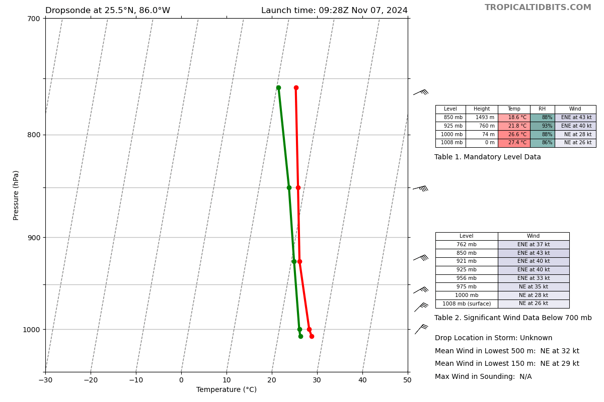
0940 | Drop 3, CH3, MP  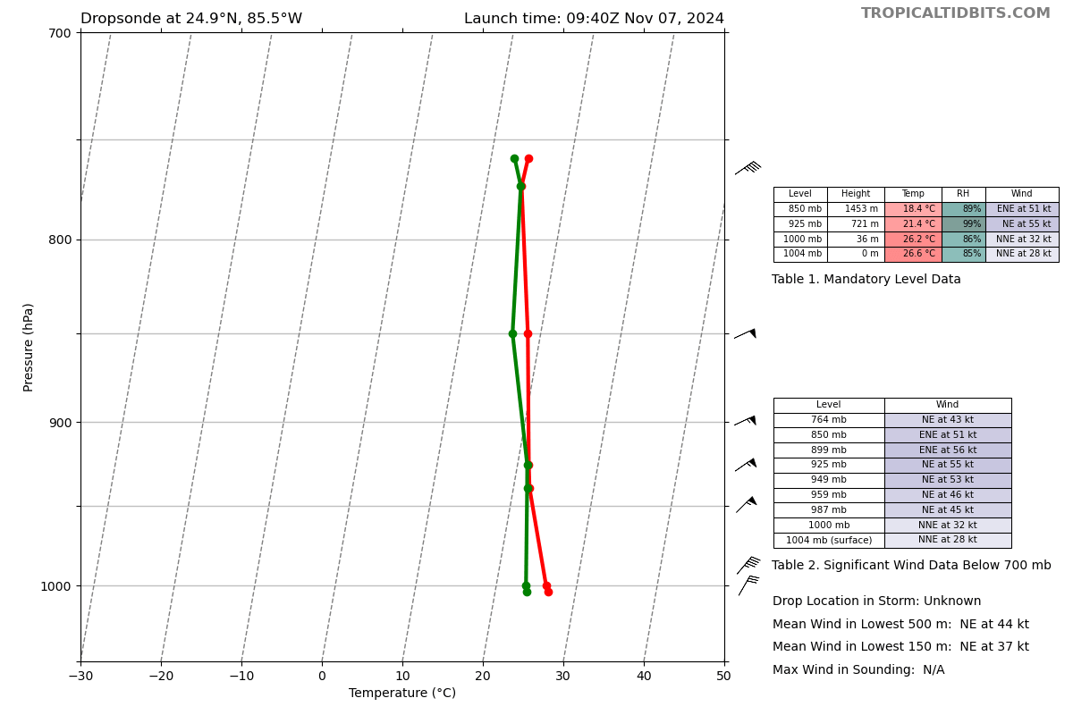
0945 | Orbiting to prep the 20 streamsondes for rapid fire. This took a long time and needs to be improved. It took two folks 15 min to get everything set and we needed to be out of any turbulence. Definitely a data point for future streamsonde swarm launches
1000 | Back on track to center
1009 | Drop 4, CH5, RMW, 20 streamsondes within 1 min, starting at 100850, dropsonde after streamsondes  IR sonde would not sync, so just a regular sonde  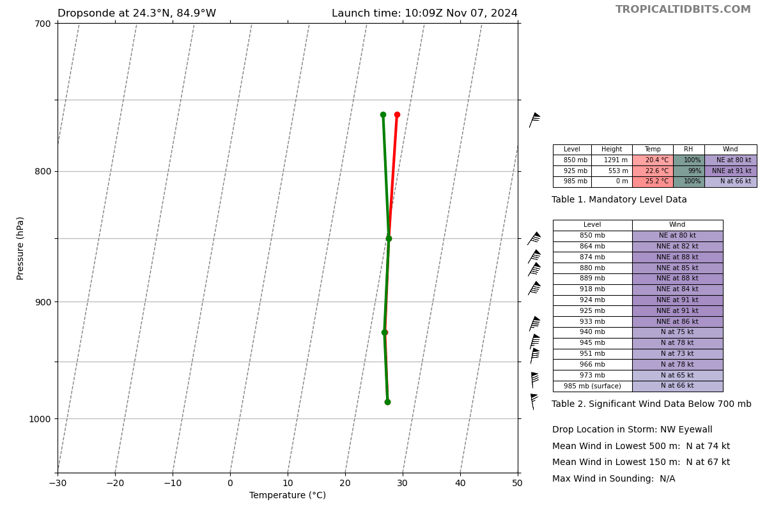
1013 | Drop 5, CH4, Center drop, intermittent lightning in N and E eyewall, however, GLM shows more lightening in the E eye wall  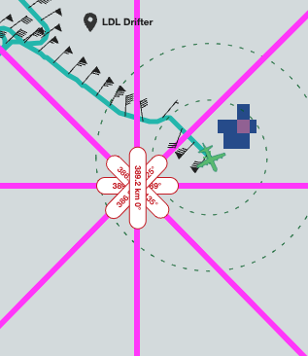  Center Drop @1013z: 24.26N 84.63W Sfc. pres. 971 mb, 10m wind 150/14kt.  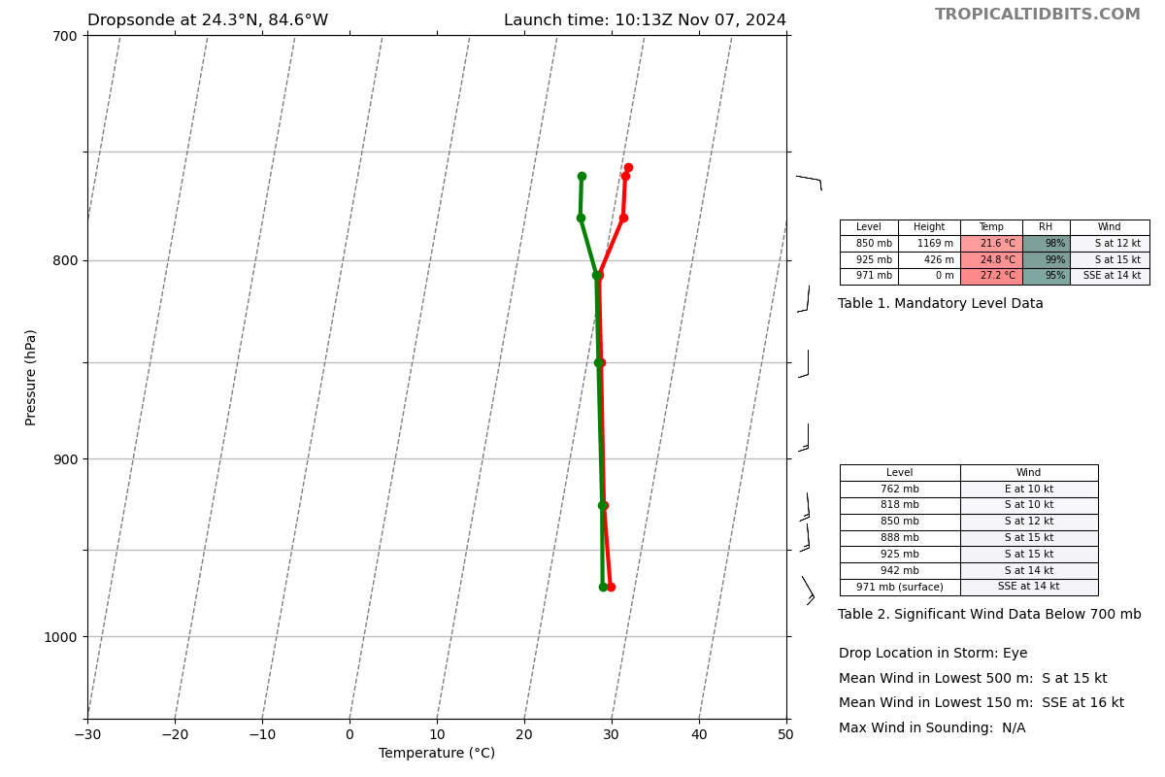
1026 | Drop 6, CH6, MP, streamsonde combo, entering major rainband  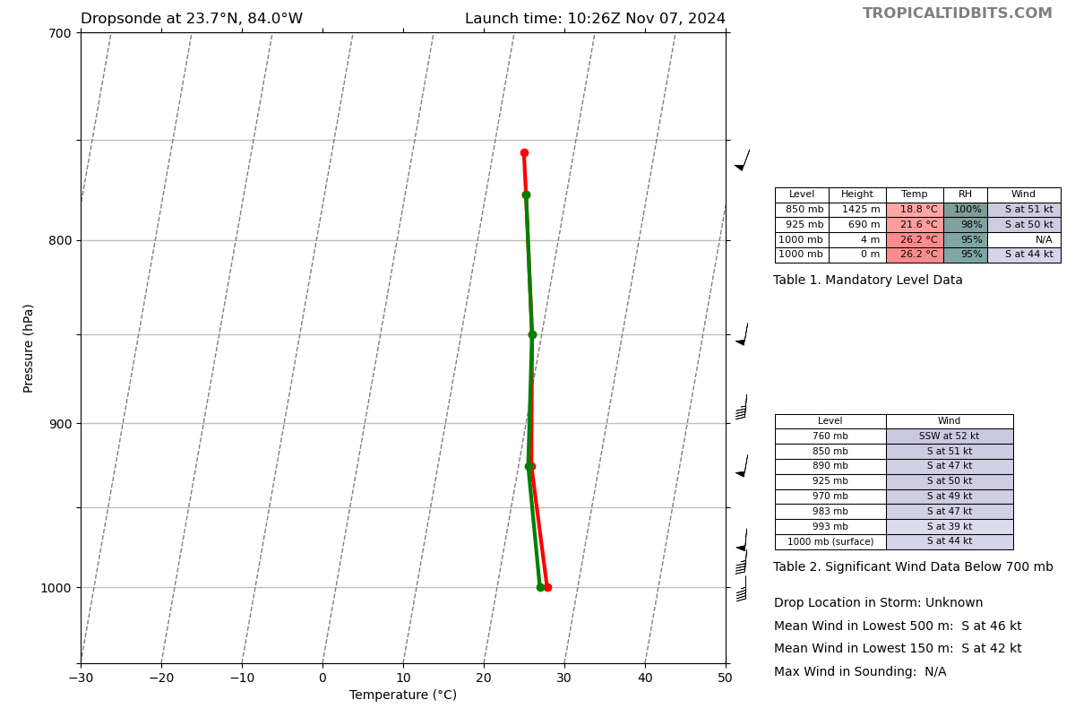
1029 | Getting some chop in outer rain band
1032 | Cutting leg short due to Cuba ADIZ; from flight “plenty of scatterers from here on until we get to the west side again.”
1036 | Drop 7, CH7, EP1, streamsonde combo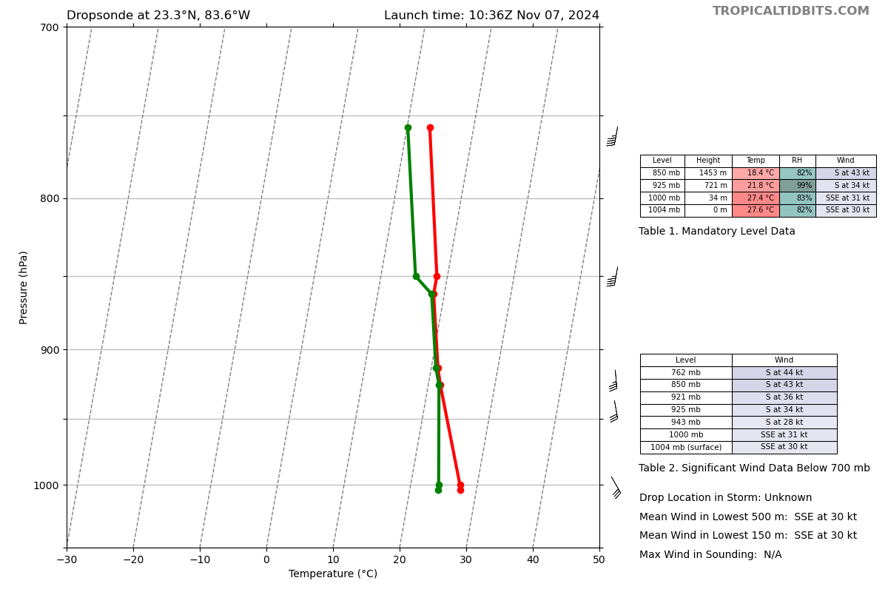
1039 | TDR job #1 started
1056 | TDR analysis #1 ended  Alt (km) Lat (deg) Lon (deg W)  0.5 99.99 99.99  2.0 24.22 84.68  3.0 24.29 84.64  6.0 24.38 84.54  2-6-km Vortex Tilt: 22.8 km at 38 deg  TDR shows “Far more substantial tilt than last night, I believe”, “tilted to the NE”  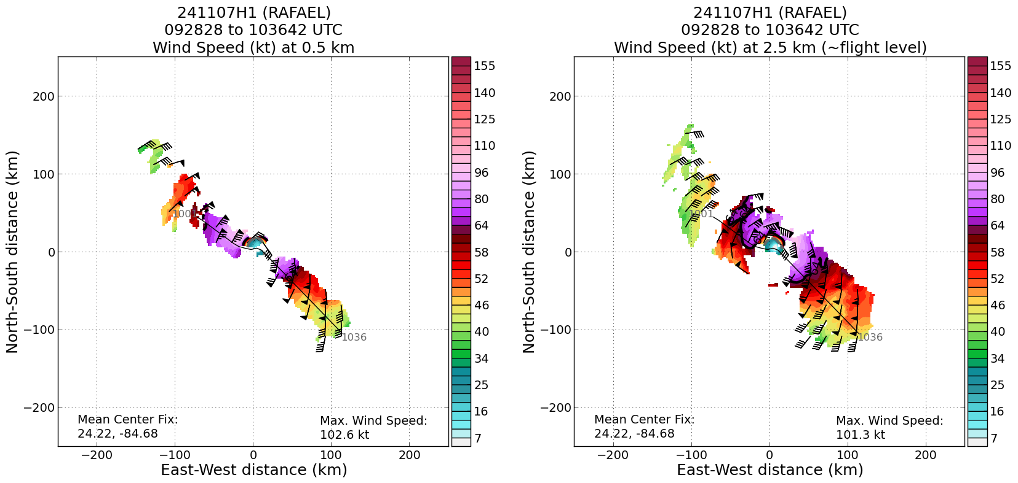  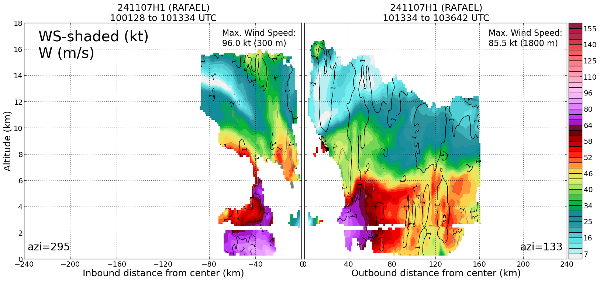
1106 | PT3, end downwind leg, turn TK 225
1108 | Drop 8, CH8, IP2, Combo drop 8 + streamsonde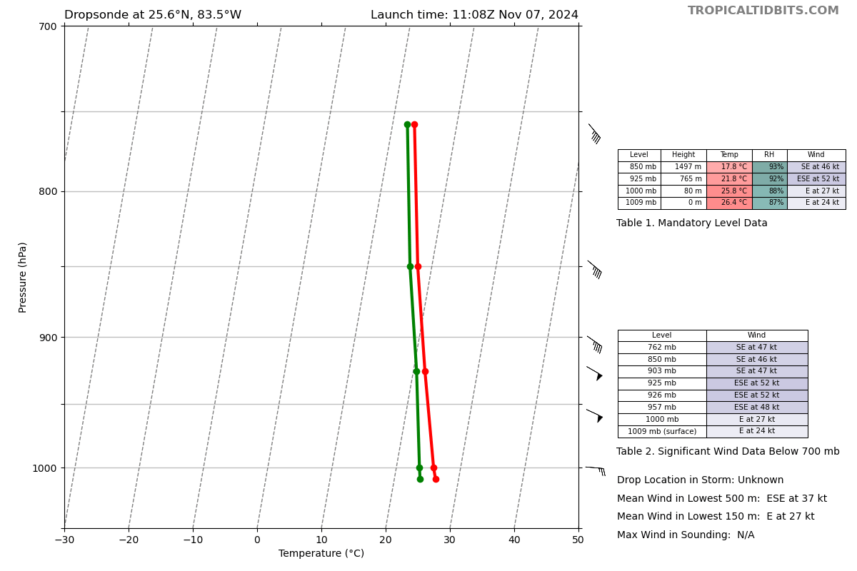
1110 | Flight back pressurized and doing the combos by dropping sonde then taking the sleeve out and dropping the stream sonde; takes 45-60 s to do the swap
1116 | In large stratiform rain area, not many bumps
1119 | Drop 9, CH1, MP, combo  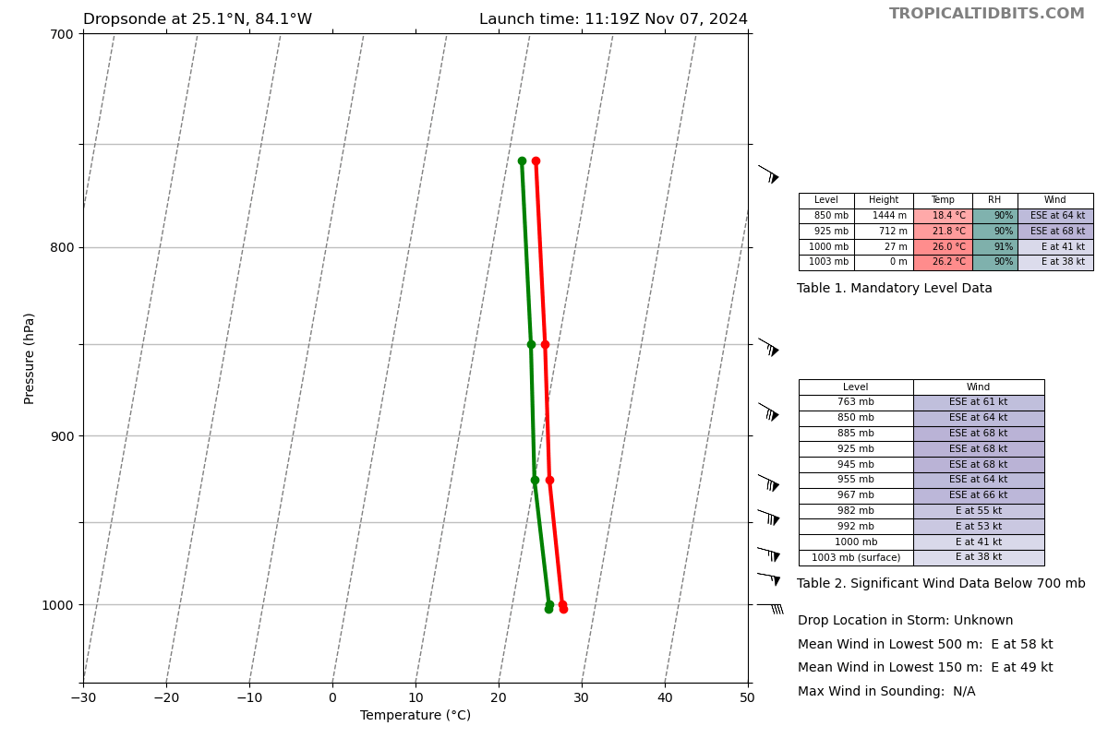
1123 | Based on W88D, 20 n mi from strongest convection in NE eye wall, 5 min out, a bit of chop in major rainband outside eye wall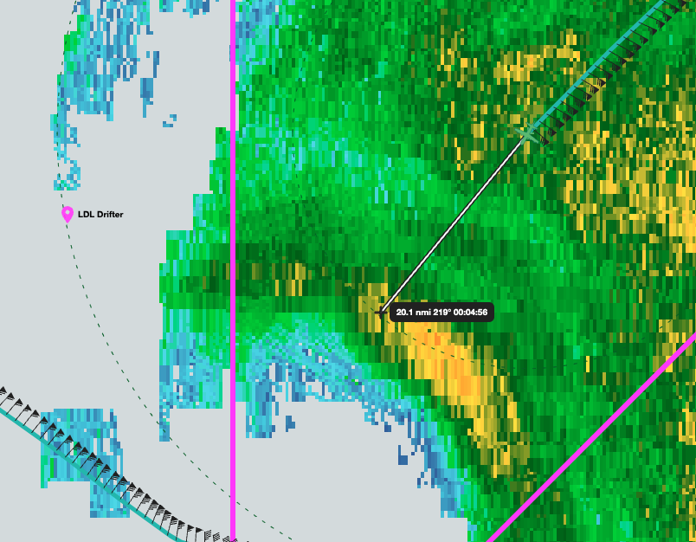
1131 | Entering eye, good bumps in eye wall, Lev noticed peak FL winds of ~90 kts (48 m/s), not hunting the eye; next TDR will show NE eye wall
1134 | Drop 10, CH2, Center combo drop with streamsonde  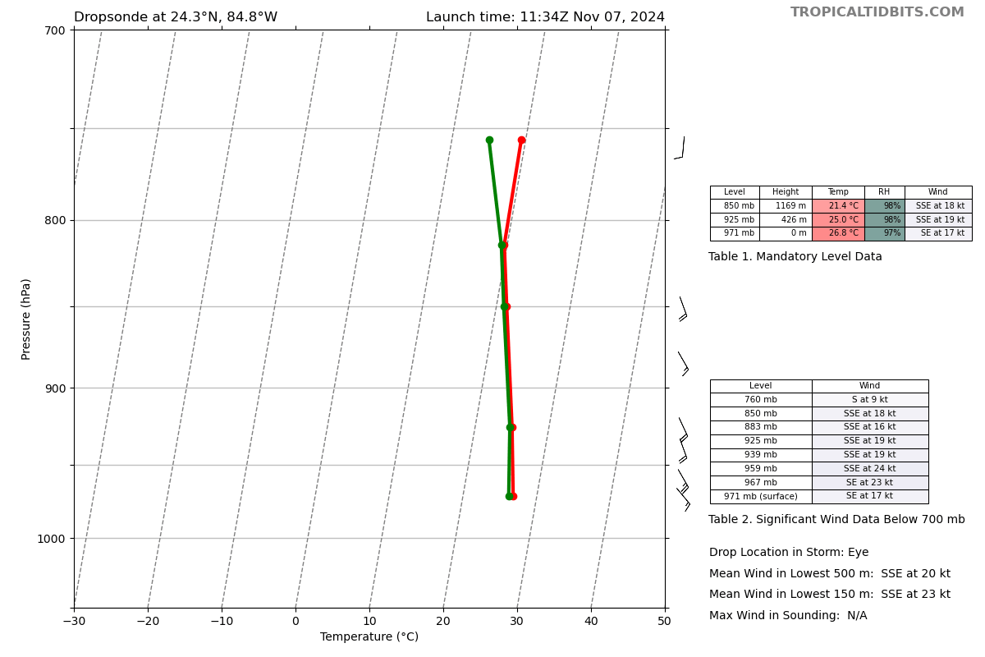
1136 | From flight: SW side of the storm is totally ope at altitude, big anvil overhead
1146 | Drop 11, CH3, MP  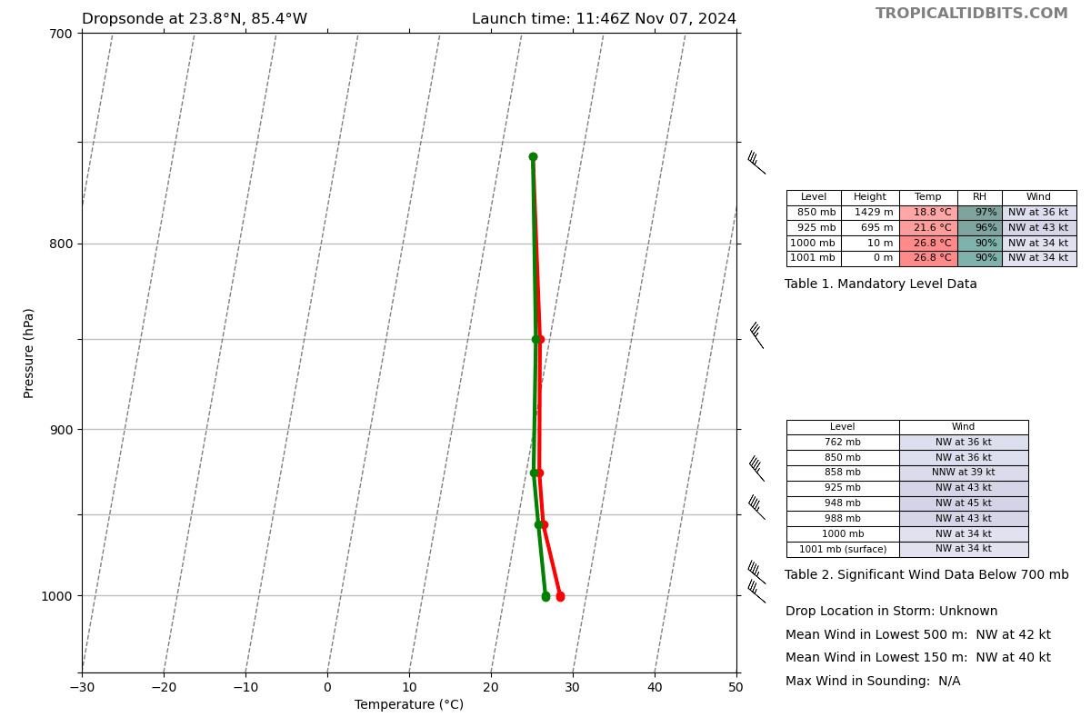
1155 | Ended TDR leg early
1159 | Drop 12, CH4, EP2 (WP4), combo drop with streamsonde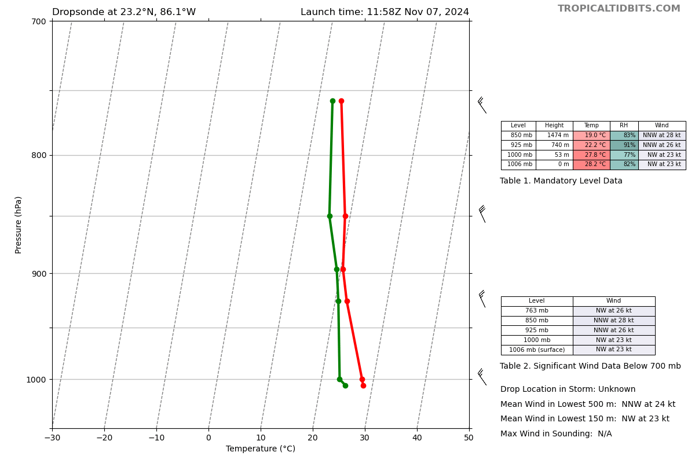
1212 | From Lev: “looks like yall may be deploying the ADWSD nearish a pre-existing one (not a bad thing necessarily at all). WD1 @ 24.720N, 85.067W...sig waves at 7.6 m”  WD2 @ 25.724N 85.183W could be nearish WP6.  SD-1057 has picked up its speed (and winds), moving nearly 4-6 kts...located at 25.68038 N, 85.84936W”
1215 | Drop 13, CH5, IP3 (WP5) combo with streamsonde  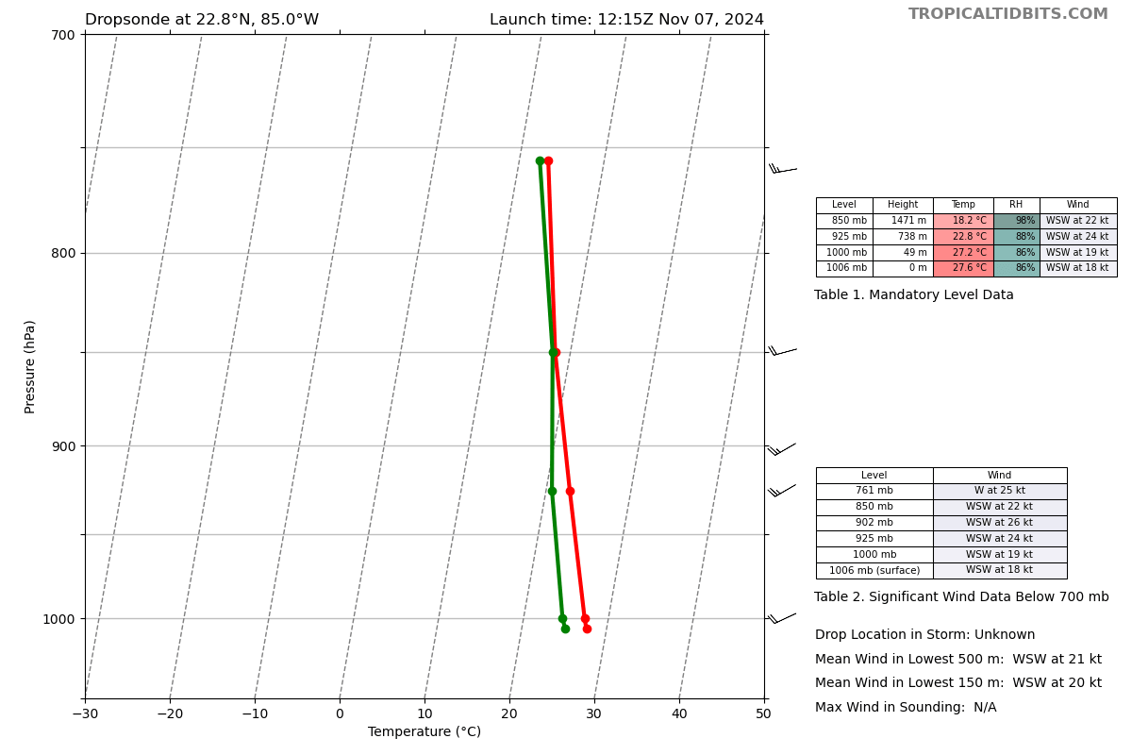
1215 | TDR Job 2 finished  TDR center info from 241107H1_1134_xy.nc:  Alt (km) Lat (deg) Lon (deg W)  0.5 24.35 84.83  2.0 24.35 84.85  3.0 24.36 84.83  6.0 24.44 84.77  2-6-km Vortex Tilt: 12.8 km at 39 deg  From Paul Reasor: “could be data coverage issues at play here ... not sure the tilt actually reduced by 10 km…”  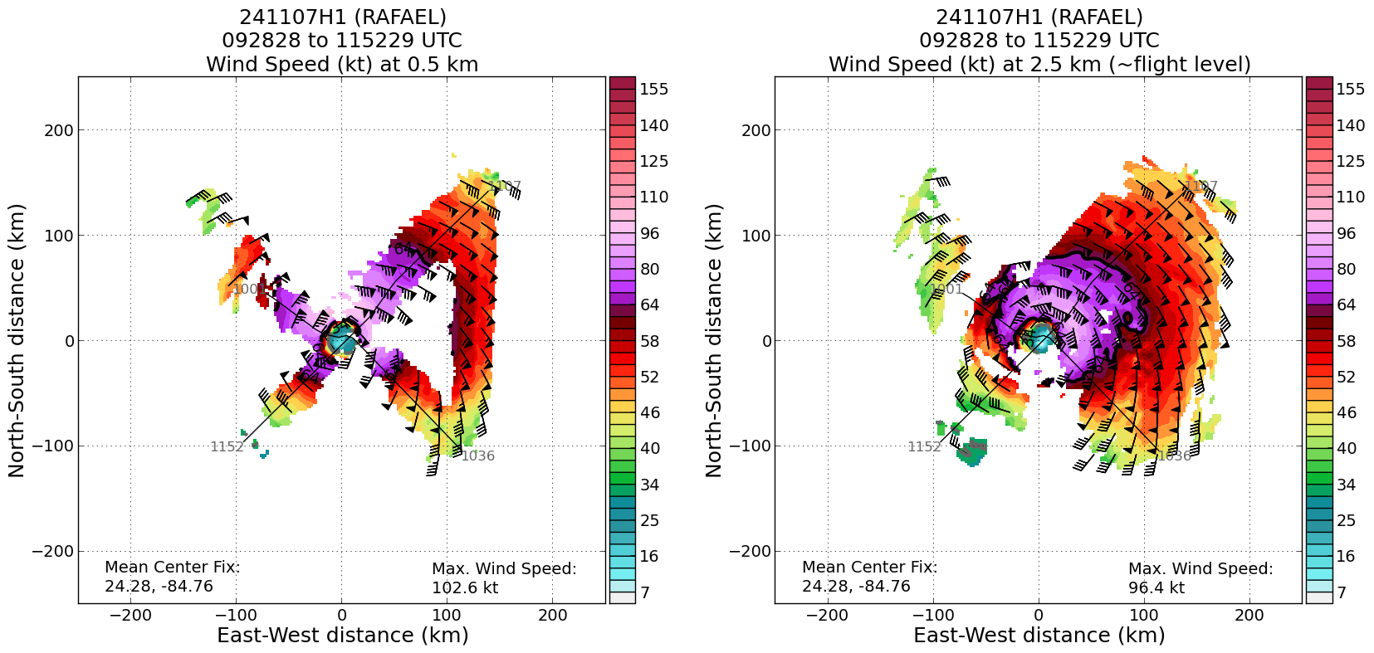  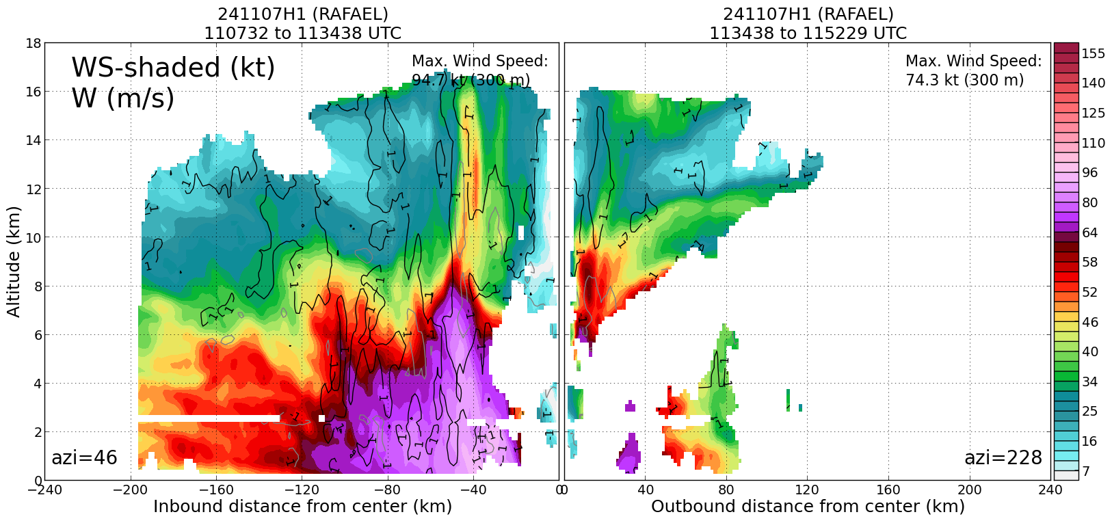
1227 | Drop 14, CH6, MP with streamsonde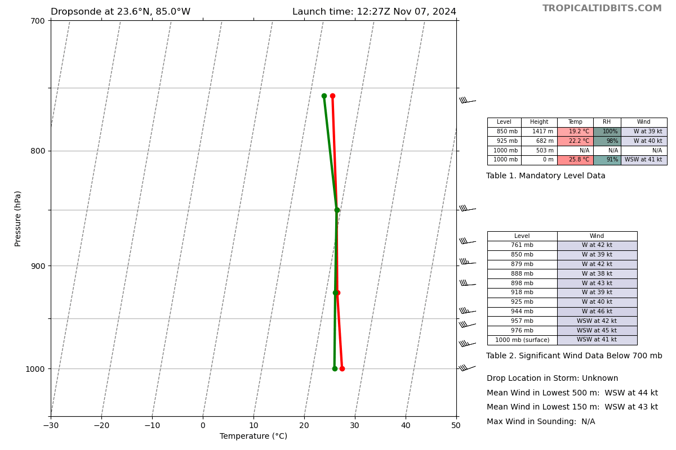
1231 | Wave drifter near outbound RMW has sig wave of 8.25 m. 24.699N, 85.077W.  WD at outbound EP (25.733N, 85.205W) has sig wave of 4.2 m
1232 | From Paul re: Radar:  Looking at the swaths, I do think a better sampling along the tilt vector on that second pass yielded a more robust result ... I'll have to talk to Michael about what he thinks of the first-pass estimate  Both showed a tilt to the NE, so that's consistent ... but whether there was an alignment of 10 km in 1 h...  (in 25-kt shear)
1234 | From flight: “entering eye from south open to the north eyewall”; “E and N eyewall have scalloped appearance on radar, suggesting blow ups in the east eyewall that roll around to the north as they dump there precip”
1238 | Drop 15, CH7, CP3, center with streamsondes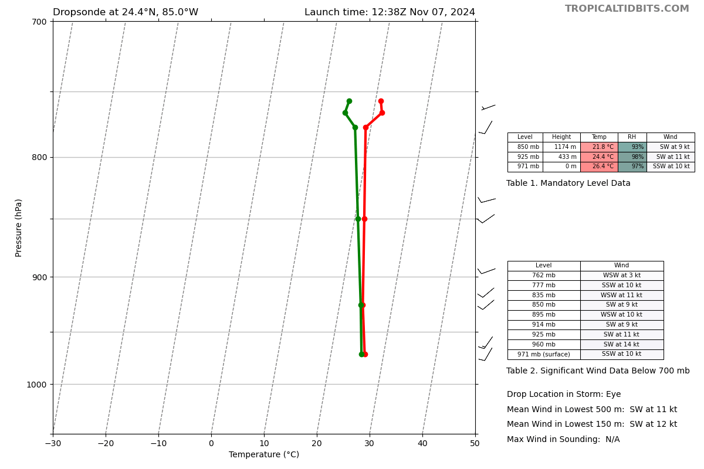
1252 | Drop 16, CH8, MP, with streamsonde (34th streamsonde)  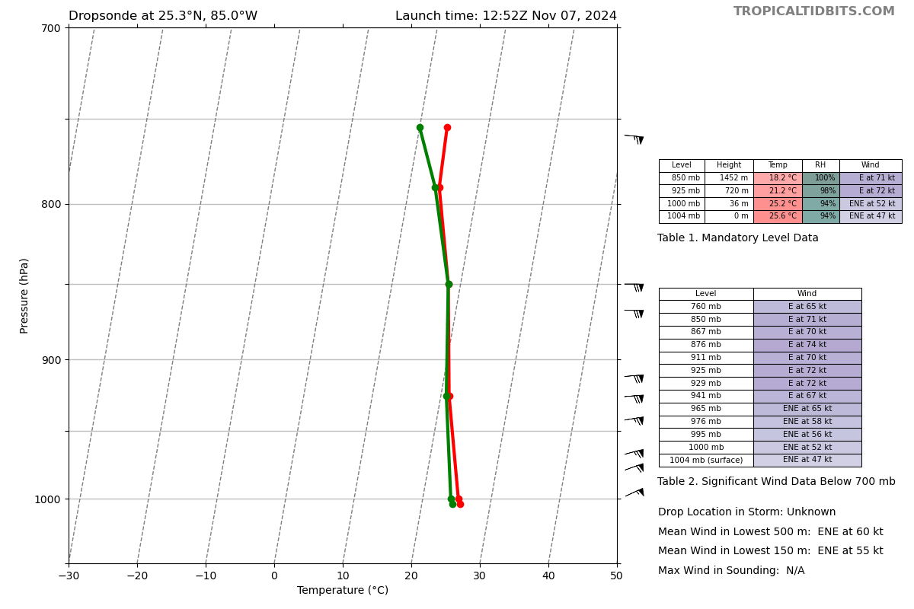
1303 | Drop 17, CH1, EP3, with streamsonde; end leg at WP6,  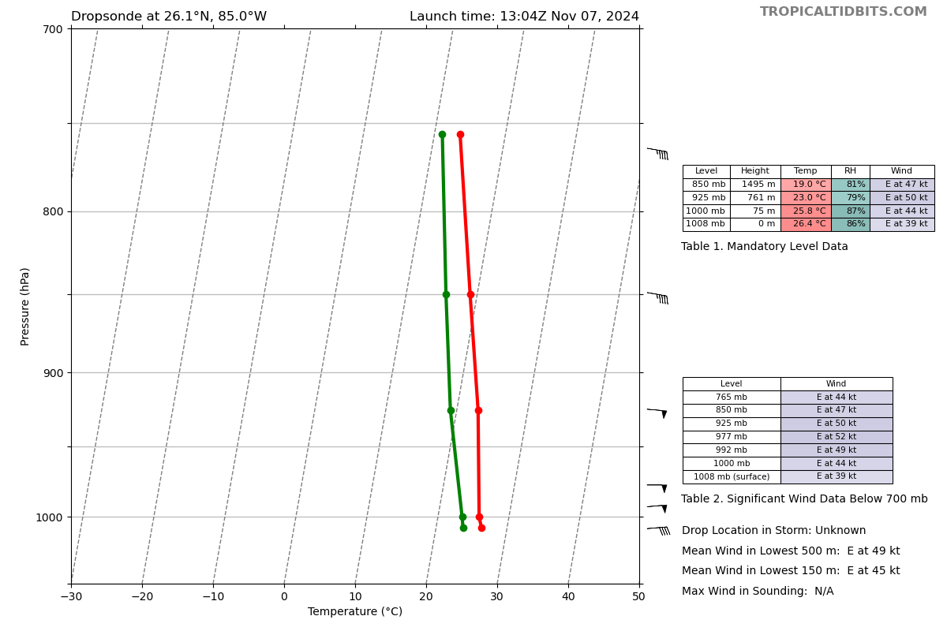
1305 | SD-1057 @ 25.60643 N, 85.85763 W; winds between 20-30 kts, gusting 30-40 kts; pressure 1008.5; Air Temp 26.4C, SST 27.1C, sig wave 4.7 m
1308 | Start 3rd TDR Analysis
1317 | Drop 18, CH2, saildrone overflight (looked extremely close)  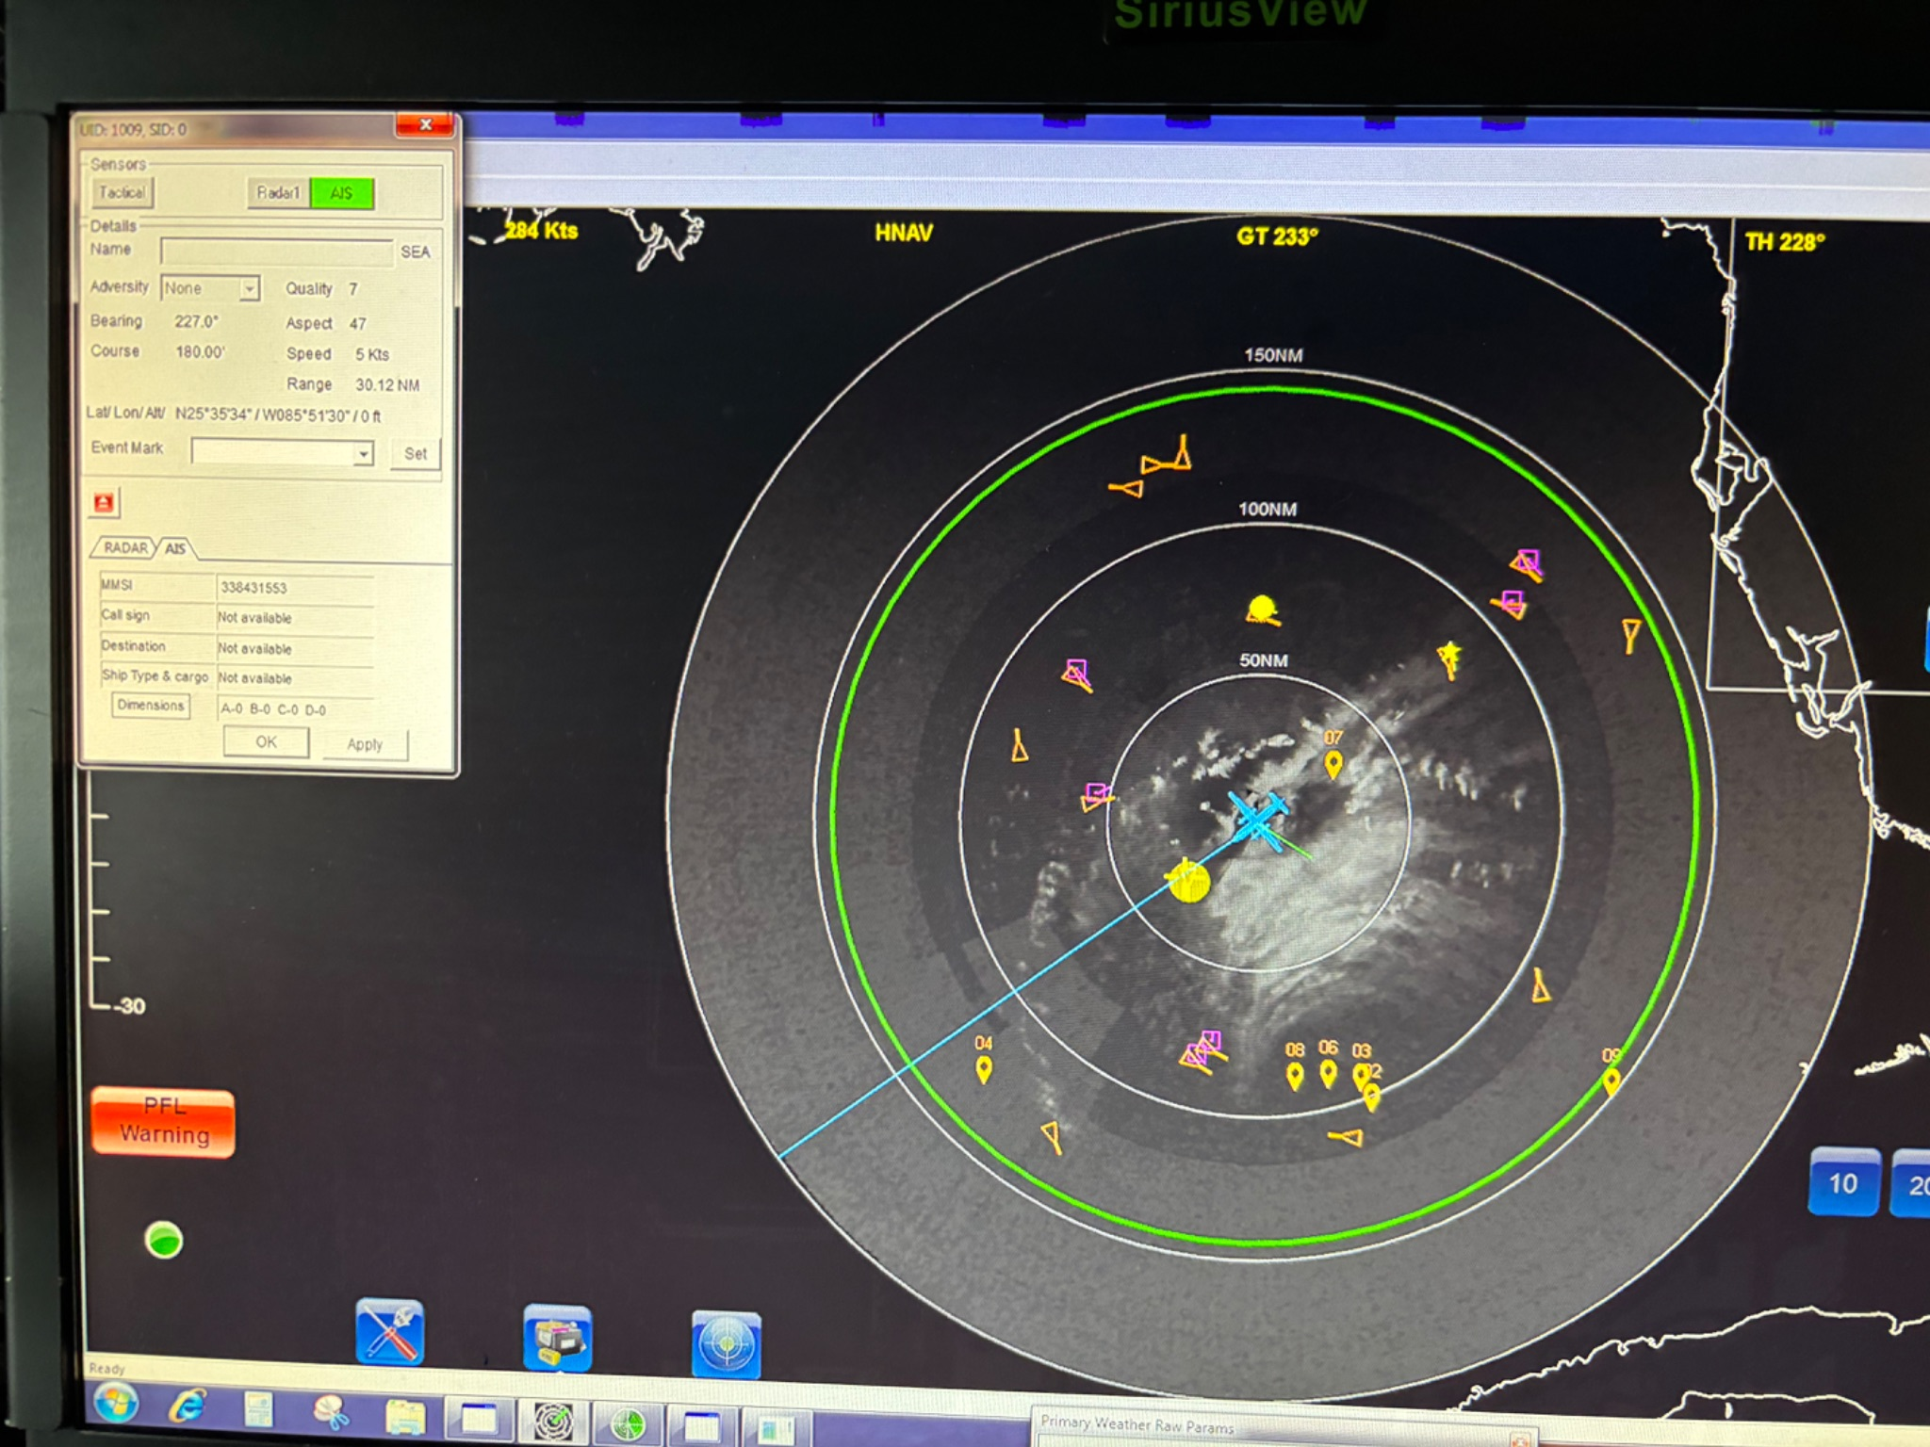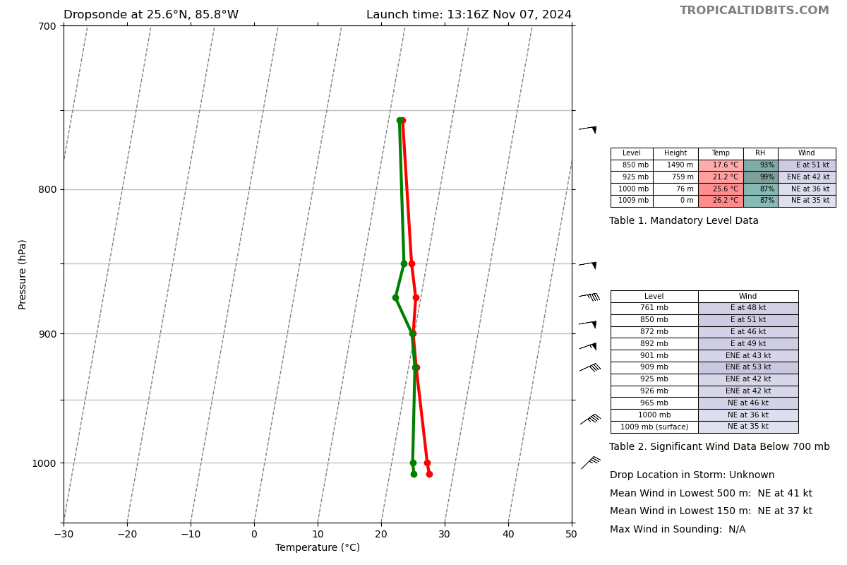
1325 | TDR Analysis #3 finished  TDR center info from 241107H1_1238_xy.nc:  Alt (km) Lat (deg) Lon (deg W)  0.5 24.38 84.95  2.0 24.40 84.97  3.0 24.42 84.97  6.0 24.45 84.89  2-6-km Vortex Tilt: 10.0 km at 53 deg  From Paul Reasor: “I'm thinking 10-12 km tilt is the true value…:  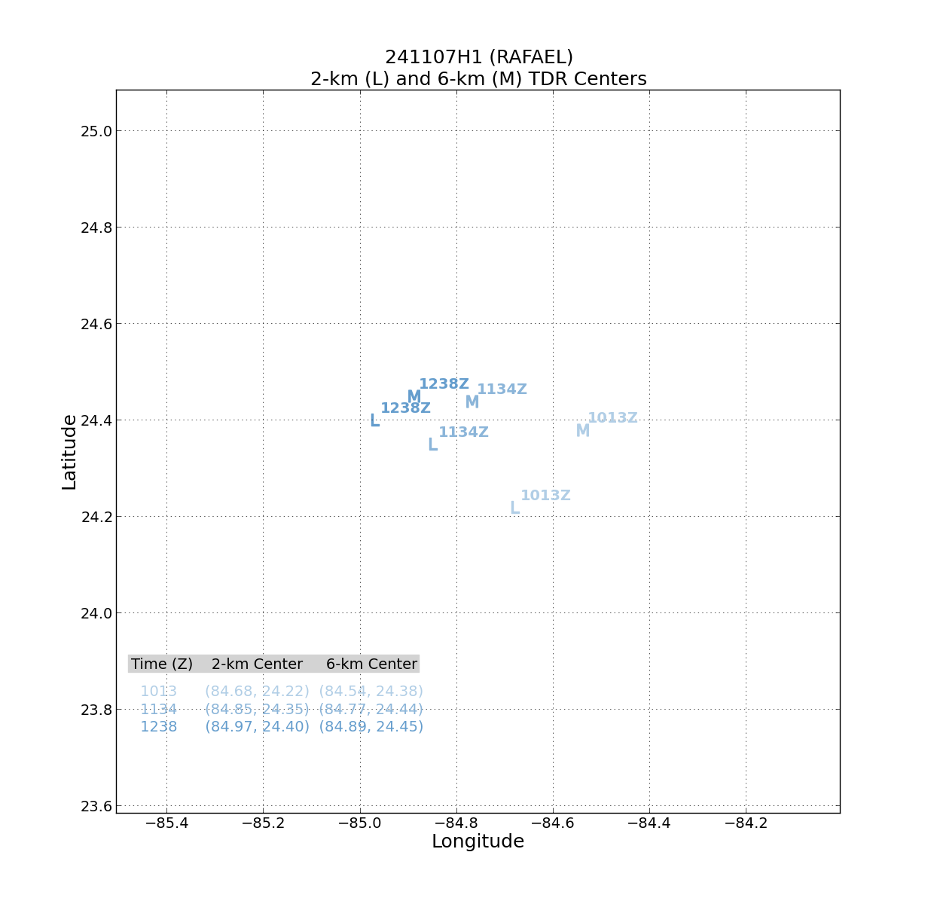  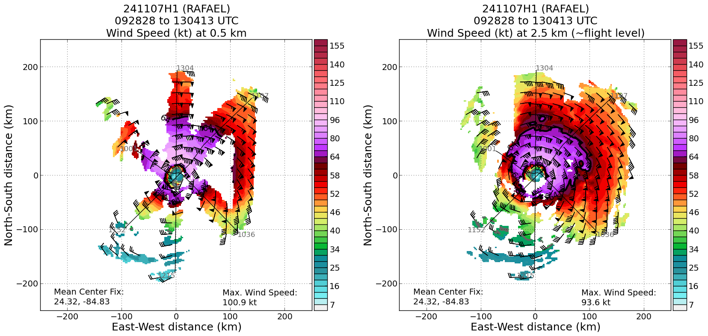  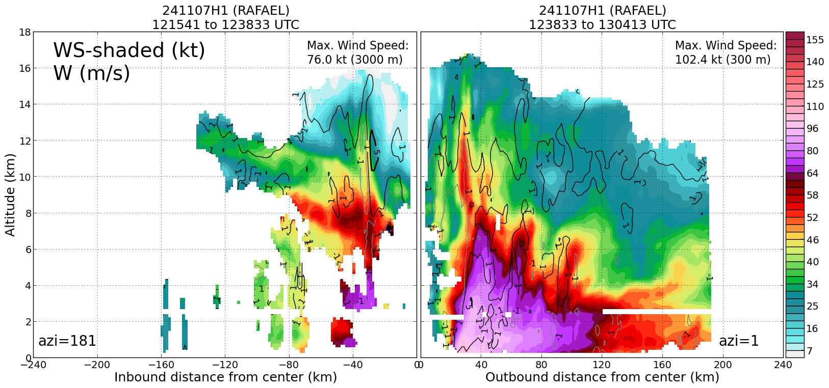
1329 | From Flight: “we are going to sample this squall line 100 n mi W of the center. Could this be a diurnal pulse?” (Jason D. confirmed),” I asked them to cross it twice to get TDR and dropsonde on the w side of it”  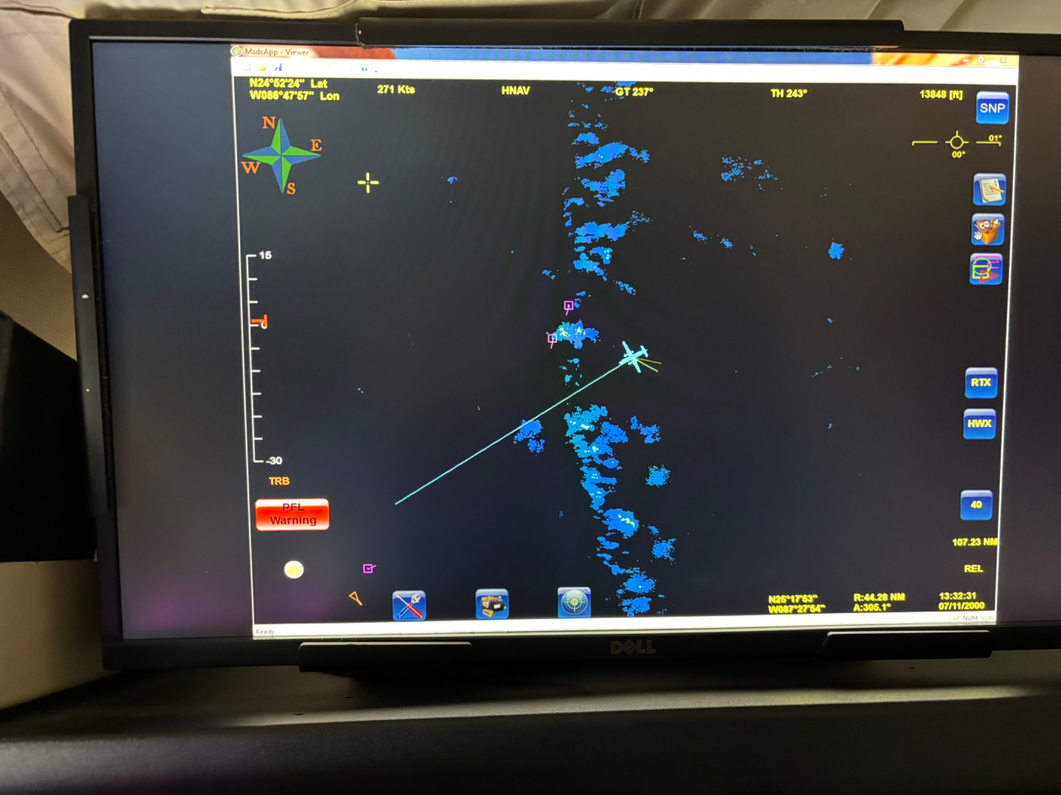
1338 | TC diurnal pulse moving out from the inner core (yellow to red ring) and is right on the diurnal clock- currently located at R~200 km (108 NM) at 1220z (~6a LT).  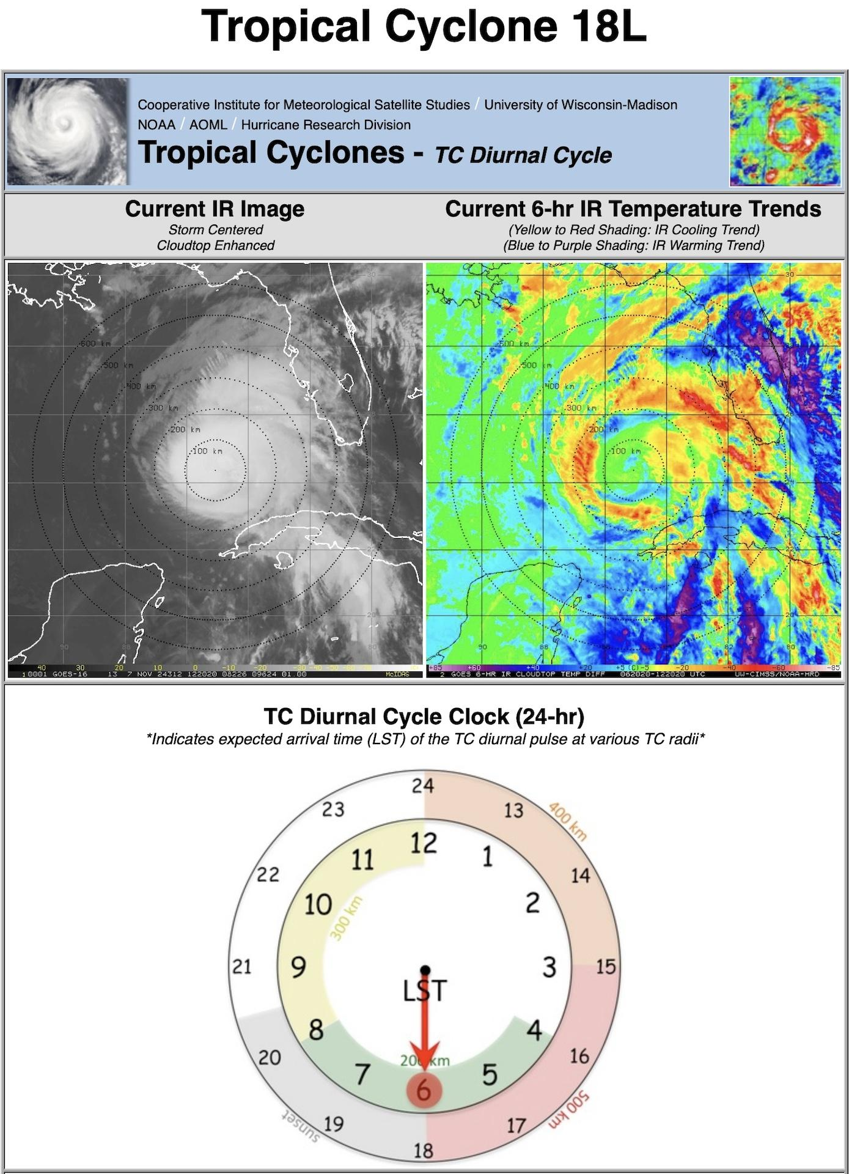
1341 | Drop 19, CH3, IP4, combo drop with streamsonde on west side of band  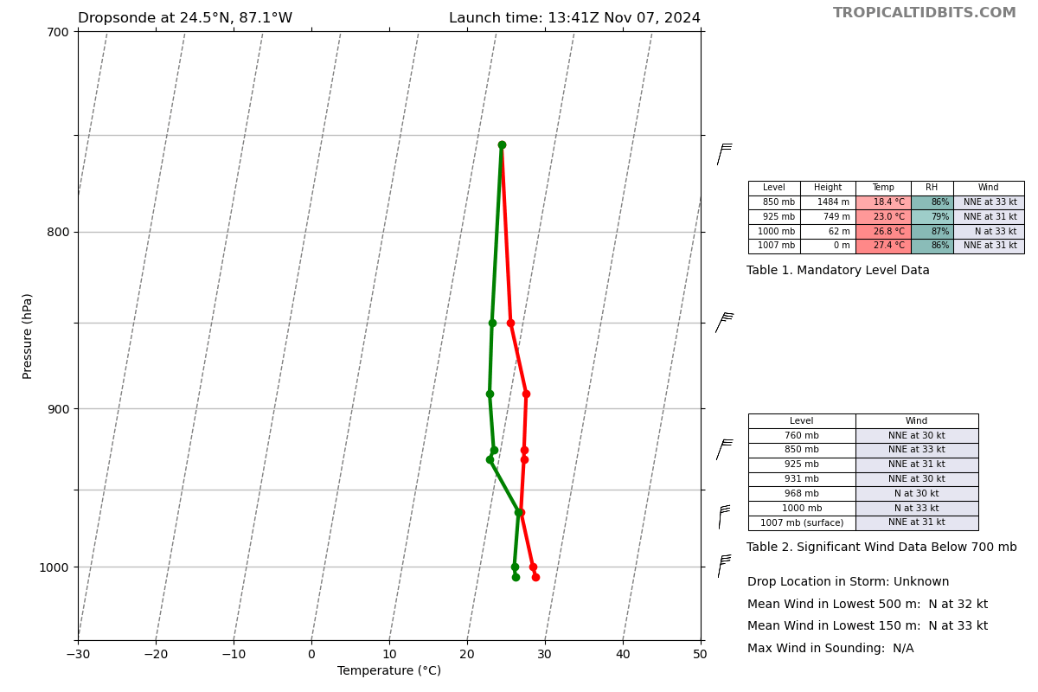
1355 | Drop 20, CH4, MP, combo with streamsonde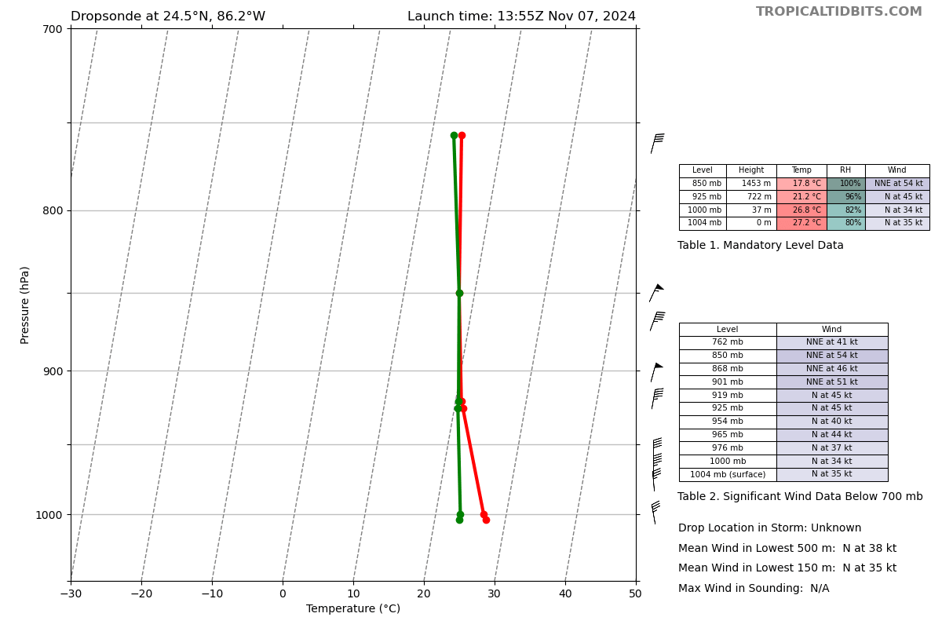
1402 | Wave drifter deployed just outside RMW in eyewall  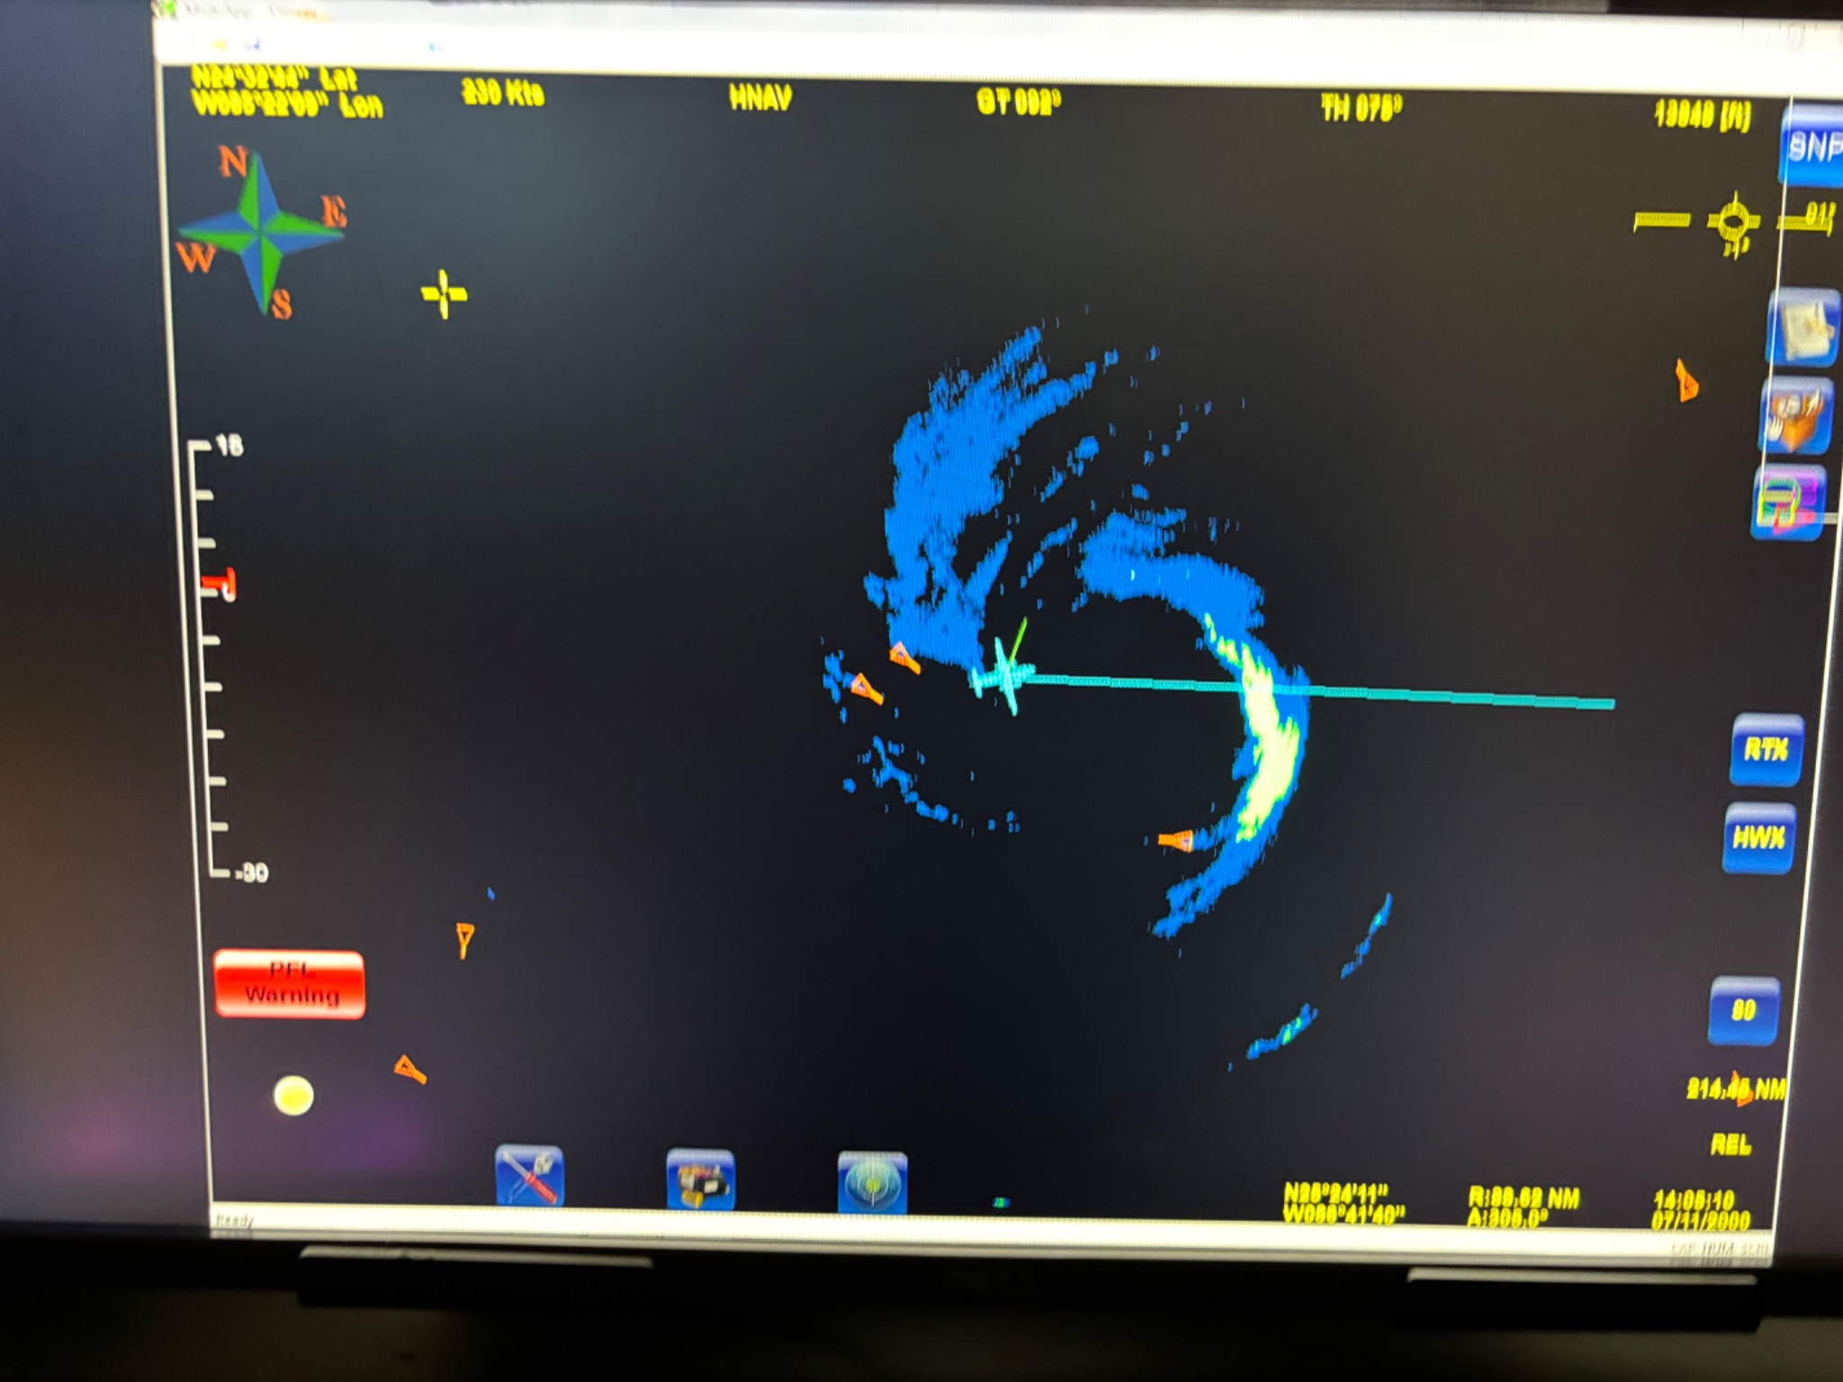
1405 | Looks like headed straight into big cell in east eyewall 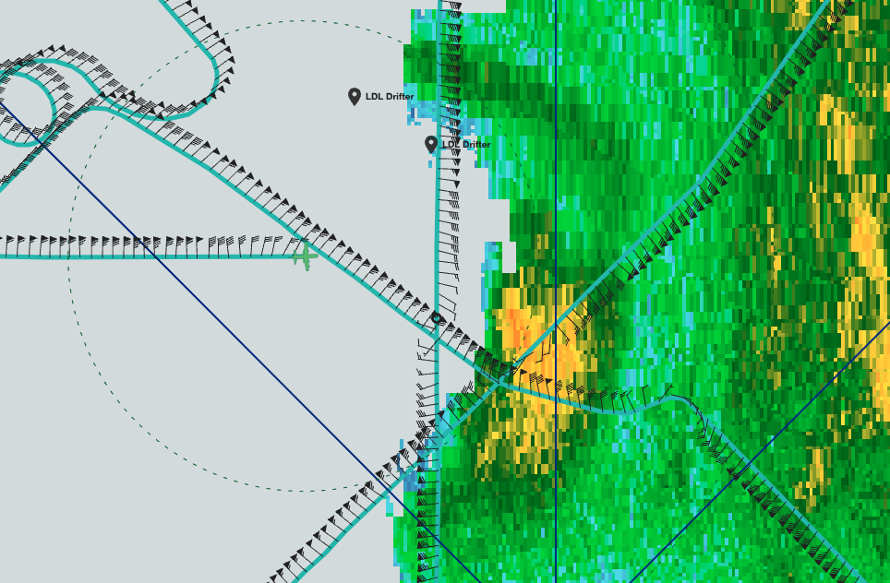  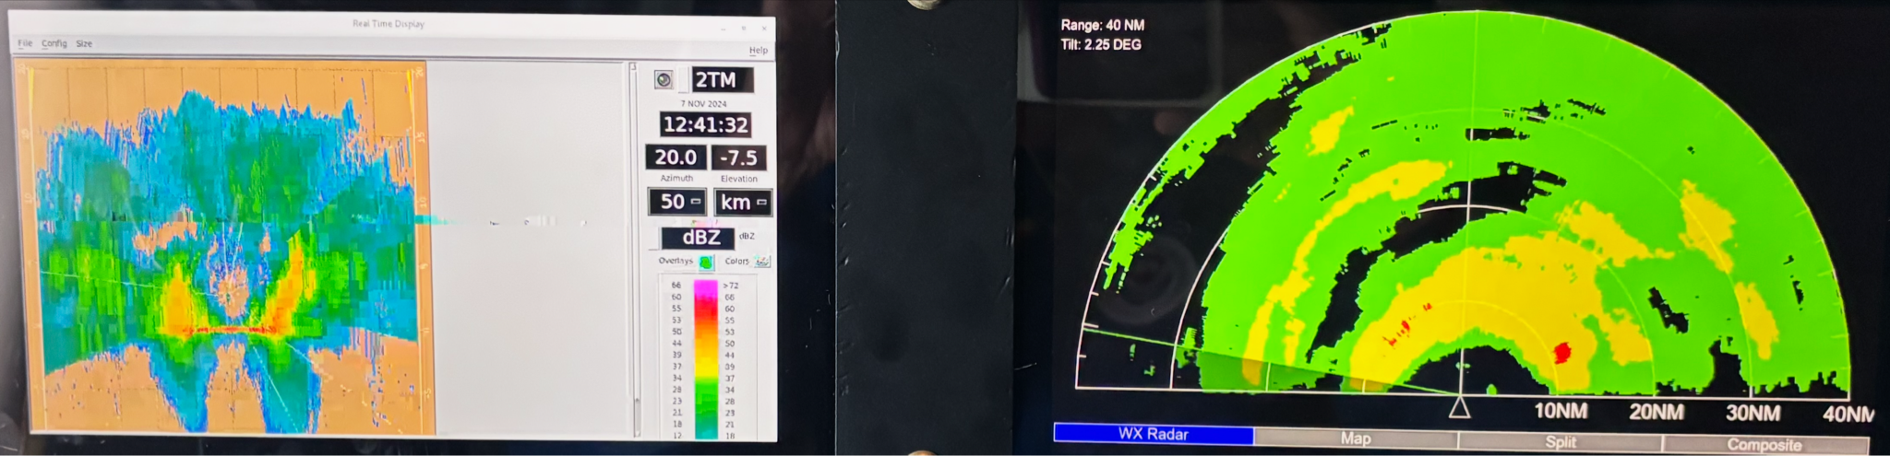
1409 | Drop 21, CH5, CP4, center drop with streamsonde  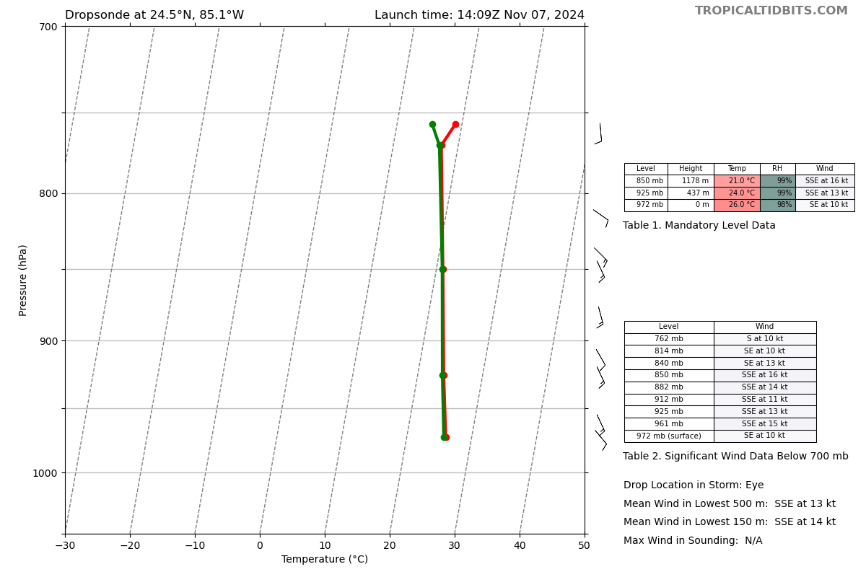
1420 | From flight: “in the bumps in major rainband E of center very heavy stratiform rain with embedded cells”
1422 | Drop 22, CH6, MP with streamsonde  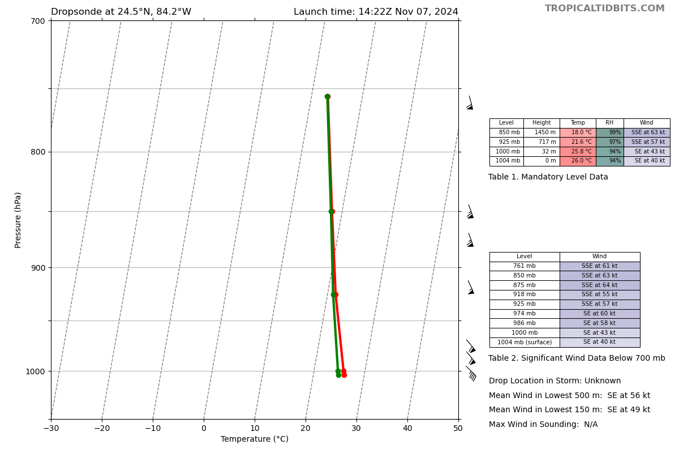
1436 | Drop 23, CH7, EP4, combo drop with streamsonde, end pattern and science  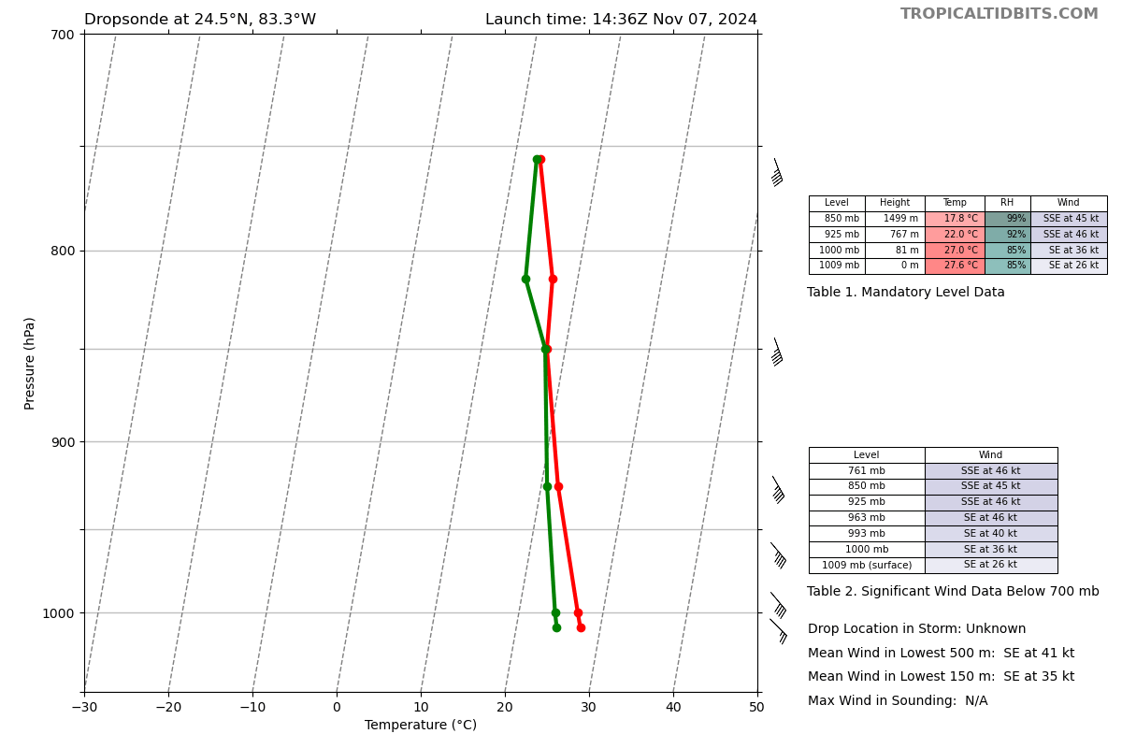
1440 | From flight: total 23 drops and 23 transmitted, deployed 40 streamsondes and 2 WDs; Will be 4 TDR analyses and 4 transmitted to NHC and EMC
1502 | TDR center info from 241107H1_1409_xy.nc:  Alt (km) Lat (deg) Lon (deg W)  0.5 24.41 85.13  2.0 24.42 85.17  3.0 24.48 85.17  6.0 24.53 85.09  2-6-km Vortex Tilt: 14.4 km at 34 deg  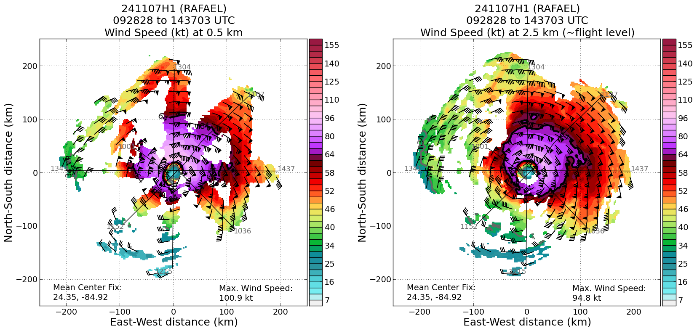  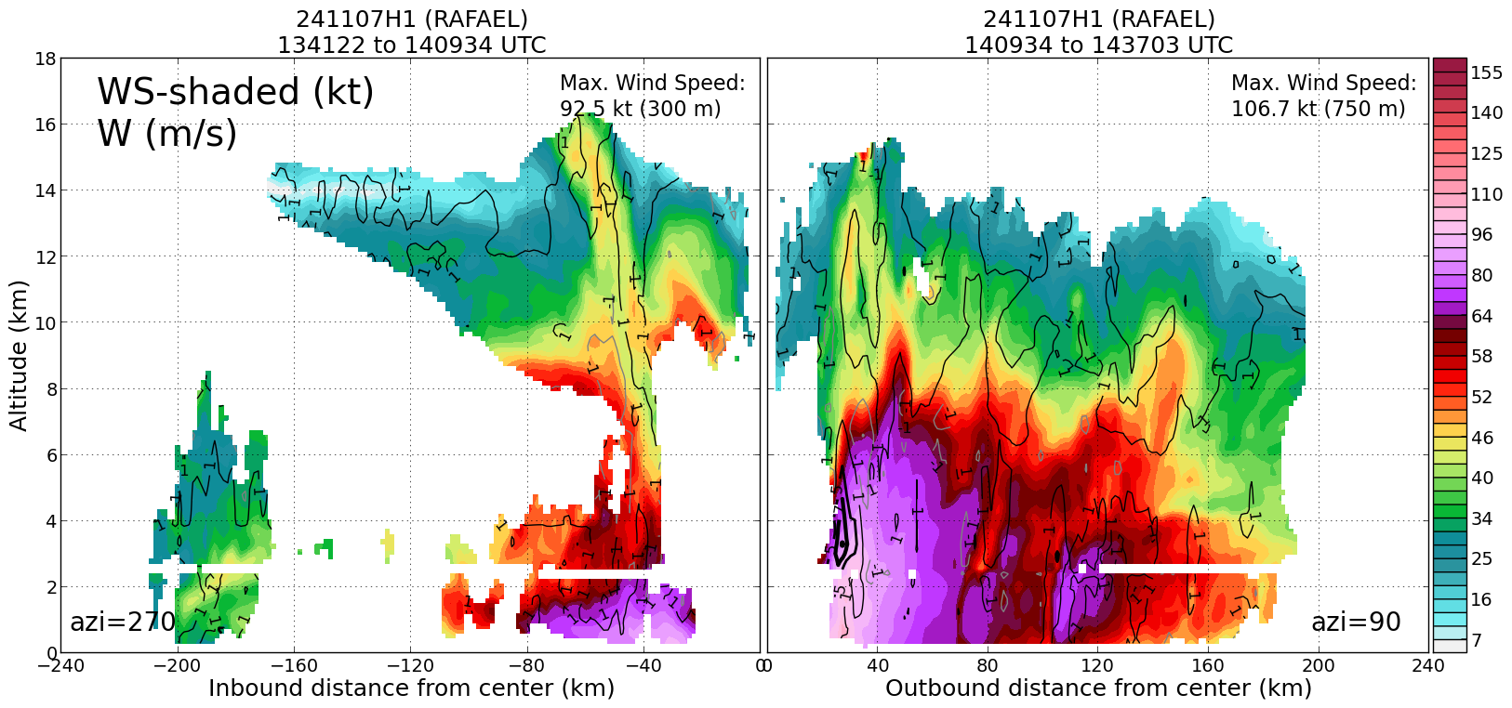

POST-FLIGHT
Mission Summary | This mission was a successful mission into category 2 Hurricane Rafael. Increasing shear following landfall over Cuba has led to some additional weakening. The south and southwest regions around the eye were clear of convection. A rotated figure-4 pattern was flown. A swarm of 20 streamsondes was deployed in the NW RMW within 1 minute. Data was transmitted from all 20 of them. Additionally, 2 A-size wave drifters were deployed, both returning data. In total, 23 dropsondes were deployed, all transmitted. 2 of the sondes were deployed over a saildrone. 40 streamsondes in total were deployed (20 in the swarm, the rest paired with the regular sondes).  During the flight, the storm started to slow down and turn to the west. A strong diurnal pulse was noticed W of the center. The aircraft flew through it, deploying a sonde. When flying through the E eye wall, there was some bubbling convection, but flight was smooth. However, there was evidence of stronger updraft to the S of track.
Actual Standard Pattern Flown | Rotated Figure-4
APHEX Experiments / Modules Flown | CHAOS, NESDIS Ocean Winds, RICO SUAVE
Plain Language Summary | - Successful flight with 2 wave drifter deployments ahead of the storm; 40 streamsonde deployments, and 2 saildrone overflights  - A swarm of 20 streamsondes was deployed within 1 minute  - The storm and eye was open to the south and southwest of center
Instrument Notes | From Frank Marks: I asked the AVAPS operator to provide feedback on how we can do better preparing streamsondes for the swarm release. He and Kim were like one armed paper hangers unpacking them and initializing them before the swarm release. That took 15 min this time. We need to develop a procedure or a place to stack them for initialization before we hit the IP.  AVAPS operator noted that they did not notice much noise around the sonde frequencies that were closest to the streamsonde frequencies.
Final Mission Track | 