MISSION PLAN
FLIGHT ID | 20241106H2 | STORM | AL18 / Rafael
MISSION ID | 1418A | TAIL NUMBER | NOAA-42
TASKING | NHC/EMC TDR | PLANNED PATTERN | Butterfly
MISSION SUMMARY
TAKEOFF [UTC] | 2037 | LANDING [UTC] | 0143
TAKEOFF LOCATION | Lakeland | LANDING LOCATION | Lakeland
FLIGHT TIME | Fractional hr, Takeoff to Landing Time | BLOCK TIME | Get from onboard LPS or Flight Director
TOTAL REAL-TIME RADAR ANALYSES  (Transmitted) | 3 (3) | TOTAL DROPSONDES Deployed (Tx to GTS) | 11 (11)
OCEAN EXPENDABLES deployed (good) | N/A | sUAS (Type) | N/A
APHEX EXPERIMENTS / MODULES | N/A
HRD CREW MANIFEST
LPS ONBOARD | Aberson | LPS GROUND | None
TDR ONBOARD | Aberson | TDR GROUND | Gamache
ASPEN ONBOARD | N/A | ASPEN GROUND | AOC FD (DeSolo)
NESDIS SCIENTISTS
GUESTS (Affiliation) | Pizzini (UM/RSMAS), Sans Souci (AOC)
AOC CREW MANIFEST
PILOTS | Keith, Ellis, Taraboletti
NAVIGATOR | Meier
FLIGHT ENGINEERS | Tyson, Wysinger
FLIGHT DIRECTOR | Englert, Zawislak
DATA TECHNICIAN | MacAllister
AVAPS | Vargas, Dykeman

PRE-FLIGHT
Flight Plan | [Insert image of submitted flight pattern here]  [Insert image of ONR/TCRI detailed pattern image, if available]  [If you want, briefly describe the pattern in words]
Expendable Distribution | 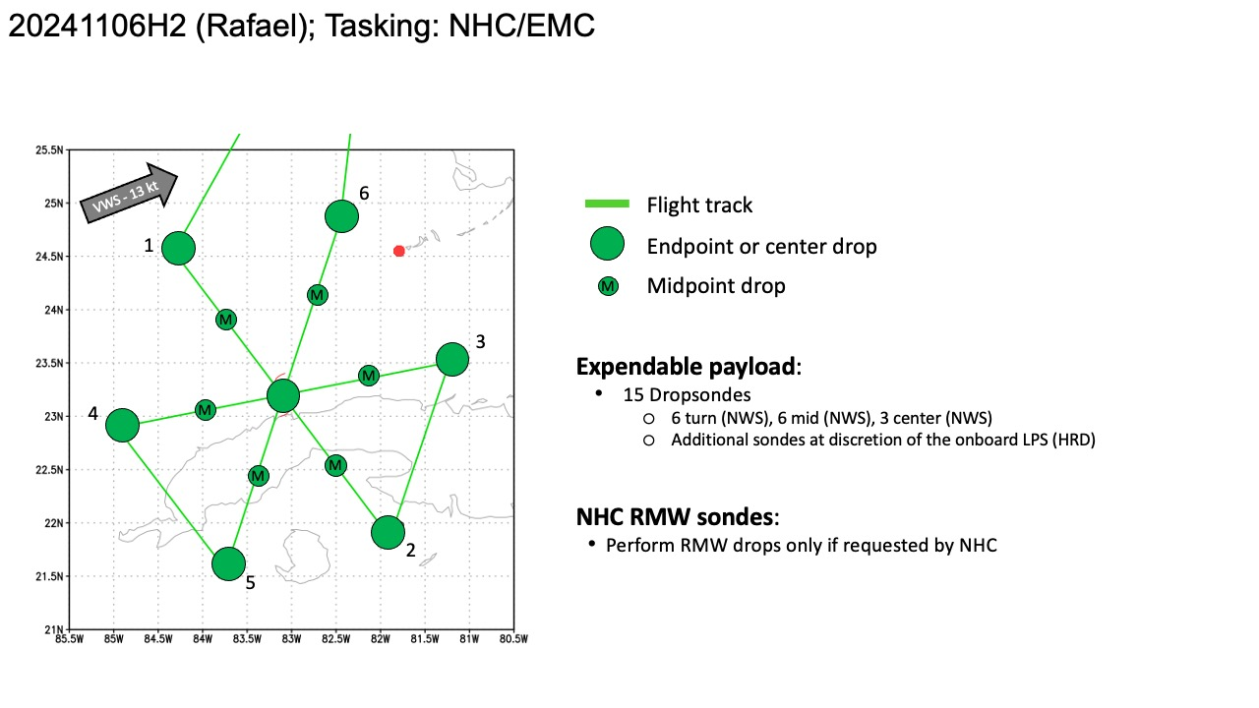
Preflight Weather Briefing | Hurricane Rafael Discussion Number 13  NWS National Hurricane Center Miami FL AL182024  400 PM EST Wed Nov 06 2024  The radar and satellite presentation of Rafael continued to improve  after the release of the previous advisory with the eye becoming  quite distinct around midday in geostationary satellite imagery.  An Air Force Reserve reconnaissance aircraft was able to fly a  couple of passes through the center earlier this afternoon and  measured a peak flight-level wind of 104 kt and an extrapolated  minimum pressure of 956 mb. The aircraft was unable to sample the  northeastern quadrant where the maximum winds were likely located.  Therefore, the initial intensity was increased to 100 kt on the  1800 UTC intermediate advisory. The 100-kt initial intensity is  supported by a blend of the various UW/CIMSS objective Dvorak  estimates, and UW/CIMSS SATCON which peaked near that value. Over  the past few hours it appears that an eyewall replacement cycle is  underway as the eye has become less distinct in satellite imagery,  and radar data has shown the erosion of the smaller inner-eyewall.  With the eyewall replacement ongoing, little additional change in  strength is expected before Rafael makes landfall in western Cuba  within the next hour or so. Some weakening is expected as the  storm crosses Cuba, but Rafael is likely to remain a hurricane over  the southeastern and southern Gulf of Mexico during the next few  days. After that time, increasing southwesterly shear and  significantly drier air are likely to result in weakening. As  noted earlier, there are some models that take Rafael southwestward  late in the period over the southwestern Gulf of Mexico where  environmental conditions could be less hostile. If additional  southward adjustments to the track forecast are needed on  subsequent advisories, it is likely that some modest upward  adjustments to the longer-range intensity may also be required.  The initial motion estimate is northwestward or 320/11 kt. Rafael  is expected to continue to move around the southwestern side of  a mid-level ridge over the southwestern Atlantic during the next  day or so. After that time, the ridge is forecast to build  westward over the eastern Gulf of Mexico which should cause Rafael  to turn more westward over the southern Gulf of Mexico. By 72  hours, the spread in the track guidance increases once again, with  the GFS showing a more northward solution than most of the  remainder of the track guidance. The NHC track forecast has been  shifted southward once again to be in better agreement with the  various consensus aids. It is possible that future southward and  southwestward adjustment will be needed as several of the models  now show the cyclone moving west-southwestward over the southwestern  Gulf by the end of the period.  Key Messages:  1. Rafael is forecast to cross western Cuba as a major hurricane  this afternoon and evening. A hurricane warning is in effect for  this region, where a life-threatening storm surge, damaging  hurricane-force winds, and destructive waves are expected.  2. Tropical-storm-force winds, especially in gusts, are expected in  the Lower and Middle Florida Keys beginning later today and tonight.  3. Rafael will bring areas of heavy rain to the Cayman Islands and  western Cuba through Thursday. Flash flooding and mudslides are  expected in areas of higher terrain in western Cuba.  4. Rafael is forecast to meander over the south-central Gulf of  Mexico this weekend and early next week. Interests in the southern  and southwestern Gulf of Mexico should monitor the progress of this  system.  FORECAST POSITIONS AND MAX WINDS  INIT 06/2100Z 22.6N 82.7W 100 KT 115 MPH  12H 07/0600Z 23.6N 83.9W 90 KT 105 MPH  24H 07/1800Z 24.1N 85.6W 90 KT 105 MPH  36H 08/0600Z 24.2N 87.4W 90 KT 105 MPH  48H 08/1800Z 24.2N 89.1W 85 KT 100 MPH  60H 09/0600Z 24.3N 90.4W 75 KT 85 MPH  72H 09/1800Z 24.5N 91.1W 65 KT 75 MPH  96H 10/1800Z 24.6N 92.0W 50 KT 60 MPH  120H 11/1800Z 24.5N 93.0W 35 KT 40 MPH  $$  Forecaster Brown  [Copy in GIF of recent (~6 hr) satellite loops (https://www.star.nesdis.noaa.gov/GOES/index.php)]
Instrument Notes | [What instruments are working, not working, not functioning nominally, not installed?]

IN-FLIGHT
Time [UTC] | Event
2037 | Take-off from Lakeland
2128 | Slight turn to begin inbound leg at 10000 ft
222345 | End outbound turning NE for downwind run
2247 | Beginning of second inbound pass
 | 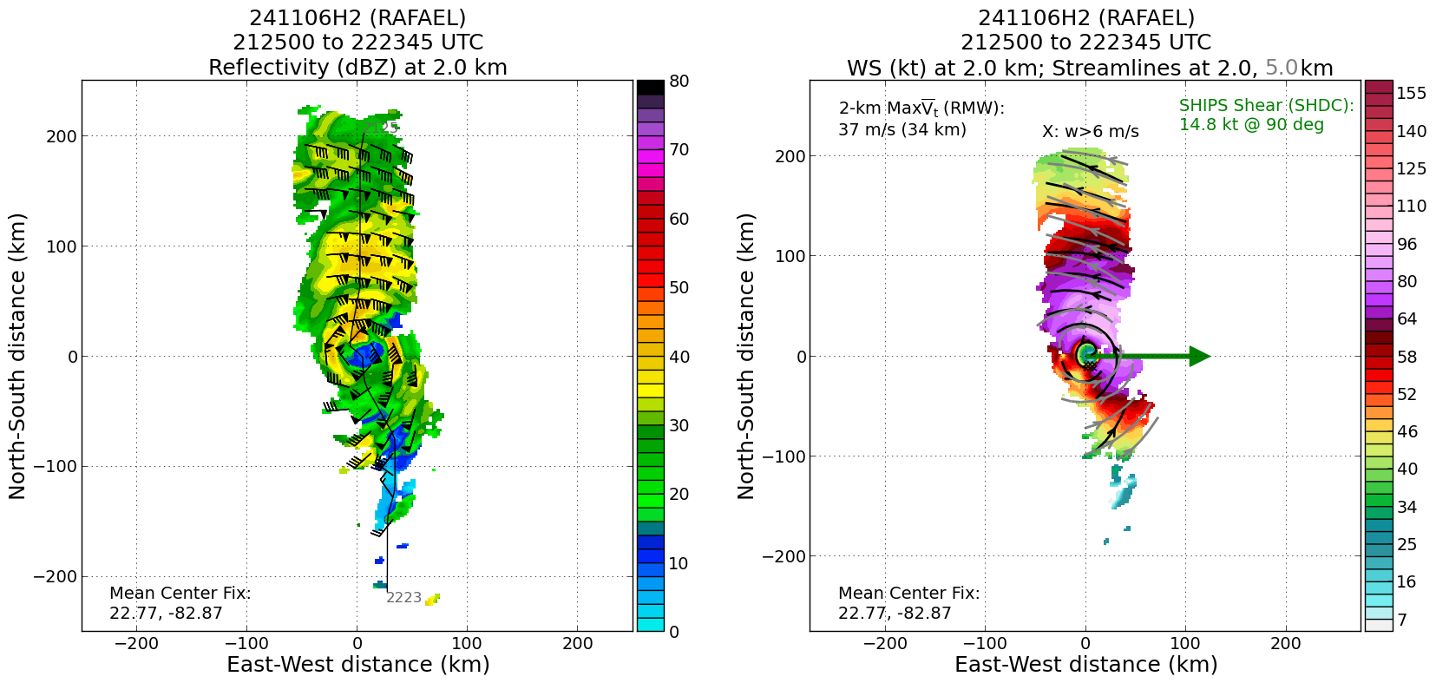
 | 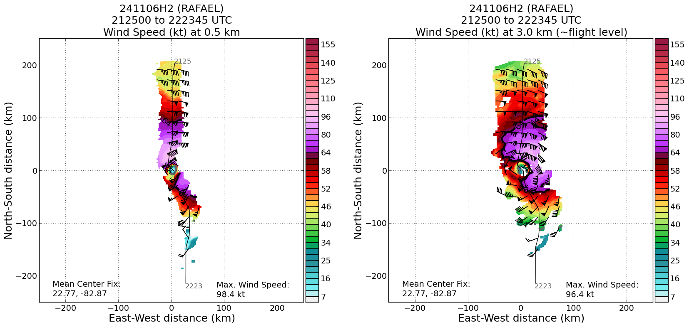
 | 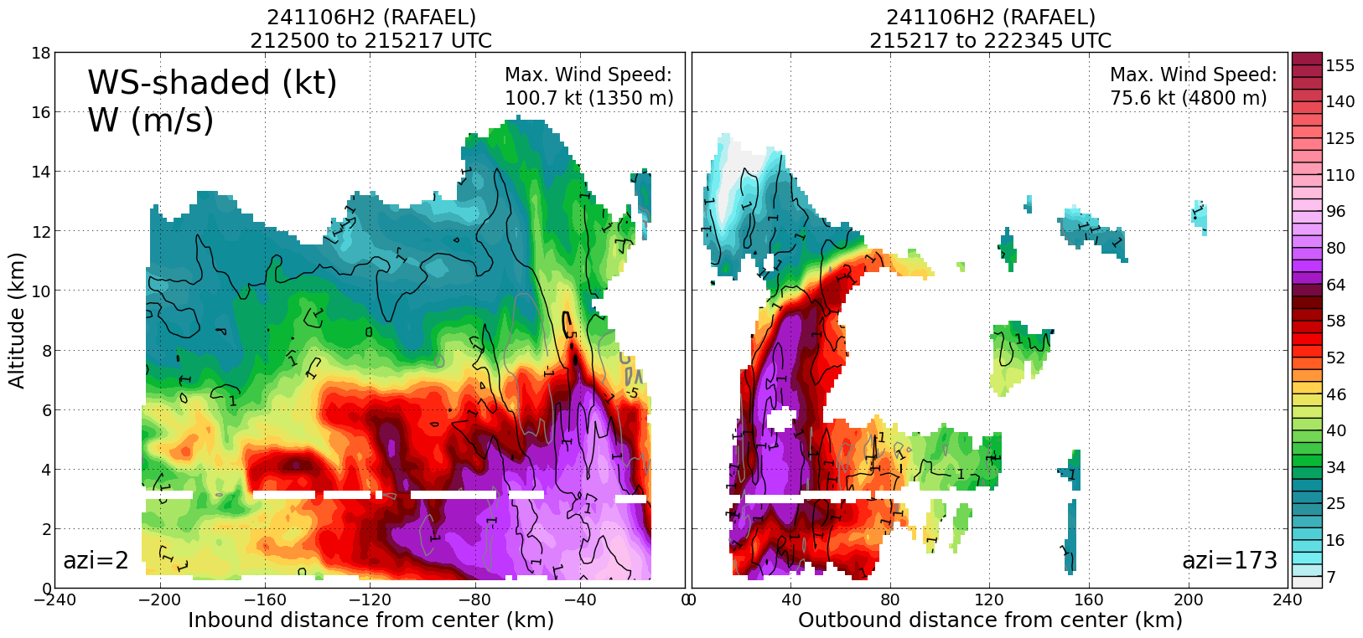
Analysis 1 | 2-6-km Vortex Tilt: 10.8 km at 22 deg
Analysis 2 | 2-6-km Vortex Tilt: 11.7 km at 31 deg
XXXX | [describe event and paste associated screenshot or gif, if available]
292930 | End of outbound of second pass
 | 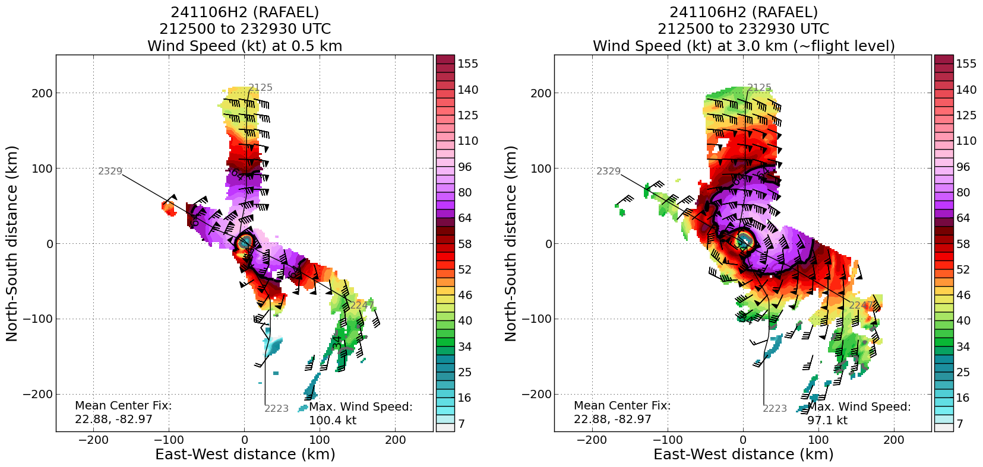
 | 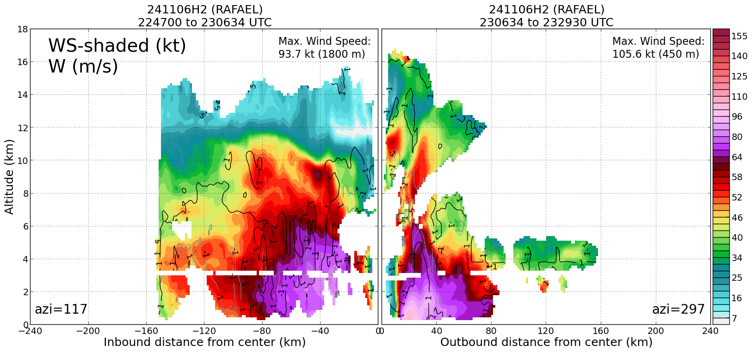
234910 | Beginning of third inbound pass
245130 | End of third outbound pass
2513 | 2-6-km Vortex tilt 10.8 km at 22 deg
 | 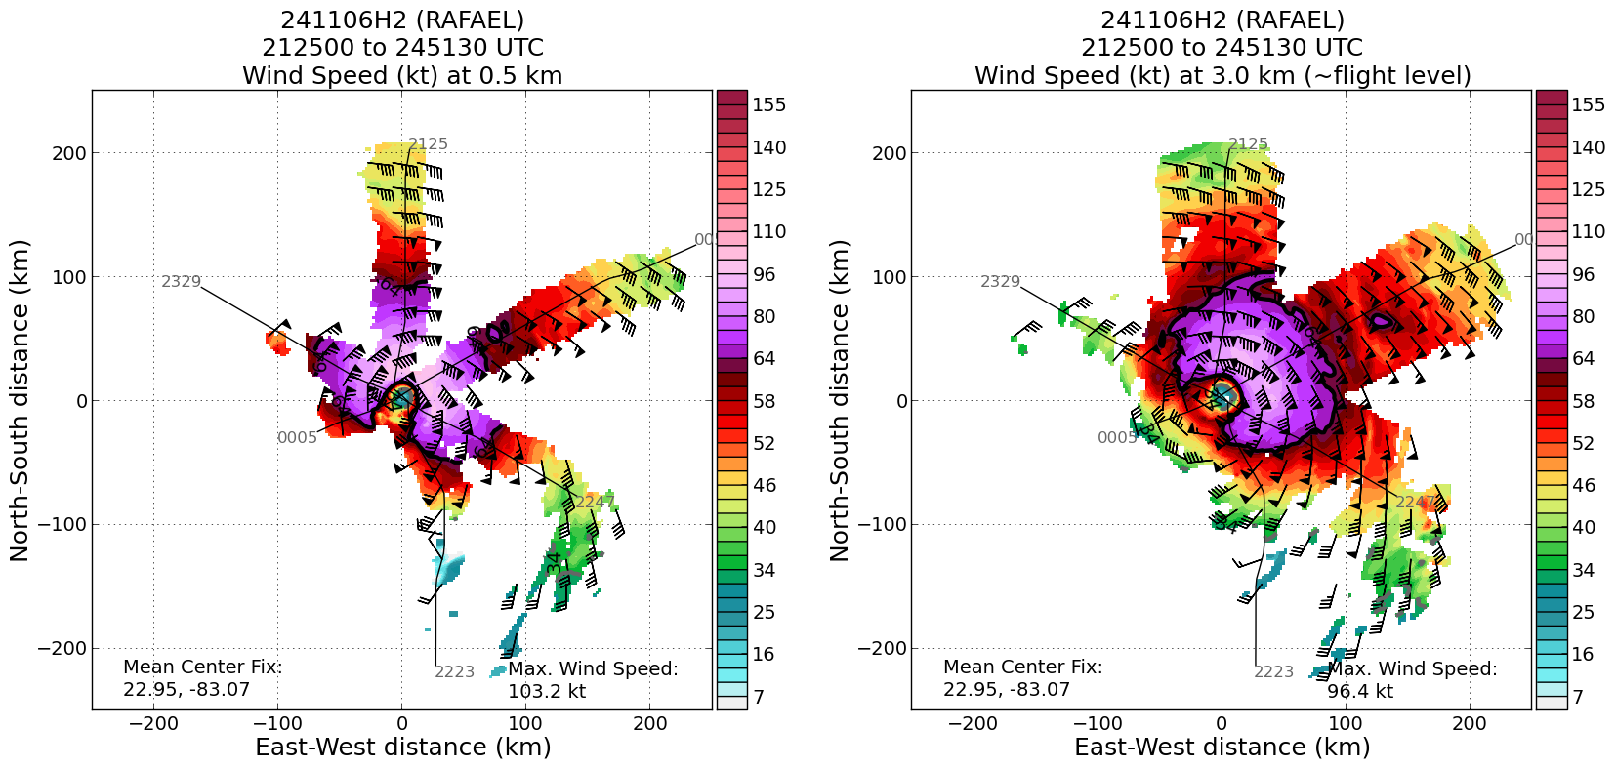
 | 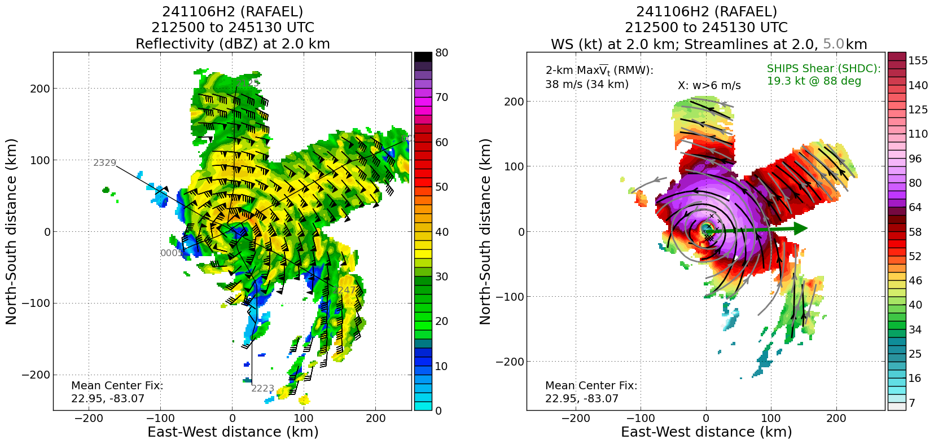
 | 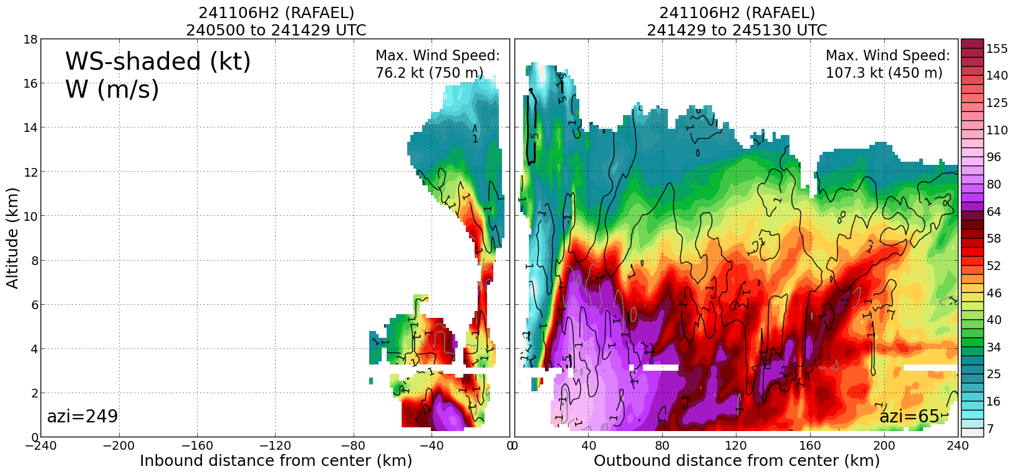

POST-FLIGHT
Mission Summary | [Short description of interesting observations from the flight; what objectives were successful? What was unsuccessful? Was the planned pattern flown? What deviations occurred?  [Don’t forget to fill in Tables on page 1]  [Sonde and ocean expendable accounting: how many total of each? How many are charged to each account?]
Actual Standard Pattern Flown | Butterfly
APHEX Experiments / Modules Flown | [Linked to HFP Plan; fill in regardless of whether the mission was operationally or research tasked]
Plain Language Summary | [Boil down the above into a couple of bullet points in “plain language”. This will help us when we report to management & OAR Public Affairs and prepare storm mission summaries]
Instrument Notes | [Notes about instrument status from during and after the mission]
Final Mission Track | [Insert MTS screenshot of final flown track, ideally at the completion of the pattern with satellite imagery]

