MISSION PLAN
FLIGHT ID | 20241008I1 | STORM | AL14/Milton
MISSION ID | 1314A | TAIL NUMBER | NOAA-43
TASKING | NHC/EMC TDR | PLANNED PATTERN | Butterfly
MISSION SUMMARY
TAKEOFF [UTC] | 0804 | LANDING [UTC] | 1449
TAKEOFF LOCATION | KLAL | LANDING LOCATION | KMOB
FLIGHT TIME | 6.9 | BLOCK TIME | 7.3
TOTAL REAL-TIME RADAR ANALYSES  (Transmitted) | 3 (3) | TOTAL DROPSONDES Deployed (Tx to GTS) | 17 (17)
OCEAN EXPENDABLES deployed (good) | 9 UM AXBTs (8) | sUAS (Type) | 1 Black Swift S0
APHEX EXPERIMENTS / MODULES | CHAOS
HRD CREW MANIFEST
LPS ONBOARD | J. Zhang | LPS GROUND | Alaka/Sippel
TDR ONBOARD | J. Zhang | TDR GROUND | X. Zhang
ASPEN ONBOARD | N/A | ASPEN GROUND | Kaplan
NESDIS SCIENTISTS | N/A
GUESTS (Affiliation) | Joshua Wadler (ERAU), Joshua Fromm (Blackswift)
AOC CREW MANIFEST
PILOTS | Rannenberg/Palmer/Taraboletti
NAVIGATOR | Utama/Saunders
FLIGHT ENGINEERS | Ripp/Dittoe
FLIGHT DIRECTOR | Englert/Carpenter
DATA TECHNICIAN | Richards
AVAPS | Brannigan/Hunsinger/Underwood

PRE-FLIGHT
Flight Plan | 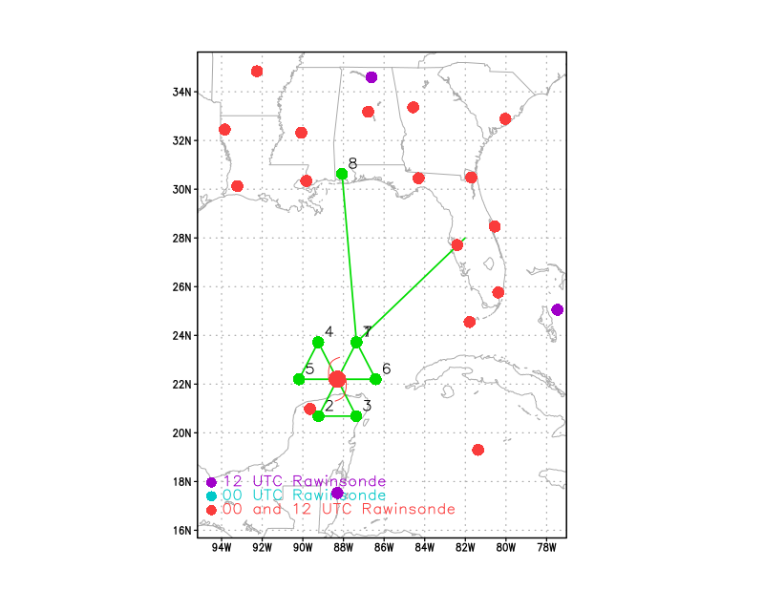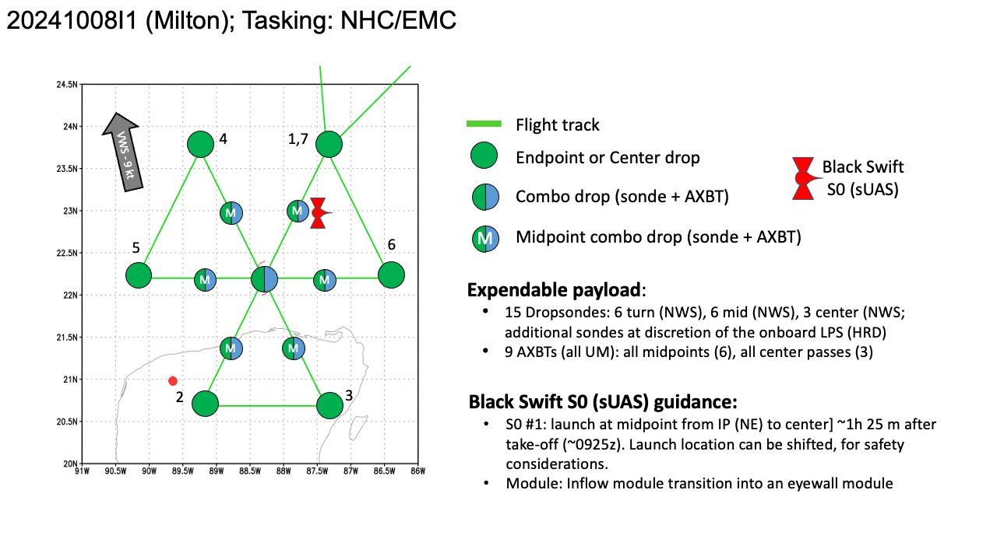  Rotated the plan to avoid flying over land.  1st pass NW - SE  2nd pass E-W  3rd pass SW-NE  AOC got clearance to fly within 12 nm of Mexico boarder.  We have to truncate two radial legs by at least half if staying with origional pattern.
Expendable Distribution | Dropsondes at endpoints and centers  Dropsondes/AXBT combo drops at midpoints  S0 in the center
Preflight Weather Briefing | The structure of Milton has changed significantly overnight. The  pinhole eye seen yesterday has filled and earlier aircraft data  showed a double eyewall structure. More recent microwave images  show only one larger eyewall, and it is clear that Milton is  completing an eyewall replacement cycle. These eyewall replacement  cycles are common in strong hurricanes and often cause the peak  winds to fluctuate, while the wind field generally expands. Based  on the aircraft data from a few hours ago, the initial intensity is  set at 135 kt. Both the NOAA and Air Force Hurricane Hunters are  scheduled to investigate Milton again later this morning.  The major hurricane is beginning to gain latitude, and the latest  initial motion estimate is 075/10 kt. A turn to the northeast with  a slight increase in forward speed is expected later today and  Wednesday as the hurricane moves in the flow between a trough  digging into the Gulf of Mexico and a ridge near the Greater  Antilles. This motion should take the core of Milton to  west-central Florida Wednesday night. After the hurricane passes  Florida, a faster east-northeastward motion is expected within a  more zonal steering flow. Little change was made to the track  forecast through landfall, but this prediction is a little slower  while the system enters and moves over the Atlantic.  Fluctuations in strength due to continued structural changes are  likely during the next day or so while Milton moves across the  central and eastern Gulf of Mexico. An increase in vertical wind  shear will likely cause some weakening before the hurricane reaches  Florida, but there is high confidence that Milton will remain an  extremely dangerous hurricane when it reaches the state. After  landfall, more notable weakening is forecast and Milton is now  expected to become extratropical by day 3 when it is over the  Atlantic. The NHC intensity forecast lies at the high end of the  model guidance in best agreement with the hurricane regional models.  Milton is still a relatively compact hurricane, but the wind field  is expected to continue to grow in size as it approaches Florida.  In fact, the official forecast shows the hurricane and  tropical-storm-force winds roughly doubling in size by the time it  makes landfall. Therefore, damaging winds, life-threatening storm  surge, and heavy rainfall will extend well outside the forecast  cone. It is worth emphasizing that this is a very serious situation  and residents in Florida should closely follow orders from their  local emergency management officials. Milton has the potential to  be one of the most destructive hurricanes on record for west-central  Florida.  [Briefly describe the relevant environmental drivers.]  [Copy in GIF of recent (~6 hr) satellite loops (https://www.star.nesdis.noaa.gov/GOES/index.php)]
Instrument Notes | [What instruments are working, not working, not functioning nominally, not installed?]

IN-FLIGHT
Time [UTC] | Event
0804 | Take-off from Lakeland
0820 | Milton appears to be reorganizing after completing an ERC
0840 | 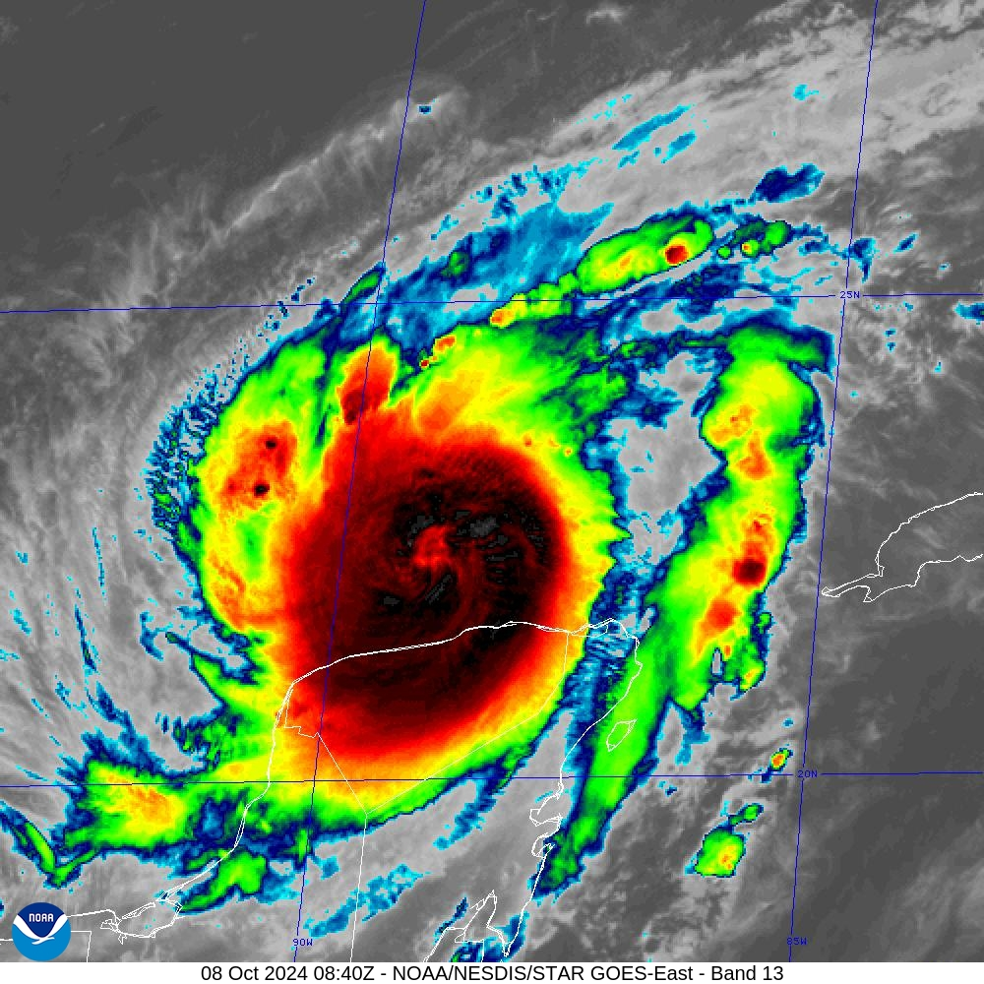
0942 | LPS notes that RMW sondes may be requested for the 2nd and 3rd passes. NHC is not specifically requesting them.
1000 | Sonde 01, AXBT 01, IP1 NW, Ch 1  AXBT SST=27.62C  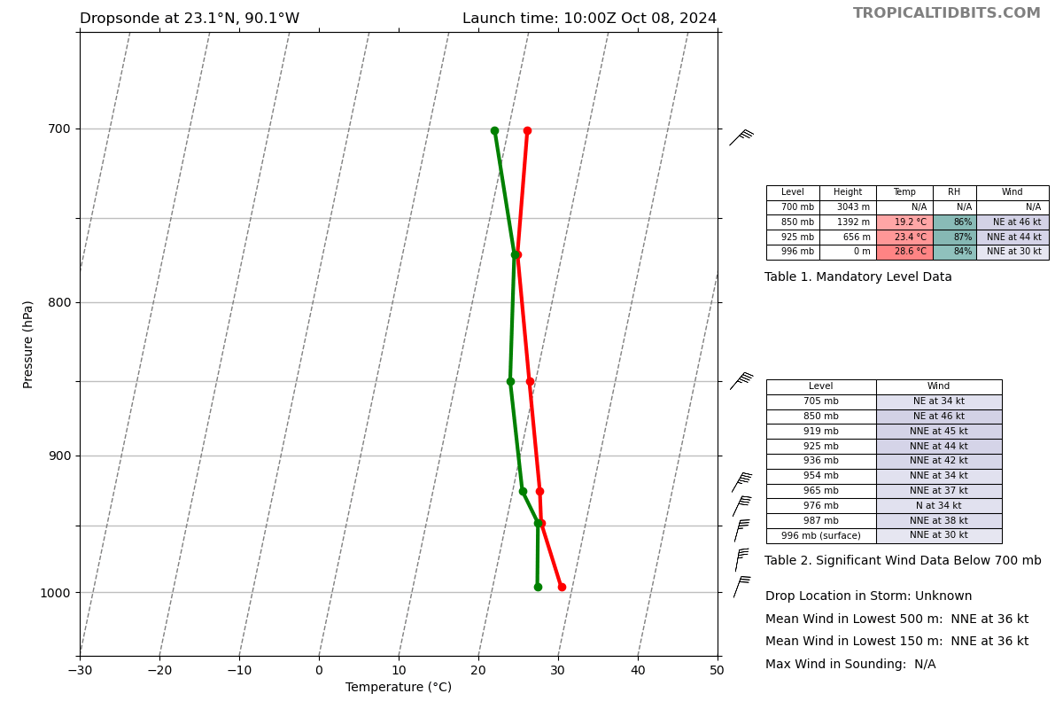
1009 | LPS running the S0 launch checklist
1012 | Sonde 02, AXBT 02, MP NW, Ch 2  AXBT SST=28.6C  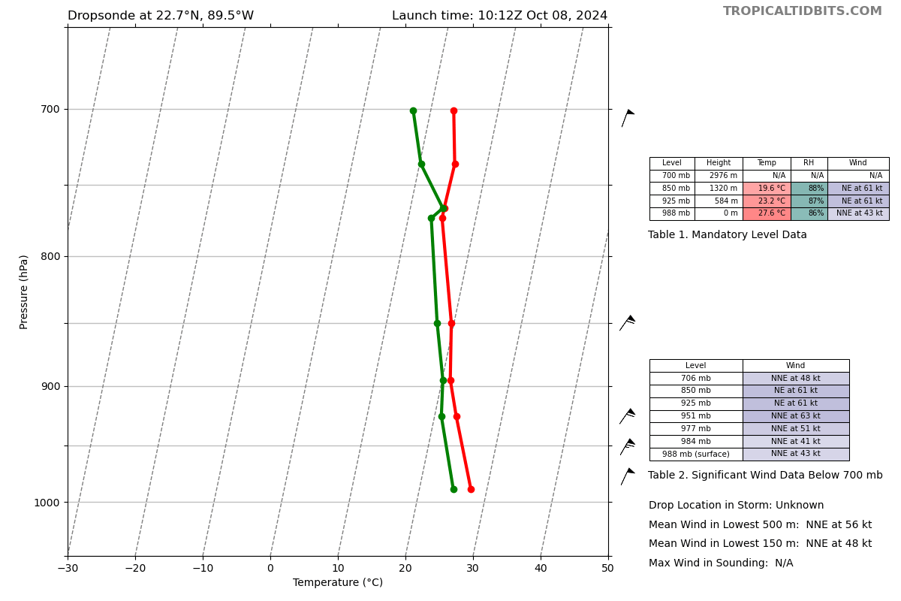
1022 | Sonde 03, AXBT03, Center, Ch3  AXBT SST=28.55C  sonde @ 1022z. 22.39N 88.90W Sfc pressure 932mb 10m wind 155/17 kt  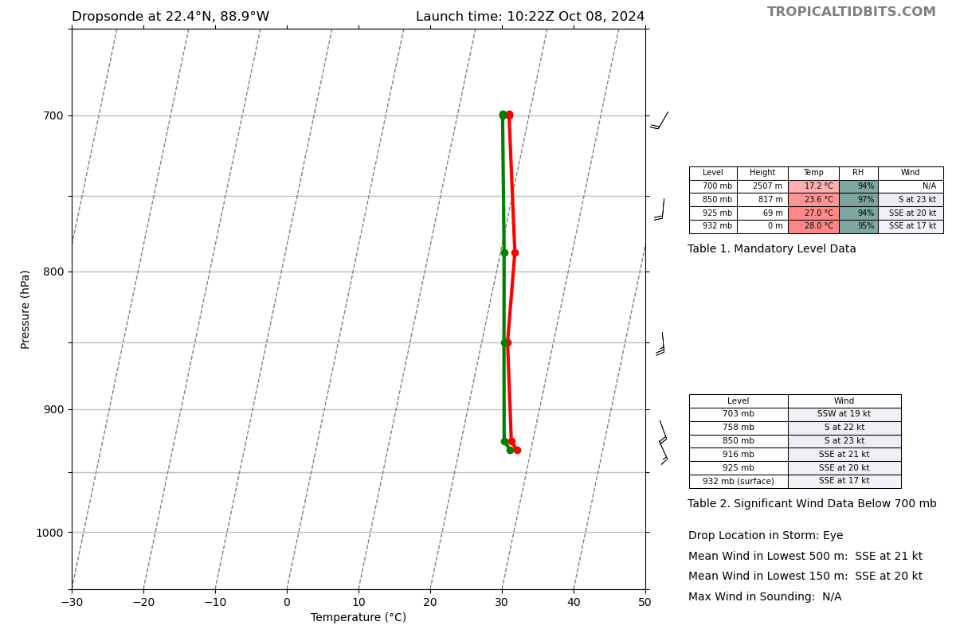
1028 | S0 launched between the eyewall and rainbands
1031 | s0 at 2km altitude, wind 77 kts;  1033: 1500 m, 68 kt
1033 | Sonde 4, AXBT04, MP, Ch4  AXBT SST=29.0C scattered data noticed by AVAPS  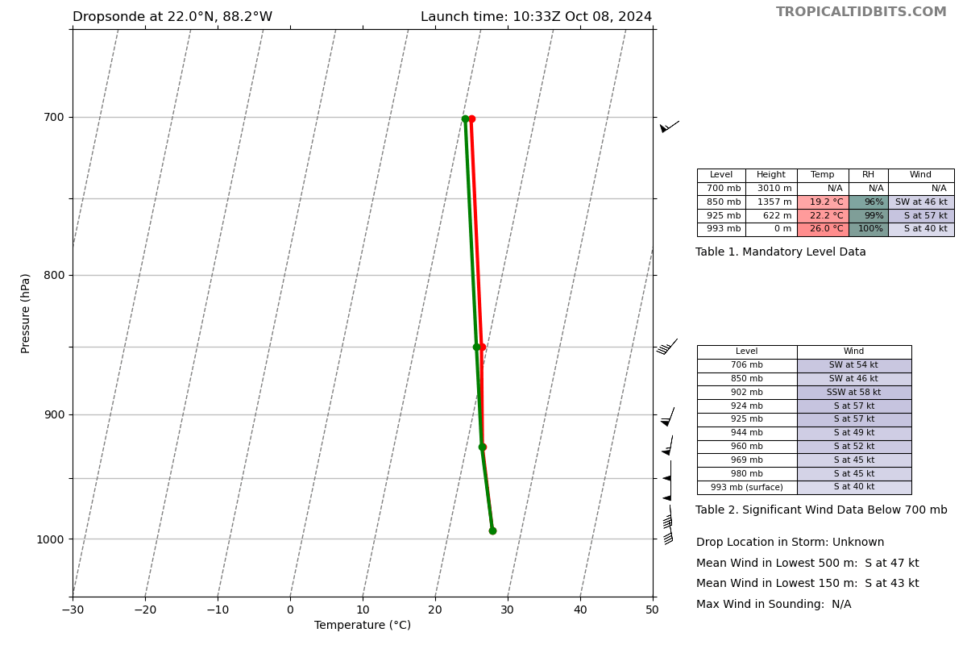
1039 | Sonde 5, EP, Ch5  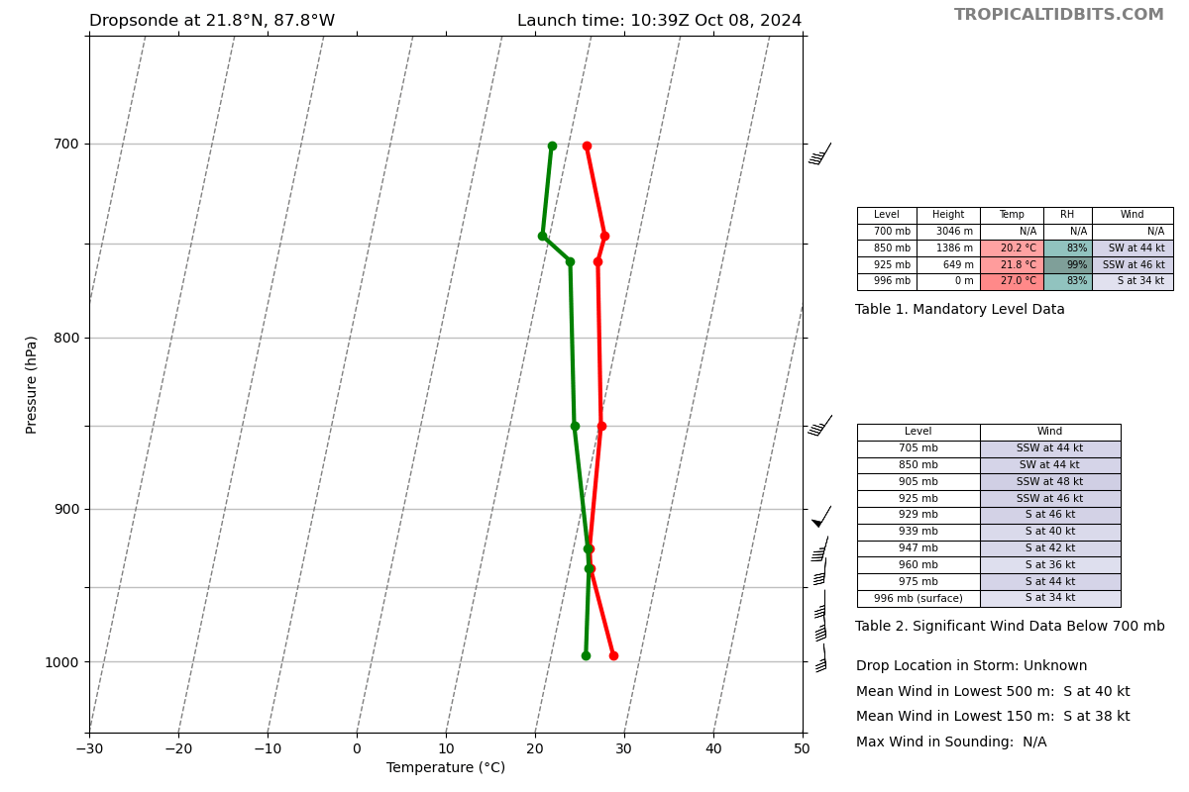
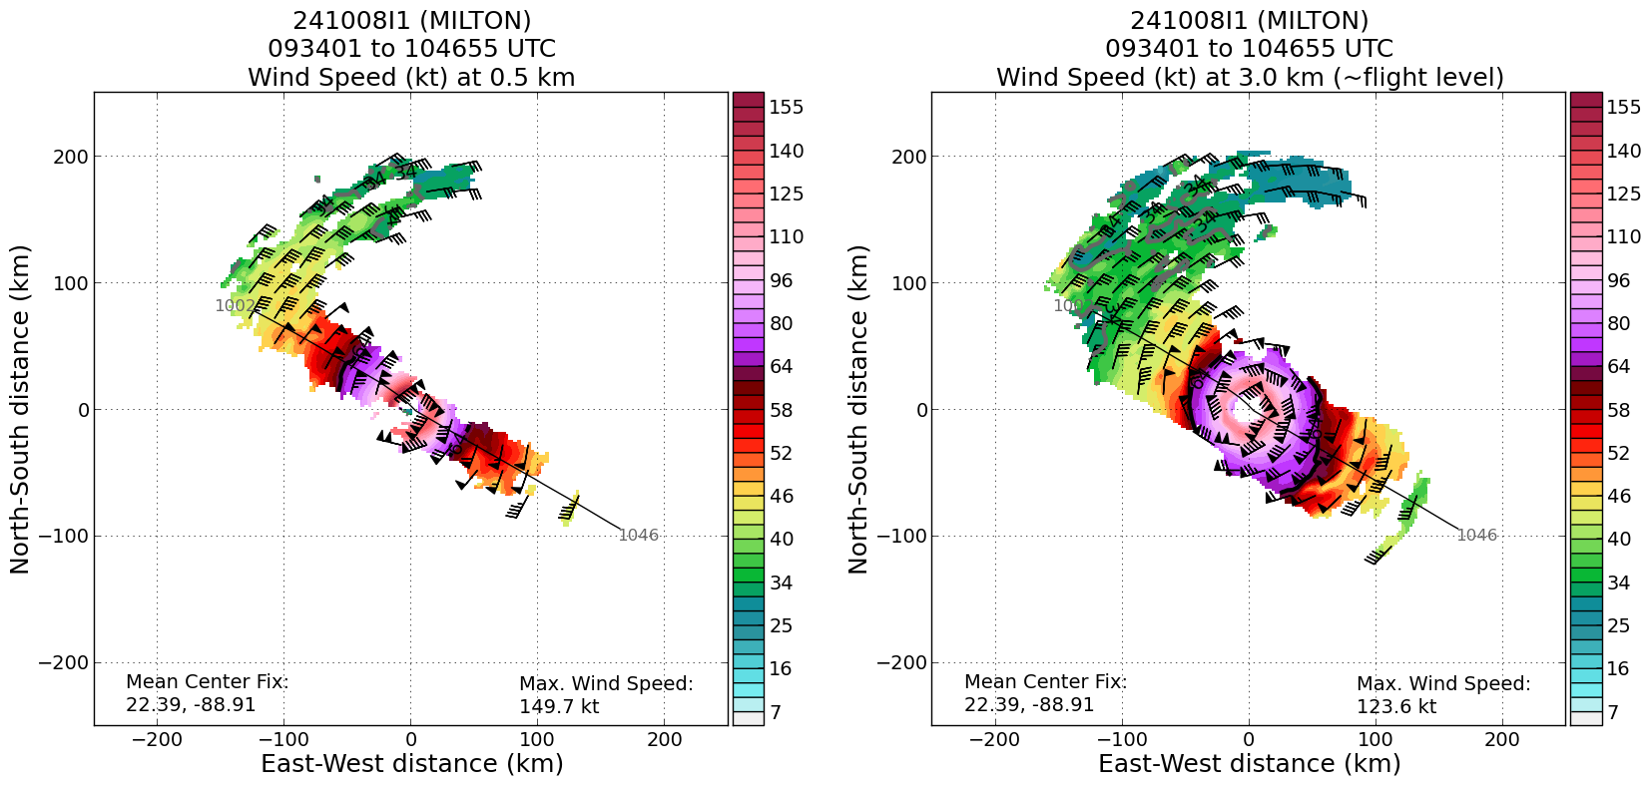
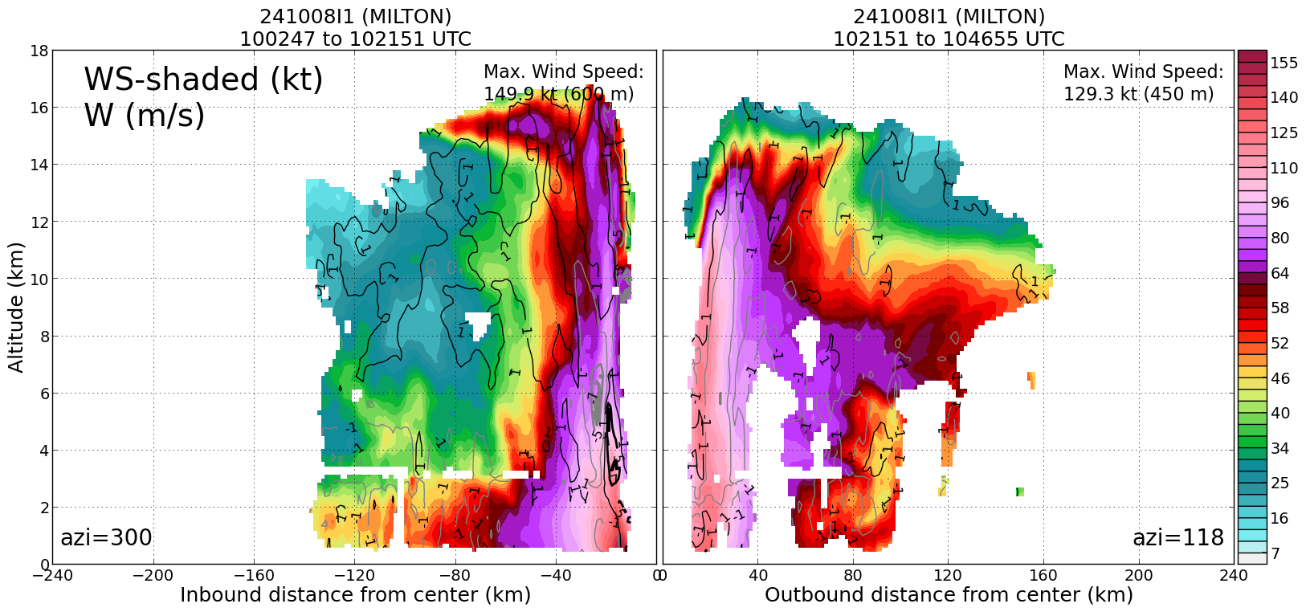
1052 | Jason D: Aspen can't open D20241008_100012.1.20241008I ....I looked at the Dfile and that one is missing the header info.. the other dfiles are fine  1114 update from Jason D: Nick just emailed with an updated drop #1 dfile...it works...John is working it up now
1105 | S0 measured 110 kt at 500 m
1105 | LPS: it sounds like the BTs are running into some software processing issues. We will still plan to launch at planned points, raw data ok
1107 | S0 measured 120-125 kt winds near 500 m
1111 | s0 measured 150 kts winds, up to 185 by 1112, 200 by 1115
1110 | Sonde 6, Ch6, IP2  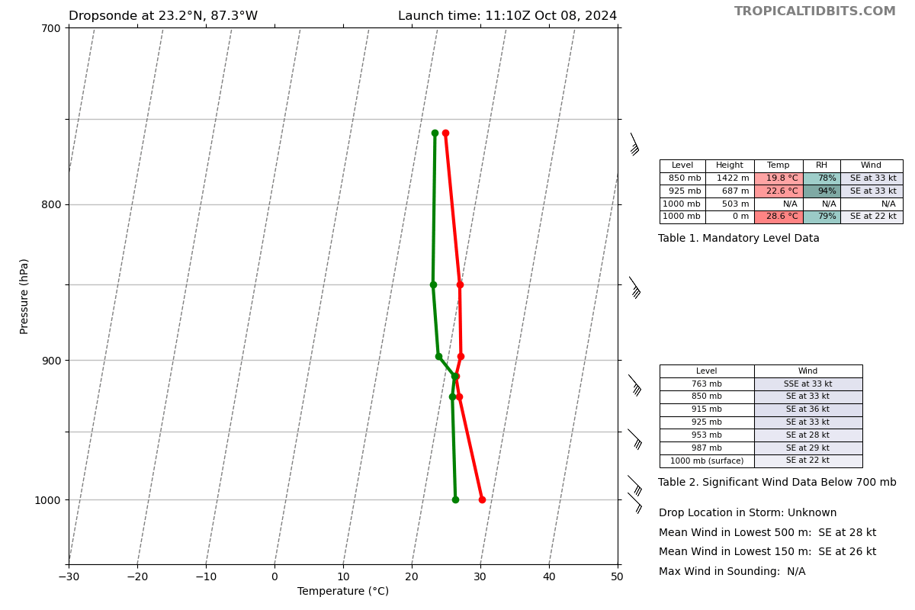
1116 | AVAPS and Data were trying to get the BT script and software to work. At least gives us awareness on when the BT is finished. Will keep recording the audio files for post-processing purposes.
1122 | Drop 7, Ch7, MP, combo  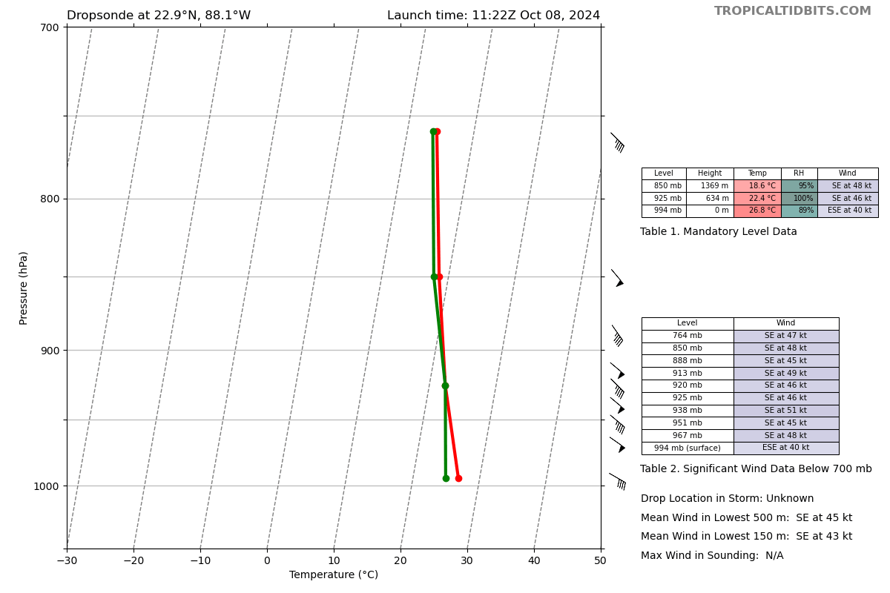
1121 | s0 at z=400 m
1122 | measured 100-110 kts winds, 120-135 at 1123, then 150
1132 | S0 splashed
1132 | Drop 8, Ch8, RMW  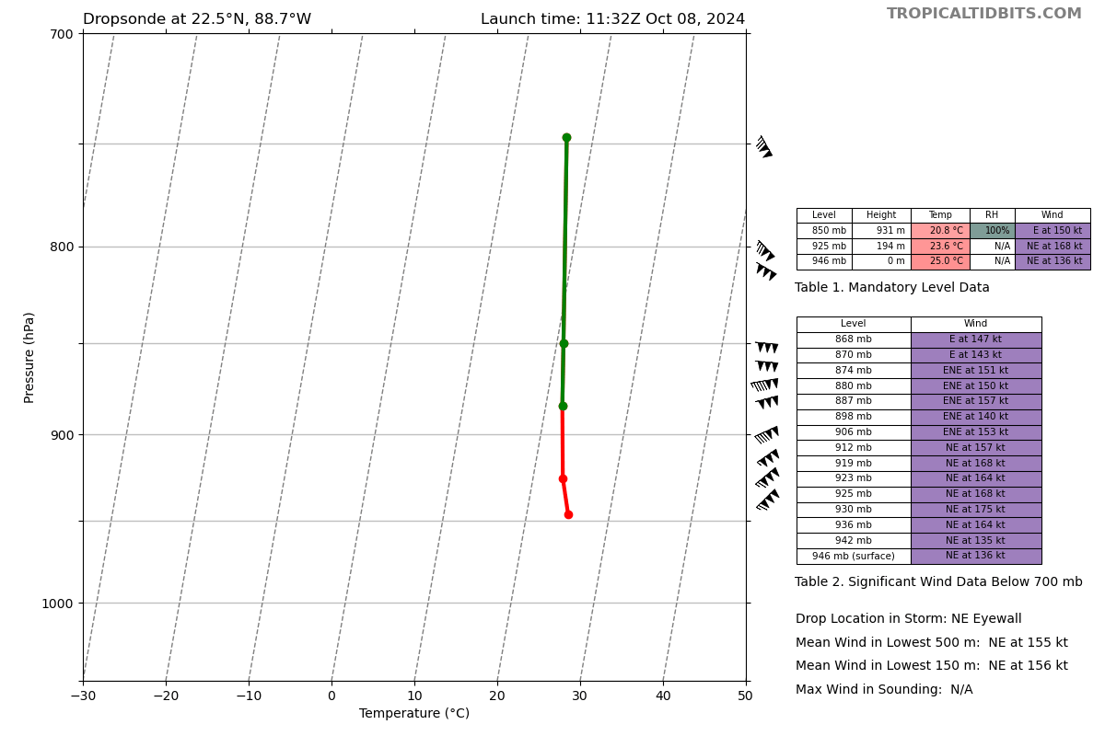
1134 | Drop 9, Ch1, Center CPA  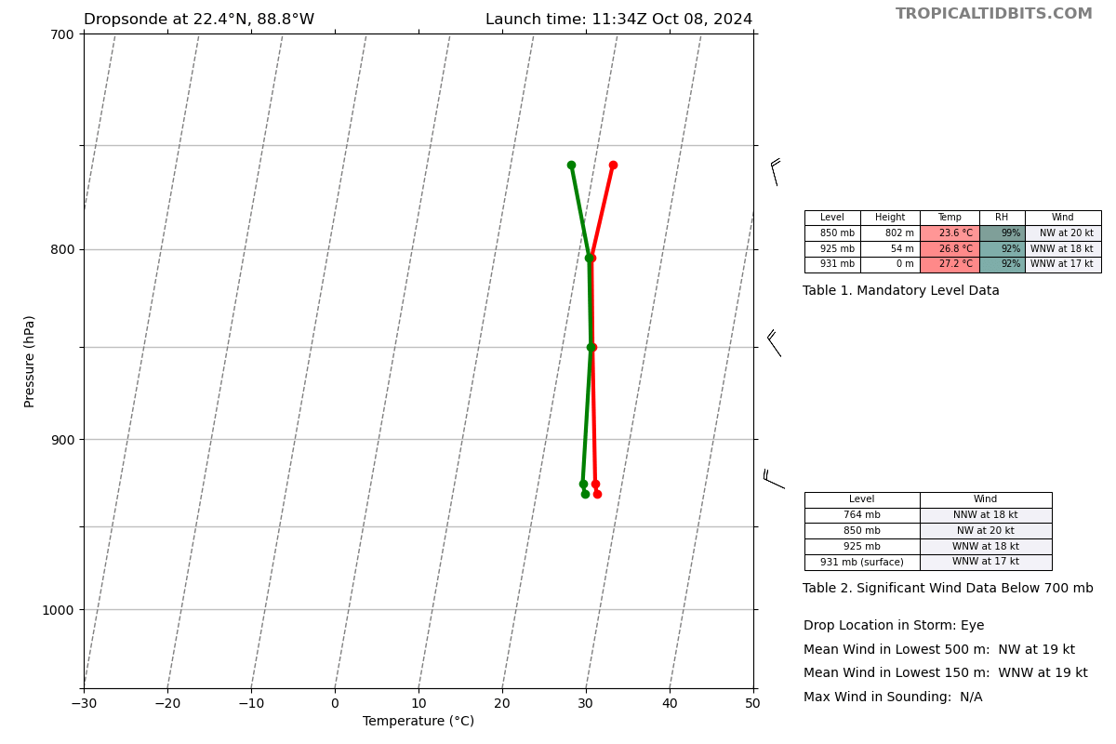
1137 | LPS: a lot of updrafts and downdrafts 5-13 m/s
1137 | Drop 10, Ch2, RMW  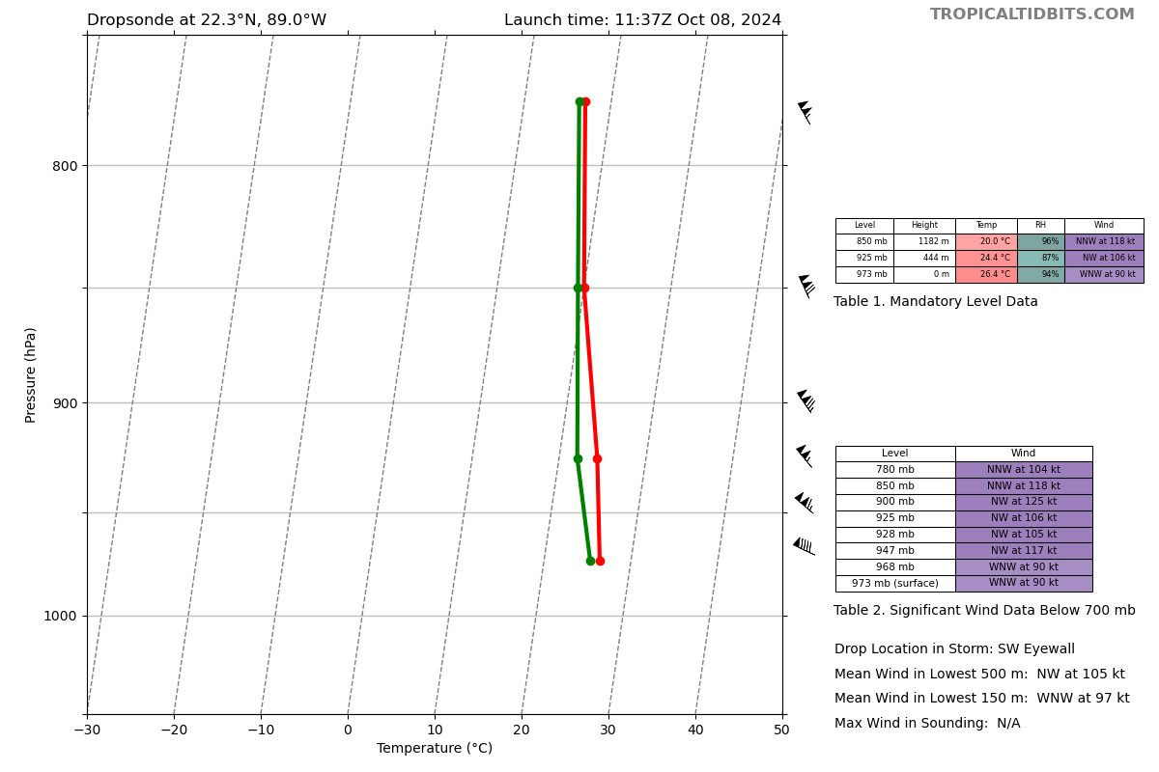
1140 | Eye warming evident once again as the massive ERC finally completes. It will be interesting to see if the pressure begins to fall noticeably on the final pass. The CDO is very symmetric, almost annular. Clear northward component to the storm motion
1148 | Drop 11, Ch3, MP, combo  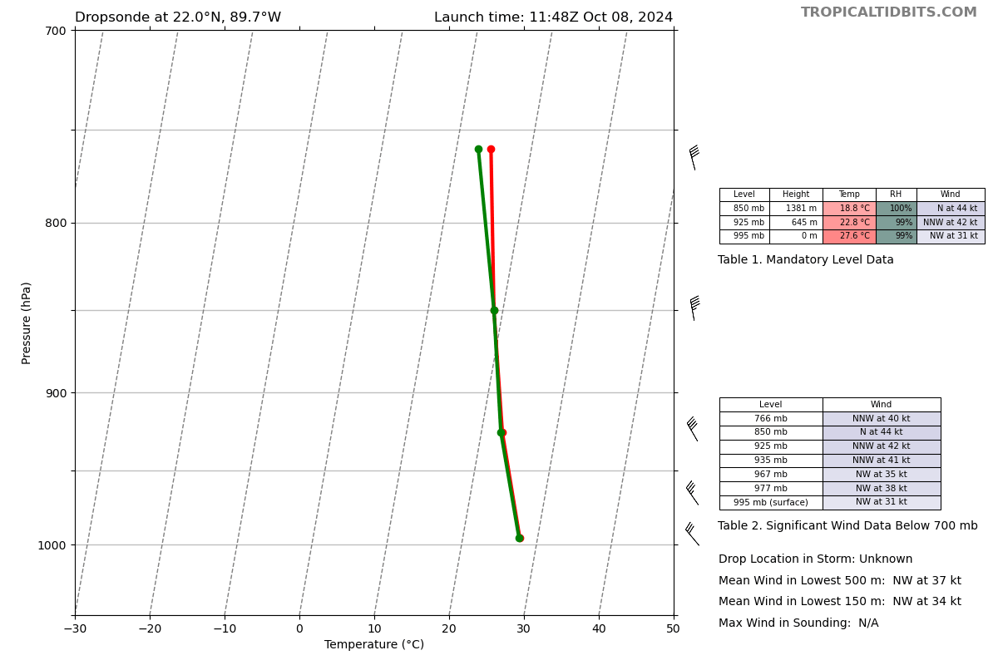
1201 | 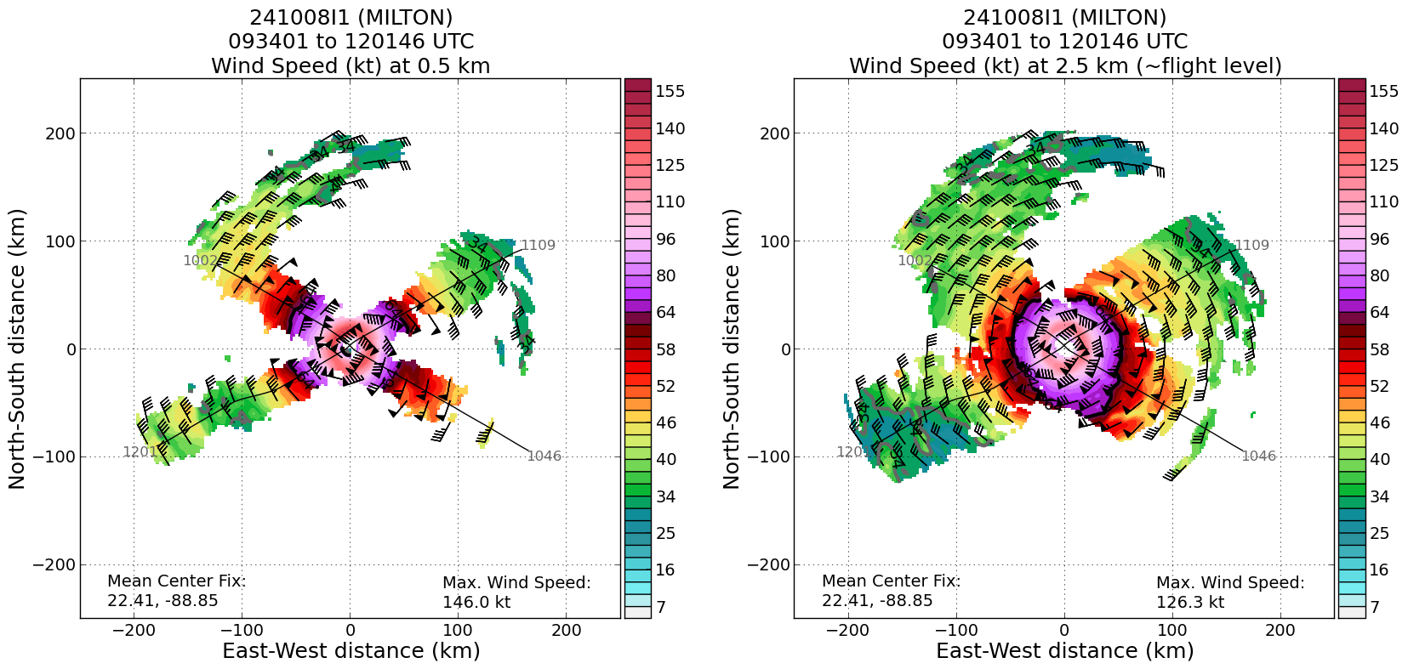  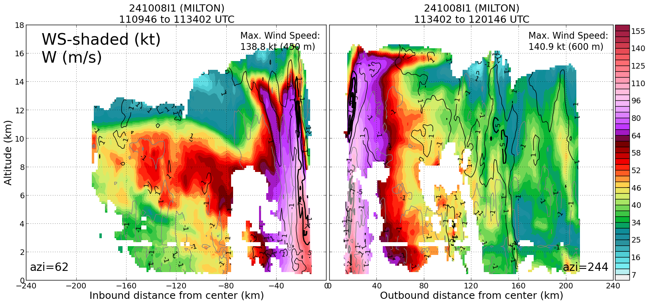  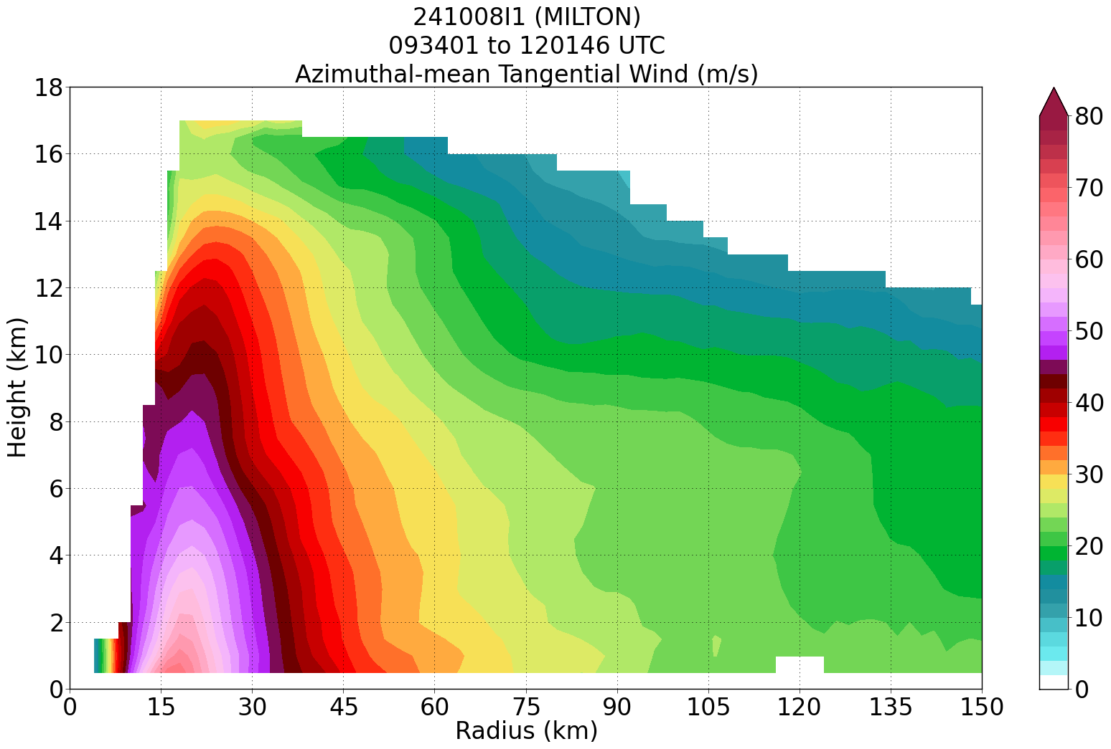
1202 | Sonde 12, Ch 4, EP2 combo  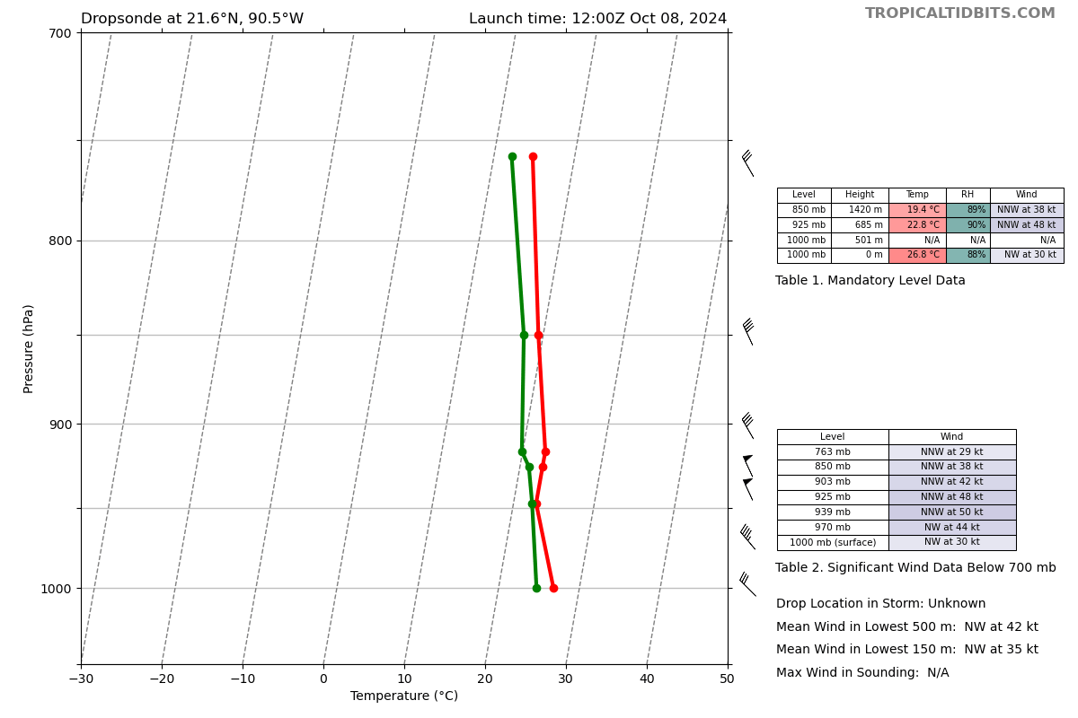
1224 | 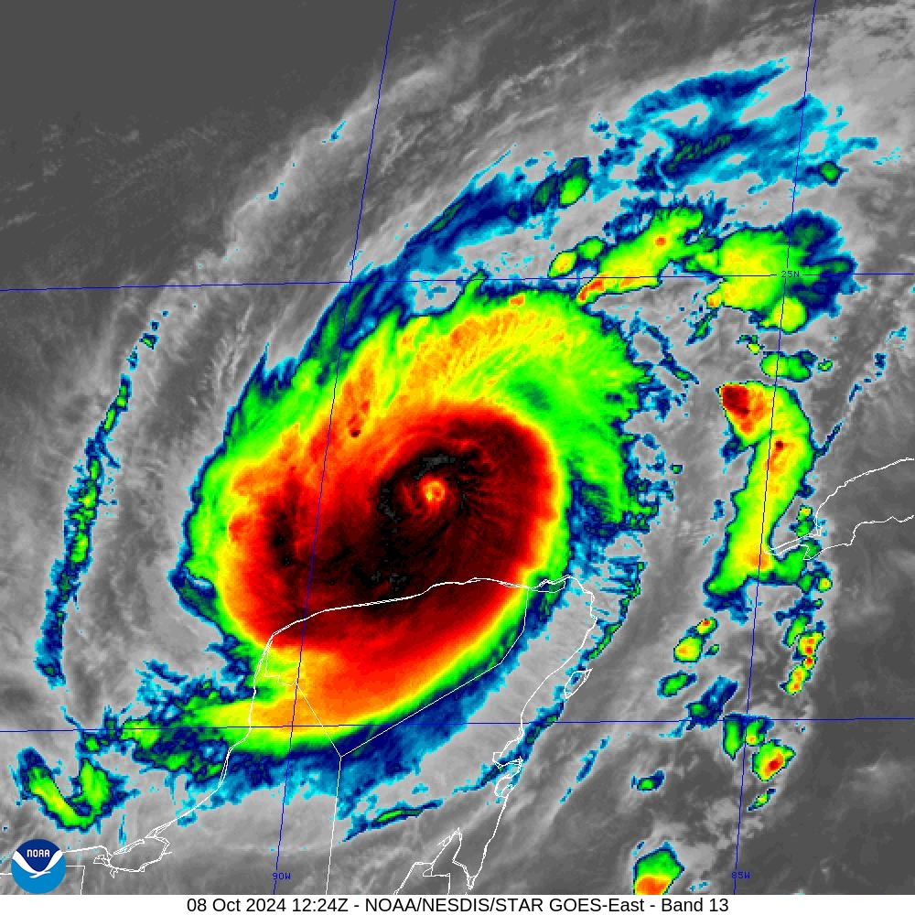
1240
1246 | Sonde 13, Ch 5, RMW
1259 | Sonde 14, Ch 6, CENTER combo  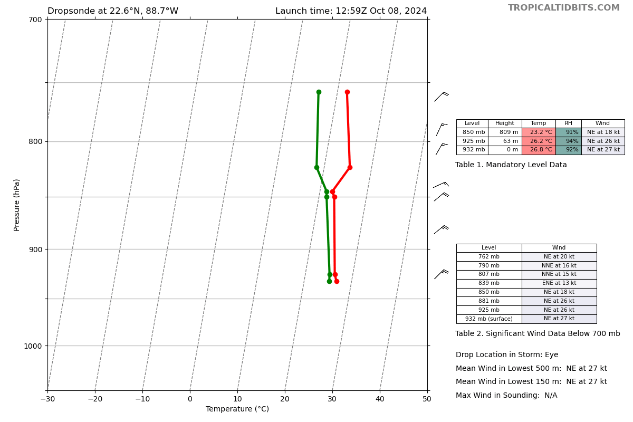
1300 | High turbulence while coming inbound from the SW. LPS reports that the aircraft hit mesovortices (2-3 couplets). Milton appears to be re-intensifying after completing its ERC. The P3 completed 3 orbits in the eye (clockwise) so the crew could clean up the aircraft.  Now, they are exiting boutbound to the North. LPS notes that the north eyewall appears very intense according to onboard radar.  Before the high turbulence, the decision was made to go south outbound. After hitting the high turbulence, decided to go north and head to base final outbound leg.
1302 | Sonde 15, Ch 7, RMW  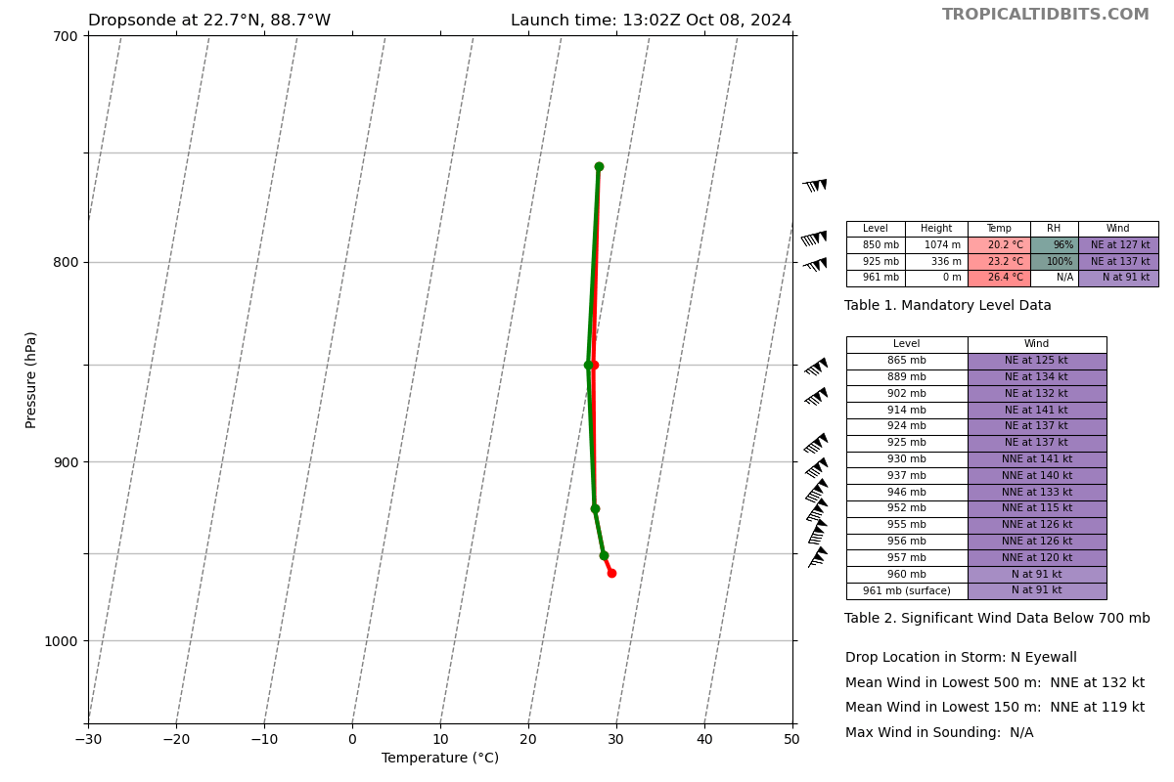
1313 | Sonde 16, Ch 8, MP combo  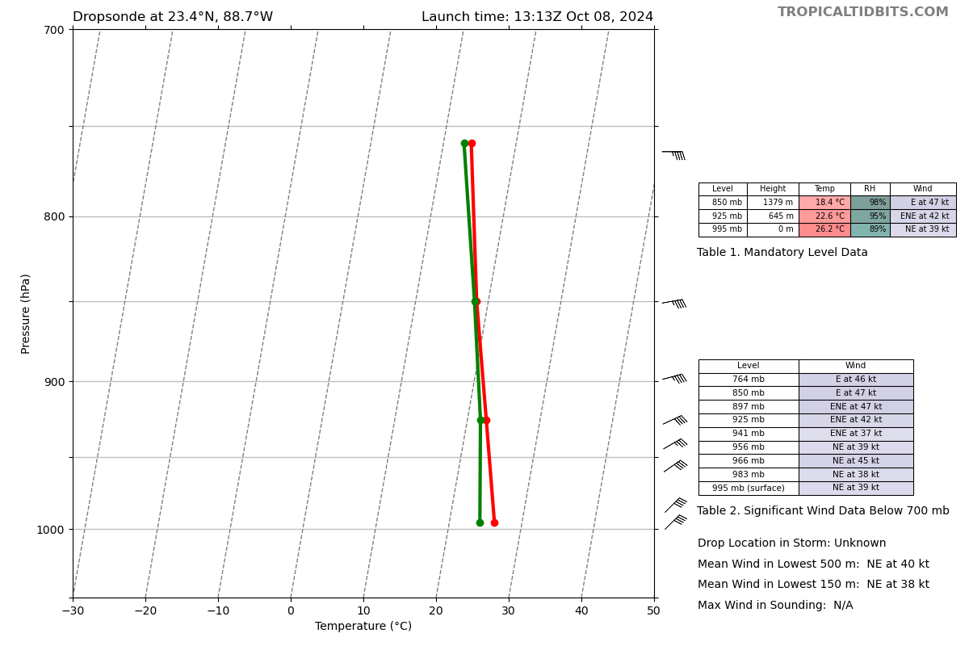
1324 | Reached EP
1324 | Sonde 17, Ch 1, EP3  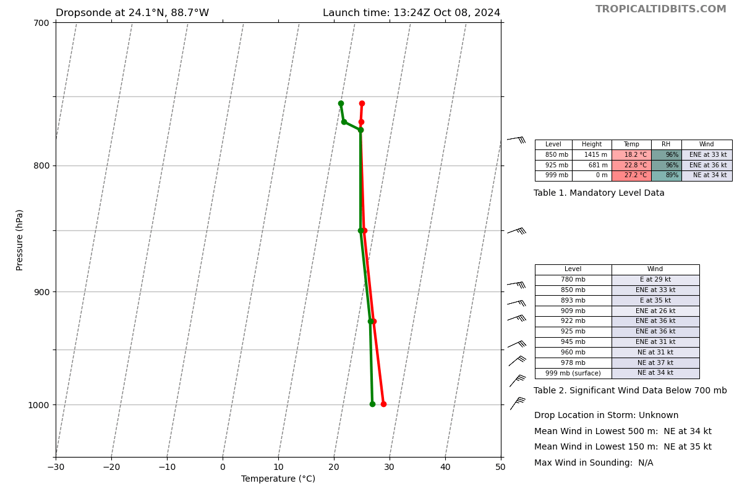
1325 | 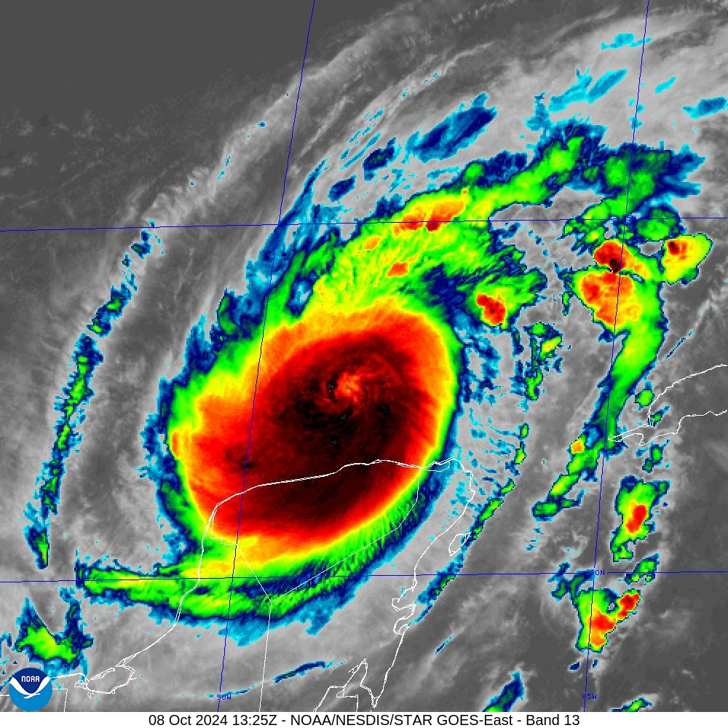
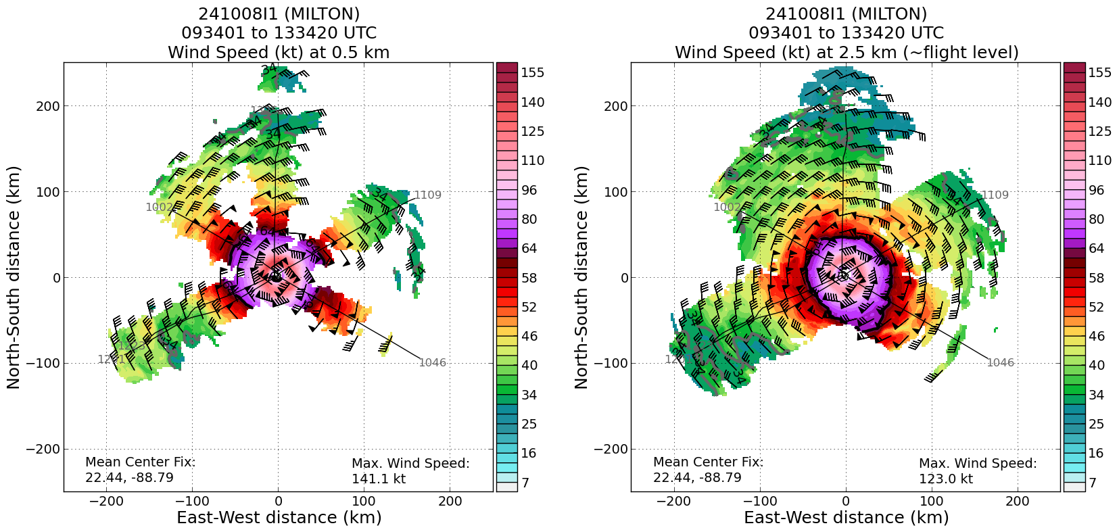
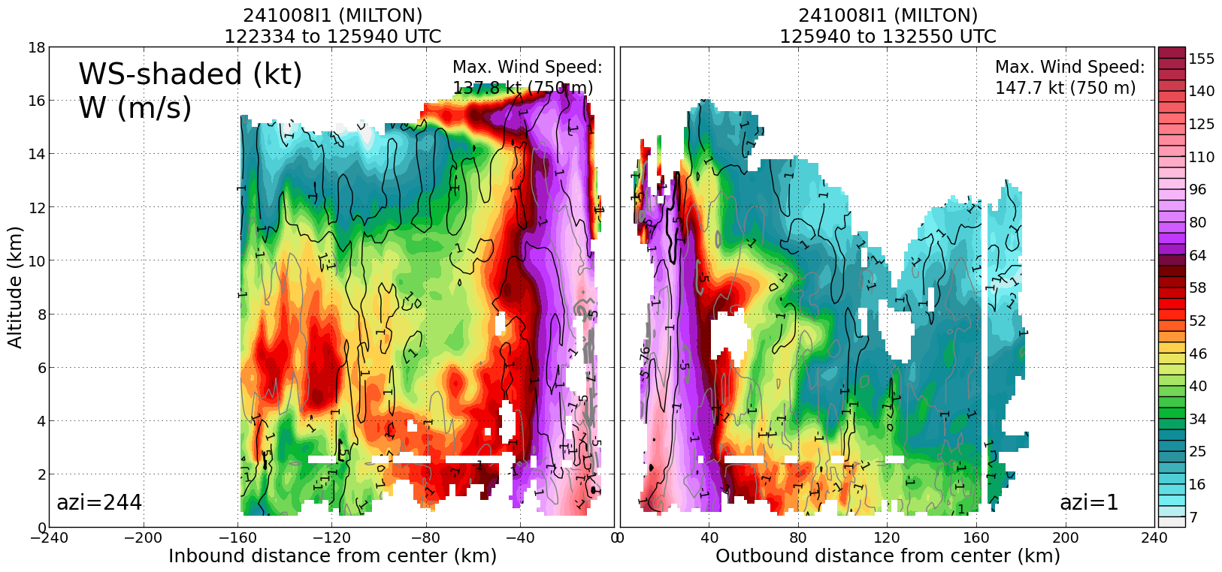
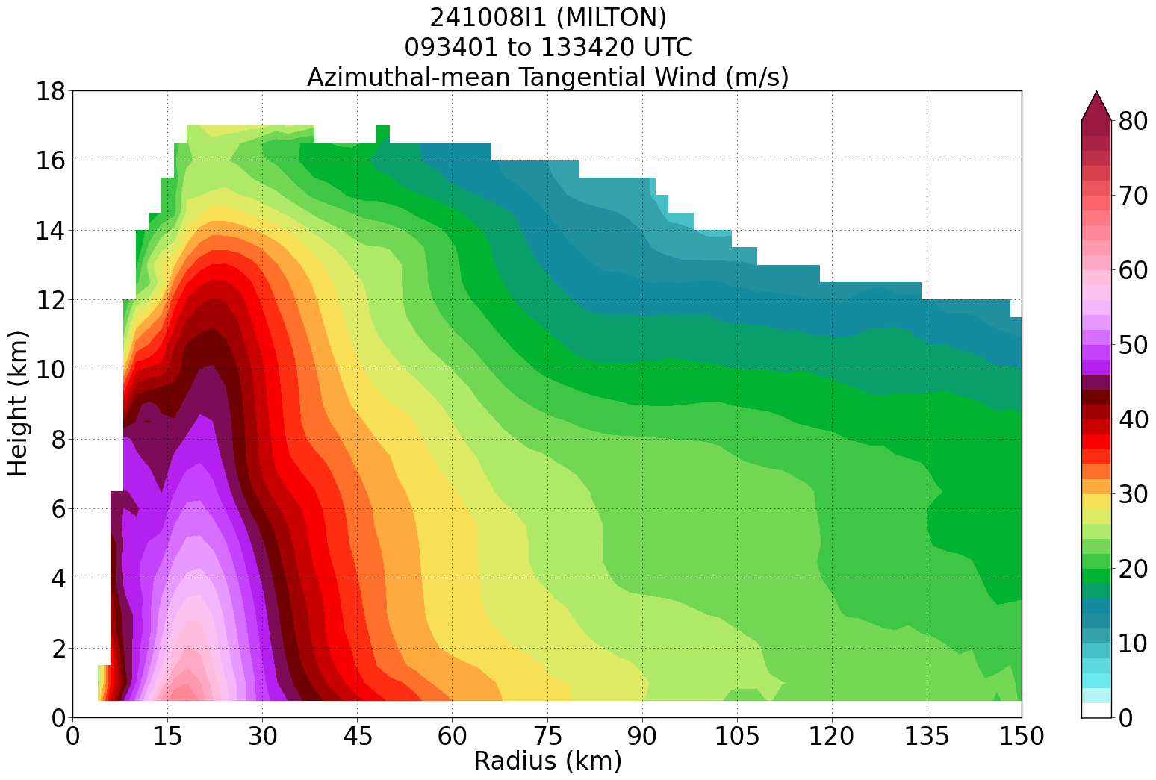
1449 | Landed at KMOB

POST-FLIGHT
Mission Summary | [Short description of interesting observations from the flight; what objectives were successful? What was unsuccessful? Was the planned pattern flown? What deviations occurred?  [Don’t forget to fill in Tables on page 1]  [Sonde and ocean expendable accounting: how many total of each? How many are charged to each account?]
Actual Standard Pattern Flown | Modified butterfly to account for land
APHEX Experiments / Modules Flown | RICO SUAVE
Plain Language Summary | [Boil down the above into a couple of bullet points in “plain language”. This will help us when we report to management & OAR Public Affairs and prepare storm mission summaries]
Instrument Notes | [Notes about instrument status from during and after the mission]
Final Mission Track | 