MISSION PLAN
FLIGHT ID | 20240706H1 | STORM | AL02 / Beryl
MISSION ID | 2402A | TAIL NUMBER | NOAA-42
TASKING | NHC/EMC TDR | PLANNED PATTERN | Butterfly
MISSION SUMMARY
TAKEOFF [UTC] | 0819 | LANDING [UTC] | 1503
TAKEOFF LOCATION | Lakeland | LANDING LOCATION | Lakeland
FLIGHT TIME | Fractional hr, Takeoff to Landing Time | BLOCK TIME | Get from onboard LPS or Flight Director
TOTAL REAL-TIME RADAR ANALYSES  (Transmitted) | 3 (3) | TOTAL DROPSONDES Deployed (Transmitted) | 18 (18)
OCEAN EXPENDABLES (Type) | n/a | sUAS (Type) | n/a
APHEX EXPERIMENTS / MODULES | Exact name of the Experiment in the HFP Plan; identify relevant experiments / module even if not a research tasking
HRD CREW MANIFEST
LPS ONBOARD | J. Zhang | LPS GROUND | X.Zhang
TDR ONBOARD | J. Zhang | TDR GROUND | Rogers
ASPEN ONBOARD | Sellwood | ASPEN GROUND | n/a
NESDIS SCIENTISTS
GUESTS (Affiliation)
AOC CREW MANIFEST
PILOTS | Rannenberg/Wood/Taraboletti
NAVIGATOR | Schaefer/Meier
FLIGHT ENGINEERS | Tyson/Wysinger/Ripp
FLIGHT DIRECTOR | Kalen, Q.
DATA TECHNICIAN | Richards,T.
AVAPS | Patel

PRE-FLIGHT
Flight Plan | [Insert image of submitted flight pattern here]  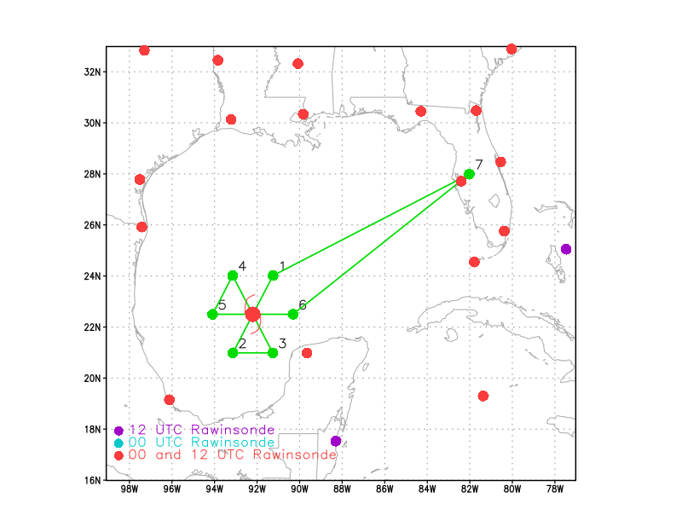  [Insert image of ONR/TCRI detailed pattern image, if available]  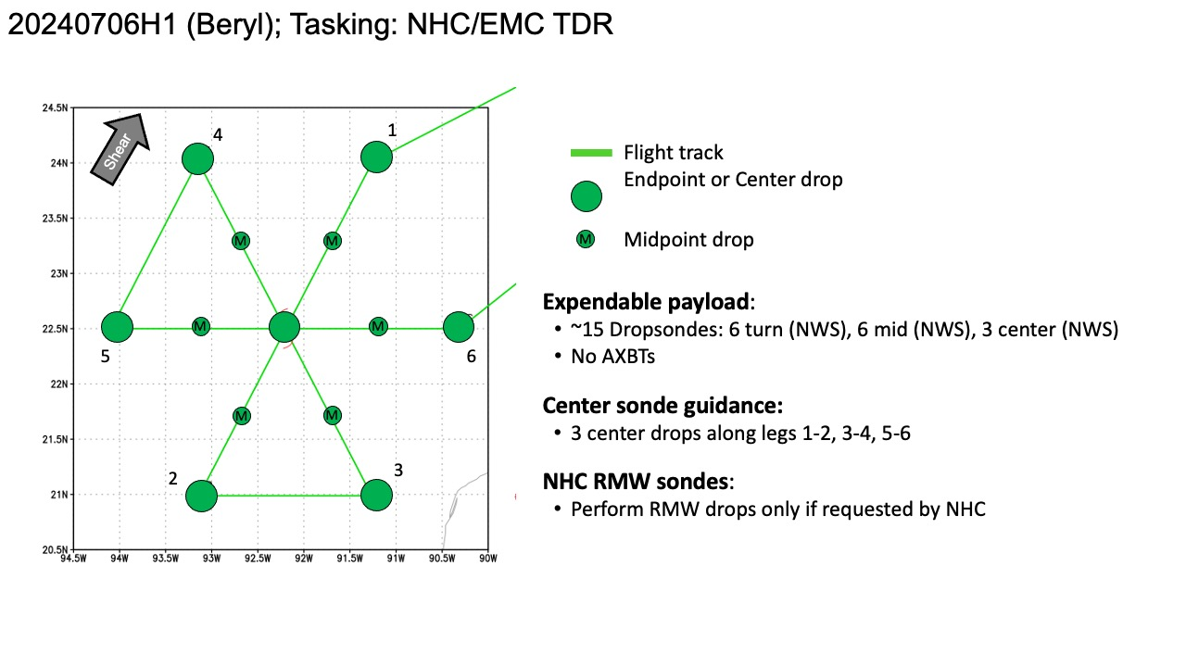  [If you want, briefly describe the pattern in words]  Pattern: Fly butterfly pattern with 105 NM legs  Altitude:  - 10 kft preferred - 8 kft if AF deconfliction is required (pressure altitude)  Potential add-on Modules: (time permitting)  - None  - Trey/Michael/Rob wanted VAM through emails
Expendable Distribution | [Describe planned dropsonde, ocean buoy, sUAS deployment locations; e.g., “Dropsondes/AXBT combo drops at endpoints, midpoints, and center”  Expendables:  - Load 30 dropsondes  - Release at endpoints, midpoints, centers, RMWs (if requested by NHC) >> charged to NWS  - All dropsondes transmitted to the GTS  - No AXBTs
Preflight Weather Briefing | [Notes from the Flight Crew Preflight Briefing and other relevant notes about the current and forecasted storm state from the most recent NHC advisory (location, intensity, MSLP, movement, possible intensity change during the flight)]  The center of Beryl has emerged over the southern Gulf of Mexico  just northwest of Progreso in the Yucatan Peninsula. Surface  observations and NOAA aircraft Tail Doppler Radar data indicate  that the storm has become significantly titled with the low-level  center located to the southwest of the mid-level vortex, with most  of the showers and thunderstorms located closer to the mid-level  center. The latest flight-level wind data from the Air Force  Hurricane Hunter aircraft support lowering the initial intensity to  50 kt. The minimum pressure is now up to 996 mb.  Beryl has been moving west-northwestward at about 11 kt as the  system remains steered by a mid-level ridge located over the  southeastern U.S. This motion should continue through early  Saturday, After that time, a gradual turn to the northwest with a  decrease in forward speed is predicted as Beryl moves toward a  weakness in the ridge caused by a trough over the south-central U.S.  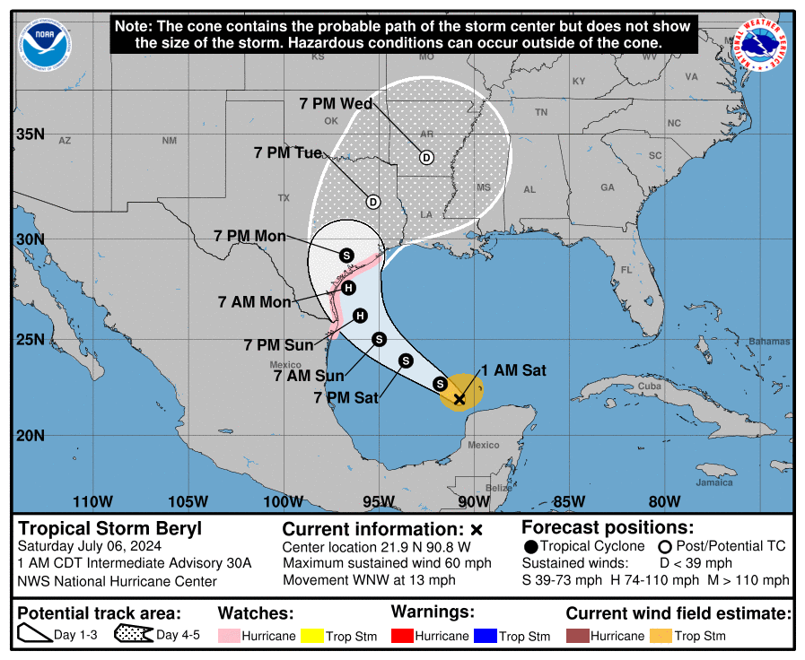  [Briefly describe the relevant environmental drivers.]  Since Beryl's structure has degraded significantly from its passage  over the Yucatan, it likely will take a little time for the storm to  recover. However, the overall environmental conditions are  conducive for strengthening with increasing water temperatures and  decreasing vertical wind shear along the expected track. In  addition, the global models are suggesting that the upper-level wind  pattern might become more diffluent before the system reaches the  coast, which could aid in the intensification process.  [Copy in GIF of recent (~6 hr) satellite loops (https://www.star.nesdis.noaa.gov/GOES/index.php)]
Instrument Notes | [What instruments are working, not working, not functioning nominally, not installed?]

IN-FLIGHT
Time [UTC] | Event
0819 | Take-off
1005 | 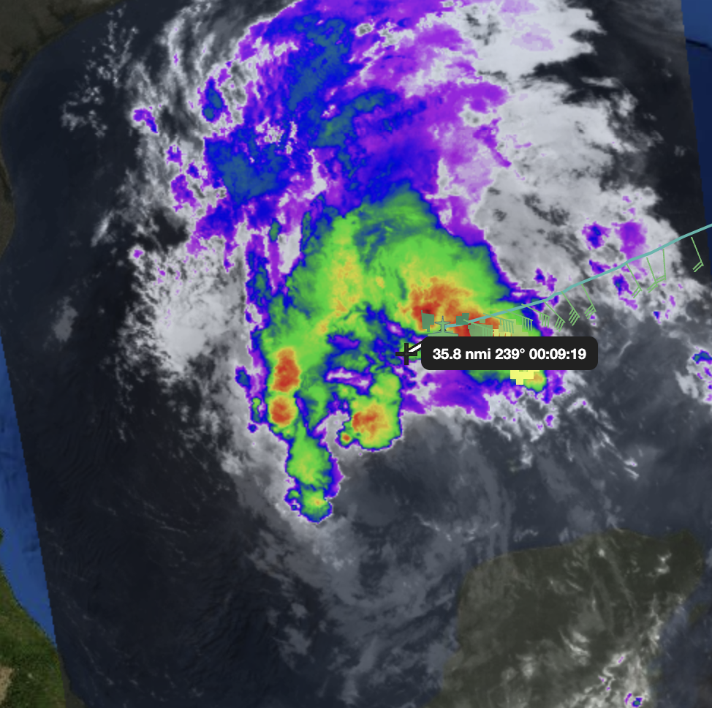  MLC and LLC are decoupled.
1012 | Sonde #1 IP NE-SW Pass
1025 | Sonde #2 MP NE
1038 | Marked FL center: 22.51002° -91.71661°, 0.4kt 299deg,
1038 | Sonde #3 Center  VORTEX DATA MESSAGE AL022024  A. 06/10:37:50Z  B. 22.51 deg N 091.72 deg W  C. 700 MB 3098 m  D. 999 mb  E. 075 deg 10 kt  F. NA  G. NA  H. NA  I. NA  J. 134 deg 59 kt  K. 040 deg 54 nm 10:22:41Z  L. NA  M. NA  N. 297 deg 32 kt  O. 211 deg 80 nm 10:57:07Z  P. 11 C / 3054 m  Q. 14 C / 3054 m  R. 9 C / NA  S. 134 / 7  T. 0.01 / 1 nm  U. NOAA2 2402A BERYL OB 99  MAX FL WIND 59 KT 040 / 54 NM 10:22:41Z  MAX FL TEMP 16 C 070 / 15 NM FROM FL CNTR
1046 | Sonde #4 QP SW
1055 | Sonde #5 MP SW
1102 | 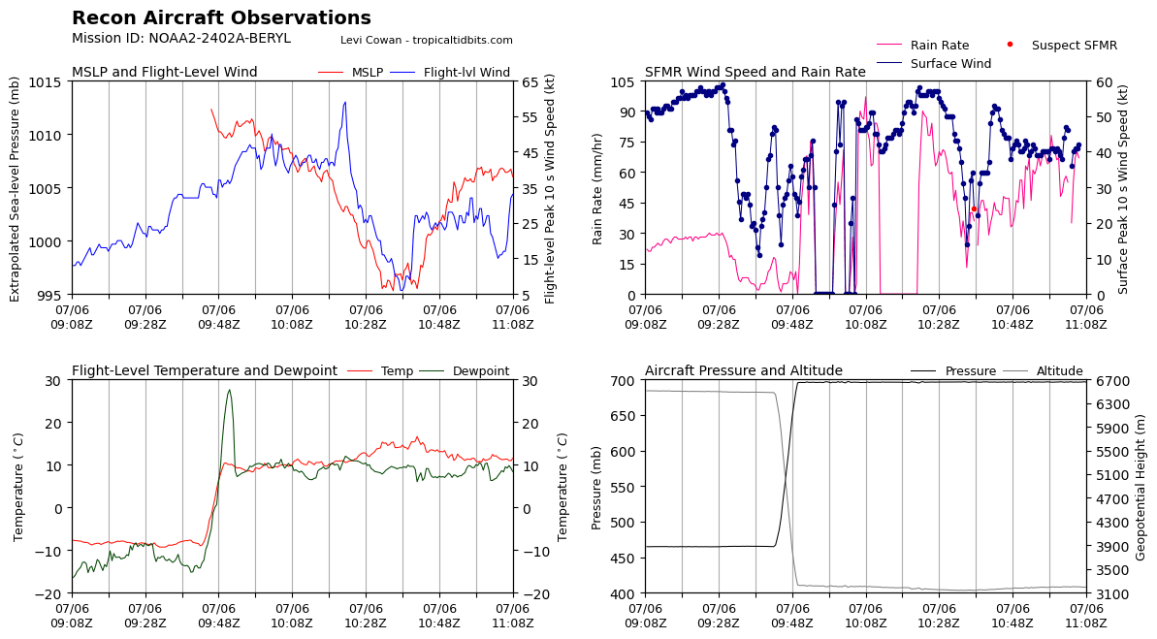  Look at time: 1043Z  SW 50 kts SFMR vs 25kts flight-level?? LPS’ comments. Need to confirm SFMR data  NE SFMR winds 50 kt vs. FL winds 60 kt, this is reasonable.  Rain rate is much stronger on NE than SW.  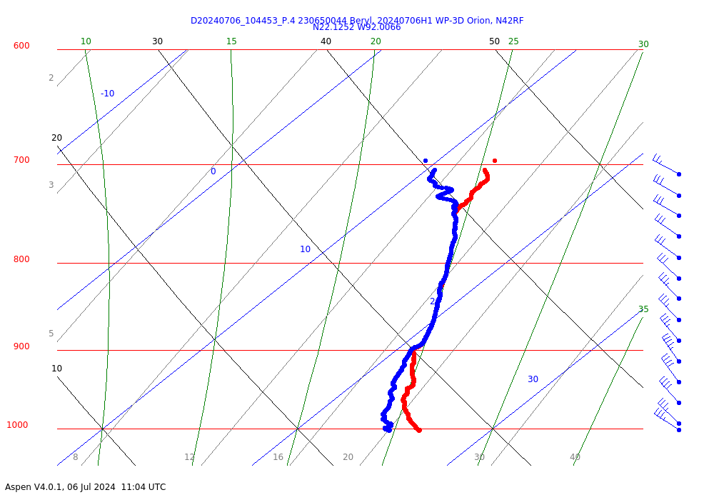  Confirmed drop sonde#4 QP sonde observation. The wind did increase a lot from FL to surface level. The wind is higher at the surface than FL. Need further investigation in the further
1104 | Sonde #6 EP SW  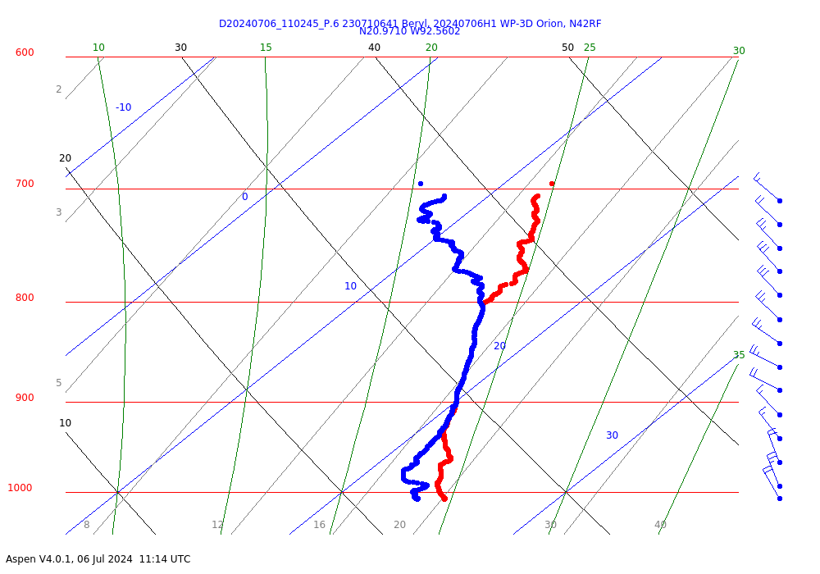
1125 | 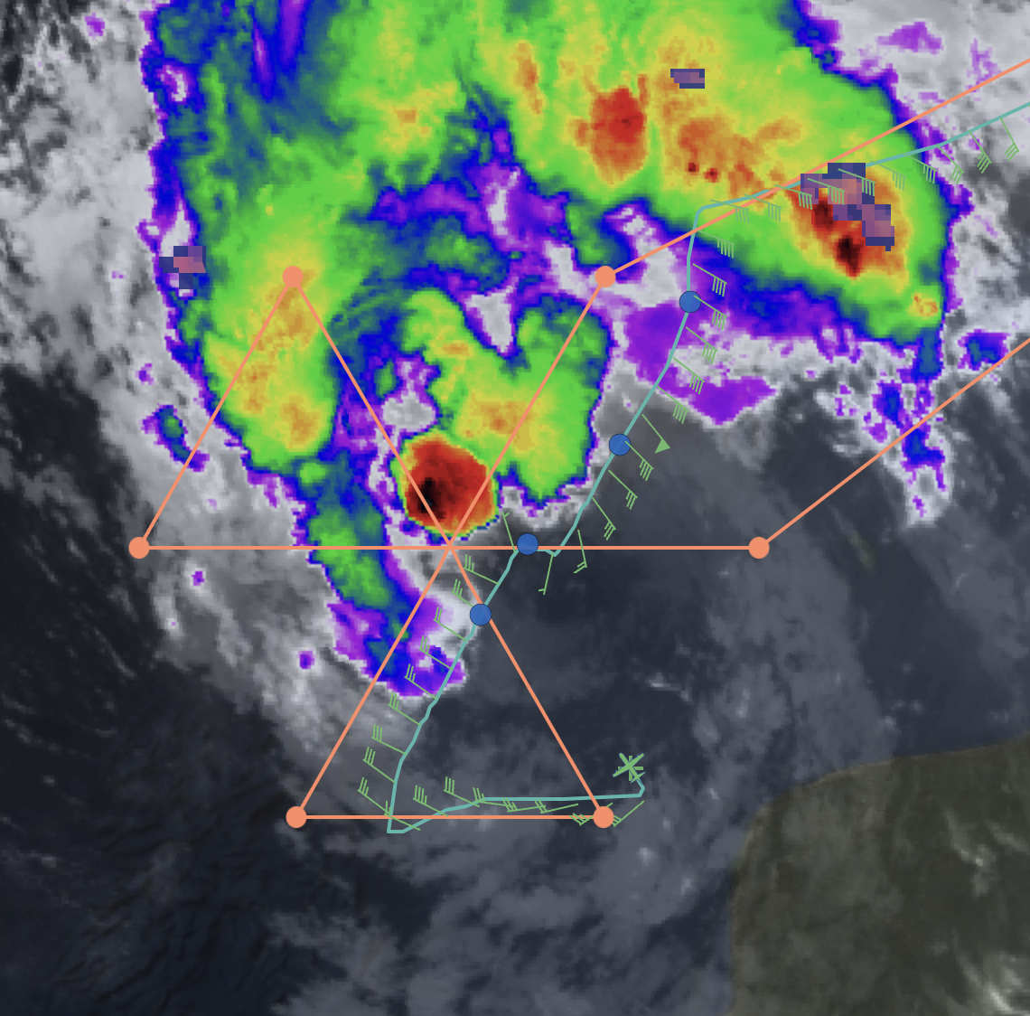
1125 | Sonde #7 IP of SE-NW pass
1128 | No rain outside during this inbound leg
1138 | Sonde #8 MP SE  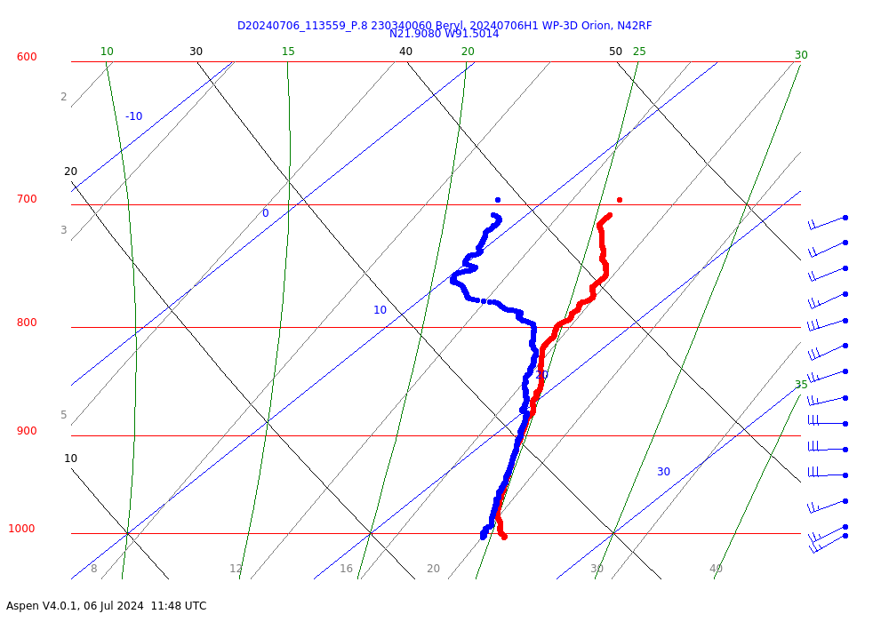
1142 | Sonde #9 QP SE
1145 | Sonde #10 Center #2  VORTEX DATA MESSAGE AL022024  A. 06/11:46:18Z  B. 22.55 deg N 091.84 deg W  C. 700 MB 3105 m  D. 999 mb  E. 295 deg 08 kt  F. NA  G. NA  H. NA  I. NA  J. 225 deg 30 kt  K. 153 deg 61 nm 11:31:36Z  L. NA  M. NA  N. 031 deg 40 kt  O. 330 deg 47 nm 11:57:38Z  P. 14 C / 3054 m  Q. 16 C / 3058 m  R. 9 C / NA  S. 134 / 7  T. 0.01 / 10 nm  U. NOAA2 2402A BERYL OB 99  MAX FL WIND 59 KT 040 / 54 NM 10:22:41Z  MAX FL TEMP 17 C 163 / 13 NM FROM FL CNTR
1154 | 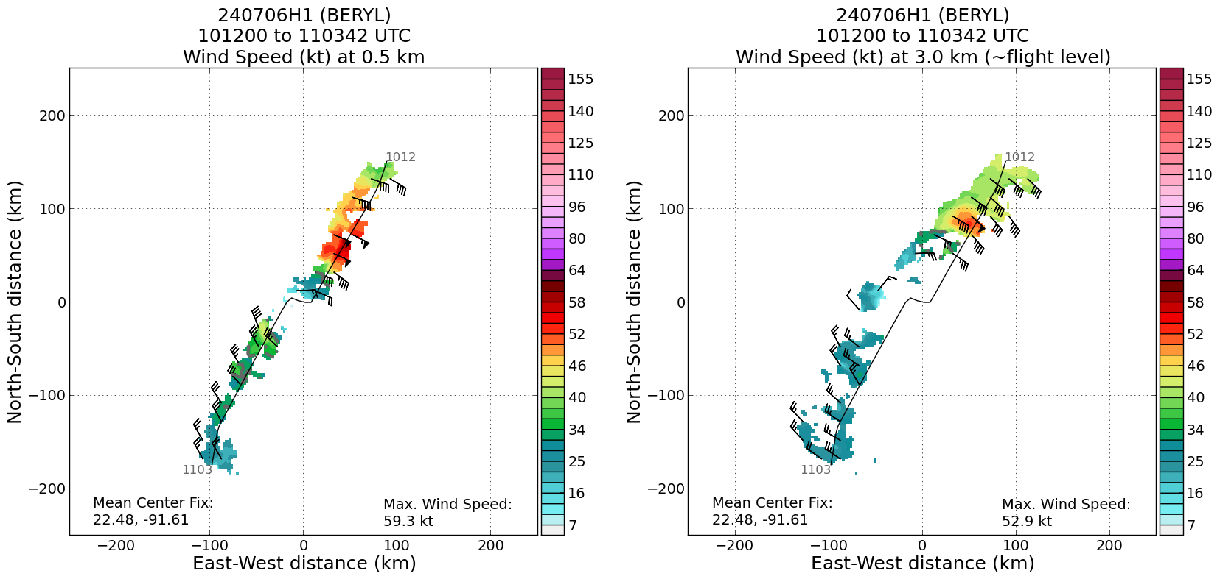  TDR analysis from first pass shows limited scatterers, but some winds. Strongest winds on NE side.
1155 | 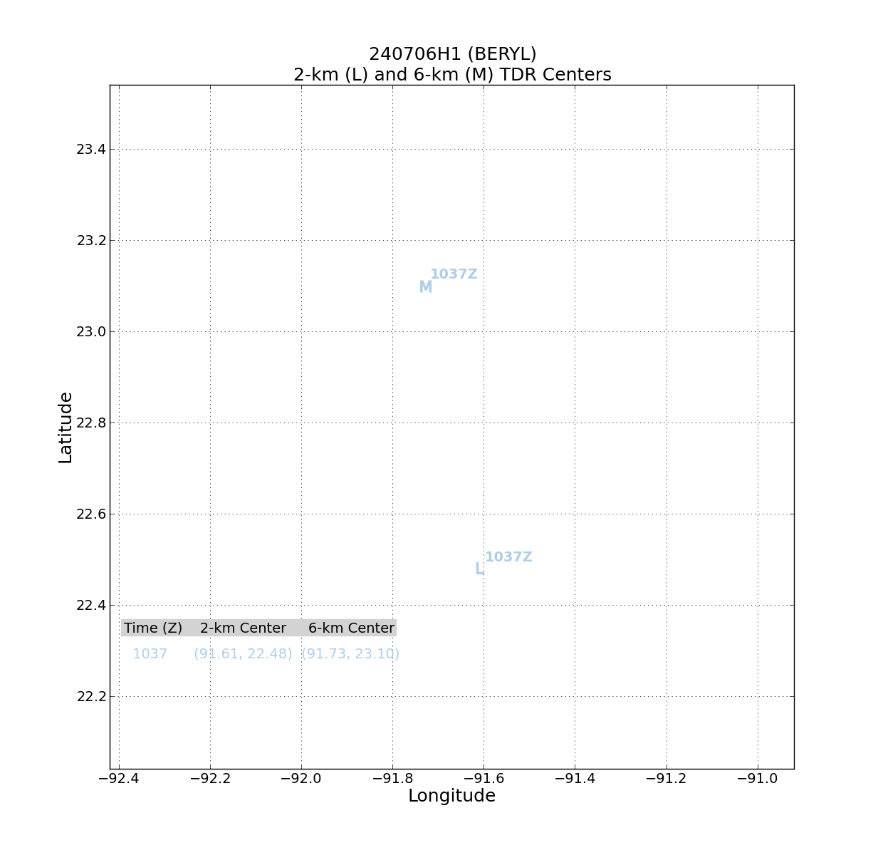  Despite lack of scatterers, a LLC and MLC were able to be identified, consistent with previous mission. Tilt of about 60 km toward the NNW. Uncertain about confidence in those center estimates, though, given limited coverage.
1159 | 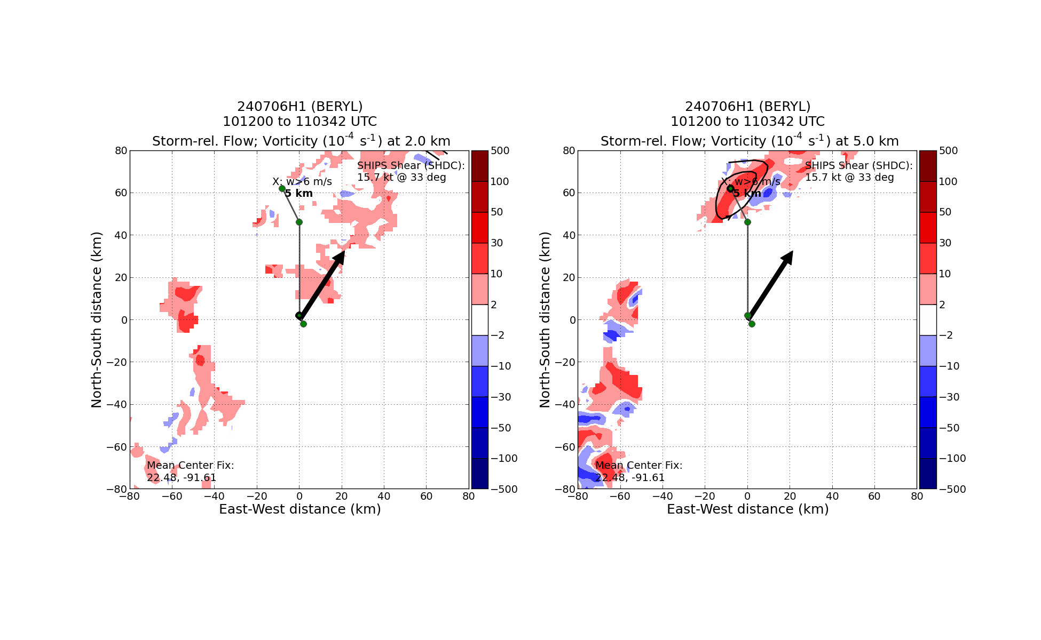  Tilt hodograph only extends up to about 5 km, shows tilt toward the north, left of SHIPS deep-layer shear vector
1155 | Sonde #11 QP NW
1201 | Sonde #12 MP NW
1202 | 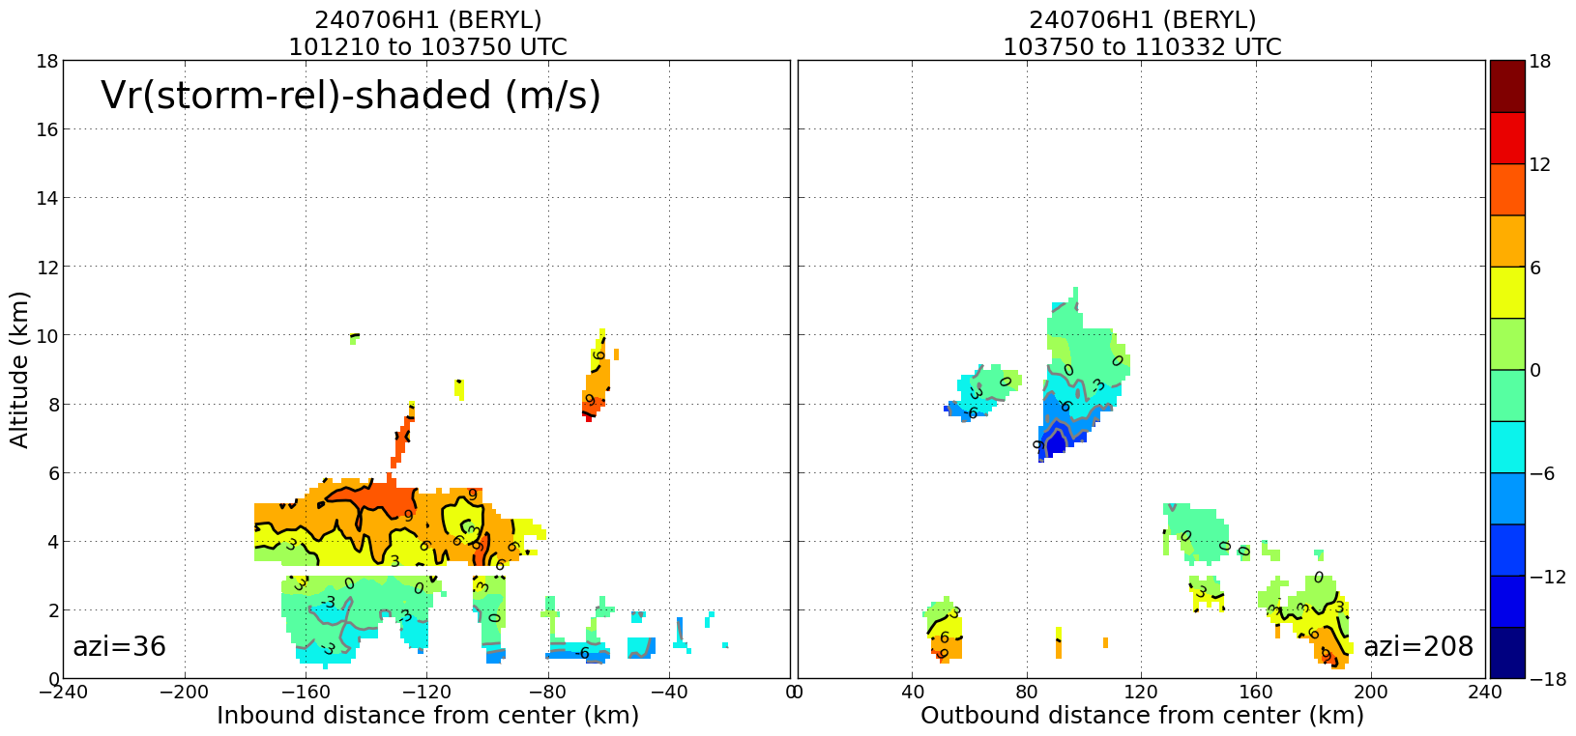  What limited coverage there is on the profiles shows shallow circulation, low-level inflow/midlevel outflow in NE quadrant (downshear), reverse flow upshear
1213 | Sonde #13 EP NW
1232 | Sonde #14 IP W-E pass
1248 | 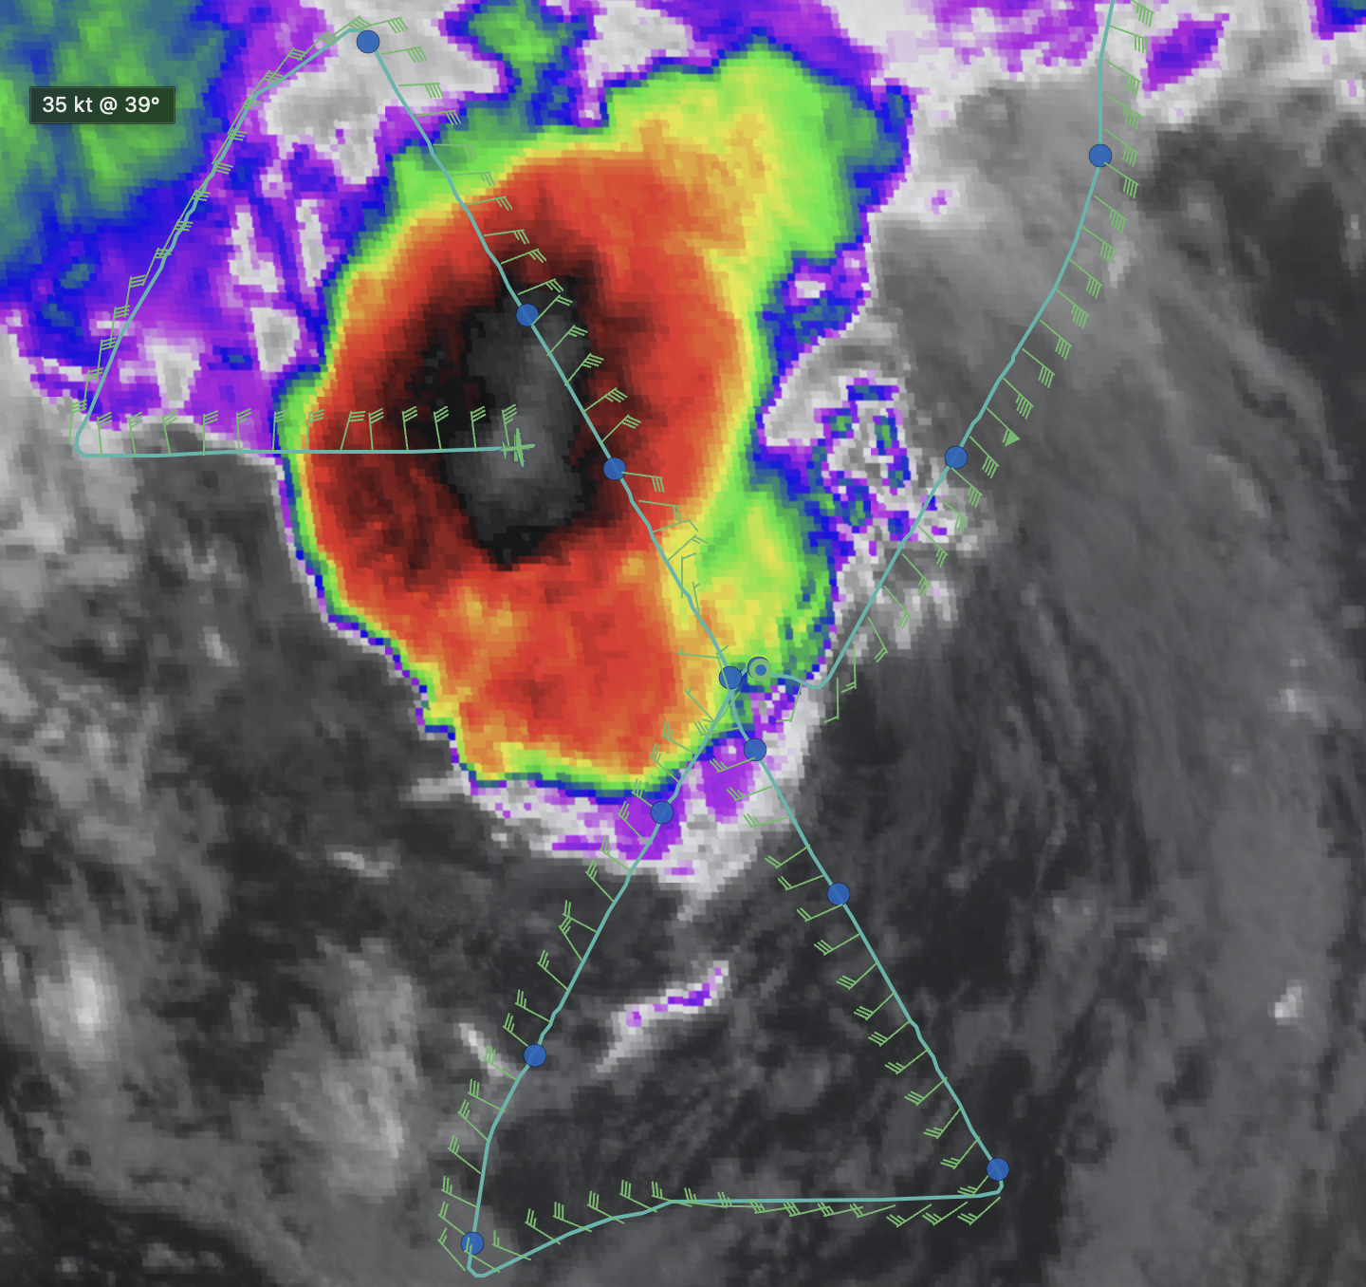
1244 | Sonde #15 MP W
1257 | Sonde #16 Center of 3rd pass (Note: this most likely not a center)  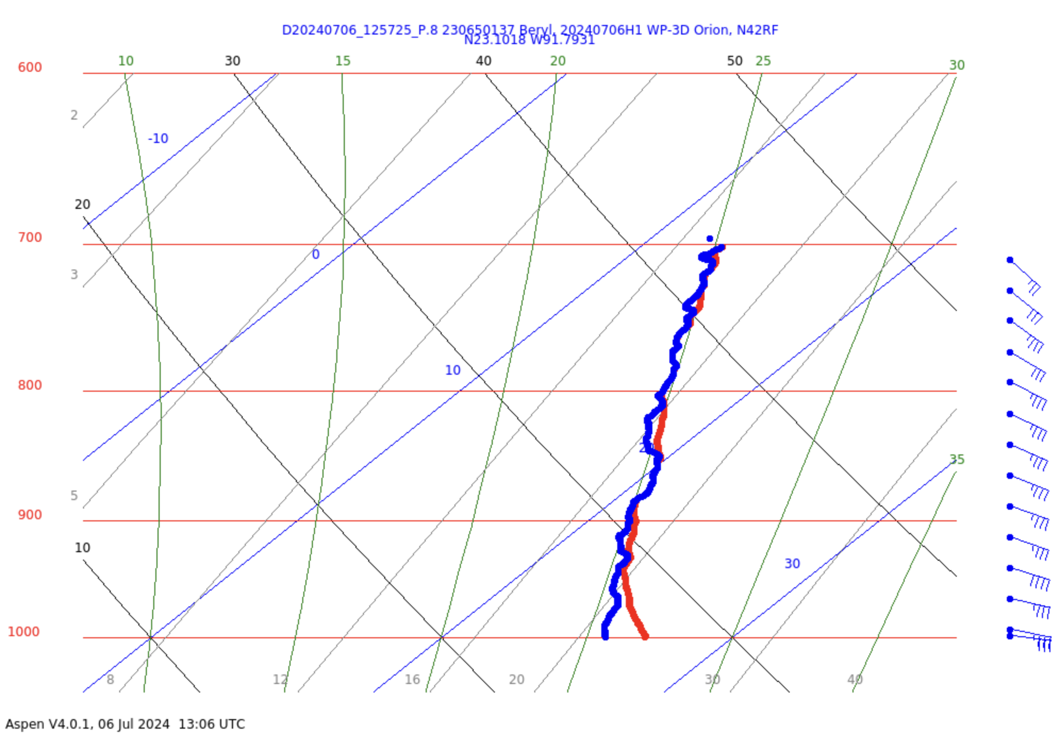
1301 | 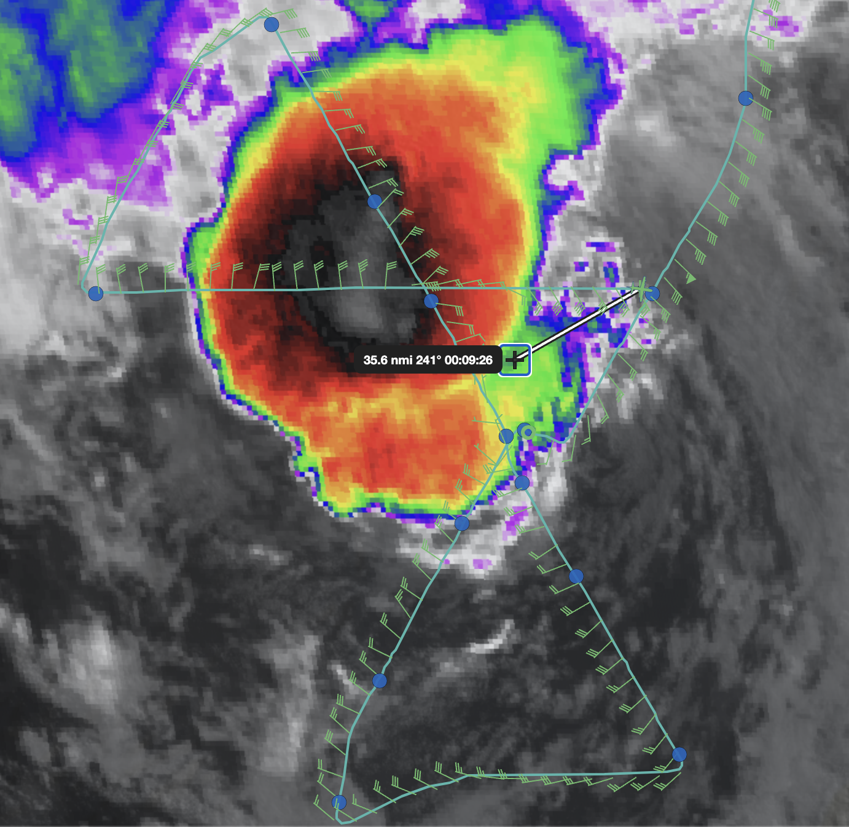  A reformation to the NW, where the MLC and deepest convection was located. Following the FL winds as before, but now it's taking you to this new location. Likely the mlc becomes the new center. That's exactly what we saw with Hermine and with Sally.  the FL winds now show a very broad circulation. I suspect the circulation is reorganizing closer to the burst  It is very hard to get the center during reformation  That is cool that you were able to estimate center using MTS  we'll see if that ends up becoming the new center
1312 | Sonde #17 MP E
1311 | 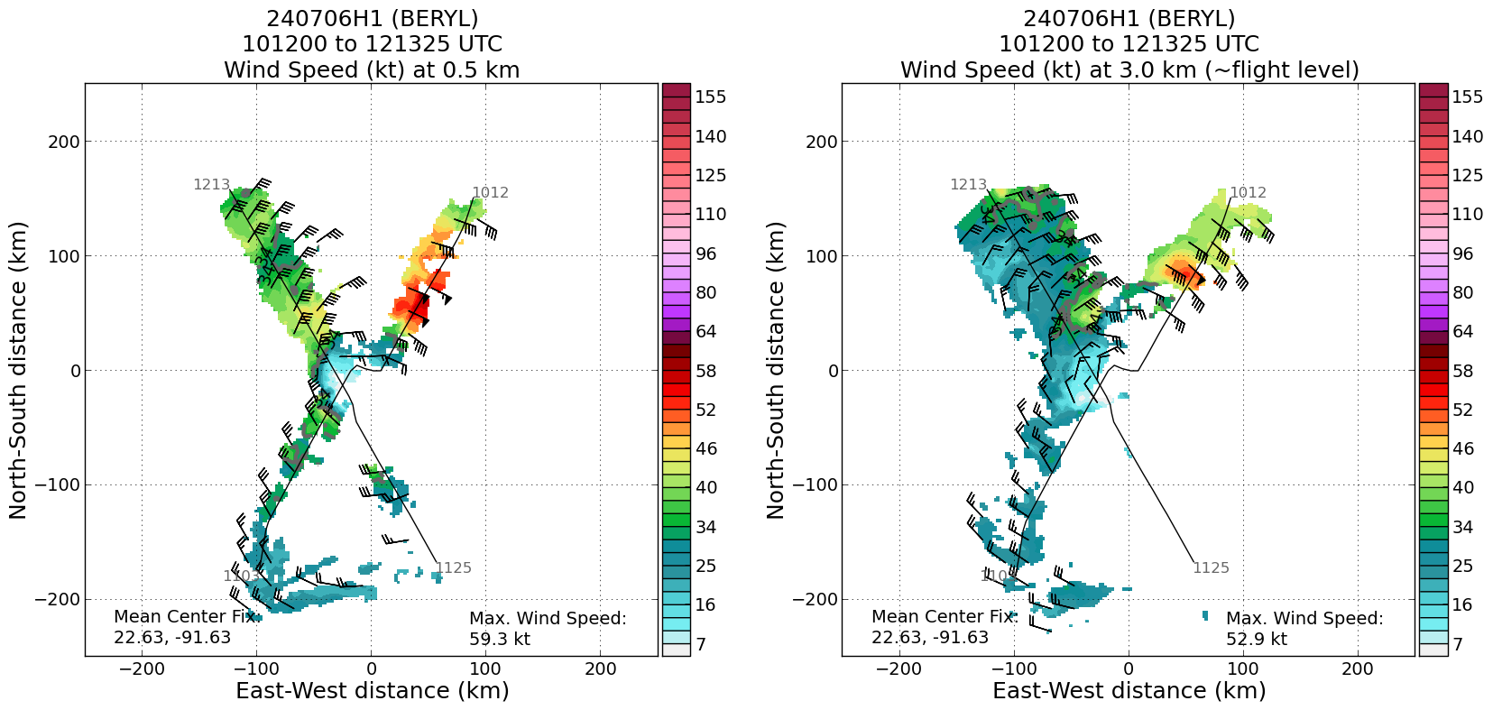  TDR analyses from second pass continue to show asymmetric wind field, peak winds at 0.5 km of 59 kt
1317 | 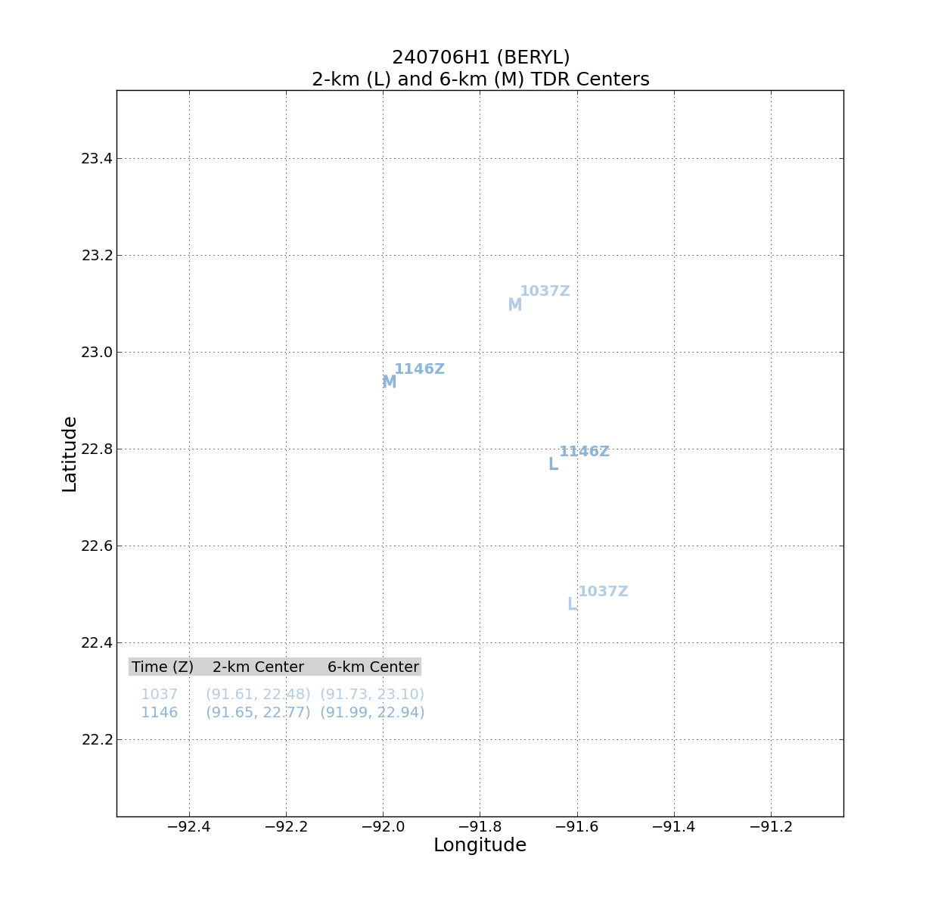  Plot of LLC and MLC shows that the center displacements have shifted from the first to the second pass. Now the MLC is about 35-40 km to the WNW of the LLC. This is a marked change from the previous pass. The orientation of the MLC relative to the LLC is consistent with the convective burst, which was developing NW of the LLC during the time of the second pass.
1319 | 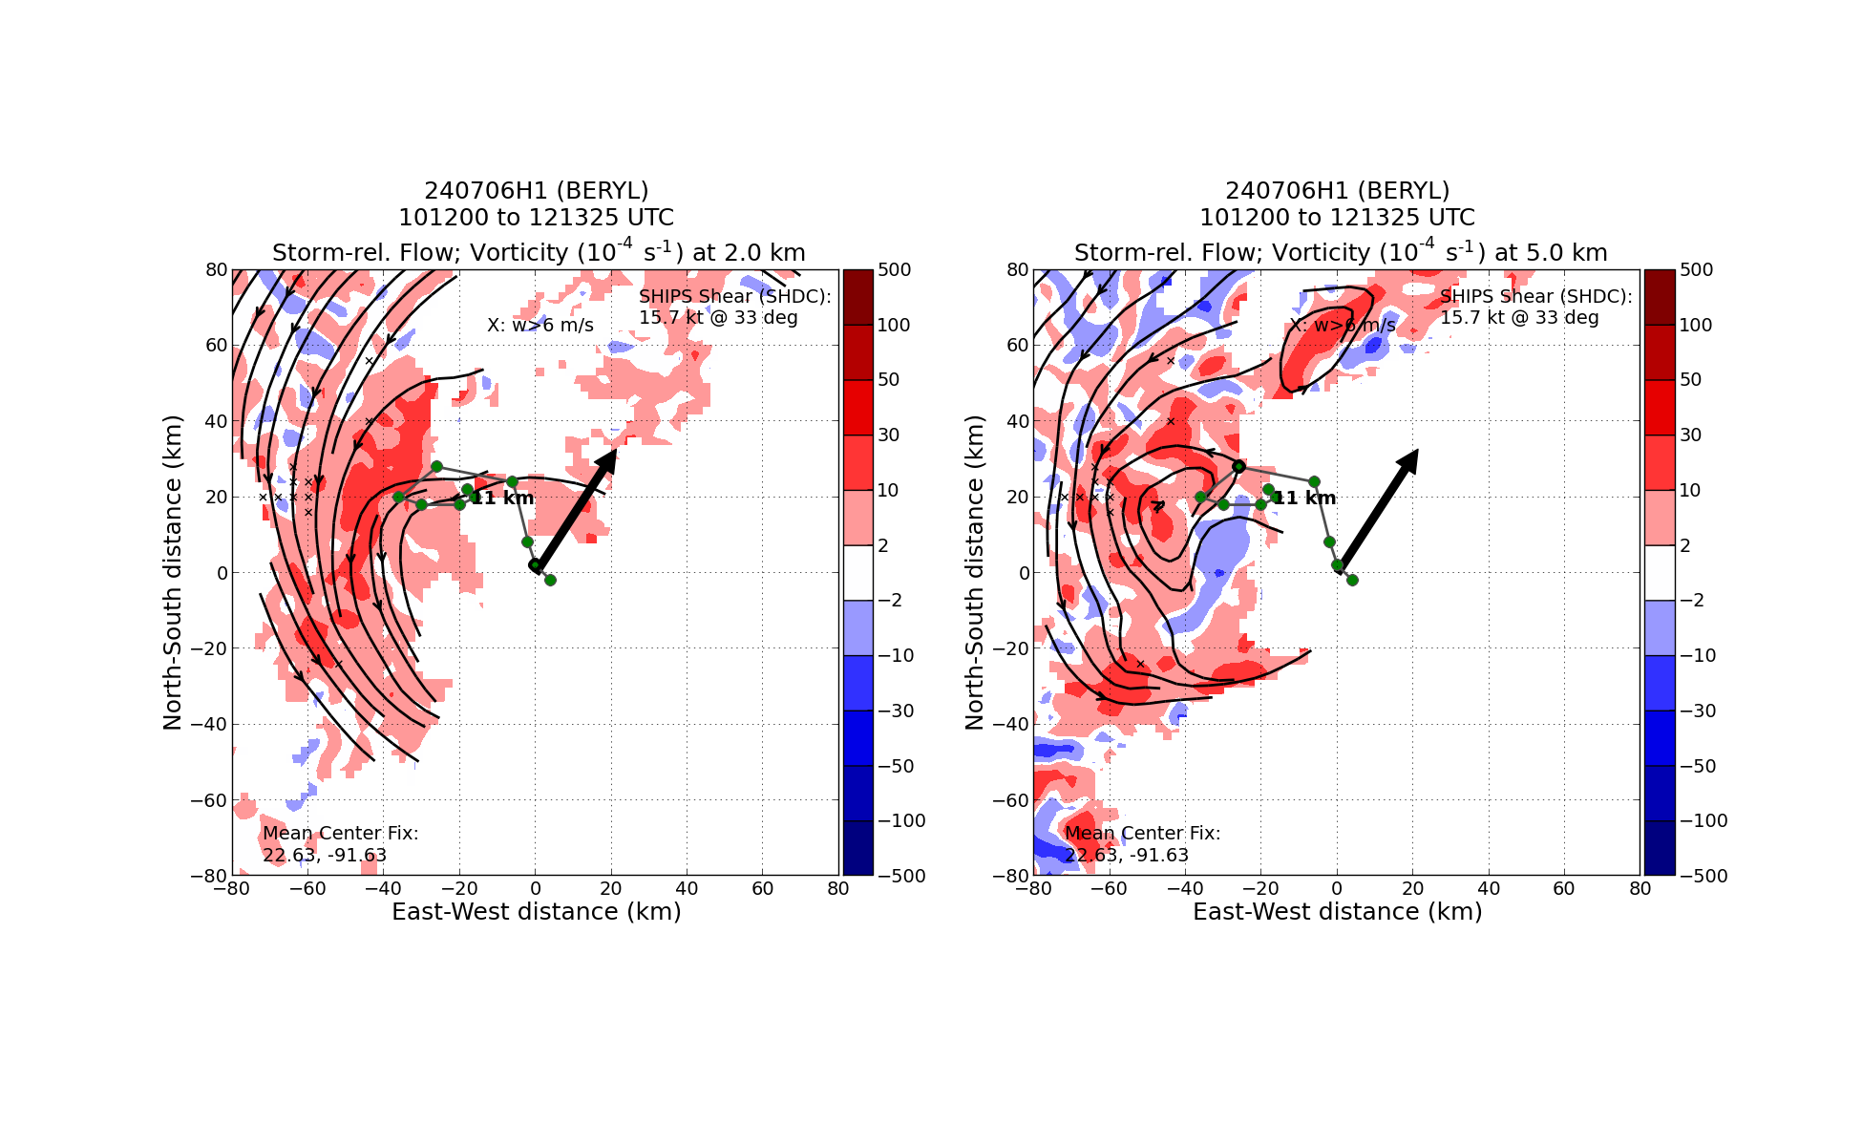  Tilt hodograph confirms this orientation to the NW. Area of high vorticity also to the NW at 5 km. No scatterers at the center or to the east.
1325 | Sonde #18 EP/FP E
1438 | 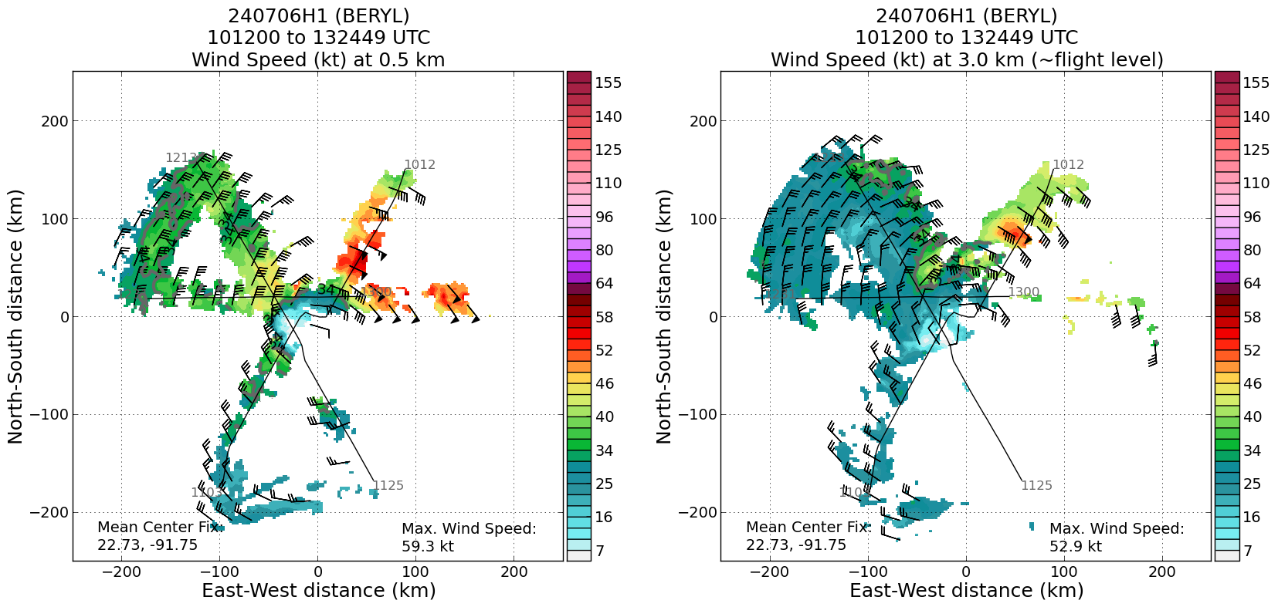  Radar analyses from all three passes shows that 0.5-km winds are strongest in the NE quadrant
1440 | 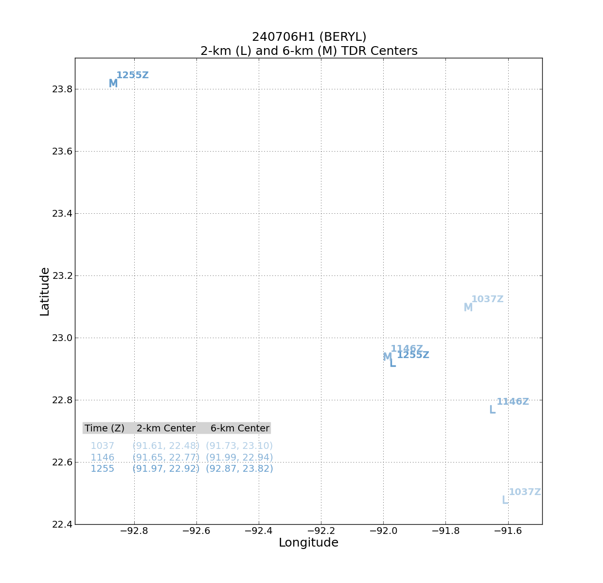  Center positions are quite a bit different from pass to pass. MLC during third pass nearly 100 km NW of MLC during previous passes. As a result the displacement between the LLC and the MLC is about 135 km toward the NW. The location of the MLC appears related to the convective burst on the NW side of the storm.
1443 | 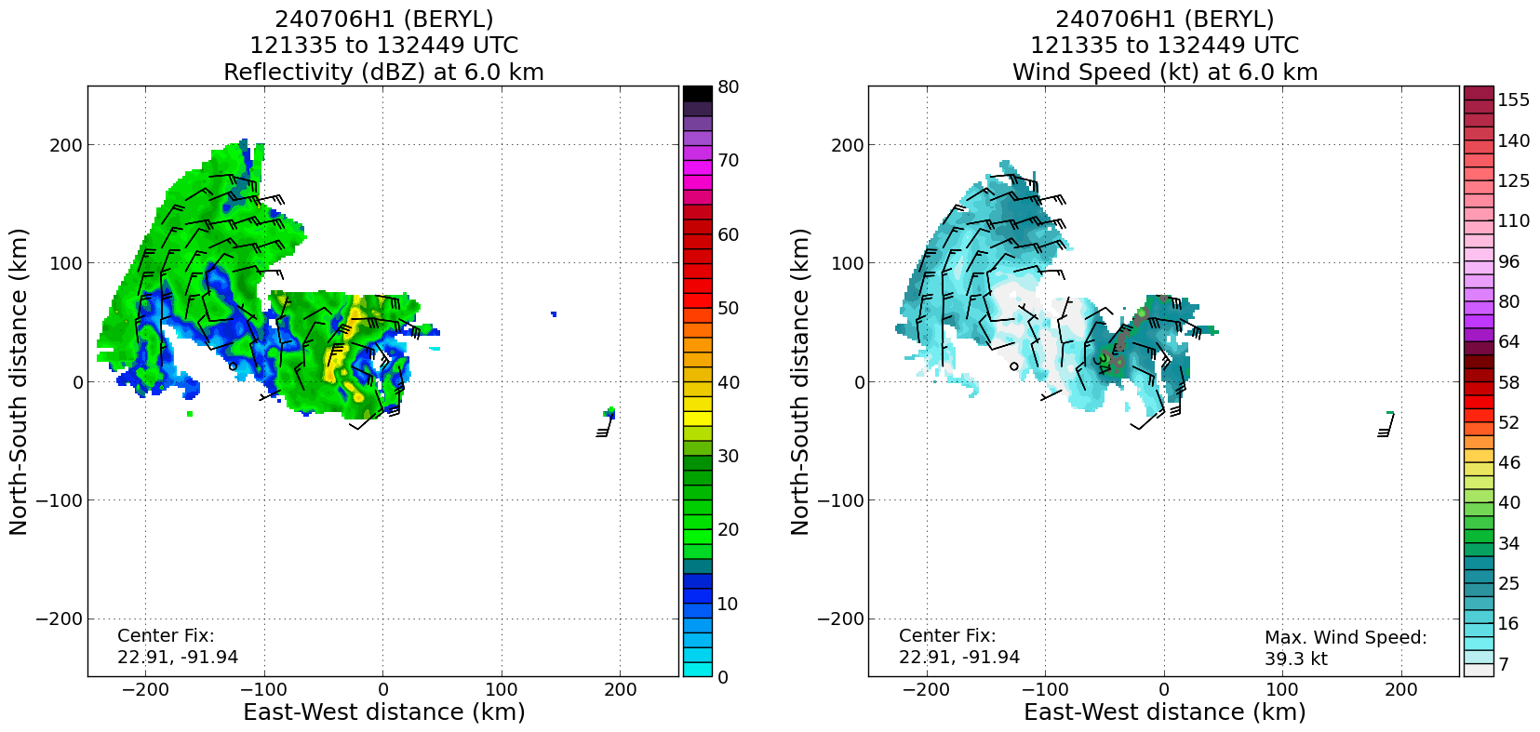  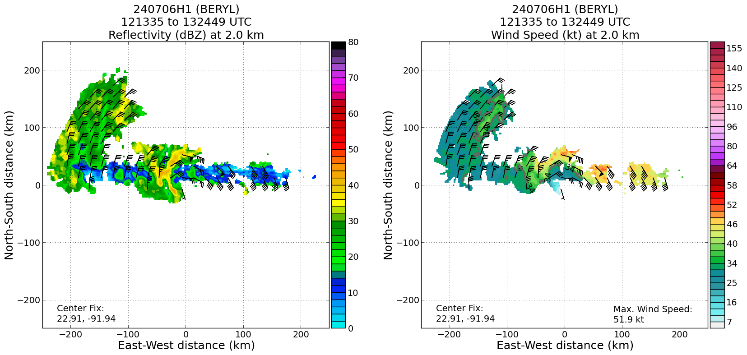  Swaths of wind speed and barbs at 2- and 6-km altitude show the differing flow patterns. MLC seems to have been identified at the region of turning winds at about x=-110 km, y=70 km
1446 | 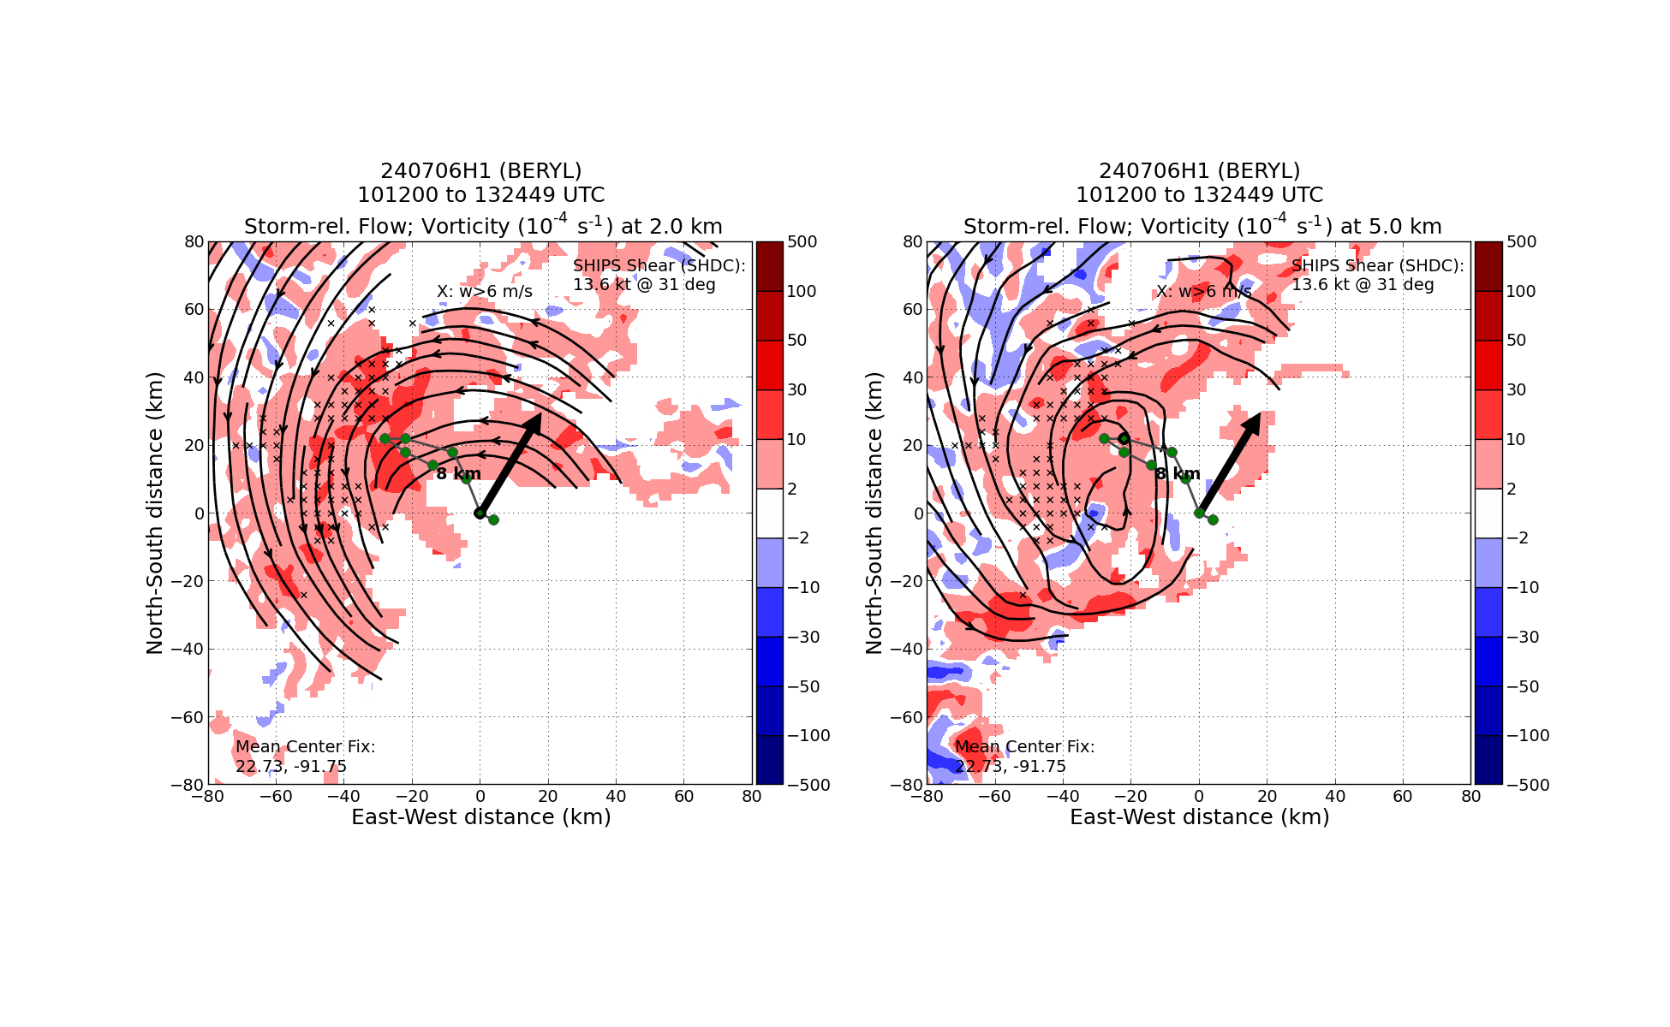  Tilt hodograph does not show that much displacement, but this is an accumulated field that does not show pass-to-pass evolution. It would be interesting to examine the tilt hodograph for the third pass only (and compare those to the first two passes). The location of strongest updrafts can be seen to the NW, where the convective burst was located.
 | << INSERT ADDITIONAL ROW AS NEEDED >>

POST-FLIGHT
Mission Summary | [Short description of interesting observations from the flight; what objectives were successful? What was unsuccessful? Was the planned pattern flown? What deviations occurred?  [Don’t forget to fill in Tables on page 1]  [Sonde and ocean expendable accounting: how many total of each? How many are charged to each account?]  AOML/HRD was supporting operationally tasked NOAA NHC/EMC P-3 Tail Doppler Radar missions into TS Beryl after passing the Yucatan kPeninsula. TS Beryl was 50kts (60 MPH) at the beginning of the mission. A butterfly pattern with three center passes was flown. The third pass was interesting. The pass may go through a pass ​​close to the newly formed storm center even without a VAM module. This may unintentionally test a new way to capture the vortex formation. The mission was successful. All 18 dropsondes were transmitted. There were some interesting characteristics we observed:  1. The storm MLC and LLC were misaligned during the whole mission. The last pass estimated the distance between MLC and LLC was 13x miles. The storm was asymmetric and the convection was located in the WNW part. No rain presented in the SE-NW inbound leg till near the storm center. There was dry air intrusion in the south side of the storm above 850mb.  2. Strong asymmetry: Strong misalignment between flight level winds and SFMR winds (see figure at 1102). Dropsonde wind profile may validate the SFMR winds are legitimate. Some SFMR data may be worth further investigation by experts.  3. Storm alignment processes: the reformation processes may be similar to the genesis and/or rapid intensification processes from a dynamics viewpoint. It’s in a lower-rotational environment so the divergence flow is more dominant. From the thermodynamics viewpoint, the precipitation and latent heating observations are observable in our current platform so how the interplay between dynamics and thermodynamics should be further investigated.
Actual Standard Pattern Flown | [Butterfly]
APHEX Experiments / Modules Flown | [Linked to HFP Plan; fill in regardless of whether the mission was operationally or research tasked]  NOAA
Plain Language Summary | [Boil down the above into a couple of bullet points in “plain language”. This will help us when we report to management & OAR Public Affairs and prepare storm mission summaries]  AOML/HRD was supporting operationally tasked NOAA NHC/EMC P-3 Tail Doppler Radar missions into TS Beryl after passing the Yucatan Peninsula. TS Beryl was 50kts (60 MPH) at the beginning of the mission. We observed the storm MLC and LCC were not aligned during the whole mission. A new center about 40 miles north away from the previous hour center seemed formed. A new observation approach for storm alignment processes may be worth testing and validating in the future. The new approach fly the pass between the MLC and LLC perpendicular to the two-center connection line. The figure 4 pattern can be aligned to this pattern.
Instrument Notes | No instrument issue reported.
Final Mission Track | [Insert MTS screenshot of final flown track, ideally at the completion of the pattern with satellite imagery]  