MISSION PLAN
2FLIGHT ID | 20240705H1 | STORM | AL02 / Beryl
MISSION ID | 2202A | TAIL NUMBER | NOAA-42
TASKING | NHC/EMC TDR | PLANNED PATTERN | Butterfly
MISSION SUMMARY
TAKEOFF [UTC] | 1957 | LANDING [UTC]
TAKEOFF LOCATION | Lakeland | LANDING LOCATION | Lakeland
FLIGHT TIME | Fractional hr, Takeoff to Landing Time | BLOCK TIME | Get from onboard LPS or Flight Director
TOTAL REAL-TIME RADAR ANALYSES  (Transmitted) | 3 | TOTAL DROPSONDES Deployed (Transmitted) | 11
OCEAN EXPENDABLES (Type) | N/A | sUAS (Type) | N/A
APHEX EXPERIMENTS / MODULES | Exact name of the Experiment in the HFP Plan; identify relevant experiments / module even if not a research tasking
HRD CREW MANIFEST
LPS ONBOARD | Aberson | LPS GROUND | Hazelton
TDR ONBOARD | Aberson | TDR GROUND | Alvey
ASPEN ONBOARD | None | ASPEN GROUND | Kaplan, Dunion
NESDIS SCIENTISTS | None
GUESTS (Affiliation) | None
AOC CREW MANIFEST
PILOTS | Copare, Palmer, Ellis
NAVIGATOR | Utama
FLIGHT ENGINEERS | Stokes, Dittoe
FLIGHT DIRECTOR | Zawislak, Englert
DATA TECHNICIAN | McCalister
AVAPS | Katz

PRE-FLIGHT
Flight Plan | 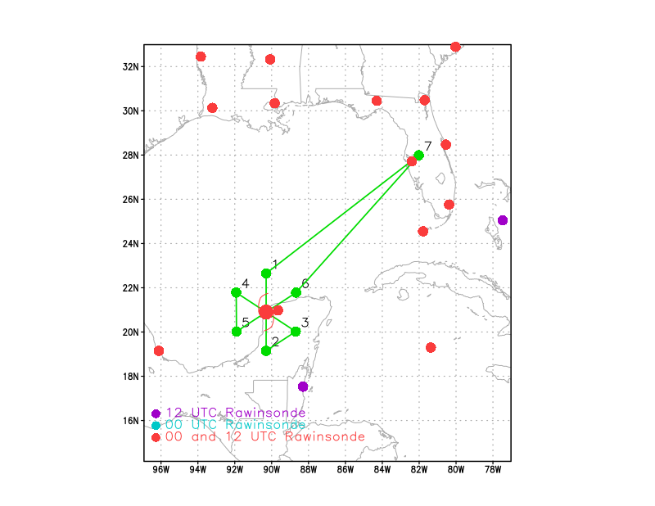
Expendable Distribution | Endpoints, midpoints, centers. Modify as needed for land.
Preflight Weather Briefing | Beryl is emerging off the Yucatan Peninsula tonight. The core has definitely been eroded after passage over land, although outflow is healthy and the MLC still appears intact.  There is some dry air to the west, associated with an upper low. It remains to be seen if this will work its way into the core.  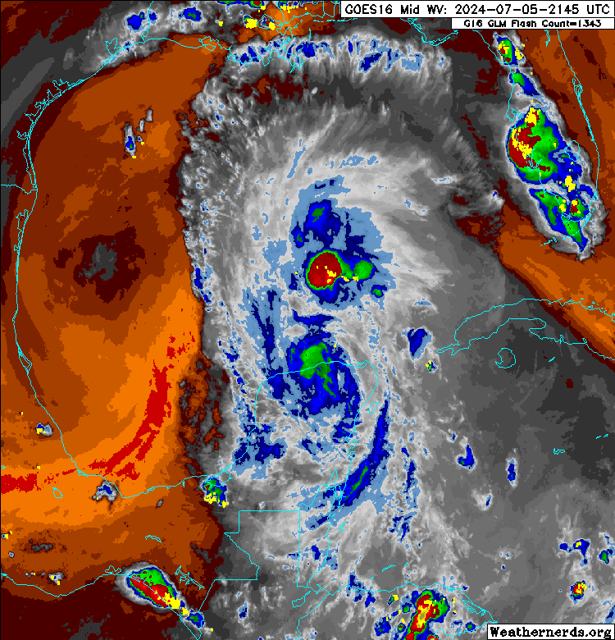
Instrument Notes | We are switching to the minisondes tonight.

IN-FLIGHT
Time [UTC] | Event
1957 | Take off from KLAL
2132 | Descending to IP
2157 | Drop 1 IP N
2211 | Drop 2 MP N
2212 | Noticing some of the SFMR HDOBs are zeroing out
2222 | Drop 3 Center
2223 | Looks like the center is right on the coast  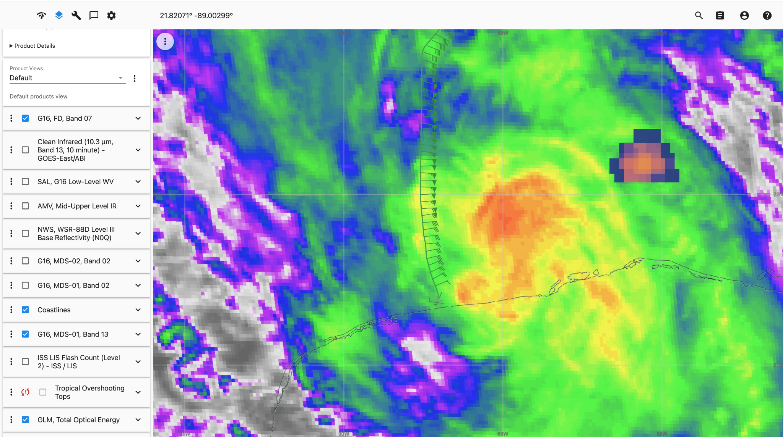
2253 | First jobfile sent, turning downwind
2328 | Center sonde 4
2336 | First TDR analysis shows notable S-N tilt  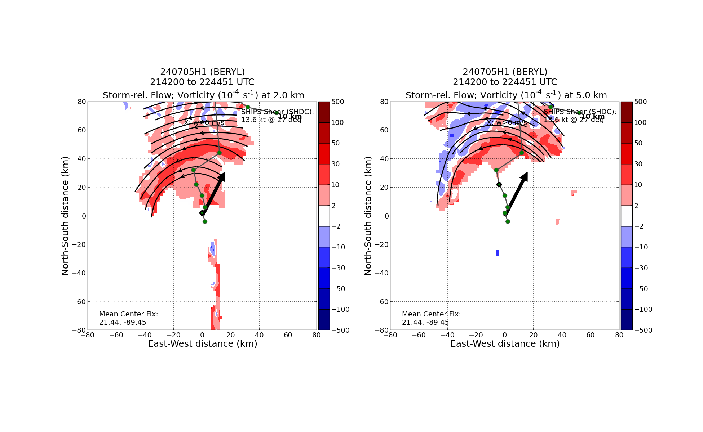
2341 | Midpoint sonde 5
2352 | Endpoint NW sonde 6
0012 | Endpoint SW Sonde 7 (IP)
0024 | Midpoint SW Sonde 8
0037 | Center sonde 9
0046 | Worth noting that the SSTs just off the Yucatan are cooler - once the center moves over the warmer water, it may have an easier time re-firing convection.  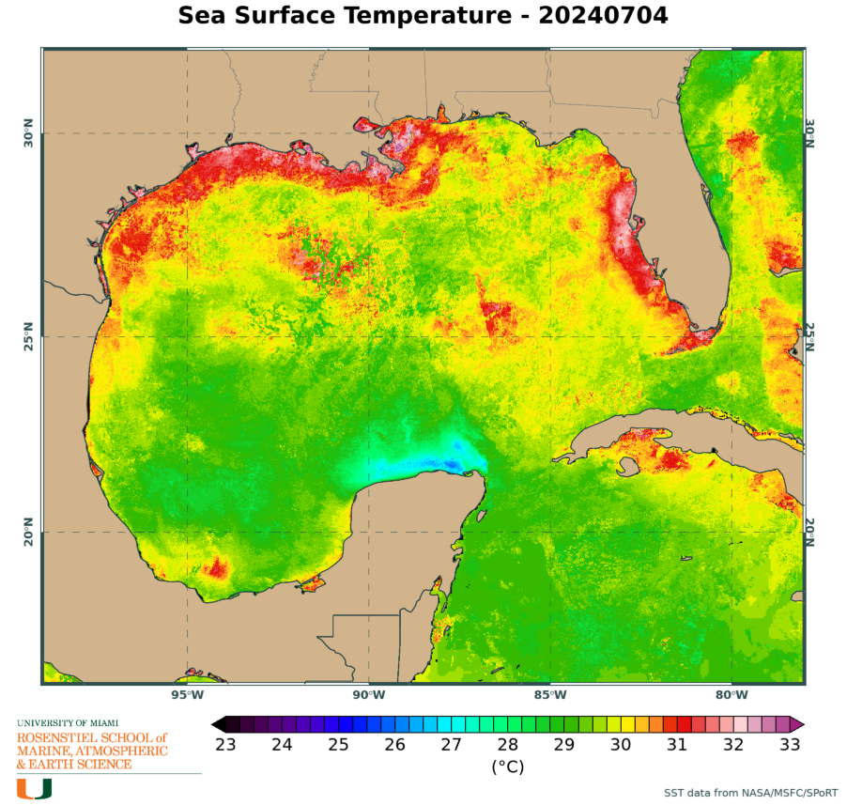
0050 | MP NE Sonde 10
0100 | EP NE Sonde 11
0111 | Science complete, leaving TDR on to paint a strong band.
0127 | 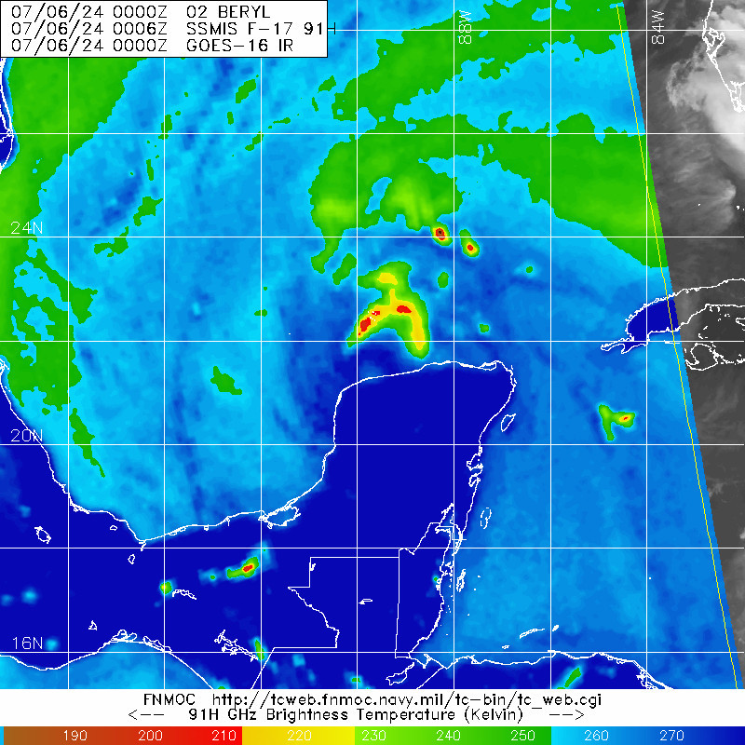
0142 | Final radar analysis  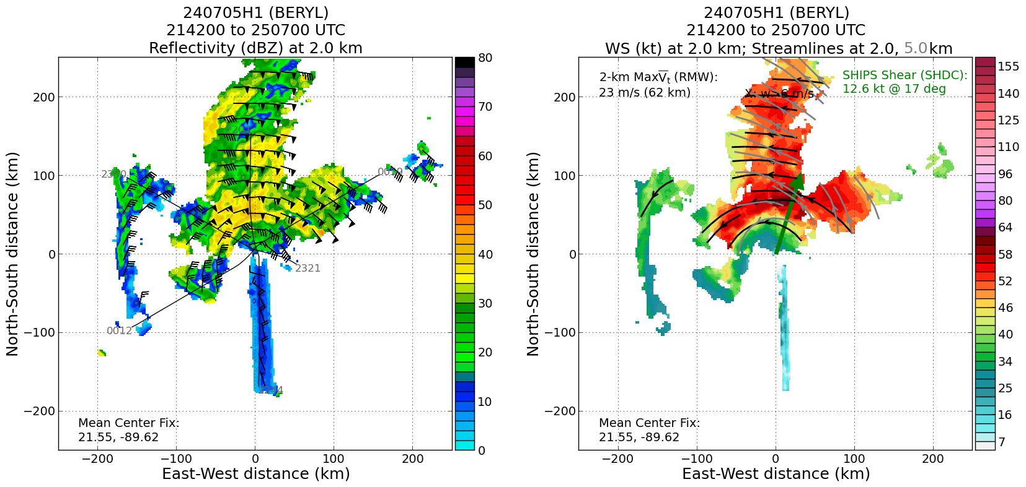  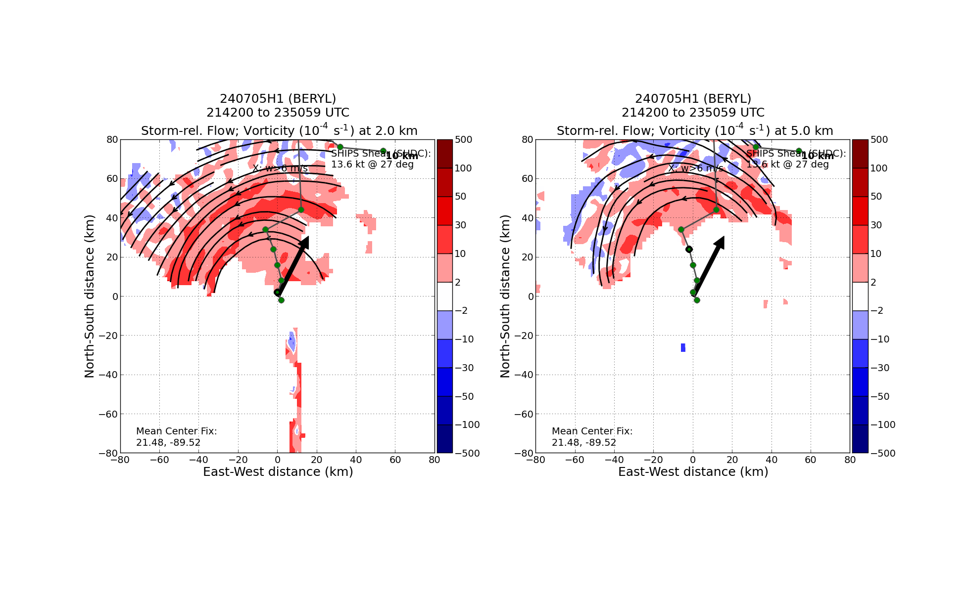

POST-FLIGHT
Mission Summary | We flew a successful butterfly pattern into Tropical Storm Beryl in the Gulf of Mexico, as it emerged off the Yucatan Peninsula.  The storm had become significantly tilted and weakened by the combination of dry air, shear, and interaction with land, with TDR analyses suggesting S-N tilt. All of the strong winds were on the N side of the circulation.  Models suggest the tilt should reduce over the next 24-36h, but there are some discrepancies in how quickly the title reduces and how much dry air is entrained into the circulation.
Actual Standard Pattern Flown | Butterfly
APHEX Experiments / Modules Flown | N/A
Plain Language Summary | We flew a TDR mission into now TS Beryl as it came off the Yucatan Peninsula. The system was notably weaker due to land interaction, and the vortex was tilted with height due to wind shear.
Instrument Notes | The SFMR HDOBS still appeared to zero out at times.
Final Mission Track | 