MISSION PLAN
FLIGHT ID | 20231022I1 | STORM | AL20/Tammy
MISSION ID | 1220A TAMMY | TAIL NUMBER | NOAA-43
TASKING | HRD | PLANNED PATTERN | Butterfly + modules
MISSION SUMMARY
TAKEOFF [UTC] | 1303 | LANDING [UTC] | 2116
TAKEOFF LOCATION | TBPB | LANDING LOCATION | TBPB
FLIGHT TIME | 8.2 | BLOCK TIME | 8.5
TOTAL REAL-TIME RADAR ANALYSES  (Transmitted) | 7 (7) | TOTAL DROPSONDES Deployed (Transmitted) | 22 (20)
OCEAN EXPENDABLES (Type) | 4 (2) AOC/HRD AXBT | sUAS (Type) | 1 Altius-600
APHEX EXPERIMENTS / MODULES | RICO SUAVE, VAM, Microphysics Spiral, CHAOS (Saildrone 1040)
HRD CREW MANIFEST
LPS ONBOARD | Marks/Cione | LPS GROUND | Dunion
TDR ONBOARD | Marks | TDR GROUND | Reasor/Fischer
ASPEN ONBOARD | J. Zhang | ASPEN GROUND | n/a
NESDIS SCIENTISTS | n/a
GUESTS (Affiliation) | Sosa, Person (Area I)
AOC CREW MANIFEST
PILOTS | Doremus/Wood/Keith
NAVIGATOR | Miller
FLIGHT ENGINEERS | Tyson/Wysinger
FLIGHT DIRECTOR | Zawislak/Lundry
DATA TECHNICIAN | Richards
AVAPS | Waggoner/Patel

PRE-FLIGHT
Flight Plan | 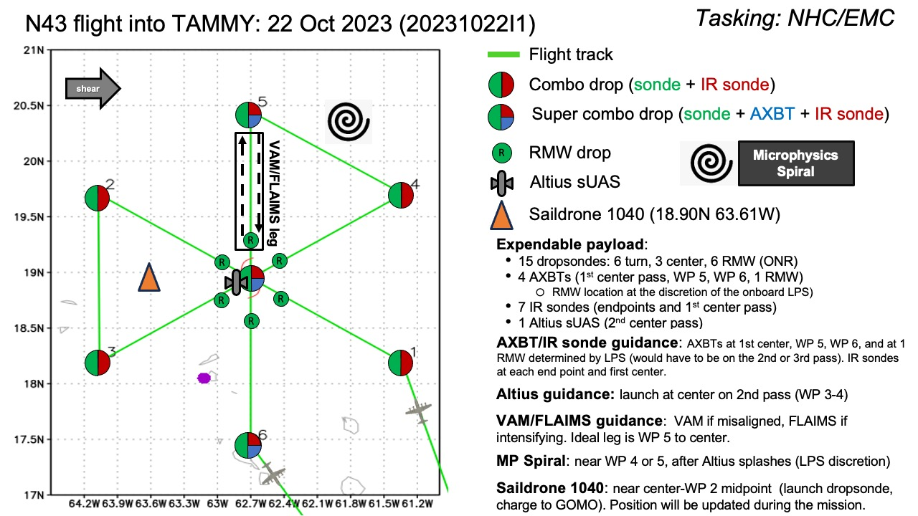  Pattern: Butterfly with 90 NM legs  - additional legs may be added after the initial butterfly pattern - at the discretion of the onboard HRD LPS  - legs may be shortened to maintain comms with Altius  Altitude:  - 8 or 10 kft (pressure altitude) depending on AF deconfliction requirements (FL 10 kft preferred)  Potential add-on APHEX Modules:  - Priority #1: RICO SUAVE (Altius)  - Launch at center of 2nd pass (WP 3-4)  - Preferred launch altitude: 12 kft (depending on AF deconfliction requirements)  - Priority #2: VAM or FLAIMS Module - see notes  - If the storm has vertically aligned, the FLAIMS module can be substituted for VAMS - at the discretion of the onboard HRD LPS  - Priority #3: Microphysics Spiral - see notes  - Perform only after Altius has splashed
Expendable Distribution | - Load 25 dropsondes  - Release at endpoints, centers (charged to NWS); no midpoint dropsondes  - Possible supplemental RMW drops (charged to ONR) - if eyewall is present (at discretion of the onboard HRD LPS)  - Additional drops may be requested at the discretion of the onboard HRD LPS  - All dropsondes transmitted to the GTS  - Dropsonde deployments should be adjusted as needed to avoid land  - IR dropsondes (7) - see notes below  - Altius sUAS (1) - see notes below  - 4 AXBTs (CAD launched) - see notes below  - All AXBTs transmitted to the AOC ground server if possible
Preflight Weather Briefing | [Notes from the Flight Crew Preflight Briefing and other relevant notes about the current and forecasted storm state from the most recent NHC advisory (location, intensity, MSLP, movement, possible intensity change during the flight)]  [Briefly describe the relevant environmental drivers.]
Instrument Notes | All instruments were nominal except WSRA that was inoperative.

IN-FLIGHT
Time [UTC] | Event
1303 | Take-off from TBPB
1316 | TDR up and is nominal Convective structure is fairly asymmetric, consistent with SW shear  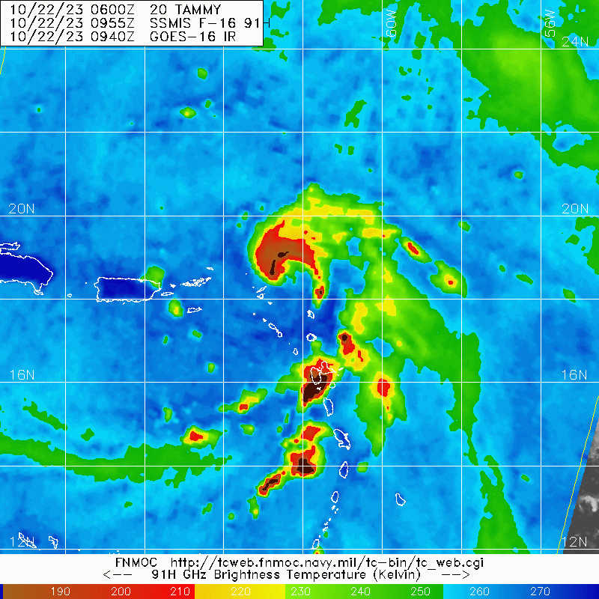
1319 | we will follow plan as drawn up for 1st pass from PT#1-PT#2. On the downwind leg from PT#2-PT#3 we will do Altius prep and checklist. We will deploy Altius on the inbound leg from PT#3, orbiting to confirm launch and comms. Once confirmed we will proceed to center and outbound to PT#4 to test comm link to Altius. If we lose comms we will return to center to restore comms.
1343 | entering stratiform rain area from principal rainband sitting over Guadalupe island
1359 | SD 1040 18.9347008 -63.3654272 2023-10-22T11:59:00Z
1400 | begin descent to 8 kft
1406 | at 8 kft, test run of Altius checklist test
1409 | <marks_n43> mfischer_hrd, tracking along between cells in major rainband
1414 | PT #1, combo IR sonde #1, drop #2, TK 300 inbound
1419 | 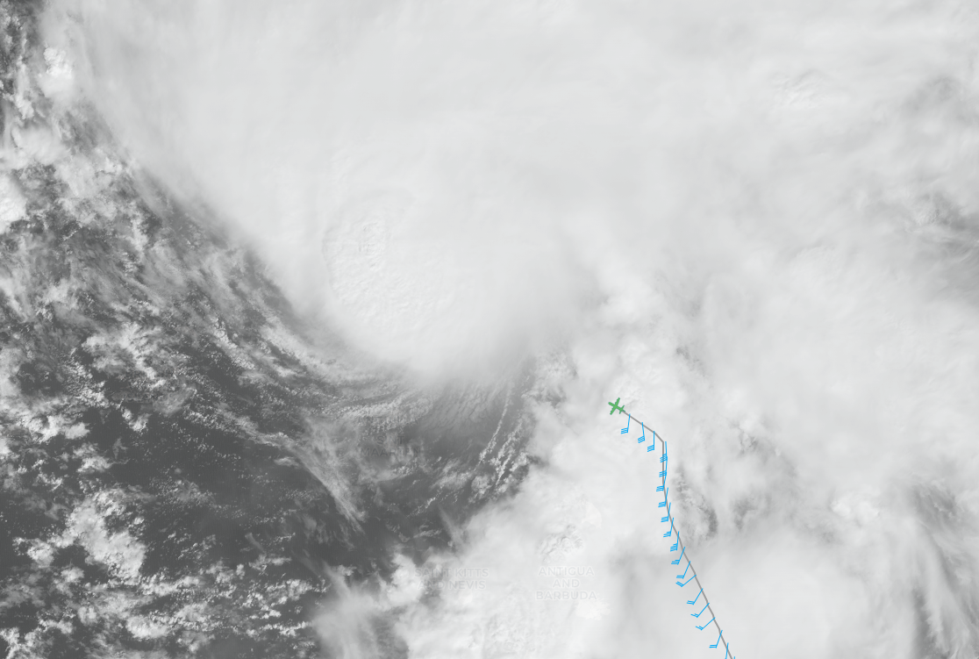  In principal rainband we are still seeing interesting across flow convective cell alignment into almost regularly space lines like yesterday marks_n43> in the band  <marks_n43> tops 12-14 km  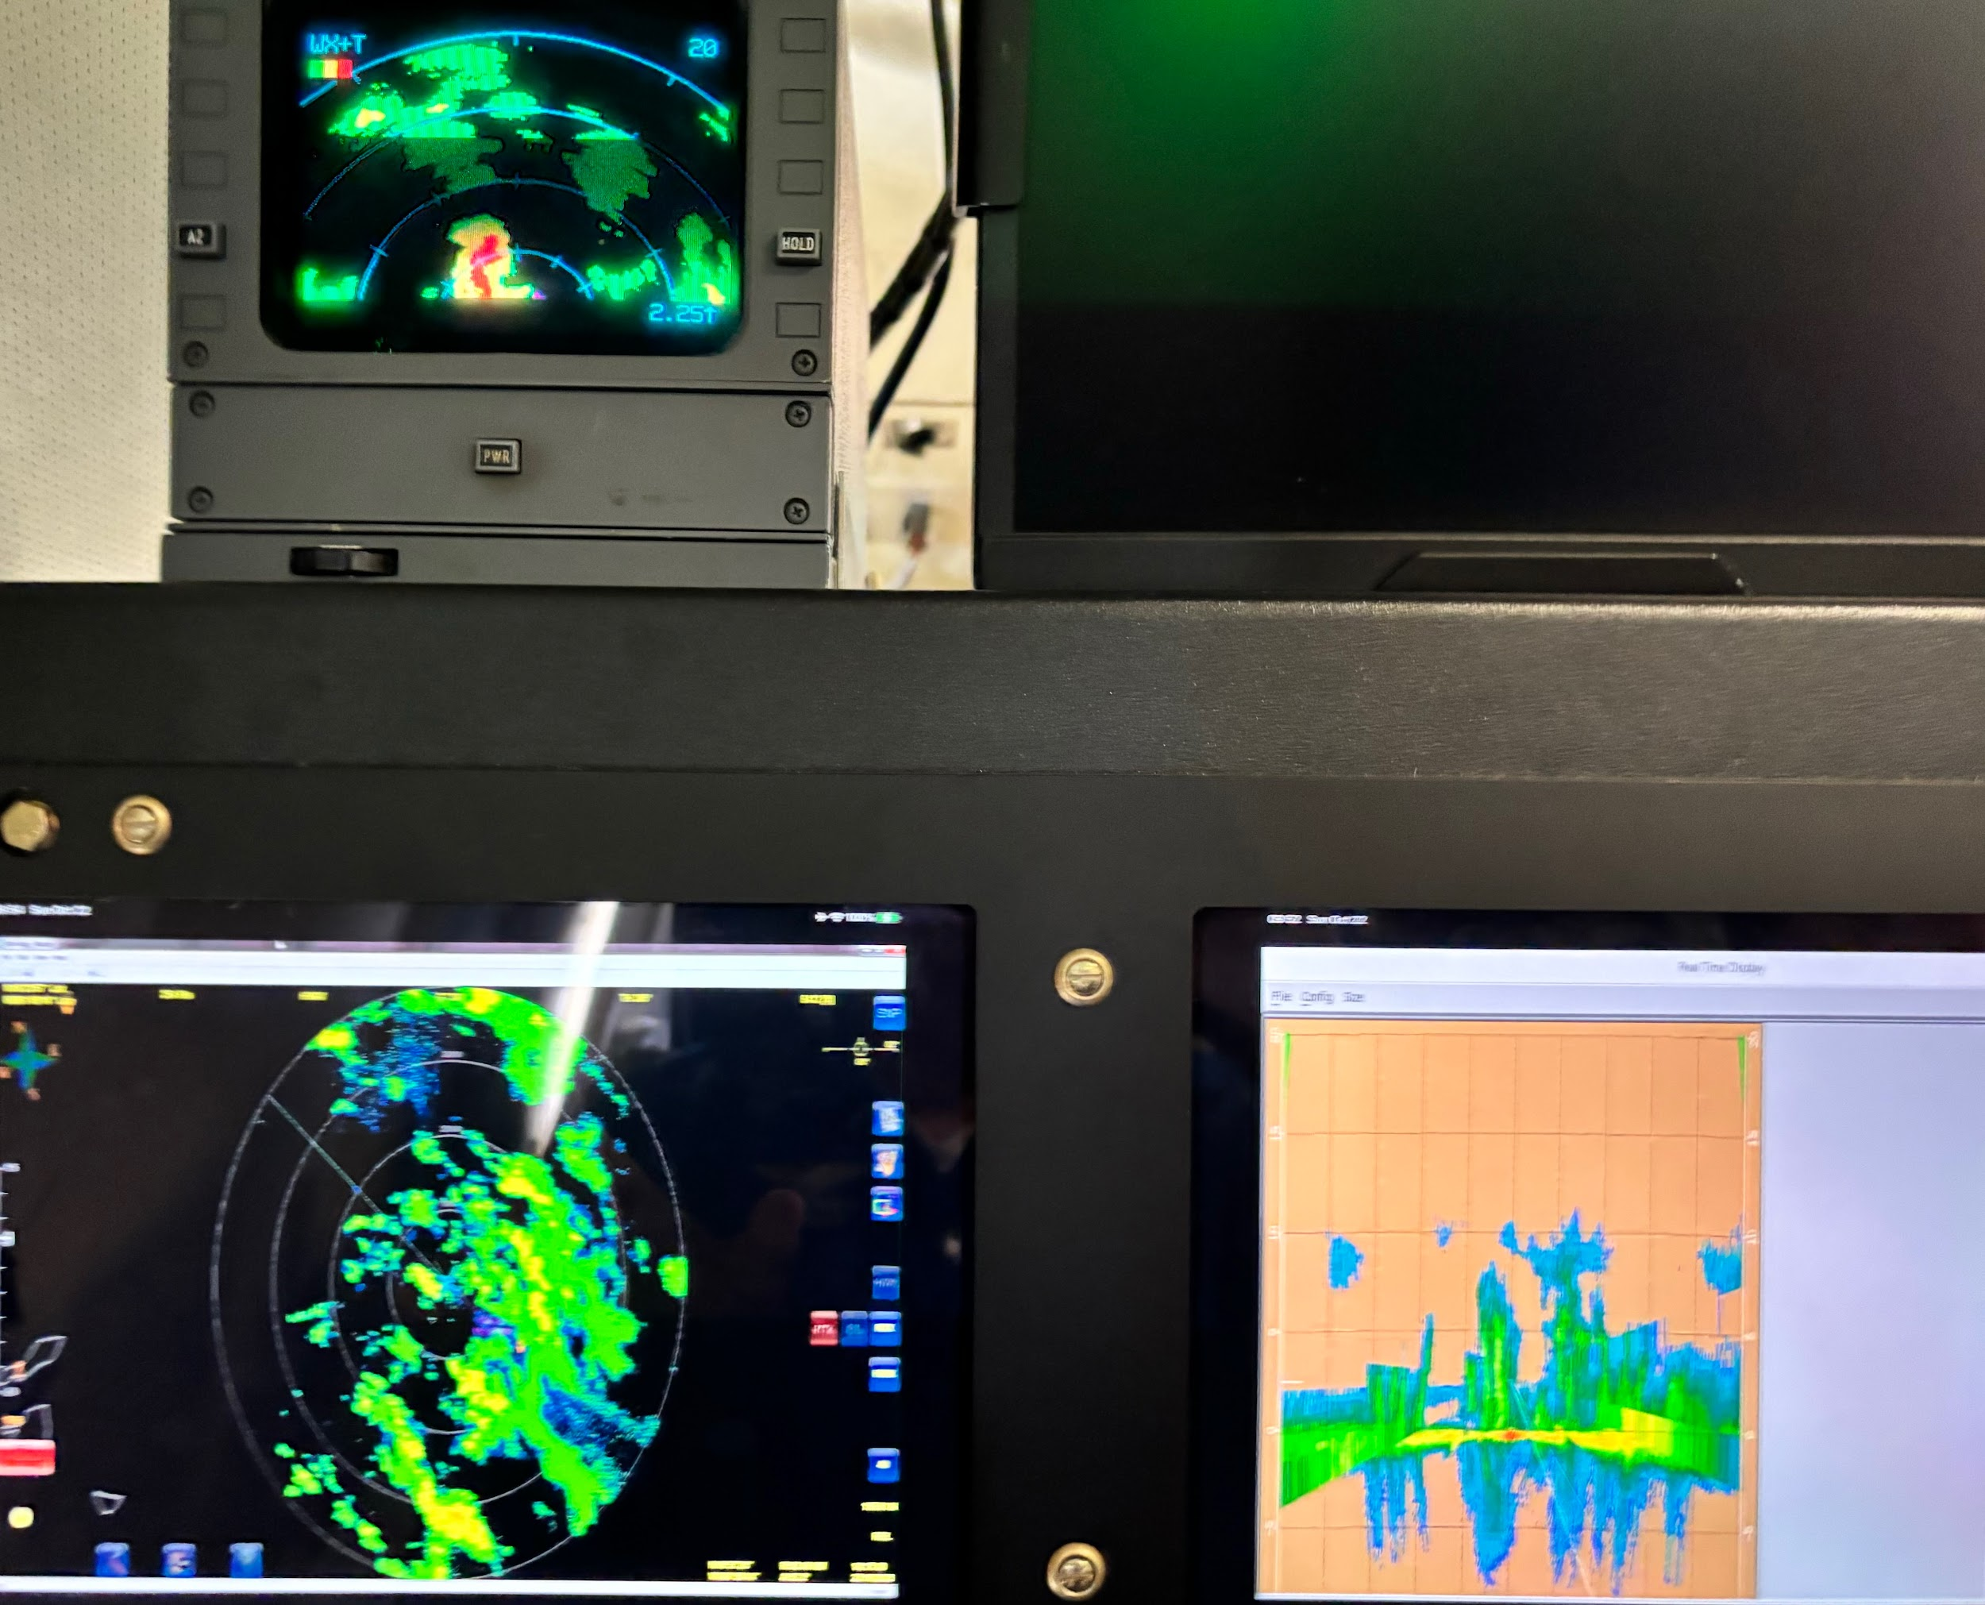
1427 | MMR shows the radar eye is elliptical with E-W major axis of 30 nmi, minor axis 25 nmi  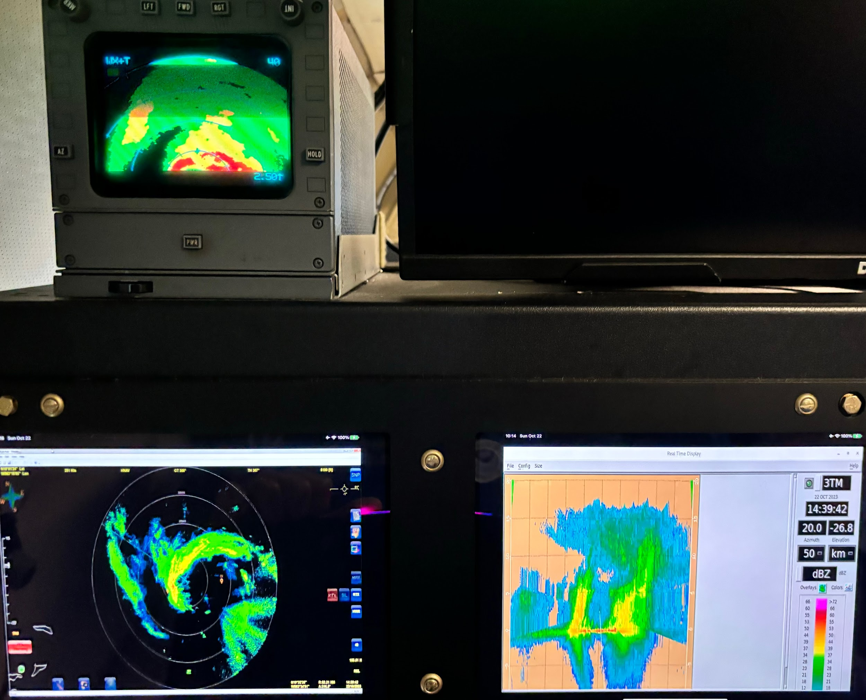
1433 | RMW drop #3, well inside radar eyewall, radius ~12
1437 | center super combo IR drop #4, drop #5, AXBT #1 SST 28.61, tucked up against NW eyewall
1440 | RMW drop #6, good one as we hit the eyewall
1444 | <marks_n43> mfischer_hrd, 1437 center supercombo IR drop #4, drop #5, AXBT #1, tucked up with NW eyewall  <marks_n43> 1440 RMW drop #6, good one as we hit the eyewall  <marks_n43> SST 28.6
1459 | PT#2, combo drop IR drop #7, drop #8, TK 180, may have to change PT#3 to avoid islands
1502 | plan is to go from PT #3 inbound to center, deploy Altius in center, verify comms, proceed to west to do super combo drop near Saildrone 1040, then return to track to NE1459
1503 | 1st TDR analysis submitted
1506 | combo IR drop#6, drop #7 trurn downwind 180
1510 | start Altius launch checklist
1517 | <marks_n43> mfischer_hrd, we are shortening leg to avoid islands. turn SE to avoid islands, moving PT#3
1519 | 1st TDR analysis complete  Alt (km) Lat (deg) Lon (deg)  0.5 18.92 63.07  2.0 18.96 63.11  3.0 19.00 63.11  6.0 19.05 63.11  2-6 km vortex tilt: 10.0 km at 360 deg
1522 | new PT #3, combo IR drop#9, drop #10, TK 060, start 2nd TDR leg as there were no scatterers on downwind leg
1528 | <marks_n43> mfischer_hrd, heads up Saildrone is positioned in the WSW radar eyewall now.
1534 | TDR analysis shows an open eyewall to the S, with deep convection in NW eyewall  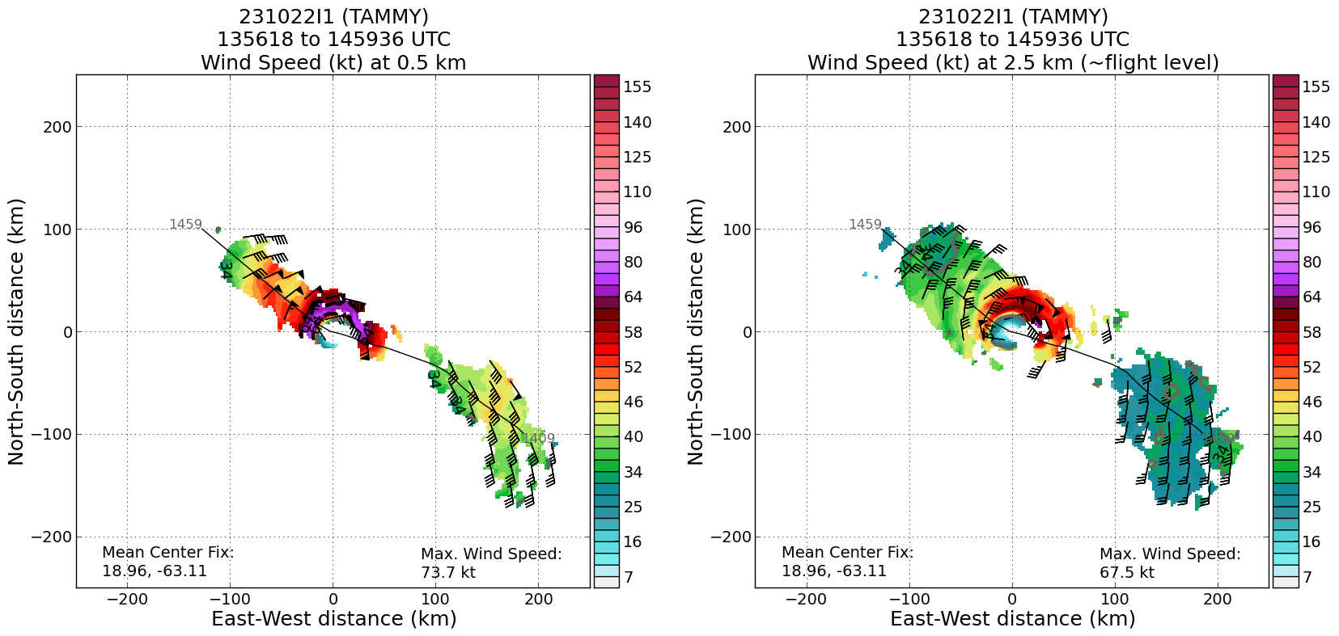
1539 | 1539 Altius launch inside SW eye
1542 | Altius checks out, descending to 2500’
1547 | marks_n43> Orbiting in SW side of eye making sure Altius is cool. looking good so far. wings deployed descending to 3000'
1549 | Orbiting in eyewall after Altius launch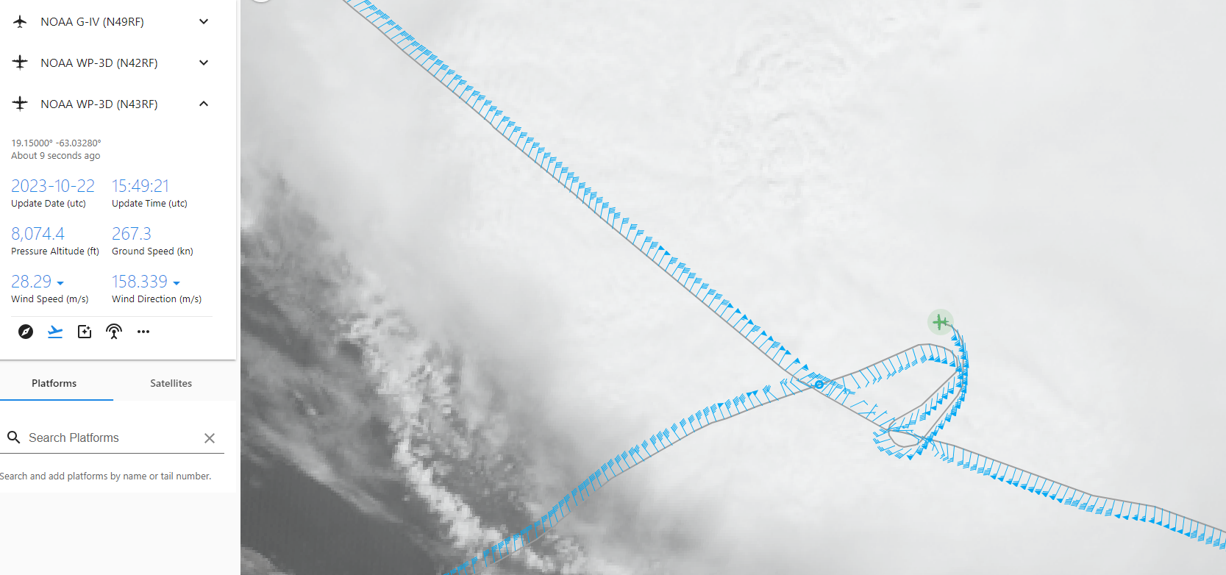
1555 | TK 225 to Saildrone
1557 | center
1558 | 2nd TDR analysis completed  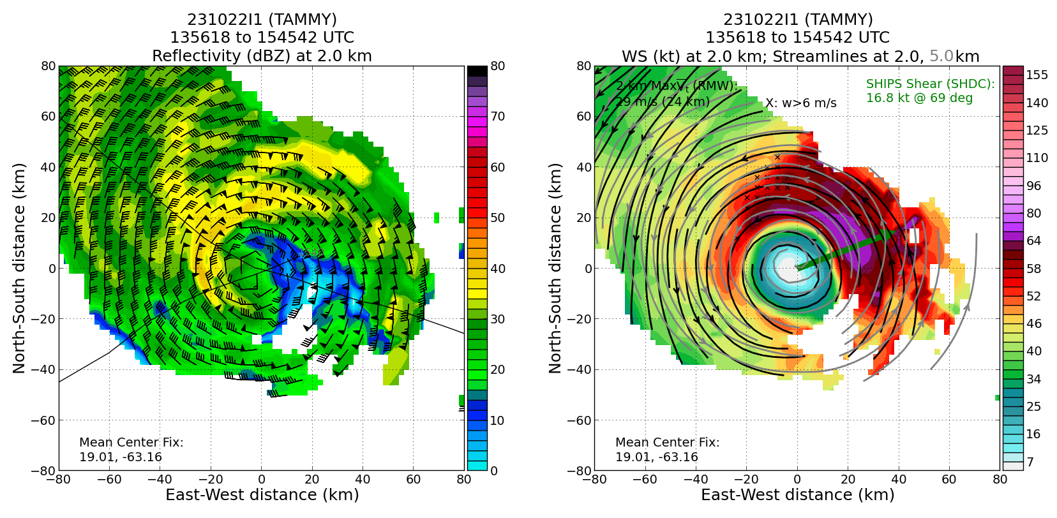
1559 | Saildrone super combo IR drops #11, drop #12, AXBT #2 SST 28.95, just in the RMW
1601 | lost Altius comms
1603 | We lost Altius comms and are turning back into the eye
1604 | turn back to eye
1608 | <marks_n43> We will orbit for a few minutes while they troubleshoot comms
1610 | center orbiting in eye to reestablish Altius comms
1614 | re-establish Altius comms and continue orbiting in center to test comm range. Altius orbited ¾ of the way around the eye from drop location S of center to the NW portion near Saildrone location.
1619 | <marks_n43> mfischer_hrd, we are tracking in the clear to test comms range to Altius
1621 | comm range limited to 25 nmi
1622 | center, TK 060, 3rd TDR analysis completed  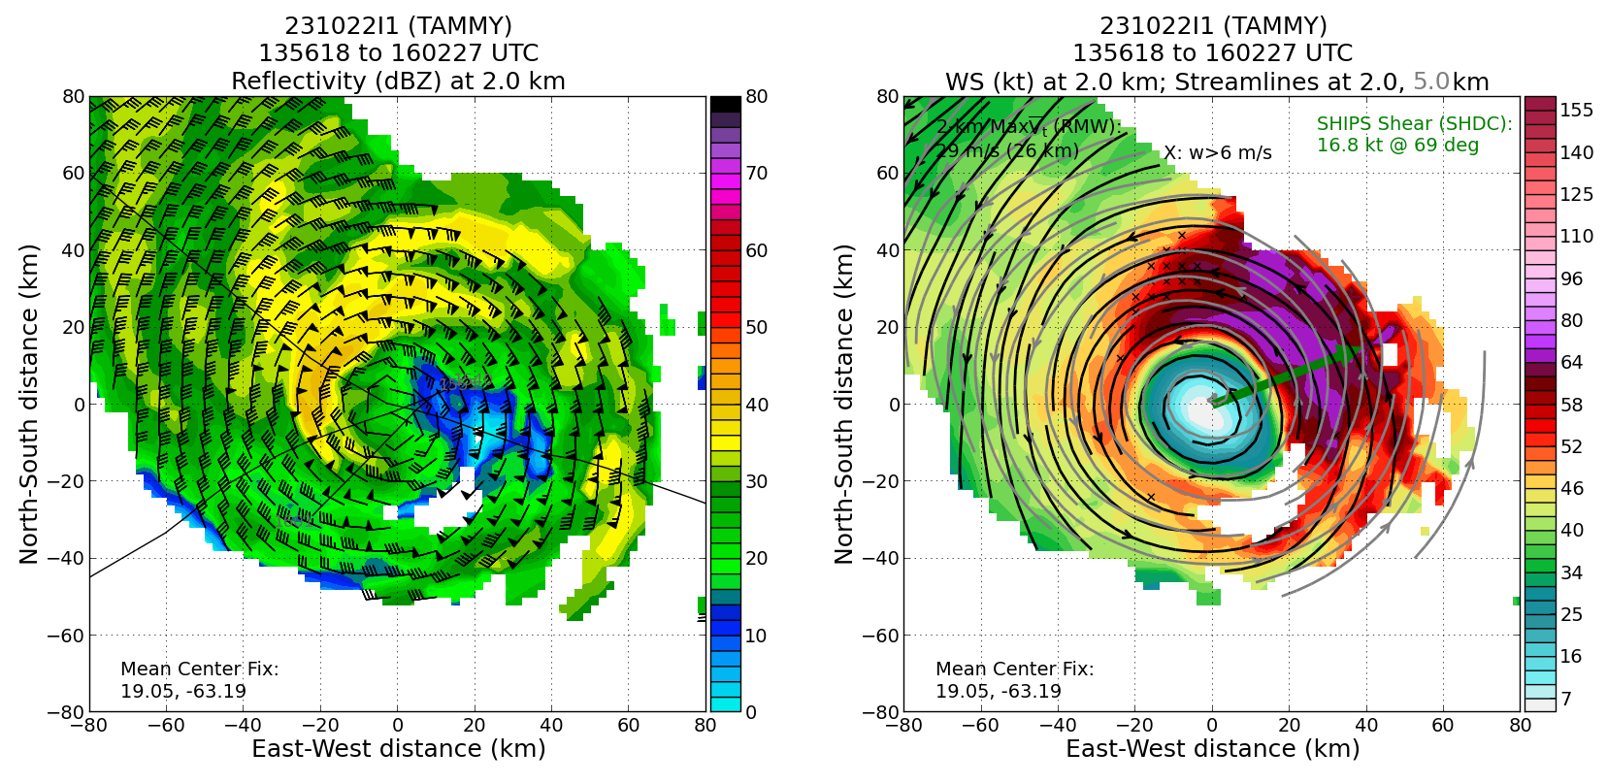
1623 | <marks_n43> mfischer_hrd, plan is to complete this outbound leg, turn around and come back inbound to eye to fly over Altius and uplink any data they collected while we were out NE
1626 | RMW drop #13
1628 | plan to TK 060 then do RMW drop #16, FL 90 kt
1635 | <marks_n43> mfischer_hrd, we will track out to PT#4 or a little closer, go downwind to do FLAIMS wedge of 30 deg, turning back into eye on a 210 TK
1639 | new PT#4, turn track downwind inside rainband
1650 | turn, drop #14, TK 210 inbound
1703 | RMW drop #15 FL 90 kt
1708 | center, orbiting around Altius last position, 4th TDR analysis completed  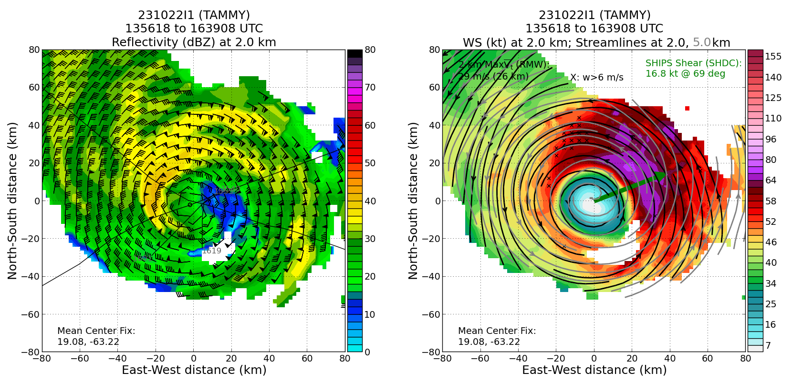
1717 | TK S out of eye to try to reestablish comms with Altius. The plan is to go back and forth to the S toward last known point of Altius to see if we can connect
1722 | no joy! TK 180 out of RMW and then back to the eye to do leg to the N
1722 | The 5th TDR analysis indicated peak low-level winds have intensified over the duration of the flight 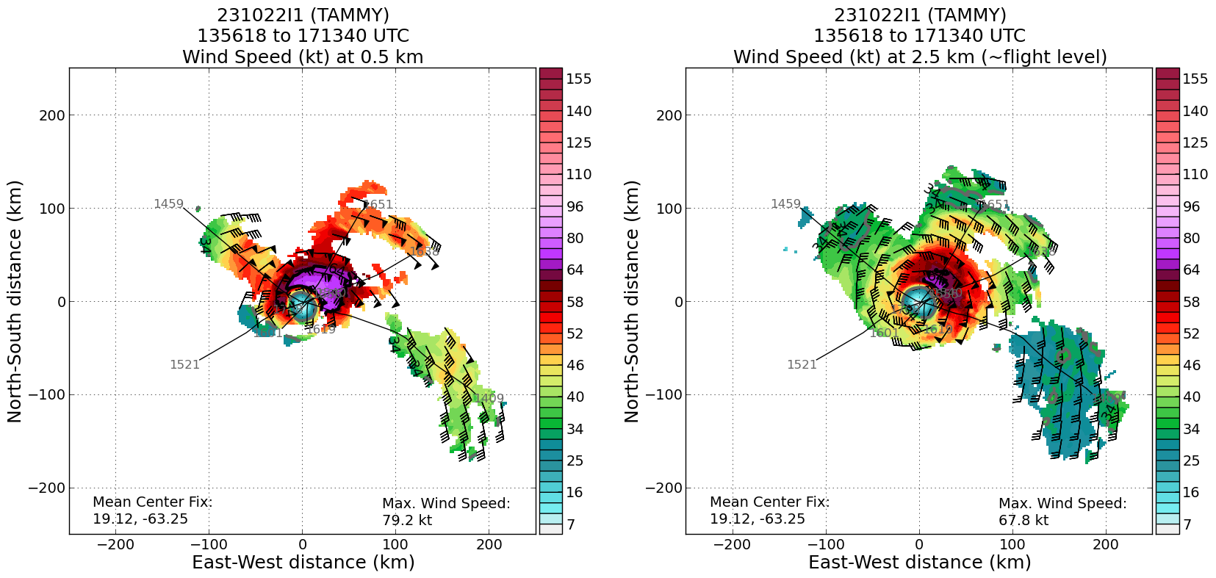
1724 | <marks_n43> 1722 TK 180 out of the eye and then we will turn around and head N for microphysics spiral
1725 | TK 360 to eye
1733 | center, combo drop #16, AXBT #3, 989 mb AXBT failed
1737 | RMW drop #17, FL 90 kt
1744 | <marks_n43> jasond_hrd, mfischer_hrd so my thinking is to finish N leg to 90 nmi, then locate a place to do microphysics spiral near the north edge of strat area, and then move inbound to find a 2nd spiral location. There is plenty of strat out N of the center
1751 | Last center drop recorded 989 mb with 11 kt, indicating some intensification
1754 | end leg turn to SW to locate spiral
1759 | start spiral 8,000 ft on far N edge of stratiform area N of center.  0 C 4.9 km altitude
1806 | MTS screenshots of location of stratiform spiral  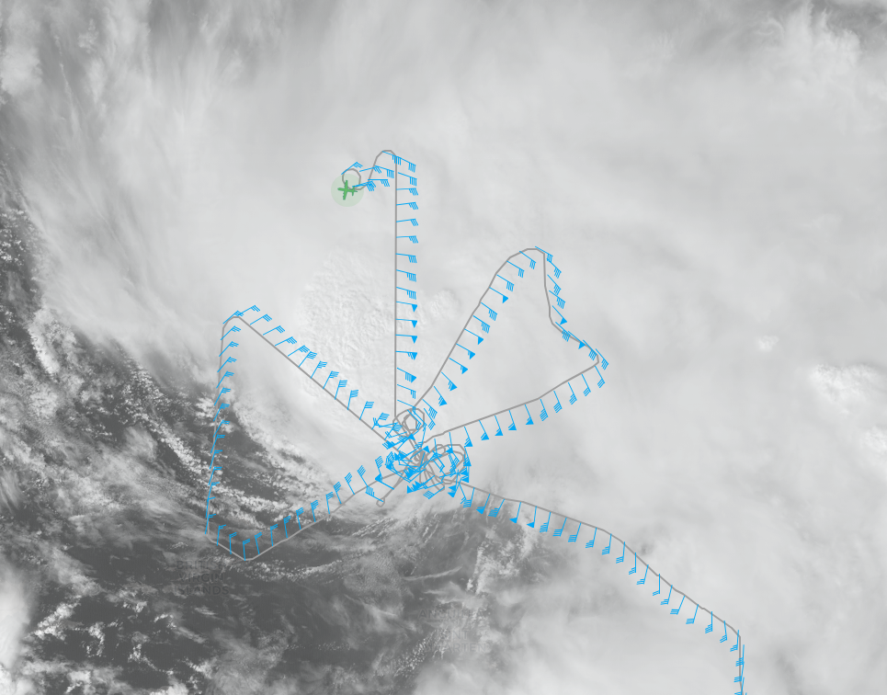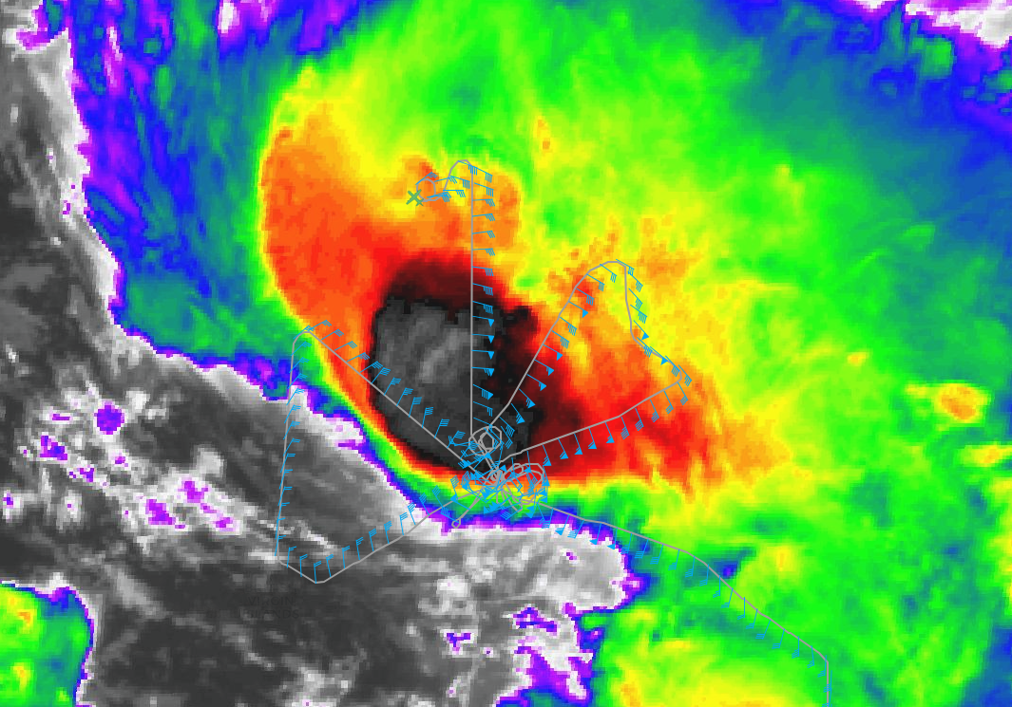
1815 | spiral top -12.2 C 22,000’ drop #18 from top of spiral, 6th TDR analysis completed  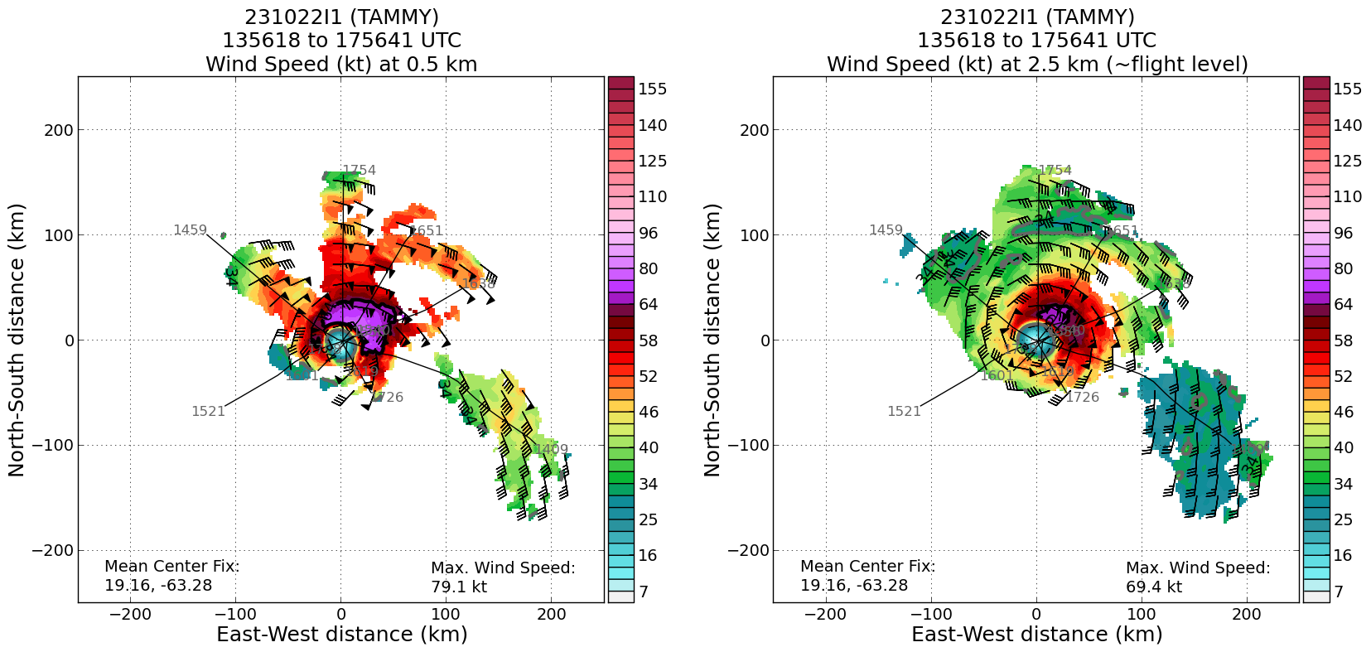
1816 | start spiral down
1826 | Completion of first spiral  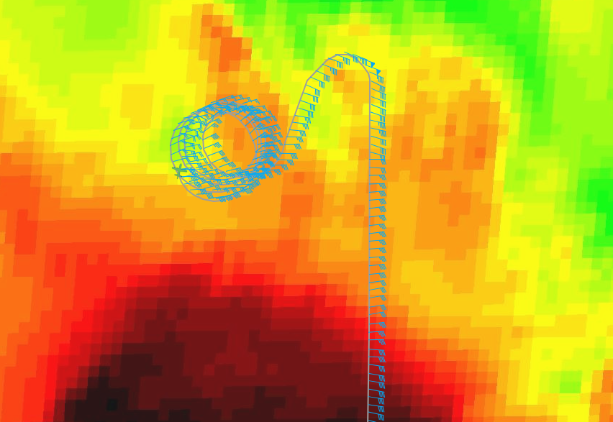
1827 | end spiral down, 8000’, track inbound 15-20 nmi for 2nd spiral
1827 | Sonde from first spiral showing an “onion sounding” 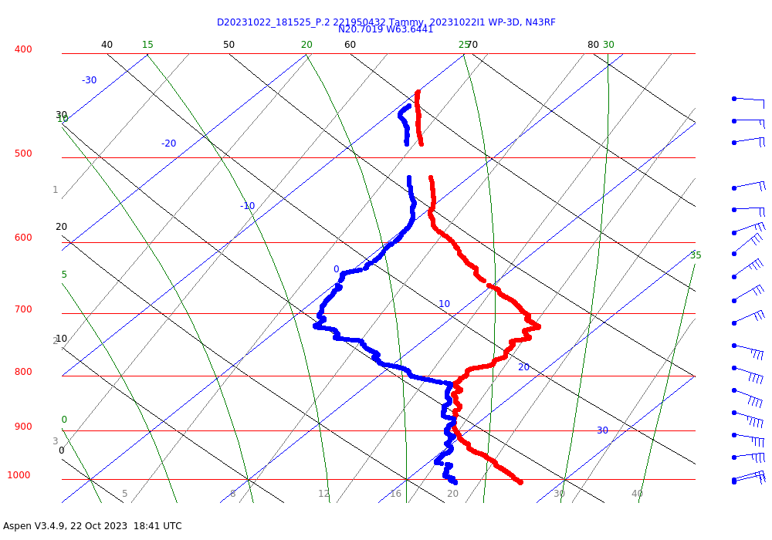
1832 | 6th TDR analysis revealed the northern eyewall is becoming better defined. GLM has indicated persistent lightning flashes over the last hour or so.  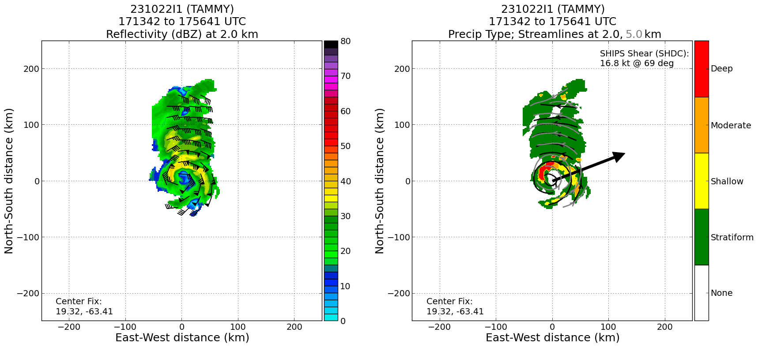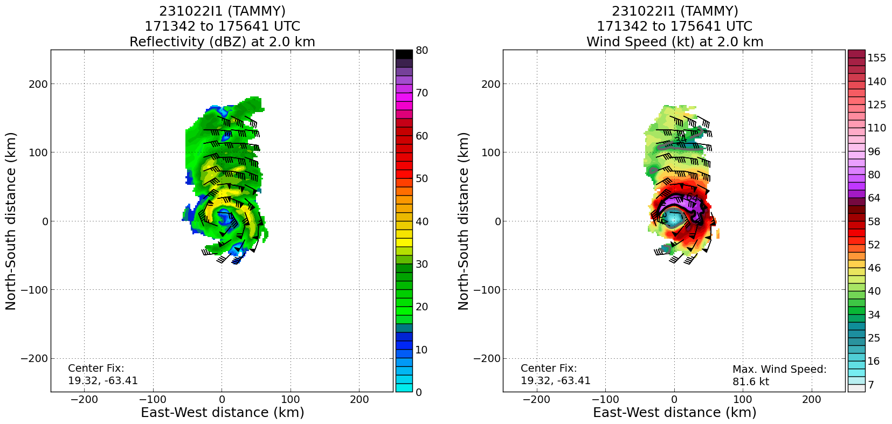
1832 | begin 2nd spiral, 35 nmi outside NW eyewall. 0 C 4.8 km altitude  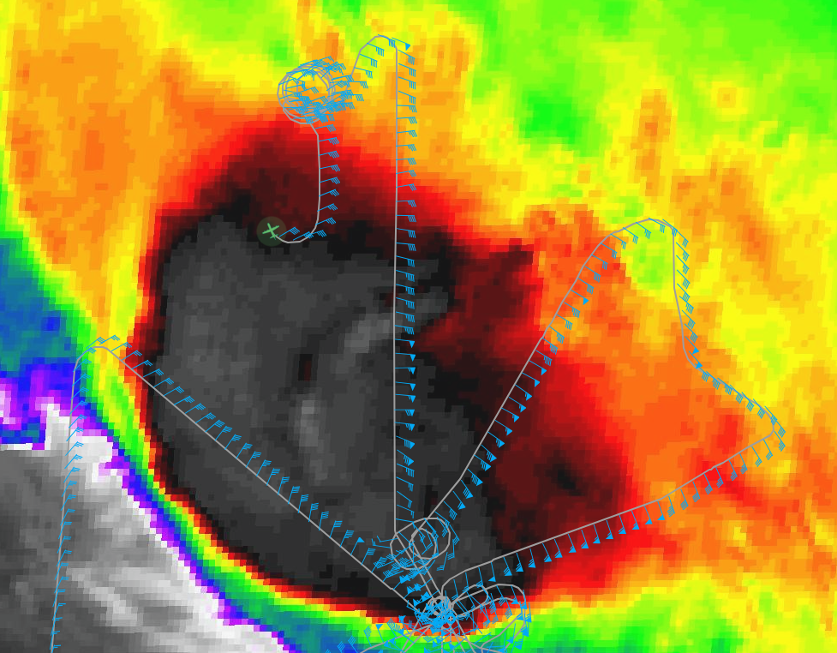
1846 | top of spiral, drop #19, -12.2 C, 22,000’
1848 | start spiral descent
1849 | Lightning flashes have been observed in NW eyewall recently
1853 | MTS screenshot near the end of 2nd spiral. First time ever two spirals were flown?  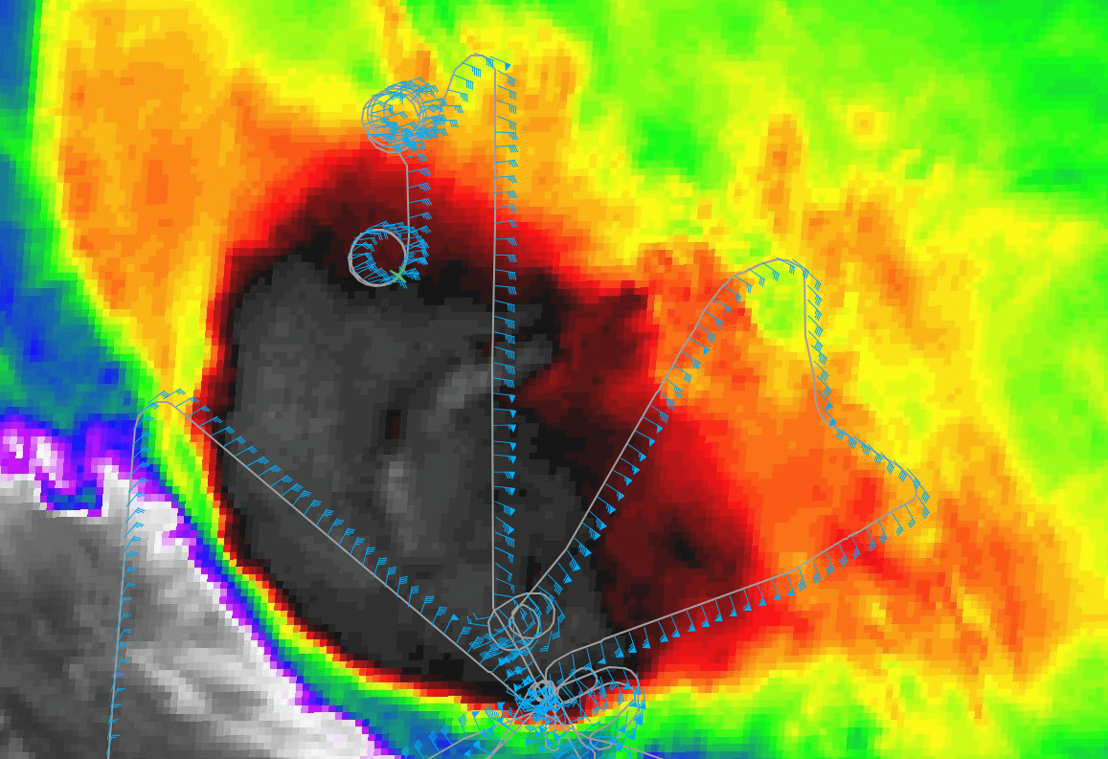
1857 | end spiral 8,000’, TK to a point N of center, climb to 10 kft and go inbound
1900 | Skew-T from second spiral  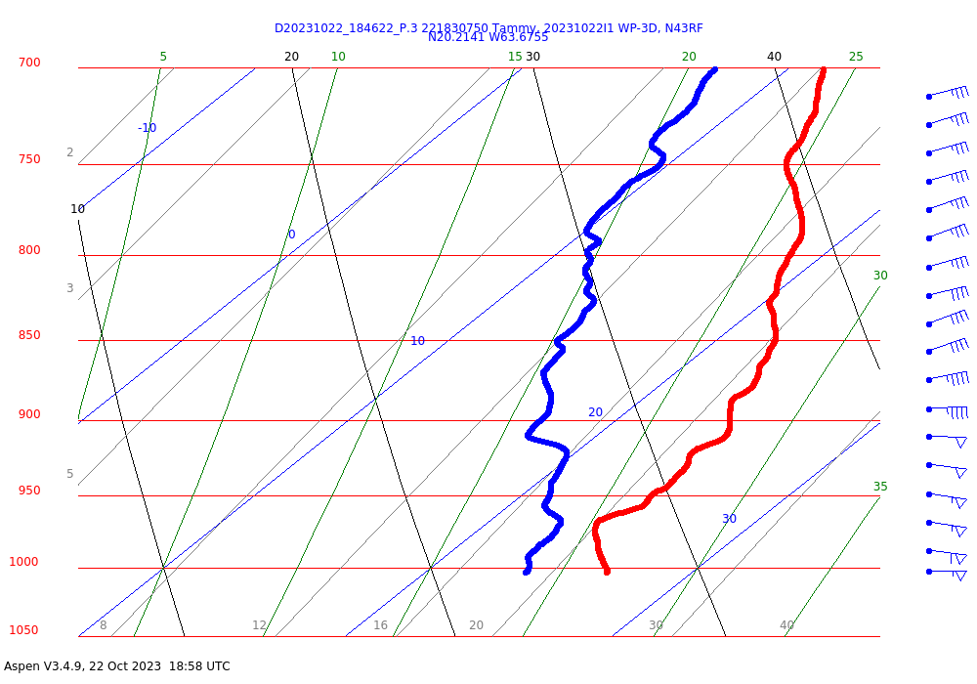
1901 | start inbound, TK 170, 10,000’
1906 | entering outer edge of N eyewall, Michael Fischer says there is potential meso forming in NW eyewall, definitely based on MMR presentation o
1908 | <mfischer_hrd> Looks like a potential mesovortex in western eyewall FYI marks_n43  <marks_n43> JZ says definitely  <marks_n43> We are in the eyewall  <marks_n43> tops 16 km  <marks_n43> we are trying to steer clear of it
1909 | in the N eyewall, tops 16-17 km, staying east of meso hook in NW eyewall, looks nasty, lightning?
1913 | in radar eye, nice view of meso (pic)  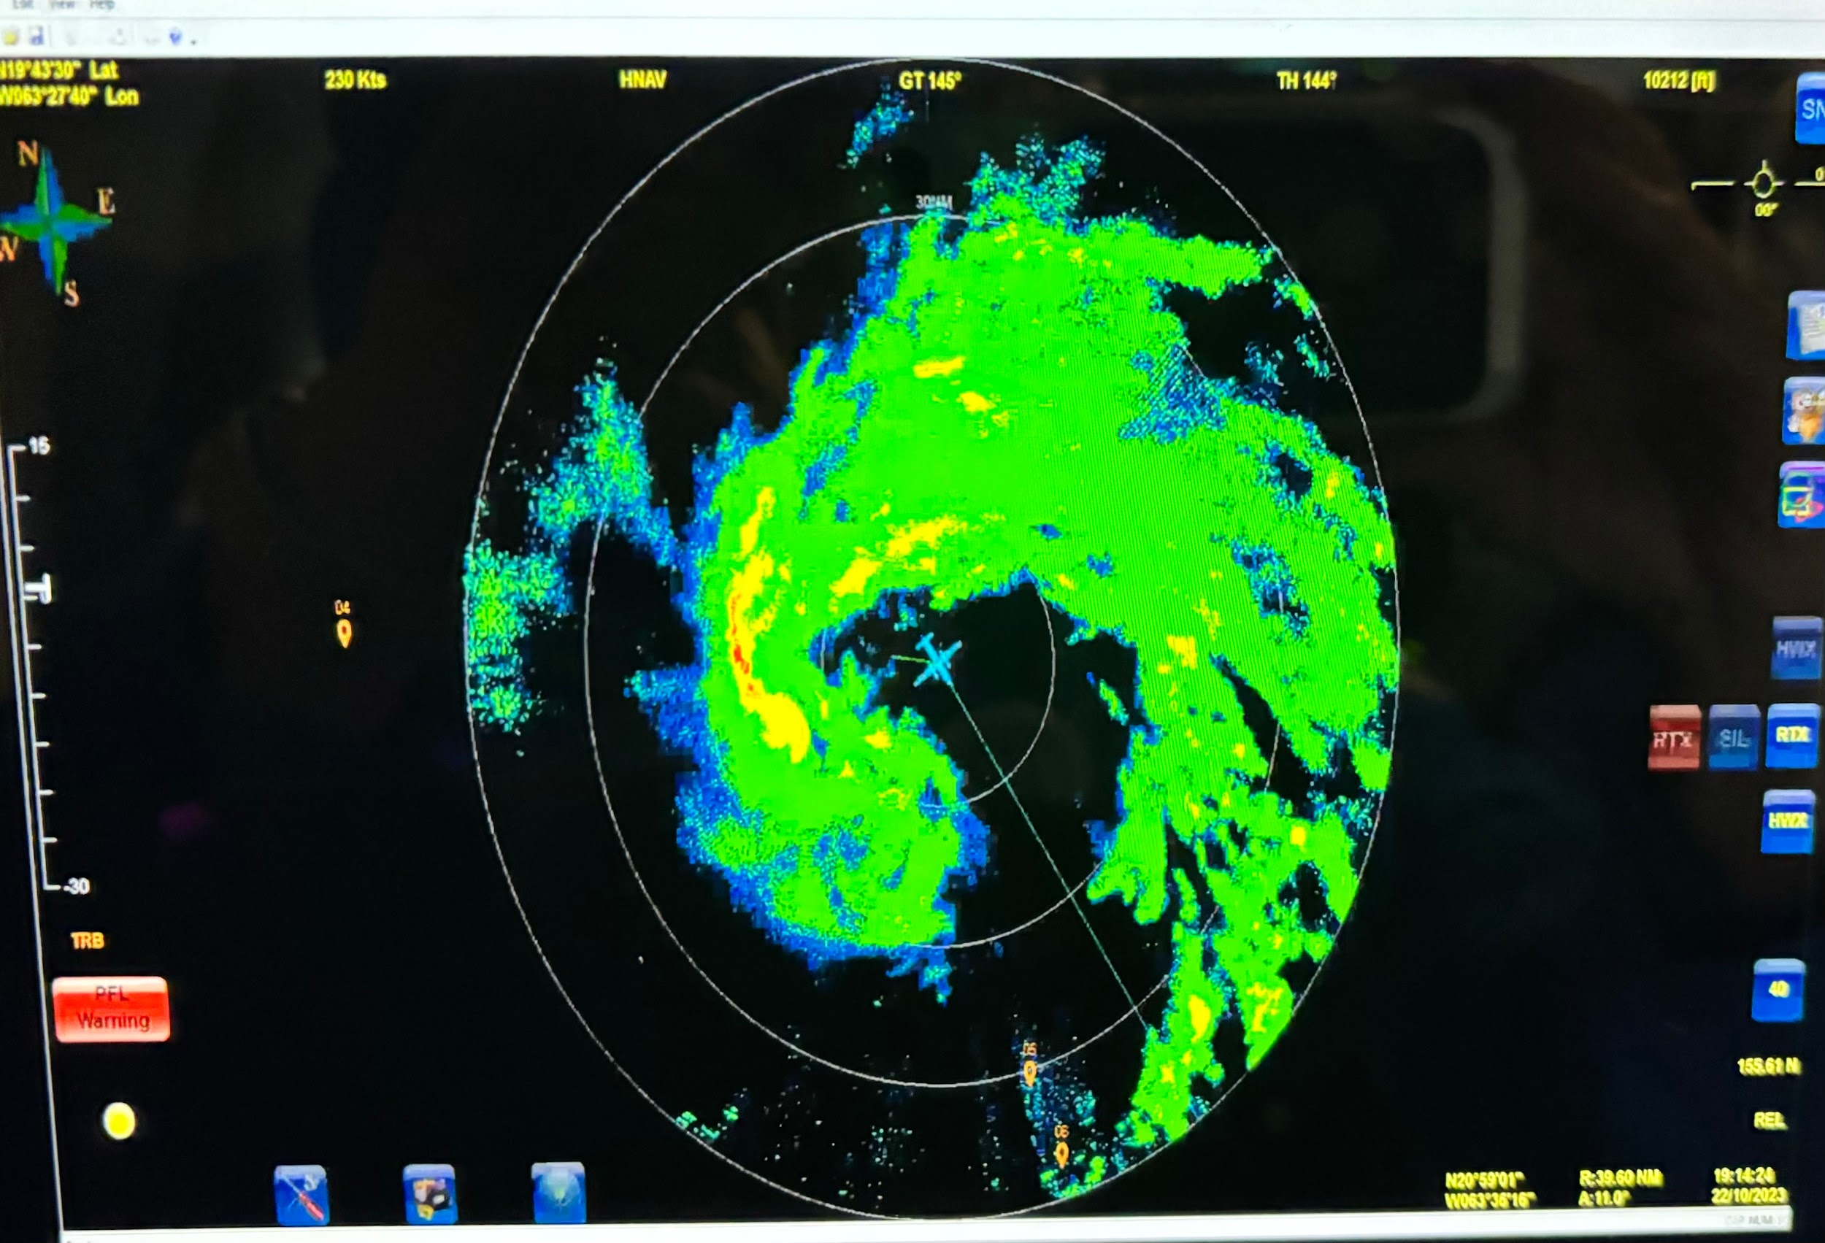
1914 | <marks_n43> we let the TDR map it
1923 | approaching outer rainband
1927 | end pattern, combo drop #20, AXBT #4, AXBT failed
1952 | MTS screenshot of final pattern  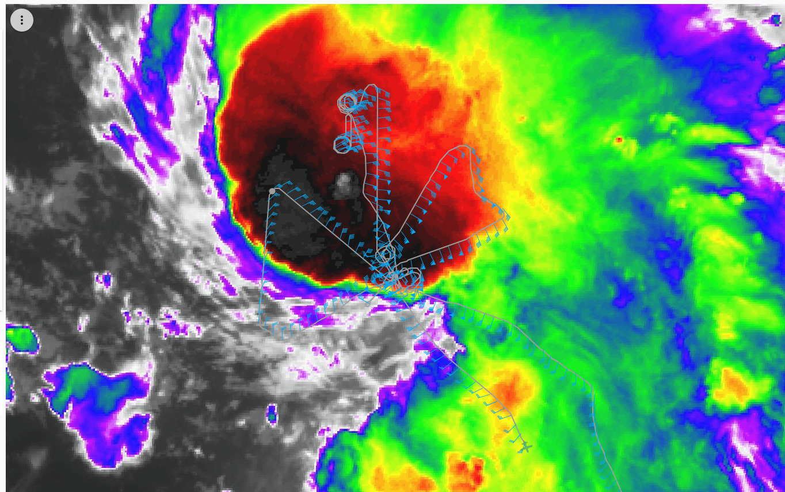
2058 | Setting up for the Ragged Point MAGPIE flightline offshore run (FL 5 kft). Overfly the Ragged Point Lighthouse, proceed to a point along the HSRL line out to an offshore point at 13.28 N 59.24W. Dropsonde at 3 NM offshore and a 2nd dropsonde at the midpoint (6 NM offshore).  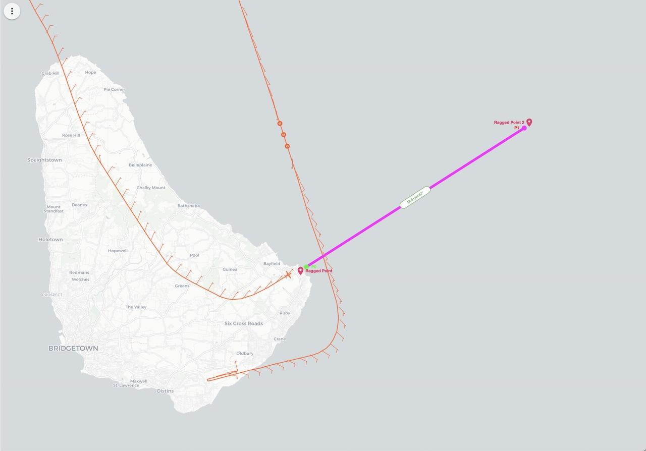
2103 | End of MAGPIE module. Both dropsondes good.  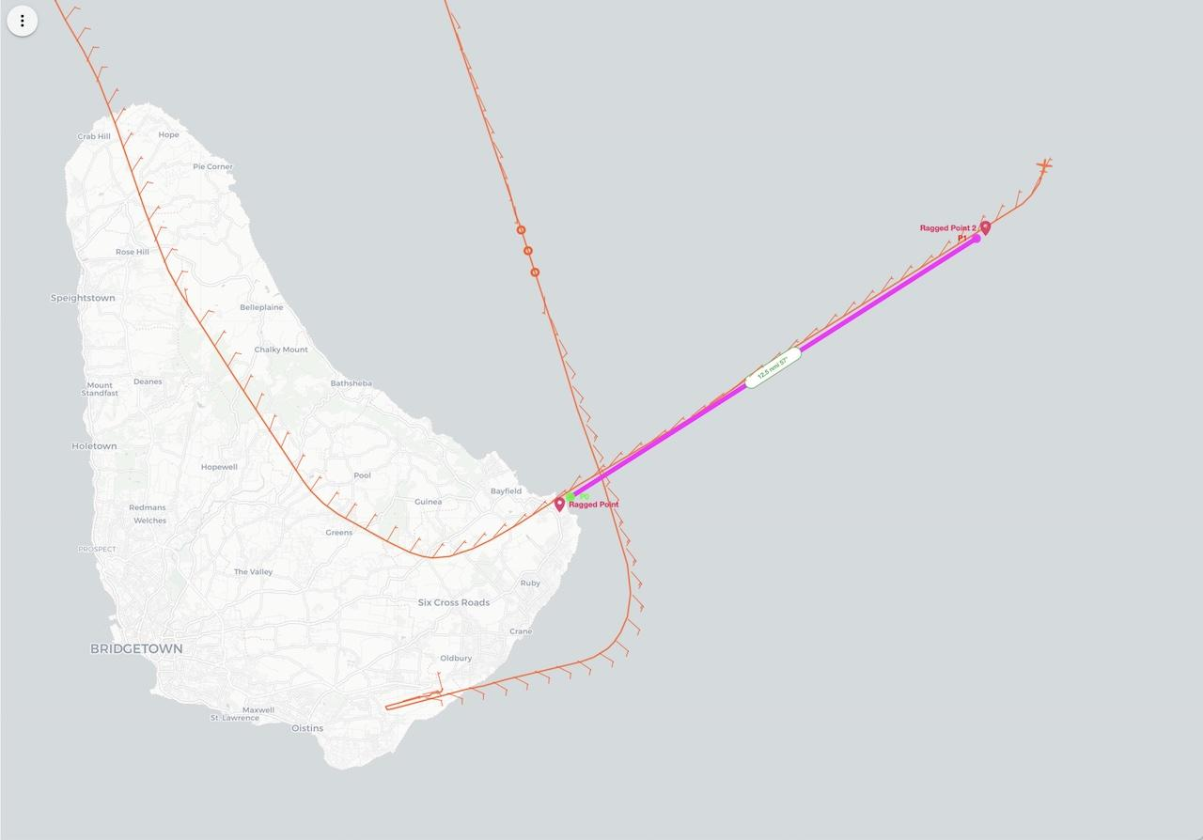
2115 | landed TBPB
2222 | Final TDR analyses 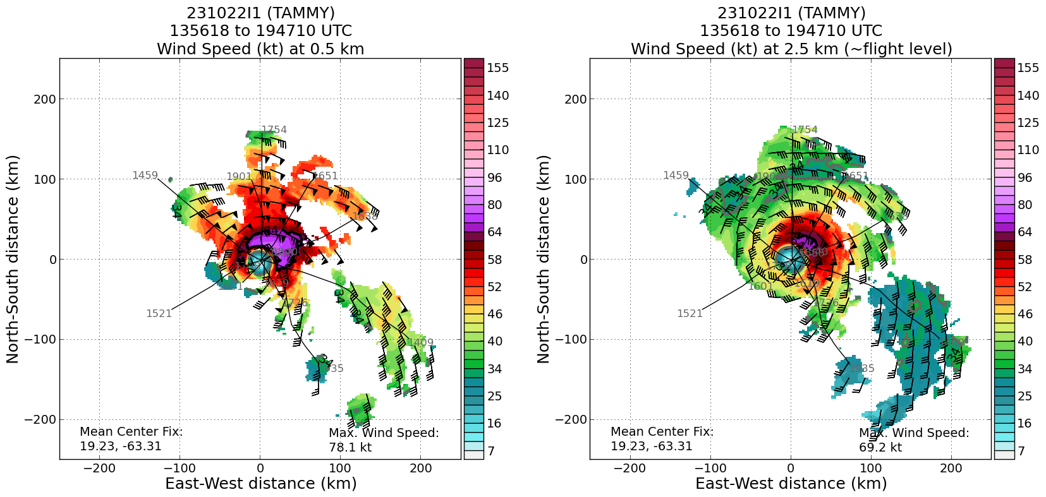 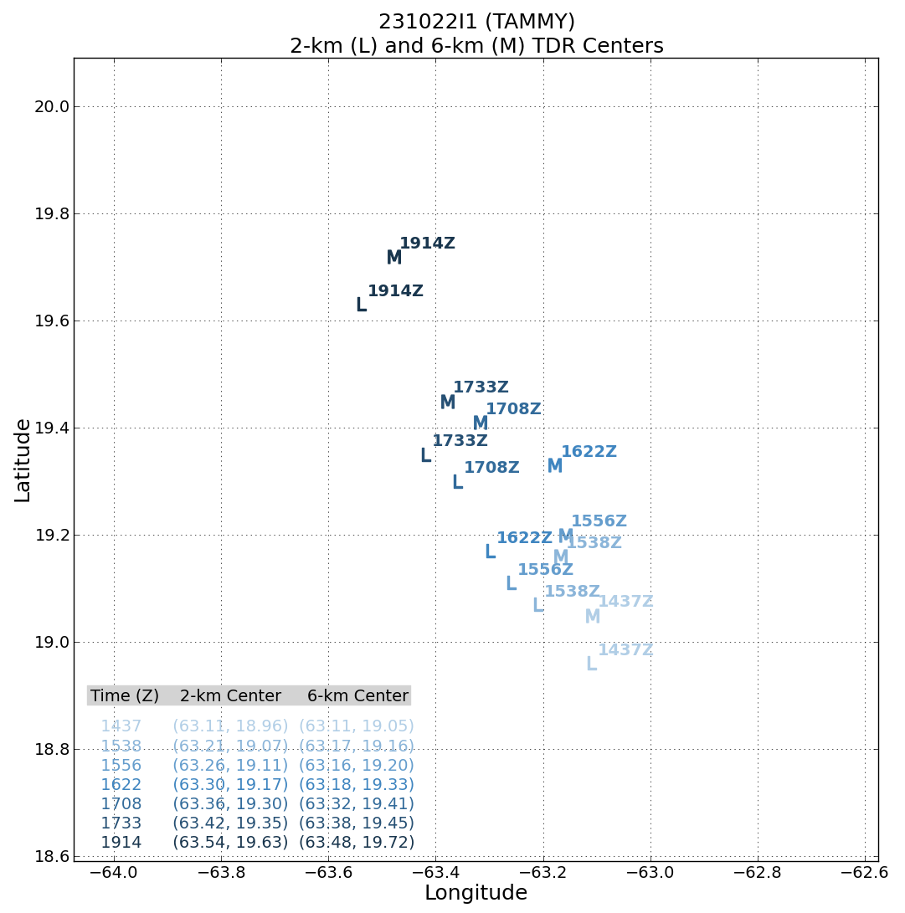

POST-FLIGHT
Mission Summary | Mission was successful – modified butterfly pattern was flown, a total of 19 drops were released, all of them worked and were transmitted, TDR analyses (7 of them) were transmitted – two analyses were performed as part of the FLAIMS wedge, two during the orbiting in the eye, and one on the final inbound and outbound leg..  Emerging technology highlight:  1. BT/IR SST sonde overflight with SD1040  2. sUAS partial eyewall circumnavigation (60kt+ winds recorded)  3. First-ever sUAS/Saildrone operations synchronized in time and space.  4. ~7 min eye spiral sounding (8k-2k feet)
Actual Standard Pattern Flown | Modified butterfly pattern to get dropsonde and TDR symmetric coverage while accommodating UAS and Saildrone comparison. Butterfly (modified)  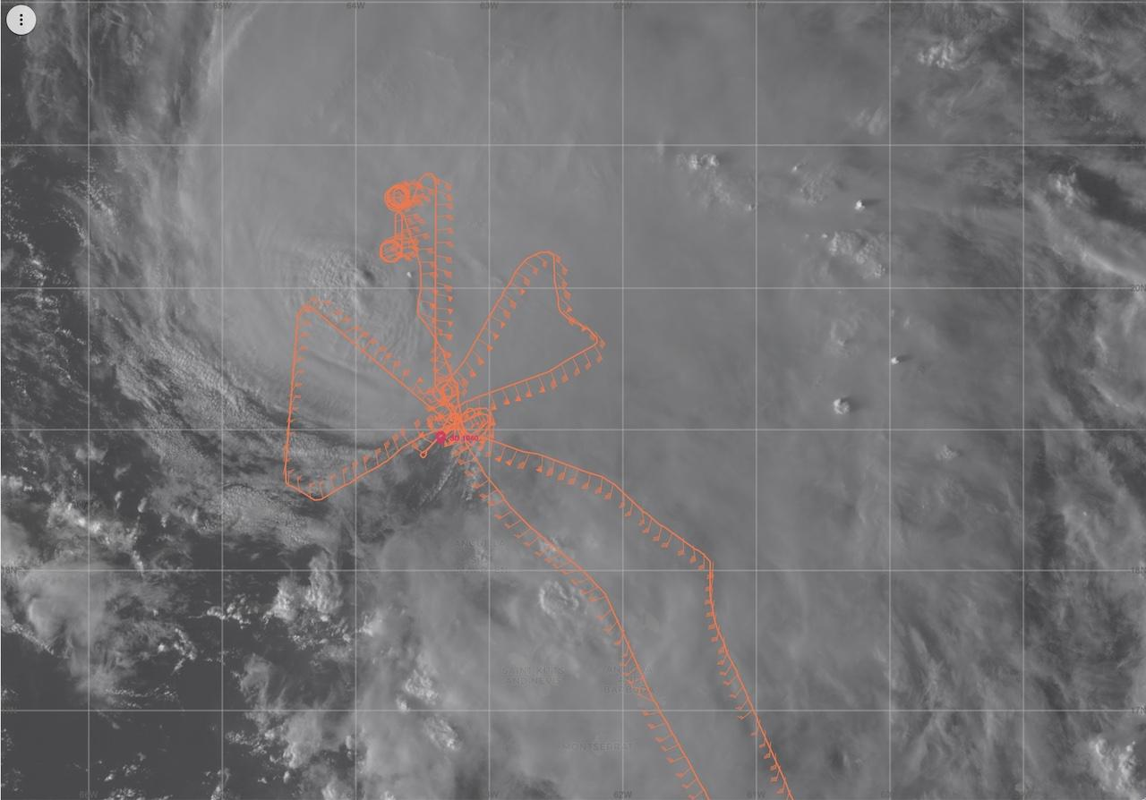
APHEX Experiments / Modules Flown | FLAIMS module, 2 Microphysics modules, and TDR sampling
Plain Language Summary | - Successfully executed module to look at the vortex tilt evolution Successful mission was flown into Hurricane Tammy, with multiple objectives accomplished.  - Important radar and dropsonde data was collected and transmitted to the ground for use in computer forecast models.  - There also was valuable data collected of precipitation particle distributions at various levels in the atmosphere below and above the freezing level. This will help evaluate and improve model representation of these structures, thought to be important for both intensity and rainfall prediction.  - First ever sUAS - Saildrone operations synchronized in time and space in the eye and eyewall of Hurricane Tammy
Instrument Notes | Instruments all worked well (TDR, sondes, AXBTs, microphysics probes, SFMR, W-band) except WSRA
Final Mission Track | 