MISSION PLAN
FLIGHT ID | 20231022H1 | STORM | AL20/TAMMY
MISSION ID | WB20A | TAIL NUMBER | NOAA 42
TASKING | HRD/NESDIS | PLANNED PATTERN | Figure-4
MISSION SUMMARY
TAKEOFF [UTC] | 2013 | LANDING [UTC] | 0339
TAKEOFF LOCATION | Barbados | LANDING LOCATION | Barbados
FLIGHT TIME | 7.4 | BLOCK TIME | 7.7
TOTAL REAL-TIME RADAR ANALYSES  (Transmitted) | 7 (7) | TOTAL DROPSONDES Deployed (Transmitted) | 14 (10)
OCEAN EXPENDABLES (Type) | 3 (2) AOC/HRD AXBT | sUAS (Type) | n/a
APHEX EXPERIMENTS / MODULES | Surface Wind & Wave Validation, CHAOS (Saildrone overflight), VAM, collaboration with NESDIS for SFMR/IWRAP comparisons
HRD CREW MANIFEST
LPS ONBOARD | Hazelton | LPS GROUND | Aberson
TDR ONBOARD | Hazelton | TDR GROUND | Alvey
ASPEN ONBOARD | Sellwood | ASPEN GROUND | n/a
NESDIS SCIENTISTS | Chang, Jelenak, Sapp
GUESTS (Affiliation) | n/a
AOC CREW MANIFEST
PILOTS | Compare/Gaston/Palmer
NAVIGATOR | Utama
FLIGHT ENGINEERS | Stokes/Kiddo
FLIGHT DIRECTOR | Kalen/Englert
DATA TECHNICIAN | McAlister
AVAPS | Warnecke/Keller

PRE-FLIGHT
Flight Plan | 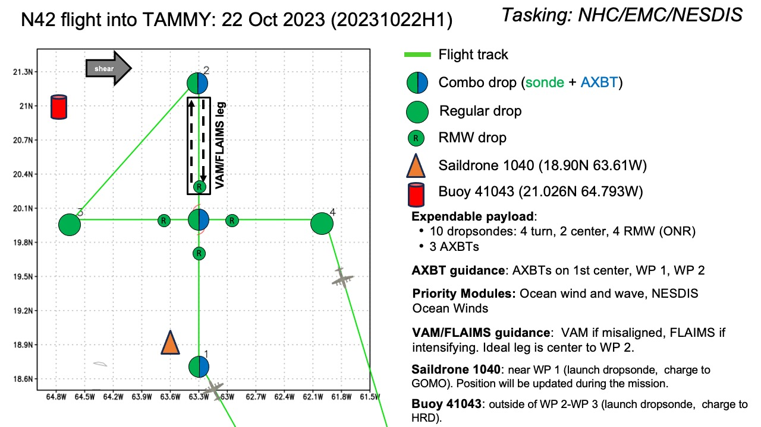  Figure 4 with saildrone overflight, VAM, buoy overflight, and drifter overflight. Then go into NESDIS legs for SFMR/IWRAP comparisons.
Expendable Distribution | 10 sondes, 3 BTs
Preflight Weather Briefing | 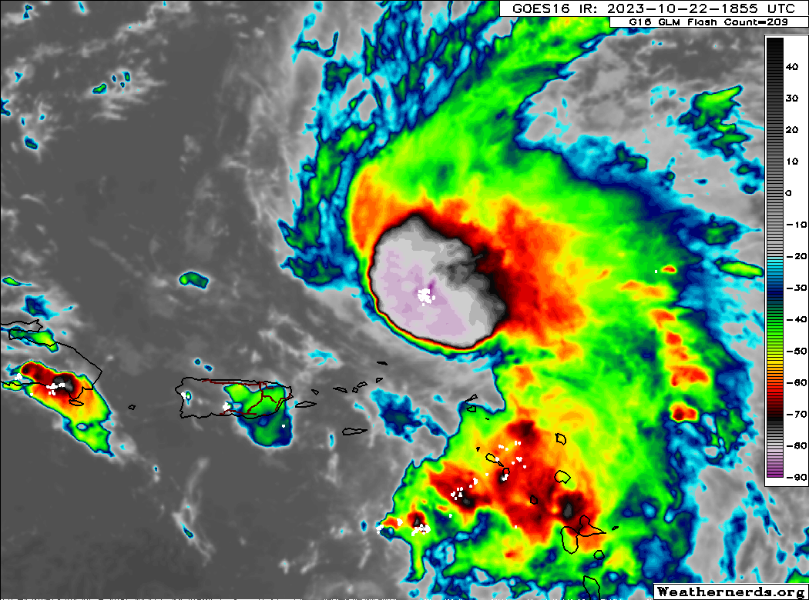  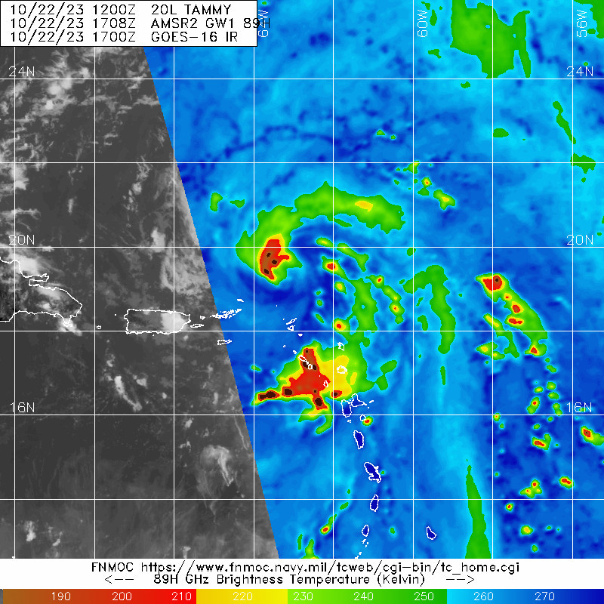  Tammy is still sheared, although convection appears to be trying to wrap around the SW side.
Instrument Notes | Instruments seem to be functioning normally

IN-FLIGHT
Time [UTC] | Event
2013 | Take-off from Barbados
2148 | IP combo drop, sonde 1, Saildrone overflight.
2202 | Sonde 2 RMW
2202 | Center radar fix from nav 19.8662N 63.7738W  2-6-km tilt 7.2 km at 124 degrees. No sonde
2203 | Centered tucked into a mesoscale feature that plan avoided. IWRAP shows wind increasing toward the surface in the northern outbound portion. Shows better in c-band than ku-band. IWRAP shows wind increasing toward the surface in the northern outbound portion. Shows better in c-band than ku-band.  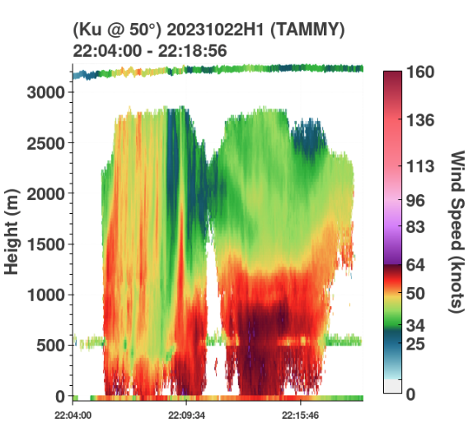  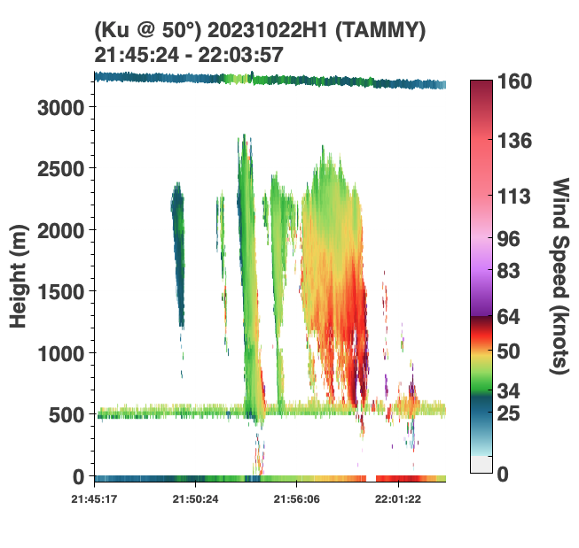
2206 | Sonde 3 RMW
2218 | Combo Sonde 4 endpoint, then turn around for VAM
2237 | Combo drop, sonde 5, center CPA, BY SST ~29C  Sonde 996 mb, 10-m wind 19518, lightning on and off in core
2247 | Went outbound SE to find a place to turn around, then back inbound and turned north to finish VAM. Turned around at time noted.  On third pass, 2-6-km tilt 6.3 km at 162 degrees  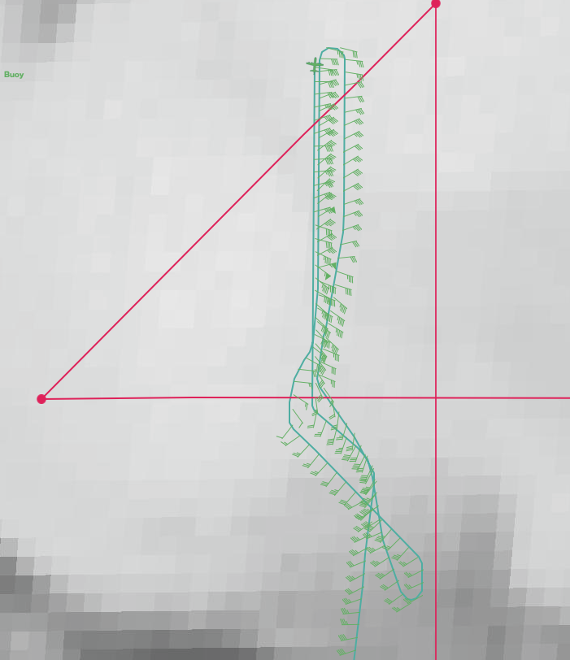
2314 | VAM complete, turn west toward buoy for surface wind/wave validation module pattern #4 wind buoy overflights
2327 | Sonde 6 at buoy, some bad data, so will replace on next pass by buoy.
2347 | Sonde 7, backup for previous one, surface wind speed 28 kt
2353 | Module complete, turn inbound.
0004 | Sonde 8 rmw nw
0011 | Sonde 9 center, surface 995 mb, wind 205/15  2-6-km tilt 12.8 km 141 degrees
0014 | Sonde 10 RMW E, bumpy. Looks almost like a double eyewall  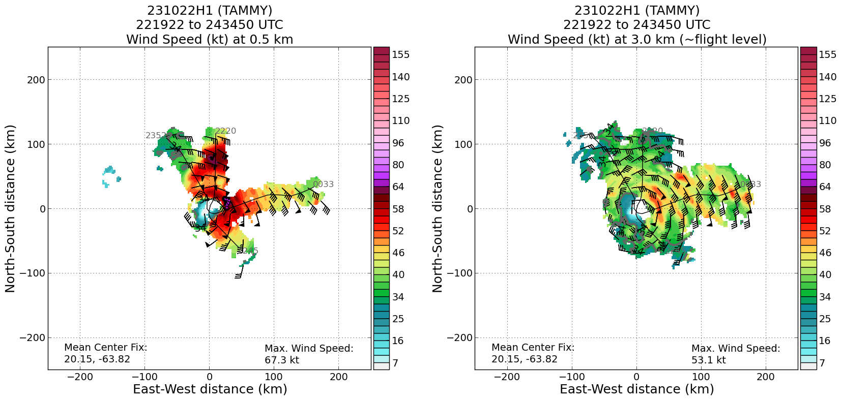
0026 | Sonde 11 drifter overflight
0047 | Turn inbound from NE to start NESDIS Ocean winds moduole
0056 | Sonde 12: NRD41 sondes from here on in: RMW NE, problematic data in sonde
0104 | Turn outbound 345
0121 | Turn inbound 165
0141 | Sonde 13. Going to SW since NE eyewall is breaking up a bit.
0145 | Turn inbound
0153 | Turn outbound south, 2-6-km tilt 26.1 at 122 degrees, getting more misaligned.
0156 | Sonde 14
 | Note that SFMR may not have been producing rain rates during the final passes of the mission, starting at 0134.
 | Tilt increased throughout flight.
0339 | Landed in Barbados

POST-FLIGHT
Mission Summary | We flew a successful research mission into Hurricane Tammy, in collaboration with NESDIS.  We executed several modules, including surface wind/wave validation by overflying a saildrone near the S endpoint of the pattern, a buoy overflight to the NW of the storm, and an overflight of a drifting buoy near the eastern endpoint of the pattern. We also did a vortex alignment module along the northern side of the storm. The tilt vector seemed to be S-N early in the flight, although it shifted to NW-SE and increased in magnitude by the end of the flight.  After these HRD modules, we did several NESDIS legs overflying areas of strong wind and rain in the eyewall for IWRAP and comparisons with SFMR. The winds appeared to have decreased somewhat since earlier fights, but we still
Actual Standard Pattern Flown | Figure 4 but with some modifications to accommodate various modules.
APHEX Experiments / Modules Flown | Surface wind/wave validation, saildrone overflight, vortex alignment module, collaboration with NESDIS for SFMR/IWRAP comparisons
Plain Language Summary | - We flew a successful research mission into Hurricane Tammy in collaboration with our NESDIS partners.  - We flew several successful research modules to study surface winds and waves, and also to assess how aligned the storm was.
Instrument Notes | Most instruments appeared to be working correctly. There was an issue noticed with the SFMR starting around 01:34 where it did not seem to be producing rain rates.
Final Mission Track | 