MISSION PLAN
FLIGHT ID | 20231021I1 | STORM | Tammy
MISSION ID | 0920A TAMMY | TAIL NUMBER | NOAA-43
TASKING | EMC/NHC | PLANNED PATTERN | Rotated Figure-4 + modules
MISSION SUMMARY
TAKEOFF [UTC] | 0952 | LANDING [UTC] | 1747
TAKEOFF LOCATION | TBPB | LANDING LOCATION | TBPB
FLIGHT TIME | 7.9 | BLOCK TIME | 8.5
TOTAL REAL-TIME RADAR ANALYSES  (Transmitted) | 6 (4) | TOTAL DROPSONDES Deployed (Transmitted) | 28 (28)
OCEAN EXPENDABLES (Type) | 2 (2) AOC/HRD AXBTs | sUAS (Type) | n/a
APHEX EXPERIMENTS / MODULES | TDR - Rotated figure-4, FLAIMS, Stratiform Spiral
HRD CREW MANIFEST
LPS ONBOARD | Marks | LPS GROUND | Rogers
TDR ONBOARD | Marks | TDR GROUND | Reasor
ASPEN ONBOARD | J. Zhang | ASPEN GROUND | n/a
NESDIS SCIENTISTS | n/a
GUESTS (Affiliation) | n/a
AOC CREW MANIFEST
PILOTS | Doremus/Wood/Keith
NAVIGATOR | Miller
FLIGHT ENGINEERS | Tyson/Wysinger
FLIGHT DIRECTOR | Zawislak/Lundry
DATA TECHNICIAN | Richards
AVAPS | Waggoner/Patel

PRE-FLIGHT
Flight Plan | 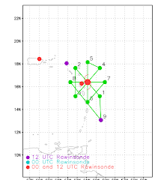  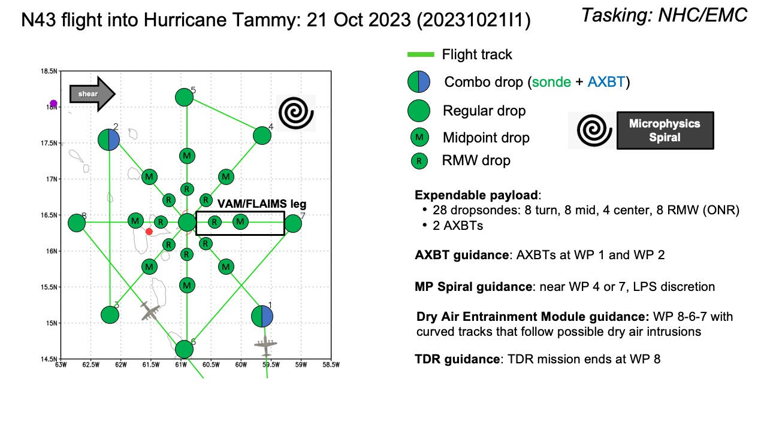  Altitude:  - 8 or 10 kft (pressure altitude) depending on AF deconfliction requirements (FL 10 kft preferred)  Potential add-on APHEX Modules:  - Priority #1: VAM or FLAIMS Module - see notes  - If the storm has vertically aligned, the FLAIMS module can be substituted for VAM - at the discretion of the onboard HRD LPS  - Priority #2: Microphysics Spiral - see notes
Expendable Distribution | - Load 35 dropsondes  - Release at endpoints, midpoints, centers (charged to NWS)  - Possible supplemental RMW drops (charged to ONR) - if eyewall is present (at discretion of the onboard HRD LPS)  - Additional drops may be requested at the discretion of the onboard HRD LPS  - All dropsondes transmitted to the GTS  - 2 AXBTs (CAD launched) - see notes below  - All AXBTs transmitted to the AOC ground server if possible
Preflight Weather Briefing | Tammy is a 70-kt hurricane, based on NHC 5am advisory. The core still is rather disorganized, with a small central dense overcast and a large convective band to the southeast of the center. This band is bringing thunderstorms to Barbados at the time of planned take-off. Tammy continues to encounter moderate westerly vertical wind shear (15 kt from 270 based on 06 UTC SHIPS).  TDR center plots from previous two P-3 missions shows MLC displaced about 20-30 km to the east or northeast of the LLC. Will be interesting to see how the core looks today.
Instrument Notes | all instruments are nominal. WSRA was inoperative.

IN-FLIGHT
Time [UTC] | Event
0951 | TBPB, wx at the field caused delayed take off, IP is so close we orbited after TO to make sure all instruments are working
1006 | suggested we start TDR analysis before IP to catch rainband north of Barbados. Maneuvering to get through the band to pick up IP
1015 | PT #1, combo drop #1, AXBT #1, TK 330, SST 29., altitude 8kft with AF at 10 kft
1027 | midpoint drop #2, restarting MMR to improve situational awareness, nose radar gives good representation (pic)  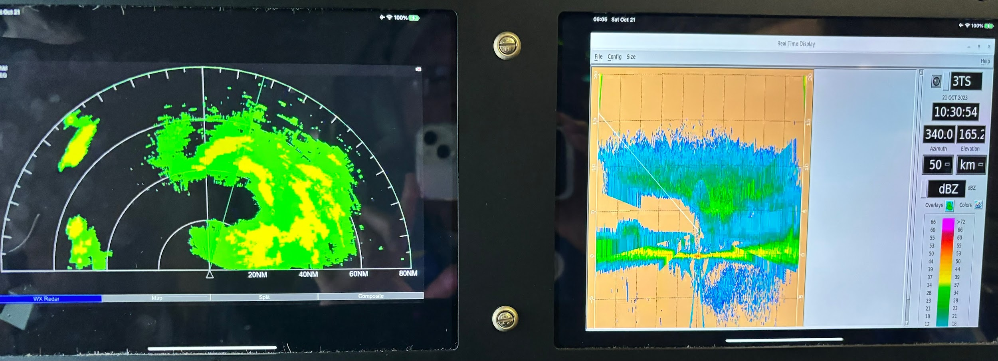
1032 | entering S eyewall, all stratiform. Elliptical eyewall, major axis WSW-ENE, open to SW
1039 | center drop #3, tucked up to the N eyewall, FL wind center, but 64 kt surface wind, 995 mb
1041 | RMW drop #4, north eyewall very sporty with some good bumps, echo tops >18 km. Ver
1052 | midpoint drop #5, still in good stratiform rain, potential spiral target area
1104 | PT#2, combo drop #6, AXBT #2, TK 220 downwind, SST 28.86 (wow, 2 AXBTs worked in a row)
1106 | 1st TDR analysis started
1118 | adjusting PT#3 to stay clear of Dominica. Set up TK to stay 12 nmi off shore then pick up 060 TK once we clear Dominica
1120 | 1st TDR analysis complete  Alt (km) Lat (deg) Lon (deg)  0.5 99.99 99.99  2.0 15.42 60.43  3.0 15.48 60.41  6.0 15.58 60.39  2-6 km vortex tilt: 18.5 km at 13 deg  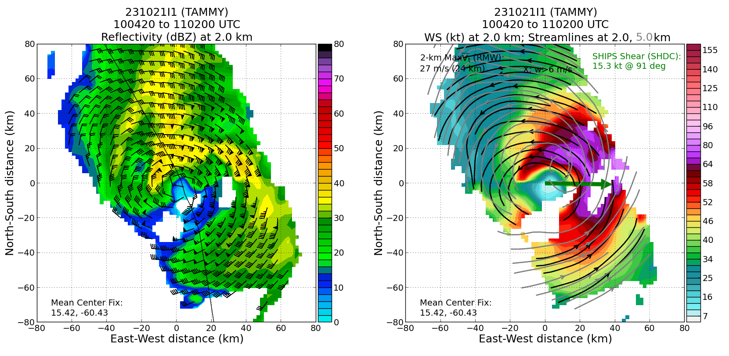
1145 | PT #3 drop #7, TK 045 to thread gap between Dominica and Martinique closer to Martinique to stay 12 nmi from Dominica
1200 | midpoint drop #8, start TDR as we are mostly clear of islands
1207 | RMW drop #9
1209 | center drop #10, 990 mb, 25 kt wind, very choppy ride across the eye. A lot of shear induced turbulence appears. Very thick anvil over the eye.
1213 | RMW drop #11, 80 kt surface with 71 kt FL
1222 | midpoint drop #12 in large stratiform area
1235 | PT #4 drop #13, end 1st Fig 4, turn TK 305 to PT #5
1239 | 2nd TDR job submitted
1250 | 2nd TDR analysis complete  Alt (km) Lat (deg) Lon (deg)  0.5 99.99 99.99  2.0 15.62 60.54  3.0 15.71 60.54  6.0 15.84 60.46  2-6 km vortex tilt: 25.3 km at 18 deg  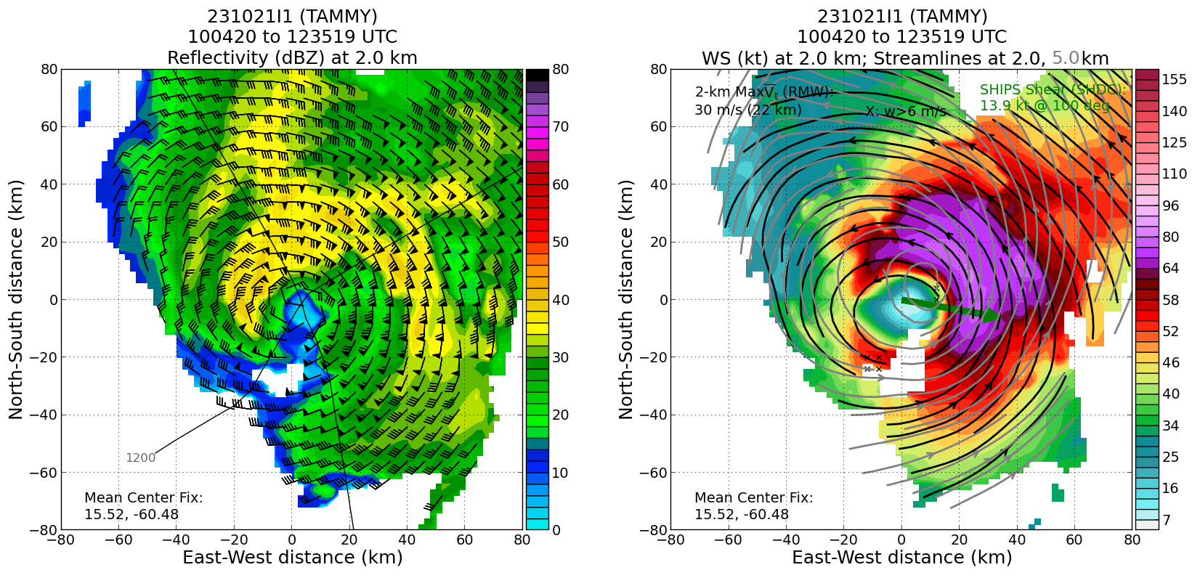
1254 | PT #5, drop #14, turn TK 195 inbound
1305 | midpoint drop #15
1316 | RMW drop #16
1319 | center, drop #17
1322 | RMW drop #18
1331 | midpoint drop #19 and PT #6 as it would be over Martinique, TK east to PT #7, decided to make sure we get TDR coverage on ESE side of the story into model as that is where the most scatterers are in the principal band
1335 | 3rd TDR analysis submitted
1350 | 3rd TDR analysis complete  Alt (km) Lat (deg) Lon (deg)  0.5 99.99 99.99  2.0 15.79 60.65  3.0 15.86 60.65  6.0 16.00 60.54  2-6 km vortex tilt: 26.9 km at 27 deg
1355 | discussed strange cross wind orientation of lines of the convective cells in the inner edge of the principal rainband. The lines were spaced 5-10 nmi apart. (Pic)  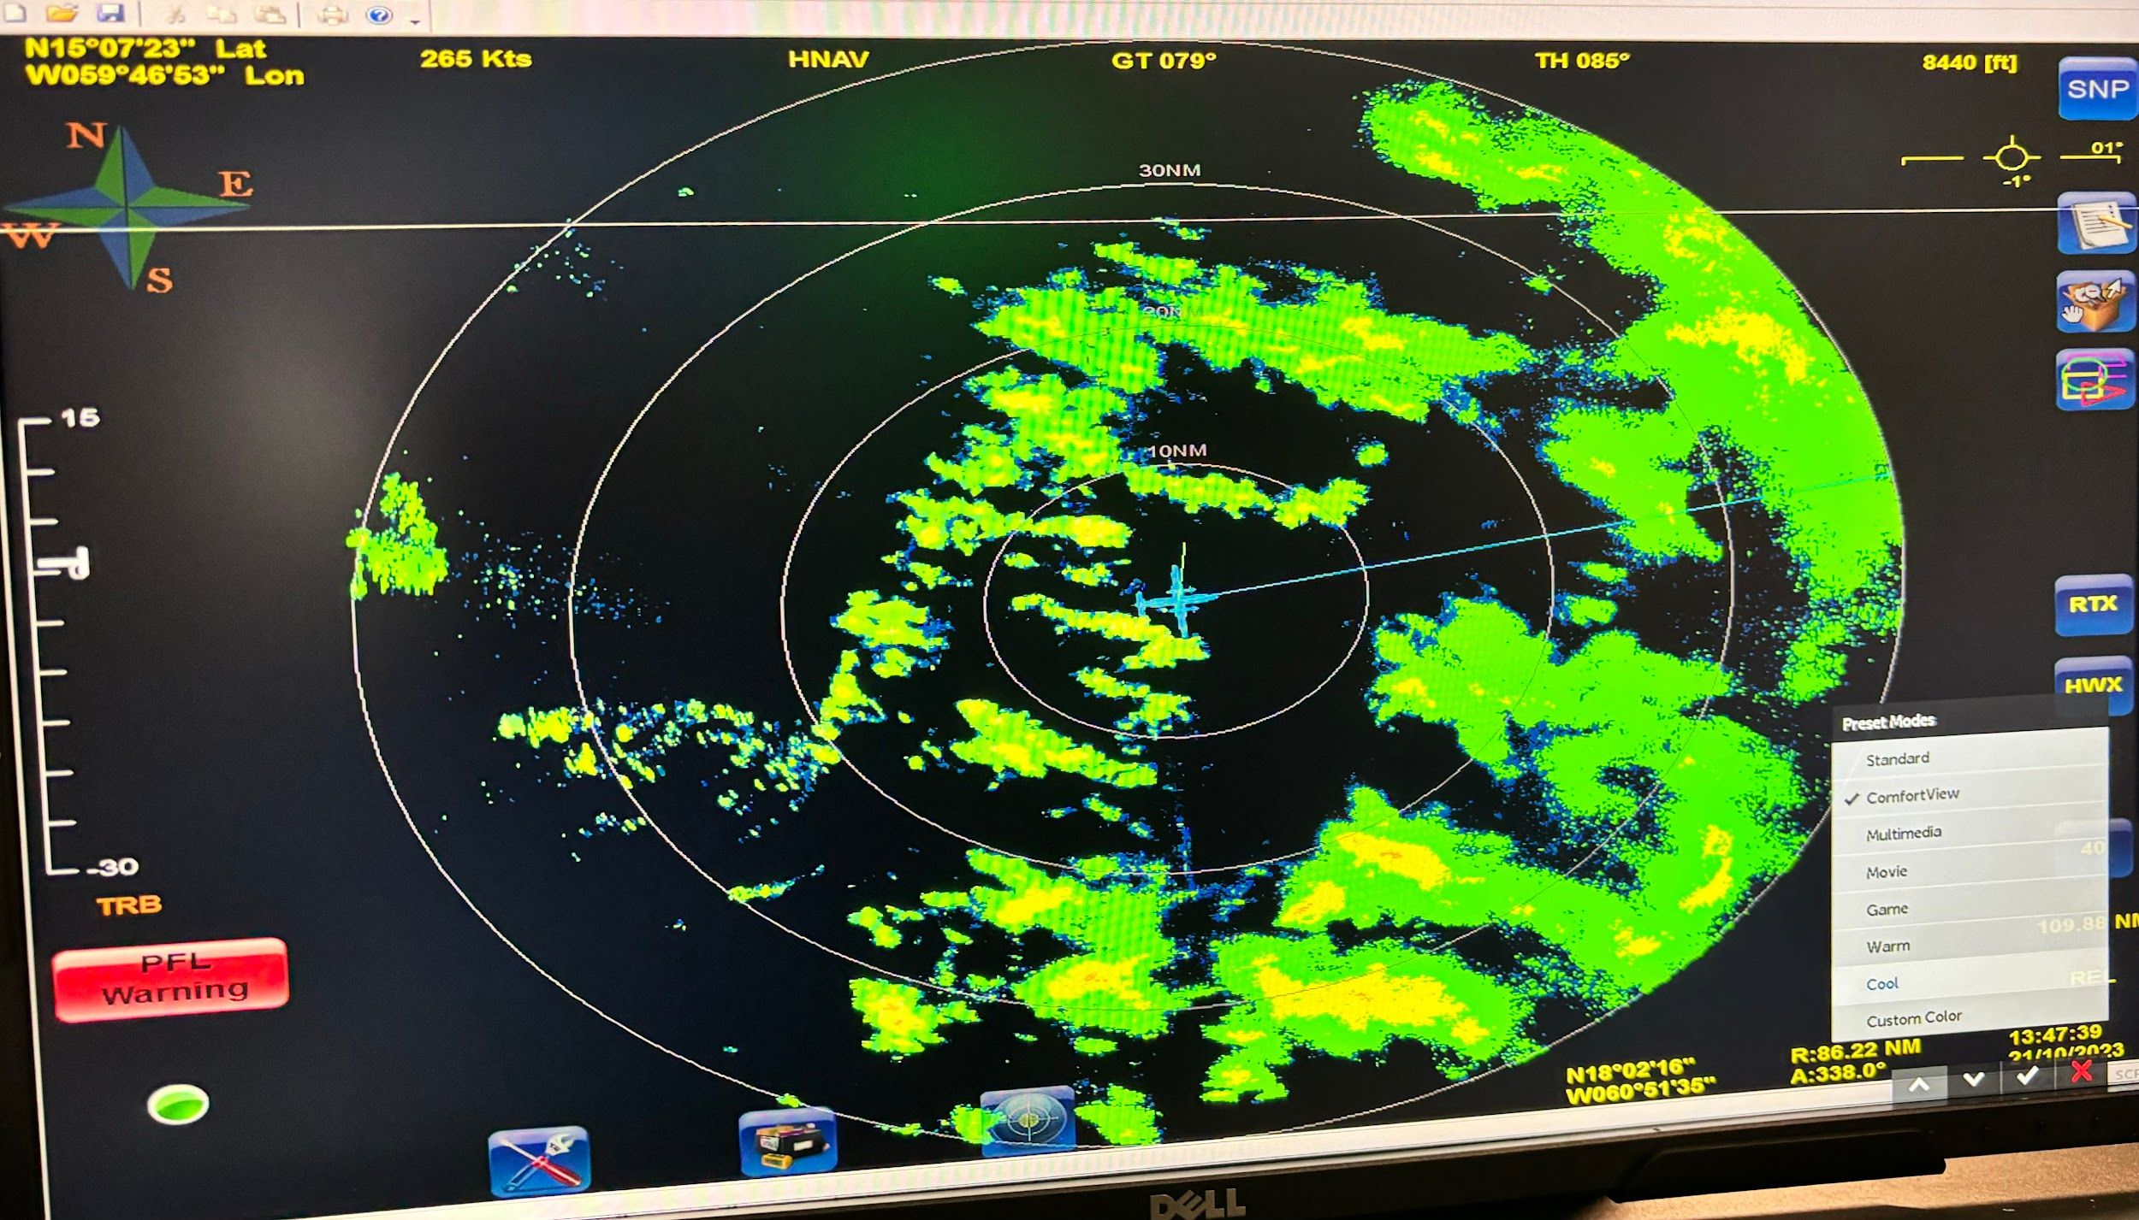
1406 | PT #7, drop #20, TK 280 inbound
1418 | midpoint drop #21
1426 | east RMW1 drop #22
1429 | east RMW drop#23, messy center with multiple FL wind max
1431 | center drop #24, TK 259 to avoid islands
1436 | midpoint drop #25, dropped early to avoid islands, MMR shows west eyewall impinging on Guadalupe leading to what appears like Bernoulli acceleration of flow and strange N-S linear rainband forming between west eyewall and island (pic)  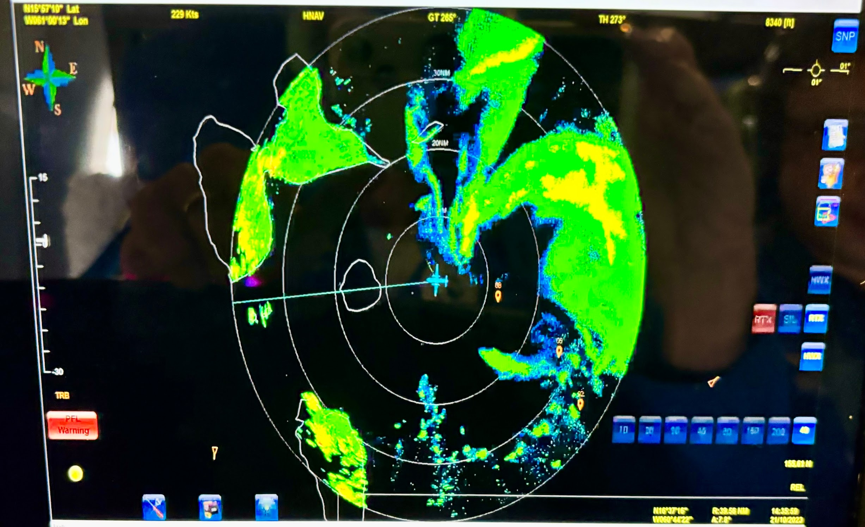
1443 | 4th TDR analysis submitted
1454 | PT#8 end 2nd Fig drop #26, turn back to center for modules, complication is we are 8 kft altitude and AF is at 10 kft. We need to get clearance to 12 kft and coordinate climb with AF.
1459 | 4th TDR analysis complete  Alt (km) Lat (deg) Lon (deg)  0.5 99.99 99.99  2.0 16.00 60.78  3.0 16.07 60.76  6.0 16.14 60.61  2-6 km vortex tilt: 26.9 km at 27 deg
1515 | heading into W eyewall
1518 | radar eye very elliptical oriented E-W with 20 nmi major axis and 10 nmi minor axis  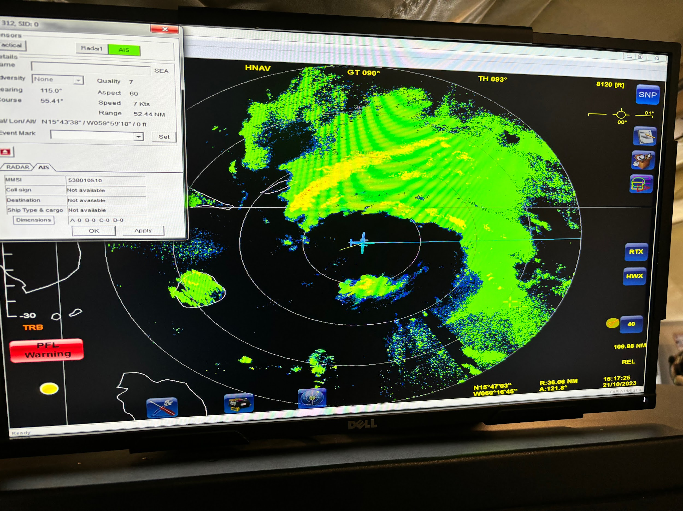
1537 | begin spiral, finally found a spot to spiral just NE of principal rainband
1541 | 4th TDR analysis submitted
1548 | end spiral up, drop #27, T=-12.2 C, RA=22 kft  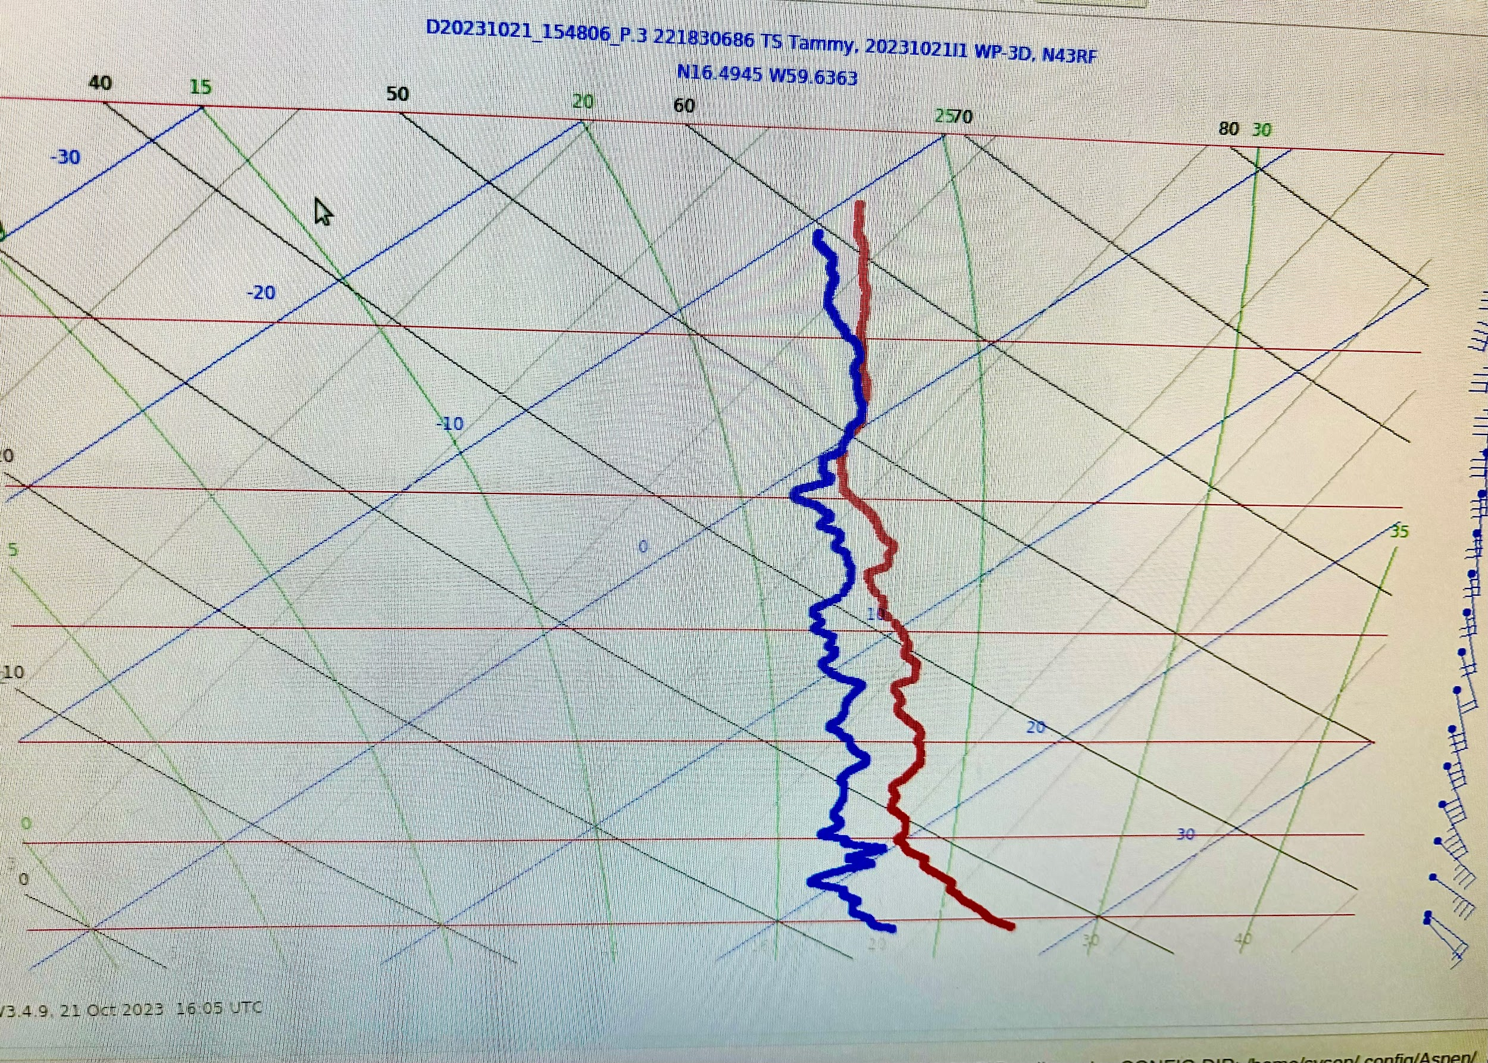
1551 | 5th TDR analysis complete  Alt (km) Lat (deg) Lon (deg)  0.5 99.99 99.99  2.0 16.13 60.88  3.0 16.20 60.84  6.0 16.33 60.65  2-6 km vortex tilt: 32.6 km at 48 deg
1555 | end spiral down, decided to finish FLAIMS wedge module from NE (tilt axis) and forego 2nd spiral (not enough time) at 8000’
1610 | drop #28 begin 2nd FLAIMS wedge leg inbound TK 225
1619 | in N eyewall. 88 kt FL wind max. Only the northern semicircle has strong convection. Strongest convection in NW eyewall (DSL) with new growth in NE portion (DS)
1623 | center, turn to TK 090 to reconnoiter ship we saw multiple times in the eye that appeared stationary to make sure they don’t need search and rescue  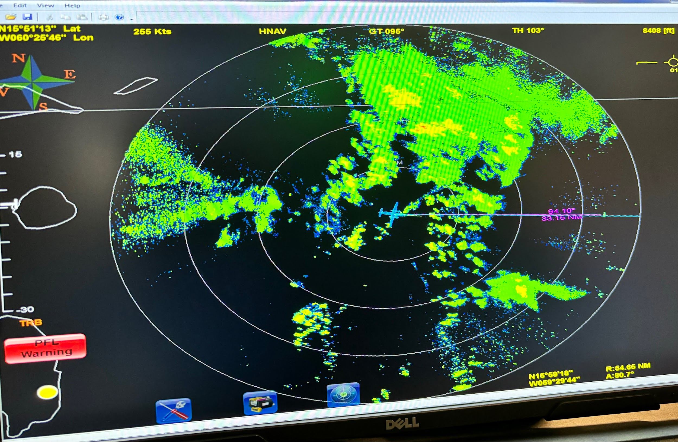
1626 | heading across the principal rainband to get to ship. Asked for additional TDR analysis on this outbound leg
1638 | end TDR leg as we descend to look for ship
1641 | see ship and it is underway. Phew!
1643 | head back to Barbados.
1646 | 6th TDR analysis submitted
1654 | passing through nasty E-W rainband that was over Barbados when we left
1658 | 6th TDR analysis complete  Alt (km) Lat (deg) Lon (deg)  0.5 16.09 60.89  2.0 16.31 60.95  3.0 16.38 60.93  6.0 16.56 60.87  2-6 km vortex tilt: 29.2 km at 16 deg  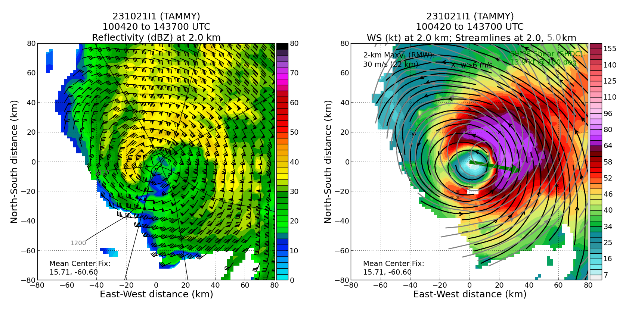  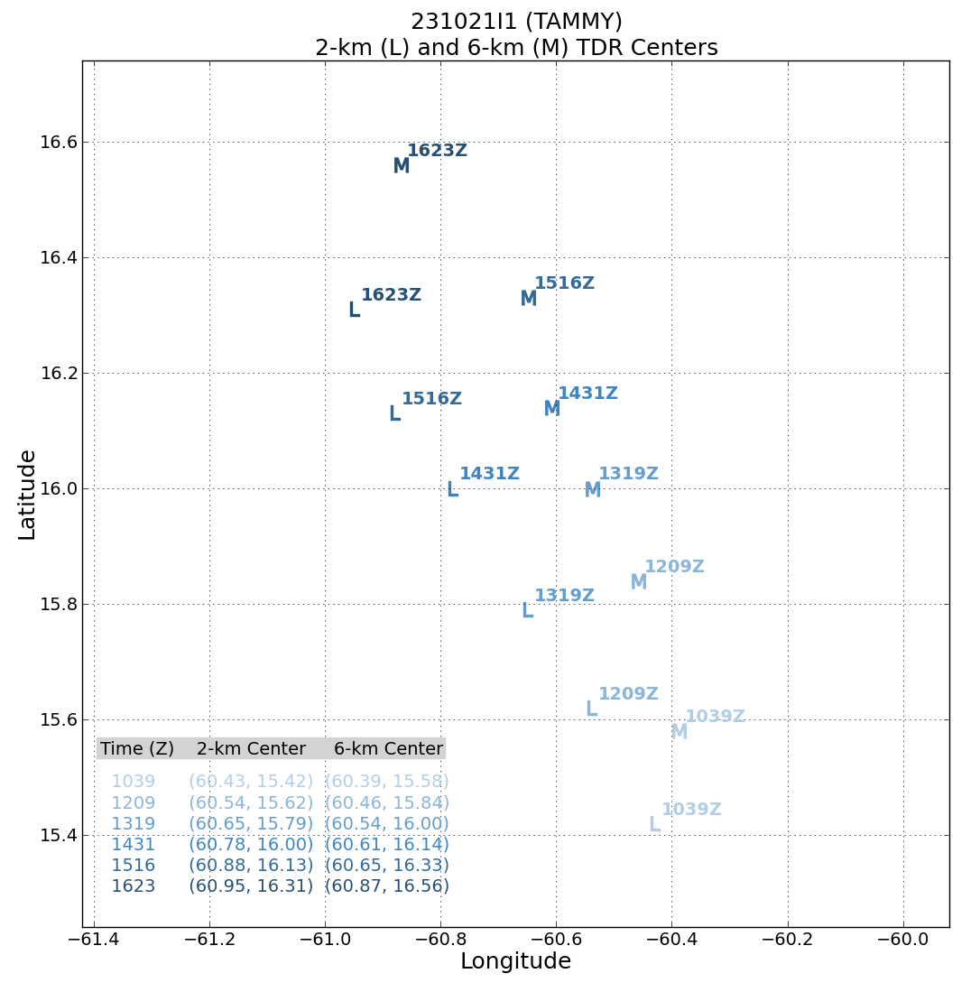
1710 | received a request to do a comms test for Altius near Barbados before we land. We flew a leg 50 nmi past island for radio check
1746 | land TBPB

POST-FLIGHT
Mission Summary | Mission was successful – rotated figure-4 was flown, a total of 28 drops were released, all of them worked and were transmitted, 4 TDR analyses were transmitted on time – an additional two analyses were performed as part of the FLAIMS wedge and final outbound leg on RTB (and search and rescue activity).
Actual Standard Pattern Flown | Rotated figure-4.
APHEX Experiments / Modules Flown | TDR sampling, also FLAIMS Wedge and Stratiform Spiral module
Plain Language Summary | - Successfully executed module to look at the vortex tilt evolution Successful mission was flown into Hurricane Tammy, with multiple objectives accomplished.  - Important radar and dropsonde data was collected and transmitted to the ground for use in computer forecast models.  - There also was valuable data collected of precipitation particle distributions at various levels in the atmosphere below and above the freezing level. This will help evaluate and improve model representation of these structures, thought to be important for both intensity and rainfall prediction.  - A repeated sampling of the winds at flight-level will yield insights into how storm structure changes over short (2-3 h) time periods, especially if it’s intensifying. This storm was not intensifying, but the observations from the radar nicely show how the inner-core structure of a non-intensifying storm evolves in the presence of continued vertical shear (change in wind speed and/or direction with height).
Instrument Notes | Instruments all worked well (TDR, sondes, AXBTs, microphysics probes, SFMR, W-band) except WSRA
Final Mission Track

