MISSION PLAN
FLIGHT ID | 20231021H1 | STORM | AL20 / TAMMY
MISSION ID | 1120A | TAIL NUMBER | NOAA 42
TASKING | EMC-NHC TDR | PLANNED PATTERN | Rotated Figure-4
MISSION SUMMARY
TAKEOFF [UTC] | 2104 | LANDING [UTC] | 0411
TAKEOFF LOCATION | Barbados | LANDING LOCATION | Barbados
FLIGHT TIME | 7.1 | BLOCK TIME | 7.3
TOTAL REAL-TIME RADAR ANALYSES  (Transmitted) | 6 (6) | TOTAL DROPSONDES Deployed (Transmitted) | 26 (24)
OCEAN EXPENDABLES (Type) | 2 (0) AOC/HRD AXBTs | sUAS (Type) | n/a
APHEX EXPERIMENTS / MODULES | VAM, Dry air entrainment module planned if time (not flown)
HRD CREW MANIFEST
LPS ONBOARD | Hazelton | LPS GROUND | None
TDR ONBOARD | Hazelton | TDR GROUND | Gamache
ASPEN ONBOARD | Sellwood | ASPEN GROUND | n/a
NESDIS SCIENTISTS | Chang, Jelenak, Sapp
GUESTS (Affiliation) | n/a
AOC CREW MANIFEST
PILOTS | Compare/Gaston/Palmer
NAVIGATOR | Utama
FLIGHT ENGINEERS | Stokes/Kiddo
FLIGHT DIRECTOR | Kalen/Englert
DATA TECHNICIAN | McAlister
AVAPS | WarneckeKeller

PRE-FLIGHT
Flight Plan | 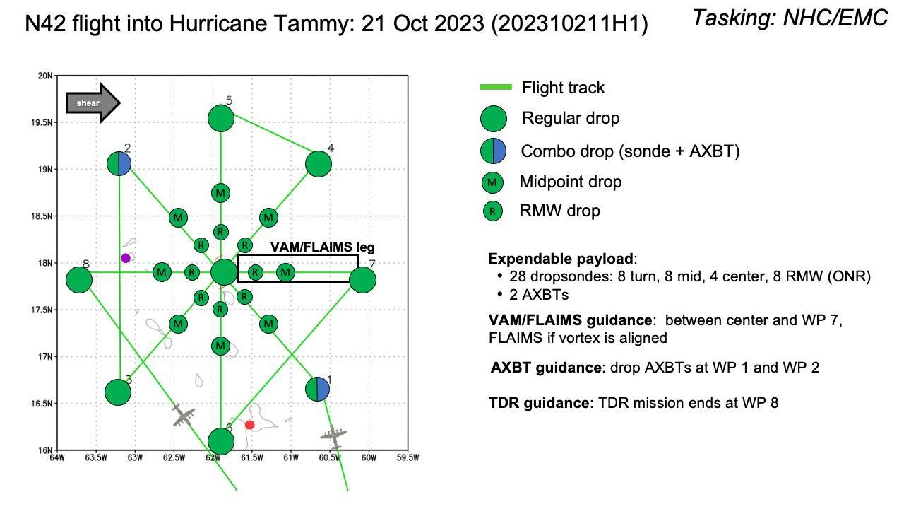  Rotated Figure 4, with possible add on of a dry air entrainment module at the end of the pattern.
Expendable Distribution | 28 dropsondes and 2 BTs during the rotated figure 4, with a possible 5 additional in the dry air entrainment module.
Preflight Weather Briefing | Tammy is a Category 1 hurricane moving north near the Leeward Islands. The system has been pulsing up and down with convection, with some shear and potentially dry air still affecting it. Earlier missions still showed tilt to the NE, in fact a little bit more tilt than previous missions. This has prevented thunderstorm activity from being able to wrap all the way around the SW side, and the eyewall has been consistently open there.  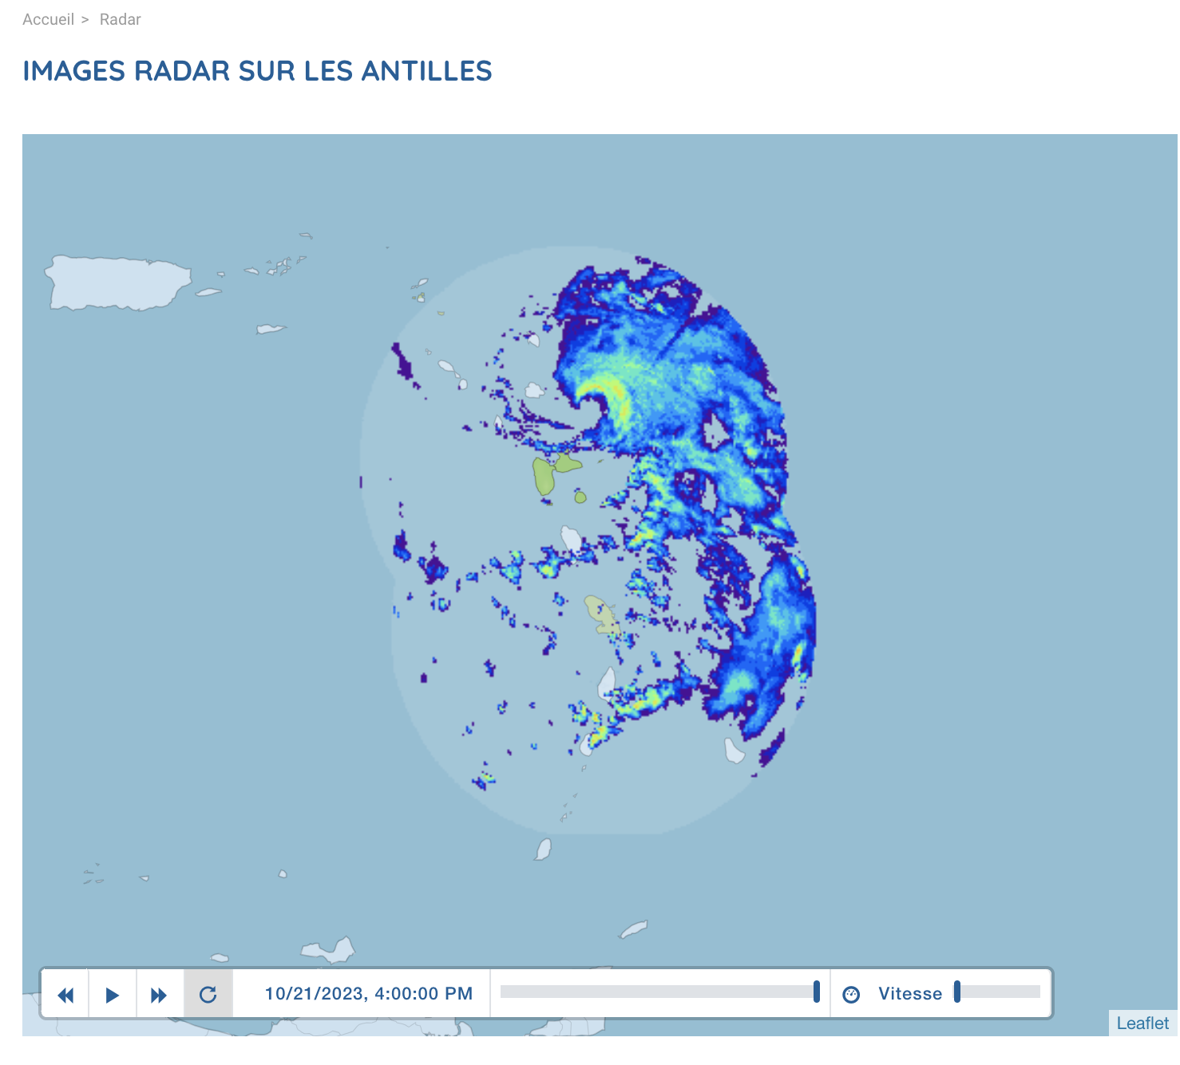
Instrument Notes | Instruments appear to be functioning properly

IN-FLIGHT
Time [UTC] | Event
2104 | Take-off from Barbados
2146 | Combo drop, Sonde 1, BT 1
2158 | Mid point 2, Sonde 2
2158 | Midpoint Sonde 3 (backup)
2206 | 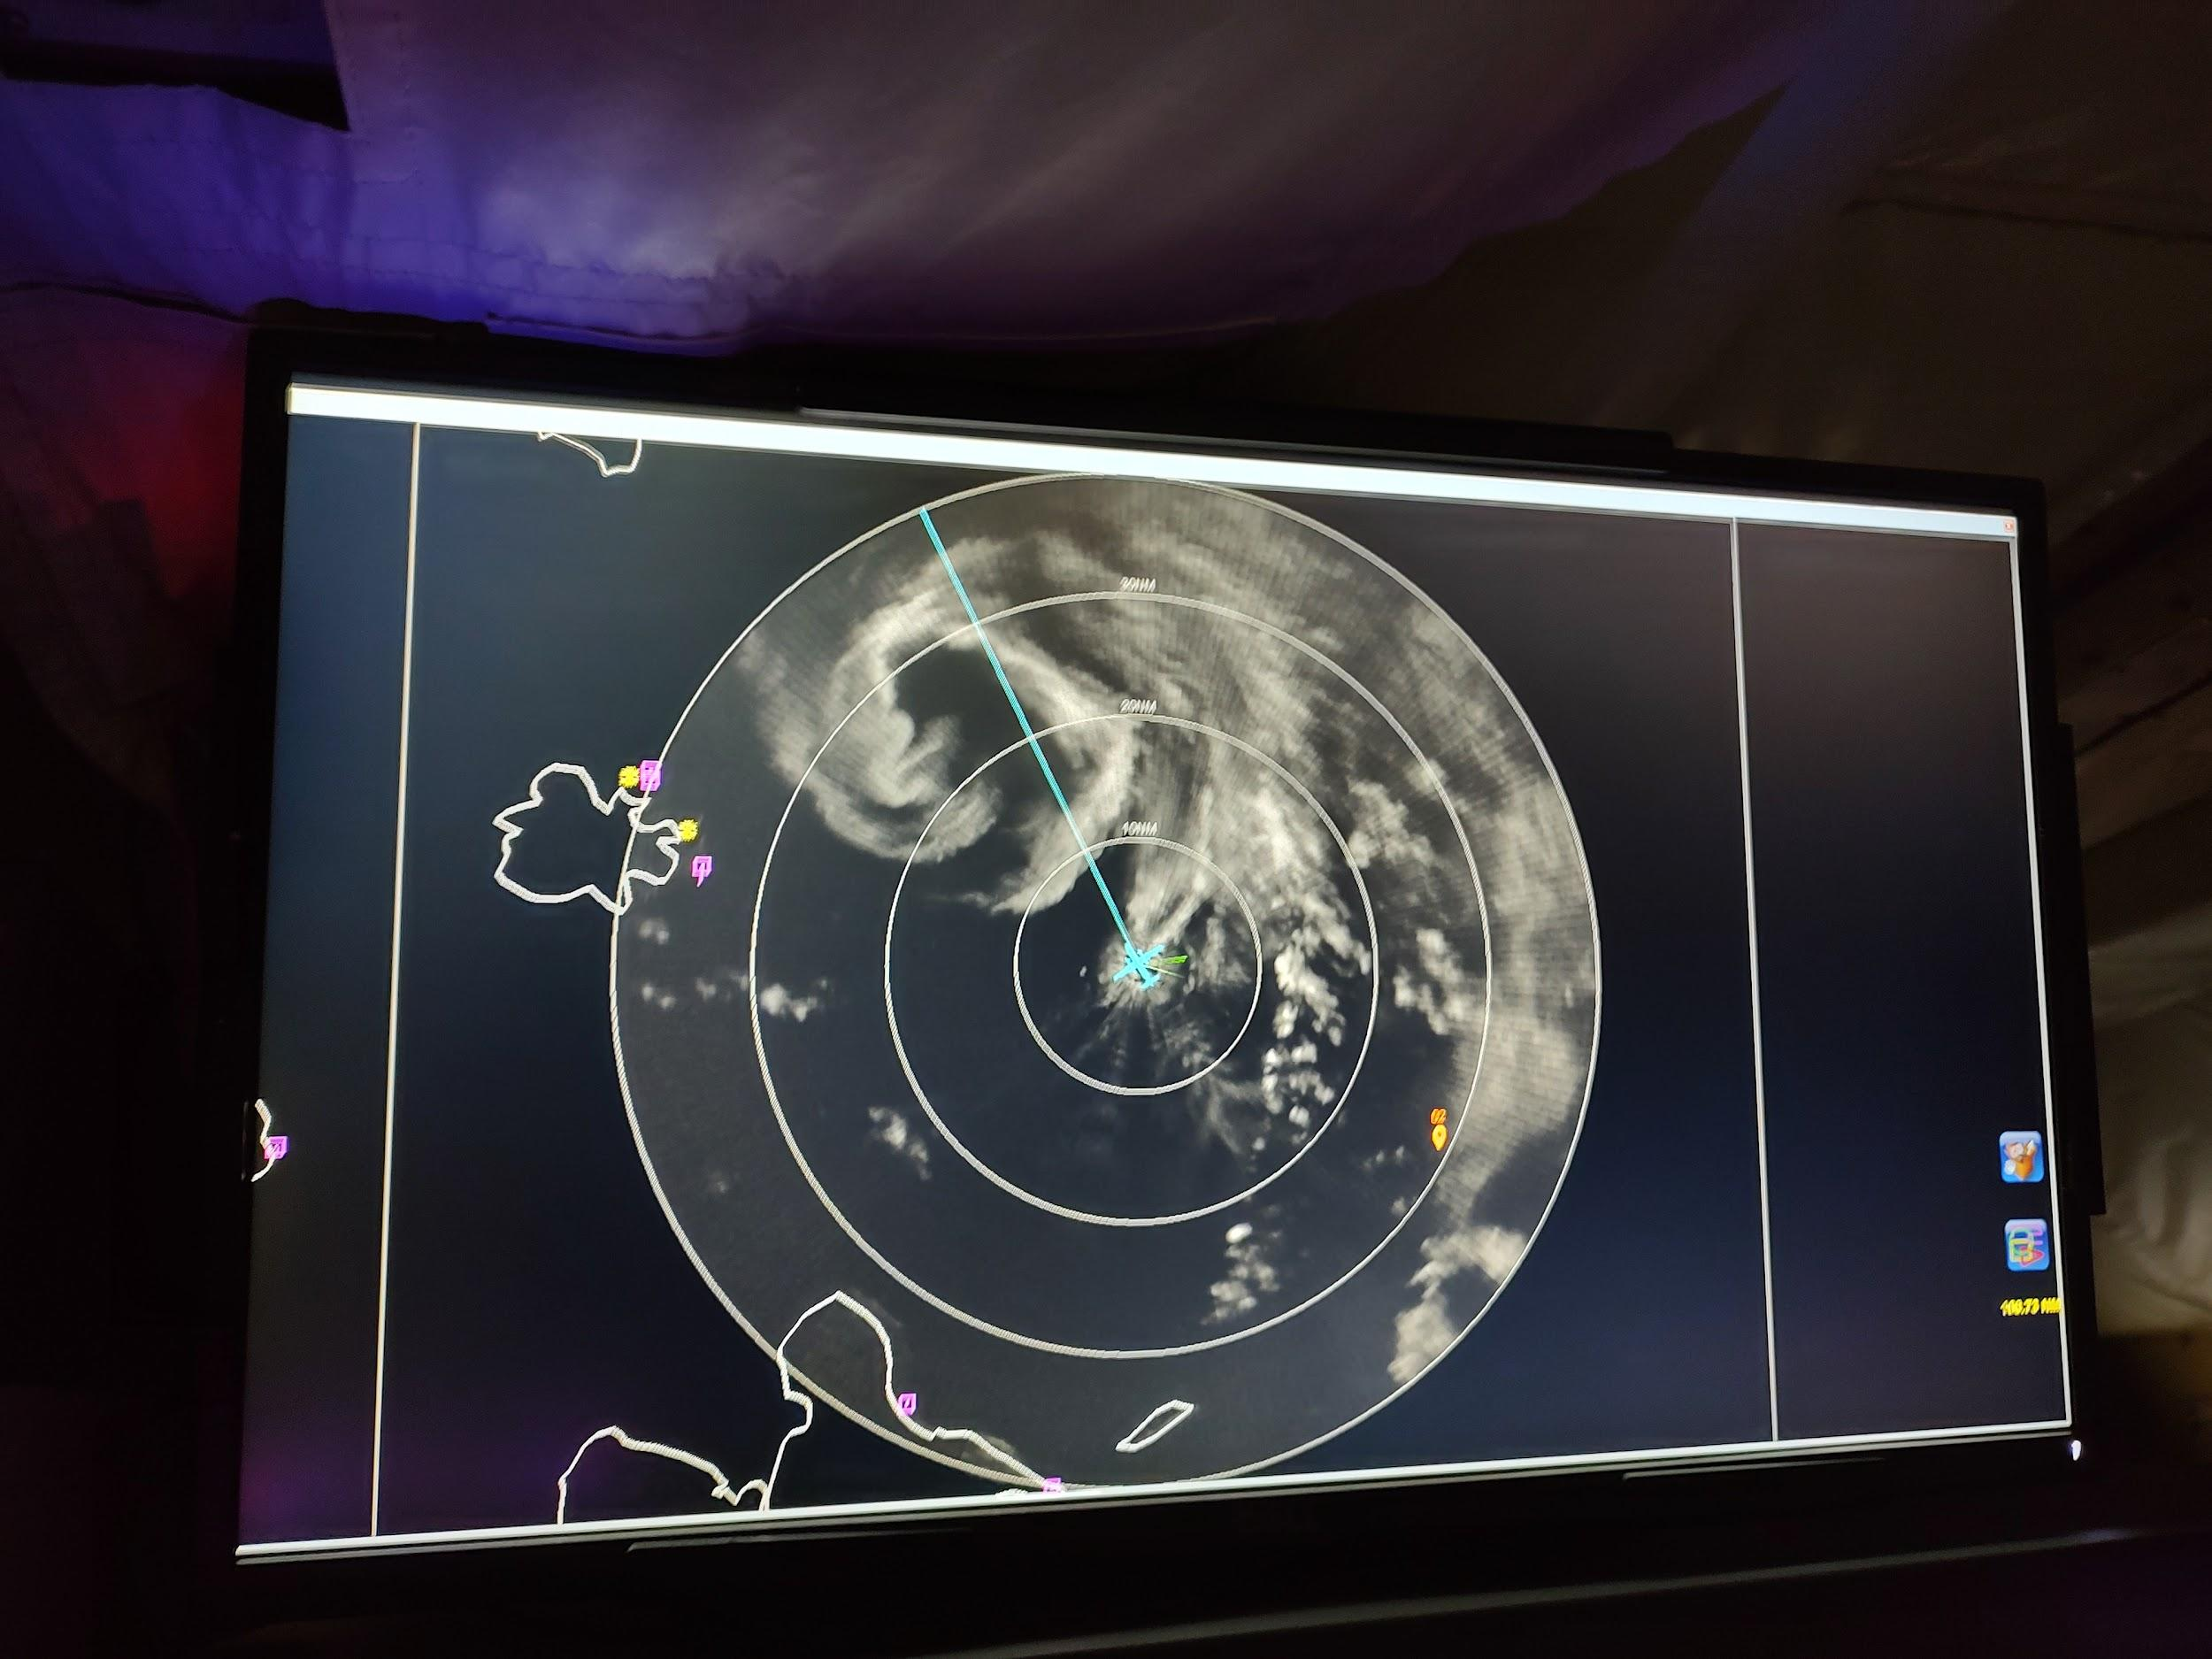
2208 | RMW SE Sonde 4
2213 | RMW NW Sonde 5
2216 | This appears to be another case where the SFMR winds drop out as the rain rate spikes  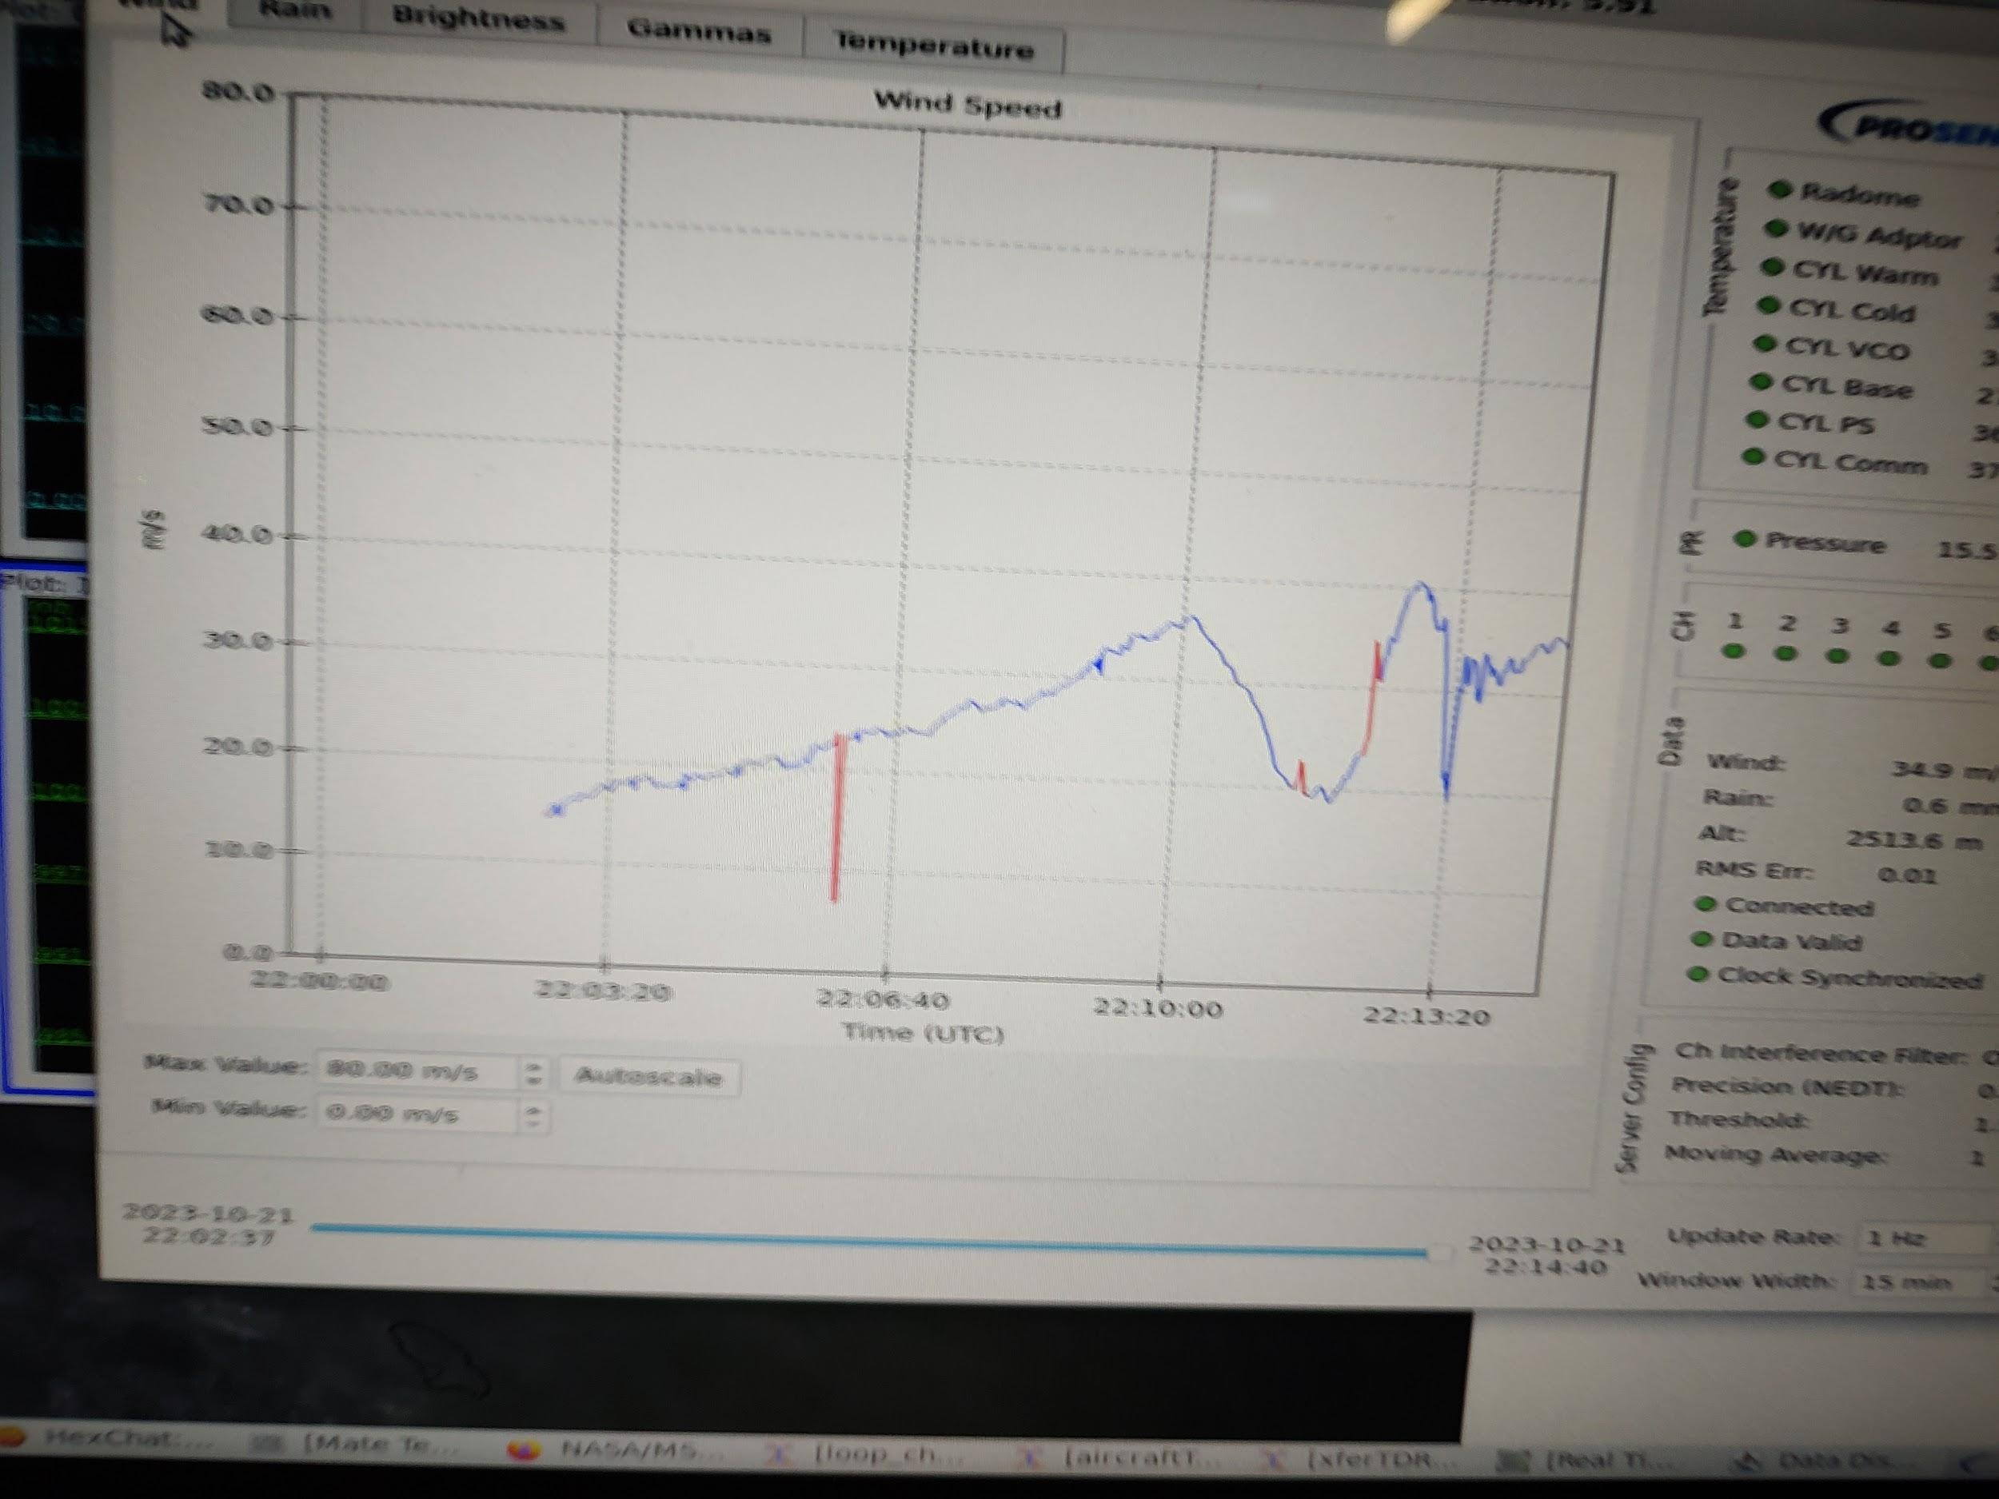  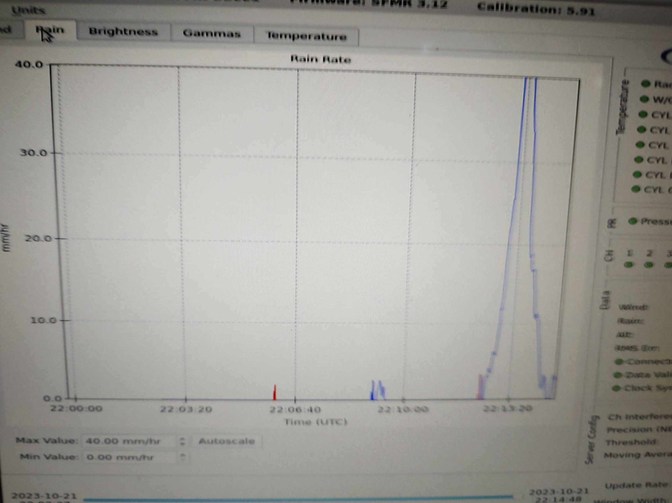
2226 | Midpoint Sonde 6
2235 | Endpoint NW Combo Drop, Sonde 7, BT 2, turning downwind
2300 | 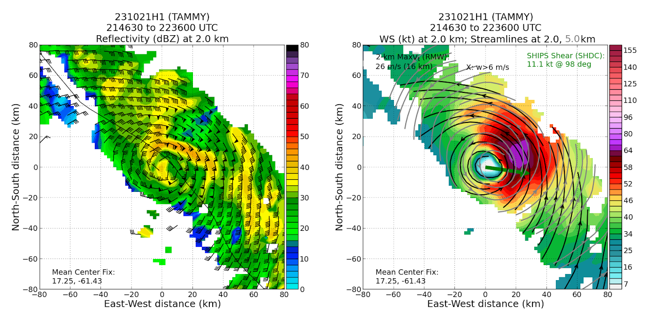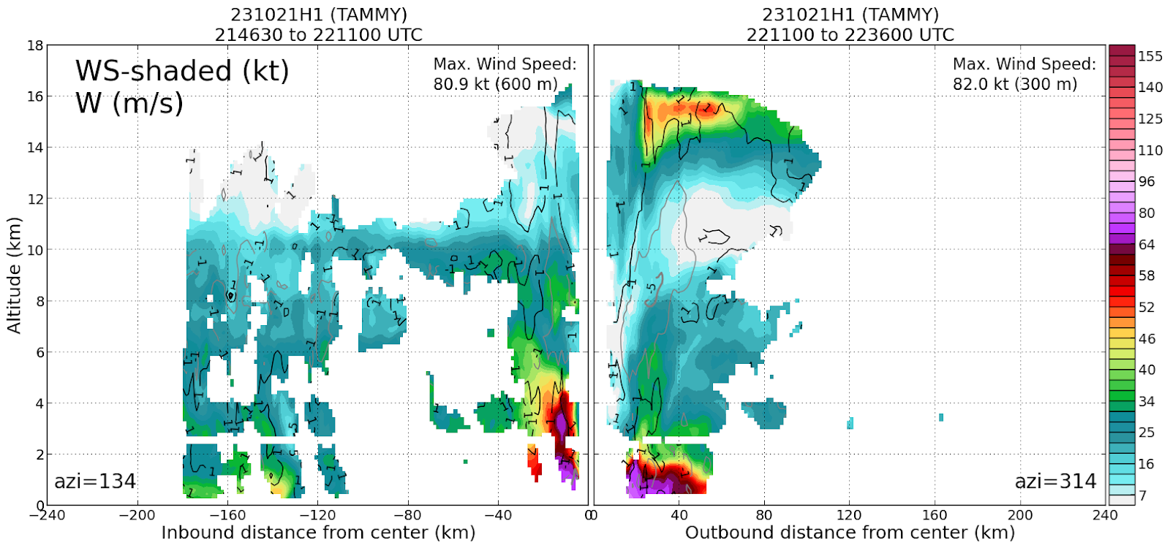  Pretty shallow vortex w/ the strongest winds (really drops off ~5km and ~2km on the NW quad)
2310 | Endpoint SW Sonde 8
2320 | Going to 12 kft for terrain concerns
2322 | Midpoint SW sonde 9
2328 | Tiny elliptical eye  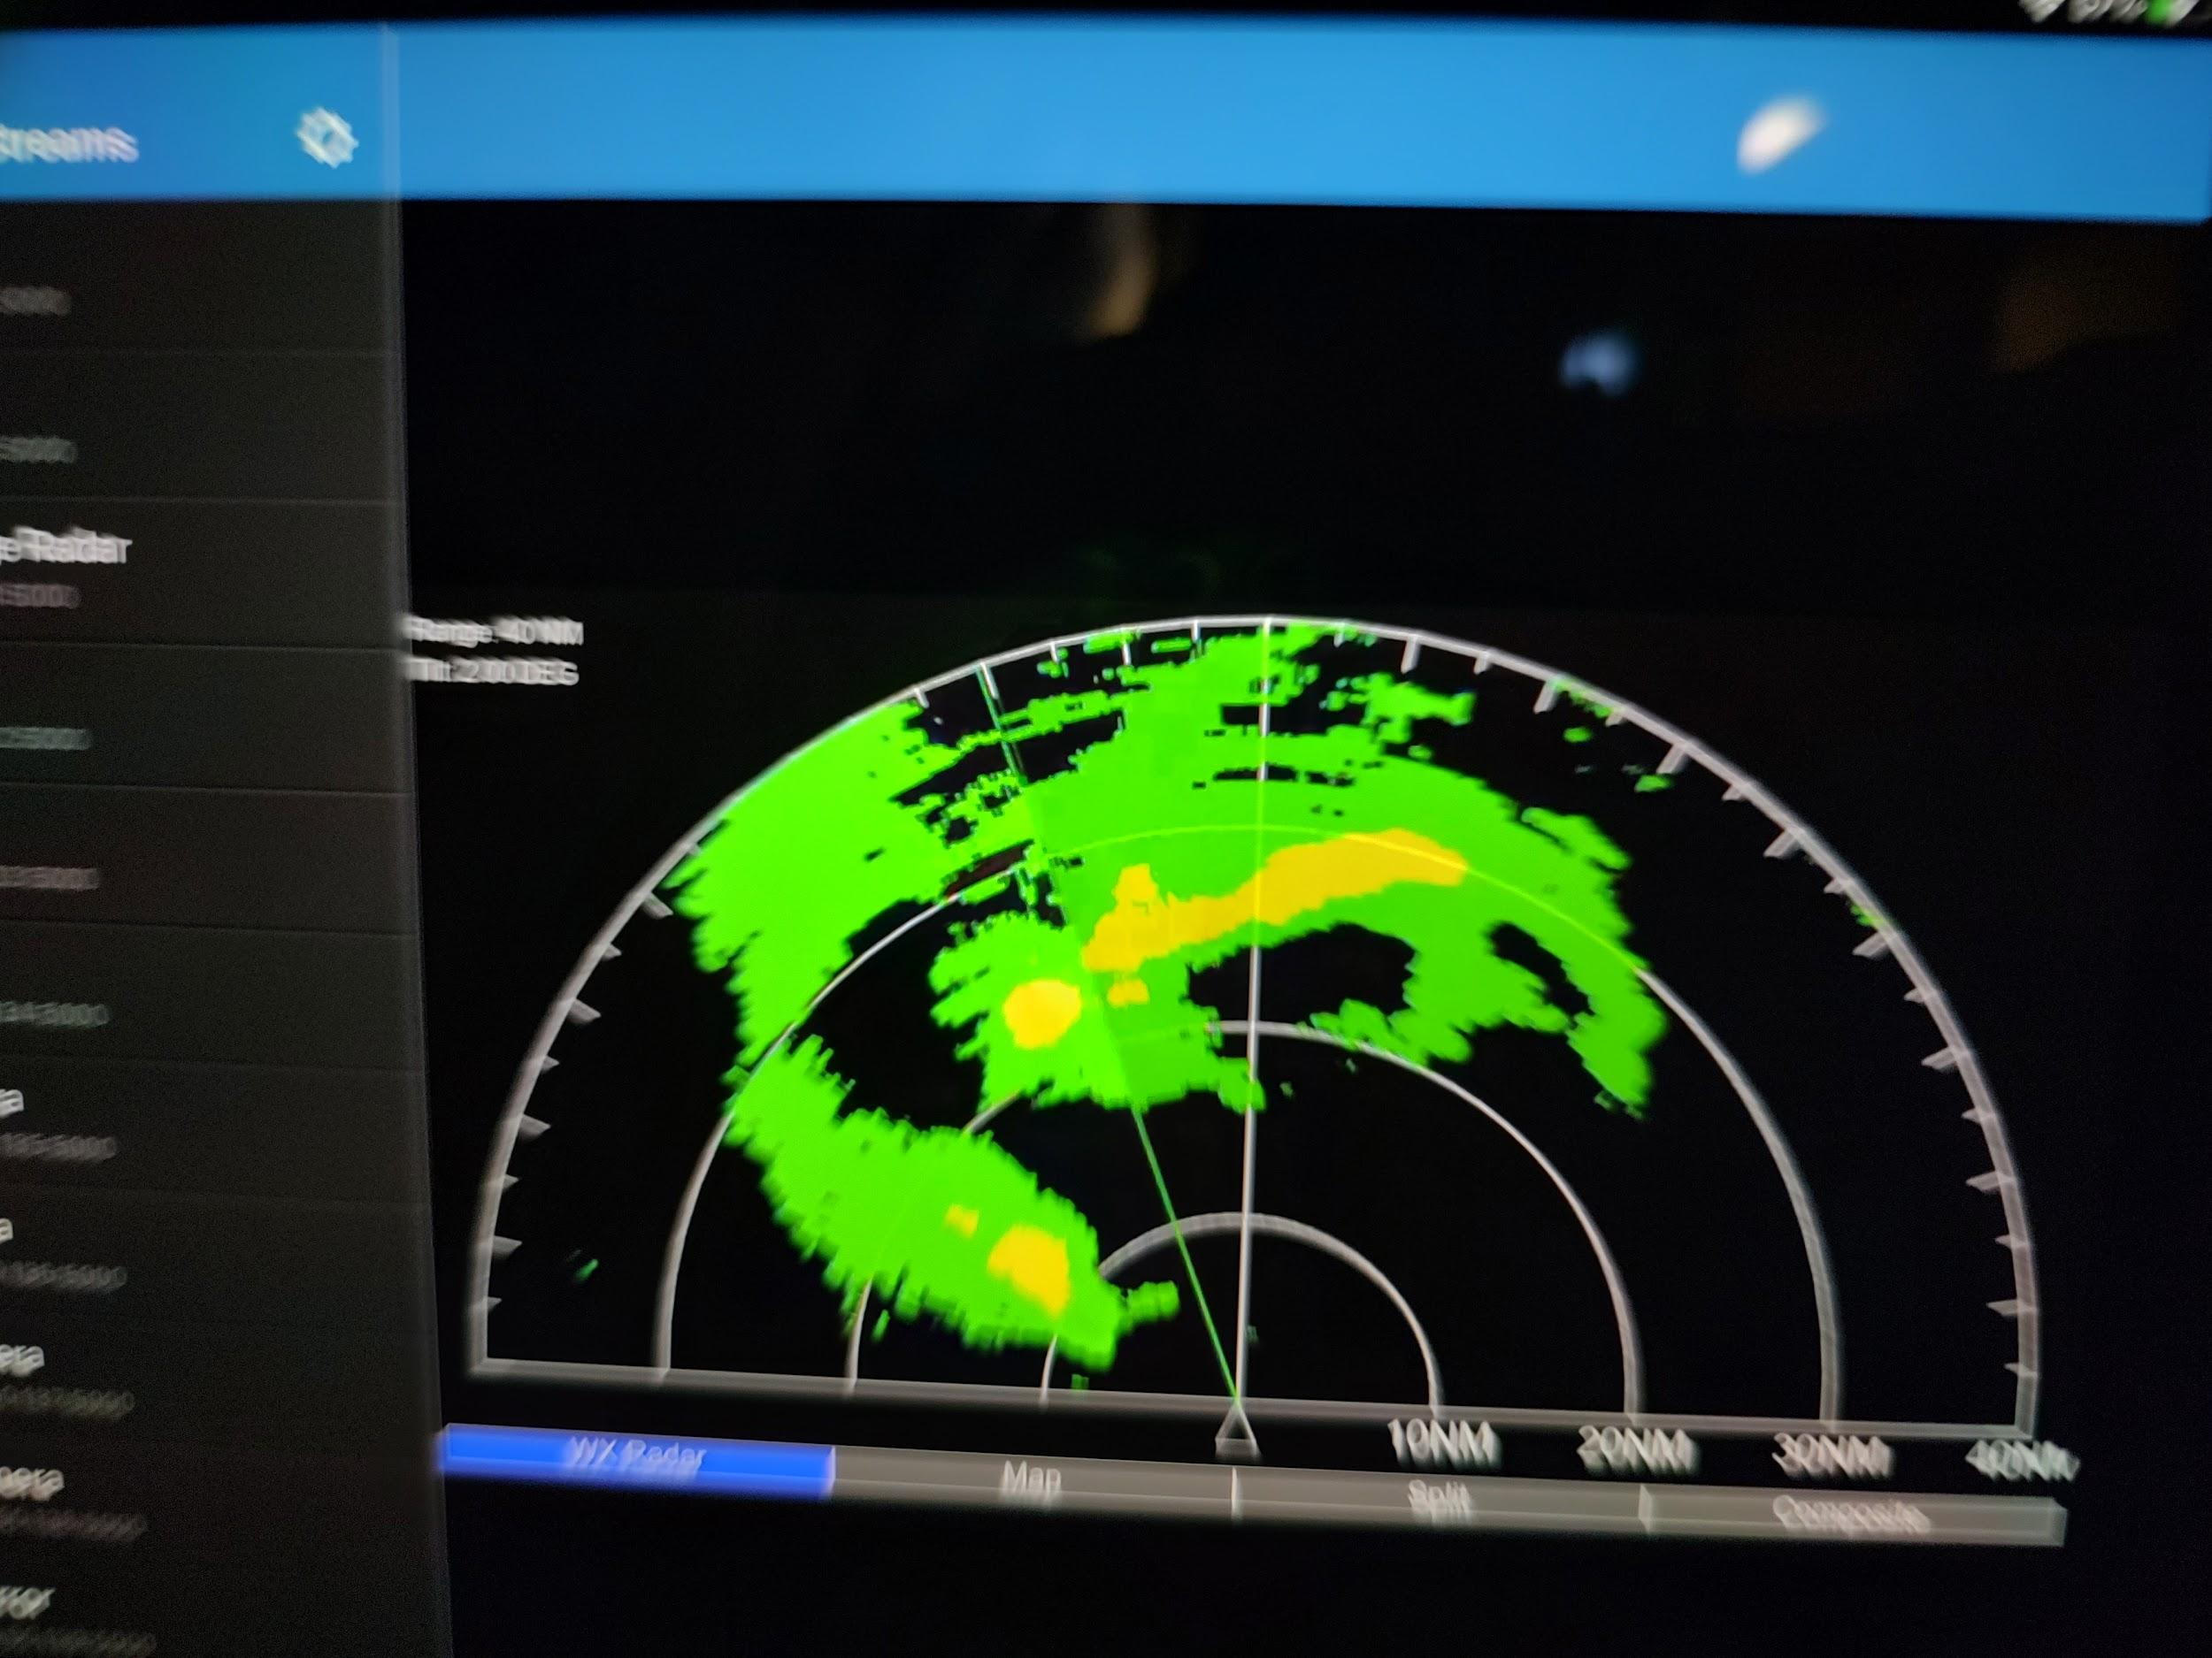
2332 | Center sonde 10
2333 | RMW sonde 11
2348 | Midpoint sonde 12
2357 | Endpoint sonde 13
0000 | ~18 UTC - 00 UTC (through 1st 2 center passes of the pattern
0006 | RGB airmass - there was a large blowup of convection near the center ~1h earlier. Now there’s some sort of boundary propagating southward away from the center that’s apparent. Is it from a downdraft? Not sure, it's hard to say since no visible imagery anymore and it's propagating through the already somewhat clear area but definitely some sort of outward propagating feature and there’s some pronounced clearing behind it.
 | Lightning with inner core blow up preceding the S’ward propagating feature
Somewhat drier on SW side. End point sonde SW and midpoint
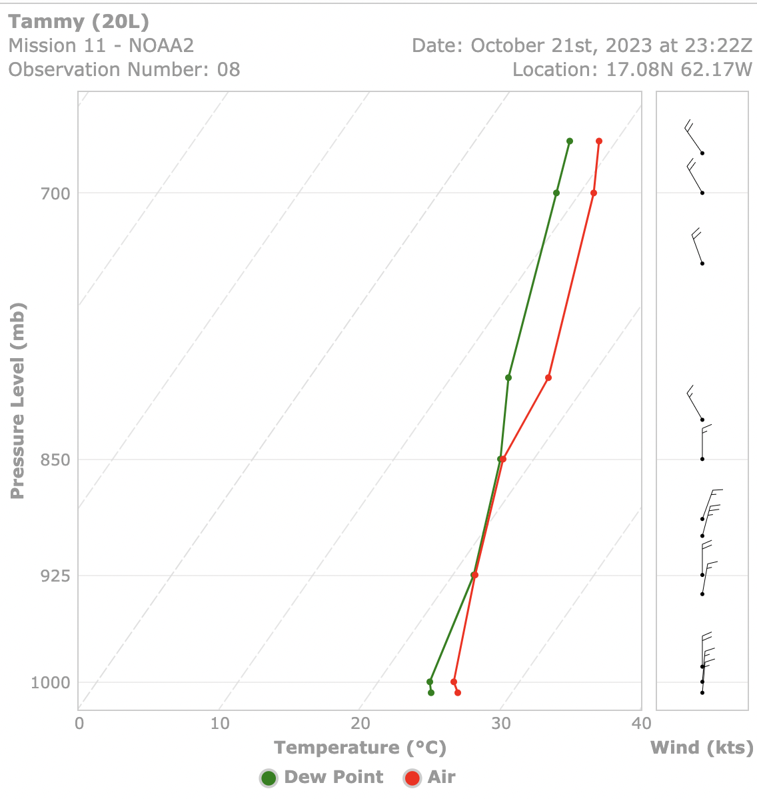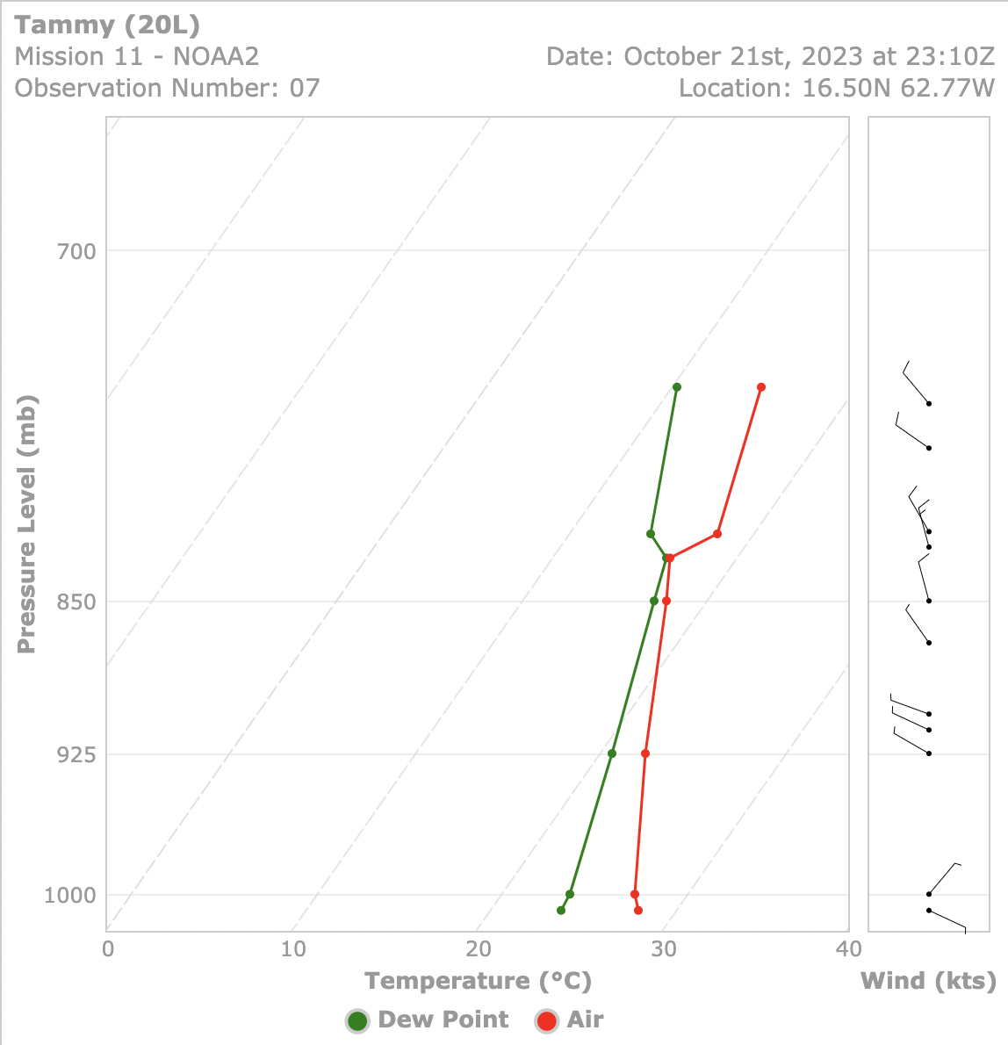
0019 | Endpoint N Sonde 14
0028 | Midpoint N Sonde 15
0038 | RMW N Sonde 16
0039 | Eye is a bit ragged/open  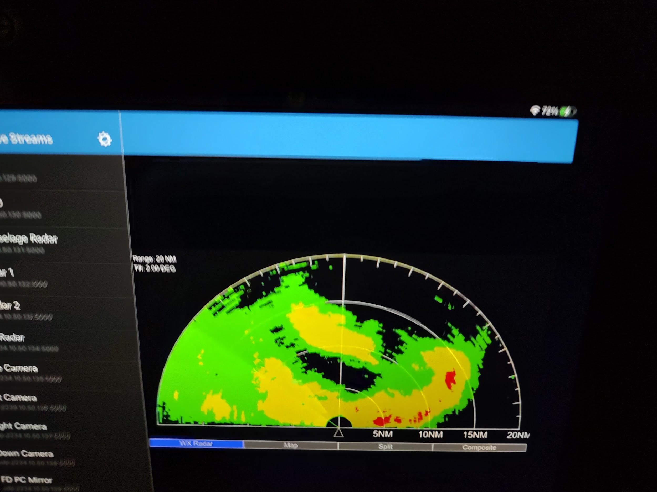
0043 | Center sonde 17
0045 | RMW S sonde 18
0052 | Audibled from dry air module back to VAM on the east side due to concerns with icing at night if we go above 12 kft
0054 | Endpoint Sonde 19
0055 | Endpoint Sonde 20 backup
0058 | Descending to 8 kft
0125 | Endpoint E Sonde 21
0138 | Midpoint E Sonde 22
0148 | RMW E Sonde 23
0149 | No center sonde since the center is over the island of Barbuda  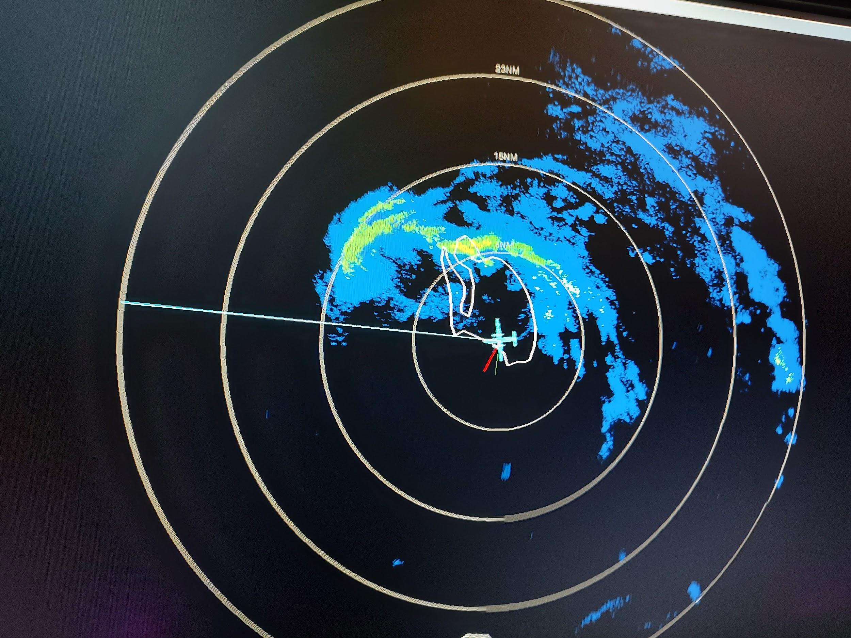
0154 | RMW W Sonde 24
0157 | Turning back to head outbound E for VAM
0205 | 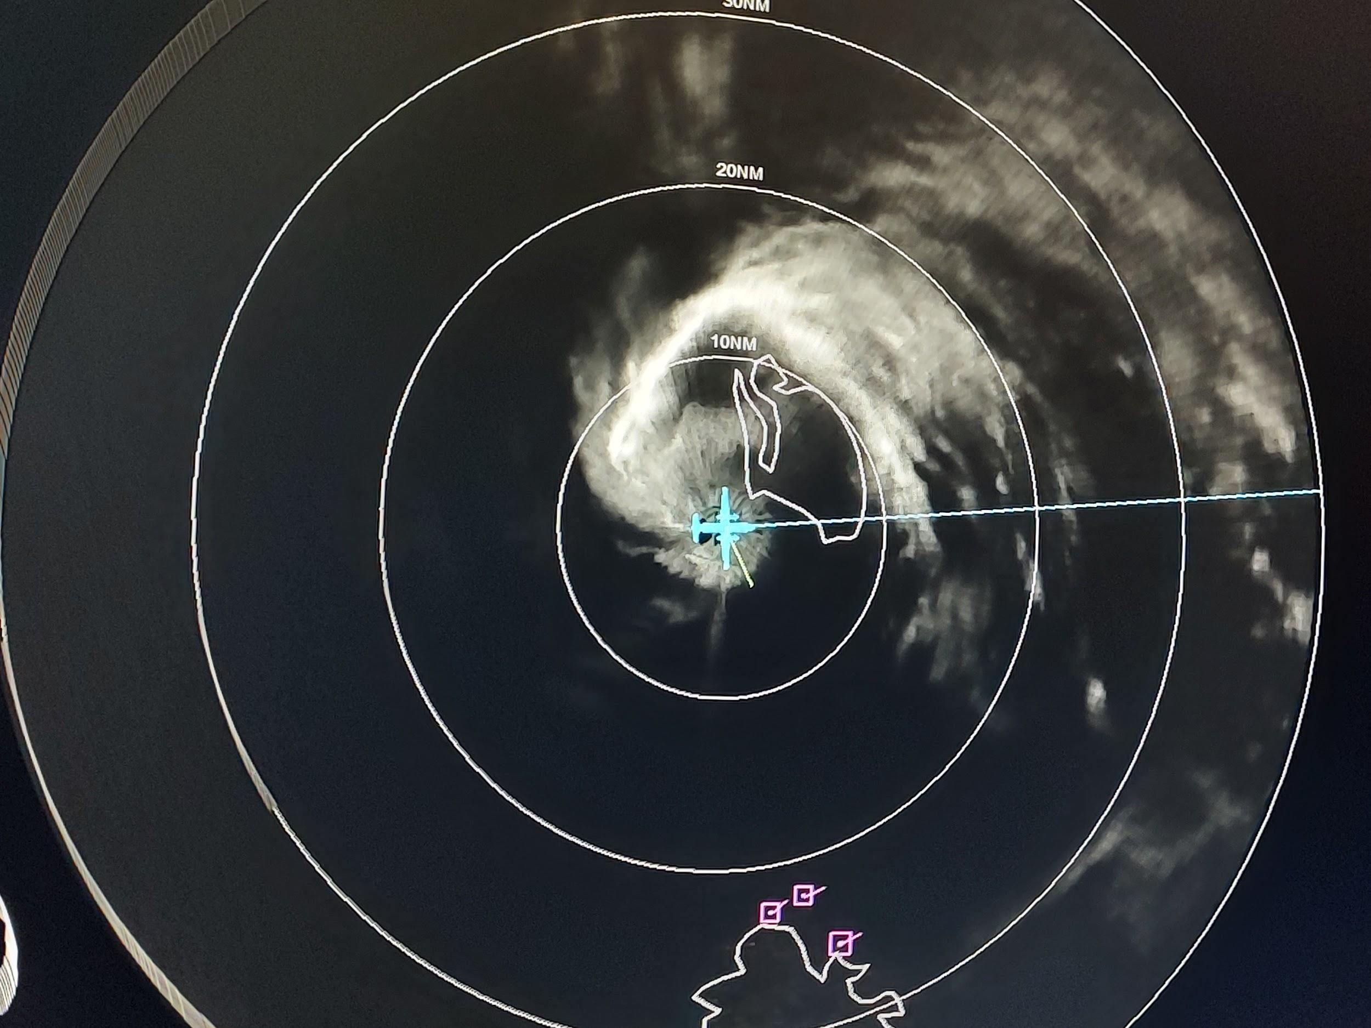
0232 | Midpoint W sonde 25
0245 | Endpoint W Sonde 26
0411 | Landed at Barbados
Notes on why we went with the VAM instead of the dry air module | They don't feel confident going up above the freezing level with what's there right now  [18:31] ahazelton_N42_LPS At night  [18:34] ahazelton_N42_LPS Sorry for the confusion treya_hrd  [18:35] treya_hrd Hmmm  [18:35] ahazelton_N42_LPS Yeah it's tricky  [18:36] treya_hrd And I'm assuming they're not confident going above frz level even if farther south?  [18:36] treya_hrd I'd maybe lean towards VAM in that case?

POST-FLIGHT
Mission Summary | We flew a successful TDR mission into Hurricane Tammy in the Lesser Antilles.  The storm had a very small eye but some ongoing vortex tilt. Therefore, we executed the vortex alignment module in the Eastern side of the storm.  The storm appeared to be impacting the island of Barbuda as we flew through it.
Actual Standard Pattern Flown | Rotated Figure-4
APHEX Experiments / Modules Flown | Vortex alignment module (VAM)
Plain Language Summary | - We flew a successful pattern to record radar data in Hurricane Tammy.  - We made several passes across the center, including a module to study how the storm was attempting to align vertically.
Instrument Notes | The MMR appeared to have an issue with an offset between the land shown on the map and the actual land (as detected by surface roughness mode).
Final Mission Track

