MISSION PLAN
FLIGHT ID | 20231020I1 | STORM | Al20/Tammy
MISSION ID | 0520A TAMMY | TAIL NUMBER | NOAA 43
TASKING | NHC-EMC TDR | PLANNED PATTERN | Rotated Figure 4 + modules
MISSION SUMMARY
TAKEOFF [UTC] | 0924 | LANDING [UTC] | 1532
TAKEOFF LOCATION | TBPB | LANDING LOCATION | TBPB
FLIGHT TIME | 6.1 | BLOCK TIME | 6.3
TOTAL REAL-TIME RADAR ANALYSES  (Transmitted) | 4 (4) | TOTAL DROPSONDES Deployed (Transmitted) | 27 (27)
OCEAN EXPENDABLES (Type) | 2 (0) AOC/HRD AXBT | sUAS (Type) | 1 Altius-600
APHEX EXPERIMENTS / MODULES | RICO SUAVE
HRD CREW MANIFEST
LPS ONBOARD | Marks/Cione | LPS GROUND | Dunion/Reasor
TDR ONBOARD | Marks | TDR GROUND | Reasor/Fischer
ASPEN ONBOARD | J. Zhang | ASPEN GROUND | n/a
NESDIS SCIENTISTS | n/a
GUESTS (Affiliation) | Sosa, Person (Area I)
AOC CREW MANIFEST
PILOTS | Doremus/Wood/Keith
NAVIGATOR | Miller
FLIGHT ENGINEERS | Tyson/Wysinger
FLIGHT DIRECTOR | Zawislak/Lundry
DATA TECHNICIAN | Richards
AVAPS | Waggoner/Patel

PRE-FLIGHT
Flight Plan | 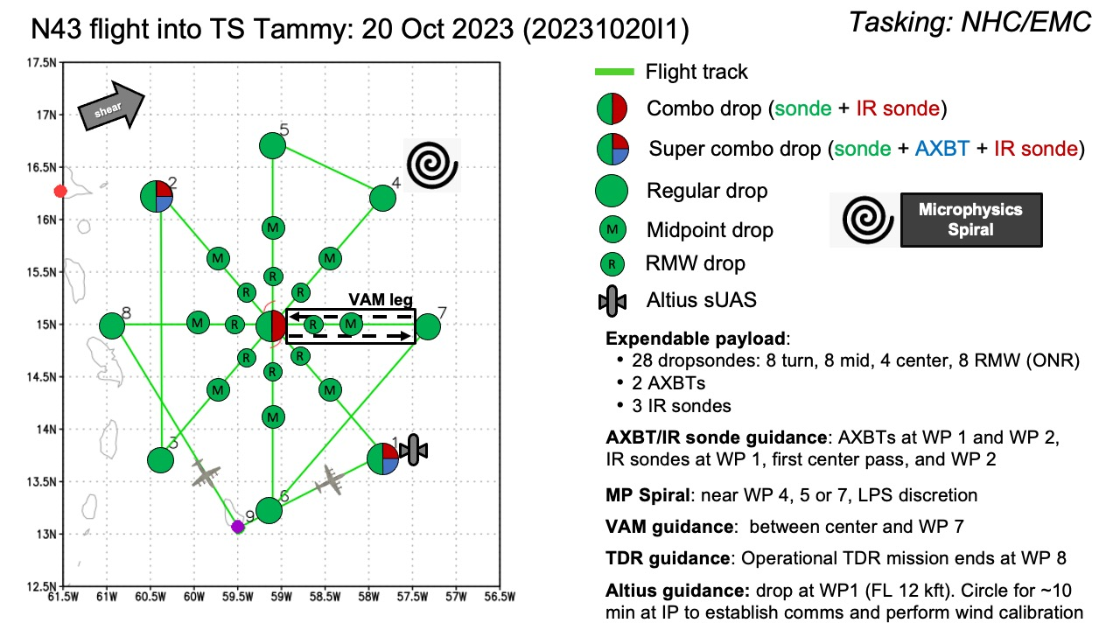  Rotated Figure-4  - 8 or 10 kft (pressure altitude) depending on AF deconfliction requirements  Potential modules:  - Priority #1: Altius sUAS (RICO SUAVE)  - Deploy Altius at IP (flight level 12 kft preferred, 10 kft acceptable)  - Circle for ~10 min at IP to establish comms and perform wind cal then proceed with main TDR mission (at FL 8 or 10 kft)  - Altius deployment at WP 3 is a back up deployment location - at discretion of the onboard HRD LPS  - Priority #2: VAM Module - see notes  - If the storm has vertically aligned, the FLAIMS module can be substituted for VAMS  - Priority #3: Microphysics Spiral - see notes
Expendable Distribution | - Load 40 dropsondes, 3 IR dropsonde, 1 Altius sUAS  - Release at endpoints, midpoints, centers (charged to NWS)  - Possible supplemental RMW drops (charged to ONR) - if eyewall is present (at discretion of the onboard HRD LPS)  - Additional drops may be requested at the discretion of the onboard HRD LPS  - All dropsondes transmitted to the GTS  - 3 AXBTs (CAD launched) - see notes below  - All AXBTs transmitted to the AOC ground server if possible
Preflight Weather Briefing
Instrument Notes | all instruments are nominal, Altius 600 pre-flight checklist completed.

IN-FLIGHT
Time [UTC] | Event
0924 | Take-off from TBPB
0938 | plan is to deploy Altius early and let it spiral into the center at 2000’ mapping asymmetries while we do rotated Fig. 4. IR satellite animation shows ongoing deep convection with lightning activity near TC center
0941 | we are already seeing deep convection near center on MMR as we skirt north of principal rainband curving into center from SW to E of centerStrong hook-shaped echo noted near mid-level center via Barbados ground radar and MMR on aircraft:  <marks_n43> mfischer_hrd, we are seeing the deeper convection on the MMR already. We are skirting N of the principal rainband rotating around from SW to E of the center. we are planning the Altius drop just inside the rainband  <mfischer_hrd> Looks like a nasty hook-shaped cell near LLC on Barbados radar  <marks_n43> mfischer_hrd, it looks just as nasty on MMR
0944 | begin Altius launch checklist. Altius launch. Launch misfire. Orbiting for second attempt.
0953 | Altius launch, first try we had misSecond Altius launch.  <marks_n43> 0954 IR drop #1 with Altius. Altius is descending to 2000'  <marks_n43> orbiting as Altius does calibration check.
0954 | IR drop #1 collocated with Altius. Altius descending tp 2000’ (pic). Lost comms with Altius:  <marks_n43> we are maneuvering to re-establish Altius comms
0957 | orbiting as Altius does calibration check<marks_n43> mfischer_hrd, 1013 IP start 1st leg combo drop IR drop #2, AXBT #1  <marks_n43> We are rotating pattern by 20 deg  <marks_n43> TK 330  marks_n43> Still no comms with Altius  <marks_n43> mfischer_hrd, AXBT failed
1001 | N43 released to track to IP (pic)  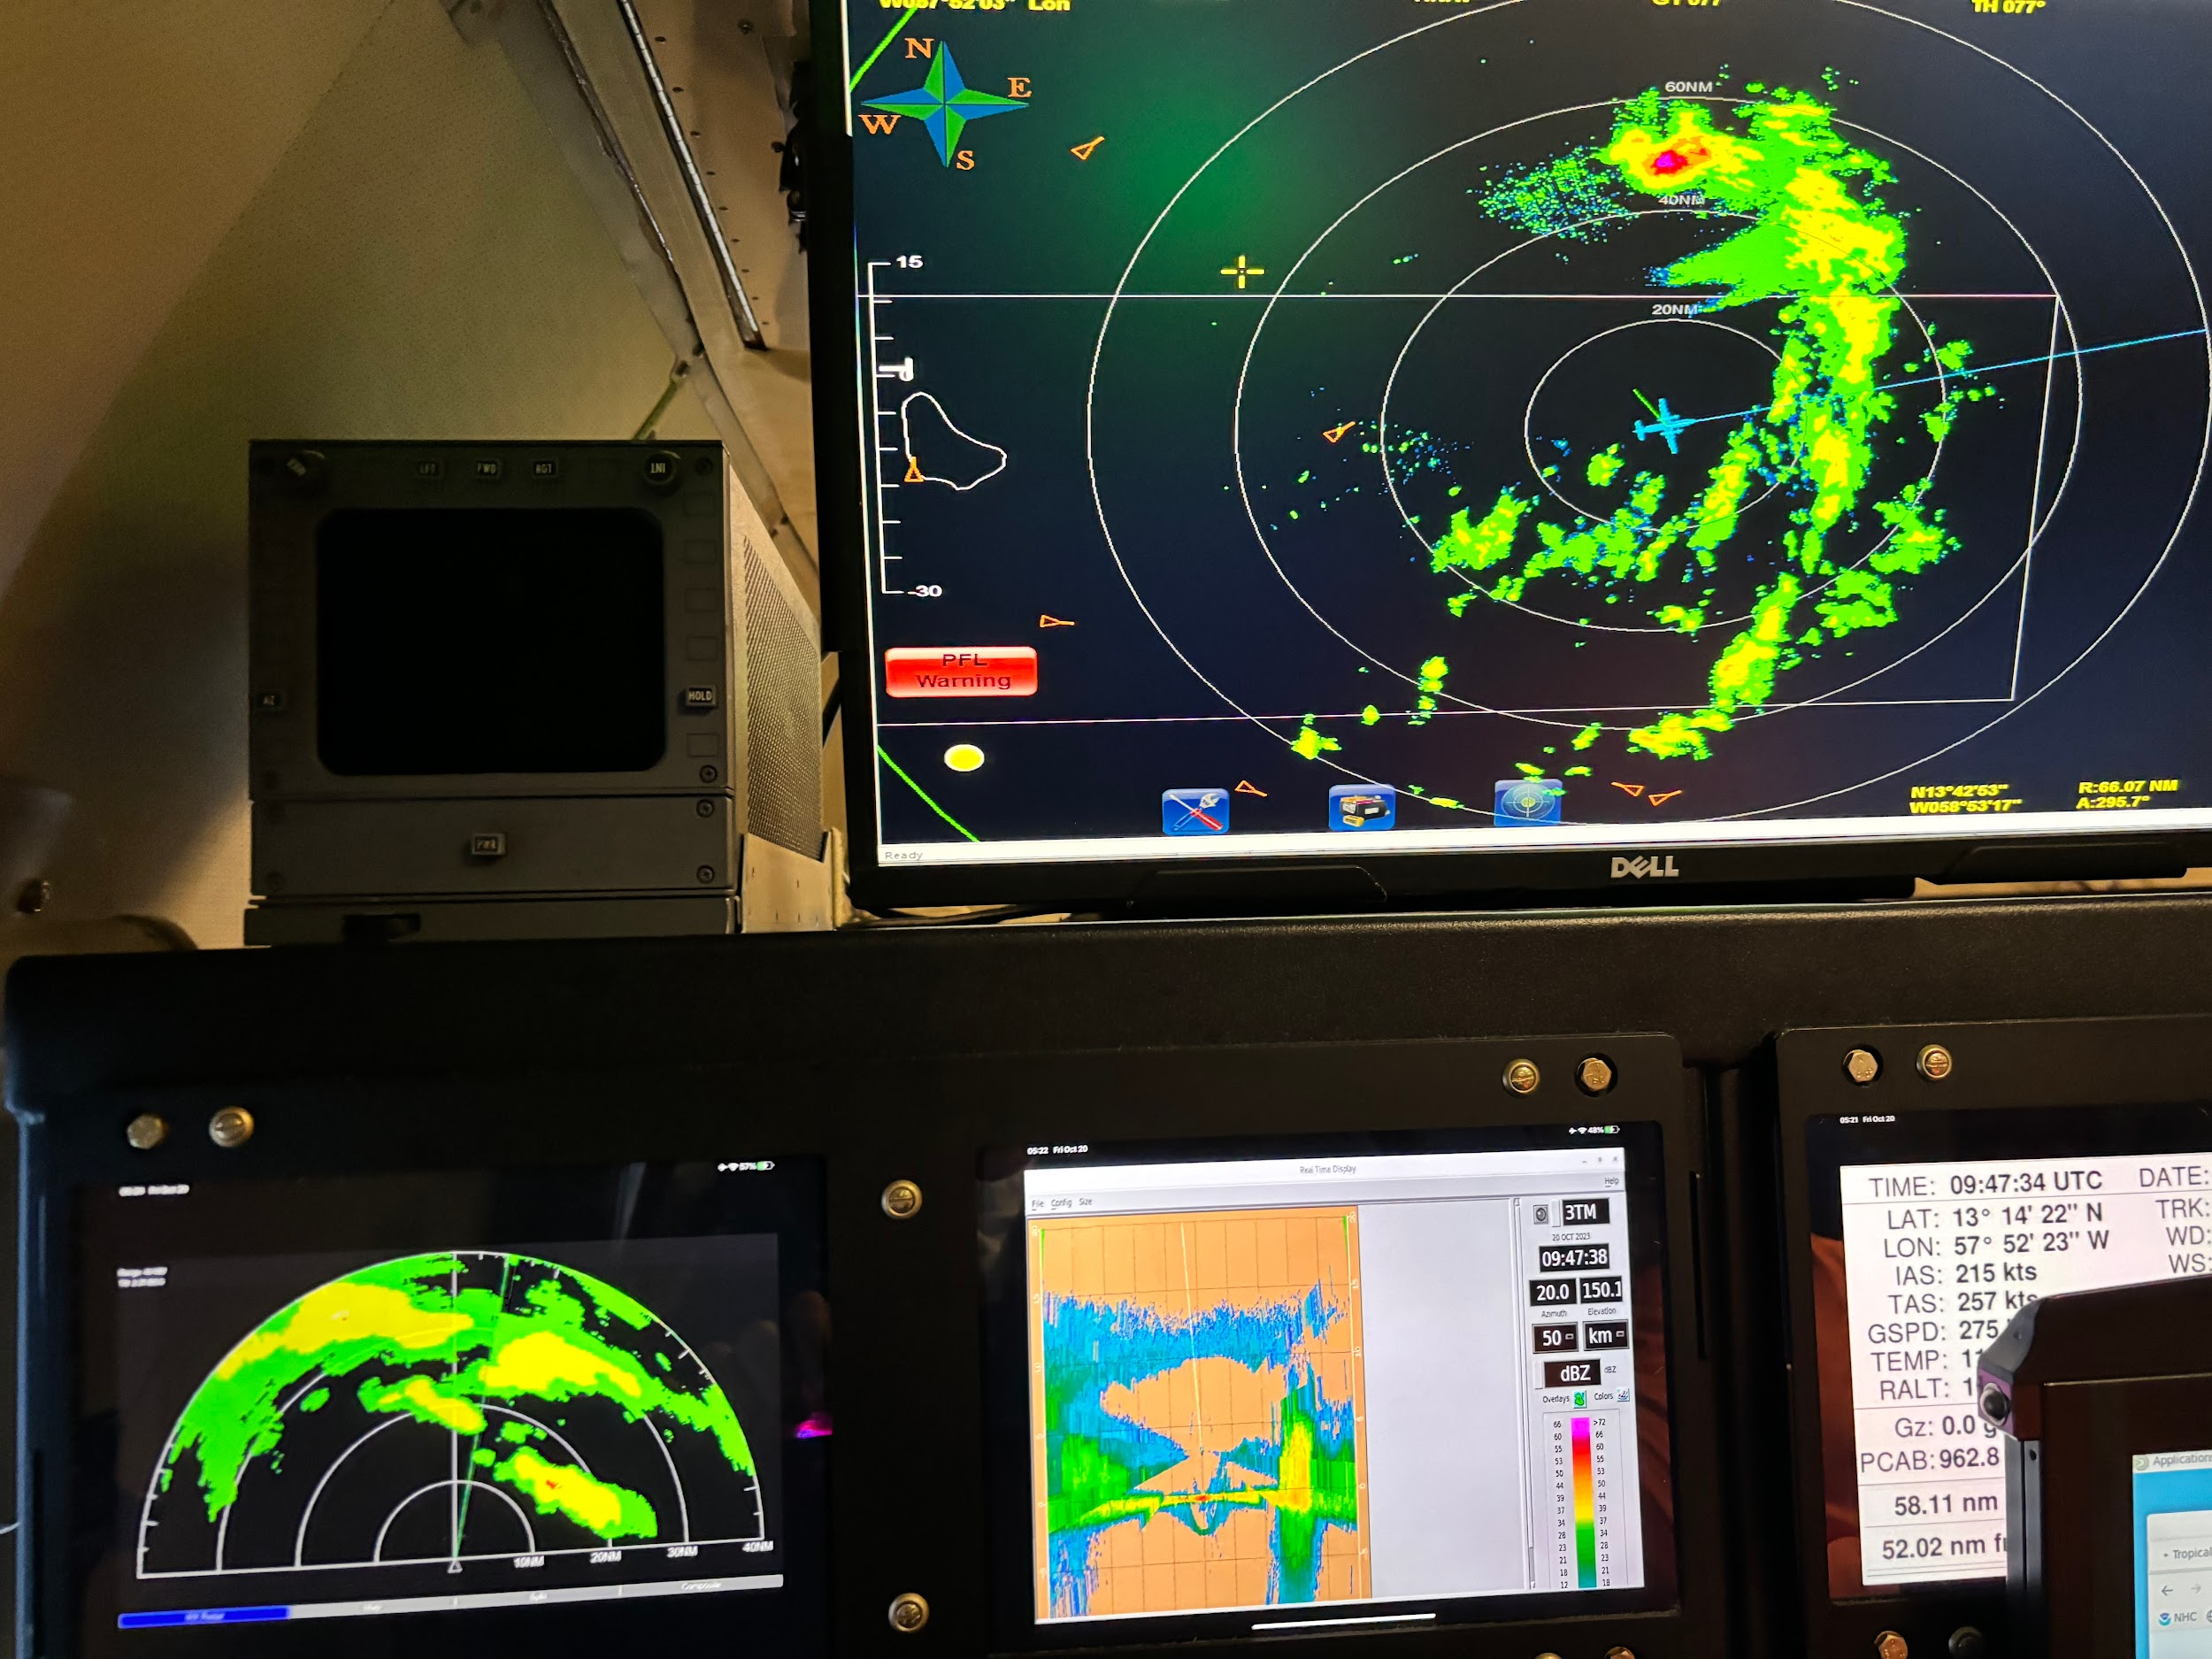  Significant lightning activity persists near TC center
1007 | lost Altius comms as we punch major rainband
1010 | maneuvering to re-establish comms
1011 | adjust IP to start 1st leg
1013 | IP (PT#1) IR drop #3, AXBT#1 (failed), rotating Fig 4 20 deg TK 330
1022 | mid point drop #3, still no Altius comms
1026 | begin orbiting to try to restore Altius comms - AF needs confirmation it is not going to interfere with their mission
1037 | roll out to pick up original Fig 4, TK 315 to center, plan is to TK 315 to center and then pick up the Fig 4 with and outbound of 315
1043 | passing extremely intense convective hook just N of center. TDR estimated tops 19-20 km - Michael Fischer said IR temps -90 C with lots of lightning
1046 | center combo IR drop #4, drop #5, restored Altius comms, bird is in the eye at 2 kft. Wow!! Comms are restricted to short distance radio meaning we can only collect data and pass changes to pattern when we are near Altius. Set up Altius to do 20 nmi around initial center estimate at 2000’ altitude to compare with TDR analysis.
1049 | <Cione_43> so much for the inflow experiment..we are in the "eye"...close to center  <Cione_43> so plan B is to do a complete cirum nav...at 2000ft...then drop to lower altitudes...1000,500 100 etc  <Cione_43> the special request window is open (for plan C!)
1053 | MTS screenshot after first pass through center 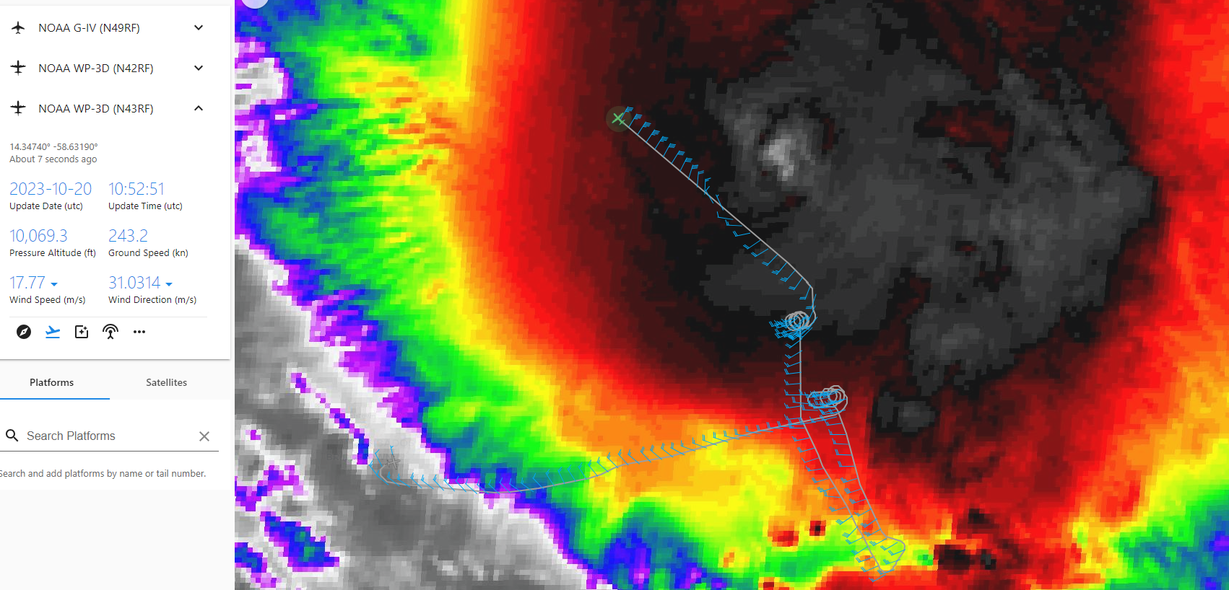
1058 | midpoint drop #6
1106 | <marks_n43> mfischer_hrd, So we learned that we are restricted to short distance comms with Altius, and can only receive data and pass nav changes when we are within 20-30 nmi of the bird. We programmed it to do a 20nmi radius orbit around the initial center estimate at 2000' to compare to the TDR analysis at 0.5 km
1110 | PT #2 super combo, IR drop #7, drop #8, AXBT #2, shortening next inbound as PT#3 is very close to Barbados. TK 160 to new PT #3 50 nmi closer to the center. Should not affect sounding coverage as Barbados sounding will cover that location.
1114 | 1st TDR analysis started
1118 | planning to orbit near the center on next inbound to gather as much Altius data as we can before heading outbound  <marks_n43> We are shortening the next inbound leg because PT #3 is really close to Barbados. we will track 160 a new PT #3 50 nmi closer to the center. Shouldn't affect drop coverage as Barbados sounding will replace our drop
1137 | 1st TDR analysis complete  Alt (km) Lat (deg) Lon (deg)  0.5 13.94 58.28  2.0 14.02 58.21  3.0 14.09 58.14  6.0 14.25 58.04  2-6 km vortex tilt: 31.7 km at 35 deg  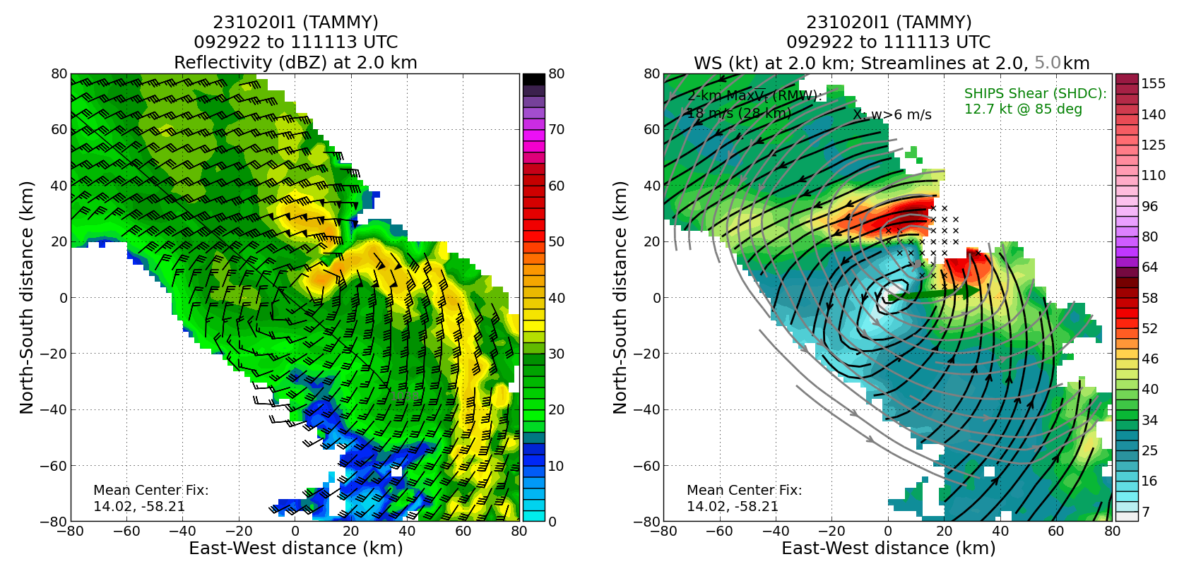
1137 | PT#3, drop #9, and midpoint
1147 | <marks_n43> mfischer_hrd, we are descending to 8 kft to deconflict with AF
1154 | start orbit in the center area to restore Altius comms. Amazing TDR mapping of intense convection north of center. Unfortunately no joy with Altius.  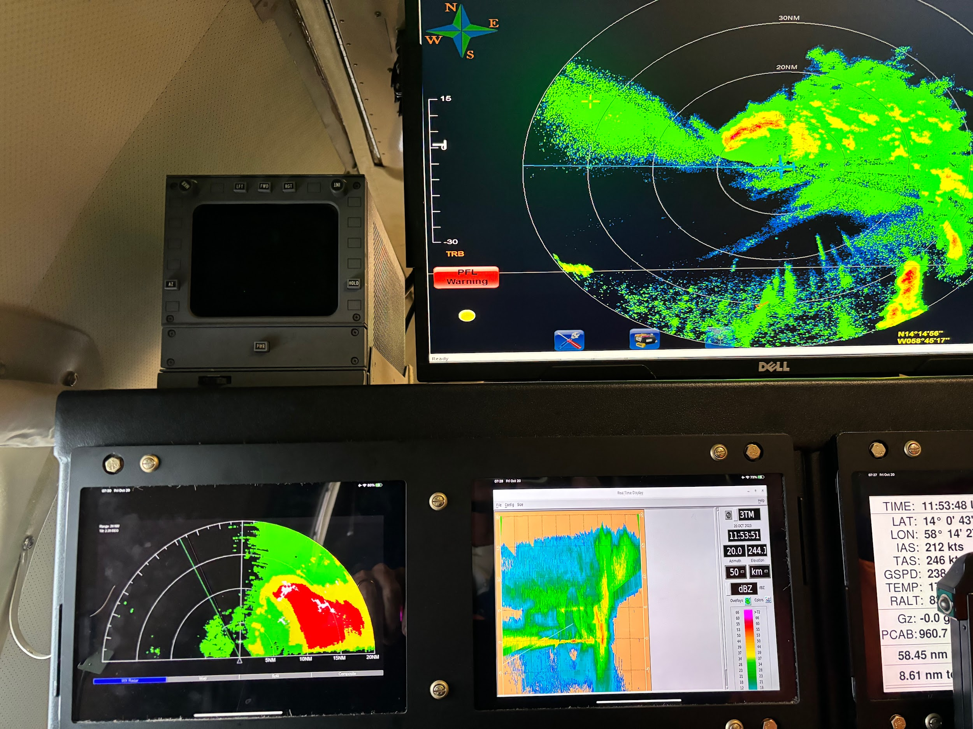
1200 | returning to outbound track
1202 | center drop #10, TK 060 to avoid intense cell
1207 | return to TK 045
1214 | midpoint drop #11, failed launch detect, backup
1215 | backup drop #12
1227 | PT#4, drop #13, end 1st Fig. 4
1233 | 2nd TDR analysis started
1249 | 2nd TDR analysis complete  Alt (km) Lat (deg) Lon (deg)  0.5 14.00 58.38  2.0 14.07 58.36  3.0 14.09 58.34  6.0 14.23 58.30  2-6 km vortex tilt: 19.0 km at 18 deg  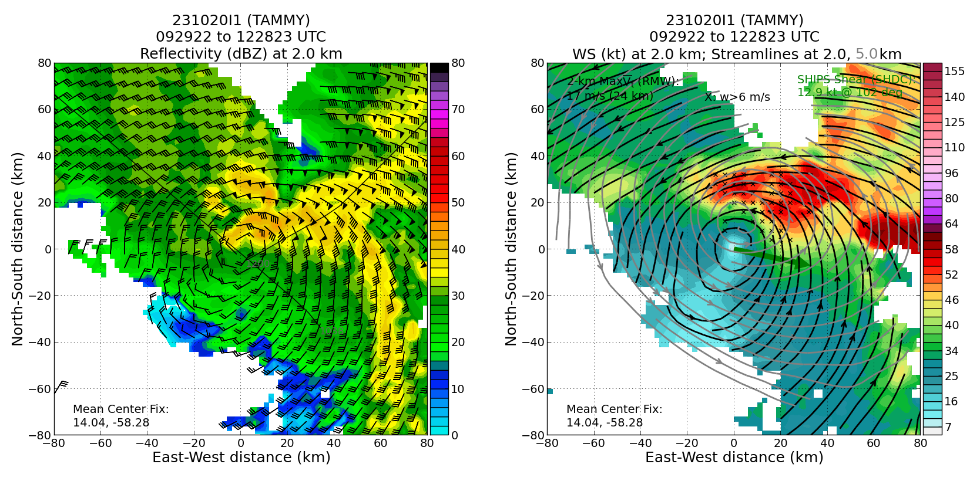
1250 | 0956z SSMIS (F17) 85 GHz image: possible eyewall trying to form around a semicircle just N of the marked center. The feature has an “unfriendly” hooked appearance.
1251 | PT #5, drop #14, start 2nd Fig. 4, TK 180. Plan is to pass to the west of the hook just N of the center if it looks nasty. N43 will get great TDR no matter what.
1305 | midpoint drop #15, decide to go for it and track through intense convection trying some RMW drops if possible
1307 | Altius has splashed- checking to see if any data was collected since N43 lost comms
1310 | 1st RMW drop #16, passing through major band FL winds 60 kt, N43 got a look at that hook region on their radar and is going to stay on this line and work though it
1312 | in the thick of the band. 8-9 m/s updrafts
1313 | 2nd RMW drop #17. Looks like we are actually NE of what looks like an eye like feature (pic). Turn TK 230 to fix it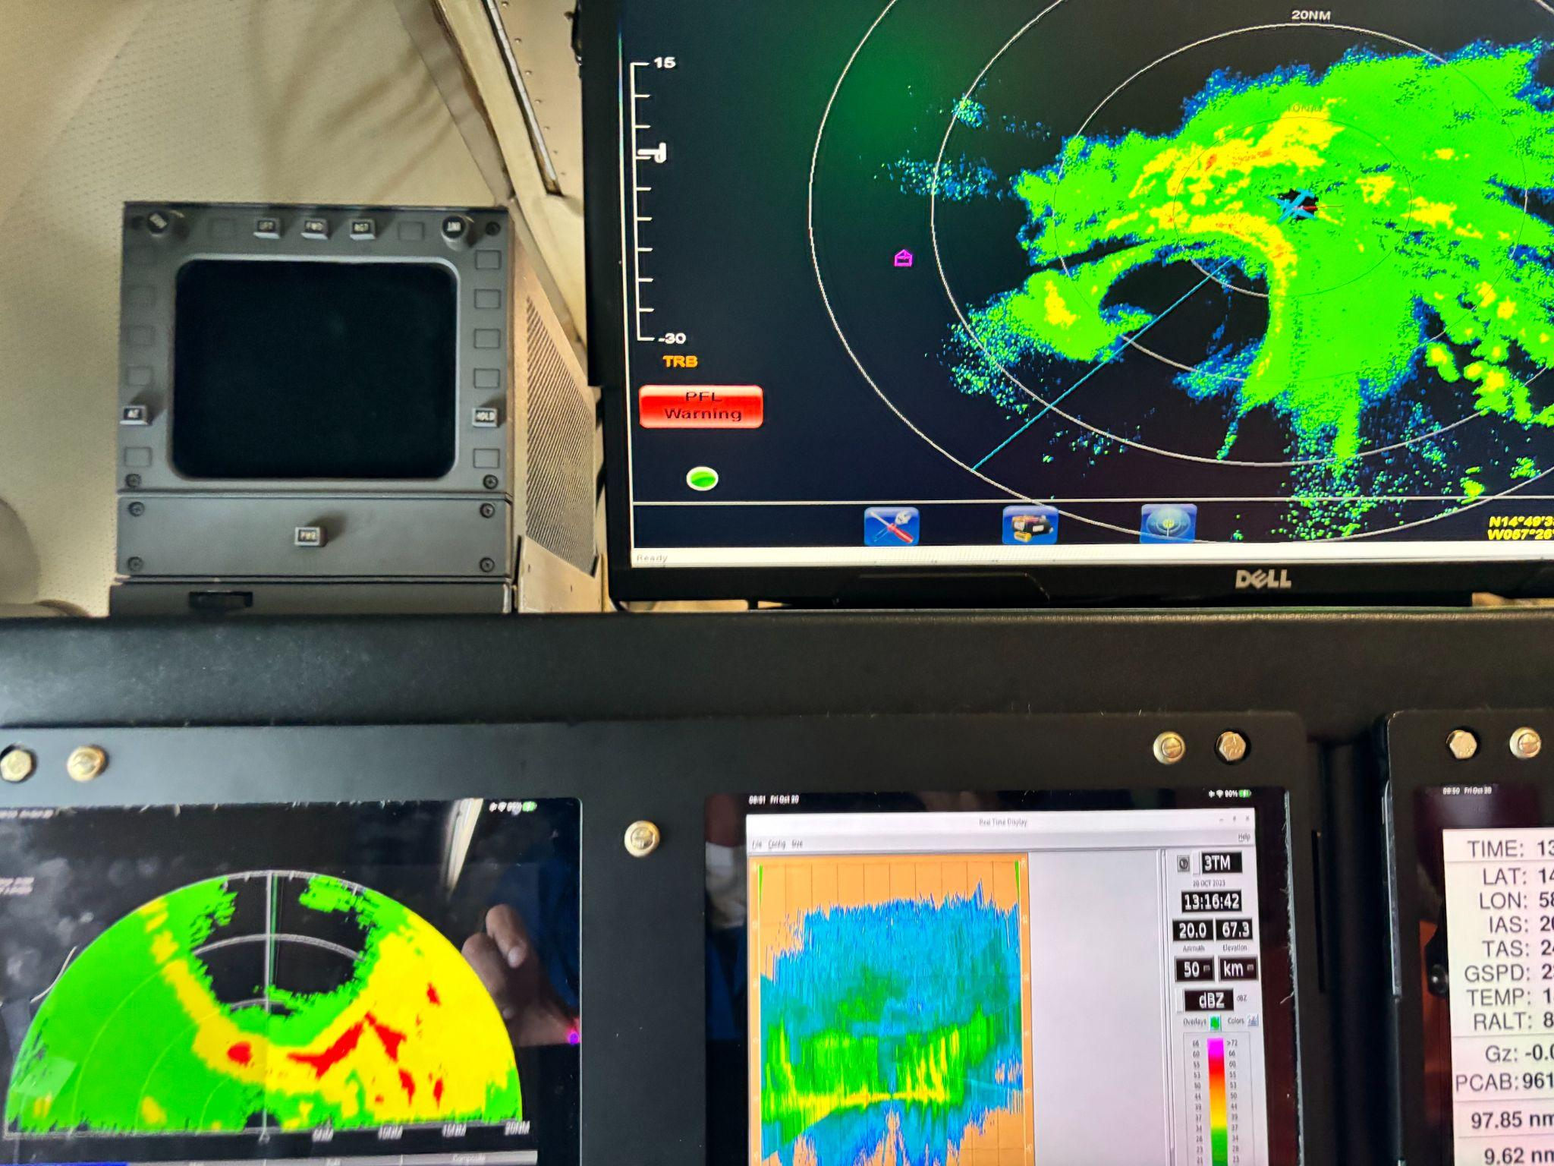
1315 | GOES-E vis shows a circular area of arc clouds pushing out from the convective center of TS Tammy.  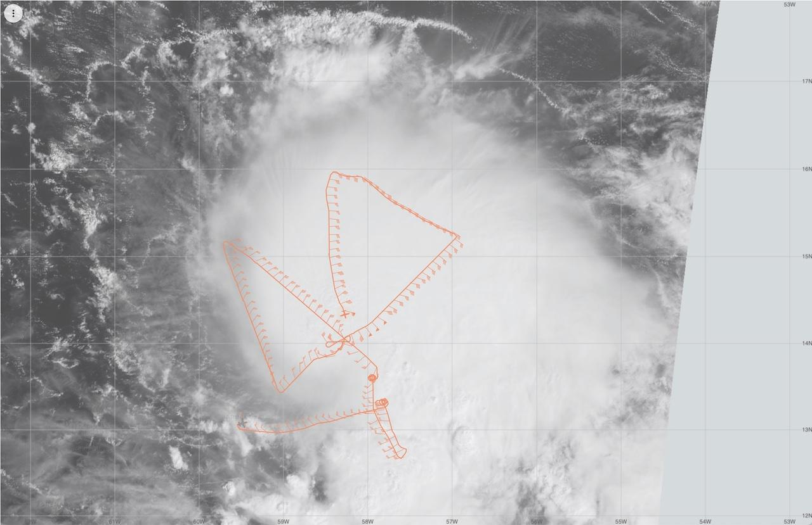  The circular area of arc clouds is nicely synched to the TC diurnal pulse moving out from the storm this morning…right on the diurnal clock.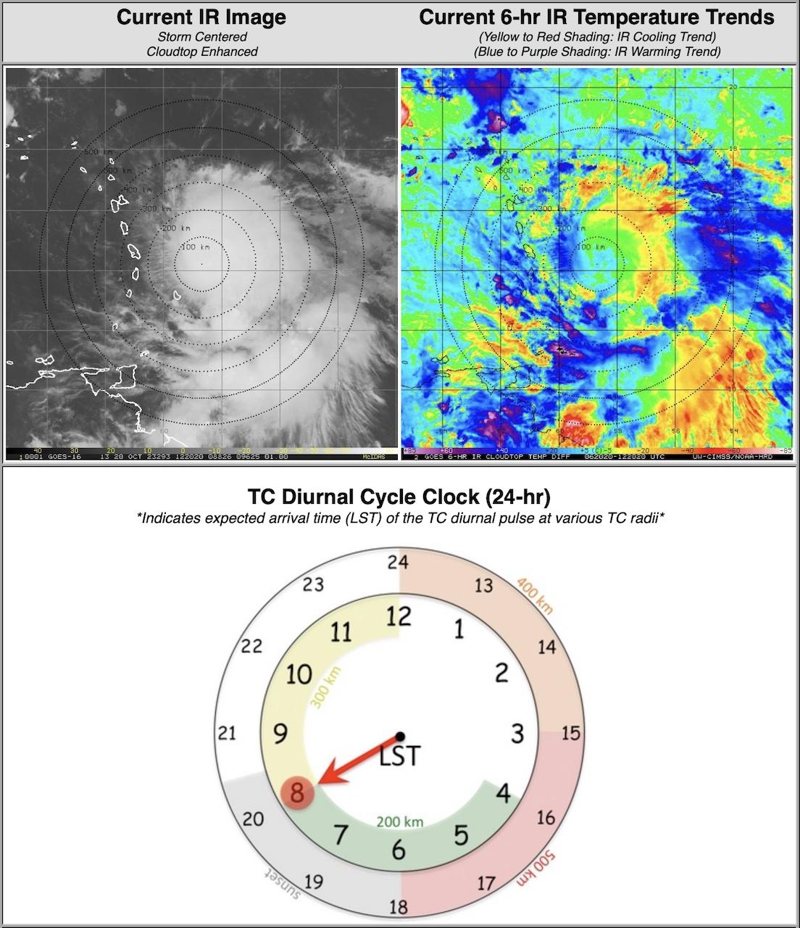
1317 | definitely an eye formed (pic)  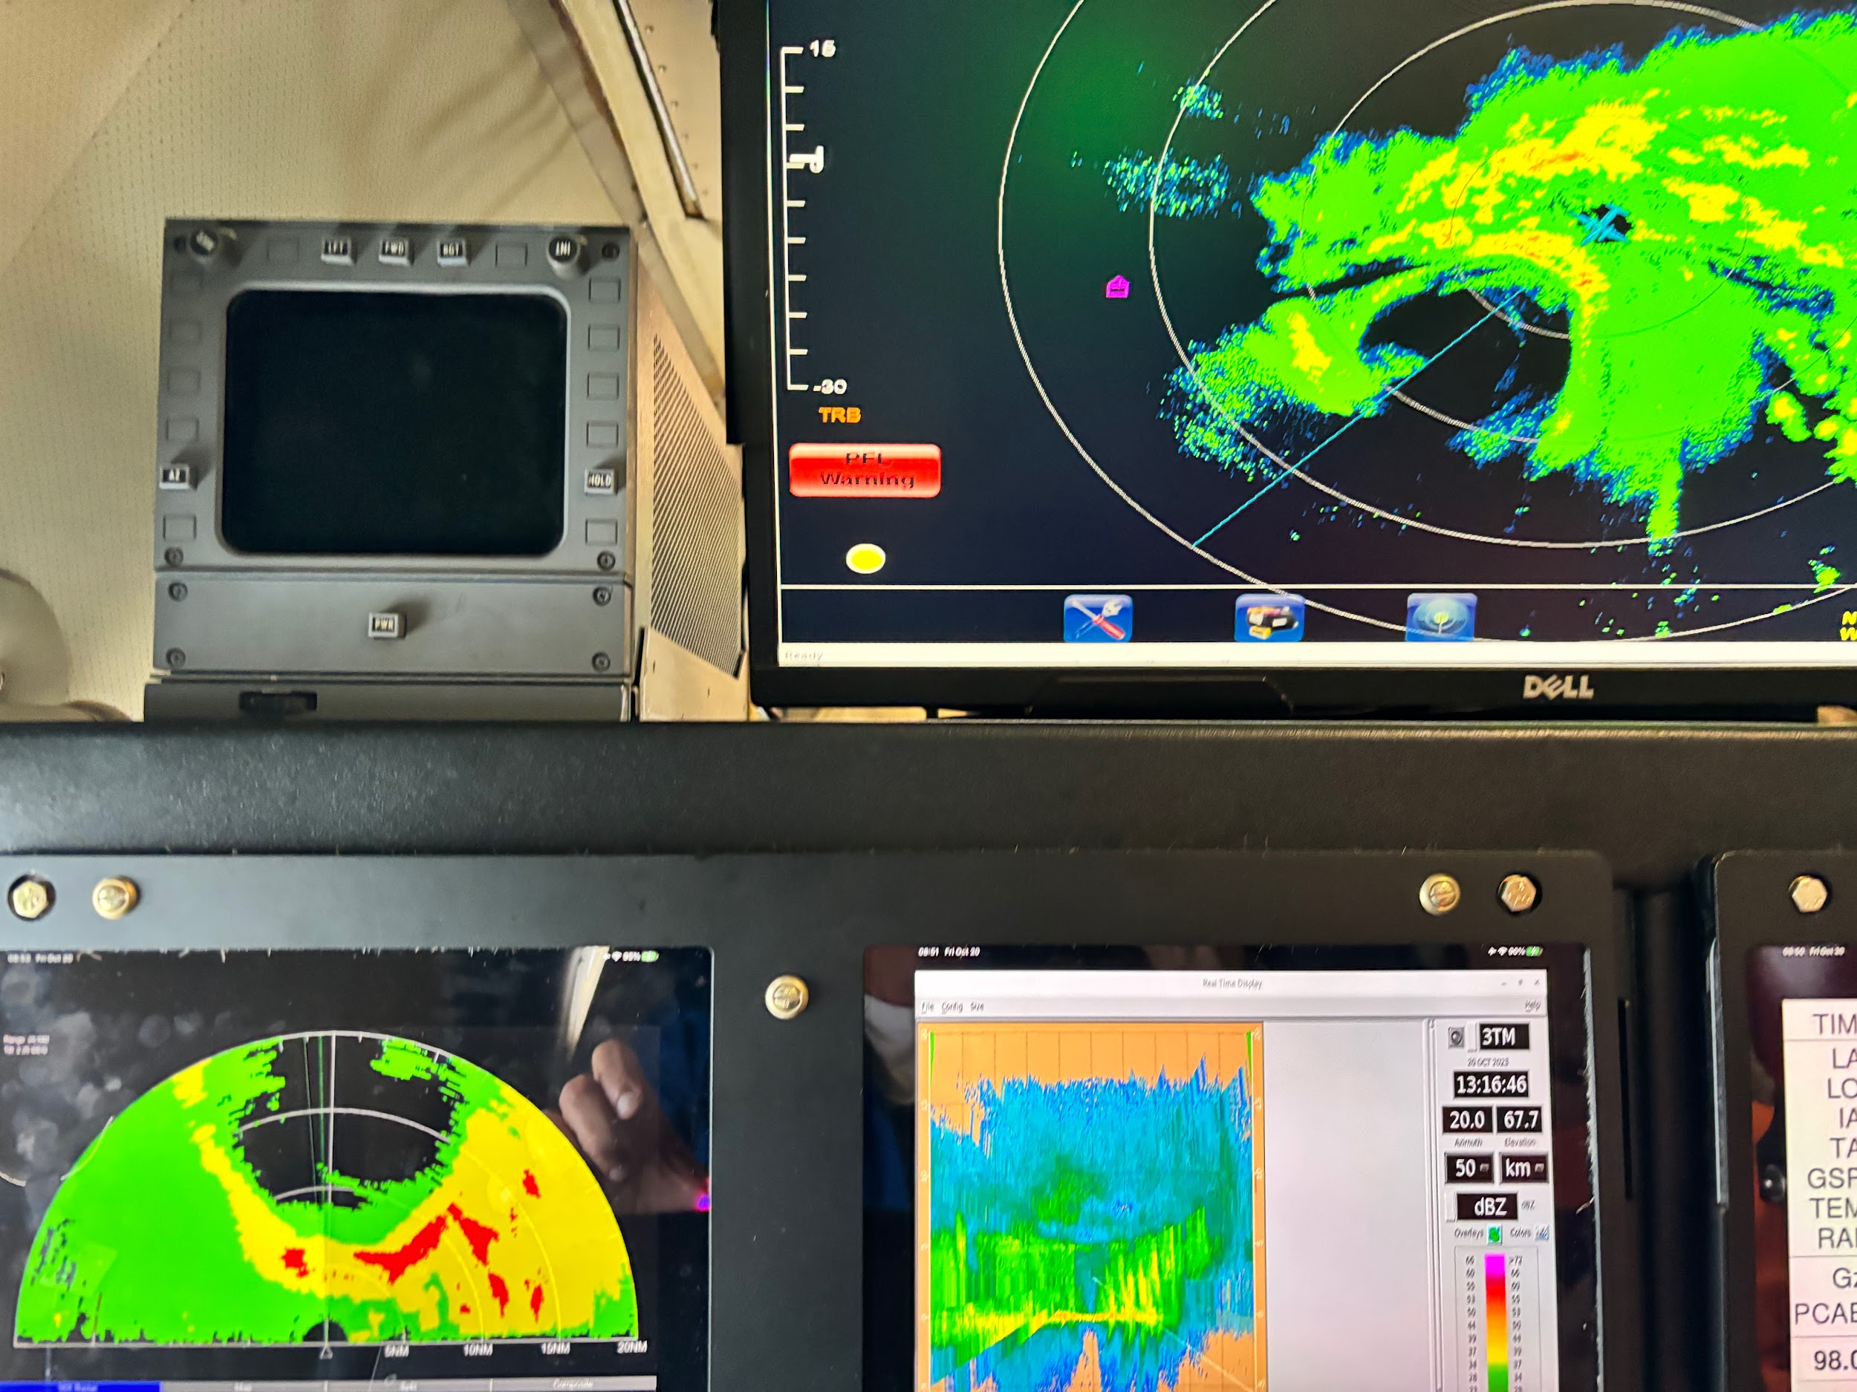
1320 | center drop #18, extrap press 992, splash 995, in the “eye” open to south, nice low level cloud swirl around center. Wow! What a leg! Saved the best for 2nd fig 4. Amazing to see eye on MMR
1335 | mid point drop #19
1340 | discussed the possibility of modules. Unfortunately, aircraft and crew safety issues will necessitate our return to Barbados to assess viability of aircraft remaining there overnight. Decided to complete 2nd Fig 4 and then return to Barbados. We will satisfy our operational requirements and have collected one heck of a data set during beginning of RI
1346 | PT #6, drop #20, end leg, TK 045 up along the principal rainband. Joy!
1347 | 3rd TDR analysis submitted
1359 | slogging up the principal rainband dodging some intense cells and plowing through some. Very bumpy ride 8-9 m/s updrafts and 2-3 m/s downdrafts. Ground reports lightning in the rainband
1405 | 3rd TDR analysis complete  Alt (km) Lat (deg) Lon (deg)  0.5 99.99 99.99  2.0 14.07 58.52  3.0 14.07 58.52  6.0 14.18 58.52  2-6 km vortex tilt: 12.0 km at 0 deg  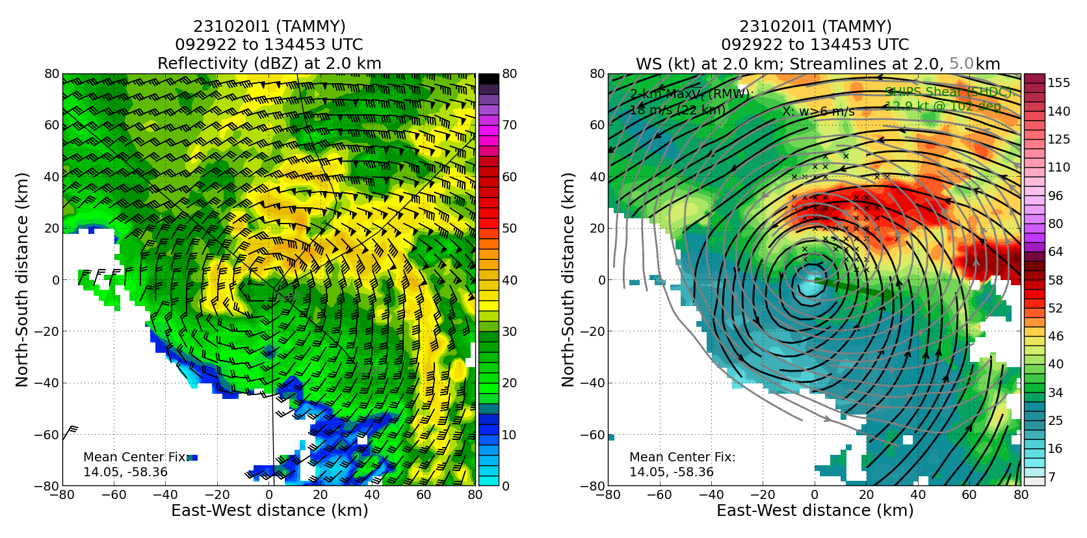
1416 | PT#7, drop #21, TK 270
1427 | mid point drop #22
1434 | closed radar eye, elliptical, wave #2, east-west major axis. (Pic)  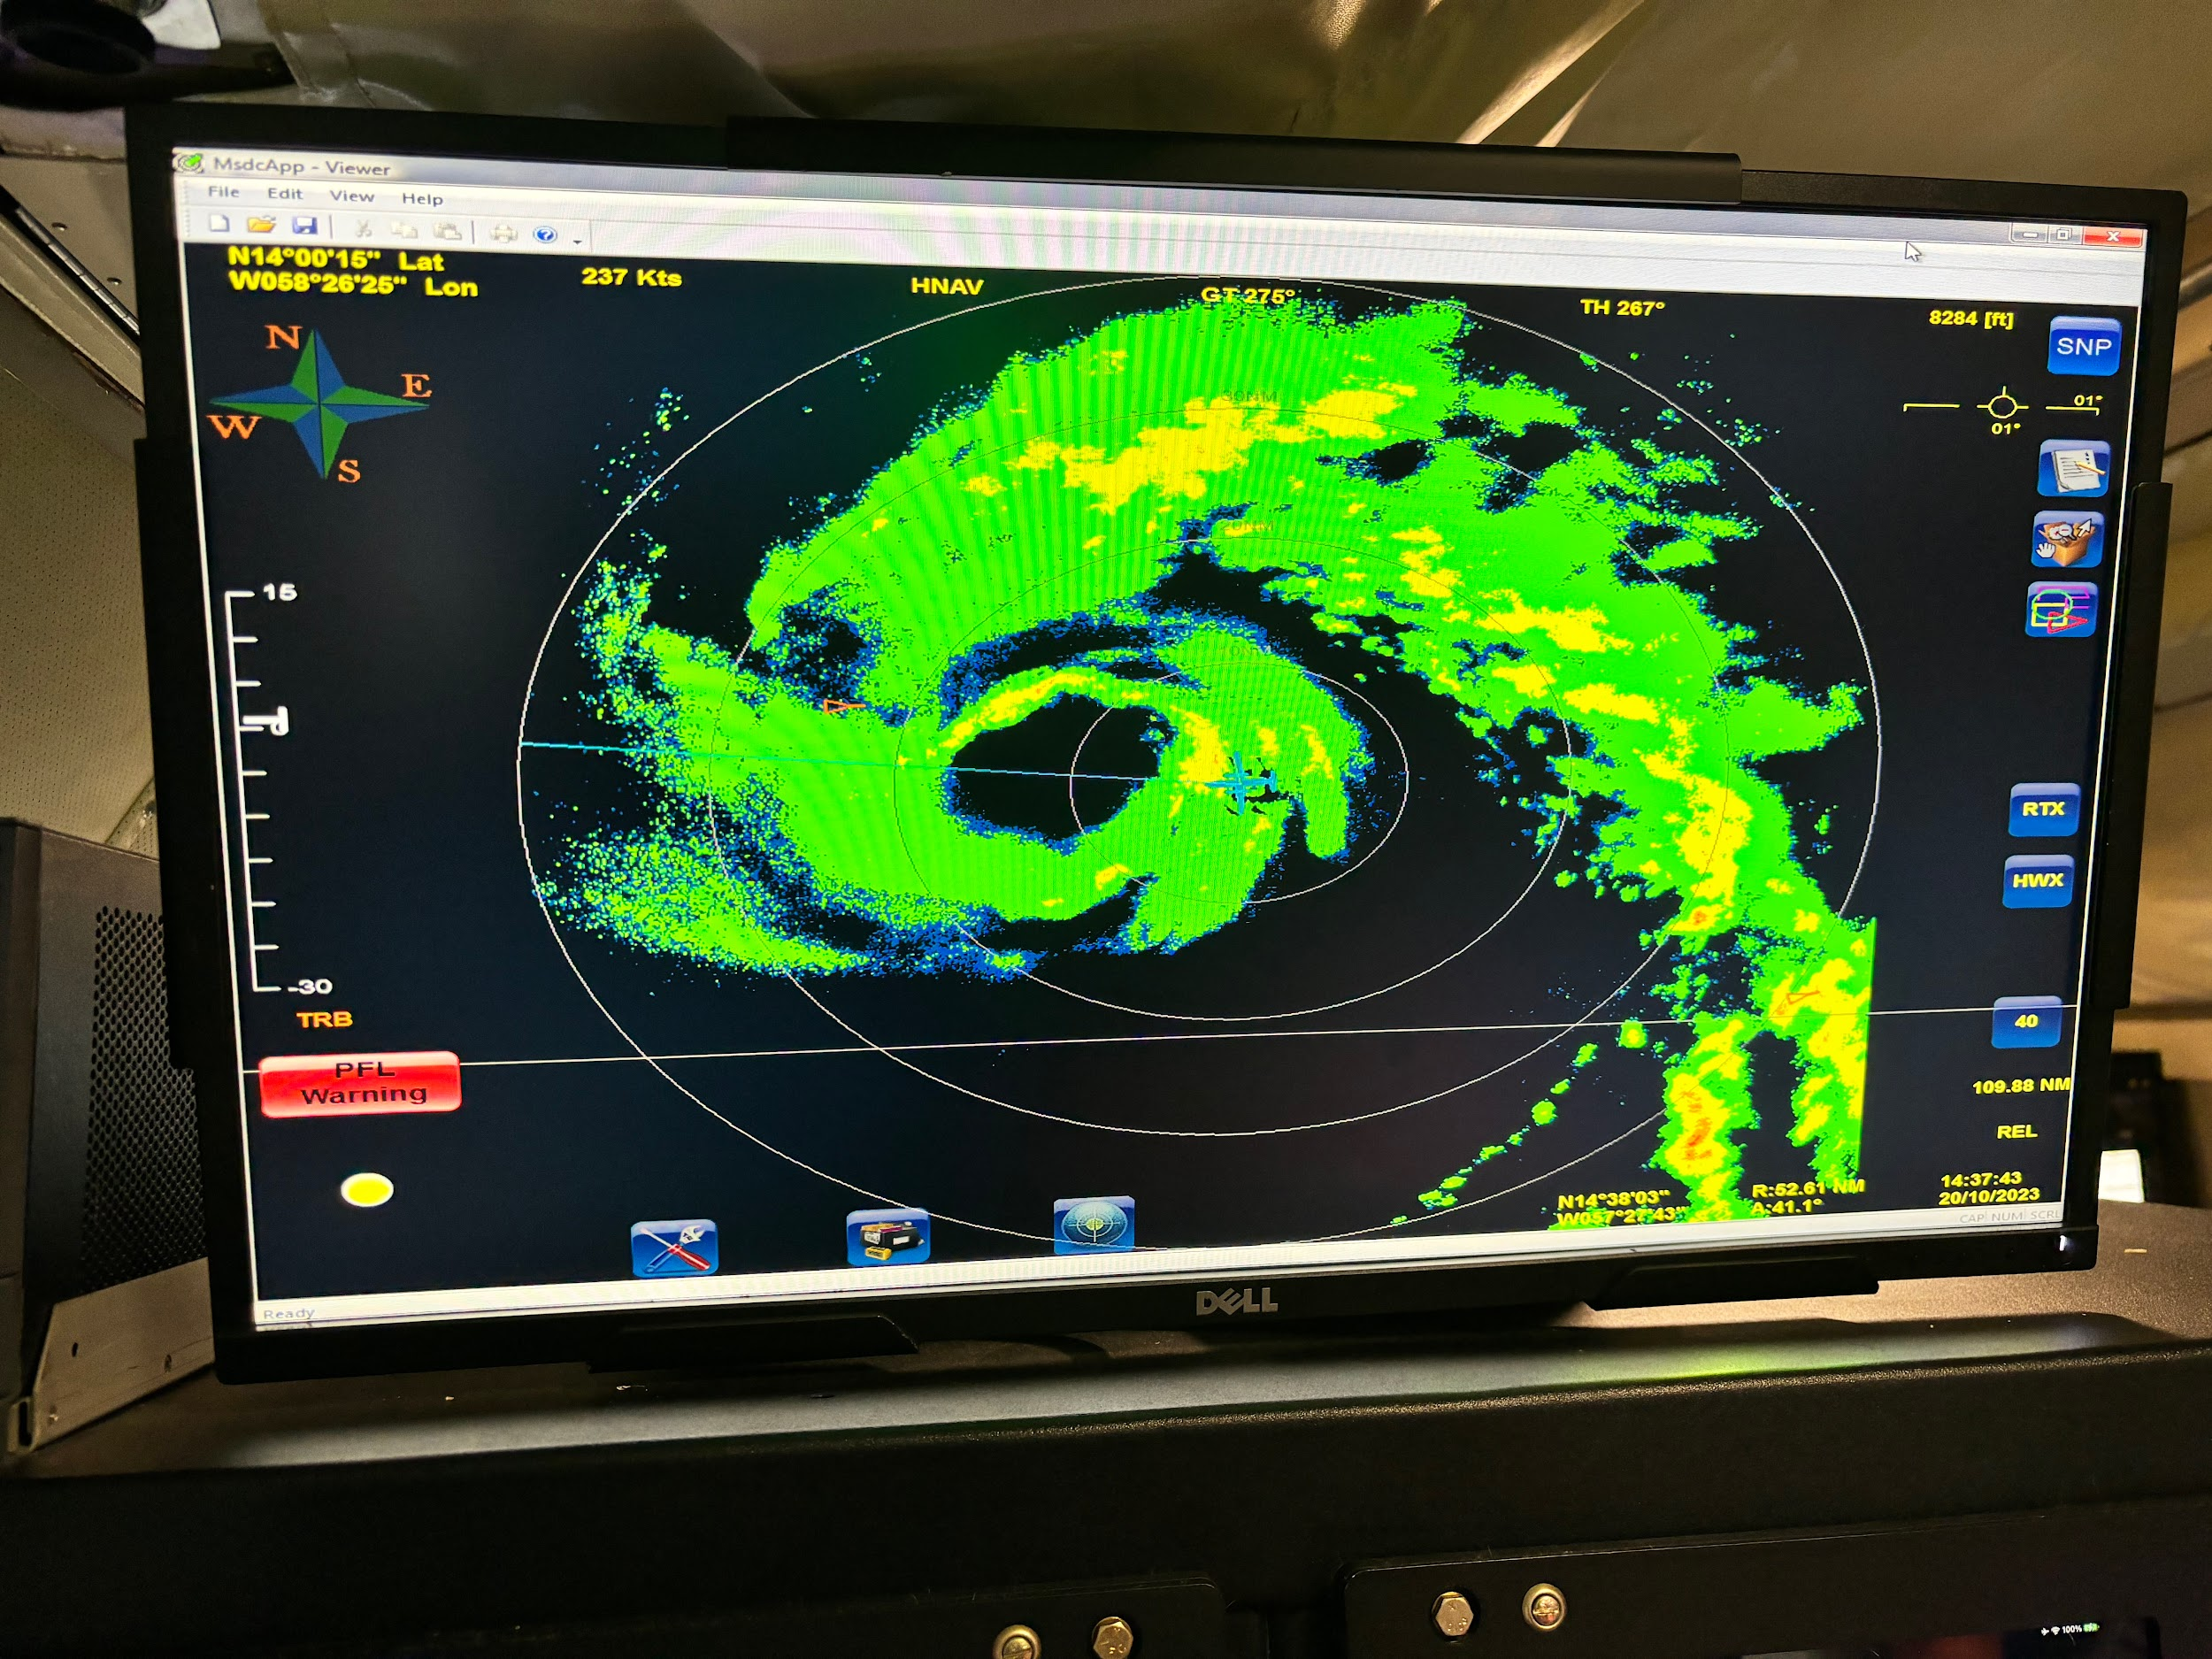
1439 | RMW drop #23
1440 | center drop #24, press 994
1454 | mid point drop #25
1501 | 4th TDR analysis submitted
1507 | PT #8, end pt drop #26, end science, head to Barbados
1519 | 4th TDR analysis complete  Alt (km) Lat (deg) Lon (deg)  0.5 13.95 58.63  2.0 14.04 58.65  3.0 14.07 58.63  6.0 14.16 58.59  2-6 km vortex tilt: 15.2 km at 23 deg  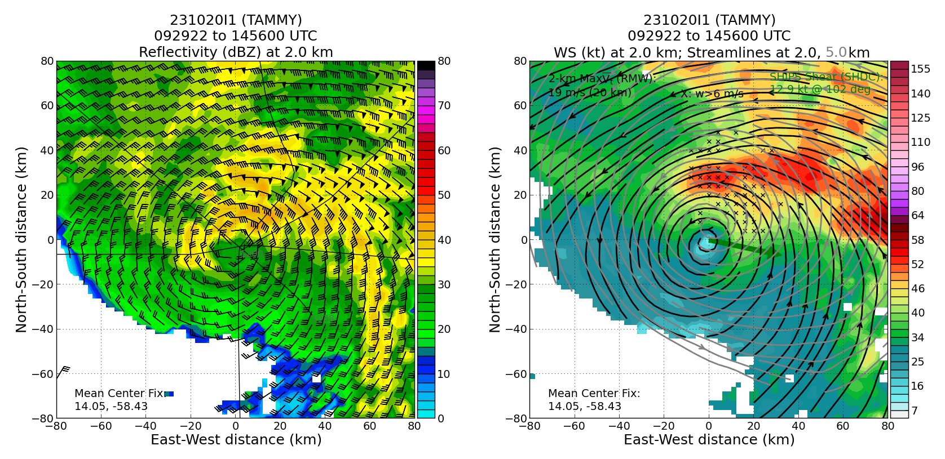  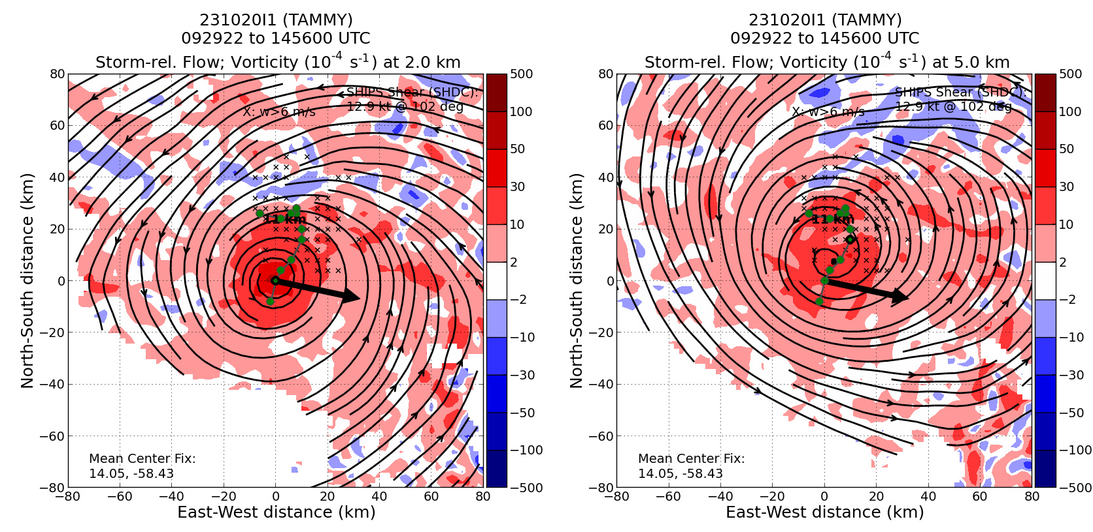
1531 | land TBPB

POST-FLIGHT
Mission Summary | Mission was successful – Completed EMC Rotated Figure-4 pattern in a strengthening Tropical Storm Tammy successfully. Tammy became a hurricane during the mission. With deteriorating weather at Barbados we only had time for the RICO-SUAVE module to be flown. We were able to do a complete TDR mapping of the storm, and anchor it using the Altius pattern sampling low level center. A total of 27 drops were released, and all 27 were transmitted, TDR analyses (4 of them) were transmitted on time.
Actual Standard Pattern Flown | Rotated Figure-4  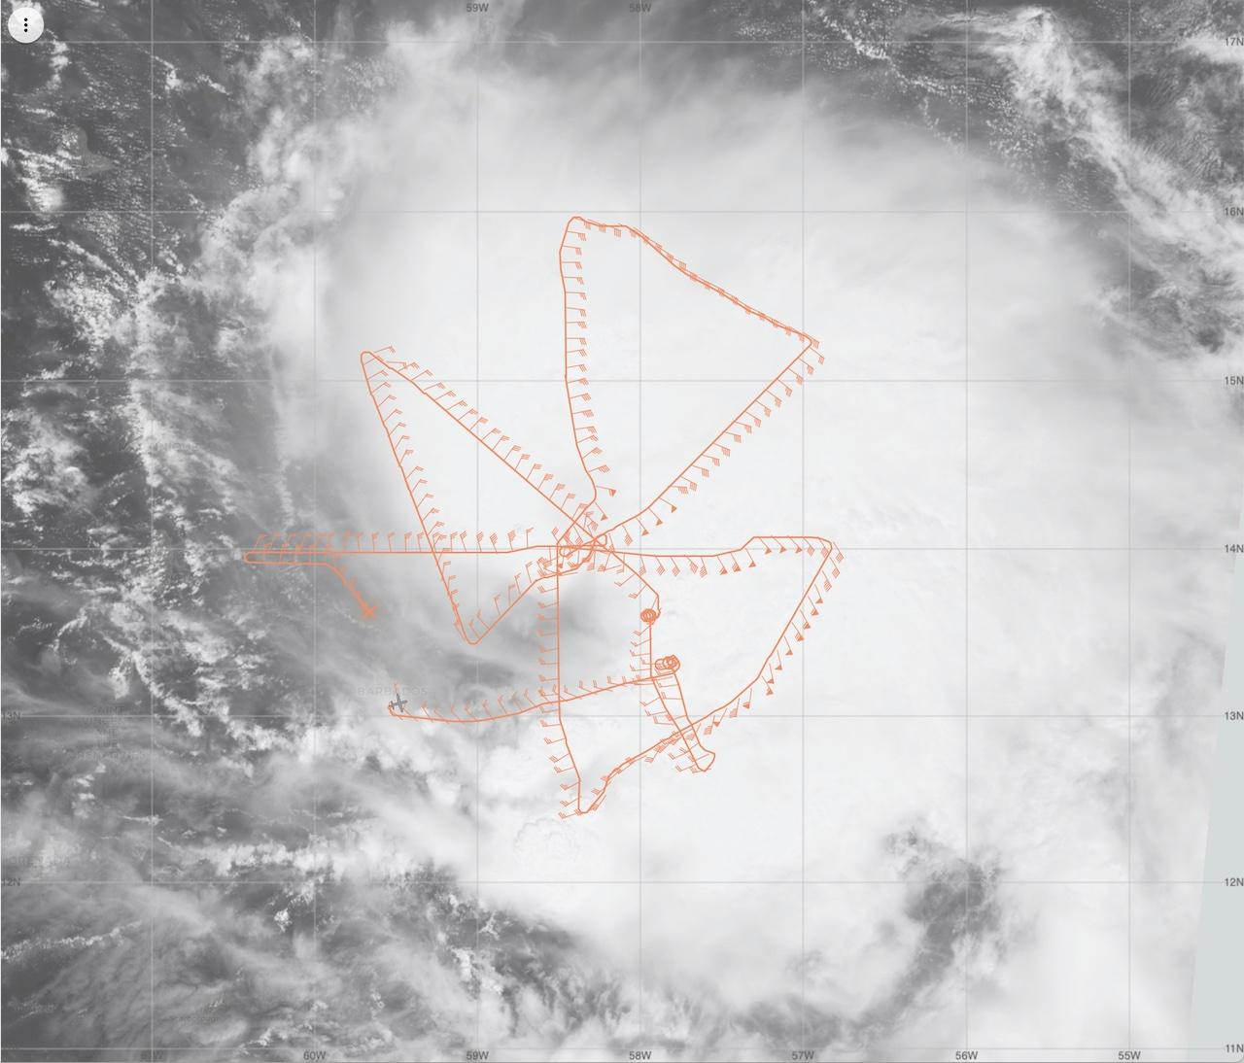
APHEX Experiments / Modules Flown | RICO-SUAVE
Plain Language Summary | - Successful mission was flown into Hurricane Tammy, with multiple objectives accomplished.  - Important radar and dropsonde data was collected and transmitted to the ground for use in computer forecast models.  - A repeated sampling of the winds at flight-level will yield insights into how storm structure changes over short (2-3 h) time periods, especially if it’s intensifying. This storm was slowly intensifying, but the observations from the radar nicely show how the inner-core structure of a non-intensifying storm evolves in the presence of continued vertical shear (change in wind speed and/or direction with height).  - Successfully deployed Altius 600 near the center of hurricane Tammy and collected 30-40 min of low-level wind observations as it spiraled toward the center.
Instrument Notes | Instruments all worked well (TDR, sondes, AXBTs, microphysics probes, SFMR, W-band, WSRA)
Final Mission Track | 