MISSION PLAN
FLIGHT ID | 20231020H1 | STORM | AL20/TAMMY
MISSION ID | 0720A | TAIL NUMBER | NOAA 42
TASKING | NHC-EMC TDR | PLANNED PATTERN | Rotated Figure-4
MISSION SUMMARY
TAKEOFF [UTC] | 2122 | LANDING [UTC] | 0114
TAKEOFF LOCATION | Barbados | LANDING LOCATION | Barbados
FLIGHT TIME | 3.9 | BLOCK TIME | 4.2
TOTAL REAL-TIME RADAR ANALYSES  (Transmitted) | 3 (3) | TOTAL DROPSONDES Deployed (Transmitted) | 21 (20)
OCEAN EXPENDABLES (Type) | 2 (0) AXBTs | sUAS (Type) | n/a
APHEX EXPERIMENTS / MODULES | n/a
HRD CREW MANIFEST
LPS ONBOARD | Hazelton | LPS GROUND | None
TDR ONBOARD | Hazelton | TDR GROUND | Gamache
ASPEN ONBOARD | Sellwood | ASPEN GROUND | n/a
NESDIS SCIENTISTS | Chang, Jelenak, Sapp
GUESTS (Affiliation) | n/a
AOC CREW MANIFEST
PILOTS | Compare/Gaston/Palmer
NAVIGATOR | Utama
FLIGHT ENGINEERS | Stokes/Kiddo
FLIGHT DIRECTOR | Kalen/Englert
DATA TECHNICIAN | McAlister
AVAPS | Warnecke

PRE-FLIGHT
Flight Plan | 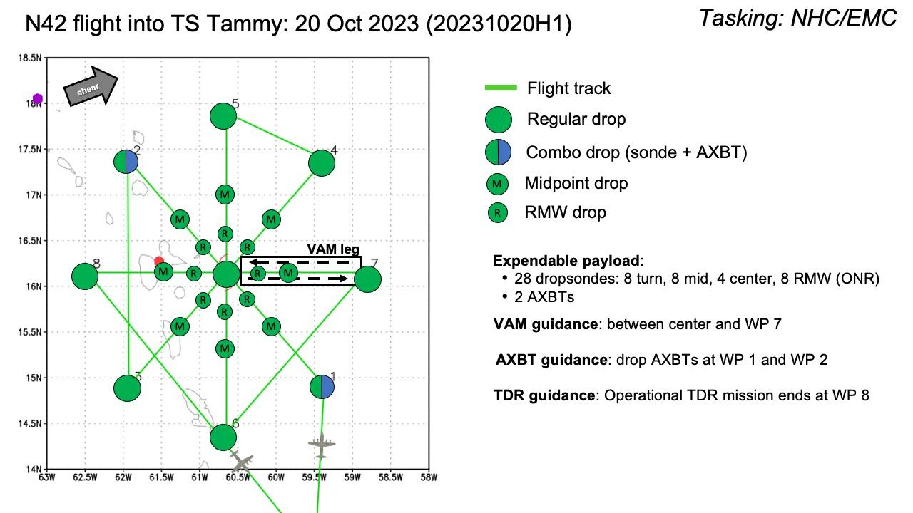
Expendable Distribution | 28 dropsondes (8 endpoints, 8 midpoints, 4 centers, 8 RMWs depending on RMW definition), 2 AXBTs (Points 1 and 2)
Preflight Weather Briefing | 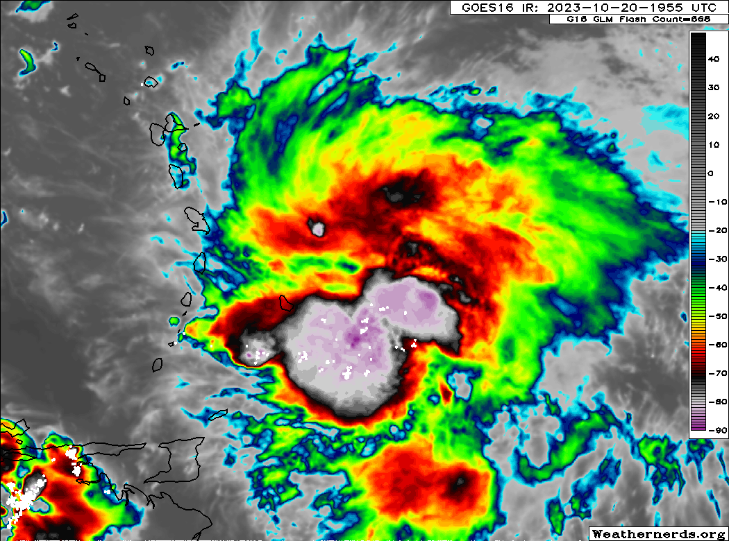  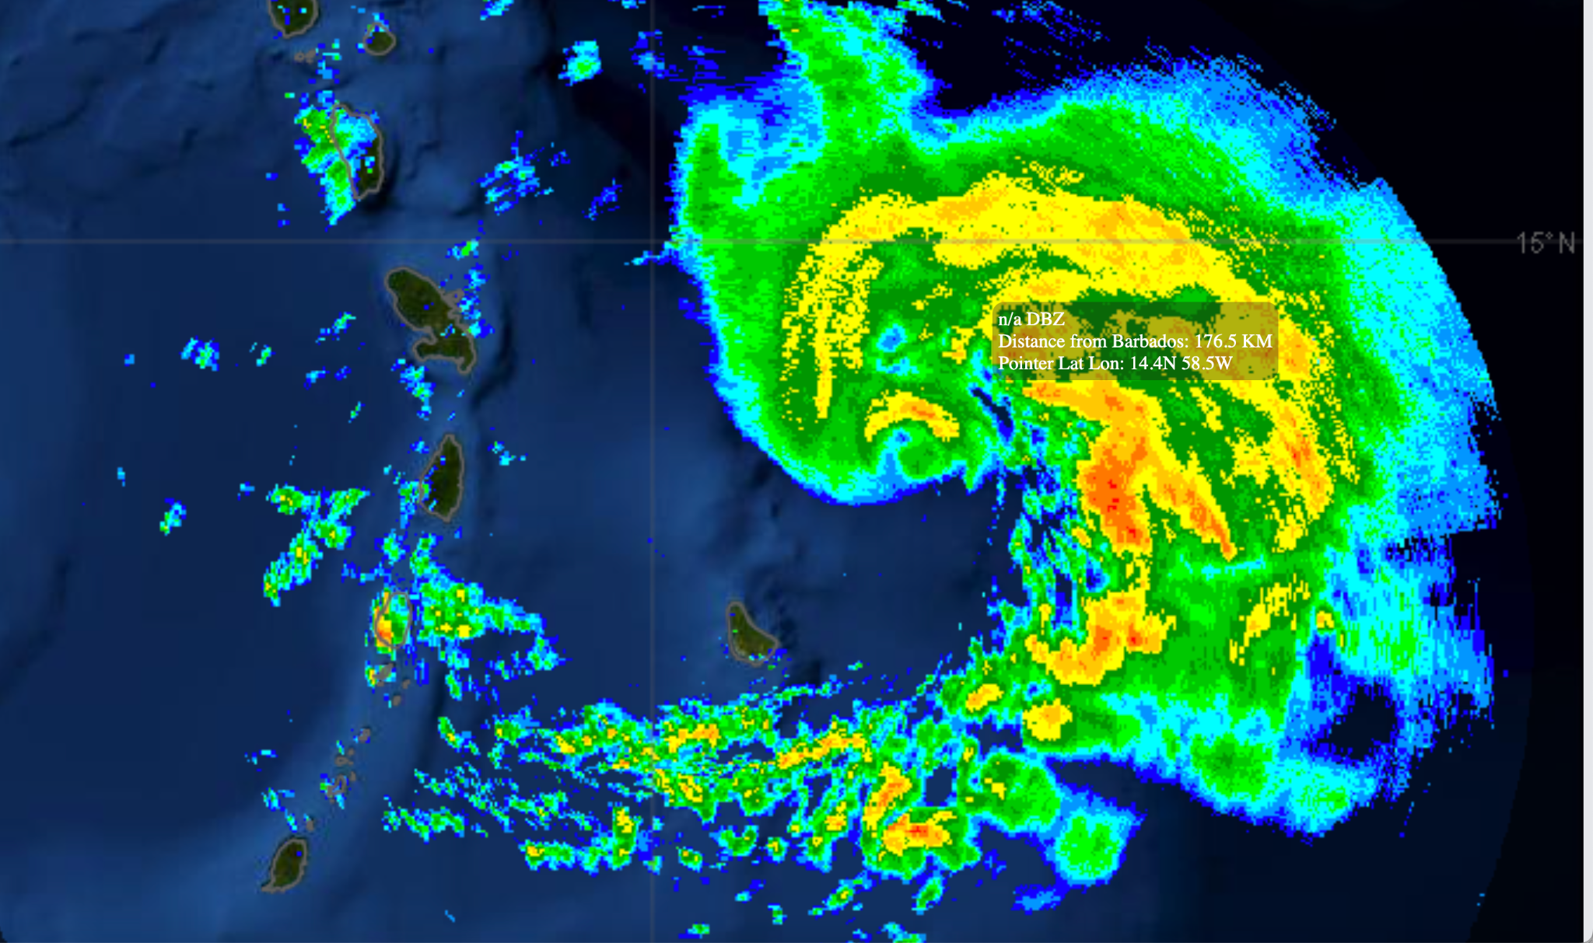  The eye that had formed earlier in Tammy appears to have eroded some as a dry slot works in from the SW. Much of the stronger convection is in the feeder band to the SE. The storm is forecast to continue slowly intensifying as it lifts off to the NW.
Instrument Notes | Instruments appear to be working as expected

IN-FLIGHT
Time [UTC] | Event
2122 | Take Off From Barbados
2130 | Planning to turn inbound slightly early due to a building band
2149 | Combo drop endpoint SE, Sonde 1, BT 1. BT was a dud - no data.
2157 | Midpoint SE sonde 2
2206 | Eyewall open sw  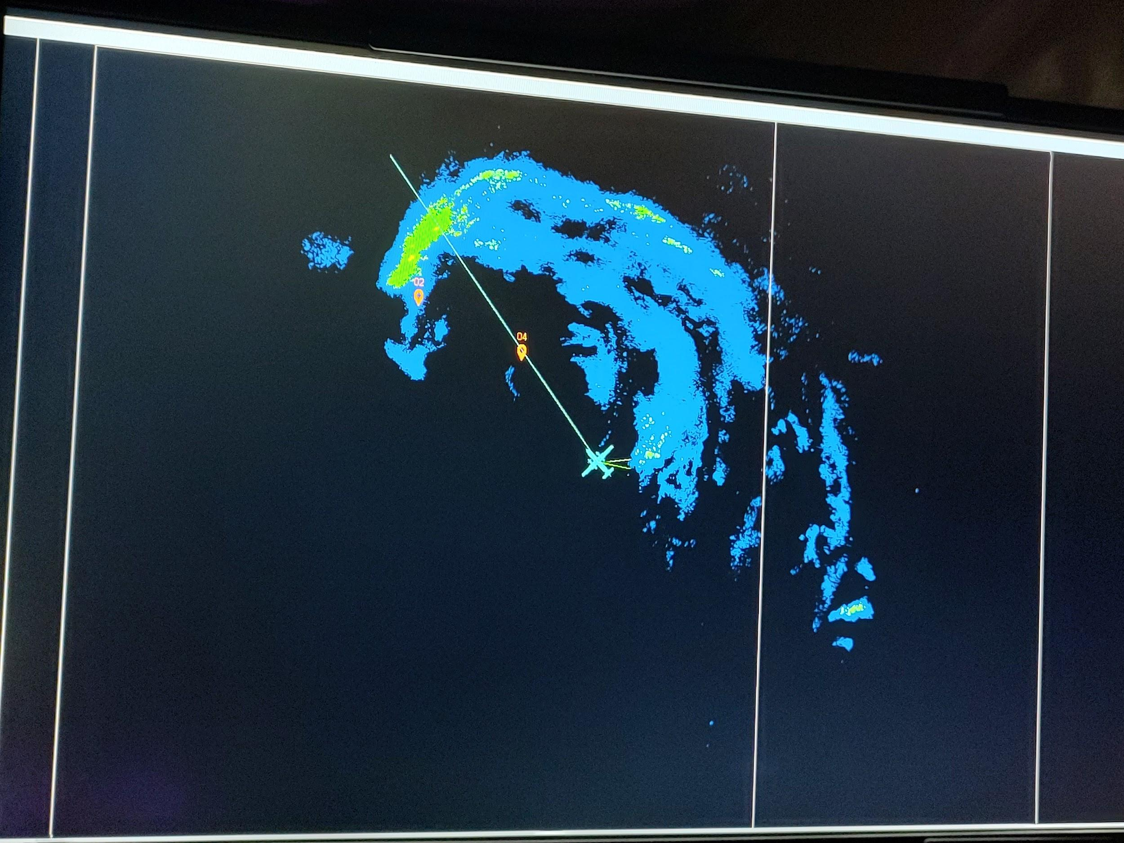
2208 | 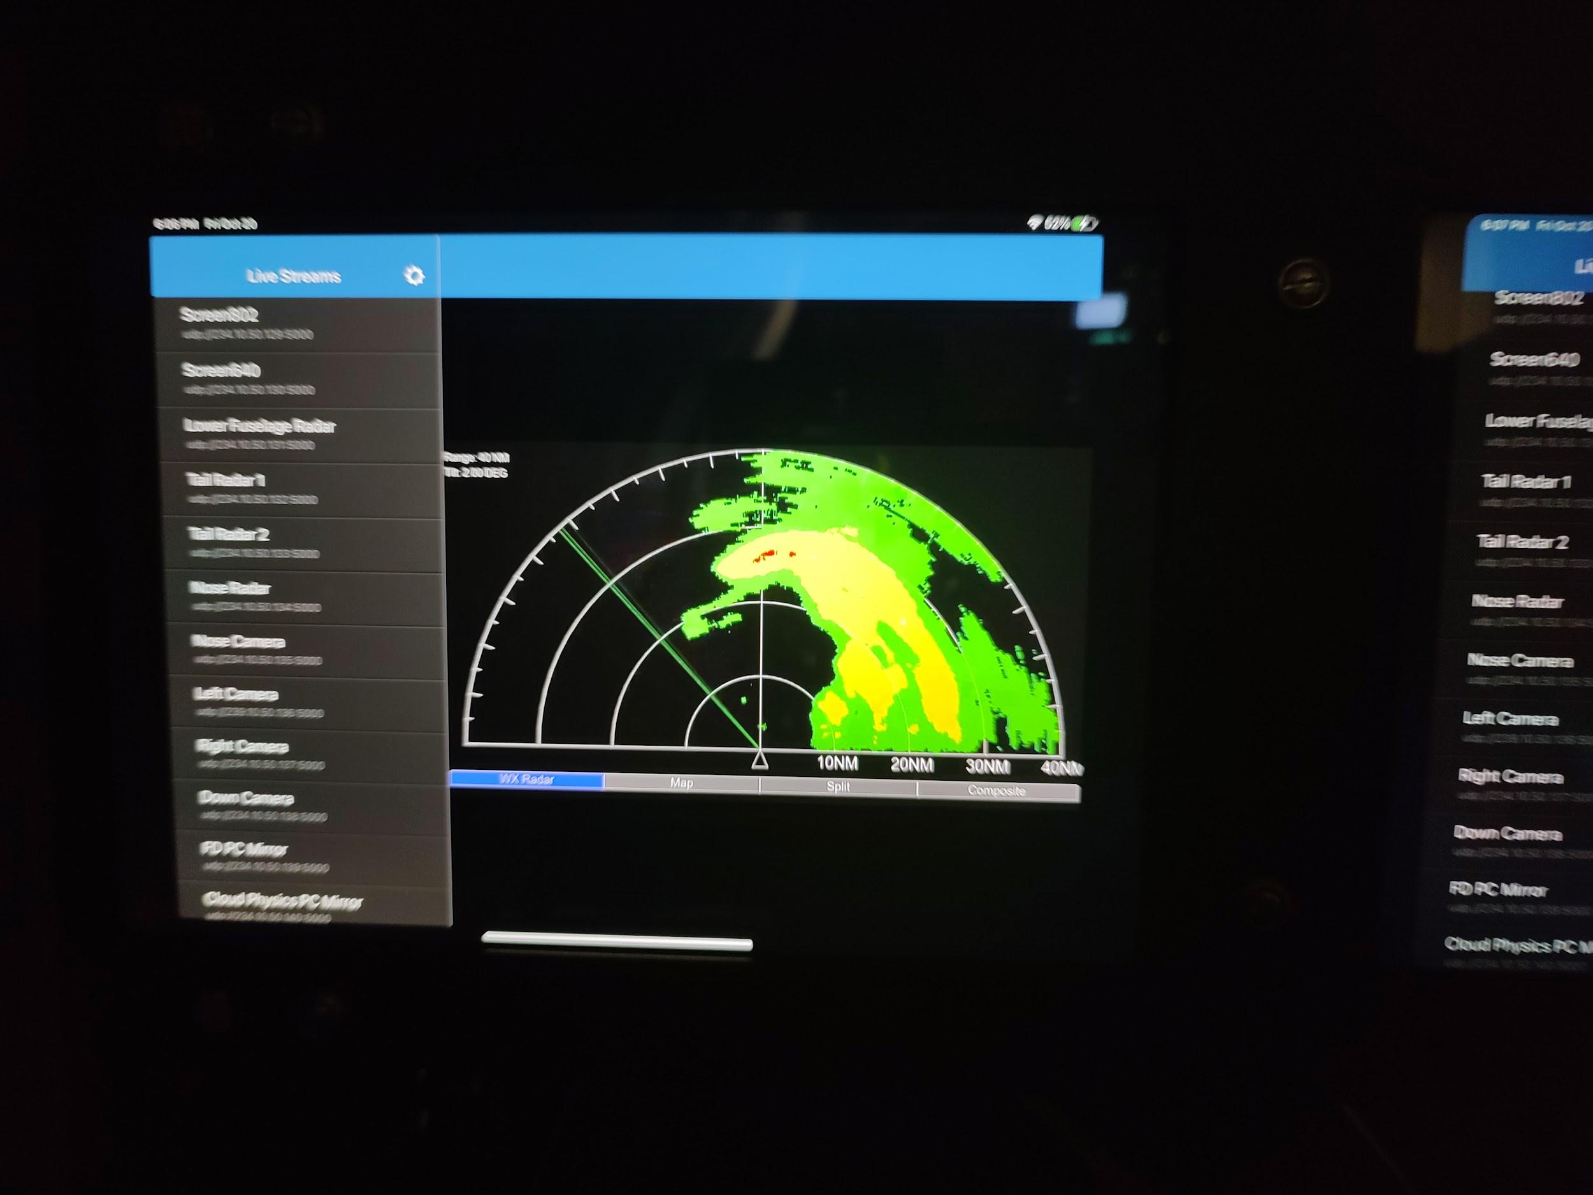
2209 | RMW SE Sonde 3
2111 | Center Sonde 4
2213 | RMW NW Sonde 5, 81 kt surface wind
2221 | Midpoint NW Sonde 6
2233 | Endpoint NW Combo Drop, Sonde 7, turning downwind
2306 | Endpoint SW Sonde 8
2317 | Midpoint SW Sonde 9
2322 | 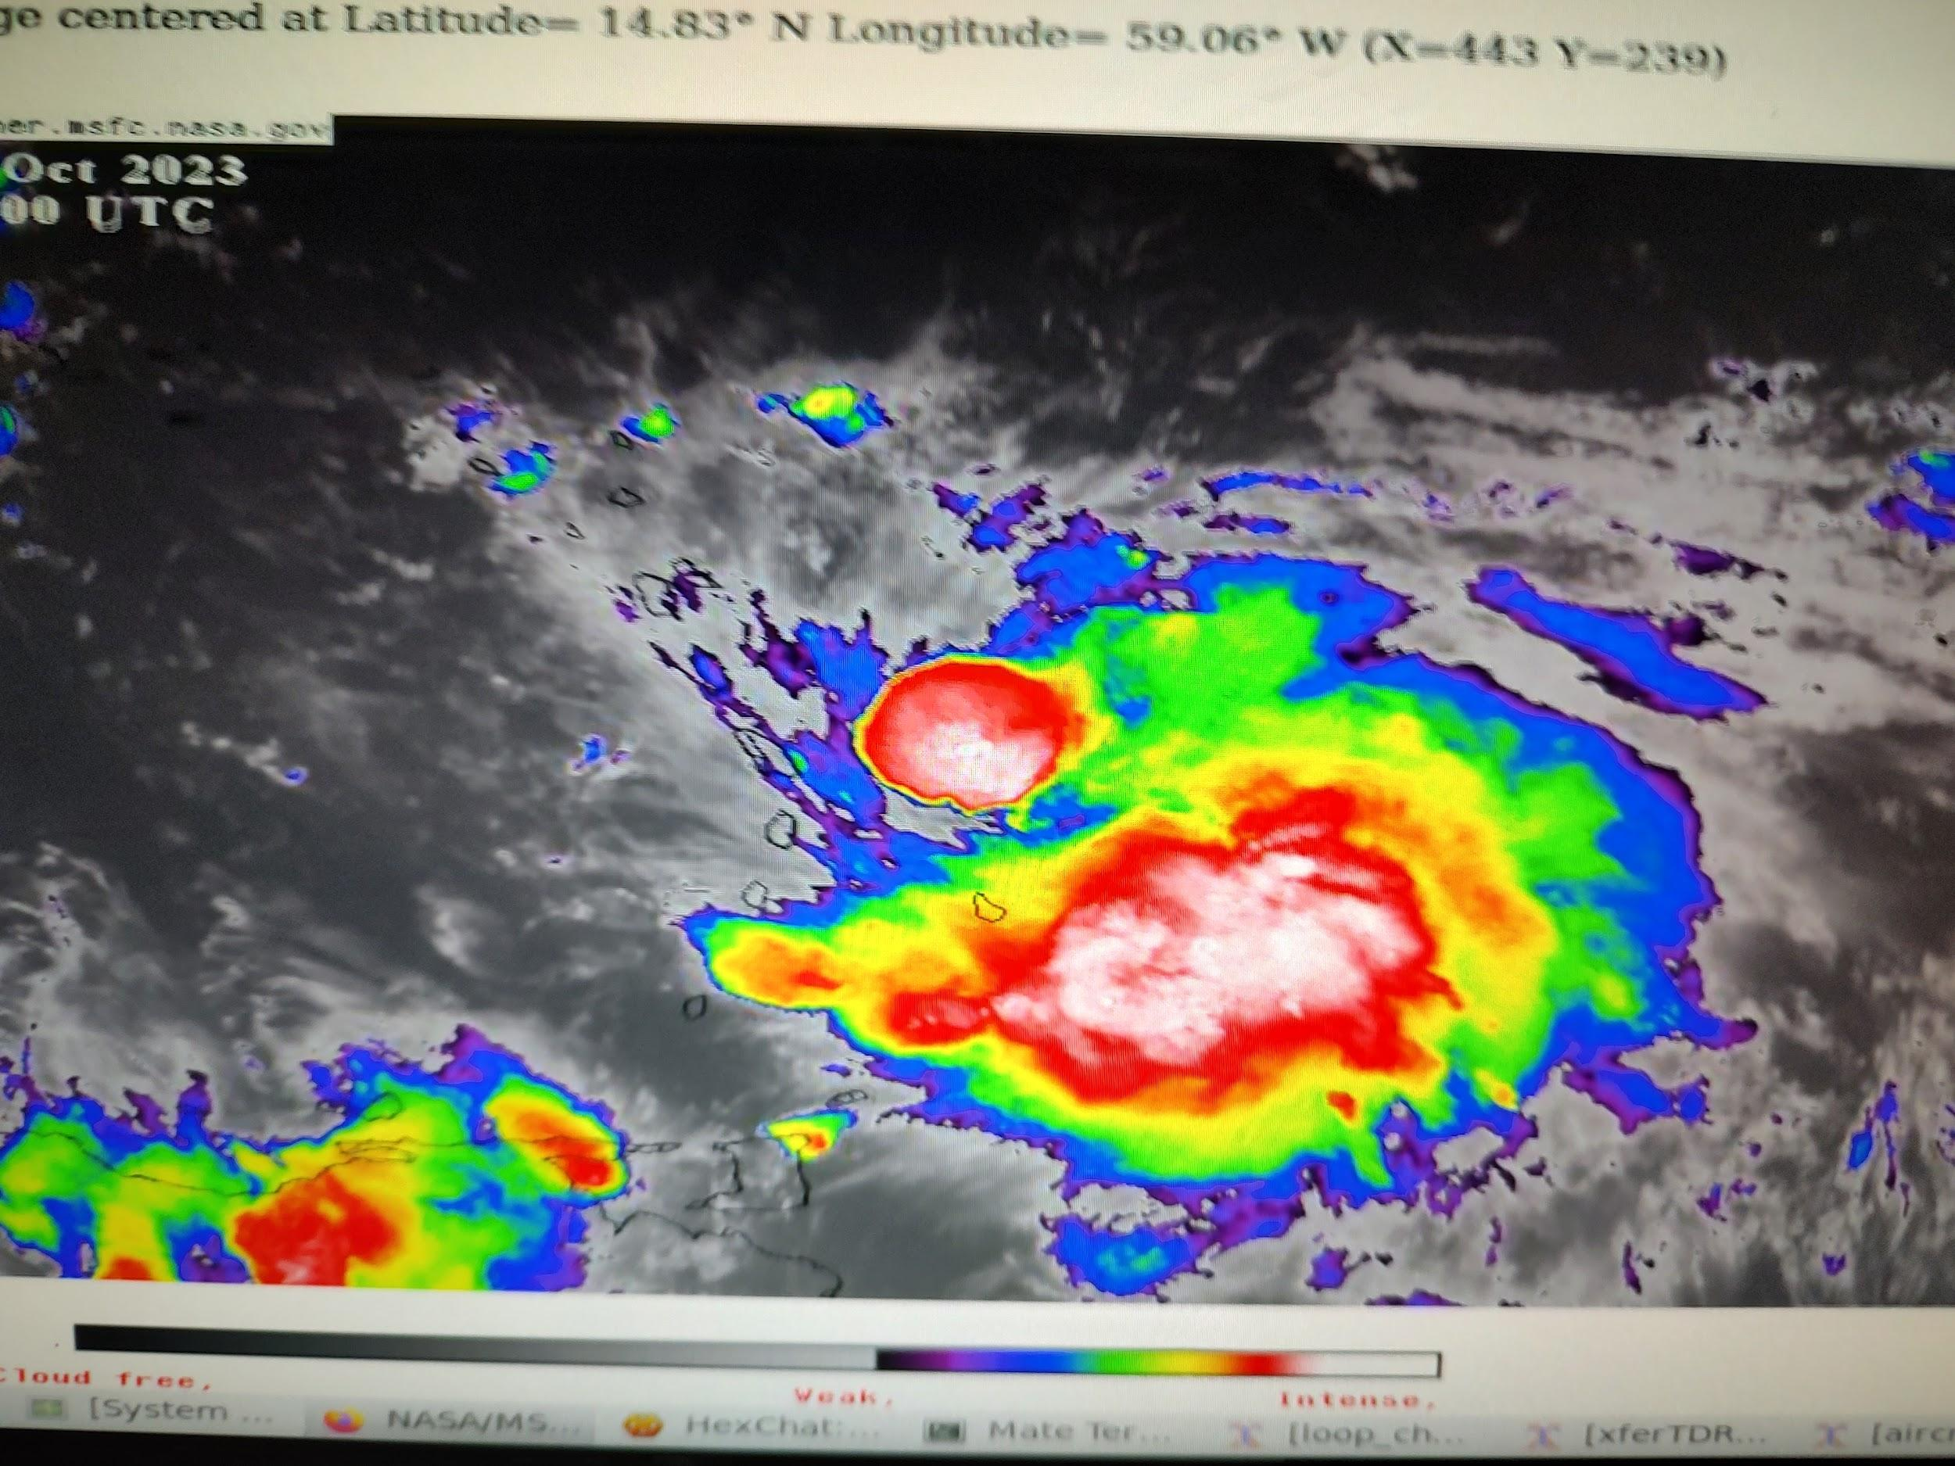
2323 | Lightning off the left side
2324 | RMW SW sonde 10
2325 | Center sonde 11
2328 | RMW NE sonde 12
2333 | Radar shows a bit of residual tilt to the east  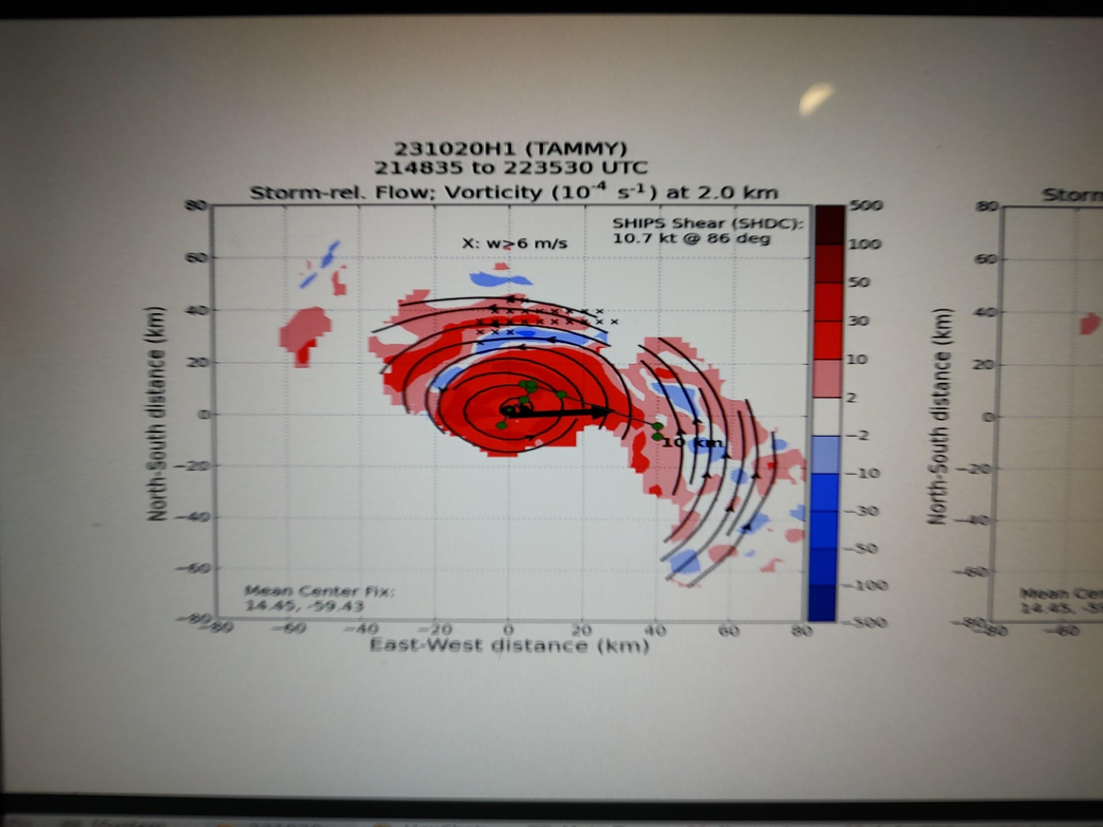
2338 | Midpoint NE sonde 13
2350 | Endpoint NE sonde 14
0005 | Discussing making the N-S pass the final due to concerns over weather in Barbados
0014 | Endpoint N Sonde 15
0026 | Midpoint N Sonde 16
0035 | RMW N Sonde 17
0038 | Eye has basically fallen apart again  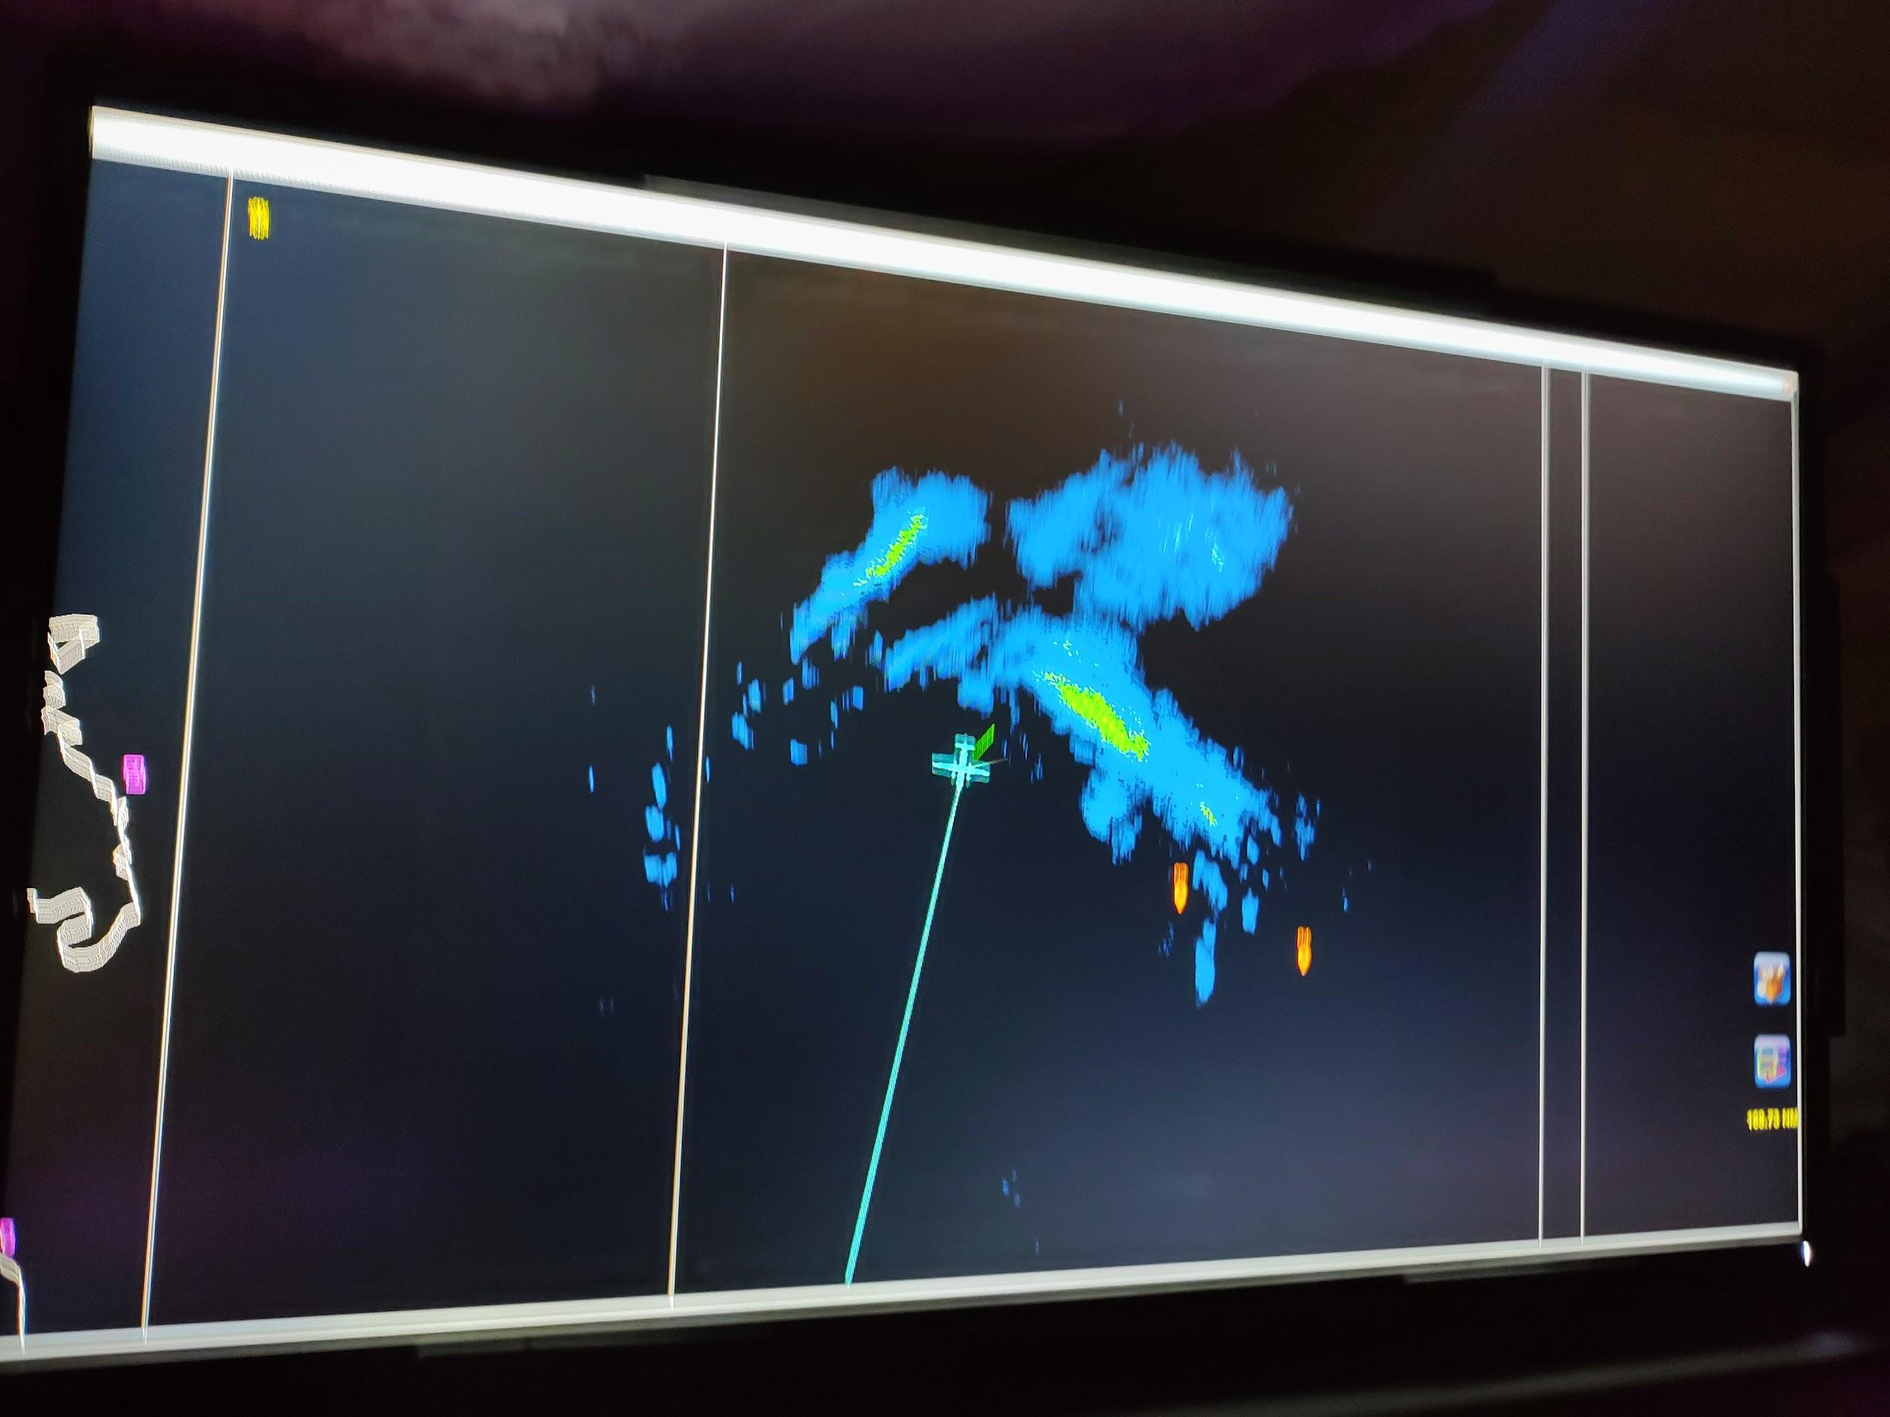
0039 | Center Sonde 18
0039 | Center Sonde 19 (Backup)
0042 | RMW S Sonde 20
0052 | Midpoint S Sonde 21, science complete
0114 | Landed Barbados

POST-FLIGHT
Mission Summary | We flew a slightly truncated rotated Figure 4 TDR mission into Hurricane Tammy. The storm had become a little more aligned since earlier, although the eyewall was very transient, pulsing up towards the start of our mission and down on the last leg. The pressure generally remained steady through the flight.  We landed early due to weather over Barbados.
Actual Standard Pattern Flown | Rotated figure 4 with final E-W leg cut off
APHEX Experiments / Modules Flown | None (VAM removed due to early landing)
Plain Language Summary | - We flew a successful mission collecting tail Doppler radar in Hurricane Tammy.  - The storm has continued to organize from earlier in the day.  - We landed a little early due to weather concerns for landing later.
Instrument Notes | Instruments seemed to work normally
Final Mission Track

