MISSION PLAN
FLIGHT ID | 20231019I1 | STORM | AL20/TAMMY
MISSION ID | 0120A | TAIL NUMBER | NOAA 43
TASKING | NHC-EMC TDR | PLANNED PATTERN | Butterfly
MISSION SUMMARY
TAKEOFF [UTC] | 0907 | LANDING [UTC] | 1652
TAKEOFF LOCATION | Barbados | LANDING LOCATION | Barbados
FLIGHT TIME | 7.8 | BLOCK TIME | 8.0
TOTAL REAL-TIME RADAR ANALYSES  (Transmitted) | 5 (5) | TOTAL DROPSONDES Deployed (Transmitted) | 18 (17)
OCEAN EXPENDABLES (Type) | 1 (0) AOC/HRD AXBT | sUAS (Type) | 2 Blackswift S01
APHEX EXPERIMENTS / MODULES | RICO SUAVE, Microphysics Spiral, VAM
HRD CREW MANIFEST
LPS ONBOARD | Marks/Cione | LPS GROUND | Dunion/Reasor
TDR ONBOARD | Marks | TDR GROUND | Reasor/Fischer
ASPEN ONBOARD | J. Zhang | ASPEN GROUND | n/a
NESDIS SCIENTISTS | n/a
GUESTS (Affiliation) | Elston (Blackswift)
AOC CREW MANIFEST
PILOTS | Doremus/Wood/Keith
NAVIGATOR | Miller
FLIGHT ENGINEERS | Tyson/Wysinger
FLIGHT DIRECTOR | Zawislak/Lundry
DATA TECHNICIAN | Richards
AVAPS | Waggoner/Patel

PRE-FLIGHT
Flight Plan | 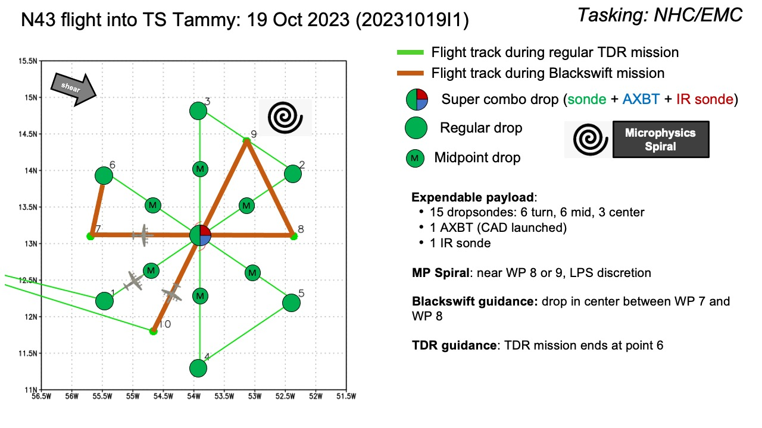  Butterfly pattern  - WPs 1-6: main NHC/EMC TDR pattern (105 NM legs)  - WPs 7-10: HRD/sUAS pattern (Blackswift deployment, 90-105 NM legs)  Altitude:  - 8 or 10 kft (pressure altitude) depending on AF deconfliction requirements  Potential add-on APHEX Modules:  - Priority #1: Blackswift sUAS (RICO SUAVE)  - Deploy Blackswift after the main TDR butterfly pattern is complete and all GPS sondes & AXBTs are closed out (to avoid signal interference issues)  - Deploy Blackswift at WP-7-8 center  - No dropsondes or AXBTs planned for this portion of the mission (WPs 7-10) to avoid signal interference issues with Blackswift  - Priority #2: Microphysics Spiral (1 sonde charged to ONR if Blackswift interference is acceptable to LPS)
Expendable Distribution | - Load 30 dropsondes, 1 IR dropsonde, Blackswift sUASs  - Release at endpoints, midpoints, centers (charged to NWS)  - Additional drops may be requested at the discretion of the onboard HRD LPS  - All dropsondes transmitted to the GTS  - 1 AXBT (CAD launched) - see notes below  - All AXBTs transmitted to the AOC ground server if possible
Preflight Weather Briefing | Tammy is a weak tropical storm experiencing WSW shear. Deep convection appears to be concentrated to the eastern semicircle of the storm with convective bursts near the eastern side of the center with very cold tops.
Instrument Notes | all instruments are working nominally

IN-FLIGHT
Time [UTC] | Event
0907 | Take-off from TBPB
0915 | TDR up, WSRA up - looks good
0933 | TDR startup script initiated tracking along a WNW-ESE band 20 nm N of our track to IP
0952 | IP (PT1) TK 060 crossing rainband near IP, drop #1 (pic)  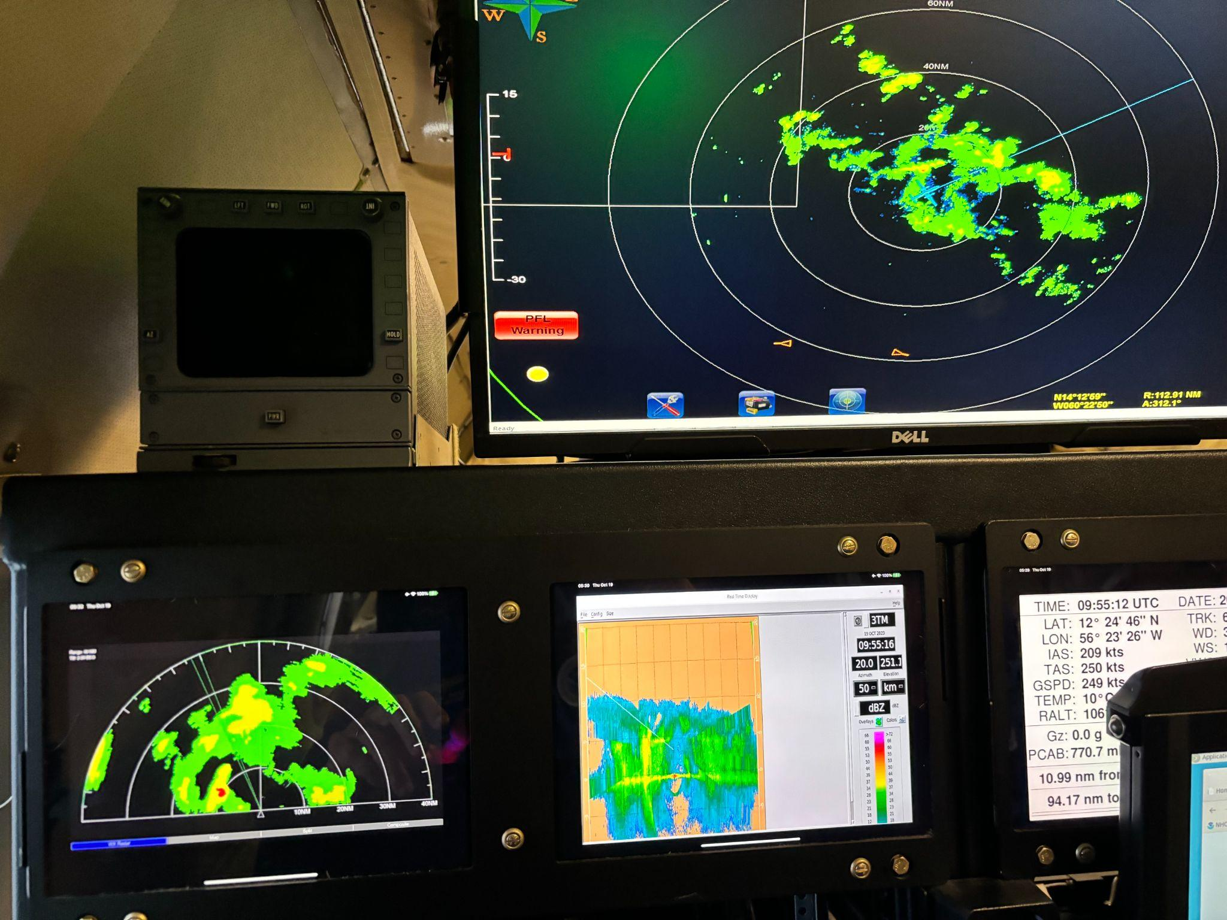
1005 | mid point drop #2
1019 | center drop #3 13.24N 54.88W TK 030 along major rainband. Tops to 18 km (pic)  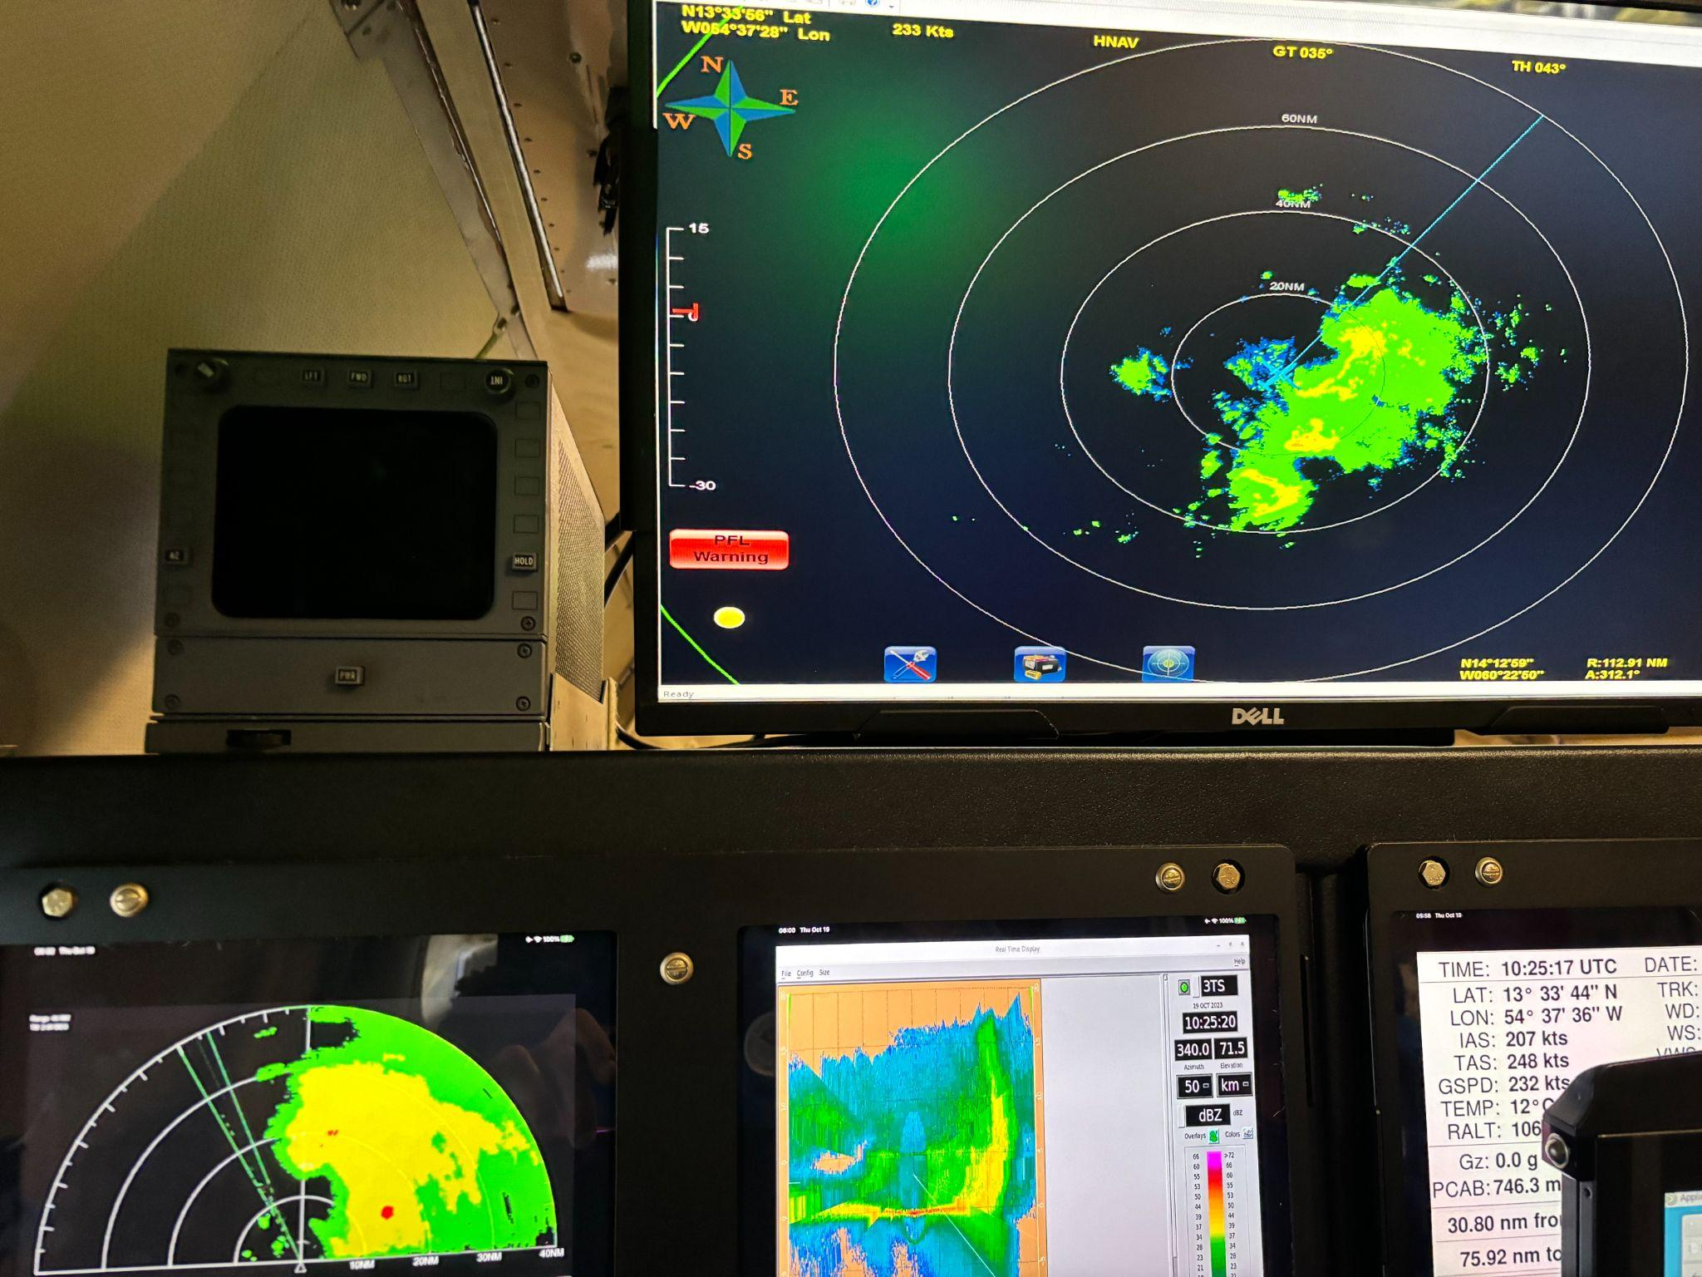
1032 | mid point drop #4 passing through stratiform precip. FL winds 40-45 kt east of center. Very asymmetric FL wind field- inbound winds 25-35 kt
1035 | GOES-East Vis with GLM lightning overlaid (yellow dots):  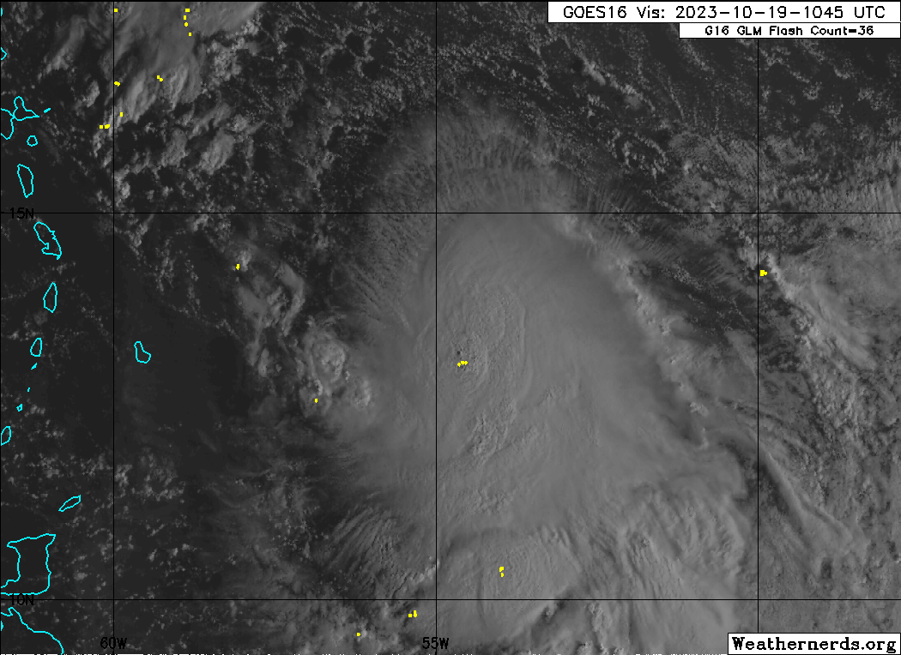  GOES-East IR: Deep convection with deep -80 to -90C cloud tops are mostly east of the center marked by NOAA-43. Some lightning(white dots) in the center and the convective blob south of the inner core (~10.5N)  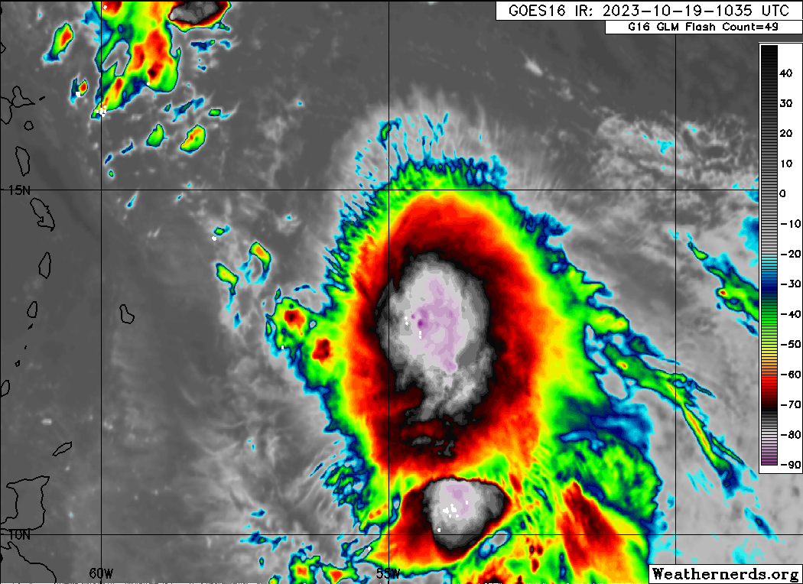
1045 | PT#2, drop #5, TK 290 downwind to PT#3 north of center, just some scattered convection in bands NE of center.
1050 | start 1st TDR analysis
1101 | CIMSS 0900z vertical wind shear analysis shows generally 15-20 kt of W to WNW shear over the storm. 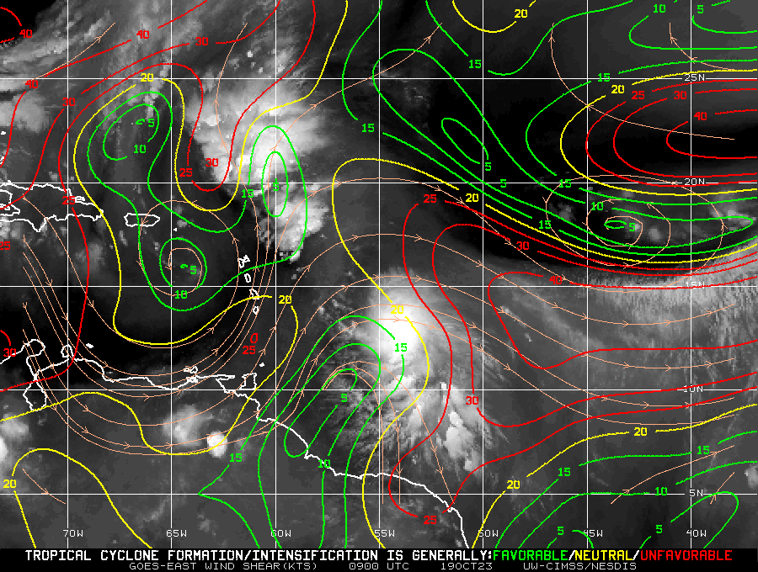
1104 | 1st TDR analysis finished  Alt (km) Lat (deg) Lon (deg)  0.5 13.44 54.89  2.0 13.48 54.89  3.0 13.39 54.85  6.0 13.48 54.37  2-6 km vortex tilt: 56.1 km at 90 deg
1102 | PT#3, drop #6, TK 180
1110 | 1st TDR pass shows a 2-6 km vortex tilt of 56.1 km at 90 deg - this E tilt with height agrees with the easterly shear noted in the CIMSS vertical wind shear analysis above. Right panel below shows the 2 km circulation (black streamlines) and the 5 km circulation (gray streamlines) and nicely shows the 56.1 km tilt of the circulation with height.  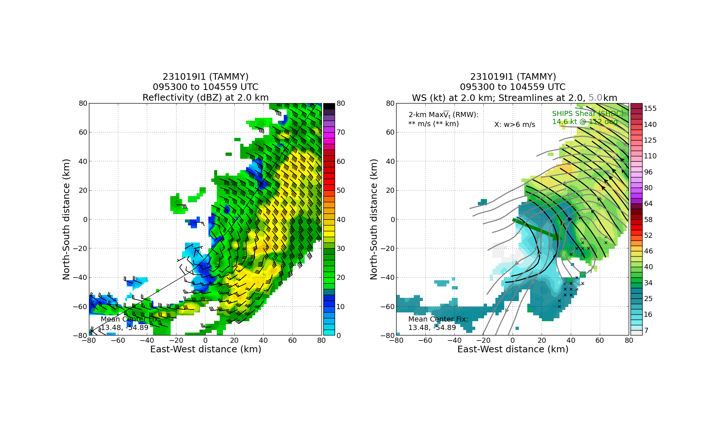
1116 | midpoint drop #7
1130 | center, super combo drop #8, AXBT #1, IR drop #9, SST 28.1  Center on this 2nd pass is ~18 NM west of the 1st marked center.  2nd pass TDR analysis: 2-6-km Vortex Tilt: 60.2 km at 86 deg (consistent with 1st pass) (pic)  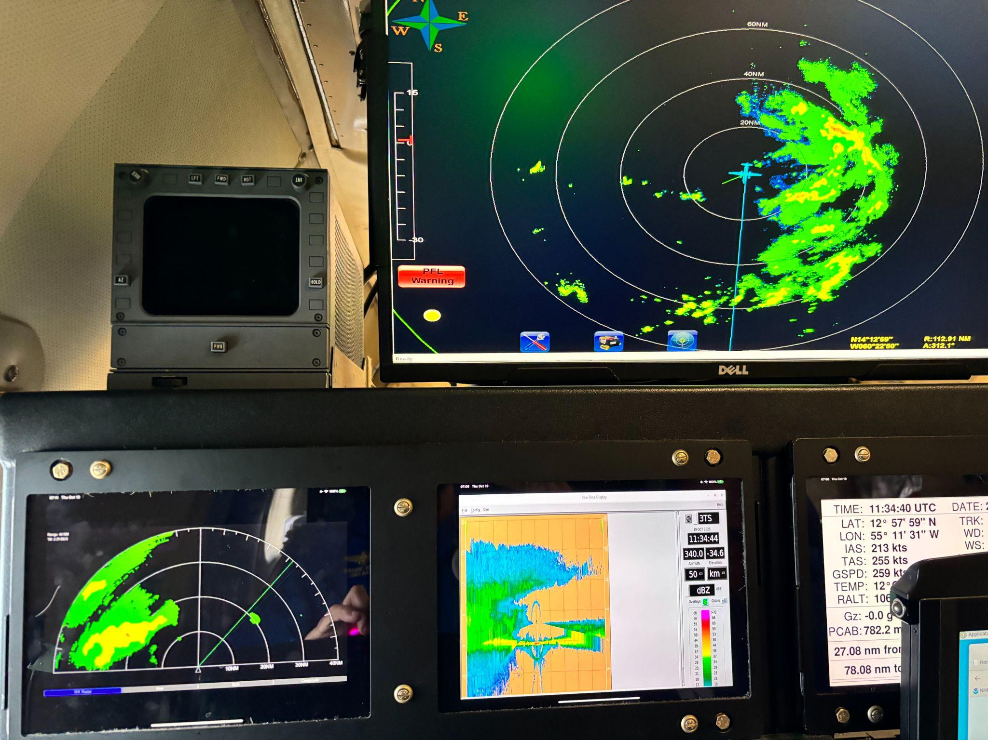
1143 | midpoint drop #10
1154 | PT#4, drop #11, TK downwind picking our way around convective cells
1155 | N43 nearing the end of the 2nd pass (N-S). A few areas of overshooting convection ~30 NM E and SE of N43- the MTS ruler shows a dx of 30 NM E of the flight track.  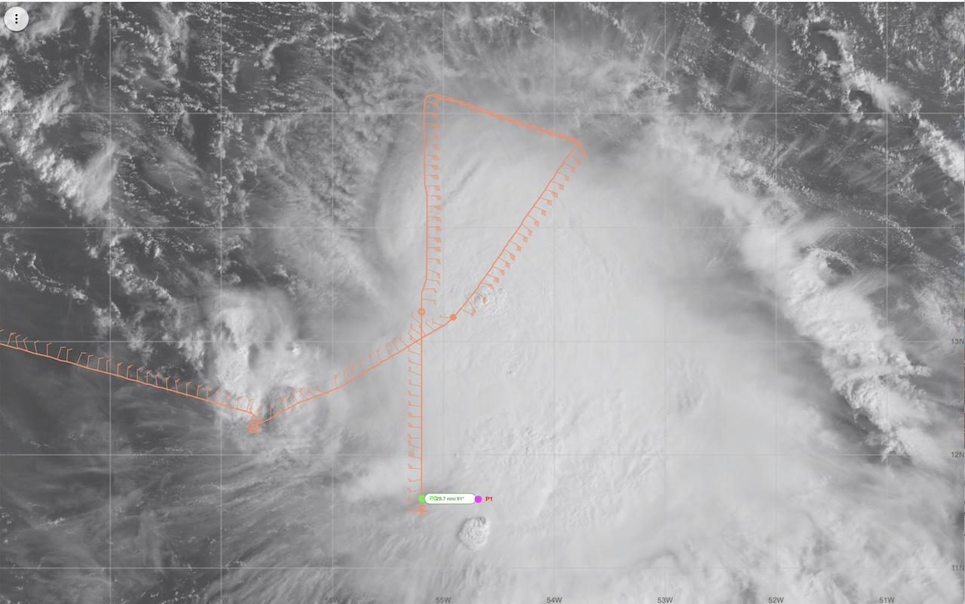
1202 | start TDR analysis #2
1217 | 2nd TDR analysis finished  Alt (km) Lat (deg) Lon (deg)  0.5 99.99 99.99  2.0 13.46 55.14  3.0 13.46 55.11  6.0 13.50 54.59  2-6 km vortex tilt: 60.2 km at 86 deg  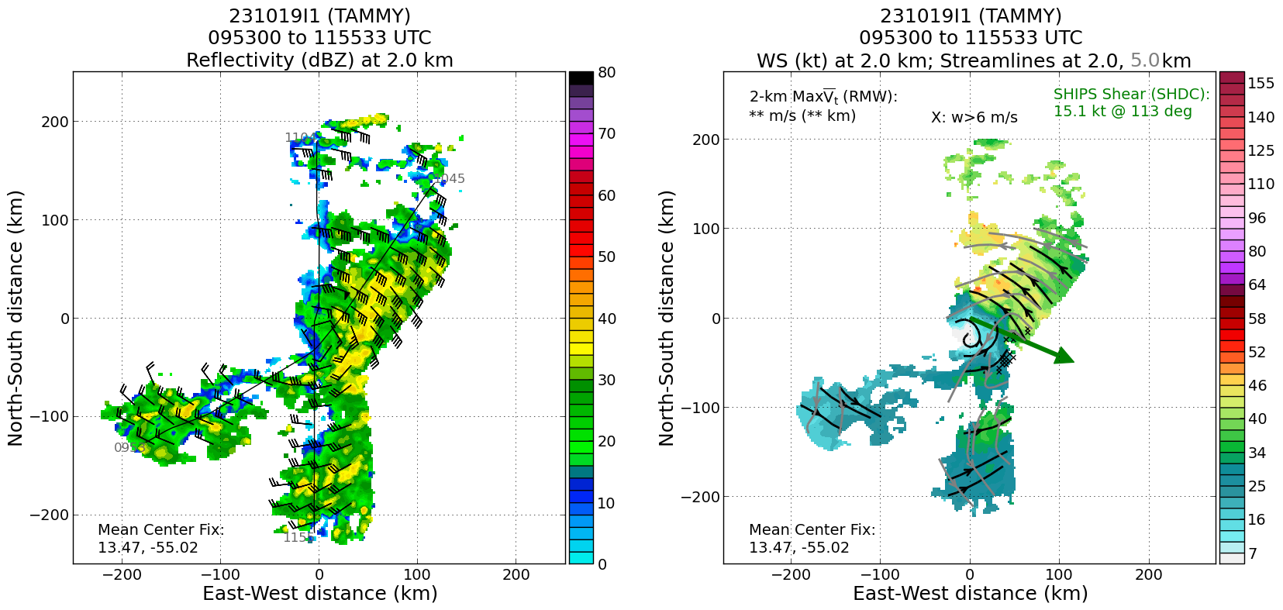
1220 | PT #5 drop #12, TK 300,
1221 | backup drop #13, heading through heavy stratiform rain
1231 | This SE part of the storm is very convectively active-should be the best part of the storm for TDR data collection today.P-3 inbound on the final SE-NW leg for the main TDR pattern.  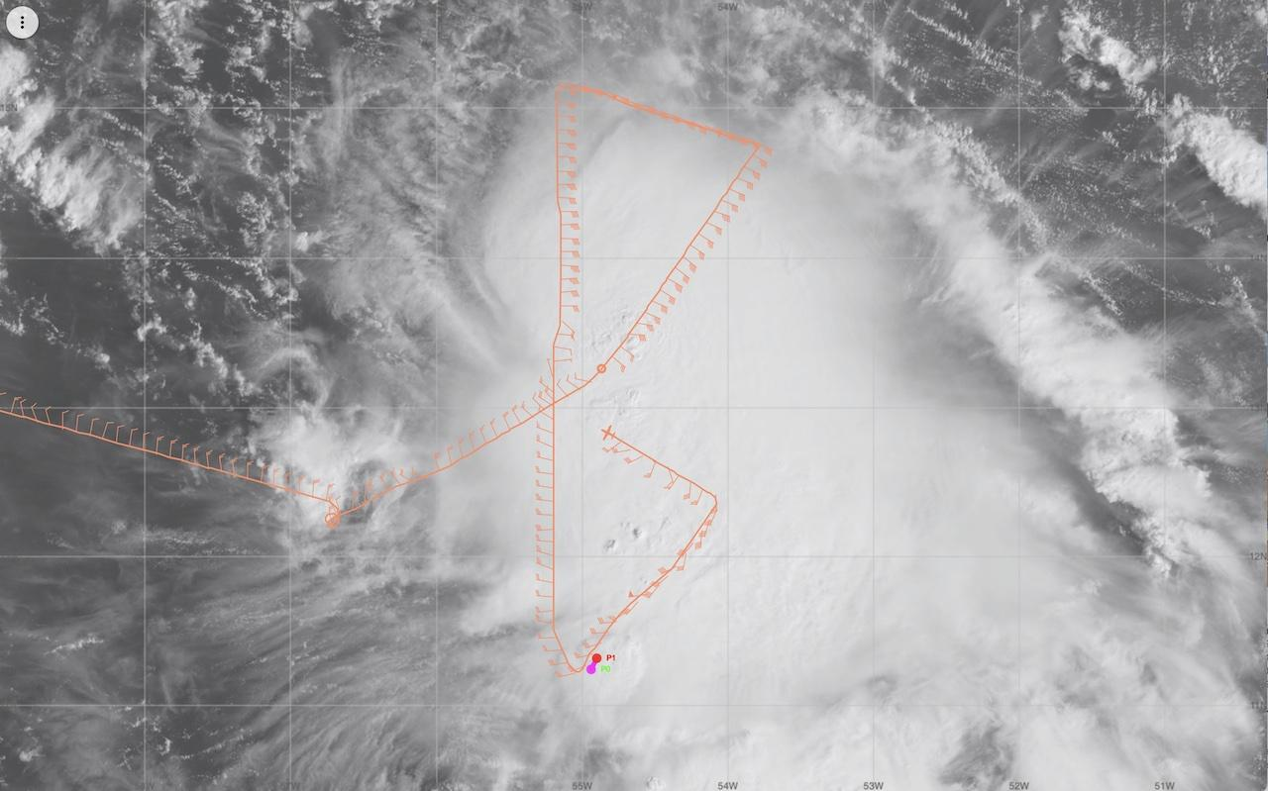
1232 | midpoint drop #14
1240 | Current plan: after the TDR pattern is completed (NW corner, WP 6), proceed to WP 7 (W IP), head inbound to center, deploy Blackswift S0 at midpoint, S0 heads SE, N43 heads south to an endpoint at ~100 NM (to stay in close/solid comms with the S0). We may proceed to an area E of the storm to set up a microphysics spiral.
1242 | center, drop #15
1255 | midpoint drop #16
1301 | start TDR analysis #3 on outbound leg where we have no scatterers
1302 | plan is to finish leg to PT#6 for dropsonde coverage, head SW to a PT 100 nmi abeam of the center position, turn and track to the center. Drop S0 about halfway inbound.
1307 | PT #6 drop #17
1316 | 3rd TDR analysis finished  Alt (km) Lat (deg) Lon (deg)  0.5 99.99 99.99  2.0 13.47 55.22  3.0 13.47 55.15  6.0 13.40 54.91  2-6 km vortex tilt: 35.0 km at 103 deg  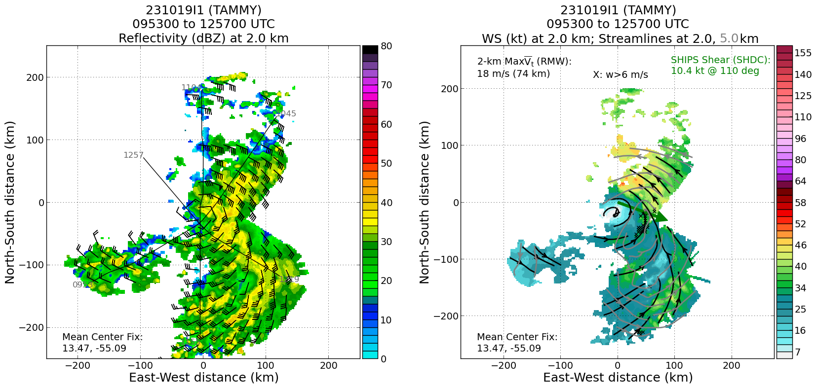
1326 | Setting up at W IP for inbound run. N43 is unpressurized now and the S0 preflight is complete.
1327 | IP for UAS inbound leg 10 kft unpressurized TK 090
1339 | S0 deployed, success!! Receiving data from S0 (movie), S0 visible on AirOps (orange line)  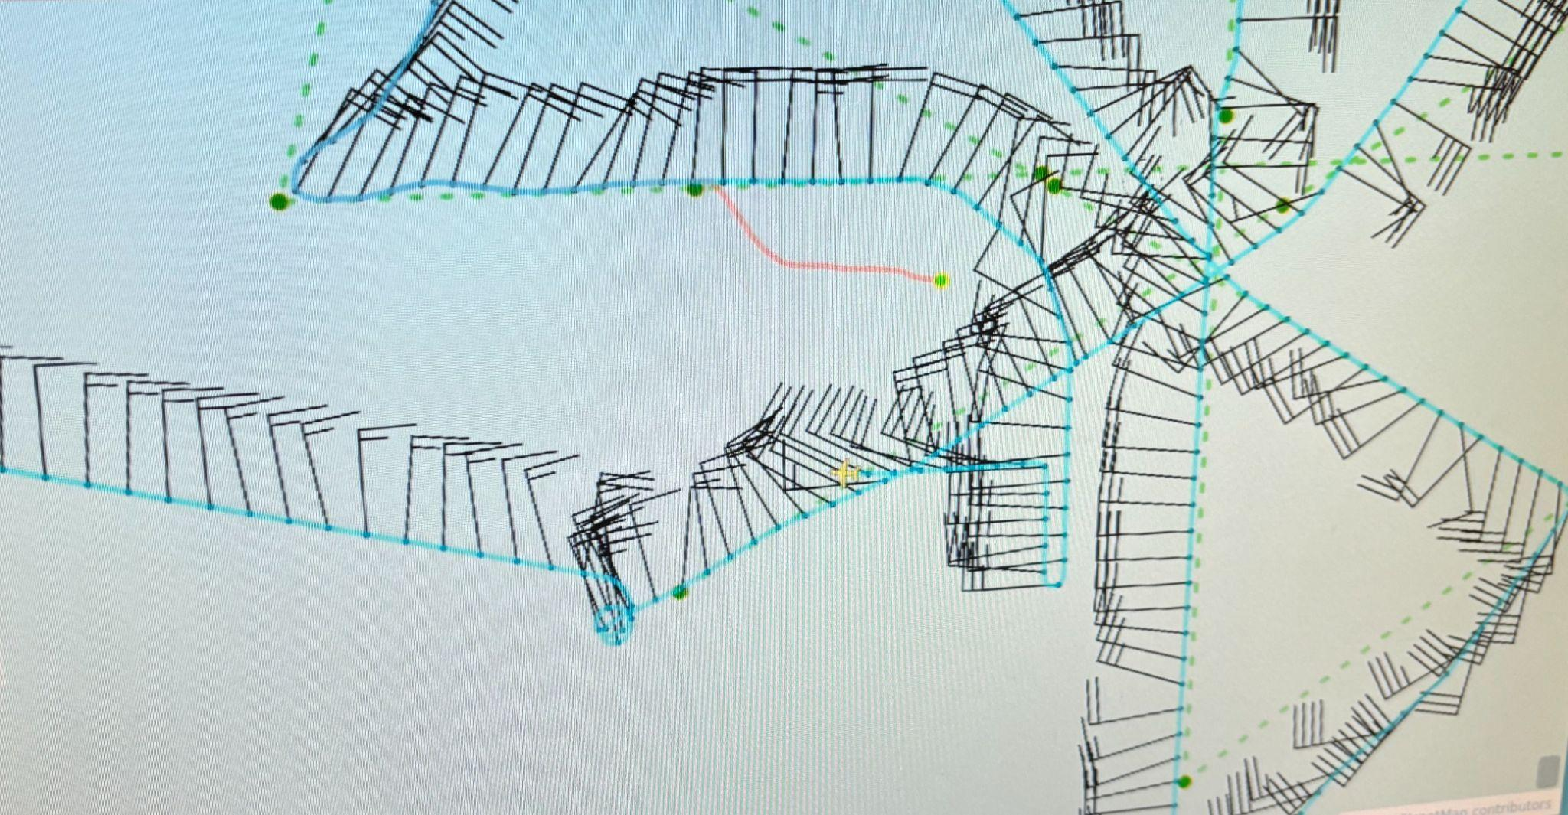
1342 | S0 deployed at midpoint of WP 7-Center leg. Successful launch and N43 is receiving data from the S0. N43 now heading southbound.
1350 | turning south before center to maneuver with S0
1403 | S Endpoint turning back north, 60 nmi from S0, lost comms in high bank turn. Turned west to get comms back
1404 | Cutting this center-S leg a bit short (60 NM) and turning back toward the center
1407 | 43 lost comms with the S0 on the “about face” turn from S to N. Now waiting for comms to return…N43 was ~ 60 NM from the S0 during the turn. Comms came back after ~5 min.
1413 | IR sonde #18, S0 descend to 500 m, some lost GPS due to S0 interference
1409 | N43 turning W now to stay with S0
1436 | S0 descending to 60 m altitude
1440 | S0 now at 50 m altitude
1442 | turn toward center, S0 descend to 50 ft
1449 | S0 splash (1 h 7 min duration), turn toward center, prep 2nd S0, look for spiral opportunity
1502 | S0 #2 launch just W of center, heading into center, orbiting low level center
1505 | TK 110 Starting VAM W-E near center
1521 | start spiral ascent 68 nmi from S0 orbiting in surface center, need to wait a bit for clearance above 15 kft, lost S0 comms in spiral, also can’t drop sonde while S0 comms are active. Losing S0 comms means we could drop in spiral.  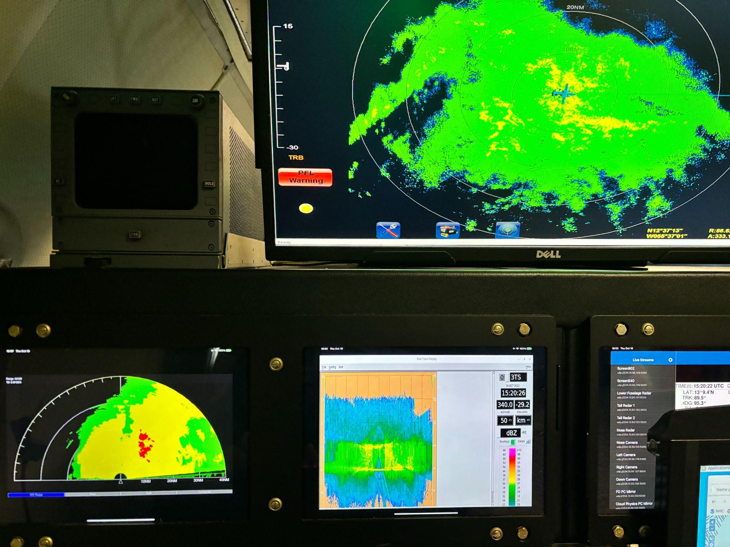
1522 | ~35 NM ENE of center Stratiform Spiral Module
1528 | cleared to 22 kft in spiral
1536 | top of spiral, altitude 7 km, temp -11 C
1537 | drop #19 (ONR), begin spiral down, drop intermittent
1542 | start VAM inbound leg giving us S0#2 orbiting low level center, two VAM legs through mid level center, and a spiral at the outer end of the VAM legs. Sweet!  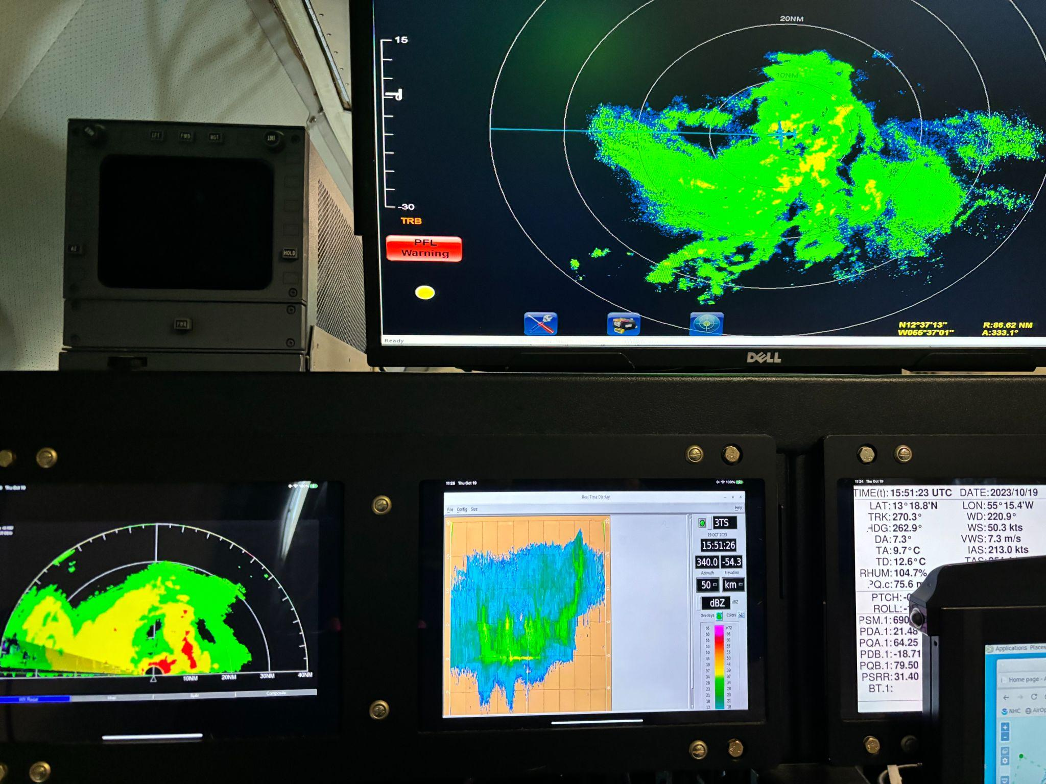
1553 | tracking south of major convective band with tops 18 km
1600 | end VAM leg just west of center, TK 270 to Barbados
1622 | 5th TDR analysis  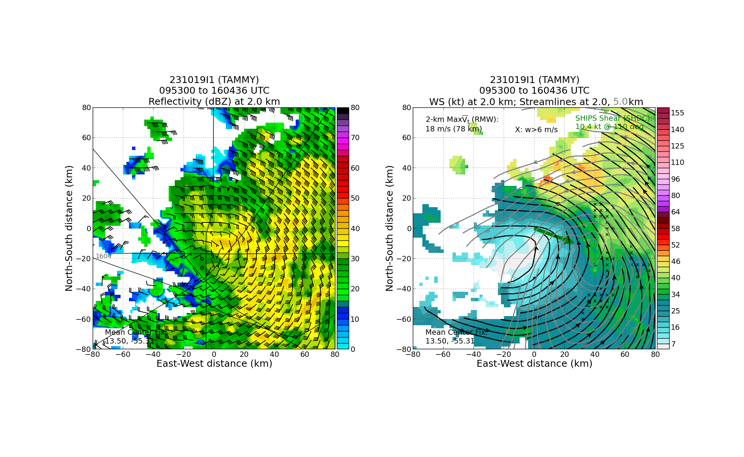  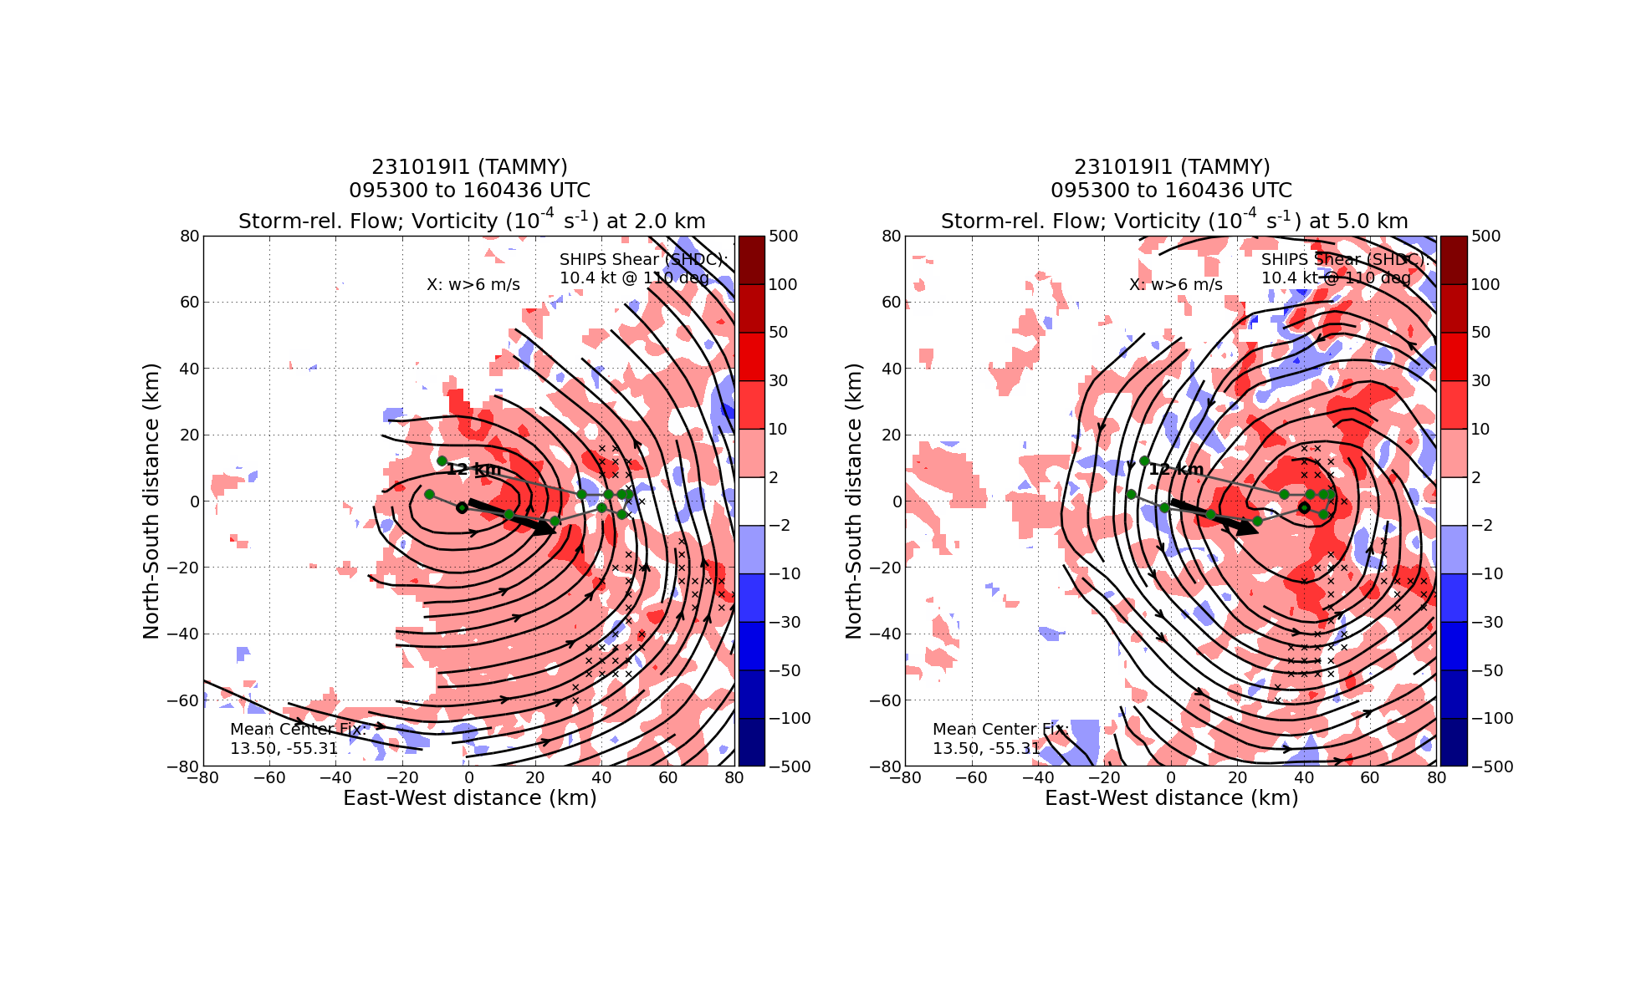
1628 | last TDR analysis submitted, stow TDR
1651 | land TBPB

POST-FLIGHT
Mission Summary | Mission was successful – Completed EMC Butterfly pattern in a strengthening Tropical Storm Tammy successfully. Short ferry time allowed time for RICO-SUAVE and microphysics spiral modules to be flown. We also were able to complete two VAM module legs on the east side of the storm using the S0 pattern sampling low level center to west while TDR mapped mid level center. A total of 18 drops were released, and 17 were transmitted, TDR analyses (5 of them) were transmitted on time – an additional analyses was performed as part of the VAM module on the east side of the storm and final outbound leg on RTB.
Actual Standard Pattern Flown | Completed EMC Butterfly pattern successfully. Short ferry time allowed time for RICO-SUAVE and microphysics spiral modules to be flown. We also were able to complete two VAM module legs on the east side of the storm using the S0 pattern sampling low level center to west while TDR mapped mid level center
APHEX Experiments / Modules Flown | - RICO-SUAVE - BlackSwift S0  - VAM module  - Microphysics Spiral
Plain Language Summary | - Successfully executed module to look at the vortex tilt evolution Successful mission was flown into Tropical Storm Tammy, with multiple objectives accomplished.  - Important radar and dropsonde data was collected and transmitted to the ground for use in computer forecast models.  - There also was valuable data collected of precipitation particle distributions at various levels in the atmosphere below and above the freezing level. This will help evaluate and improve model representation of these structures, thought to be important for both intensity and rainfall prediction.  - A repeated sampling of the winds at flight-level will yield insights into how storm structure changes over short (2-3 h) time periods, especially if it’s intensifying. This storm was slowly intensifying, but the observations from the radar nicely show how the inner-core structure of a non-intensifying storm evolves in the presence of continued vertical shear (change in wind speed and/or direction with height).  - First successful sUAS BlackSwift S0 in the center of Tropical Storm Tammy
Instrument Notes | Instruments all worked well (TDR, sondes, AXBTs, microphysics probes, SFMR, W-band, WSRA)
Final Mission Track | 