MISSION PLAN
FLIGHT ID | 20231019H1 | STORM | AL20/TAMMY
MISSION ID | 0320A | TAIL NUMBER | NOAA 42
TASKING | NHC-EMC TDR | PLANNED PATTERN | Butterfly
MISSION SUMMARY
TAKEOFF [UTC] | 2111 | LANDING [UTC] | 0150
TAKEOFF LOCATION | Barbados | LANDING LOCATION | Barbados
FLIGHT TIME | 4.7 | BLOCK TIME | 4.9
TOTAL REAL-TIME RADAR ANALYSES  (Transmitted) | 5 (5) | TOTAL DROPSONDES Deployed (Transmitted) | 14 (14)
OCEAN EXPENDABLES (Type) | 1 (1) AOC/HRD AXBT | sUAS (Type) | n/a
APHEX EXPERIMENTS / MODULES | VAM
HRD CREW MANIFEST
LPS ONBOARD | Hazelton | LPS GROUND | Aberson
TDR ONBOARD | Hazelton | TDR GROUND | Alvey
ASPEN ONBOARD | Sellwood | ASPEN GROUND | n/a
NESDIS SCIENTISTS | Jelenak, Chang, Sapp
GUESTS (Affiliation) | n/a
AOC CREW MANIFEST
PILOTS | Copare/Gaston/Palmer
NAVIGATOR | Utama
FLIGHT ENGINEERS | Stokes/Kiddo
FLIGHT DIRECTOR | Kalen/Englert
DATA TECHNICIAN | McAlister
AVAPS | Warnecke/Keller

PRE-FLIGHT
Flight Plan | 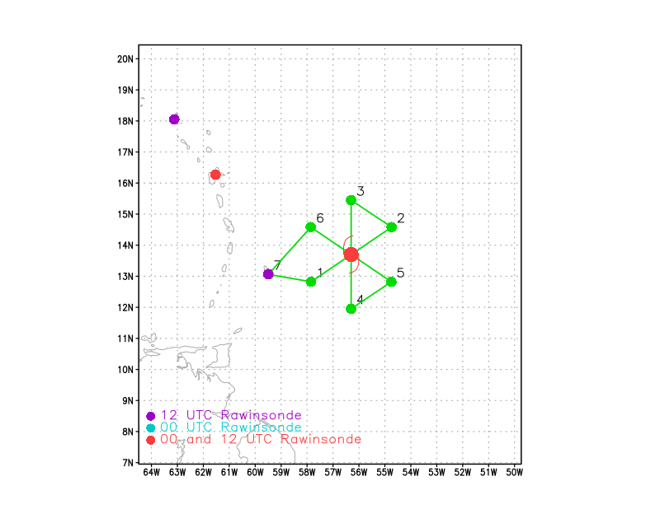  Butterfly pattern with 105-NM legs at 8 or 10 kft (pressure altitude) depending on AF deconfliction requirements
Expendable Distribution | 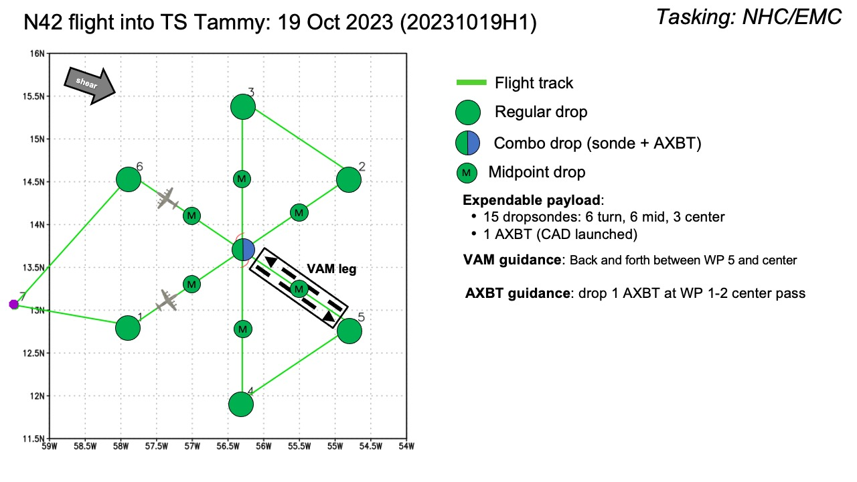
Preflight Weather Briefing | Tammy has not become any better organized since this morning. The  center of the cyclone has become partially exposed to the west and  northwest of the main area of deep convection, and there is little  evidence of banding except over the southeastern portion of the  storm. An Air Force Reserve reconnaissance aircraft has been  investigating Tammy this afternoon and has reported peak 850 mb  flight-level winds of 53 kt and SFMR values of around 40 kt.  Earlier scatterometer data revealed some 40-45 kt vectors over the  southeastern portion of the circulation. The latest motion estimate is 285 degrees at 11 kt. Warm SSTs and moderate vertical shear conditions could allow for some modest intensification.
Instrument Notes | [What instruments are working, not working, not functioning nominally, not installed?]

IN-FLIGHT
Time [UTC] | Event
2111 | takeoff
 | Did a circle to reset the SFMR.
2133 | IP SW, sonde 1
2144 | Midpt sonde 2
 | Looks like it is trying to form a new center - very tilted. Center probably SE of recent AF fix
2157 | Center closest approach sonde 3. Center is further southeast than even the adjusted flight track suggested. Center drop 1005mb 17kt 30deg at 10m  First analysis 2-6-km vortex tilt: 19.7 km at 156 deg, not quite as much as earlier
2210 | Midpt sonde 4
2225 | Endpoint NE sonde 5, turning downwind
2246 | IP north sonde 6
2257 | Midpoint sonde 7
2309 | Center, combo drop sonde 8, SST ~30C, center drop 1005mb 17kt 30deg at 10m  2-6-km tilt 18.9 km at 148 degrees
2323 | Midpoint sonde 9
2331 | High wind speed from SFMR well south of center in rainband. Flight-level wind did not increase.
2335 | Endpoint sonde 10
 | Interesting wind shift at flight-level near start of downwind leg.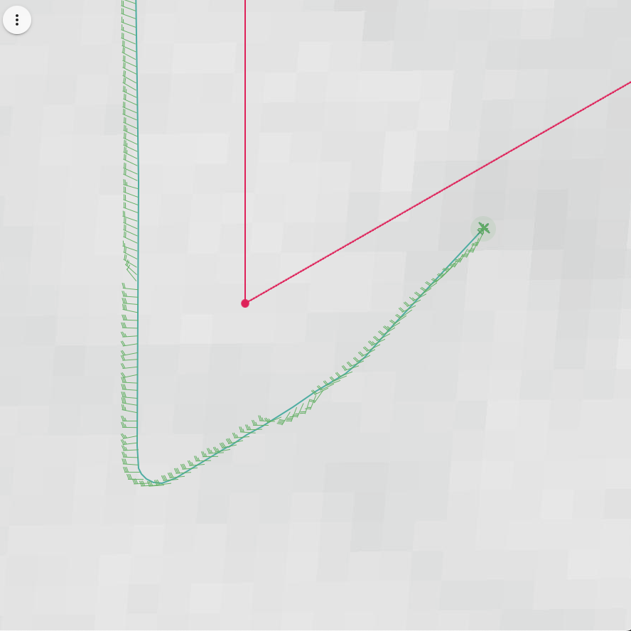
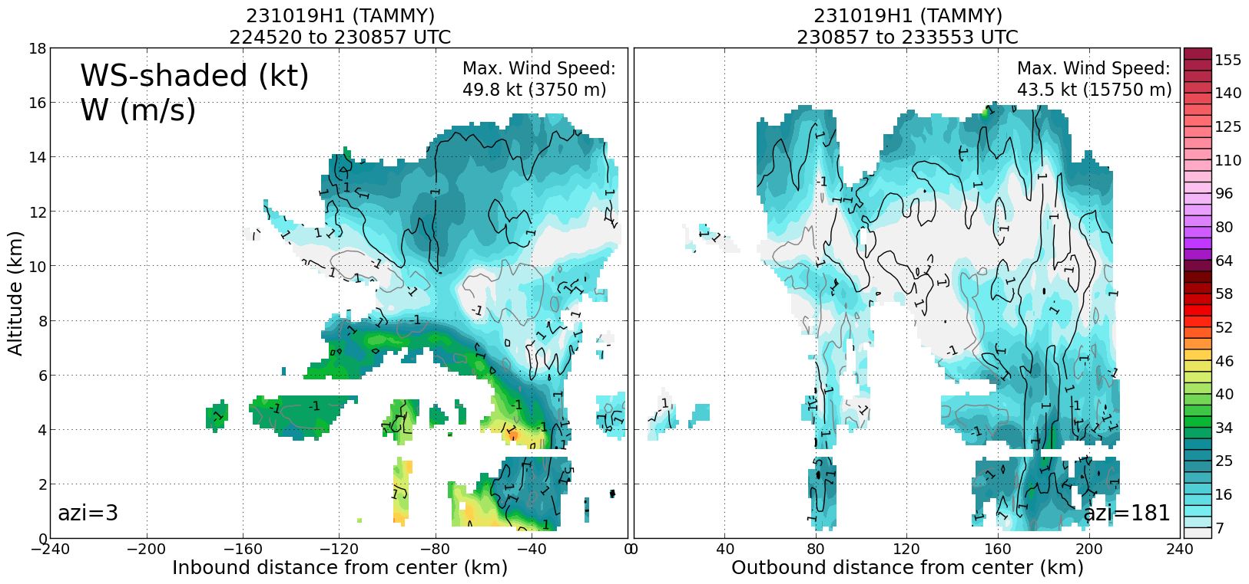
Profile from pass 2, very asymmetric
 | Doing VAMS, inbound to northwest, then back outbound to southeast.
2-6-km vortex tilt 14.2 km at 98 deg. Slowly aligning with possible precession.
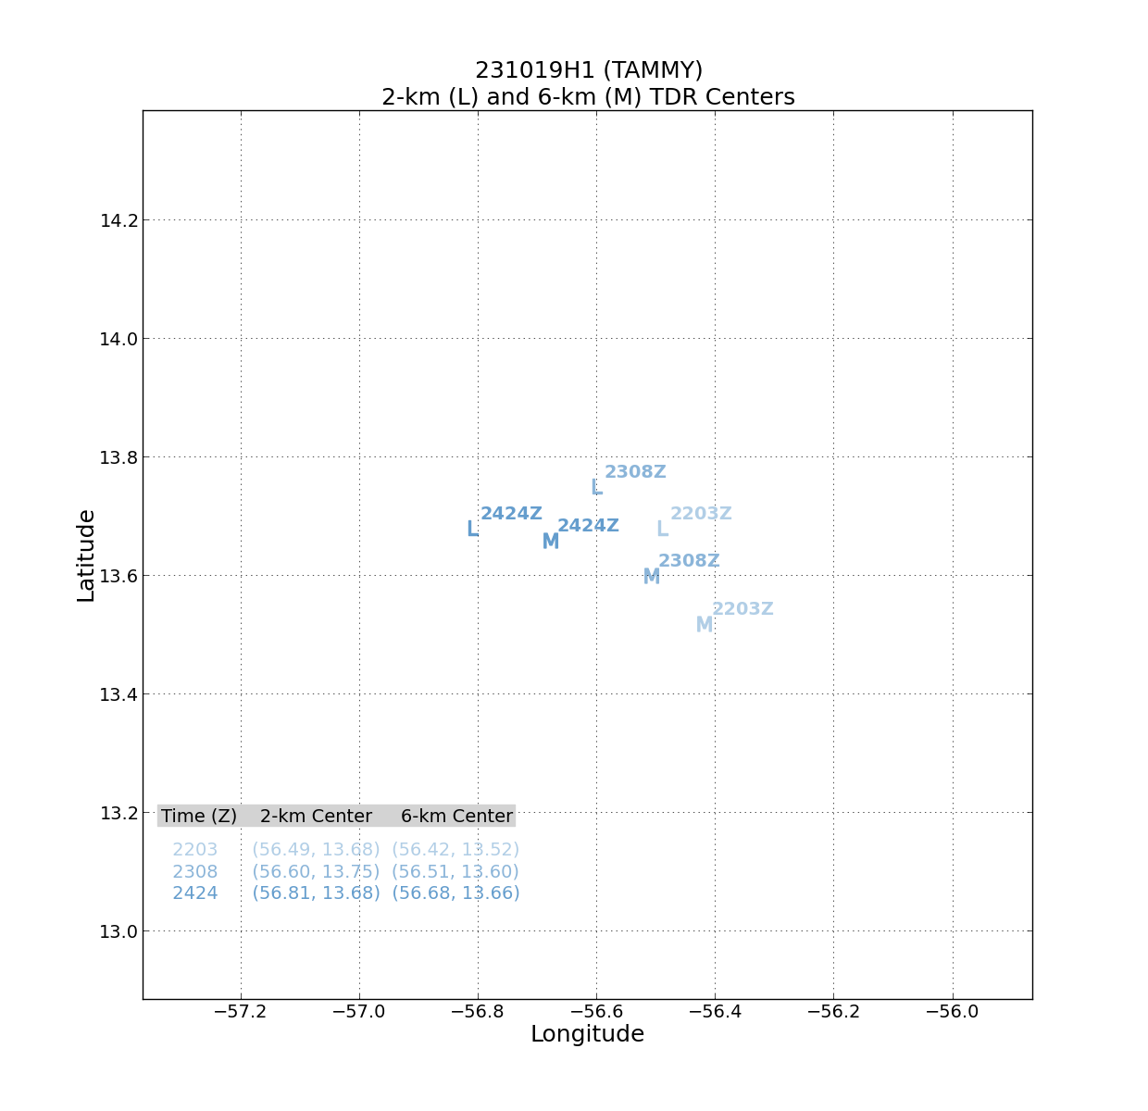
0040 | Convection blowing up to the northeast may be trying to tug center into it - speculation  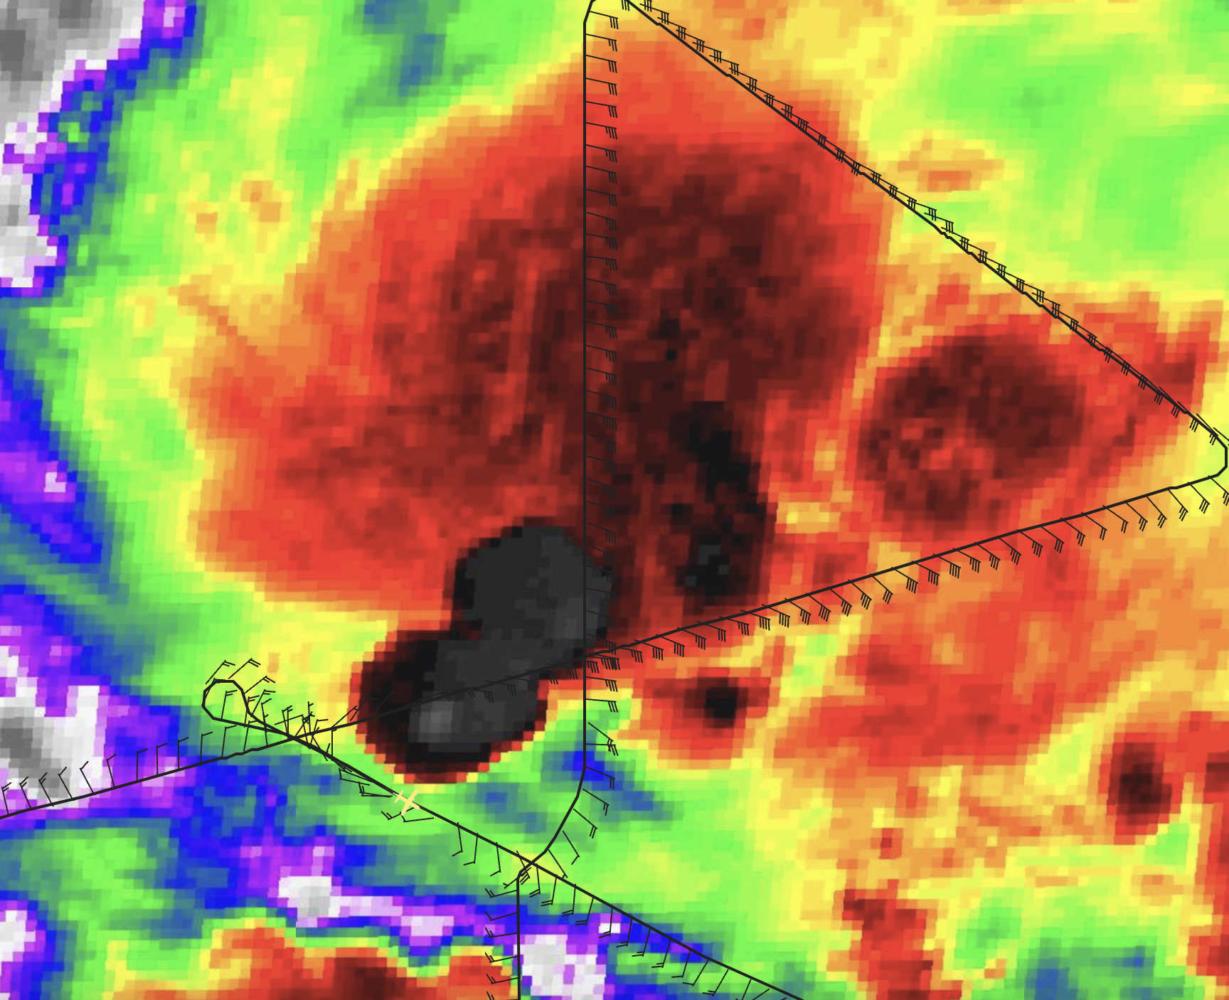
 | 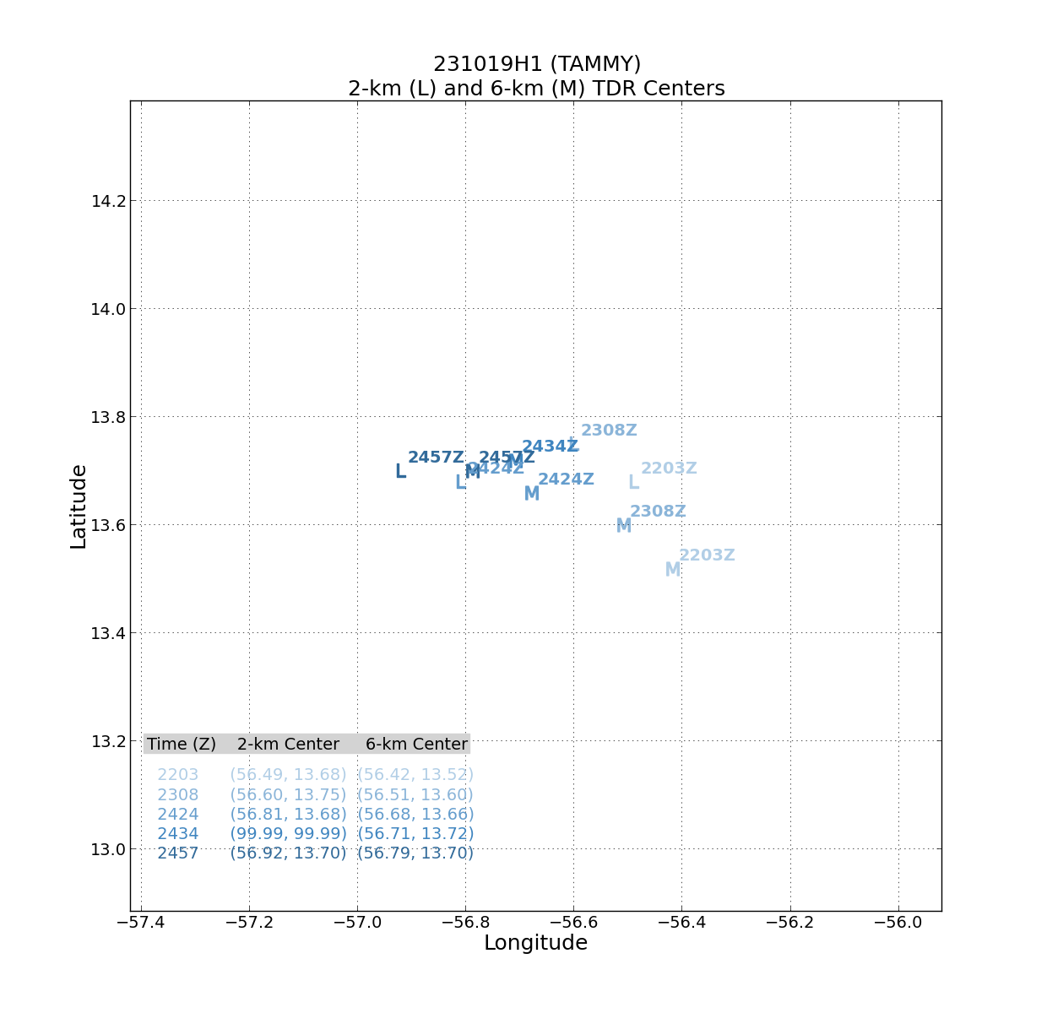
0047 | Cutting southeast leg short due to convection. So, can’t get far SE sonde.
0050 | IP sonde 11 after inbound turn. This would really be midpoint.
0057 | Center drop, cpa again due to nearby convection. 1007mb 29kt 175deg at 10m
0058 | Some bumps
 | Some slow tilt reduction & tilt vector progressing more along shear vector towards downshear left
0111 | Midpoint sonde 12
0122 | Endpoint sonde 13, turn to base
0145 | Convective burst developing near the end of the flight that was sampled during VAM and final E-W leg
0150 | Landed

POST-FLIGHT
Mission Summary | We flew a successful TDR pattern in Tropical Storm Tammy. The storm was slowly becoming more aligned through the flight. We executed a vortex alignment module (VAM) in the southeast part of the storm.  Towards the very end of the flight we saw evidence of convection starting to rotate upshear.
Actual Standard Pattern Flown | Butterfly
APHEX Experiments / Modules Flown | VAM
Plain Language Summary | - We flew a mission to collect radar data in Tropical Storm Tammy to feed into the hurricane models.  - The mission was successful and allowed for useful operational and research data collection
Instrument Notes | The SFMR had to be restarted but eventually started functioning properly
Final Mission Track | 