MISSION PLAN
FLIGHT ID | 20230920I1 | STORM | AL15/Nigel
MISSION ID | WC15A | TAIL NUMBER | NOAA 43
TASKING | HRD | PLANNED PATTERN | Mod. Figure-4
MISSION SUMMARY
TAKEOFF [UTC] | 1348 | LANDING [UTC] | 2110
TAKEOFF LOCATION | TXKF | LANDING LOCATION | TXKF
FLIGHT TIME | 7.4 | BLOCK TIME | 7.6
TOTAL REAL-TIME RADAR ANALYSES  (Transmitted) | 3 (3) | TOTAL DROPSONDES Deployed (Transmitted) | 13 (13) regular sondes,  10 (10) IR sondes, 12 Skyfora stream sondes
OCEAN EXPENDABLES (Type) | 10 (8) AXBTs | sUAS (Type) | Altius-600 (launch failed)
APHEX EXPERIMENTS / MODULES | RICO SUAVE  Tail Doppler Radar Dual-PRF in Hurricanes Experiment  Stratiform Spiral Module (SSM)
HRD CREW MANIFEST
LPS ONBOARD | Alaka | LPS GROUND | Hazelton/Dunion
TDR ONBOARD | Alaka | TDR GROUND | Reasor
ASPEN ONBOARD | Sippel | ASPEN GROUND | n/a
NESDIS SCIENTISTS | n/a
GUESTS (Affiliation) | Cione (HRD), Wadler (ERAU), Dana (Area-I), Patrick (Area-I), Kim (Skyfora)
AOC CREW MANIFEST
PILOTS | Rannenberg/Palmer/Keith
NAVIGATOR | Miller
FLIGHT ENGINEERS | Darby/Tyson
FLIGHT DIRECTOR | Kalen/Lundry
DATA TECHNICIAN | Richards
AVAPS | Wernecke/Underwood

PRE-FLIGHT
Flight Plan | 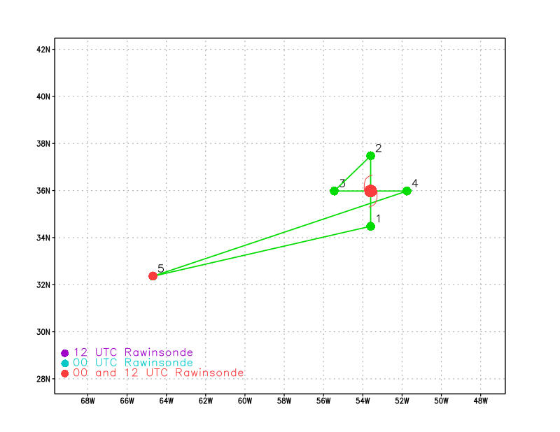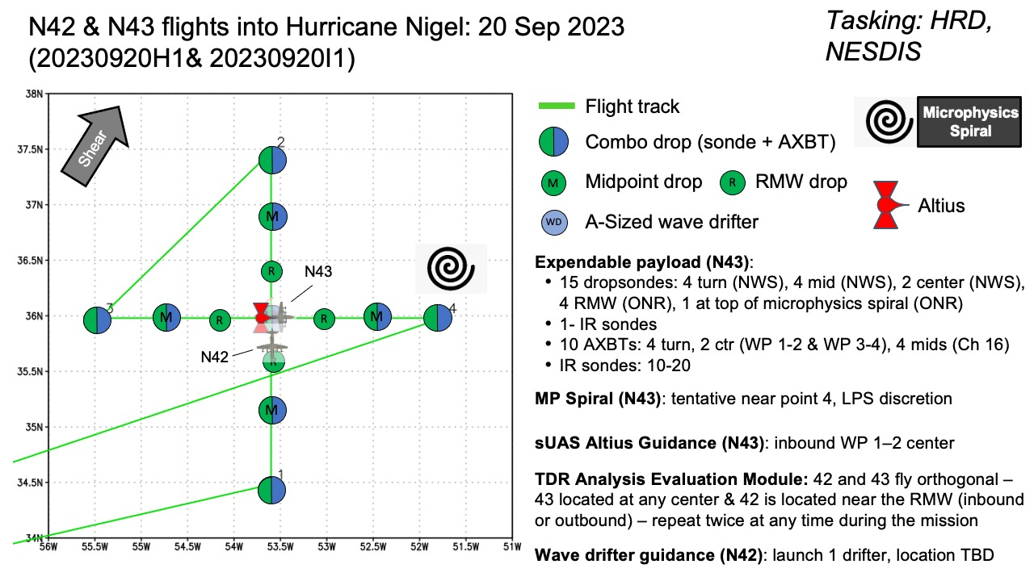
Expendable Distribution | 15 sondes (4 turn, 4 midpoints, 2 centers, 4 RMW), 1 MP spiral  10 AXBTs  Altius on first center pass
Preflight Weather Briefing | 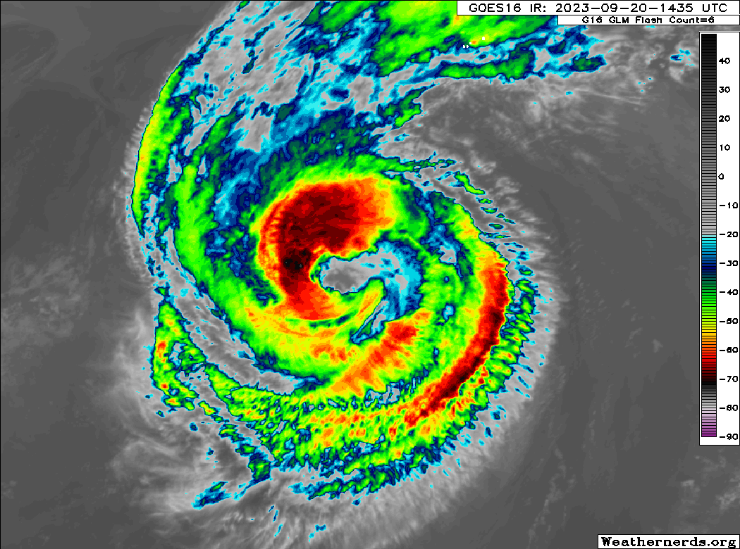  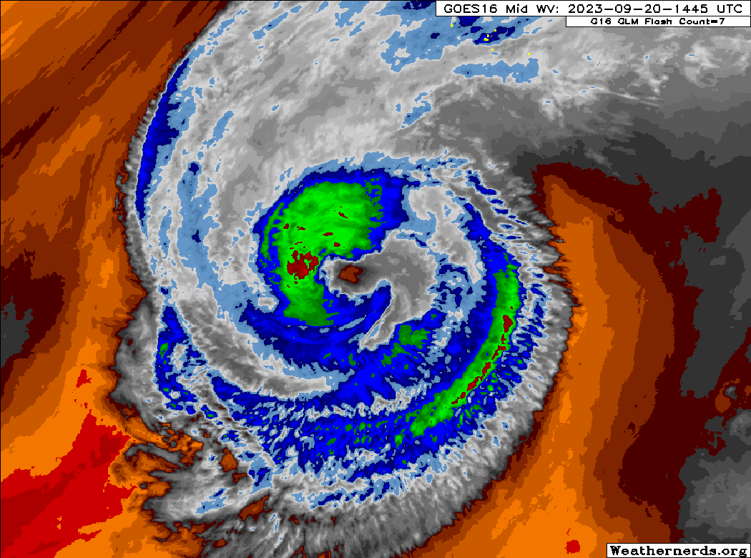  Nigel looks somewhat less organized than yesterday, with some erosion of the core (possibly due to dry air).
Instrument Notes | Instruments appear to be working normally

IN-FLIGHT
Time [UTC] | Event
1348 | Take-off from TXKF
1418 | Altius Pre-Launch Checklist simulation
1427 | Altius Launch Execution Checklist simulation
1445 | LPS confirmed that TDR is up and display looks good
1458 | We removed BTs from the midpoint drops. They are all Ch. 12 and the EP/MP are too close together. The BTs were moved to later endpoints (on passes 3 & 4)
1507 | The 2nd pass will start in the NW
1536 | The band that we are about to intercept has echo tops up to 10 km with an anvil stretching overhead. Consistent for this outer band
1537 | IP1 (S), IR sonde 1, Stream sonde 1, BT 1
1545 | Nothing much ahead of us. Eyewall appears to be open to the south and southeast
1547 | Midpoint S, Regular Sonde 1
1551 | RMW (S), stream sonde 1, reg. sonde 2
1602 | Unfortunately, the Altius safety is not releasing properly so it can not be launched
1602 | Center 1, IR sonde 2, Stream sonde 3, BT 2
1608 | RMW (N) reg. sonde 3
1620 | EP1 (N), IR sonde 3, Stream sonde 4, BT 3  Skipped midpoint - too close to RMW
1638 | No Altius launch
1639 | IP2 (NW), IR sonde 4, BT 4
1656 | 8 stream sondes were intended for rapid launch at this RMW (W), but they couldn't get the system ready in time so we are only doing a regular sonde at this RMW and will try the stream sonde 8-pack on a different RMW
1657 | RMW (W) reg. sonde 4
1703 | center, IR sonde 5, reg. sonde 5, BT 5
1713 | RMW (SE), reg sonde 6
1718 | MP (SE), reg. sonde 7
1727 | EP2 (SW), IR sonde 6, BT 6
1728 | Coordinating for dual TDR legs
1759 | After we reach the center, both planes will repo to set up the orthogonal pass targeting the N eyewall
1800 | IP3 (NE), IR sonde 7, BT 7
1809 | 8 Stream sondes released rapidly in the NE RMW (# 5-12)
1810 | RMW (NE), reg. sonde 8
1816 | Center, IR sonde 8, reg. sonde 9, BT 8
1824 | RMW (E), reg. sonde 10
1838 | Planning to turn W to do dual TDR coordination
1838 | IP4, IR sonde 9, BT 9
1846 | RMW (E), reg. sonde 11
1851 | center-ish (N of true center), reg. sonde 12
1908 | Dual-TDR coordination went well this time. Great coordination: 43 was in the eye while 42 was in the N eyewall and then 42 was in the eye while 43 was in the W eyewall. Two-for-one!  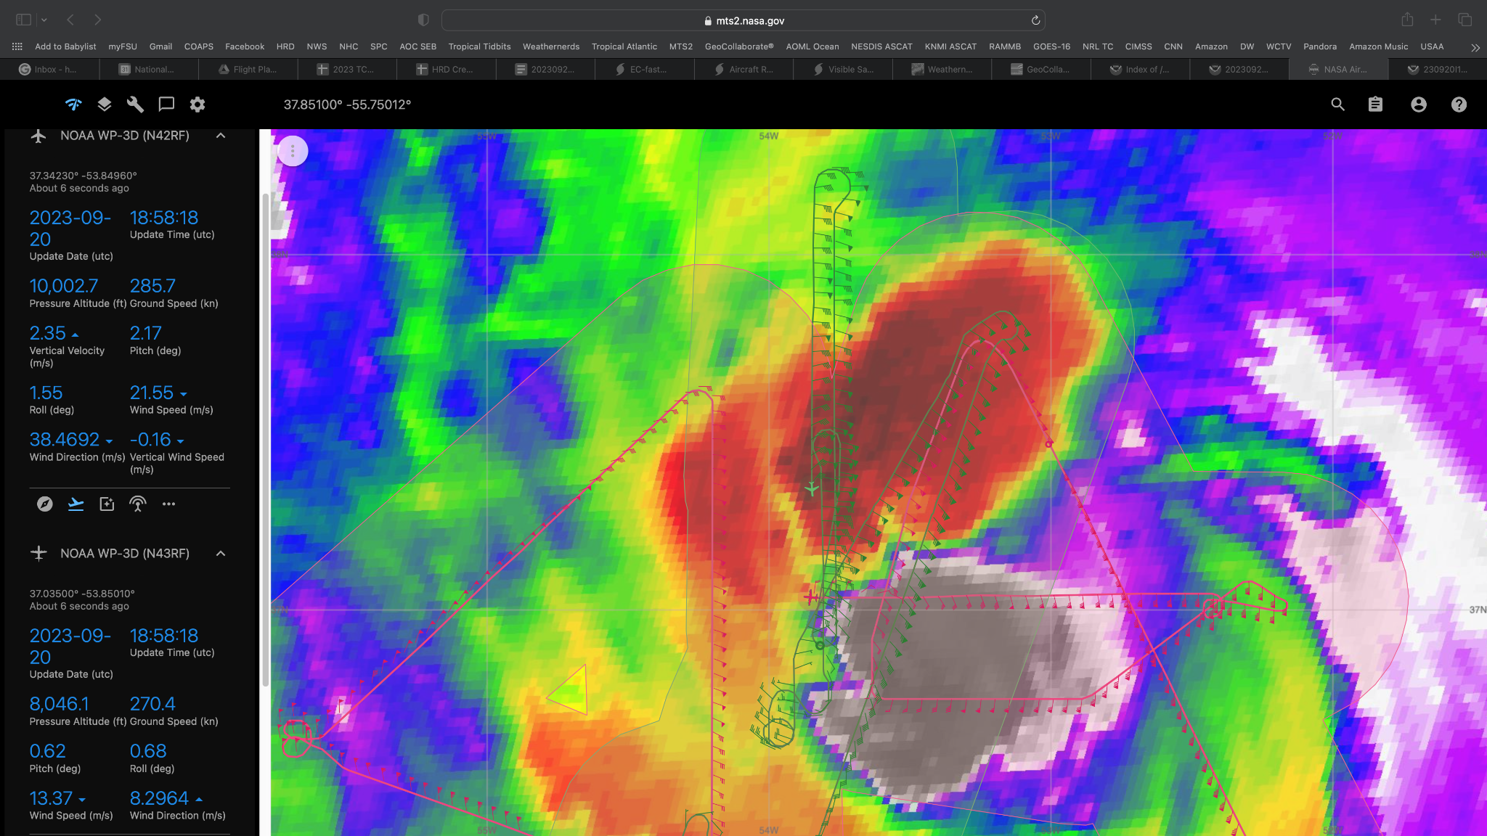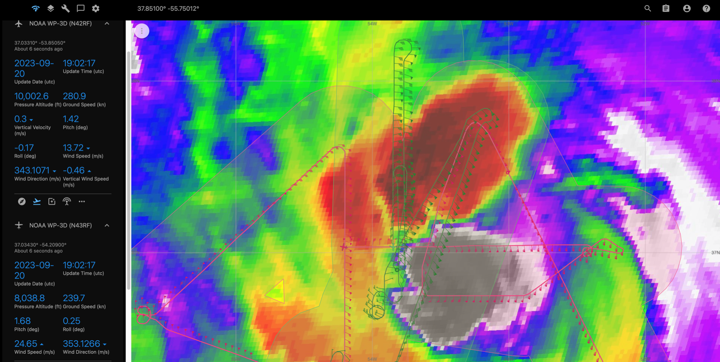
1904 | RMW (W), reg. sonde 13
1913 | EP4 (W), IR sonde 10, BT 10
1915 | Canceled the microphysics spiral because not enough fuel to deviate to a stratiform region to our north.
2110 | Land at TXKF
 | << INSERT ADDITIONAL ROW AS NEEDED >>

POST-FLIGHT
Mission Summary | The ground radar support noted that this is not an ideal case for the two-plane TDR comparison .  After some early coordination challenges, we were able to get a successful dual-TDR pass between N42 and N43 on the final legs.  Nigel appeared to have grown larger since yesterday’s flight, but the peak wind had come down despite the pressure remaining steady.
Actual Standard Pattern Flown | Butterfly pattern with some additional legs for dual-TDR coordination
APHEX Experiments / Modules Flown | Coordination between NOAA42 and NOAA43 for a two-plane mission for calibration/validation.
Plain Language Summary | - We flew a successful mission into Hurricane Nigel as the storm was starting to recurve over the North Atlantic.  - This mission had a successful coordination between NOAA42 and NOAA43 to compare radar data for better calibration and interpretation of TDR wind data in future flights.
Instrument Notes | Instruments worked OK for the most part. The sUAS launch did not work. Issue with WSRA for first part of flight that resulted in data dropouts. Problem was resolved about ⅔ of the way through the flight.
Final Mission Track | 