MISSION PLAN
FLIGHT ID | 20230919I1 | STORM | AL15 / NIGEL
MISSION ID | WB15A | TAIL NUMBER | NOAA 43
TASKING | HRD | PLANNED PATTERN | Figure-4
MISSION SUMMARY
TAKEOFF [UTC] | 1312 | LANDING [UTC] | 2055
TAKEOFF LOCATION | KLAL | LANDING LOCATION | TXKF
FLIGHT TIME | 7.7 | BLOCK TIME | 8.1
TOTAL REAL-TIME RADAR ANALYSES  (Transmitted) | 2 (2) | TOTAL DROPSONDES Deployed (Transmitted) | 14 (13)
OCEAN EXPENDABLES (Type) | 8 (7) AXBTs | sUAS (Type) | Two Blackswift Launches attempted
APHEX EXPERIMENTS / MODULES | RICO SUAVE (Blackswift)
HRD CREW MANIFEST
LPS ONBOARD | Alaka | LPS GROUND | Hazelton
TDR ONBOARD | Alaka | TDR GROUND | Reasor
ASPEN ONBOARD | Sippel | ASPEN GROUND | n/a
NESDIS SCIENTISTS | n/a
GUESTS (Affiliation) | Wadler (ERAU), Elston (Blackswift)
AOC CREW MANIFEST
PILOTS | Rannenberg/Palmer/Keith
NAVIGATOR | Miller
FLIGHT ENGINEERS | Darby/Stokes
FLIGHT DIRECTOR | Kalen/Lundry
DATA TECHNICIAN | Richards
AVAPS | Wernecke

PRE-FLIGHT
Flight Plan | 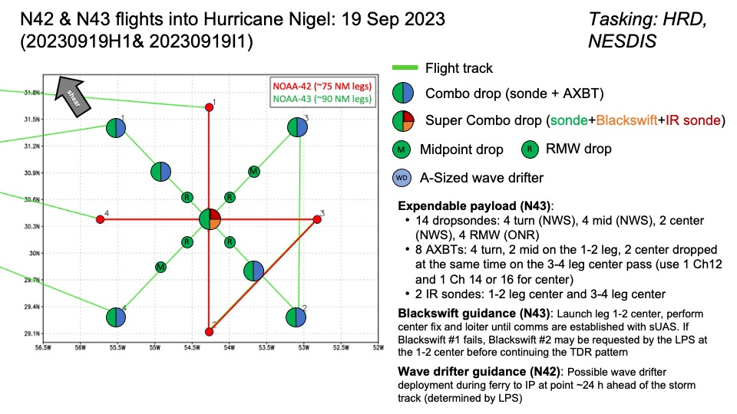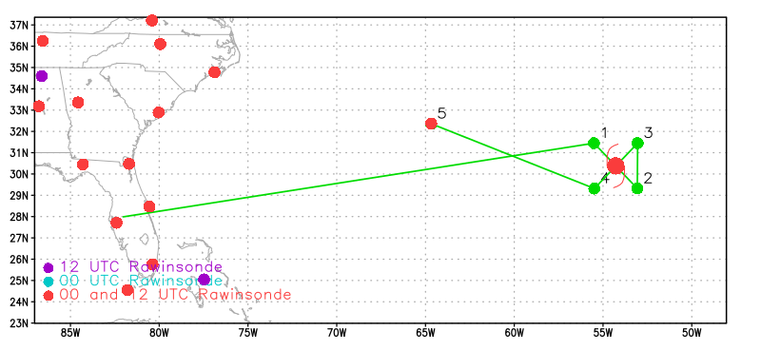
Expendable Distribution | 14 sondes: 4 turn, 4 mid, 2 center, 4 RMW.  8 AXBTs: 4 turn, 2 mid, 2 center  2 IR Sondes: 2 center
Preflight Weather Briefing | 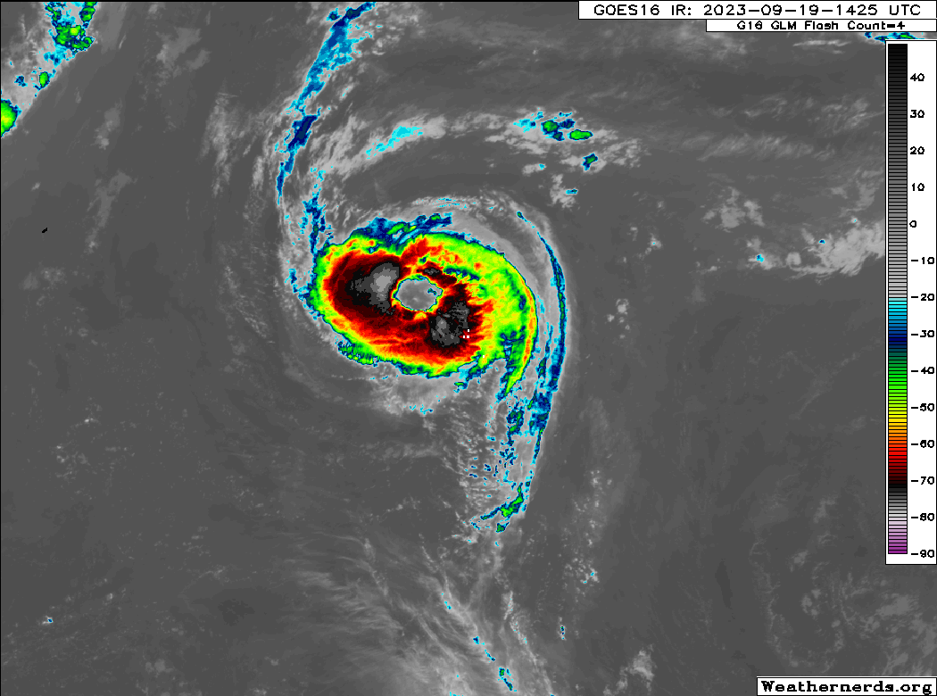  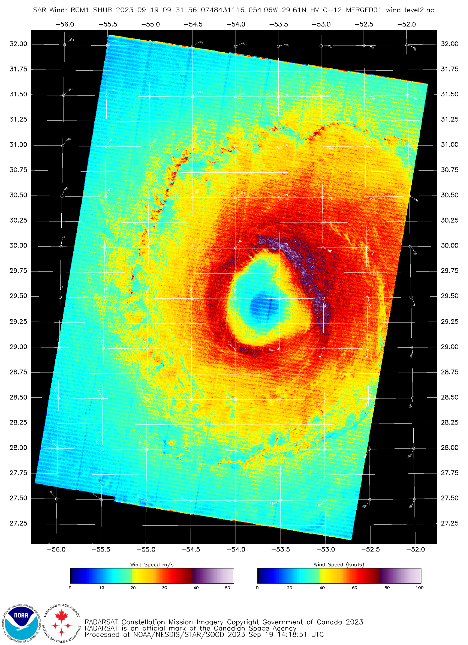  Nigel is a large Category 1 hurricane. The rapid intensification forecast previously has not materialized, and instead the storm has formed a very large eye. The dry air entrainment that was seen yesterday seems to have subsided, so we will see if the storm is able to contract and intensify at all. An earlier SAR overpass showed maximum sustained winds of ~80 kt.
Instrument Notes | [What instruments are working, not working, not functioning nominally, not installed?]

IN-FLIGHT
Time [UTC] | Event
1312 | Take-off from KLAL
1315 | With the addition of a 30-min mandatory compass calibration enroute to the IP, today’s planned flight time is approaching 9 h. To accommodate missions on Wed & Thu, trimming down the flight time safely and reasonably is a priority.  Mod 1: Break the alpha pattern and change the first leg to W->E  Mod 2: Shorten legs from 90 n mi to 75 n mi  Mod 1 saves ~15 min. Mod 2 saves ~15 min. Total savings of 30 min?  LPS asked for both modifications to save as much time as possible while maintaining ~1.5 h of on station time to meet Blackswift objectives
1420 | Tweak Mod 2 (above) so only the eastern legs are shortened to 75 n mi. Scrap the midpoint dropsondes on those eastern legs, but will drop a BT on the eastbound leg from the center
1530 | The latest plan has more modifications:  1) Modify the second leg to save time (NW->SE->E->W)  2) Space out BTs to avoid overlap while launching all 8  3) Loiter in the eye on the 2nd pass if Blackswift is still operating (if there is time)  Total flight time is ~8 h (perfect!) and allows for ~90 min of on station time to communicate with the Blackswift drone. (3) probably won’t be necessary
1608 | Blackswift pre-launch checklist simulation
1610 | Blackswift launch execution checklist simulation
1732 | Flying through outer rainband - moderate convection with some embedded deep convection
1737 | Repositioning to the NW of the IP to avoid turning in convection
1742 | IP; combo (sonde 01 & BT 01); inbound 135deg  BT did not report SST; 19.79C at ~50m
1748 | Blackswift Pre-flight Checklist commenced
1753 | Midpoint Combo drop: Sonde 2, BT 2
1758 | RMW Sonde 3; N42 and N43 passing each other  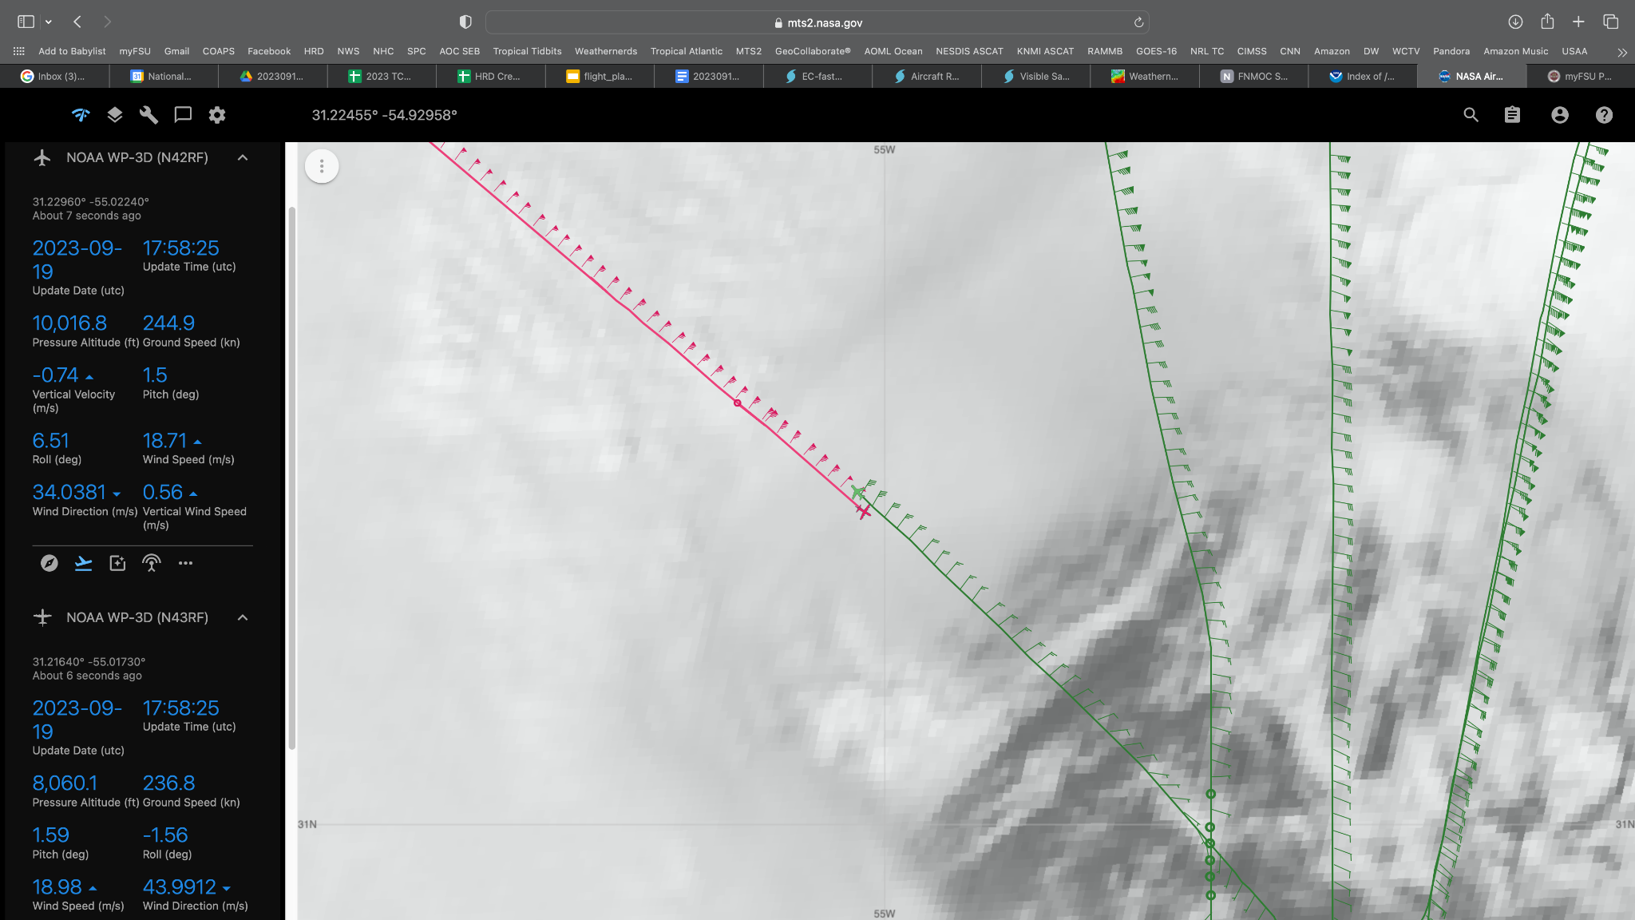  Notes on SFMR comparison from HDOBs near location where N42 and N43 passed each other: SFMR maxed at 66 kts in HDOBs from N42 at 175830 and 175930 with max RR at 180000 of 32 mm/hr. N43 max was 71 kts at 175830 and 175900 with max RR at 175700 of 24 mm/hr. Interesting to see N43 had higher winds but lower max rain than N42. Curious if it's related to the algorithm/direction through gradient and/or calibration.
1800 | Commencing the Blackswift launch execution
1801 | Blackswift away! 1st IR sonde launched.  Note that the first Blackswift splashed without releasing from its tube
1803 | Center combo, Sonde 4, BT 3
1805 | Orbiting in the eye
1812 | 2nd Blackswift launched, 2nd IR sonde launched
1815 | RMW Sonde 5
1825 | Endpoint SE Sonde 6
1838 | N42 is posturing to go outbound over our inbound from the east
1843 | Endpoint E Sonde 7, Combo Drop  SST 26.9C
1851 | FL wind max seems well inbound from IR minimum, indicating a very sloped eye  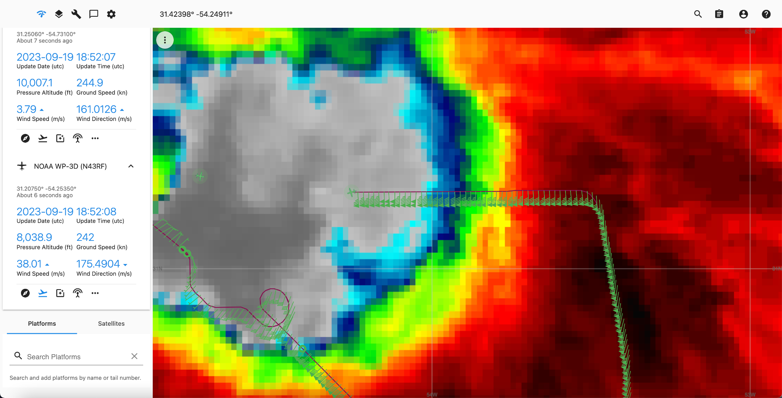
1855 | N42 and N43 passing each other in the eye  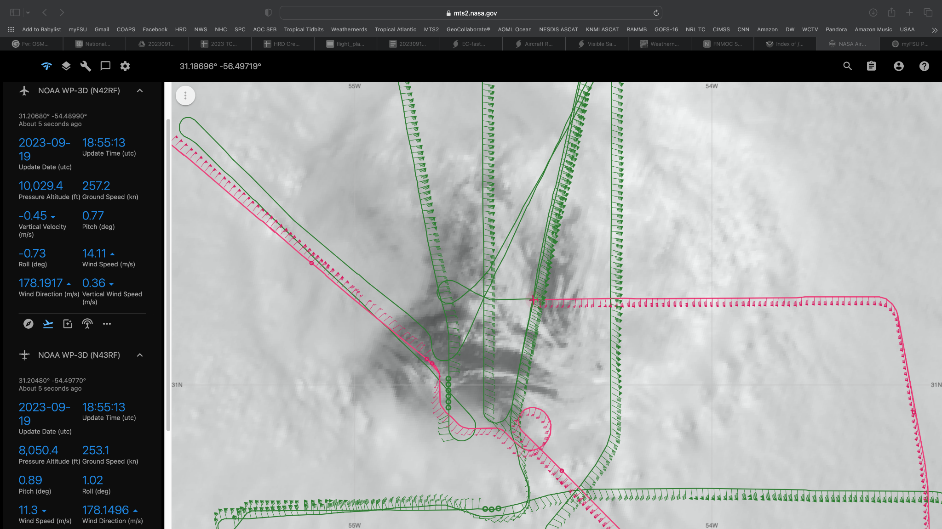
1851 | RMW E Sonde 8
1901 | Center Combo Drop (Sonde 9, BT 6)
1904 | RMW W Sonde 10
1914 | Midpoint W Sonde 11, Combo Drop (BT 7)
1922 | Endpoint W Sond 12, Combo Drop (BT 8)
1927 | Science Complete

POST-FLIGHT
Mission Summary | We completed a tacrepo from Lakeland to Hurricane Nigel and then to Bermuda. The storm had a very large eye and the winds were starting to increase somewhat.  We got two passes across the storm, and NOAA42 followed along some of the same legs, providing valuable calibration data.
Actual Standard Pattern Flown | Butterfly with 75 n mi legs
APHEX Experiments / Modules Flown | Coordination with NOAA-42 on flying over the same areas for calibration.
Plain Language Summary | - x
Instrument Notes | The 2 Blackswift launches both failed.  Many of the sondes seem to be missing data at low levels.
Final Mission Track | 