MISSION PLAN
FLIGHT ID | 20230915N1 | STORM | AL13 / Lee
MISSION ID | 3413A | TAIL NUMBER | NOAA 49
TASKING | NHC Synoptic Surv | PLANNED PATTERN | Synoptic Surveillance
MISSION SUMMARY
TAKEOFF [UTC] | 0529 | LANDING [UTC] | 1255
TAKEOFF LOCATION | Lakeland | LANDING LOCATION | Lakeland
FLIGHT TIME | 7/5 | BLOCK TIME | 7.8
TOTAL REAL-TIME RADAR ANALYSES  (Transmitted) | 2 (2) | TOTAL DROPSONDES Deployed (Transmitted) | 35 (37)
OCEAN EXPENDABLES (Type) | n/a | sUAS (Type) | n/a
APHEX EXPERIMENTS / MODULES | n/a
HRD CREW MANIFEST
LPS ONBOARD | n/a | LPS GROUND | n/a
TDR ONBOARD | n/a | TDR GROUND | Reasor
ASPEN ONBOARD | AOC FD | ASPEN GROUND | n/a
NESDIS SCIENTISTS | n/a
GUESTS (Affiliation) | n/a
AOC CREW MANIFEST
PILOTS | Mansour, Bhatnagar,Cozart
NAVIGATOR
FLIGHT ENGINEERS
FLIGHT DIRECTOR | Henning, Timmer
DATA TECHNICIAN | Dykeman
AVAPS | Patel

PRE-FLIGHT
Flight Plan | 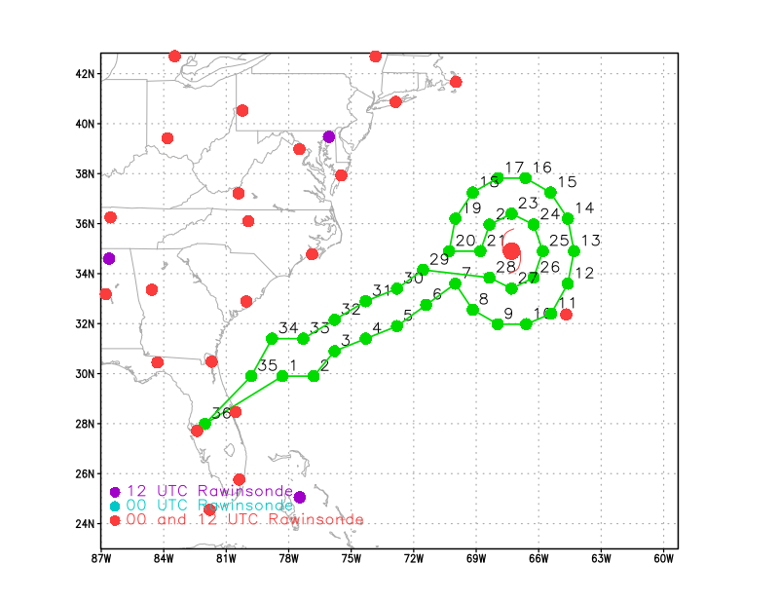

IN-FLIGHT
Time [UTC] | Event
0529 | Take-off from Lakeland
XXXX | [describe event and paste associated screenshot or gif, if available]
1255 | Landing at Lakeland

POST-FLIGHT
Mission Summary | 37 dropsondes deployed, 35 good and transmitted.  2 Real-time radar analyses completed.
Actual Standard Pattern Flown | 