MISSION PLAN
FLIGHT ID | 20230915I1 | STORM | AL13 / LEE
MISSION ID | 3513A | TAIL NUMBER | NOAA 43
TASKING | NHC-EMC TDR | PLANNED PATTERN | Butterfly
MISSION SUMMARY
TAKEOFF [UTC] | 0844 | LANDING [UTC] | 1610
TAKEOFF LOCATION | KILM | LANDING LOCATION | KILM
FLIGHT TIME | 7.4 | BLOCK TIME | 7.6
TOTAL REAL-TIME RADAR ANALYSES  (Transmitted) | 3 (3) | TOTAL DROPSONDES Deployed (Transmitted) | 21 (20)
OCEAN EXPENDABLES (Type) | n/a | sUAS (Type) | 1 Altius-600
APHEX EXPERIMENTS / MODULES | RICO SUAVE (Altius)
HRD CREW MANIFEST
LPS ONBOARD | J. Zhang | LPS GROUND | None
TDR ONBOARD | J. Zhang | TDR GROUND | Reasor
ASPEN ONBOARD | Dahl | ASPEN GROUND | n/a
NESDIS SCIENTISTS | n/a
GUESTS (Affiliation) | Cione, Josh Wadler (Embry-Riddle), Sosa (Altius), Owens (Altius)
AOC CREW MANIFEST
PILOTS | Copare/Keith/Wood
NAVIGATOR | Utama
FLIGHT ENGINEERS | Tyson/Tufnell
FLIGHT DIRECTOR | Kalen/Lundry
DATA TECHNICIAN | Richards
AVAPS | Warneke/Kotz

PRE-FLIGHT
Flight Plan | 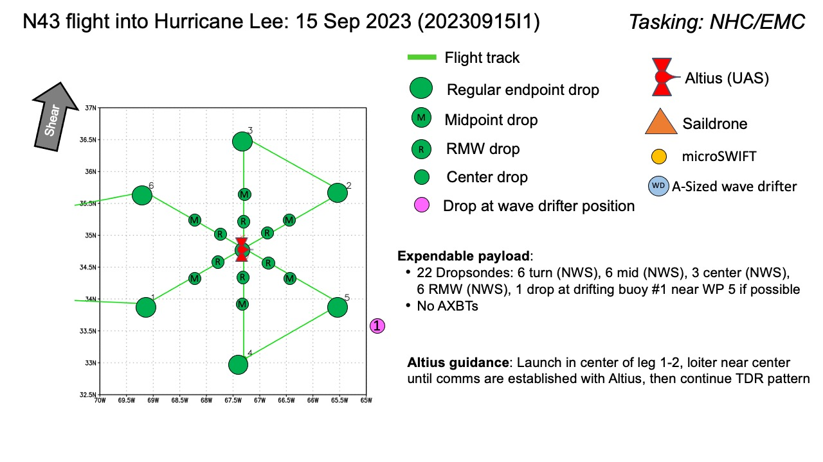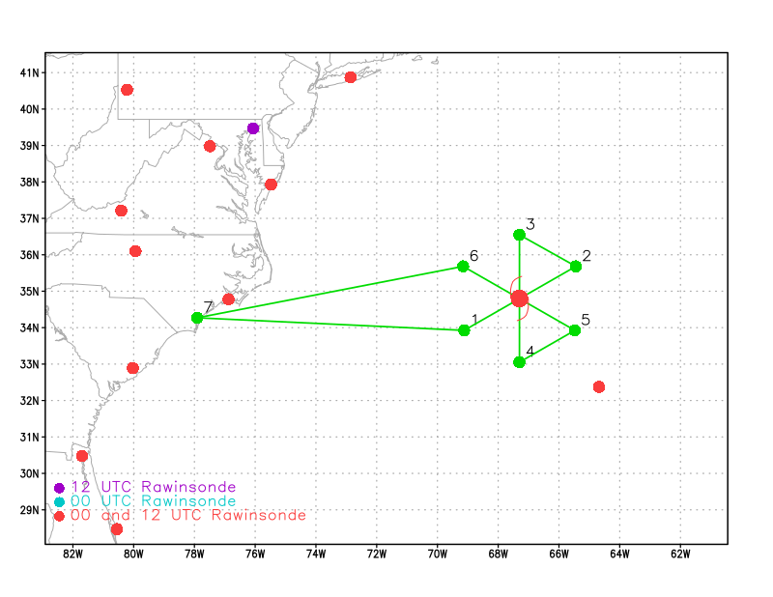  Pattern: Butterfly pattern with 105 NM legs  Altitude:  - 8 or 10 kft (pressure altitude) depending on AF deconfliction requirements  Potential add-on APHEX Modules: (time permitting)  - Altius sUAS (RICO SUAVE)  - Drop at WP 1-2 center, establish comms between Altius & the P-3, continue reminder of TDR butterfly pattern  - No additional research due to AOC crewing limitations
Expendable Distribution | Expendables:  - Load 30 dropsondes  - Release at endpoints, midpoints, centers, RMWs (charged to NWS)  - 1 dropsonde near wave drifter #1 if possible (GOMO)  - Additional drops may be requested at the discretion of the onboard HRD LPS  - All dropsondes transmitted to the GTS  - No AXBTs
Preflight Weather Briefing | Observations from an Air Force Reserve Unit Hurricane Hunter  aircraft indicate that Lee's eyewall is not well defined, and this  is also suggested by geostationary satellite and microwave imagery.  Although the peak 700 mb flight-level winds reported by the plane  were near 93 kt, the highest SFMR-observed surface winds were 72 kt.  Thus the winds aloft in the hurricane are not being transported  very effectively to the surface. This is not surprising, since the  central deep convection is no longer very strong. The current  intensity is kept at 75 kt based on the aircraft data, which is  well above the Dvorak satellite estimates.  Lee wobbled a bit to the northeast early this evening, but the  longer-term motion appears to be just east of north, or around  010/12 kt.  [South-southwesterly shear is predicted to increase significantly  over Lee during the next couple of days. This, along with cooler  SSTs, particularly after the system moves north of 40N latitude,  should result in weakening. However, baroclinic processes could  help the cyclone maintain its intensity, or at least slow the  weakening rate.  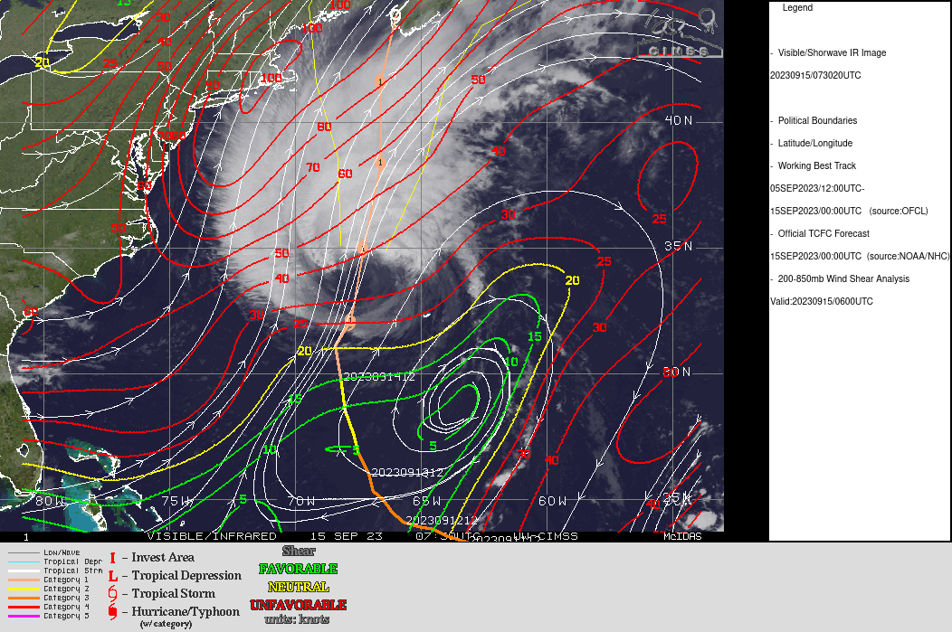  Lee appears to be in the very initial stages of extratropical  transition. The cloud pattern is becoming increasingly asymmetric,  and scatterometer data from last evening showed a band of strong  winds developing along a boundary to the northwest of the center.  Lee's initial intensity remains 75 kt based on continuity from last  evening's reconnaissance and scatterometer data.  Lee has been wobbling a bit since yesterday afternoon, but the smoothed motion is northward (010 degrees) at a faster speed of 14 kt.  Although southerly shear is forecast to increase markedly through  the day, baroclinic influences during Lee's extratropical transition  are likely to keep the intensity relatively steady for the next 24  hours or so. Extratropical transition is forecast to be  complete by 36 hours (although it could be sooner), and Lee is  likely to be weakening--but still near or just below hurricane  force--as it is approaching Nova Scotia due to the continued shear  and much colder ocean temperatures.
Instrument Notes | TDR: working  SFMR: working  MMR: working  WSRA: not working

IN-FLIGHT
Time [UTC] | Event
0745 | GOES-16 IR image (0745 UTC)  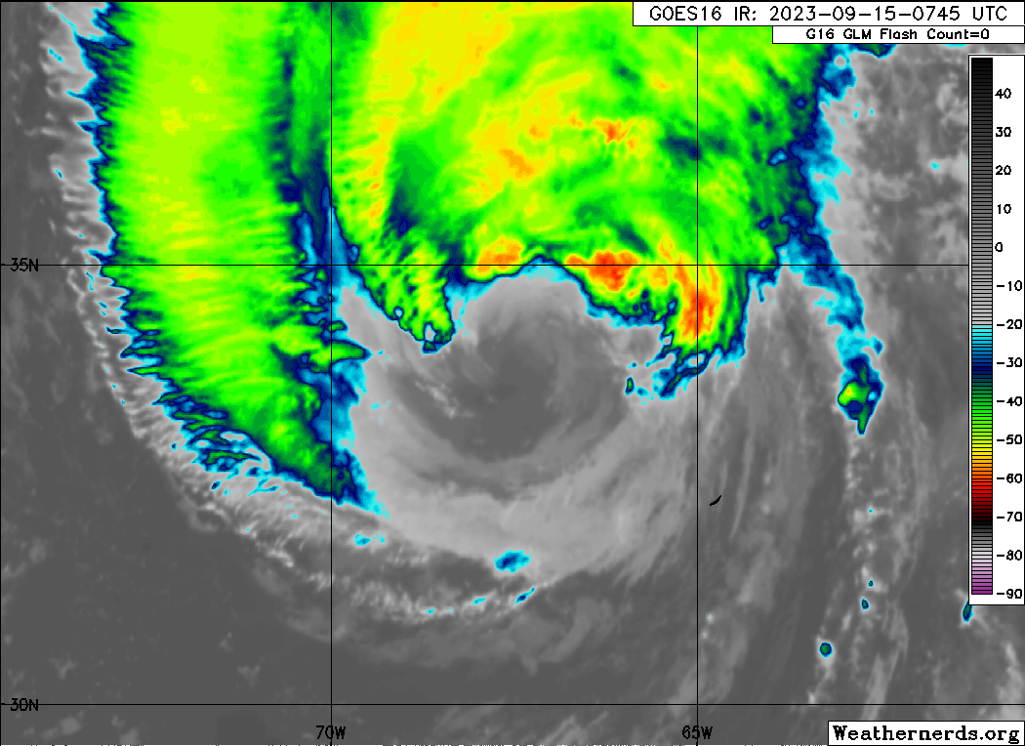
0844 | Take-off from KILM
1016 | N43 (red) at IP while N49 (blue) is just finishing its inner circumnavigation (NHC Synoptic Surveillance). Flight patterns are quite complimentary for TDR and dropsonde coverage.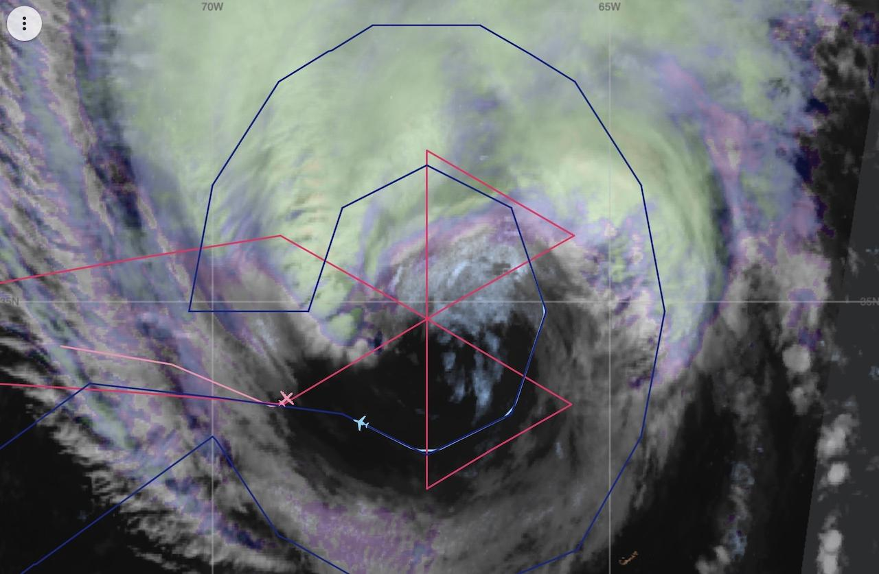
0859 | Radar status update - Run radar start_script  Checked TDR display, confirmed radar running well
0859 | Run radar start_script
0907 | Changed route, time to IP will be 30 minutes shorter than planned
0910 | Altius folks started working on the preparation
0931 | Altius launch dry run- went through the pre-launch check list
0935 | Went through flight plan again, Jun call the RMW sonde, then pre-launch list checking, then release Altius and dropsonde
1001 | Started descent to IP
1015 | IP #1 SW-NE Pass Drop#1
1020 | Storm moving faster than expected, so we adjusted the inbound leg azimuth to head to the real time center
1026 | Mid-pt SW Drop#2
1030 | Altius pre-launch check verification complete at 1031
1033 | RMW SW Drop#3 (not real RMW)
1044 | Altius real time launch check list
104431 | Altius launched and Drop #4
104453 | Launch Altius complete
1045 | Center fix hunting started – flight level wind
104519 | We lost the Altius no comm and it went to the water straight down. The last data recording height is 260 ft
1047 | Center Drop #5 Center sonde: sfc p 963 mb sfc wind 035 at 7 kt
1048 | Altius and P3 communication status update; Patrick confirmed the Altius is in the water. We’ll continue the flight pattern as planned.
1057 | RMW NE Drop#6 combined with midPT  flight-level wind is ~72 kt
1112 | End-PT NE Drop#7
1152 | IP #2 N-S Pass Drop#8, no launch detection
1154 | Backup of IP2 Drop#9
1207 | Mid-pt N Drop#10
1211 | RMW N Drop#11
1216 | 2nd CENTER Drop#12 – FL and surface wind relatively high
1219 | RMW S Drop#13
1230 | Mid-PT S Drop#14
1243 | End-PT S Drop# 15
1312 | IP#3 SE-NW Pass Drop#16
1325 | Mid-pt and EYEwall combined SE Drop#17
1335 | 3rd Center Drop#18
1343 | RMW NW Drop#19
1347 | Mid-pt NW Drop#20 (wind is higher than RMW) extra tropical transition
1400 | End-pt NW Drop#21 last sonde Science complete
1407 | TDR composites from 101441-140700 UTC.  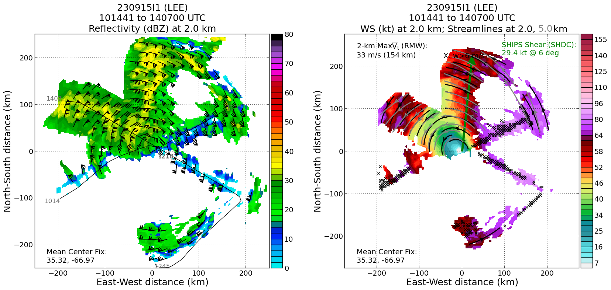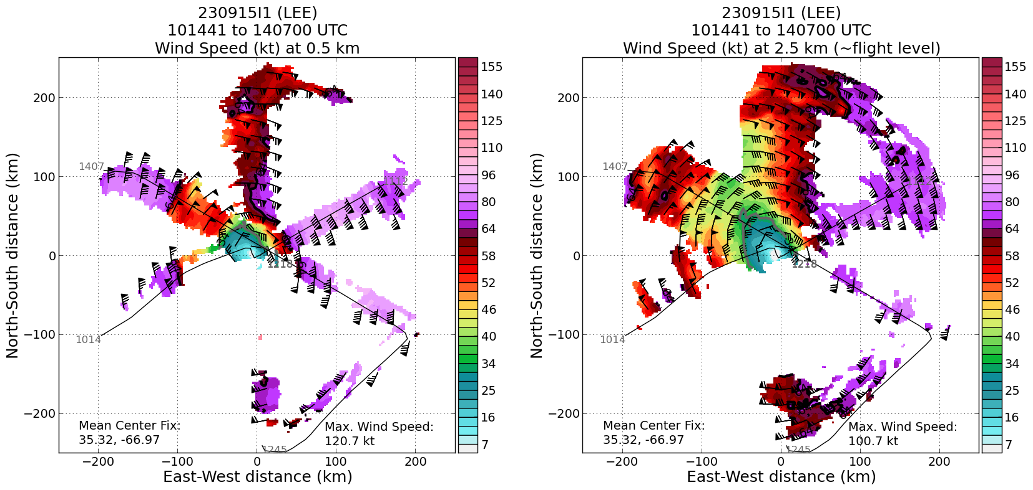

POST-FLIGHT
Mission Summary | [Short description of interesting observations from the flight; what objectives were successful? What was unsuccessful? Was the planned pattern flown? What deviations occurred?  [Don’t forget to fill in Tables on page 1]  [Sonde and ocean expendable accounting: how many total of each? How many are charged to each account?]
Actual Standard Pattern Flown | [Butterfly, Rotated Figure-4, Lawnmower, etc]
APHEX Experiments / Modules Flown | [Linked to HFP Plan; fill in regardless of whether the mission was operationally or research tasked]
Plain Language Summary | [Boil down the above into a couple of bullet points in “plain language”. This will help us when we report to management & OAR Public Affairs and prepare storm mission summaries]
Instrument Notes | [Notes about instrument status from during and after the mission]
Final Mission Track | 