MISSION PLAN
FLIGHT ID | 20230914N2 | STORM | AL13 / Lee
MISSION ID | 3213A | TAIL NUMBER | NOAA 49
TASKING | NHC Synoptic Surv | PLANNED PATTERN | Synoptic Surveillance
MISSION SUMMARY
TAKEOFF [UTC] | 1728 | LANDING [UTC] | 0024
TAKEOFF LOCATION | Lakeland | LANDING LOCATION | Lakeland
FLIGHT TIME | 6.9 | BLOCK TIME | 7.3
TOTAL REAL-TIME RADAR ANALYSES  (Transmitted) | 5 (5) | TOTAL DROPSONDES Deployed (Transmitted) | 30 (28)
OCEAN EXPENDABLES (Type) | n/a | sUAS (Type) | n/a
APHEX EXPERIMENTS / MODULES | n/a
HRD CREW MANIFEST
LPS ONBOARD | n/a | LPS GROUND | n/a
TDR ONBOARD | n/a | TDR GROUND | Gamache/Alvey
ASPEN ONBOARD | AOC FD | ASPEN GROUND | n/a
NESDIS SCIENTISTS | n/a
GUESTS (Affiliation) | n/a
AOC CREW MANIFEST
PILOTS | de Triquet/Varwig/Smith
NAVIGATOR | n/a
FLIGHT ENGINEERS | n/a
FLIGHT DIRECTOR | Flaherty/de Solo
DATA TECHNICIAN | Defeo
AVAPS | Weinmann/Keller

PRE-FLIGHT
Flight Plan | 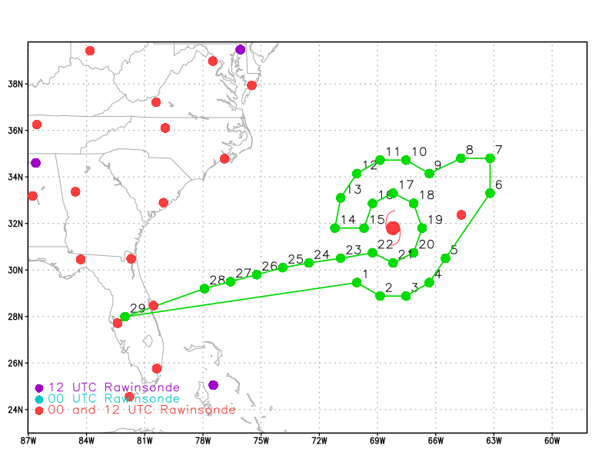
Expendable Distribution | [Describe planned dropsonde, ocean buoy, sUAS deployment locations; e.g., “Dropsondes/AXBT combo drops at endpoints, midpoints, and center”
Preflight Weather Briefing | [Notes from the Flight Crew Preflight Briefing and other relevant notes about the current and forecasted storm state from the most recent NHC advisory (location, intensity, MSLP, movement, possible intensity change during the flight)]  [Briefly describe the relevant environmental drivers.]  [Copy in GIF of recent (~6 hr) satellite loops (https://www.star.nesdis.noaa.gov/GOES/index.php)]
Instrument Notes | [What instruments are working, not working, not functioning nominally, not installed?]

IN-FLIGHT
Time [UTC] | Event
HHMM | Take-off from TBD
XXXX | [describe event and paste associated screenshot or gif, if available]
 | << INSERT ADDITIONAL ROW AS NEEDED >>

POST-FLIGHT
Mission Summary | [Short description of interesting observations from the flight; what objectives were successful? What was unsuccessful? Was the planned pattern flown? What deviations occurred?  [Don’t forget to fill in Tables on page 1]  [Sonde and ocean expendable accounting: how many total of each? How many are charged to each account?]
Actual Standard Pattern Flown | [Butterfly, Rotated Figure-4, Lawnmower, etc]
APHEX Experiments / Modules Flown | [Linked to HFP Plan; fill in regardless of whether the mission was operationally or research tasked]
Plain Language Summary | [Boil down the above into a couple of bullet points in “plain language”. This will help us when we report to management & OAR Public Affairs and prepare storm mission summaries]
Instrument Notes | [Notes about instrument status from during and after the mission]
Final Mission Track | [Insert MTS screenshot of final flown track, ideally at the completion of the pattern with satellite imagery]

