MISSION PLAN
FLIGHT ID | 20230913H1 | STORM | AL13 / LEE
MISSION ID | 2713A | TAIL NUMBER | NOAA-42
TASKING | EMC/NHC | PLANNED PATTERN | Butterfly
MISSION SUMMARY
TAKEOFF [UTC] | 2016 | LANDING [UTC] | 0405
TAKEOFF LOCATION | KLAL | LANDING LOCATION | KLAL
FLIGHT TIME | 7.8 | BLOCK TIME | 8.3
TOTAL REAL-TIME RADAR ANALYSES  (Transmitted) | 3 (3) | TOTAL DROPSONDES Deployed (Transmitted) | 21 (20)
OCEAN EXPENDABLES (Type) | 5 AXBT (4) | sUAS (Type) | n/a
APHEX EXPERIMENTS / MODULES | n/a
HRD CREW MANIFEST
LPS ONBOARD | Alaka | LPS GROUND | Rogers
TDR ONBOARD | Alaka | TDR GROUND | Alvey/Gamache
ASPEN ONBOARD | Sellwood | ASPEN GROUND | Hathaway (TAG)
NESDIS SCIENTISTS | Zhang, Jelenak, Sapp, Bjorland
GUESTS (Affiliation) | ABC: Zee & Crew
AOC CREW MANIFEST
PILOTS | Doremus/Rannenberg/Gaston
NAVIGATOR | Hough
FLIGHT ENGINEERS | Gee/Wysinger
FLIGHT DIRECTOR | Zawislak/Parrish
DATA TECHNICIAN | McAlister
AVAPS | Waggoner/Carroll

PRE-FLIGHT
Flight Plan | 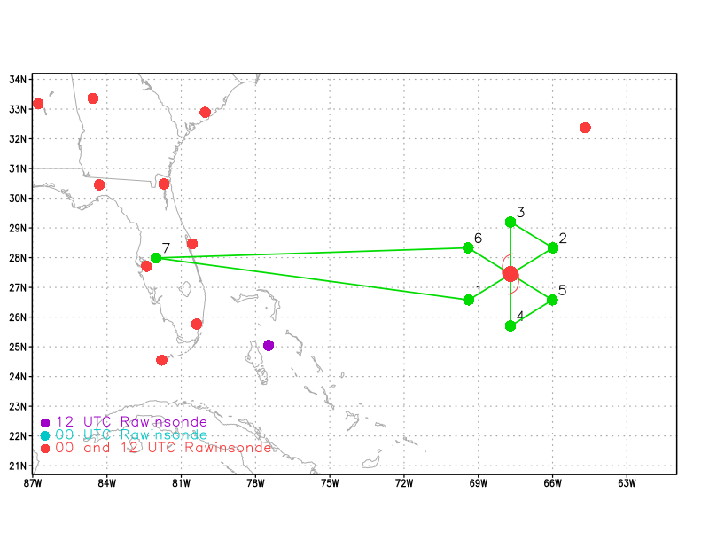  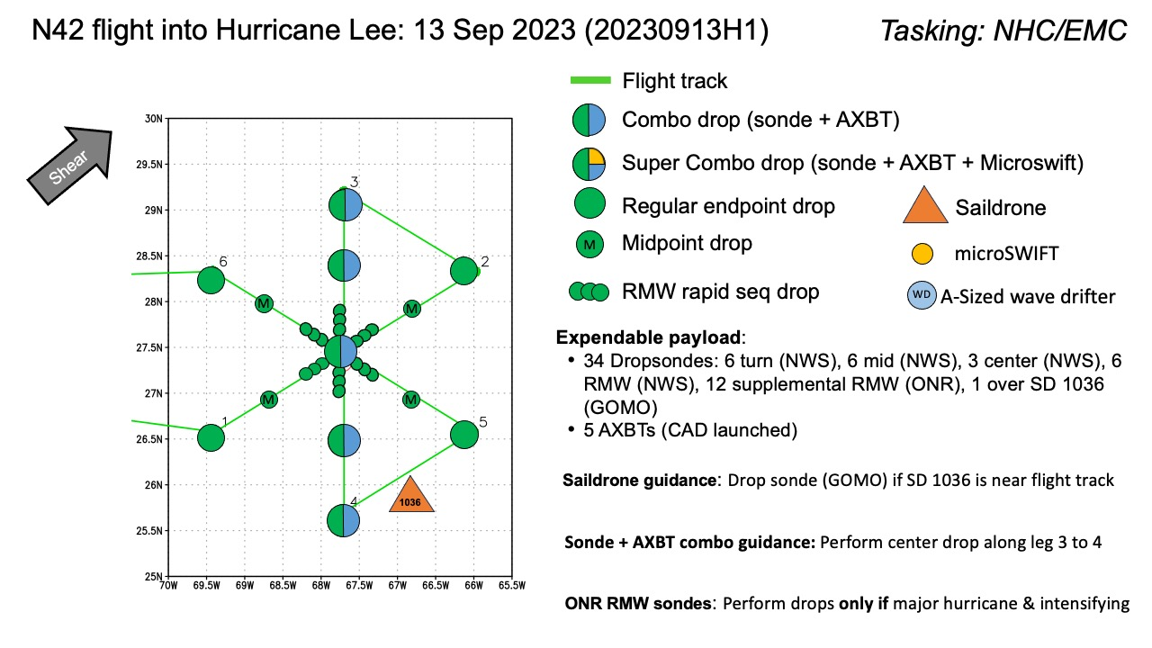  Butterfly pattern, 105 nm leg lengths, 8 kft altitude. No modules, other than AXBT combo drops and a dropsonde at Saildrone 1036.
Expendable Distribution | 5 total AXBTs. expected AXBTs are all Ch. 12, so 2 mid-point AXBTs were moved to endpoints (2&5) for better spacing. Both end points are in the eastern semicircle where ocean cooling is expected to be maximized.  22 total dropsondes expected. Rapid RMW drop sequence cancelled because Lee did not meet the “intensifying” requirement from ONR. Single RMW dropsondes (6 total; charged to NWS). Single dropsonde near Saildrone 1036 (charged to GOMO).
Preflight Weather Briefing | Hurricane Lee has weakened to a 90-kt Category 2 hurricane, located about 380 nm SSW of Bermuda and tracking toward the NNW at 10 mph. While the peak winds have dropped, the wind field is now quite expansive, with hurricane-force winds extending about 100 nm from the center. This suggests much of the pattern could be in hurricane-force winds.  IR animation shows a large eye with cold cloud tops primarily on the west and southwest sides of the eyewall.  Vertical shear is fairly low over the core, with elevated shear values to the north of the center.  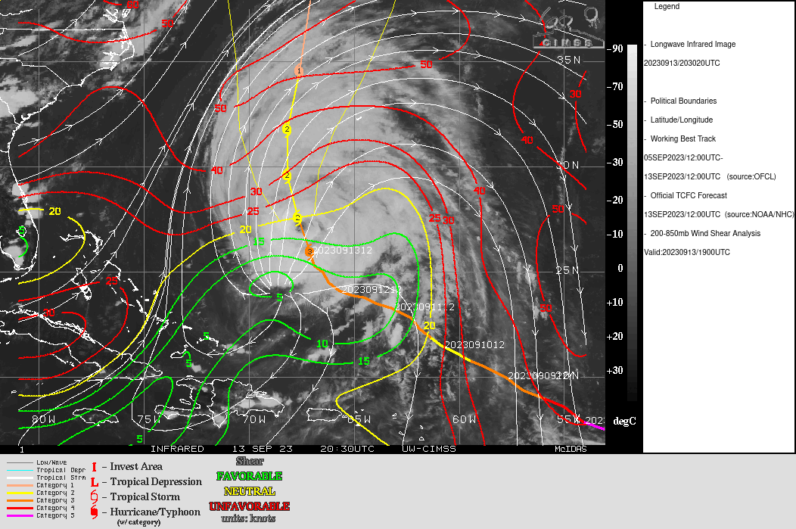  Microwave image from about 12 h ago shows an open inner eyewall on the west and south sides and a distinct outer band along the north and east sides of the storm. This is an old image though, it will be interesting to see how the structure of the storm has changed since then, given current appearance on IR.
Instrument Notes | TDR: working  SFMR: working  MMR: working (functioning nominally?)

IN-FLIGHT
Time [UTC] | Event
2016 | Take-off from KLAL
2047 | SFMR and TDR are up and running
2104 | Saildrone 1036 location (at take off): 25.612N 67.894W. Will update position by Pt3 (northernmost endpoint)
2117 | TEAL76 off the deck. NOAA42, NOAA49, and TEAL76 will all be in Lee simultaneously.
2134 | IR image as aircraft is approaching IP shows multiple regions of lightning in isolated convective cores in a band well-removed (about 200 nm) from the center. No lightning evident in inner core
2146 | 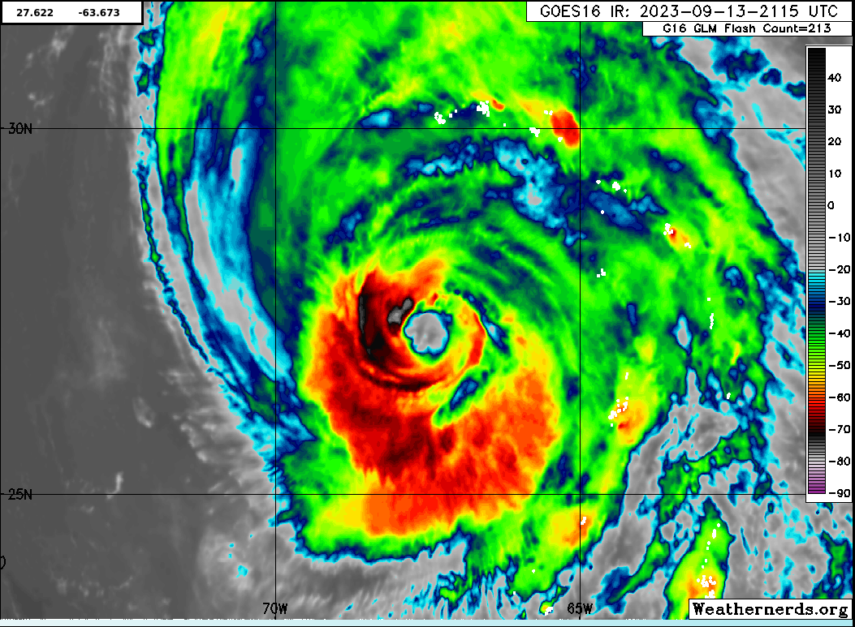  Inner core has become better defined in the last few hours. Not sure IR supports the notion of concentric eyewalls, although at the very least the system has spiraling rainbands. Is this improved appearance related to gaining latitude?
2210 | Descended to 10 kft before reaching the outer rain band (which is radially outward from IP). ~27.0N, ~70.6W. Would be nice to include this in the first TDR analysis (already spoke to Trey). Echo tops 9-10 km in the rain band. Sea surface very choppy with large white caps.
2227 | IP, sonde 01 (NWS)  Evidence of somewhat dry air (RH<80%) all the way to the surface
2242 | Midpoint, sonde 02 (NWS)
2244 | Visual of the eyewall from the moat approaching from the southwest. It is quite shallow! Eyewall is ragged and open to the west and northwest. Remnant stratiform cloud deck above us (10-15 km)
2250 | RMW, sonde 03 (NWS)
2254 | Center (27.4N, 67.6W), sonde 04 (NWS)
2258 | Eye is open to the west and northwest (d=30 n mi), ragged about 30 nm diameter  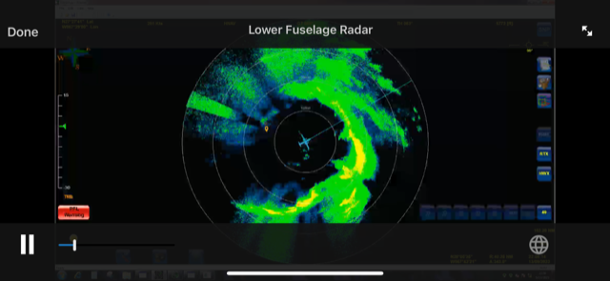
2300 | RMW, sonde 05 (NWS)  70-80 kt at the surface
2301 | Eastern eyewall much stronger, with echo tops > 15 km. More obvious banding on eastern side compared to western side (no obvious moat). Mostly stratiform precipitation overall.
2308 | Midpoint, sonde 06 (NWS), no launch detect  sonde 07 (NWS), good
2309 | Most recent IR image void of cold cloud tops on the N side, except for band about 200 nm N of center  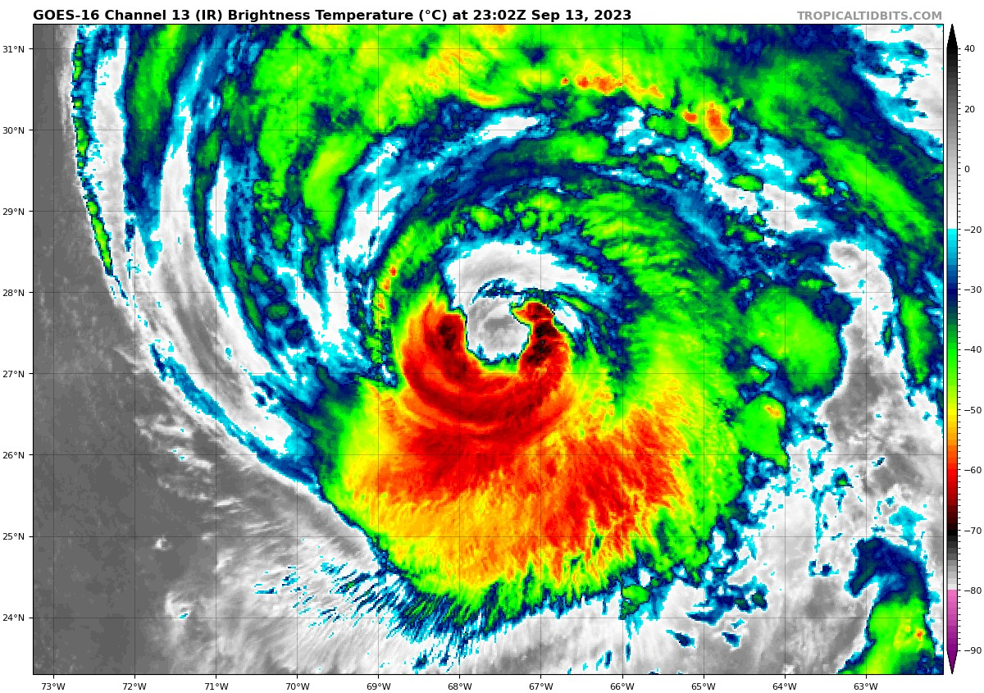
2310 | Double wind maximum on this outbound leg to the NE
2316 | Based on IR, LPS thinks these structures seen on MMR must indeed be stratiform remnants that are rotating around from the south. Echo tops of around 10 km.
2320 | FL winds near 85 kt near the endpt NE, very broad wind field. Evidence of a triple wind max in FL winds on this NE outbound leg
2320 | Endpoint, sonde 08 (NWS), AXBT 01
2334 | On this downwind leg, FL winds are consistently 85-90 kt. Storm-to-hurricane force at the surface
2343 | Endpoint, sonde 09 (NWS), AXBT 02
2345 | Zorana Jelenak noted that the SFMR measurements are ~6 m/s too low when compared with IWRAP and sonde data. Seems to be everywhere but she checked specifically in a rain band. Specifically the SFMR is too low in the outbound eyewall, when comparing with 3d wind lowest level retrievals (30m height) reduced to 10m they are ~5-6m/s higher than sfmr. IWRAP winds agree very well with rmw sonde.  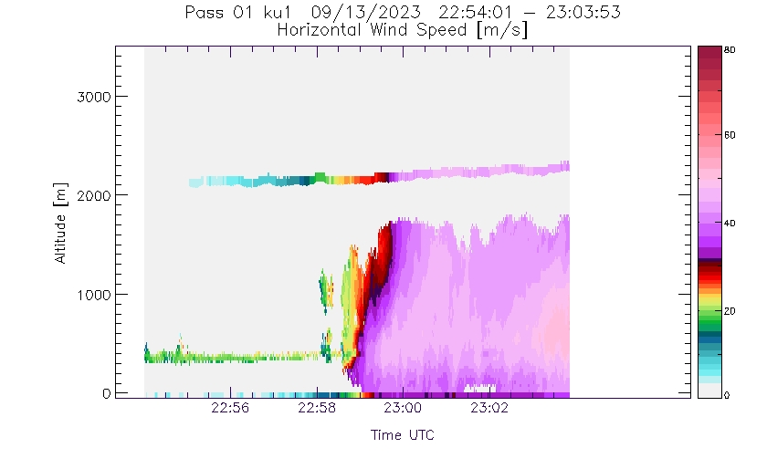  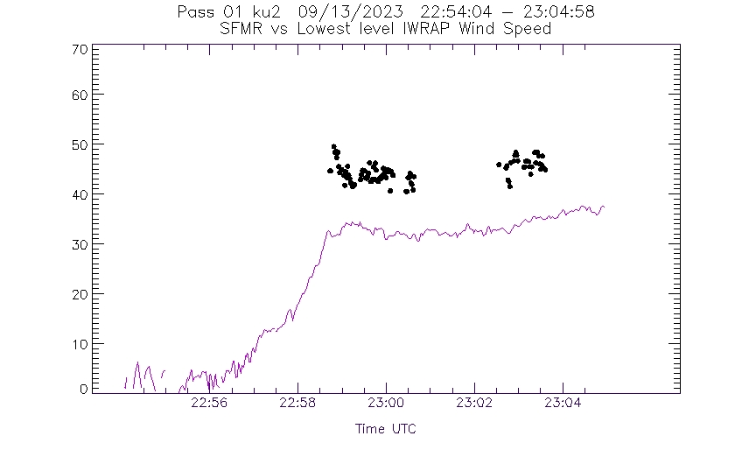
2356 | Midpoint, sonde 10 (NWS)
2359 | 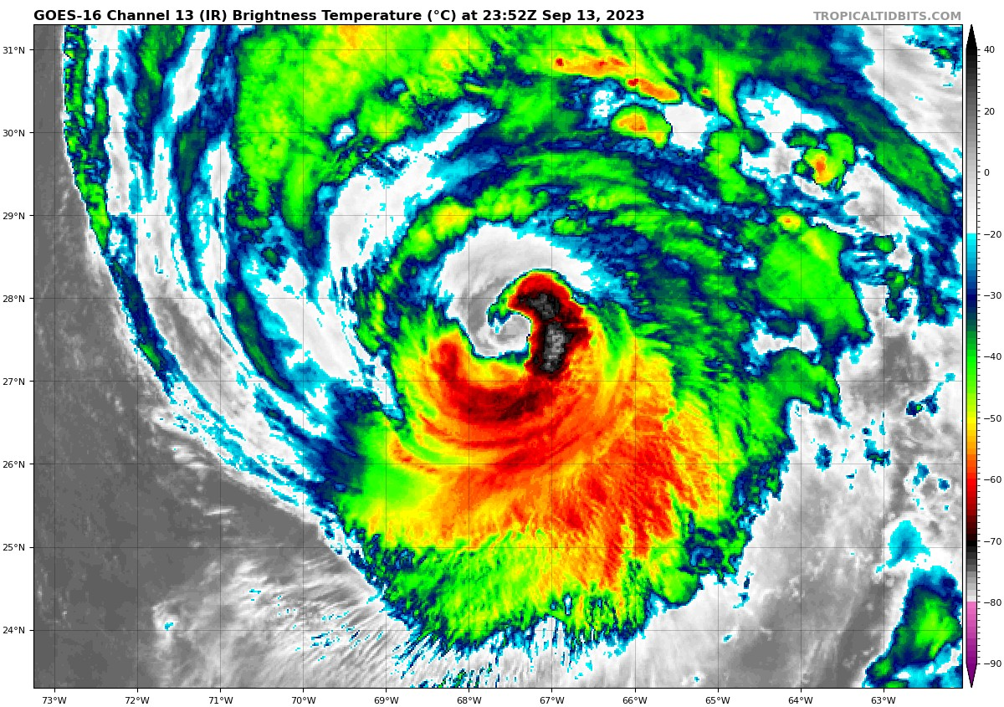  Comparison of IR image 50 minutes after previous image shows coldest cloud tops well-defined on east side, appears to be wrapping around the NE eyewall. Presumably downwind extension/growth/advection of cloud mass seen previously in the SE eyewall.
2359 | Clear secondary wind max on FL winds on this southbound, inbound leg. No obvious 2nd max on SFMR.
0004 | RMW, sonde 11 (NWS)  No real RMW on this leg - very broad wind max 65-70 kt
0009 | Center (26.6N, 67.7W), sonde 12 (NWS), AXBT 03  Eye is very ragged. Eyewall is shrinking, now < 50% coverage. It will be interesting to see how the inner core evolves with degraded structurea secondary wind max  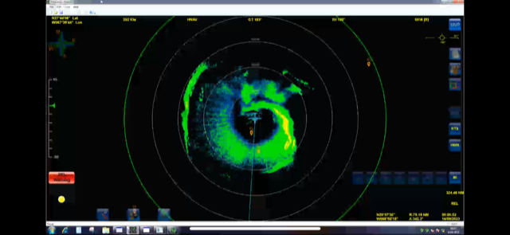
00160021 | RMW, sonde 13 (NWS)Extending outbound leg to S to go directly to Saildrone
0022 | Midpt S, sonde 14 (NWS)
0035 | Endpt S, sonde 15 (NWS), AXBT 04
0039 | Saildrone drop, sonde 16 (GOMO), within 10 nm of Saildrone
0050 | Profile analysis of wind speed from first, SW-NE pass shows highly asymmetric wind structure, very broad and deep windfield on the NE side  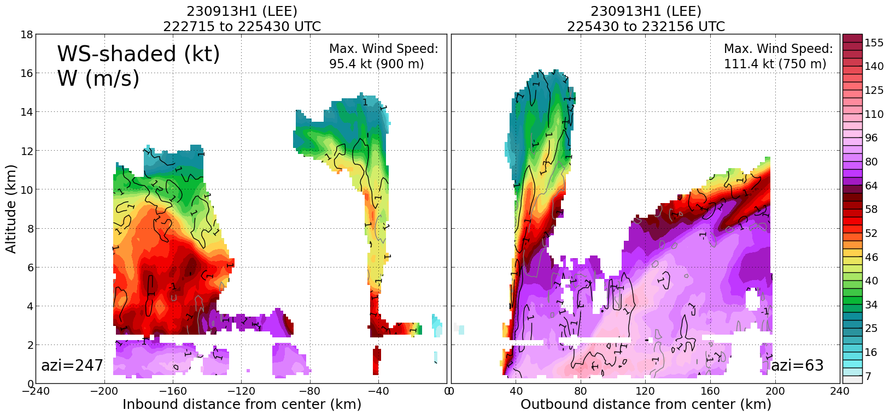
0051 | Mostly heavy stratiform and some embedded convective elements, particularly on NE side  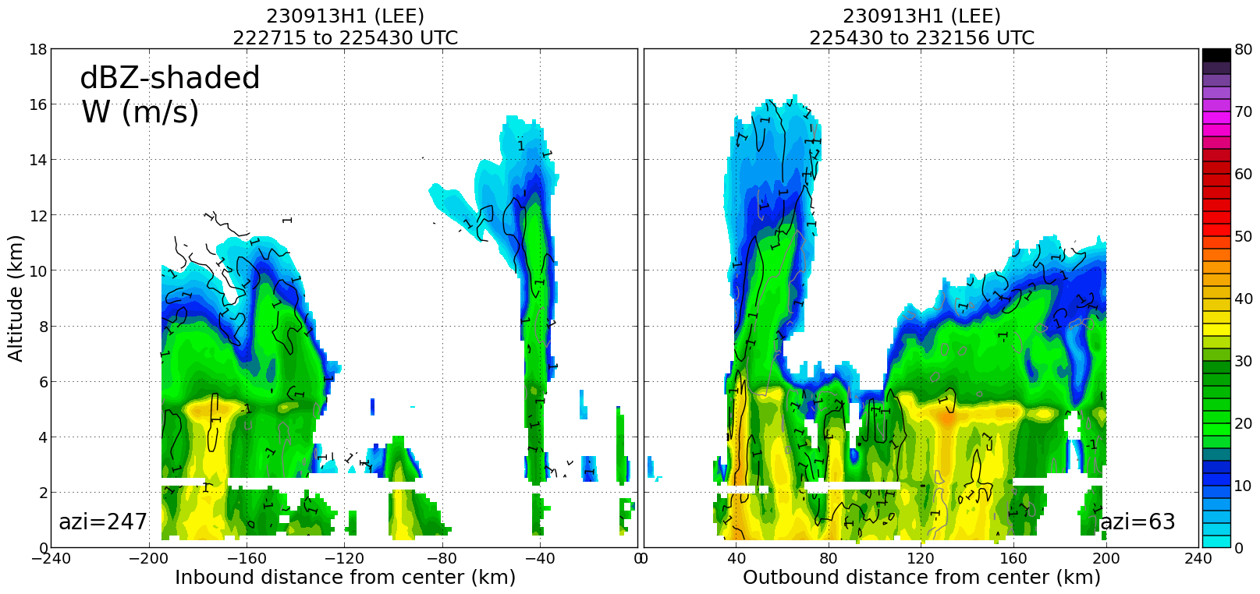
0052 | 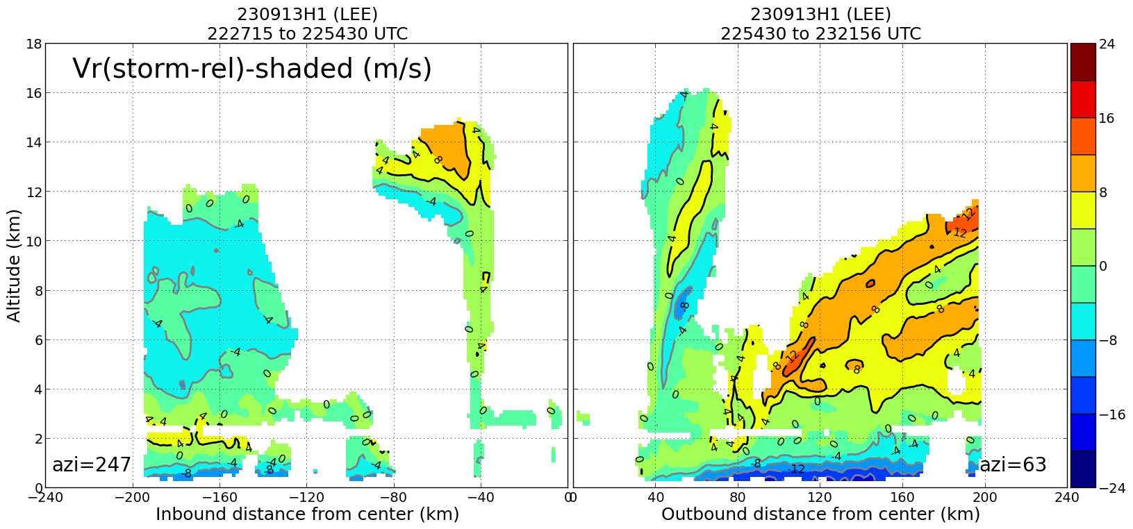  Radial flow shows strong inflow on the NE side, pronounced, but shallow, outflow aloft
0054 | 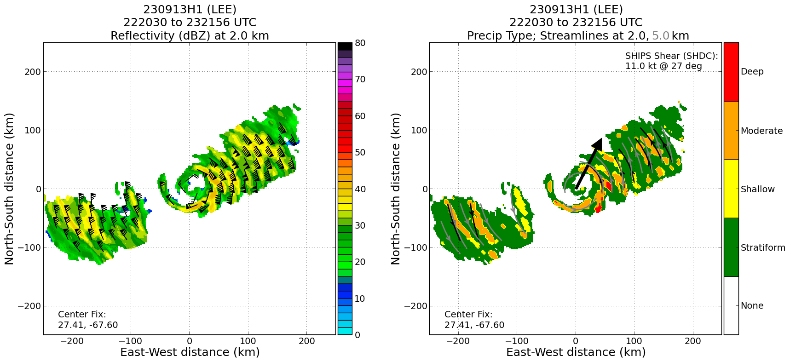  Mostly stratiform and moderate, some shallow convection, very little deep convection. Even the inner eyewall is only moderate convection
0101 | 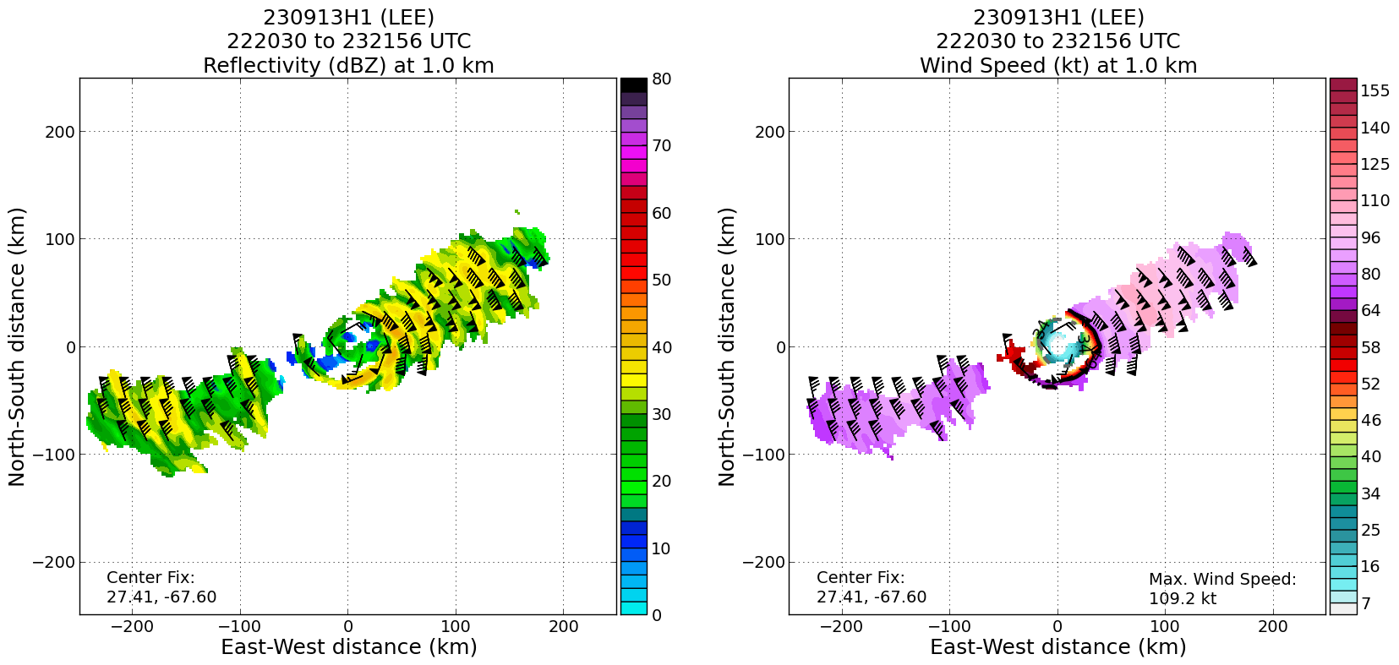  Horizontal plot shows the extent of the wind field on the NE side
0103 | 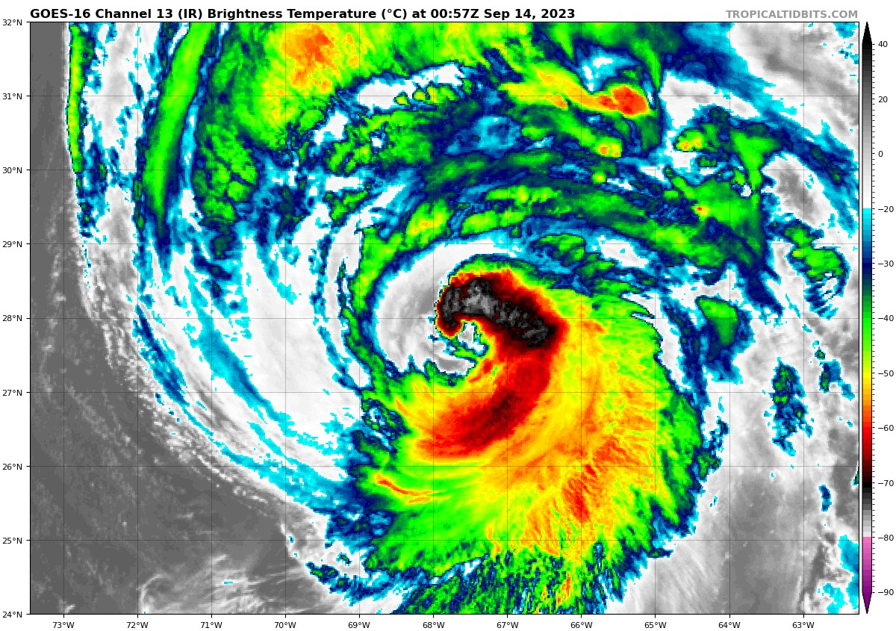  Cloud field asymmetry has now rotated around to the N side
0104 | Animation captures this well of course
0106 | 2-6-km Vortex Tilt: 4.0 km at 90 deg on first pass  2-6-km Vortex Tilt: 10.2 km at 79 deg on second pass  Tilt magnitude increased from first to second pass
0106 | Endpoint SE, sonde 17 (NWS), AXBT 05
0116 | Midpt/RMW SE, sonde 18 (NWS)
0123 | 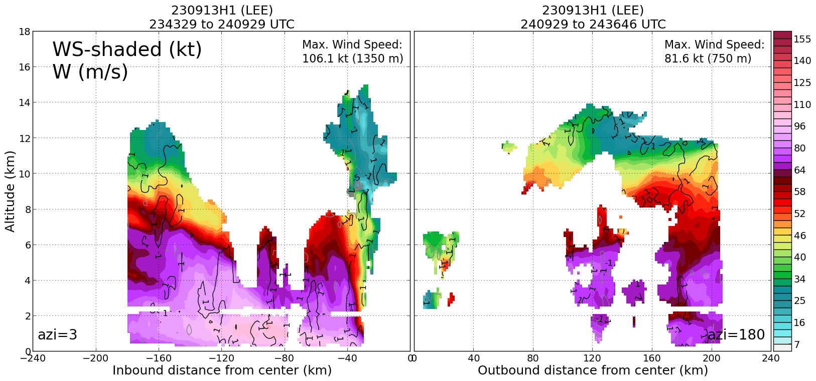  Profile analysis of wind speed from the second, N-S leg shows broad and deep wind field on the N side, similar to that seen on the NE side
0126 | 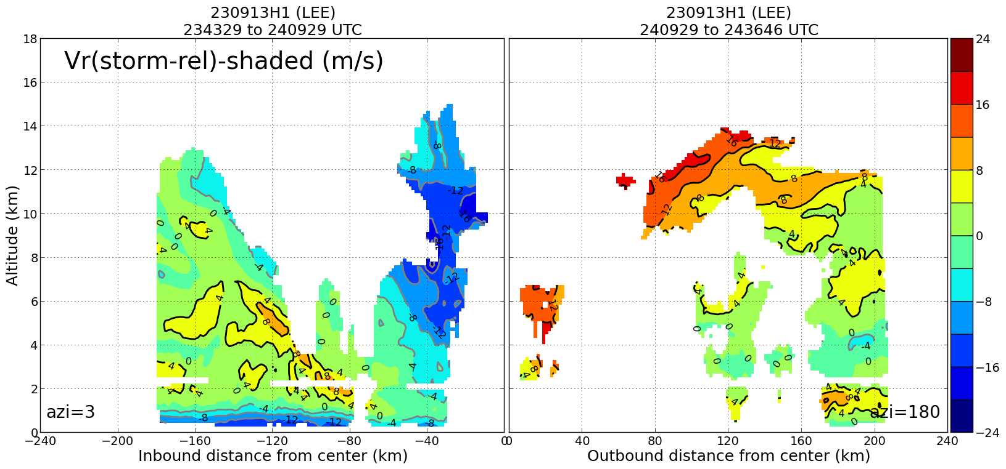  Radial flow shows similar structure on N side to that seen on NE side, strong PBL inflow and return flow at about 6 km
0127 | 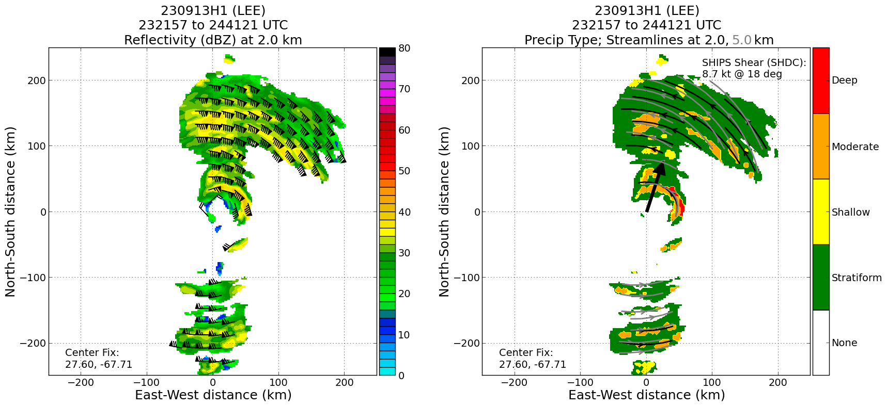  Some deep convection in the eastern eyewall – may be related to the cold cloud tops wrapping around in the inner eyewall seen in IR?
0128 | 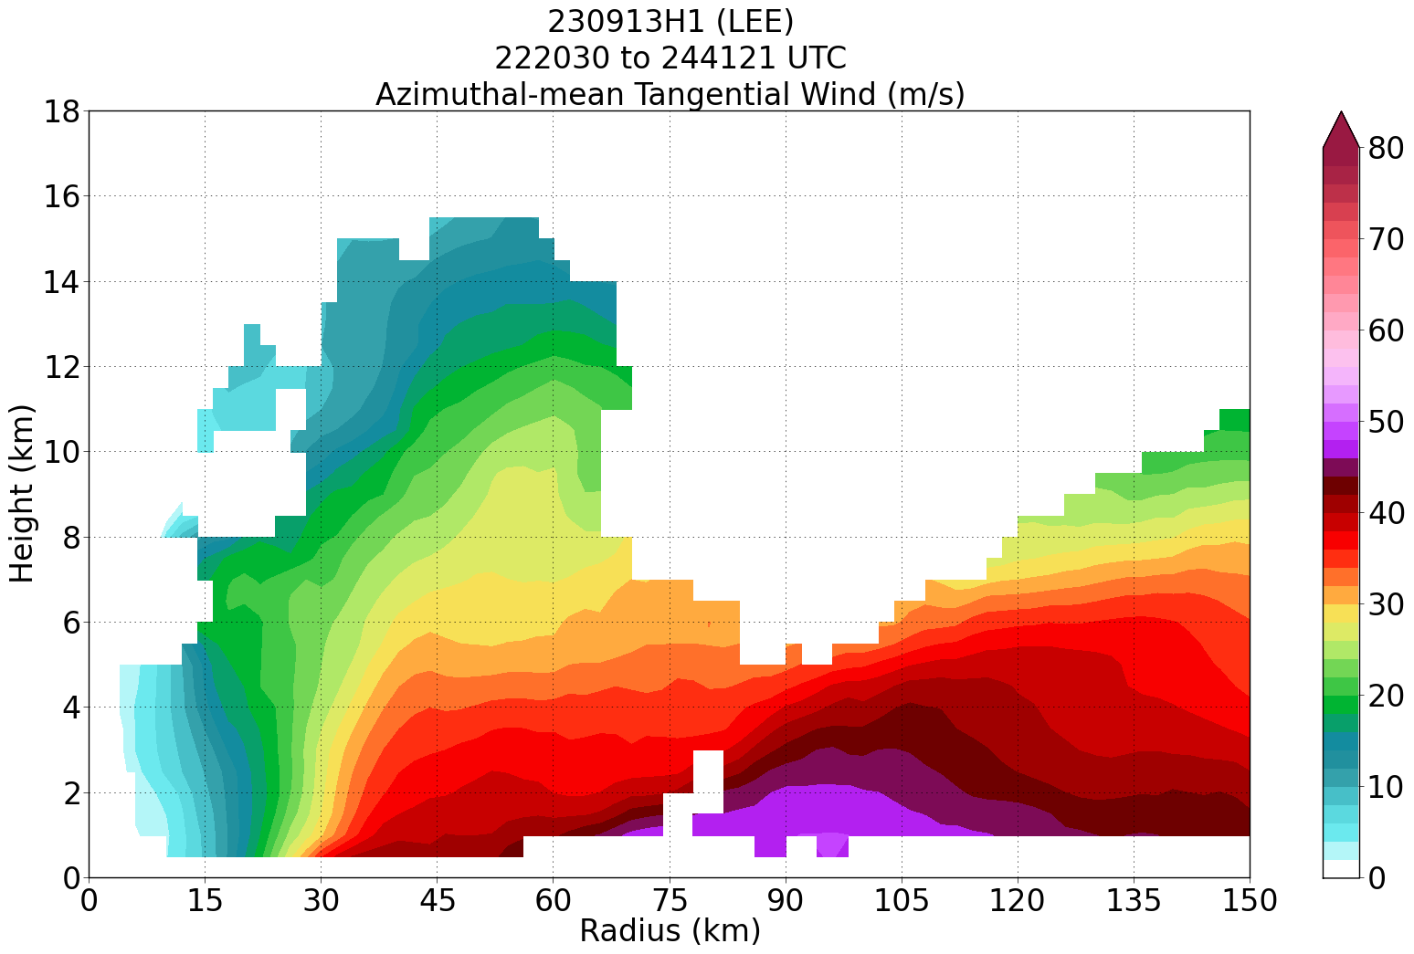  Azimuthal mean plot from first two passes shows shallow, broad vortex, peak mean winds at 90 km
0129 | 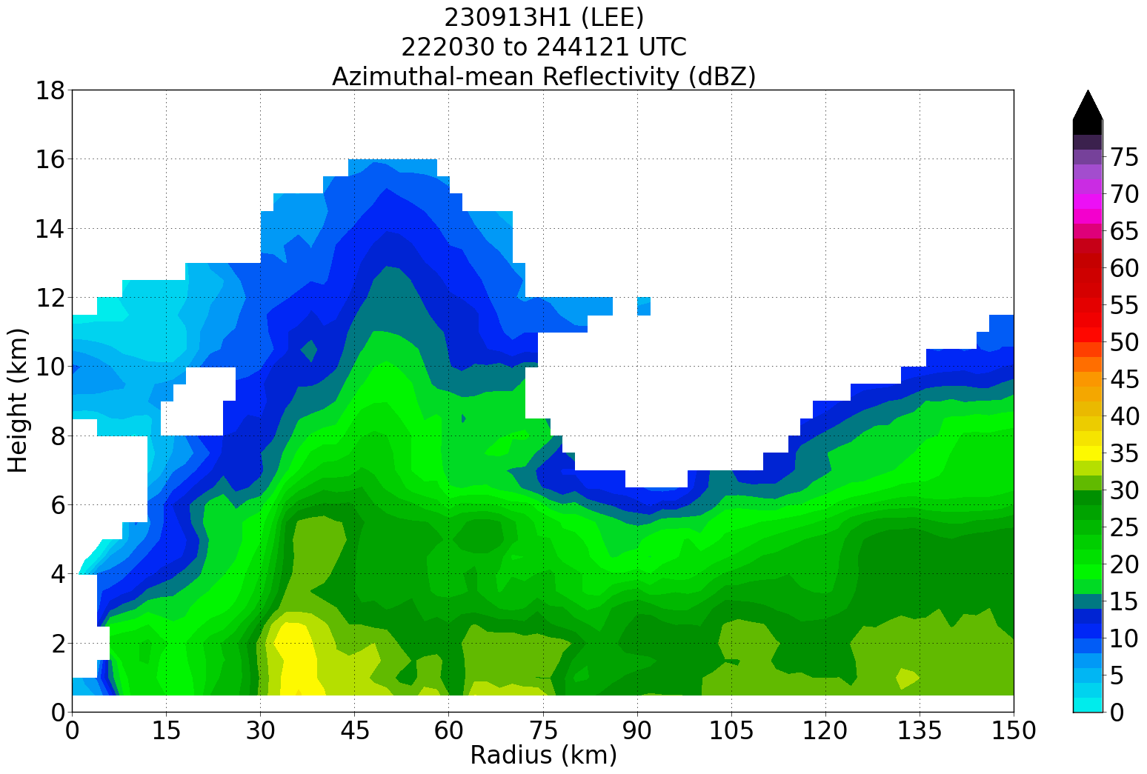  Azi-mean reflectivity shows inner eyewall at 35 km, indications of outer reflectivity maxima beyond 105 km (just outside peak winds)
0128 | Center drop, sonde 19 (NWS), 27.77N, 67.81W
0136 | The remnant eyewall has deteriorated even more, based on MMR. Evidence of a "new eyewall" with a radius of 40 n mi
0139 | FL winds and SFMR indicated at least 2 wind maxima each on the SE inbound leg
0139 | 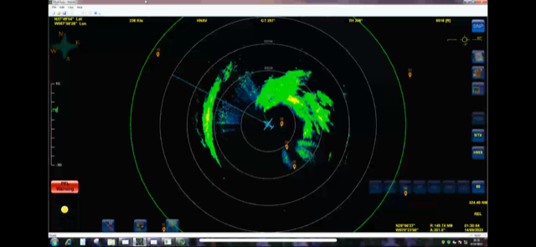  MMR from 3rd and final pass shows continued deterioration in appearance of inner eyewall, probably less coverage than previous passes
0141 | About to pass through the western "outer eyewall", accompanied by an increase in FL winds and SFMR
0141 | There was a very narrow inner wind max near the remnant eyewall
0143 | Midpt/RMW drop, sonde 20 (NWS), RMW and midpoint co-located (about 50 nm from center)
0145 | 4/5 AXBTs worked
0155 | Endpt NW, sonde 21 (NWS)
 | << INSERT ADDITIONAL ROW AS NEEDED >>

POST-FLIGHT
Mission Summary | Mission was successful. Full butterfly pattern was flown. Three TDR analyses and 20 sondes were transmitted. Sampled a hurricane that has spent several days undergoing multiple eyewall replacement cycles. Vortex structure is a very broad and shallow vortex, in an azimuthal-mean sense. Radial flow patterns indicate hurricane still responding to southwesterly shear. Profile of tangential winds shows very broad, and relatively deep, strong winds on the NE and N sides of the storm. Precipitation is mostly stratiform and moderate convection, with some isolated regions of deep convection in the eastern eyewall during the second, N-S pass. This vortex has a stable configuration (i.e., unlikely to intensify or weaken quickly), with a broad wind field (hurricane force winds extending out nearly 100 nm from the center) likely to have substantial impacts from wind and waves.  A sonde was also released within 10 nm of a Saildrone to the southeast of the center.  20 sondes were dropped, of which 19 are charged to NWS and 1 is charged to GOMO. 5 AXBTs were dropped; 4 of them worked.
Actual Standard Pattern Flown | Butterfly
APHEX Experiments / Modules Flown | TDR
Plain Language Summary | - Successful mission into Hurricane Lee flown. Valuable Doppler radar and dropsonde data were collected and transmitted to the ground, where they will give important information to NHC forecasters and improve forecasts from computer models  - The hurricane remains in a steady state, neither intensifying nor weakening. The wind field covers a very large region, with hurricane force winds extending nearly 100 nm from the center on the east and north sides of the storm.  - Multiple eyewalls have been forming and replacing existing eyewalls for several days – the storm structure reflects these repeated replacement cycles.
Instrument Notes | All instrumentation functioned. SFMR had some indication of a low bias in the NE eyewall.
Final Mission Track

