MISSION PLAN
FLIGHT ID | 20230912I1 | STORM | AL13 / Lee
MISSION ID | 2213A LEE | TAIL NUMBER | NOAA 43
TASKING | NHC/EMC | PLANNED PATTERN | Butterfly pattern with 105 NM legs
MISSION SUMMARY
TAKEOFF [UTC] | 0831 | LANDING [UTC] | 1453
TAKEOFF LOCATION | TISX | LANDING LOCATION | TISX
FLIGHT TIME | 6.4 | BLOCK TIME | 6.6
TOTAL REAL-TIME RADAR ANALYSES  (Transmitted) | 3 (3) | TOTAL DROPSONDES Deployed (Transmitted) | 29 (28) all NWS
OCEAN EXPENDABLES (Type) | 5 (4) AXBT | sUAS (Type) | n/a
APHEX EXPERIMENTS / MODULES | n/a
HRD CREW MANIFEST
LPS ONBOARD | Aberson | LPS GROUND | Marks
TDR ONBOARD | Aberson | TDR GROUND | Reasor/Alvey
ASPEN ONBOARD | J. Zhang/Ko | ASPEN GROUND | n/a
NESDIS SCIENTISTS | n/a
GUESTS (Affiliation) | Kelly Ryan (UM/CIMAS)
AOC CREW MANIFEST
PILOTS | Copare/Keith/Wood
NAVIGATOR | Utama
FLIGHT ENGINEERS | Tyson/Tufnell
FLIGHT DIRECTOR | Kalen/Lundry
DATA TECHNICIAN | Richards
AVAPS | Warneke/Kotz

PRE-FLIGHT
Flight Plan | - 8 or 10 kft (pressure altitude) depending on AF deconfliction requirements
Expendable Distribution | - Load 40 dropsondes  - Release at endpoints, midpoints, centers, RMWs (charged to NWS)  - Possible supplemental rapid RMW drops (charged to ONR)  - 1 dropsonde near Saildrone 1064 if possible (GOMO)  - Additional drops may be requested at the discretion of the onboard HRD LPS  - All dropsondes transmitted to the GTS  - 8 AXBTs - see notes below  - All AXBTs transmitted to the AOC ground server if possible  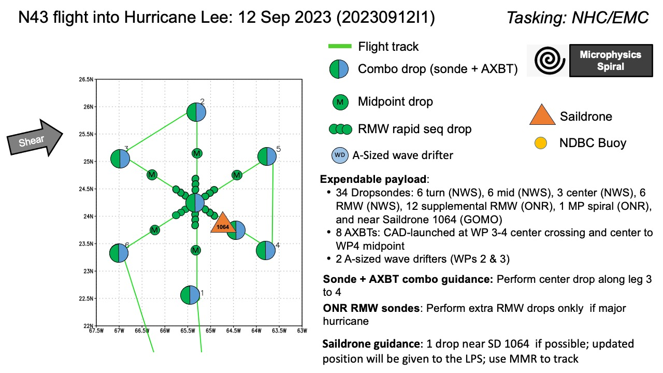
Preflight Weather Briefing | Lee is still experiencing moderate shear as seen in the GFS initial analysis for 00Z 12 September  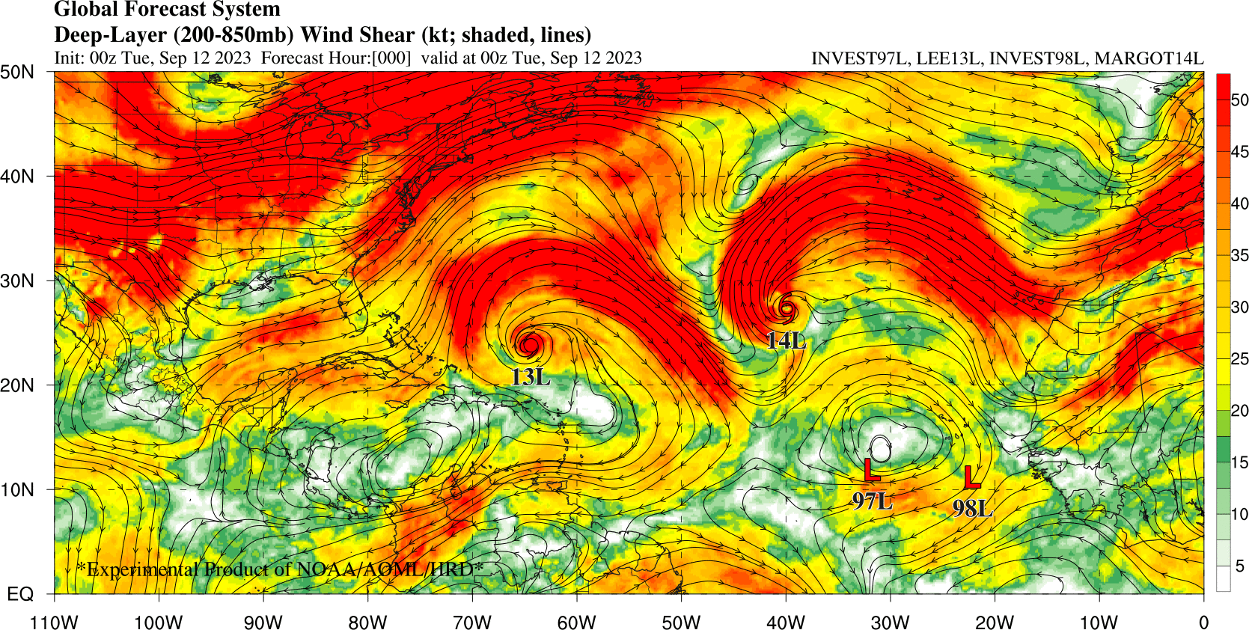  However, the ERC has not really completed and the larger outer eyewall has not contracted, and the remains of the inner eyewall is still pulsing with convective bursts as evidenced in the satellite loop.
Instrument Notes | All instruments but the WSRA are nominal. WSRA in inoperative

IN-FLIGHT
Time [UTC] | Event
0831 | Take-off from TISX, crabs on taxiway - LOL
2 Saildrones are in the vicinity of Lee and along our flight track - SD-1041 is located very near our IP; SD-1064 passed very near the center of Lee and is located near the midpoint of the outbound leg from the center to PT#4
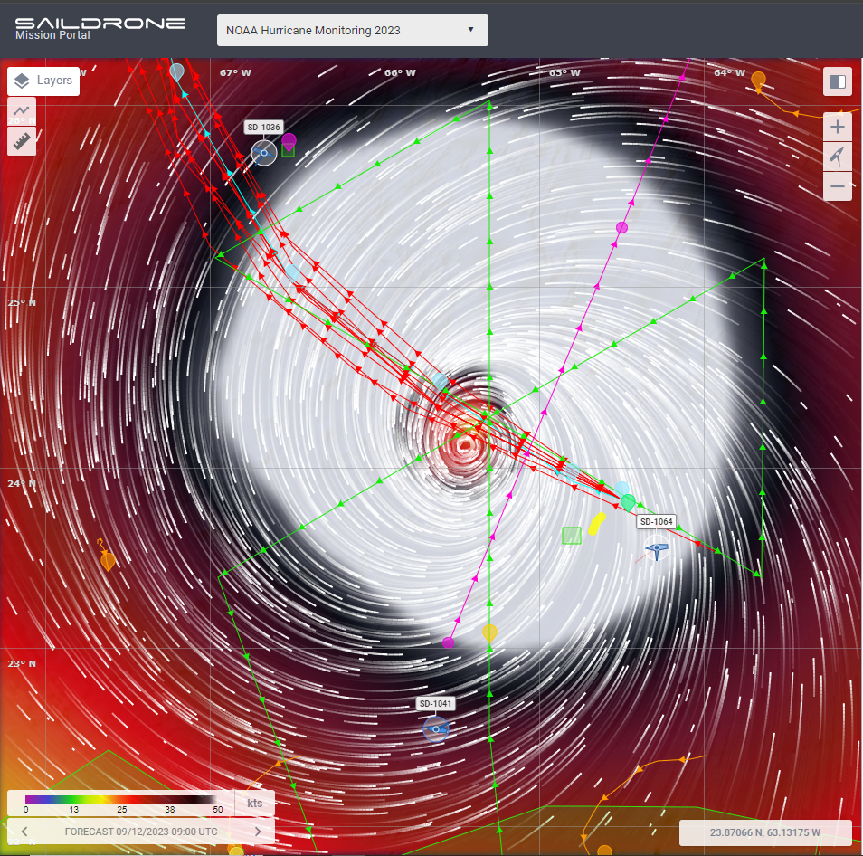
0912 | N49RF is doing their first circumnav and will pass just north of N43RF inbound track shortly. N49RF FL winds there is definitely westerly shear over Lee. FL winds are westerly all over the ENE side of the storm.  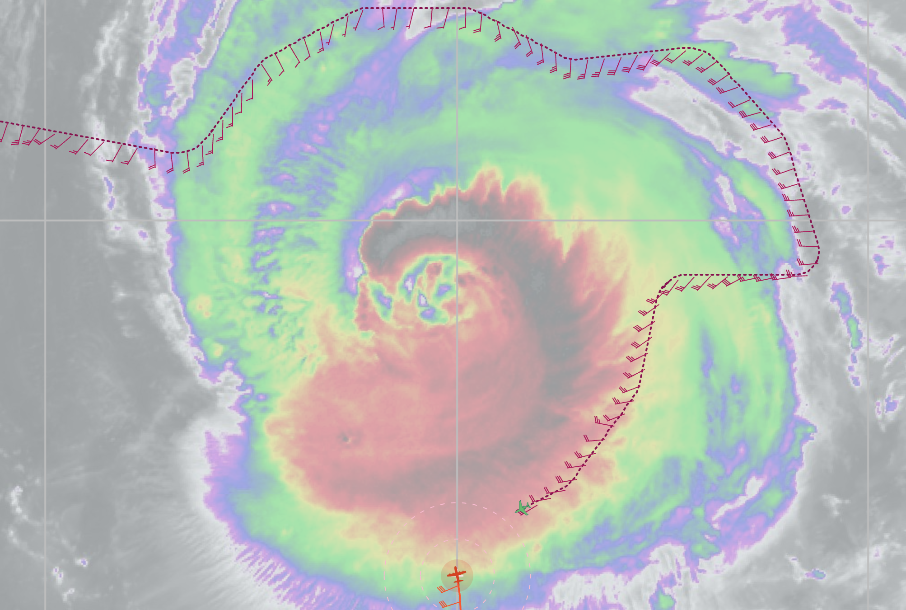
0919 | Begin descent to 10 kft
0931 | Passing through the outer band with sharp IR brightness gradient
0934 | IP (PT#1)/Saildrone-1041 sonde (Drop #1), just inside the outer band, sonde splash 28.5 km SE of SD-1041
0938 | BT (AXBT #1) sst=28.39
0948 | Midpt. RMW sonde (Drop #2). No surface windspeed max in outer eyewall (SFMR 45 kt)
0949 | New convective burst is going off in the inner eyewall again on the NE side of the center. Likely will advect along the outbound track. North side of the outer eyewall is looking very potent as well, with the coldest cloud tops.  Convective feature seen in SE inner eyewall on MMR.  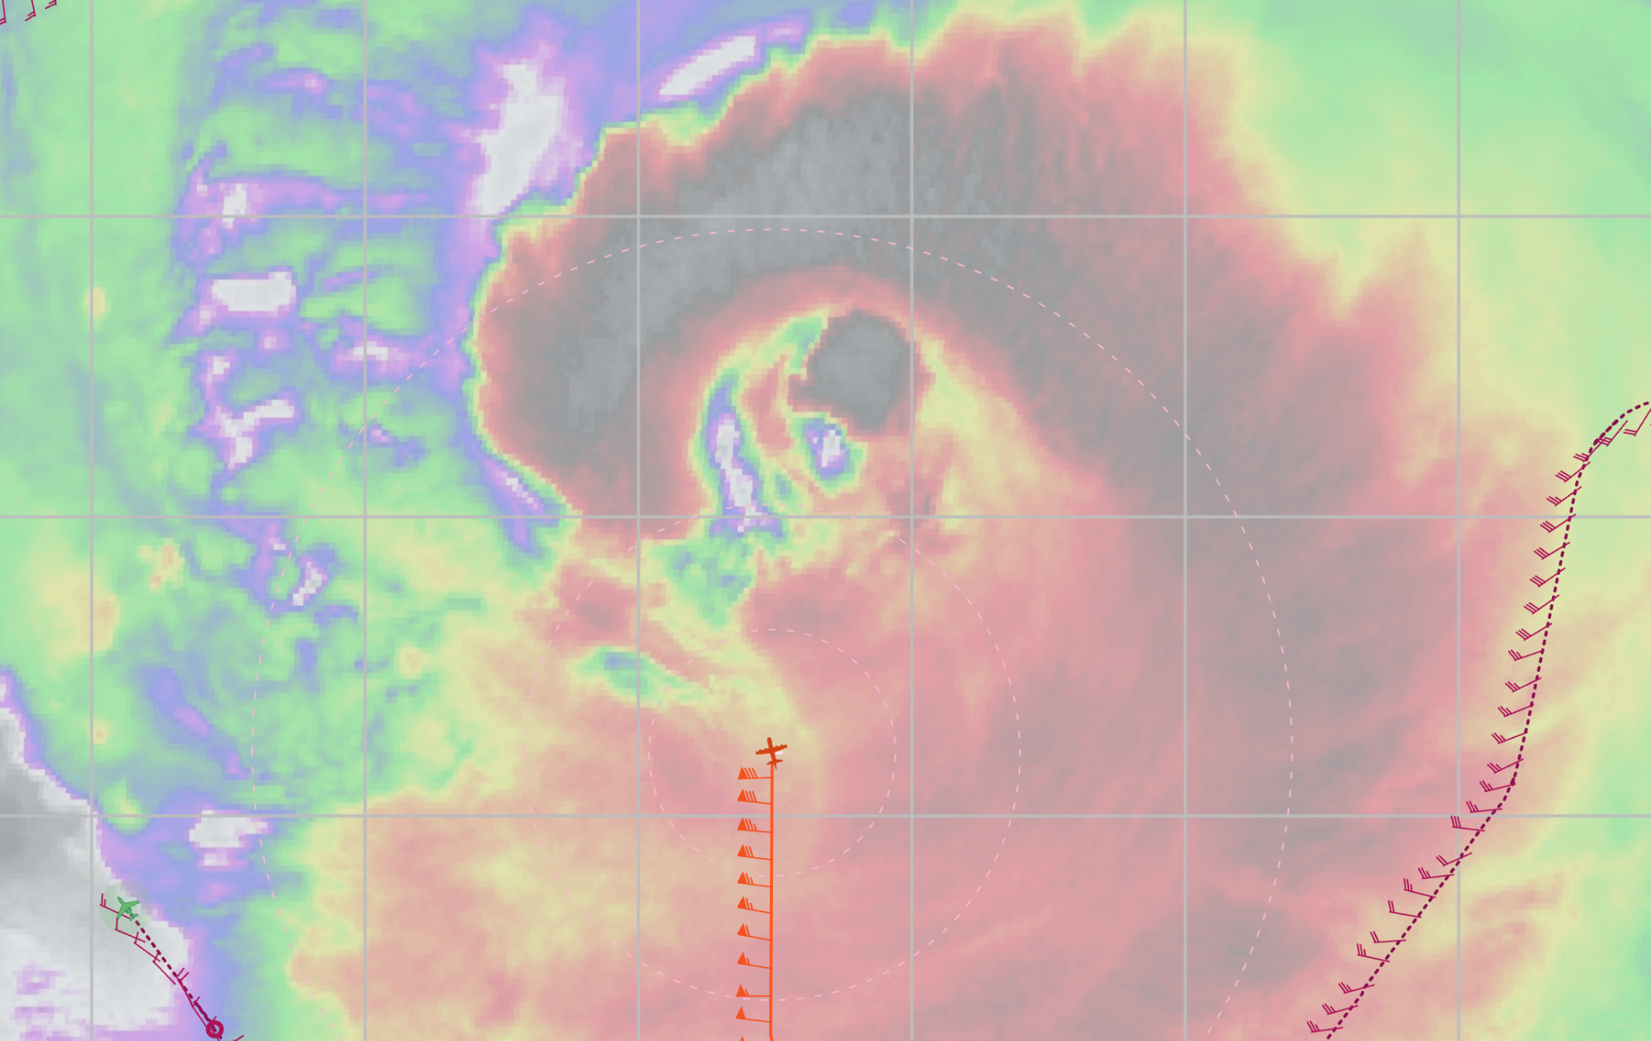
0953 | RMW sonde (Drop#3)
0955 | RMW sonde (Drop #4)
1001 | Center sonde/bt (Drop #5, AXBT #2), SST=28.34. 24.09N, 65.50W, 950 hPa  Two convective bursts on inside edge of inner eyewall, one N, one SE. Avoiding one to north on outbound leg.  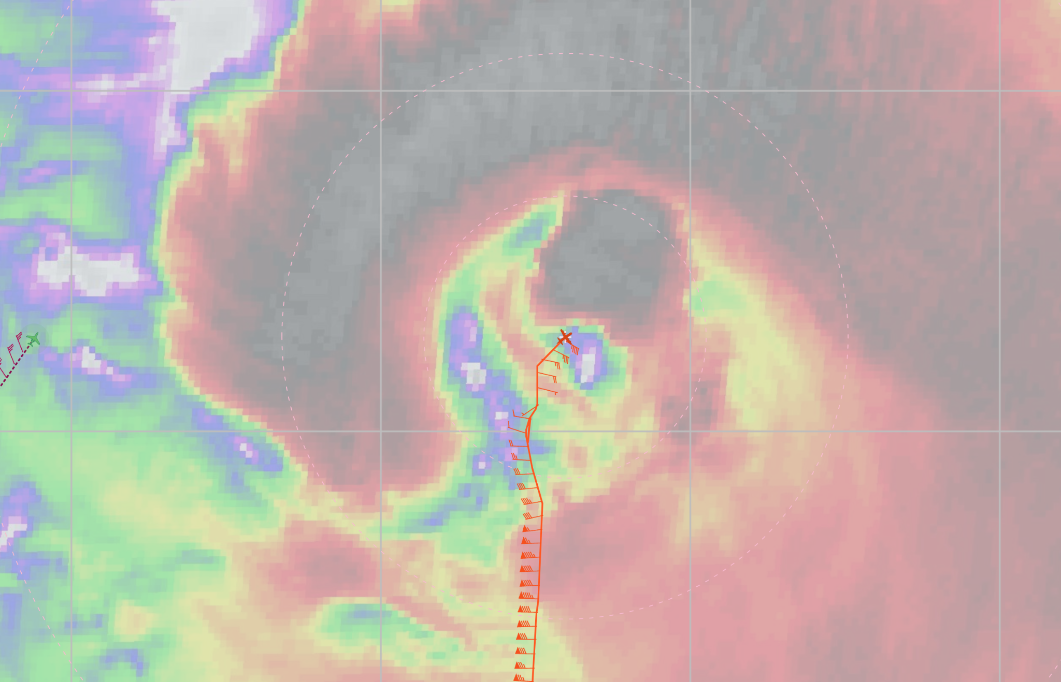
1007 | RMW sonde 1 (Drop #6)
1008 | RMW sonde 2 (Drop #7), no launch detect on second RMW sonde.  N49 is starting their inner circumnav to the WNW side of the outer eyewall
1015 | Midpt sonde (Drop #8)
1019 | No reflectivity moat in NE quadrant, but there is a flight-level wind-speed maximum
1026 | TDR Analysis #1 started
1028 | Endpt (PT#2) sonde (Drop #9), no AXBT, passed very close to N49RF doing their inner circumnav. N49 FL winds on the N side of the outer eyewall suggests they passed very close to the flow stagnation point.  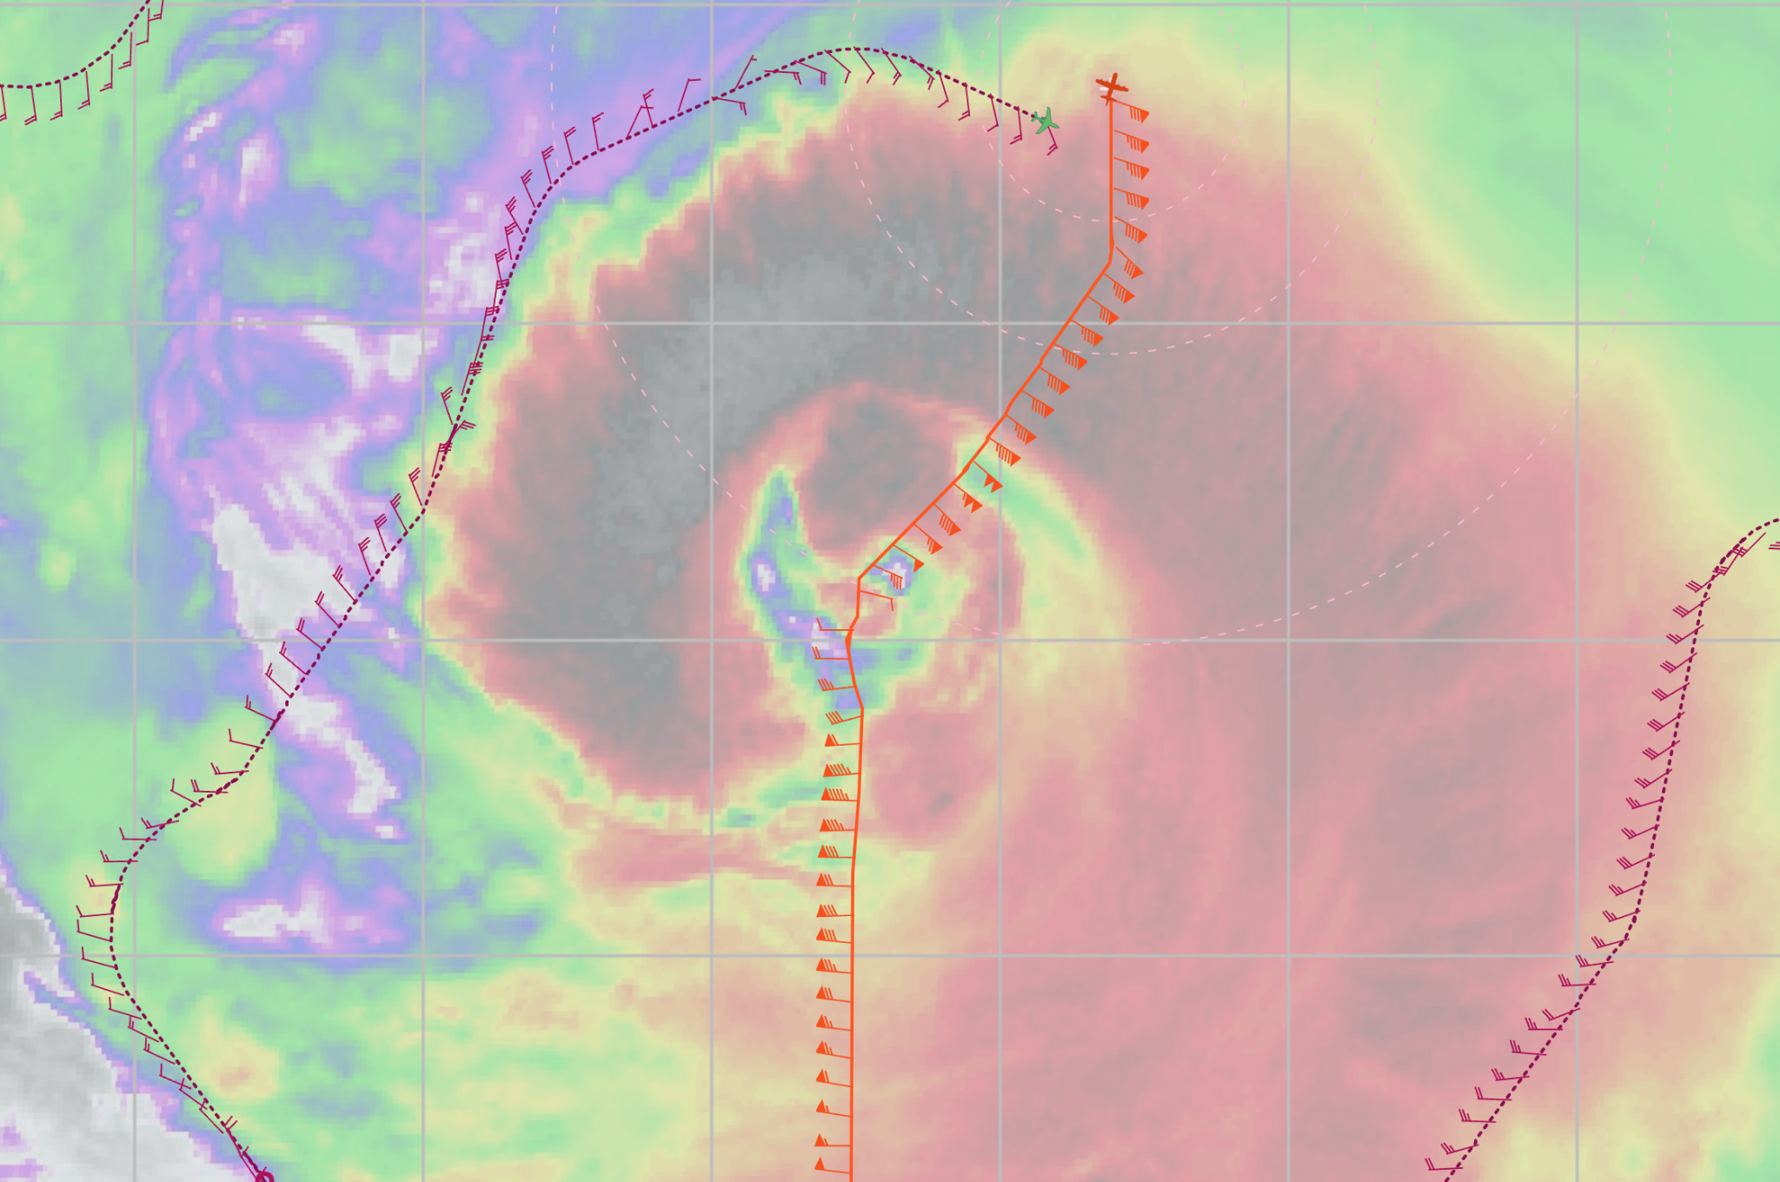
1037 | TDR Analysis #1 completed  TDR center info from 230912I1_1001_xy.nc:  Alt (km) Lat (deg) Lon (deg W)  0.5 99.99 99.99  2.0 24.10 65.49  3.0 24.10 65.51  6.0 24.14 65.49  2-6-km Vortex Tilt: 4.0 km at 0 deg  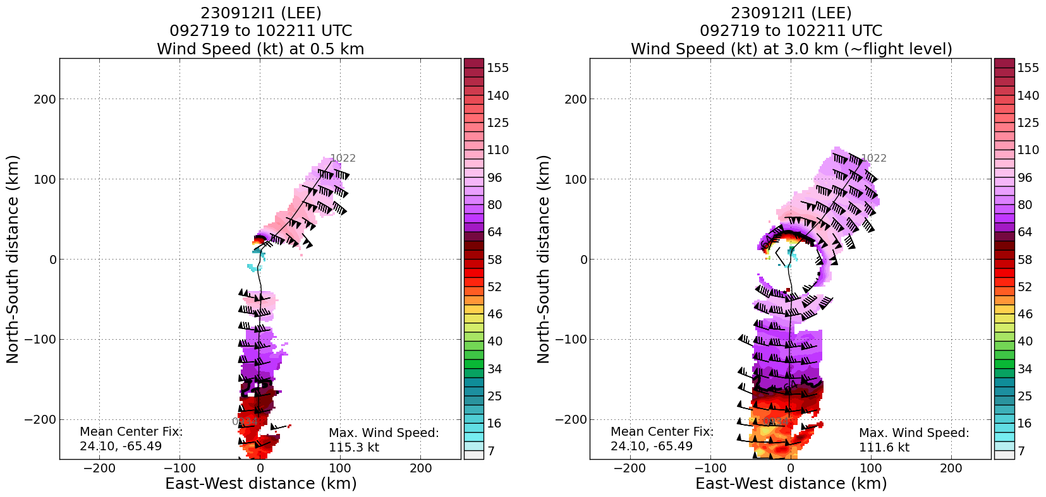  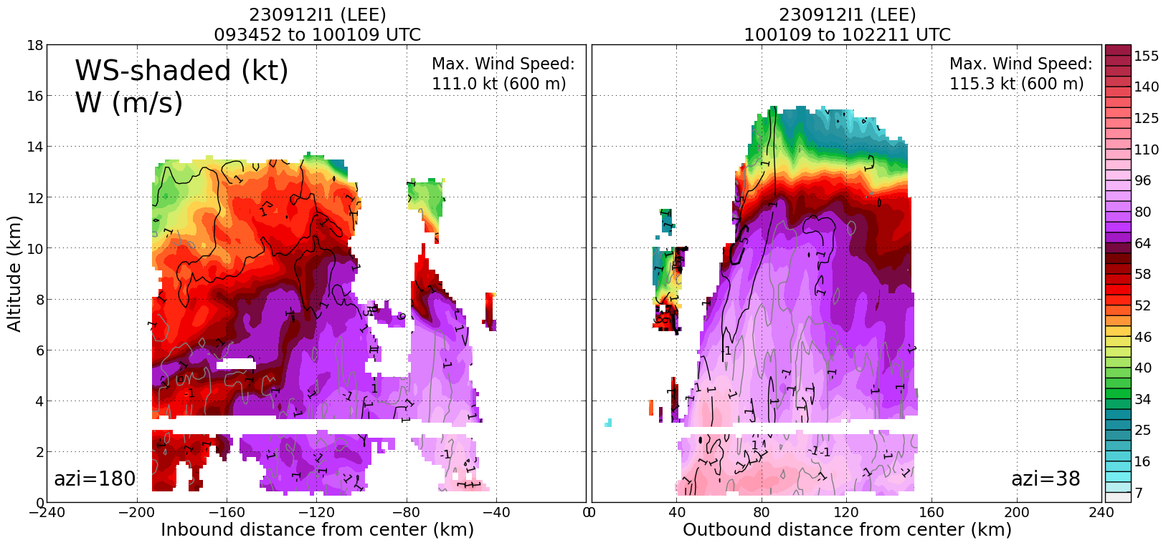
1101 | Endpt (PT#3) sonde combo (Drop #10, AXBT #3), SST=28.47, turn TK 120  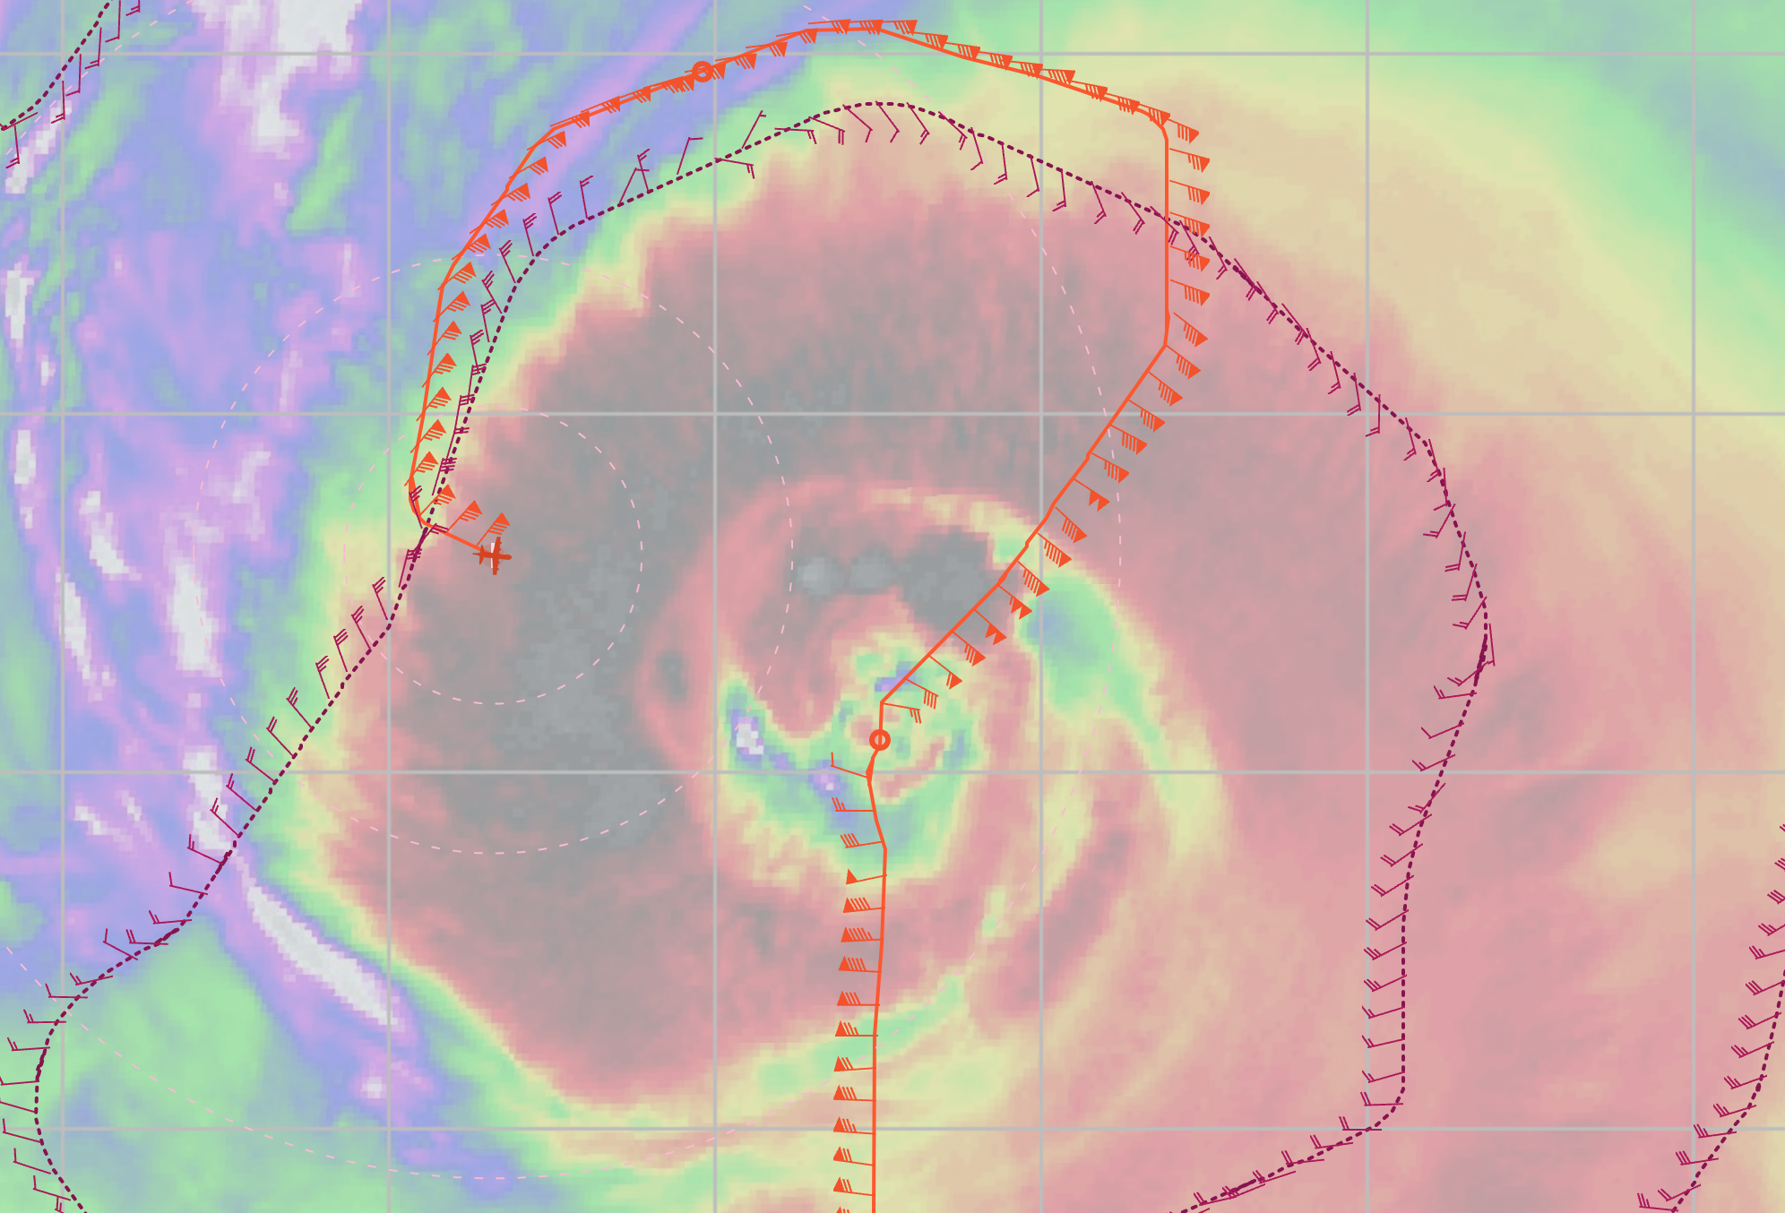
1112 | Midpt outer eyewall sonde (Drop #11)
1118 | Two inner eyewall sondes (Drops #12-13)  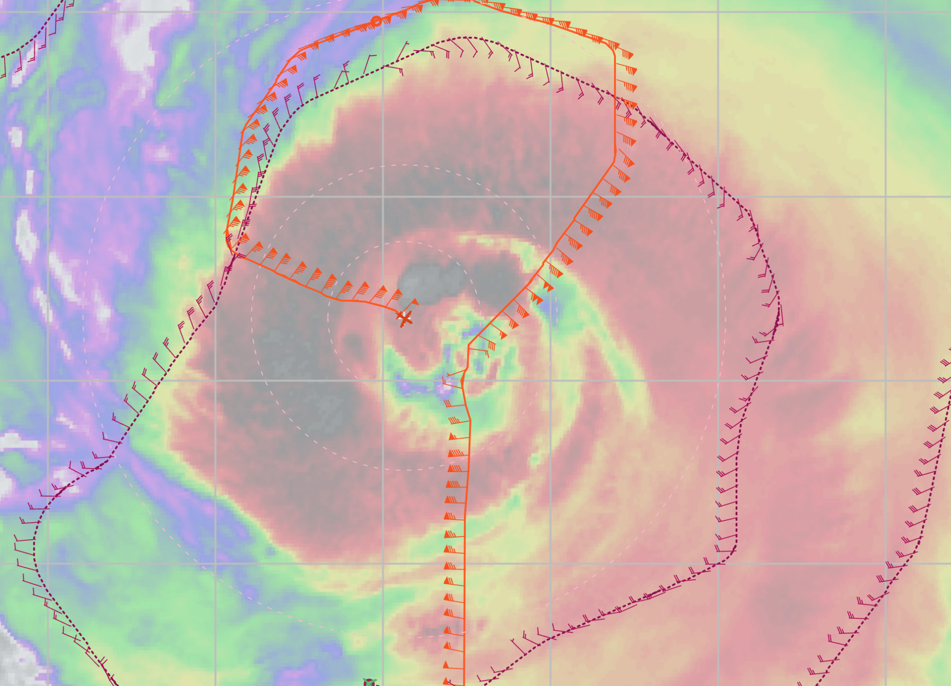
1126 | CPA center (Drop #14)
1130 | RMW sonde 1 (Drop #15)
1133 | RMW sonde 2, (Drop #16), high FL, but SFMR never rose much
1138 | RMW sonde 3 sonde (Drop #17), Outer eyewall gone
1152 | midpt sonde (Drop #18) near Saildrone (SD-1064), drop splash 52 km from SD-1064
1204 | Endpt (PT#4) sonde and bt (Drop #19, AXBT #4)
1205 | TDR Analysis #2 started
1223 | TDR Analysis #2 completed:  TDR center info from 230912I1_1125_xy.nc:  Alt (km) Lat (deg) Lon (deg W)  0.5 99.99 99.99  2.0 24.14 65.64  3.0 24.15 65.62  6.0 24.21 65.60  2-6-km Vortex Tilt: 9.0 km at 27 deg  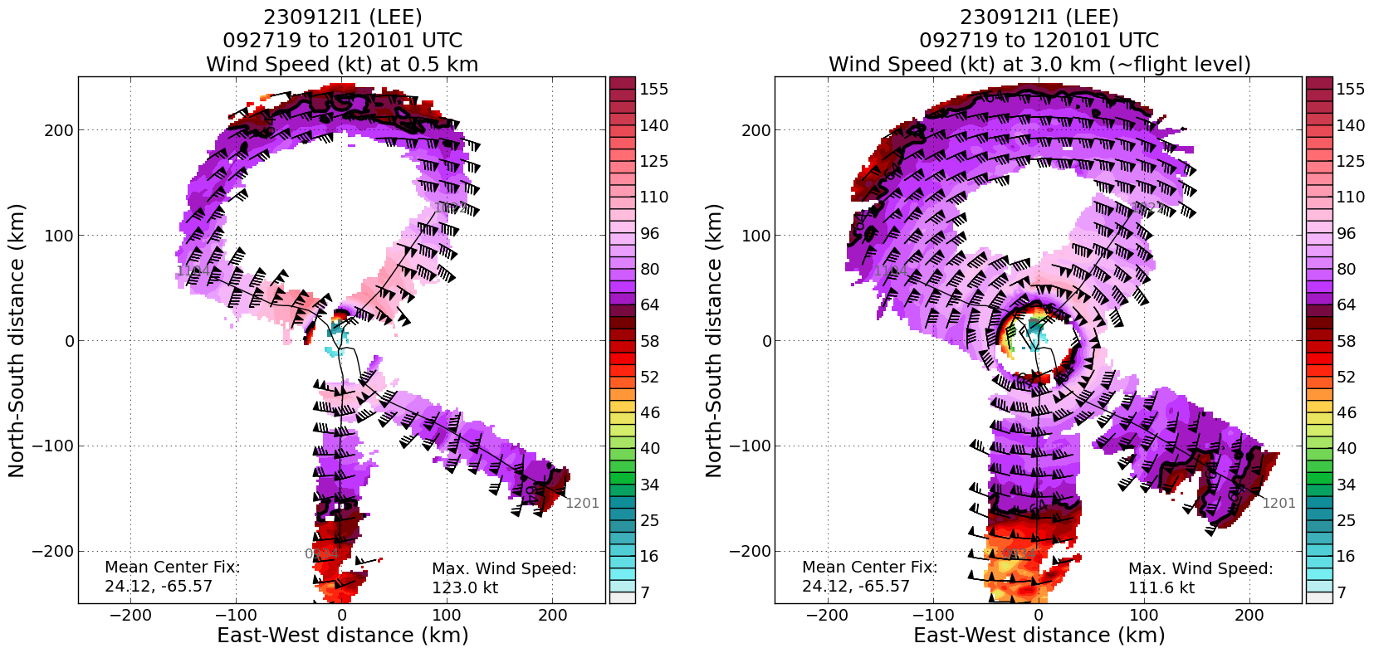  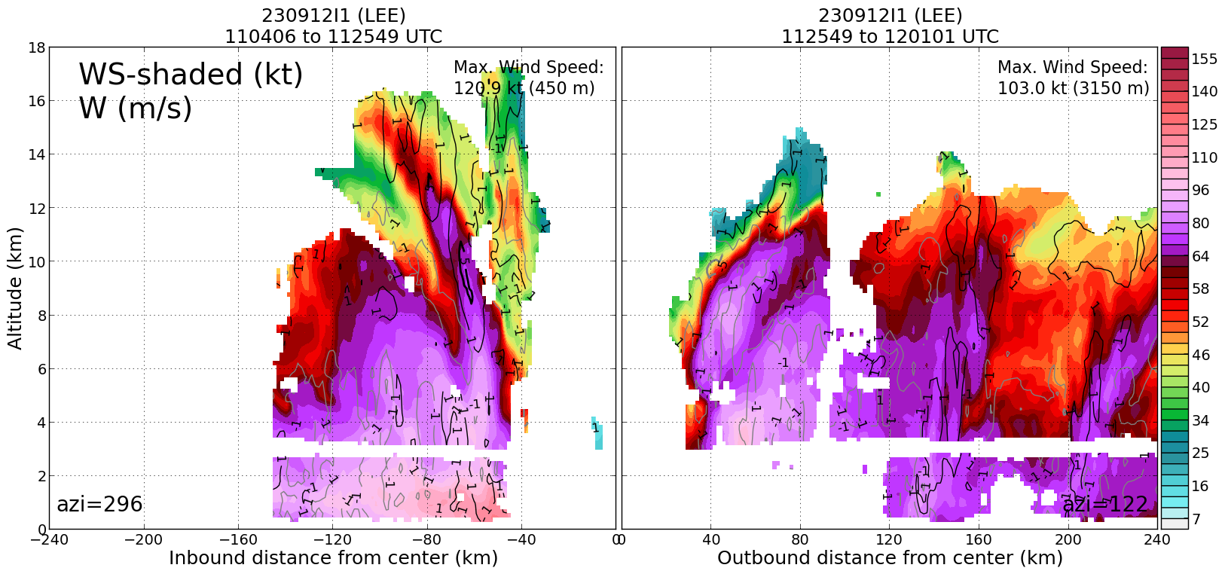
1240 | Endpt (PT#5) combo drop (Drop #20, AXBT #5) TK 240, bad BT, found out that the WSRA is up, but only have WSRA on last leg
1254 | Midpt drop (Drop #21)
1302 | RMW drop 1 (Drop #22)
1303 | RMW drops 2, 3 (Drops #23-24)
1309 | Center (Drop #25)
1314 | RMW drop 1 (Drop #26)
1315 | RMW drop 2 (Drop #27)
1321 | Midpt/RMW sonde (Drop #28)
1330 | Endpt (PT#6) combo (Drop #29, AXBT#6), Mission end, head for TISX
1331 | TDR Analysis #3 started
1347 | TDR Analysis #3 completed  TDR center info from 230912I1_1308_xy.nc:  Alt (km) Lat (deg) Lon (deg W)  0.5 24.19 65.85  2.0 24.21 65.85  3.0 24.23 65.83  6.0 24.26 65.81  2-6-km Vortex Tilt: 7.2 km at 34 deg  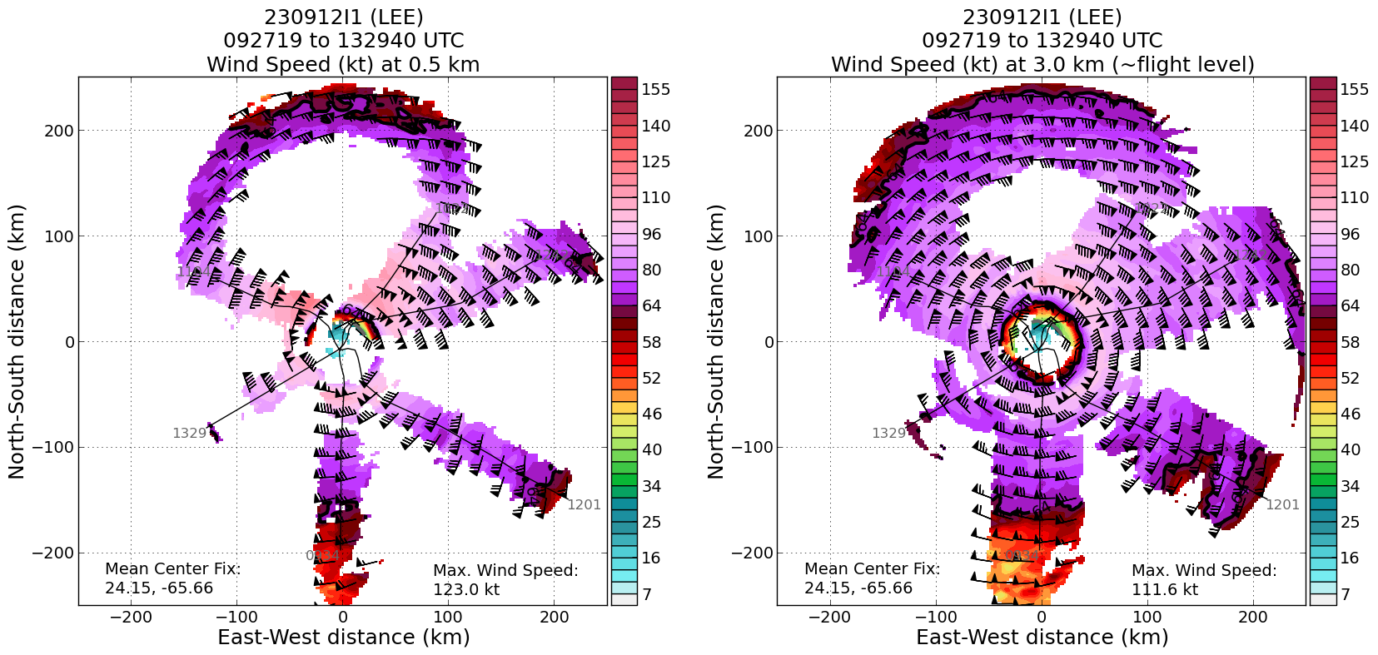  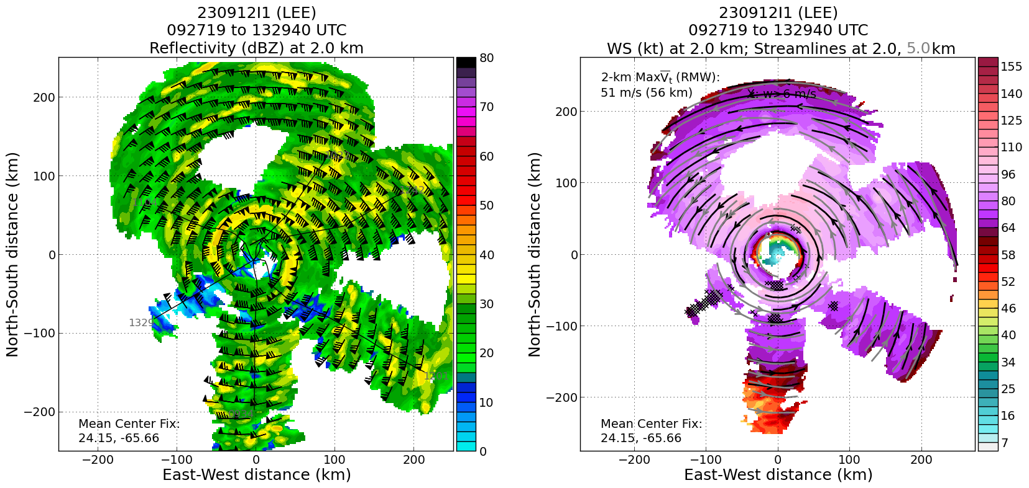  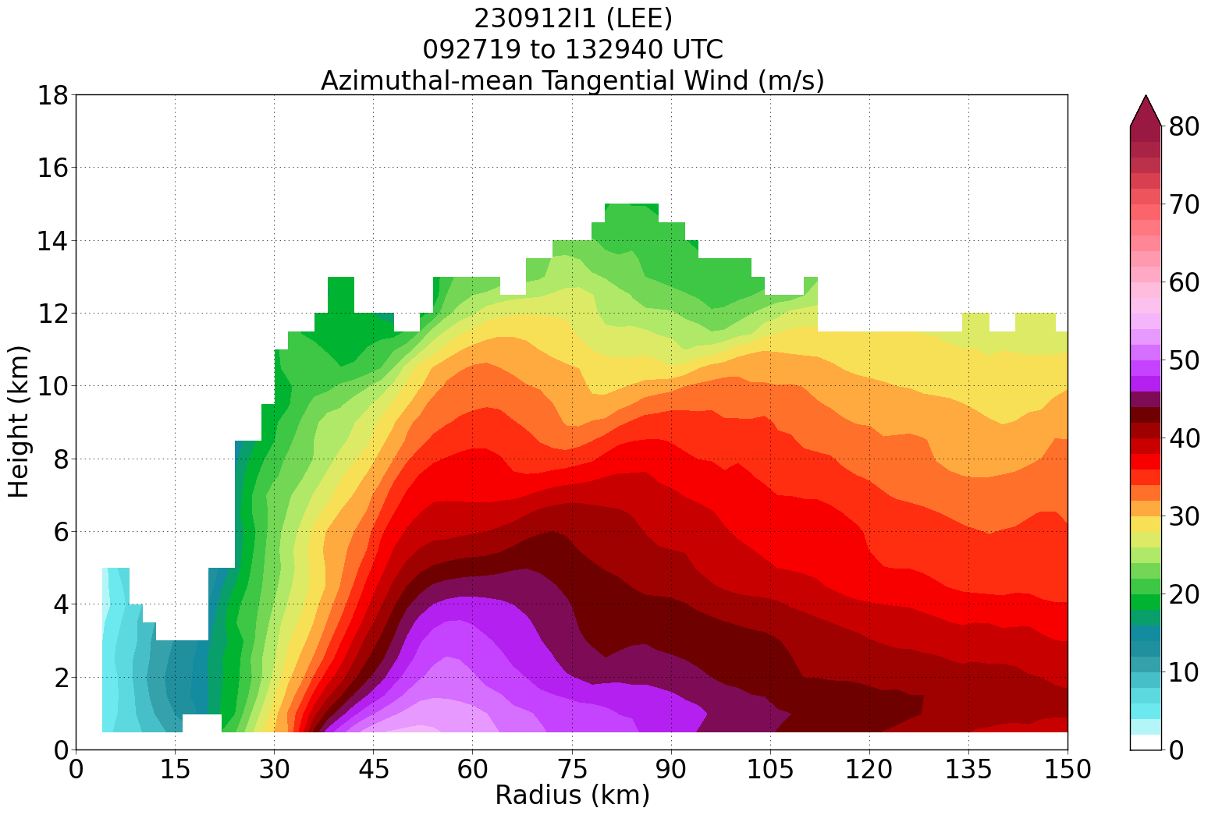
1453 | Landed TISX

POST-FLIGHT
Mission Summary | - Executed the butterfly pattern as planned.  - Completed intercomparisons with 2 Saildrones (SD-1041, SD-1064) dropping sondes and AXBTs within 28.5 km and 52 km, respectively. SD-1041 was near the IP and SD-1064 was near midpoint of outbound leg from the center to PT#4.  - Inner core structure changes during the mission were very interesting. On the first pass it was apparent that there were concentric eyewalls, however, by the 2nd and 3rd passes it appeared that the outer eyewall collapsed and that there was only a single larger eyewall present, particularly looking at the SFMR winds.  - Really interesting shear vortex interactions. Looking at 49 and 43 FL data on the NW to SE semicircle. Appeared like there was a stagnation point in the 49 FL wind on the NNW side and a strange transition in the FL wind on the east side. Should be a very interesting data set when combining the 49 TDR analyses from their inner circumnav with the 43 TDR analyses  - Excellent TDR/dropwindsonde coverage:  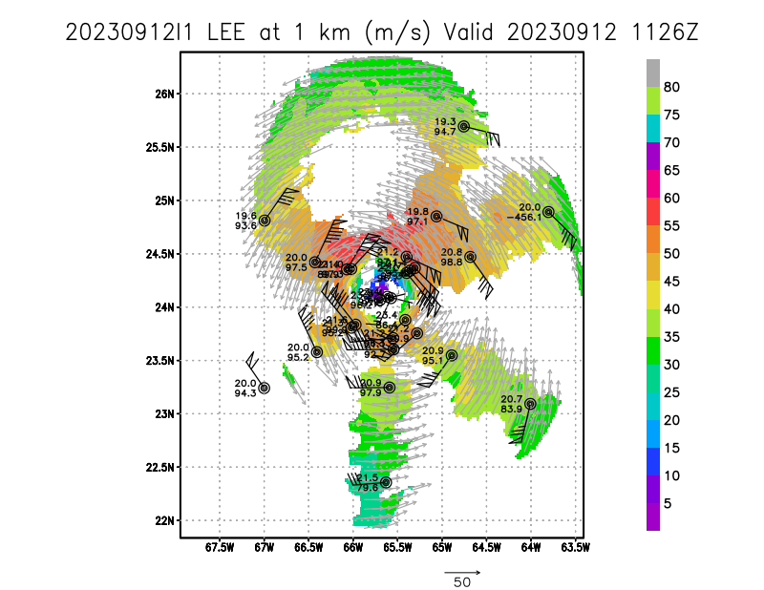
Actual Standard Pattern Flown | Butterfly
APHEX Experiments / Modules Flown | NA
Plain Language Summary | Very successful operationally tasked TDR mission:  - Produced 3 TDR analyses with radial wind files transmitted to EMC and NHC  - Produced 29 dropsondes transmitted to EMC and NHC  - On the first pass there were concentric eyewalls, however, on the 2nd and 3rd passes it appeared that the outer eyewall collapsed.
Instrument Notes | All the instruments worked well, but WSRA. Found out that the WSRA came back up late in the mission. Only available on the last leg from PT#5->6
Final Mission Track | 