MISSION PLAN
FLIGHT ID | 20230911I1 | STORM | AL13 / Lee
MISSION ID | 1613A | TAIL NUMBER | NOAA 43
TASKING | NHC-EMC TDR | PLANNED PATTERN | Butterfly pattern with 105 NM legs
MISSION SUMMARY
TAKEOFF [UTC] | 0832 | LANDING [UTC] | 1611
TAKEOFF LOCATION | TISX | LANDING LOCATION | TISX
FLIGHT TIME | 7.7 | BLOCK TIME | 7.9
TOTAL REAL-TIME RADAR ANALYSES  (Transmitted) | 4 (4) | TOTAL DROPSONDES Deployed (Transmitted) | 37 (36)
OCEAN EXPENDABLES (Type) | 8 (6) AXBT,  1 A-size wave drifter (ASWD) near Saildrone | sUAS (Type) | n/a
APHEX EXPERIMENTS / MODULES | Surface Wind & Wave Validation Mod (P-3 Pattern #4), SEF Module, CHAOS
HRD CREW MANIFEST
LPS ONBOARD | Aberson | LPS GROUND | Marks
TDR ONBOARD | Aberson | TDR GROUND | Reasor
ASPEN ONBOARD | J. Zhang/Ko | ASPEN GROUND | n/a
NESDIS SCIENTISTS | n/a
GUESTS (Affiliation) | Branka, Cappucci, (WaPost), Ryan (CIMAS), Duran (NASA/MSFC)
AOC CREW MANIFEST
PILOTS | Copare/Keith/Wood
NAVIGATOR | Utama
FLIGHT ENGINEERS | Tyson/Tufnell
FLIGHT DIRECTOR | Kalen/Lundry
DATA TECHNICIAN | Richards
AVAPS | Warneke/Kotz

PRE-FLIGHT
Flight Plan | Butterfly pattern with 105 NM legs, 8-12 kft altitude  Possible modules:  - Surface Wind and Wave Validation Module- P-3 Pattern #1 and #4  - Triangle FLAIMS Module with Secondary Eyewall Formation Module  - Stratiform Spiral Module  - In-storm location(s) for the modules may be determined/adjusted at the discretion of the onboard HRD LPS
Expendable Distribution | - 34 Dropsondes: 6 turn (NWS), 6 mid (NWS), 3 center (NWS), 6 RMW (NWS), 12 supplemental RMW (ONR), 1 MP spiral (ONR),  - 8 AXBTs  - 1 A-sized wave drifter  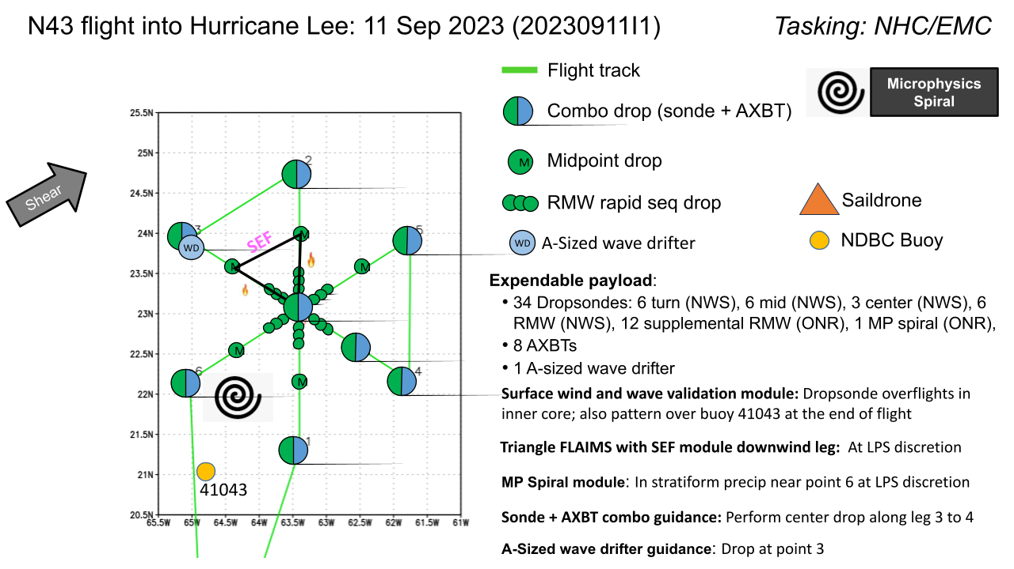
Preflight Weather Briefing | Still experiencing moderate shear  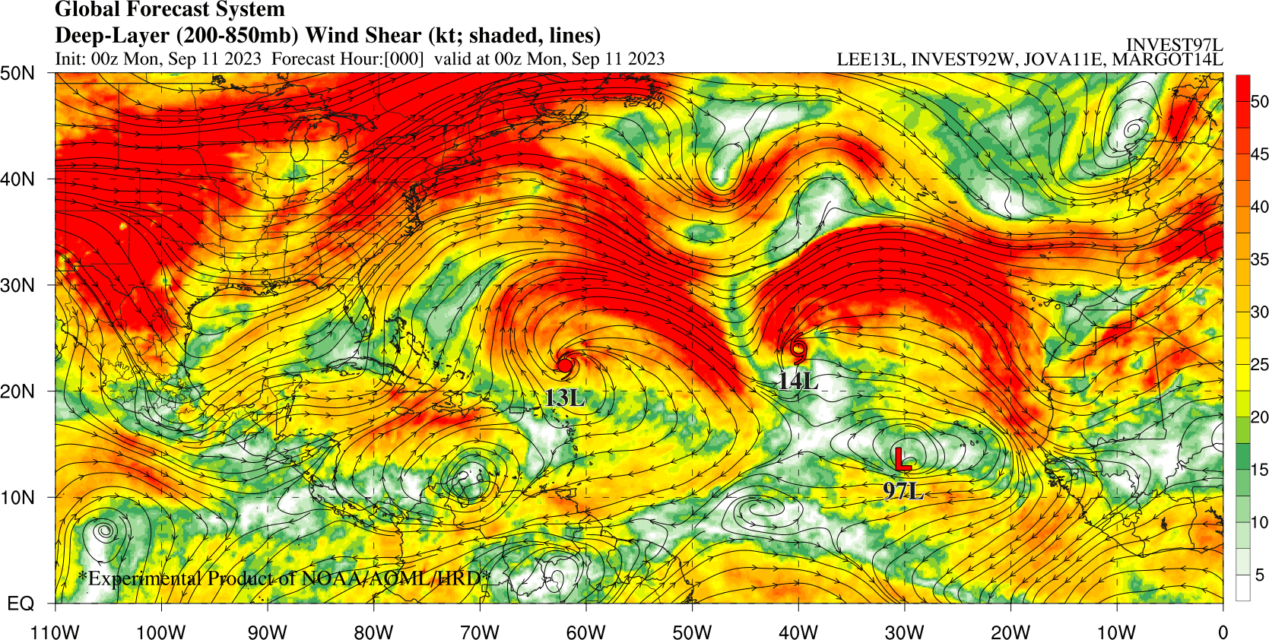  Possible Saildrone intercomparisons:  - SD-1064: 23.72056 N, 64.5412 W
Instrument Notes | All appear to be nominal

IN-FLIGHT
Time [UTC] | Event
0832 | Take-off from TISX
0913 | Satellite suggests that there is still a major wave#1 asymmetry with convective bursts starting in the NE portion of the eyewall and then rotating downwind . There also appears to be an eye, but not totally clear.  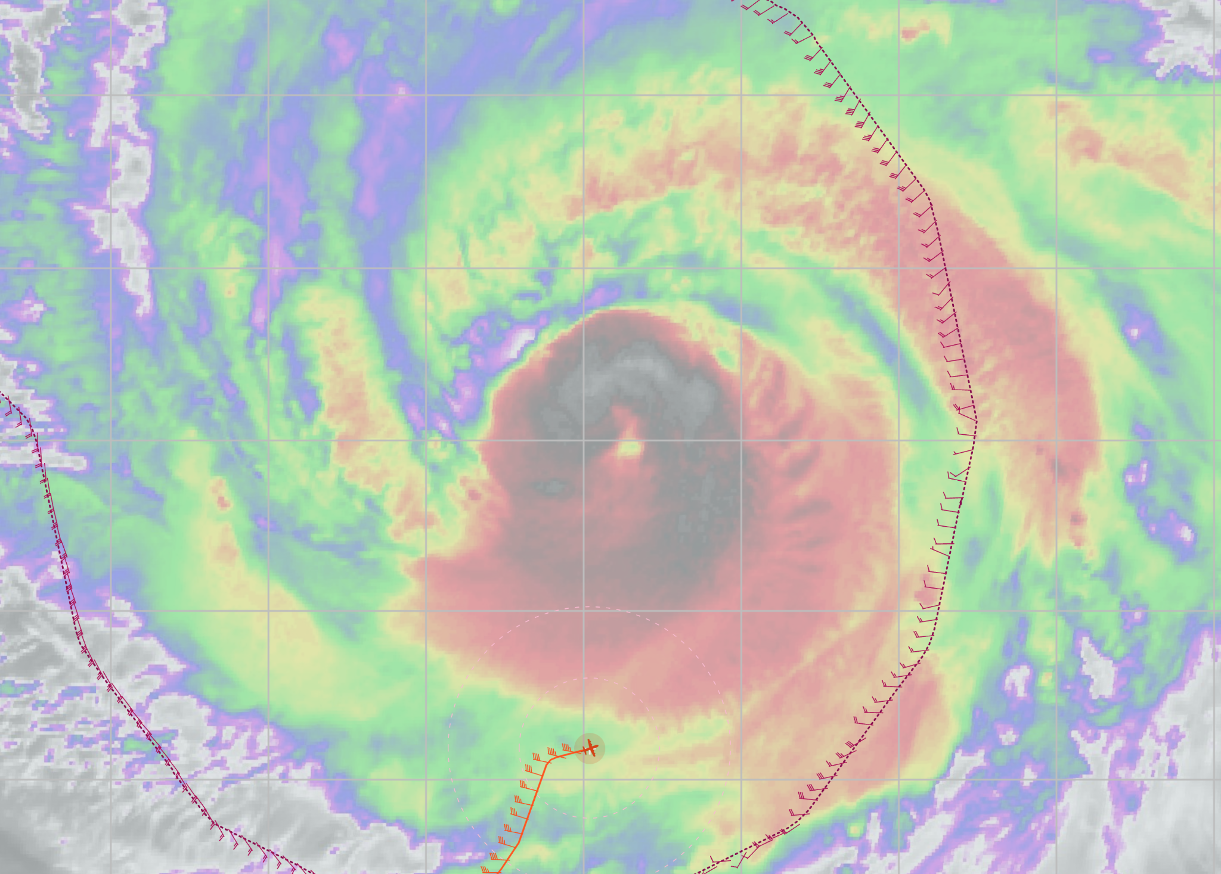
0929 | IP (PT #1) sonde/bt combo (Drop #1, AXBT #1), SST=29.28, 10 kft altitude, TK 360
0942 | Midpt sonde (Drop #2), in outer rainband (eyewall?), in area where SFMR>FL
0945 | satellite suggests the south side of the eye has the warmest tops, but the north side of the eye has a convective burst going on. Satellite shows some scalloping of the eastern edge of the CDO with fingers of cold tops tilted by the horizontal shear along the edge of the CDO. Very interesting! Seem a bit large for K-H billows, but very reminiscent of that.  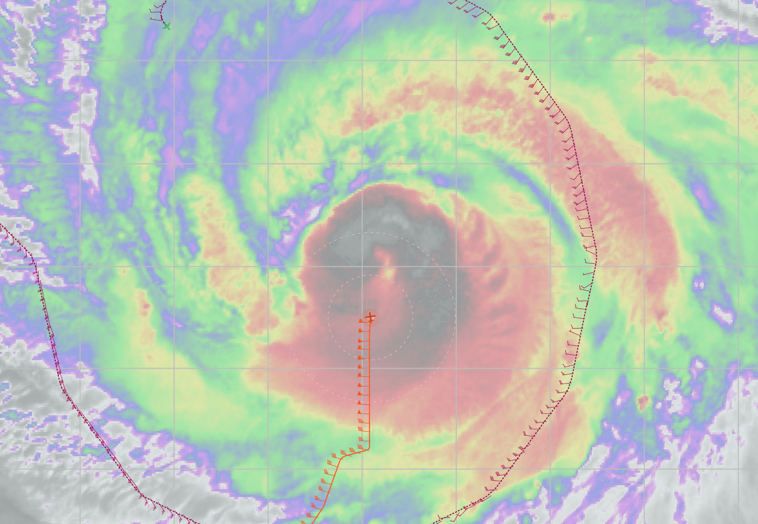
0948 | RMW sondes 1, 2 (Drops #3-4) too early
0952 | RMW sonde 3, well inside reflectivity. (Drop #5)
0955 | Center drop (Drop #6), estimated 23.1N, 62.88W, 949 hPa
0959 | 3 RMW sondes (Drops #7-9)
1008 | Midpt sonde (drop #10)
1016 | Endpt (PT #2) sonde Dop #11  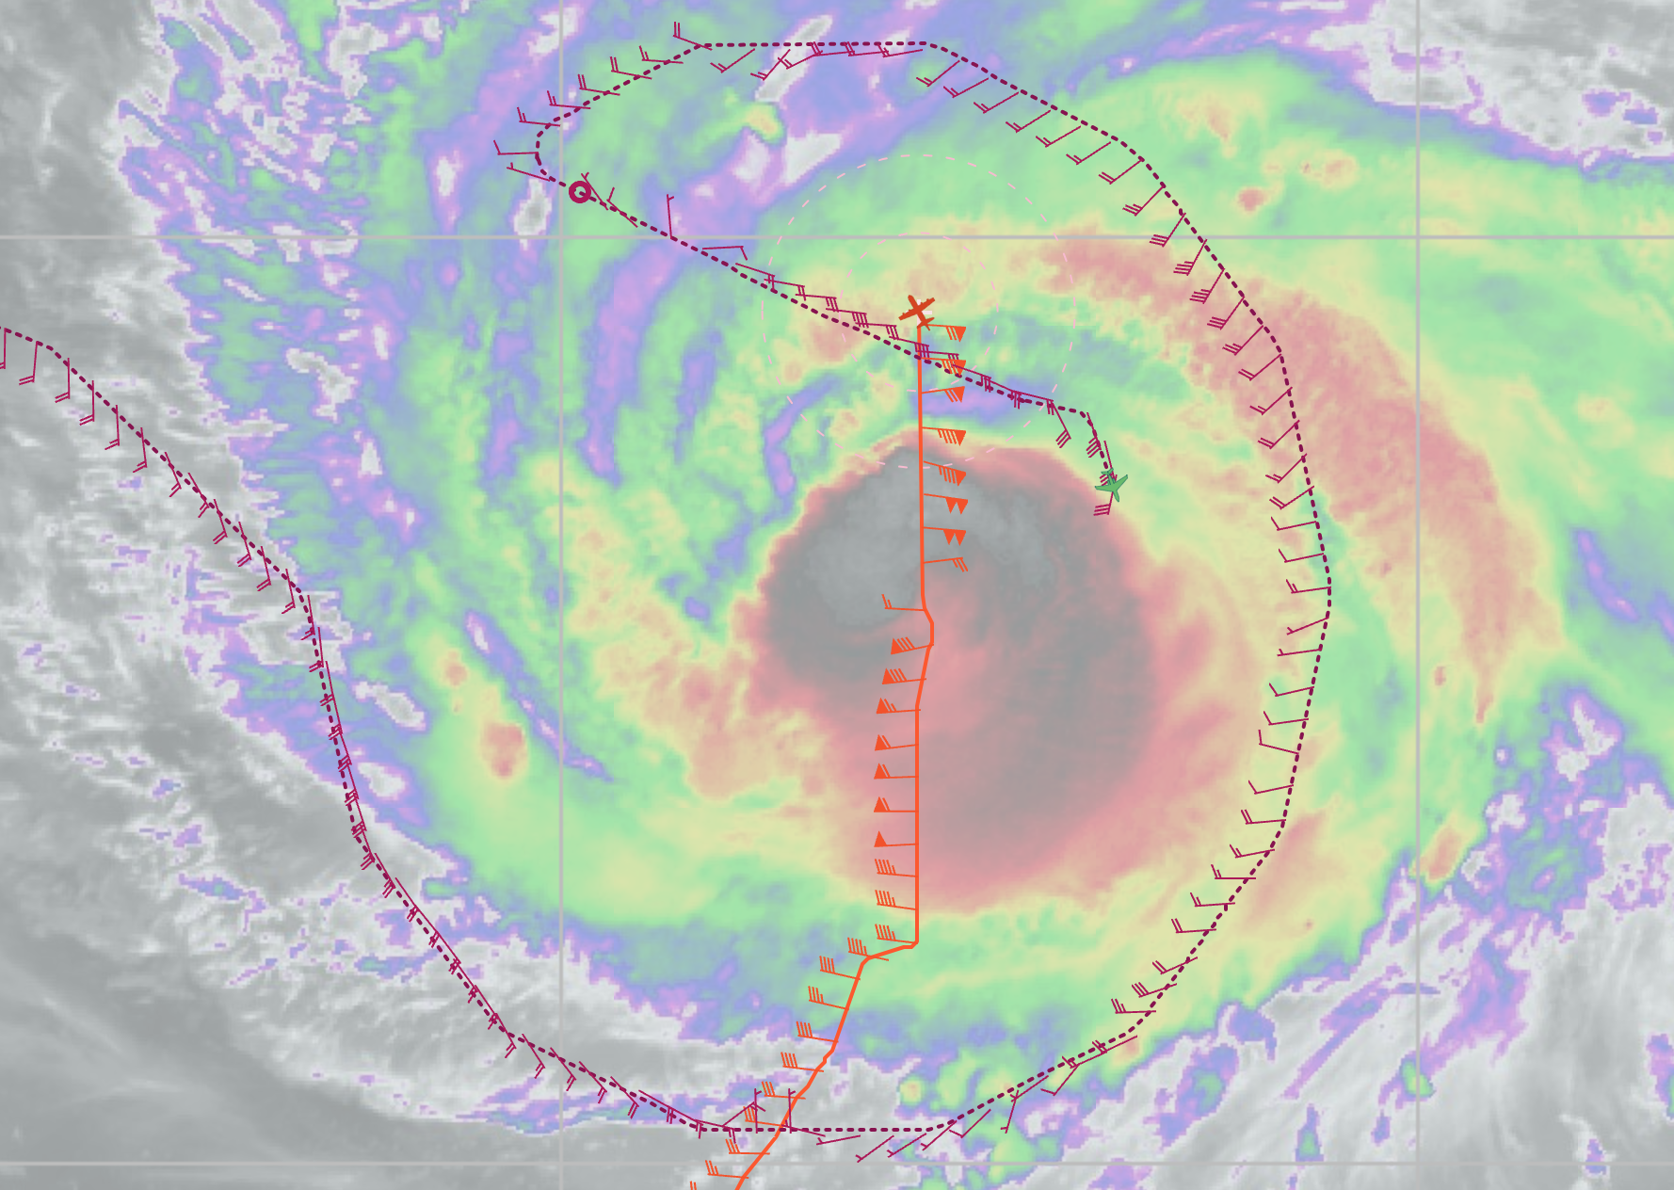
1020 | TDR analysis #1 started
1022 | BT (AXBT #2) sst=29.32
1034 | TDR analysis complete: 230911I1_0923_1016_analysis.tar  TDR center info from 230911I1_0955_xy.nc:  Alt (km) Lat (deg) Lon (deg W)  0.5 23.09 62.87  2.0 23.11 62.89  3.0 23.13 62.87  6.0 23.16 62.87  2-6-km Vortex Tilt: 6.3 km at 18 deg  Note interesting upper-level structure on north side in profile.  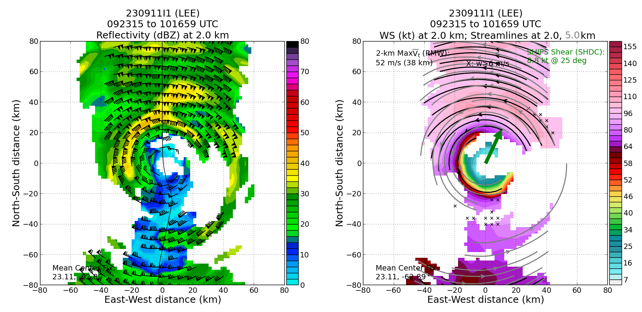  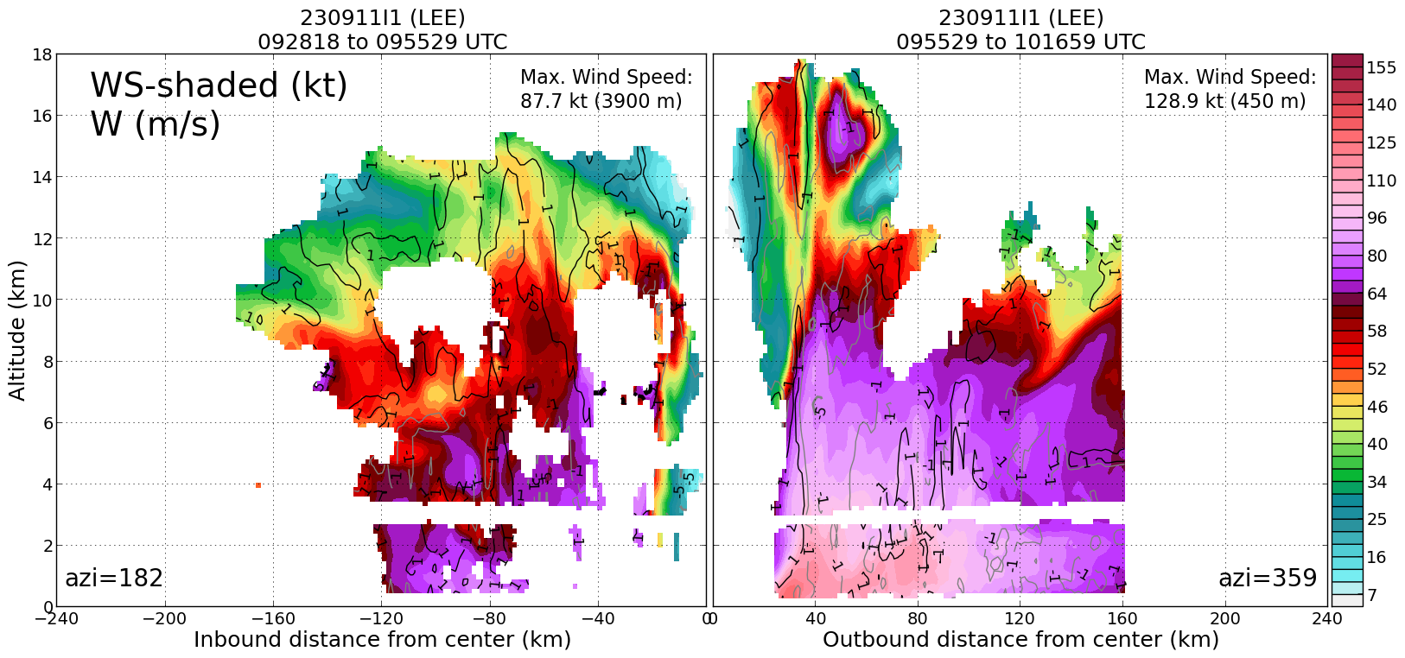
1047 | Bt (AXBT #3) and ASWD released ~20-25 nm from Saildrone, SST=28.56
1051 | Endpoint (PT #3) /Saildrone sonde (Drop #12), turn TK 135  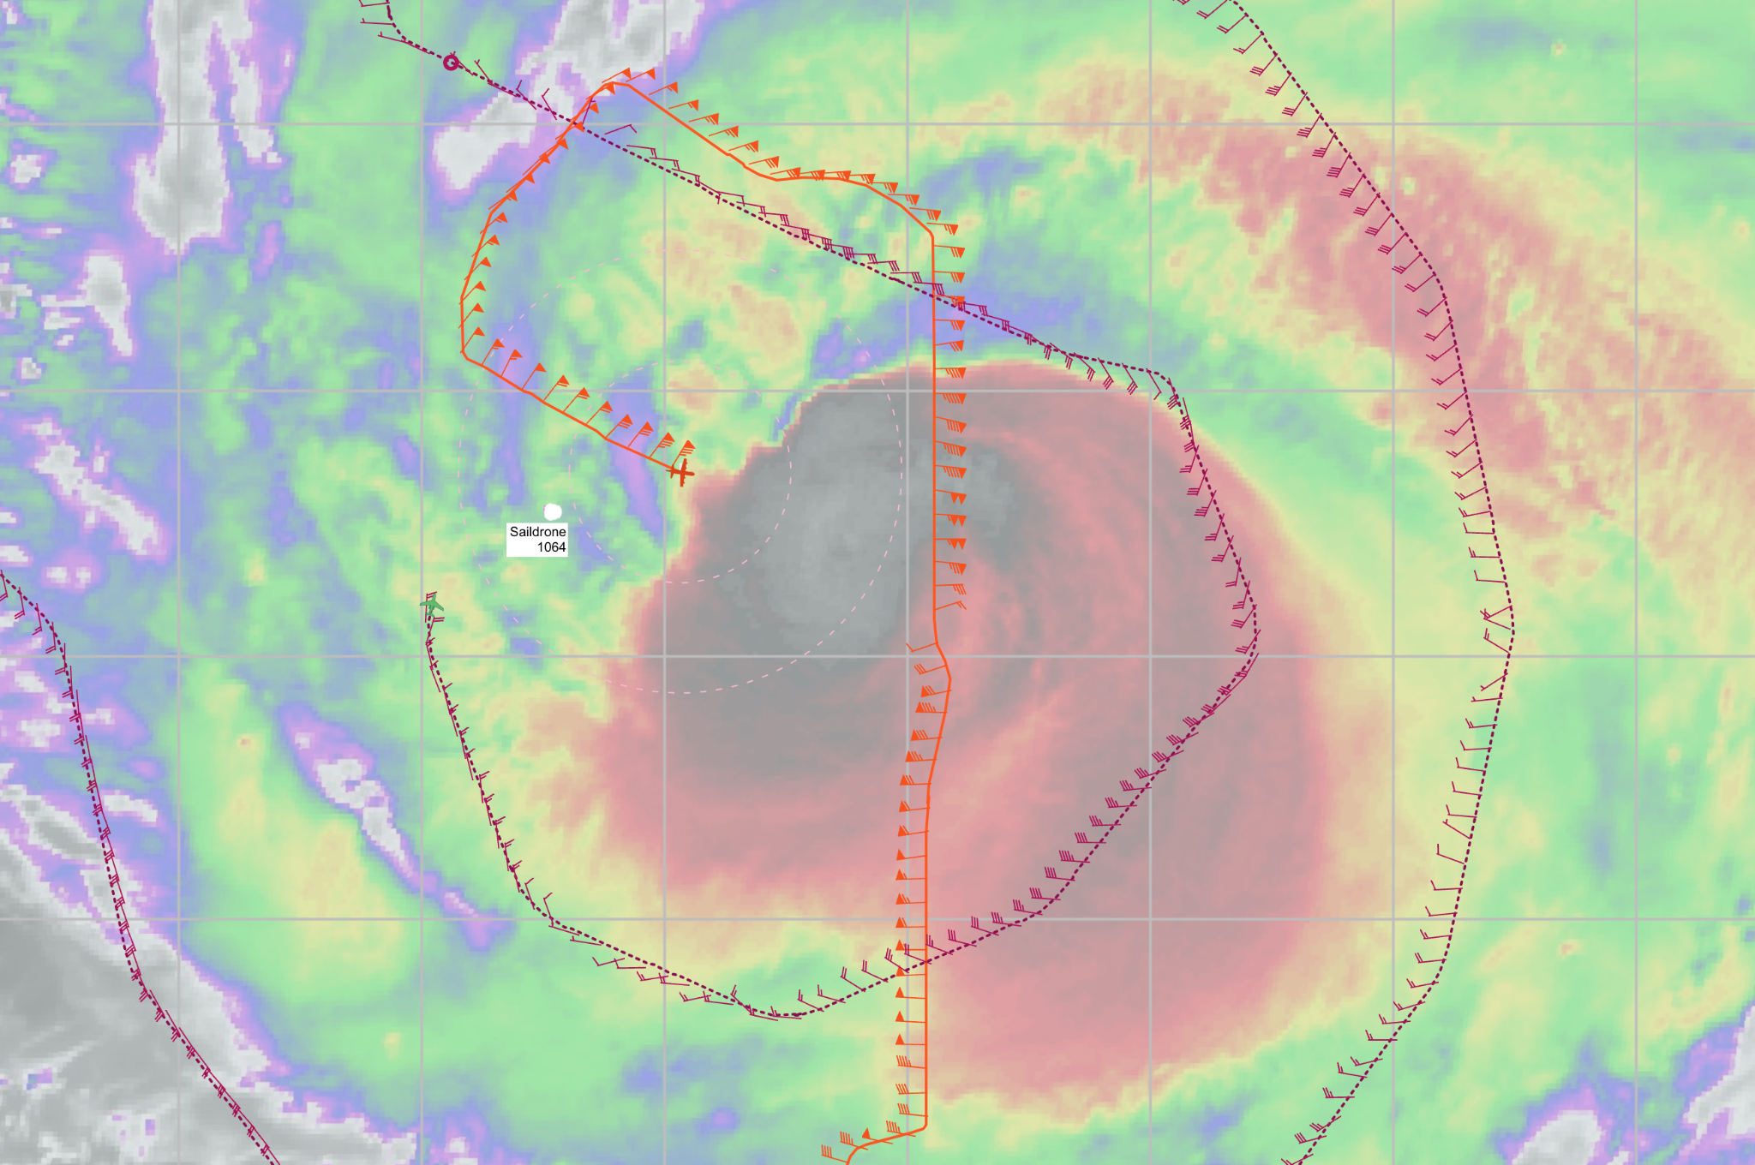
1104 | Midpt sonde (Drop #13)
1112 | RMW sonde 1 (Drop #14)
1113 | RMW sondes 2,3 (Drops #15-16)
1118 | Center combo (Drop #17, AXBT #4), estimate 23.16N, 63.1W, SST 26.56 at surface, but 28.5 or so below
1128 | RMW drop in very weak inner eyewall (Drop #18)
1135 | Midpoint sonde (Drop #19), SFMR > FL
1137 | Secondary wind max RMW sonde (Drops #20)  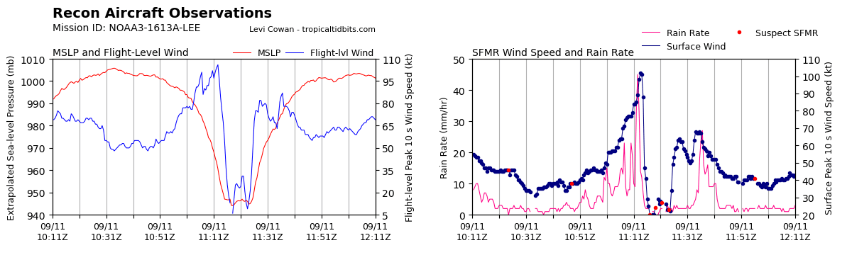
1137 | AXBT #5, sst=28.27
1151 | Endpoint (PT #4) sonde/bt combo (Drop #21, AXBT #6), TK 045, sst=27.06
1153 | TDR analysis #2 started
1206 | Picking way downwind along major rainband  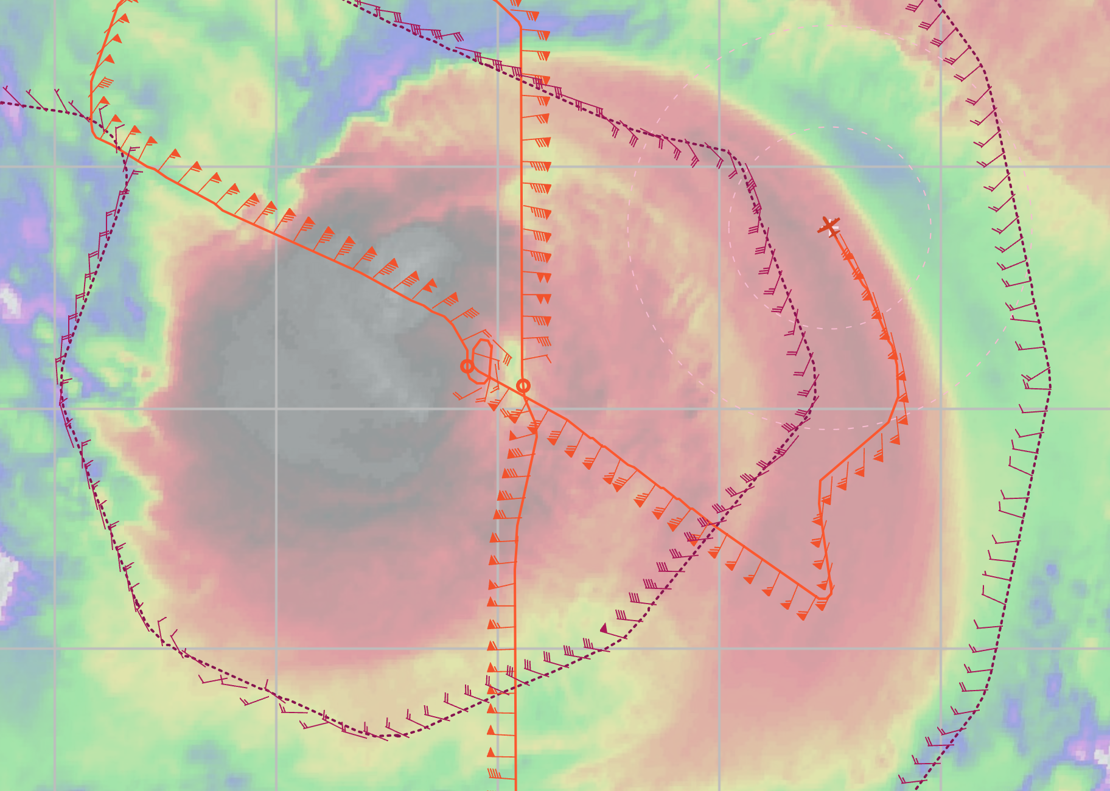
1209 | TDR analysis #2 complete:  TDR center info from 230911I1_1118_xy.nc:  Alt (km) Lat (deg) Lon (deg W)  0.5 99.99 99.99  2.0 23.19 63.13  3.0 23.20 63.11  6.0 23.22 63.11  2-6-km Vortex Tilt: 4.5 km at 27 deg  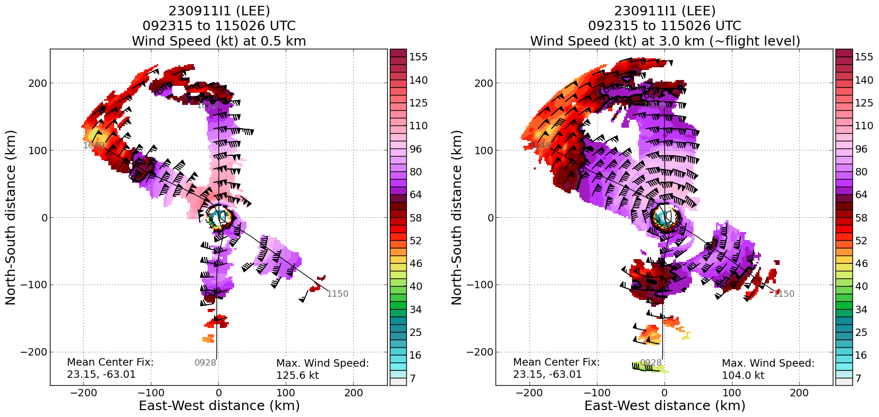  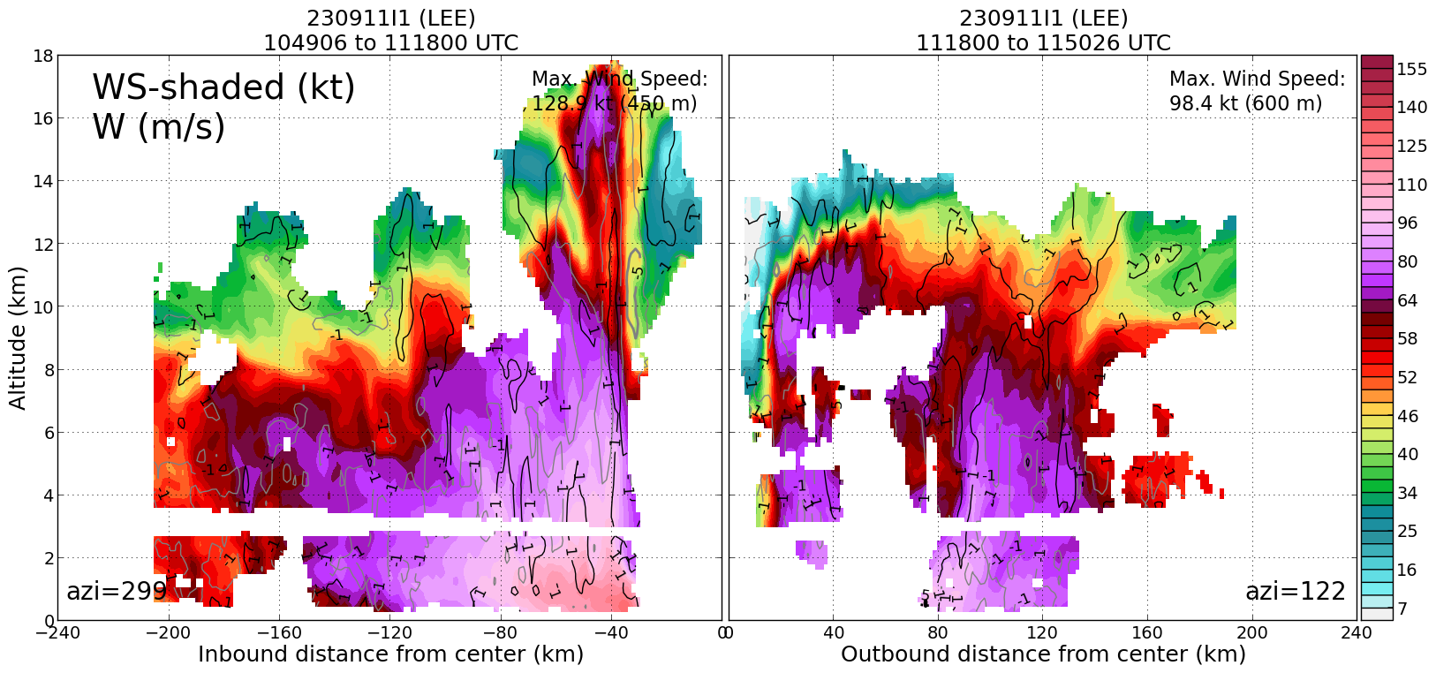
1216 | Endpoint (PT #5) sonde bt combo (Drop #22, AXBT #7)
1226 | midpt/RMW sonde 1 (Drop #23)
1227 | RMW sonde 2 (Drop #24)
1129 | RMW sonde 3, (Drop #25) well inside FL RMW, where SFMR is max
1236 | RMW drop (Drop #26) for old inner eyewall
1240 | Center drop (Drop #27), nearly complete double eyewall, TDR RZ mean shows two RMW, 1 ~35 km and 2 ~60 km  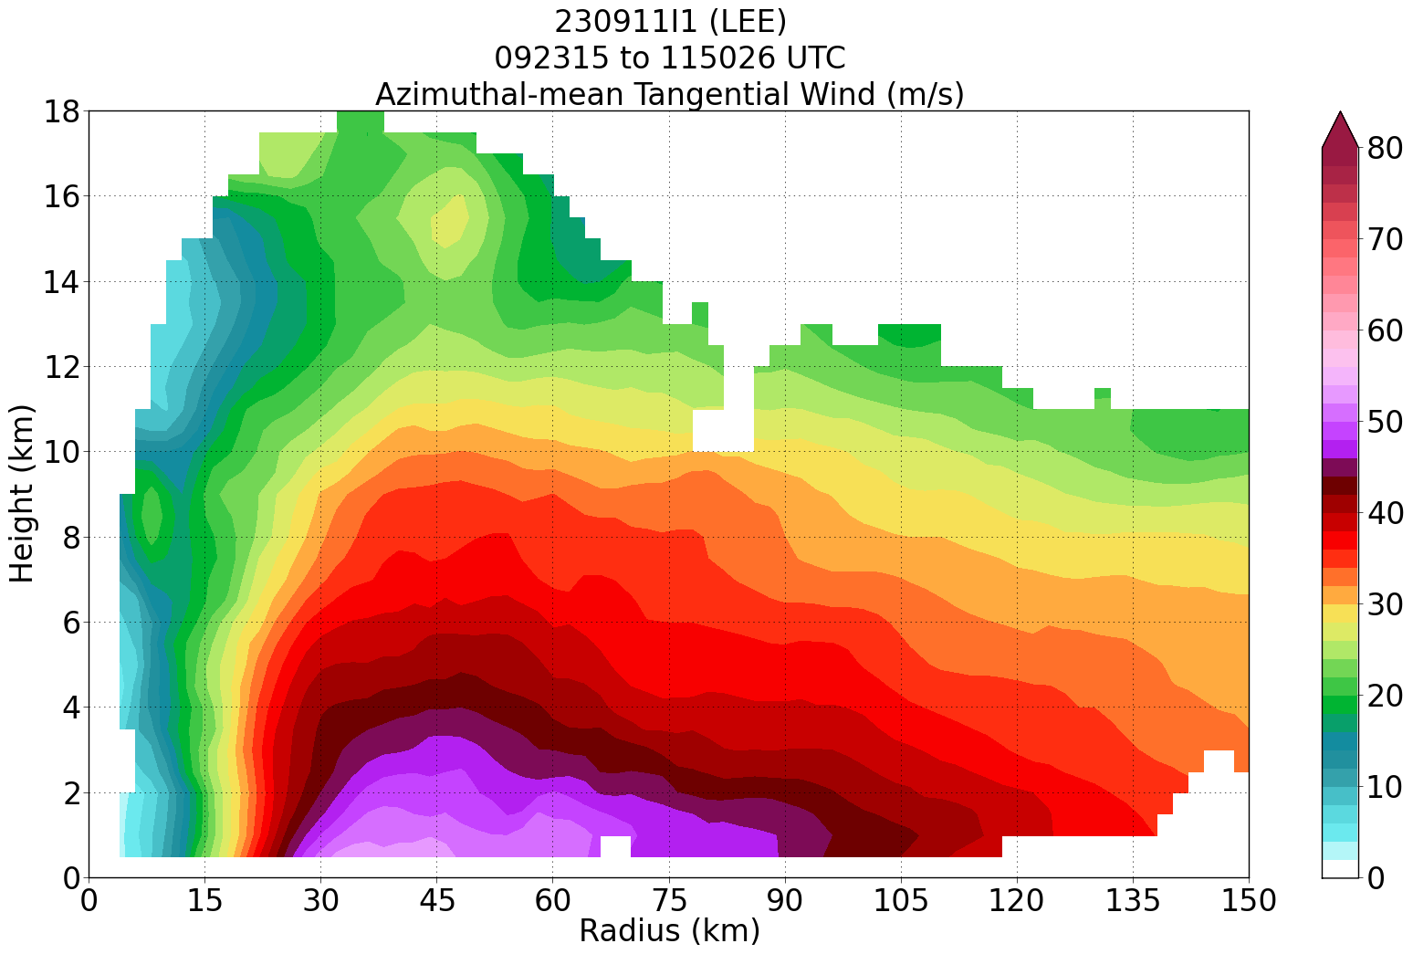
1245 | RMW sonde 1 (Drop #28) in old inner eyewall
1249 | RMW sonde 2 (Drop #29) outer eyewall
1250 | RMW sonde 3 (Drop #30)
1253 | Midpoint (Drop #31)
1303 | Endpoint (PT#6) sonde (Drop #32)
1304 | Bt, (AXBT #8) SST=29.75
1308 | TDR Analysis #3 started
1316 | Begin leg toward center to start modified version of Rainband Secondary Eyewall Formation Module by circumnavigating the moat separating the inner and outer eyewall. Dropping 4 sondes on cardinal locations within the moat.
1322 | TDR analysis #3 completed  TDR center info from 230911I1_1240_xy.nc:  Alt (km) Lat (deg) Lon (deg W)  0.5 23.18 63.26  2.0 23.20 63.28  3.0 23.20 63.28  6.0 23.22 63.28  2-6-km Vortex Tilt: 2.0 km at 0 deg  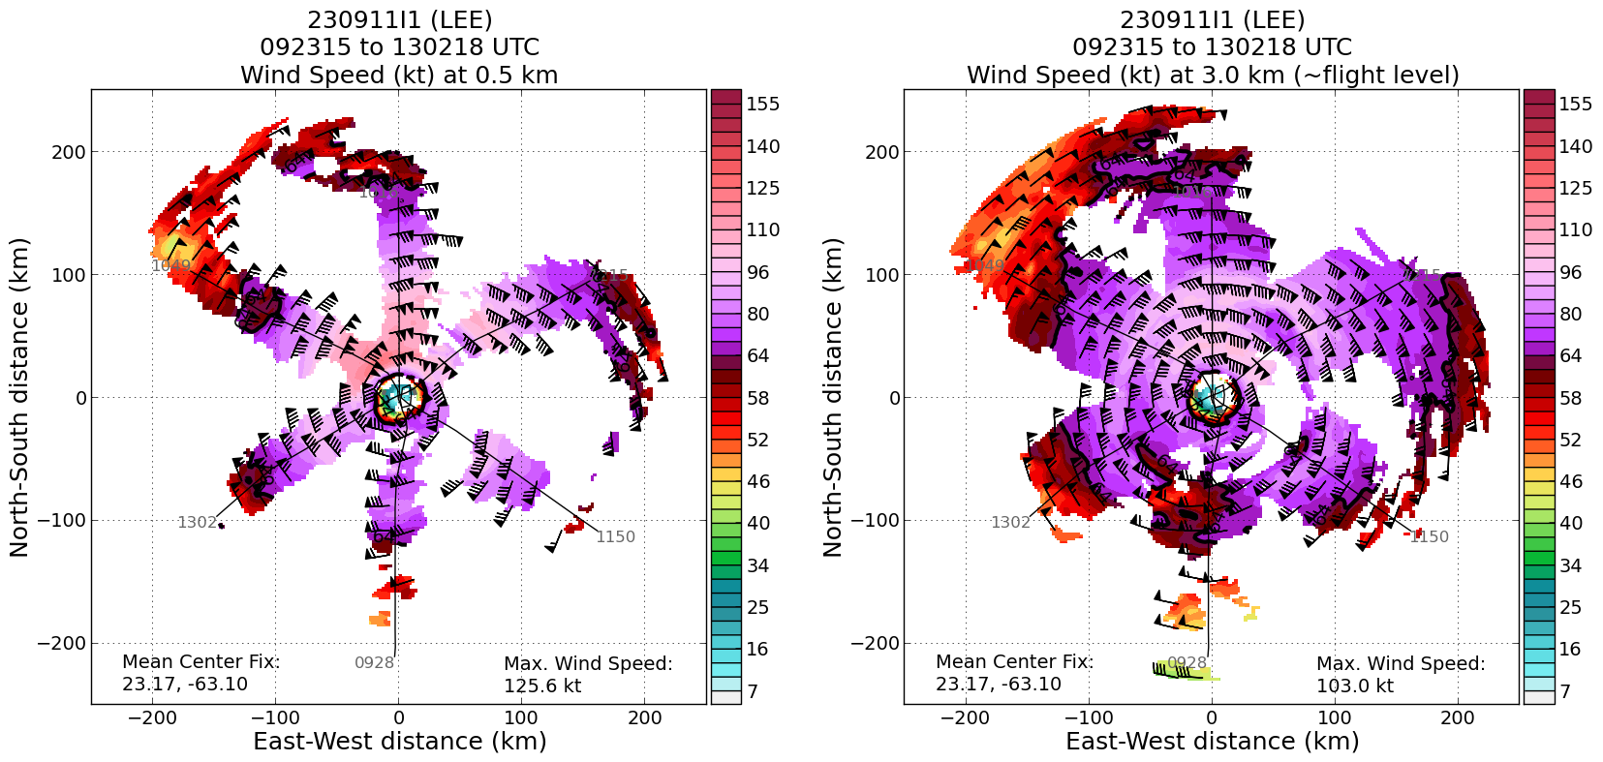  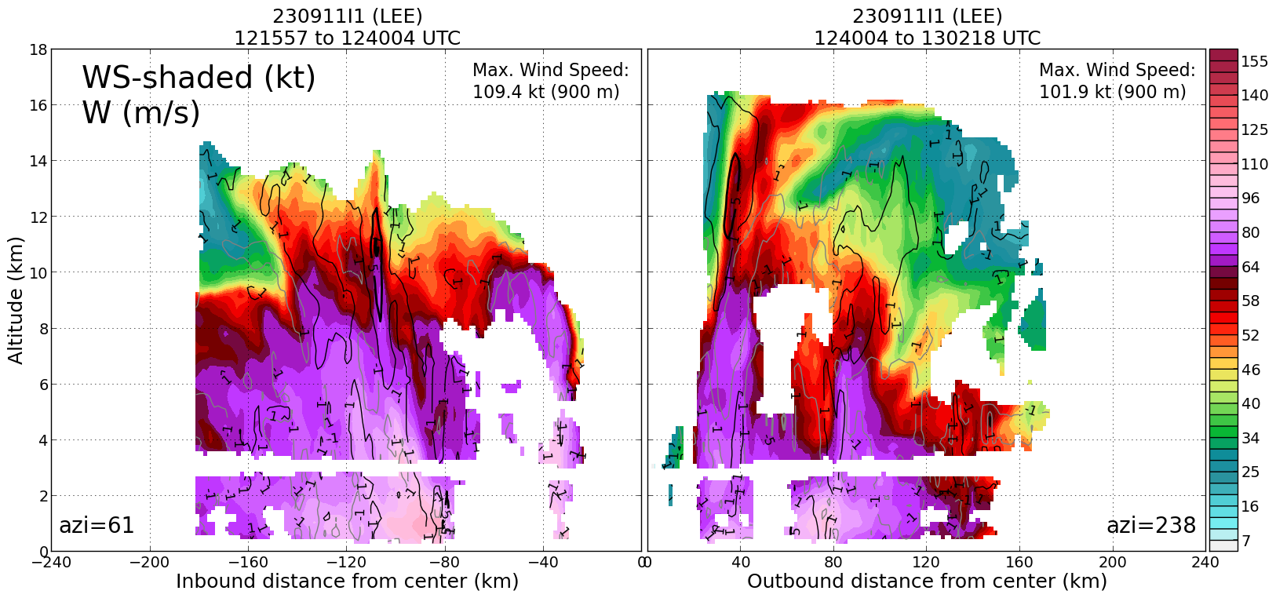
1340 | Center
1348 | South dropsonde (Drop #33)
1354 | East sonde (Drop (#34)
1404 | North sonde (drop #35)
1411 | West sonde (drop #36), only place in circumnav where SFMR wind speed approached FL
1419 | End circumnav, turn TK 180
1422 | TDR Analysis #4 started for the complete circumnav
1432 | TDR Analysis #4 complete:  TDR center info from 230911I1_1403_xy.nc:  Alt (km) Lat (deg) Lon (deg W)  0.5 23.27 63.40  2.0 23.31 63.44  3.0 23.32 63.44  6.0 23.34 63.42  2-6-km Vortex Tilt: 4.5 km at 27 deg  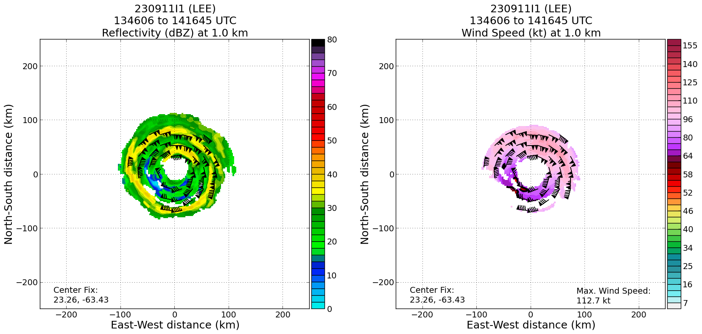  Very clear double eyewall structure in the vorticity field from circumnav  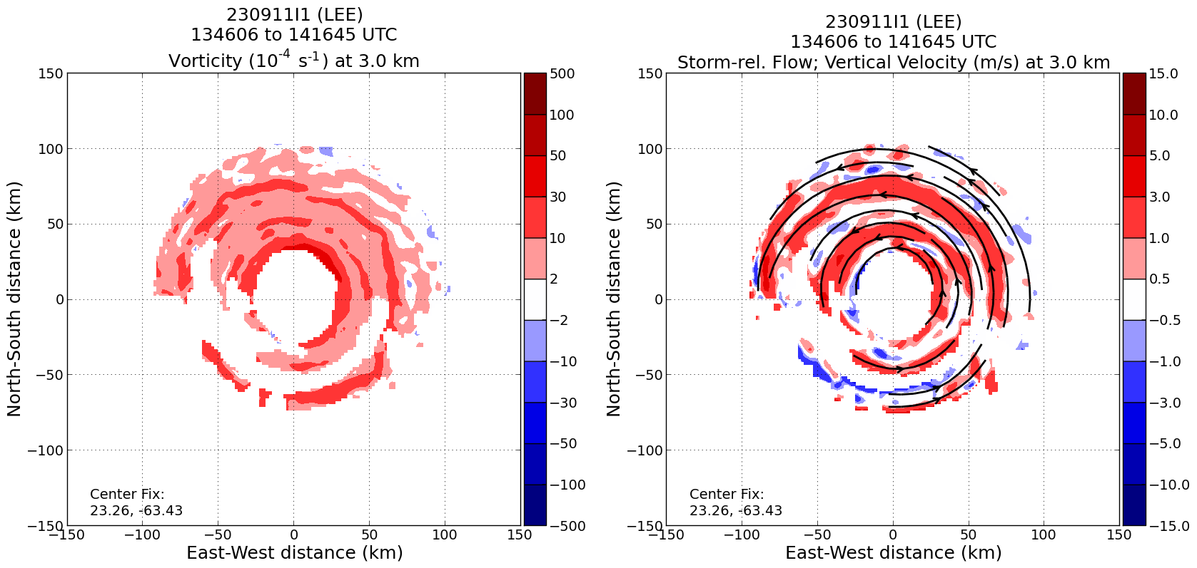  Looking at the vorticity/w analysis for 9 km altitude there is a large area of >10 m/s updraft right where the deep precipitation is suggesting that there is still some decent mass flux in that inner eyewall. It seemed to diminish on the 3rd butterfly pass, but then it appears to still be pulsing. Satellite animation suggests that another burst is ongoing in the inner eyewall on the north side. This might explain the high Vt values way up near 16 km we have been seeing in the bursts the last two days. The circumnav likely picked up the ongoing burst up as it was passing through the melting level, see 6 km.
1437 | TK to overfly buoy 41043 for Surface Wind and Wave Validation Module, Pattern #4
1453 | Attempting to overfly buoy, but rainband overhead
1501 | Start buoy pattern
1504 | First buoy sonde (Drop #37)
1523 | Ending attempted buoy overflight. Too much precip to successfully execute the module. Heading to TISX
1611 | Land TISX

POST-FLIGHT
Mission Summary | - Executed the butterfly pattern as planned, including Saildrone intercomparison by dropping a sonde, BT, and ASWD 17 nmi from the Saildrone  - Executed a modified Secondary Eyewall module while the storm had a picturesque double eyewall, flying a circumnav within the moat between the two eyewalls, dropping 4 sondes at the cardinal locations around the storm  - Looking at the vorticity/w analysis from the circumnav for 9 km altitude there was a large area of >10 m/s updraft right where the deep precipitation was observed in the TDR analysis suggesting that there is still some decent mass flux in the inner eyewall. The inner eyewall seemed to diminish on the 3rd butterfly pass, but then it appeared to still be pulsing. Satellite animation suggested that another burst was ongoing in the inner eyewall on the north side during the circumnav. The circumnav likely picked up the ongoing burst as it was passing through the melting level, 6 km altitude.  - This convective burst activity might explain the high Vt values way up near 16 km we have been seeing in the north eyewall the last two days.  - Excellent TDR and dropwindsonde coverage  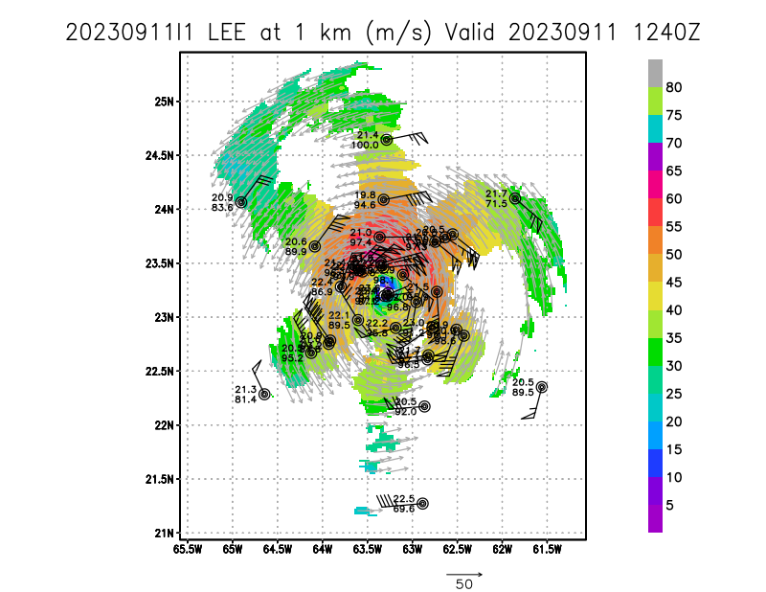
Actual Standard Pattern Flown | - Butterfly pattern with 105 NM leg
APHEX Experiments / Modules Flown | - Modified version of Rainband Secondary Eyewall Formation Module by circumnavigating the moat separating the inner and outer eyewall.  - Surface Wind and Wave Validation Module, Pattern #4 over buoy 41043
Plain Language Summary | Very successful operationally tasked TDR mission:  - Produced 4 TDR analyses with radial wind files transmitted to EMC and NHC  - Produced 37 dropsondes transmitted to EMC and NHC  - Completed Rainband Secondary Eyewall Module when Lee had a beautiful double eyewall sampling the moat between the two eyewalls  - Captured explosive convective bursts in decaying inner eyewall with echo tops >18 km altitude and large areas of >10 m/s updrafts at 8-9 km altitude
Instrument Notes | Appears WSRA might have shut down midflight
Final Mission Track | 