MISSION PLAN
FLIGHT ID | 20230910I2 | STORM | AL13/LEE
MISSION ID | 1413A | TAIL NUMBER | NOAA-43
TASKING | EMC-NHC | PLANNED PATTERN | Butterfly
MISSION SUMMARY
TAKEOFF [UTC] | 2028 | LANDING [UTC] | 0409
TAKEOFF LOCATION | STX | LANDING LOCATION | STX
FLIGHT TIME | 7.7 | BLOCK TIME | 7.9
TOTAL REAL-TIME RADAR ANALYSES  (Transmitted) | 5 (5) | TOTAL DROPSONDES Deployed (Transmitted) | 37 (24)
OCEAN EXPENDABLES (Type) | 3 (3) AXBT | sUAS (Type) | n/a
APHEX EXPERIMENTS / MODULES | Surface Wind and Wave Validation (dropsonde overflights)
HRD CREW MANIFEST
LPS ONBOARD | Hazelton | LPS GROUND | Rogers
TDR ONBOARD | Hazelton | TDR GROUND | Gamache
ASPEN ONBOARD | Sellwood | ASPEN GROUND | Hathaway
NESDIS SCIENTISTS | Jelenak
GUESTS (Affiliation) | n/a
AOC CREW MANIFEST
PILOTS | Doremus/Rannenberg/Palmer
NAVIGATOR | Hough
FLIGHT ENGINEERS | Stokes/Gee
FLIGHT DIRECTOR | Zawislak/Parrish
DATA TECHNICIAN | McAlister
AVAPS | Santoni/Waggoner

PRE-FLIGHT
Flight Plan | 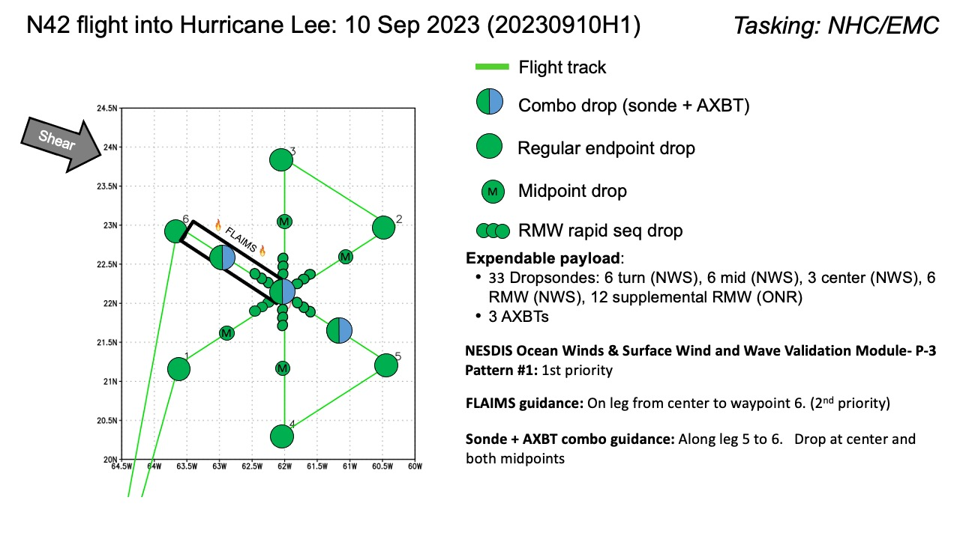  Butterfly with possible add ons of surface wind validation  Because of a failure of the MMR on N42, this mission is now being flown on N43. Since there are no Ocean Winds instruments on N43, that module will not be flown. However, FLAIMS and the surface wind/wave validation are still candidate modules.  There is a glider just beyond the NW leg. N43 will extend its NW leg to overfly the glider. No sonde is requested there, however.
Expendable Distribution | Dropsondes endpoints, midpoints, 3X RMW, Centers, and for overflights. BTs Endpoints and Center along final leg.
Preflight Weather Briefing | Lee continues to be dealing with moderate southwesterly shear. The storm is situated along a sharp shear gradient, with strong shear further northeast of the storm center. Over the center itself there appears to be about 20 kt of shear.  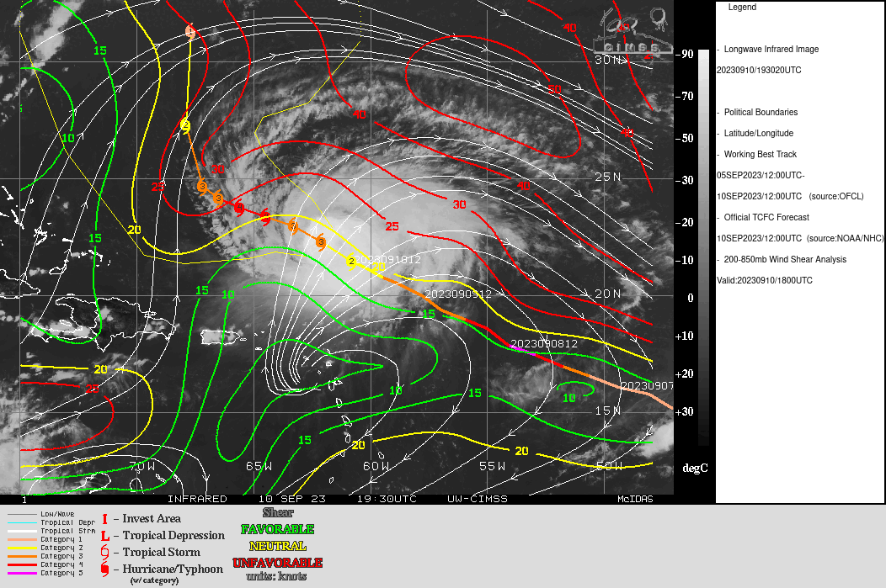  There also appears to be substantial mid- to upper-level dry air surrounding Lee.  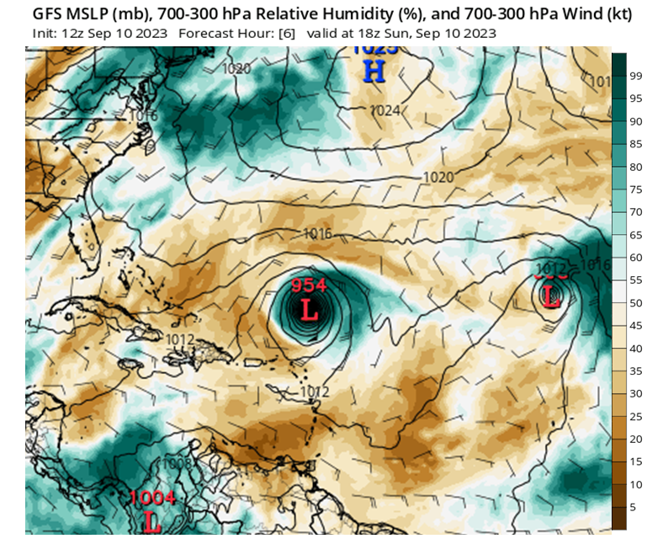  Despite these inhibiting factors, Lee appears to be trying to re-strengthen after completing an eyewall replacement cycle. The eye appears to be popping back out and convection is wrapping around most of the eyewall. The Air Force plane just exiting the storm found winds over 100 kt again, and the pressure is starting to fall.  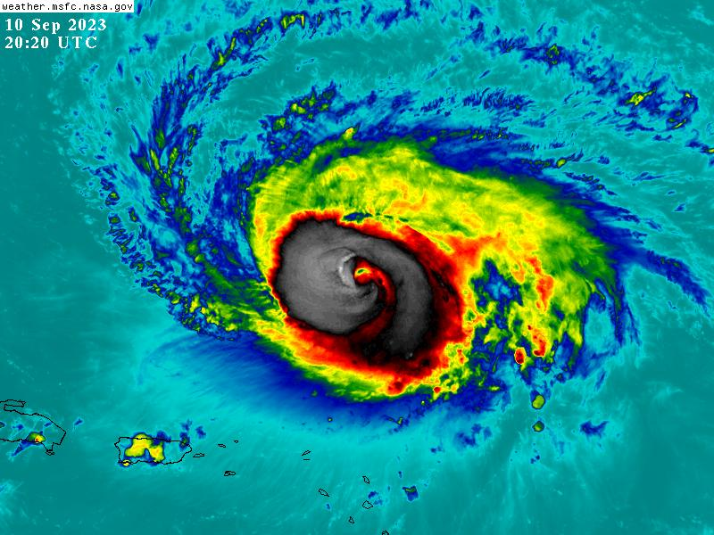  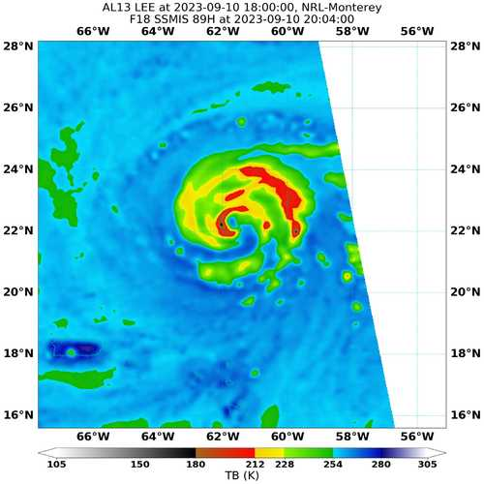  Most recent microwave overpass shows an inner eyewall open on the southeast side and multiple bands wrapping from the west clockwise around toward the north and east sides. Appears that they connect to the primary eyewall in the downshear left quadrant, as expected. Greatest amount of ice scattering, indicative of deep convection, is on the upwind (east) end of the outer band, becoming higher brightness temperature, suggesting a transition to more stratiform precipitation, on the downwind end of the band (north and northwest). Again, this is expected in a southwesterly shear environment.
Instrument Notes | Instruments appear to be working normally.

IN-FLIGHT
Time [UTC] | Event
2028 | Take-off from STX
2128 | Sonde 1, SW endpt, at IP
2139 | IR animation during inbound leg shows structure very similar to yesterday – bursting of convection starting downshear, broad shield of cold cloud tops on southwest side (upshear). Shield may be a bit more expansive and persistent today than yesterday.
2140 | On inbound leg, onboard LPS says wind field clearly has expanded since yesterday, encountering 30 m/s winds beyond 50 nm from center. More rain on the SW side than yesterday, suggesting shear has relaxed a bit. Also consistent with IR animation showing more expansive and persistent shield upshear.
2141 | Sonde 2, SW midpt
2148 | Visible animation shows convective bursts erupting on the west and southwest sides. Perhaps some mesovortices as well, but radar will give a better indication of that.
2152 | Sonde 3, 1st SW RMW
2153 | Sonde 4, 2nd SW RMW
2154 | Sonde 5, 3rd SW RMW
2156 | Sonde 6, center
2200 | Sonde 7, 1st NE RMW
2200 | Sonde 8, 2nd NE RMW
2201 | Sonde 9, 3rd NE RMW
2210 | Sonde 10, NE midpt
2210 | Limited lightning seen on MTS and visually, a single flash reported by aircraft
2216 | Flight-level wind peak reported near the midpoint on the NE
2218 | Ending outbound leg early to avoid a band, turning downwind, ended leg at about 100 nm
2218 | Sonde 11, NE endpt
2232 | On downwind leg, reporting 70 kt FL
2242 | Sonde 12, N endpt
2254 | On inbound leg, multiple local wind maxima indicative of lots of banding  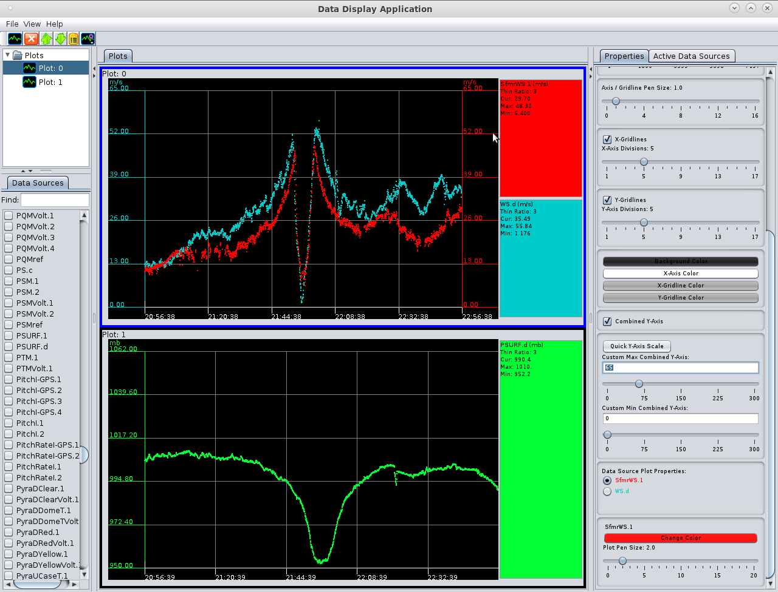
2255 | Sonde 13, N midpt. Big flight-level wind spike.
2303 | Profile analysis from the first leg (SW-NE) shows a broad wind field on NE side. Radial flow features show mid- to upper-level inflow, and lower-level outflow on the SW side. Classic signature of a vortex in shear (SWerly shear)  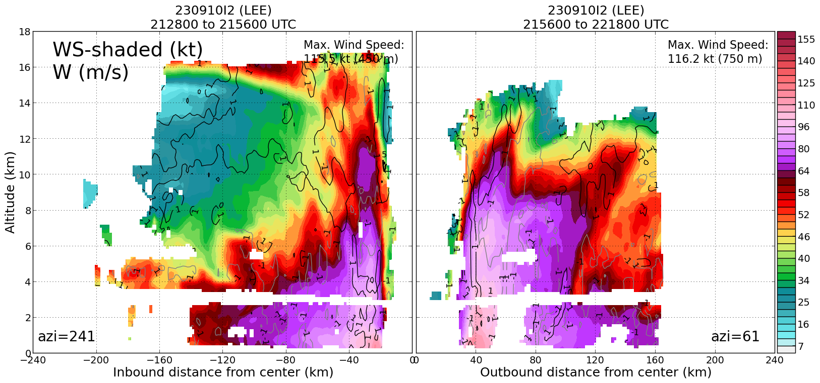  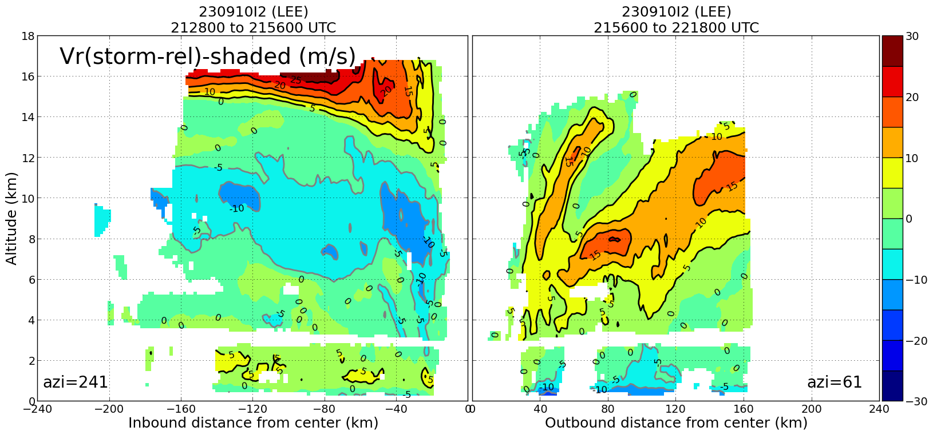
2304 | RMW Sonde 14
2305 | RMW Sonde 15
2305 | RMW Sonde 16
2308 | Center Sonde 17
2311 | RMW Sonde 18
2312 | RMW Sonde 19
2313 | RMW Sonde 20
2321 | Midpoint Sonde 21
2322 | Midpoint Sonde 22 (Backup)
2333 | Endpoint Sonde 23, turning downwind
2353 | Endpoint Sonde 24, inbound SE
0000 | Taking some bumps in an outer band
0005 | Midpoint Sonde 25, Combo Drop
0012 | RMW Sonde 26
0013 | RMW Sonde 27
0013 | RMW Sonde 28
0014 | Center BT Released
0018 | Center Sonde 29
0021 | RMW Sonde 30
0021 | RMW Sonde 31
0022 | RMW Sonde 32
0033 | Midpoint Sonde 33, Combo Drop
0046 | Endpoint Sonde 34
0053 | Noticed an SFMR rain spike with slight wind dropout in an outer band  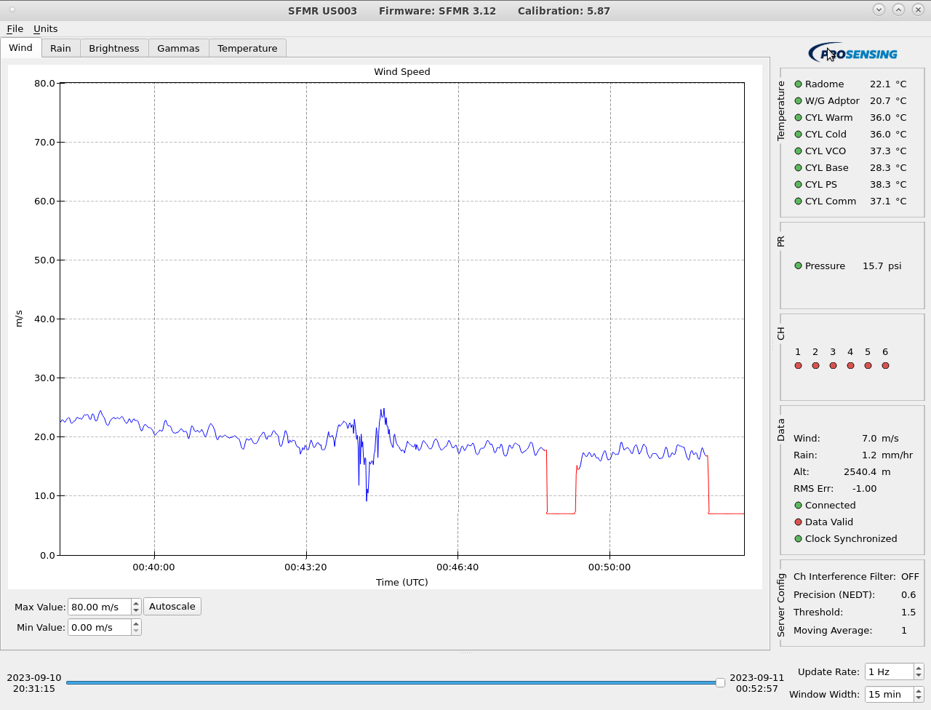  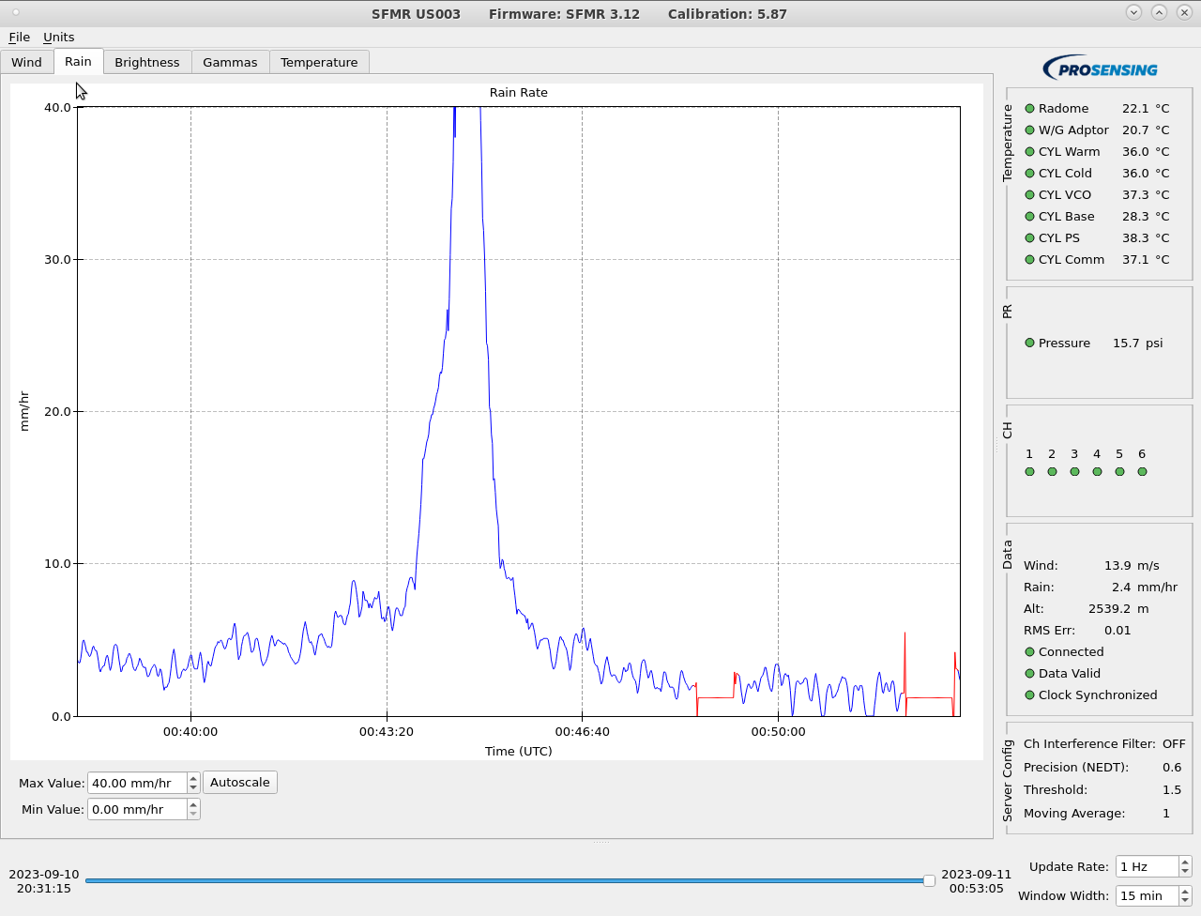
0056 | Turning back inbound to do some overflight module action
0059 | Overflew drifter
0115 | Analysis of tilt from first two passes shows vortex is aligned, with tilt values < 10 km up to 12 km altitude. Slight anticylonic rotation with height, DSL.  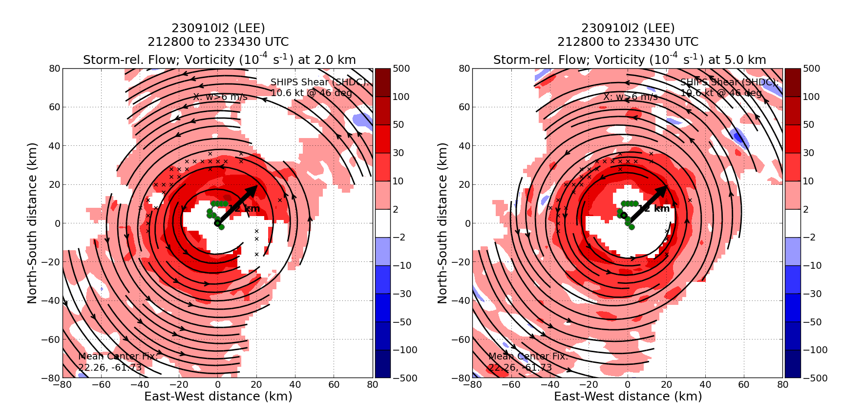
0125 | Eye has been contracting over the course of the mission, now a 20 nm diameter
0138 | RMW sonde 35 for overflight
0213 | Heading downwind in a moat region to set up a 170 inbound for next overflight
0219 | Turning inbound 170 for 2 more sondes for overflight
0229 | RMW sonde 36 for overflight
0229 | RMW sonde 37 for overflight
0251 | Heading west for 2nd drifter overflight then RTB
0258 | Second drifter overflight
0302 | Science Complete
 | << INSERT ADDITIONAL ROW AS NEEDED >>

POST-FLIGHT
Mission Summary | We completed a successful mission into Hurricane Lee. The storm appeared to be strengthening some during the mission, although there were still some shear-relative asymmetries apparent.  We also did an overflight of a drifter in the NW quadrant on the way out NW after the initial TDR pattern, and another one heading out west after completion of inner core modules.  We did two sonde overflights for surface wind validation, one in the NE and one in the NW quadrants.
Actual Standard Pattern Flown | Butterfly
APHEX Experiments / Modules Flown | Surface winds validation with sonde overflights
Plain Language Summary | - We flew a successful mission into Hurricane Lee during a strengthening phase.  - We collected radar data for model assimilation and also performed science modules to study surface wind measurements.
Instrument Notes | Instruments seemed to work normally
Final Mission Track | 