MISSION PLAN
FLIGHT ID | 20230910I1 | STORM | AL13 / Lee
MISSION ID | 1113A LEE | TAIL NUMBER | NOAA43
TASKING | EMC | PLANNED PATTERN | Butterfly pattern with 105 NM legs
MISSION SUMMARY
TAKEOFF [UTC] | 0836 | LANDING [UTC] | 1637
TAKEOFF LOCATION | St. Croix | LANDING LOCATION | St. Croix
FLIGHT TIME | 8.0 | BLOCK TIME | 8.3
TOTAL REAL-TIME RADAR ANALYSES  (Transmitted) | 6 (6) | TOTAL DROPSONDES Deployed (Transmitted) | 39 (38)
OCEAN EXPENDABLES (Type) | 3 ONR AXBT (1 bad),  1 MicroSWIFT | sUAS (Type) | n/a
APHEX EXPERIMENTS / MODULES | - Surface Wind and Wave Validation Module- P-3 Pattern #1 (Priority 1)  - FLAIMS Module (Priority 2)  - Stratiform Spiral Module (Priority 3)  - TDR Dual-PRF module  - In-storm location(s) for the modules may be determined/adjusted at the discretion of the onboard HRD LPS
HRD CREW MANIFEST
LPS ONBOARD | Aberson | LPS GROUND | Marks
TDR ONBOARD | Aberson | TDR GROUND | Reasor
ASPEN ONBOARD | J. Zhang/Ko | ASPEN GROUND | n/a
NESDIS SCIENTISTS | n/a
GUESTS (Affiliation) | Ryan (CIMAS), Duran (NASA/MSFC), Scotland, Knox-Limbacker, Walters
AOC CREW MANIFEST
PILOTS | Copare/Keith/Wood
NAVIGATOR | Utama
FLIGHT ENGINEERS | Tyson/Tufnell
FLIGHT DIRECTOR | Kalen/Lundry
DATA TECHNICIAN | Richards
AVAPS | Warneke/Kotz

PRE-FLIGHT
Flight Plan | Butterfly pattern with 105 NM legs  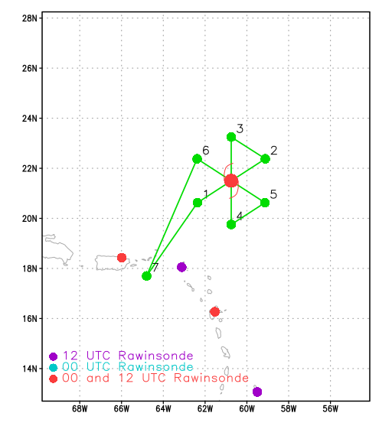  - 8-12 kft (pressure altitude) depending on AF deconfliction requirements
Expendable Distribution | - Load 40 dropsondes  - Release at endpoints, midpoints, centers, RMWs (NHC)  - Possible drops for Surface Wind and Wave Validation Module (HRD)  - Possible supplemental rapid RMW drops (ONR)  - Possible drops at top of the Microphysics Spiral (ONR)  - Additional drops may be requested at the discretion of the onboard HRD LPS  - All dropsondes transmitted to the GTS  - 3 AXBTs - see notes below  - All AXBTs transmitted to the AOC ground server if possible  - 1 microSWIFT wave buoy - see notes below  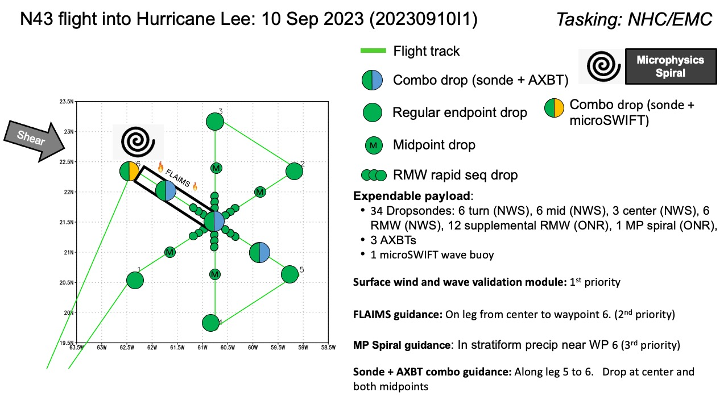
Preflight Weather Briefing | 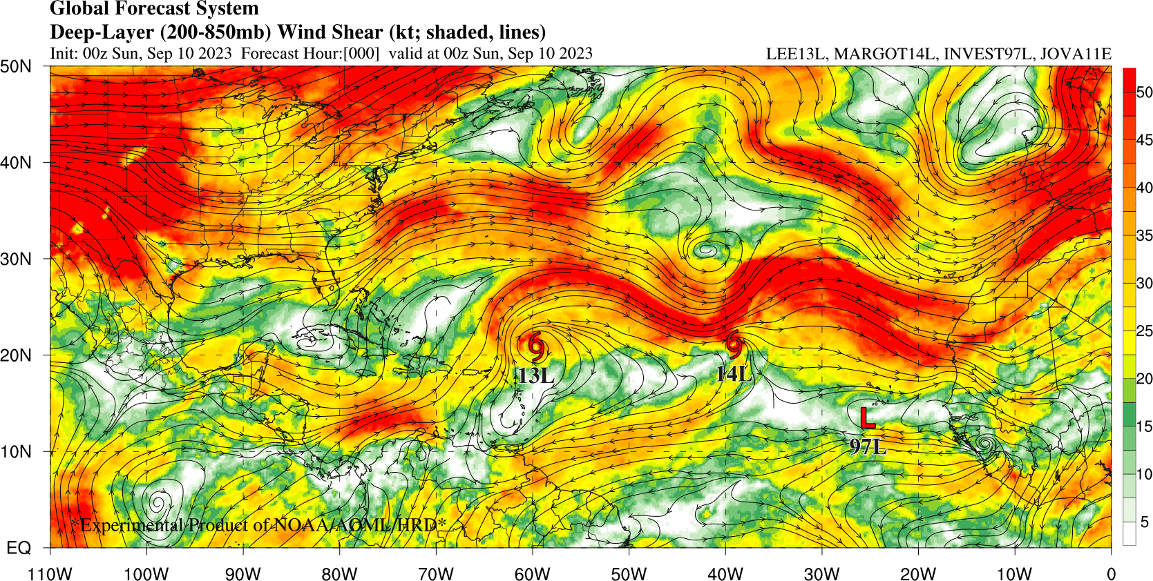  A. 10/1200Z  B. NOAA3 1113A LEE  C. 10/0830Z  D. 21.5N 60.8W  E. 10/0930Z TO 10/1530Z  F. SFC TO 10,000 FT  G. TAIL DOPPLER RADAR
Instrument Notes | Everything working nominally

IN-FLIGHT
Time [UTC] | Event
0836 | Take-off from St. Croix
0929 | IP Point 1 drop #1, 10 kft altitude, TK 045  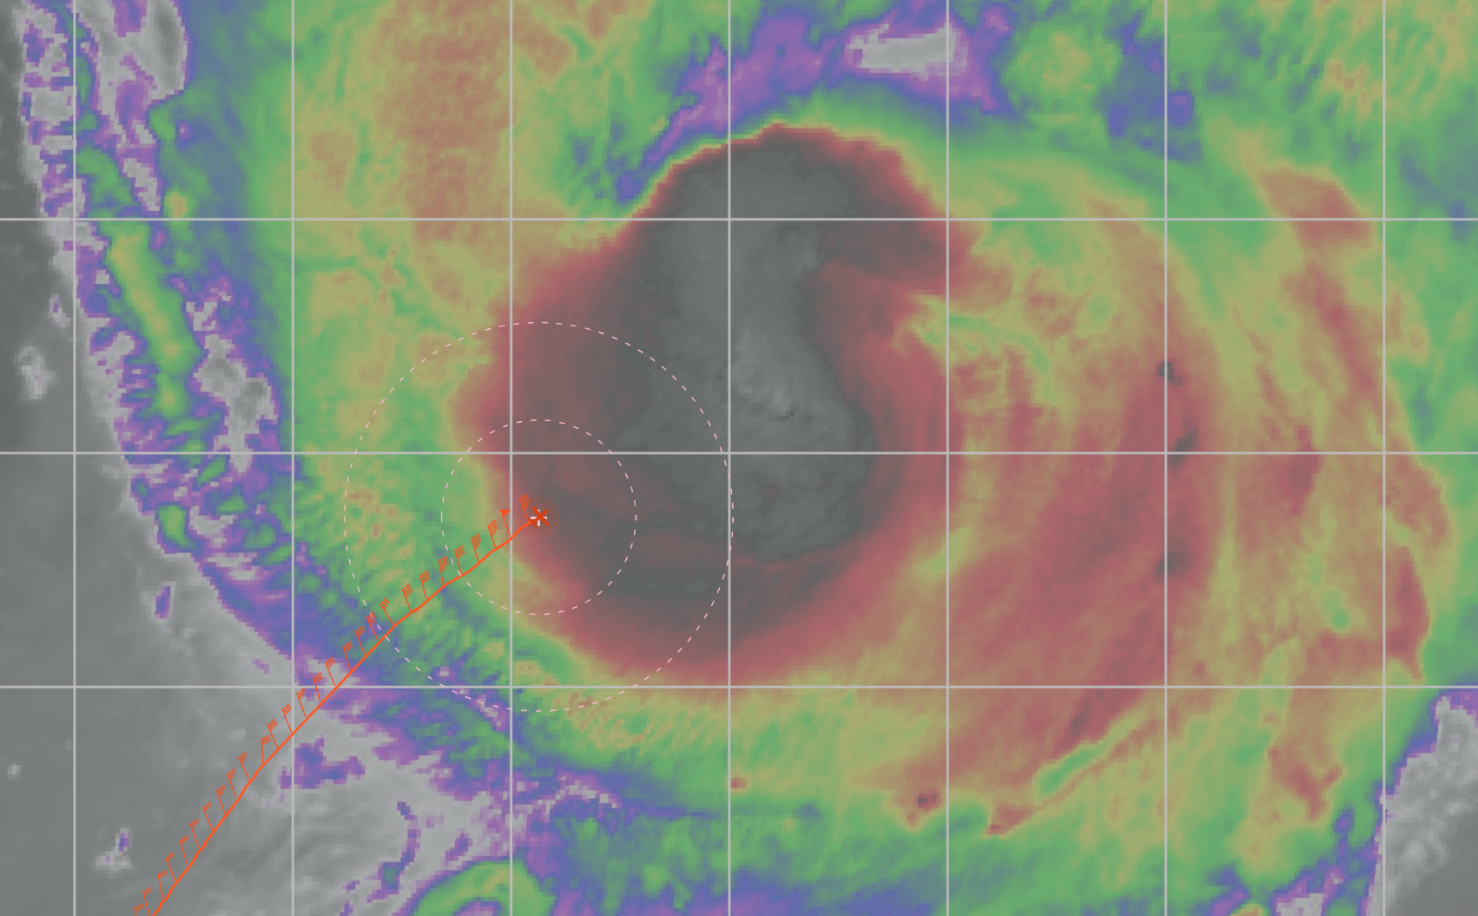  Pretty good wave#1 asymmetry in IR. Coldest IR tops in the WSW quadrant. Expect north eyewall to be the most active right now to produce those cold tops. Some lightning detected in SW eyewall.
0942 | Midpoint drop #2, inside edge of possible outer eyewall
0950 | RMW sondes 1, 2, 3 (drops #3-5)
0954 | Eye drop (drop #6), early because FD display went out.  Estimated center 21.35 N, 60.67 W. Central press 957.  On satellite it appears that the center is just inside the coldest IR tops  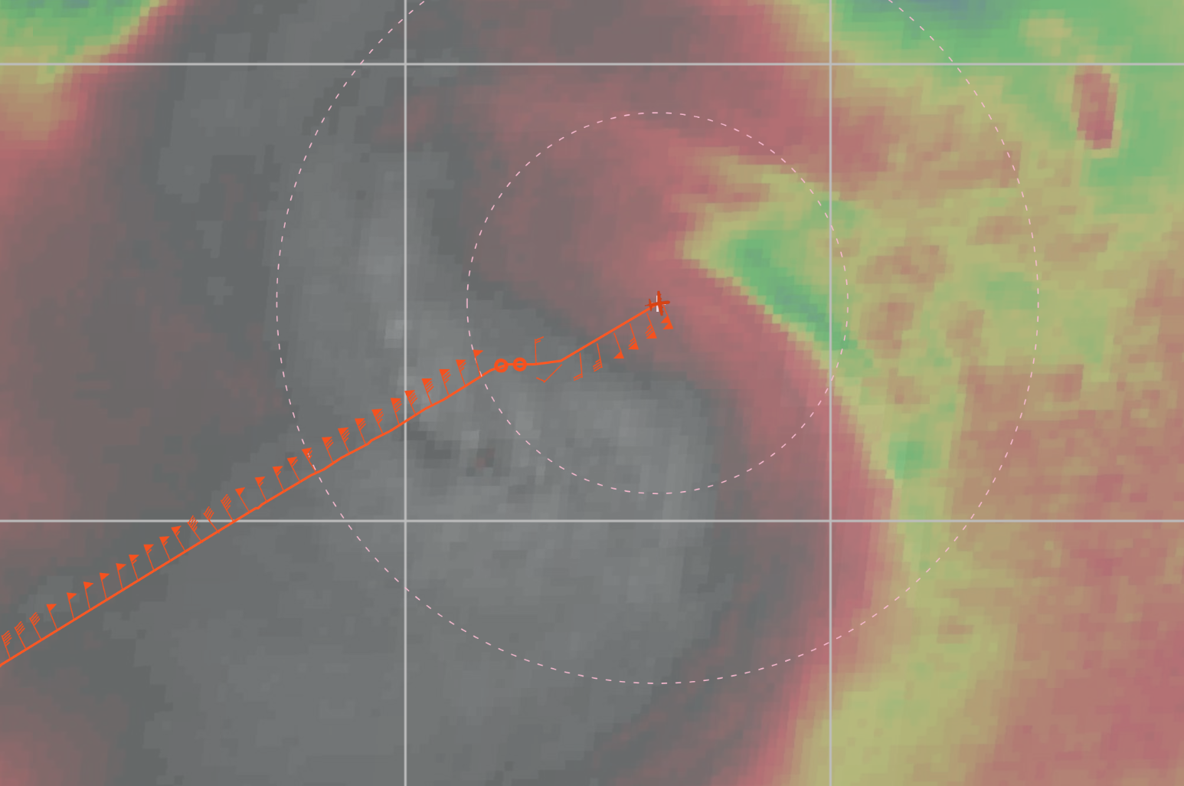
0958 | RMW sonde 1, 2 (drops #7-8)
0959 | RMW sonde 3 (drop#9), on MMR eyewall is a spiral starting east, then extending all the way around northeast again. West side has higher SFMR winds than the east. Opposite at FL
1007 | Midpt sonde (drop #10)
 | MMR has lots of missing rays in the display
1019 | Endpoint (PT #2) sonde (drop #11), TK 300 to PT #3
1023 | TDR jobfile #1 started  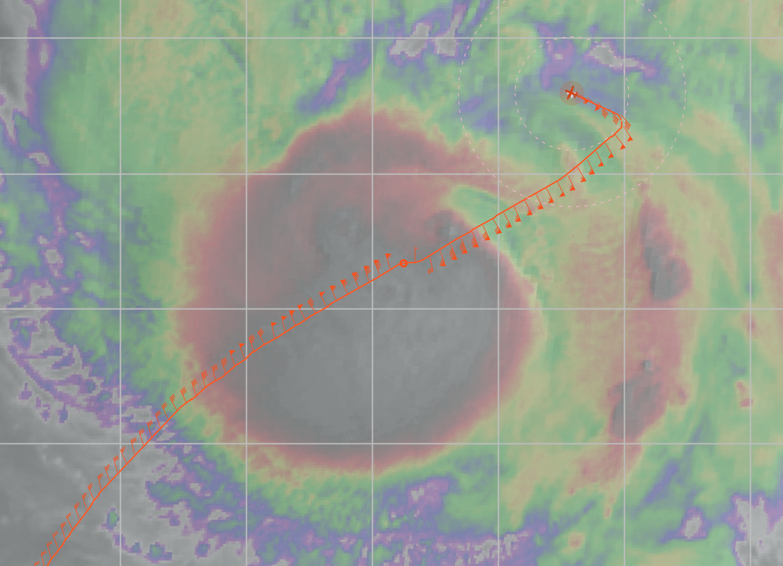
1038 | TDR analysis #1 complete  TDR center info from 230910I1_0954_xy.nc:  Alt (km) Lat (deg) Lon (deg W)  0.5 21.38 60.64  2.0 21.38 60.64  3.0 21.38 60.68  6.0 21.41 60.68  2-6-km Vortex Tilt: 5.7 km at 315 deg  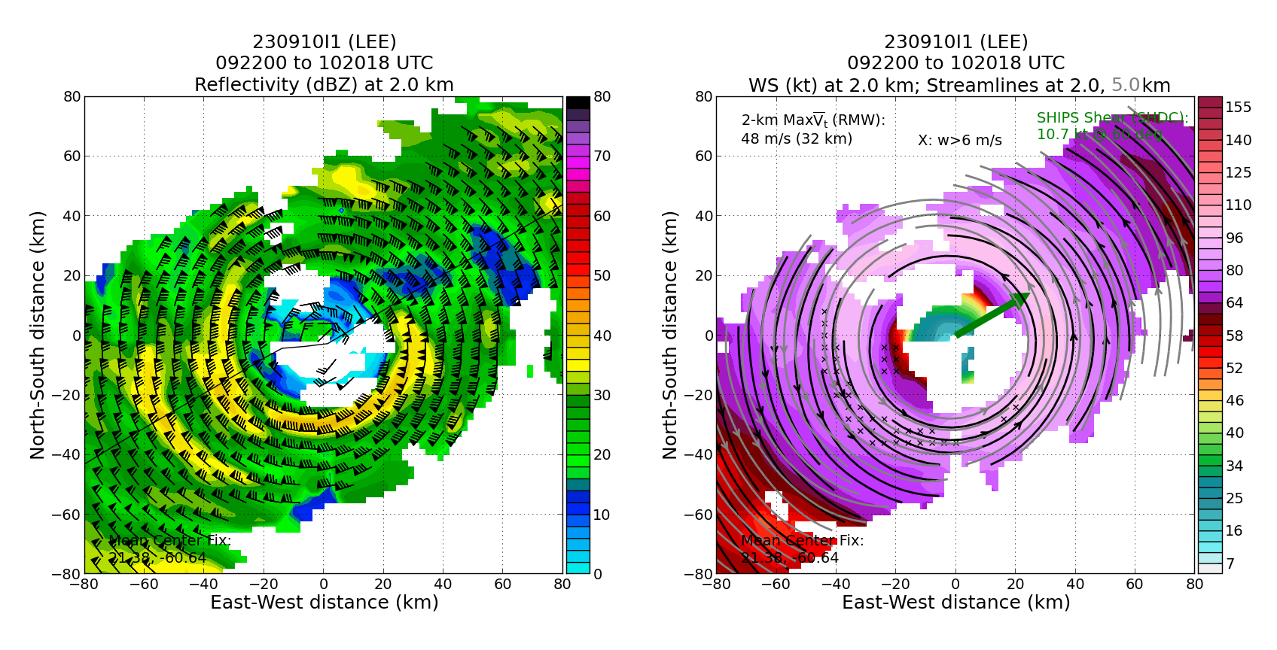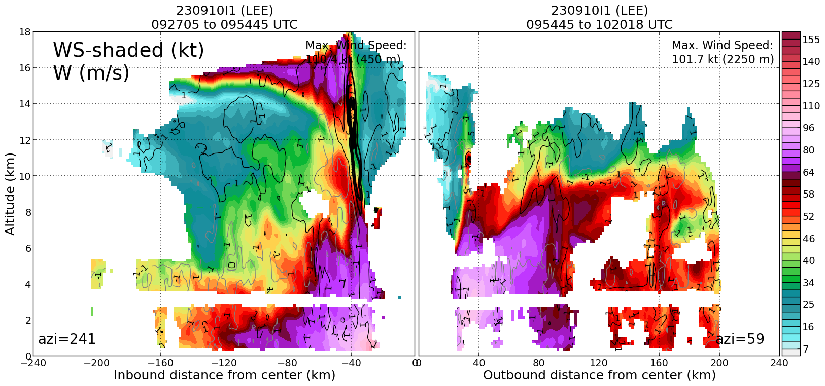  Analysis shows peak FL WS 101.5 kt at ~95 deg. Peak 0.5-km WS 108.3 kt at ~265 deg (opposite side). Agrees with SFMR and FL winds  Tilt hodograph suggests a more vertically-coherent vortex. Centers no longer displaced prominently downshear at upper levels.
1043 | Endpoint (PT #3) drop #12, turn TK 180
1051 | Midpt sonde in small moat between bands (drop #13),  Satellite imagery suggests a new convective pulse is starting in NE eyewall and will rotate downwind to a point along inbound track.
1100 | RMW sondes 1, 2 (drops #14-15), passed just west of convective pulse
1102 | RMW sonde 3 (Drop #16)
1106 | Center sonde (Drop #17), Eye very different, now circular open south  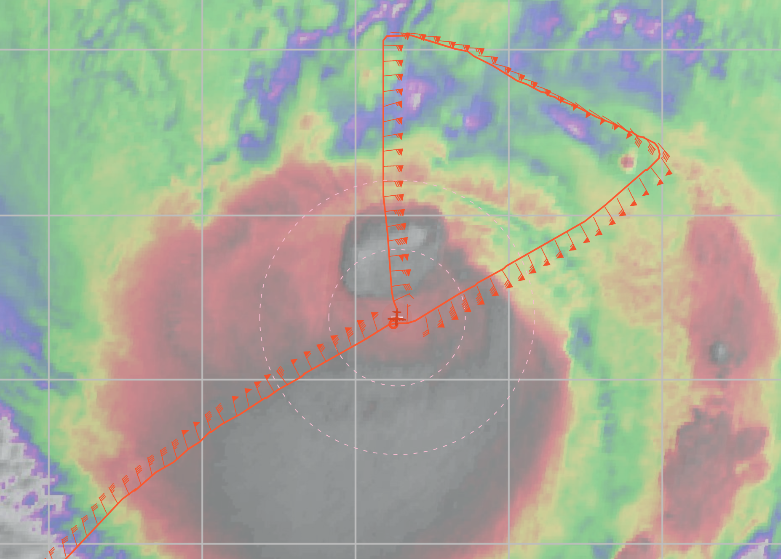
1109 | RMW sonde 1 (Drop #18)
1110 | RMW sondes 2, 3 (Drops #19-20)
1122 | Midpt sonde (Drop #21)
1132 | Endpt (PT #4) sonde (Drop #22), turn TK 045, sonde shows layers of dry air remaining in environment with many inversions
1133 | Convective pulse has rotated to the NW of center  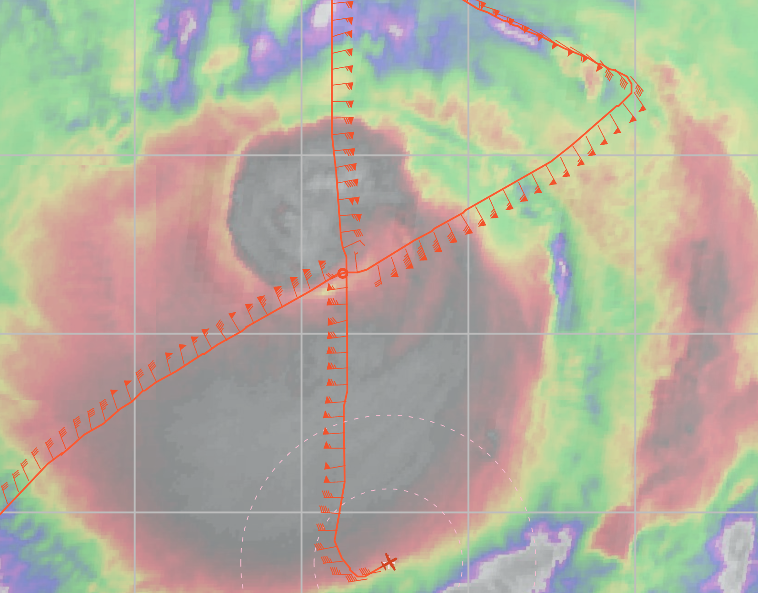
1136 | TDR job #2 started
1155 | Endpt (PT #5) sonde (Drop #23)
1156 | TDR analysis #2 complete  TDR center info from 230910I1_1106_xy.nc:  Alt (km) Lat (deg) Lon (deg W)  0.5 21.44 60.71  2.0 21.44 60.73  3.0 21.46 60.75  6.0 21.50 60.77  2-6-km Vortex Tilt: 7.2 km at 326 deg  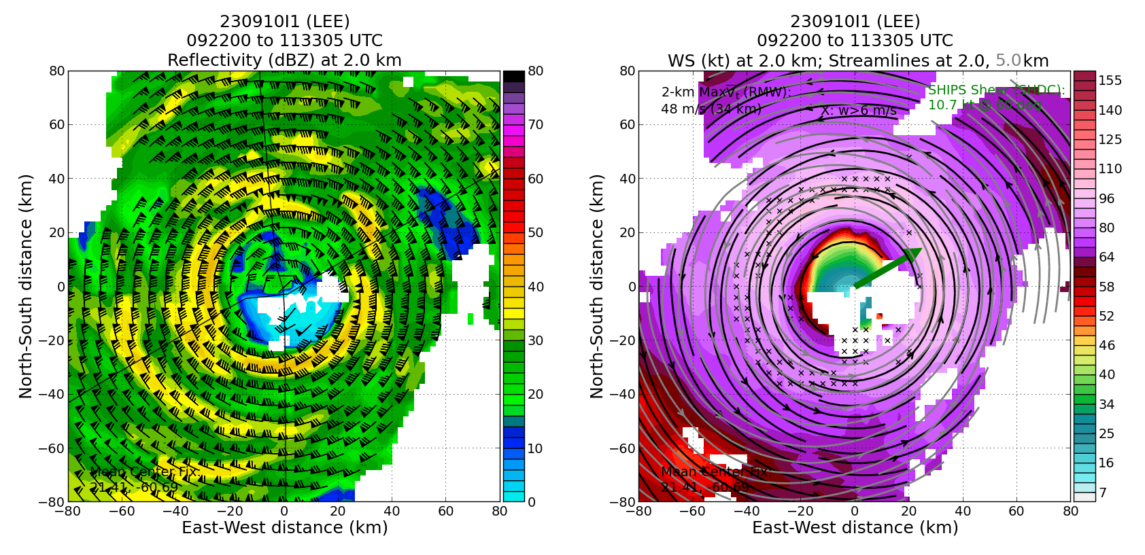  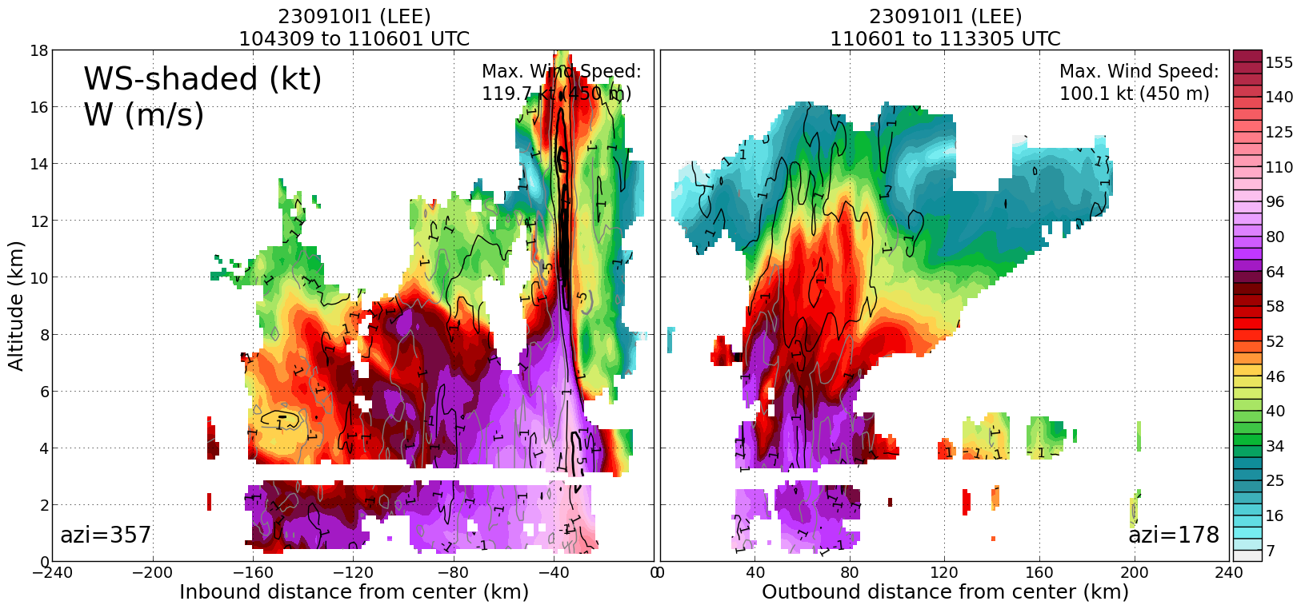
1200 | Active outer rainband, extreme turbulence, satellite image showed band had some relatively cold tops
1206 | Midpt combo (drop #24, AXBT #1) SST=28.45
1214 | RMW sonde 1 (drop #25)
1215 | RMW sonde 2 (drop #26)
1216 | RMW sonde 3 (drop #27)
1219 | Center combo (drop #28, AXBT #2), SST=28.94
1222 | RMW sondes 1, 2 (drops #29-30)
1223 | RMW sonde 3 (drop #31)  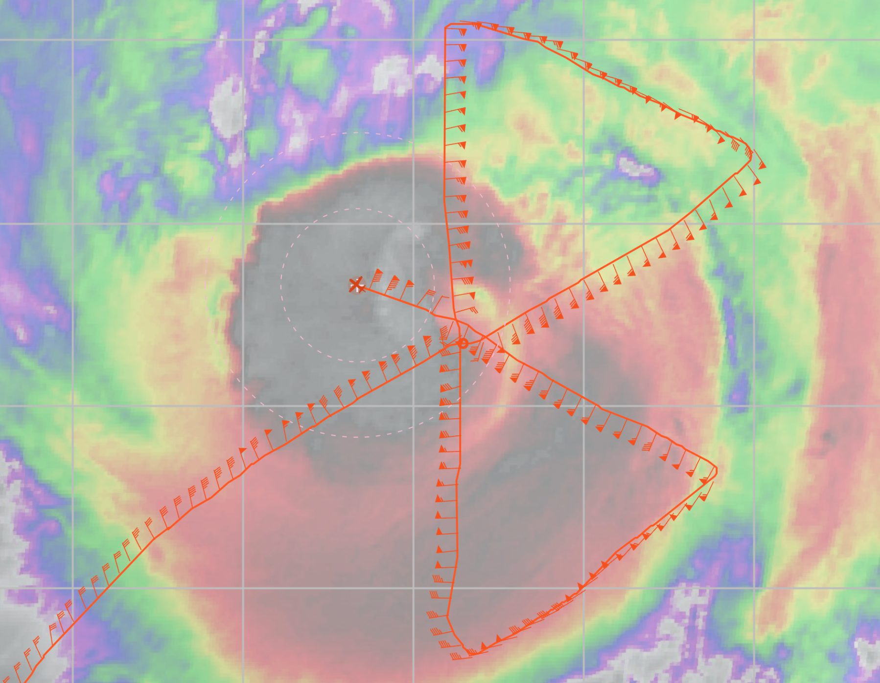
1230 | Setting up to do Surface Wind and Wave Validation Module - P-3 Pattern #1 along radial 090 deg from center. Set up to do some 3-4 in/out spokes. First outbound (090)/inbound (270) with dual PRF, the rest at single PRF.
1233 | Midpt combo (drop #32, AXBT #3) SST= system froze, not sure if we got data, will check later
1244 | Endpt (#6) sonde (drop #33), microswift buoy, TRK 135 to center  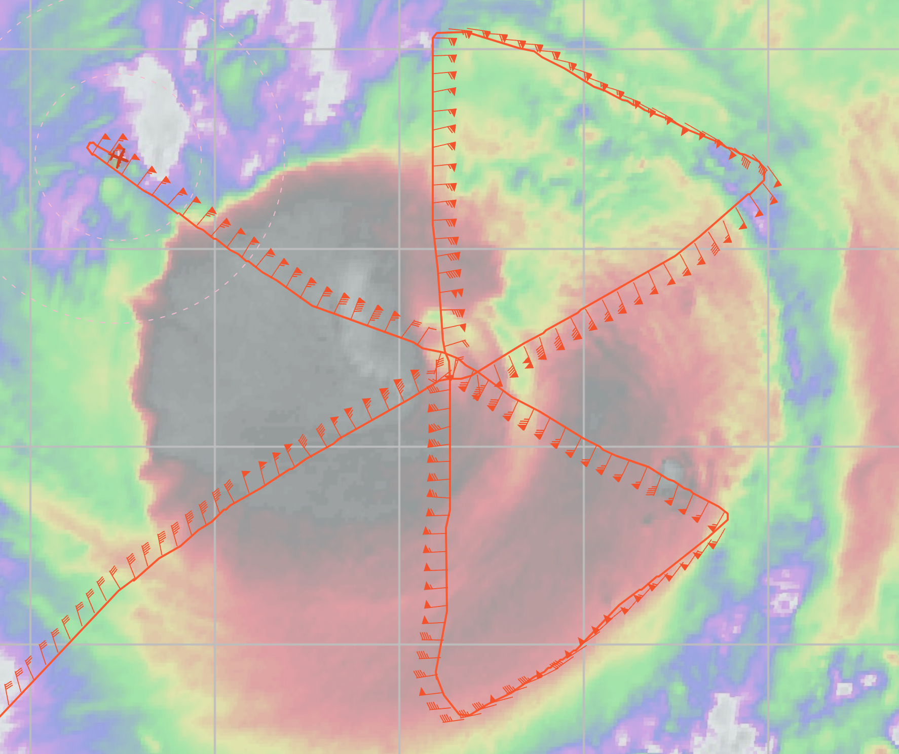
1249 | Inbound, switch TDR to dual prf
1253 | TDR Job #3 started
1309 | TDR Job #3 complete  TDR center info from 230910I1_1219_xy.nc:  Alt (km) Lat (deg) Lon (deg W)  0.5 99.99 99.99  2.0 21.51 60.82  3.0 21.53 60.84  6.0 21.55 60.90  2-6-km Vortex Tilt: 9.0 km at 297 deg... vortex just doesn't want to align in low-mid levels  ~34-km azi-mean RMW ... so 9 km is not huge in the grand scheme of things  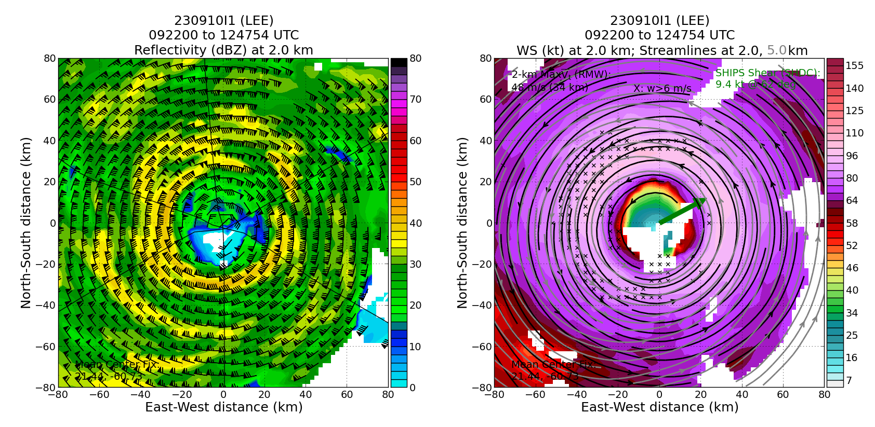  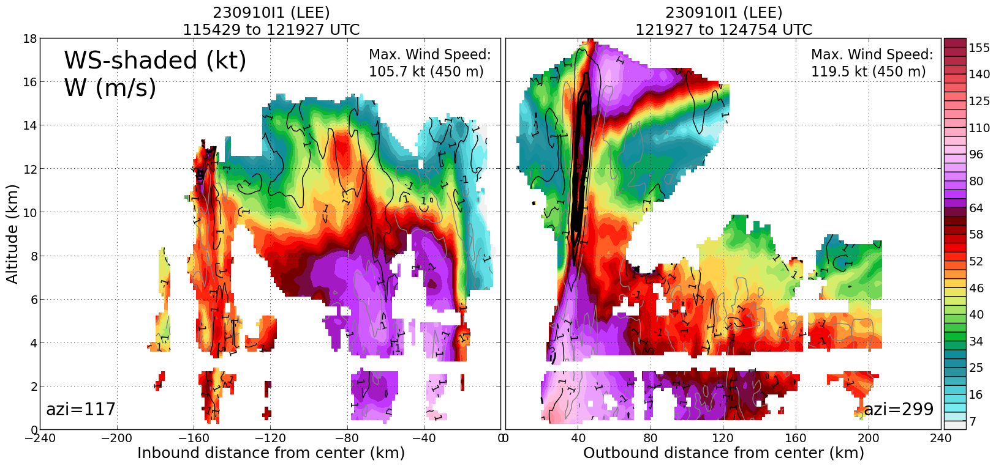
1323 | Inbound rmw sonde (drop #34)
1326 | Center, begin Surface Wind and Wave Validation Module along radial 090 deg from center. First outbound (090)  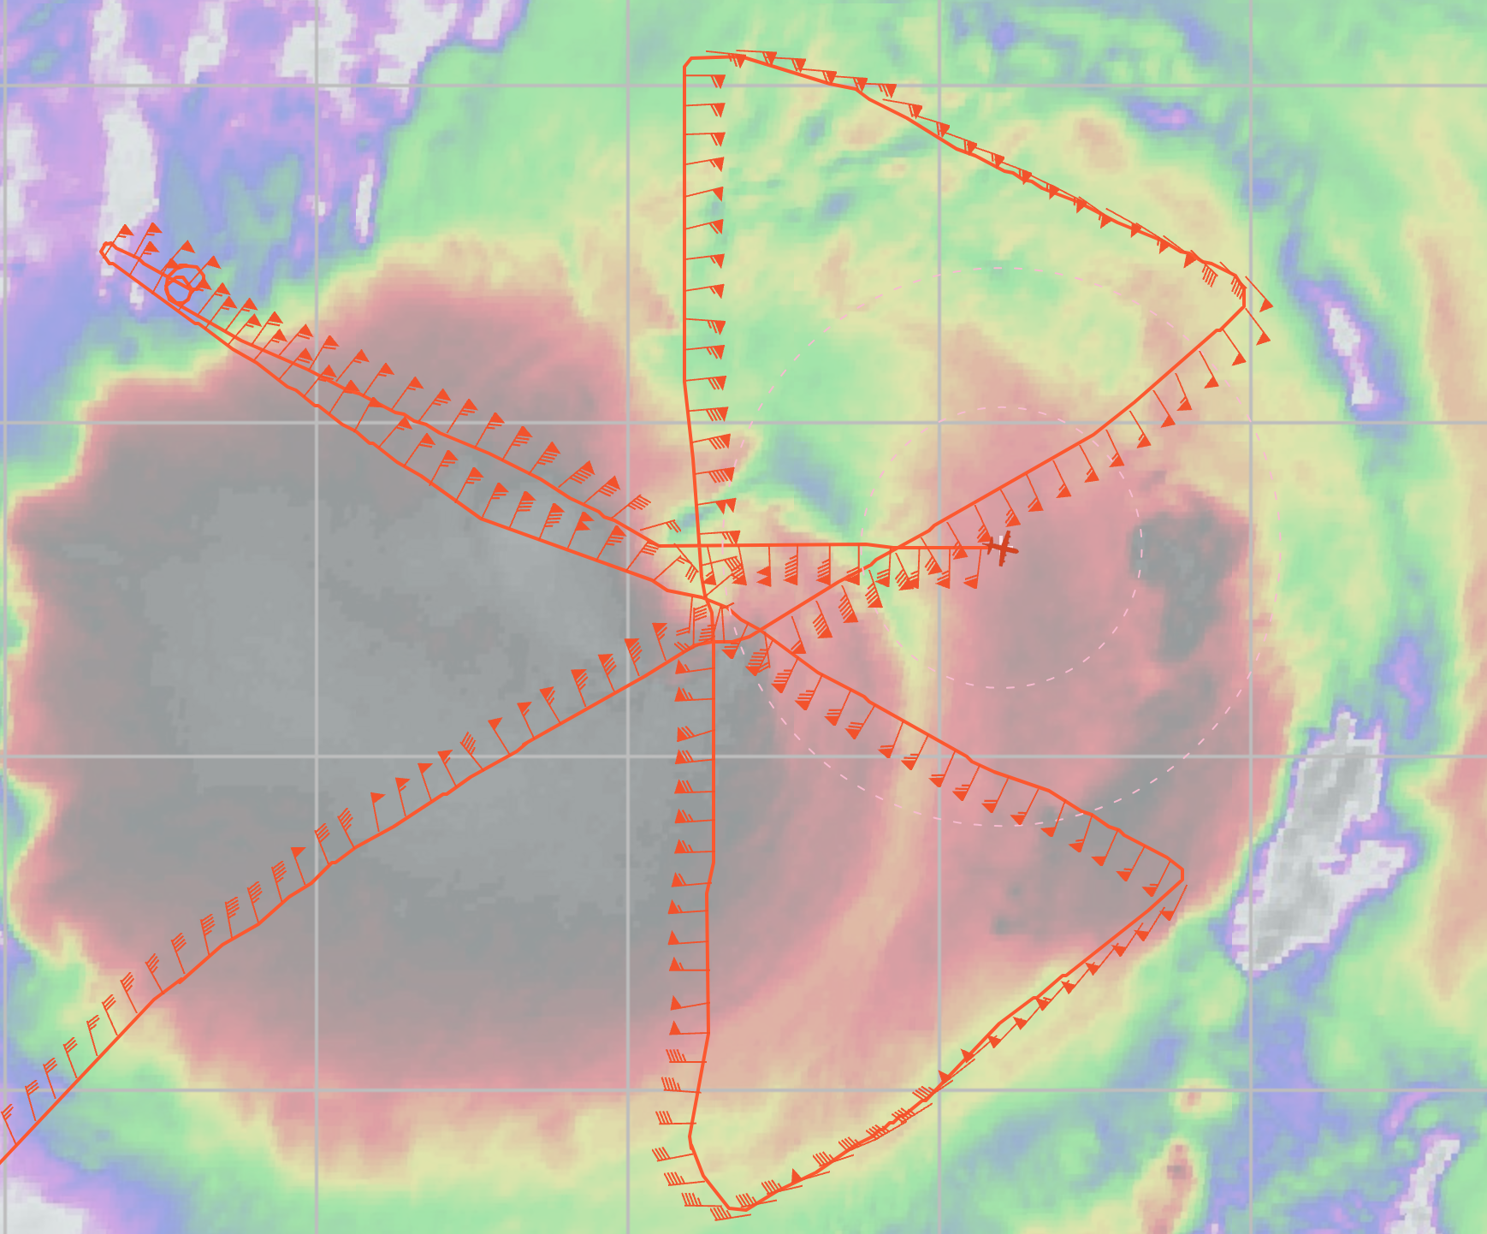
1343 | Endpt turn inbound TK 270 to center
1348 | Switch to single prf
1356 | RMW Sonde (drop #35), failed above 1000 m, going out to try again.
1400 | Orbiting in center waiting for drop location, unfortunately sonde failed at 1100 m, so going out to try again
1404 | Start outbound leg TK 090, this time we will try to drop 2 RMW sondes
1413 | Endpt turn inbound TK 270 to center
1417 | 2 RMW sondes (drops #36-37). Sondes dropped within 2 s of each other, landed about 30 s apart. Second one had higher 10-m wind (80.8 kt vs 72 kt). WL150 96 kt
1420 | Orbiting in center waiting for drop locations. Will try a different azimuth
1432 | Start outbound leg, TK 060, satellite shows another major convective burst that started in the NNW eyewall and is rotating down wind
1442 | Endpt turn TK 240
1443 | TDR analysis #4 (1415-1442) - Should capture convective burst in N eyewall development
1449 | 2 RMW drops (drops #38-39) Sondes dropped within 2 s of each other, landed about 30 s apart. One had higher 10-m wind (109.5 kt vs 100.5 kt). WL150 117 kt
1453 | TDR analysis #4 completed  TDR center info from 230910I1_1422_xy.nc:  Alt (km) Lat (deg) Lon (deg W)  0.5 99.99 99.99  2.0 21.68 61.02  3.0 21.68 61.02  6.0 21.70 61.06  2-6-km Vortex Tilt: 4.5 km at 297 deg  Really good coverage of the eyewall in the swaths that captured two major convective bursts in the NE and NW part of the eyewall with tops >18 km
1455 | Orbiting in the eye waiting on drops
1459 | Start outbound leg TK 030
1507 | Endpt turn TK 210
1513 | Start TDR analysis #5
1518 | Center, end module, TK 230 for St. Croix (TISX)
1551 | TDR analysis #6 started
1603 | TDR analysis #6 completed.  TDR center info from 230910I1_1518_xy.nc:  Alt (km) Lat (deg) Lon (deg W)  0.5 99.99 99.99  2.0 21.77 61.09  3.0 21.77 61.11  6.0 21.82 61.15  2-6-km Vortex Tilt: 8.5 km at 315 deg
1637 | Landed TISX

POST-FLIGHT
Mission Summary | Today’s missions collected important airborne radar information and transmitted it to NOAA/NCEP for assimilation into NOAA’s HAFS and HWRF models to improve forecasts of the track, structure, and intensity of Lee. In addition, today’s NOAA-43 AM mission deployed a University of Washington microSWIFT expendable wave buoy, collected additional observations in the region of strongest winds within the eyewall to improve measurements of the surface wind speeds in this region, tested a new sampling mode for the TDR, and sampled a region of rapidly changing and growing convection in the eyewall. These additional research observations will lead to improvements in our observing capabilities of tropical cyclones along with a better understanding of the processes that impact changes to the structure and intensity of tropical cyclones.  Excellent radar and dropwindsonde coverage, much larger eye than previous days:  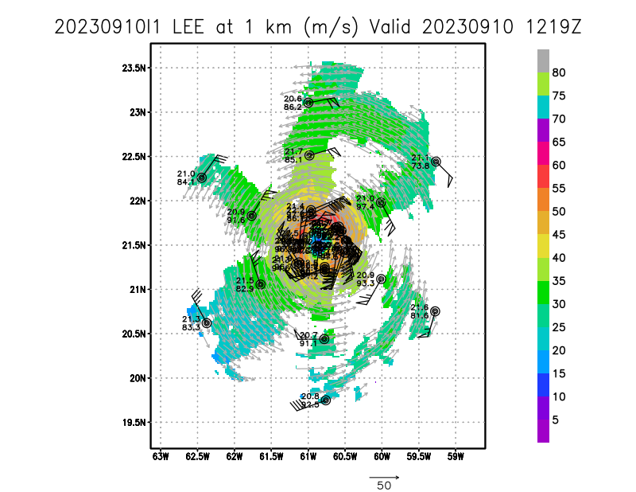
Actual Standard Pattern Flown | Butterfly, Rotated Figure-4, plus Surface Wind and Wave Validation Module - P-3 Pattern #1 (3 legs), plus TDR dual-PRF module
APHEX Experiments / Modules Flown | https://www.aoml.noaa.gov/wp-content/uploads/2023/04/2023HFP_MatureStage_Flight_Patterns_Wind_Wave.pdf  https://www.aoml.noaa.gov/wp-content/uploads/2023/04/2023HFP_MatureStage_Flight_Patterns_TDR_Dual_PRF.pdf
Plain Language Summary | Very successful operationally tasked TDR mission:  - Produced 6 TDR analyses with radial wind files transmitted to EMC and NHC  - Produced 38 dropsondes transmitted to EMC and NHC  - Completed Surface Wind and Wave Validation Module with 3 legs  - Completed a TDR Dual-PRF Module  - Captured explosive convective bursts in redeveloping eyewall with echo tops >18 km altitude. It may be possible to see structure of these features rotating inside the eye using the TDR.
Instrument Notes | [Notes about instrument status from during and after the mission]
Final Mission Track | 