MISSION PLAN
FLIGHT ID | 20230909I1 | STORM | AL13/LEE
MISSION ID | LEE | TAIL NUMBER | NOAA-43
TASKING | EMC | PLANNED PATTERN | Butterfly
MISSION SUMMARY
TAKEOFF [UTC] | 0834 | LANDING [UTC] | 1244
TAKEOFF LOCATION | St. Croix | LANDING LOCATION | St. Croix
FLIGHT TIME | 4.2 | BLOCK TIME | 4.4
TOTAL REAL-TIME RADAR ANALYSES  (Transmitted) | 2 (2) | TOTAL DROPSONDES Deployed (Transmitted) | 7 (7)
OCEAN EXPENDABLES (Type) | 1 (1) AXBT | sUAS (Type) | n/a
APHEX EXPERIMENTS / MODULES | SEF (partial)
HRD CREW MANIFEST
LPS ONBOARD | Aberson | LPS GROUND | Alaka
TDR ONBOARD | Aberson | TDR GROUND | Reasor
ASPEN ONBOARD | J. Zhang/Ko | ASPEN GROUND | n/a
NESDIS SCIENTISTS | n/a
GUESTS (Affiliation) | Kelly Ryan (UM CIMAS), DAvid Nolan (UM), Patrick Duran (NASA MSFC)
AOC CREW MANIFEST
PILOTS | Copare/Keith/Wood
NAVIGATOR | Utama
FLIGHT ENGINEERS | Tyson/Tufnell
FLIGHT DIRECTOR | Kalen/Lundry
DATA TECHNICIAN | Richards
AVAPS | Kotz/Warnecke

PRE-FLIGHT
Flight Plan | 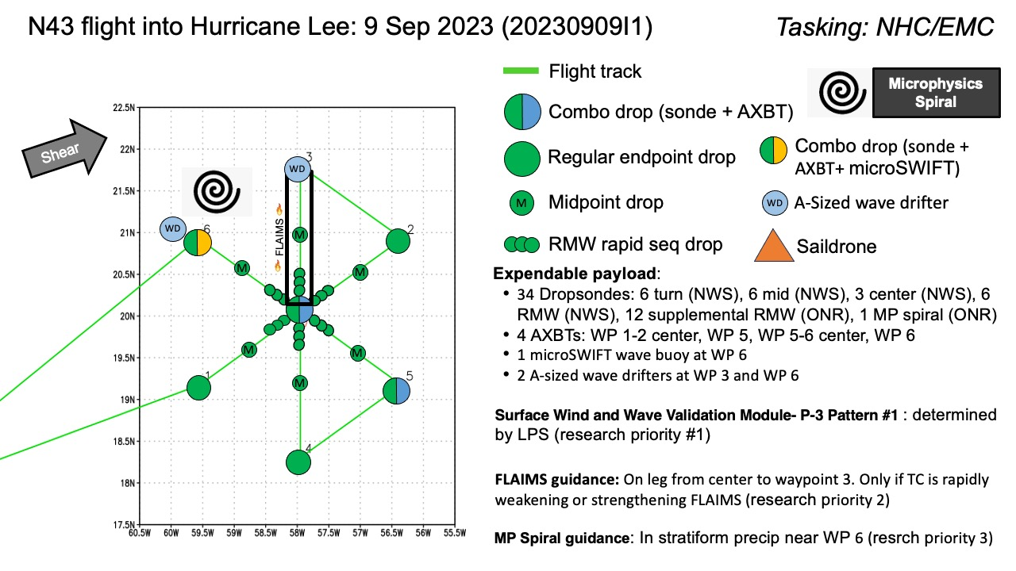
Expendable Distribution | [Describe planned dropsonde, ocean buoy, sUAS deployment locations; e.g., “Dropsondes/AXBT combo drops at endpoints, midpoints, and center”
Preflight Weather Briefing | [Notes from the Flight Crew Preflight Briefing and other relevant notes about the current and forecasted storm state from the most recent NHC advisory (location, intensity, MSLP, movement, possible intensity change during the flight)]  [Briefly describe the relevant environmental drivers.]  [Copy in GIF of recent (~6 hr) satellite loops (https://www.star.nesdis.noaa.gov/GOES/index.php)]
Instrument Notes | [What instruments are working, not working, not functioning nominally, not installed?]

IN-FLIGHT
Time [UTC] | Event
0833 | Take-off from TISX
0928 | Begin descent to IP
0932 | Going through first outer band. Will be included in TDR analysis.
0944 | Latest SSMIS pass (from 0722Z) shows an outer eyewall forming at low levels (cyan ring in 37GHz) and healthier upper levels on the west side of the circulation compared with previous passes  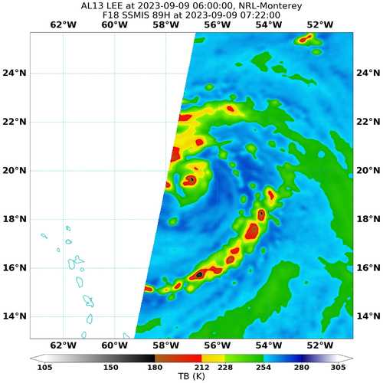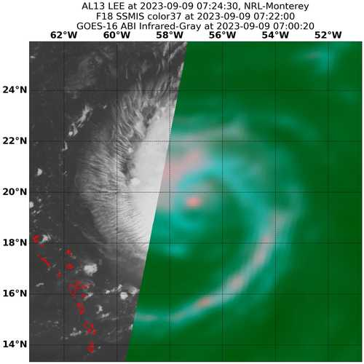
0945 | IP sonde release
0947 | Tiny eye on MMR, may make doing in-out legs difficult
0954 | Tiny eye somewhat apparent on IR  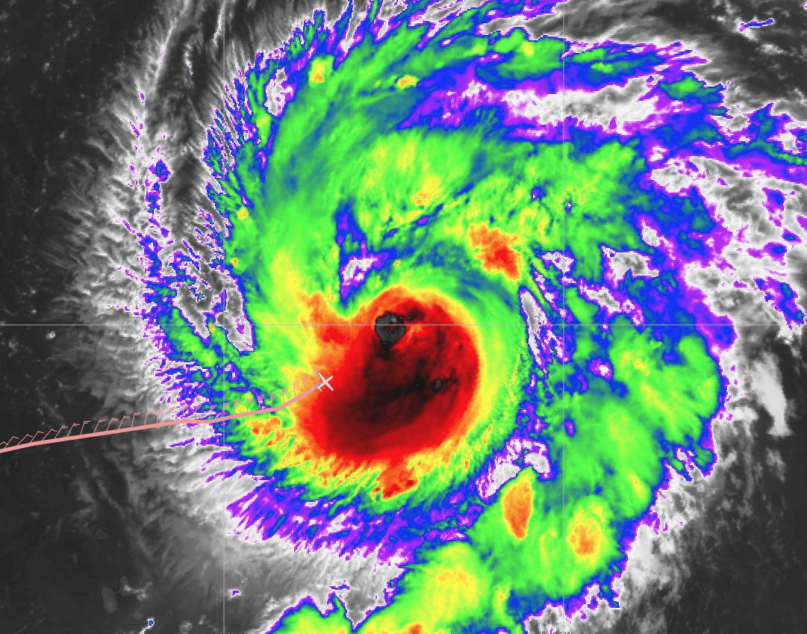
0958 | Midpt sonde
1012 | features in eyewall look like mesovortices, spiral shape in mmr
1012 | RMW sonde 1, could not get more out
1013 | Combo out, sst=29.15, tiny, slanted eye. Sonde had 38 kt at surface, 957 mb
1015 | Two RMW sondes, LPS to take over calling RMW sondes
1018 | Eye is tiny and elliptical, 2x5 n mi, ragged
1019 | Through primary rainband
 | 2/3 RMW rapid sondes. One with 93 kt at surface,the other with 20 kt
1027 | Midpt sonde
1040 | Decision to abort. Gen light engine 4. Heading north around the storm to STX. This part is reminiscent of a SEF module.

POST-FLIGHT
Mission Summary | Lee has a very small eye, down to 2 n mi across. Smaller eye, but weaker than the previous day.
Actual Standard Pattern Flown | One pass, return to base
APHEX Experiments / Modules Flown | Accidental SEF
Plain Language Summary | AOML/HRD is supporting operationally tasked NOAA NHC/EMC P-3 Tail Doppler Radar missions into Hurricane Lee. Hurricane Lee is now a Category 3 hurricane and is located about 300 miles northeast of the northern Leeward Islands. The APHEX-HRD, ONR, NESDIS, AOML/PHOD, Global Ocean Monitoring and Observing (GOMO) Program, and University of Washington science teams are also collaborating to conduct research modules to collect supplemental atmospheric and oceanic data in the storm environment. One pass through the hurricane, then a return to base due to mechanical issues
Instrument Notes | Only forward camera recording works. No down, left, or right. ASPEN computer had a very old version of ASPEN.
Final Mission Track

