MISSION PLAN
FLIGHT ID | 20230909H1 | STORM | AL13/LEE
MISSION ID | 0913A | TAIL NUMBER | NOAA-42
TASKING | EMC | PLANNED PATTERN | Butterfly
MISSION SUMMARY
TAKEOFF [UTC] | 2024 | LANDING [UTC] | 0254
TAKEOFF LOCATION | STX | LANDING LOCATION | STX
FLIGHT TIME | 6.5 | BLOCK TIME | 6.7
TOTAL REAL-TIME RADAR ANALYSES  (Transmitted) | 5 (5) | TOTAL DROPSONDES Deployed (Transmitted) | 31 (29)
OCEAN EXPENDABLES (Type) | 4 (4) AXBTs | sUAS (Type) | N/A
APHEX EXPERIMENTS / MODULES | Ocean Winds Module
HRD CREW MANIFEST
LPS ONBOARD | Hazelton | LPS GROUND | Rogers
TDR ONBOARD | Hazelton | TDR GROUND | Alvey
ASPEN ONBOARD | Sellwood | ASPEN GROUND
NESDIS SCIENTISTS | Zhang, Sapp, Jelenak, Bjorland
GUESTS (Affiliation) | Buohoo (Axios)
AOC CREW MANIFEST
PILOTS | Doremus/Rannenberg/Palmer
NAVIGATOR | Hough/Schaefer
FLIGHT ENGINEERS | Stokes/Gee
FLIGHT DIRECTOR | Zawislak/Parrish
DATA TECHNICIAN | McAlister
AVAPS | Waggoner/Santoni

PRE-FLIGHT
Flight Plan | 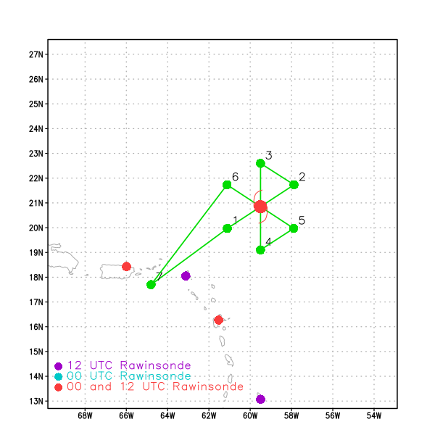  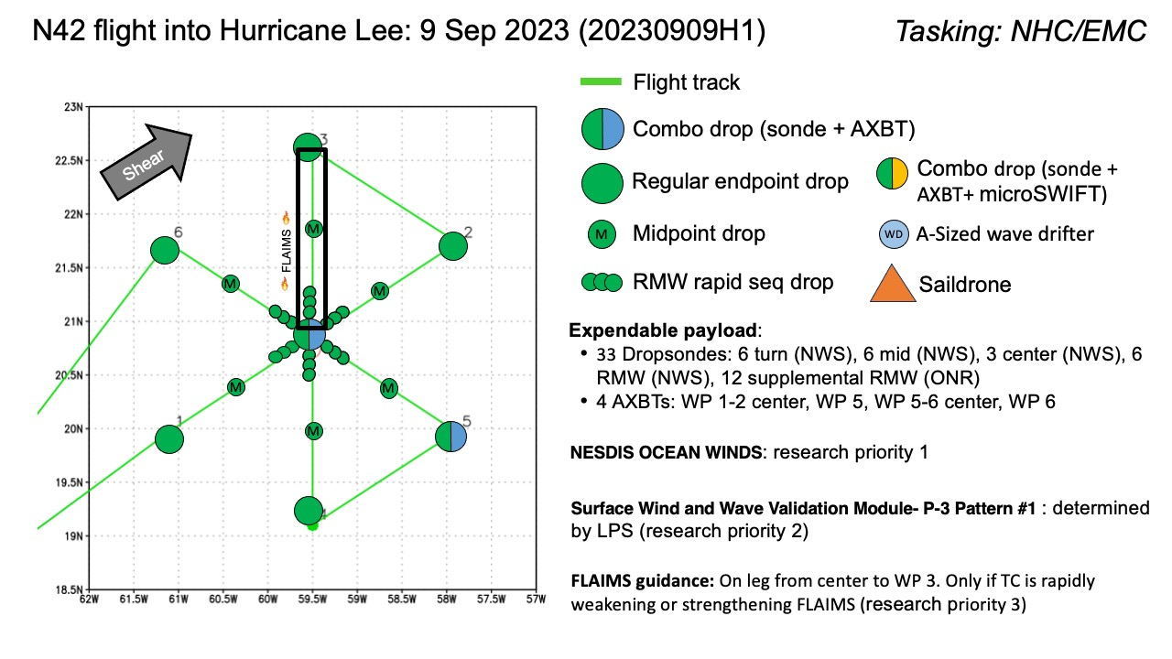  Butterfly pattern, IP on SW side, 105 nm legs. Flight altitude 8 or 10 kft. After completion of the butterfly, attempt several modules, with the order of priority the Ocean Winds module, SFMR wind/wave validation, and FLAIMS (if Lee is intensifying or weakening)
Expendable Distribution | Sondes at endpoints, midpoints, RMWs, centers. 3 RMWs possible if winds seem useful. BTs at initial center, and center and endpoints on last leg.
Preflight Weather Briefing | Lee appears to be a steady-state Category 3 hurricane after battling with some shear and dry air intrusions over the last day. The forecast is for the shear to drop which may allow for some additional intensification in the next day or two.  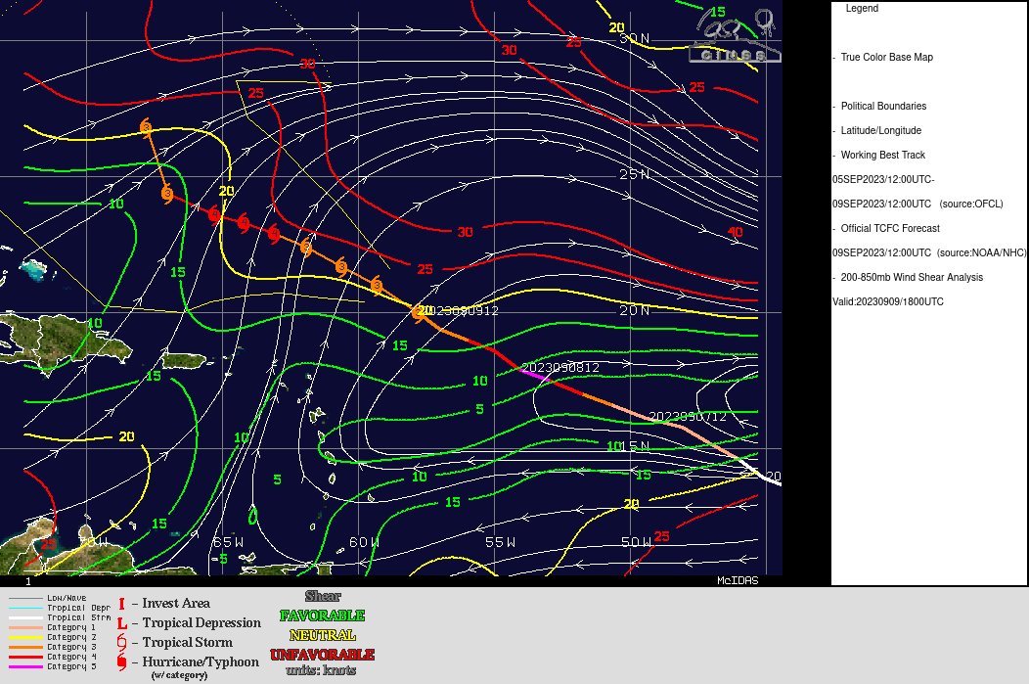  Lee is showing recurring bursting occurring. Initiation of bursts consistent with notion of southwesterly shear impacting the storm. Numerous lightning flashes in the coldest cloud tops as convection develops and matures on the northwest (left of shear) side of storm.
Instrument Notes | Instruments working overall. We are operating with a slightly degraded MMR (no navigation capability)

IN-FLIGHT
Time [UTC] | Event
2024 | Take-off from STX
2054 | P-3 on ferry to IP, IR image shows obscured eye, CDO, some evidence of banding structures on east side wrapping around to south side, and extending out in the northwest quadrant
2106 | 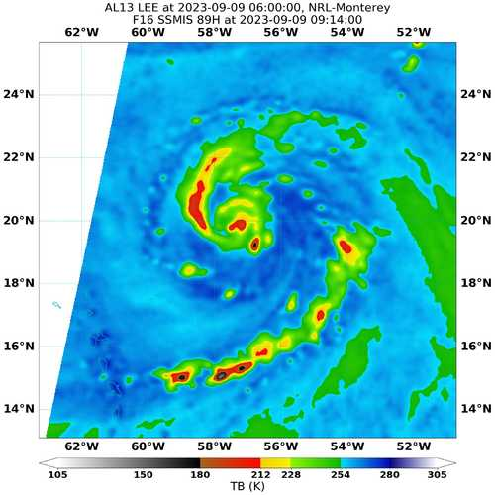  Most recent microwave overpass with good coverage (0914 UTC, or about 12 h prior) showed bands coming out into northwest quadrant, and an outer band wrapping around the east and southeast sides. This appears generally consistent with the IR presentation shown above, even though this microwave image is 12 h old.
2117 | Descending to IP
2126 | At IP, sonde 1, SW endpt
2130 | FL winds 30 m/s even ~80 nm SW of center
2139 | Sonde 2, SW midpt
2139 | Encountered a slight local FL wind maximum about 50 nm SW of center, not really co-located with much precipitation. MMR showing concentric eyewalls.
2146 | Sonde 3, outer eyewall SW. Sonde failed, no backup
2147 | Eye is open SW
2149 | Onboard LPS reports pressure field seems broader than yesterday
2150 | Both FL and SFMR winds show a local spike in winds on SW inbound leg  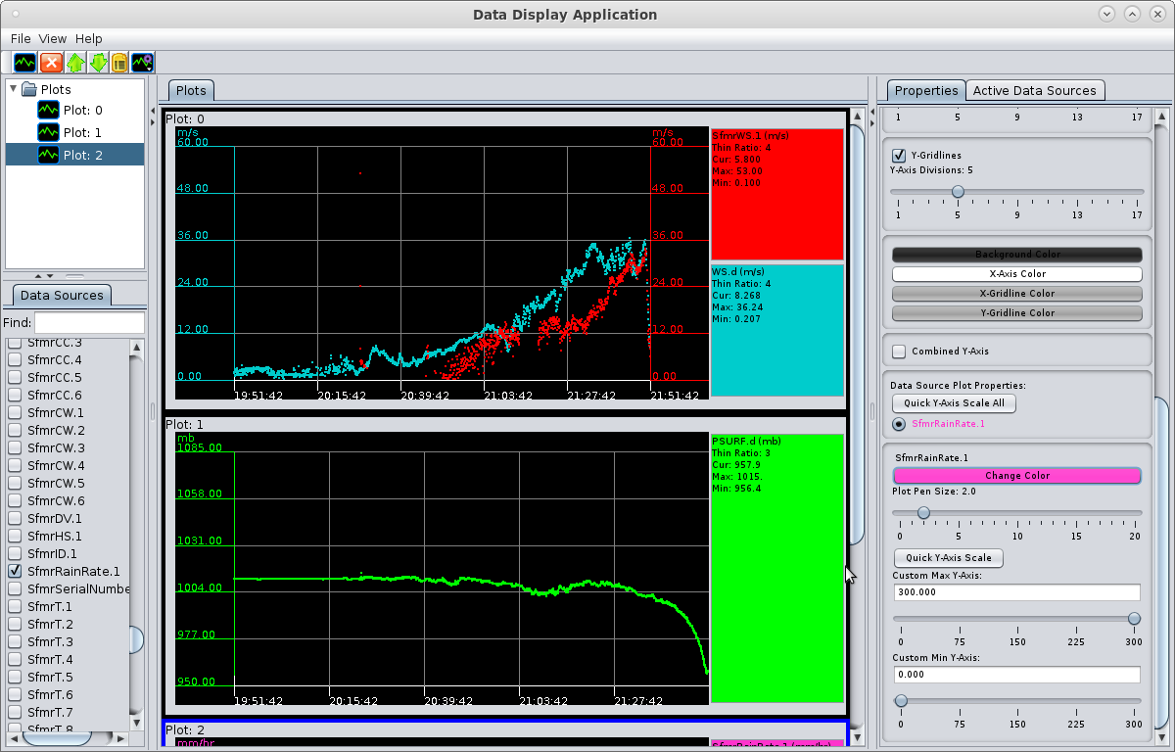
2150 | Sonde 4, SW inner RMW.
2152 | Sonde 5, center drop, combo (BT1). 29.09 C SST
2154 | Sondes 6,7, rapid-fire drops NE RMW
2155 | Sonde 8, NE RMW
2201 | Concentric eyewalls, inner at 20 nm, outer at 80 nm
2203 | Sonde 9, NE midpt
2208 | 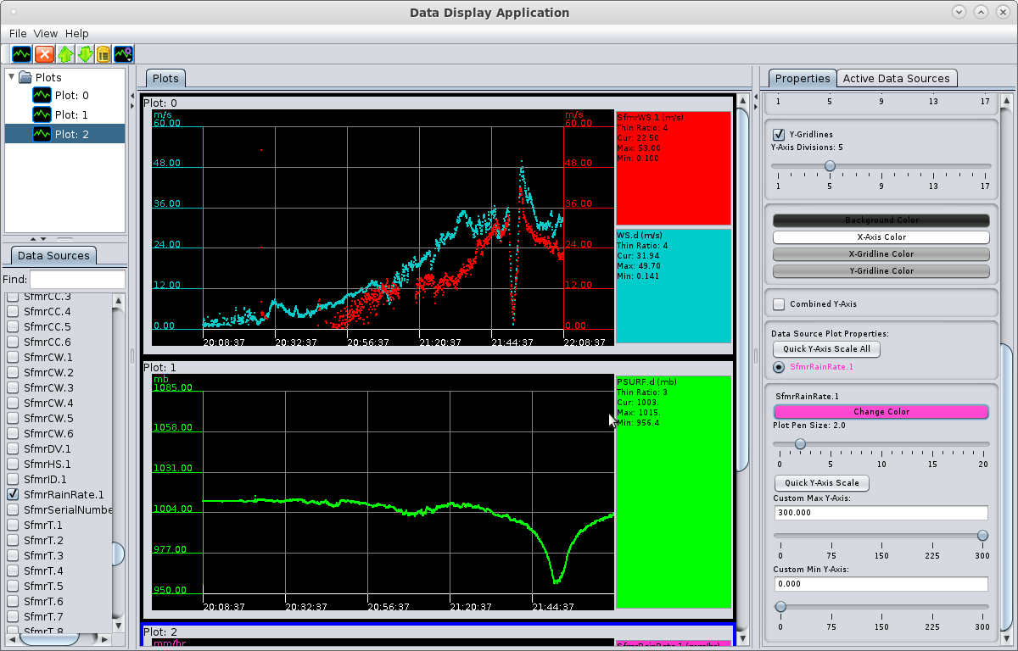  Time series of FL and SFMR winds shows a highly asymmetric storm from SW to NE eyewall. Multiple maxima on SW side, some indications on NE side.
2218 | Sonde 10, NE endpt
2245 | Sonde 11, inbound N endpt
2254 | 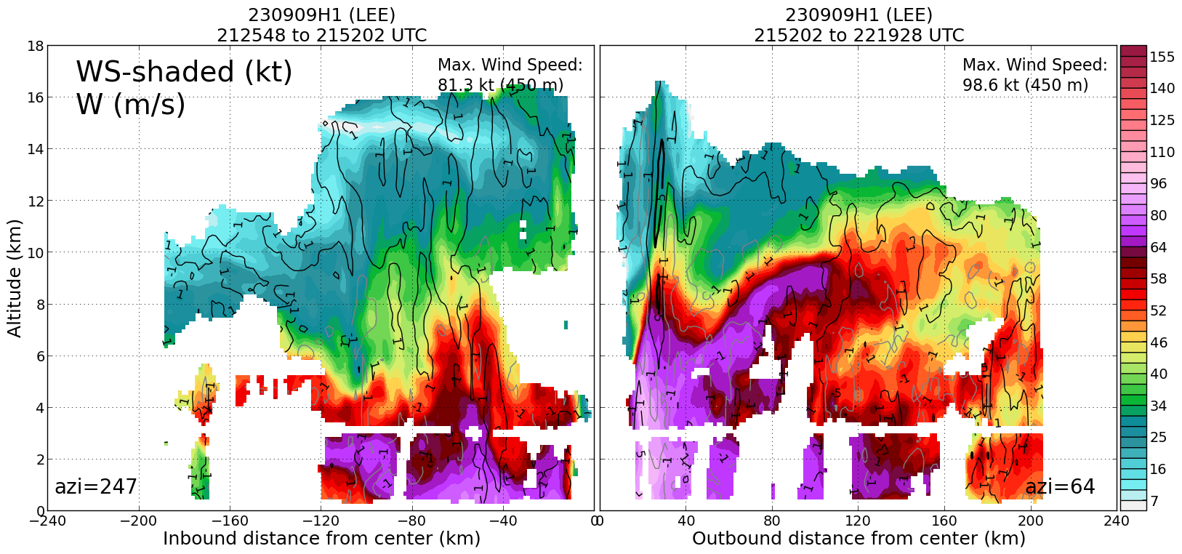  Profile analysis shows outer wind maximum on the SW side, broad wind field with upper-level wind maximum sloping outward on the NE side
2254 | 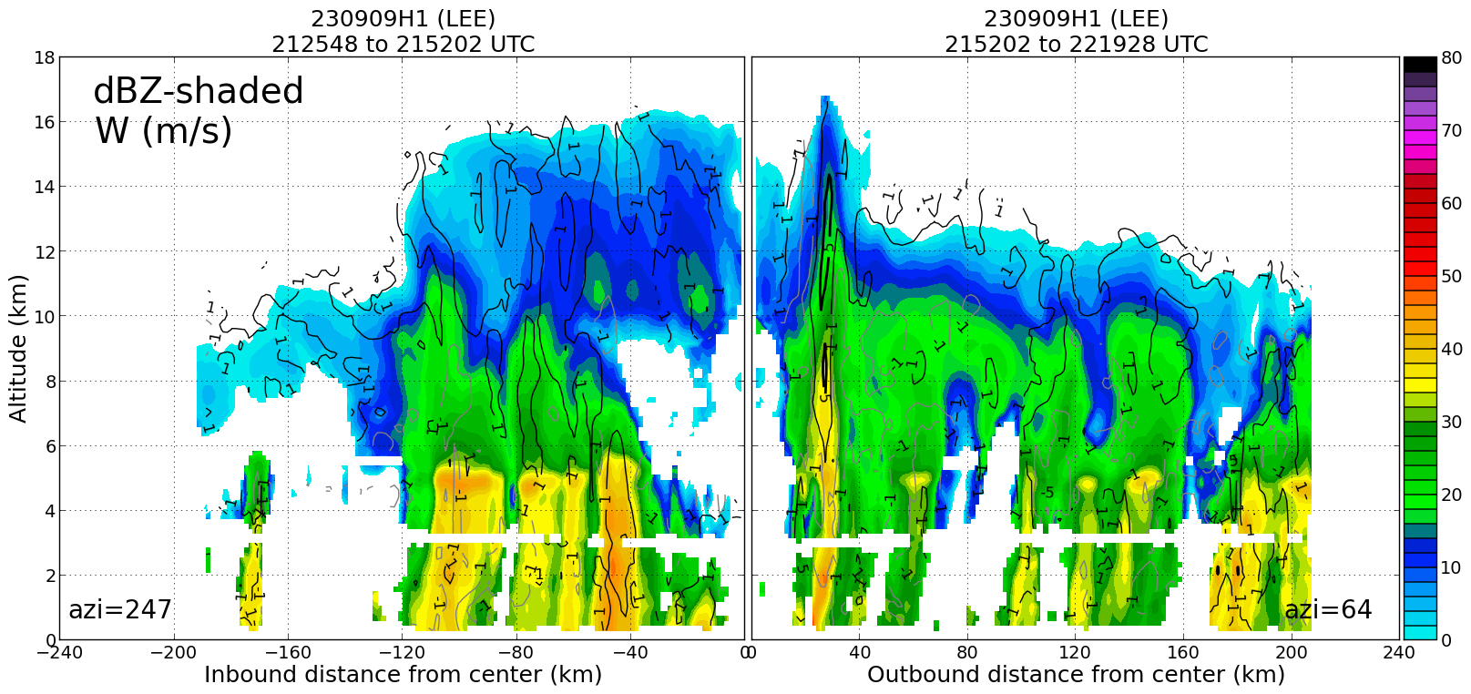  Reflectivity analysis shows broad area of stratiform precipitation, moderate convection on the SW side, deep convection in the NE eyewall and more mixed convective/stratiform region outer NE
2257 | Sonde 12, midpt N
2300 | 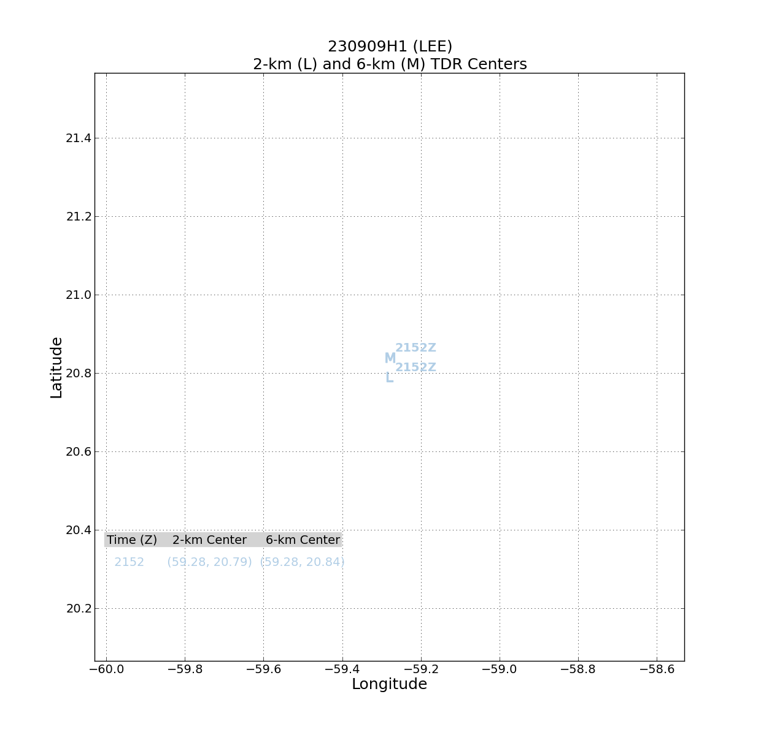  Storm seems to be pretty aligned between 2 and 6 km
2309 | SFMR plots. Snapshots of possible rain spikes with SFMR wind dropouts in the N eyewall.  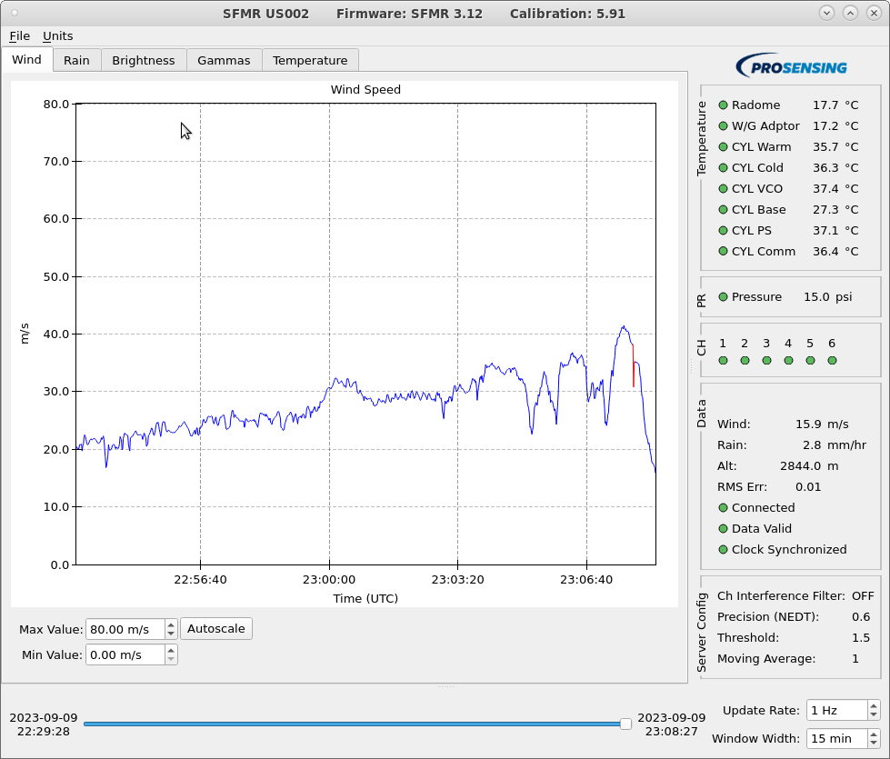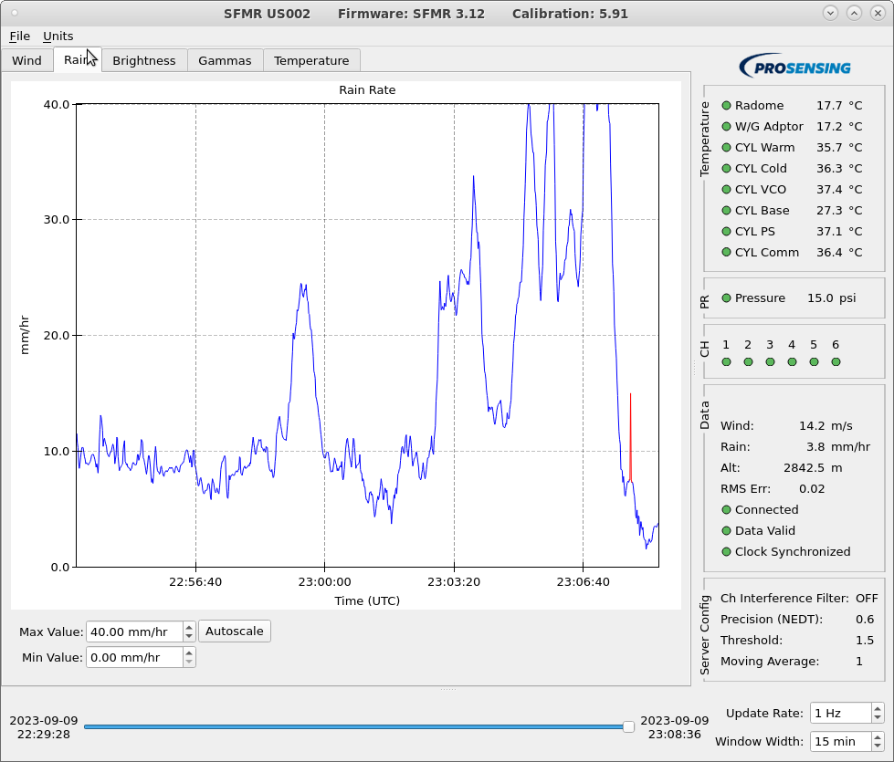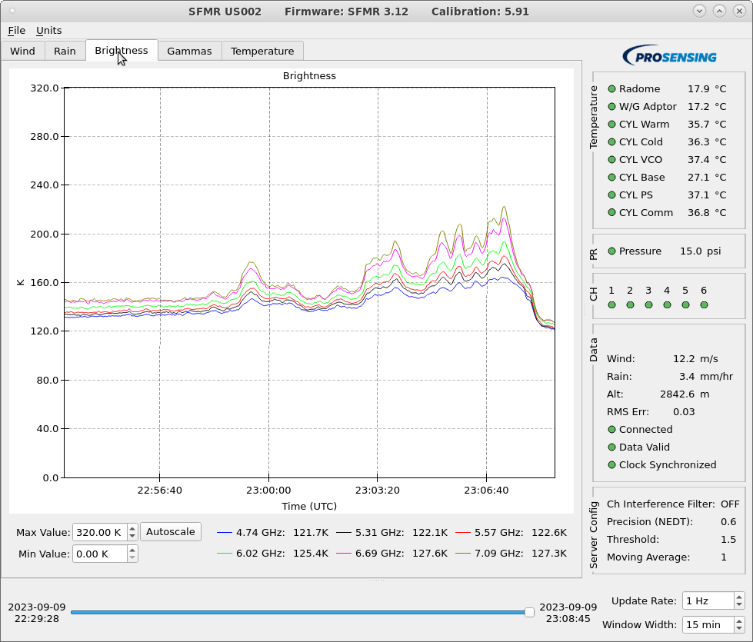
2303 | Sonde 13, 1st RMW N
2304 | Sonde 14, 2nd RMW N
2305 | Sonde 15, 3rd RMW N
2306 | Sonde 16, 4th RMW N
2309 | Sonde 17, center
2313 | Sonde 18, RMW S
2318 | Extensive area of lightning in the NW eyewall
2322 | Sonde 19 midpt S
2333 | Sonde 20, endpt S
2351 | Plan for mission after butterfly pattern is complete: We are probably gonna try to come back in from the NW to the center, then go out 45 degrees to a turn point, come back in, drop a sonde (or two) and overfly. Then come back in along that radial, and repeat. Working our way counter-clockwise (downwind)
2352 | Comparisons of SFMR with new IWRAP rain rate and surface 10 m scatterometer wind retrieval (not corrected for rain attenuation yet so they should be lower than SFMR) products  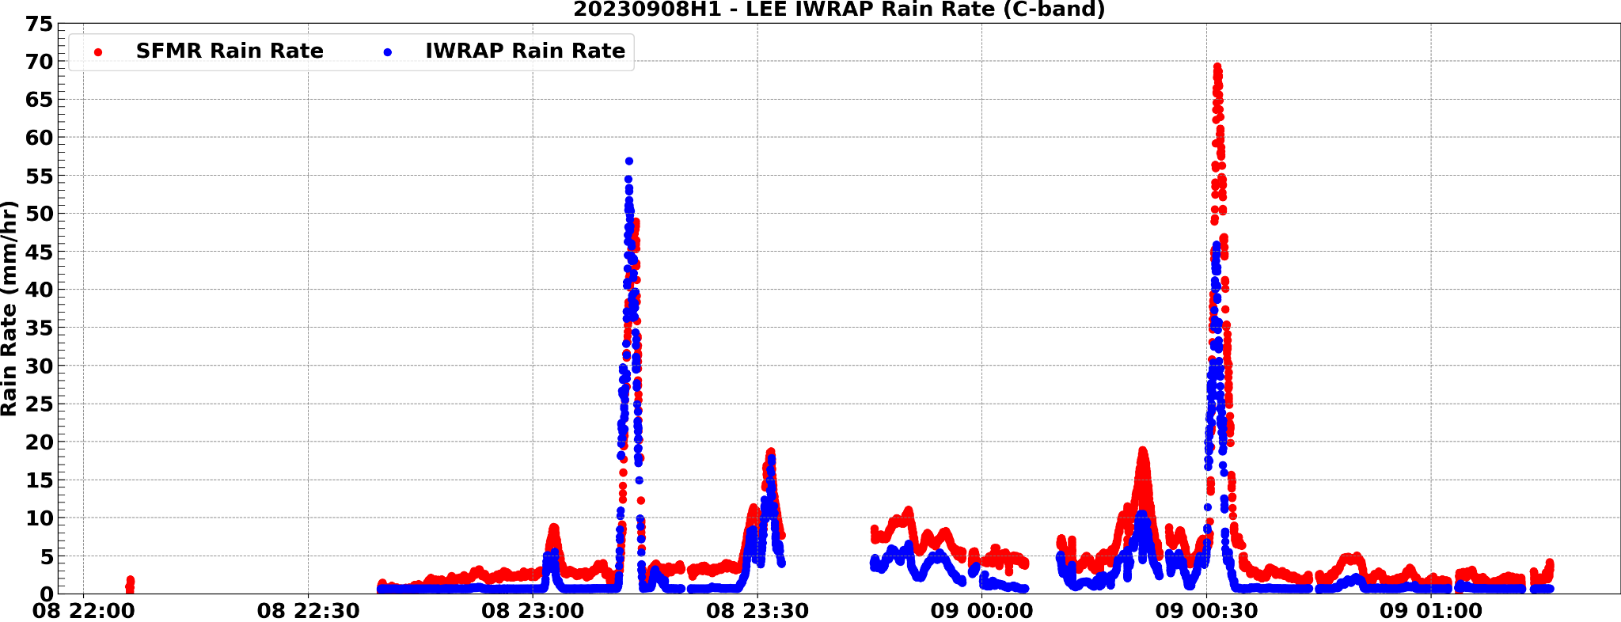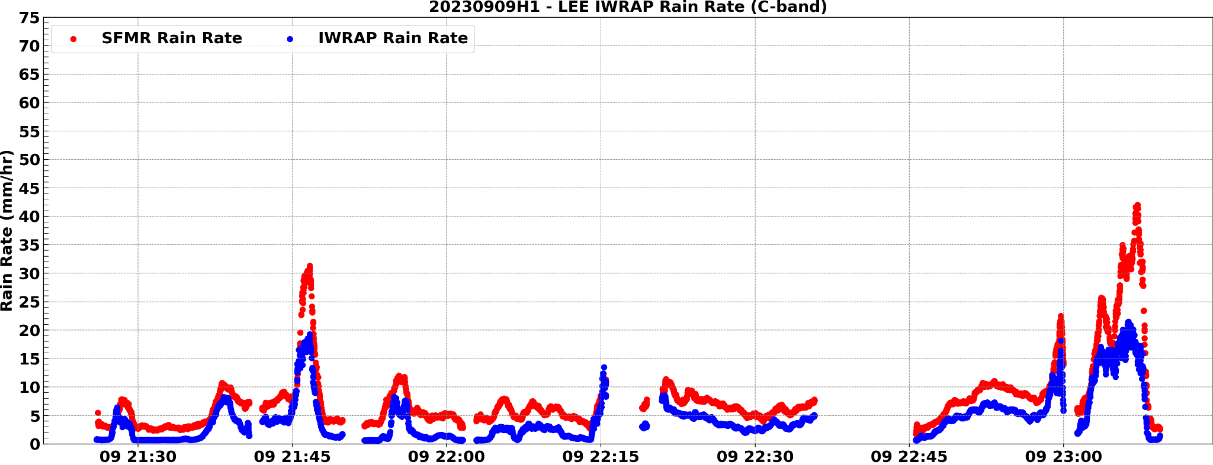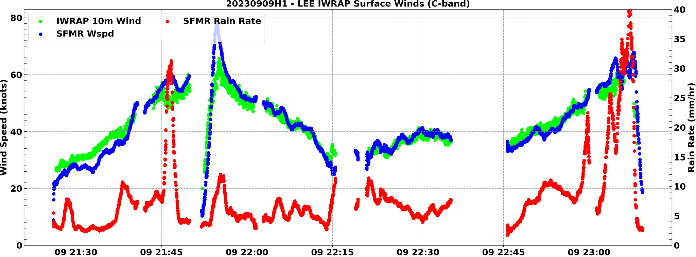
2354 | Sonde 21, endpt SE, combo (BT3), 29.41 C SST
0005 | MMR and nose radar indicate the outer eyewall may be contracting
0006 | Sonde 22, midpt SE
0016 | Sonde 23, RMW SE
0018 | Sonde 24, center drop
0019 | 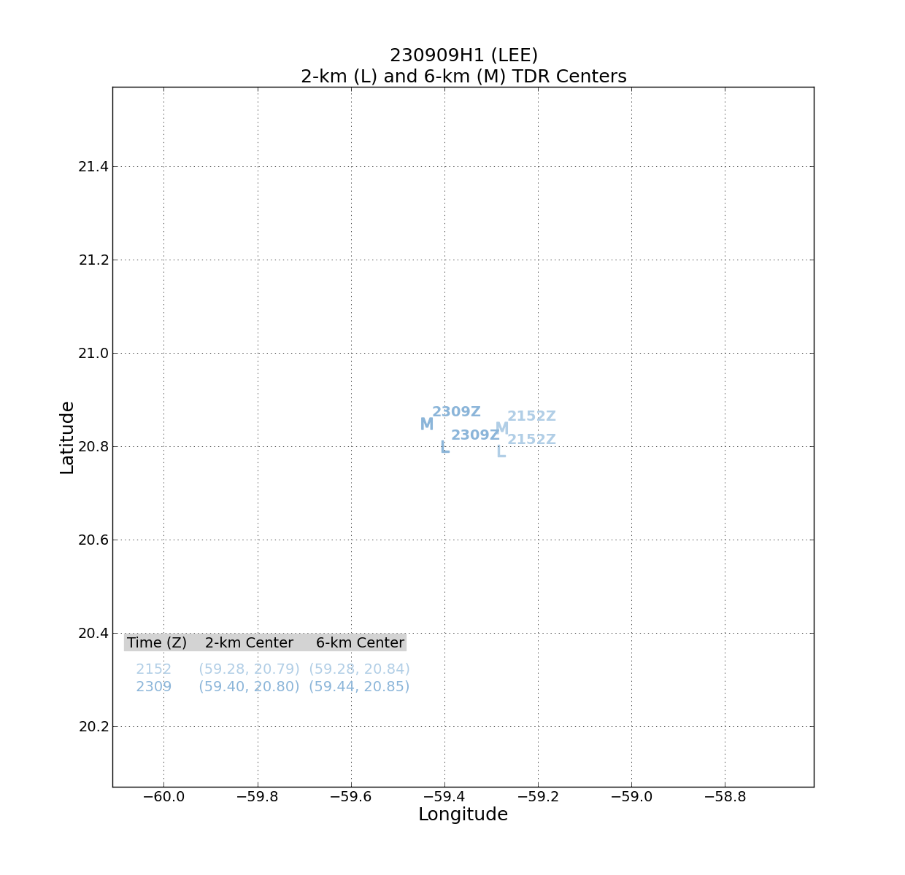  Tilt from 1st to 2nd pass shows 6-km center now NW of 2-km center, possible precession upshear?
0021 | 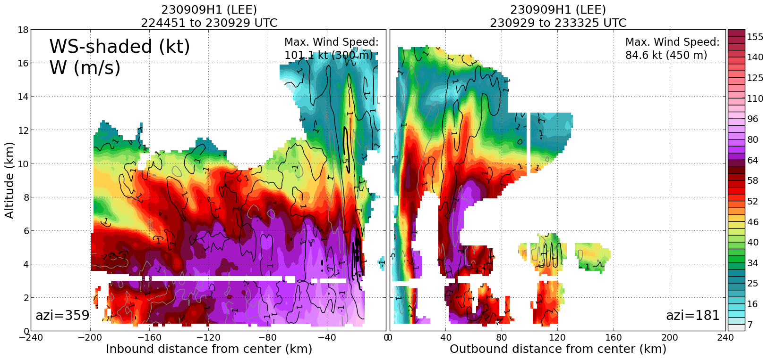  Profile analysis shows very broad wind field on N side, secondary wind maximum at around 120 km N of center
0020 | Sonde 25, 1st NW RMW
0021 | Sonde 26, 2nd NW RMW
0021 | Sonde 27, 3rd NW RMW
0022 | Sonde 28, 4th NW RMW
0023 | 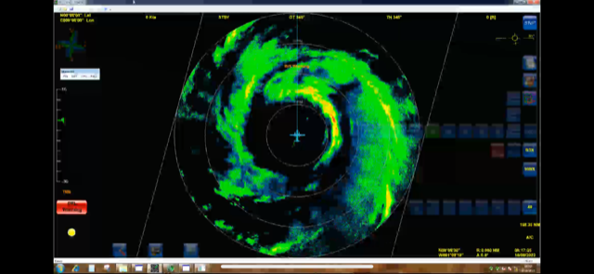  MMR picture of the eye at 0018 UTC
0030 | Sonde 29, midpt NW
0044 | Sonde 30, endpt NW, combo
0053 | Sonde 31, end NW (Backup)
0110 | Updated plan for module: inbound from NW, out 45, in 45, drop RMW, to center, overfly splash, inbound from that point, drop RMW, overfly (probably NW/W) and then RTB
0118 | 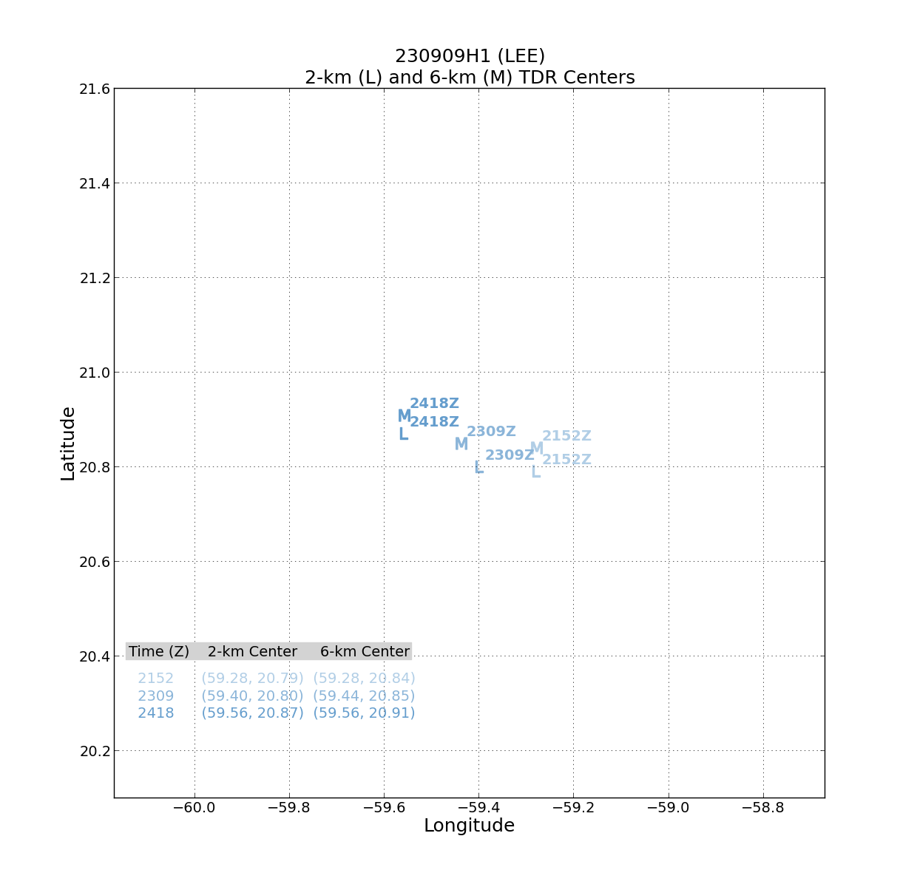  Centers on 3rd pass show vortex better-aligned from previous two passes, toward the N with tilt
0120 | 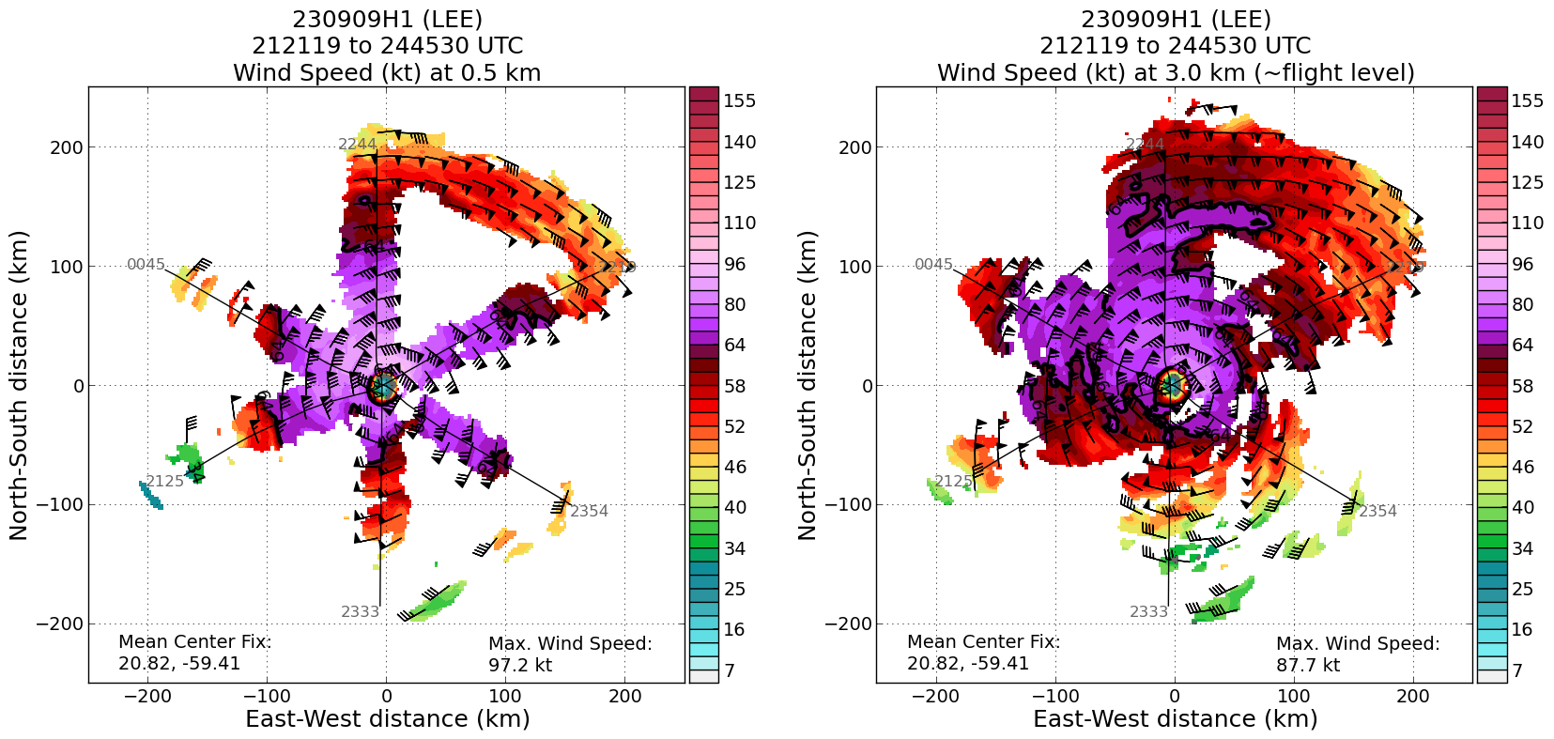  Composite shows strongest winds in eyewall in the NE. Some indication of an outer wind speed max at 3 km in the NW and N quadrants
0121 | 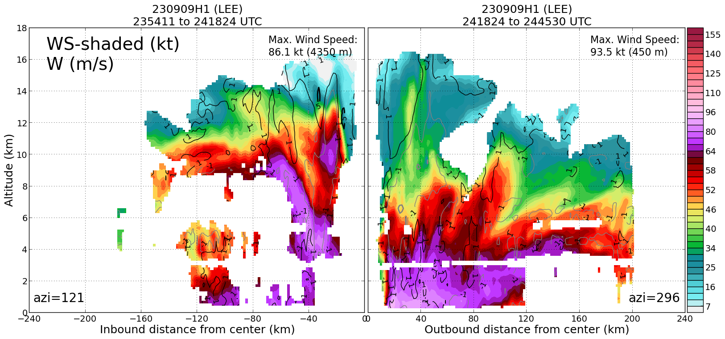  Profile on the NW side confirms this outer wind maximum. Multiple maxima in fact (DSL quad).
0127 | 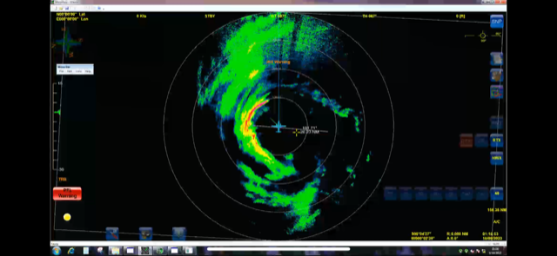  MMR view of eyewall at 0119 UTC. Aircraft pointing toward NE, showing asymmetric eyewall open on the S and SE.
0129 | Aircraft coming back inbound as part of Ocean Winds module. Encountering turbulent conditions in the NE eyewall. Lightning in vicinity as well.
0130 | An issue arose with the MMR, mission is cutting off science and modules, and returning to base
0250 | Land in STX
 | << INSERT ADDITIONAL ROW AS NEEDED >>

POST-FLIGHT
Mission Summary | Primary butterfly pattern was flown successfully. TC remains steady-state, with evidence of multiple wind maxima particularly on the NW side, but also SW and NE. System remains essentially aligned, with tilt magnitude on the order of 6-7 km, with tilts toward the N or NNW. Concentric eyewalls likely to develop, if not already present. Sea-surface temperatures are in the 29 C range. The primary factors that seem to be inhibiting intensification is the presence of this broader wind field (SEF potential) and midlevel SW shear impacting the system. SHIPS forecasts the shear dropping in 6-12 h, so potential for intensification is there.  After completion of the butterfly, returned inbound to begin some legs for Ocean Winds. Went outbound along a 45 azimuth, returned back inbound. However, MMR had a failure on the inbound leg as the aircraft encountered turbulence and the mission was forced to end science and return to base.  31 sondes dropped (29 sent), 21 charged to NWS, 10 charged to ONR, 4 AXBTs dropped.
Actual Standard Pattern Flown | Butterfly
APHEX Experiments / Modules Flown | TDR pattern, Ocean Winds module
Plain Language Summary | - P-3 flew mission into Hurricane Lee, collecting important radar and dropsonde data that was transmitted to the ground in real-time to improve numerical model forecasts  - Lee remains at a steady-state intensity, though the wind field has expanded in size with evidence of outer wind maxima (outside of the usual eyewall wind maximum)  - Data was collected that compares surface wind measurements with other instruments that can be used to improve those surface wind estimates
Instrument Notes | Instruments worked fine until the Ocean Winds module, where the MMR failed, prompting a RTB
Final Mission Track

