MISSION PLAN
FLIGHT ID | 20230908H1 | STORM | AL13/LEE
MISSION ID | 0513A | TAIL NUMBER | NOAA 42
TASKING | NHC-EMC TDR | PLANNED PATTERN | Butterfly
MISSION SUMMARY
TAKEOFF [UTC] | 2123 | LANDING [UTC] | 0452
TAKEOFF LOCATION | St. Croix | LANDING LOCATION | St. Croix
FLIGHT TIME | 7.5 | BLOCK TIME | 7.7
TOTAL REAL-TIME RADAR ANALYSES  (Transmitted) | 3 (3) | TOTAL DROPSONDES Deployed (Transmitted) | 32 (27)
OCEAN EXPENDABLES (Type) | 4 AXBTs | sUAS (Type) | n/a
APHEX EXPERIMENTS / MODULES | FLAIMS, Ocean Winds
HRD CREW MANIFEST
LPS ONBOARD | Hazelton | LPS GROUND | None
TDR ONBOARD | Hazelton | TDR GROUND | Gamache
ASPEN ONBOARD | Sellwood | ASPEN GROUND
NESDIS SCIENTISTS | Chang, Sapp, Jelenak
GUESTS (Affiliation) | 2 Officials from the Government of the USVI
AOC CREW MANIFEST
PILOTS | Doremus/Rannenberg/Palmer
NAVIGATOR | Hough/Schaeffer
FLIGHT ENGINEERS | Stokes/Gee
FLIGHT DIRECTOR | Zawislak/Parrish
DATA TECHNICIAN | McAlister
AVAPS | Waggoner/Santoni

PRE-FLIGHT
Flight Plan | We are flying a TDR butterfly pattern with the possibility of adding on legs for a FLAIMS module or NESDIS work.
Expendable Distribution | 31 sondes, 4 BTs
Preflight Weather Briefing | Lee is a strong Category 4 hurricane, weakening slightly from earlier after dealing with some SW shear undercutting the outflow.  The storm appears to have a shrinking (collapsing?) inner eye that is becoming less apparent on geostationary satellite imagery.  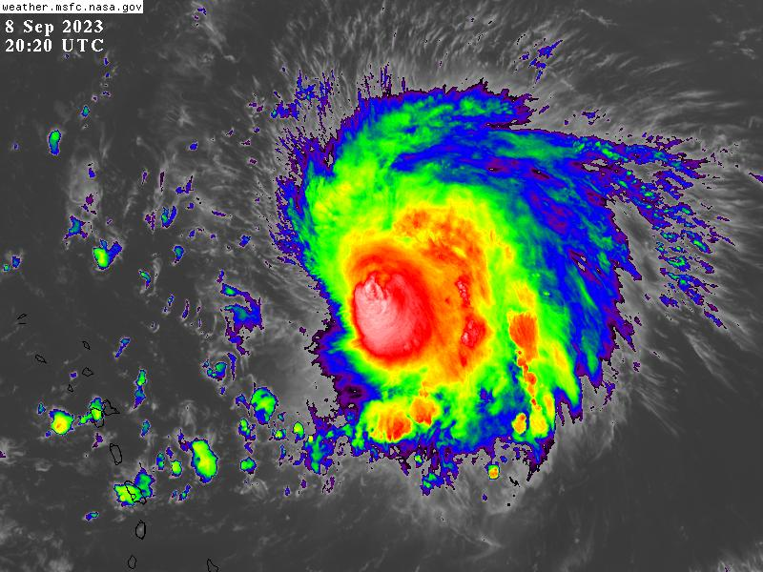
Instrument Notes | The MMR location component is not working. We are planning to fly just with the nose radar for as long as the crew is comfortable.

IN-FLIGHT
Time [UTC] | Event
2123 | Take-off from St. Croix
2228 | Descent to 8 kfts
2248 | IP From SW, Endpoint Sonde 1. Some dry air noted on this sonde.
2300 | Midpoint Sonde 2
2306 | Small eye ahead of us on radar
2312 | RMW Sonde 3
2313 | RMW Sonde 4
2313 | RMW Sonde 5
2316 | RMW Sonde 6
2317 | RMW Sonde 7
2318 | RMW Sonde 8
2329 | Midpoint Sonde 9
2340 | Endpoint Sonde 10
0000 | 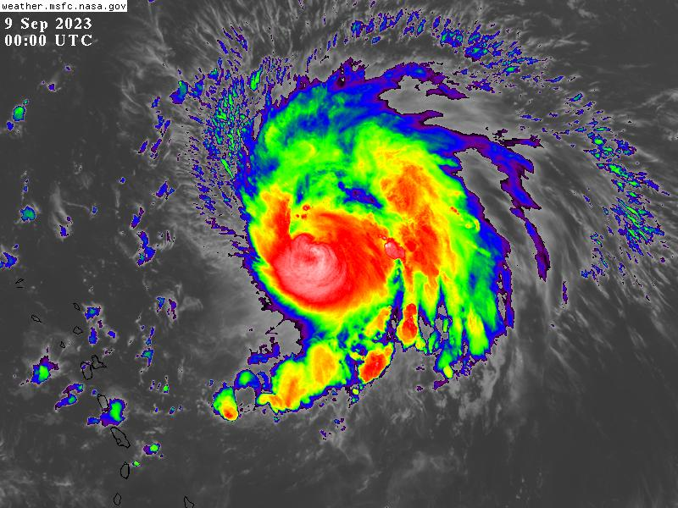
0010 | Endpoint Sonde 11
0022 | Midpoint Sonde 12
0031 | RMW sonde 13
0031 | RMW sonde 14, lots of eyewall lightning
0032 | RMW Sonde 15
0033 | RMW Sonde 16
0035 | Center Sonde 17, Combo Drop with BT  Inner eye has totally collapsed
0037 | RMW Sonde 18
0040 | 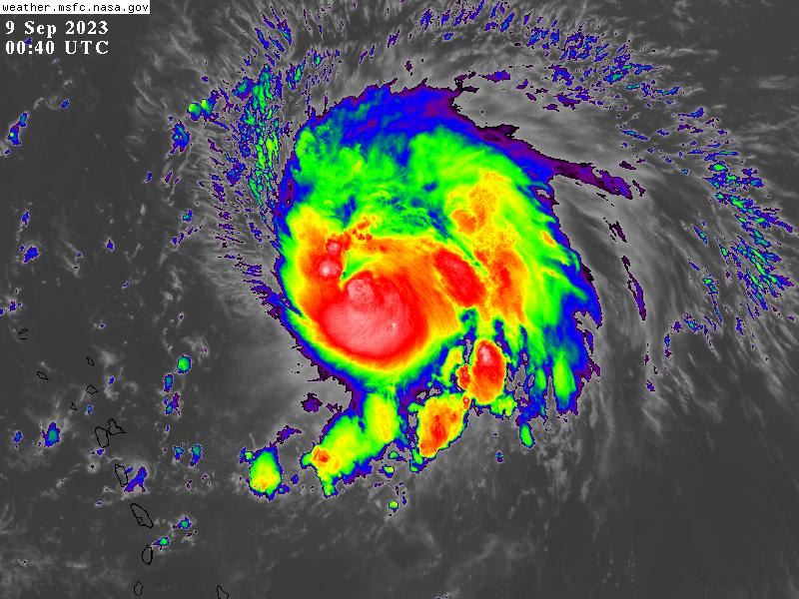
0048 | Midpoint Sonde 19, 20 (Backup)
0101 | Endpoint Sonde 21
0124 | Endpoint Sonde 22, inbound from SE
0133 | Fascinating remnant of the inner eye ahead
0137 | Midpoint Sondhe 23
0140 | Eyewall gone on S side
0144 | RMW Sonde 24 S
0145 | RMW Sonde 25 S
0147 | RMW Sonde 26 S
0148 | Center Sonde 27, Combo Drop, Eyewall lightning
0149 | RMW Sonde 28
0149 | RMW Sonde 29
0149 | RMW Sonde 30
0201 | Midpoint Sonde 31, Combo Drop
0209 | Preparing to do some extra NESDIS legs
0217 | Starting inbound from NW for NESDIS legs
0330 | Heading back west to STX

POST-FLIGHT
Mission Summary | We flew a successful EMC TDR mission in Major Hurricane Lee. The storm appeared to be weakening due to the combination of some southwesterly shear and perhaps an ongoing eyewall replacement cycle. During the flight the small inner eye basically collapsed.
Actual Standard Pattern Flown | Butterfly
APHEX Experiments / Modules Flown | [Linked to HFP Plan; fill in regardless of whether the mission was operationally or research tasked]
Plain Language Summary | - We flew a successful TDR mission into Hurricane Lee.  - The storm was weakening somewhat unexpectedly during the mission.
Instrument Notes | The MMR directional/navigation components were not working correctly.
Final Mission Track | 