MISSION PLAN
FLIGHT ID | 20230829I2 | STORM | AL10 / Idalia
MISSION ID | 1210A Idalia | TAIL NUMBER | NOAA-43
TASKING | NHC/EMC | PLANNED PATTERN | Butterfly
MISSION SUMMARY
TAKEOFF [UTC] | 2039 | LANDING [UTC]
TAKEOFF LOCATION | FLL | LANDING LOCATION | FLL
FLIGHT TIME | Fractional hr, Takeoff to Landing Time | BLOCK TIME | Get from onboard LPS or Flight Director
TOTAL REAL-TIME RADAR ANALYSES  (Transmitted) | 6 (6 to EMC, 5 to AWIPS) | TOTAL DROPSONDES Deployed (Transmitted) | ? (26)
OCEAN EXPENDABLES (Type) | 5 (5) UM AXBT  0 MicroSWIFT | sUAS (Type) | n/a
APHEX EXPERIMENTS / MODULES | Exact name of the Experiment in the HFP Plan; identify relevant experiments / module even if not a research tasking
HRD CREW MANIFEST
LPS ONBOARD | Aberson | LPS GROUND | Sellwood / Alvey
TDR ONBOARD | Aberson | TDR GROUND | Alvey / Gamache
ASPEN ONBOARD | Sippel, Zhang | ASPEN GROUND
NESDIS SCIENTISTS
GUESTS (Affiliation) | Nicole LBoeuf (NOS AA), Peyton Collado,
AOC CREW MANIFEST
PILOTS | Abitbol, Keith
NAVIGATOR
FLIGHT ENGINEERS
FLIGHT DIRECTOR
DATA TECHNICIAN
AVAPS | Underwood

PRE-FLIGHT
Flight Plan | 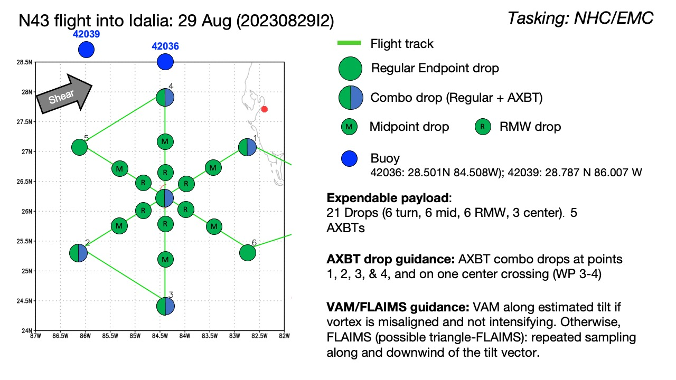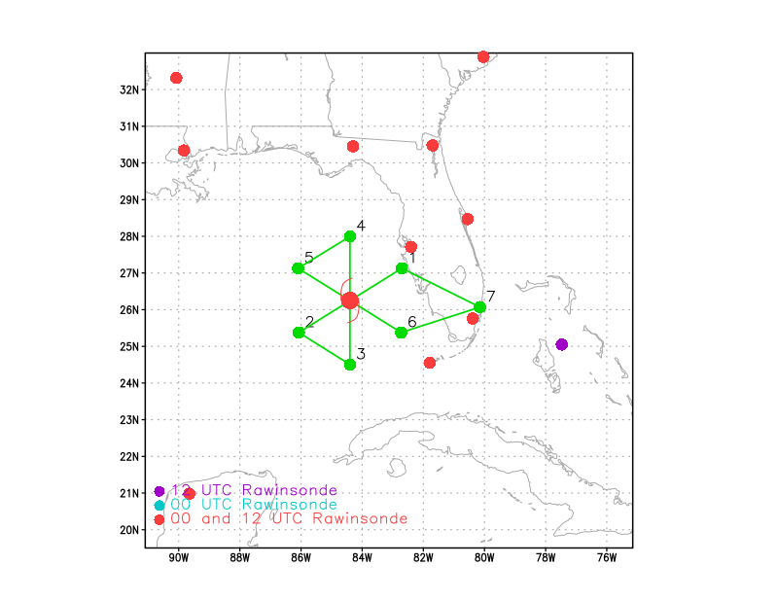  - Surface Wind and Wave Validation Module  - Pattern #4 (Wind Buoy Overflights) >> target area of homogeneous ~20-30m/s (~39-58 kt) surface winds  - Pattern #1 (Dropsonde Overflights (One P-3)) >> target surface winds >50 m/s (97 kt)  - Vortex Alignment Module (VAM) or FLAIMS Module  - Distribution of Hazardous Winds
Expendable Distribution | - Load 35 dropsondes  - Release at endpoints, midpoints, centers (charged to NWS)  - Additional drops may be requested at the discretion of the onboard HRD LPS  - All dropsondes transmitted to the GTS  - 5 AXBTs (Univ of Miami shallow water; see notes below)  - All AXBTs transmitted to the AOC ground server if possible
Preflight Weather Briefing | LOCATION...25.2N 84.9W  ABOUT 130 MI...210 KM WNW OF THE DRY TORTUGAS  ABOUT 240 MI...390 KM SW OF TAMPA FLORIDA  MAXIMUM SUSTAINED WINDS...90 MPH...150 KM/H  PRESENT MOVEMENT...N OR 360 DEGREES AT 15 MPH...24 KM/H  MINIMUM CENTRAL PRESSURE...974 MB...28.76 INCHES  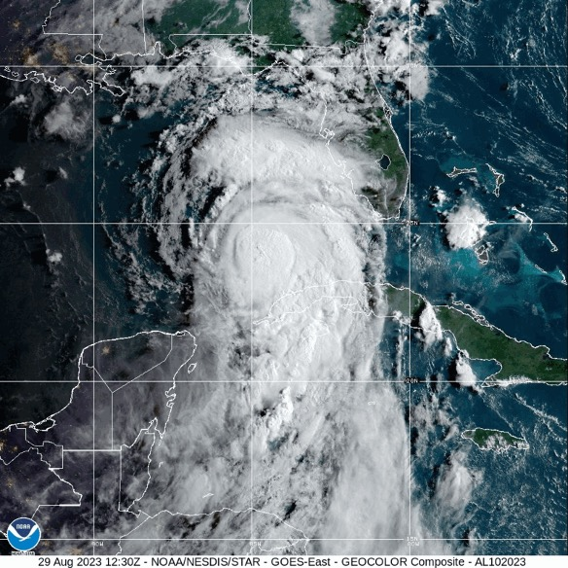  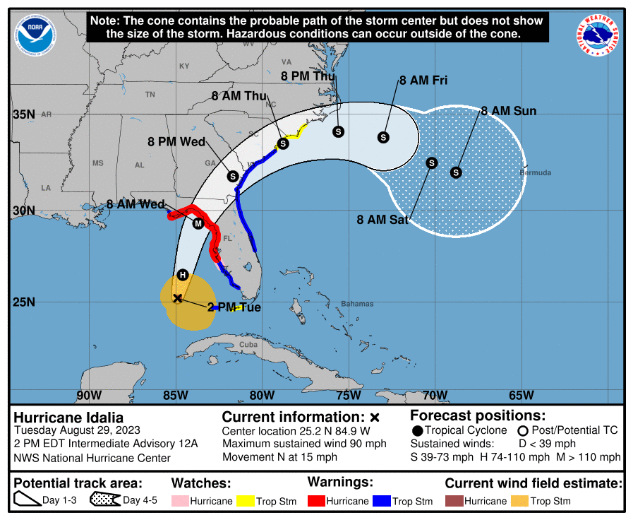  NHC Discussion 11am:  “Idalia is currently over a maximum of oceanic heat content  associated with the Loop Current, and water temperatures remain  30-31 degrees Celsius along the forecast path up until landfall.  Vertical shear is also expected to be low for the next 18-24 hours,  and these conditions are expected to foster rapid intensification  before Idalia reaches the coast of Florida. The 06 UTC runs of all  4 regional hurricane models (HAFS-A, HAFS-B, HWRF, and HMON) show  Idalia potentially reaching an intensity of 110-120 kt in 24 hours,  and as a result, the new NHC intensity forecast indicates a peak  intensity of 110 kt just before landfall.”  Very low VWS (< 5 kt via SHIPS) and very warm SSTs (See image below). Max sustained winds up to 100MPH at 5PM EDT update.
Instrument Notes

IN-FLIGHT
Time [UTC] | Event
2039Z | Take-off from FLL
 | 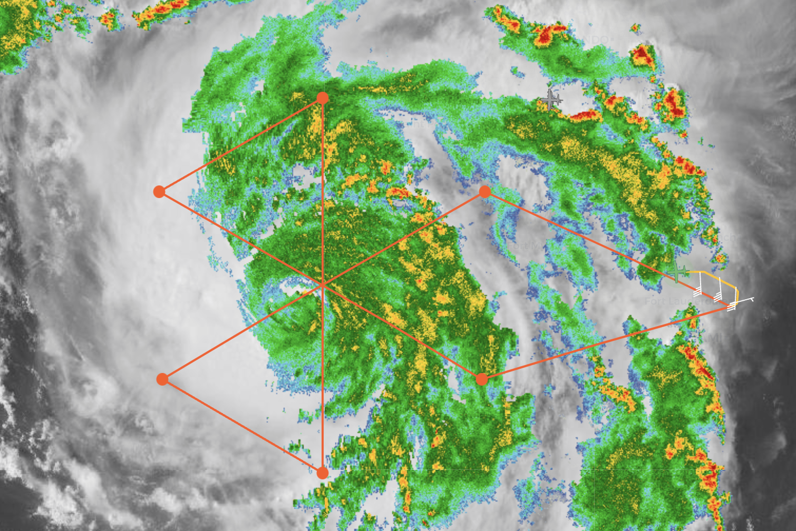
 | 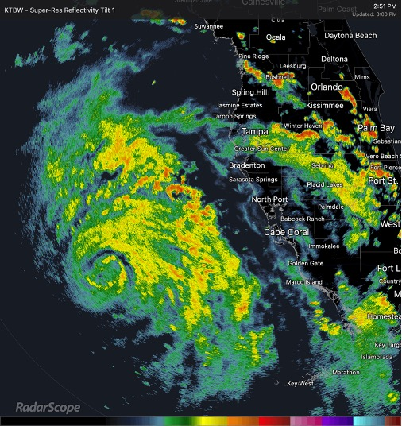
2109 | Turn inbound
2110 | Drop 1 (endpoint, inbound ENE-center)
 | 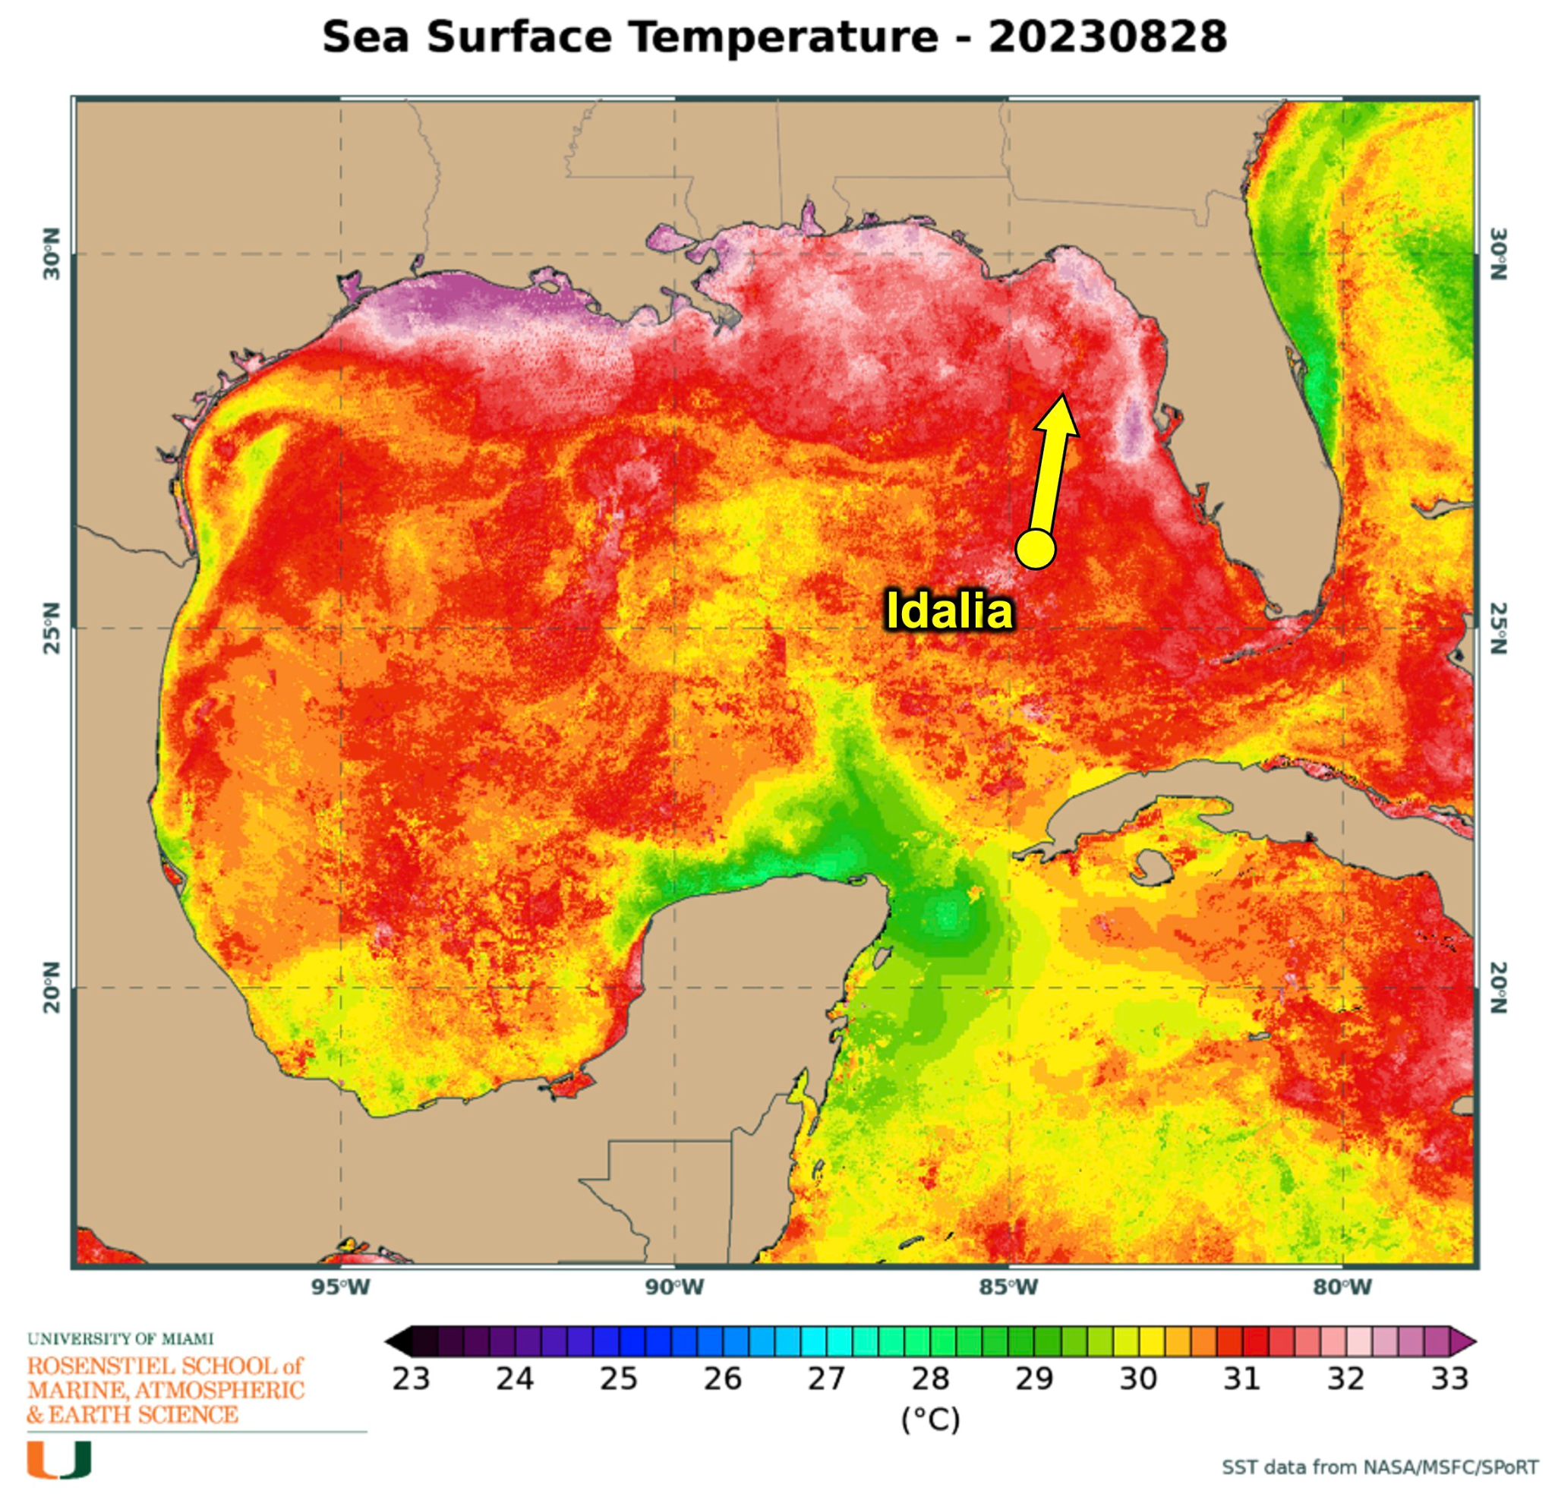
2124 | Midpoint combo, BT failed
2127 | Convection increasing near the center, and the eastern eyewall is beginning to consolidate on KTBW ground radar (~18 mi diameter). Eastern eyewall also looks strong on MMR 50 n mi out.
 | Saildrone: 26.456392 -84.57616 as of 17:59Z
 | 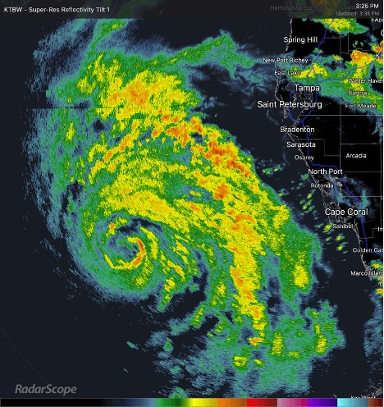
2137 | Outer windband sonde (NHC) sfc wind 59kt 145 deg
2140 | Inner RMW sonde, but still too early. Eye open SW sfc wind 74kt 135 deg
195
URNT12 KWBC 292211
VORTEX DATA MESSAGE AL102023
A. 29/21:44:51Z
B. 26.28 deg N 084.74 deg W
C. NA
D. 968 mb
E. 065 deg 4 kt
F. RAGGED
G. CO12-20
H. 84 kt
I. 099 deg 12 nm 21:41:47Z
J. 181 deg 103 kt
K. 095 deg 15 nm 21:40:55Z
L. 64 kt
M. 244 deg 6 nm 21:46:18Z
N. 313 deg 64 kt
O. 242 deg 10 nm 21:47:27Z
P. 15 C / 2458 m
Q. 23 C / 2460 m
R. 17 C / NA
S. 1234 / NA
T. 0.01 / 2 nm
U. NOAA3 1210A IDALIA OB 06
MAX FL WIND 103 KT 095 / 15 NM 21:40:55Z

 | 54 m/s FL wind eastern eyewall
2144 | Mark center sfc 968mb 4kts 65deg
2147 | RMW SW sfc wind 63kt 310deg
 | 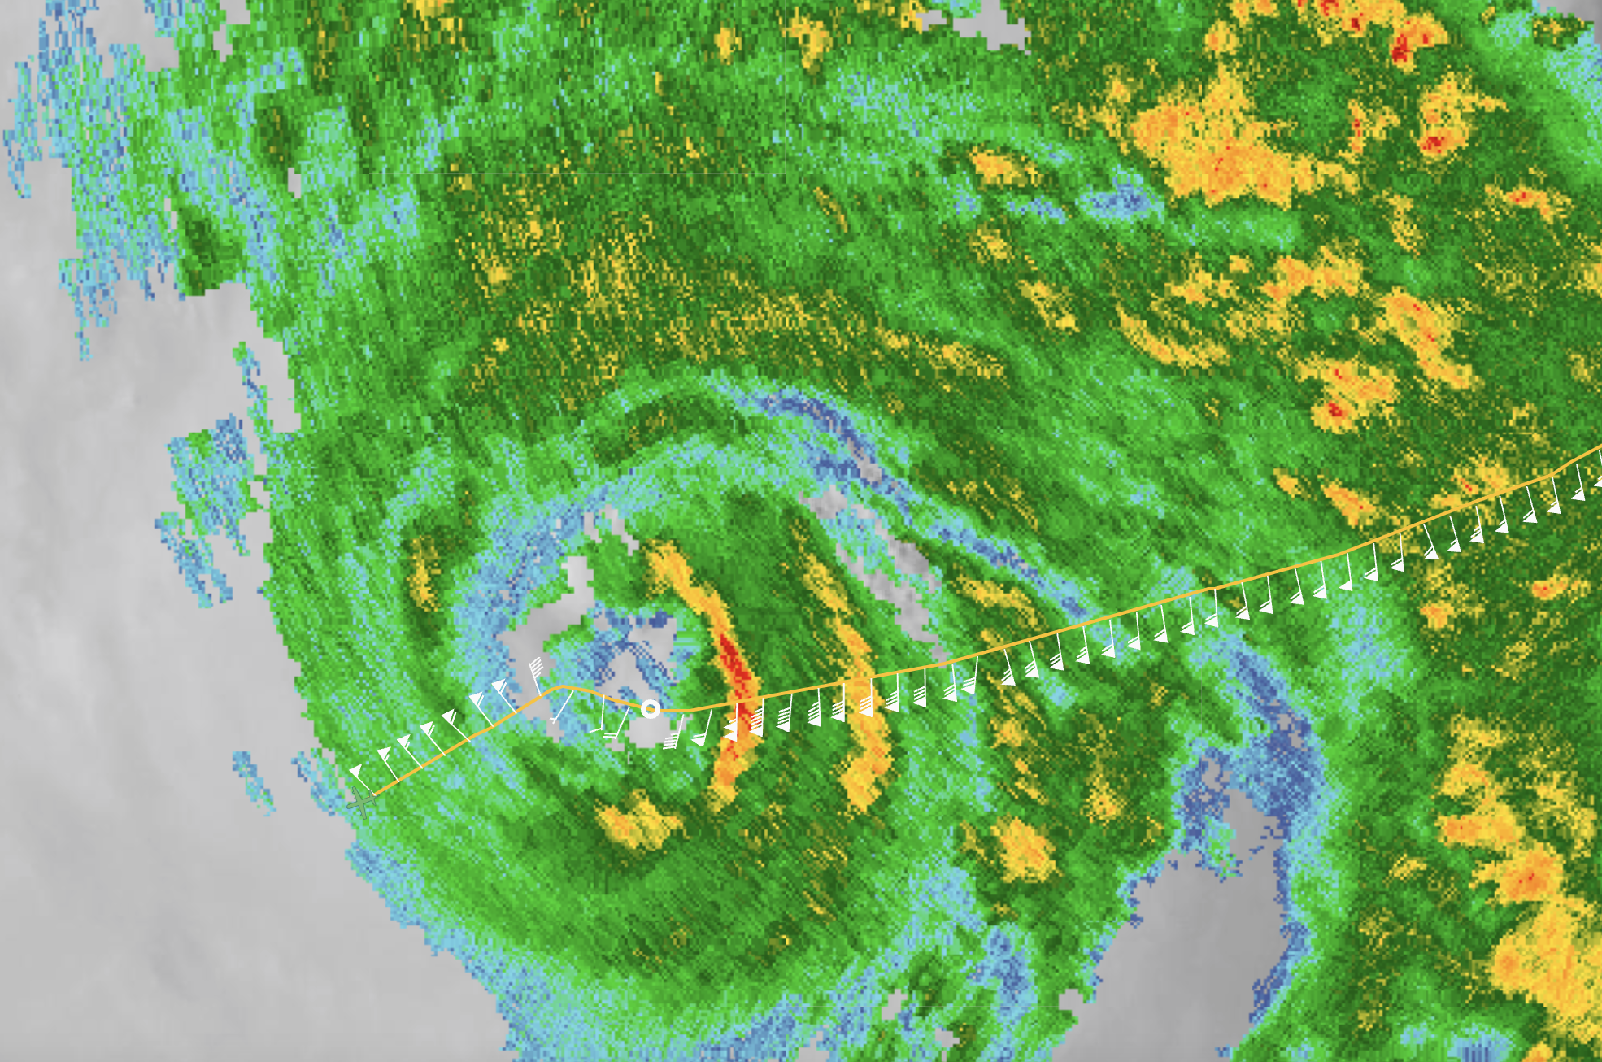
2159 | Midpoint sonde
2204 | 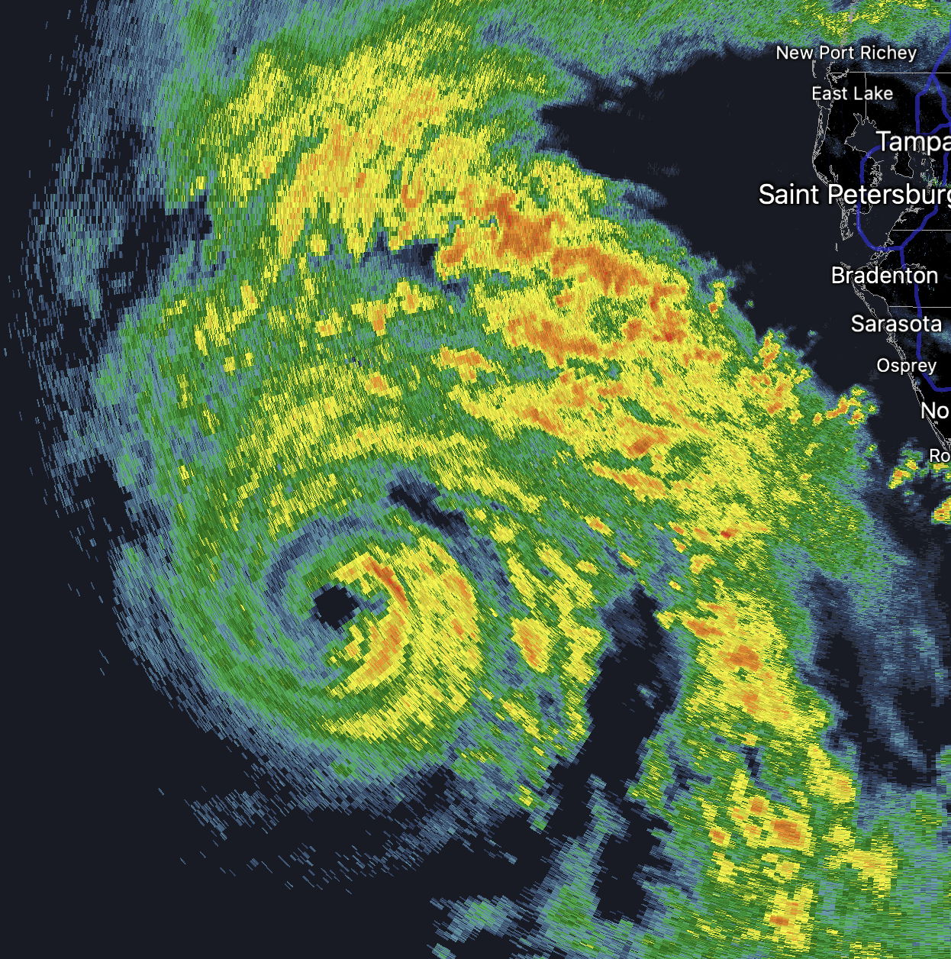  New convective cells popping in SE quadrant inside of RMW
2211 | Endpoint combo, SST 30.1C
 | Time is in MDT
2234 | Turn inbound
2235 | Endpoint combo, SST=28C
2248 | midpoint
2254 | Rmw sfc wind 69kt 220deg
2300 | Center combo, SST=28.7C 965mb 02kts 340deg
619
URNT12 KWBC 292334
VORTEX DATA MESSAGE AL102023
A. 29/23:00:55Z
B. 26.67 deg N 084.66 deg W
C. NA
D. 965 mb
E. 340 deg 02 kt
F. OPEN SW
G. C12
H. 69 kt
I. 178 deg 10 nm 22:58:15Z
J. 267 deg 78 kt
K. 182 deg 13 nm 22:57:31Z
L. 79 kt
M. 337 deg 10 nm 23:03:28Z
N. 081 deg 80 kt
O. 336 deg 12 nm 23:03:51Z
P. 15 C / 2451 m
Q. 21 C / 2451 m
R. 18 C / NA
S. 1234 / NA
T. 0.01 / 2 nm
U. NOAA3 1210A IDALIA OB 15
MAX FL WIND 103 KT 095 / 15 NM 21:40:55Z
MAX FL TEMP 21 C 176 / 9 NM FROM FL CNTR
2303 | RMW
2313 | midpoint
 | 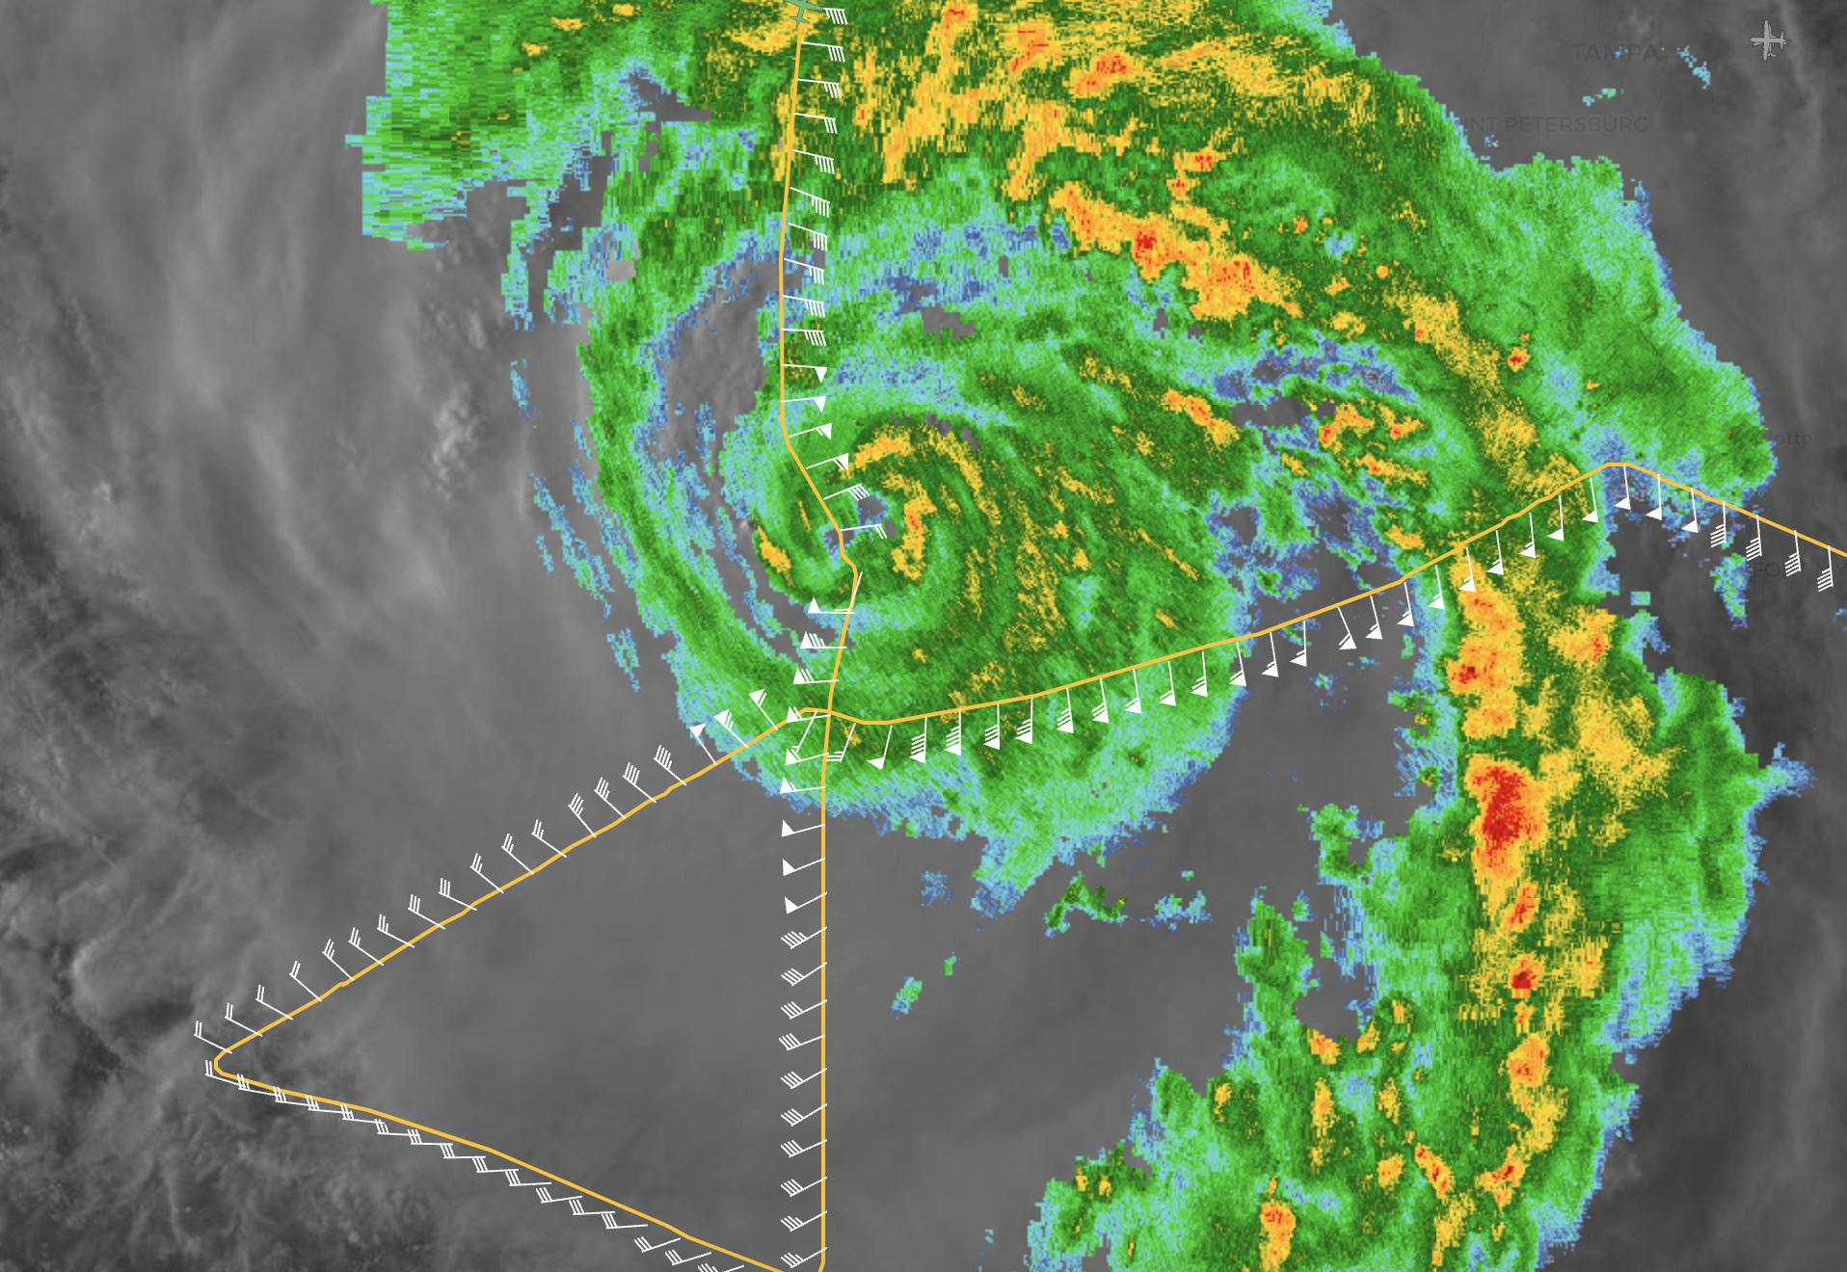
2325 | Endpoint combo, BT started collecting about 50 m down
2327 | Turn downwind
2348 | endpoint
0002 | midpoint
0007 | Eyewall quickly tightening up on radar and eye clearing out  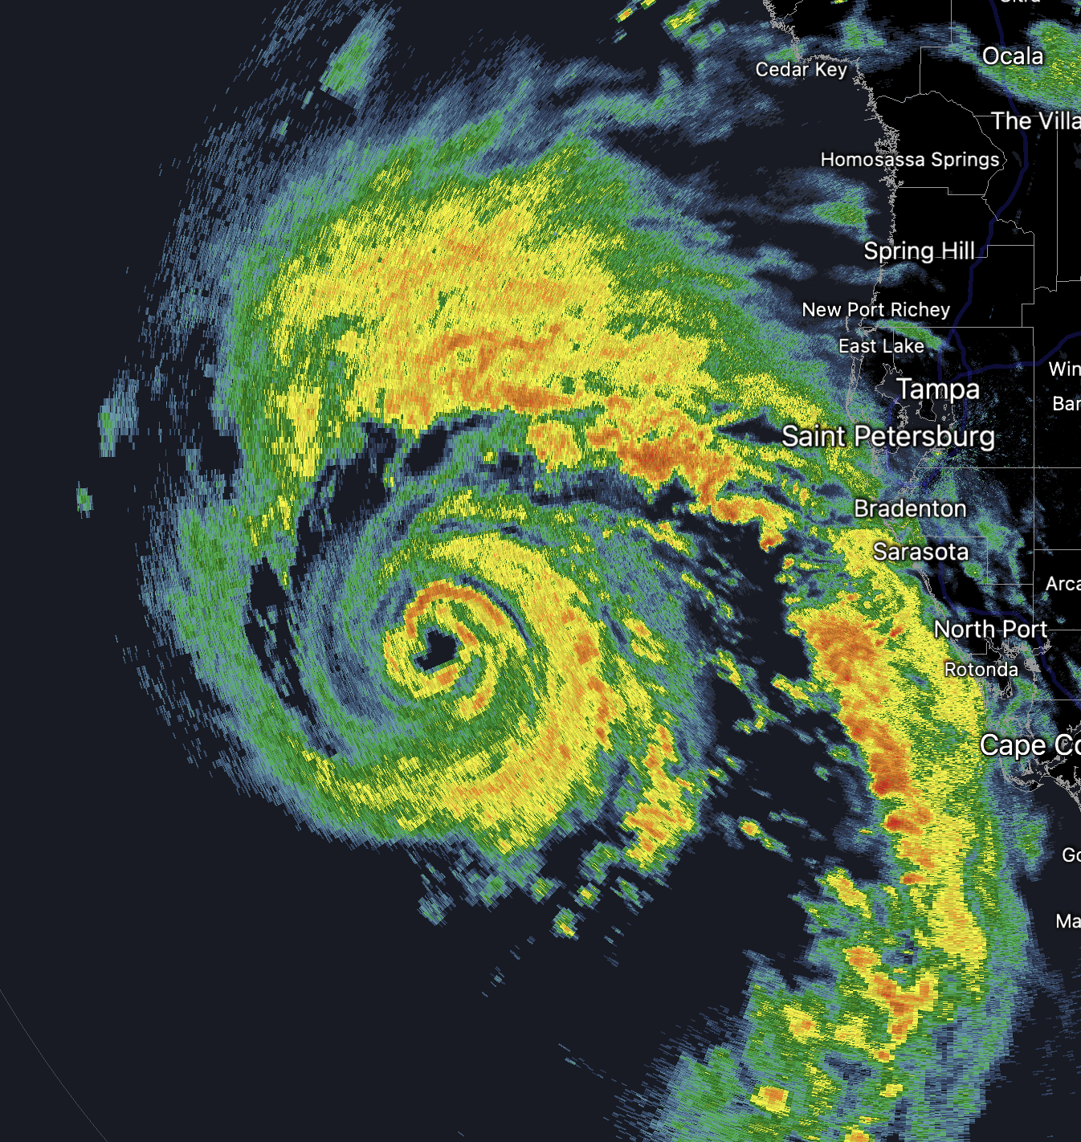
0012 | RMW sonde, too early sfc. Wind 51kt 25deg
0017 | Center sfc 962mb 25kts 170deg
0020 | RMW sfc wind 88kts 150deg
0030 | Midpoint sonde
0046 | Endpoint
 | Begin modules
 | Doing an inadvertent convective burst module to get around very strong rainband and back to the center
 | 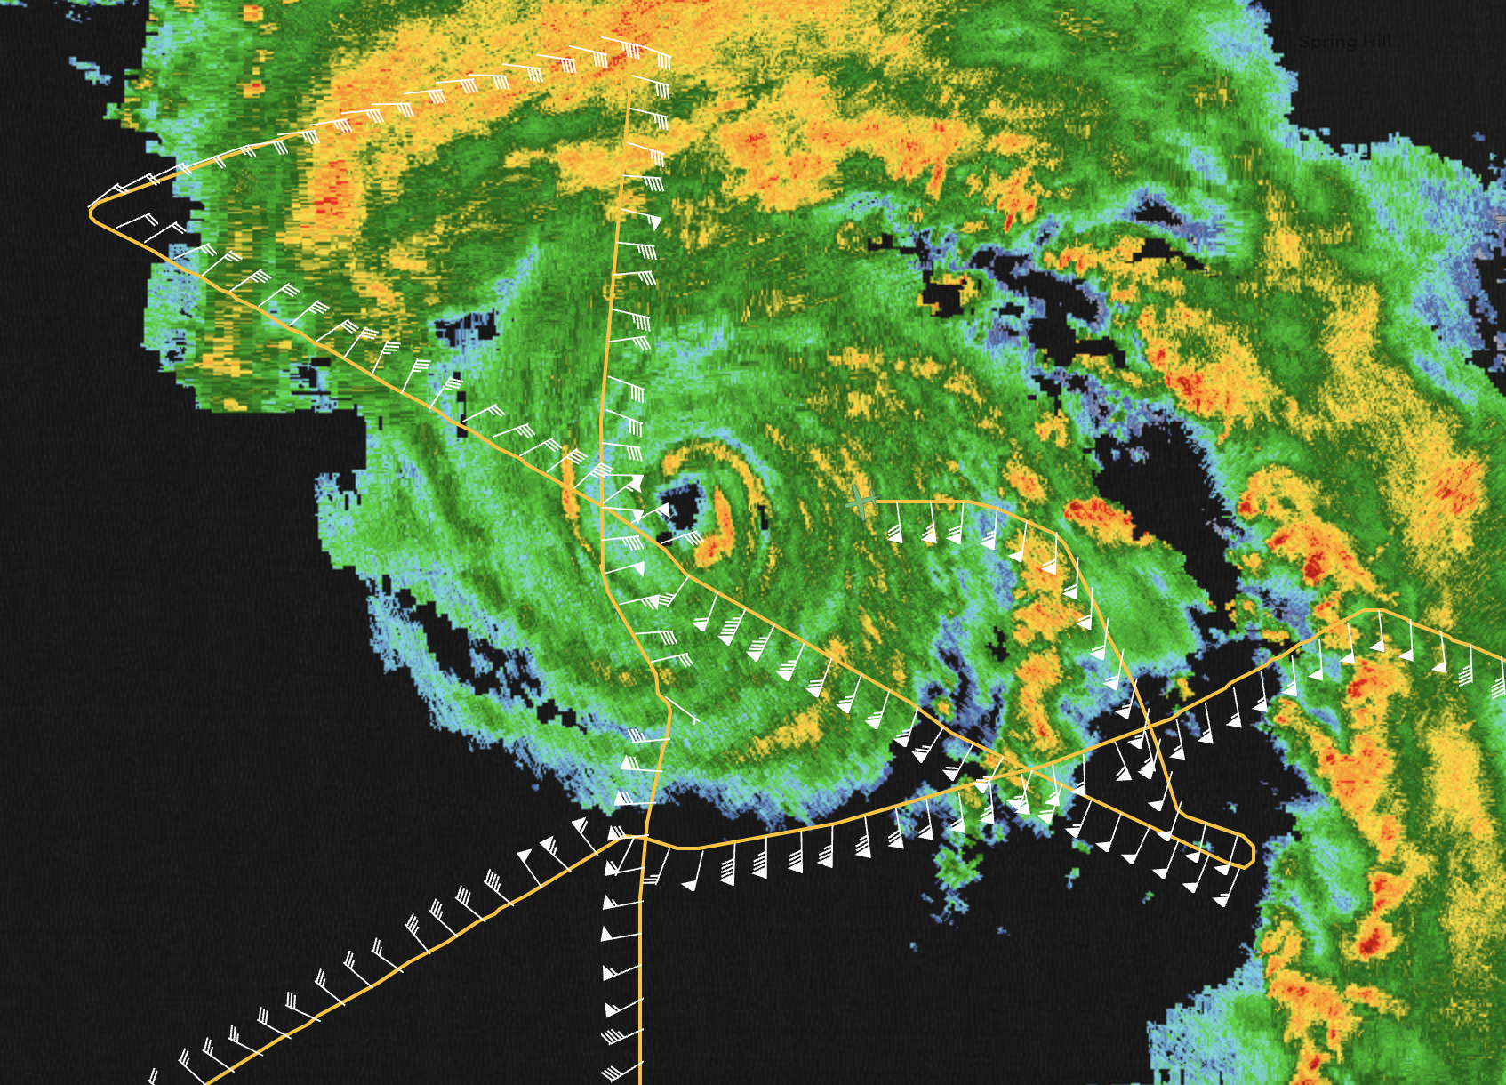
0113 | 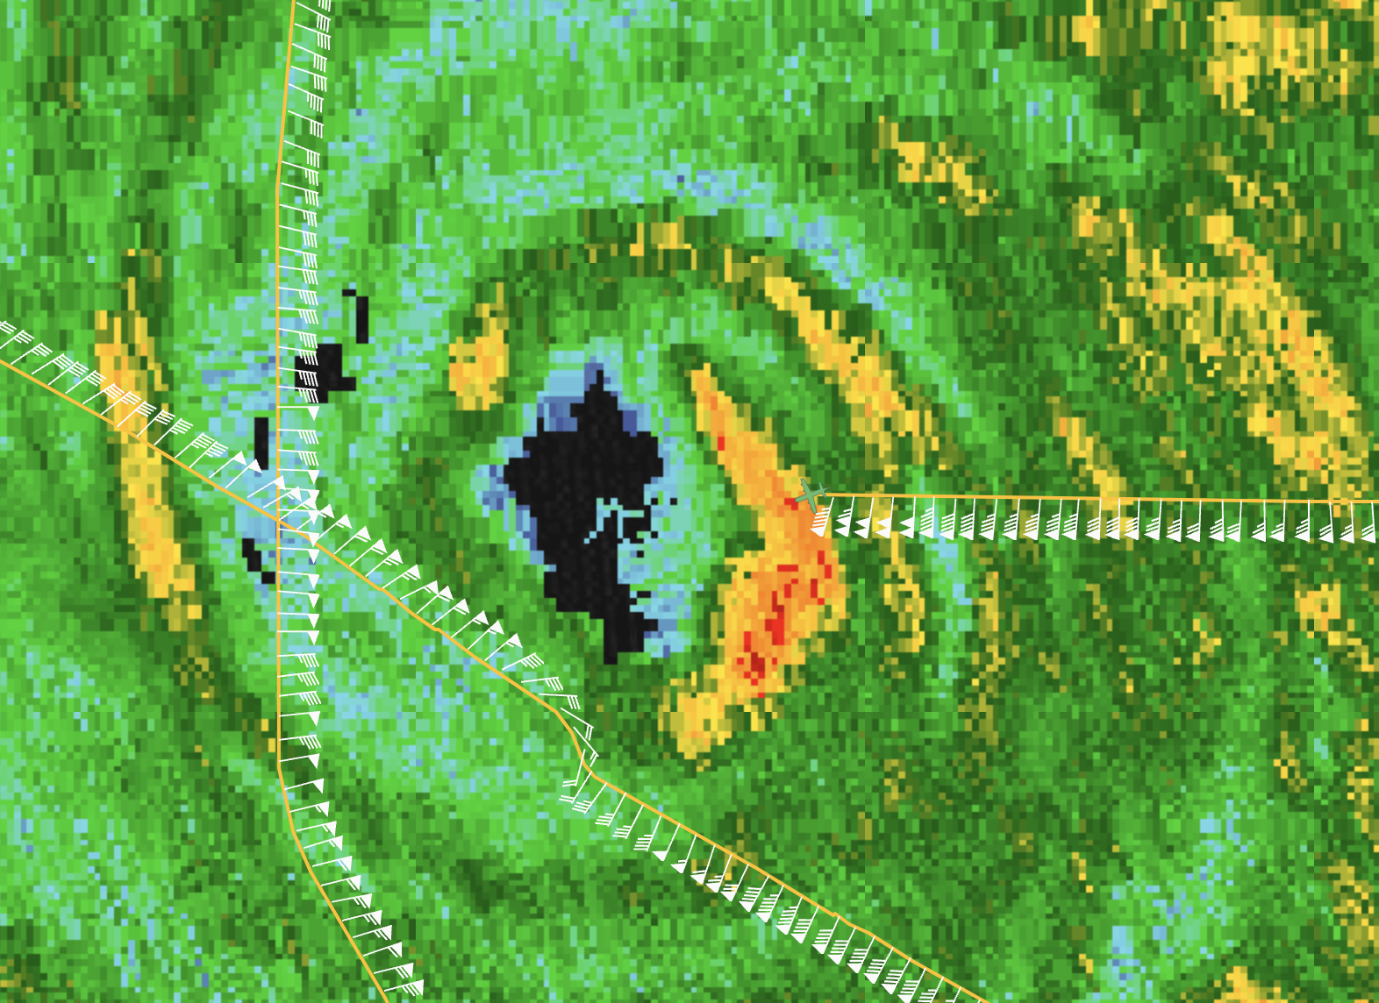  New CB inside of the RMW they’re flying through. 115 kt FL wind
 | Had to abort module due to miscommunication on azimuth to enter storm.
0119 | RMW sonde outbound sfc wind 94kt 140deg
0121 | Mmr down
0125 | Mmr up
0144 | 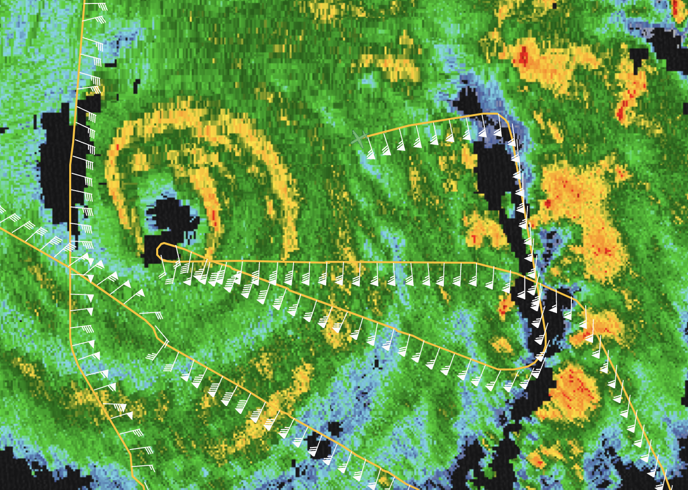
0148 | Sonde out
0151 | Turn to fly over splash from first sonde
 | 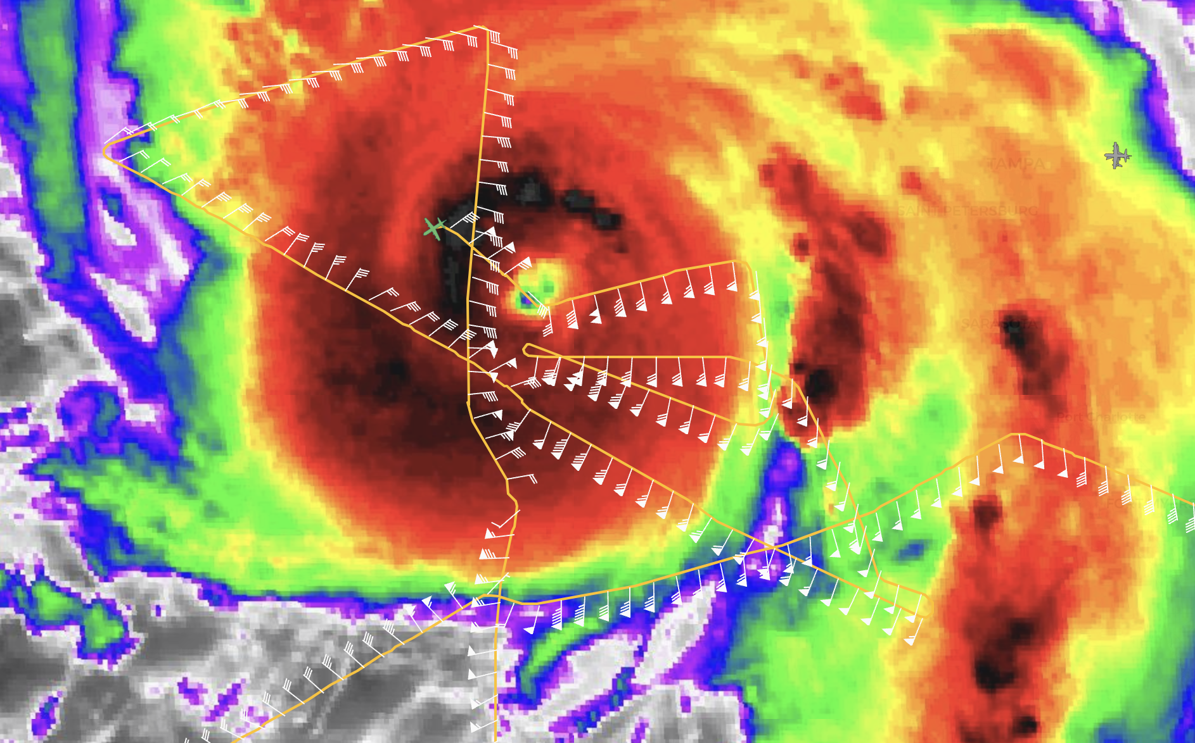
First sonde overflight was incorrect, since Ash thought it was in DMS, not decimal. Need to make sure we note units
Second sonde overflight done, but splash location made no sense given where it was released. Must investigate. Stopped science after that.
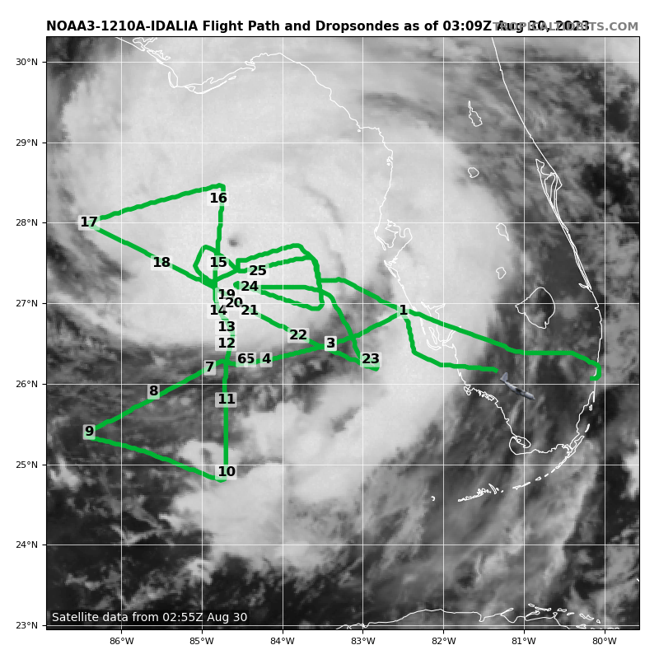
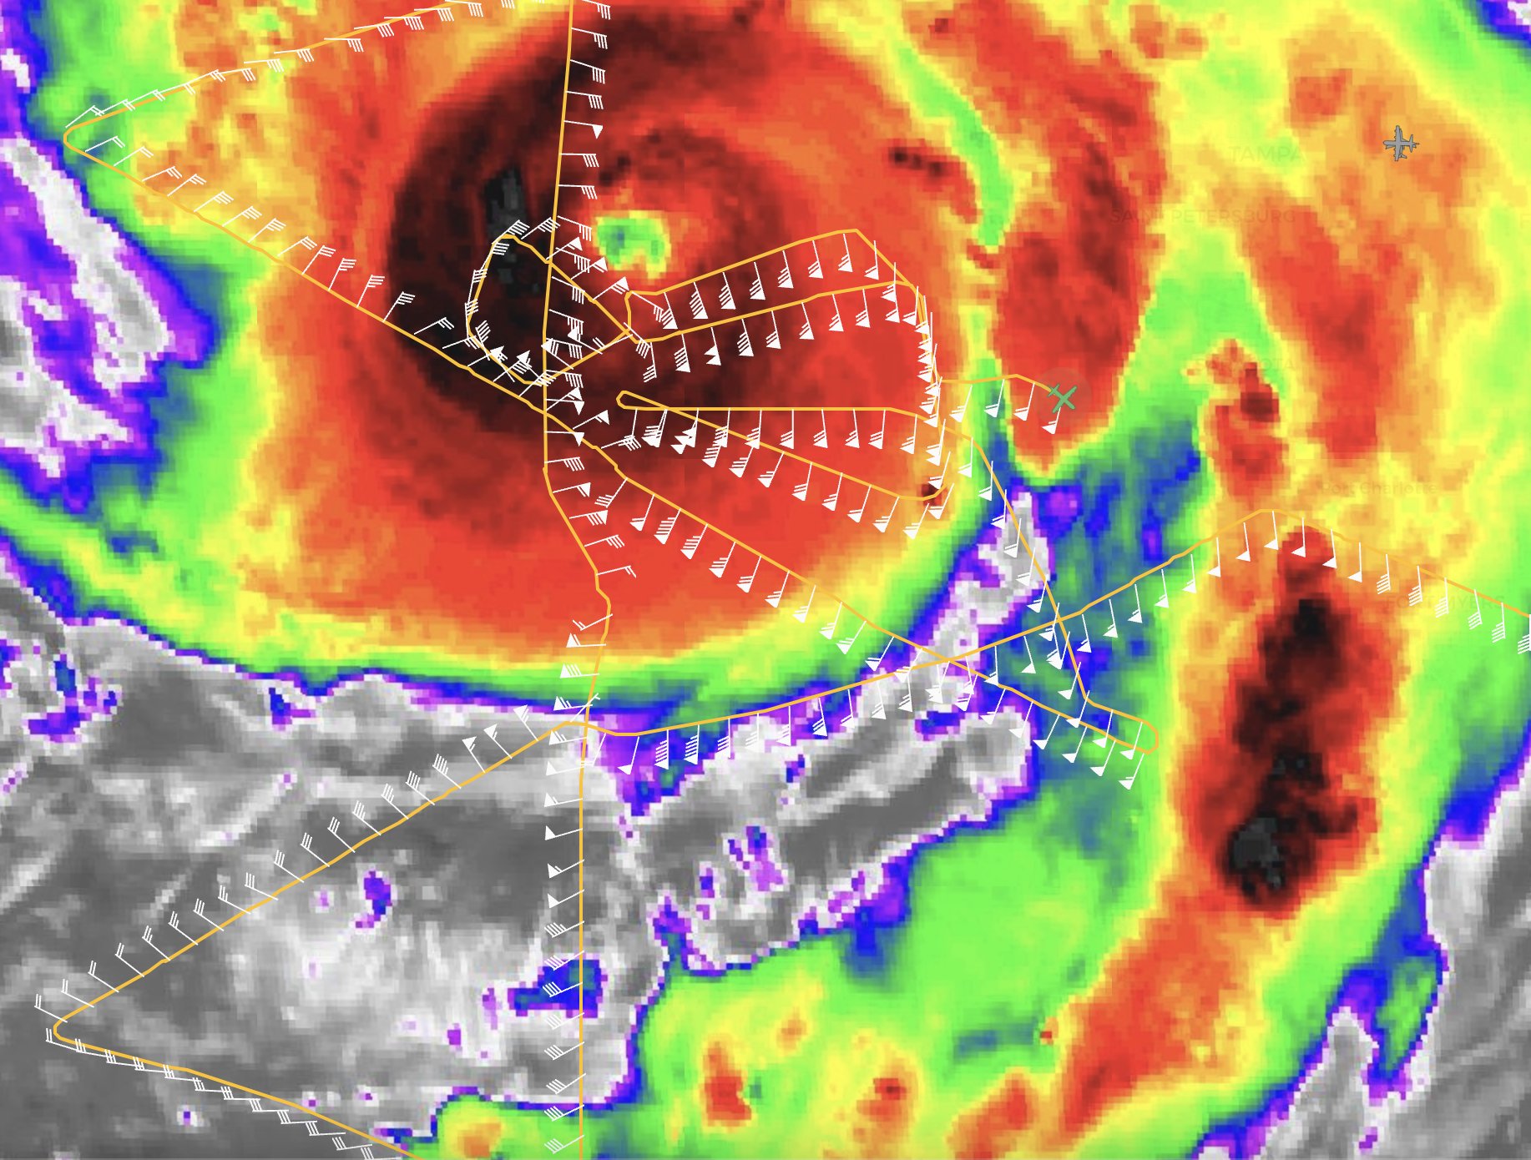
 | 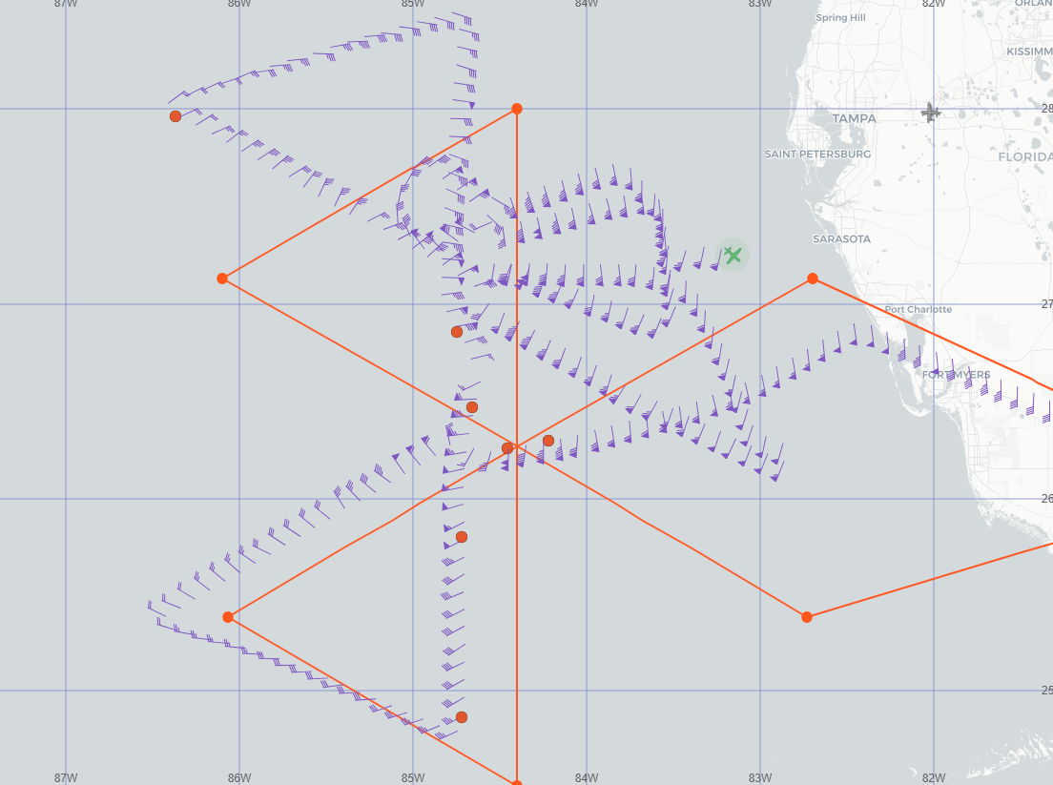
 | 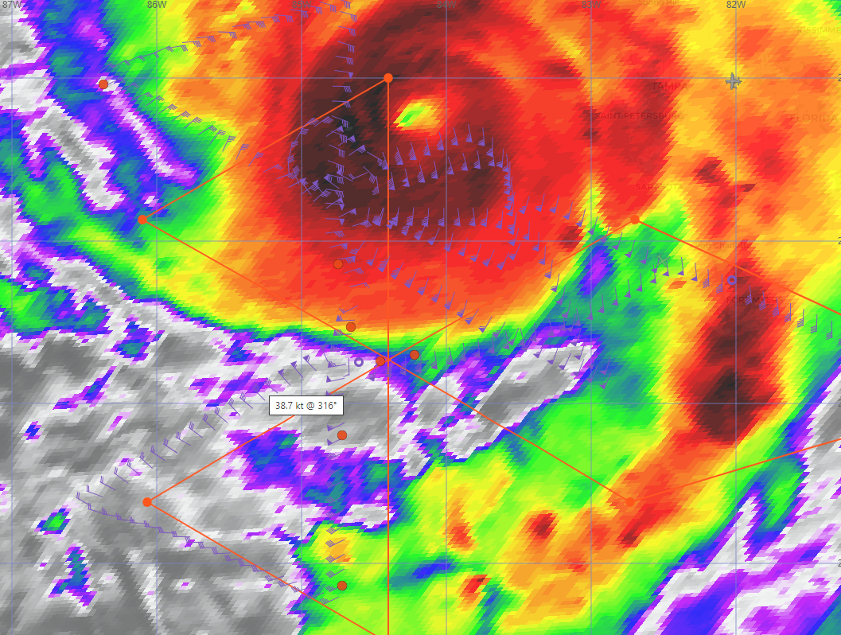
 | 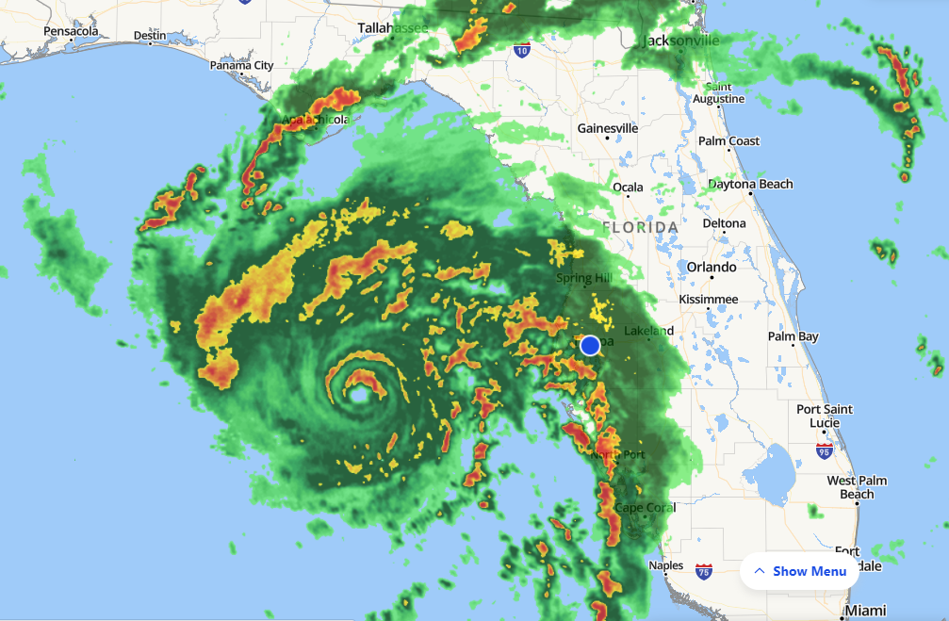

POST-FLIGHT
Mission Summary | [Short description of interesting observations from the flight; what objectives were successful? What was unsuccessful? Was the planned pattern flown? What deviations occurred?  [Don’t forget to fill in Tables on page 1]  [Sonde and ocean expendable accounting: how many total of each? How many are charged to each account?]
Actual Standard Pattern Flown | [Butterfly, Rotated Figure-4, Lawnmower, etc]
APHEX Experiments / Modules Flown | [Linked to HFP Plan; fill in regardless of whether the mission was operationally or research tasked]
Plain Language Summary | [Boil down the above into a couple of bullet points in “plain language”. This will help us when we report to management & OAR Public Affairs and prepare storm mission summaries]
Instrument Notes | [Notes about instrument status from during and after the mission]
Final Mission Track | [Insert MTS screenshot of final flown track, ideally at the completion of the pattern with satellite imagery]

