MISSION PLAN
FLIGHT ID | 20230828I2 | STORM | AL10/Idalia
MISSION ID | 0810A | TAIL NUMBER | NOAA 43
TASKING | EMC | PLANNED PATTERN | Butterfly
MISSION SUMMARY
TAKEOFF [UTC] | 2026 | LANDING [UTC] | 0248
TAKEOFF LOCATION | FLL | LANDING LOCATION | FLL
FLIGHT TIME | 6.4 | BLOCK TIME | 6.6
TOTAL REAL-TIME RADAR ANALYSES  (Transmitted) | 4 (4 to EMC/ 0 to AWIPS)* | TOTAL DROPSONDES Deployed (Transmitted) | 21 (21)  16 NHC 5 ONR
OCEAN EXPENDABLES (Type) | 5 (4) 5 U.M.AXBT 4 good 1 failure | sUAS (Type) | NA
APHEX EXPERIMENTS / MODULES | FLAIMS, or VAM depending on alignment
HRD CREW MANIFEST
LPS ONBOARD | Marks | LPS GROUND | Alvey/Sellwood
TDR ONBOARD | Marks | TDR GROUND | Alvey/Gamache
ASPEN ONBOARD | J. Zhang/Sippel | ASPEN GROUND | n/a
NESDIS SCIENTISTS | n/a
GUESTS (Affiliation) | n/a
AOC CREW MANIFEST
PILOTS | Abitbol/Rannenberg/Keith
NAVIGATOR | Utama
FLIGHT ENGINEERS | Stokes/Wysinger
FLIGHT DIRECTOR | Lundry/Zawislak
DATA TECHNICIAN | McAlister
AVAPS | Underwood

PRE-FLIGHT
Flight Plan | 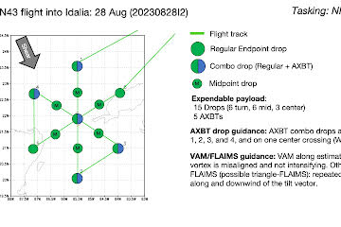  Pattern: Butterfly pattern with 105 NM legs (except when restricted by land)  Altitude:  - 12 kft (pressure altitude)  Potential add-on APHEX Modules: (time permitting)  - Vortex Alignment Module (VAM)  - FLAIMS Module  In-storm location(s) for the modules may be /determined adjusted be at the discretion of the onboard HRD LPS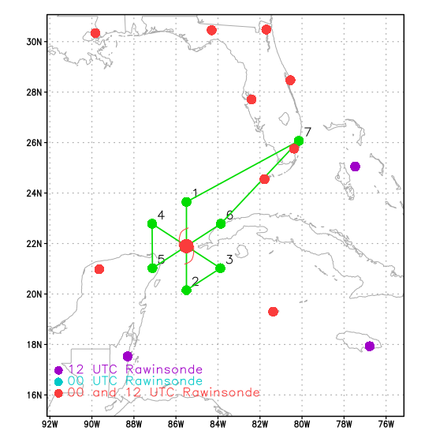
Expendable Distribution | - Load 30 dropsondes  - Release at endpoints, midpoints, centers (charged to NWS)  - Additional drops may be requested at the discretion of the onboard HRD LPS  - All dropsondes transmitted to the GTS  - 5 AXBTs (Univ of Miami shallow water;)  - All AXBTs transmitted to the AOC ground server if possible  - Drops done internally from 10kftLoad 30 dropsondes  - Release at endpoints, midpoints, centers (charged to NWS)  - Additional drops may be requested at the discretion of the onboard HRD LPS  - All dropsondes transmitted to the GTS  - 5 AXBTs (Univ of Miami shallow water; see notes below)  - All AXBTs transmitted to the AOC ground server if possible
Preflight Weather Briefing | 28 Aug 2023 - 18:00 UTC ...IDALIA STRENGTHENING AS IT NEARS THE WESTERN TIP OF CUBA... ...LIFE-THREATENING STORM SURGE AND DANGEROUS WINDS BECOMING INCREASINGLY LIKELY FOR PORTIONS OF FLORIDA... As of 1:00 PM CDT Mon Aug 28 the center of Idalia was located near 21.2, -85.1 with movement N at 8 mph. The minimum central pressure was 987 mb with maximum sustained winds of about 70 mph.  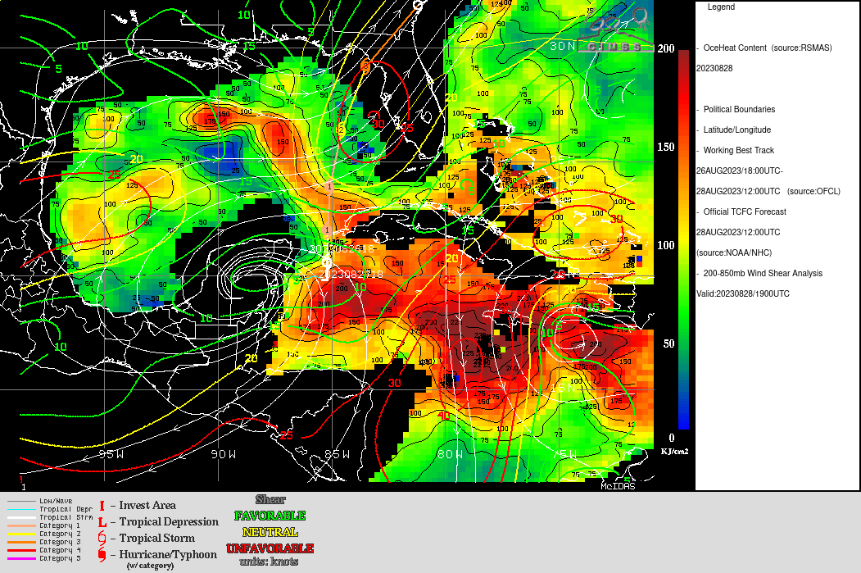  Both shear and OHC favorable for RI  Convection appears to be increasing over the center  Some indication of eye formation  Lightning over center  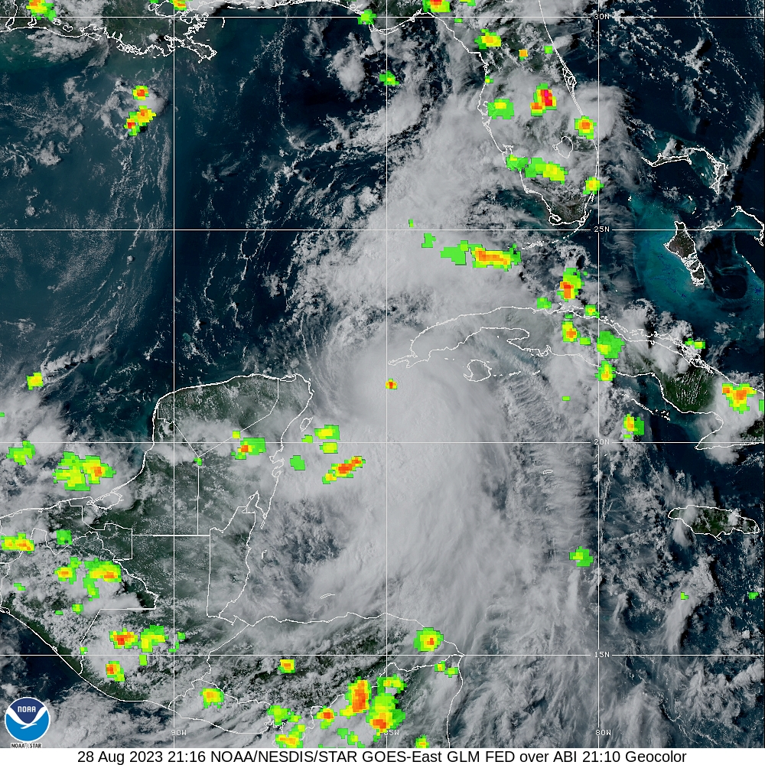
Instrument Notes | Instruments appear to be nominal, but the precipitation probe which is a bit flaky

IN-FLIGHT
Time [UTC] | Event
202550 | Take off FLL
2035 | passing over Miami
2036 | TDR up. Looking good  Repeated convective bursts - unable to propagate farther upshear/left of shear up until this point. Perhaps some signs of trying on the latest Cancun radar loop. Still tilted but more upshear left now
2102 | picking our way along and through the first outer band. TDR tops 12-14 km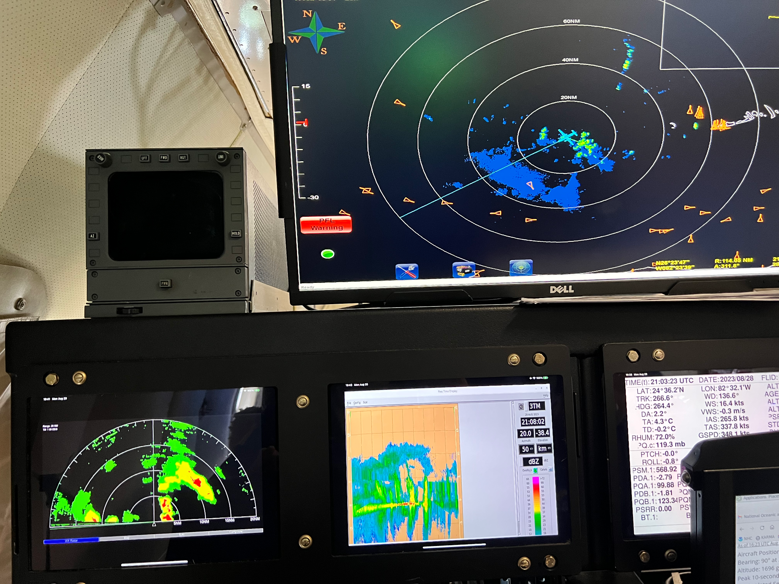
2110 | in a big stratiform region south of the band. Plenty of scatterers. Alititude12800’
2121 | passing along the south edge of a huge stratiform area. Still good scatterer coverage to the N 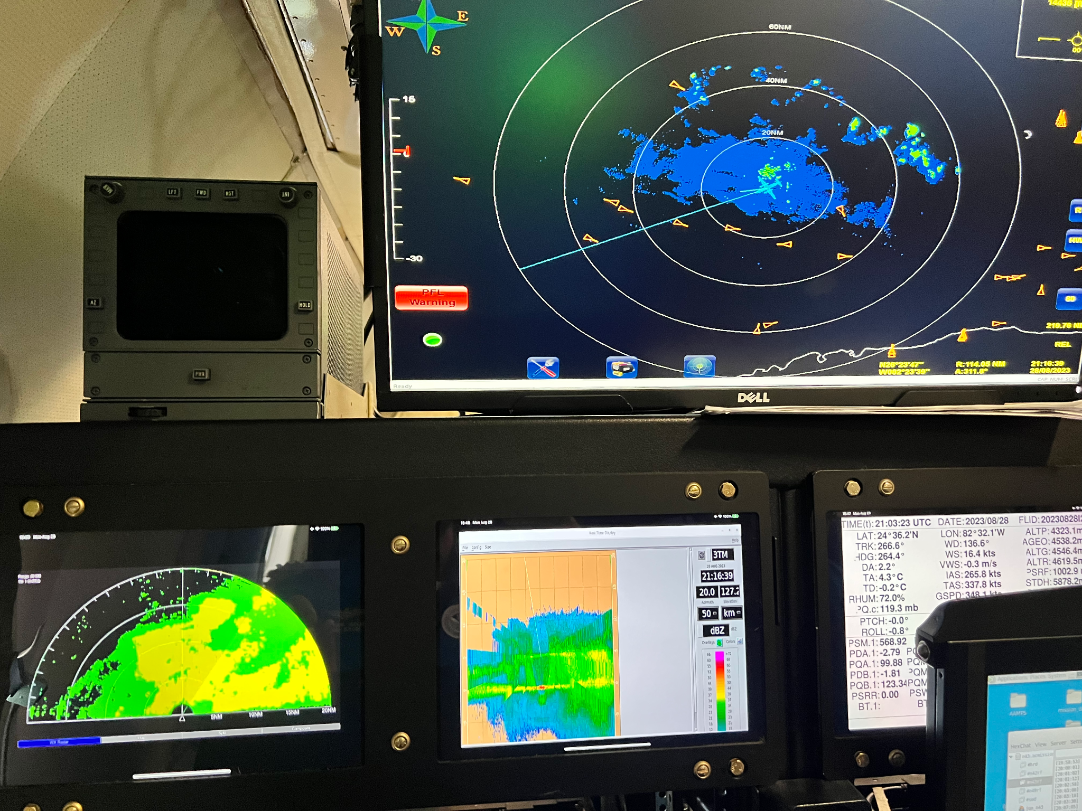  Marks: hitting some growers to our altitude here. few bumps
2124 | passing through shallow convective line along south edge of stratiform area.
2127 | descend to 10 kft
2129 | depressurizing cabin for internal AXBT drops on first legDoing some light center hunting on this first pass
2135 | had to restart plane data server to set flight folder up for AOC server
2141 | IP Combo drop #1, AXBT #1, SST 30.1, TK 180, BT profile looks great
2154 | midpoint drop #2 - pretty dry on the north side inbound, hardly any scatterers2223 mid point drop #4
2158 | MMR shows strong E eyewall just 15-20 nm south of W tip of Cuba (pic)
2200 | hunting a bit to get fix as center is east of planned flight leg. Should not affect TDR analysis. Center drop was 985 hPa with 17kt wind so estimating 983-984. Continuing to intensify (not RI) it seems from previous flights. AXBT #2 failed
2203 | it appears that center is open to the west. Troubleshooting error in original radar analysis - resubmitting
2210 | center drop #3 very strong east eyewall, massive anvil overhead, open to west (pic)
2223 | mid point drop #4 approaching intense E-W rain and 60 nm south of center (pic)
2227 | entering the rainband. Tops 14-16 km, plenty of scatterers, some nice chop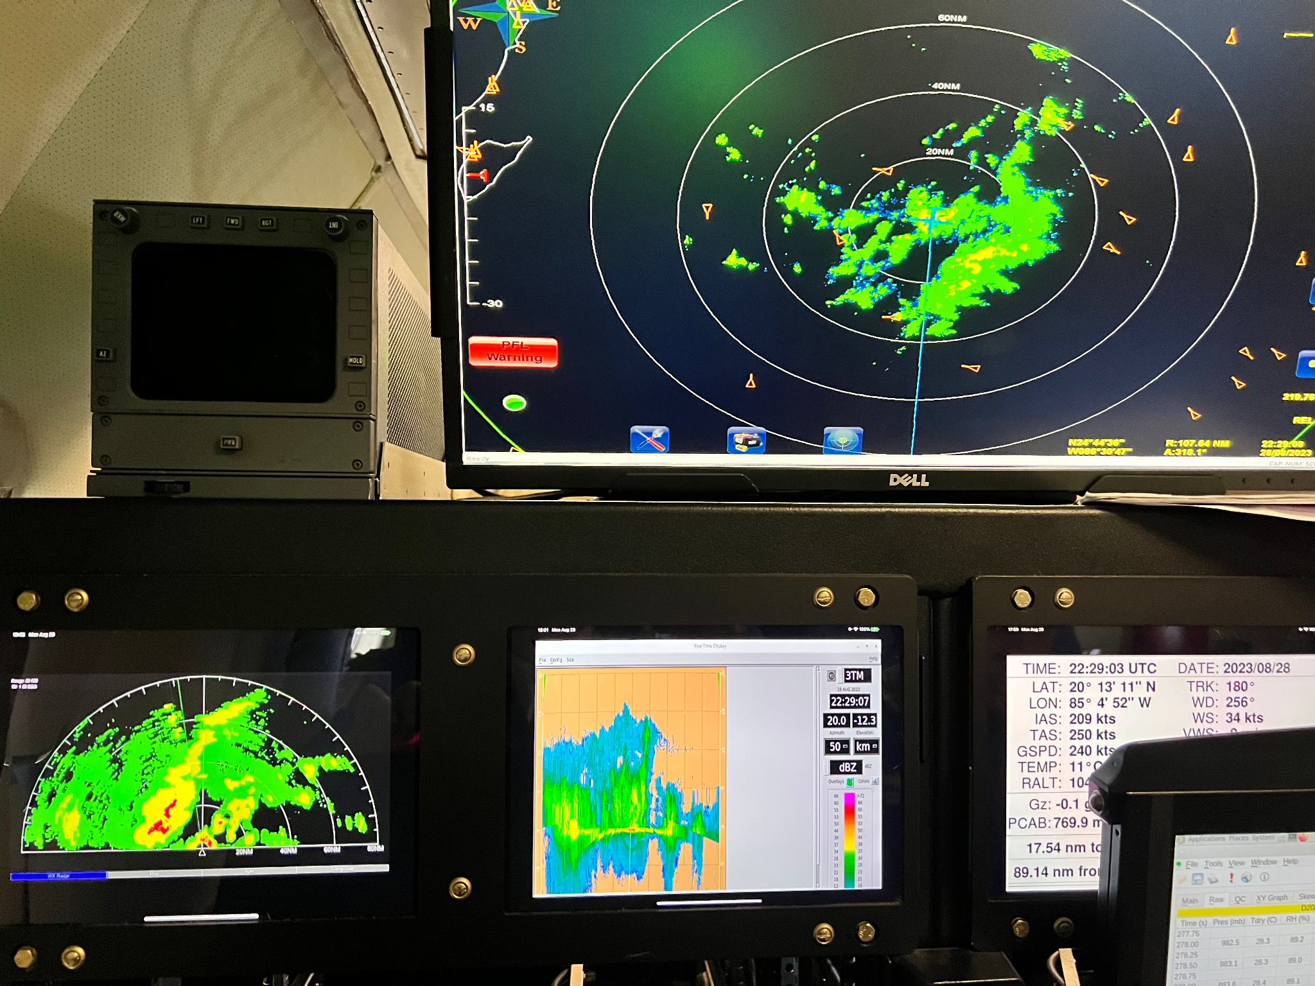
2232 | combo drop #5, AXBT #2, in major SW-NE band into center - 2nd BT failed
2235 | extending leg before downwind turn and holding track to get out of major rainband, repressurizing cabin (pic)
2239 | cutting across rainband to go downwind (pic)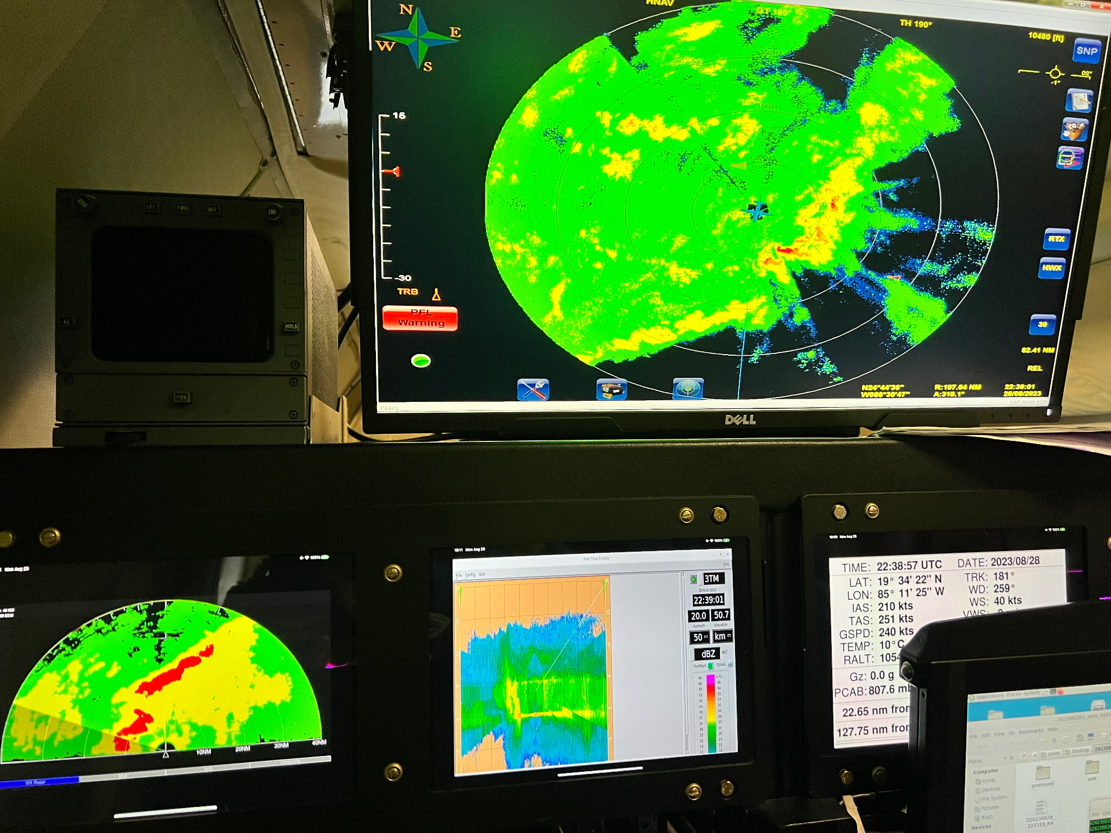
2247 | TK 045 going downwind to Pt #3 in major rainband (pic)
2305 | PT #3 turn TK 320 combo drop #6 BT #3, in heavy stratiform area, SST 30.1, depressurizing
2319 | mid point drop #7 just inside rainband, inbound SE to NW
2324 | RMW drop #8 in broad wind max WPO-qt nmi from center, Inbound
2329 | center combo drop #9 AXBT #4 SST 29.1, 988 hPa wind 14 kts 225
2342 | mid point drop #10 in the clear with slight undercast, outbound
2354 | PT #4 combo drop #11, AXBT #5 turn TK 165 to PT #4 near Cozumel, repressurizing, SST 28.6, Marks noted center in open to the west
0015 | PT #5 drop #12, turn TK 060
0024 | mid point drop #13, 2-6 km Tilt from radar 44.5km at 82deg
0033 | center, drop # 14 , turn TK 120, 987mb wind 29 kts 225deg  starting FLAIMS, all the energy in the storm seems to be concentrated in this small partially enclosed small center. Hasn’t moved much during the mission. Seems pinned to mountains on the western tip of Cuba. 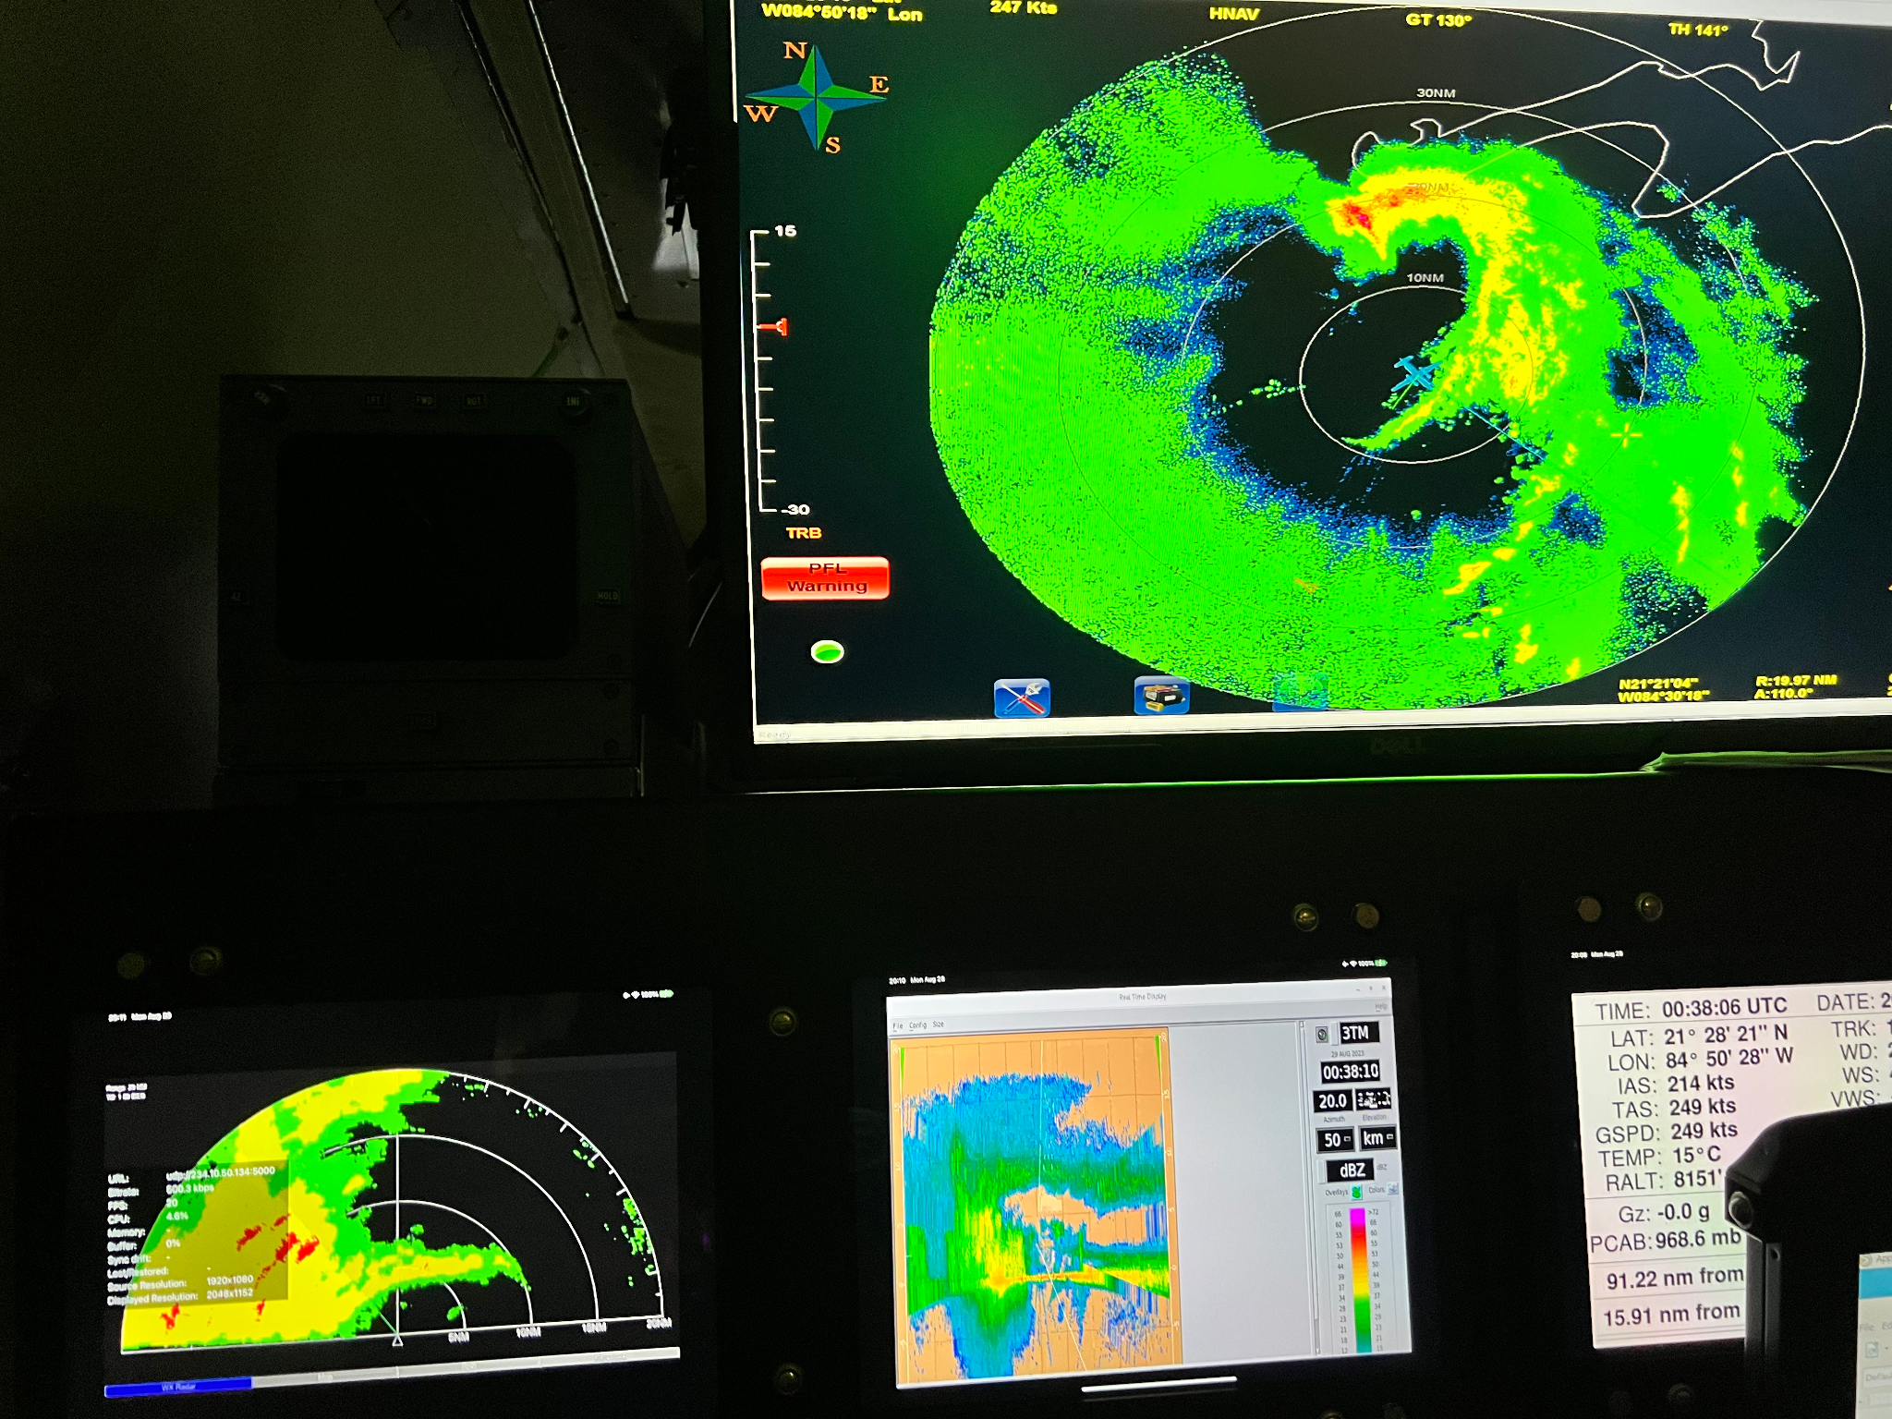
0039 | RMW drop #15 (ONR) (pic), Jun reporting echo tops to 15km in the most intense convection. track 330 deg, surface wind 42kt 170 deg
0052 | FLAIMS end point drop #16 (ONR) turn TK 020 to point 60 nm ESE of center, Partial eyewall forming E-NE quadrant with some help from the terrain
0059 | FLAIMS IP inbound drop #17 (ONR) TK 290
0108 | RMW drop #18 (ONR)
0114 | center drop # 19 extend leg 20 nm to clear Cuba westernmost peninsula
0118 | turn TK 045 to Pt #6 great for TDR mapping of the hook interacting with land and mountains. Fascinating interaction. We are capturing it from the south and north side of the peninsula (see flight track)
0133 | mid point drop #20 start climb to 19 kft
0145 | end mission Pt #6 drop #21, Endpoint outbound final leg - end of science
0248 | landed FLL
Tilt estimates from hrd-status:
Job 3 0025 2-6-km Vortex Tilt: 44.5 km at 82 deg
 | Job 4 0141 2-6-km Vortex Tilt: 28.7 km at 78 deg
 | Job 5 0206 2-6-km Vortex Tilt: 33.0 km at 76 deg
 | Maybe a precessional type pathway here towards alignment? Perhaps consistent with the hypothesis of a stronger vortex leading more towards that type of evolution vs. reformation

POST-FLIGHT
Mission Summary | Butterfly pattern flown as planned with FLAIMS module add on module on the final leg. Some weather between FLL and IP required small deviations.
Actual Standard Pattern Flown | Butterfly pattern with FLAIMS module before final outbound leg (3rd pass). Then continue outbound to complete pattern
APHEX Experiments / Modules Flown | Tasked TDR mission with research objectives vortex response to shear, rapid intensification, vortex re-alignment.
Plain Language Summary | - Extremely interesting mission into developing tropical storm Idalia where the storm was experiencing significant WSW wind shear.  - During the mission almost all of the precipitation was located in a large rainband encompassing a semicircle from SSW to NNE with the storm center located in the far NNE cusp of the large rainband. The other semicircle was rather dry in the lower troposphere and mostly devoid of deep convection  - The storm center moved very slowly toward the NNE impinging on the very western tip of Cuba.  - We captured what appeared to be an interaction of the storm center with the terrain over the western tip of Cuba during the FLAIMS module with legs along the south and north side of the peninsula. The mission TDR observations should provide a great opportunity to study storm terrain interactions
Instrument Notes | Instruments worked great. Issues with Satcom affected data getting to EMC and NHC. One TDR analysis (1st) had erroneous storm motion and was probably rejected at EMC. Other TDR data was good and transmitted to EMC. Issues with transmission of analysis files for AWIPS Flight level data were initially not making it to MTS required shutting down and restarting the data stream. Radar data was slow getting off the aircraft at times.
Final Mission Track | 