MISSION PLAN
FLIGHT ID | 20230828I1 | STORM | AL10 / Idalia
MISSION ID | 0610A | TAIL NUMBER | NOAA 43
TASKING | EMC/NHC | PLANNED PATTERN | Butterfly
MISSION SUMMARY
TAKEOFF [UTC] | 1003 | LANDING [UTC] | 1632
TAKEOFF LOCATION | FLL | LANDING LOCATION | FLL
FLIGHT TIME | 6.5 | BLOCK TIME | 6.7
TOTAL REAL-TIME RADAR ANALYSES  (Transmitted) | 6 (6) | TOTAL DROPSONDES Deployed (Transmitted) | 19 (17)
OCEAN EXPENDABLES (Type) | 4 AXBT,  1 MicroSWIFT | sUAS (Type) | n/a
APHEX EXPERIMENTS / MODULES | Exact name of the Experiment in the HFP Plan; identify relevant experiments / module even if not a research tasking
HRD CREW MANIFEST
LPS ONBOARD | Hazelton | LPS GROUND | Rogers
TDR ONBOARD | Hazelton | TDR GROUND | Reasor
ASPEN ONBOARD | X. Zhang | ASPEN GROUND | n/a
NESDIS SCIENTISTS | n/a
GUESTS (Affiliation) | n/a
AOC CREW MANIFEST
PILOTS | Copare/Wood/Palmer
NAVIGATOR | Miller/Schaefer
FLIGHT ENGINEERS | Darby/Tyson
FLIGHT DIRECTOR | Kalen/Parrish
DATA TECHNICIAN | Richards
AVAPS | Kotz/Santoni

PRE-FLIGHT
Flight Plan | 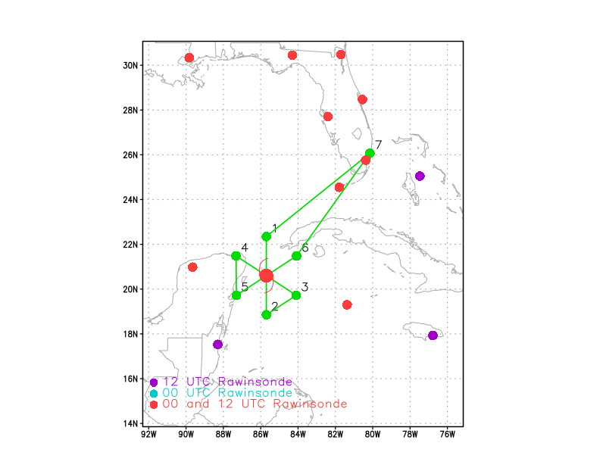  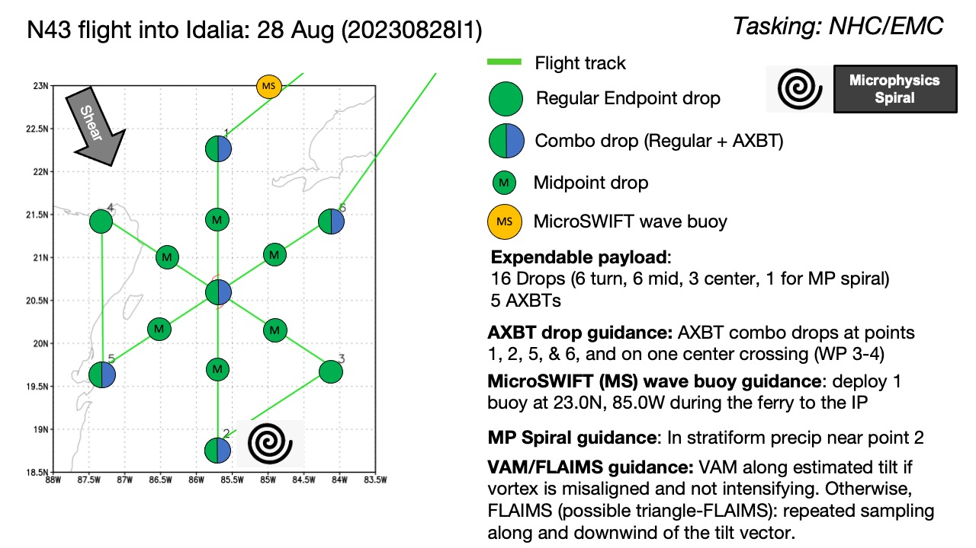  Fly butterfly pattern, 105 nm leg lengths, 12 kft pressure altitude. IP on the N side, FP on the NE side. Potentially fly a stratiform spiral on the downshear (S/SE) side of storm, and/or fly a VAM (if misaligned and not intensifying) or a FLAIMS module.
Expendable Distribution | Drop sondes at all turn, mid-points, all three center passes, and one drop at the top of the microphysics spiral if it occurs. AXBT combo drops at points 1, 2, 5, and 6, and on SE-NW center pass. Drop MicroSWIFT wave buoy during ferry to (and near) IP.
Preflight Weather Briefing | Idalia is an intensifying tropical storm moving toward the north in the northwestern Caribbean. As of 5am EDT, NHC had Idalia as a 55-kt tropical storm with MSLP of 989 hPa. Infrared satellite imagery shows an extensive cold cloud shield, indicative of a convective burst, developing near the NHC-analyzed center at 20.1N 85.2W.  Ground radar from Cuba shows an attempt at an eyewall formation, but it does not appear to have been completed.  Idalia is in a region of moderate northerly and north-northwesterly shear.  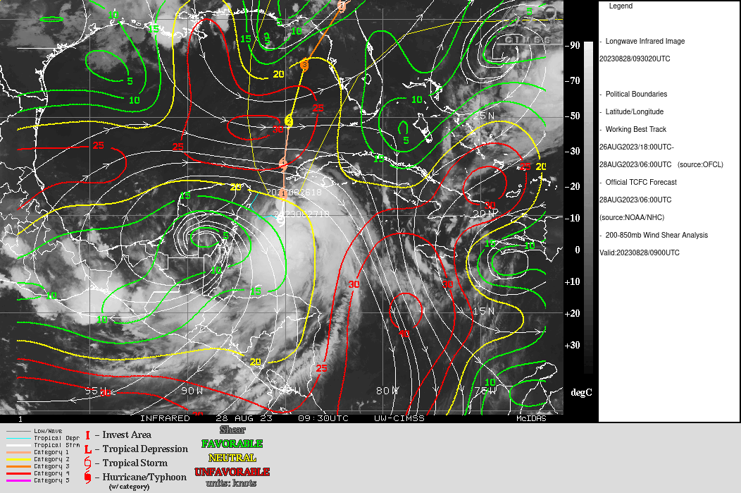  In the 5am discussion, NHC mentioned that recent aircraft missions had noted that the storm was tilted to the south, consistent with such a shear environment.
Instrument Notes | No issues with instruments

IN-FLIGHT
Time [UTC] | Event
1004 | Take-off from FLL
1124 | Release MicroSWIFT buoy, near IP
1134 | At IP, combo drop, drop 1
1146 | Most recent Cuba radar shows possibly some stratiform areas around where the first downwind leg would be. But it's a long way from the radar. There are some embedded convective cells there too, though, so it may be tricky if SSM is attempted.
1146 | Sonde 2, midpoint N
1153 | Aircraft reports 1/3 to 1/2 of an eyewall appearance on MMR, open W and somewhat on the N
1156 | Echo tops up to 18 km in eastern eyewall
1157 | Sonde 3, center sonde
1202 | Descending to 10 kft, likely icing concerns
1203 | From LPS: “There's kind of a band spiraling into that eyewall. Like wrapping from NW-S-E. Fully open west/north.”
1208 | Lightning evident in N-S band on the east side of the storm. No lightning in convection near center.
1209 | Precipitation wrapping from the S is mostly shallow for now. Also we got 26 m/s on the SFMR north but only about 20 m/s FL. Band they’re currently in to the S of the center has echo tops up to about 10 km, moderate convection.
1209 | Sonde 4, midpoint S
1216 | On S (downshear) side of storm, aircraft is in widespread convective areas, with moderate turbulence being encountered. SFMR is showing some dropouts to 0.
1217 | Maximum FL winds are in the outer band (28 m/s FL and 25 m/s SFMR). Broad outer wind field with a small core trying to form.
1221 | Sonde 5, endpoint combo drop S
1226 | Some lightning occurring now in two other areas: near the identified TC center, and another region near the turn point on the south. Small area of very cold cloud tops. Possible MLC located here. TDR analysis should show this.
1230 | There was a nice burst in that region at the S turn point, but it's waning now on IR. Should be a nice remnant MLC there, though. This is still very much in its organizational stage, divergent flow dominant. Or at least more important than it otherwise would be, maybe not "dominant". But heating profiles playing an important role here I'd think
1252 | Turn inbound from the SE. After completion of inbound leg, will execute a VAM module. TDR analysis from first, N-S pass showed a 30 km tilt toward 122 degrees, or essentially right along the inbound leg.
1252 | Sonde 6, endpoint SE
1258 | Lightning becoming more widespread near LLC. Aircraft coming in along a different azimuth to remain in a moat region for a while.
1303 | Sonde 7, midpoint SE
1308 | Analysis from first TDR pass shown below. Tilt of about 30 km toward the SE up to 5-6 km, much larger tilt above there. 2-6 km centers consistent with vorticity plot. Precipitation mode shows widespread moderate and deep convection on the south side of the storm, limited stratiform. That’s consistent with reports of moderate turbulence on the outbound leg to the S.  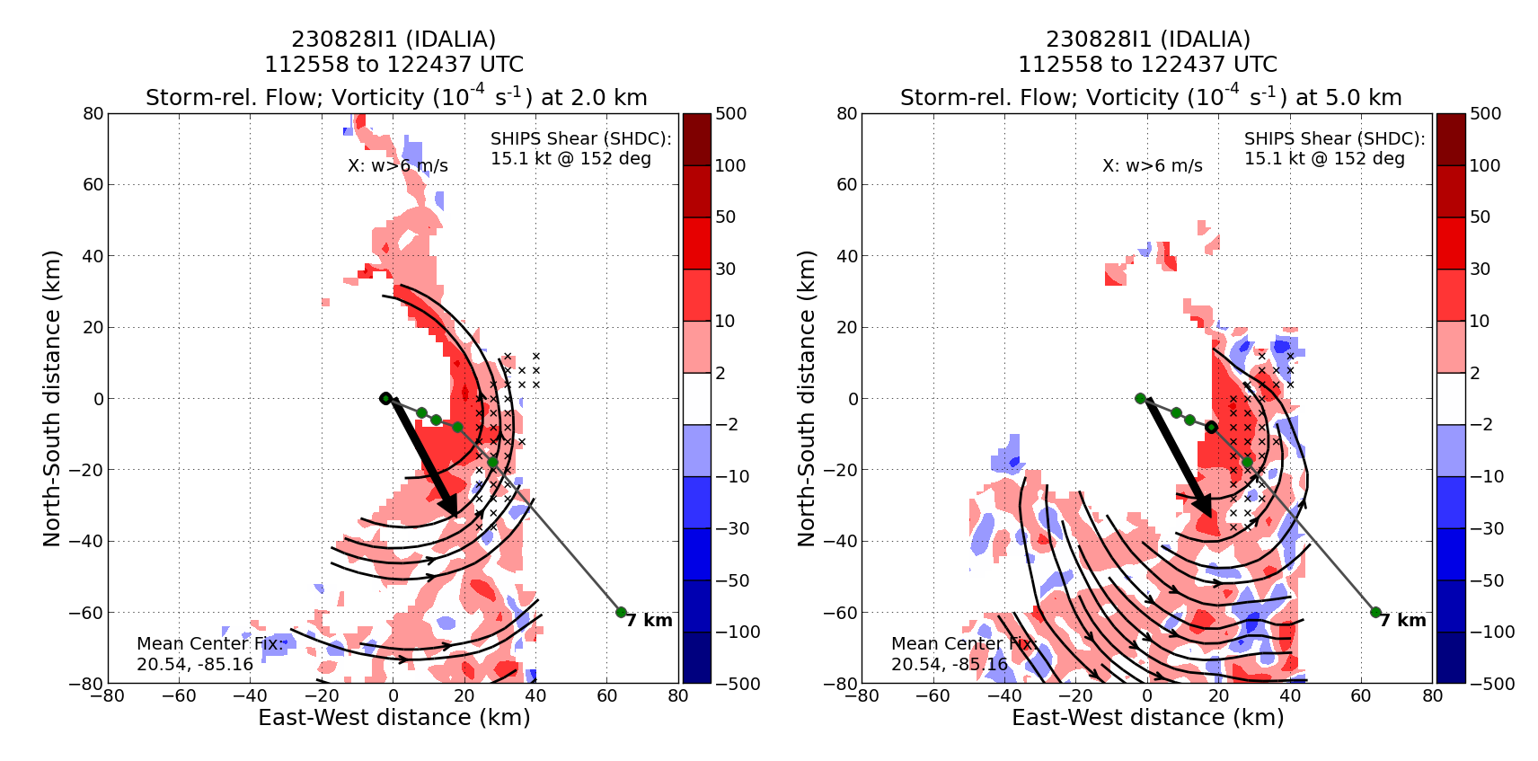  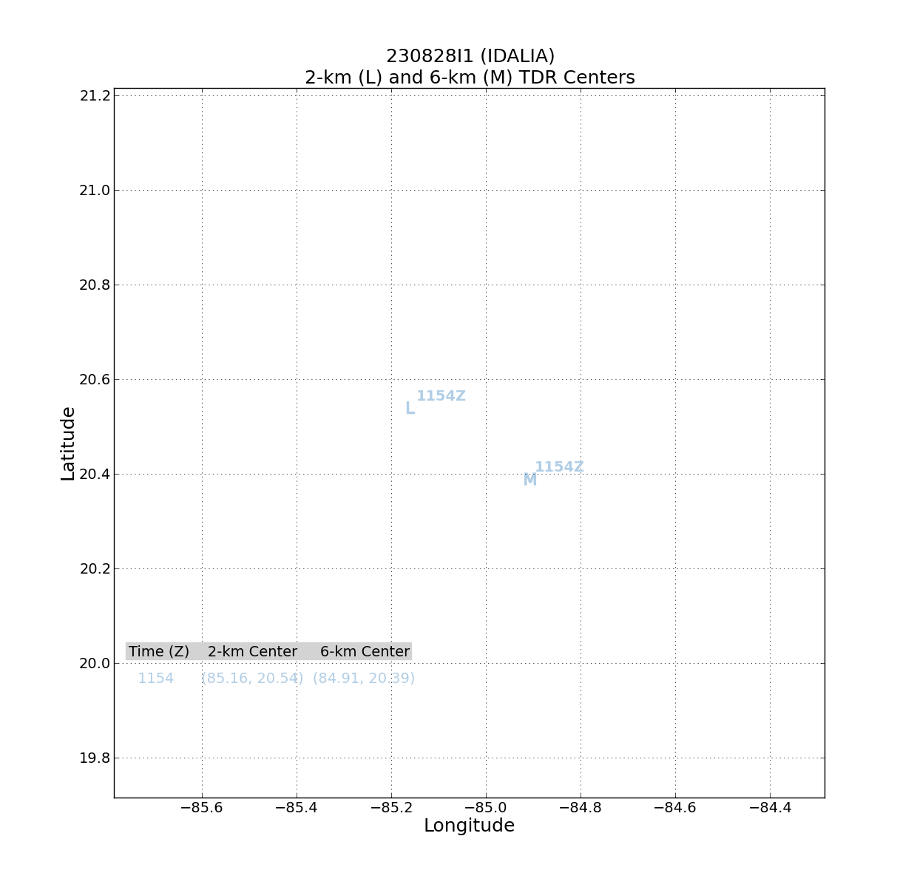  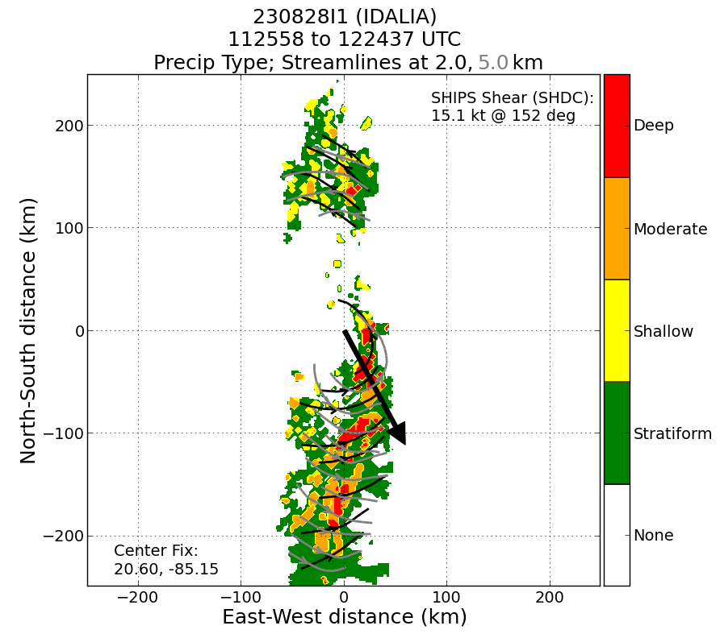
1310 | IR presentation looks a bit less sheared, or maybe the cold cloud tops are displaced further to the SE, away from shear. Or shear is more midlevel and undercutting the cirrus shield.
1312 | RMW (attempted), sonde 8
1316 | Center drop, sonde 9
1324 | Turn outbound to SE, begin VAM
1339 | Executing VAM, extensive lightning near the MLC
1343 | Reverse track for inbound leg portion of VAM
1351 | Sonde 10, SE eyewall, got 35 m/s on SFMR on inbound on VAM
1358 | The MMR is showing a very shallow elliptical eye
1403 | Sonde 11, midpoint NW
1424 | SE-NW profile from VAM of windspeed shows broad, shallow circulation plus the presence of a compact, stronger core of high winds. That high wind core does not extend deep yet, but may with time.  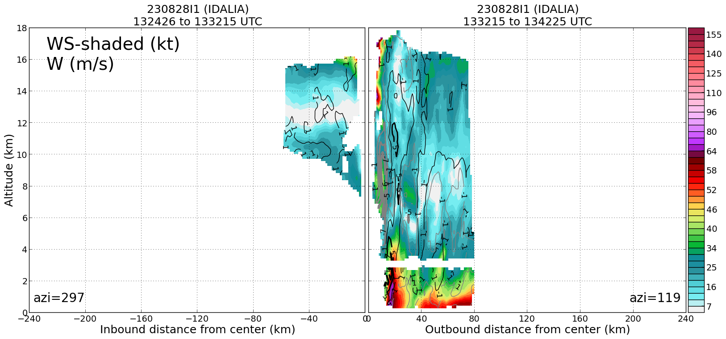
1437 | Drop 12, endpoint SW
1438 | Drop 13, endpoint SW (backup to 12)
1442 | Turning inbound early to ensure that as much of butterfly pattern gets into the TDR assimilation window. All data has to be off plane by 1515 UTC, so data collection has to be complete by 1500 UTC.
1446 | Drop 14, midpoint SW
1447 | Drop 15, midpoint SW (Backup)
1452 | Drop 16, center
1454 | Mark end of TDR data collection, to process and get transmitted within window of 1515 UTC. Just a little to the NE of the center.
1456 | Drop 17, NE RMW
1502 | Drop 18, midpoint NE
1513 | Drop 19, endpoint NE, combo
1522 | Data collected pre-15Z from TDR did successfully get transmitted from plane
1613 | TDR analyses show a brief period where the MLC appeared to be located close to the LLC, a shift of about 15-20 km toward the LLC.  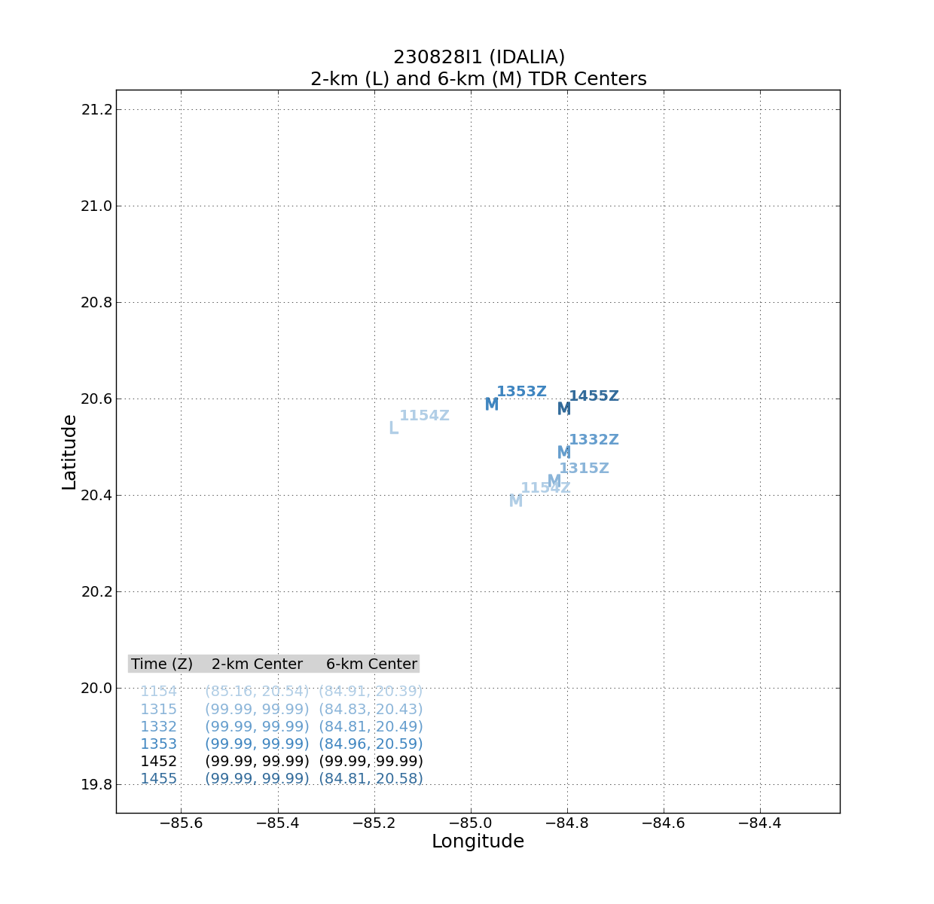  This is at 1353 UTC, when the MLC shifts toward the LLC. By the next pass the MLC had returned to a location roughly consistent with an extrapolated position of the previous MLC identifications.  Wind speed analyses at 1 km (note plots are in reverse chronological order) show a spike in the 1-km winds between 1344 and 1435 UTC (i.e., during time when MLC showed shift). This suggests MLC shift and low-level wind field spike may have been physical, rather than an artifact of data coverage and quality control issues. It is possible that there was a brief period of alignment during this leg. It is also coincident with a transient burst that appeared on Mexican radar.  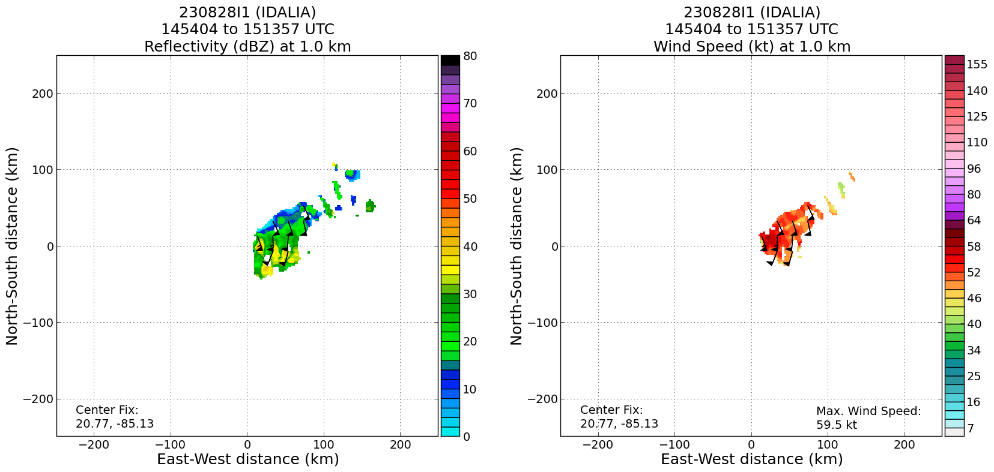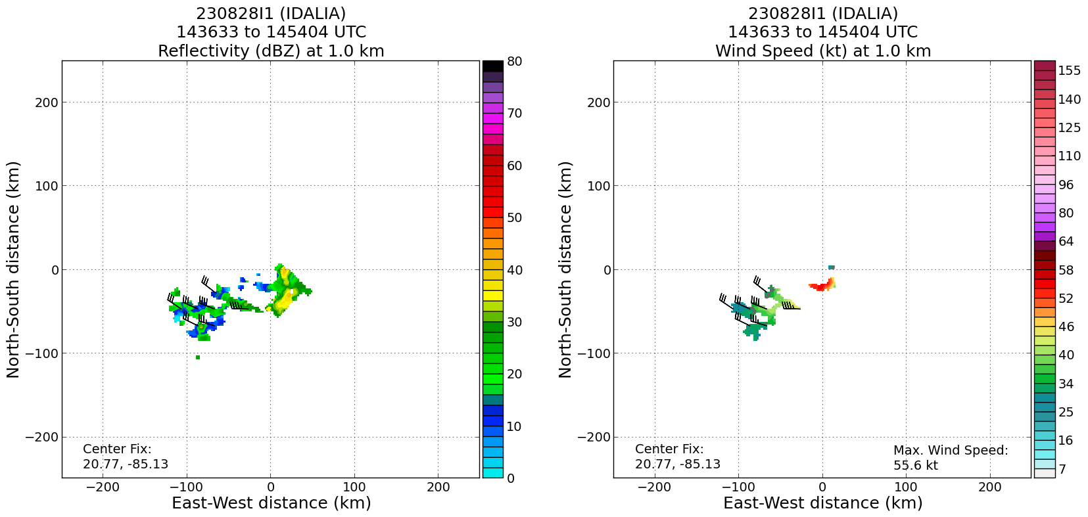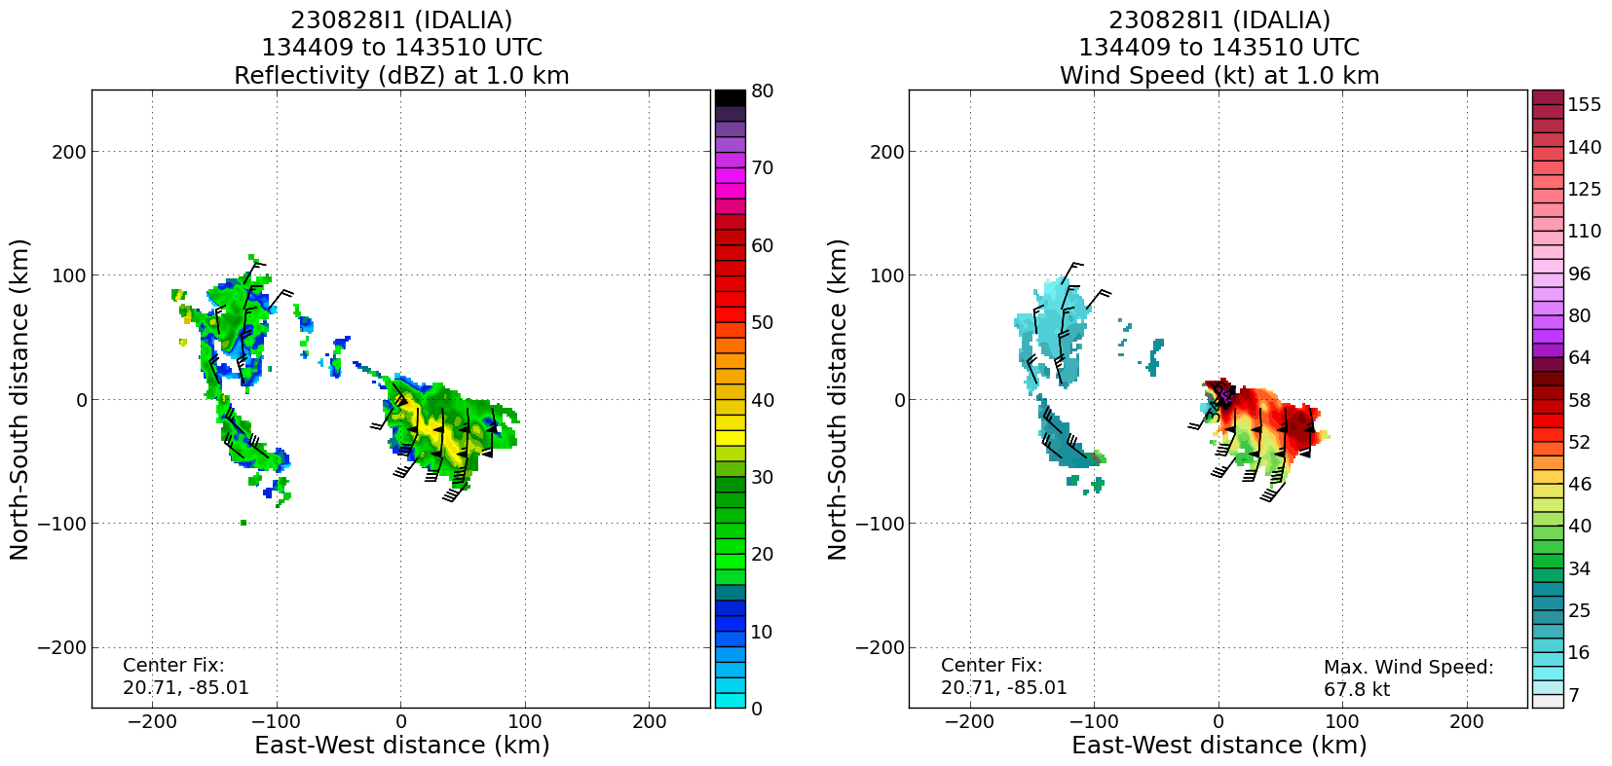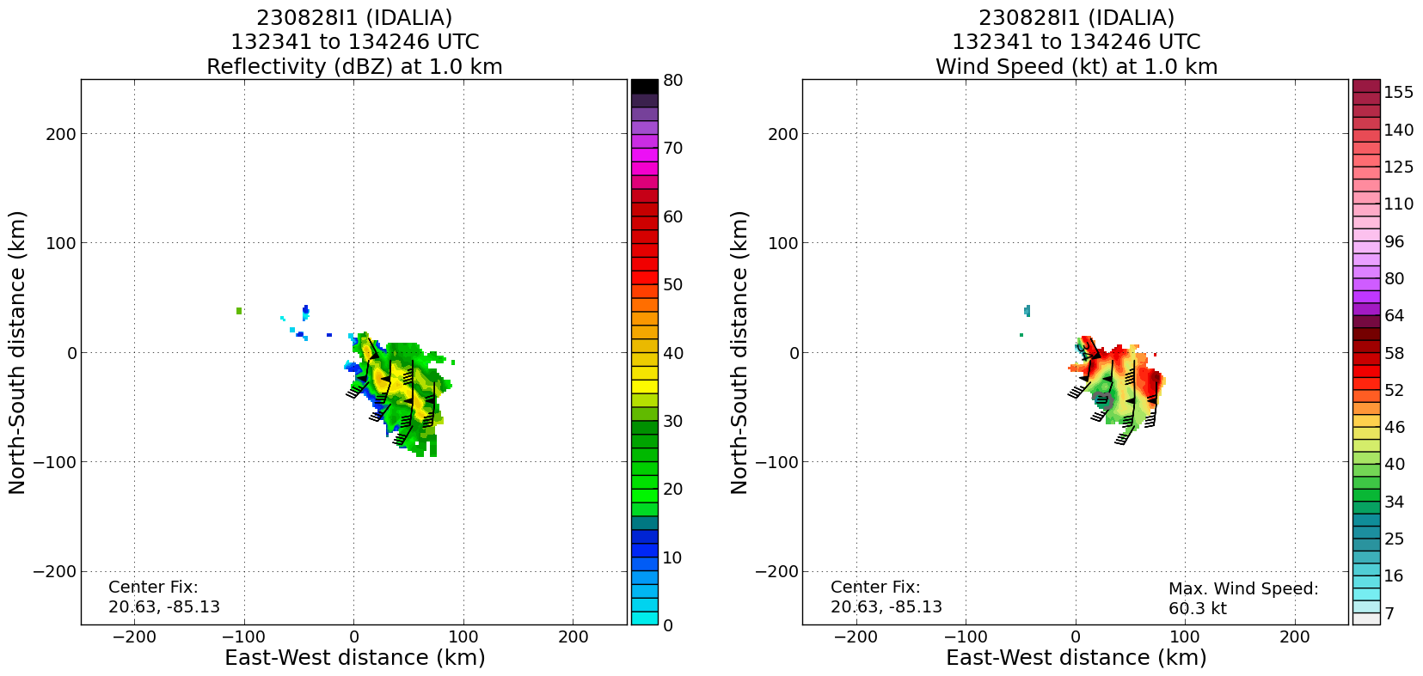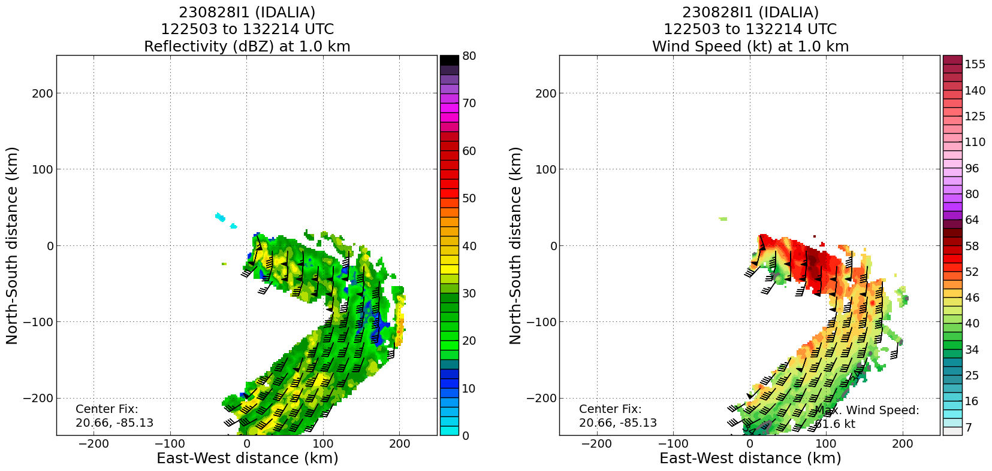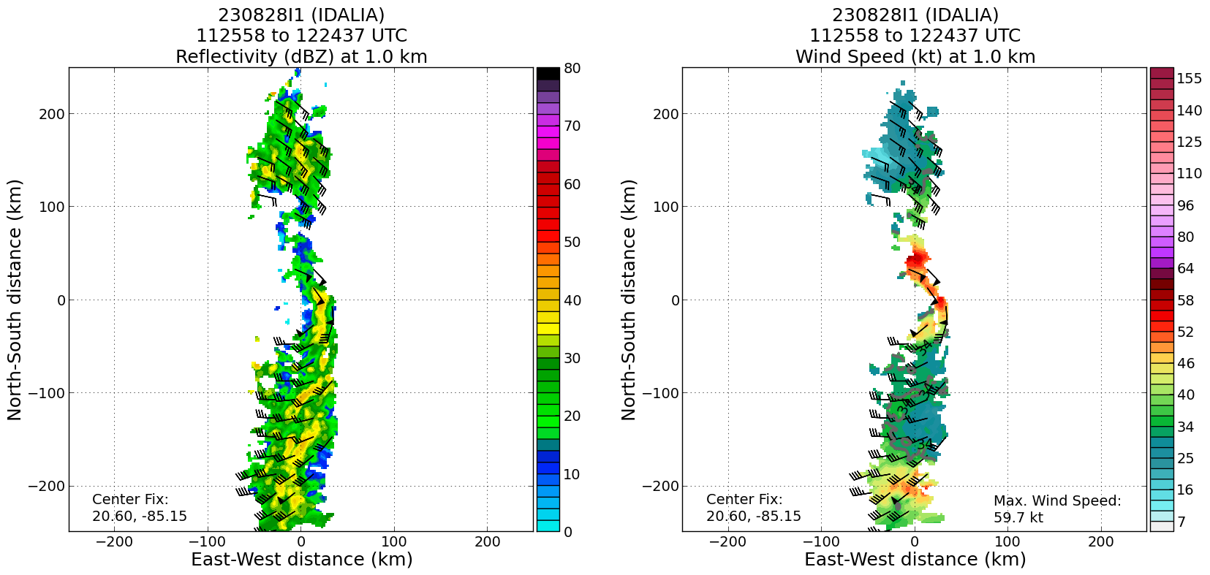

TDR analysis during this time shows core of high reflectivity near domain center (and LLC location) extending up to 10 km altitude, likely higher.

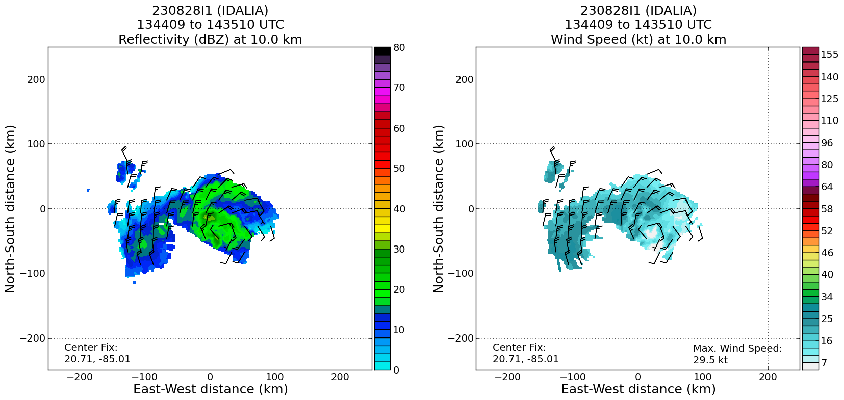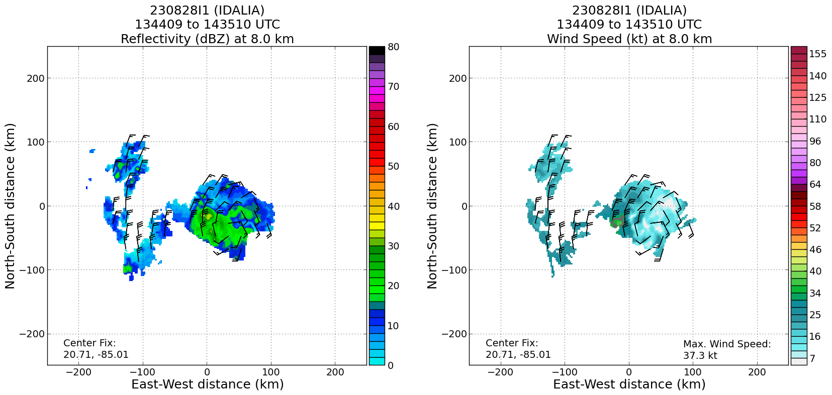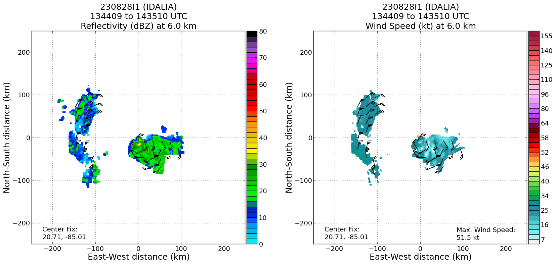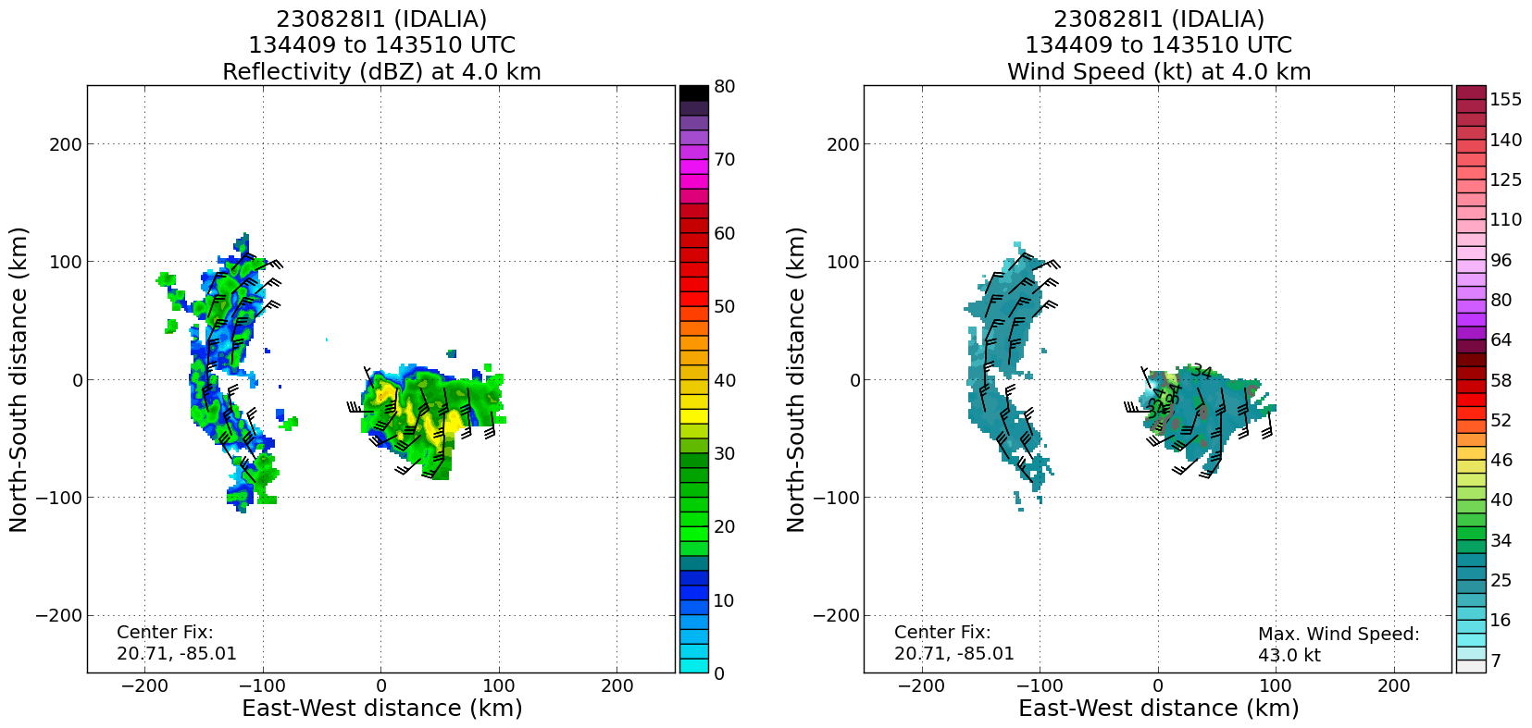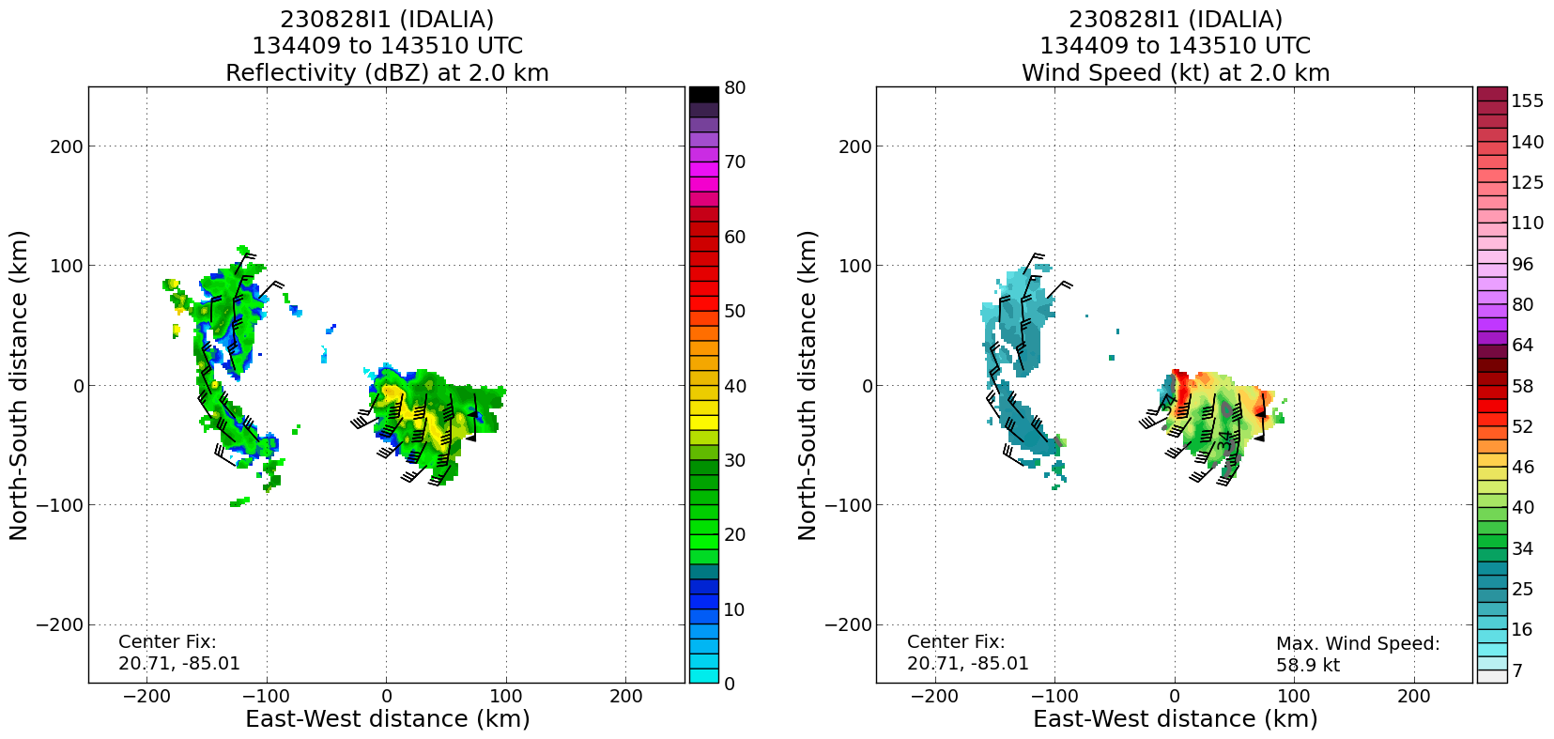

As burst dissipated, it is possible that the MLC relaxed back toward its location consistent with moderate NW shear. This could be an example of a failed attempt at alignment.
1632 | Land at FLL
 | << INSERT ADDITIONAL ROW AS NEEDED >>

POST-FLIGHT
Mission Summary | Objectives were largely successful. A butterfly pattern was flown, along with a VAM module. MicroSWIFT buoy was dropped prior to reaching IP, at desired location.  Aircraft was a little late taking off, and there were some periods where the aircraft had to loiter and/or deviate for weather and aircraft deconfliction. Decision was also made to conduct the VAM during the survey pattern, rather than afterward, because the tilt vector was essentially along the SE/NW inbound leg mid-pattern. Because of this, not all of the butterfly survey pattern made it in time for the 12Z cycle. All of the pattern except for the final outbound leg to the NE made it in (the final outbound leg made it in for the following cycle). In the future greater attention will be paid to the timing issues, and modules like VAM will either be postponed or modified to ensure that primary objective (TDR data collection and transmission within window) is met.  In terms of research potential, the VAM module was flown successfully. Interesting evolution during the course of the mission, with a possible aborted attempt at alignment coincident with a transient convective burst. This has the potential to provide a good examination of factors that may ultimately prevent, sustained alignment from occurring.  19 sondes in total launched, 17 were transmitted. 3 of sondes were RMW/eyewall sondes, so charged to ONR. Remaining 14 sondes charged to NWS. 5 AXBTS dropped, 1 MicroSWIFT buoy launched.
Actual Standard Pattern Flown | Butterfly
APHEX Experiments / Modules Flown | TDR, VAM
Plain Language Summary | - Important airborne radar information was collected and transmitted to the computer modeling centers to improve forecasts of the track, structure, and intensity of Idalia  - Additional patterns were flown to sample how the structure of Idalia may transition to become better organized (become more stacked in the vertical direction), even in the presence of otherwise rather hostile conditions for a storm to organize and intensify  - These observations help us better understand why some storms get better organized and others do not, ultimately improving our intensity forecasts
Instrument Notes | Some issues with SFMR dropping out early in the mission
Final Mission Track

