MISSION PLAN
FLIGHT ID | 20230827I1 | STORM | AL93/TD10
MISSION ID | 0110A CYCLONE | TAIL NUMBER | NOAA43
TASKING | NHC-EMC TDR | PLANNED PATTERN | Figure-4 pattern with 70-105 NM legs
MISSION SUMMARY
TAKEOFF [UTC] | 0945 | LANDING [UTC] | 1821
TAKEOFF LOCATION | St. Croix | LANDING LOCATION | Ft. Lauderdale
FLIGHT TIME | 8.7 | BLOCK TIME | 8.9
TOTAL REAL-TIME RADAR ANALYSES  (Transmitted) | 3 (3) | TOTAL DROPSONDES Deployed (Transmitted) | 11 (11)
OCEAN EXPENDABLES (Type) | n/a | sUAS (Type) | n/a
APHEX EXPERIMENTS / MODULES | n/a
HRD CREW MANIFEST
LPS ONBOARD | Hazelton | LPS GROUND | Marks
TDR ONBOARD | Hazelton | TDR GROUND | Fischer/Reasor
ASPEN ONBOARD | X. Zhang | ASPEN GROUND | n/a
NESDIS SCIENTISTS | n/a
GUESTS (Affiliation) | n/a
AOC CREW MANIFEST
PILOTS | Copare/Wood/Palmer
NAVIGATOR | Miller/Schaefer
FLIGHT ENGINEERS | Darby/Tyson
FLIGHT DIRECTOR | Kalen/Parrish
DATA TECHNICIAN | Richards
AVAPS | Kotz/Santoni

PRE-FLIGHT
Flight Plan | 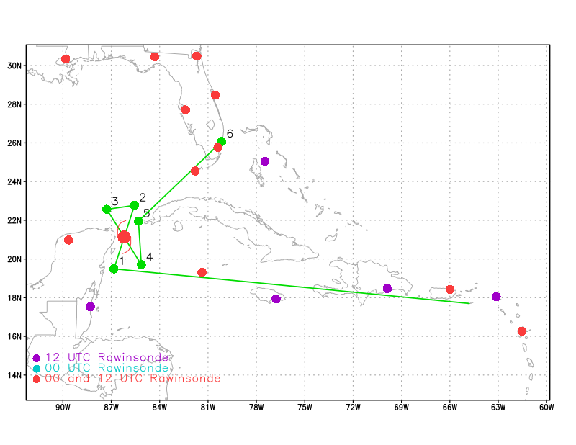
Expendable Distribution | - 12 dropsondes  - Release at endpoints, midpoints, centers, & WP 4-5 midpoint  - All dropsondes transmitted to the GTS  - All sondes charged to NWS
Preflight Weather Briefing | (https://www.star.nesdis.noaa.gov/GOES/index.php)]  GFS Wind shear  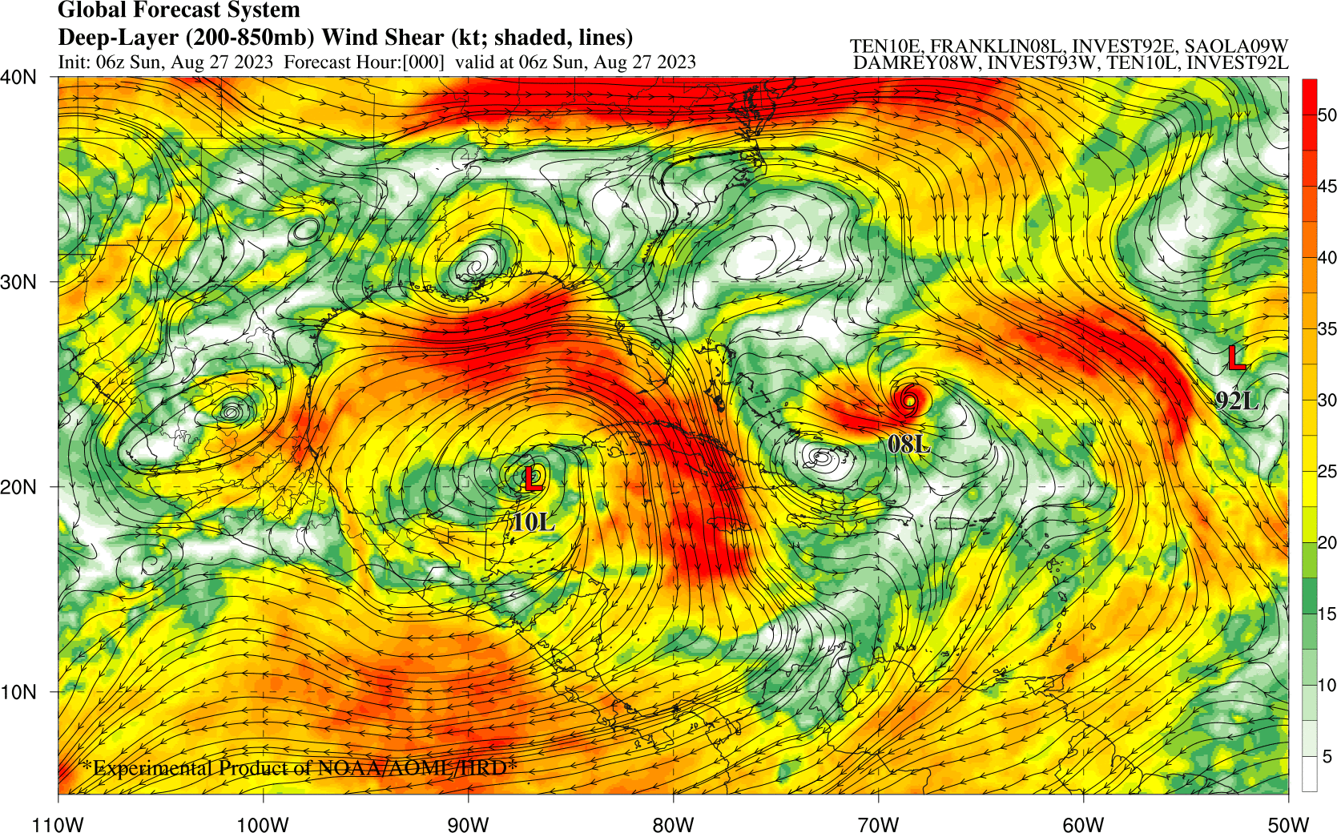
Instrument Notes | Almost all instruments are working nominally. Cloud physics PIP probe is acting up a little.

IN-FLIGHT
Time [UTC] | Event
0939 | Take-off from St. Croix
1123 | Will adjust the pattern slightly due to the further SE position of the center
1300 | 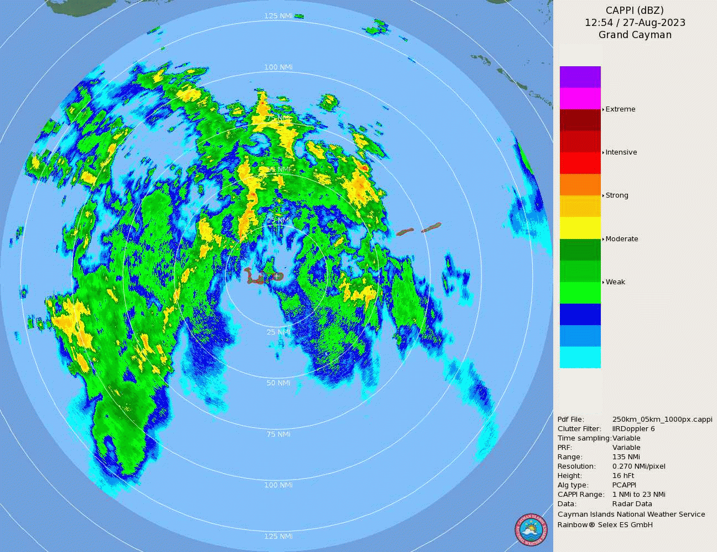  Grand Cayman radar near the time of NOAA43 maneuvering to avoid cells in the rainband to the west of the island.
1335
1348 | A 1207 UTC SSMIS overpass shows multiple convective bands to the east of the LLC with strong ice scattering (low 91-GHz PCT), indicative of deep convection. A smaller burst exists near the LLC.  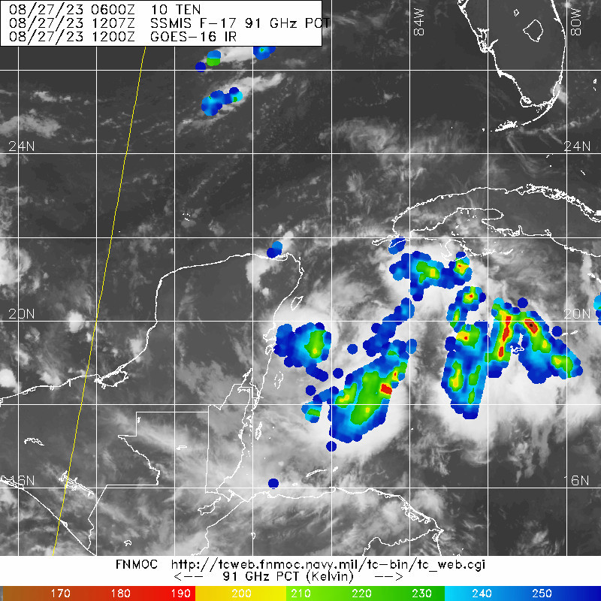
1355 | Picking the way through convection to the IP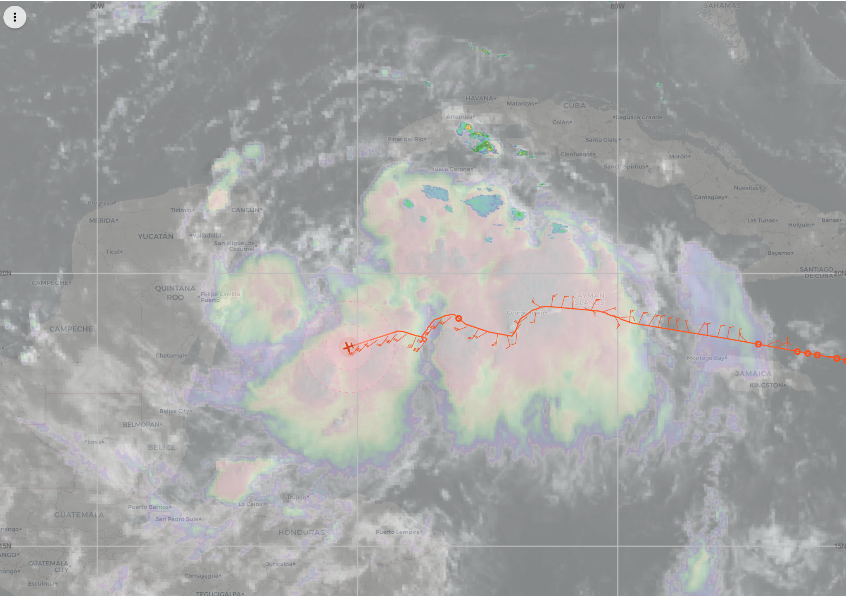
1420 | IP TK 020 Sonde #1 10 kft altitude clear low level circulation (LLC) in visible image. LLC seems to be dominant although exposed.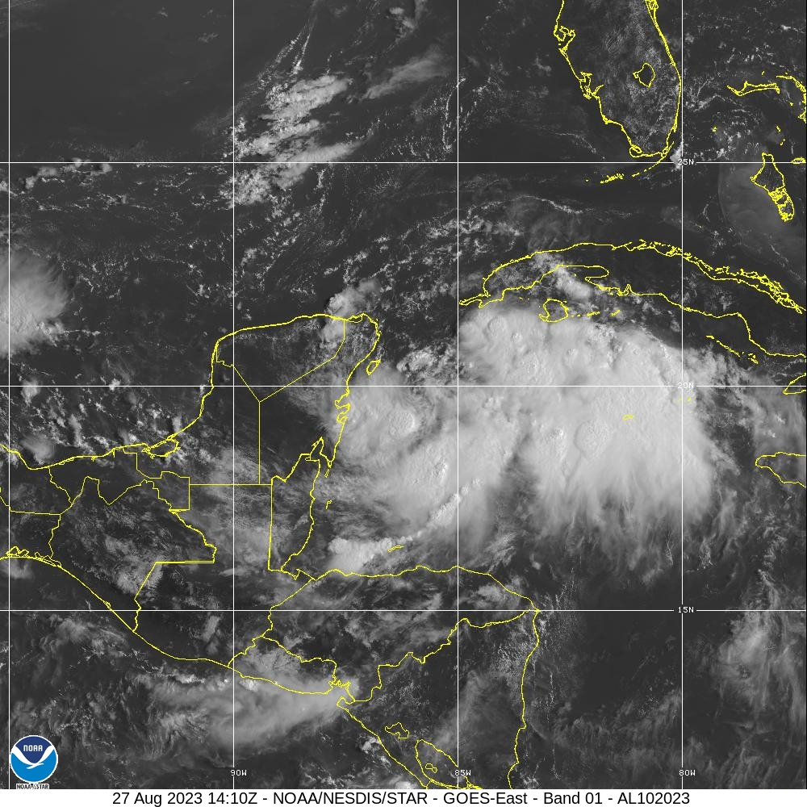
1434 | Midpoint Sonde #2
1435 | Getting some bumps now in this convection
1442 | Discussed options for 1st TDR analysis. We decided to end the first TDR analysis right after the plane gets through the center. There are not many scatterers on leg to the N.
1449 | Center Sonde #3 995.1 extrap - estimated center 19.82 N 85.72 W for TDR analysis - very tilted with 22 m/s SFMR
1501 | Midpoint Sonde #4
1505 | EMC TDR observations completed - should make the data cutoff
1514 | Point #2 Sonde #5, turn TK 270 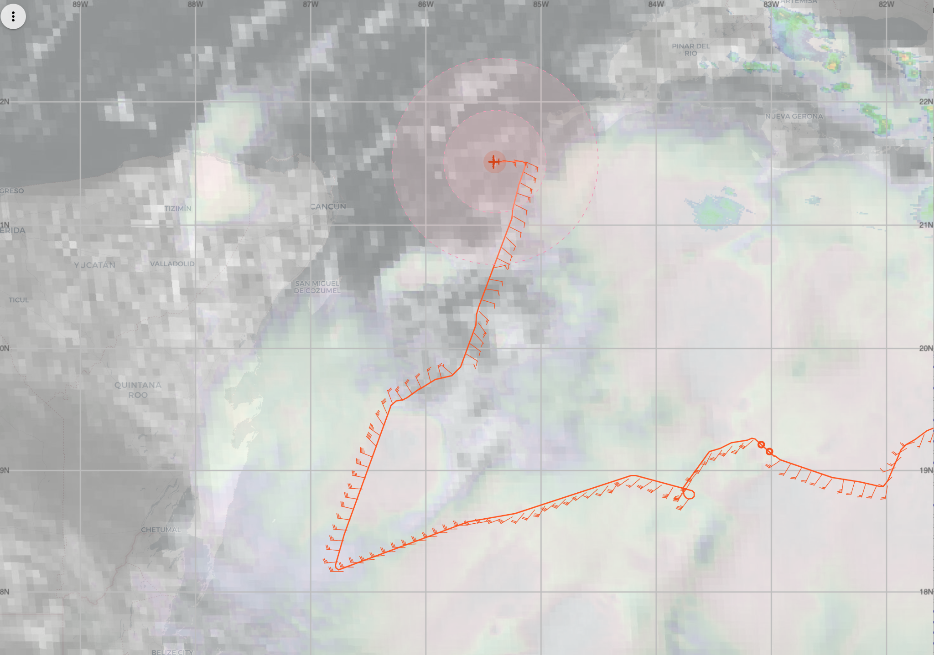
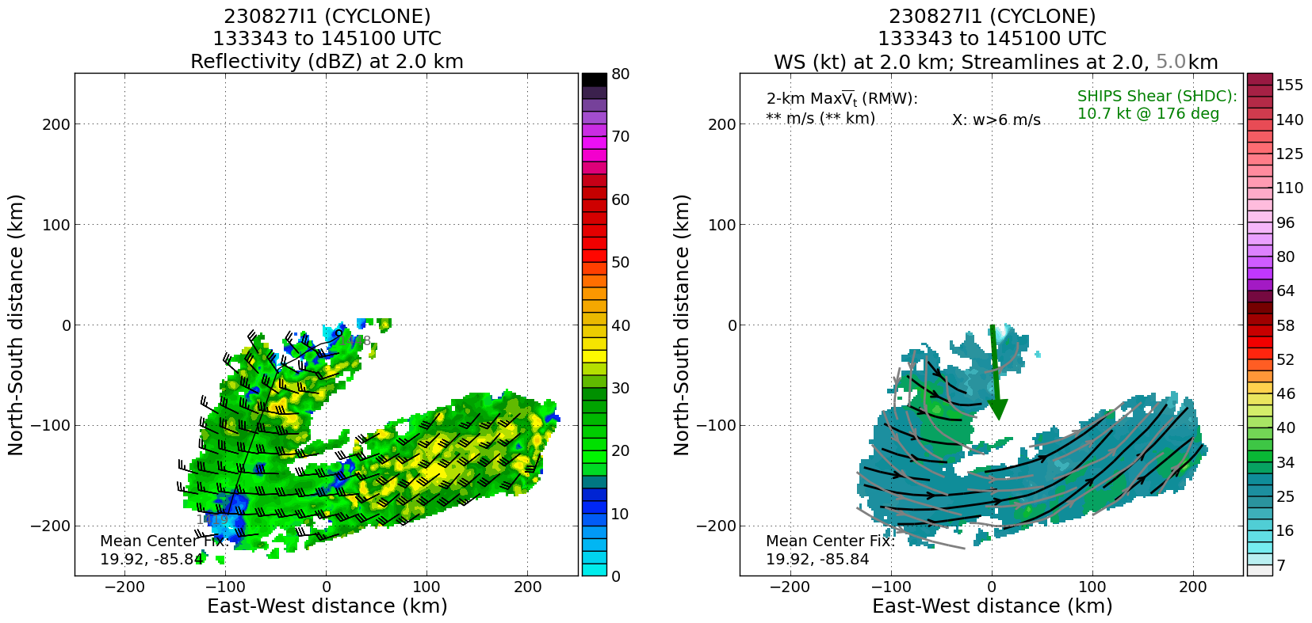

TDR analysis centers and tilt:
Alt (km) Lat (deg) Lon (deg W)
0.5 99.99 99.99
2.0 19.92 85.84
3.0 19.85 85.81
6.0 19.40 85.92
2-6-km Vortex Tilt: 58.6 km at 188 deg

1529 | Point #3 Sonde #6, turn TK 160
1540 | Midpoint Sonde #7
1552 | Center Sonde #8 SFMR has 12 m/s surface winds at FL center - Heather is looking into possible SFMR HDOB issues.
 | 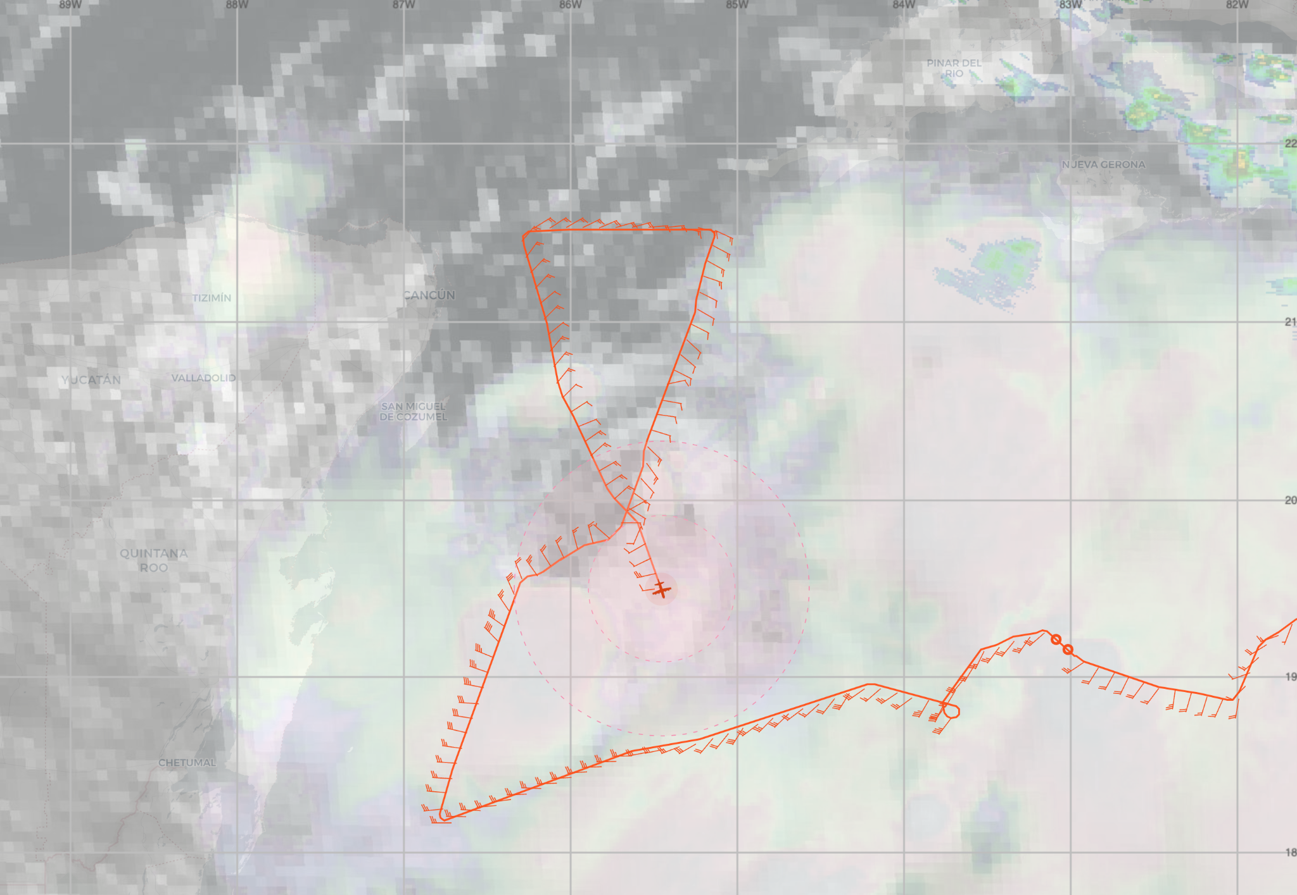
1605 | Got bounced around in outer band heading SE from the center, cells seem to be strengthening in the rainband SE of the center
1609 | Midpoint Sonde #9
1615 | Heather said: “Suspicious values from SFMR showing up in HDOBs. 0 m/s is being reported in regions where the 1-sec data are reporting valid wind speeds. This has occurred on the past few flights."
1618 | Point #4 Sonde #10 Turn TK 360
1621 | Visible satellite loop suggests LLC is moving a bit toward the ENE over the last hour. Seems to be in a trochoidal loop as it tries to organize. Convection strengthening to the S and SE of the center, open to the N and NNW. Pretty dry air to the NW of the center over the Gulf and Yucatan. Cloud motions in the Gulf north of Yucatan also show strong W shear.
1631 | Radar painting rainband to the west of the track with tops to 14 km. In the area of coldest cloud tops.  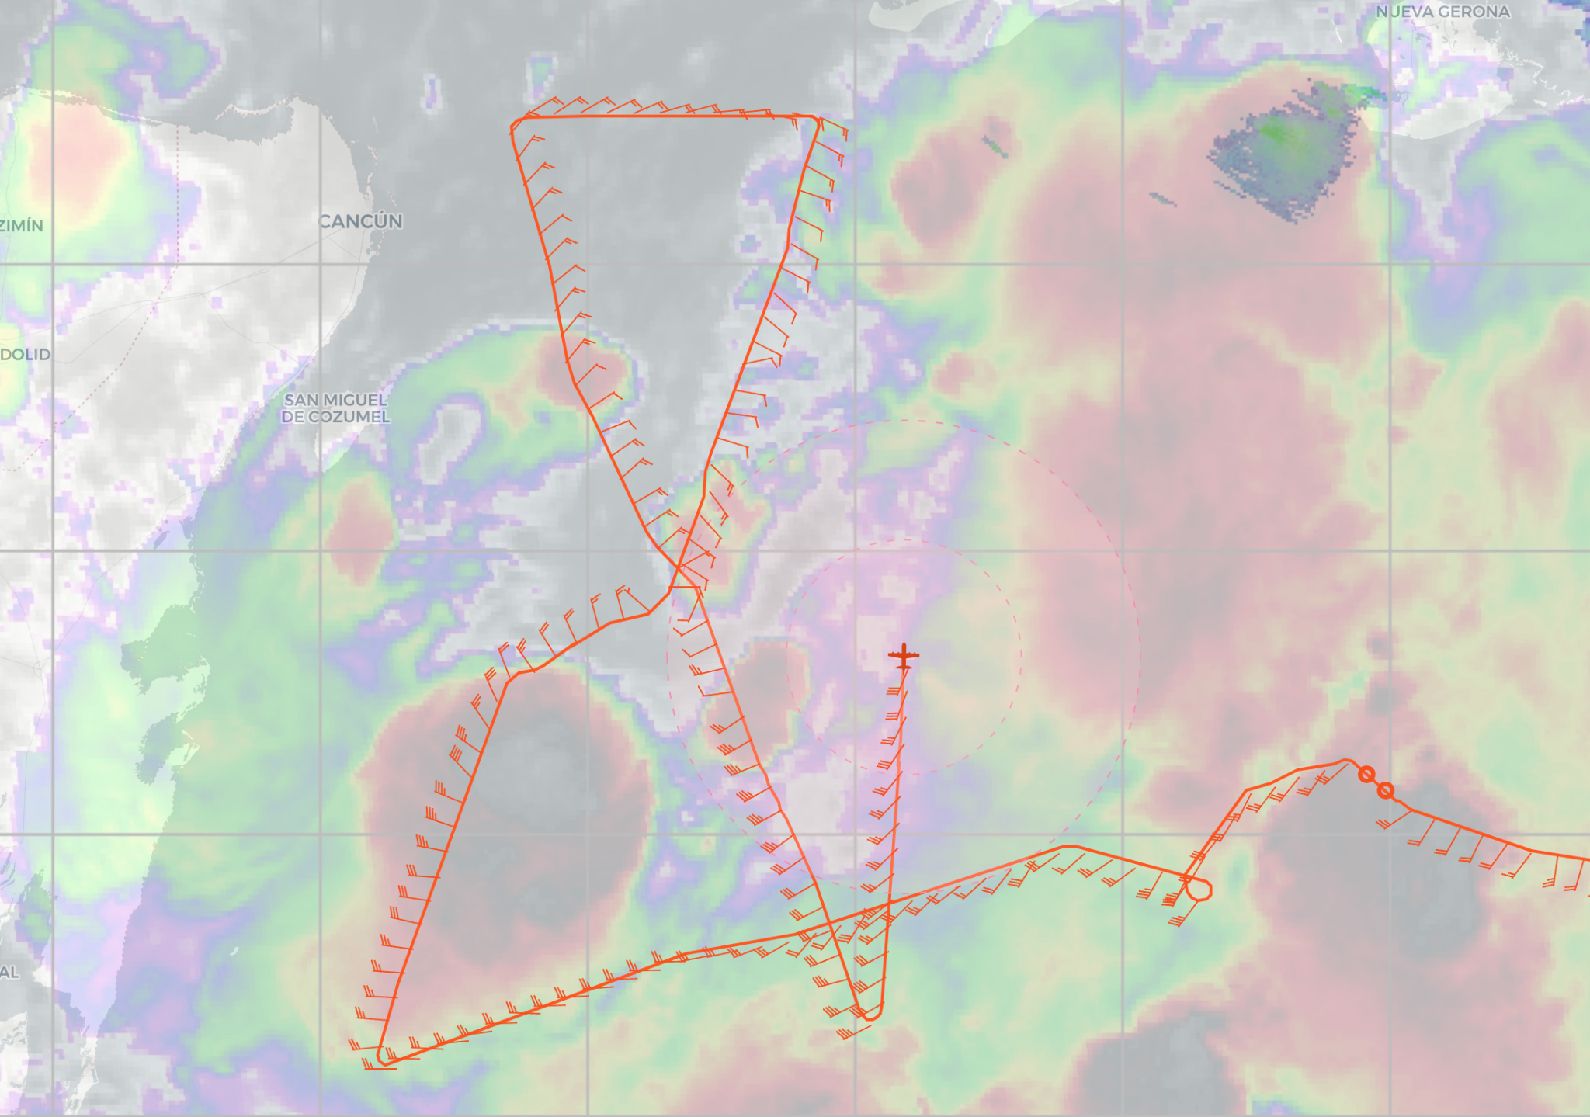
1641 | 2nd TDR analysis finished.  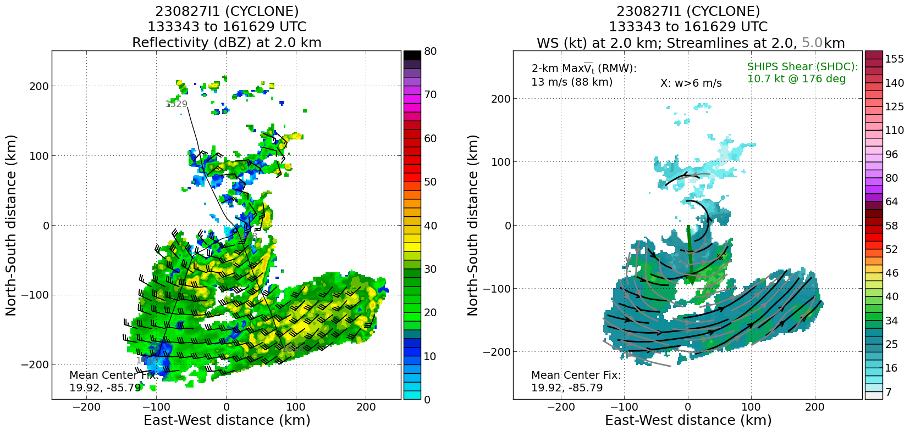  TDR analysis centers and tilt:  Alt (km) Lat (deg) Lon (deg W)  0.5 19.91 85.78  2.0 19.92 85.75  3.0 19.87 85.69  6.0 19.56 85.55  2-6-km Vortex Tilt: 44.8 km at 153 deg  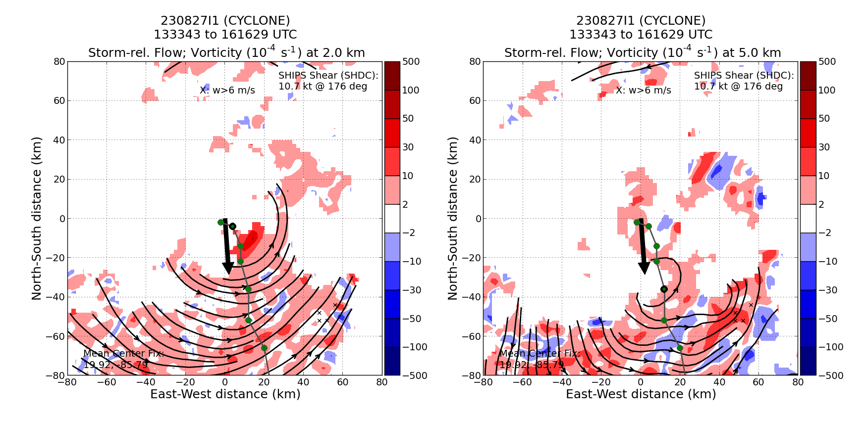  Echo tops on the SE side to 16 km altitude, and to 13 km on the NW side of the center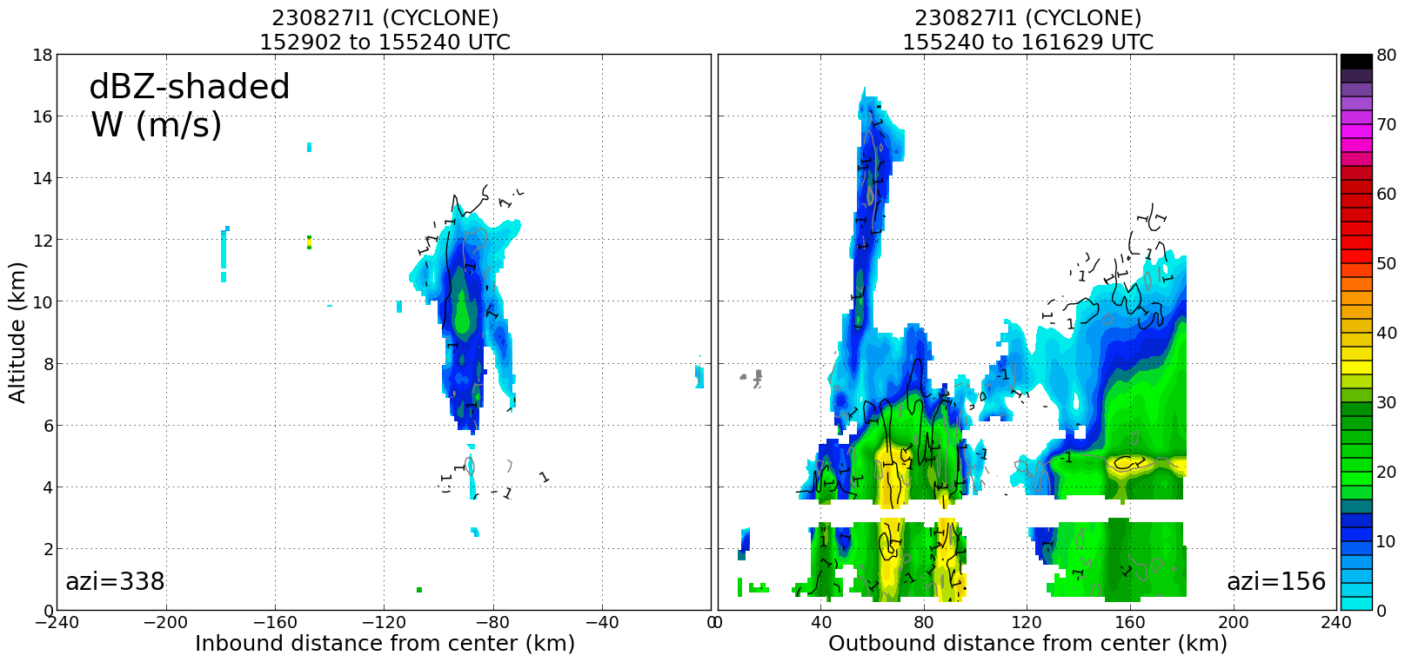
1648 | Sonde #11 (last sonde) end pattern TK to west of convection near W edge of Cuba  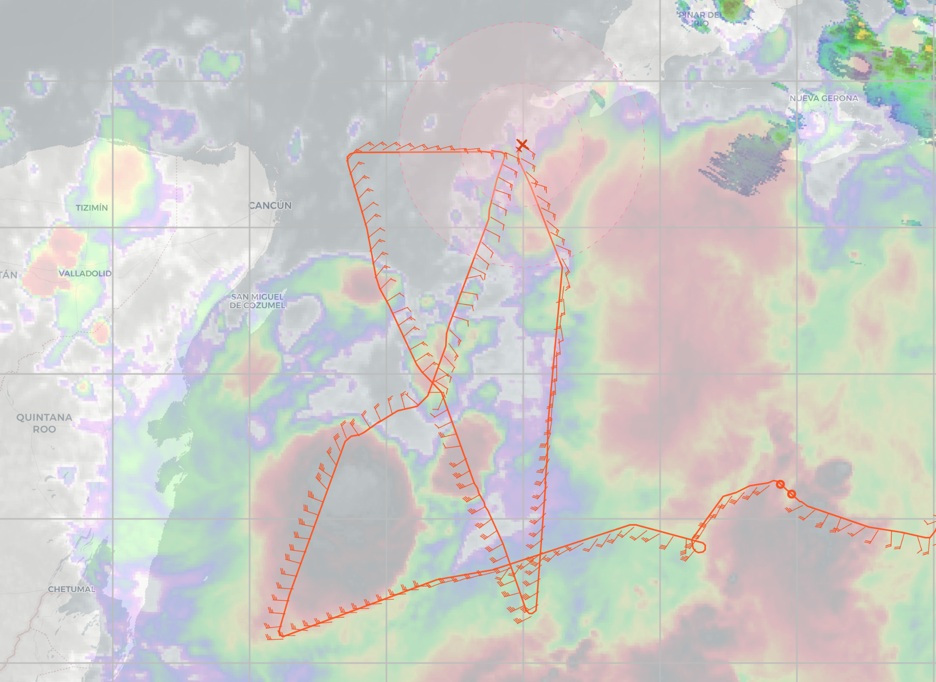
1700 | Science complete
Final flight track and TDR analysis
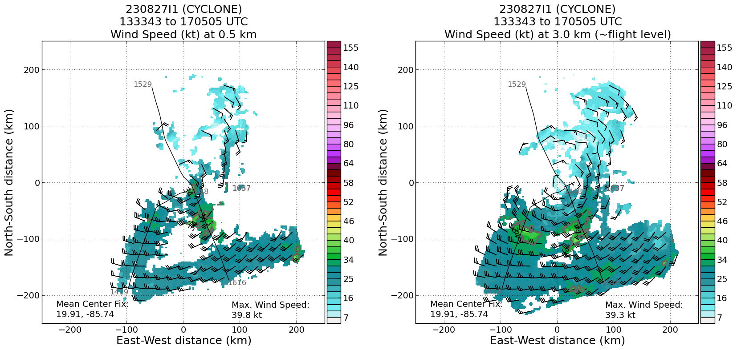
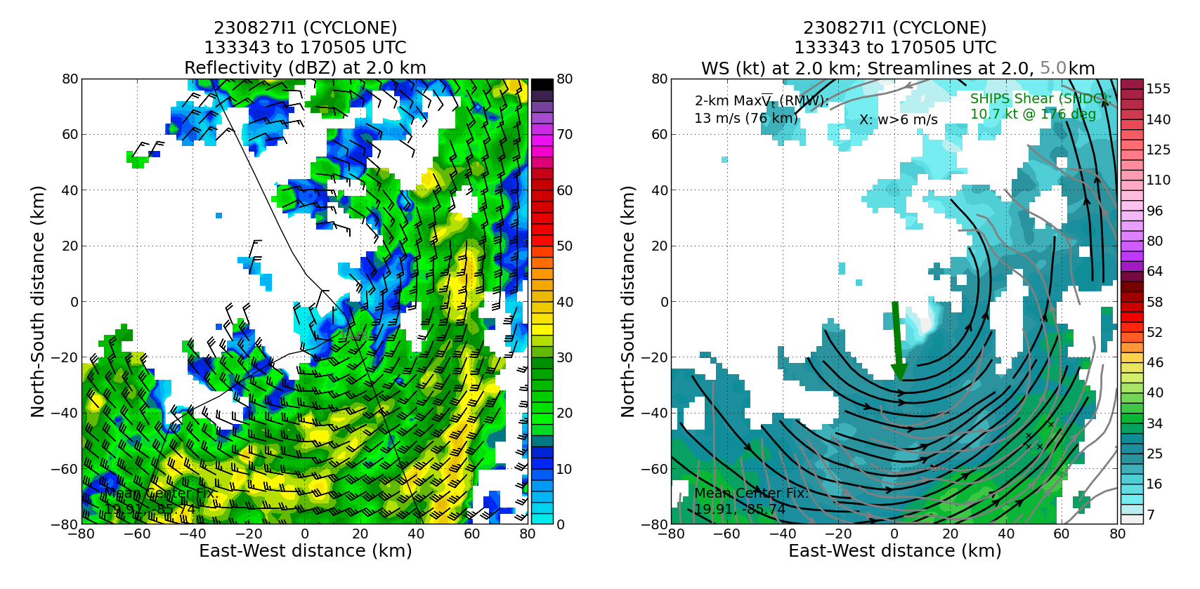

POST-FLIGHT
Mission Summary | Very interesting mission into developing TD10 in the Yucatan Straits. Thanks to the observations during the mission, NHC upgraded TD10 to TS Idalia. When the aircraft arrived it was clear that the center was further S than the suggested position, and the pattern was shifted S. During the mission the TDR analyses showed a clear tilt to the S from the LLC to 6 km altitude. Visible satellite loop suggests LLC was moving a bit toward the ENE over the 3-4 h of the mission. Seems to be in a trochoidal loop as it tries to organize. Convection strengthened to the S and SE of the center, open to the N and NNW. Pretty dry air to the NW of the center over the Gulf and Yucatan. Cloud motions in the Gulf north of Yucatan also show strong W shear.
Actual Standard Pattern Flown | Abbreviated Figure 4
APHEX Experiments / Modules Flown | Early Stage operational mission, No APHEX modules
Plain Language Summary | - Mission observations resulted in TD 10 being upgraded to TS Idalia  - Tail Doppler Radar analyses showed a clear tilt to the south of ~40 km from the low-level center to 6 km altitude suggesting that the storm is still organizing  - Low-level center appeared in satellite images to be in a trochoidal loop as it tries to organize.  - Convection strengthened to the south and southeast of the center  - Environment north and west of the center was relatively dry and had strong westerly shear
Instrument Notes | Instruments seemed to perform optimally during the mission. Heather made one note concerning the SFMR HDOBS: "Suspicious values from SFMR showing up in HDOBs. 0 m/s is being reported in regions where the 1-sec data are reporting valid wind speeds. This has occurred on the past few flights."
Final Mission Track | 