MISSION PLAN
FLIGHT ID | 20230826N1 | STORM | AL08/Franklin
MISSION ID | WC08A | TAIL NUMBER | (NOAA-49)
TASKING | HRD | PLANNED PATTERN | (Circumnavigation)
MISSION SUMMARY
TAKEOFF [UTC] | 1344 | LANDING [UTC] | 2054
TAKEOFF LOCATION | Lakeland | LANDING LOCATION | Lakeland
FLIGHT TIME | 7.2 | BLOCK TIME | 7.4
TOTAL REAL-TIME RADAR ANALYSES  (Transmitted) | 3 (3) | TOTAL DROPSONDES Deployed (Transmitted) | 32 (29) 1 ob sent 2x
OCEAN EXPENDABLES (Type) | n/a | sUAS (Type) | n/a
APHEX EXPERIMENTS / MODULES | Exact name of the Experiment in the HFP Plan; identify relevant experiments / module even if not a research tasking
HRD CREW MANIFEST
LPS ONBOARD | n/a | LPS GROUND | Kaplan
TDR ONBOARD | n/a | TDR GROUND | Alvey
ASPEN ONBOARD | AOC FD | ASPEN GROUND | n/a
NESDIS SCIENTISTS | n/a
GUESTS (Affiliation) | n/a
AOC CREW MANIFEST
PILOTS | de Triquet/Varwig/Bhatnagar
NAVIGATOR | n/a
FLIGHT ENGINEERS | n/a
FLIGHT DIRECTOR | Henning/de Solo
DATA TECHNICIAN | Defeo
AVAPS | Dykeman/Paul

PRE-FLIGHT
Flight Plan | 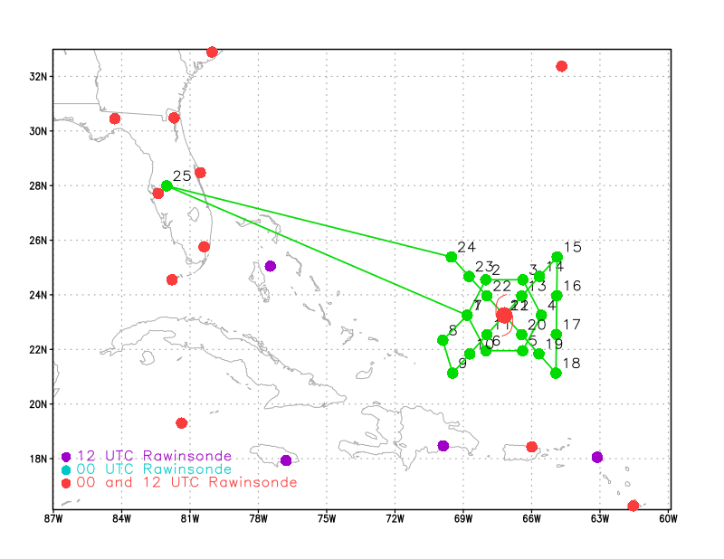  Circumnavigation with Figure 4 around Franklin.
Expendable Distribution | Equally spaced drops with a few midpoint drops on the west and southwest side of the system.
Preflight Weather Briefing | 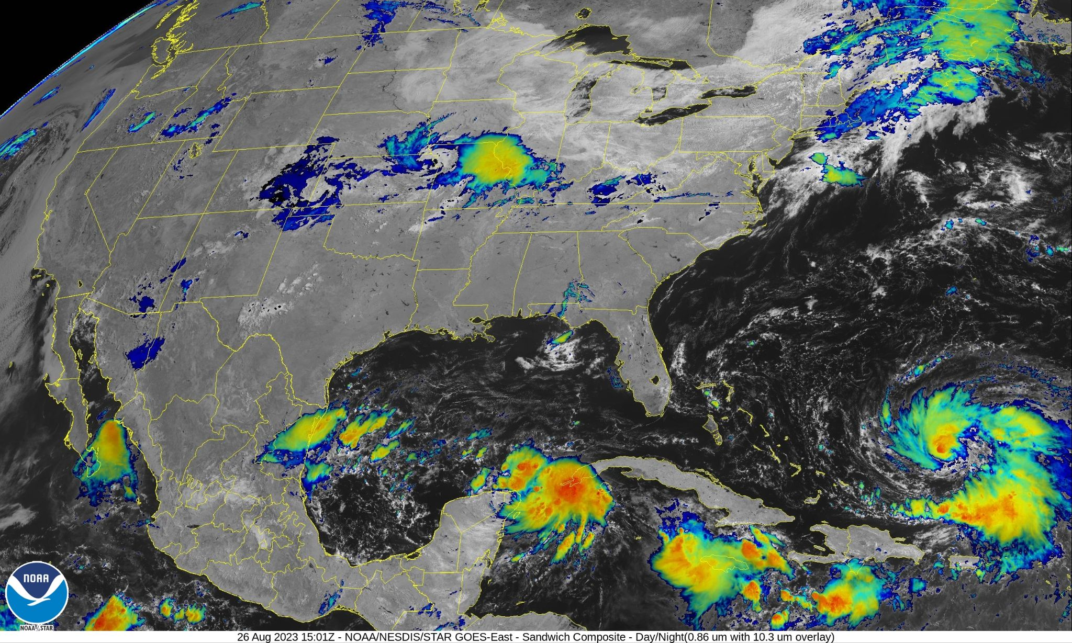  NHC 11 AM advisory: Position: 23.5 N 66.7 W  Intensity: 65 kt 989 mb  Heading: NNW 7 mph.  Franklin is getting better organized with convection increasing on the west and northwest side. There is an upper-level low to the west southwest of Franklin that has been imparting a bit of southwest shear that is forecast to move southwest providing a much more favorable environment for Franklin to intensify over the next couple of days perhaps rapidly.  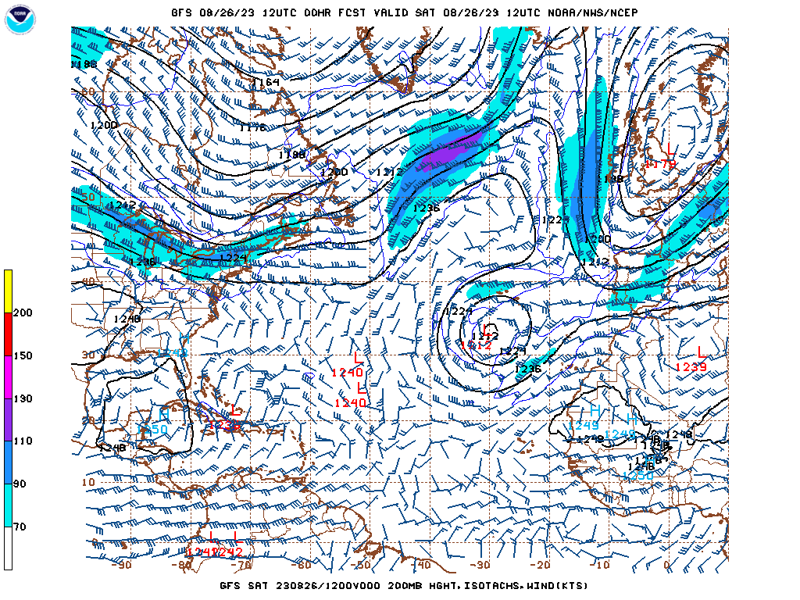  GFS 200 mb analysis 230826 1200 UTC. Note upper-level low to west-southwest of Franklin.  [Copy in GIF of recent (~6 hr) satellite loops (https://www.star.nesdis.noaa.gov/GOES/index.php)]
Instrument Notes | Instruments working as expected

IN-FLIGHT
Time [UTC] | Event
1344 | Take-off from Lakeland
1534 | Drop 1/Ob1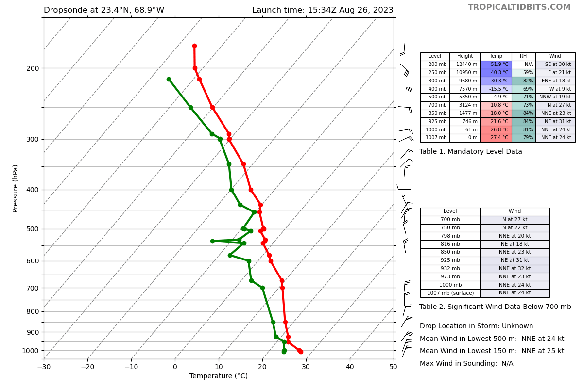
1546 | Drop 2/Obs 2
1553 | Drop3/Obs 3 Intermediate drop requested between drops 2 and 3 (Kelly Ryan)
1555 | Having some difficulty running real-time TDR script. TDR is working and data is being collected though.
1558 | Drop 4/Obs 4
1610 | Drop 5/obs 5
1623 | Drop 6/Obs 6
1629 | Drop 7/Obs 7
1635 | Drop8/obs 8
1640 | Drop 9/obs 9  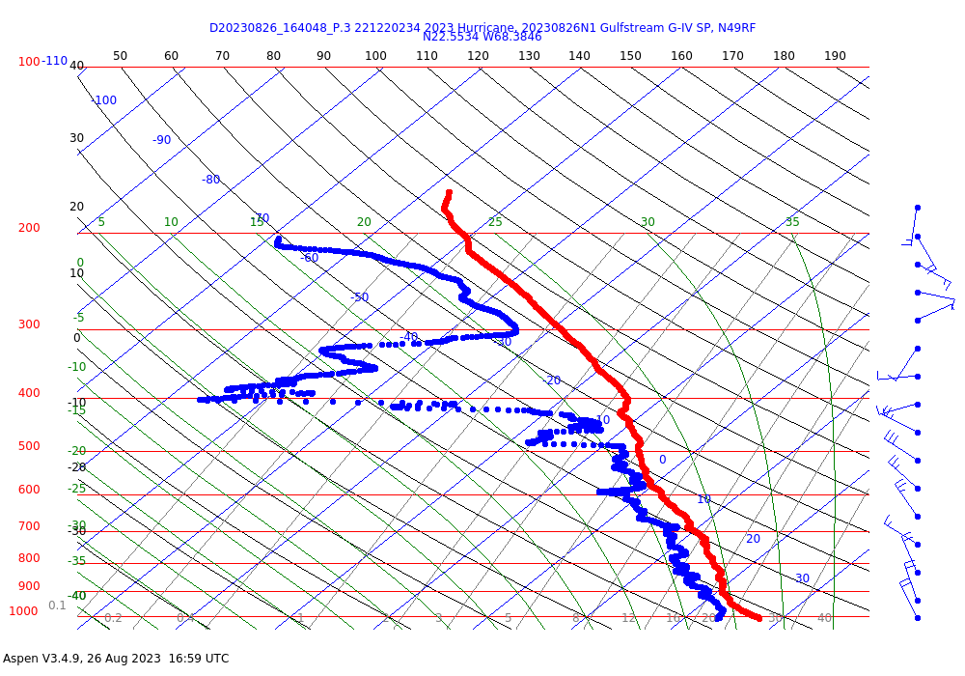  Note cyclonic circulation and drier air near 300 mb likely reflection of upper-level low to the system's west.
1646 | Drop 10/obs 10
1657 | Drop 11/obs 11
1702 | Drop 12/obs 12
1706 | Drop 13/obs 13
1713 | Drop 14
1721 | Drop 15
1729 | Drop 16/obs 16 994 mb sfc. pressure. Wind 185/69 kt at 15 m (AOC requested drop)
1738 | Drop 17
1745 | Drop 18
1752 | Drop 19
1755 | First TDR analysis file sent to NCEP gateway
1802 | Drop 20
1915 | Second TDR analysis file sent to NCEP gateway
1814 | Drop 21/Obs 21
1825 | Drop 22/Obs 22
1832 | Drop 23/Obs 23
1832 | Drop 23/obs 24 (Drop 23 was sent out twice by mistake)
1840 | Drop 24/obs 25
1849 | Drop 25/obs 26
1852 | Drop 26/obs 27. Western Eyewall. Sfc. pressure 987 mb.
1947 | Third TDR analysis sent to NCEP gateway
1857 | Drop 27/Obs. 28
1905 | Drop 28/Obs. 29
1913 | Drop 29/Obs. 30 Last report.

POST-FLIGHT
Mission Summary | Mission went well with a very good dataset collected. Overall the pattern was flown as planned though there was a need to deviate somewhat near the storm center due to some heavy convection. There were also some technical problems with the generation of TDR analyses initially due to scripting issues but those were ultimately resolved and 3 TDR analyses were sent to NCEP’s gateway as well as 29 dropsondes (there was 1 duplicate sonde sent) so a total of 30 total observations were sent off the plane. The transmission of sondes and Doppler analyses was quite slow at times.
Actual Standard Pattern Flown | 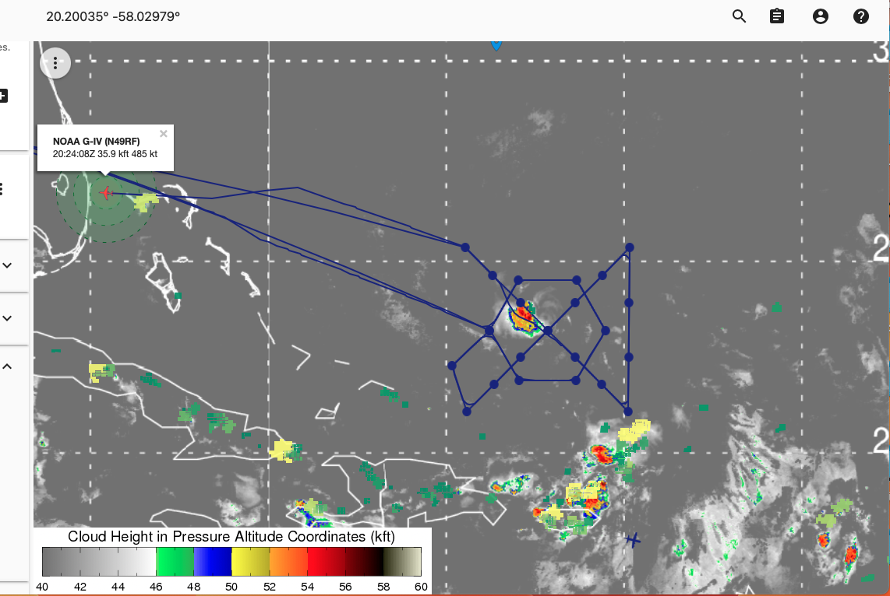
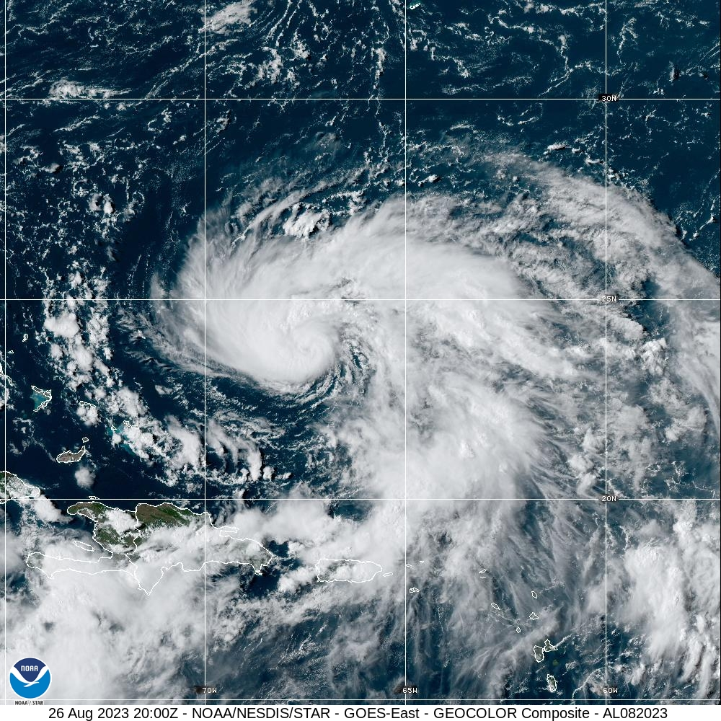

NOAA visible image of Franklin at 8/26 2000 UTC.
The 5 PM NHC estimated intensity was 75 kt and 982 mb.

Plain Language Summary | The mission was designed to examine the degree to which Franklin was aligning and the impact of the alignment on the system’s potential for subsequent intensification. Franklin became better organized during the system likely due to improved alignment as the upper-level low moved southwest of the system.
Instrument Notes | All instrumentation worked as expected. There were some TDR scripting issues, but those were resolved.
Final Mission Track | See above.

