MISSION PLAN
FLIGHT ID | 20230826I2 | STORM | AL08/Franklin
MISSION ID | WD08A | TAIL NUMBER | NOAA-43
TASKING | HRD | PLANNED PATTERN | Butterfly
MISSION SUMMARY
TAKEOFF [UTC] | 2034 | LANDING [UTC] | 0301
TAKEOFF LOCATION | STX | LANDING LOCATION | STX
FLIGHT TIME | 6.5 | BLOCK TIME | 6.6
TOTAL REAL-TIME RADAR ANALYSES  (Transmitted) | 4 (4) | TOTAL DROPSONDES Deployed (Transmitted) | 30 (28)
OCEAN EXPENDABLES (Type) | 5 (4 good) AXBTs | sUAS (Type) | n/a
APHEX EXPERIMENTS / MODULES | FLAIMS
HRD CREW MANIFEST
LPS ONBOARD | Aberson | LPS GROUND | Rogers
TDR ONBOARD | Aberson | TDR GROUND | Gamache
ASPEN ONBOARD | J. Zhang/Sippel | ASPEN GROUND | n/a
NESDIS SCIENTISTS | n/a
GUESTS (Affiliation) | n/a
AOC CREW MANIFEST
PILOTS | Abitbol/Rannenberg/Keith
NAVIGATOR | Utana
FLIGHT ENGINEERS | Stokes/Wyssinger
FLIGHT DIRECTOR | Lundry/Zawislak
DATA TECHNICIAN | McAlister
AVAPS | Underwood

PRE-FLIGHT
Flight Plan | 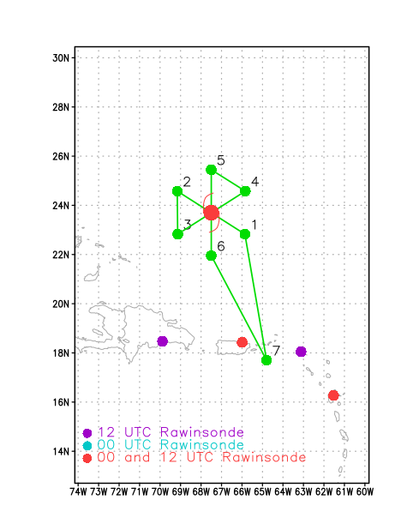  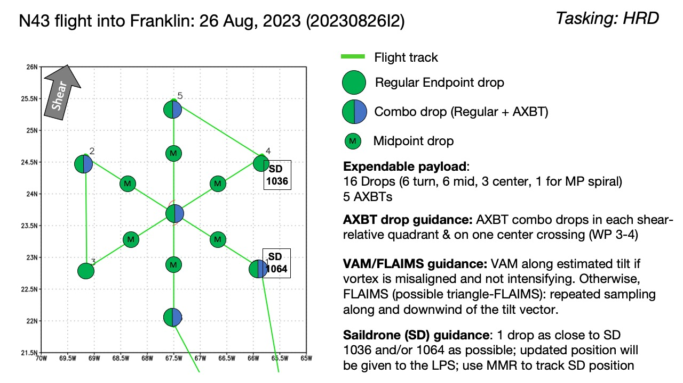  Fly butterfly pattern, IP on southeast side, final point on south side. Possible triangle FLAIMS module, likely on northeast triangle of pattern. Fly at 10 kft to start, then descend to 8 kft once the Air Force arrives.
Expendable Distribution | Drop sondes at all endpoints and midpoints, and each center pass. Also one drop as close to Saildrone (SD) 1036 and/or 1064 as possible. AXBT combo drops in each shear-relative quadrant (shear expected to be from the south-southwest), and on one center crossing (likely the SW-NE pass).
Preflight Weather Briefing | Franklin has steadily intensified throughout the morning and afternoon hours. It is now a hurricane, 989 hPa and 65 kt as of 11 AM EDT. System has become aligned as of the previous P-3 mission, which was also essentially confirmed from nice TDR analyses from the G-IV mission that just completed.  Shear has decreased significantly from previous days, now at or below 10 kt. That is a large part of the reason why Franklin has become aligned.  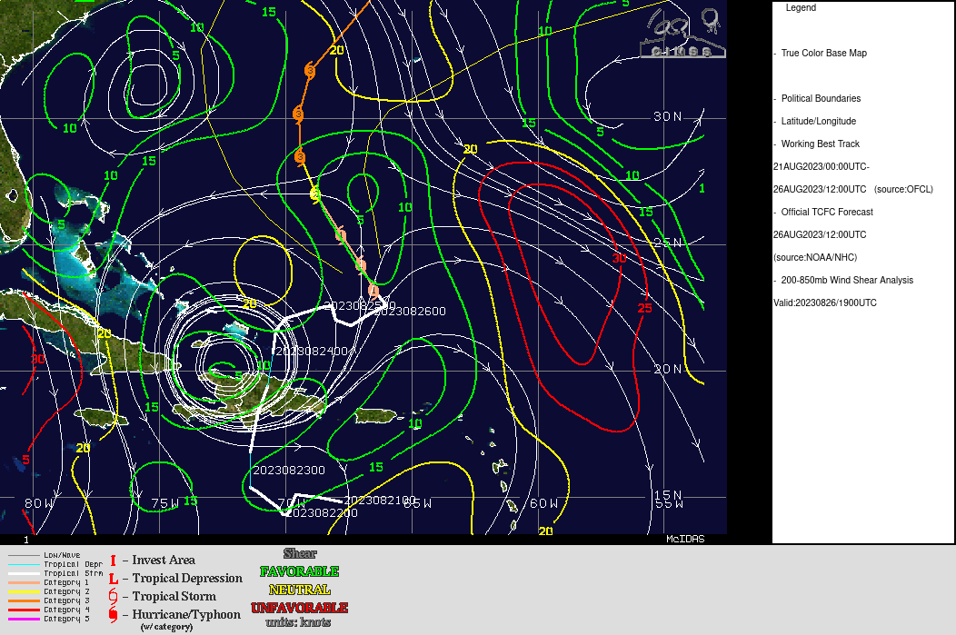  IR animation shows precipitation becoming symmetrically-distributed around the TC center. Coldest cloud tops are found on the SW side. That is also where lightning is being seen. This type of setup is reminiscent of Edouard (2014) during the time when that storm was intensifying. It indicates a favorable upshear environment to maintain and sustain the convection that initiates on the downshear (northeast) side of the TC. Earlier in the day the IR presentation was much less impressive, with little to no cold cloud tops on the southeast and east sides of the TC. That was suggestive of some dry air that was present on that upshear side. The presentation now, however, suggests that that dry air has been replaced by moist air, again a marker of intensification.
Instrument Notes | Instruments are working, but there is an issue with the IWG stream and its appearance on MTS. Don’t know if it’s just a problem with MTS, but there are no winds on the track plot.  Camera recording not working.

IN-FLIGHT
Time [UTC] | Event
2035 | Take-off from STX
2131 | Approaching IP, passed through MCS on approach. TC shows a similar presentation as before (coldest cloud tops upshear).
214729 | Begin inbound leg 214729, track 290. BT dropwindsonde combo out. Near Saildrone, drop 1. SST=28.8C
2152 | Turn to 280 inbound toward radar eye
2201 | Midpoint drop out, drop 2
2204 | In outer rainband
 | Eye open on the NE, convection only on the west side
2210 | RMW. SFMR same as FL here. 31 m/s max sfmr drop 3
221240 | Mark center drop, drop 4
 | Near center now, coldest cloud tops all on south side. Reports from aircraft are that convection is on the west side. Seems consistent with notion of convection initiating downshear (NE side), most prevalent on west side as it ascends, and anviling out on upshear (south) side.
2215 | RMW west sonde, wind speed slightly higher than on east side, drop 5.
2218 | Secondary wind max in band
2228 | Buoy sonde released drop 6
2232 | In left-of-shear region here, mostly stratiform precipitation. Some convection in eyewall and secondary band on west side.
2238 | Center drop had pressure of 979 hPa
2240 | Turn downwind, track 170, end first center pass leg, drop 7
2251 | MMR is having issues. Display only goes on 40 NM. Not sure if data goes further or not. No way to check.
2304 | Turn inbound drop combo, drop 8. SST=29.5C
2316 | Midpoint sonde, drop 9
2322 | On inbound leg in SW quadrant. FL winds are much higher than SFMR winds here. On the leg outbound to the WNW, FL and SFMR winds were much closer to one another.
2325 | RMW sonde, drop 10
2327 | 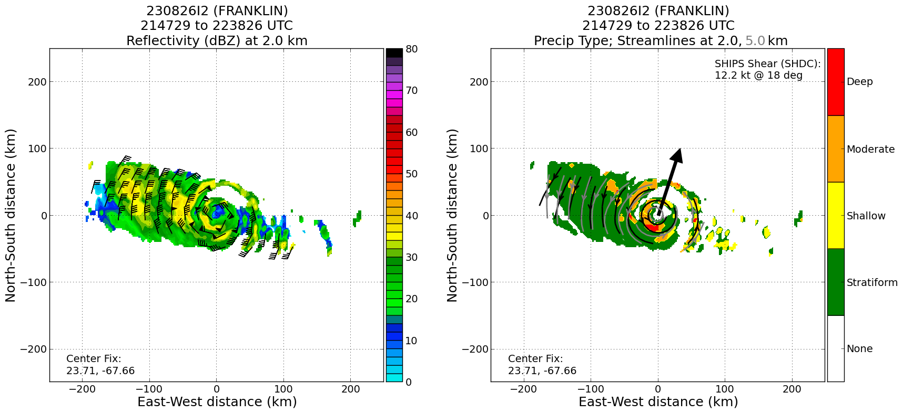  Plot of precip mode from the first pass shows widespread moderate convection in the NW quadrant, consistent with idea of convection in the left of shear side containing growing convection in the eyewall, then once you get upshear there’s deep convection, which is what is seen with the coldest cloud tops upshear.
232811 | Mark center, combo drop out, drop 11, BT failed (very spotty data)
2329 | 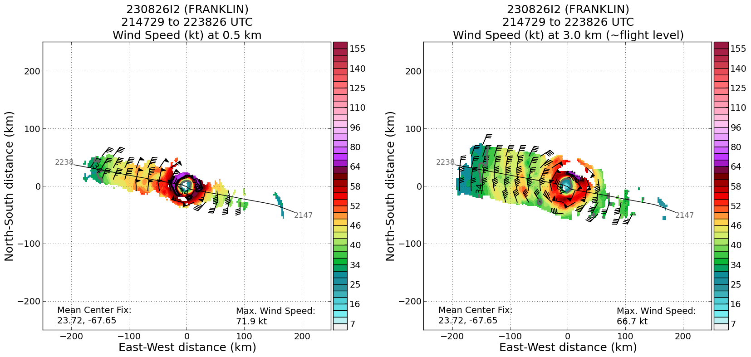  TDR analyses show winds at 0.5 km of about 80 kt, maximized on the north and northeast sides of the TC
2331 | RMW NE sonde, drop 12
2343 | Midpoint drop, drop 13, lots of convective cells, some pretty good bumps
2344 | Profile is very interesting, Very high (altitude) wind-speed maximum on east side.
2248 | Comparison of azimuthal-mean tangential winds from composite from previous P-3 mission and first pass from current mission shows a bit of a contraction in RMW. It was ~30 km, now it’s about 22-25 km. We’ll see if that structure holds for the remainder of the mission and as more passes are added to the composite.  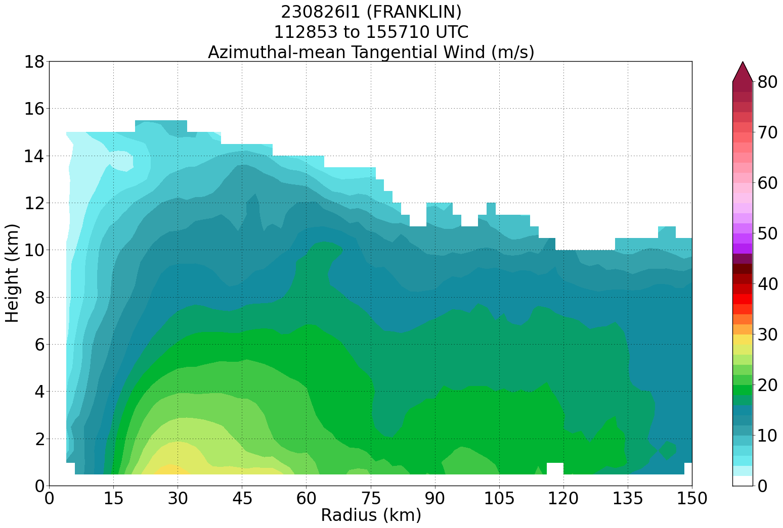  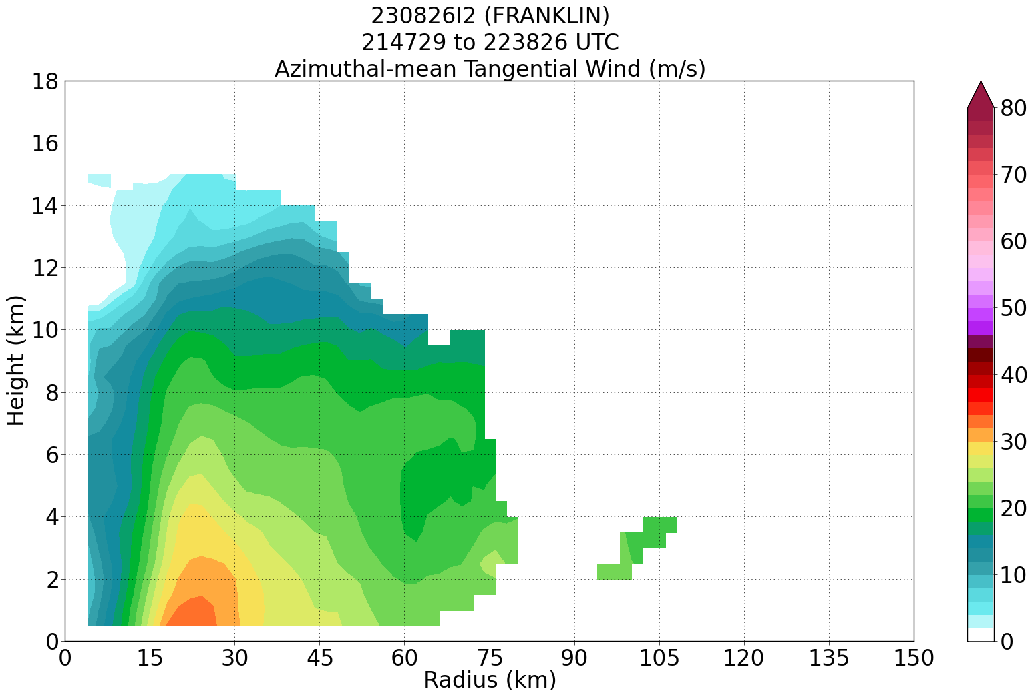
2351 | Sonde where SFMR was higher than FL, no launch detect
2351 | Replacement sonde
2354 | endpoint/saildrone sonde, spotty telemetry
2355 | Backup sonde
0022 | Heading north to debug issues with FD workstation
0026 | Endpoint combo drop, no telemetry on sonde, BT 29.1C
0027 | Backup sonde
0036 | Midpoint sonde
0046 | RMW sonde
0049 | Center sonde and beginning FLAIMS module
0052 | RMW sonde
0102 | FLAIMS endpoint sonde
0116 | FLAIMS endpoint sonde
0126 | RMW sonde. Heading to S after completing FLAIMS
0131 | RMW sonde
0133 | SFMR much higher than FL on south side. Outside of radar reflectivity, but it was bumpy. Past the head of the comma and the RMW seemed to be well outside that, like it was was curling into the center
0144 | Midpoint sonde
0156 | Endpoint sonde, science complete

POST-FLIGHT
Mission Summary | Great radar and sonde coverage.  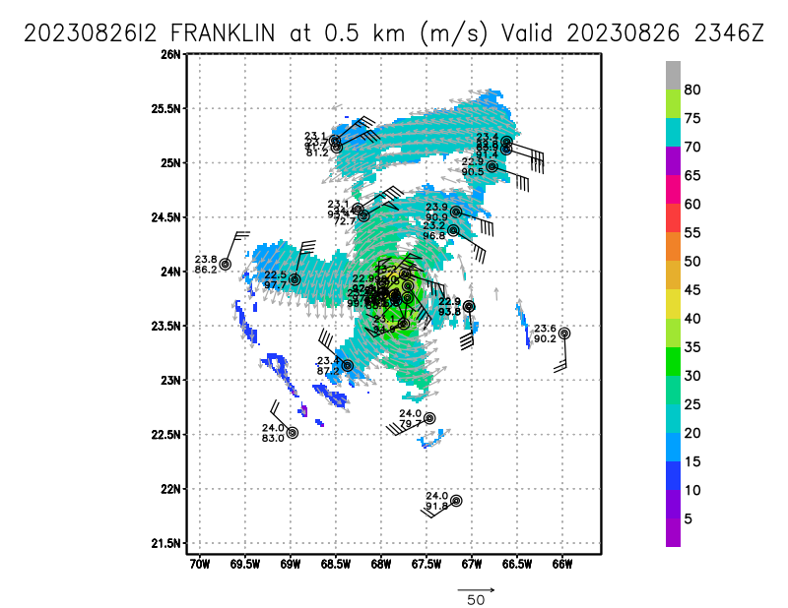  Lots of low-level AMVs, which is unusual  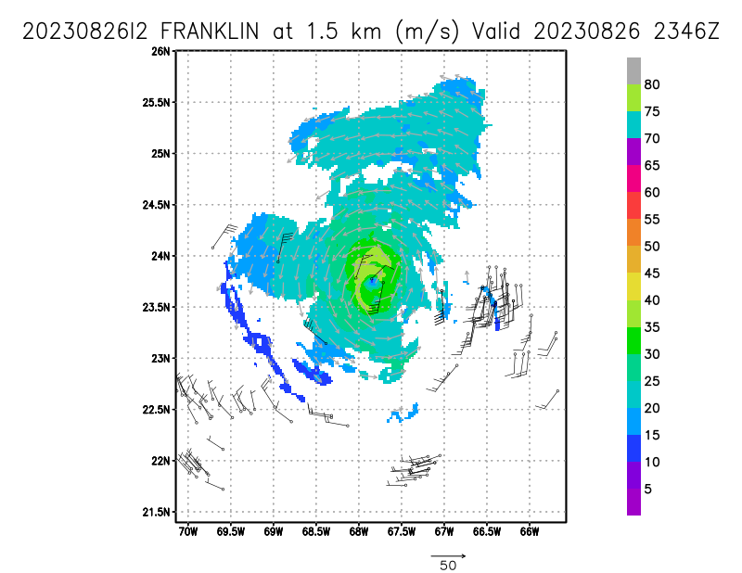  AMVs show an upper-level low to the southwest.  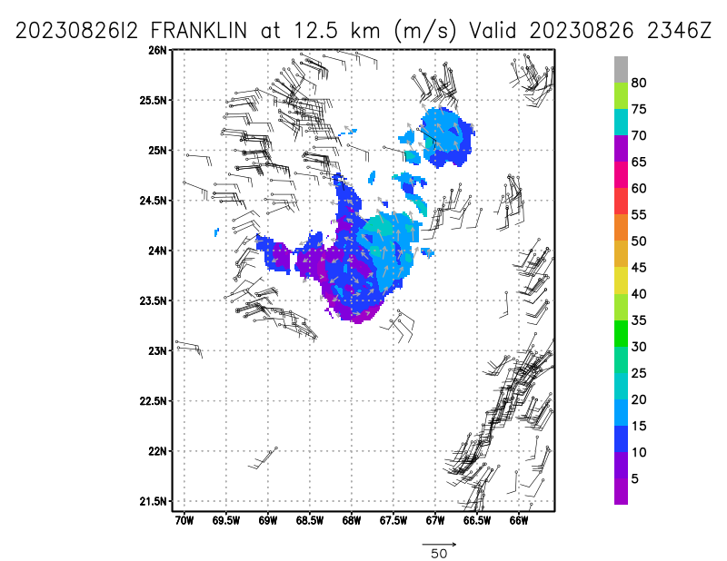
Actual Standard Pattern Flown | Butterfly + FLAIMS
APHEX Experiments / Modules Flown | FLAIMS
Plain Language Summary | The storm has become better organized since yesterday and went through its first period of rapid intensification late this afternoon. A GPS dropsonde and Airborne EXpendable BathyThermograph (AXBT) were also deployed in the southwest quadrant of Franklin near Saildrone 1064. These aircraft observations will be compared to the Saildrone measurements and also provide a unique opportunity to examine details of the local atmospheric and ocean conditions in the storm. Ten AXBTs were deployed from the P-3s today and near real-time transmission of that data down to NOAA AOC was successfully tested. The APHEX-HRD and ONR science teams also collaborated to collect supplemental atmospheric and oceanic data in the storm environment.
Instrument Notes | No camera recording. MMR difficulty - see above.
Final Mission Track | [Insert MTS screenshot of final flown track, ideally at the completion of the pattern with satellite imagery]

