MISSION PLAN
FLIGHT ID | 20230825I1 | STORM | AL08 / Franklin
MISSION ID | WAWXA Franklin | TAIL NUMBER | NOAA-43
TASKING | HRD | PLANNED PATTERN | Butterfly
MISSION SUMMARY
TAKEOFF [UTC] | 1119 | LANDING [UTC]
TAKEOFF LOCATION | Lakeland | LANDING LOCATION | St. Croix
FLIGHT TIME | Fractional hr, Takeoff to Landing Time | BLOCK TIME | Get from onboard LPS or Flight Director
TOTAL REAL-TIME RADAR ANALYSES  (Transmitted) | Ex. 3 (3) | TOTAL DROPSONDES Deployed (Transmitted) | Ex. 32 (30)
OCEAN EXPENDABLES (Type) | Ex. 8 ONR AXBT,  2 MicroSWIFT | sUAS (Type) | Ex. 1 Altius-600
APHEX EXPERIMENTS / MODULES | Vortex Alignment Module (VAM)
HRD CREW MANIFEST
LPS ONBOARD | Hazelton | LPS GROUND | Alvey
TDR ONBOARD | Hazelton | TDR GROUND | Reasor
ASPEN ONBOARD | Zhang | ASPEN GROUND | n/a
NESDIS SCIENTISTS | n/a
GUESTS (Affiliation) | n/a
AOC CREW MANIFEST
PILOTS | Copare, Wood, Palmer
NAVIGATOR | Miller / Schaefer
FLIGHT ENGINEERS | Darby / Tyson
FLIGHT DIRECTOR | Kalen / Parrish
DATA TECHNICIAN | Richards
AVAPS | Kotz

PRE-FLIGHT
Flight Plan | 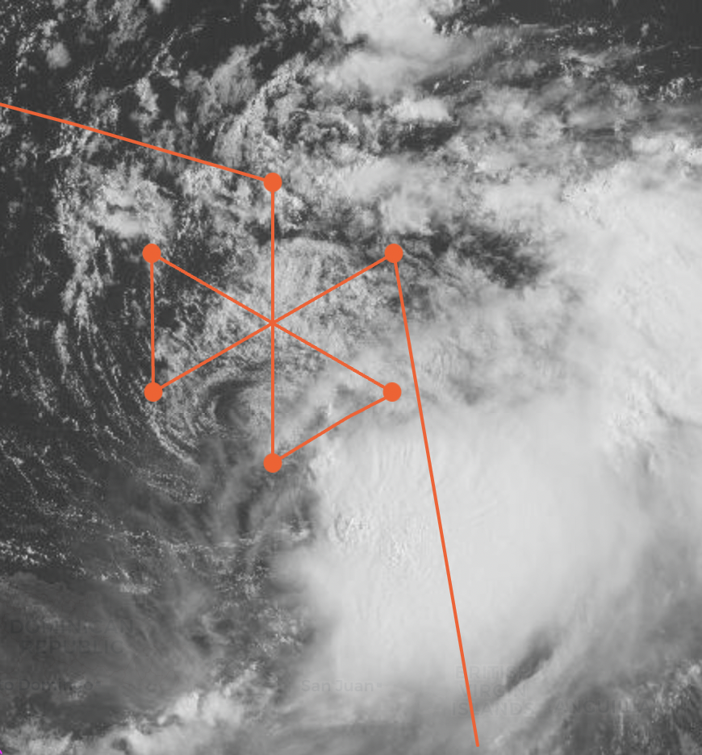  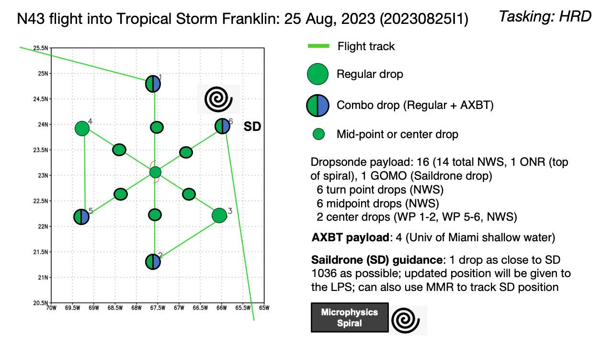
Expendable Distribution | Endpoints, midpoints, center
Preflight Weather Briefing | The storm remains strongly shear by westerly (WNW) vertical wind shear >20 knots (moderate to strong). The storm appears to be misaligned by >100 miles (~150 miles based on visible satellite and Puerto Rico radar).  NHC update: “...FRANKLIN MOVING ERRATICALLY SOUTHEASTWARD...  Satellite and aircraft data indicate that the center of Tropical  Storm Franklin is moving well south of the current NHC track  Forecast.”  Storm is over relatively warm SSTs (29.4 SST), perhaps allowing storm to not fully decouple. Shear is expected to be near its peak right now and quickly relax over the weekend as the storm moves into a very favorable upper level wind pattern. Global models are fairly bullish along with HAFS (sub 920 hPa in 72-84h)
Instrument Notes | none

IN-FLIGHT
Time [UTC] | Event
1119 | Take-off from Lakeland
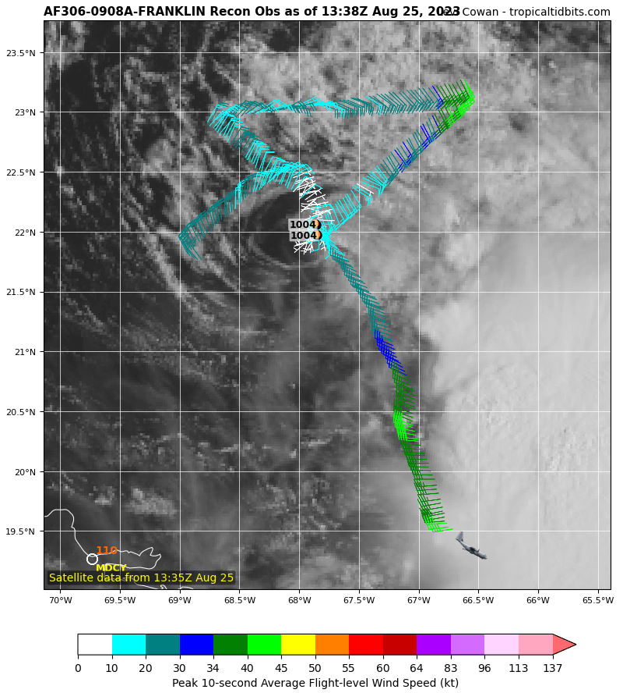
Air Force - interesting wind shift towards the convective mass region (flying ~700 hPa?)
 | 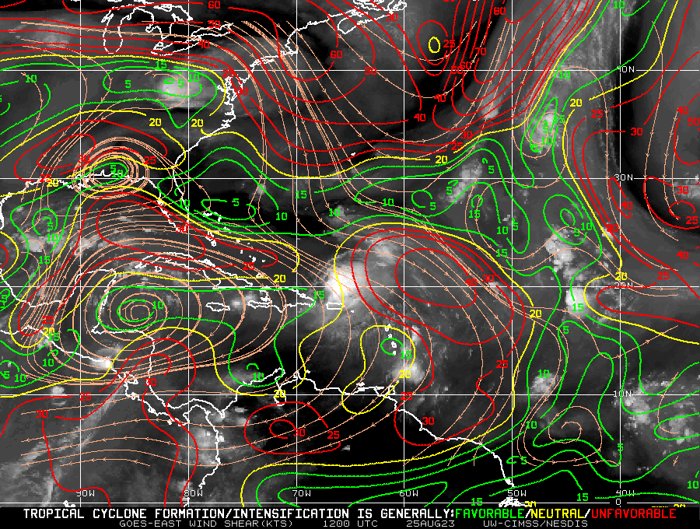
1358 | Sonde 1 endpoint inbound
1412 | Sonde 2 midpoint
 | Plan is to fly 20nm past LLC and then turn more SSE towards 19.8-20N -66.3 W to get closer to the MLC and convective region/precip. Downwind leg should fly them through stratiform between 2 large convective features
 | 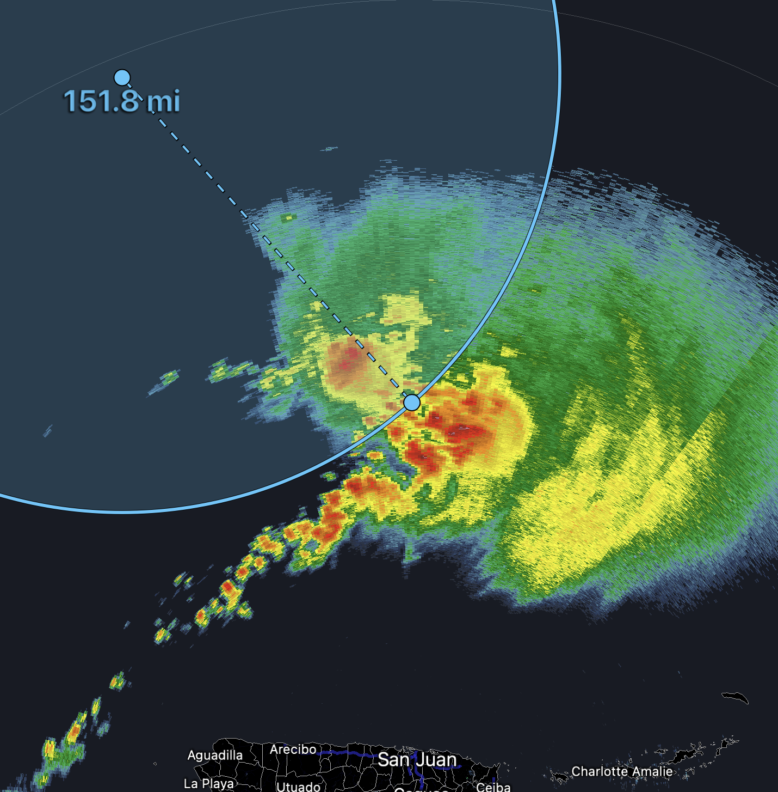
 | 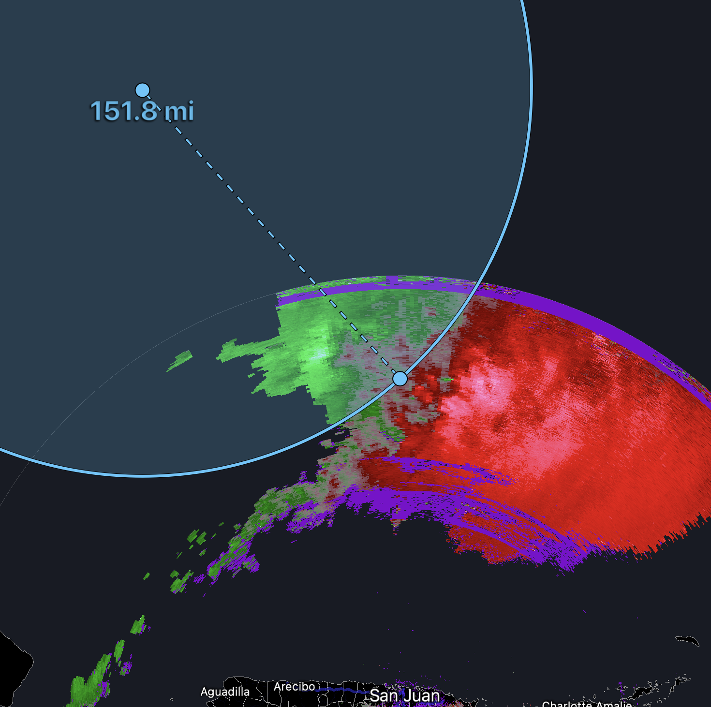
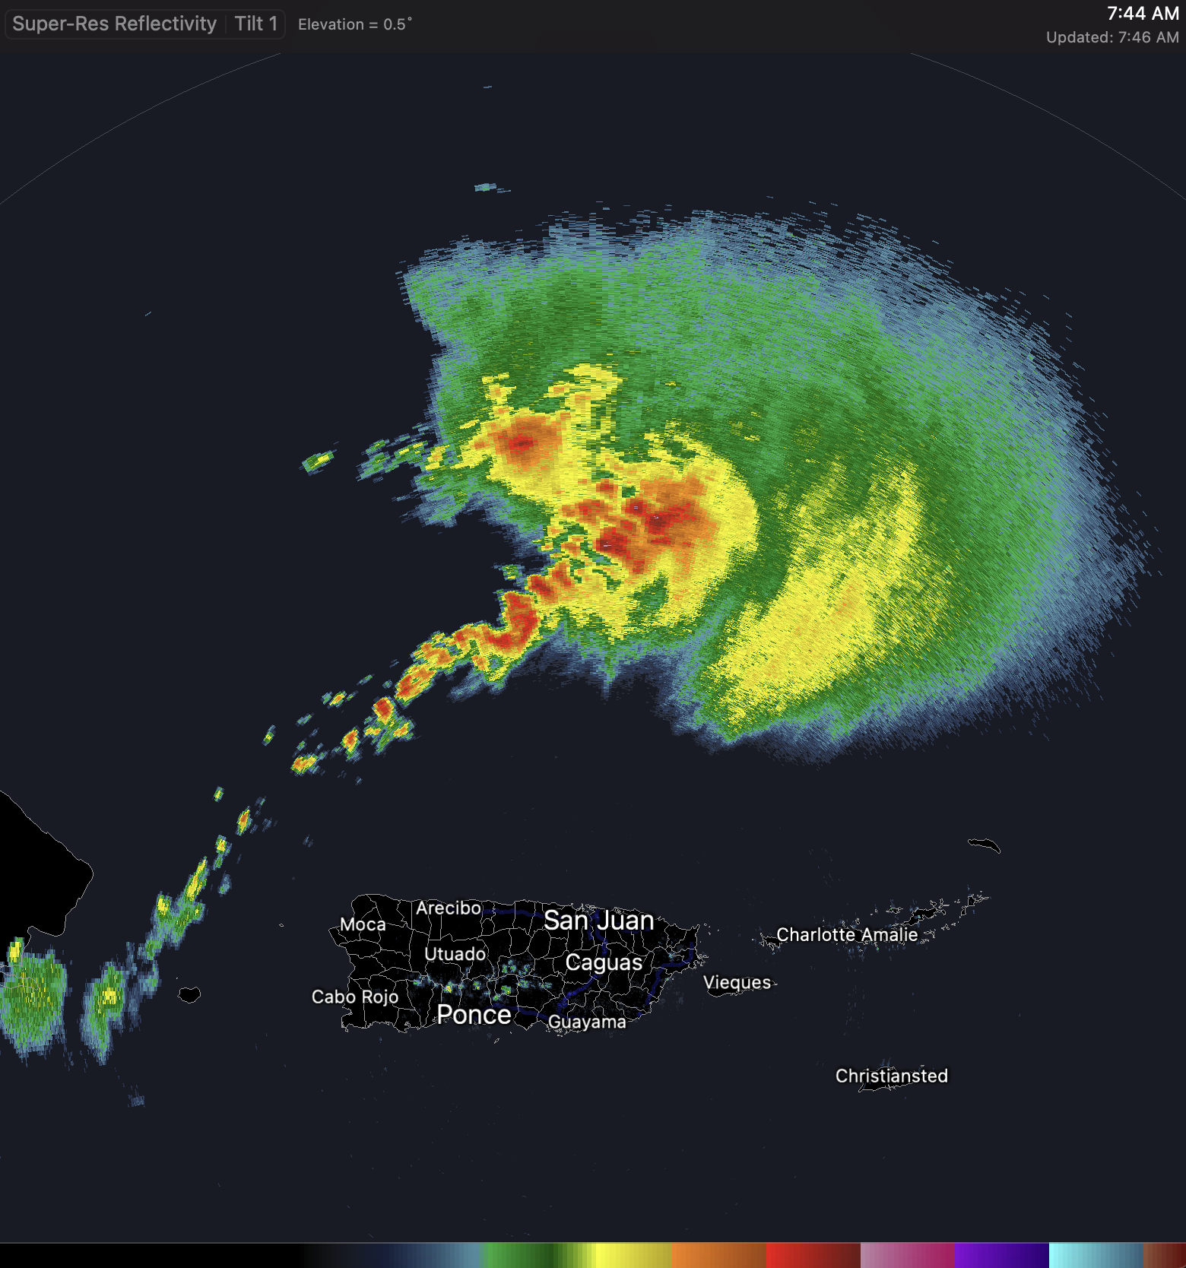
Mountain time
1423 | Dropsonde #3
 | 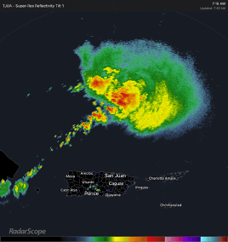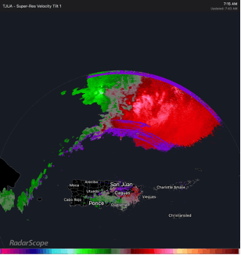
1423 | Dropsonde #3
 | 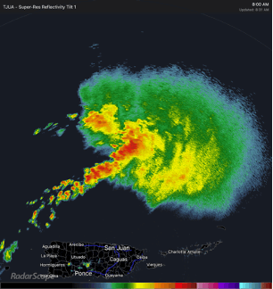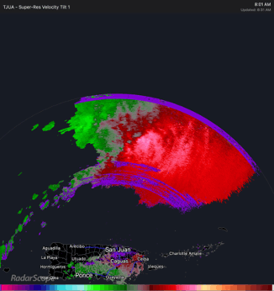
1440 | Midpoint Sonde #4
1456 | Sonde #5 endpoint
1514 | Sonde 6 SE of IP back inbound
1521 | 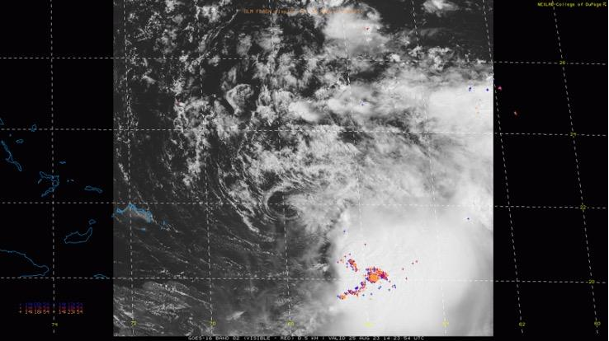  Few small cells starting to pop with lightning closer to the LLC
1529 | Midpoint sonde 7
1546 | Sonde 8
1618 | 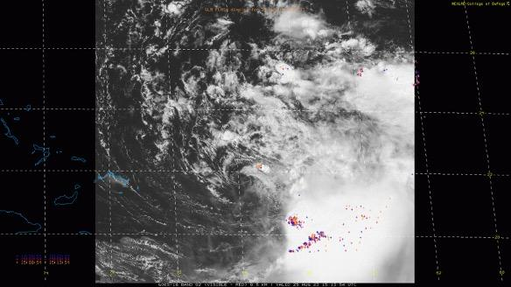  Continuing to get lightning with cell near LLC and some other new development but pushing southward (against low-level background flow) and starting to weaken  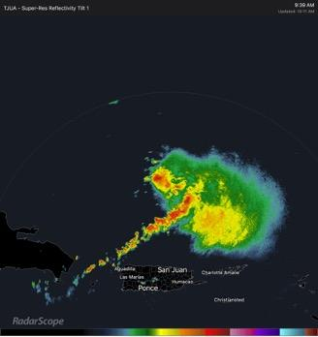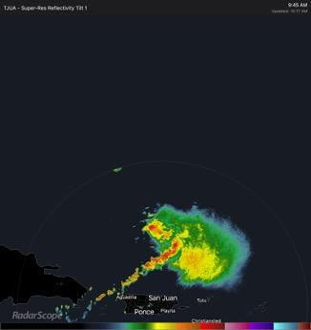
1st analysis TDR - westerly flow at mid-levels. Background flow too strong to amplify vorticity likely
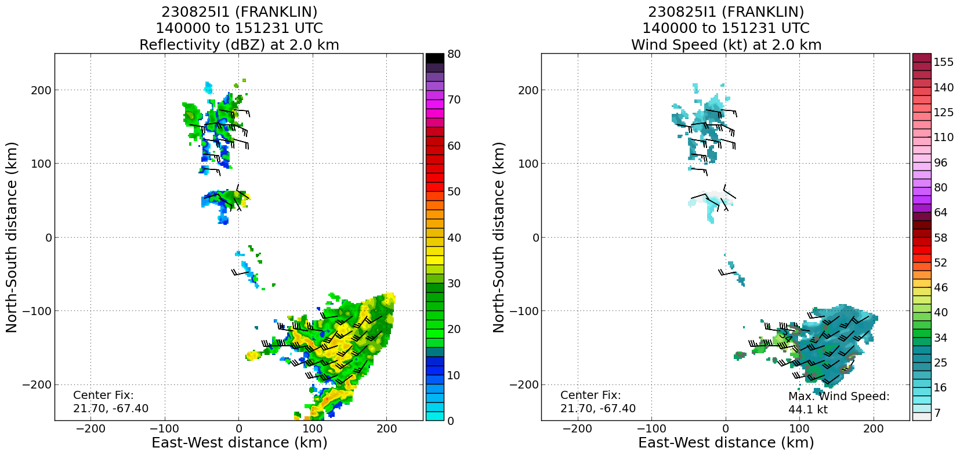
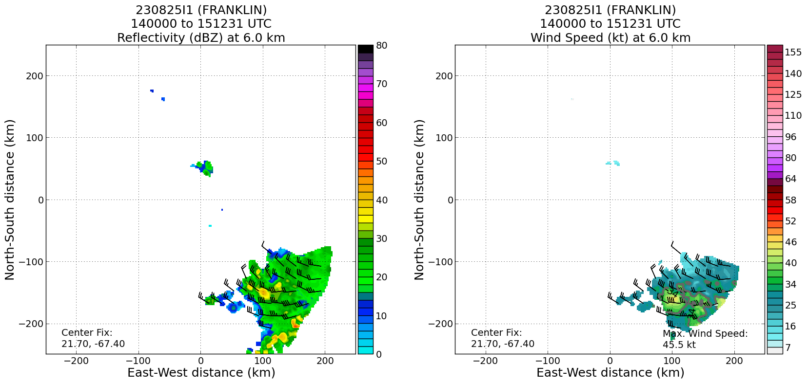
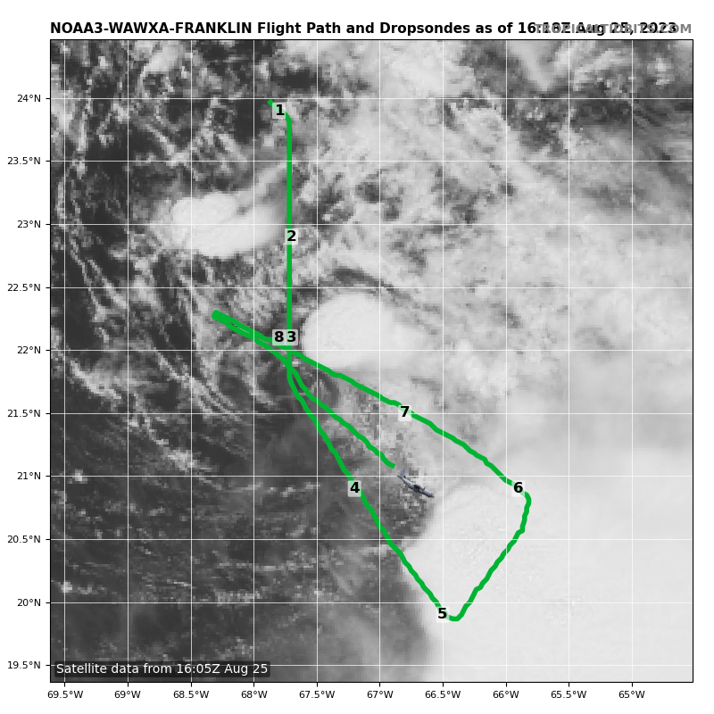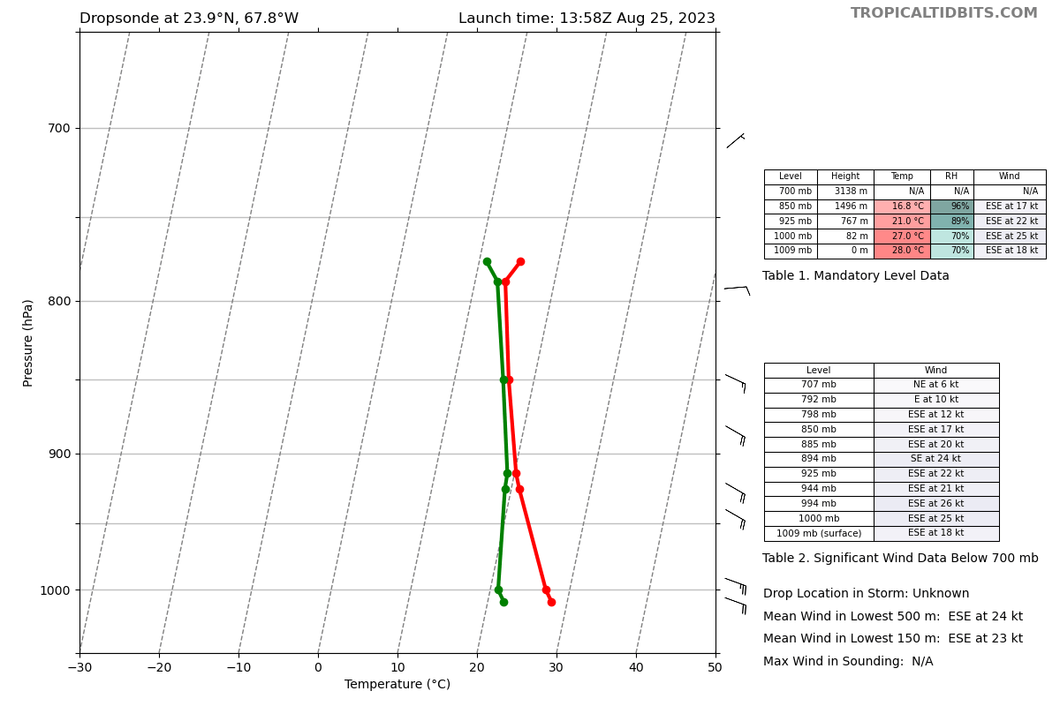
Very dry dropsonde #1 in boundary layer
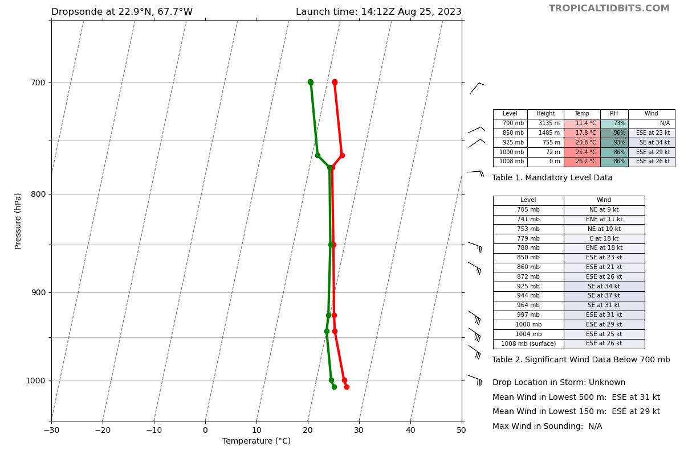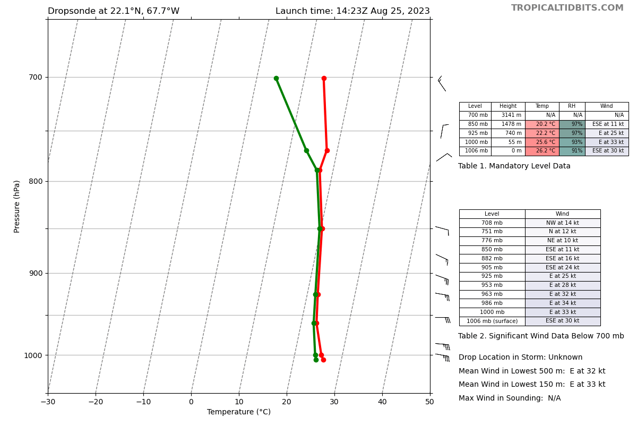
More moist - dropsonde #2 and #3 near LLC
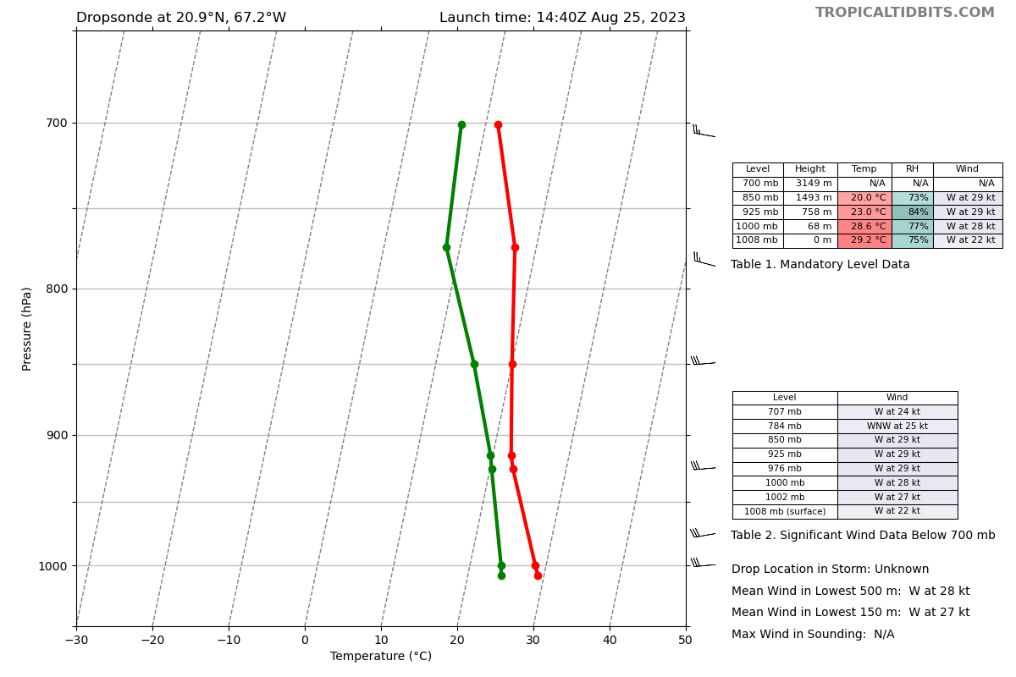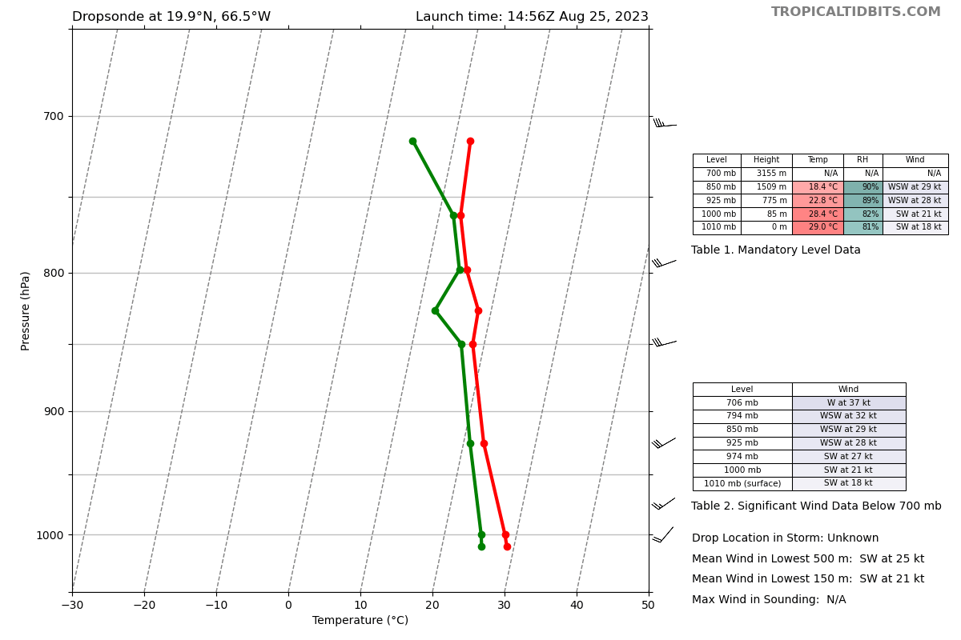
Warmer/more unstable in inflow region near deep convection far displaced?
 | Little more definition to LLC with convective cell that has developed for more scatterers. *2nd analysis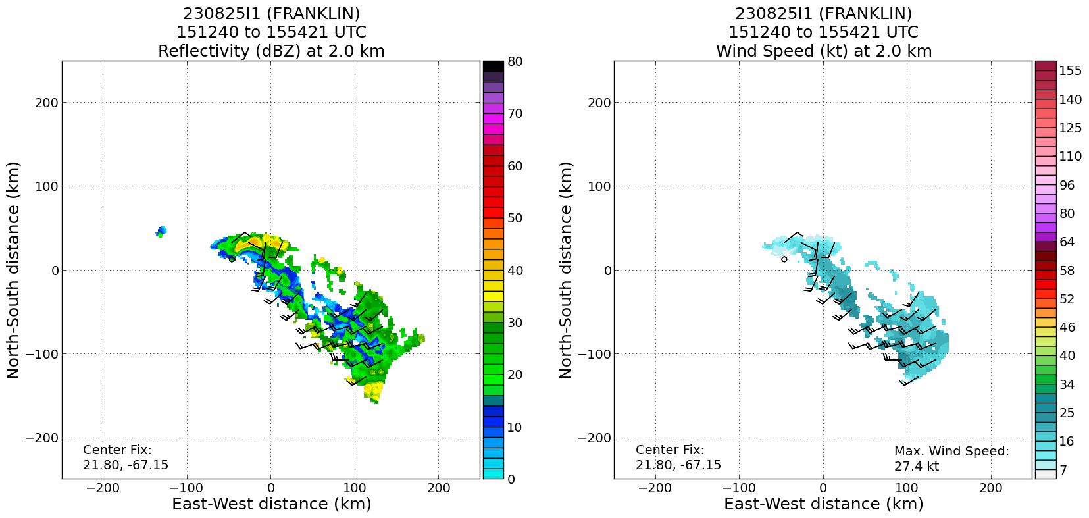

POST-FLIGHT
Mission Summary | [Short description of interesting observations from the flight; what objectives were successful? What was unsuccessful? Was the planned pattern flown? What deviations occurred?  [Don’t forget to fill in Tables on page 1]  [Sonde and ocean expendable accounting: how many total of each? How many are charged to each account?]
Actual Standard Pattern Flown | [Butterfly, Rotated Figure-4, Lawnmower, etc]
APHEX Experiments / Modules Flown | [Linked to HFP Plan; fill in regardless of whether the mission was operationally or research tasked]
Plain Language Summary | [Boil down the above into a couple of bullet points in “plain language”. This will help us when we report to management & OAR Public Affairs and prepare storm mission summaries]
Instrument Notes | [Notes about instrument status from during and after the mission]
Final Mission Track | [Insert MTS screenshot of final flown track, ideally at the completion of the pattern with satellite imagery]

